[Artificial Intelligence in Agriculture 5 (2021) 223–232](https://doi.org/10.1016/j.aiia.2021.10.001)

Contents lists available at [ScienceDirect](http://www.sciencedirect.com/science/journal/)

Artificial Intelligence in Agriculture

journal homepage: [http://www.keaipublishing.com/en/journa ls/artificial- intelligence- in-agriculture/](http://www.keaipublishing.com/en/journals/artificial-intelligence-in-agriculture/)

[](http://crossmark.crossref.org/dialog/?doi=10.1016/j.aiia.2021.10.001&domain=pdf)Early stage detection of Downey and Powdery Mildew grape disease using atmospheric parameters through sensor nodes

Kainjan Sanghavi a,⁎, Mahesh Sanghavi b, Archana M. Rajurkar c

a *SNJB COE and Research Scholar SRTMU, Nanded, India*

b *Department of Computer Engineering, SNJB COE, Chandwad, India*

c *Department of Computer Science and Engineering, MGM COE, Nanded, India*

## a r t i c l e i n f o

*Article history:*

Received 19 March 2021

Received in revised form 5 October 2021 Accepted 6 October 2021

Available online 18 October 2021

*Keywords:* Downey mildew Powdery mildew Grape diseases

Internet of things (IoT) Sensor

## a b s t r a c t

Grape diseases are major factors causing severe diminution in its fruit development. Unfavorable climatic condi- tions are one of the principal dangers for grape disease development. Downy Mildew, Powdery Mildew, Anthrac- nose, Stem borer, Black Rot, Leaf Blight are widespread grape leaf vermin and diseases, which cause stern monetary losses to the grape industry. Devices ready to quantify the climate conditions in real-time for disease onset are hence crucial to perform timely diagnosis and precise detection of grape leaf diseases. This will ensure the healthy growth of grape plants, further controlling the spread of diseases. This paper discusses the require- ments for building a consistent grape disease detection framework that would encourage headways in agribusi- ness. The primary aim of this work is to adapt an Internet of Things (IoT) based approach to predict the occurrence of Downey and Powdery Mildew grape diseases at an early stage. The sensor values received are transmitted to the Central Server with the help of the IoT device NodeMCU. At the server side, an analysis is made based on weather conditions. Further notification to the farmer is sent if weather properties are conducive for disease onset. The exclusivity of the system lies in using a rain gauge sensor along with the temperature sen- sor to predict the occurrence of grape diseases. This system realizes an overall accuracy of 94.4% for Downey Mil- dew and 96% for Powdery Mildew. Experimental results suggest the projected model can proficiently recognize Downey and Powdery Mildew grape diseases.

© 2020 The Authors. Publishing services by Elsevier B.V. on behalf of KeAi Communications Co., Ltd. This is an open access article under the CC BY-NC-ND license (<http://creativecommons.org/licenses/by-nc-nd/4.0/>).

1. Introduction

The grape industry is one of the significant organic product indus- tries in India. Nearly 2,46,133 tons of fresh grapes worth $334.79 million were exported by India in 2018–19 (Indian Grape Forum, 2019). Maha- rashtra (third largest state in India) comprising over 81% of the yield for grape production in India. However, grape plants are vulnerable to dif- ferent types of diseases due to the ongoing climate conditions such as rain and humidity. Ranchers struggle with various issues in keeping grape quality and trade responsibilities in diverse business sectors. Sub- sequently, detection and prevention of grape leaf diseases at an early stage are required by vineyard peasants and research experts.

Downey Mildew (induced by Plasmoparaviticola), and Grape Pow- dery Mildew (induced by Uncinulanecator (Schw.) Burr.), are two sig- nificant diseases of grape in numerous parts of the world (GuanlinLi and Wang, 2011). These diseases affect both leaves and grapefruits. Downey is particularly severe under severe precipitation, high relative

* Corresponding author at: SNJB's KBJ COE, Chandwad Research Scolar, SRTMU, Nanded, India.

*E-mail address:* [sanghavi.kmcoe@snjb.org](mailto:sanghavi.kmcoe@snjb.org) (K. Sanghavi).

moistness, and significant stretches of dampness on leaves and fruits (Indu et al., 2010); whereas high humidity and moist weather favours the development of Powdery disease (Mundankar et al., 2008). Crop protection products (fungicides) are applied to minimize these diseases. Fungicides are expensive for farmers and can cause ecological contami- nation (Weissteiner et al., 2014), (Zhang et al., 2011) (Zhao and Pei, 2012). Thus, only applied when there are vibrant signals about the exis- tence of the disease.

Many recent approaches for disease identification depends primarily on visual or image recognition. Nonetheless, this is a tedious and onerous task. Precision horticulture (McBratney et al., 2005) aims to improve the yield per unit of cropland using Information and Communication Tech- nologies (ICT) equipment and advancements. Utilization of ICT devices and identification frameworks have been created to notify the farmers about the unexpected advent of diseases. Grape diseases can disseminate swiftly in various climates due to temperature and humidity (Eitzinger et al., 2013) under India climatic conditions. Other countries such as the

U.S. and Australia have various systems in place that use both hourly and daily meteorological conditions to anticipate the onset of a variety of different crop diseases but not for grapes. The disease model developed by (Thomas et al., 1994) computes the day-to-day average temperature

<https://doi.org/10.1016/j.aiia.2021.10.001>

2589-7217/© 2020 The Authors. Publishing services by Elsevier B.V. on behalf of KeAi Communications Co., Ltd. This is an open access article under the CC BY-NC-ND license ([http://](http://creativecommons.org/licenses/by-nc-nd/4.0/) [creativecommons.org/licenses/by-nc-nd/4.0/](http://creativecommons.org/licenses/by-nc-nd/4.0/)).

along with the hours of moisture and propose treatment solutions for as- cospore infections. They discuss the model testing in California climatic conditions. There is a need for devices to quantify the climate conditions in real-time such that onset of grape disease can be predicted. In recent years, modern mechanisms from the Internet of Things (IoT) have been utilized to acquire real-time onsite observations (Pesonen et al., 2014) and it is crucial to build disease models referenced to these IoT devices.

The principal objective of this work is to acclimate a disease warning model in the field of viticulture via an innovative framework using sen- sors to measure real-time meteorological conditions within the vine- yard. Measured data is sent to a central server using the cloud and an alert message is sent to the farmer, when the favorable conditions arise, for the occurrence of Downey and Powdery on grapes or leaves. Distinctively, the contributions of this effort are:

1. Effective determination of Downey and Powdery mildew via leaf wetness, humidity and temperature.
2. Pro-creation of regular warnings, contingent on the level of de- velopment and kind of disease, sent directly to farmers; and.
3. Application of the models for use on IoT hubs sent legitimately.

The rest of the paper is organized as follows: Section 2 presents the background. Section 3 details methodology used to detect Downey and Powdery Mildew grape disease, in vineyards. Section 4 shows experi- mental results of this system followed by insights on performance. Section 5 concludes the work and proposes commendation of future work.

1. Background

Downey Mildew (PlasmoparaViticola) is a major grape disease in India (Emmett et al., 1992). Farmers need to use judgment on whether to use fungicides for Downey Mildew (Magarey et al., 1991) noting that both cost and residue levels on crops increase with fungicide use. Clearly, farmers need to restrict the occasions to shower, so that the cost diminishes along with ecological contamination; however they likewise need to limit the danger of crop failure because of the disease. Decades ago only a few methodologies were utilized to anticipate Grape Downy Mildew disease. Various statistical models were evolved (Hill, 2000) (Maurin, 1983) (Tran Manh Sung et al., 1990)(Blaise and Gessler, 1992) (Orlandini et al., 1993) that performed without explaining all functioning details. Robotic models often depends on the assessment of numerous parameters and require a good knowledge of mechanisms and impact of various ecological factors on these

mechanisms. In 1992, an Austrian analyst built up the Metos pro- grammed climate station and related software, to foresee the occur- rence of Downy Mildew. The abroad could not precisely determine diseases in India. The Metos software model (G. Pessl, 2000) was per- sonalized for South African environment in 1995. Consequences have revealed that supplementary splashes were required in the protection showering program, rather than proposals of the Metos-2 model, for the equivalent or even further developed control of Downey mildew. Metos-2 model didn't caution of any Downey mildew contaminations. In 2006 to make it more exact and easy to use DonsigeSkimmelVroeg- Waarskuwings model (DSVW) (Afrikaans for “Downey Mildew Early Warning Model”) was developed (Haasbroek and Vermeulen, 2005). Two significant changes were made in comparison to Metos-2, the leaf wetness was supplanted with a numerical, non-linear regression and the Metos-2 model's “Yes/No” admonitions for Downey Mildew dis- eases were supplanted with four classes of potential dangers. The deter- mined leaf wetness of the DSVW model, which used estimated relative dampness and air temperature as info esteems, had a critical coefficient of assurance of 0.70, compared to estimated leaf wetness.The DSVW model yield at present gives a graphical depiction of the past climate factors (as long as 3 weeks), and an alert of (3 unique tones - high, me- dium and low possibility) of probable favorable condition for both es- sential and optional disease occurrence.

Powdery Mildew is another monetarily significant disease. In India, this disease reoccurs in grape plantations with humid climate (e.g. high relative dampness) favoring growth of the disease (Oberti et al., 2014). Presently, in the hotter and drier grapevine-developing terri- tories, powdery mildew is meticulously constrained by agrochemicals, applied consistently in grape plantations (Stummer et al., 2003) (Calonnec et al., 2004) (Crisp et al. (2006a)) (Crisp et al. (2006b)) (Iriti et al., 2011).

Sensor mechanization for grape yield malady has been comprehen- sively analyzed by (Sankaran et al., 2010), who describe current tech- nologies for developing a ground-based sensor framework which aid in supervising disease in plants under field conditions. The authors also reviewed that the spectroscopic and imaging innovation could be incorporated with a self-governing agricultural automobile for reliable and real time disease detection recognition to accomplish predominant plant disease monitoring and control. Various researchers have projected solutions for identifying the condition of a vineyard by utiliz- ing sensors. Sensors permit us to recognize the particular necessities of every territory, which improves the supervision of the grape plantation and addresses the potential issues precisely. The majority of recent liter- ature centers on remote monitoring of vineyards grapevines by utilizing

Table 1

Summary of literature review.

Reference System Description Findings

Blaise and Gessler (1992)

Statistical They can anticipate complex frameworks, but they do this without explaining all functioning in details.

Pessl, 2000 Uses a variety of wireless sensors and devices to monitor field conditions

Cannot precisely determine diseases in India

Haasbroek and Vermeulen, 2005

Gives an alert of probable favorable condition and also a graphical depiction

Works for South African Environment

Sankaran et al., 2010

Review of various plant disease detection techniques. Sensor Mechanization, spectroscopic and imaging Can be incorporated for reliable and

real time disease detection recognition to accomplish predominant plant disease monitoring and control

Luvisi et al., 2012 Assess the impact of explicitly planned High and Low Frequency transponders.

Distress the development of the shoots examined

Rossi et al., 2014 A real-time monitoring framework and online system. Provide up-to-date information for managing the vineyard in the form of alerts and

decision supports

Matese et al., 2009

Incorporates a climate station and a few remote hubs situated that transmits the information to a remote central server.

This system gathers only miniature meteorological factors without bearing about infection counteraction.

VintiOS Props the choices of grapevine cultivators and vintners on the grapevine growth.

Monet Incorporate precision sensors equipped for seizing the most precise weather parameters.

Product shows the location of the homestead and permits the farmers to deal with all the information identified with it.

Monitors the wellbeing of a grape plantation, including the danger of rising diseases, climate data

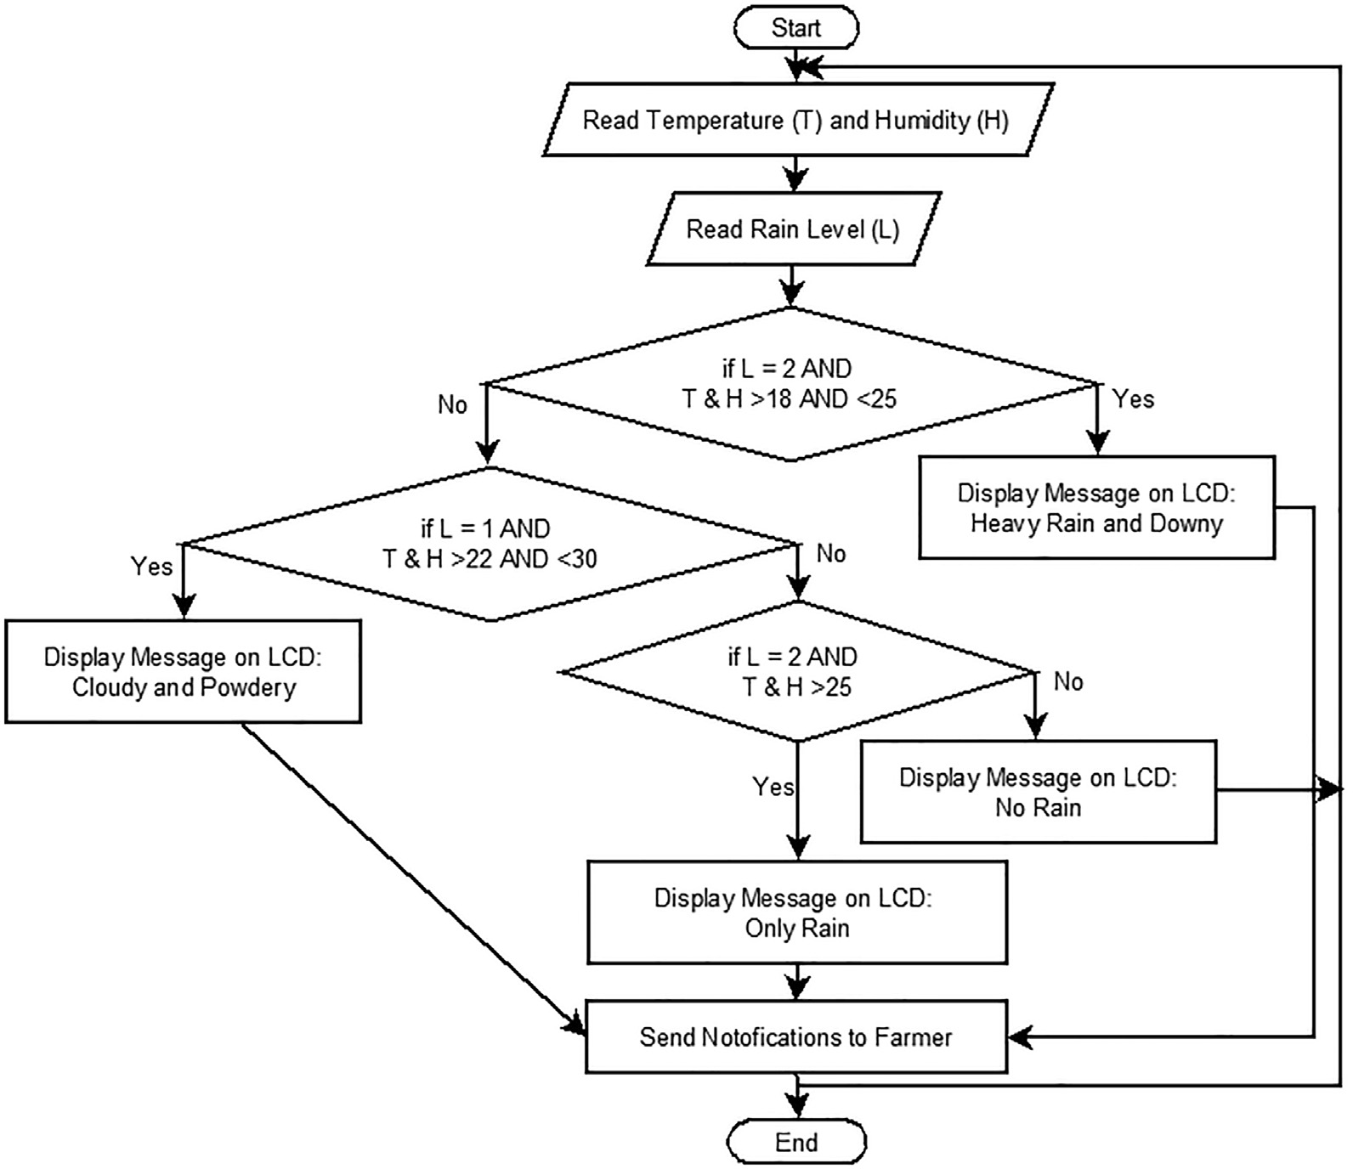

Fig. 1. Flow chart of the proposed Algorithm 3.2.

thermal imaging (aeronautical and ground-based) and hyperspectral methods (Pôças et al., 2015) (Sepúlveda-Reyes et al., 2016) (Rey- Caramés et al., 2015) (Turner et al., 2011) (Karakizi et al., 2016). These approaches include the procurement of spectral information using ex- pensive technologies, for example, satellites, airplanes, or Unmanned Aerial Vehicles. Agrochemical information can be utilized to develop the grape plant growth process and to ensure tractability and precise grapevine health perceptions. The impact of explicitly planned High and Low Frequency transponders when embedded in grape vineyards is documented in (Luvisi et al., 2012). In spite of the fact that the tracta- ble data is helpful, the authors describe that the embedding methods distress the development of the shoots examined.

Vite.net, introduced in (Rossi et al., 2014) is an encompassing meth- odology which incorporates a real-time monitoring framework and on- line system to deal with the grape plantation. Nonetheless, the authors depend on third –party hardware, so details on the sensor hubs are pre- cluded. A wireless sensor network for precision viticulture (Matese et al., 2009) is useful for observing grape plantations progressively. The framework incorporates a climate station and a few remote hubs situated in the grape plantation. A modem introduced on the hubs transmits the information to a remote central server. This system gathers only minia- ture meteorological factors. (Zhang et al., 2015) proposed a system for ag- riculture monitoring using factors like temperature, soil dampness, and computes system dependent on the field information. The system incor- porated WSN with decision support system and computerized many un- dertakings including climate monitoring. It gives an instrument to ranchers, framework clients, and viticulture ventures, to further develop the grape plantation proficiency. Various organizations now offer im- proved monitoring solutions for grape plantations. SGSMap developed an agribusiness system that sustains the choices of grapevine cultivators and vintners on grapevine growth (VintiOS, 2020). The product shows

both the location and all information identified with it. (Monet, 2020), outlines a comparative instrument, which monitors the wellbeing of a grape plantation, that includes the danger of rising disease outbreak, cli- mate data. Other exclusive arrangements have been proposed by SmartVineyard (SmartVineyard, 2020) which incorporate precision sen- sors equipped for seizing precise weather parameters (e.g. hourly, daily). The sensor is intended for grapes and can be placed among leaves to convey this important information to viticulturists.

On studying all the frameworks referenced and summarized (See Table 1.), Our proposed system intends five primary focal points that have not been discussed simultaneously in the literature. To begin with, it gives a total hardware and software framework, so similarity is- sues are limited. Secondly, this system tries not to gather information from or through third-party cloud-based platforms Third, because of the utilization of standard android Nodes, the arrangement cost of the framework is genuinely reasonable, while giving a decent coverage. Fourth, it focuses on early stage detection in grape production. Lastly, this approach has been devised in a secluded manner for ease in adding new alerts, sensors, and actuators to the framework.

Hence, the objective for this work lies in developing an adaptable system for the management of grape diseases that occurs at much early stages for crop disease using wireless sensors nodes.

1. Proposed work
   1. *Functionality of the proposed system*

The proposed system empowers the ranchers with a simple device for grape disease manifestation and prevention to preserve the grape vineyard. The framework was considered to assist in monitoring the

development of grape plantation and ultimately expand the quality of grapes via exhibiting the data about weather conditions and in adding selection for fungicide use. Thus, the proposed system stands in for two essential necessities:

1. It tracks important factors that influence growth of grapes within vineyard while offering data through the Internet by utilizing a wide scope of sensors.
2. It helps in grape disease prevention through prescient models, pro- curing alerts to the farmers from the vineyard.

The implementation of algorithms 3.1 and 3.2 automates the identification of Downey and Powdery mildew grape diseases and sends notification for these diseases to the farmers. Algorithms are executed on a central server which monitors the status of the dis- ease occurrence using the climatic parameters gathered from the sensor hubs. A notification is sent to the farmer when leaf wetness and the temperature range sensed by the sensors surpasses the threshold value necessary for disease onset. The flow diagram for our approach demonstrates its inward operations and multifaceted nature(Fig. 1).

# Algorithm to Check Rain Level

**Function chkRainLevel() Declarations:**



**Begin**



**nLevel = ReadWaterLevel() if(nLevel< 0.10)**



**else if(nLevel>=0.10 &&nLevel<=0.30) else if(nLevel> 0.30)**

**End**

# Algorithm identify Occurrence of Downey and Powdery

**Function Main() Declarations:**





**Begin**



**fTemperature = readTemperature() fHumidity = readHumidity() nRange=chkRainLevel()**

**if(nRange==0 && fTemperature>=18 &&fTemperature<=25) then**



**else if(nRange==1 &&fTemperature>=22 &&fTemperature<=30 )**





**End if**

**End**

**else if(nRange==0 && fTemperature>25)**

**else if(nRange==1 && fTemperature>30 ) else**



**##Write Data on Cloud**



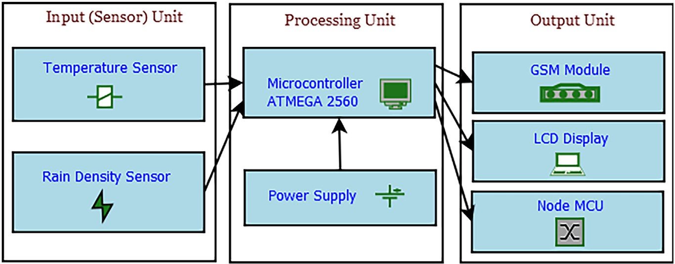

Fig. 2. System architecture.

Table 2

Specification of proposed solution.

Sr. No Component Description Specification

* 1. Power Supply: Battery 40A, 14.8 V - 16.8 V
  2. Temperature Sensor DHT11
  3. Rain Density Sensor Nil
  4. GSM Module SIM800L GSM/GPRS, 4 V
  5. LCD 16 * 2 Display
  6. Node MCU ESP8266, 16 Digital Pins, Analog −1 Pin
  7. RTC Clock DS3231 RTC
  8. *System architecture*
     1. *Overview*

The architecture of the proposed system (See Fig. 2) depicts the pre- dominant components and linkage that occurs. Temperature and Rain Sensor nodes are used to gather sensor information and send them to the central server via IoT device platform NodeMCU(NodeMCU ESP8266, 2020).

NodeMCU is liable for transmitting the records accrued from the sensor nodes to the Central Server.

* + 1. *Sensors*

Temperature Sensor and Rain Sensor measure essential environ- mental parameters viz. temperature, humidity and rainfall. Each sensor is managed by a NodeMCU (a low cost firmware and development board particularly designed for Internet of Things (IoT) based applica- tions (NodeMCU ESP8266, 2020)). NodeMCU is programmed by the

IDE of Arduino Microcontroller ATMEGA 2560 utilizing sensor libraries offered by Arduino commune. Specification of the proposed solution can be observed in Table 2.

* + 1. *GSM module and LCD display*

Notification are sent to the farmers by the means of Short Messaging Service (SMS) about the grape disease occurrence. SIM800L GSM/GPRS, 4 V, is the modem selected for the transmission of messages, and LCD Display allows the farmers to visualize the temperature and humidity values on the field.

1. Results and discussions

This section discusses about the experimental setup deployed in the field and actual results captured from the field at real time. Captured data from IoT sensors were analyzed using the algorithm stated to test for the occurrences of Downey and Powdery Mildew. After analysis the proposed system is compared with the existing system which re- veals that the proposed system is worth detecting the occurrence of both diseases.

* 1. *Experimental setup*

The deployment of the field apparatus was carried out in a vineyard located in Materwadi (Tal- Pimpalgaon) and Sakura(Tal- Pimpalgaon) as can be viewed in Fig. 3. The sensor nodes were placed 1 m above the ground to monitor the weather parameters, based on the regulation of World Meteorological Organization (WMO) (1996).

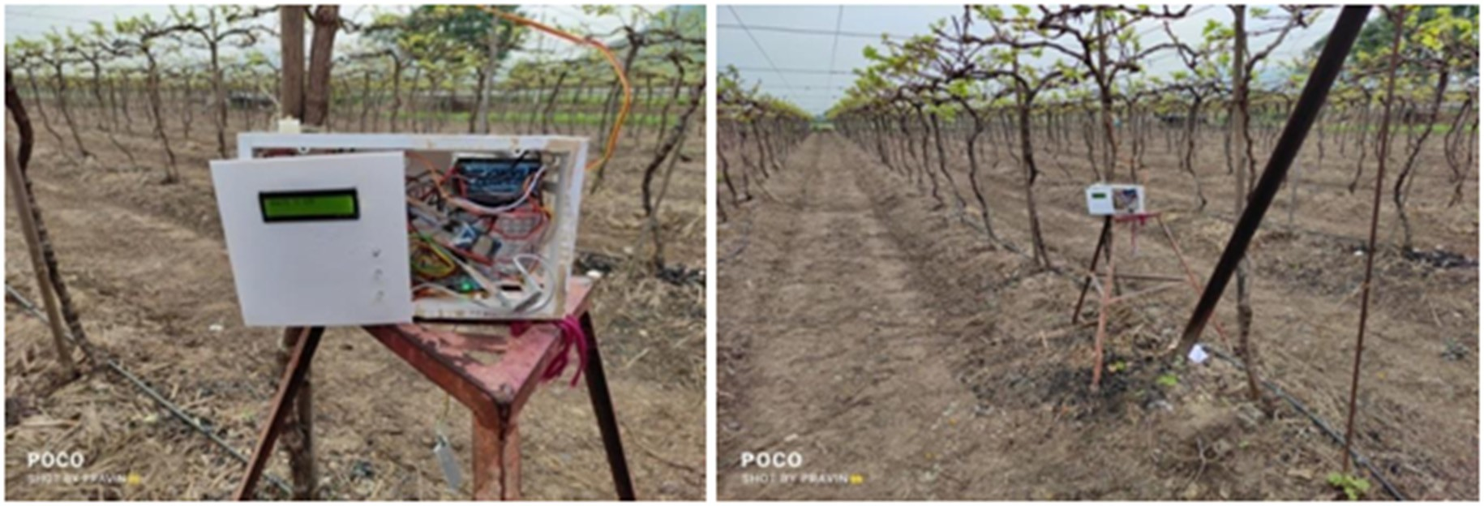

Fig. 3. Experimental device setup in farm for monitoring weather.

Table 3

Number of sensor recordings in each farm.

|  |  |  |  |
| --- | --- | --- | --- |
| Sr·No | Source of Data | Total Samples | Testing Samples (20%) |
| 1 | Prashant Agro Farm, Materwadi, Pimpalgaon, Nashik | 1080 | 215 |
| 2 | Boraste Agro Farms, Sakura, Pimpalgaon, Nashik | 1080 | 215 |
|  | Total | 2160 | 430 |

Temperature, Rain Fall Level Vs Date-Time

35

33

31 30

31

32

28

29 29

28

29

30 30 30 30 30 30 30 30 30 30 30 30 30 30

28

2234 2234 22343 222343 2234 2234 2234 2234 2234 22234 2234 22234 22234 2234 22234 2243 23 23 23 23 23 23 23 23 23 23 23 23 23 23 23

265 265

25 25 25 265 265 265 25 26 25 25 25 25 276 25 276 25 276 25 276 25 276 25 276 25 276 27 27

21 21

21 22 22

22

30

25

Rain Fall Level, Temperature

20

15

10

5 2

0 0 0

0

15-09-2019 00:00

16-09-2019 00:00

17-09-2019 00:00

18-09-2019 00:00

19-09-2019 00:00

20-09-2019 00:00

21-09-2019 00:00

22-09-2019 00:00

23-09-2019 00:00

24-09-2019 00:00

25-09-2019 00:00

26-09-2019 00:00

27-09-2019 00:00

28-09-2019 00:00

29-09-2019 00:00

30-09-2019 00:00

01-10-2019 00:00

02-10-2019 00:00

03-10-2019 00:00

04-10-2019 00:00

05-10-2019 00:00

06-10-2019 00:00

07-10-2019 00:00

08-10-2019 00:00

09-10-2019 00:00

10-10-2019 00:00

11-10-2019 00:00

12-10-2019 00:00

13-10-2019 00:00

14-10-2019 00:00

15-10-2019 00:00

21 2 2

1 2 2 2 2 2 2 2 2 2 2 2 2 2 2 2 2 2 2 2 2 2 2 2 2 2 2

Date-Time (15 September, 2019 to 15 October, 2019)

Series1 Series2

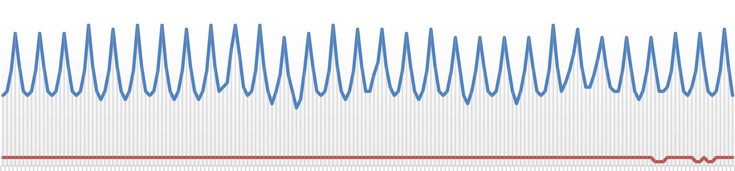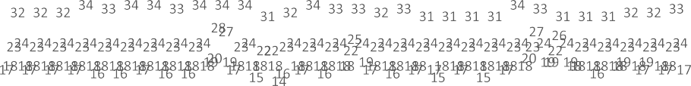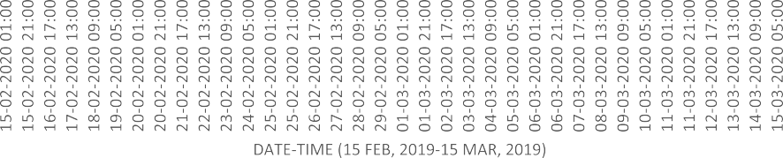

Fig. 4. Daily temperature values collected by the Hub.

1. (15th Sept 2019 to 15th Oct 2019)
2. (15thFeb 2020 to 15th March 2020)

Downy Mildew : Temperature, Rain Fall Level Vs.

Date-Time

Temperature, Rain Fall

30



25

20

15

10

5



0

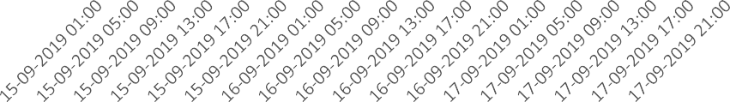

## Date-Time

 Temperature  Rain Fall Level



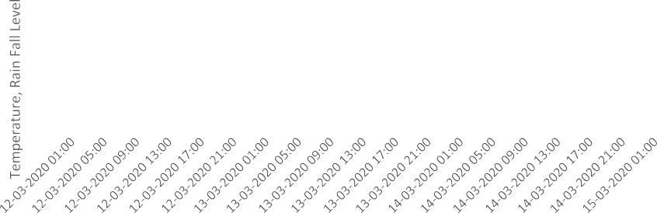

Fig. 5. (a)Downy Mildew Favorable Condition (15thSept to 17thSept 2019).(Rossi et al., 2014). (b) Powdery Mildew Favorable Condition (12thMarch to 15th March 2020)

* 1. *Simulation*

The proposed model has been evaluated based on the data gathered in real -time by the IoT based device placed in the farm. This section pre- sents the evaluation of the devised model.

Table 3, shows the data collection values for experimental purpose. The recordings of sensor values were collected during 1stSeptember 2019 to 31stAugust 2020, 1080 recordings in each farm under consider- ation i.e. 6 values per day.

Fig. 4.depicts a graph of the information sensed by sensors (temper- ature and rainfall) and sent to the server by NodeMCU from 15thSeptember 2019 to 15thOctober 2019 at Prashant Agro Farm. It also shows the temperature values sensed in the period of 15th Feb 2020 to 15th March 2020. It demonstrates the estimations after every four hours. This is also depicted in Table 3 i.e. testing samples estima- tions are 215 per farm.

Fig. 5 shows the temperature acquired by the hub on 15th September

-17th September 2019 and 12thMarch to 15th March 2020 respectively (from Prashant Agro Farm). The encircled value in Fig. 5a indicates the favorable condition for Downey Mildew showing temperature value 21 °C and heavy rainfall in accordance to the algorithm 3.2. Similarly, in Fig. 5b. The encircled value indicates the favorable condition for Pow- dery Mildew showing temperature value 23 °C and cloudy atmosphere in accordance to the algorithm 3.2.

A small dissimilarity can modify the turn of events and necessities of

approximately at night 9.00 p.m. on 15th Sept 2019 as heavy rain was sensed by the rain gauge sensor, Fig. 5. (a). These conditions occurred because of the downpour, and a decrease in the temperature. Similar ex- perimentation was carried out to demonstrate occurrence of Powdery Mildew from 12thMarch 2020 to 15thMarch 2020.

* 1. *Alerts*

The temperature and rain level values are checked after every four hours. Fig. 6, depicts the Experimental device set on the field to display and gather the agroparameters value and also the message of disease occurrence. If the parameters convene the threshold values, a notifica- tion is sent to the farmer. Fig. 6 also illustrates an instance of a warning sent by SMS about the occurrence of Downey and Powdery Mildew disease.

* 1. *Performance measure*

The performance of the developed merchandise is assessed by com- puting accuracy Eq. (1), recall Eq. (2), and precision Eq. (3) based on Confusion Matrix as shown in Tables 4.1 and 4.2 for Downey and Pow- dery respectively. The Accuracy, Recall and Precision are derived from True Positive (TP), True Negative(TN), False Positive (FP), False Nega- tive(FN). These are calculated as follows:

*TP* + *TN*

the plant even though initially the information may appear to be analo- gous. For example, favorable conditions for Downey Mildew arose

*Accuracy* =

*Total* (1)

*Recall* = *TP TP* + *FN*

*Precision* = *TP*

*TP* + *FP*

(2)

(3)

* 1. *Comparison with other systems*

Depending upon the proposed system, the grape diseases can be ef- fectively identified at a much early stage. The novelty of the proposed system lies in using the Rain sensor along with temperature and humid- ity sensor. The accuracy of disease notification is therefore considerably increased then if a rain gauge was omitted. Thus, the projected device demonstrates higher performance in recognizing grape diseases.

Precision, Recall and Accuracy are calculated as demonstrated in Tables 5.1 and 5.2 for Downey and Powdery respectively based on the Confusion Matrix illustrated in Tables 4.1 and 4.2.

From the above results we can observe that 94.4% of recordings were correctly identified in case of Downey Mildew disease occurrence and 96% for Powdery Mildew. Thus, the accuracy achieved has helped the farmers to reduce the use of fungicides on grape plants. This increases the quality of grapes.

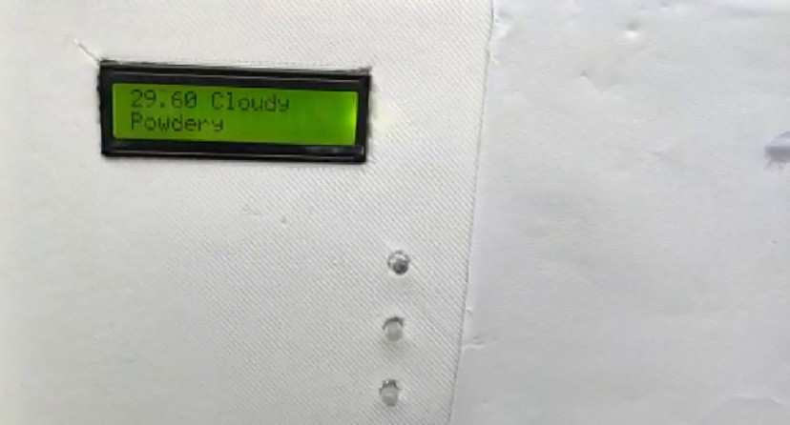

Fig. 6. Occurrence Notification for Powdery Mildew showing temperature value 29.60 and Cloudy atmosphere on the experimental device.

Table 4.1

Confusion Matrix of the proposed system for Downey Mildew.

|  |  |  |  |
| --- | --- | --- | --- |
| *n* = 430 | Predicted (No) | Predicted Yes | Total |
| Actual (No) | TN = 106 | FP = 14 | 120 |
| Actual (Yes) | FN = 10 | TP = 300 | 310 |
|  | 116 | 314 | 430 |

Table 4.2

Confusion matrix of the proposed system for Powdery Mildew.

|  |  |  |  |
| --- | --- | --- | --- |
| n = 430 | Predicted (No) | Predicted Yes | Total |
| Actual (No) | TN = 115 | FP = 11 | 126 |
| Actual (Yes) | FN = 6 | TP = 298 | 304 |
|  | 121 | 309 | 430 |

Table 5.1

Performance measures Downey Mildew.

In this proposed system, temperature and rainfall level have been used as features to identify the favorable conditions for grape disease growth. The performance of the projected framework has been contrasted with existing detailed strategies and is conferred in Table 6, proposed (Patil and Thorat, 2016), (Das et al., 2009) (Kharde and Kulkarni, 2016). The systems used for comparison have used IoT, WSN and Image Processing approach. All the systems have been analyzed on our augmented data set and achieved accuracy of approximately 90%. However, the accuracy proposed in our system is increased due to the use of rain sensor along with humidity and temperature sensor. From the comparison, it is clear that the proposed algorithm is capable of identifying Downey and Powdery Mildew grape disease with high ac- curacy better than other systems investigated.

1. Conclusion

This paper presents a framework dependent on wireless sensor hubs that considers remote monitoring of grape plantations. Particularly, the proposed system suggests an executive approach to control Downey and Powdery Mildew (devastating grape diseases for vine producers). Based on literature surveys, we develop an adaptable system for the management of grape diseases at much early stage using wireless sen- sor nodes. When a particular threshold level is achieved, the proposed framework generates an alert to the farmer so they may take preventive measures by scouting and potentially using a fungicide. Consequently, the framework avoids the use of pesticides and herbicides when not re- quired, thereby reducing the impact on the surroundings and minimiz- ing the cost to farmers.

The system was deployed initially in Prashant Agro Farm (Materwadi, PimalgaonBaswant) and also Boraste farm(Sakura, PimapalgaonBaswant) in September 2019. The arrangement included two types of sensor hubs dependent on ESP8266 microcontrollers. Type-1 nodes monitor environmental information and Type-2, precipi- tation level. A battery was used to satisfy the power supply of the grape- vine in an economical manner. The data gathered by the developed system is introduced through an easy to understand LCD interface for representation. The information can also be accessed online through the cloud and can be operated from any PC, tablet or smartphone with the sole prerequisite of having a browser and an Internet link. Addition- ally, the framework offers state-of-art information to deal with the grape plantation in the form of cautions by means of messages to the farmers. As regards to the tests performed, it was confirmed that the framework executed well in a real-world situation and also gave accu- rate information gathered on the climate, the nodes, and the alarms re- lated with the advancement of Downey and Powdery Mildew grape

|  |  |  |  |
| --- | --- | --- | --- |
| Measure | Estimation | % | disease. |
| Accuracy | 0.944186047 | 94.4 | To summarize, all outcomes from the proposed system affirm that it |
| Recall | 0.967741935 | 96.8 | offers excellent information to the grapevine producers to automate the |
| Precision | 0.955414013 | 95.5 | detection of Downey and Powdery Mildew through monitoring |
|  |  |  | weather related variables while providing a cost-effective system for |
|  |  |  | the ranchers to address real-time climate issues surrounding disease |
| Table 5.2  Performance measures Pow | dery Mildew. |  | manifestation in grape plantations. |

CRediT authorship contribution statement Kainjan Sanghavi: Conceptualization, Methodology, Writing – orig-

|  |  |  |
| --- | --- | --- |
| Measure | Estimation | % |
| Accuracy | 0.960465116 | 96 |
| Recall | 0.980263 | 98 |
| Precision | 0.9126984 | 91.3 |

inal draft, Visualization, Investigation. Mahesh Sanghavi: Data curation,

Table 6

Comparison of proposed system with existing systems.

|  |  |  |  |  |
| --- | --- | --- | --- | --- |
| Parameters / Authors | Early Detection of Grapes Diseases Using Machine Learning and IoT (Patil and Thorat, 2016) | WSN Monitoring of Weather and Crop Parameters for Possible Disease Risk (Das et al., 2009) | Unique Technique for Grape Leaf Disease Detection(Kharde and Kulkarni, 2016) | Proposed Scheme |
| Diseases Covered | Downey Powdery | Downey Powdery | Downey Powdery | Downey Powdery |
| Early Stage Detection | Bacteria LeafSpot Anthracnose  Yes | Yes | Black Rot  No | Yes |
| Notification | No | No | Yes | Yes |
| Technique Used | IOT | WSN | IP | IoT |
| Accuracy  Cloud based | Downey 90.9%  Powdery 90.9% No | Downey 87%  Powdery 84% Yes | Downey 90.47%  Powdery 92.85% No | Downey 94.4%  Powdery 96% Yes |
| Year | 2016 | 2014 | 2016 | 2020 |

Writing – original draft. Archana M. Rajurkar: Writing – original draft, Supervision.

Declaration of Competing Interest

The authors declare that they have no known competing financial interests or personal relationships that could have appeared to influ- ence the work reported in this paper.

References

Blaise, Ph., Gessler, C., 1992. Vinemild: toward a management tool for grape Downy Mil- dew. ActaHortic 313, 257–262. <https://doi.org/10.17660/ActaHortic.1992.313.32>.

Calonnec, A., Cartolaro, P., Poupot, C., Dubourdieu, D., Darriet, P., 2004. Effects of Uncinulanecator on the yield and quality of grapes (Vitisvinifera) and wine. Plant Pathol. 53 (4), 434–445. <https://doi.org/10.1111/j.0032-0862.2004.01016.x>.

Crisp, Peter, Wicks, T.J., Lorimer, Michelle, Scott, Eileen, 2006a. [An evaluation of biological](http://refhub.elsevier.com/S2589-7217(21)00028-3/rf0015) [and abiotic controls for grapevine powdery mildew. 1. Greenhouse studies. Aust.](http://refhub.elsevier.com/S2589-7217(21)00028-3/rf0015)

[J. Grape Wine Res. 12, 192–202 10.1111/j.1755-0238.2006.tb00059.x](http://refhub.elsevier.com/S2589-7217(21)00028-3/rf0015).

Crisp, Peter, Wicks, T.J., Bruer, D., Scott, Eileen, 2006b. [An evaluation of biological and abi-](http://refhub.elsevier.com/S2589-7217(21)00028-3/rf0020) [otic controls for grapevine powdery mildew. 2. Vineyard trials. Aust. J. Grape Wine](http://refhub.elsevier.com/S2589-7217(21)00028-3/rf0020) [Res. 12, 203–211 (10.1111/j.1755-0238.2006.tb00060.x.)](http://refhub.elsevier.com/S2589-7217(21)00028-3/rf0020).

Das, Ipsita, Naveen, C.P.R.G., Shah, Narendra, Merchant, Shabbir, Desai, Uday, 2009. [WSN](http://refhub.elsevier.com/S2589-7217(21)00028-3/rf0025) [Monitoring of Weather and Crop Parameters for Possible Disease Risk Evaluation for](http://refhub.elsevier.com/S2589-7217(21)00028-3/rf0025) [Grape Farms - Sula Vineyards, A Case Stud](http://refhub.elsevier.com/S2589-7217(21)00028-3/rf0025)y.

Eitzinger, J., Thaler, S., Schmid, E., Strauss, F., Ferrise, R., Moriondo, M., Bindi, M., Palosuo, T., Rötter, R., Kersebaum, K., 2013. Sensitivities of crop models to extreme weather conditions during flowering period demonstrated for maize and winter wheat in Austria. J. Agric. Sci. 151 (6), 813–835. <https://doi.org/10.1017/S0021859612000779>. Emmett, R.W., Harris, A.R., Taylor, R.H., McGechan, J.K., 1992. Grape diseases and vineyard protection. In: Coombe, B.G., Dry, P.R. (Eds.), Viticulture. Adelaide, SA: Winetitles. 2 ,

pp. 232–278 Ch.11. 62 refs, illus [http://hdl.handle.net/102.100.100/248149?index=](http://hdl.handle.net/102.100.100/248149?index=1)

[1](http://hdl.handle.net/102.100.100/248149?index=1).

GuanlinLi, Zhanhong Ma, Wang, Haiguang, 2011. [Image recognition of grape Downy Mil-](http://refhub.elsevier.com/S2589-7217(21)00028-3/rf0040) [dew and grape Powdery Mildew based on support vector machine. 5th Computer](http://refhub.elsevier.com/S2589-7217(21)00028-3/rf0040) [and Computing Technologies inAgriculture (CCTA), (Oct 2011), Beijing, China,](http://refhub.elsevier.com/S2589-7217(21)00028-3/rf0040)

[pp. 151–162 (ff10.1007/978-3-642-27275-2_17ff. ffhal01361130f)](http://refhub.elsevier.com/S2589-7217(21)00028-3/rf0040).

Haasbroek, P., Vermeulen, A., 2005. [New and future early-warning models for downy mil-](http://refhub.elsevier.com/S2589-7217(21)00028-3/rf0045) [dew, Agricultural Research Council, Stellenbosch (South Africa). Inst. for Soil, Climate](http://refhub.elsevier.com/S2589-7217(21)00028-3/rf0045) [and Water, Agricultural Science And Technology Information, Technical Yearbook.](http://refhub.elsevier.com/S2589-7217(21)00028-3/rf0045) [2004/5, pp. 50–52](http://refhub.elsevier.com/S2589-7217(21)00028-3/rf0045).

Hill, G.K., 2000. [Simulation of P. viticola oospore-maturation with the model SIMPO.](http://refhub.elsevier.com/S2589-7217(21)00028-3/rf0050) [Simul. P Vitic Oospore-Matur. Model SIMPO 23, 7–8 4, 2000](http://refhub.elsevier.com/S2589-7217(21)00028-3/rf0050).

Indian Group Forum, 2019. Indian Grape Forum. [https://www.freshplaza.com/article/](https://www.freshplaza.com/article/9164030/indian-grape-forum-2019-to-launch-november-17th/) [9164030/indian-grape-forum-2019-to-launch-november-17th/](https://www.freshplaza.com/article/9164030/indian-grape-forum-2019-to-launch-november-17th/) (2019).

Indu, Sawant, Sawant, Sanjay, Sharma, Jagdev, Upadhyay, Ajay Kumar, Shetty, Dinesh, Bhirangi, Rita, 2010. [Crop loss in grapes due to downy mildew infection on clusters](http://refhub.elsevier.com/S2589-7217(21)00028-3/rf0060) [at pre- and post bloom stages under non-epiphytotic conditions. Indian J. Hortic.](http://refhub.elsevier.com/S2589-7217(21)00028-3/rf0060) [67, 425–43](http://refhub.elsevier.com/S2589-7217(21)00028-3/rf0060)2.

Iriti, M., Vitalini, S., Di Tommaso, G., D’amico, S., Borgo, M., Faoro, F., Vitalini, S., Di Tommaso, G., Di Tommaso, D., Faoro, F., 2011. [A new chitosan formulation induces](http://refhub.elsevier.com/S2589-7217(21)00028-3/rf0065) [grapevine resistance against powdery mildew and improves grape quality traits.](http://refhub.elsevier.com/S2589-7217(21)00028-3/rf0065) [Aust. J. Grape Wine Res. 17 (2), 263–269 201](http://refhub.elsevier.com/S2589-7217(21)00028-3/rf0065)1.

Karakizi, C., Oikonomou, M., Karantzalos, K., 2016. Vineyard detection and vine variety discrimination from very high resolution satellite data. Remote Sens. 8 (3), 235. <https://doi.org/10.3390/rs8030235>.

Kharde, Prathamesh K., Kulkarni, H., 2016. [An unique technique for grape leaf disease de-](http://refhub.elsevier.com/S2589-7217(21)00028-3/rf0075) [tection. Int. J. Sci. Res. Sci. Eng. Technol. 2, 343–34](http://refhub.elsevier.com/S2589-7217(21)00028-3/rf0075)8.

Luvisi, Andrea, Panattoni, Alessandra, Bandinelli, Roberto, Rinaldelli, Enrico, Pagano, Mario, Triolo, Enrico, 2012. Ultra-High Frequency transponders in grapevine: A tool

for traceability of plants and treatments in viticulture. Biosyst. Eng. 113, 129–139. <https://doi.org/10.1016/j.biosystemseng.2012.06.015>.

Magarey, P.A., Wachtel, M.F., Weir, P.C., Seem, R.C., 1991. [A computer-based simulator for](http://refhub.elsevier.com/S2589-7217(21)00028-3/rf0085) [rational management of grapevine downy mildew (Plasmoparaviticola). Plant Pro-](http://refhub.elsevier.com/S2589-7217(21)00028-3/rf0085) [tect. Q. 6 (1), 29–33 (ref.23)](http://refhub.elsevier.com/S2589-7217(21)00028-3/rf0085).

Matese, A., Di Gennaro, S.F., Zaldei, A., Genesio, L., Vaccari, F.P., 2009. A wireless sensor network for precision viticulture: The NAV system. Comput. Electron. Agric. 69 (1), 51–58. <https://doi.org/10.1016/j.compag.2009.06.016> November.

Maurin, G., 1983. [Association de Coordination Technique Agricole, Paris (France) Applica-](http://refhub.elsevier.com/S2589-7217(21)00028-3/rf0095) [tion of the Infection Potential Model to Vine Downy Mildew [Plasmoparaviticola], @](http://refhub.elsevier.com/S2589-7217(21)00028-3/rf0095) [eng, Bulletin-OEPP (France). (Jan 1983). 13(2) pp. 263–26](http://refhub.elsevier.com/S2589-7217(21)00028-3/rf0095)9.

McBratney, Alex, Whelan, Brett, Ancev, Tihomir, Bouma, Johan, 2005. Future directions of precision agriculture. Precis. Agric. 6, 7–23. [https://doi.org/10.1007/s11119-005-](https://doi.org/10.1007/s11119-005-0681-8) [0681-8](https://doi.org/10.1007/s11119-005-0681-8).

Monet, 2020. [Translated Version (Available online: http://monet-ti.com, accessed on 21](http://refhub.elsevier.com/S2589-7217(21)00028-3/rf0105) [December 2020](http://refhub.elsevier.com/S2589-7217(21)00028-3/rf0105)).

Mundankar, K.Y., Sawant, S.D., Sawant, I.S., Sharma, J., 2008. An expert system for the management of powdery mildew disease of grapes in India. Acta Hortic. 785, 297–300. <https://doi.org/10.17660/ActaHortic.2008.785.36>.

NodeMCU ESP8266, 2020. .Available online [https://components101.com/development-](https://components101.com/development-boards/nodemcu-esp8266-pinout-features-and-datasheet) [boards/nodemcu-esp8266-pinout-features-and-datasheet](https://components101.com/development-boards/nodemcu-esp8266-pinout-features-and-datasheet) (accessed on 22 Decem- ber 2020).

Oberti, Roberto, Marchi, Massimo, Tirelli, Paolo, Calcante, Aldo, Iriti, Marcello, Alberto, N., 2014. Borghese Automatic detection of powdery mildew on grapevine leaves by image analysis: Optimal view-angle range to increase the sensitivity. Comput. Elec- tron. Agric. 104, 1–8 ISSN 0168-1699 <https://doi.org/10.1016/j.compag.2014.03.001>. Orlandini, S., Gozzini, B., Rosa, M., Egger, E., Storchi, P., Maracchi, G., Miglietta, F., 1993. PLASMO: a simulation model for control of Plasmoparaviticola on grapevine1. EPPO

Bull. 23, 619–626. <https://doi.org/10.1111/j.1365-2338.1993.tb00559.x>.

Patil, S.S., Thorat, S.A., 2016. Early detection of grapes diseases using machine learning and IoT. Second International Conference on Cognitive Computing and Information Pro- cessing (CCIP), Mysore, pp. 1–5 <https://doi.org/10.1109/CCIP.2016.7802887>.

Pesonen, L.A., Teye, F.K.W., Ronkainen, A.K., Koistinen, M.O., Kaivosoja, J.J., Suomi, P.F., Linkolehto, R.O., 2014. [Cropinfra—An Internet-based service infrastructure to support](http://refhub.elsevier.com/S2589-7217(21)00028-3/rf0135) [crop production in future farms. Biosyst. Eng. 120, 92–101](http://refhub.elsevier.com/S2589-7217(21)00028-3/rf0135).

Pessl, G., 2000. Instruments and Software for Agricultural Climate Monitoring and Elec- tronic Sprayer Calibration. [http://www.metos.at](http://www.metos.at/) (Last Accessed on 25/8/21\).

Pôças, Isabel, Rodrigues, Arlete, Gonçalves, Sara, Costa, Patricia, Gonçalves, Igor, Pereira, L., Cunha, Mario, 2015. Predicting grapevine water status based on hyperspectral reflec- tance vegetation indices. Remote Sens. 7, 16460–16479. [https://doi.org/10.3390/](https://doi.org/10.3390/rs71215835) [rs71215835](https://doi.org/10.3390/rs71215835).

Rey-Caramés, C., Diago, M.P., Martín, M.P., Lobo, A., Tardaguila, J., 2015. Using RPAS multi- spectral imagery to characterisevigour, leaf development, yield components and berry composition variability within a Vineyard. Remote Sens. 7 (11), 14458–14481. <https://doi.org/10.3390/rs71114458>.

Rossi, Vittorio, Salinari, Francesca, Poni, Stefano, Caffi, Tito, Bettati, Tiziano, 2014. Address- ing the implementation problem in agricultural decision support systems: the exam- ple of vite.net®. Comput. Electron. Agric. 100, 88–99 ISSN 0168–1699 [https://doi.org/](https://doi.org/10.1016/j.compag.2013.10.011) [10.1016/j.compag.2013.10.011](https://doi.org/10.1016/j.compag.2013.10.011).

Sankaran, Sindhuja, Mishra, Ashish, Ehsani, Reza, Davis, Cristina, 2010. A review of ad- vanced techniques for detecting plant diseases. Comput. Electron. Agric. 72 (1), 1–13 ISSN 0168–1699 <https://doi.org/10.1016/j.compag.2010.02.007>.

Sepúlveda-Reyes, Daniel, Ingram, Benjamin, Bardeen, Matthew, Zúñiga, Mauricio, Ortega- Farías, Samuel, Poblete, Carlos, 2016. Selecting canopy zones and thresholding ap- proaches to assess grapevine water status by using aerial and ground-based thermal imaging. J. Remote Sens. <https://doi.org/10.3390/rs8100822> ISSN: 2072–4292.

Smart Vineyard, 2020. .Available online <http://smartvineyard.com/> accessed on 21 De- cember.

Stummer, B.L., Francis, L., Markides, A.J., Scott, E.S., 2003. [The effect of powdery mildew](http://refhub.elsevier.com/S2589-7217(21)00028-3/rf0185) [infection on grape berries and wine composition and sensory properties of chardon-](http://refhub.elsevier.com/S2589-7217(21)00028-3/rf0185) [nay wines. Aust. J. Grape Wine Res. 9, 28–39](http://refhub.elsevier.com/S2589-7217(21)00028-3/rf0185).

Thomas, C.S., Gubler, W.D., Leavitt, G., 1994. Field testing of a powdery mildew disease forecast model on grapes in California. Phytopathology 84, 1070 abstr [http://ipm.](http://ipm.ucanr.edu/DISEASE/DATABASE/grapepowderymildew.html) [ucanr.edu/DISEASE/DATABASE/grapepowderymildew.html](http://ipm.ucanr.edu/DISEASE/DATABASE/grapepowderymildew.html).

Tran Manh Sung, C., Strizyk, S., Clerjeau, M., 1990. [Simulation of the date of maturity of](http://refhub.elsevier.com/S2589-7217(21)00028-3/rf0195) [plasmoporaviticola oospores to predict the severity of primary infections in grape-](http://refhub.elsevier.com/S2589-7217(21)00028-3/rf0195) [vine. Plant Dis. 74 (2), 120–12](http://refhub.elsevier.com/S2589-7217(21)00028-3/rf0195)4.

Turner, Darren, Lucieer, Arko, Watson, Christopher, 2011. [Development of an Unmanned](http://refhub.elsevier.com/S2589-7217(21)00028-3/rf0200) [Aerial Vehicle (UAV) for hyper-resolution vineyard mapping based on visible, multi-](http://refhub.elsevier.com/S2589-7217(21)00028-3/rf0200) [spectral and thermal imagery. Proceedings of 34th International Symposium on Re-](http://refhub.elsevier.com/S2589-7217(21)00028-3/rf0200) [mote Sensing of Environment, Sydney, Australi](http://refhub.elsevier.com/S2589-7217(21)00028-3/rf0200)a.

VintiOS, 2020. Translated Version. (Available online: [http://www.vintios.com](http://www.vintios.com/), accessed on 21 December).

Weissteiner, C.J., Pistocchi, A., Marinov, D., Bouraoui, F., Sala, S., 2014. An indicator to map diffuse chemical river pollution considering buffer capacity of riparian vegetation–a pan-European case study on pesticides. Sci. Total Environ. 484, 64–73. [https://doi.](https://doi.org/10.1016/j.scitotenv.2014.02.124) [org/10.1016/j.scitotenv.2014.02.124](https://doi.org/10.1016/j.scitotenv.2014.02.124) Jun 15. (Epub(2014) Mar 29. PMID: 24686146).

World Meteorological Organization, 1996. [Guide to Meteorological Instruments and](http://refhub.elsevier.com/S2589-7217(21)00028-3/rf0215) [Methods of Observation. Secretariat of the World Meteorological Organization, Ge-](http://refhub.elsevier.com/S2589-7217(21)00028-3/rf0215) [neva, Switzerland](http://refhub.elsevier.com/S2589-7217(21)00028-3/rf0215).

Zhang, W., Jiang, F., Ou, J., 2011. [Global pesticide consumption and pollution: with China](http://refhub.elsevier.com/S2589-7217(21)00028-3/rf0220) [as a focus. Preced. Int. Acad. Ecol. Environ. Sci. 1 (2), 125–144 Aug](http://refhub.elsevier.com/S2589-7217(21)00028-3/rf0220).

Zhang, X., Wen, Q., Tian, D., Hu, 2015. [PVIDSS: developing a WSN-based Irrigation Deci-](http://refhub.elsevier.com/S2589-7217(21)00028-3/rf0225) [sion Support System (IDSS) for viticulture in a protected area, Northern China.](http://refhub.elsevier.com/S2589-7217(21)00028-3/rf0225) [Appl. Math. Inf. Sci. 9, 669–67](http://refhub.elsevier.com/S2589-7217(21)00028-3/rf0225)9.

Zhao, Y.Y., Pei, Y.S., 2012. Risk evaluation of groundwater pollution by pesticides in China: a short review. Procedia Environ. Sci. 13, 1739–1747 ISSN 1878–0296 [https://doi.org/](https://doi.org/10.1016/j.proenv.2012.01.167) [10.1016/j.proenv.2012.01.167](https://doi.org/10.1016/j.proenv.2012.01.167).