Available online at [www.sciencedirect.com](http://www.sciencedirect.com/)



**ScienceDirect**

AASRI Procedia 9 (2014) 57 – 63

2014 AASRI Conference on Circuit and Signal Processing (CSP 2014)

Eddy Current Sensor Modeling For the Nondestructive Evaluation of Stress Intensity Factor

Salaheddine Harzallah*, Mohamed Chabaat

*Built Environmental Research Lab., Civil Engineering Faculty, University of Sciences and Technology Houari Boumediene,*

*B.P 32 El Alia Bab Ezzouar, Algiers 16111 Algeria.*

**Abstract**

In this paper, a nondestructive evaluation by sensor Eddy current is used as a tool to control cracks and microcracks in materials. A simulation by a numerical approach such as the finite element method is employed to detect cracks in materials and eventually to study their propagation using a crucial parameter such as a Stress Intensity Factor (SIF). This

method has emerged as one of the most efficient techniques for prospectin cracks in materials, evaluating SIFs and

analyzing crack’s growth in the context of linear elastic fracture mechanics (LEFM). This technique uses extrapolation of displacements from results compared with those obtained by the integral interaction. On the other hand, crack’sgrowth is analyzed as a model by combining the maximum circumferential stress criteria with the critical plane for predicting the direction of crack growth. In this research, a constant crack growth increment is determined using the classical Paris’s model, or the so-called modified Paris’s model. It is also shown herein that stress intensity factors needed for these models are calculated using the domain form of the J-integral interactions.

© 2014 The Authors. Published by Elsevier B. V. This is an open access article under the CC BY-NC-ND license ([http://creativecommons.org/licenses/by-nc-nd/3.0/).](http://creativecommons.org/licenses/by-nc-nd/3.0/))

© 2014Harzallah S. and Chabaat M. .Published by Elsevier B.V.

Selection and/or peer review under responsibility of American Applied Science Research Institute

Peer-review under responsibility of Scientific Committee of American Applied Science Research Institute

*Keywords:* Nondestructive evaluation, Eddy currents, complex impedance, Stress Intensity Factor.

* Corresponding author. Tel.: +213-772-771-071; fax: +0-000-000-0000

*E-mail* [*address:*harzallahozil@yahoo.fr.](mailto:harzallahozil@yahoo.fr)

2212-6716 © 2014 The Authors. Published by Elsevier B. V. This is an open access article under the CC BY-NC-ND license ([http://creativecommons.org/licenses/by-nc-nd/3.0/).](http://creativecommons.org/licenses/by-nc-nd/3.0/))

Peer-review under responsibility of Scientific Committee of American Applied Science Research Institute doi:10.1016/j.aasri.2014.09.011

# Introduction

Stress Intensity Factor (SIF) is an important parameter in Linear Elastic Fracture Mechanics (LEFM) for the structural integrity assessment of structures containing cracks and singular stress fields [1]. SIF gives a measure of the intensity of the stress field in the crack tip region. It gives also the possibility to analyze a crack growth or a catastrophic failure if a load is applied to the structure [2]. The stress intensity factors can be calculated using stress and strain analysis or parameters that measure the energy released by crack growth. SIF can be estimated analytically or using numerical techniques [3, 4].Analytical methods are more complex to calculate SIF, however, they have some advantage; an analytical solution can be applied for a range of crack lengths and on the other hand, numerical techniques require the calculation of stress or strain field for each crack length corresponding to each value of SIF.

Stress and strain fields for a given structure can be calculated using several techniques [5]. The most common and available ones can be found in several commercial packages employing the Finite Element Method (FEM) [6] or the Boundary Element Method (BEM) [7]. Nowadays, new techniques based on mesh less methods such as the Extended Finite Element Model (XFEM), are emerging and have several advantages compared to the traditional methods, particularly in problems of fracture mechanics [8].

# J-Integral

To determine the energy quantity that describes the elastic-plastic behavior of materials, Rice [9] introduced a contour integral or a line integral that encloses the crack front as shown in Figure 1.

ܬ௜ ൌ ׬*Ƚ* ቂ݊ݓ௜ െ ߪ௝௞݊௝ డ௨೔ቃ ݀*Ƚ (1)*

డ௫೔

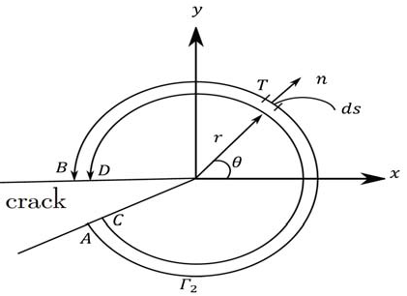

Fig. 1: J-integral contours around the crack surfaces.

where J, w, ds, u୧, Ƚ, and n are the effective energy release rate, the elastic strain energy density (or plastic loading work), a differential element along the contour, the displacement vector at ds, the arbitrary counter clockwise contour, and the outward unit normal to Ƚ, respectively.

In using J-integral method, a program is developed to calculate the stress intensity factors,

ܭ௜ ൌ ඥܬ௜ܧȀͳ െ ߭ଶ *(2)*

Here, K୧correspond to the stress intensity factor, J୧is the J-Integral value, E is the Young modulus, ɓis thePoisson’s ratio and i = 1, 2.

# Displacement extrapolation

The displacement extrapolation method was developed to obtain crack tip singular stresses and stress intensity factors using only nodal displacements of elements around the crack tip [10]. The near crack tip displacement field may be expressed as a series function of the stress intensity factor, the position to the crack tip as well as the orientation to the crack propagation direction.

ܭூ ൌ  *μ*ξଶగ ሾሺ௥್Ǥ೏כ௱௨ೌǤ೎ሺ௬ሻ െ ሺ௥ೌǤ೎כ௱௨್ǡ೏ሺ௬ሻሿ *(3)*

఑ାଵሺ௥್Ǥ೏ି௥ೌǤ೎ሻ

ξ௥ೌǤ೎

ඥ௥್Ǥ೏

ܭூூ ൌ  *μ*ξଶగ ൤ሺ௥್Ǥ೏כ௱௨ೌǤ೎ሺ௫ሻ െ ሺ௥ೌǤ೎כ௱௨್ǡ೏ሺ௫ሻ൨ *(4)*

఑ାଵሺ௥್Ǥ೏ି௥ೌǤ೎ሻ

ξ௥ೌǤ೎

ඥ௥್Ǥ೏

This technique is used when the model includes singular elements and where extrapolation can be done inside these elements in order to take into account the singularities they induce [11].Using this method, we can determine the SIF by detecting the crack opening displacementsሺȟuୟǤୡǡ ȟuୠǡୢǡ rୟǤୡǡ rୠǡୢሻ. These latest are obtained using the nondestructive technique by Eddy current in order to extrapolate the corresponding nodesaǡ c, bǡ d[2]

# Basic equations

Fundamental laws of electromagnetism govern the distribution of the magnetic fields and the currents induced in a conducting material. These laws are given by Maxwell's equations [12] as follows;

rot(

→

→ ) 

→

E

→

−  B

✰ t

✰ →

*(5)*

*(6)*

rot( H )  J  D

✰ t

→ *(7)*

div(

→

B )  0

→

→ → →

where H , B are vectors magnetic field and induction, respectively. J is the vector density of current. E and D

correspond to the vectors of electric flux field and density, respectively. In the above equations,

→   →

B  *μ H* . H

*(8)*

→ →

İ



D . E

→ →

*(9)*

J  *σ* E

*(10)*

where H is the absolute permeability of the material for the field H,  is the permittivity of the material

and  is the conductivity of the material .In addition, the magnetic potential vector is given by:

→ →

B  rot( A)

*(11)*

Substituting equation (11) into equation (5) and considering the scalar potential, yields:

→

✰

→

E   A

✰ t

*(12)*

and combining equation (10) with equation (12) leads to the following equation:

→

✰

→

J   ı A

✰ t

*(13)*

One can notice from equations (12) and (13) that the magnetic potential and the density of the induced currents are in the same direction. Induced currents have only one component, which can be obtained by substituting equations (8) into equation (11) and equation (13) into equation (6);

 → 

✰ → →

rot Ȟrot A

  ı

A  J

✰ t *s*

*(14)*

Where Js represents the density of the current sources. Equation (14) refers to the magneto-dynamic equation. All the above expressions are written in a form such that they can be used in the finite element formulation using electromagnetic equations. This weak form is considered as being a boundary integral, which makes it possible to define natural boundary conditions. Then, discretization of the latest uses polynomial of order two, which can lead to the following system;

S.A  j T.A  TJ *(15)*

→

where[A] is the vector column sum of values of *A* , [J] is the matrix vectors of source. [S]and[T]are square matrixes starting from the geometry of the device.

# Simulation of one (sensor - plate non-magnetic) without crack

Consider the test of a non-magnetic tube without a crack, characterized by a permeability equal to unity, a high conductivity 36.7ms, excited by a sinusoidal current of density J = 2.67 106 A/m, and a frequency of 1 kHz. The results of simulation are shown in figures 2, 3, and 4. The control by Eddy currents requires the use of very high frequencies.

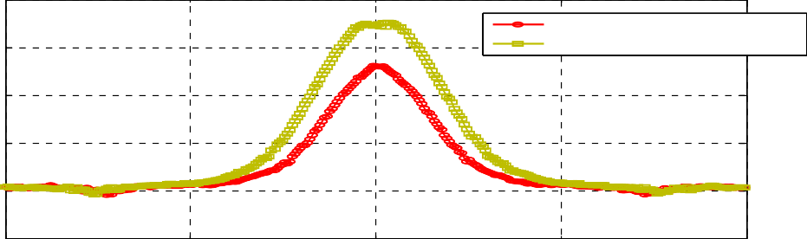8

cracks w=5mm

6 cracks propagation

4

2

0

-2

-2 -1 0 1 2

Fig. 2:Shapeof Z for f =10 kH

35

|  |  |  |  |
| --- | --- | --- | --- |
|  |  |  |  |
|  |  |  |  |
|  |  |  |  |
|  |  |  |  |
|  |  |  |  |

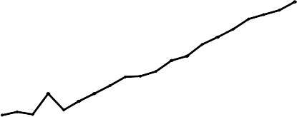30

25

20

15

10

0 1 2 3 4

x 10-3

4500

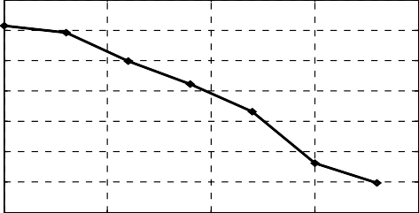4000

3500

3000

2500

2000

1500

1000

0 1 2 3 4

x 10-3

Fig. 3: Simulation of a non-magnetic sensor-plate containing external cracks under mode I Pace of impedance Z vs. crack’s propagation in mode I, b) SIF in mode I vs. crack’slength.

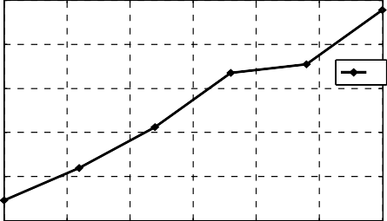8.5

8

a

7.5

7

6.5

6

0 0.5 1 1.5 2 2.5 3

x 10-3

2500

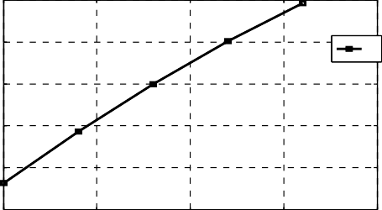2000

b

1500

1000

500

0

0 0.5 1 1.5 2

x 10-3

Fig. 4: Simulation of non-magnetic sensor-plate containing external cracks under mode II;

a) Pace of impedance Z vs. crack’s propagation in mode II, b) SIF in mode II vs. crack’s length.

# Results interpretation

Figure3 shows the variation of the impedance Z and KI with respect to the propagation of crack’s depth. It is obvious that the difference in impedance ǻZ is dependent on the crack’s depth. The latter is proportional to the increase of ǻZ. Moreover, SIF KI is evaluated when the depth decreases with ǻZ leading to a decrease of KI. Then, the depth of defection influences the impedance. Figure 4 shows the variation of the impedance Z

and KII with respect to the crack’s width. We observe that the difference in impedance ǻZ is dependent on the crack’s width; when the latter increases ǻZ decreases, and vice versa.

Color: von Mises Height: von Mises

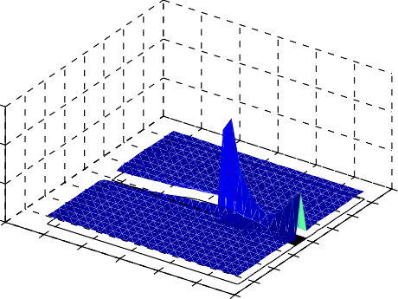12000



10000

15000

8000

10000

5000

0

0.046

0.045

0.044

0.043

0.042

0.041

0.04

0.01

0.02

0.03

0.04

0.05

0.06

0.07

0.

0.08

6000

4000

09

2000

Color: exy Height: exy

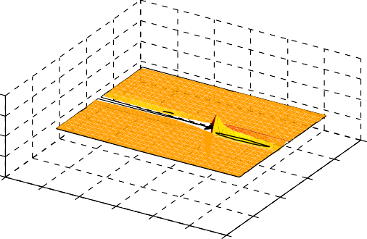0.02



0

0.1

0.05

-0.02

0

-0.05

-0.1

0.046

0.045

0.044

0.043

0.042

0.041

0.04 0

0.02

0.04

0.06

0.

0.08

-0.04

-0.06

1

-0.08

Fig. 5: a) Stress Fields. b) Displacement fields.

# Conclusion

In this paper, we studied the usefulness of Eddy current sensors as a tool to control cracks and micro cracks in materials. The simulations performed in this study led to the following conclusions:

* + Determination of the impedance in only one point is not enough to confirm the presence or the absence of a defect for two types of materials (non-magnetic or magnetic). This behavior leads us to the evaluation of the impedance along the tube.
  + Detection of an external defect requires the energy of the sensor using high frequencies.
  + The position of defect (internal, middle or external) has a large effect on the impedance. Obtained results show the great sensitivity of the differential sensor with respect to the detection of the surface defects. However, the major disadvantage of this type of sensor lies in the fact that it is unable to detect a defect located between two reels.
  + Determination of SIF is an important parameter in detecting singularities in a given model.

# References

1. A.Zaoui, H.Menana, M.Feliachi,G.Berthiau; Inverse Problem in Nondestructive Testing Using Arrayed Eddy Current Sensors, Sensors 2010, 10, 8696-8704
2. S. Harzallah, M. Chabaat; Nondestructive Technique for the Determination of Cracks Parameters by

Eddy Current in Differential Mode, Journal of Applied Mechanics and Materials, Vol. 532, pp. 81-87, (2014).

1. Y. Liu, S.Mahadevan;Threshold stress intensity factor and crack growthratepredictionunder mixed mode loading, Engineering FractureMechanics, Vol. 74, 2007, pp. 332-345.
2. M. H.Aliabadi;Boundary element method;Application in solidsandstructures, Vol. 2, p. 580 Chester, Ed. John Wiley&sons, 2002.
3. K.Dréau, N. Chevaugeon,N.Moë;Studied X-FEM enrichmentto handle materialinterfaceswithhigher order finite element, Computer Methods in AppliedMechanicsand Engineering, Vol. 199, 2010.
4. O. C. Zienkiewiczand R. L. Taylor; The finite element method;McGrawHillBookCompany, London, 4thedition, 1994.
5. F. París, J. Cañas; Boundary element method; Fundamentalsandapplications, Oxford University Press, 1997.
6. S. Bordas, B. Moran; Enrichedfinite elements andlevel sets fordamagetolerance assessment of complex structures. Engineering FractureMechanics, 73:9, pp. 1176-1201, 2006.

[9]J. R. Rice; J. Appl. Mech. 35 (1968) 379-386

1. P. C. Paris and G. C. Sih; Stress analysis of cracks. In FractureToughnessTestingandits Applications, ASTM STP 381, pp. 30-83, Philadelphia, 1965. ASTM (American Society forTestingandMaterials).
2. M. Chabaat, H. Seddiki; Stress Analysis during Crack-Crazing Patterns Interactions: A Mathematical Approach, International Journal of Key Engineering Materials, Vol. 345-346, pp. 1617-1620, 2007.
3. A. Skarlatos, G. Pichenot, D. Lesselier, M. Lambert and B. Duchêne; Electromagneticmodeling of a damagedferromagneticmetaltube via a volume integralformulation. IEEE Trans. Mag, Vol. 44, pp. 623-632, 2008.