Available online at [www.sciencedirect.com](http://www.sciencedirect.com/)



AASRI Procedia 3 (2012) 160 – 165

2012 AASRI Conference on Modelling, Identification and Control

Effect of Turning Parameters on Roundness and Hardness of Stainless Steel: SUS 303

Komson Jirapattarasilpa* and Choobunyen Kuptanawin a

*aDepartment of Production Technology Education,*

*Faculty of Industrial Education and Technology, King Mongkut's University of Technology Thonburi 126 Pracha-utid Rd. Bangmod, Thongkru District, Bangkok 10140, Thailand*

**Abstract**

Stainless steel JIS:SUS 303 is widely used for automotive part. This part is mostly manufactured by turning operation. However, turning parameters could be affected to roundness and hardness of workpieces. The purpose of this research was to study factors, which were affecting to roundness and hardness of stainless steel turning. Cutting tool was inserted carbide coated TiCN+Al2O3+TiN with polycrystalline vapor deposited (PVD) cutting tools. Experimental design was conducted as two factors and three levels. The parameters were consisted of cutting speed at 100, 150 and 200 m/min. Feed rate was setting at 0.08, 0.12 and 0.16 mm./rev. Furthermore, the experiment was done by turning with cooling and non-cooling. The results showed that only one factor affected to roundness was cooling condition. It means that cooling would cause on better roundness than non-cooling. On the other hand, cutting speed and feed rate was not affected to roundness. Moreover, the hardness of specimens was not increasing after turning. The studied parameters were not affected to hardness after turning significantly.

© 2012 The Authors. Published by Elsevier B.V. Open access under [CC BY-NC-ND license.](http://creativecommons.org/licenses/by-nc-nd/3.0/)

© 2012 The Authors. Published by Elsevier B.V.

Selection and/or peer review under responsibility of American Applied Science Research Institute

Selection and/or peer review under responsibility of American Applied Science Research Institute

*Keyword:* Turning, Cutting speed, Feed Rate, Roundness, Hardness, Stainless Steel, SUS 303

### Introduction

Stainless steel JIS:SUS 303 is widely used for automotive part. This part is mostly manufactured by turning operation. However, turning parameters could be affected to characteristics of workpieces especially roundness and hardness. Therefore, there are several parameters that were considered to turning quality such as cutting speed, feed rate, cooling, and depth of cut. [1-3]. There are previous researches to study the roundness of workpieces in any material by machining processes. Pedro Jose Núñez et al. [4] studied error of roundness during turning operations. AISI 4140 steel and high chromium cast iron was studied influenced factors affecting to roundness by cylindrical grinding [5-6]. Mohammadi A. et al. [7] was proposed a new approach to roundness improvement in wire electrical discharge turning**.** Moreover, the hardness of material after machining has been

* Corresponding author. Tel.: +66-2-470-8554; fax: +66-2-470-8557.

*E-mail address:* [komson.jir@kmutt.ac.th.](mailto:komson.jir@kmutt.ac.th)

2212-6716 © 2012 The Authors. Published by Elsevier B.V. Open access under [CC BY-NC-ND license.](http://creativecommons.org/licenses/by-nc-nd/3.0/) Selection and/or peer review under responsibility of American Applied Science Research Institute doi:10.1016/j.aasri.2012.11.027

## study. Lei Zhang et al.[8] analyzed hardness layer depth of alloy steel by grinding process. Fu X.L. et al.[9] investigated surface hardening for aluminum alloy in high speed milling. Therefore, turning of stainless steel:JIS SUS 303 was interesting. The study of factors that affected to the quality of turning was important. Thus, the propose of this research was to investigate the factors that affected to roundness and hardness of turning a stainless steel :JIS SUS 303

1. **Material, Tools and Equipment**

## Material used for this experiment was stainless steel grade JIS: SUS 303. The thirty-six specimens were prepared in diameter of 26 mm and 120 mm long as shown in Fig.1 and 2. The chemical composition of specimen was showed in Table 1. The experiment was run on CNC turning machine ‘*MAZAK model Quick Turn Smart 100S* ’. Insert carbide cutting tool was used with TiCN+Al2O3+TiN with polycrystalline vapor deposited (PVD) coated carbide cutting tool, as shown in Fig.3. The data of roundness was measured by the roundness tester ‘*Rondcom model 40A*’ and data on hardness was tested by Rockwell hardness tester ‘*Future-Tech model FR-3e*’ in Rockwell scale B (HRB).

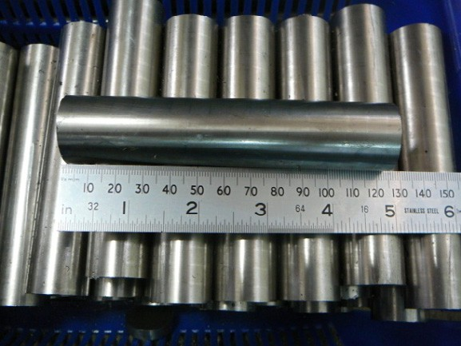

Fig. 1. Specimen of Stainless Steel JIS:SUS 303

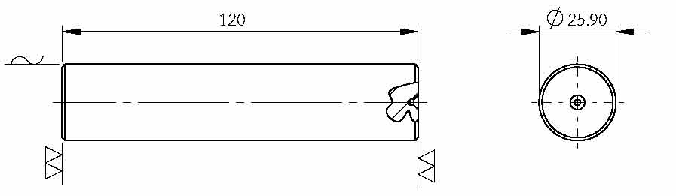

Fig. 2. Dimension of Specimen

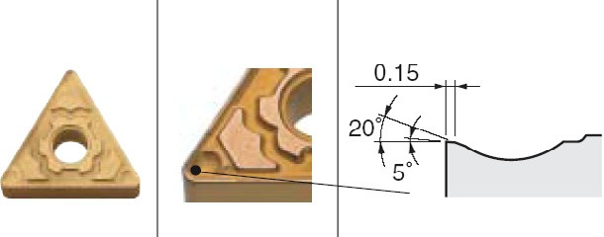

Fig. 3. Cutting Tool : TiCN+Al2O3+TiN PVD Coated Carbide Cutter

Table 1. The chemical composition of stainless steel JIS : SUS303.

Chemical Composition [%]

|  |  |  |  |  |  |  |
| --- | --- | --- | --- | --- | --- | --- |
| C | Si | Mn | Ni | Cr | Mo | S |
| 0.05 | 0.35 | 1.66 | 8.45 | 17.17 | 0.26 | 0.267 |

### Experimental Procedure

The experiment was designed by using two factors with three levels (32 designs). Factors used for this study were cutting speed and feed rate. Cutting speed was identified at 100, 150, and 200 meter per minute and feed rate was set at 0.08, 0.12, and 0.16 millimetre per revolution. In addition, the experiment was done by comparing between cooling and non-cooling as shown in Table 2. The experimental factors were tested with eight trials before running the actual experiment.

The actual experiment was randomly run with two replicates. The machined specimens were measured for roundness that using average value and for hardness with Rockwell scale B as responses. The measuring was done by three positions on machined surface. Data were analysed by statistical methods to finding the effect of factor on roundness and hardness.

Table 2. The Experiment Design (2x32 designs)

Cutting Speed

Feed Rate [mm/rev]

|  |  |  |  |  |
| --- | --- | --- | --- | --- |
|  | [m/min] | 0.08 | 0.12 | 0.16 |
|  | 100 | A1 , A4 | B1, B4 | C1 , C4 |
| Cooling | 150 | A2 , A5 | B2 , B5 | C2 , C5 |
|  | 200 | A3 , A6 | B3 , B6 | C3 , C6 |
|  | 100 | D1 , D4 | E1 , E4 | F1 , F4 |
| Non-cooling | 150 | D2 , D5 | E2 , E5 | F2 , F5 |
|  | 200 | D3 , D6 | E3 , E6 | F3 , F6 |

### Results and Discussion

The appropriate levels of experiment, initial setting factors, were determined. The results were tested by the normality test. The result of normality test was showed that significantly normal. It means that the experimental factors have been appropriate levels. The mainly outcome of this experiment was main factors and factor interactions that affected to roundness and hardness, as following below.

* 1. *Effect on Roundness*

The results of roundness was analysed by analysis of variance (ANOVA) as showed in Table 3. It indicated that factor affecting to roundness was only cooling condition that showed significantly different at the level of .01. Non-cooling turning or dry-cutting would cause on worse roundness as showed in Fig. 4-5. The turning with cooling was showed that roundness value was lower than dry-cutting. It means that the turning with cooling was the better process for quality of stainless steel SUS 303. Moreover, increasing cutting speed in dry cutting would be increasing roundness quality of workpieces. On the other hand, on cooling cutting with high cutting speed was not increasing roundness quality of stainless steel SUS 303. Furthermore, increasing feed rate in cooling turning would be decreasing roundness quality but in dry-cutting was not different.

Table 3. The ANOVA Result of Roundness

|  |  |  |  |  |  |
| --- | --- | --- | --- | --- | --- |
| Source | DF | SS | MS | F | P |
| Cutting Speed | 2 | 3.0813 | 1.5406 | 1.90 | 0.178 |
| Feed | 2 | 2.1089 | 1.0544 | 1.30 | 0.297 |
| Cooling | 1 | 25.7838 | 25.7838 | 31.82 | 0.000* |
| Cutting Speed*Feed | 4 | 0.3848 | 0.0962 | 0.12 | 0.974 |
| Cutting Speed*Cooling | 2 | 1.5945 | 0.7973 | 0.98 | 0.393 |
| Feed*Cooling | 2 | 1.7232 | 0.8616 | 1.06 | 0.366 |
| Cutting Speed*Feed*Cooling | 4 | 2.7890 | 0.6973 | 0.86 | 0.506 |
| Error | 18 | 14.5856 | 0.8103 |  |  |
| Total | 35 | 52.0511 |  |  |  |

S = 0.900171 R-Sq = 71.98% R-Sq(adj) = 45.51%

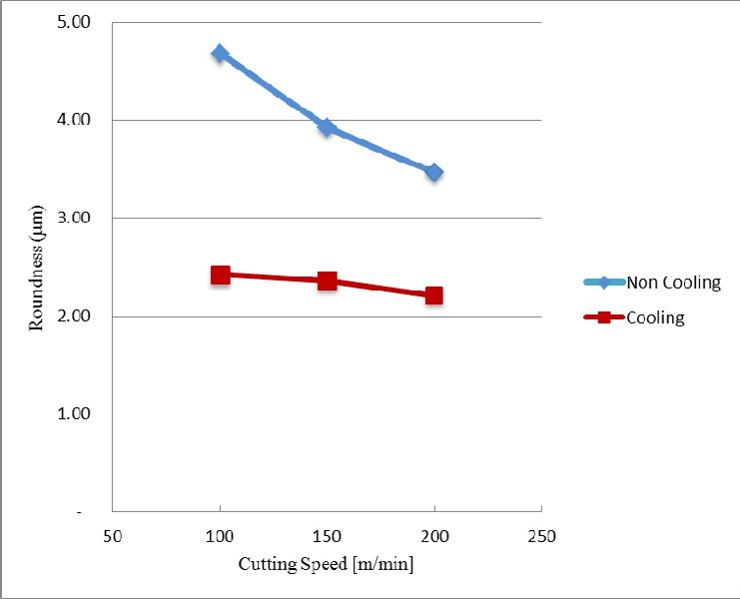

Fig. 4. Effect of cooling on roundness verus cutting speed.

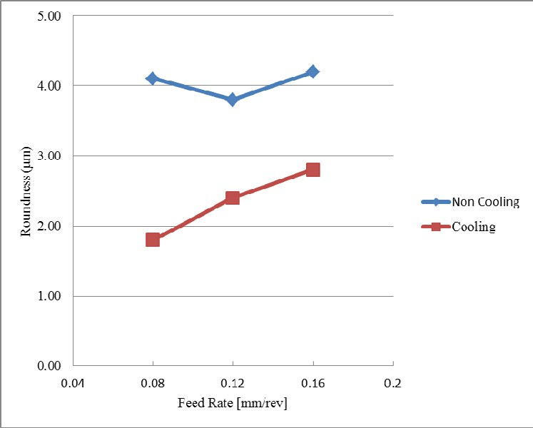

Fig. 5. Effect of cooling on roundness verus feed rate.

* 1. *Effect on Hardness*

## In addition, the hardness of specimens was tested between before and after turning. The mean hardness before experiment (raw surface) was 96.47 HRB and mean hardness after turning (machined surface) was 93.23 HRB as shown in Fig 6. The effects of cutting speed and feed rate on surface hardness were showed in Fig 7-8. There were showed that the hardness of raw and machined surface were not different. Similarly, the effect of the cooling condition was presented in Fig 9. It shows that means hardness was closely. It was confirmed by the paired T-test which was done for analysis on hardness results as showed in Table 4. The T-test was showed not significantly different between hardness of raw and machined surface. It means that the all of turning parameters

in experiment were not affected to hardness of stainless steel SUS 303.

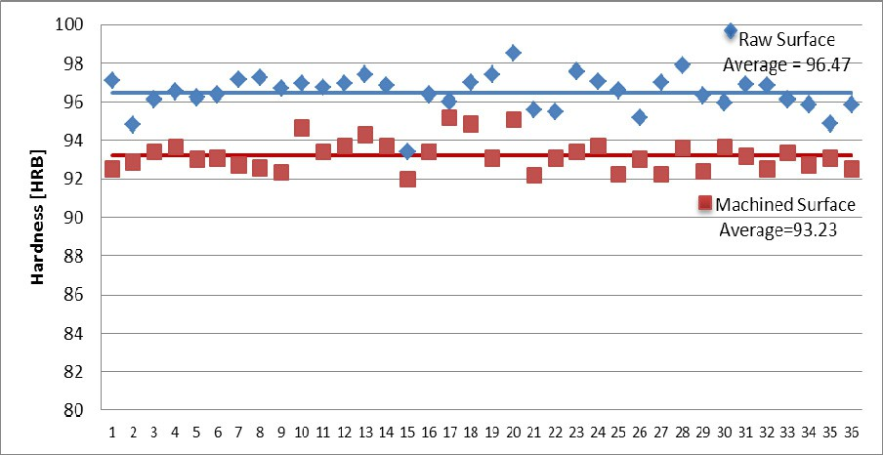

Fig. 6. Comparison of hardness between raw surface before turning and machined surface after turning.

Table 4. Paired T-Test for Hardness of Material Surface – Hardness of Turning Finished Surface.

|  |  |  |  |  |
| --- | --- | --- | --- | --- |
|  | N | Mean | StDev | SE Mean |
| Hardness Before | 36 | 96.478 | 0.963 | 0.161 |
| Hardness After | 36 | 93.234 | 0.814 | 0.136 |
| Difference | 36 | 3.244 | 0.986 | 0.164 |

95% CI for mean difference: (2.910, 3.577) T-Test of mean difference = 0 (vs not = 0): T-Value = 19.75 P-Value = 0.000

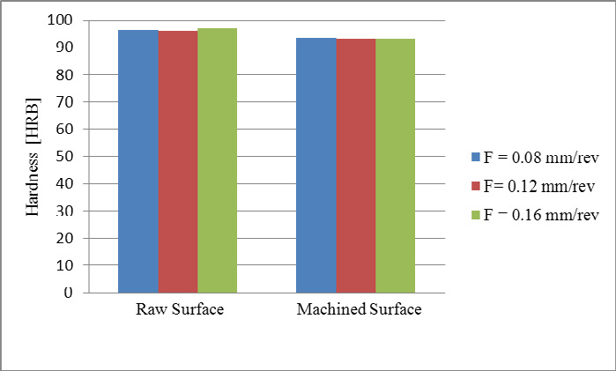

Fig. 7. Effect of feed rate on hardness

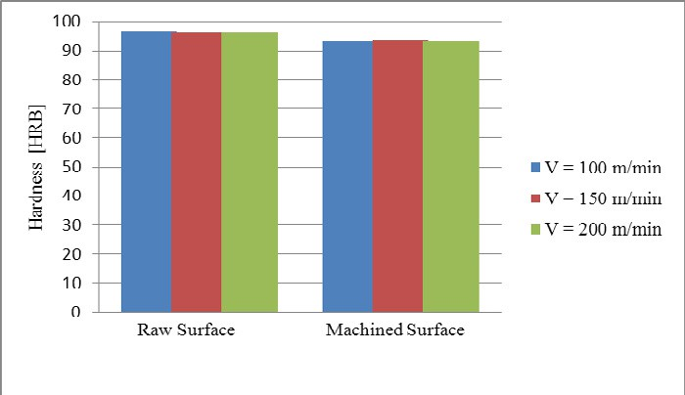

Fig. 8. Effect of cutting speed on hardness

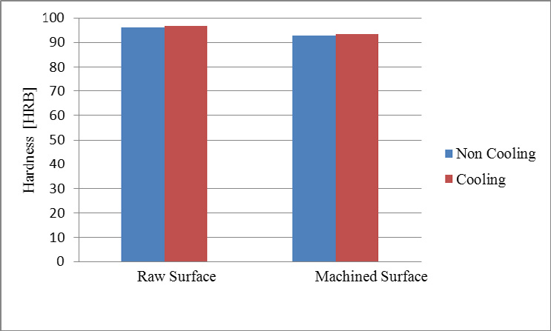

Fig. 9. Effect of cooling condition on hardness

# Conclusion

This research was to study the turning parameters that affected to roundness and hardness of turning stainless steel SUS 303. As the result of the experiment, it could be conclude that cooling was mainly affected to the roundness. Non-cooling cutting or dry-cutting would cause of worse quality for roundness. It means that cooling on turning was the better process for quality of roundness.

Moreover, hardness of surface after turning was studied. It was found that hardness was not influenced by cutting speed, feed rate and cooling or non-cooling. The hardness of stainless steel SUS 303 specimen between raw surface and machined surface was not significantly difference.

# References

1. Tu CJ, Gu X, Research on the Predicted Model of the Surface Roughness in Dry Turning Hardened Steel,

Advanced Materials Research, 2011;337:363

1. Bartarya G, Choudhury SK, A Regression Model for Force and Surface Roughness Estimation during Hard Turning, Advanced Materials Research, 2011;299-300:1167
2. Ahmad N, Tanaka T, Saito Y, Optimization of Multipass Turning Parameters by Genetic Algorithm,

Advanced Materials Research, 2011;264-265:1545

1. Núñez PJ, Simao J, Alvir EMR, Rincón JL, Influence of the Machining Parameters on Workpiece Roundness Error during Turning Operations, Materials Science Forum, 2006;526:127
2. Jirapattarasilp K., Sittichai K, Klahan P, The study of influenced factors affecting to quality of cylindrical grinding harden AISI 4140 steel, The Proceeding of The 2nd Int. Conf. on Mechanical and Electronics Engineering (ICMEE), 2010;2:329-333.
3. Jirapattarasilp K., Sittichai K, Pongpal P, The study of influenced factors affecting to quality of High Chromium Cast Iron Cylindrical Grinding, The Proceeding of The 2nd Int. Conf. on Mechanical and Electronics Engineering (ICMEE), 2010; 2:357-361.
4. Mohammadi A, Tehrani AF, Emanian E, Karimi D., A new approach to surface roughness and roundness improvement in wire electrical discharge turning based on statistical analyse Int J Adv Manuf Technol 2008; 39:64–73
5. Zhang L, Xu XU, Yang CF, Analysis of Grinding Parameters on Hardness Layer Depth, Applied Mechanics and Materials, 2010;37-38:13
6. Fu X.L. et al., Experimental Investigations of Surface Hardening for Aviation Aluminum Alloy in High Speed Milling, Advanced Materials Research, 2012;426:60