Available online at [www.sciencedirect.com](http://www.sciencedirect.com/)



**ScienceDirect**

AASRI Procedia 7 (2014) 75 – 80

2013 2nd AASRI Conference on Power and Energy Systems

Equipment for Predictive Maintenance in Hydrogenerators

L. C. Ribeiroa, E. L. Bonaldib,c, L. E. L. de Oliveirab,c, L. E. Borges da Silvab, C. P.

Salomonb,c, W.C. Santanab,c, J. G. Borges da Silvab,c, and G. Lambert-Torresc*

a*Itapebi - Neoenergia Power Plant Co., Salvador, BA 41186-900 Brazil*

b*Itajuba Federal University,Itajuba, MG 37500-903 Brazil*

c*Institute Gnarus, Itajuba, MG 37500-052 Brazil*

**Abstract**

This paper presents an equipment for predictive maintenance in large hydrogenerators. This equipment uses techniques of digital signal processing of the information contained in the electrical variables involved in the operation of the generator. Basically, the current and voltage signals of the generator are monitored and applied the techniques of electric signature analysis. The central idea is to unite the techniques of current signature analysis (CSA), voltage signature analysis (VSA) and Enhanced Park's Vector Approach (EPVA), to separate the spectra of signals and detect frequencies related to electrical and mechanical defects of generator-turbine set. This is possible because the generator is basically a device handling magnetic fields, so it's believable to infer that any operating conditions of all, somehow, influences the behavior of the magnetic field, reflecting noticeably in variations in signs of tensions and currents provided by its. The problem is to detect these variations, because some of them are under existing noise signs, and relate them to defects which they represent. This paper presents a real implementation in a hydrogenerator at Itapebi Power Plant, Brazil.

© 2014 The Authors. Published by Elsevier B. V. This is an open access article under the CC BY-NC-ND license ([http://creativecommons.org/licenses/by-nc-nd/3.0/).](http://creativecommons.org/licenses/by-nc-nd/3.0/))

© 2013 L.C. Ribeiro et al. Published by Elsevier B.V.

Selection and/or peer review under responsibility of American Applied Science Research Institute

Peer-review under responsibility of Scientific Committee of American Applied Science Research Institute

*Keywords:* Predictive maintenance, measurements, signal Processing, hydrogenerators, DSP

* Corresponding author. Tel.: +55-35-99860378; fax: +55-35-36211525.

*E-mail address:* [germanoltorres@gmail.com.](mailto:germanoltorres@gmail.com)

2212-6716 © 2014 The Authors. Published by Elsevier B. V. This is an open access article under the CC BY-NC-ND license ([http://creativecommons.org/licenses/by-nc-nd/3.0/).](http://creativecommons.org/licenses/by-nc-nd/3.0/))

Peer-review under responsibility of Scientific Committee of American Applied Science Research Institute doi:10.1016/j.aasri.2014.05.032

# Introduction

The condition monitoring of electrical machines is understood as the ongoing process of assessing the health of the equipment throughout its useful life. The primary function of a predictive monitoring system is to recognize the development of faults in an initial state. The more premature for failure detection is made easier for the maintenance department to schedule a shutdown for the correction of the problem. The process of continuous monitoring of the condition of electrical machines is vital for the production process and it brings significant benefits to the company [1]. The main benefits are: increased efficiency of the productive process, reduction of losses due to non-scheduled shutdowns, increasing the useful life of the equipment, and the creation of a history of failures.

In the case of hydrogenerators, insulation condition represents an important point of failure and concern. Other important points to strengthen the diagnosis on predictive analytics that can also be listed would be: bearings, unwanted vibrations, partial discharges, alignment, balancing etc. Thus, equipment for monitoring condition needs to have a system for extracting features that can through data mining techniques relate to possible elements that contribute to premature deterioration of the equipment.

This paper presents equipment for supervision and predictive diagnosis of operating conditions of hydrogenerators based on digital processing of the information contained in the electrical variables. Based on information obtained specifically by the currents and tensions, it is expected to be able to infer about the operating conditions of the generator, because the pattern involving the behavior of variables monitored presents some degree of correlation with the deterioration of the operating conditions of the same. Through the information contained in the collected signals, extracted after an adequate digital signal processing, it is possible to obtain an assessment of the operational state of the observed generator and turbine set.

The equipment consists basically of current, voltage, vibration and temperature transducers with adequate pass band, a signal conditioning circuit to adjust the signal measured data acquisition circuit, a high speed and resolution circuit for converting analog/digital signals, a DSP type microprocessor for processing and storage of electrical variables and measures of an intelligent program data consolidation, evaluation and diagnosis of operational condition of the generator.

Initially, this paper presents a brief overview of the electric signature analysis techniques, and then the proposed equipment is presented. Following that, some aspects of the real implementation is made and some results are carried out.

# Electric Signature Analysis Techniques

Electrical Signature Analysis (ESA) is the term used for the evaluation of voltage and current signals of electric machines [2]. In the most common case, the voltage and current signals are transformed to the frequency domain where are analyzed. Fig. 1 presents pictographic form the signal processing occurred, between its acquisitions until the fault detection.

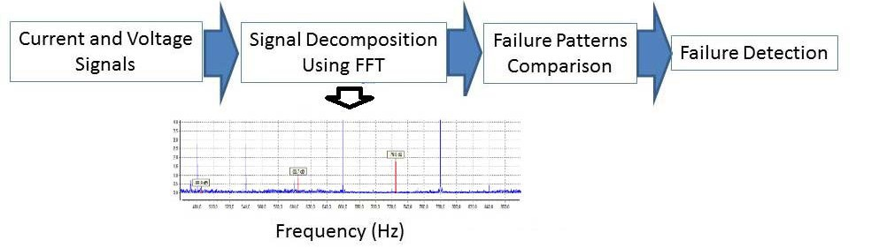

Fig. 1. Simplified block diagram of the application of ESA.

The fact that ensures the viability of the comparative analysis is that the signature of a machine in the process of failure is different from signing a machine in perfect operation. Patterns of failure can be identified and related to parts of the pivoting on its constructive data function.

ESA techniques can be applied in motors and generators, and it is important to note that the Voltage Signature Analysis (VSA) is related to an upstream circuit analysis under monitoring, i.e. towards the generator; already the Current Signature Analysis (CSA) is related to a downstream analysis of the circuit under monitoring, i.e. toward the load.

In one hand, CSA or VSA are techniques used to analyze and follow the trend of energized dynamic systems. The proper analysis of the results of applying the technique helps in the identification of predictive problems in stator winding, rotor problems, problems in the coupling on charge-coupled, efficiency and charging system, bearing problems, etc. These techniques use electric machine under monitoring as a transducer, allowing the user to evaluate the electrical and mechanical condition from the power panel and it consists primarily of monitoring one of the three phases of the current or voltage of the machine.

Thus, the current and voltage signals of the generator phases are analyzed to produce the spectrum of current and voltage, usually referenced as a signature. The goal is to obtain such signature to identify the magnitude and frequency of each individual component that constitutes the current or voltage signal from the machine. This allows patterns in the signature of the current or voltage to be identified to distinguish "healthy" generators of missing generators and even detect in that part of the machine the fault should occur.

In the other hand, EPVA is a useful technique in the analysis of electric stator imbalance. It can also be used in signature analysis of voltage or current in the spectrum demodulated. The early research involving the use of Park vector method for the diagnosis of faults in engines such as short circuit between turns, eccentricity of the air gap, broken bars, etc. [3], demonstrating itself efficient. The process can be represented by Fig. 2.

**iA**



**~**

**Data Acquisition**

**iD**

**FFT**

**Computation of Park’s Vector Module**

**Park’s Transformation**

**iB**



**iC**

**iQ**

Fig. 2. Block diagram of the EPVA technique.

# Hardware presentation of equipment

The hardware of the equipment is composed by three parts: voltage transducers, current transducers, and a data acquisition module. The voltage transducers have the capacity to measure DC and AC voltage, because the developed system has AC voltage for stator voltage and DC voltage for excitation circuit. The current transducers are CT with the following main features: accuracy less than ± 1%; and total linearity error inferior of 0.1%. The signals in these two transducers are filtered by anti-aliasing filters and then delivered to an analog/digital converter (A/D). Here also all care should be taken, as regards the specification of the transducers, which must have a tolerance of current exceeding the generator, frequency range compatible with the frequencies to be sampled and isolation level higher than the desktop [4]. The data acquisition module chosen was the National Instrument CDaq-9181 and NI-9239. Fig. 3 shows the equipment developed for each generation unit; while Fig. 4 shows the equipment installed in unit#3 panel.

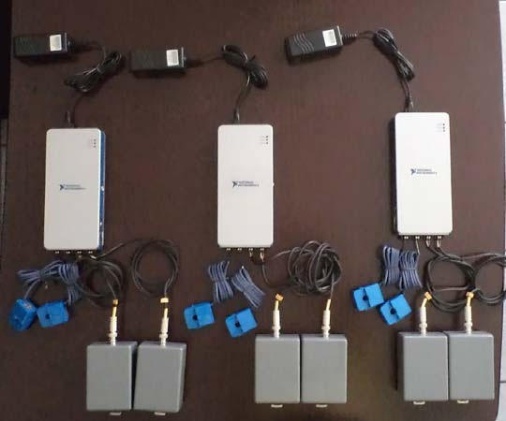

Fig. 3. Three Equipment to be installed in Units #1, #2 and #3 at Itapebi Power Plant.

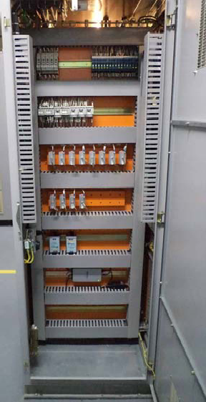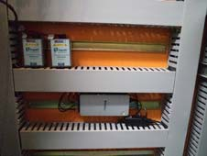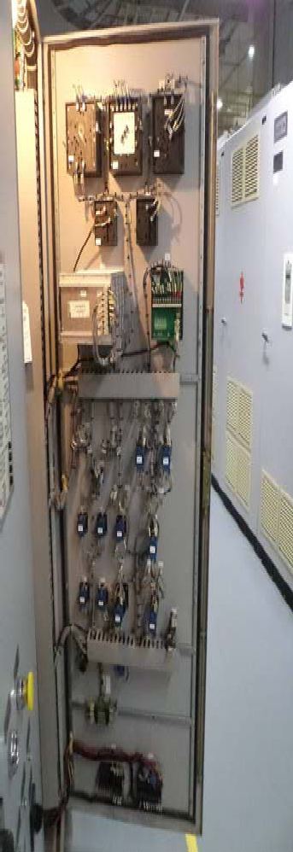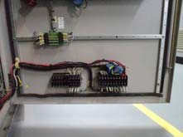

(a) (b)

Fig. 4. Transducers at the Unit #3 main control panel: (a) voltage transducers and data acquisition system; and (b) current transducers.

# Other Details about the Installation and Power Plant

The Itapebi Hydroelectric Power Plant is located in the Jequitinhonha River, between the Brazilian States of Bahia and Minas Gerais, in Southeast of Brazil. The Itapebi Power Plant is composed by three generating units of 160 MW each. The first installation of the proposed equipment occurred on the unit #3, and started the operation in 2010. The other two units received the equipment in 2012. Fig. 5 shows pictures of each generating unit. Table 1 shows some features of the hydrogenerators.

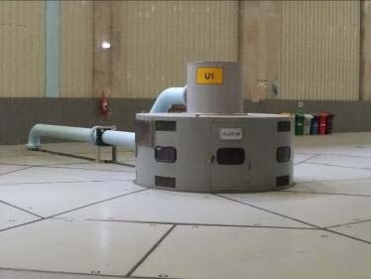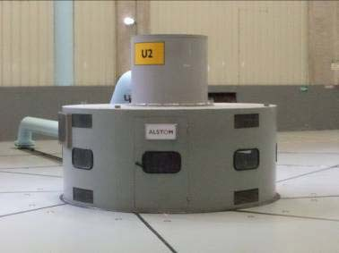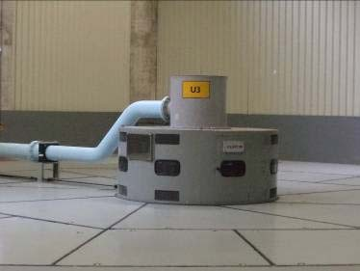

Unit #1 Unit #2 Unit #3

Fig. 5. Units #1, #2 and #3 at Itapebi Power Plant. Table 1. Features of Itapebi’s Hydrogenerators

Manufacturer: Alstom Year of manufacture: 2002

Nominal Power: 160,000 KVA Nominal voltage: 13800 +/-5% V Nominal current: 6,693.9 A Power factor: 095

Nominal speed: 138.5 rpm Frequency: 60 Hz Number of phases: 3

Number of poles: 52

# Some Features of the Developed Software

Fig. 6 presents the main screen of the developed software. The user-interface was developed in Portuguese language, and the user can have access to all software features and data acquisition control. Fig. 6 presents the software used during a data acquisition and interpretation in unit #1. The three graphics show the tendency and the points of data acquisition for current, voltage and generator speed, respectively. The inferior part of the screen shows the last acquisitions (in these case in January 2013). The data is expressed in European style (dd/mm/yy – day, month, and year, and time). The last one was made in this example in January 28, 2013 at 2 pm, 10 minutes and 23 seconds. The user can also get all other acquisitions by historic database. In the top of the screen, the user can choose the technique used for analysis among: CSA, VSA and EPVA. Also the user can be access to electric parameters and information about acquisition, nominal rates of transducers, among others.

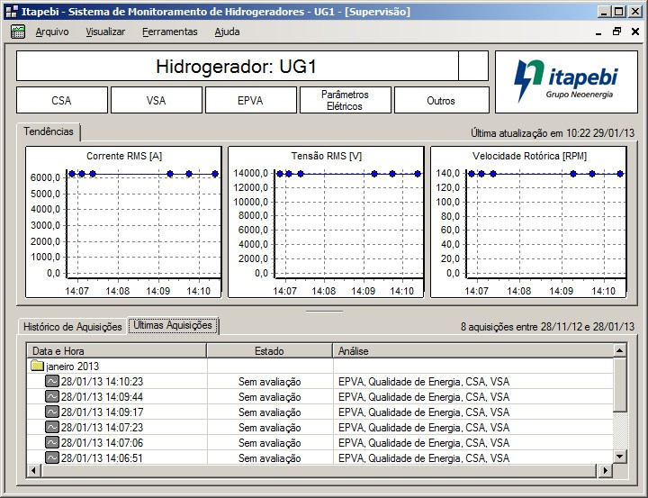

Fig. 6. Main screen of the developed software.

# Conclusions

This paper presented equipment for predictive maintenance developed and installed at Itapebi Power Plant. This equipment were installed in three 160 MW generating units, and it is used with good performance from 2012. The equipment uses electric signature analysis (CSA, VSA, and EPVA) in its analysis, and information from vibration and temperature to carry out the condition of the machine. Alarms are also setting to alert the operator if some failure is detect in the generating unit.

# Acknowledgements

The authors would like to express their thanks to all Itapebi Power Plant technicians, and CNPq, and ANEEL R&D.

# References

1. Farag WA, Quintana VH, Lambert-Torres G, “A Genetic-Based Neuro-Fuzzy Approach for Modeling and Control of Dynamical Systems”, *IEEE Trans. on Neural Networks*, Vol. 9, No. 5, pp. 756-767, Sept. 1998.
2. Bonaldi EL, de Oliveira LEL, Borges da Silva JG, Lambert-Torres G, Borges da Silva LE, “Predictive Maintenance by Electrical Signature Analysis to Induction Motors”, In: *Induction Motors - Modelling and Control*, by Rui Araujo, ISBN 978-953-51-0843-6, InTech, Croacia, pp. 487-520, DOI 10.5772/48045, 2012.
3. Bonaldi EL, Borges da Silva LE, Lambert-Torres G, de Oliveira LEL, “A Rough Sets Based Classifier for Induction Motors Fault Diagnosis”, *WSEAS Transactions on Systems*, WSEAS Press, ISSN 109-2777, No. 2,

Vol. 2, pp. 320-327, April 2003

1. Borges da Silva LE, de Oliveira LEL, Lambert-Torres G, da Silva VF, Pinto JOP, Bose BK, “Improving the Dynamic Response of Active Power Filters Based on the Synchronous Reference Frame Method”, in *Applied Power Electronics Conference*, APEC2002, Vol.2, pp. 742-748, Dallas, USA, Mar. 10-14, 2002.