[Artificial Intelligence in the Life Sciences 3 (2023) 100076](https://doi.org/10.1016/j.ailsci.2023.100076)

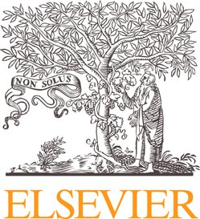 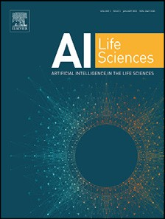

Contents lists available at [ScienceDirect](http://www.ScienceDirect.com/)

Artificial Intelligence in the Life Sciences

journal homepage: [www.elsevier.com/locate/ailsci](http://www.elsevier.com/locate/ailsci)

Erratum regarding missing Conflict of Interest Statement & Ethical Statement in previously published articles

1. Conflict of Interest Statement was not included in the published version of the following article that appeared in Volume-2 of *Artificial Intelligence in the Life Sciences*.

[“AI for drug design: From explicit rules to deep learning” [Artificial Intelligence in the Life Sciences, 2022, 100041] https://doi.org/10.1016/ j.ailsci.2022.100041](https://doi.org/10.1016/j.ailsci.2022.100041)

The appropriate Conflict of Interest Statement, provided by the Author, is included below:

# Conflict of Interest Statement:

The authors declare that they have no known competing financial interests or personal relationships that could have appeared to influence the work reported in this paper.

1. Ethical Statement was not included in the published version of the following article that appeared in Volume-1 of *Artificial Intelligence in the Life Sciences*.

“BeeToxAI: An artificial intelligence-based web app to assess acute toxicity of chemicals to honey bees” [Artificial Intelligence in the Life Sciences, 2021, 100013] <https://doi.org/10.1016/j.ailsci.2021.100013>

The appropriate Ethical Statement, provided by the Author, is included below:

# Ethical Statement:

This material is the authors’ own original work, which has not been previously published elsewhere. The paper is not currently being considered for publication elsewhere. The paper reflects the authors’ own research and analysis in a truthful and complete manner. The paper properly credits the meaningful contributions of co-authors and co-researchers. The results are appropriately placed in the context of prior and existing research. All sources used are properly disclosed (correct citation). Literally copying of text must be indicated as such by using quotation marks and giving proper reference. All authors have been personally and actively involved in substantial work leading to the paper, and will take public responsibility for its content.

DOIs of original articles: [10.1016/j.ailsci.2022.100041](https://doi.org/10.1016/j.ailsci.2022.100041), [10.1016/j.ailsci.2021.100013](https://doi.org/10.1016/j.ailsci.2021.100013) <https://doi.org/10.1016/j.ailsci.2023.100076>

Available online 11 May 2023

2667-3185/© 2023 The Authors. Published by Elsevier B.V. All rights reserved.