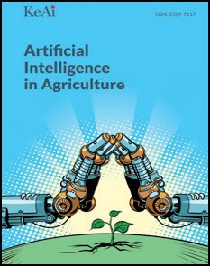Artificial Intelligence in Agriculture 5 (2021) 303

Contents lists available at [ScienceDirect](http://www.sciencedirect.com/science/journal/)

Artificial Intelligence in Agriculture

journal homepage: [http://www.keaipublishing.com/en/journa ls/artificial- intelligence- in-agriculture/](http://www.keaipublishing.com/en/journals/artificial-intelligence-in-agriculture/)

[](http://crossmark.crossref.org/dialog/?doi=10.1016/j.aiia.2021.01.001&domain=pdf)Erratum regarding missing Declaration of Competing Interest statements in previously published articles

Declaration of Competing Interest statements were not included in the published version of the following articles that appeared in previous issues of Artificial Intelligence in Agriculture.

The appropriate Declaration/Competing Interest statements, pro- vided by the Authors, are included below.

1. “Comparison of veracity and application of different CFD turbulence models for refrigerated transport” [Artificial Intelligence in Agricul- ture, 2019; 3: 11–17] https://10.1016/j.aiia.2019.10.001 Declaration of competing interest: The authors declare that they have no known competing financial interests or personal

relationships that could have appeared to influence the work re- ported in this paper.

1. “Carbon sequestration and emissions mitigation in paddy fields

based on the DNDC model: A review” [Artificial Intelligence in Agri- culture, 2020; 4: 140–149] https://10.1016/j.aiia.2020.07.002 Declaration of competing interest: The authors declare that they have no known competing financial interests or personal relation- ships that could have appeared to influence the work reported in this paper.

https://doi.org/10.1016/j.aiia.2021.01.001

2589-7217/© 2021 The Author. Publishing services by Elsevier B.V. on behalf of KeAi Communications Co. Ltd. This is an open access article under the CC BY-NC-ND license (http:// creativecommons.org/licenses/by-nc-nd/4.0/).