[](Journal%20logo)[Artificial Intelligence in Agriculture 4 (2020) 39–47](https://doi.org/10.1016/j.aiia.2020.04.001)

Contents lists available at [ScienceDirect](http://www.sciencedirect.com/science/journal/)

Artificial Intelligence in Agriculture

journal homepage: [http://www.keaipublishing.com/en/j ournals/artificial- intelligence-in-agriculture/](http://www.keaipublishing.com/en/journals/artificial-intelligence-in-agriculture/)

[](http://crossmark.crossref.org/dialog/?doi=10.1016/j.aiia.2020.04.001&domain=pdf)Evaluation of optimization techniques in predicting optimum moisture content reduction in drying potato slices

Onu Chijioke Elijah a,⁎, K. Igbokwe Philomena a, T. Nwabanne Joseph a, O. Nwajinka Charles b, E. Ohale Paschal a

a *Department of Chemical Engineering, Nnamdi Azikiwe Univeristy, P. M. B. 5025 Awka, Nigeria*

b *Department of Agric and Bioresource Engineering, Nnamdi Azikiwe Univeristy, P. M. B. 5025 Awka, Nigeria*

# a r t i c l e i n f o

*Article history:*

Received 26 December 2019

Received in revised form 5 April 2020

Accepted 6 April 2020

Available online 14 April 2020

*Keywords:*

Moisture content Potato

Adaptive neuro fuzzy inference systems Artificial neural network

Response surface methodology

# a b s t r a c t

The use of artificial intelligence models in predicting the moisture content reduction in the drying of potato (*Ipomoea batata*) slices was the focus of this work. The models used were adaptive neuro fuzzy inference systems (ANFIS), artificial neural network (ANN) and response surface methodology (RSM). The parameters considered were drying time, drying air speed and temperature. The capability and sensitivity analysis of the three models were evaluated using the correlation coefficient (R2) and some statistical error functions such as the average rel- ative error (ARE), root mean square error (RMSE), Hybrid Fractional Error Function (HYBRID) and absolute aver- age relative error (AARE). The result showed that the three models demonstrated significant predictive behaviour with R2 of 0.998, 0.997 and 0.998 for ANFIS, ANN and RSM respectively. The calculated error functions of ARE (RSM = 1.778, ANFIS = 1.665 and ANN = 4.282) and RMSE (RSM = 0.0273, ANFIS = 0.0282 and ANN =

0.1178) suggested good harmony between the experimental and predicted values. It was concluded that though the three models gave adequate predictions that were in good agreement with the experimental data, the RSM and ANFIS gave better model prediction than ANN.

© 2020 The Authors. Publishing services by Elsevier B.V. on behalf of KeAi Communications Co. Ltd. This is an open access article under the CC BY-NC-ND license (<http://creativecommons.org/licenses/by-nc-nd/4.0/>).

1. Introduction

The need for food security is one of the global challenges of our time. In addition to insufficient production of needed agricultural products, one of the major challenges with the issue of food security is inadequate post-harvest processing and insufficient preservation techniques. This is in addition to the fact that most of the agricultural food crops are perish- able and seasonal. If these agricultural products are not adequately pre- served and stored, they will spoil and become unhealthy for human consumption. Food preservation is very important because it enhances preservation, storage and easier transportation of such agricultural products while mitigating unexpected rise in prices of agricultural prod- ucts (Akinola et al., 2006).

Spoilage of agricultural products is caused mainly by the activities of the microorganisms and enzymes in the food. The growth of the micro- organisms normally leads to faster rate of spoilage. The presence of water in the form of moisture content is the major factor that aids the growth and activities of the microorganisms because it increases their

* Corresponding author at: Department of Chemical Engineering, Nnamdi Azikiwe Univeristy, P. M. B. 5025 Awka, Anambra State, Nigeria.

*E-mail addresses:* [ce.onu@unizik.edu.ng](mailto:ce.onu@unizik.edu.ng) (C.E. Onu), [pk.igbokwe@unizik.edu.ng](mailto:pk.igbokwe@unizik.edu.ng)

(P. K. Igbokwe), [jt.nwabanne@unizik.edu.ng](mailto:jt.nwabanne@unizik.edu.ng) (J. T. Nwabanne), [oc.nwajinka@unizk.edu.ng](mailto:oc.nwajinka@unizk.edu.ng) (C. O. Nwajinka), [pe.ohale@unizik.edu.ng](mailto:pe.ohale@unizik.edu.ng) (P. E. Ohale).

metabolic activities. Without water or in the presence of limited amount of water, agricultural products will become inhospitable for the micro- organism and inhibit their growth and activities thereby preserving the product for a longer time (Rajeev et al., 2012).

The sweet potato (*Ipomoea batata*) is highly nutritious and is rich in carbohydrates, digestive starch, essential amino acid, etc. It equally con- tains some important elements such as calcium, iron, potassium etc. which are necessary for proper maintenance of the human body. Nigeria is one of the biggest producers of potato. Ugonna et al. (2013) reported that Nigeria is the fourth biggest producer of potato in Sub- Saharan Africa with production yield of about 843,000 t per year. The major drawback in potato production is that it decays easily after har- vesting due to its high moisture content which aids the growth and ac- tivities of microorganisms. Hence, there is need to increase its preservation especially through drying.

Drying is one of the post-harvest handling processes that involves the removal of moisture from products due to simultaneous heat and mass transfer (Onu, 2017). Drying is a thermo-physical process that can reduce the moisture content to a minimal acceptable limit that hin- ders the growth and activities of microorganisms in agricultural prod- ucts (Ravinder et al., 2014; Sajith and Muraleedharan, 2004; Shahzad et al., 2013; Wankhade et al., 2012). Moisture content removal should be done in such a manner that desired quality of the product is not af- fected for prolonged time (Correia et al., 2015; Brooks et al., 2008,

<https://doi.org/10.1016/j.aiia.2020.04.001>

2589-7217/© 2020 The Authors. Publishing services by Elsevier B.V. on behalf of KeAi Communications Co. Ltd. This is an open access article under the CC BY-NC-ND license ([http://](http://creativecommons.org/licenses/by-nc-nd/4.0/) [creativecommons.org/licenses/by-nc-nd/4.0/](http://creativecommons.org/licenses/by-nc-nd/4.0/)).

Akanbi et al., 2006). The drying of potato can be enhanced by optimizing the major factors involved. This will lead to more efficient and cost ef- fective preservative method.

Response surface methodology (RSM) is an advanced tool for devel- oping, improving and optimizing a process where an output variable de- pends on several input variables (Nwabanne et al., 2017; Mansour and Mostafa, 2011). RSM reveals the interactive relationships between the process parameters and needs only relatively few experimental runs to determine the optimum response and propose a predictive model (Adepoju and Olawale, 2014; Ohale et al., 2017). As an improved sys- tematic approach to process variation, RSM considers all the input var- iables involved simultaneously and their effect on the response in a way that is difficult to depict with mathematical formulations (Onu, 2014; Okpe et al., 2018). RSM has been used in optimizing several processes such as the extraction of *Terminalia catappa* L. kernel oil (Agu et al., 2020); in predicting the optimum process parameters for production of activated carbon from rice husk (Iheanacho et al., 2019), in adsorp- tion of malachite green using Nteje clay (Onu and Nwabanne, 2014), in optimizing chromium VI reduction by isolated acinetobacter (Nur et al., 2019), in determining the optimum extraction yield of *Ferulago angulata* through supercritical fluid (Gholamhossein et al., 2016).

Artificial neural network (ANN) is an information processing para- digm whose functioning is inspired by the technique used by the brain and other biological nervous systems in processing information (Assidjo et al., 2008). It was derived from artificial intelligence (AI) research in the efficient description of multivariate nonlinear processes with ade- quate data and the application of correct training algorithm (Mingyi et al., 2017). An artificial neural network usually has input layer (consisting of the input variables), hidden layers (neurons), and an output layer (the output). ANN is usually applied in complex systems because it is robust and effective with special ability to describe nonlinear relation- ships between the independent variables and the dependent variable by the training and retraining of the input-output systems (Nur et al., 2019; Pareek et al., 2002). Artificial Neural network modeling is essen- tially black box in nature with the major merit being that it employs mul- tiple input variables in predicting output variables even without prior knowledge of the process relationships (Mojtaba et al., 2012). Further- more, in application of engineering to agriculture, it serves as a better al- ternative for conventional empirical modeling based on linear and/or polynomial regressions (Ngankham and Ram, 2011). ANN was employed in predicting the quality characteristics of apples during convective dehy- dration (Karina et al., 2013), in optimum extraction of artemisinin from *Artemisia annua* (Josh et al., 2014), in predicting the microwave-assisted extraction procedure (Mansour and Mostafa, 2011).

Adaptive neuro fuzzy inference systems (ANFIS) is an adaptive net- work that is based on Takagi-Sugeno fuzzy inference system (You et al., 2017). It is an artificial intelligence model that has effective self-learning function and mechanism (Ling et al., 2014). ANFIS is a nonlinear compu- tational intelligent system that adapts itself by forming rules to survive with changing environment and uncertainty. It is a synergetic system of

peeled, sliced to a thickness of 1.5 mm. The slices were then washed to remove dirt.

* 1. *Drying experimental procedure*

The drying experiment was conducted using a conventional hot-air dryer fabricated in Faculty of Engineering, Nnamdi Azikiwe Univeristy, Awka, Nigeria. One of its features is that the temperature and air veloc- ity can be regulated. One hundred grams (100 g) of the sample was used for each run of the experiments. The fan and heater were started and allowed to run without load until a stabilized (steady) drying tempera- ture and air speed were observed in the drying chamber. Thereafter, the drying chamber was loaded with the samples for the experiments. The actual temperature of the drying chamber was 30 °C lower than the set temperature of the dryer. The speed of the air was measured by a speed meter (hot wire anemometer, model 20004 AHYK, China), with the pre- cision of 0.01 m/s, while the temperature was measured by digital ther- mometer and the mass of the sample was obtained using a digital weighing balance (M-Metlar, model M311L, China). Three replicates of the experiments were conducted and the average used to reduce ex- perimental error.

* 1. *Determination of moisture content*

The moisture content was determined by using the gravimetric method as given in eq. 1.

*MC* = *M*1−*M*2 × 100 (1)

*M*2

where MC is the moisture content of the sample after drying in dry basis (d/b), M1 is the initial mass before drying, M2 is the mass after oven drying.

* 1. *RSM, ANN and ANFIS modeling*

The three most commonly used RSM methods are the Box-Behnken, central composite design (CCD) and the factorial design (Mohammad et al., 2014). CCD is a five-level design that incorporates the axial points in the design of the experimental runs while the Box-Behnken and the factorial design are three-level designs. The RSM modeling was per- formed by applying the CCD. This was done to study the interactive ef- fects of the independent input variables on the moisture content which serves as the response. The independent input variables were drying time (minutes), drying air speed (m/s) and drying temperature (°C). These independent variables were varied at five different levels: +1 and −1 (factorial points), 0 (center point) and +α and −α (axial points). The coded values of the process parameters were determined by the equation given by Rajeshkannan et al. (2012) in Eq. (2).

fuzzy inference and artificial neural network that uses a generated influ-

ential tool from numerical data to predict output (Adem et al., 2018; Ling et al., 2014). The major strength of ANFIS is that it enhances fuzzy

*N Xi*−*Xo*

Δ*X*

*i* =

(2)

controllers with self-learning capability for achieving minimum steady state error (Kiran and Rajput, 2011).

Therefore, the aim of this work is to contribute to the ongoing efforts in ensuring food security by modeling the predictive behaviour of mois- ture content reduction in potato drying using ANN, RSM and ANFIS models which will enhance the post-harvest preservation of potato.

1. Materials and methods
   1. *Sourcing and preparation of samples*

Fresh potato tubers used in this work were sourced from the local Eke Awka market in Anambra State, Nigeria. The tubers were washed,

where Ni is the coded value of the ith variable, xi is the real value of the ith test variable, xo is the real value of the ith test variable at the center point, Δx is the step change of the variable. The values of the five factor levels of the three input variables were given in Table 1.

Table 1

Factors levels of independent variables for the hot air dryer.

|  |  |  |  |  |  |
| --- | --- | --- | --- | --- | --- |
| Independent | −α | Low level | Medium level | High level | +α |
| factors |  | (−) | (0) | (+) |  |
| Time (mins) | 64.2 | 80.0 | 130.0 | 180.0 | 195.8 |
| Air speed (m/s) | 0.60 | 1.00 | 2.25 | 3.50 | 3.90 |
| Temperature (°C) | 55.3 | 60.0 | 75.0 | 90.0 | 94.7 |

The aim of the optimization was to minimize the moisture content which will increase its shelf life and preservation. Design expert version

11.0.1 was used in generating the factor levels and the experimental runs, analysis of variance (ANOVA) and regression analysis.

The quadratic model was used to express the behaviour of the sys- tem response which is the moisture content (Y) as a function of the in- dependent input variables in Eq. (3). The input variables were drying time (X1), drying air speed (X2) and temperature (X3).

Y = β0 + β1X1 + β2X2 + β3X3 + β11X12 + β22X22 + β33X32

+ β12X1 X2 + β13X1X2 + β23X2X3 + ε (3)

where β0 is the offset term or model constant; β1, β2, β3 are the linear or first order terms; β11 β22 β33 are the pure quadratic or squared terms; β12 β13 β23 are the interactive terms of the quadratic function; ε is the random error term that allows uncertainties between the experimental and predicted values.

According to Arulkumar et al. (2011), the total number of experi- mental runs N, in CCD is given by Eq. (4).

*N* = 2n + 2*n* + nc; (4)

where n is the number of independent factors or input variables and nc is the number of center points or null points chosen. The term 2n corre- sponds to the core (factorial) points, 2n corresponds to the star-like or axial points and nc corresponds to the center points. Therefore, by using six (6) center points, a total of twenty (20) experimental runs were utilized in the optimization process. This consists of 8 core points, 6 star-like points and 6 center points. The distance of the star-like point, α, used was 1.316. The center points aids in minimizing experimental error while allowing the reproducibility of the data (Khodadoust et al., 2014). The star-like points or axial points were used for the rotatability of the experimental runs which makes the variance of the model predic- tion to be equidistant from the design center (Sahu et al., 2010). The ex- periments were performed in random in order to avoid systematic error.

The acceptability of the quadratic model depended on the *p*-value of the analysis of variance and the value of the correlation coefficient (R2). The difference between the experimental and the predicted values was utilized in determining the significance of the regression model ob- tained. The three-dimensional (3D) surface plots were employed in the study of the interactive effects of the input variables.

The ANN and ANFIS were simulated by utilizing the Neural Network of MATLAB 8.5 software 2015 version. The ANN design can be satisfacto- rily modeled using the RSM generated experimental data (Mourabet et al., 2014; Nazerian et al., 2018). Thus, twenty (20) experimental

runs were used in the ANN modeling. The input layer consisted of dry- ing time (minutes), drying air speed (m/s) and temperature (°C) while the corresponding moisture content served as the target or output layer as seen in Fig. 1.

About 70% of the experimental runs were used to train the net- work, 15% was used in testing the network while the remaining 15% was used to validate the result. These represented 14 experi- ments, 3 experiments and 3 experiments respectively. According to Kiran and Pragnesh (2016), using more data sets in training re- duces processing time in ANN learning and improves the generali- zation capability of models. The 15% used in testing the network was to provide an independent measure of network performance during and after training. In the validation, the network generalization was measured by network validation and halted when generalization stopped improving in order to avoid over fitting.

The learning algorithm utilized in modeling the ANN process was the Levenberg-Marquardt. In order to enhance reduction of network error, the response and the input variables were normalized between 0 and 1 (Mourabet et al., 2014). Trainlm was used as the training func- tion because it regularizes the bias value using the algorithm of the Levenberg-Marquardt.

The appropriate number of hidden neurons was determined by trial and error method with the aim of getting the lowest possible error be- tween the predicted and the measured values. Large number of neurons leads to unwanted over-fitting and complicated network topology while very few neurons reduces the convergence rate of the network (Mingyi et al., 2017).

The ANFIS model was stimulated as a five-layered neural net- work that employed the fuzzy inference system principle. Fig. 2 is the ANFIS architecture. The nodes in the first and fifth layers repre- sent the overall input and output variables respectively. The nodes in the second layer acted as the membership function for the input variables while the neurons in the third layer represented fuzzy rules indicating the preconditions and the consequences of the rules. Each individual node in the fourth layer was an adaptive node with a node function. The fifth layer was made up of only one node that gave the summation of the incoming signals as the overall output.

The model predictions by the RSM, ANN and ANFIS were compared by plotting the comparative parity plots of the model prediction with the experimental data. Equally, some statistical models were used to evaluate the magnitude of the error between the experimental values and the predicted values.

In addition to the correlation coefficient (R2), the error functions used include Average relative error (ARE), root mean square error

[Input layer](Image%20of%20Fig.%201)

[Output layer](Image%20of%20Fig.%201)

[Hidden layer](Image%20of%20Fig.%201)

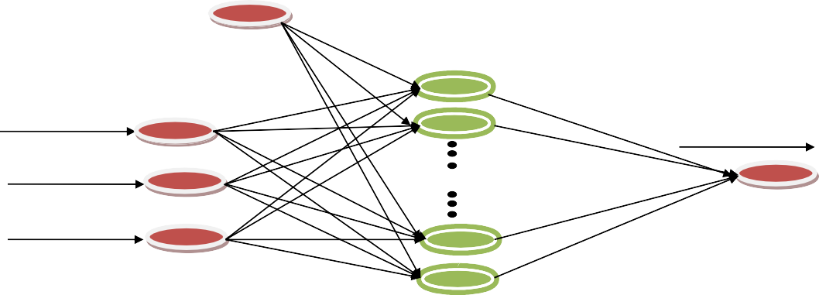

[Bias](Image%20of%20Fig.%201)

[Drying time, mins](Image%20of%20Fig.%201)

[Moisture content, db%](Image%20of%20Fig.%201)

[Air speed, m/s](Image%20of%20Fig.%201)

[Neurons](Image%20of%20Fig.%201)

[Temperature, oC](Image%20of%20Fig.%201)

Fig. 1. ANN architecture of the drying process.

[**Layer 1**](Image%20of%20Fig.%202)

[***x*1**](Image%20of%20Fig.%202)

[**Layer 2**](Image%20of%20Fig.%202)

[**π**](Image%20of%20Fig.%202)

[**Layer 3**](Image%20of%20Fig.%202)

[**N**](Image%20of%20Fig.%202)

[**Layer 4**](Image%20of%20Fig.%202)

[***y***](Image%20of%20Fig.%202)

[***x*i**](Image%20of%20Fig.%202)

[**∑**](Image%20of%20Fig.%202)

[***x*n**](Image%20of%20Fig.%202)

[**π**](Image%20of%20Fig.%202)

[**N**](Image%20of%20Fig.%202)

[**Layer 5**](Image%20of%20Fig.%202)

Fig. 2. ANFIS architecture.

(RMSE), Hybrid Fractional Error Function (HYBRID) and the absolute average relative error (AARE) given in Eqs. (5)–(9).

2 ∑*n* 1 *Yi pre*−*Yi exp* 2

*R*

= 1− *i*= , ,

(5)

∑*n* *Yi exp* −*Ym* 2

*i*=1

,

0.9961 and standard deviation of 1.49. The same trend of quadratic model was reported in extraction of artemisinin from *Artemisia annua* (Josh et al., 2014)

The adjusted R2 of the quadratic model was 0.9925 which was in good agreement with the predicted R of 0.9651. The adjusted R was

2

2

very close to R2 which indicated good correlation of experimental data

100 Xn "qe cal −qe exp#

(Samaram et al., 2015; Mazaheri et al., 2017; Betiku and Ajala, 2014).

ARE = n

i=1

, ,

qe, exp

(6)

The relatively small PRESS statistic of 196.92 suggests that the quadratic

model best fits the data point and can be used to navigate the design space (Nwabanne et al., 2017). Therefore, the quadratic regression

RMSE

vutﬃﬃﬃﬃ1ﬃﬃﬃﬃﬃﬃﬃXﬃﬃﬃnﬃﬃﬃﬃﬃ ﬃﬃﬃqﬃﬃﬃﬃﬃﬃﬃﬃﬃﬃﬃﬃ−ﬃﬃﬃﬃﬃqﬃﬃﬃﬃﬃﬃﬃﬃﬃﬃ ﬃﬃﬃ2ﬃﬃ

model of the drying process was given in their actual values in Eq. (2).

7

= n−1

i=1

e, exp

e,cal

( ) The regression terms with positive sign indicated synergistic effect,

while those with negative sign indicate an antagonistic effect (Onu and Nwabanne, 2014). The model quadratic model in terms of the ac-

*HYBRID*(%) = 1

*N*−*P*

X*n* "*qexp* −*qcal*#

× 100 (8)

tual factors was given in Eq. (10).

1 Xn "q

*q*

AARE =

n i=1

*n*−*p*

−q #

cal exp

qexp

*exp*

Y(MC)

(9)

= +165.02–1.3435 ×

1–6.332 ×

+ 0.0374X1X2 + 0.00505X1X3–0.066X2X3 + 0.0020068

× 12–0.003831 × 22–0.012215 × 32 (10)

2 + 0.7622 × 3

where n is the number of experimental runs, qcal is the predicted values of the model under investigation, qexp is the experimental values ob- tained in the drying process and p is number of input variables.

1. Results and discussion
   1. *Experimental result*

Analysis of variance (ANOVA) in Table 4 was used in further analysis of the suggested quadratic model.

Table 2

: CCD matrix of the input variables and the response.

S/N Point Coded Values Actual values Response

|  |  |  |  |  |  |  |  |  |  |  |
| --- | --- | --- | --- | --- | --- | --- | --- | --- | --- | --- |
| The experimental result of the design matrix together with the  coded and actual factors was given in Table 2. The experiments were |  | Type | X1 | X2 | X3 |  | X1 | X2 | X3 | (Moisture  content) |
| used to evaluate the single and interactive effects of the drying time, | 1 | Factorial | −1 | −1 | −1 |  | 80 | 1 | 60 | 90.4 |
| drying air speed and drying temperature on the moisture content re- | 2 | Factorial | +1 | −1 | −1 |  | 180 | 1 | 60 | 39.3 |
| duction of potato. The lowest moisture content of 18.9% dry basis (db) was obtained at drying time of 180 min, drying air speed of 3.5 m/s | 3  4  5 | Factorial  Factorial Factorial | −1  +1  −1 | +1  +1  −1 | −1  −1  +1 | 80  180  80 | | 3.5  3.5  1 | 60  60  90 | 71.2  32.2  66.9 |
| and dryer temperature of 90 °C. | 6 | Factorial | +1 | −1 | +1 | 180 | | 1 | 90 | 33.7 |
|  | 7 | Factorial | −1 | +1 | +1 | 80 | | 3.5 | 90 | 45.5 |
| *3.2. Modeling and prediction using RSM* | 8  9 | Factorial  Axial | +1  −1.316 | +1  0 | +1  0 | 180  64.2 | | 3.5  2.25 | 90  75 | 18.9  77.4 |
| The linear, two factor interaction (2FI), quadratic and the cubic | 10  11 | Axial  Axial | +1.316  0 | 0  −1.316 | 0  0 | 195.8  130 | | 2.25  0.605 | 75  75 | 35.0  58.8 |
| models were compared to determine the model that best described | 12 | Axial | 0 | +1.316 | 0 | 130 | | 3.9 | 75 | 36.2 |
| the drying process in Table 3. The suggested best model was based on | 13 | Axial | 0 | 0 | −1.316 | 130 | | 2.25 | 55.26 | 53.6 |
| the model with the lowest standard deviation value and the highest cor-  relation coefficient. The cubic model was aliased because the CCD does not contain enough runs to support a full cubic model (Oguanobi | 14  15  16  17 | Axial Center Center  Center | 0  0  0  0 | 0  0  0  0 | +1.316  0  0  0 | 130  130  130  130 | | 2.25  2.25  2.25  2.25 | 94.74  75  75  75 | 31.9  47.5  47.8  47.6 |
| et al., 2019). The model fitting using regression analysis showed that | 18 | Center | 0 | 0 | 0 | 130 | | 2.25 | 75 | 47.3 |
| the quadratic model best described the relationship between the output and input variables with relatively high correlation coefficient (R2) of | 19  20 | Center Center | 0  0 | 0  0 | 0  0 | 130  130 | | 2.25  2.25 | 75  75 | 47.3  47.5 |

Table 3

Model summary statistics of the RSM.

|  |  |  |  |  |  |  |
| --- | --- | --- | --- | --- | --- | --- |
| Source | Standard deviation | R-squared | Adjusted R2 | Predicted R2 | PRESS | Remark |
| Linear | 4.98 | 0.9297 | 0.9166 | 0.8727 | 718.71 | Not suggested |
| 2FI | 4.17 | 0.9600 | 0.9415 | 0.9126 | 493.49 | Not suggested |
| Quadratic | 1.49 | 0.9961 | 0.9925 | 0.9651 | 196.92 | Suggested |
| Cubic | 0.17 | 1.0000 | 0.9999 | 0.9999 | 0.44 | Aliased |

Table 4

ANOVA of the RSM process.

|  |  |  |  |  |  |
| --- | --- | --- | --- | --- | --- |
| Source | Sum of squares | df | Mean squares | F-value | *p*-Value (Prob N F) |
| Model | 5622.49 | 9 | 624.72 | 280.27 | b0.0001 |
| X — Drying time | 3690.92 | 1 | 3690.92 | 1655.85 | b0.0001 |
| X2 — Drying air speed | 742.21 | 1 | 742.21 | 332.98 | b0.0001 |
| X3 — Temperature | 814.97 | 1 | 814.97 | 365.62 | b0.0001 |
| X1 X2 | 43.71 | 1 | 43.71 | 19.61 | 0.0013 |
| X1 X3 | 114.76 | 1 | 114.76 | 51.49 | b0.0001 |
| X2 X3 | 12.25 | 1 | 12.25 | 5.50 | 0.0410 |

1

X2 175.38 1 175.38 78.68 b0.0001

1

2

X

|  |  |  |  |  |
| --- | --- | --- | --- | --- |
| 0.0002497 1 | | 0.0002497 0.000112 | | 0.9918 |
| 52.63 | 1 | 52.63 | 23.61 | 0.0007 |
| 22.29 | 10 | 2.23 | – | – |

2

2

X

3

Residual

|  |  |  |  |  |
| --- | --- | --- | --- | --- |
| Lack of Fit | 22.11 | 5 | 4.42 | – – |
| Pure Error | 0.18 | 5 | 0.036 | – – |
| Cor Total PRESS = 96.92  C.V. = 3.06 | 5644.78 | 19  –  – | –  –  – | – –  – –  – – |

Adequate Precision = 65.209 – – – –

The *p*-value gave information whether a statistical hypothesis is sig- nificant or not and how significant it is (Agu et al., 2020). The model F- value of 280.27 and *p*-value of b0.0001 showed that the quadratic model chosen was significant. The individual model terms were tested for their significance based on the *p*-values of each term. A significance level of 95% was chosen hence, all the terms whose p-values are b0.05 were significant otherwise, they were termed insignificant (Gholamhossein et al., 2016).

Relatively lower *p*-value and higher F-values showed better signifi- cance effect of the model term on the response (Josh et al., 2014; Tan et al., 2008). Therefore, all linear terms of drying time (X1), drying air speed (X2) and temperature (X3), the interactive terms of X1X2, X1X3 and X2X3 and the squared terms of X2 and X2 were significant. Only the squared model term of X2 was found to be insignificant. The model term found to have the significant effect on the response was drying time (X1) followed by temperature (X3) while the interaction of X2X3 and the squared term of X2 have the least effect on the response.

2

3

1

3

The insignificant model term was eliminated and the final quadratic model equation was given in Eq. (11).

Y(MC) = +165.02–1.3435 × 1–6.332 × 2 + 0.7622 × 3

+ 0.0374X1X2 + 0.00505X1X3–0.066X2X3 + 0.0020068

× 12–0.012215 × 32 (11)

The coefficient of variation (C.V.) of 3.06% obtained shows the repro- ducibility and repeatability of the quadratic model since its numerical value was b10% (Chen et al., 2011). Adequate precision of 65.209 sug- gests adequate model efficacy because it is N4 (Oguanobi et al., 2019; Krumar et al., 2007).

The Normal plot of Residuals and the Predicted vs Actual plots in Fig. 3 (a and b) are graphical estimations that compares of the nature of the residuals depicting the correlation between the experimental values and the predicted value. The plot of predicted against actual re- vealed that the points were closely distributed to the straight line of the plot. Therefore, it is concluded that the residuals followed a normal distribution (Iheanacho et al., 2019). The Normal plot of Residuals showed that the points were firmly aligned to the straight line of the plot however; some little disperse like a “S” shape was observed as an- ticipated (Nwabanne et al., 2017). These plots show minimal diver- gence of the points from the diagonal.

The response surface plots were utilized in investigating the main and interactive effects between the combination of the independent fac- tors and the response (Iheanacho et al., 2019; Nwabanne et al., 2017). This was done by varying any two of the input variables while keeping the other constant at its null point. The three dimensional (3-D) plots of the interactive effects are shown in Fig. 4 (a–c). Fig. 4 is the interactive effect of temperature and drying air speed. The two factors showed sig- nificant combined effect on the moisture content reduction of the dry- ing process. Minimal moisture content was observed at temperature of about 75 °C and drying air speed of 2.5 m/s. The figure equally depicted that the combined effect was mainly as a result of singular ef- fect of temperature because the drying air speed showed little effect. Fig. 4b is the plot of the interactive effect of temperature and drying time while Fig. 4c is for drying air speed and temperature. These two fig- ures show that the interactive effects of these combinations are

[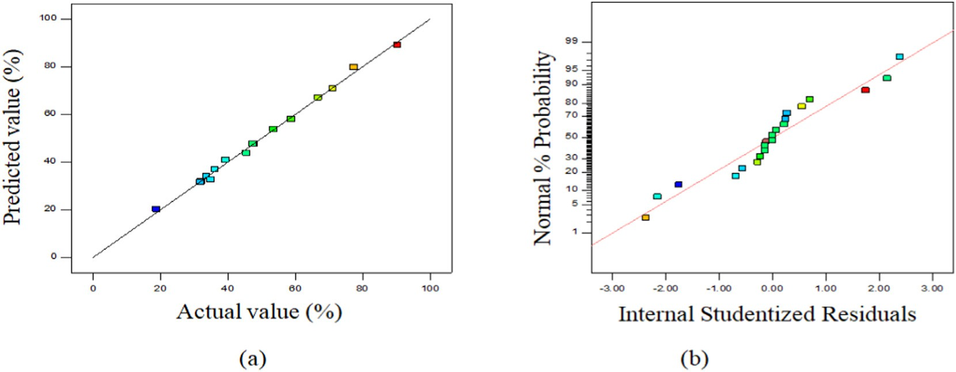](Image%20of%20Fig.%203)

Fig. 3. Plot of predicted vs actual values (a) and Normal plot of residuals (b).

[1 80](Image%20of%20Fig.%204)

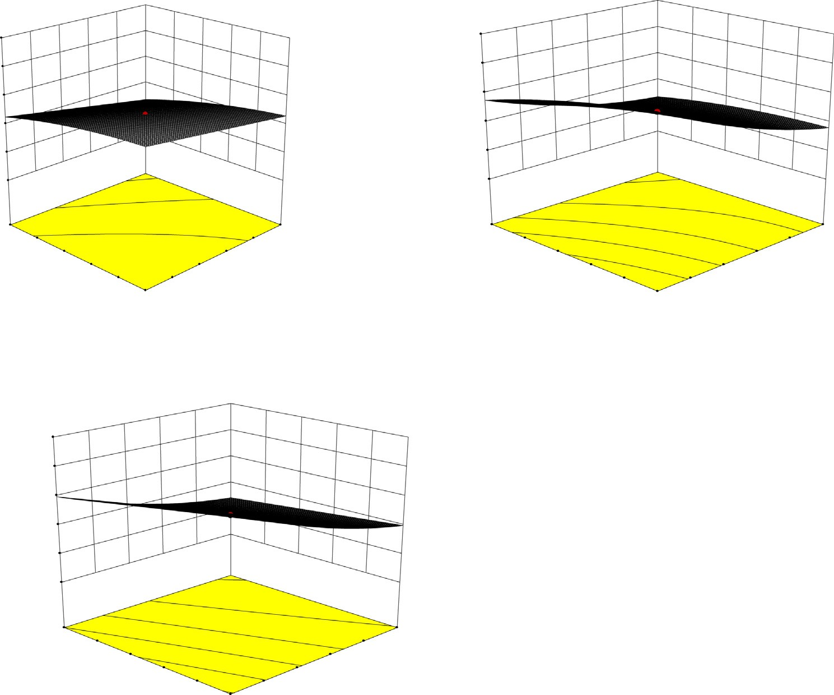

[100](Image%20of%20Fig.%204)

[100](Image%20of%20Fig.%204)

[80](Image%20of%20Fig.%204)

[80](Image%20of%20Fig.%204)

[60](Image%20of%20Fig.%204)

[60](Image%20of%20Fig.%204)

[40](Image%20of%20Fig.%204)

[40](Image%20of%20Fig.%204)

[20](Image%20of%20Fig.%204)

[20](Image%20of%20Fig.%204)

[0](Image%20of%20Fig.%204)

[0](Image%20of%20Fig.%204)

[90](Image%20of%20Fig.%204)

[3.5](Image%20of%20Fig.%204)

[90](Image%20of%20Fig.%204)

[180](Image%20of%20Fig.%204)

[84 3 84 160](Image%20of%20Fig.%204)

[78 2.5 78 140](Image%20of%20Fig.%204)

[72 2 72 120](Image%20of%20Fig.%204)

[C: Temperature (oC) 66 1.5B: Drying air speed (m/s) C: Temperature (oC) 66 100 A: Drying time (mins)](Image%20of%20Fig.%204)

[60 1 60 80](Image%20of%20Fig.%204)

[a b](Image%20of%20Fig.%204)

[100](Image%20of%20Fig.%204)

[80](Image%20of%20Fig.%204)

[60](Image%20of%20Fig.%204)

[40](Image%20of%20Fig.%204)

[20](Image%20of%20Fig.%204)

[0](Image%20of%20Fig.%204)

[3.5](Image%20of%20Fig.%204)

[180](Image%20of%20Fig.%204)

[3 160](Image%20of%20Fig.%204)

[2.5 140](Image%20of%20Fig.%204)

[2 120](Image%20of%20Fig.%204)

[B: Drying air speed (m/s)1.5 100 A: Drying time (mins)](Image%20of%20Fig.%204)

[Moi](Image%20of%20Fig.%204)sture Content (%)

[c](Image%20of%20Fig.%204)

Fig. 4. a–c: 3-D surface interactive plots of the input variables.

relatively less significant than that of temperature and drying air speed. It was found that increasing the drying time reducing the moisture con- tent of the potato slices. Again, drying air speed seems to have the least effect on the drying process among the three independent factors con- sidered. The elliptical nature of the 3D curves suggested good correla- tion between the two variables (Iheanacho et al., 2019). These results indicated that the quadratic model selected is appropriate for the modeling. Similar trend was reported by Oguanobi et al. (2019).

Moisture Content (%)

Moisture Content (%)

* 1. *Modeling and prediction using ANN*

The drying process was equally modeled using the Artificial Neural Network. As explained earlier, 70% of the experimental runs were used for training of the neural network while the rest were used for test- ing and validation. This was to prevent over-training and over- parameterization (Jamil et al., 2018). The correlation coefficient and the minimum value of mean squared error (MSE) were used as perfor- mance check to determine the optimum number of neurons in the hid- den layer. MSE is the mean squared difference of the output and input. Correlation coefficient values (R2) was used to validate the correlation between input variables and the output. These two were used to mea- sure the predictability of the artificial neural network (Agu et al., 2020). Through trial and error method, the number of neurons for opti- mal performance was obtained as five in the trainlm algorithm. Gholamhossein et al. (2016) reported six neurons for efficient extrac- tion of *Ferulago angulata.*

Based on enough neurons (5) in the hidden layer and the consis- tency of the input data, a two-layer feed-forward neural network with sigmoid hidden neurons and linear output neurons were employed in multi-dimensional mapping of the process inputs in Fig. 5.

The regression plots with respect to the targets for the training, val- idation, testing and overall network process are presented in Fig. 6. A

mean square error (MSE) of 0.0000396 and correlation coefficient of 0.99947 was obtained for the training. The correlation coefficient ob- tained was very close to that reported by Gholamhossein et al. (2016). Correlation coefficients of 0.9343, 1.000 and 0.9698 were equally ob- tained for the validation, testing and overall neural network process re- spectively. The fit is reasonably good for the data sets, with correlation coefficient values in each case were very close to unity. The data fell rea- sonably along a 45-degree line, where the network outputs were equal to the targets. Based on these performance values, it was concluded that the network response was satisfactory and that the output adequately tracked the target in the drying of potato.

The plot of the best validation performance was presented in Fig. 7. The performance of the network process for validation was analyzed to determine the reliability of the training process. The training network showed a validation performance with mean square error of 0.00656 at epoch 4. This did not indicate any over-fitting problem with the training network since the error was very small.

* 1. *Modeling and prediction using ANFIS*

The ANFIS model was structured using a hybrid-learning algorithm that encompasses the least square and the gradient method. Data

[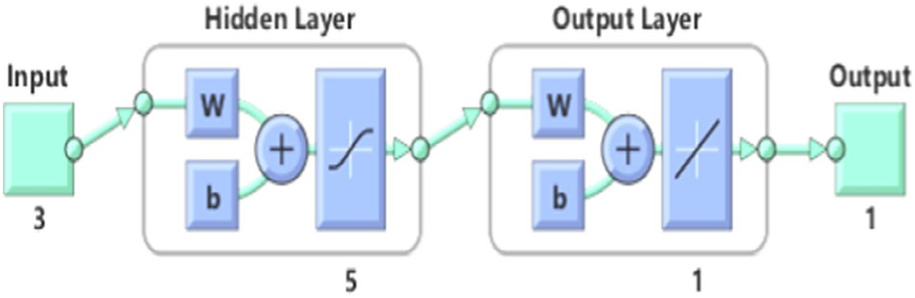](Image%20of%20Fig.%205)

Fig. 5. The ANN network architecture showed five neurons in the hidden layer.

[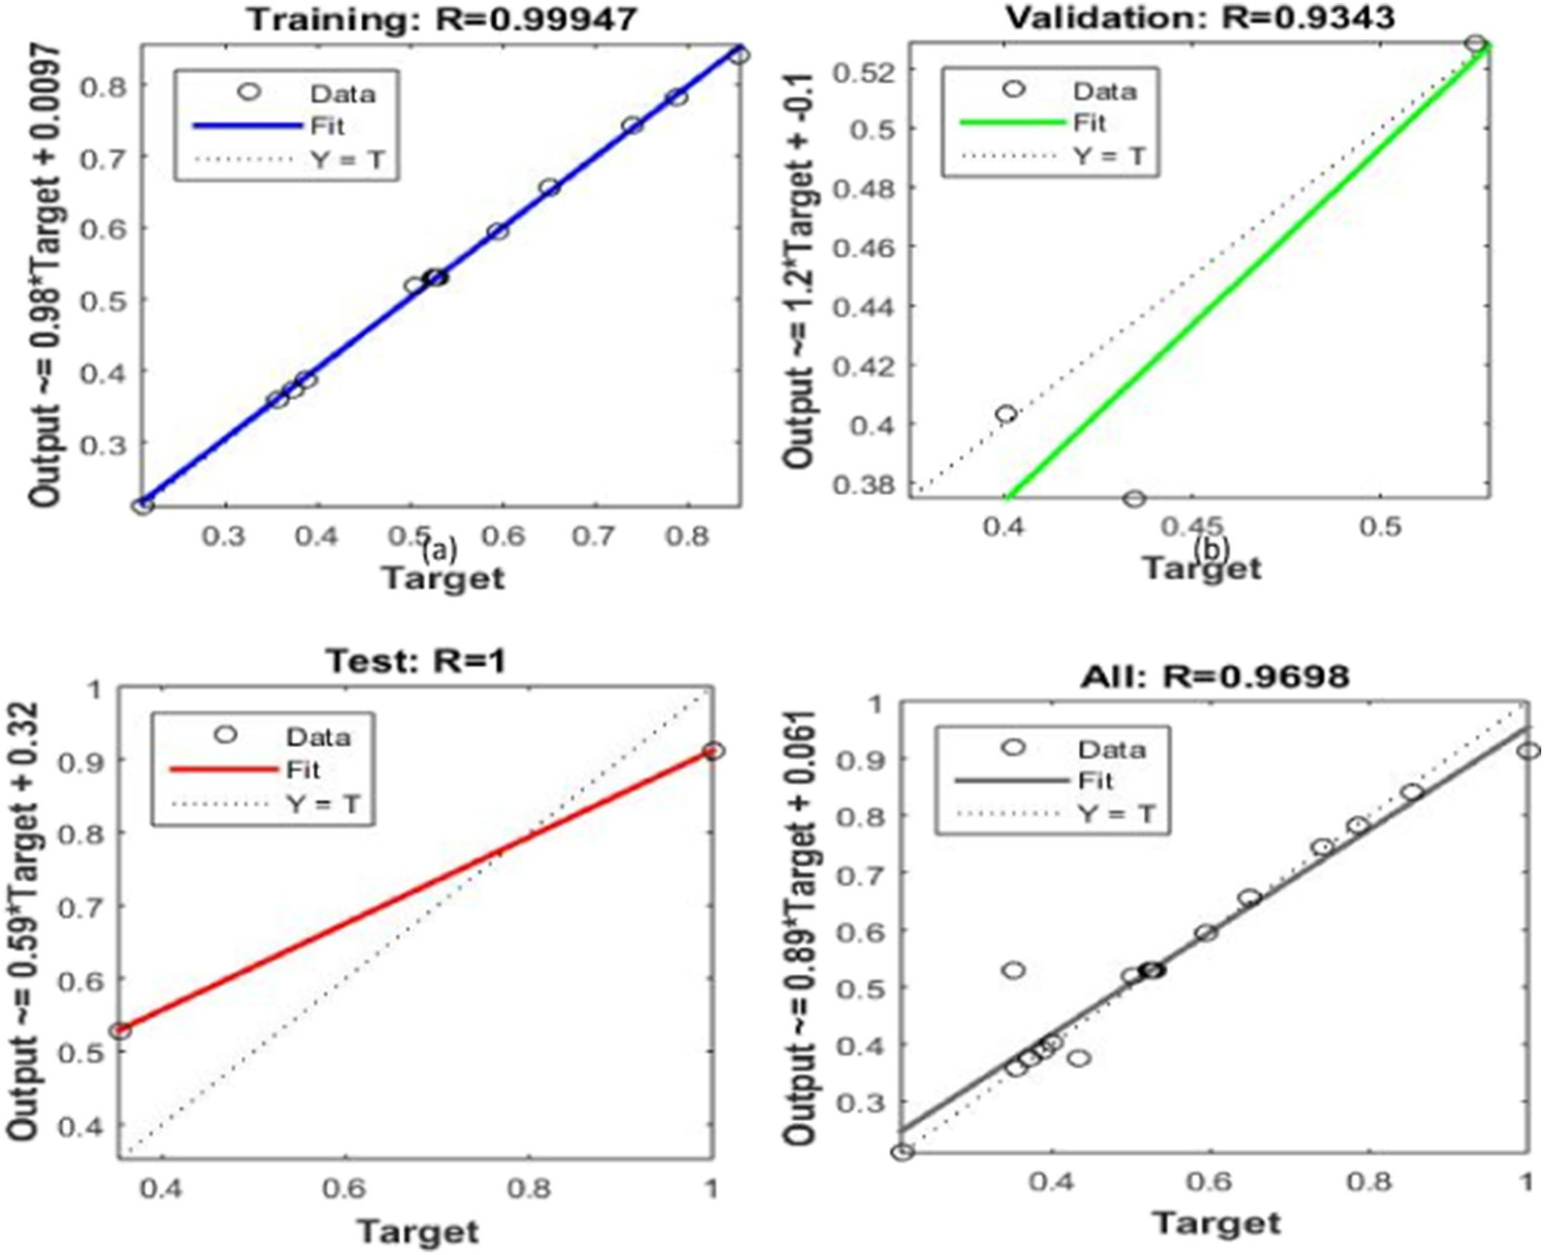](Image%20of%20Fig.%206)

Fig. 6. Regression plots for training (a), validation (b), testing (c) and overall network (d) processes.

normalization was implemented before the training of the ANFIS model. Twenty seven fuzzy rules, nine input membership functions and twenty seven output membership functions were employed as shown in Fig. 8. The training was completed at epoch 2 with average training error of 0.03574 and average testing error of 0.57092. Kiran and Rajput (2011) reported a training error of 0.011555 at epoch 135 when modeling the effectiveness of an indirect evaporative cooling system. The total num- ber of parameters was 54 which were evenly distributed between the linear and nonlinear parameters. The ANFIS model predicted the mois- ture content with a correlation coefficient of 0.998.

* 1. *Comparison of the performances of the RSM, ANN and ANFIS models*

The experimental values were compared with the predicted values of the RSM, ANN and ANFIS models in Table 5. In most of the axial and starlike combinations, the ANFIS model gave a residual of zero. The highest positive and negative residuals of 7.95 and −15.92 were

[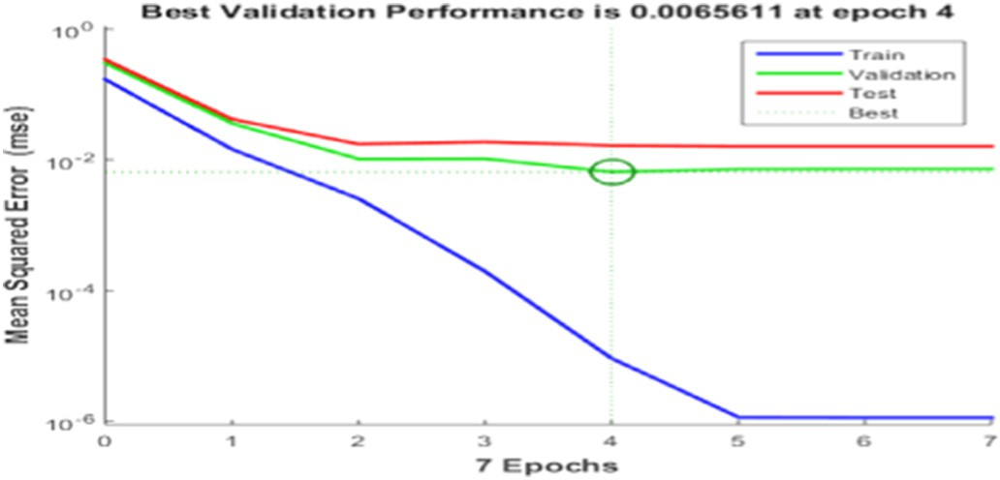](Image%20of%20Fig.%207)

Fig. 7. Network validation performance of the training process.

observed in the ANN model. The three models were found to be reason- ably accurate in predicting the moisture content of the drying process though the ANFIS with many residual of zero gave the best prediction.

The predictive capacity of the models was evaluated with closeness of the correlation coefficient to unity. Furthermore, smaller values of ARE, RMSE, HYBRID and AARE values indicates better predictive capac- ity. The statistical error analysis was given in Table 6.

The R2 values of RSM and ANFIS were 0.998 showing better correla- tion than that of ANN which was 0.970. The ARE value of the ANFIS was smaller than that of the RSM. The RMSE values were 0.0273, 0.0282 and 0.1178 for RSM, ANFIS and ANN respectively. This result showed that the RSM and ANFIS gave better significant prediction than the ANN in the drying of potato slices. RSM was reported to be better than ANN in op- timizing the design parameters for a V perforated baffle (Sunil, 2015) though in most other cases, ANN gave a better prediction than RSM.

* 1. *Model optimization and validation*

Optimum moisture content value of 31.995% was predicted at a dry- ing time of 180 min, drying air speed of 3.5 m/s and dryer temperature of 60 °C. The test re-test experimental validation technique was employed in validating the predicted optimal value. The experiment was carried out in triplicate and an average value of 32.65% was ob- tained. This showed close agreement with the predicted optimal value.

1. Conclusion

RSM, ANN and ANFIS models were used to predict the moisture con- tent reduction of potato slices in a hot-air drying process. CCD was employed in the RSM analysis where a quadratic model with R2 value of 0.9980 was obtained. Drying time had the most significant singular effect on the drying process followed by temperature. ANN model

[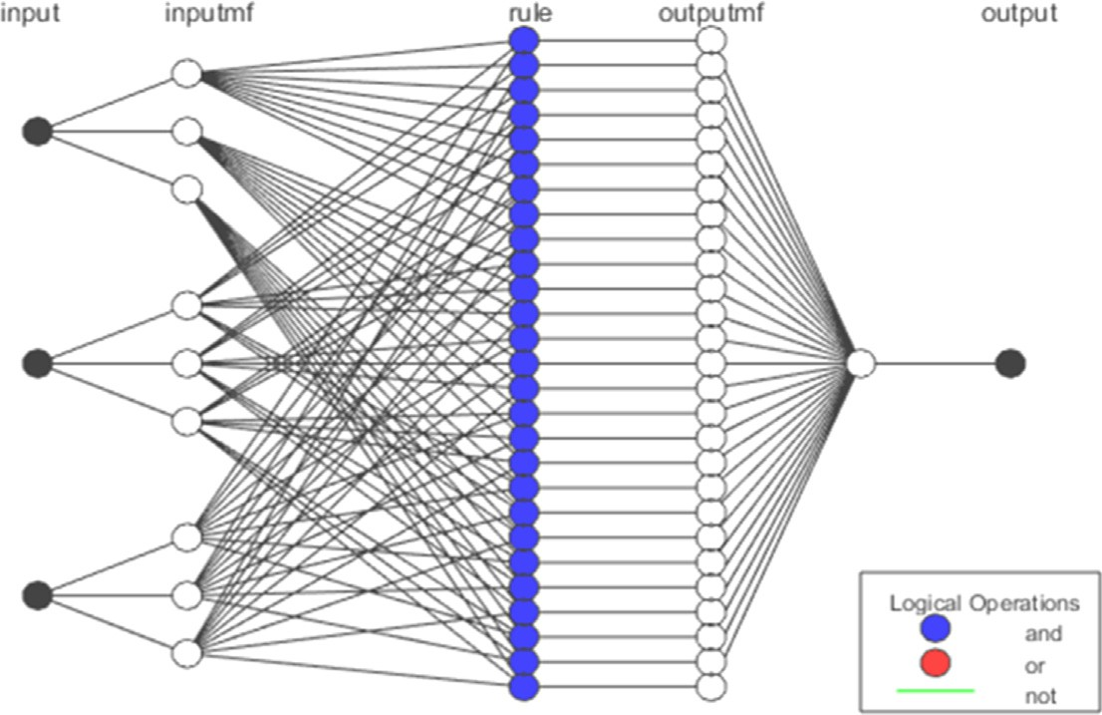](Image%20of%20Fig.%208)[Drying time (minutes)](Image%20of%20Fig.%208)

[Drying air speed (m/s)](Image%20of%20Fig.%208)

[Temperature (oC)](Image%20of%20Fig.%208)

# [Moisture content](Image%20of%20Fig.%208)

Fig. 8. ANFIS model structure of the drying process.

Table 5

RSM, ANN and ANFIS predicted values of the drying of potato slices.

|  |  |  |  |  |  |  |  |
| --- | --- | --- | --- | --- | --- | --- | --- |
| Std run no. | Exp. | RSM ANN ANFIS    Predicted Residual Predicted Residual Predicted Residual | | | | | |
| 1 | 90.4 | 89.07 | 1.33 | 82.45 | 7.95 | 90.4 | 0 |
| 2 | 39.3 | 40.94 | −1.64 | 33.89 | 5.41 | 39.3 | 0 |
| 3 | 71.2 | 70.78 | 0.42 | 70.76 | 0.44 | 71.2 | 0 |
| 4 | 32.2 | 32 | 0.2 | 32.35 | −0.15 | 32.2 | 0 |
| 5 | 66.9 | 67.11 | −0.21 | 67.22 | −0.32 | 66.9 | 0 |
| 6 | 33.7 | 34.12 | −0.42 | 33.77 | −0.07 | 33.7 | 0 |
| 7 | 45.5 | 43.87 | 1.63 | 46.83 | −1.33 | 45.5 | 0 |
| 8 | 18.9 | 20.23 | −1.33 | 18.99 | −0.09 | 18.9 | 0 |
| 9 | 77.4 | 79.81 | −2.41 | 76.1 | 1.3 | 77.4 | 0 |
| 10 | 35 | 32.58 | 2.42 | 35.09 | −0.09 | 35 | 0 |
| 11 | 58.8 | 58.08 | 0.72 | 59.17 | −0.37 | 58.8 | 0 |
| 12 | 36.2 | 36.9 | −0.7 | 36.47 | −0.27 | 36.2 | 0 |
| 13 | 53.6 | 53.84 | −0.24 | 53.7 | −0.1 | 53.6 | 0 |
| 14 | 31.9 | 31.65 | 0.25 | 47.82 | −15.92 | 30.24 | 1.66 |
| 15 | 47.5 | 47.5 | 0 | 47.82 | −0.32 | 45.24 | 2.26 |
| 16 | 47.8 | 47.5 | 0.3 | 47.82 | −0.02 | 45.24 | 2.56 |
| 17 | 47.6 | 47.5 | 0.1 | 47.82 | −0.22 | 45.24 | 2.36 |
| 18 | 47.3 | 47.5 | −0.2 | 47.82 | −0.52 | 45.24 | 2.06 |
| 19 | 47.3 | 47.5 | −0.2 | 47.82 | −0.52 | 45.24 | 2.06 |
| 20 | 47.3 | 47.5 | −0.2 | 47.82 | −0.52 | 45.24 | 2.06 |

gave R2 of 0.970 with 5 neurons in the hidden layer. Mean square error of 0.00656 was obtained at epoch 4. ANFIS model also showed good pre- dictive behaviour with R2 of 0.998 and average training error of 0.03574 at epoch 2. The comparative analysis showed that the RSM and ANFIS were better in predicting the moisture content reduction of potato drying.

CRediT authorship contribution statement

Onu Chijioke Elijah: Conceptualization, Data curation, Investiga- tion, Writing - original draft. K. Igbokwe Philomena: Project adminis- tration, Supervision, Visualization. T. Nwabanne Joseph: Formal

Table 6

Statistical error analysis of the RSM, ANN and ANFIS models.

Error function RSM ANFIS ANN

analysis, Writing - review & editing, Supervision. O. Nwajinka Charles: Methodology, Formal analysis. E. Ohale Paschal: Software, Validation, Data curation.

Declaration of competing interest

The authors declare that there is no conflict of interest regarding the publication of this paper.

Acknowledgment

The authors will like to acknowledge Engr. Chinedu Umebalu and Engr. Ugochukwu Emeka for assistance in the construction of the hot- air dyer.

References

Adem, Y.S., Semih, K., Rahmi, C.O., Ali, E.K., 2018. An adaptive neuro-fuzzy inference system (ANFIS) to predict of cadmium (Cd) concentrations in the Filyos River, Turkey. Turk.

J. Fish. Aquat. Sci. 18, 1333–1343. <https://doi.org/10.4194/1303-2712-v18_12_01>.

Adepoju, T.F., Olawale, O., 2014. [Acid-catalyzed esterification of waste cooking oil with](http://refhub.elsevier.com/S2589-7217(20)30011-8/rf0010) [high FFA for 538 biodiesel production. Chem. Process Eng. Res. 21, 80–84](http://refhub.elsevier.com/S2589-7217(20)30011-8/rf0010).

Agu, C.M., Menkiti, M.C., Ekwe, E.B., Agulanna, A.C., 2020. [Modeling and optimization of](http://refhub.elsevier.com/S2589-7217(20)30011-8/rf0015) [*Terminalia catappa* L. kernel oil extraction using response surface methodology and](http://refhub.elsevier.com/S2589-7217(20)30011-8/rf0015) [artificial neural network. Artif. Intell. Agric. 3, 1–20](http://refhub.elsevier.com/S2589-7217(20)30011-8/rf0015).

Akanbi, C.T., Adeyemi, R.S., Ojo, A., 2006. [Drying characteristics and sorption isotherm of](http://refhub.elsevier.com/S2589-7217(20)30011-8/rf0020) [tomato slices. J. Food Eng. 73 (2), 157–16](http://refhub.elsevier.com/S2589-7217(20)30011-8/rf0020)3.

Akinola, O.A., Akinyemi, A.A., Bolaji, B.O., 2006. [Evaluation of traditional and solar fish dry-](http://refhub.elsevier.com/S2589-7217(20)30011-8/rf0025) [ing systems toward enhancing fish storage and preservation in Nigeria. J. Fish. Int. 1](http://refhub.elsevier.com/S2589-7217(20)30011-8/rf0025) [(2), 44–49](http://refhub.elsevier.com/S2589-7217(20)30011-8/rf0025).

Arulkumar, M., Sathishkumar, P., Palvannan, T., 2011. [Optimization of Orange G dye ad-](http://refhub.elsevier.com/S2589-7217(20)30011-8/rf0030) [sorption by activated carbon of *Thespesia populnea* pods using response surface](http://refhub.elsevier.com/S2589-7217(20)30011-8/rf0030) [methodology. J. Hazard. Mater. 186 (1), 827–83](http://refhub.elsevier.com/S2589-7217(20)30011-8/rf0030)4.

Assidjo, E., Yao, B., Kisselmina, K., Amané, D., 2008. [Modeling of an industrial drying pro-](http://refhub.elsevier.com/S2589-7217(20)30011-8/rf0035) [cess by artificial neural networks. Braz. J. Chem. Eng. 25 (3), 515–52](http://refhub.elsevier.com/S2589-7217(20)30011-8/rf0035)2.

Betiku, E., Ajala, S.O., 2014. [Modeling and optimization of *Thevetia peruviana* (yellow ole-](http://refhub.elsevier.com/S2589-7217(20)30011-8/rf0040) [ander) oil biodiesel synthesis via *Musa paradisiacal* (plantain) peels as heterogeneous](http://refhub.elsevier.com/S2589-7217(20)30011-8/rf0040) [base catalyst: a case of artificial neural network vs. response surface methodology.](http://refhub.elsevier.com/S2589-7217(20)30011-8/rf0040) [Ind. Crop. Prod. 53, 314–32](http://refhub.elsevier.com/S2589-7217(20)30011-8/rf0040)2.

Brooks, M.S., Abou El-Hana, N.H., Ghaly, A.E., 2008. [Effects of tomato geometries and air](http://refhub.elsevier.com/S2589-7217(20)30011-8/rf0045) [temperature on the drying behavior of plum tomato. Am. J. Appl. Sci. 5 (10),](http://refhub.elsevier.com/S2589-7217(20)30011-8/rf0045) [1369–1375](http://refhub.elsevier.com/S2589-7217(20)30011-8/rf0045).

Chen, G., Chen, J., Srinivasakannan, C., Peng, J., 2011. [Application of response surface](http://refhub.elsevier.com/S2589-7217(20)30011-8/rf0050) [methodology for optimization of the synthesis of synthetic rutile from titania slag.](http://refhub.elsevier.com/S2589-7217(20)30011-8/rf0050) [Appl. Surf. Sci. 258 (7), 3068–3073](http://refhub.elsevier.com/S2589-7217(20)30011-8/rf0050).

Correia, A.F.K., Loro, A.C., Zanatta, S., Spoto, M.H.F., Vieira, T.M.F.S., 2015. Effect of temper- ature, time, and material thickness on the dehydration process of tomato. Int. J. Food Sci. 970724, 1–7. <https://doi.org/10.1155/2015/970724>.

Gholamhossein, S., Seyed, A.S., Nedasadat, S.A., 2016. [Evaluation of the response surface](http://refhub.elsevier.com/S2589-7217(20)30011-8/rf0060)

|  |  |  |  |  |
| --- | --- | --- | --- | --- |
| R2 0.998 | | 0.998 | 0.970 | [and hybrid artificial neural network-genetic algorithm methodologies to determine](http://refhub.elsevier.com/S2589-7217(20)30011-8/rf0060) |
| ARE (%) | 1.778 | 1.665 | 4.282 | [extraction yield of *Ferulago angulata* through supercritical fluid. J. Taiwan Inst.](http://refhub.elsevier.com/S2589-7217(20)30011-8/rf0060) |
| RMSE | 0.0273 | 0.0282 | 0.1178 | [Chem. Eng. 60, 165–17](http://refhub.elsevier.com/S2589-7217(20)30011-8/rf0060)3. |
| HYBRID (%) | 3.071 | 4.207 | 55.780 | Iheanacho, C.O., Nwabanne, J.T., Onu, C.E., 2019. Optimum process parameters for acti- |

AARE 0.01496 0.01665 0.03154

vated carbon production from rice husk for phenol adsorption. Curr. J. Appl. Sci. Technol. 36 (6), 1–11. <https://doi.org/10.9734/CJAST/2019/v36i630264>.

Jamil, S., Zhonghua, S., Mingshan, Ji, Zumin, G., Waqas, A., 2018. ANN and RSM based modeling for optimization of cell dry mass of *Bacillus* sp. strain B67 and its antifungal activity against *Botrytis cinerea*. Biotechnol. Biotechnol. Equip. 32 (1), 58–68. [https://](https://doi.org/10.1080/13102818.2017.1379359) [doi.org/10.1080/13102818.2017.1379359](https://doi.org/10.1080/13102818.2017.1379359).

Josh, L.P., Chris, P., Rachel, L.G., 2014. [Comparison of response surface methodology (RSM)](http://refhub.elsevier.com/S2589-7217(20)30011-8/rf0075) [and artificial neural networks (ANN) towards efficient extraction of artemisinin from](http://refhub.elsevier.com/S2589-7217(20)30011-8/rf0075) [*Artemisia annua*. Ind. Crop. Prod. 58, 15–24](http://refhub.elsevier.com/S2589-7217(20)30011-8/rf0075).

Karina, D.S., Gustavo, M., Antonio, V.G., Roberto, L.M., Sara, R., Rodolfo, M., 2013. [An arti-](http://refhub.elsevier.com/S2589-7217(20)30011-8/rf0080) [ficial neural network model for prediction of quality characteristics of apples during](http://refhub.elsevier.com/S2589-7217(20)30011-8/rf0080) [convective dehydration. Food Sci. Technol. (Campinas) 33 (3), 411–41](http://refhub.elsevier.com/S2589-7217(20)30011-8/rf0080)6.

Khodadoust, S., Ghaedi, M., Sahraei, R., Daneshfar, A., 2014. [Application of experimental](http://refhub.elsevier.com/S2589-7217(20)30011-8/rf0085) [design for removal of sunset yellow by copper sulfide nanoparticles loaded on acti-](http://refhub.elsevier.com/S2589-7217(20)30011-8/rf0085) [vated carbon. J. Ind. Eng. Chem. 20 (5), 2663–2670](http://refhub.elsevier.com/S2589-7217(20)30011-8/rf0085).

Kiran, A.P., Pragnesh, K.B., 2016. [A comparative study of the RSM and ANN models for](http://refhub.elsevier.com/S2589-7217(20)30011-8/rf0090) [predicting surface roughness in roller burnishing. Procedia Technol. 23, 391–397](http://refhub.elsevier.com/S2589-7217(20)30011-8/rf0090).

Kiran, R.T., Rajput, S.P.S., 2011. [An effectiveness model for an indirect evaporative cooling](http://refhub.elsevier.com/S2589-7217(20)30011-8/rf0095) [(IEC) system: comparison of artificial neural networks (ANN), adaptive neuro-fuzzy](http://refhub.elsevier.com/S2589-7217(20)30011-8/rf0095) [inference system (ANFIS) and fuzzy inference system (FIS) approach. Appl. Soft](http://refhub.elsevier.com/S2589-7217(20)30011-8/rf0095) [Comput. 11, 3525–3533](http://refhub.elsevier.com/S2589-7217(20)30011-8/rf0095).

Krumar, A., Prasad, B., Mishra, I.M., 2007. [Process parametric study of ethane carboxylic](http://refhub.elsevier.com/S2589-7217(20)30011-8/rf0100) [acid removal onto power activated carbon using Box-Behnken design. Chem. Eng.](http://refhub.elsevier.com/S2589-7217(20)30011-8/rf0100) [Technol. 30 (7), 932–93](http://refhub.elsevier.com/S2589-7217(20)30011-8/rf0100)7.

Ling, Z., Jianye, L., Jizhou, L., Zhi, X., 2014. Performance analysis of adaptive neuro fuzzy in- ference system control for mems navigation system. Math. Probl. Eng., 961067 <https://doi.org/10.1155/2014/961067>.

Mansour, G.M., Mostafa, K., 2011. Comparison of response surface methodology and arti- ficial neural network in predicting the microwave-assisted extraction procedure to determine zinc in fish muscles. Food Nutr. Sci. 2, 803–808. [https://doi.org/10.4236/](https://doi.org/10.4236/fns.2011.28110) [fns.2011.28110](https://doi.org/10.4236/fns.2011.28110).

Mazaheri, H., Ghaedi, M., Ahmadi Azqhand, M.H., Asfaram, A., 2017. Application of ma- chine/statistical learning, artificial intelligence and statistical experimental design for the modeling and optimization of methylene blue and CD (II) removal from a bi- nary aqueous solution by natural walnut carbon. R. Soc. Chem. [https://doi.org/](https://doi.org/10.1039/c6cp08437k) [10.1039/c6cp08437k](https://doi.org/10.1039/c6cp08437k).

Mingyi, F., Tongjun, L., Jiwei, H., Rensheng, C., Xionghui, W., Xuedan, S., Wenqian, R., 2017. Artificial neural network modeling and genetic algorithm optimization for cadmium removal from aqueous solutions by reduced graphene oxide-supported nanoscale zero-valent iron (nzvi/rgo) composites. Materials 10 (544), 1–22. [https://doi.org/](https://doi.org/10.3390/ma10050544) [10.3390/ma10050544](https://doi.org/10.3390/ma10050544).

Mohammad, Y.S., Shaibu-Imodagbe, E.M., Igboro, S.B., Giwa, A., Okuofu, C.A., 2014. Model- ing and optimization for production of rice husk activated carbon and adsorption of phenol. J. Eng. Vol., 278075 <https://doi.org/10.1155/2014/278075>.

Mojtaba, T., Morteza, S., Seyed, R.M., Seyed, A.M., 2012. [Artificial neural network modeling](http://refhub.elsevier.com/S2589-7217(20)30011-8/rf0130) [of process and product indices in deep bed drying of rough rice. Turk. J. Agric. For. 36,](http://refhub.elsevier.com/S2589-7217(20)30011-8/rf0130) [738–74](http://refhub.elsevier.com/S2589-7217(20)30011-8/rf0130)8.

Mourabet, M., El Rhilassi, A., Bennani-Ziatni, M., Taitai, A., 2014. Comparative study of ar- tificial neural network and response surface methodology for modelling and optimi- zation the adsorption capacity of fluoride onto apatitic tricalcium phosphate. Univers.

J. Appl. Math. 2 (2), 84–91. <https://doi.org/10.13189/ujam.2014.020202>. Nazerian, M., Kamyabb, M., Shamsianb, M., Dahmardehb, M., Kooshaa, M., 2018. [Compar-](http://refhub.elsevier.com/S2589-7217(20)30011-8/rf0145)

[ison of response surface methodology (RSM) and artificial neural networks (ANN) to-](http://refhub.elsevier.com/S2589-7217(20)30011-8/rf0145) [wards efficient optimization of flexural properties of gypsum-bonded fiberboards.](http://refhub.elsevier.com/S2589-7217(20)30011-8/rf0145) [CERNE 24 (1), 35–47](http://refhub.elsevier.com/S2589-7217(20)30011-8/rf0145).

Ngankham, J.S., Ram, K.P., 2011. [Neural network approaches for prediction of drying ki-](http://refhub.elsevier.com/S2589-7217(20)30011-8/rf0150) [netics during drying of sweet potato. Agric. Eng. Int. 13 (1), 2011](http://refhub.elsevier.com/S2589-7217(20)30011-8/rf0150).

Nur, S.R.T., Ram, T., Mohd, I.E.H., Effendi, H., Siti, S.A.G., Uswatun, H.Z., Mohd, Y.A.S., 2019. Artificial neural networks (anns) and response surface methodology (rsm) approach for modelling the optimization of chromium (vi) reduction by newly isolated

acinetobacter radioresistens strain ns-mie from agricultural soil. Biomed. Res. Int., 5785387 <https://doi.org/10.1155/2019/5785387>.

Nwabanne, J.T., Okpe, E.C., Asadu, C.O., Onu, C.E., 2017. [Application of response surface](http://refhub.elsevier.com/S2589-7217(20)30011-8/rf0160) [methodology in phenol red adsorption using kola nut (*Cola acuminata*) shell acti-](http://refhub.elsevier.com/S2589-7217(20)30011-8/rf0160) [vated carbon. Int. Res. J. Pure Appl. Chem. 15 (4), 1–14](http://refhub.elsevier.com/S2589-7217(20)30011-8/rf0160).

Oguanobi, N.C., Onu, C.E., Onukwuli, O.D., 2019. [Adsorption of a dye (crystal violet) on an](http://refhub.elsevier.com/S2589-7217(20)30011-8/rf0165) [acid modified non-conventional adsorbent. J. Chem. Technol. Metall. 54 (1), 95–110](http://refhub.elsevier.com/S2589-7217(20)30011-8/rf0165). Ohale, P.E., Uzoh, C.F., Onukwuli, O.D., 2017. Optimal factor evaluation for the dissolution of alumina from Azaraegbelu clay in acid solution using RSM and ANN comparative

analysis. S. Afr. J. Chem. Eng. 24, 43–54. <https://doi.org/10.1016/j.sajce.2017.06.003>.

Okpe, E.C., Asadu, C.O., Onu, C.E., 2018. Statistical analysis for orange G adsorption using kola nut shell activated carbon. J. Chinese Adv. Mater. Soc., 1–9 [https://doi.org/](https://doi.org/10.1080/22243682.2018.1534607) [10.1080/22243682.2018.1534607](https://doi.org/10.1080/22243682.2018.1534607).

Onu, C.E., 2014. [Adsorption Study on the Removal of Dyes from Aqueous Solution Using](http://refhub.elsevier.com/S2589-7217(20)30011-8/rf0180) [Nteje and Ukpor Clays. M.Eng Thesis. Department of Chemical Engineering, Faculty](http://refhub.elsevier.com/S2589-7217(20)30011-8/rf0180) [of Engineering Nnamdi Azikiwe University, Awka, Anambra State, Nigeria](http://refhub.elsevier.com/S2589-7217(20)30011-8/rf0180).

Onu, C.E., 2017. [Kinetic modeling and optimization of the drying of cocoyam and potato.](http://refhub.elsevier.com/S2589-7217(20)30011-8/rf0185) [Ph.D Thesis. Department of Chemical Engineering, Faculty of Engineering Nnamdi](http://refhub.elsevier.com/S2589-7217(20)30011-8/rf0185) [Azikiwe University, Awka, Anambra State, Nigeria](http://refhub.elsevier.com/S2589-7217(20)30011-8/rf0185).

Onu, C.E., Nwabanne, J.T., 2014. [Application of response surface methodology in malachite](http://refhub.elsevier.com/S2589-7217(20)30011-8/rf0190) [green adsorption using Nteje clay. Open J. Chem. Eng. Sci. 1 (2), 19–33](http://refhub.elsevier.com/S2589-7217(20)30011-8/rf0190).

Pareek, V.K., Brungs, M.P., Adesina, A.A., Shar-ma, R., 2002. [Artificial neural network](http://refhub.elsevier.com/S2589-7217(20)30011-8/rf0195) [modeling of a multiphase photodegradation system. J. Photochem. Photobiol. 149,](http://refhub.elsevier.com/S2589-7217(20)30011-8/rf0195) [139–14](http://refhub.elsevier.com/S2589-7217(20)30011-8/rf0195)6.

Rajeev, B., AbdKarim, A., Gopinadhan, P., 2012. [Factors Affecting the Growth of Microor-](http://refhub.elsevier.com/S2589-7217(20)30011-8/rf0200) [ganisms in Food. Progress in Food Preservation. Second ed. John Wiley & Sons Ltd.](http://refhub.elsevier.com/S2589-7217(20)30011-8/rf0200)

Rajeshkannan, R., Rajasimman, M., Rajamohan, N., 2012. [Decolourisation of malachite](http://refhub.elsevier.com/S2589-7217(20)30011-8/rf0205) [green using tamarind seed: optimisation, isotherm and kinetic studies. Chem. Ind.](http://refhub.elsevier.com/S2589-7217(20)30011-8/rf0205) [Chem. Eng. Q. 17 (1), 67–79](http://refhub.elsevier.com/S2589-7217(20)30011-8/rf0205).

Ravinder, K.S., Sandeep, K., Mahesh, K., 2014. [An experimental study on open sun drying](http://refhub.elsevier.com/S2589-7217(20)30011-8/rf0210) [of corn kernels. Int. J. Eng. Res. Technol. 2 (7), 1112–1119](http://refhub.elsevier.com/S2589-7217(20)30011-8/rf0210).

Sahu, J.N., Acharya, J., Meikap, B.C., 2010. [Optimization of production conditions for acti-](http://refhub.elsevier.com/S2589-7217(20)30011-8/rf0215) [vated carbons from tamarind wood by zinc chloride using response surface method-](http://refhub.elsevier.com/S2589-7217(20)30011-8/rf0215) [ology. Bioresour. Technol. 101 (6), 1974–1982](http://refhub.elsevier.com/S2589-7217(20)30011-8/rf0215).

Sajith, K.G., Muraleedharan, C., 2004. [Economic analysis of a hybrid photovoltaic/thermal](http://refhub.elsevier.com/S2589-7217(20)30011-8/rf0220) [solar dryer for drying Amla. Int. J. Eng. Res. Technol. 3 (8), 907–91](http://refhub.elsevier.com/S2589-7217(20)30011-8/rf0220)1.

Samaram, S., Mirhosseini, H., Tan, C.P., Ghazali, H.M., Bordbar, S., Serjouie, A., 2015. [Opti-](http://refhub.elsevier.com/S2589-7217(20)30011-8/rf0225) [misation of ultrasound-assisted extraction of oil from papaya seed by response sur-](http://refhub.elsevier.com/S2589-7217(20)30011-8/rf0225) [face methodology: oil recovery, radical scavenging antioxidant activity, and](http://refhub.elsevier.com/S2589-7217(20)30011-8/rf0225) [oxidation stability. Food Chem. 172, 7–17](http://refhub.elsevier.com/S2589-7217(20)30011-8/rf0225).

Shahzad, F., Ruhi, T., Vishal, K., 2013. [Performance evaluation and process optimization of](http://refhub.elsevier.com/S2589-7217(20)30011-8/rf0230) [potato drying using hot air oven. J. Food Process. Technol. 4 (10), 1–](http://refhub.elsevier.com/S2589-7217(20)30011-8/rf0230)9.

Sunil, C., 2015. [ANN and RSM approach for modeling and optimization of designing pa-](http://refhub.elsevier.com/S2589-7217(20)30011-8/rf0235) [rameters for a V down perforated baffle roughened rectangular channel. Alex. Eng.](http://refhub.elsevier.com/S2589-7217(20)30011-8/rf0235)

[J. 54, 429–44](http://refhub.elsevier.com/S2589-7217(20)30011-8/rf0235)6.

Tan, I.A.W., Ahmad, A.L., Hameed, B.H., 2008. [Preparation of activated carbon from coco-](http://refhub.elsevier.com/S2589-7217(20)30011-8/rf0240) [nut husk: optimization study on removal of 2,4,6-trichlorophenol using response sur-](http://refhub.elsevier.com/S2589-7217(20)30011-8/rf0240) [face methodology. J. Hazard. Mater. 153 (1–2), 709–717](http://refhub.elsevier.com/S2589-7217(20)30011-8/rf0240).

Ugonna, C.U., Jolaoso, M.O., Onwualu, A.P., 2013. [A technical appraisal of potato value](http://refhub.elsevier.com/S2589-7217(20)30011-8/rf0250) [chain in Nigeria. Int. Res. J. Agric. Soil Sci. 3 (8), 291–30](http://refhub.elsevier.com/S2589-7217(20)30011-8/rf0250)1.

Wankhade, P. K., Sapkal, R. S., Sapkal, V. S., 2012. Drying characteristics of okra slices using different drying methods by comparative evaluation. Proceedings of the World Con- gress on Engineering and Computer Science San Francisco, US October 24–26.

You, H., Zengyi, M., Yijun, T., Yuelan, W., Jianhua, Y., Mingjiang, N., Kefa, C., Qunxing, H., 2017. Comparison of ANN (MLP), ANFIS, SVM, and RF models for the online classification of heating value of burning municipal solid waste in circulating fluidized bed incinerators. Waste Manag. 68, 186–197. <https://doi.org/10.1016/j.wasman.2017.03.044>.