Available online at [www.sciencedirect.com](http://www.sciencedirect.com/)



AASRI Procedia 3 (2012) 242 – 247

2012 AASRI Conference on Modelling, Identification and Control

Factorial Study on the Tensile Strength of a Coir Fiber- Reinforced Epoxy Composite

Fairuz I. Romlia,*, Ahmad Nizam Aliasb, Azmin Shakrine Mohd Rafiec,

Dayang Laila Abang Abdul Majidd

*a,c,d Department of Aerospace Engineering, Faculty of Engineering, Universiti Putra Malaysia, 43400 Serdang, Selangor, Malaysia*

*b Mechanical and Manufacturing Section, University Kuala Lumpur-Malaysia France Institute, 43650 Bandar Baru Bangi, Selangor, Malaysia*

**Abstract**

This paper presents a factorial analysis on the tensile strength of a coir-based composite. Three interested parameters in this study are fiber volume fraction, curing time and compression load applied during fabrication of the composite. The experimental setting is based on the full-factorial design of experiments, which amounts to a total of 18 tensile test cases. Overall, the results from analysis of variance on the test data show that coir fiber volume fraction and interaction effect between curing time and coir fiber volume fraction are the prominent factors to the tensile strength of the composite. On the opposite end, the contribution from compression loading during fabrication of the material seems to be negligible.

© 2012 The Authors. Published by Elsevier B.V. Open access under [CC BY-NC-ND license.](http://creativecommons.org/licenses/by-nc-nd/3.0/)

© 2012 Published by Elsevier B.V. Selection and/or peer rev[iew under responsi](http://creativecommons.org/licenses/by-nc-nd/3.0/)bility of American Applied Science Research Institute

Selection and/or peer review under responsibility of American Applied Science Research Institute

*Keywords:* coir fiber; composite; tensile strength; factorial analysis

# Introduction

There is an emerging potential for natural fiber composites to become future replacement of many conventional materials such as metal or plastic in product application. Among the general advantages of these natural fiber composites include low density, low cost, high toughness, reasonable specific strength,

* Corresponding author. Tel.: +603-89466399; fax: +603-86567125.

*E-mail address:* [firomli@eng.upm.edu.my](mailto:firomli@eng.upm.edu.my)

2212-6716 © 2012 The Authors. Published by Elsevier B.V. Open access under [CC BY-NC-ND license.](http://creativecommons.org/licenses/by-nc-nd/3.0/) Selection and/or peer review under responsibility of American Applied Science Research Institute doi:10.1016/j.aasri.2012.11.040

recyclability and biodegradability [1]. In tropical countries such as Malaysia, the rich supply of coconuts makes it a sustainable source for natural fibers to be used for composites. Many parts of the coconut fruit have found their application in composites. For instance, the high strength and modulus properties of the coconut shell filler have enabled its utilization in new composites for a broad range of applications like building materials and household appliances [2]. In addition, composite using natural fiber from coconut husk (known as coir fiber) has been studied for potential aerospace applications [3].

Similar to other materials, selection and use of coir fiber-reinforced epoxy composites depend on their mechanical properties. Previous studies highlighted that these properties for natural fiber composites are influenced by several factors such as stress-strain behavior of the fiber and matrix phases, volume fraction and fiber distribution and orientation within the composite [2, 4]. In addition, the fabrication process parameters through which the composite is being produced could also affect these properties. The settings for these factors are generally decided in the early stages of the production process. Thus it is essential to recognize the level of effects that they contribute to the composite beforehand.

This research study intends to analyze the level of influences that some of these factors have on the tensile properties of a coir fiber composite. In this case, the composite is made from the combination of coir fibers and epoxy resin, and it is fabricated using the compression molding method. Parameters that are of great interest in this study include fiber volume fraction in the material, curing time and amount of compression load applied during the fabrication process.

# Introduction

The preparation of the test specimens starts with the mold fabrication. For tensile testing purposes, the dog- bone shape that is tailored to the ASTM D638 Type I standard (shown in Fig. 1) is chosen. A mild steel plate of thickness 6mm and width 80mm is used for the mold and fabricated using HAAS VF4 3-axis CNC machine. To ease and speed up the specimens preparation, the mold is designed with three slots that are spaced at about 8mm gap to each other in order for a liquid gasket to be applied to avoid leakage during pouring and compressing of the composite mixture.

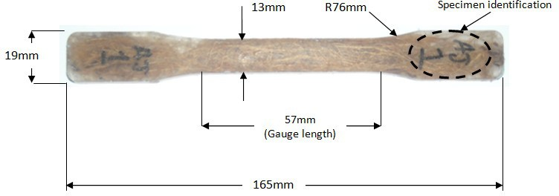

Fig. 1. Test sample dimensions according to standard ASTM D638 Type I

However, before the test specimens can be fabricated, the experiment needs to be properly planned first. It is necessary to know the right amount and type of the material samples that are required for the testing. A proper planning of experiments is essential to ensure that the results are useful and adequate for the factorial analysis later on. In this study, three parameters are to be varied for the experiments: the curing time, the coir fiber volume fraction and the applied compression loading during the curing process. The curing time is varied at two different levels: 24 hours and 48 hours. On the other hand, both compression load and coir fiber volume fraction will have three variation levels. The former is varied at 0.5 kg, 1 kg and 4 kg settings whereas the

latter is set at 3%, 9% and 15% settings. With this in mind, the test is designed following a full factorial design of experiments (DOE) with one 2-level and two 3-level parameters. In total, the number of experimental runs to be done based on this set-up is 18. Fabrication of test specimens for each run follows the respective parameter setting as specified in Table 1.

The fabrication of the test specimen is done using hand lay-up technique. First, epoxy and hardener are thoroughly mixed at 4:1 ratio to form the matrix. A release agent is used to clean and dry the mold before the matrix mix is uniformly poured to about 1/3 of the mold volume. The coir fiber at specified volume fraction setting is then spread in the mold on top of the matrix mix before it is covered with another layer of the matrix on its top. A spatula is used to make sure that the coir fibers are intact and firm inside the mold. After the mixture has settled down, the next step is to compress it by applying a compressive load. This is achieved by placing a specified amount of loading on top of the top plate of the mold. This compression set-up is maintained throughout whole duration of the specified curing time. The fabrication is entirely done in room temperature condition, which is about 25°C.

Table 1. Full factorial DOE tensile test settings

|  |  |  |  |
| --- | --- | --- | --- |
| Runs | Curing Time (hr) | Coir Fiber Volume Fraction (%) | Compression Load (kg) |
| 1 | 24 | 3 | 0.5 |
| 2 | 24 | 3 | 1.0 |
| 3 | 24 | 3 | 4.0 |
| 4 | 24 | 9 | 0.5 |
| 5 | 24 | 9 | 1.0 |
| 6 | 24 | 9 | 4.0 |
| 7 | 24 | 15 | 0.5 |
| 8 | 24 | 15 | 1.0 |
| 9 | 24 | 15 | 4.0 |
| 10 | 48 | 3 | 0.5 |
| 11 | 48 | 3 | 1.0 |
| 12 | 48 | 3 | 4.0 |
| 13 | 48 | 9 | 0.5 |
| 14 | 48 | 9 | 1.0 |
| 15 | 48 | 9 | 4.0 |
| 16 | 48 | 15 | 0.5 |
| 17 | 48 | 15 | 1.0 |
| 18 | 48 | 15 | 4.0 |

Once all test samples have been prepared, the standard tensile test is performed using tensile test machine INSTRON 3366. In brief description of the test, a constant strain of 2mm/min speed is applied to the test specimen and the tensile load is measured and recorded up until the test specimen broke off as depicted in Fig.

2. All tests are performed in room condition, which is roughly around 25°C in temperature. Three specimens are prepared and tested for each experimental case setting and the highest recorded value of tensile strength among them is taken as resultant test value.

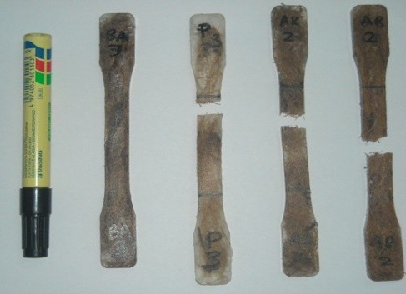

Fig. 2. Example test specimens that broke into two pieces during the tensile test

The coir fibers used to form the composite material are purchased from commercial market and they come in the form of custom-made sheets with random fiber orientation. No treatment is applied on them during the fabrication of the test specimens. For information, the coir fibers used have been prepared for producing mattresses. In general industrial process, these fibers may have undergone the partial retting process that could change their physical properties [5]. This notion could be used to explain any deviation of properties from those established for natural coir fibers.

Using the test results, a factorial analysis is done to estimate t MINITAB statistical software is used to facilitate the execution of analysis of variance (ANOVA) procedure.

# Results and Discussion

The obtained tensile test results for all 18 experimental runs are plotted and summarized in Fig. 3. For the 24-hour curing time setting, the composite tensile strength initially increases with increment in the coir fiber volume and the compression loading. However, the tensile strength goes down after that when the coir fiber and the compression load are increased further. On the other hand, some samples of the 48-hour curing time setting show an increase in maximum tensile strength with the increase in coir fiber and compression load. As reported in [6], tensile strength of coir fiber composite has an optimum point with respect to the fiber volume fraction where the strength will first increase towards the maximum point before it starts decreasing. Hence it can be hypothesized that the observed situation occurs due to the shifting of such optimum point based on changes made in the production settings. Another possible explanation on the observations is the less-known contributing effects of curing time and compression load, and their interaction effects with coir fiber volume fraction setting. Nevertheless, it is hard to establish any obvious conclusion just by looking at the plot. These effects can probably be better explained with the support of ANOVA results.

The tensile strength data is entered into MINITAB software for analysis and the resultant ANOVA table is shown in Table 2. Factorial ANOVA not only helps to study the effect of two or more factors but also provides an insight into their dependence or independence. Based upon their corresponding F- and p-values, the level of influence of the three interested parameters on tensile strength of the coir fiber composite can be estimated. The F-value corresponds to the null hypothesis test on whether that main parameter effect is not significant using F-statistics. Meanwhile, the corresponding p-value refers to the probability of obtaining results as the ones observed, provided that the null hypothesis is correct. In this case, a high F-value means that the null hypothesis is not correct and that the parameter effect is significant. Coming back to Table 2, the results highlight that the coir fiber volume fraction is the most dominant parameter that will affect the tensile

strength. On the contrary, it is noted that the effects of compression loading is comparatively negligible. Given a very low F-value (and correspondingly very high p-value), it could be said that varying the applied compression load during the fabrication process between the range of 0.5 to 4 kilograms has very little effects on the tensile properties of the resultant composite. Note that error element in the ANOVA results table is due to exclusion of the three-way interaction effects between the parameters from full factorial experimental data.

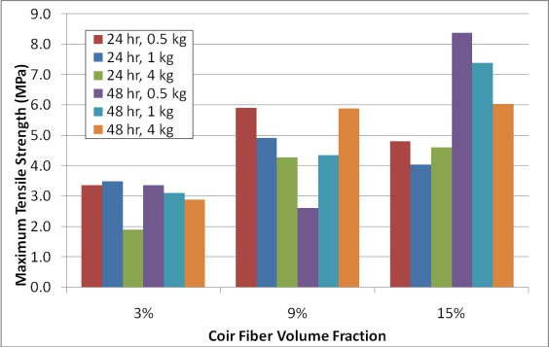

Fig. 3. Experimental results on maximum tensile strength of the coir fiber composite material Table 2. Analysis of variance table for maximum tensile strength

|  |  |  |  |  |  |
| --- | --- | --- | --- | --- | --- |
| Source | DF | SS | MS | F | p |
| Curing Time | 1 | 2.464 | 2.464 | 1.46 | 0.293 |
| Volume Fraction | 2 | 24.637 | 12.318 | 7.32 | 0.046 |
| Compression Load | 2 | 0.677 | 0.339 | 0.20 | 0.826 |
| Curing Time*Volume Fraction | 2 | 9.949 | 4.974 | 2.95 | 0.163 |
| Curing Time*Compression Load | 2 | 1.178 | 0.589 | 0.35 | 0.725 |
| Volume Fraction*Compression | 4 | 2.862 | 0.716 | 0.42 | 0.786 |
| Load | 4 | 6.735 | 1.684 |  |  |

Error

Moreover, it should also be noted from Table 2 that the interaction effect between coir fiber volume

the setting of the coir fiber volume in the material composition ought to also take into account the amount of curing time allowed due to their significant combined effects. The interaction plot for these two parameters in Fig. 4 seems to suggest that there exists an optimum combination setting that will correspond to the highest possible tensile strength. In this case, the optimum point for 24-hour curing time seems to fall in between the test range of the coir fiber volume fraction (in between 3% and 15%) while it can be stipulated that the optimum point is yet to be reached for 48-hour curing time set-up.

# Conclusion

It should be noted that this study is not aimed to establish tensile properties of coir fiber composite. Instead, its objective is to establish the significance level of influence that the three considered parameters have on

dictating the tensile strength of the coir fiber composite. In that regard, the factorial effects of the coir fiber volume, curing time and compression load have been analyzed. Based on the ANOVA result, the coir fiber volume fraction appears to be the most dominant factor in influencing the tensile strength of the resultant composite. In addition, the effects from curing time, as well as its combined effects with the setting of coir fiber volume fraction, are also significant and have to be considered in the fabrication process of the composite. On the opposite end, the effects of compression load seem to be comparatively insignificant. While a deeper study may need to be run to clearly quantify how insignificant is the effect from compression loading

ll be safely concluded here that its effects is comparatively much less that those of coir fiber volume fraction and curing time. Based on the results, the future work on modeling the tensile strength of the composite with regards to the fabrication process parameters should include both the curing time and the coir fiber volume fraction.

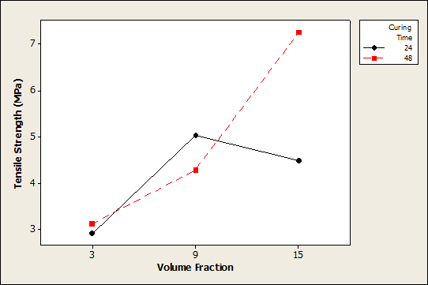

Fig. 4. Interaction plot for tensile strength between coir fiber volume fraction and curing time

# References

1. Yusoff, M. Z. M., et al., Mechanical Properties of Short Random Oil Palm Fibre Reinforced Epoxy Composites. *Sains Malaysiana* **2010**, *39*, 87-92.
2. Sapuan, S. M., M. Harimi, and A. M. Maleque, Mechanical Properties of Epoxy/Coconut Shell Filler Particle Composites. *The Arabian Journal for Science and Engineering* **2003**, *28*, 171-181.
3. Affandi, N. B., et al., A Preliminary Study on Translational Kinetic Energy Absorption Using Coconut- fiber (Coir) Sheets as a Potential Impact-worthy Constituent in Advanced Aerospace Material. *Key Engineering Materials* **2011**, *471-472*, 1028-1033.
4. Bujang, I. Z., M. K. Awang, and A. E. Ismail. Study on the Dynamic Characteristic of Coconut Fibre Reinforced Composites, Regional Conference on Engineering Mathematics, Mechanics, Manufacturing and Architecture, Putrajaya, Malaysia, 2007.
5. Rajan, A. and T. E. Abraham, Coir Fiber-Process and Opportunities. *Journal of Natural Fibers* **2006**, *3,*

29-41.

1. Hussain, S. A., Pandurangadu, V. and K. Palanikuamr, Mechanical Properties of Green Coconut Fiber Reinforced HDPE Polymer Composite, *International Journal of Engineering Science and Technology,* **2011**, *3,* 7942-7952