Available online at [www.sciencedirect.com](http://www.sciencedirect.com/)

**ScienceDirect**

AASRI Procedia 5 (2013) 54 – 61

2013 AASRI Conference on Parallel and Distributed Computing Systems

False Alarm Detection in Cyber-Physical Systems for Healthcare Applications

Shah Ahsanul Haquea,* , Syed Mahfuzul Azizb

*a,b School of Engineering, University of South Australia, Mawson Lakes, SA 5095, Australia*

**Abstract**

Cyber-Physical System (CPS) is an integration of physical processes with computation and communication. CPS connects the virtual world with physical world. It has the ability to add more intelligence to social life. A CPS integrates physical devices, such as sensors and cameras, with cyber (or informational) components to form a situation-integrated analytical system that responds intelligently to dynamic changes in the real-world scenarios. Wireless Sensor Networks (WSN) can be a vital part of CPS as strong sensing capabilities can be one of the major driving factors for CPS applications. Still CPS is considered as a nascent technology and there are many challenges yet to be addressed. These challenges are often posed due to the complexity of communication, computation and the uncertainty of physical processes. CPS can have wide ranging applications, such as smart medical technology, assisted living, environmental control and traffic management. Unfortunately, no unified architecture for CPS has yet been developed, primarily due to variations among the applications. In CPS healthcare application, a wide range of medical sensors are used, however these sensors generate a large number of false alarms. These false alarms add confusion and reduce the efficiency of overall healthcare service. Although a few CPS healthcare architectures have been proposed for healthcare application they all lack of efficient false alarm detection. In this paper, a novel false alarm detection architecture is proposed in CPS for healthcare applications.

© 2013 The Authors. Published by Elsevier B.V. Open access under [CC BY-NC-ND license.](http://creativecommons.org/licenses/by-nc-nd/3.0/)

© 2013 Published by Elsevier B.V.

Selection and/or peer review under responsibility of American Applied Science Research Institute

Selection and/or peer review under responsibility of American Applied Science Research Institute

*Keywords:* Cyber-Physical Systems (CPS); Wireless Sensor Networks (WSN); Healthcare; False Alarm

* Shah Ahsanul Haque. Tel: +61 416 746 444;

*E-mail address:* [shah.haque@mymail.unisa.edu.au](mailto:shah.haque@mymail.unisa.edu.au)

2212-6716 © 2013 The Authors. Published by Elsevier B.V. Open access under [CC BY-NC-ND license.](http://creativecommons.org/licenses/by-nc-nd/3.0/) Selection and/or peer review under responsibility of American Applied Science Research Institute doi:10.1016/j.aasri.2013.10.058

## Introduction

Cyber Physical System (CPS) is attracting a lot of attention in recent years and is being considered as an area of emerging technological revolution. It combines computation and communication capabilities with the physical world. CPS was identified as a key research area in 2008 by the US National Science Foundation (NSF) and was listed as the number one research priority by the US President’s Council of advisors on science and technology [1]. CPS has close connections with sensors, processing and networking. The recent advances in Wireless Sensor Networks (WSN) and medical sensors are making CPS a powerful candidate for healthcare applications including in-hospital and in-home patient care [2]. These advances promise to provide CPS the ability to observe patient conditions remotely and take actions regardless of the patient’s location. A lot of research is being conducted on medical sensors [3], [4]. These medical sensors are able to collect vital patient information containing health data. Different wireless sensors can also be used for patient observation. Collected data are sent to a gateway via wireless communication medium. Wired sensors can also be used, however wireless sensors provide much more flexibility and comfort to both the caregiver and the patients. The data collected by the sensors can be stored in a server and made accessible to clinicians. Security is a vital concern here as patient data is confidential from legal and ethical perspectives. As medical data can be vital for saving a patient’s life, all data should be readily available and accessible to authorized medical personnel anytime from anywhere. Medical sensors must alert the physician in case of emergency. At present, medical sensors generate considerable amount of false alarm. To the best of our knowledge, there are few false alarm architectures developed for CPS healthcare applications. In this paper, a novel false alarm detection architecture is proposed for healthcare applications in CPS and explore the challenges associated with its practical implementation. The proposed architecture utilizes an approach to detect and minimize false alarms generated by the patient monitoring sensors. We begin section 2 with an overview of some background of CPS and sensor alarm. In section 3, the false alarm detection architecture for the healthcare applications is proposed. This section also explores different parts of the proposed architecture. Section 4 presents the results. Finally, section 5 concludes the paper.

## Related Work

CPS has been gathering pace in recent years with the academia, industry and government being attracted to it as a promising field of research [5]. The growing importance of CPS comes from the need to resolve some of the critical issues faced by various sectors, such as rapidly increasing healthcare costs, environmental concerns, energy scarcity or mission critical requirements where timely monitoring and controlling are in high demand. With the capability to integrate WSNs from different domains, CPS can be the driving force to move the cyber world closer to the physical world. Connecting the two worlds in a meaningful manner will require regular exchange of critical information in timely and reliable fashion. WSNs can use the internet and cellular communication networks to connect to distant areas. Recent developments in embedded systems can contribute significantly meeting some of these demands. Increasing number of embedded microprocessors is currently being used in the new generation of smart devices. Considerable amount of research work is being performed on different aspects of CPS. Although CPS, embedded systems e.g. WSN and MANET have some similarities, there are some differences which are given in table 1:

Table 1 Comparison among MANET, WSN and CPS

MANET WSN CPS

Communication Type

Unicast, multicast and broad cast

Converge cast Cross domain

|  |  |  |  |
| --- | --- | --- | --- |
| Networking | Random | Field specific | Cross domain relying on  internet |
| Mobility | Supported | Less supported | Supported |
| Power Management | Energy saving based | Energy saving based | Application specific |

Network Coverage and connectivity

Connectivity based Connectivity and coverage

Collection and

Connectivity and coverage Discovering new knowledge

Data emphasize Networking issue

management

across domains and added

intelligence

QoS Transmission data Sensed data High level QoS

A few works have been done on the CPS healthcare application [6], [1]. The CPS architecture proposed in [7], [8] investigated different applications such as assisted living, monitoring network etc. They emphasize on reliable data analysis, event detection and security. They also stated that CPS architectures must be reliable and capture a variety of physical information. An innovative paradigm can be built around the notion of being “globally virtual, locally physical” which expresses that manipulation of physical world but control and observation is done securely across virtual network [9]. [1] proposed a CPS architecture called CPeSC3 (cyber physical enhanced secured wireless sensor networks integrated cloud computing for u-life care). This architecture is composed of three main components, namely 1) communication core, 2) computation core, and

3) resource scheduling and management core. They adopted cloud computing technology in the context of healthcare application. But they lack the details of alarm system of sensing data which is addressed in our proposed architecture. CPeSC3 doesn’t highlight on complete reliability of system which is vital for any CPS healthcare application.

In [10], authors tried to answer the limitation of CPeSC3 but failed to propose a complete CPS architecture. A promising framework has been proposed in [11] where automated secure framework of community cloud would provide cheaper healthcare service with the end-goal of better health outcomes. But in their architecture, the issue of alerting the physicians in emergency has been left unanswered.

This high rate of alarm generation in independent threshold alarm system also creates false alarms. False alarm causes fatigue to the caregivers. Since, CPS in this healthcare scenario will consider different types of sensors an approach needs to be taken for reliable coexistence of heterogeneous sensors. In [20], the authors proposed a Tru-Alarm method based on battle ground situation, which can find out trustworthy alarms and increase the feasibility of CPS. Once the locations of objects causing alarms are estimated, an object-alarm graph is constructed and trustworthiness inferences are carried out based on link information in the graph. Simulation results validated that their method can effectively filter out noises and false information and guarantee the accuracy of meaningful alarms. To determine the trustworthy alarms, an improved method can be used to detect and reduce the false alarms. As vital information is assessed to determine the state of the patient and multiple sensors may provide different data, trustworthiness analysis can be a useful tool.

## Proposed False Alarm Detection Architecture in CPS Healthcare

The main phases of our proposed architecture are shown in Figure 1. This framework for sensor alarm architecture in CPS healthcare application integrates physical and virtual capabilities through the phases of sensing, computation and communication. Recent technology advances in integration and miniaturization of physical sensors, embedded microcontrollers, radio interfaces on a single chip, wireless networking and micro-fabrication have enabled a new generation of wireless sensor networks suitable for many applications [2]. Many medical sensors and wearable health monitoring devices are playing an important role in healthcare

applications [2, 3, 12-14]. Constituent blocks of our proposed alarm architecture are explained in the following subsections.



Vital Sign 1 Classifier

Vital Sign 1

Alarm Generator

Decision Set

Vital Sign 2 Classifier

Vital Sign 2

Vital Sign 3 Classifier

Vital Sign 3

Vital Sign 4 Classifier

Vital Sign 4

Fig. 1 Proposed alarm architecture

In the proposed healthcare alarm system, the status of a patient is classified as Normal, Intensive, Critical or Highly Critical. As shown in figure 1, a status will be decided based on the reception of threshold alarms from different vital sensors. It is expected that the alarms associated with a patient are related to each other [15]. It is unlikely to have a scenario where only one alarm will be activated leaving other alarms inactive. Let us consider a scenario where four vital signs are used for patient monitoring. If one vital sign crosses the threshold value but remaining three vital signs are stable, the alarm will not be generated. All vital signs or a predetermined number of vital signs must cross the threshold in order to activate the alarm. Using classifiers can improve the situation. Adopting multiple threshold alarms for vital patient signs, this alarm generation rate can be reduced depending on the number of vital sign classifiers. As each vital sign is connected to each other and comparison is done using the classifiers, the rate of alarm generation is minimized.

* 1. *Computation*

Doctors or clinicians play an important role in the CPS healthcare application. In this application they need to monitor and observe patients from anywhere and anytime. They need the ability to access the required patient data accurately. In case of hospital scenario, large-scale and complex computation and communication is necessary so that doctors can easily collect patient data by bio-sensors from hospitals and remote observation centres. It is necessary to execute some algorithms for reduction of data bottleneck, calculation of data size etc. to ensure system efficiency. Threshold based alarm is a suitable method for false alarm detection. In this method, the presence or the absence of the reference value is deducted from the comparison between the output and predetermined threshold value. Mathematically, the probability of detecting the alarm is integral of signal with noise in probability density function.

*P*det

*psn* (*v*)*dv*

*threshold*

*(1)*

Similarly, the probability of false alarm, *PF*, is the probability of sample value when the reference value is absent.

*PF * *pn* (*v*)*dv*

*threshold*

*(2)*

Based on that, we get the two probability density functions applicable either on the reference value or on the noise value alone which is in the presence or absence of the signal.

*v*2

2

2

*v*,*n*

*pn* (*v*)

1. *e* 2*v* ,*n* 2

*(3)*

*psn*

*v vs* 2

(*v*)

1. *e* 2*v* ,*s n*2

*(4)*

Where,  is variance.

2

2

*v*,*s n*

In these circumstances, the probability of detection and the probability of false alarm are:

1 *v * *v* 2

2

2

*v*,*s n*

2

*P*det

exp  *s dv*

*(5)*

*Vthreshold*

1. *v*,*sn*

# 1

2

2

*v*,*n*

*P*

*F*

*Vthreshold*

# exp

2

*v*2

2 *dv*

*v*,*n*

*(6)*

We apply equation 6 in each classifier of our proposed alarm architecture using which the decision set determines the final decision on false alarm.

## Results

MATLAB simulations have been conducted to determine the approximate threshold alarm generation. For 10, 100, 1000 and 10,000 incidents and the threshold level taken as 1, one vital sign of the threshold alarm can raise up to 30% for 10 incidents and It can be up to 15.6% for 10,000 samples. The rate of alarm generation is high enough for the caregivers to attend in healthcare application. Simulation result for 100 incidents is shown in figure 2(a). Comparative analysis for the four sets of incidents is shown in figure 2 (b).

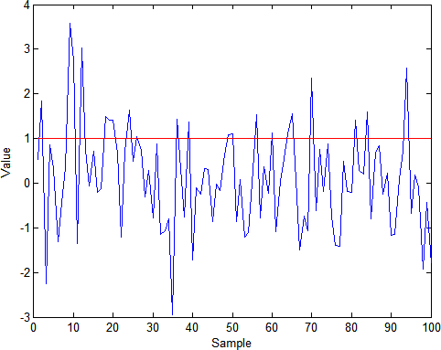

Fig. 2. (a) Threshold alarm output for 100 samples

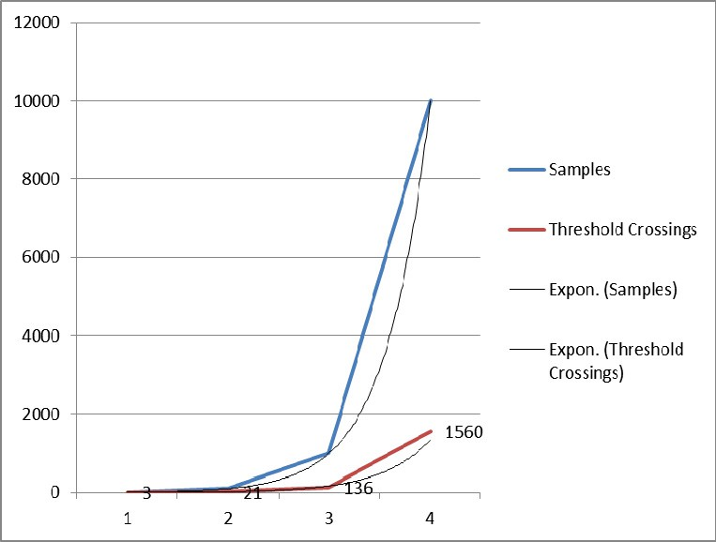

Fig. 2. (b) Performance analysis of threshold alarm output

## Conclusion and Future Works

A false alarm detection architecture for CPS healthcare application has been proposed. It aims to combine the threshold alarm method with multiple classifiers in decision set. In addition, the proposed architecture aims to answer some unanswered questions such as completeness, false alarm detection and accurate alarm generation. The architecture proposes to utilize multiple classifiers and compare those with vital health data from patients for detecting false alarm of medical sensors. It proposes a framework that is expected to perform better in regards of accuracy, efficiency and smart alarm system. In future we plan to explore the security issue and implement prototype architecture in a healthcare scenario.

## Corresponding Author:

Shah Ahsanul Haque, email: [shah.haque@mymail.unisa.edu.au,](mailto:shah.haque@mymail.unisa.edu.au) Mobile No: +61 416 746 444

## References

1. J. Wang, H. Abid, S. Lee, L. Shu, and F. Xia, "A Secured Health Care Application Architecture for Cyber- Physical Systems," *Control Engineering and Applied Informatics,* 2011.
2. A. Milenkovic, C. Otto, and E. Jovanov, "Wireless sensor networks for personal health monitoring: Issues and an implementation," *Computer Communications,* vol. 29, pp. 2521-2533, 6 March 2006.
3. E. Jovanov, A. Milenkovic, C. Otto, and P. C. d. Groen, "A wireless body area network of intelligent motion sensors for computer assisted physical rehabilitation," *Journal of NeuroEngineering and Rehabilitation,* vol. 2, 2005.
4. V. Shnayder, B.-r. Chen, K. Lorincz, T. R. F. F. Jones, and M. Welsh, "Sensor networks for medical care," presented at the Proceedings of the 3rd international conference on Embedded networked sensor systems, San Diego, California, USA, 2005.
5. F.-J. Wu, Y.-F. Kao, and Y.-C. Tseng, "From wireless sensor networks towards cyber physical systems,"

*Elsevier Pervasive and Mobile Computing,* pp. 397-413, 2011.

1. A. Lounis, A. Hadjidj, A. Bouabdallah, and Y. Challal, "Secure and Scalable Cloud-based Architecture for e-Health Wireless sensor networks," in *International Conference on Computer Communication Networks (ICCCN)*, Munich, Germany, 2012.
2. R. R. Rajkumar, I. Lee, L. Sha, and J. Stankovic, "Cyber-Physical Systems: The Next Computing Revolution," presented at the Design Automation Conference, Anaheim, California, USA, 2010.
3. F. Xia, L. Ma, J. Dong, and Y. Sun, "Network QoS Management in Cyber-Physical Systems," presented at the Int’l Conf. Embedded Software and Systems Symp., 2008.
4. F. Xie. (2006, Component-Based Cyber-Physical Systems.
5. C. O. Rolim, F. L. Koch, C. B. Westphall, J. Werner, A. Fracalossi, and G. S. Salvador, "A cloud computing solution for patient’s data collection in health care institutions," presented at the Second International Conference on eHealth, Telemedicine, and Social Medicine, ETELEMED ’10, St. Maarten, Netherlands, 2010.
6. B. Perumal, P. Rajasekaran.M, and H. M. Ramalingam., "WSN Integrated Cloud for Automated Telemedicine (ATM) Based e-Healthcare Applications," presented at the 2012 4th International Conference on Bioinformatics and Biomedical Technology IPCBEE, Singapore, 2012.
7. D. Arney, S. Fischmeister, J. M. Goldman, I. Lee, and R. Trausmuth, "Plug-and-Play for Medical Devices: Experiences from a Case Study," *Biomedical instrumentation & technology / Association for the Advancement of Medical Instrumentation,* vol. 43, pp. 313-317, 2009.
8. J. M. Feldman, M. H. Ebrahim, and I. Bar-Kana, "Robust Sensor Fusion Improves Heart Rate Estimation:

Clinical Evaluation," *The Journal of Clinical Monitoring,* vol. 13, pp. 379-384, 1997.

1. Z. Jiang, M. Pajic, and R. Mangharam, "Cyber–Physical Modeling of Implantable Cardiac Medical Devices," *Proceedings of the IEEE,* vol. 100, pp. 122-137, January 2012 2012.
2. M. Imhoff and S. Kuhls, "Alarm algorithms in critical care monitoring," *Anesthesia and analgesia,* vol. 102, pp. 1525-1537, 2006.
3. P. Kulkarni and Y. O¨ztu¨rk, "Requirements and Design Spaces of Mobile Medical Care," *Mobile Computing and Communications Review,* vol. 11, pp. 12-30, 2007.
4. C. C. Y. Poon, Y.-T. Zhang, and S.-D. Bao, "A novel biometrics method to secure wireless body area sensor networks for telemedicine and m-health " *IEEE Communications Magazine,* vol. 44, pp. 73-81, 2006.
5. W. Dargie and C. Poellabauer, *Fandamentals of Wireless Sensor Networks Theory and Practice*: Wiley, 2010.
6. C. Buratti, A. Conti, D. Dardari, and R. Verdone, "An Overview on Wireless Sensor Networks Technology and Evolution," *Sensors,* vol. 9, pp. 6869-6896, 2009.
7. L.-A. Tang, X. Yu, S. Kim, J. Han, C.-C. Hung, and W.-C. Peng, "Tru-Alarm: Trustworthiness Analysis of Sensor Networks in Cyber-Physical Systems," presented at the IEEE International Conference on Data Mining, Sydney, NSW, 2010.