[Artificial Intelligence in the Life Sciences 1 (2021) 100016](https://doi.org/10.1016/j.ailsci.2021.100016)

 

Contents lists available at [ScienceDirect](http://www.ScienceDirect.com/)

Artificial Intelligence in the Life Sciences

journal homepage: [www.elsevier.com/locate/ailsci](http://www.elsevier.com/locate/ailsci)

Fiscore package: Effective protein structural data visualisation and exploration

Auste Kanapeckaite

*School of Pharmacy, University of Reading, Hopkins Building, Reading RG6 6UB, United Kingdom*

a b s t r a c t

The lack of bioinformatics tools to quickly assess protein conformational and topological features motivated to create an integrative and user-friendly R package. Moreover, the *Fiscore* package implements a pipeline for Gaussian mixture modelling making such machine learning methods readily accessible to non-experts. This is especially important since probabilistic machine learning techniques can help with a better interpretation of complex biological phenomena when it is necessary to elucidate various structural features that might play a role in protein function. Thus, *Fiscore* builds on the mathematical formulation of protein physicochemical properties that can aid in drug discovery, target evaluation, or relational database building. In addition, the package provides interactive environments to explore various features of interest. Finally, one of the goals of this package was to engage structural bioinformaticians and develop more robust and free R tools that could help researchers not necessarily specialising in this field. Package *Fiscore* (v.0.1.3) is distributed free of charge via CRAN and Github.

# Introduction

*Fiscore* R package was developed to quickly take advantage of protein topology/conformational feature assessment and perform various anal- yses allowing a seamless integration into relational databases as well as machine learning pipelines [1]. The package builds on protein structure and topology studies which led to the derivation of the Fi-score equa- tion capturing protein dihedral angle and B-factor influence on amino acid residues (Eqs. (1) and (2)) [1]. The introduced tools can be very beneficial in rational therapeutics development where successful engi- neering of biologics, such as antibodies, relies on the characterisation of potential binding or contact sites on target proteins [1,2]. Moreover, translating structural data into scores can help with target classification, target-ligand information storage, screening studies, or integration into machine learning pipelines [1,2]. As a result, Fi-score, a first-of-its-kind *in silico* protein fingerprinting approach, created a premise for the devel- opment of a specialised and freely distributed R package to assist with protein studies and new therapeutics development [1].

*Fiscore* package allows capturing dihedral angle and B-factor effects

metric or non-parametric density estimation methods, a specific trans- formation was required to use this data. An additional parameter, specif- ically the oscillation amplitudes of the atoms around their equilibrium positions (B-factors) in the crystal structures, was also used. B-factors encompass a lot of information on the overall biomolecule structure; for example, these parameters depend on conformational disorder, ther- mal motion paths, and the rotameric state of amino acids side-chains. B-factors also show dependence on the three-dimensional structure as well as protein flexibility [1,4]. Normalised dihedral angles (standard deviation scaling to account for variability and distribution) and scaled B-factors (min-max scaling) (Eq. (1)) were integrated into the Fi-score equation (Eq. (2)). It is important to highlight that B-factors need to be scaled so that different structural files can be compared and that the di- hedral angle normalisation transforms angular data into adjusted values based on the overall variability [1]. Thus, combining dihedral angle and B-factor values into a single parameter provides a way to extract infor- mation on individual residues, residue clusters, motifs, and structural features. This information can be eﬃciently transferred into machine learning to detect data characteristics not easily identifiable otherwise.

on protein topology and conformation. Since these physicochemical

*𝐵𝑖*−*𝑛𝑜𝑟𝑚*

*𝐵𝑖* −*𝐵*min

*𝐵*max−*𝐵*min

=

characteristics could help with the identification or characterisation of a binding pocket or any other therapeutically relevant site, it is important to extract and combine data from structural files to allow such informa- tion integration [1,3,4]. Protein dihedral angles were selected as they contain information on the local and global protein structural features

**Equation 1**. Min-max normalisation and scaling of B-factors where

*𝐵𝑖*−*𝑛𝑜𝑟𝑚* is a scaled B-factor, *𝐵𝑖* - B-factor for a selected *𝐶𝛼* atom in a chain, Bmax - the largest B-factor value for all *𝐶𝛼* B-factors in a protein, Bmin

- the smallest B-factor value for all *𝐶𝛼* B-factors in a protein. B-factor

normalisation is based on the full length protein.

where protein backbone conformation can be highly accurately recre-

ated based on the associated dihedral angles [1,4]. Furthermore, since

*𝐹 𝑖*

*𝑠𝑐𝑜𝑟𝑒*

1 ∑ *𝜙𝑖 𝜓𝑖*

*𝑁 𝑖 𝜎𝜙𝑖 𝜎𝜓𝑖*

= *𝐵*

*𝑖*−*𝑛𝑜𝑟𝑚*

distributions, namely *𝜙* (phi) and *𝜓* (psi), allows only a holistic descrip- Ramachandran plot, which provides a visualisation for dihedral angle

tion of conformation and cannot be integrated with traditional para-

*E-mail address:* [auste.kan@algorithm379.com](mailto:auste.kan@algorithm379.com)

for which dihedral angle information is available, *𝜙* and *𝜓* values rep- **Equation 2**. Fi-score evaluation where N is the total number of atoms resent dihedral angles for a specific *𝐶𝛼* atom, *𝜎𝜙𝑖* and *𝜎𝜓𝑖* represent cor-

<https://doi.org/10.1016/j.ailsci.2021.100016>

Received 16 November 2021; Accepted 18 November 2021

Available online 26 November 2021

2667-3185/© 2021 The Authors. Published by Elsevier B.V. This is an open access article under the CC BY-NC-ND license (<http://creativecommons.org/licenses/by-nc-nd/4.0/>)

responding standard deviations for the torsion angles and *𝐵𝑖*−*𝑛𝑜𝑟𝑚* is a normalised B- factor value for the *𝐶𝛼* atom. B-factor, *𝜎𝜙𝑖* and *𝜎𝜓𝑖* nor-

malisation is based on the full length protein.

In order to identify meaningful clusters based on the structural com- plexity, Gaussian mixture models (GMM) were selected as a primary machine learning classifier [1]. The strength of GMM lies in the proba- bilistic model nature since all data points are assumed to be derived from a mixture of a finite number of Gaussian distributions with unknown parameters [1,5]. Consequently, the soft classification of GMM where a data point has a probability of belonging to a cluster is much more suitable to assess biological parameters compared to other hard classifi- cation techniques in machine learning, such as k-means, which provide only a strict separation between classes. GMM pipeline offers a number of benefits to categorise protein structural features and the information can be used to explore amino acid grouping based on their physico- chemical parameters. The designed GMM implementation takes care of the information criterion assessment to fine tune the number of clusters for modelling and predicts the best suited model for the expectation- maximisation (EM) algorithm to maximise the likelihood of data point assignments [1,5]. As a result, protein residues can be grouped based on their Fi-scores where this information can be used to identify emerging patterns in the protein conformation or topology.

Nur77 protein was used as a case example to demonstrate various

package functionalities. Nuclear receptor subfamily 4 group A member 1 (NR4A1), also known as Nur77/TR3/NGFIB, is a member of the nu- clear receptor superfamily and regulates the expression of multiple tar- get genes [6]. This nuclear receptor is classified as an orphan receptor since there are no known endogenous ligands. Nur77 has the typical structure of a nuclear receptor which consists of N-terminal, DNA bind- ing, and ligand-binding domains. This regulatory protein plays many po- tentially therapeutically relevant roles regulating cell proliferation and apoptosis [6]. Consequently, the Nur77 protein is an excellent example to highlight how in-depth structural analysis and classification could be used in better understanding protein functions and finding druggable binding sites or identifying ligands.

Based on the need to develop integratable and specialised tools for protein analyses, the *Fiscore* package was developed to assist with a wide spectrum of research questions ranging from exploratory analy- ses to therapeutic target assessment (Fig. 1). The introduced set of new tools provides an interactive exploration of targets with an easy integra- tion into downstream analyses. Importantly, the package and associated tools are written to be easy to use and freely available facilitating anal- yses for non-specialists in structural biology or machine learning.

# Methods

*Fiscore* package architecture is divided into exploratory and ad- vanced functions (Fig. 1). Several key packages, such as ggplot2 [7], Bio3D [8], plotly [9], and mclust [10], are also employed to create an easy-to-use analytical environment where a user-friendly machine learn- ing pipeline of GMM [1] allows for a robust structural analysis. GMM implementation is designed to include the optimal cluster number eval- uation (Bayesian information criterion; BIC), automatic model fitting in the EM phase of clustering, model-based hierarchical clustering, den- sity estimation, as well as discriminant analysis [1,11]. Researchers also have an option to perform advanced exploratory studies or integrate the package into their development pipelines. *Fiscore* also takes care of raw data pre-processing and evaluation with optional settings to adjust how the analyses are performed. The package was built using functional pro- gramming principles with several R S3 methods to create objects for PDB files [12]. *Fiscore* is accompanied by documentation and vignette files to help the users with their analyses [11]. Since PDB files are typically large, the documentation provides a compressed testing environment as well as a detailed tutorial. Additional visualisations were generated with PyMol [13]. Proteins were retrieved from the Protein Data Bank database [14]. Protein sequence alignments were performed with PSI-

BLAST using default parameters and a single iteration [15]. Hydropho- bicity plots for Nur77 functional analysis were generated with the fol-

lowing parameters: window = 15,weight = 25, model=“exponential”.

Student’s *t*-test (two-sided, unpaired, sig. level=95%) was performed in

the R programming environment.

# Results

* 1. *Data preparation*

The workflow begins with the PDB file pre-processing and prepara- tion. The user should also generally assess if the structure is suitable for the analysis; that is, the crystallographic data provides a good resolution and there are no or a minimal number of breakages within the reported structure. Function *PDB_process* takes a PDB file name which can be expressed as 6KZ5.pdb or path/to/the/file/6KZ5.pdb. One of the func- tion’s dependencies is package Bio3D [8], this useful package provides several tools to begin any PDB file analysis. In addition, the *PDB_process* function can take a path parameter which can point to a directory where to split PDB files into separate chain files (necessary for the downstream analysis). If this option is left empty, a folder in the working directory will be created automatically. If the user splits multiple PDB files in a loop, they will be continuously added to the same folder. After the pro- cessing, the function *PDB_process* returns a list of split chain names. It is important to highlight that PDB files need to be split for the downstream processing so that separate chains can be analysed independently.

After a file or files are pre-processed the function *PDB_prepare* can be used to prepare a PDB file to generate Fi-score and normalised B-factor values as well as secondary structure designations. The function takes a PDB file name that was split into separate chains, e.g., 6KZ5_A.pdb, where a letter designates a split chain. The file is then cleaned and only the complete entries for amino acids are kept for the analysis, i.e., amino acids from the terminal residues that do not contain both dihe- dral angles are removed. The function returns a data frame with pro- tein secondary structure information ‘*Type*’, Fi-score values per residue

‘*Fi_score*’, as well as normalised B-factor values for each amino acid *𝐶𝛼*

‘*B_normalised*’ (Fig. 2). Extracting protein secondary structure informa-

tion, i.e., ‘*Type*’, helps to prepare a data object so that the information about a target can be supplied into cheminformatics or other bioinfor- matics pipelines where structural features are important to assess pro- tein sites and amino acid composition. These features are new and ex- tend structural file exploration possibilities compared to, for example, other software packages, such as Bio3D [8].

Function calls are simple and user-friendly:

#General function for pre-processing raw PDB files pdb_df*<*-PDB_process(pdb_path)

#Cleaning and preparation of PDB file pdb_df*<*-PDB_prepare(pdb_path) #Explore the output

head(pdb_df)

#The package allows to call test data directly for the Nur77 example file

pdb_path*<*- system.file(“extdata”, “6kz5.pdb”, package=“Fiscore”)

* 1. *Exploratory analyses*

The scope of the exploratory analyses provides options to evaluate physicochemical parameters, such as dihedral angles, B-factors, or hy- drophobicity scores, and visualise their distribution (Fig. 1).

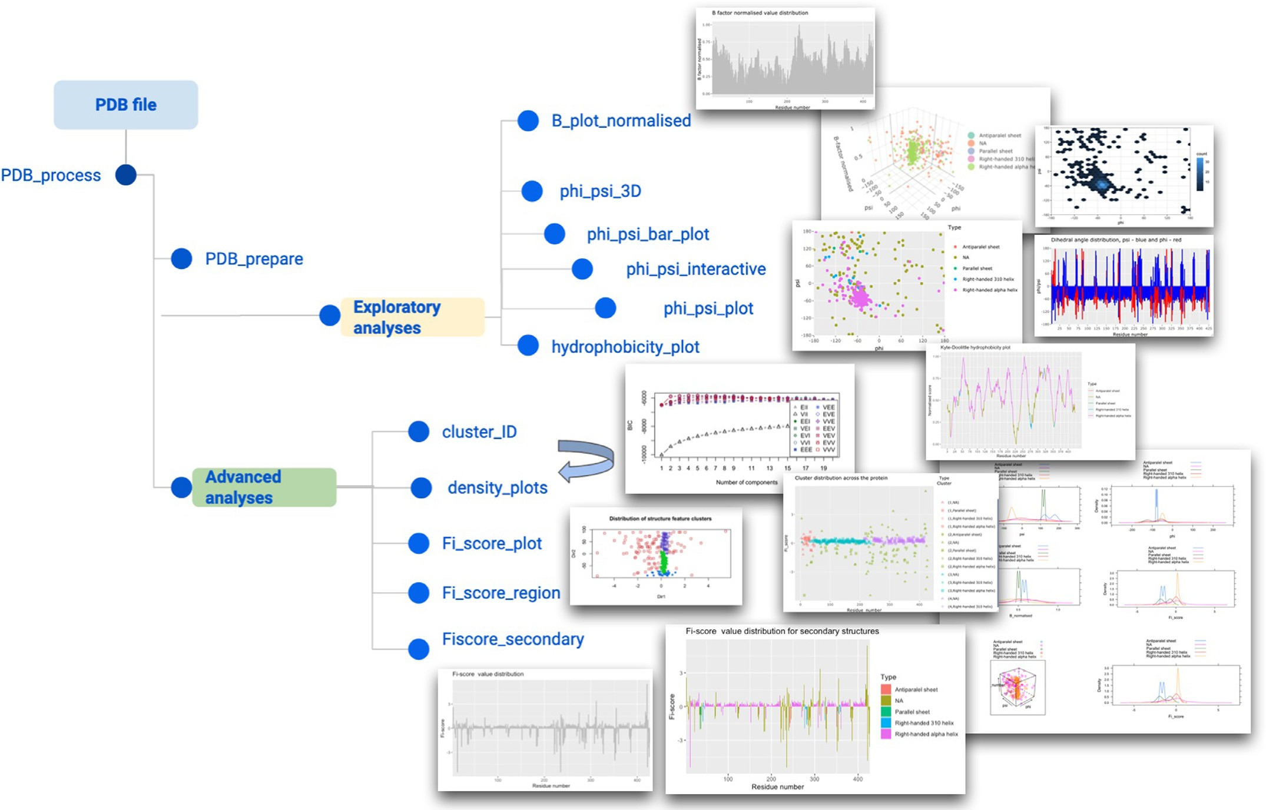

**Fig. 1.** Schematic visualisation of the package features.

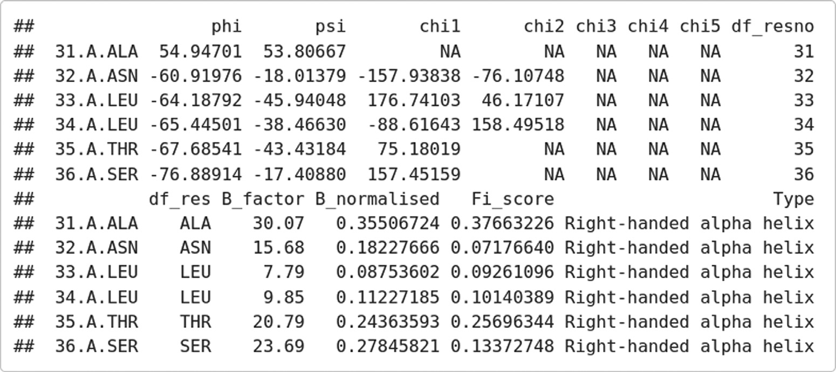**Fig. 2.** PDB file processing output.

Basic analyses are accessed through simple function calls to ex- plore how dihedral angles and B-factors are distributed. These anal- yses offer interactive and easy visualisations of key parameters that are currently not offered in any other package. For example, while Bio3D [8] has many useful functionalities for the exploration of PDB files, ‘*Fi_score*’ extends exploratory analyses by allowing a simplified and in-depth look into the key physicochemical parameters, such as B- factor value visualisation or generation of Ramachandran plots. Simi- larly, other freely available tools (distributed as an online service), such as Expasy ProtScale [16,17], provide only one dimensional assessment without incorporating structural features and do not process PDB files. ‘*Fi_score*’, however, combines sequence, structural, and physicochemical analyses in simple function calls to quickly explore the user data.

#Calling a Ramachandran plot function

phi_psi_plot(pdb_df)

#Visualisation of dihedral angle juxtaposed distributions phi_psi_bar_plot(pdb_df)

#B plot value visualisation B_plot_normalised(pdb_df)

#Interactive plot to map amino acids via 2D distribution

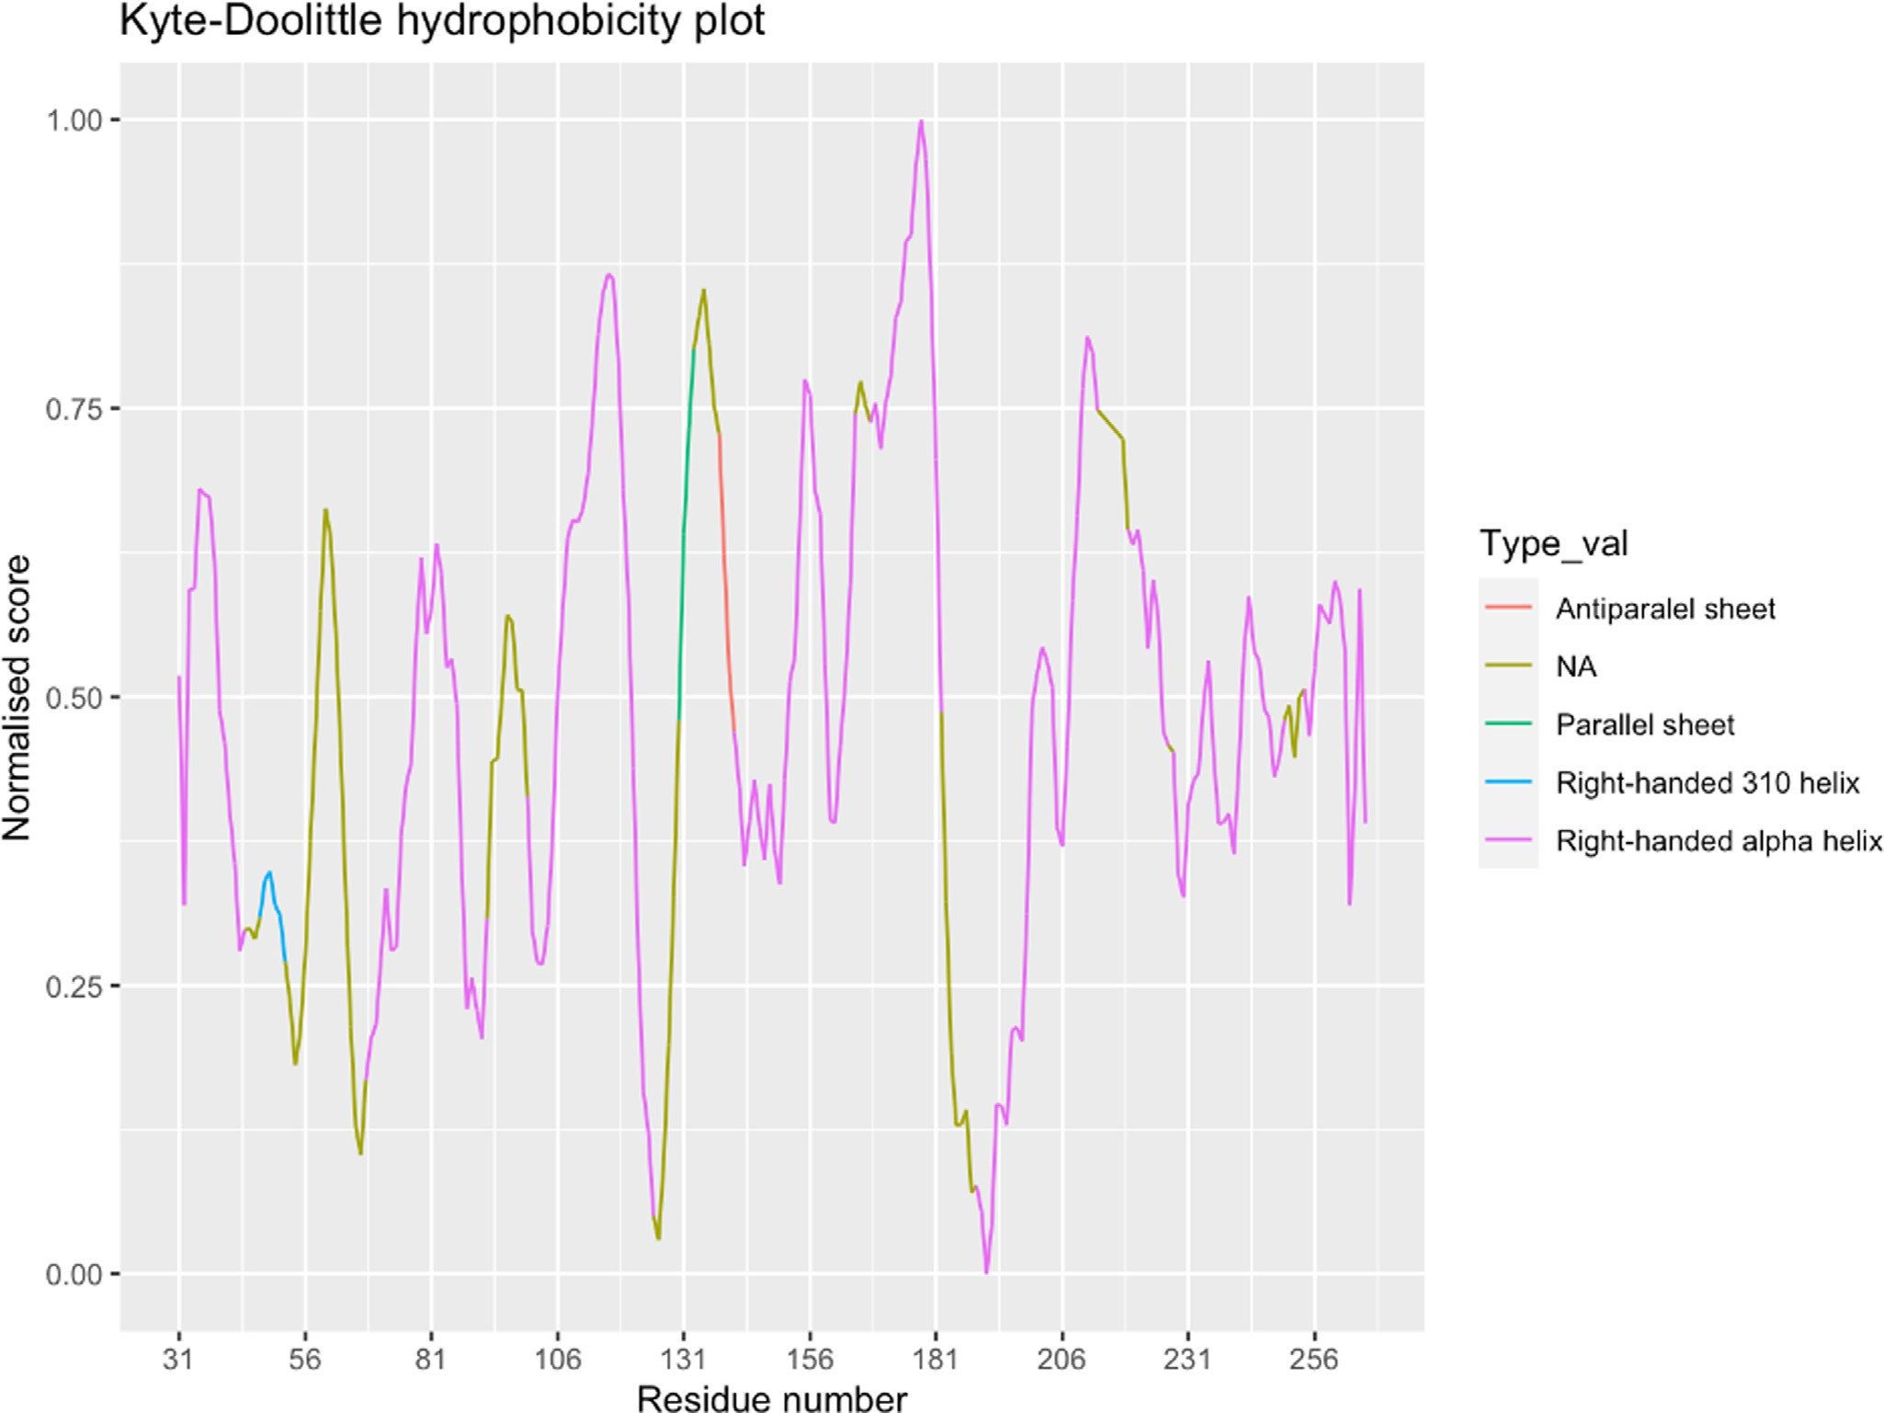

**Fig. 3.** Hydrophobicity plot with secondary structure superimposition.

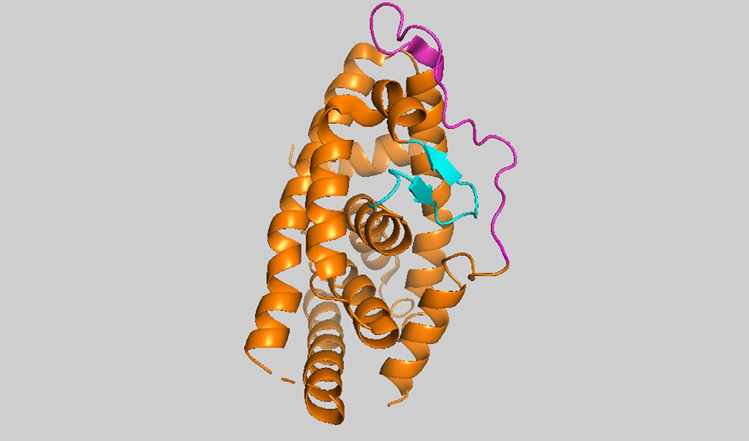#to precisely see what parameters an individual amino acid has phi_psi_interactive(pdb_df)

#3D visualisation of dihedral angles and B-factor values phi_psi_3D(pdb_df)

An especially useful functionality is the hydrophobicity visualisation with the superimposed secondary structure elements. To the author’s knowledge, there are currently no tools implementing such a visuali- sation (Fig. 3). In contrast to Expasy ProtScale [16,17], it is possible to visualise hydrophobicity values and their corresponding secondary structure elements as extracted from the PDB file. Such an assessment provides a direct way to compare structural features based on their aﬃn- ity to water. This can be very helpful in evaluating or predicting poten- tial binding sites as well as bioengineering new proteins.

The package provides an easy to use wrapper: #Alternatively an exponential model can be selected

hydrophobicity_plot(pdb_df,window = 9,weight = 25,model = ’’ex-

ponential’’)

The nuclear receptor was assessed to provide a case example for the introduced hydrophobicity analysis. The evaluation revealed an overall dynamic profile for the protein. Moreover, Nur77 evidently contains a

**Fig. 4.** Nur77 protein where magenta highlights are used to define a likely dis- ordered region between 50 and 70 amino acids and the cyan color indicates a region between 127 and 140 amino acids.

relatively large number of right-handed alpha helices with the majority showing a hydrophobic profile, i.e., the larger the score, the more hy- drophobic the region. Some likely disordered regions can be seen span- ning 50–70 amino acids (Fig. 4). Another interesting region is around 126–136 amino acids since these amino acids undergo significant shifts in their hydrophilicity and hydrophobicity. Similarly, the region around 180–210 amino acids appears to be actively changing preferences from

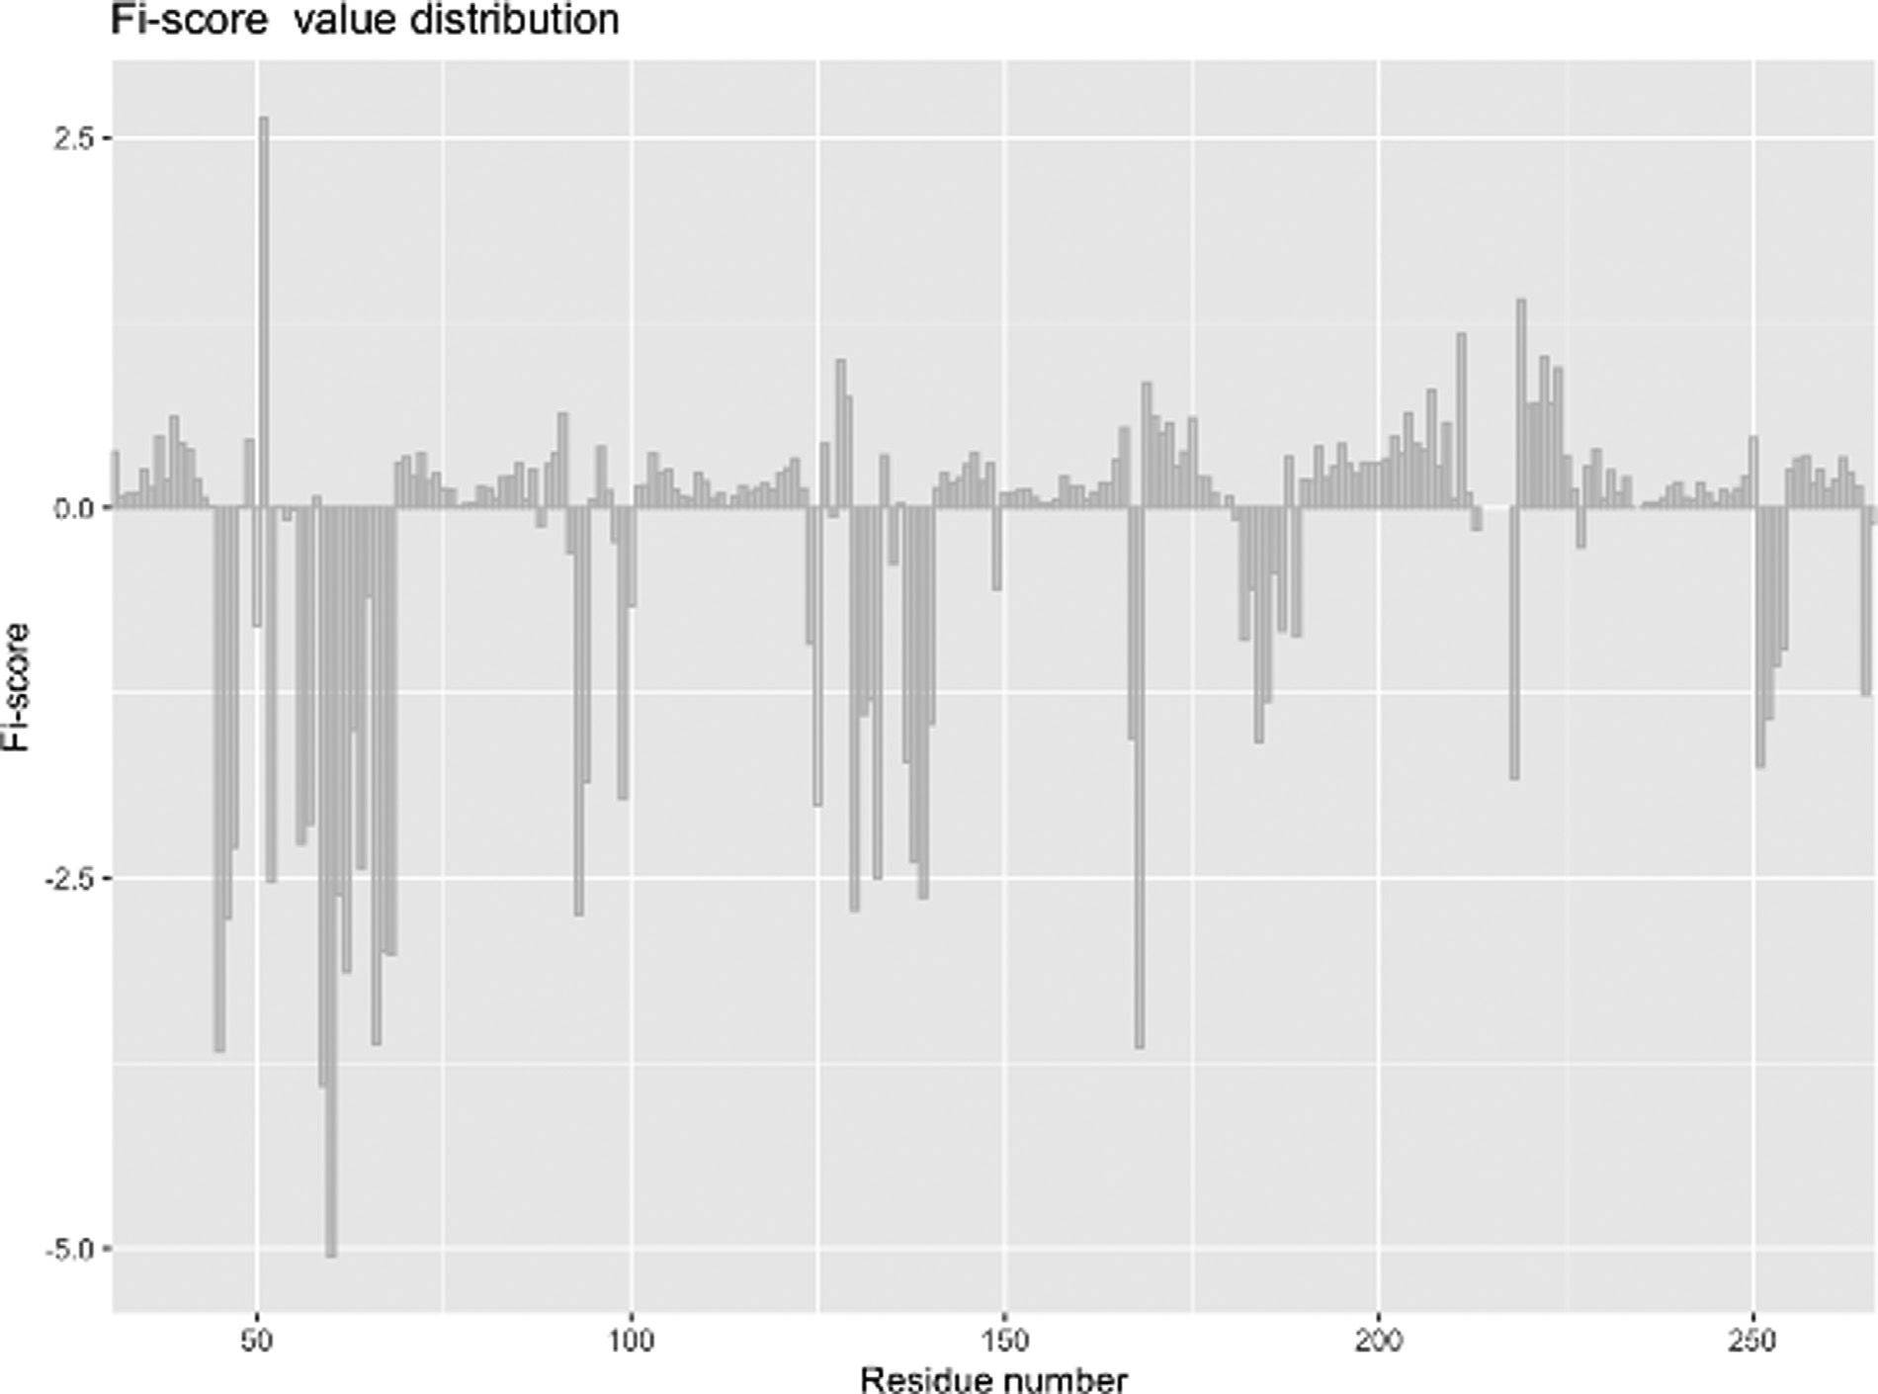

**Fig. 5.** Fi-score distribution for Nur77.

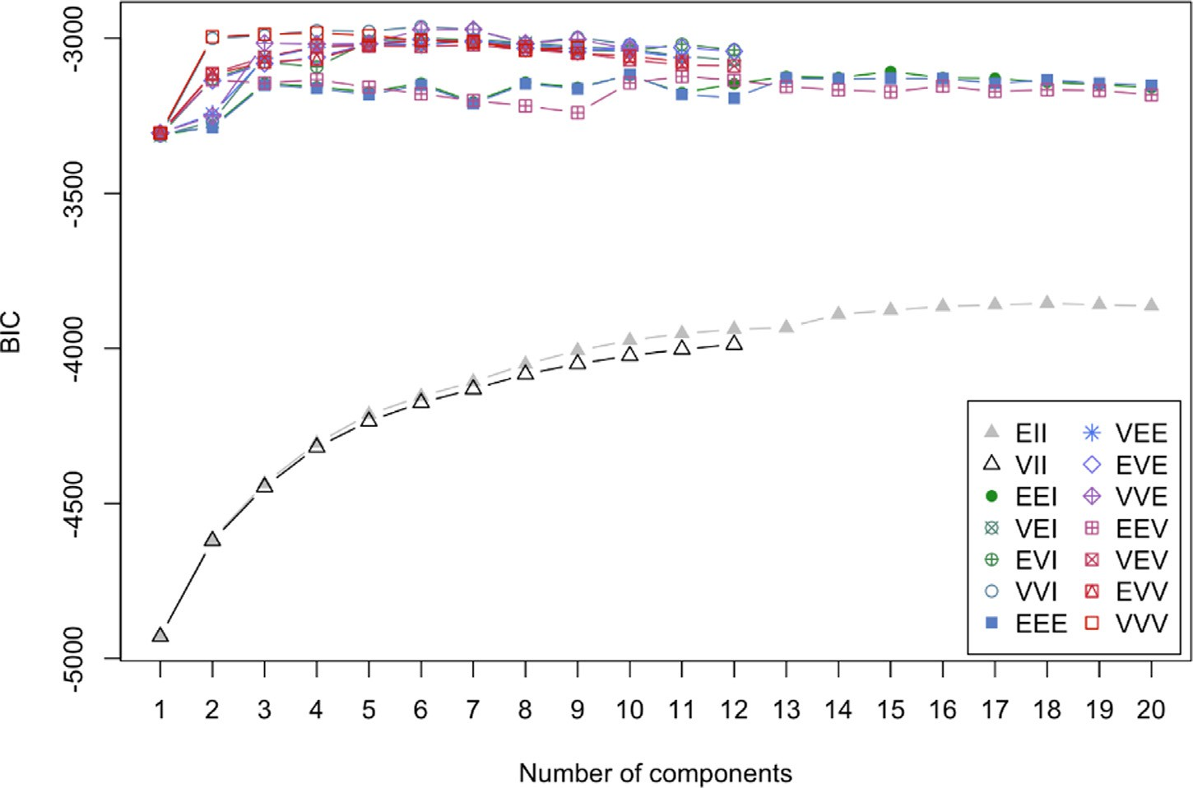**Fig. 6.** Gaussian mixture modelling output show- ing Bayesian information criterion evaluation.

little solvent to being solvent exposed. This might suggest that the site undergoes considerable movements or actively engages other proteins or the DNA sequence. The disordered elements in this sequence stretch also imply that the region has to likely accommodate various rearrange- ments. Thus, studying these sites could provide hints at functionally im- portant protein domains or subdomains (Figs. 3 and 4). Finally, evalu-

ating N and C terminal sites for the purpose of protein engineering, we can see that a histidine tag would not significantly disrupt the confor- mation of the molecule and the C-terminus is probably the best site for the tag.

It is worth commenting on the derivation of the hydrophobicity scor- ing since the algorithmic nature of the process provides several impor-

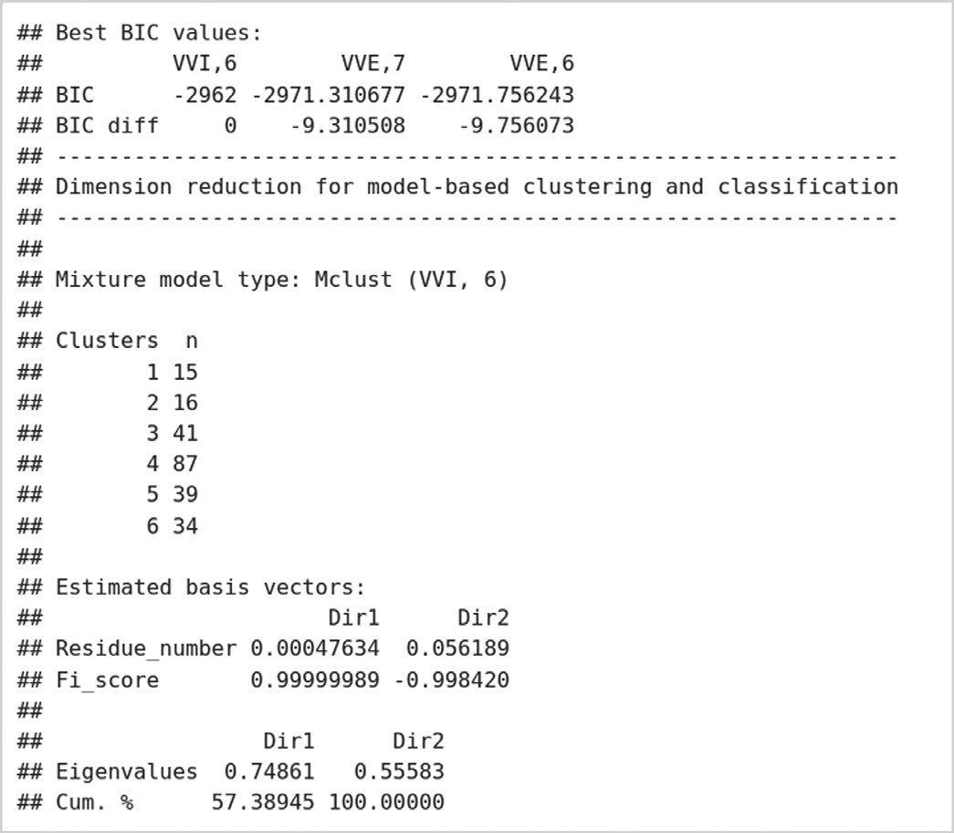

**Fig. 7.** Output table for Gaussian mixture modelling evaluation.

tant analytical angles. The function builds on the Kyte-Doolittle hy- drophobicity scale [1,18] to detect hydrophobic regions in proteins. Regions with a positive value are hydrophobic and those with neg- ative values are hydrophilic. This scale can be used to identify both surface-exposed as well as transmembrane regions, depending on the

window size used. However, to make comparisons easier, the original scale is transformed from 0 to 1 (similar scaling is also implemented in Expasy ProtScale [16,17]). The function requires a PDB data frame generated by *PDB_prepare* and the user needs to specify a window pa- rameter to determine the size of the window for hydrophobicity cal- culations. The selection must be any odd number between 3 and 21 with the default being 21. Another parameter is weight that needs to be supplied to the function to establish a relative weight of the window edges compared to the window center (%); the default setting is 100%. Finally, a model parameter provides an option for weight calculation; that is, the selection determines whether weights are calculated linearly

(*𝑦* = *𝑘* ⋅ *𝑥* + *𝑏*) or exponentially (*𝑦* = *𝑎* ⋅ *𝑏𝑥*); the default model is ‘linear’.

The function evaluates each amino acid in a selected window where a

hydrophobic influence from the surrounding amino acids is calculated in. While the terminal amino acids cannot be included into the window for centering and weighing, they are assigned unweighted values based on the Kyte-Doolittle scale [18]. The plot values are all scaled from 0 to 1 so that different proteins can be compared without the need to convert.

Thus, the hydrophobicity analysis can be especially useful when preparing to engineer proteins for various expression systems as the superimposition of structural features and hydrophobicity scores can help deciding if a protein region or domain is likely to be solvent ex- posed or prefer hydrophobic environments. For example, assessing the hydrophobicity and structural milieu of the N or C terminal amino acids can help selecting which terminal site should be tagged (as was demon- strated with Nur77). Moreover, this tool could be broadly applied in drug discovery studies involving the assessment of protein-protein in- teractions, protein-nucleic acid interactions, and membrane association events based on physicochemical characteristics.

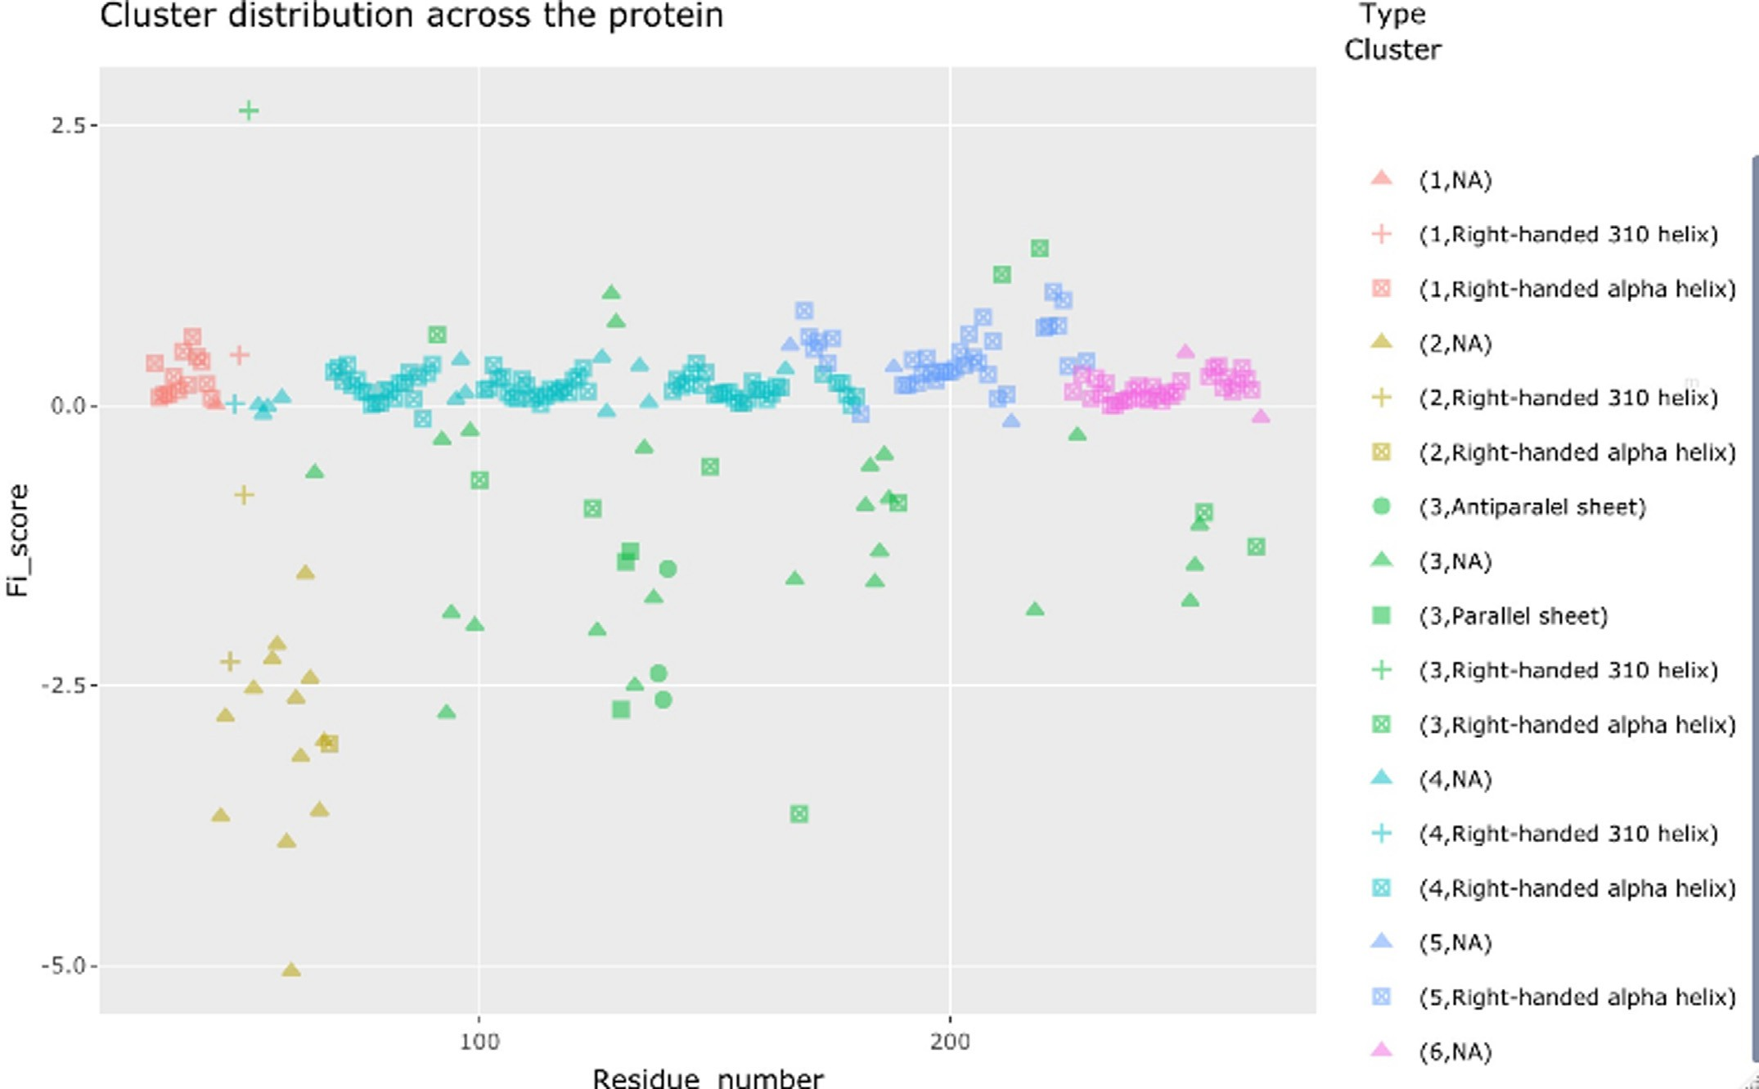

**Fig. 8.** The Nur77 protein cluster identification with secondary structure elements.

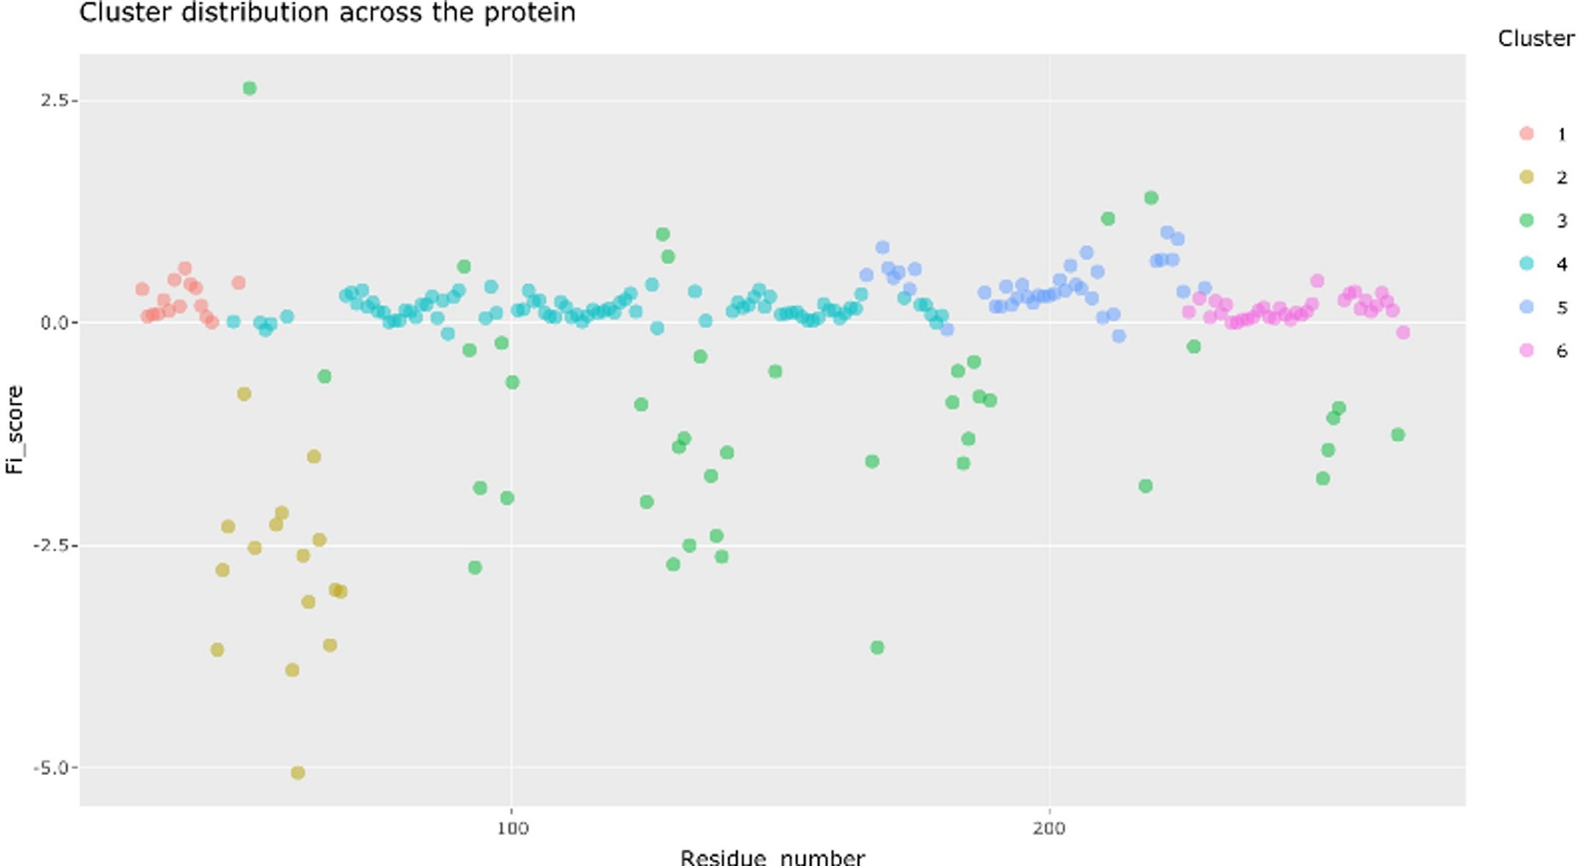

**Fig. 9.** Nur77 cluster identification.

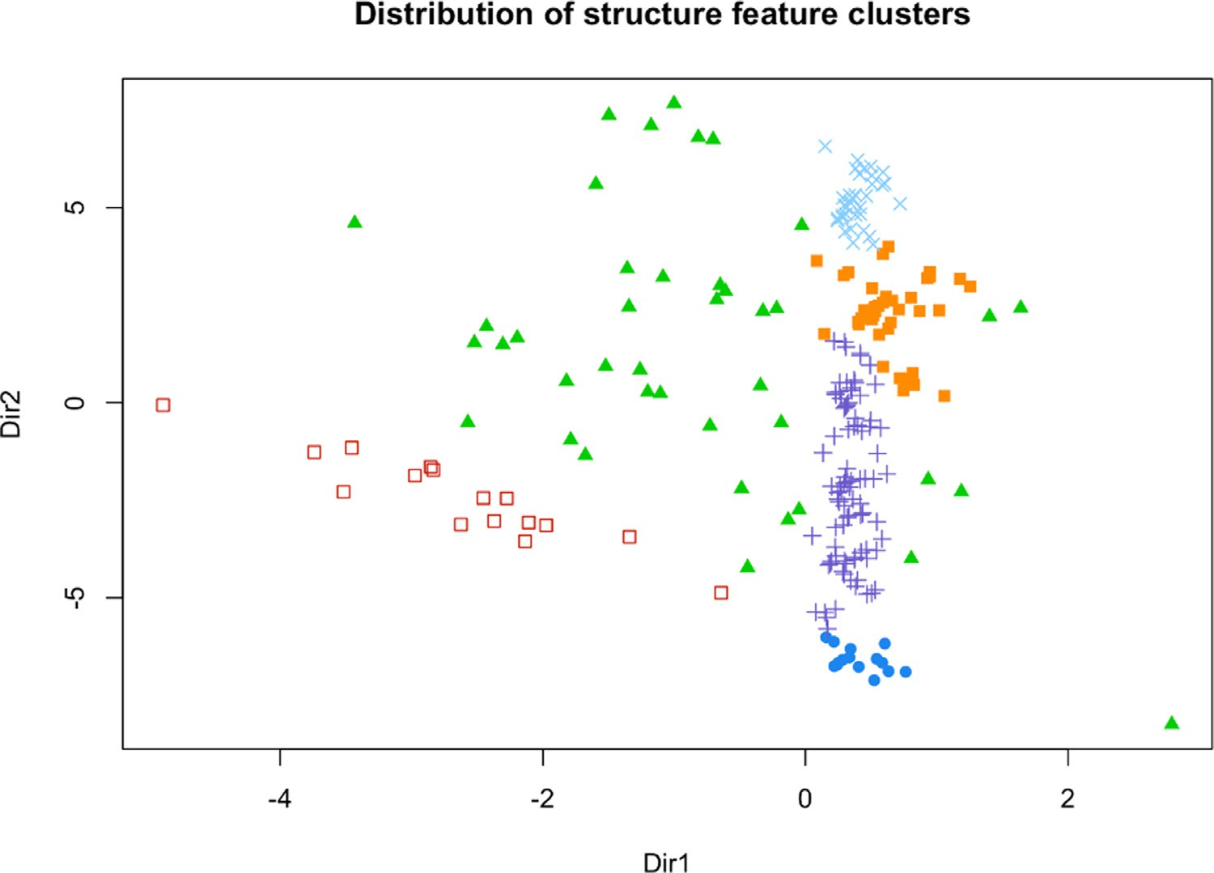**Fig. 10.** Dimension reduction plot for the iden- tified clusters.

* 1. *Advanced analyses*

Advanced analyses provide an opportunity to evaluate Fi-score dis- tributions and take advantage of a streamlined GMM pipeline (Fig. 1). The main impetus for the development of this pipeline was the need for functions and data modelling tools that could be made freely

accessible to non-experts. By contrast, commercial solutions, namely Schrȵdinger chemical simulation software [19], or non-commercial/ semi-commercial solutions, including PSIPRED, AutoDock, MGLtools, and Expasy [16,20–22], lack a simple software platform to summarise and assess protein structural data that can be integrated into machine learning. While the mentioned software suites or online workbenches

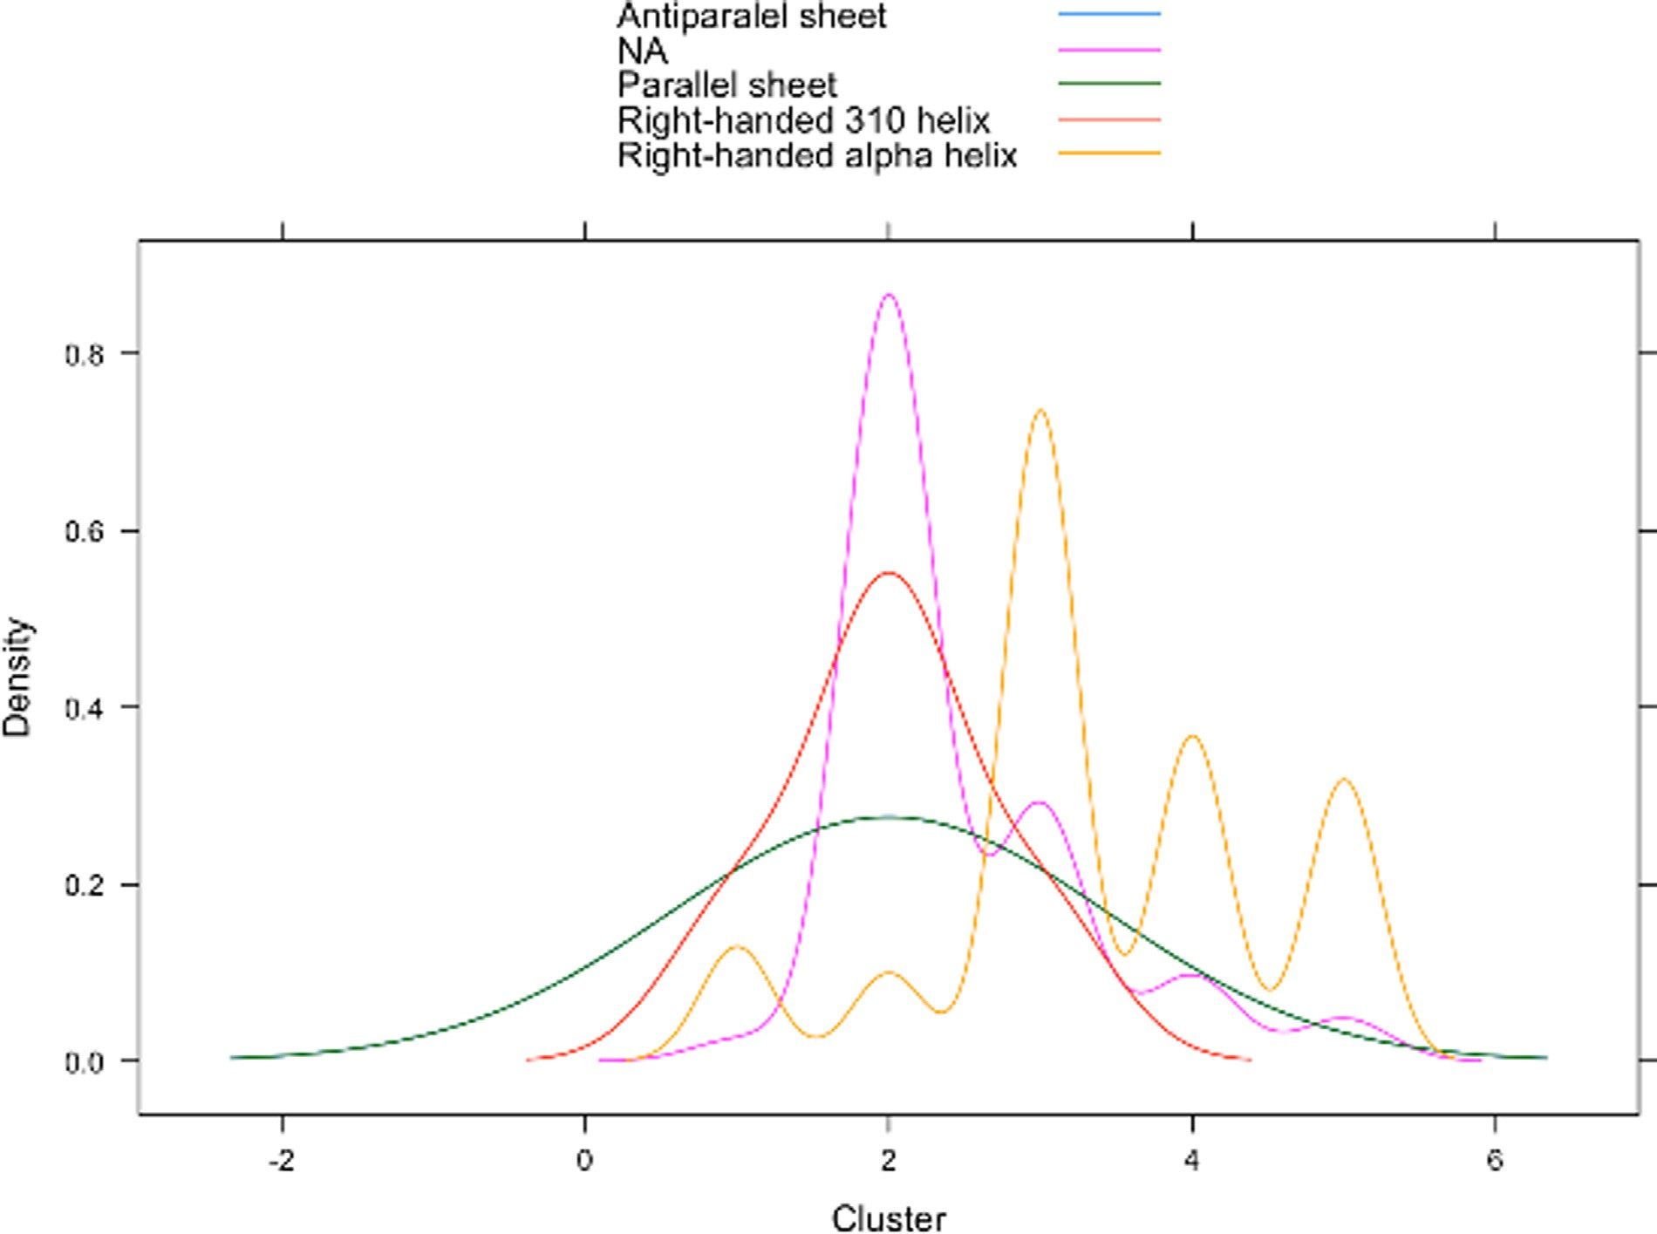

**Fig. 11.** Protein cluster density plots.

provide many useful functionalities, there is no one solution to use ma- chine learning based inferences on the user’s structural data. ‘*Fi_score*’ enables researchers to quickly extract, assess, and summarise key fea- tures of their data and incorporate that information into downstream analyses or custom pipelines. That is, more advanced users are also given opportunity to supply custom parameters for the GMM workflow and extract probabilities from the output to use scores in other analyses or integrate the values in their own discovery pipelines.

#Fi-score distribution plot to explore scores for correspond- ing amino acids

Fi_score_plot(pdb_df)

#Fi-score for a selected region

#this value for multiple sites can be stored in relational databases Fi_score_region(pdb_df,50,70)

#Plot of Fi-score values with superimposed secondary structures Fiscore_secondary(pdb_df)

For example, a Fi-score distribution plot captures several interesting regions in Nur77 around the 50, 130, and 180 amino acids (Fig. 5) that coincide with the Fi-score shifts and mirroring patterns. Some other re- gions are also picked up which should be studied in more detail based on the amino acid composition and 3D conformations. The uncovered char- acteristics can be juxtaposed to other similar sites to better understand

interaction mechanisms. Such approaches are especially useful when comparing known structures with the newly identified or investigating potential structural outliers.

Extracted Fi-score values can be used in machine learning modelling and this is enabled through the function *cluster_ID*. This function groups structural features using the Fi-score and Gaussian mixture modelling where an optimal number of clusters and a model to be fitted during the EM phase of clustering for GMM are automatically selected (Fig. 6). The output of this analytical tool summarises cluster information and also provides plots to visualise the identified clusters based on the cluster number and BIC value (Fig. 7). These outputs can be used to better assess model performance for the select parameters if the users chose to customise their model building.

#User selected parameters

df*<*-cluster_ID(pdb_df,clusters = 5, modelNames = ’’VVI’’)

The users are advised to set seed for more reproducible results when initiating their projects. *cluster_ID* takes a data frame containing a pro- cessed PDB file with Fi-score values as well as a number of clusters to consider during model selection; by default 20 clusters (‘max_range’) are explored. In addition, a ‘secondary_structures’ parameter is needed to define whether the information on secondary structure elements from the PDB file needs to be included when plotting; the default value is TRUE. Researchers also have an option to select a cluster number to test ‘clusters’ together with ‘modelNames’. However, it is important to stress that both optional entries need to be selected and defined, if the

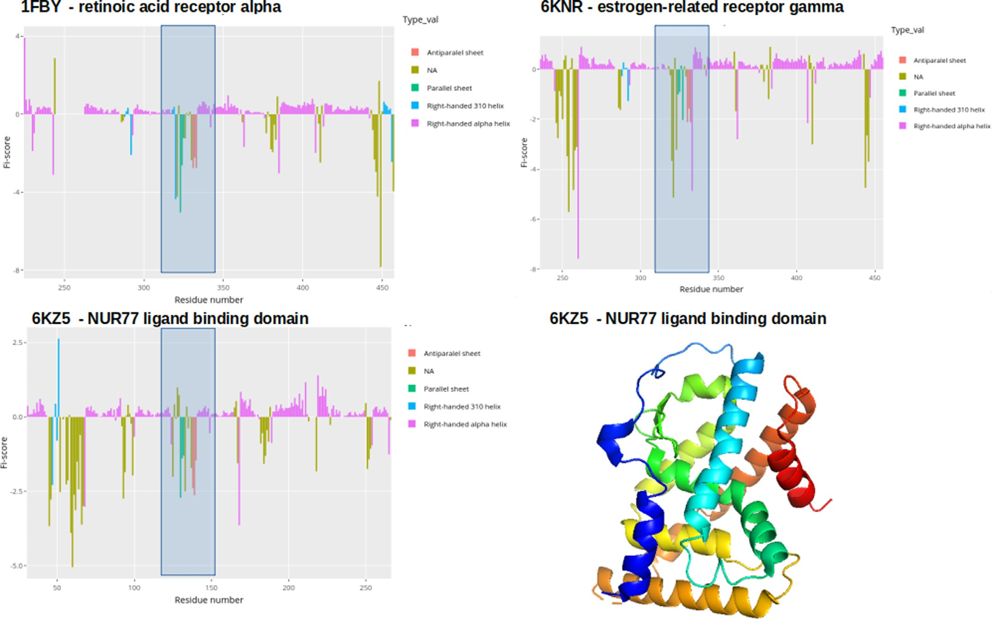

**Fig. 12.** Fi-score distribution plots with the Nur77 ligand binding domain (PDB ID:6KZ5), retinoic acid receptor alpha (PDB ID: 1FBY), and estrogen-related receptor gamma (PDB ID: 6KNR). Rainbow spectrum of the Nur77 structure allows to visualise the sequence from N-terminal (blue) to C-terminal (red). (For interpretation of the references to colour in this figure legend, the reader is referred to the web version of this article.)

user wants to test other clustering options that were not provided by the automated BIC output. This is an advanced option and the user should assess the BIC output to decide which model and what cluster number he or she wants to try out. It is important to note that *cluster_ID* offers a user-friendly implementation of GMM where most technical decisions are already incorporated automatically.

A dimension reduction method for the visualisation of clustering is also automatically provided (Fig. 10). Dimension reduction is a use- ful technique to explore multi-dimensional biological data through key eigenvalues that define the largest information content of the explored features [10]. In other words, one can infer how well the explored char- acteristics define the data and if the classification is suﬃcient for down- stream analyses. For example, in the case of Nur77 Fi-score clustering, this analysis allowed assessing how well the number of clusters separates data points based on their distribution features. Nur77 has six clusters which might indicate functionally and structurally distinct regions in the target protein. It appears that the data points are well separated into groups accounting for the different variability. The dimension reduction approach could also help deciding if a different number of clusters might better classify Fi-scores. One of the goals of building this software pack- age was not only to provide accessible and easy-to-use functions but also to generate additional plots allowing to assess model performance and data point distribution.

In addition, one of the most valuable features of this set of functions is to generate clusters with secondary structure information (Figs. 8 and 9).The produced interactive plots enable researchers to explore struc- tural characteristics of a protein of interest (Figs. 8 and 9). Thus, the subdivision of a protein structure based on the physicochemical features

offers a new way to detect and explore functional sites or structural el- ements. Figs. 9 and 10 clearly indicate that some structural elements in Nur77 are likely similar in their function and physicochemical charac- teristics. For example, different types of helices as well as beta sheets in some cases overlap in their Fi-score characteristics and the assigned clus- ter type. This detailed capture of structural elements can help evaluate conformational outliers or infer similarities for different motifs. More- over, it can be clearly seen that the region around the 50 amino acid is set to be distinct from the other two sites around 130 and 180 amino acids which could suggest overall different motion and interaction pro- files. These findings also correspond with the earlier observations for the hydrophobicity features (Fig. 3). A similar trend can be seen for N and C terminus clusters which form distinct groups and might indicate sites where the receptor mediates specific functions [6]. GMM guided analyses offer a novel way to extract patterns that might not be observ- able using other methods dependent on sequence based analytics, e.g., Expasy [16,17].

vides a density plot set for *𝜙*/*𝜓* angle distributions, Fi-scores, and nor- All previous analyses tie in with the function *density_plots* which pro-

malised B-factors. 3D visualisation of dihedral angle distribution for ev- ery residue is also included. These plots can be used for a quick as- sessment of the overall parameters as well as to summarise the obser- vations. Density plots are very useful when evaluating how well the selected features or scores separate protein structural elements and if a protein structure is of good quality (i.e., dihedral angles, B-factors, or Fi- scores provide reasonable separation between elements). The function also gives another reference point to establish if the selected number of clusters differentiates residues well based on the secondary structure

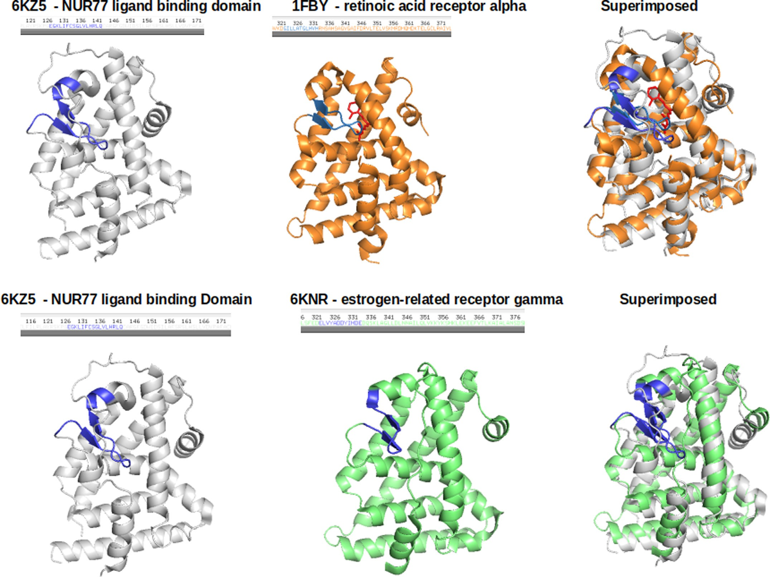

**Fig. 13.** PyMol generated plots to visualise protein structures where blue colors indicate the region identified through Fi-score patterns where cis-9 retinoic acid is highlighted in red. (For interpretation of the references to colour in this figure legend, the reader is referred to the web version of this article.)

elements. In order to get this information, the user is only required to supply the output from the *cluster_ID* function (Fig. 11).

Data summary and evaluation density_plots(pdb_df)

Data summary and evaluation including GMM outputs

cluster_IDs*<*-cluster_ID(pdb_df) density_plots(cluster_IDs)

* 1. *Case study: exploring potential ligands for the Nur77 orphan receptor*

To demonstrate some of the *Fiscore* applications, potential ligands were searched for the Nur77 receptor which can be considered as a complex target since no endogenous ligands are known for this orphan receptor [6]. The first analysis step involved searching for other similar human proteins that did not belong to the Nuclear receptor subfam- ily 4. PSI-BLAST alignment analysis led to several candidate proteins, namely the retinoic acid receptor alpha (PDB ID: 1FBY) and estrogen- related receptor gamma (PDB ID: 6KNR) [15]. These proteins showed a good alignment to the Nur77 ligand binding domain sequence (av- erage percent identity 31.68%; Suppl. Table 1) and were subsequently

used for the structural and functional exploration. Comparing Nur77 Fi- scores with the retinoic acid receptor alpha and estrogen-related recep- tor gamma Fi-score distributions revealed several interesting patterns (Fig. 12). The shaded blue region highlights a matching distribution pattern for all the proteins and the Student’s *t*-test confirmed that none of the distributions differed significantly (Fig. 12; Suppl. Table 2). In- triguingly, this region is involved in mediating interactions with retinoic acid in the retinoic acid receptor alpha (Fig. 13). Similarly, the estrogen- related receptor gamma (PDB ID: 6KNR) has a known inverse agonist binding to the same cavity created by paired alpha-helices, an anti- parallel beta sheet, and disordered stretches [23]. The inverse agonist exhibits several structural features, such as the scaffold size/orientation and key aromatic groups, that are similar to retinoic acid. Moreover, despite the different amino acid composition, the key physicochemical features are preserved in this site across the investigated proteins as can be seen from the superimposition studies (Fig. 13). These observations point to the fact that this region might be essential in accommodating binding events. Importantly, machine learning exploration (Fig. 8& 9) helped to classify Fi-scores around this region which revealed a repeat- ing pattern very different from a surrounding N- and C-terminal regions. This further implies a site of special functional importance where data was grouped based on emerging probabilistic patterns in data point val- ues. This case study suggests an interesting possibility that Nur77 with no known ligands might bind to chemical entities similar to retinoic

acid [6]. This is also supported by the alignment data and hydrophobic- ity plots (Suppl. Figs. 1–3) where Nur77 and the retinoic acid receptor alpha show substantial structural and physicochemical overlaps for this interactor site. Further molecular modelling and docking studies could aid in better understanding binding energetics and emerging interac- tions.

Overall, this example reveals that extracting patterns through scor- ing and machine learning could help identify proteins that have shared and functionally related features. Thus, *Fiscore* allows an easy implemen- tation of protein structural data mining and classification without nec- essarily performing multiple visual inspections of the structures. These analytical principles can also be applied to explore other proteins of interest and their potential ligands.

# Discussion

*Fiscore* package was developed to address the need for a simple-to- use, freely available, and adaptable set of tools for protein physicochem- ical feature exploration via machine learning. By contrast, other com- mercial, semi-commercial, or free software tools lack machine learn- ing pipeline implementation to explore structural features and in most cases users need special knowledge to employ these pieces of software [8,16,19–22].

*Fiscore* package (Fig. 1) allows a user-friendly exploration of PDB structural data and integration with various machine learning methods. The package was benchmarked through several analytical stages that involved a diverse set of proteins (3352) to assess scoring principles

[1] and package functionalities (1337 structures) [11]. With a number of helpful functions, including distribution analyses or hydrophobicity assessment in the context of structural elements, *Fiscore* enables the ex- ploration of new target families and comprehensive data integration since the described fingerprinting captures protein sequence and physic- ochemical properties. Such analyses could be very helpful when explor- ing therapeutically relevant proteins. In addition, provided tutorials and documentation should guide researchers through their analysis and al- low adapting the package based on individual project needs [1]. *Fiscore* could also aid in drug repurposing studies when a chemical compound needs to be juxtaposed to a number of potential targets. This was demon- strated during a native ligand search for Nur77 where a case study of a nuclear receptor revealed the usefulness of the introduced scoring and physicochemical data capturing via GMM. Furthermore, the novel scor- ing system as well as machine learning applications can lead to inter- esting insights about sites of structural and functional importance. The retrieved information could be used in comparative studies to search for other proteins that share similar features. For example, some of the shifts in Fi-score values coincide or precede post-translational modifications in Nur77 (Fig. 5) [24]. This information could be included in the fu- ture studies together with fingerprinting to better understand structural characteristics of this receptor.

Another important aspect of the *Fiscore* package is the simplification

of complex analytical steps so that the researchers without an exten- sive background in structural bioinformatics or machine learning could still use the tools for their analyses, such as protein engineering, pro- tein assessment, and data storage based on specific target sites. Thus, the interactive analytical and visualisation tools could become espe- cially relevant in the pharmaceutical research and drug discovery stud- ies as more complex targets and protein-protein interactions need to be assessed in a streamlined fashion. In other words, ability to trans- late structural data into parameters could accelerate target classifica- tion, target-ligand studies, or machine learning integration. Since target evaluation is paramount for rational therapeutics development, there is an undeniable need for specialised analytical tools and techniques that can be used in R&D or academic research. Implementing these novel approaches could significantly improve our ability to assess new targets and develop better therapeutics. As a result, the *Fiscore* package was de- veloped to aid with therapeutic target assessment and make machine

learning techniques free-to-use and more accessible to a wider scientific audience.

# Funding

The package development was not supported by outside funding.

# Declaration of Competing Interest

The author reports no conflicts of interest.

# Acknowledgments

The author would like to thank the anonymous reviewers and code testers for helping to improve the package with their valuable sugges- tions and advice.

# Supplementary material

Supplementary material associated with this article can be found, in the online version, at [10.1016/j.ailsci.2021.100016.](https://doi.org/10.1016/j.ailsci.2021.100016)

# References

1. Kanapeckaitė A, Beaurivage C, Hancock M, Verschueren E. Fi-score: a novel ap- proach to characterise protein topology and aid in drug discovery studies. J Biomol Struct Dyn 2021. doi:[10.1080/07391102.2020.1854859](https://doi.org/10.1080/07391102.2020.1854859).
2. Du J, Guo J, Kand D, Li Z, Wang G, Wu J, et al. New techniques and strategies in drug discovery. Chin Chem Lett 2020;31. doi:[10.1016/j.cclet.2020.03.028](https://doi.org/10.1016/j.cclet.2020.03.028).
3. Fauman E, Rai B, Huang E. Structure-based druggability assessment–identifying suitable targets for small molecule therapeutics. Curr Opin Chem Biol 2011;15. doi:[10.1016/j.cbpa.2011.05.020](https://doi.org/10.1016/j.cbpa.2011.05.020).
4. Faraggi E, Xue B, Zhou Y. Improving the prediction accuracy of residue solvent accessibility and real-value backbone torsion angles of proteins by guided-learning through a two-layer neural network. Proteins 2009;74. doi:[10.1002/prot.22193](https://doi.org/10.1002/prot.22193).
5. Reynolds D.. Gaussian mixture models2015; 10.1007/978-1-4899-7488-4
6. Wu L, Chen L. Characteristics of nur77 and its ligands as potential anticancer com- pounds. Mol Med Rep 2018. doi:[10.3892/mmr.2018.9515](https://doi.org/10.3892/mmr.2018.9515).
7. Wickham H.. ggplot2: Elegant graphics for data analysis2016; [https://ggplot2.tidyverse.org](https://ggplot2.tidyverse.org/).
8. [Grant BJ, Rodrigues APC, ElSawy KM, McCammon JA, Caves LSD. Bio3d: an R package for the comparative analysis of protein structures. Bioinformatics 2006;22:2695–6.](http://refhub.elsevier.com/S2667-3185(21)00016-7/sbref0008)
9. Sievert C.. Interactive web-based data visualization with R, Plotly, and Shiny2020; [https://plotly-r.com](https://plotly-r.com/).
10. Scrucca L, Fop M, Murphy TB, Raftery AE. Mclust 5: clustering, classification and density estimation using gaussian finite mixture models. R J 2016;8(1):289–317. doi:[10.32614/RJ-2016-021](https://doi.org/10.32614/RJ-2016-021).
11. Kanapeckaite A.. Fiscore: effective protein structural data visualisation and explo- ration2021;R package version 0.1.3; <https://github.com/AusteKan/Fiscore>.
12. Chambers J. Object-oriented programming, functional programming and R. Stat Sci 2014;29. doi:[10.1214/13-STS452](https://doi.org/10.1214/13-STS452).
13. DeLano W.. The PyMOL molecular graphics system, version 2.3.02021;.
14. Berman H, Westbrook J, Feng Z, Gilliland G, Bhat T, Weissig H, et al. The protein data bank. Nucleic Acids Res 2000. doi:[10.1093/nar/28.1.235](https://doi.org/10.1093/nar/28.1.235).
15. Altschul S, Madden T, Schäffer A, Zhang J, Zhang Z, Miller W, et al. Gapped blast and psi-blast: a new generation of protein database search programs. Nucleic Acids Res 1997. doi:[10.1093/nar/25.17.3389](https://doi.org/10.1093/nar/25.17.3389).
16. Gasteiger E., Hoogland C., Gattiker A., vaud S.D., ans Ron D. Appel M.R.W., Bairoch A.. Protscale2021;.
17. Gasteiger E., Hoogland C., ans S’everine Du vaud A.G., ans Ron D. Appel M.R.W., Bairoch A.. Protein identification and analysis tools on the expasy server2005; 10.1385/1592598900
18. Kyte J, Doolittle RF. A simple method for displaying the hydropathic character of a protein. J Mol Biol 1982;157(1):105–32. doi:[10.1016/0022-2836(82)90515-0](https://doi.org/10.1016/0022-2836(82)90515-0).
19. Schrödinger. Schrödinger platform2021; <https://www.schrodinger.com/platform>.

<http://bioinf.cs.ucl.ac.uk/index.php?id=779>. [20] UCL. Predict secondary structure (psipred)2021;

1. Institute T.S.R.. Autodock suite2021; <https://autodock.scripps.edu/>.
2. the Sanner lab at the Center for Computational Structural Biology (CCRB). Mgltools software suite2021; <https://ccsb.scripps.edu/mgltools/>.
3. Kimag J, Hwanga H, HeeseokYoona, Jae-EonLeed, Oh JM, An H, et al. An orally available inverse agonist of estrogen-related receptor gamma showed expanded ef- ficacy for the radioiodine therapy of poorly differentiated thyroid cancer. Eur J Med Chem 2020. doi:[10.1016/j.ejmech.2020.112501](https://doi.org/10.1016/j.ejmech.2020.112501).
4. Hornbeck P, Zhang B, Murray B, Kornhauser J, Latham V, Skrzypek E. Phos- phositeplus, 2014: mutations, PTMs and recalibrations. Nucleic Acids Res 2015. doi:[10.1093/nar/gku1267](https://doi.org/10.1093/nar/gku1267).