Available online at [www.sciencedirect.com](http://www.sciencedirect.com/)

**ScienceDirect**

AASRI Procedia 4 (2013) 190 – 195

2013 AASRI Conference on Intelligent Systems and Control

Formulation Process of Knowledge for an Expert Healthcare System Unit

Kenedy Greysona*, Mathew Mburumaa, Nsatusile Nzowaa, Frank Mbanoa, Georgia Rugumiraa, Jumanne Allya, Athman Mfinangaa, Promota Haulea, Romwald Lihakangaa, Eunice Abayoa

*aIntelligent Systems Research Unit, Department of Electronics and Telecommunications Engineering, Dar es Salaam Institute of Technology, P. O. Box 2958, Dar es Salaam, Tanzania*

**Abstract**

The successful adaptation of a technology in health system will enhance in achievement of better standard of living. In order to improve health care and support services in developing countries, expertise in health sector is required in all levels of health system starting from low level of village health centres up to the top level of referral hospitals. Due to shortage of human resources such as medical doctors this applied research intends to implement an expert healthcare unit to support in health services in low level of health systems. Equipped with knowledge, the system concludes and acts according to the condition of a patient. As for any other expert system, learning process distinguish one system from another. Better performance is based on knowledge acquainted within the system. This research express the method used to formulate knowledge in an expert healthcare system unit.

© 2013 The Authors. Published by Elsevier B.V. Open access under [CC BY-NC-ND license.](http://creativecommons.org/licenses/by-nc-nd/3.0/)

© 2013. Published by Elsevier B.V.

Selection and/or peer review under responsibility of American Applied Science Research Institute

Selection and/or peer review under responsibility of American Applied Science Research Institute

*Keywords*: expert systems, formulation, health, knowledge.

* Corresponding author. Tel.: +255 686-222-123; fax: +255-222-152-504.

*E-mail address:* [kenedyaliila@yahoo.com.](mailto:kenedyaliila@yahoo.com)

2212-6716 © 2013 The Authors. Published by Elsevier B.V. Open access under [CC BY-NC-ND license.](http://creativecommons.org/licenses/by-nc-nd/3.0/) Selection and/or peer review under responsibility of American Applied Science Research Institute doi:10.1016/j.aasri.2013.10.029

# Introduction

It should be noted that the definition of a ‘system’ in engineering perceptive might differ from health policy makers or any other field. In a policy makers and possibly economic perceptive, for example, heath system is defined as a set of relationships in which the structural components and their interactions are associated and connected to the goals the system desires to achieve (Hsiao and Li, 2003). In Collins English Dictionary, a system itself is defined as an ordered and comprehensive assemblage of facts, principles, doctrines, or the like in a particular field of knowledge or thought. Engineers define a system as an assemblage or combination of things or parts forming a complex or unitary whole (Collins English Dictionary). This report defines system in engineering perceptive. Immerging computer technologies is among the key-drives for this project motivation.

In this research, we intend to design a system that gives support to the health services in the rural areas of developing countries (remote centers), Tanzania as a case study. The goal is to improve and address challenges of health services provision in communities as stipulated in national health policy (NHP, URT, 2003). By using physiological sensors, patients’ records are collected, and if the need be, are analyzed or forwarded to the higher level Health centre as shown in national structure of health services: referral hospitals (the highest level) – regional hospitals – district hospitals – health centre services (approximately fifty thousand people) – dispensaries (approximately six to ten thousand people) – village health centre (the lowest level) as shown in Figure 1.

# Statement of the problem

In expert system, inference engine uses the knowledge (rules and facts) to learn the environment and act accordingly. The knowledge equipped in a system defines its ability to act properly. If the knowledge is not adequate, the wrong reaction to the environment might happen. The process of developing knowledge tank in an expert system is challenging. This research elucidates the technique used in knowledge formulation.

# Expert healthcare system unit

It is very common to find in various literatures that, the term expert- and intelligent systems are used interchangeably. Negnevitsky is making a line between the two be defining an expert system as a computer program that performs at a human expert level (Negnevitsky, 2005). The engine or brain of the expert systems depends on the rules extracted from the set of rules as shown in Figure 2.

* 1. *System development setup*

As for many expert systems, expert healthcare system unit is composed of inference engine, knowledge and logic tank (rules and facts), database, and the communication network as shown in Figure 2. Generally, components can be grouped in their categories as input unit (s), control unit and output unit as shown in Figure 3. The principle framework of experts systems remain the same although they may differ in design strategies.

The input unit informs the main unit about the domain, in this case human body and environmental situation. These are basically physiological sensors which are linked with the main unit. There are various physiological sensors. For instance, the goal of electrodiagnostic studies is to determine whether there is a problem along the peripheral nervous system pathway and if so, where the problem is (Weiss, *et al*., 2004, Khandpur, 2005).



Remote centres

Health centre services

Village Health centre

Dispensary

Regional hospital

District hospital

Referral hospital

Fig. 1. Structure of national health services

Communication network



Remote Centres

Database

Rules and facts

Inference Engine

District hospitals

Regional hospitals

Referral hospitals

Fig. 2. Arrangement of parts of an expert healthcare system unit

Electrocardiogram (ECG or EKG) sensors are cardiologic used to check the electrical waves of the activities of the contractions of heart which is translated in line tracing papers (Khan, 2008). The blood volume pulse (BVP) sensor also called photoplethysmography. In principle, the BVP sensor shines infrared light through the finger and measures the amount of light reflected by the skin which varies during each heartbeat. The sensor converts the reflected light into electrical signal which is then sent processed accordingly (Combatalade, 2010). Other sensor include: respiration sensor used to monitor abdominal or thoraxial breathing. Actually, BVP and respiration sensor are used in heart rate variability monitoring. Another class of sensors mentioned earlier is a *central nervous system* sensors which include: electroencephalogram (EEG), used to measure and record the electrical activity of the brain. This will help to analyse abnormalities in brain electrical waves based on wave frequency count. It can show a brain dead or deep coma status of a human. Electroocculogram (EOG) on the other hand is used to measure the resting potential of the eye (retina in particular) for diagnosis of physiology and diseases of the eye. All these are coupled with the main unit, using communication network or direct link, which process the information and provide the response.

The main unit is comprised of system database, knowledge tank, system engine, and communication network for external data transportation. System database is integrated in the system so as to manage data collected by the input sensors discussed earlier. The EEG table, EMG table, ECG table, BVP table, and other table according to the input data are to be constructed. The Memo data type to store lengthy data is also included for comments from the person in charge. Likewise, a comment from a doctor or medical officer in charge must have a room to be stored in the system database.

Audio, Visual, or



1

2

*k*

Database, inference engine, and knowledge tank

Combination of audio and visual Actuators

Others

Input unit (e.g. Sensors)

Main unit (processing unit)

Output unit (e.g. screen, speakers, actuators, etc)

Fig. 3. The main components of an expert health system

# Knowledge tank: condition-action rule

Inference engine learn the domain environment so as to act according to the rules and facts. The database and knowledge tank containing rules and fact provide information to the inference engine for analysis and decision making. In order to conclude and perform action, inference engine must be acquainted with a specific intended task or goal which is the goal of the system. To attain the intended goal is the main function of the expert system. Expert healthcare system unit home health system description can be broadly stated as to support in provision of health services: monitor the patient’ physiological changes and report to the health person in charge. The goals can be extracted from this description as; to check physiological changes against normal situation, and to communicate the patients’ status to the health person in charge.

These two goals then are refined to a one or more *specific* goals or sub-goals based on the simple technique of asking ‘how this goal can be achieved’ as proposed by (Padgham and Winikoff, 2004). To check physiological changes can be achieved by having biomedical instrumentations to perceive the domain status, to know the expected physiological conditions of the normal situation, and to compare the recorded measurements and that of the normal condition. The development of goal-based process of the expert healthcare unit system is shown in Figure 4. The two main entities are broken into simple to the specific goals. In case of system modification or addition of another objective, the new entity is added together with its specific objectives without affecting the previous entities’ performance.

* 1. *Entity functionalities*

The entity goal(s) stated earlier as specific goals are closely related to the entity functionalities. The functionality is a mechanism used by the entity to achieve its goal or responsibility. The identification of entities, the domain, and processes define the system functionality. This main function which basically perceives the domain status and identifies the action is a combination of entity functions. Each entity function achieves its goal as depicted in Figure 4. In adapting the presentation method in (Padgham and Winikoff, 2004), rectangles represent functionalities, ovals represent goals, and a rectangles extended with triangles pointing to the right present actions as shown in Figure 5. The entity functionalities of the smart home health system are generalized as follows:

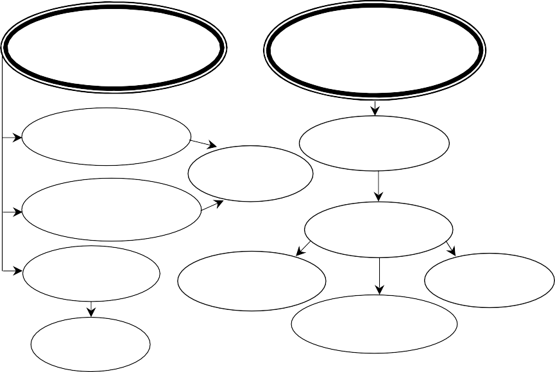Check physiological changes against normal situation

Communicate the patients’ status to the health person in charge

Select biomedical instrumentation

Knowledge tank (normal conditions)

Information Processing

Activate an action

Database system

End the communication

Construct comm. network

Initiate the communication

Manage machine language

Authenticate users

Fig. 4. Goals for the expert health system

 Data collection (*Functionality*): get patients’ physiological status (*goal*), collect and store data in database (*action*).

 Communicate the information (*Functionality*): consulting doctor (*goal*), relay patients’ status to the doctor (*goal*), provide request response to and from the doctor (*goal*), send and receive physiological data, requests and responses (*action*)

* 1. *Knowledge planning*

Knowledge representation for the smart home health system, our scenario, can be formulated in the form *if*

*<antecedent>…then <consequent>*. Because of the fact that the system has a number of inputs representing various symptoms, some of these rules will tend to have more than one antecedent depending on the knowledge to be conveyed. These will be in the form: *if <antecedent 1> and <antecedent 2> …, and*

*<antecedent n>then <consequent>.* Also the combination can take the form *if <antecedent 1> or*

*<antecedent 2> …, or <antecedent n> then <consequent>.* The condition-conclusion-action is represented as: *if (condition) then (conclusion) if (conclusion) then (action)*.

# Conclusion

The method used in this research is for a basic expert healthcare system unit. The new function, such as adding treatment or control of another disease, can be easily added in the expert system simply by defining the new function entity and its goal(s). Thereafter set of rules and facts are incorporated accordingly without affecting other goals or functions.



Consulting doctor

Send and receive physiological data

Collect/store data in database

Relay patients’ status to the doctor

Communicate the information

Fig. 5. Functionalities for the basic expert health system



Data collection

Get patients’ physiological status

# References

1. MNH. Muhimbili National Hospital. [http://mnh.co.tz.](http://mnh.co.tz/) Accessed: October 12, 2012.
2. Negnevitsky M. Artificial Intelligence: A Guide to Intelligent Systems. Second Edition, Addison Wesley; 2005.
3. Hsiao WC, Li KT. What is a Health System? Why Should We Care? Harvard School of Public Health; 2003.
4. System. Dictionary.com. Collins English Dictionary - Complete and Unabridged. 10th Edition. Harper Collins Publishers. [http://dictionary.reference.com/browse/system.](http://dictionary.reference.com/browse/system) Accessed: January 30, 2013.
5. NHP, URT. National Health Policy. United Republic of Tanzania. Ministry of Health; 2003.
6. Weiss L, Silver JK, Weiss J. Easy EMG. Butterworth-Heinemann; 2004.
7. Khan MG. Rapid ECG Interpretation. Third Edition, Humana Press; 2008.
8. Combatalade DC. Basics of Heart Rate Variability Applied to Psychophysiology, Thought Technology Ltd. [http://www.emfandhealth.com/HRVThoughtTechnology.pdf.](http://www.emfandhealth.com/HRVThoughtTechnology.pdf) Accessed: January 31, 2013.
9. Khandpur RS. Biomedical Instrumentation Technology and Applications, McGraw-Hill; 2005.
10. Nikos Vlassis (2007). A Concise Introduction to Multiagent Systems and Distributed Artificial Intelligence. Morgan & Claypool Publishers series; 2007.
11. Padgham L, Winikoff M. Developing Intelligent Agent Systems: A practical guide, John Wiley & Sons Ltd; 2004.
12. Bellifemine F, Caire G, Greenwood D. Developing Multi-Agent Systems with JADE. John Wiley & Sons Ltd.; 2007.
13. JADE. JADE Agent Development Framework. [http://jade.tilab.com.](http://jade.tilab.com/) Accessed: December 21, 2012.
14. Hindriks KV. Programming Rational Agents in GOAL. EEMCS, Delft University of Technology, Mekelweg 4, Delft; 2011.
15. 2APL(a). 2APL A Practical Agent Programming Language: User Guide. [http://tenet.dl.sourceforge.net/project/apapl/UserGuide/manual.pdf.](http://tenet.dl.sourceforge.net/project/apapl/UserGuide/manual.pdf) Accessed: May 11, 2011.
16. 2APL(b). Download Latest 2apl (Beta). [http://apapl.sourceforge.net/*.*](http://apapl.sourceforge.net/)Accessed: February 13, 2012.
17. Negnevitsky M. Artificial Intelligence: A Guide to Intelligent Systems. Second Edition, Pearson Education Limited; 2005.