Available online at [www.sciencedirect.com](http://www.sciencedirect.com/)

**ScienceDirect**

AASRI Procedia 4 (2013) 297 – 305

# 2013 AASRI Conference on Intelligent Systems and Control

Identification Accuracy of Nonlinear System Based on Volterra Model in Frequency Domain

Pavlenko Vitaliya, Fomin Aleksandrb, Pavlenko Sergeyc, Grigorenko Yuriyd *

*abcdICS, Odessa National Polytechnic University, Odessa, Ukraine*

**Abstract**

The accuracy of the interpolation method for identification of nonlinear dynamical systems based on the Volterra model in the frequency domain is studied. To highlight the *n*-th partial component in the response of the system to the test signal the *n*-th partial derivative of the response using the test signal amplitude is found and its value is taken at zero. The polyharmonic signals are used as test ones. The algorithmic and software toolkit is developed for identification processes. This toolkit is used to construct the informational model of test system. The model is built as a first, second and third order amplitude–frequency characteristics and phase–frequency characteristics. The comparison of obtained characteristics with standard is given.

© 2013 The Authors. Published by Elsevier B.V. Open access under [CC BY-NC-ND license.](http://creativecommons.org/licenses/by-nc-nd/3.0/)

© 2013 Pavlenko Vitaliy, Fomin Aleksandr, Pavlenko Sergey, [Grigorenko Yu](http://creativecommons.org/licenses/by-nc-nd/3.0/)riy. Published by Elsevier B.V. Selection and/or peer review under responsibility of American Applied Science Research Institute

Selection and/or peer review under responsibility of American Applied Science Research Institute

*Keywords:* Identification; Nonlinear Dynamic Systems; Volterra Models; Multifrequency Characteristics; Polyharmonic Signals; Communication Channels

### Introduction

It is necessary to consider technical conditions of the communication channels (CC) operation for effective data transfer. Changes in environmental conditions cause reducing the transmission data rate: in the digital CC- up to a full stop of the transmission, in analog CC - to the noise and distortion of the transmitted signals.

* Corresponding author. Tel.: +38-067-481-22-90.

*E-mail address:* [aleksandr.fomin@gmail.com.](mailto:aleksandr.fomin@gmail.com)

2212-6716 © 2013 The Authors. Published by Elsevier B.V. Open access under [CC BY-NC-ND license.](http://creativecommons.org/licenses/by-nc-nd/3.0/) Selection and/or peer review under responsibility of American Applied Science Research Institute doi:10.1016/j.aasri.2013.10.044

The new methods and supporting toolkit are developing to automate the measurement of parameters and taking into account the characteristics of the CC. This toolkit allows obtaining the informational and mathematical model of such nonlinear dynamic object, as the CC [1], i.e. to solve the identification problem. Modern continuous CCs are nonlinear stochastic inertial systems. The model in the form of integro-power Volterra series used to identify them [2–5].

The nonlinear and dynamic properties of such system are completely characterized by a sequence of multidimensional weighting functions – Volterra kernels).

Building a model of nonlinear dynamic system in the form of a Volterra series lies in the choice of the test actions form. Also it uses the developed algorithm that allows determining the Volterra kernels and their Fourier-images for the measured responses (multidimensional amplitude–frequency characteristics (AFC) and phase-frequency characteristics (PFC)) to simulate the CC in the time or frequency domain, respectively [6].

The additional research of new method of nonlinear dynamical systems identification, based on the Volterra model in the frequency domain is proposed. This method lies in *n*-fold differentiation of responses of the identifiable system by the amplitude of the test polyharmonic signals. The developed identification toolkit is used to build information model of the test nonlinear dynamic object in the form of the first, second and third order model [8].

### Interpolation Method of Volterra Kernels Computation

An interpolation method of identification of the nonlinear dynamical system based on Volterra series is used [7–8]. It is used *n*-fold differentiation of a target signal on parameter–amplitude *a* of test actions to separate the responses of the nonlinear dynamical system on partial components *y*ˆ*n* (*t*) [9].

*ax*(*t*) type test signal is sent to input of the system, where *x*(*t*) – any function; |*a*|1 – scale factor for *n*-th order

partial component allocation *y*ˆ*n* (*t*) from the measured response of nonlinear dynamical system such case it is necessary to find *n-*th private derivative of the response on amplitude *a* at *a*=0

*y ax t*

. In

*y*ˆ*n* (*t*)

*t*

...

*n*

0 *times*

*t*

*wn* ( 1,...,

0

*n*

*n* ) *x*(*t*

*l *1

*l* )*d*

*l* .

1 *n y a x*(*t*)

*n*!

*an*

*a * 0

*(1)*

where *x*(*t*) and *y*(*t*) are input and output signals of system respectively; *wn* (1,  2 ,  ,  *n* ) – weight function

or *n-*order Volterra kernel; *yn x t* – *n–*th partial component of object response [4].

Partial components of responses

*y*ˆ*n* (*t*)

can be calculated by using the test actions and procedure (1).

Diagonal and subdiagonal sections of Volterra kernel are defined on basis of calculated responses.

Formulas for numerical differentiation using central differences for equidistant knots

*yr * *y*[*ar x*(*t*)]

*y*[*rhx*(*t*)], *r*

*r*1 ,

*r*1 1,..., *r*2 with step of computational mesh on amplitude *h=a* [8] are

received. Volterra kernel of the first order is defined as the first derivative at accordingly.

*r*1  *r*2

1 or

*r*1  *r*2  2

*y* 1 (

0 2*h*

*y* 1  *y*1), *y*0

1 ( *y*

12*h* 2

 8*y* 1

 8*y*1

 *y*2 ).

*(2)*

Volterra kernel of the second order is defined as the second derivative at accordingly.

*r*1  *r*2

1 or

*r*1  *r*2  2 ,

*y* 1 ( *y*

0 *h*2

1  *y*1 ), *y*0

1 (

12*h*2

*y* 2  16 *y*

1 16 *y*1

 *y*2 ).

*(3)*

Volterra kernel of the third order is defined as the third derivative at *r*1  *r*2

 2 or *r*1  *r*2

 3 , accordingly.

*y* 1 (

# 0 2*h*3

*y* 2  2 *y* 1

 2 *y*1 

*y*2 ), *y*0

1. ( *y*

8*h*3 3

 8 *y* 2

 13 *y* 1

13 *y*1

 8 *y*2

*y*3 )

*(4)*

The amplitudes of the test signals

(*k*) and the corresponding coefficients *c* (*k*) for responses are shown in fig. 1,

*i i*

where *k* – order of the estimated Volterra kernel; *i –* number of the experiment (*i=*1, 2, …, *N*); *N -* quantity of

*i*

interpolation knots, i.e. quantity of identification experiments. The amplitudes coefficients *c* (*k*) determined by (2), (3) [8].

*i*

(*k*) and the corresponding

The component with summary frequency 1*+…+n* is selected from the response to test signal (2):



*An W* ( *j* ,

*n*

1

, *jn*

) cos (1

*n* )*t*

 arg*Wn* ( *j*1,

, *jn* ).

In [10] it is defined that during determination of multidimensional transfer functions of nonlinear systems it is necessary to consider the imposed constraints on choice of the test polyharmonic signal frequencies. It provides an inequality of combination frequencies in output signal harmonics: 10, 20 and 12 for the

second order identification procedure, and 10, 20, 30, 1 2, 1 3, 23, 212+3, 221+3,



1. 31+2, 212–3, 221–3, 231–2, 21–2+ 3, 2 2 – 1+ 3  23–1+2 for the third order

identification procedure.

Given method was fully tested on a nonlinear test object described by Riccati equation:

*dy* (*t*)



*dt*

*y*(*t*)

*y* 2 (*t*)

 *u*(*t*), 

 2.64,

 1.45.

*(5)*

Analytical expressions of AFC and PFC for the first, second and third order model were received:



1

2 2

| *W*1( *j*

) |



, arg*W*1( *j*) arctg;

(2 2



)( )

|*W*2 ( *j*

1, *j*

2) |

, arg*W*2 ( *j* 1, *j* 2 )

arctg

( 2

1 2

1 2 )

1 2 ;

( 1 2 )



2 2

3

1

[ 2

(

1

2 3

)2]( 2

1

2 )( 2

2

2 )( 2

3

2 )

2

*W*3( *j*

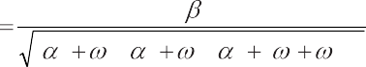

( 2

1

2 )( 2

2

2 )[ 2

(

1 2

)2]

1, *j*

2, *j*3)

arg*W*3( *j*

1, *j*

2, *j*3 )

arctg *DA*

## *AB*

,

*CB* ,



[3 2 (

1

3 1

)(

2

[ 2

) (

1

2 2

)](

3

) (

1

3 2

)(

3

)]2 16 2(

1 2 3

)2

(

1 2

)2][ 2 (

1 3

)2][ 2 (

2 3

)2]

## *CD*

where *A * 32

2

 3 1 2

 32 3

 3 1 3 2

2 2 ; *C*

 4(1 2

3) ; *B*

*uw * *vz* ; *D*

*vwuz* ;

*u * 1 3

3

1

2

3

2

(

2

23 (1  2

3 ); *v * (1  2

3 )(2 1 3

23 );

2

*w * (

1 2

2

23 )(  1 2

1 3 )  1  2

)2 ;

*z *(1  2



3

3 )(2

 2 1 2 1 3

23 ).

### The techniques of test object identification

The main purpose was to identify the multifrequency performances characterizing nonlinear and dynamical properties of nonlinear test object. Volterra model in the form of the second order polynomial is used. Thus, test object properties are characterized by transfer functions of *W*1(*j*), *W*2(*j*1,*j*2), *W*3(*j*1,*j*2,*j*3)  by Fourier-images of weight functions *w*1(*t*), *w*2(*t*1, *t*2) and *w*3(*t*1, *t*2, *t*3).

Structure charts of identification procedure – determinations of the first, second and third order AFC of CC are presented accordingly on fig. 1.

The weighted sum is formed from received signals – responses of each group (fig. 1). As a result the partial components of CC responses *y*1(*t*), *y*2(*t*) and *y*3(*t*) are got. For each partial component of response the Fourier transform (the FFT is used) is calculated, and from received spectrum only an informative harmonics (which amplitudes represent values of required characteristics of the first, second and third orders AFC) are taken.

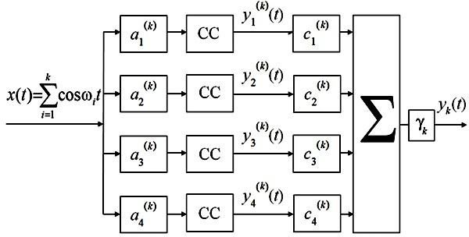

Fig. 1. The structure chart of identification procedure using the third order Volterra model in frequency domain, number of experiments

*N*=4, 1=1/*h*, 2=1/2*h*2, 3=1/2*h*3.

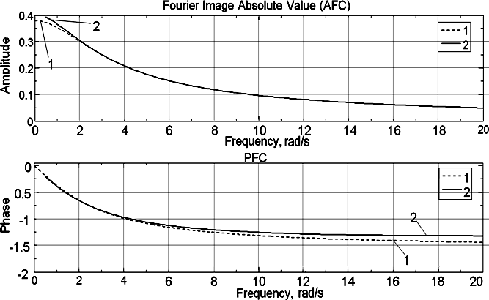

Fig. 2. First order AFC and PFC of the test object: analytically calculated values (1), section estimation values with number of experiments for the model *N*=4 (2)

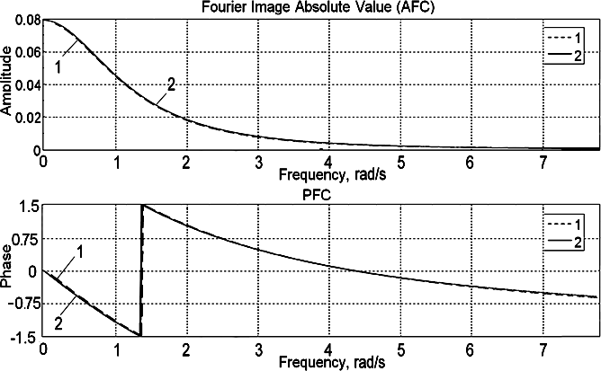

Fig. 3. Second order AFC and PFC of the test object: analytically calculated values (1), subdiagonal cross-section values with number of experiments for the model *N*=4 (2), 1 =0,01 rad/s

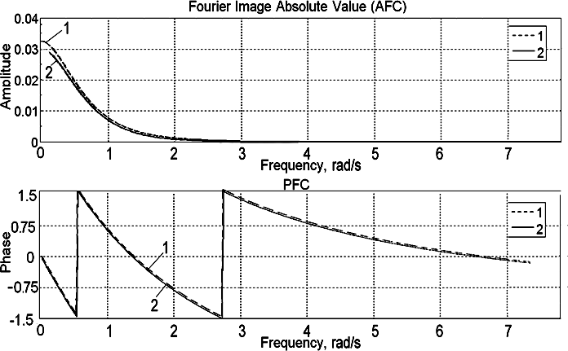

Fig. 4. Third order AFC and PFC of the test object: analytically calculated values (1), subdiagonal cross-section values with number of experiments for the model *N*=6 (2), 1 =0,01 rad/s, 2 =0,1 rad/s

The first order AFC |*W*1(*j*)| and PFC arg*W*1(*j*) is received by extracting the harmonics with frequency *f*

from the spectrum of the CC partial response *y*1(*t*) to the test signal *x*(*t*)=*A*/2(cos*t*).

The second order AFC |*W2*(*j*,*j(+*1))| and PFC arg*W2*(*j*,*j(+*1)), where *1*=  *2*=+1, was received by extracting the harmonics with summary frequency 1+2 from the spectrum of the CC partial response *y*2(*t*) to the test signal *x*(*t*)=(*A*/2)(cos1*t*+cos2*t*).

The third order AFC |*W3*(*j*,*j(+*1)),*j(+*2))| and PFC arg*W3*(*j*,*j(+*1)),*j(+*2)), where *1*=*,*

*2*=+1 and *3*=+2, was received by extracting the harmonics with summary frequency 1+2+3

from the spectrum of the CC partial response *y*2(*t*) to the test signal *x*(*t*)=(*A*/2)(cos1*t*+cos2*t*+cos3*t*).

The results (first, second and third order AFC and PFC) which had been received after procedure of identification are represented in fig. 2–4 (number of experiments for the model *N*=4).

The surfaces shown on fig. 5–8 are built from subdiagonal cross-sections which were received separately. 1 was used as growing parameter of identification with different value for each cross–section in second order characteristics*.* Fixed value of 2 and growing value of 1 were used as parameters of identification to obtain different value for each cross-section in third order characteristics*.*

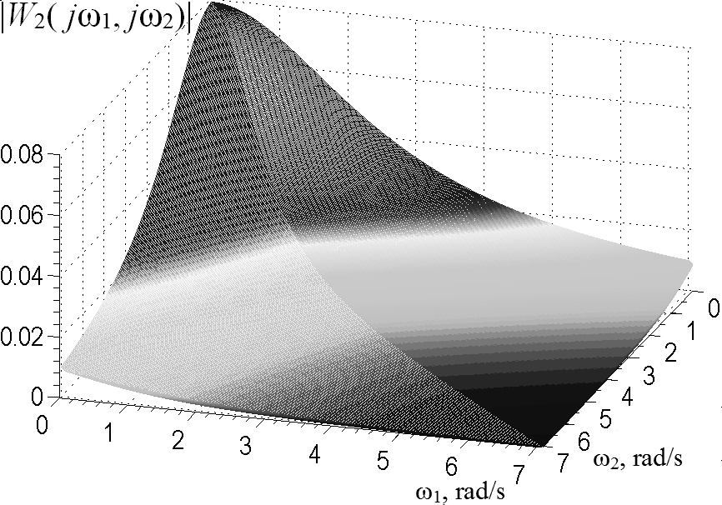

Fig. 5. Surface of the test object AFC built of the second order subdiagonal cross–sections received for *N*=4, 1=0,01 rad/s

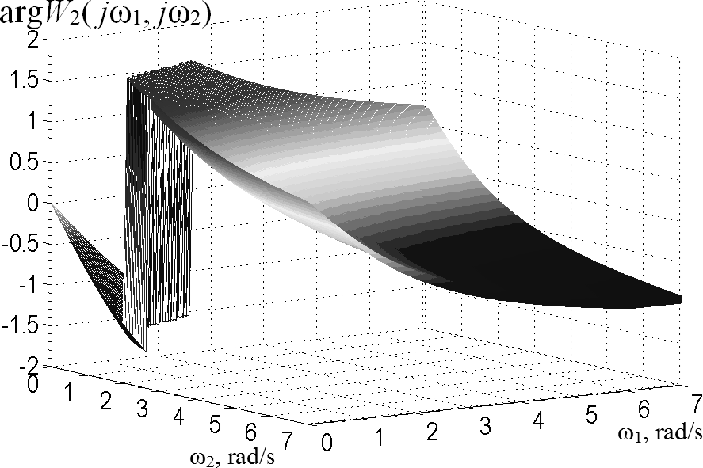

Fig. 6. Surface of the test object PFC built of the second order subdiagonal cross–sections received for *N*=4, 1=0,01 rad/s

The second order surfaces for AFC and PFC which had been received after procedure of the test object identification are shown in fig. 5–6 (number of experiments for the model *N*=4).

The third order surfaces for AFC and PFC had been received after procedure of the test object identification are shown in fig. 7–8 (number of experiments for the model *N*=6).

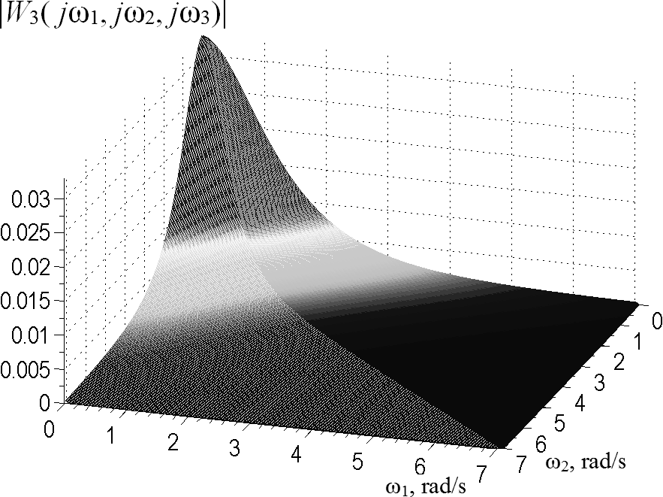

Fig. 7. Surface of the test object AFC built of the third order subdiagonal cross–sections received for *N*=6, 1=0,01 rad/s, 2=0,1 rad/s

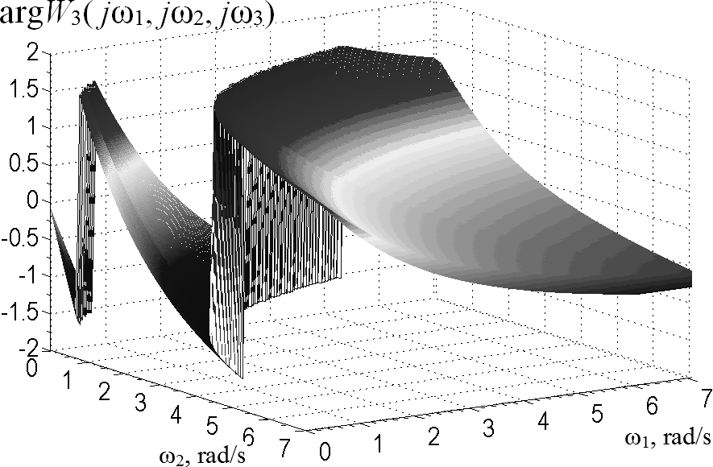

Fig. 8. Surface of the test object PFC built of the third order subdiagonal cross-sections received for *N*=6, 1=0,01 rad/s, 2=0,1 rad/s

Numerical values of identification accuracy using interpolation method for the test object are represented in table 1.

Table 1. Numerical values of identification accuracy using interpolation method.

|  |  |  |  |
| --- | --- | --- | --- |
| Kernel order, *k* | Experiments  order, *N* | quantity / approximation  AFC relative error, % | PFC relative error, % |
|  | 2 | 2.1359 | 2.5420 |
| 1 | 4 | 0.3468 | 2.0618 |
|  | 6 | 0.2957 | 1.9311 |
|  | 2 | 30.2842 | 76.8221 |
| 2 | 4 | 2.0452 | 3.7603 |
|  | 6 | 89.2099 | 5.9438 |

3 4 10.981 1.628

6 10.7642 1.5522

### Conclusions

The method based on Volterra model using polyharmonic test signals for identification nonlinear dynamical systems is analyzed. To differentiate the responses of object for partial components we use the method based on composition of linear responses combination on test signals with different amplitudes.

New values of test signals amplitudes were defined and model were validated using the test object. Excellent accuracy level for received model is achieved as in liner model so in nonlinear ones. Given values are greatly raising the accuracy of identification compared to amplitudes and coefficients written in [12]. The accuracy of identification of nonlinear part of the test object growth almost 10 times and the standard deviation in best cases is no more than 5%.

Interpolation method of identification using the hardware methodology written in [13] is applied for constructing of informational Volterra model as an APC of the first and second order for UHF band radio channel.

Received results had confirmed significant nonlinearity of the test object characteristics that leads to distortions of signals in different type radio devices.

In the further researches the received frequency characteristics of the CC will be used to decrease level of nonlinear distortions in telecommunication systems taking into account its nonlinear characteristics.

### References

1. Giannakis, G.B., Serpedin, E. “A bibliography on nonlinear system identification and its applications in signal processing, communications and biomedical engineering”. *Signal Processing – EURASIP*, Elsevier Science B.V., 81(3), 2001, 533–580.
2. Westwick, D.T. *Methods for the Identification of Multiple–Input Nonlinear Systems, Departments of Electrical Engineering and Biomedical Engineering*, McGill University, Montreal, Quebec, Canada, 1995, 192–232.
3. Doyle, F.J, Pearson, R.K., Ogunnaike, B.A. *Identification and Control Using Volterra Models*. Published Springer Technology & Industrial Arts, 2001, 58–72.
4. Boyd, S., Jang, Y.S., Chua, L.O. “Measuring Volterra Kernels”. IEEE Trans. on Circuits and Systems, Vol. CAS-30, No.8, 1983, 571–578.
5. Peddanarappagari, K.V., Brandt-Pearce, M. “*Volterra Series Approach for Optimizing Fiber–Optic Communications System Designs*”. J. Lightwave Tech., 16 (11), 1998, 2046–2055.
6. Chang, K.F., Binh, L.N., Cambrell, G.K., Dabke, K.P. “Nonlinear frequency domain modeling of optical fibre transmission systems by Volterra series”. *IOOC/OECC Conference*, Sydney, July 2001, 360–362.
7. Pavlenko V.D. “Identification of Nonlinear Dynamic Systems in the Form of the Volterra Kernels on the Basis of the Data of Pulse Response Measurements”. *Electronic Modeling*, Vol. 32, 3, 2010, 3–18.
8. Pavlenko, V.D., Speranskyy, V.O. Identification of Nonlinear Dynamical Systems Using Volterra Model with Interpolation Method in Frequency Domain. *Electrotechic and Computer Systems*.  05 (81), 2012, 229–234.
9. Schetzen, M. *The Volterra and Wiener Theories of Nonlinear Systems*. Wiley & Sons, New York., 1980, 321–360.
10. Pavlenko, V.D., Issa, S.I.M. “The Limitation of the choice frequencies test polyharmonic signals for the identification nonlinear system”. *Proceedings of Odessa Polytechnic University*, Ukraine, 1 (31), 2008, 107–113.
11. Goswami, J.G., Chan, A.K. *Fundamentals of Wavelets: Theory, Algorithms, and Applications*. Publishing John Wiley & Sons, Inc., 1999, 125–137.
12. Danilov, L.V., Mathanov, P.N., Philipov, E.S. *The theory of nonlinear electrical circuits*. Published Energoatomizdat, Leningrad, 1990, 136–148.
13. Pavlenko, V.D., Speranskyy, V.O. “Communication Channel Identification in Frequency Domain Based on the Volterra Model”. *Proceedings of the International Conference on Computers, Digital Communications and Computing (ICDCC'11)*, Barcelona, Spain, September 15-17, 2011. Published by WSEAS Press, 2011, 218–222.