Available online at [www.sciencedirect.com](http://www.sciencedirect.com/)



ScienceDirect

AASRI Procedia 6 (2014) 66 – 72

2013 2nd AASRI Conference on Computational Intelligence and Bioinformatics

Implementation of Decision-making Methods in Intelligent Automated Educational System Focused on Complete Individualization in Learning

Victor Ugleva*

*aDepartment of Automated Systems, Siberian Federal University, No 12a, Kirova, Zheleznogorsk, 662971, Russia*

**Abstract**

To solve a problem of individualization in learning based on Intelligent Automated Educational Systems (IAES) involves to devise special methods of decision-making. In this article we propose to implement a complete individualization in learning (assessment, individual learning path management, adaptation of the curriculum and test sampling, the synthesis of man-machine dialog) by means of afference process simulation. It is considered the problem of searching for a compromise of goals between the models of a student, a teacher and a tutor within the base of the current learning environment. To this effect it is proposed a four-stage IAES-based decision-making scheme and synthesis mechanism of Cognitive Maps of Knowledge Diagnostic (CMKD). The problems of CMKD synthesis and visualization is considered. In conclusion, the results of approbation the proposed technologies in learning are provided.

© 2014 The Authors. Published by Elsevier B. V. This is an open access article under the CC BY-NC-ND license ([http://creativecommons.org/licenses/by-nc-nd/3.0/).](http://creativecommons.org/licenses/by-nc-nd/3.0/))

© 2013 Uglev V.A. Published by Elsevier B.V.

Selection and/or peer review under responsibility of American Applied Science Research Institute

Peer-review under responsibility of Scientific Committee of American Applied Science Research Institute

*Keywords: Intelligent Automated Educational System, individualization, Cognitive Maps of Knowledge Diagnosis, decision making*

* Corresponding author. Tel.: +8-923-581-2917; fax: +8-913-185-71-82.

*E-mail address:* [uglev-v@yandex.ru.](mailto:uglev-v@yandex.ru)

2212-6716 © 2014 The Authors. Published by Elsevier B. V. This is an open access article under the CC BY-NC-ND license ([http://creativecommons.org/licenses/by-nc-nd/3.0/).](http://creativecommons.org/licenses/by-nc-nd/3.0/))

Peer-review under responsibility of Scientific Committee of American Applied Science Research Institute doi:10.1016/j.aasri.2014.05.010

# Introduction

Sustainable improvement of modern intelligent automated training systems brings in individual learning in education to a new qualitative level. However in the recent times such systems serve as bridging tool for traditional forms in education. E-learning resources available through global and corporate computer networks allow develop a learned-oriented didactic material capable to solved individual goals [Schejbal, 2012]. But the accessibility of individual-oriented net-training (self-study) implies an integrated approach to the analysis of the learning environment and decision-making by solver of Intelligence Automated Educational/Training System (IAES).

As a first approximation, IAES includes such component as an e-course translator, training subsystem (virtual laboratory, programmed mathematical model, e-workbook) control subsystem (usually in the form of computer tests), I/O interfaces, database, solver, along with a set of models comprising knowledge base aimed at performing such functions as presentation, consolidation and didactic material control by means of making decisions of individualization of educational material, on-line guiding the learning of an individual, adaptation of the e-material presentation and control functions and flexible man-machine dialog in a natural language interaction form [Uglev, 2008 and 2010] when implementing individualized learning. To provide these IAES should apply an effective mechanism for decision-making that the kernel of the system (the solver) will perform in conflict-of-interest cases. The conflict arises when determining the IALS strategy performance that simultaneously considers both the problem of learning (e-learning developer in the form of teacher's model), and individual goals of a learner (student model). This work is an attempt of a comprehensive view of the topic.

The structure of the article encompasses: updated study (section 2); problem setting (section 3); the unified principle of a four-stage information processing solver IAES (section 4); detailing phase metric concentration (section 5); including the results of experimental approbation of the proposed approaches (section 6), the conclusion contains the prospects for further research on improvement of the new generation IAES performance.

# Related Work

When thinking about education and technology the basic difficulty in assessing the educational environment in the student- IAES interaction turns out to be the insufficiency of objective data about human behavior: what only registered is mouse reactions and keystrokes (assuming that learning goes on an average personal computer). Thus, IAES is mainly forced to operate with indirect information about student response, which impedes the individualized feedback and slows down wide-scale up-take of such training systems [Dendeva, 2013]. Consequently, the task of building up a learning environment model and its complex processing by the solver are key elements in the organization of effective IAES decision-making.

Various researchers have identified a set of models in the IAES knowledge base that are critical for decision-making for learning process guiding i.e. a model of student, a model of teacher, a model of learning environment [Karpenko and Dobryakov, 2011] and a model of tutor. Focusing of the nature on decision- making the following three trends in the development of strategy of decisions made by IAES become obvious: knowledge-based model, behaviors-based and hybrid-based approaches. The third approach looks as the most promising as it combines the principles of cybernetics (the formalization of decision logic) and neurophysiology (achievements of bioinformatics) because of taking into account limited data on the student status. From our point of view, the number of comprehensive complex research based on the manipulation of explicit knowledge (without the use of artificial neural networks) in this area is not enough [Brusilovsky, 2003]. As for the challenge of solving the problem of conflict-of-interest, it requires more extended study for

the interaction model of student and model of teacher within IAES structure: individualization process is reduced to gradually bring the student's knowledge to rigidly electronic educational resource standard as specified by the developer, ignoring individual goals of a student [Uglev, 2010]. This side of IAES operation will benefit to further investigation from methodological, technological and technical points of view.

# Problem Setting

Let’s consider a problem of constructing the logic of the IAES solver allowing for orchestration of a collaborate model of student, model of teacher and model of tutor (e.g. in kind of a program agents) in solving problems of managing individually learning path, adaptation of the curse curriculum and the test sampling, evaluation , synthesis man-machine dialog, i.e. providing complete individualization in learning [Uglev, 2011]. It is obvious, that for resolution of conflict-of-interest in individualization of didactic impacts asks for building an entirely new scheme of adequate decision making training system that will have reasonable expectations in computer processing capacity. It is necessary to obtain a strategy of knowledge representation, at which the decision can be clearly explained, i.e. to avoid a semantic leap in reasoning that would impede getting arguments of the IAES operation when discussing the learning case with students.

For this we introduce some notation. Let’s define a set of didactic material as *D*; with formalized semantic links within e-learning course and user’s individual preferences and some physiological parameters with the content of training *A* (usually conducted through questionnaires and test output control) are identified. In

addition, the history of the student work with IAES in kind of a protocol data system *Xt*  in time *t* is known.

Broadly speaking, an automatic decision-making will be to implement a mapping mechanism (1), where *i*

and *j* are the identifier of a solution aspect and serial number to the status, respectively.

*f* : *A*, *X* | *D*  *R*

*(1)*

Obviously, to move to a weighted decision or combination of them, a detail logic display *f* should be implemented, organizing expert conclusion with advanced computing capabilities (e.g. in the form of a weighted ontology). We can offer a unified approach to the complex processing of original data on the student's interactions with IAES, allowing to organize decision-making process in individualized learning.

# Technology of Information Processing in IAES

Formalizing the pattern of decision-making logic an expert teacher must apply to its physiological structure. It was disclosed in the fundamental work of P.K. Anokhin on the theory of functional systems [Anokhin, 1974, WIKI]. A key element of decision-making in the implementation of targeted behavioral act, in our opinion, is the afferent synthesis. He suggests that to analyze the situation not only it requires to know the current state of the learning environment, but also the dynamics of changes in key factors (memory and experience), as well as their own (individual) target setting. Then let’s introduce some number of stages of the original information and knowledge transformation that will enable the IAES solver to implement decision-making (Table 1) at a moment t when a need for guiding learning process arises.

Thus, we can speak about four stages of the synthesis and concentration of the benchmark data in the implementation of inference in multivariate decision-making situation intelligent kernel of tutoring system. We emphasize that the implementation of stages 1-3 is performed single fold when the learning environment is changing, and the implementation of stage 4 is performed multiple. This is due to the fact that processing of substantial volume of an array of benchmark information requires considerable computer resources and decision-making situation occurs frequently. For example, a grade adjustment for a test, generation of

complex clues and the synthesis of man-machine dialog (explaining difficulties) require knowledge at the level of aspects and should be implemented almost simultaneously (only the final stage of generalization is specified). Fundamentally, the essence of metric concentration (stage 2) from the table is not clear so we shall explain it in more details.

Table 1. IAES decision-making stages

Stage Description

(operation)

Benchmark data Performance result Basic mechanisms Multiplicity

1. Statistics concentration

*X t*  data Pooled fact Statistics processing, Fuzzy Logic

results [Zadeh, 1988] and special calculation (including Numerical Probabilistic Analysis [Dobronets and Popova, 2012])

Single fold

1. Metric

concentration

Knowledge base and Stage 1 results

Cognitive Maps of Knowledge Diagnosis

Mapping, heuristics, cognitive graphics

Single fold

1. Semantic concentration
2. Logical concentration

Knowledge base and Stage 2 results

Knowledge base and Stage 3 results

Intermediate deductions (aspects)

Decision sampling from *R* for specific IAES responces

Heuristics Single fold

Production rules Multiple

# The CMKD Stage

For concentration and visualization of data on the situation in which IAES needs to make decision an

A.A. Zenkin [Nechaev et al., 2002] mapping-based cognitive computer graphics approach was selected. Typically, map metaphor used in training for the concentration of learning subject material [Shteinberg, 2002] or extracting knowledge from it [Gladun A.J. et al., 2012]. For the purpose of methodological support of educational process (as a teacher’s tool, especially IAES) mapping approaches is not studied enough.

So, *Cognitive Maps of Knowledge Diagnosis* (CMKD) – is the result of the implementing of the phase of information generalization (afferent synthesis) with the IAES logic of automatic preparing (translation) of the information about the process of learning to simplify complex expert analysis of the learning environment and work out an adequate response system to the student action [Uglev, 2012]. As any map CMKD possesses the features of metric, orientation (vector) and scale [Kovaleva, 2012].

CMKD is processed with IAES solver each time when you need to make a decision from *R* or a need for rebuilding the map arises. In IAES window represents the discipline structure with overlapping of pooled dynamic and calculated characteristics of learning environment, as well as bringing the common meaningful data from the passport and student discipline for the selected semantic layer in the reference area. The semantic layers are responsible for grouping and normalization (metric concentration) of the pooled data, as well as their visualization, operating symbols, arrows and numbers, their design (shape, color, contours, shading, etc.). The basic semantic layers are considered integrated, competence, assessment, profiling and several others.

In fact, the CMKD synthesis technique can be applied to semi-automatic learning process (tutor conducts surveys and testing), then the map building is done by hand, and the task of decision-making rests on a individual (teacher or subject tutor). The main goal of the automated CMKD synthesis is to contribute to the development of heuristics that enables IAES to reasonably approach to logical concentration on intermediate conclusions (aspects).

# Experiment

The approbation of the proposed solutions in the learning process was carried out on the basis on individualized course "Simulation”.

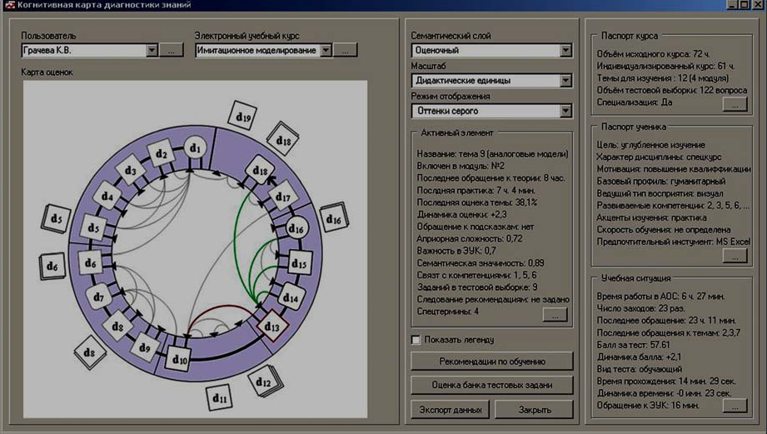

Fig. 1. CMKD fragment in IAES window

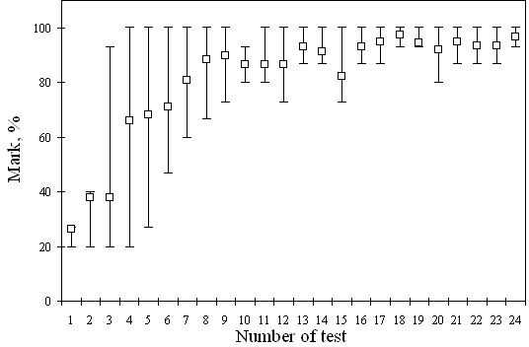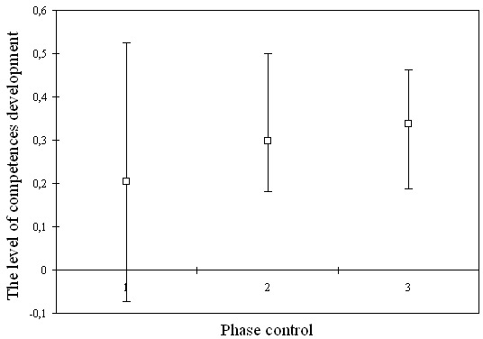On Fig. 1 the individual curse structures of the learning material on the CMKD and some it parameters was presented, adapted to targets of particular student. Decision-making on management of the educational process was based on a comprehensive analysis of the IAES educational applying the identified approach.

(a) (b)

Fig. 2. The results of IAES-based pedagogical experiment

By combining the capabilities of direct and indirect adaptation [Uglev and Samrina, 2008], development of tips and assessment of competencies a positive dynamics of self-study results presented at Fig. 2 was recorded:

(a) pooled group dynamics of the knowledge assessments of the results of the solutions of test materials; (b) pooled dynamics on the level of competences development of a sampled learner (the tests were performed with a half - year interval, the confidence scale is normalized to the [-1;1] interval).

Approbation is also realized with some more courses and via operators learning applying space-using equipment on the base programmed mathematical models.

# Conclusion and Future Works

Integrated automation of individualized learning means further research into the methodological, technological and technical potential of intelligent algorithms application. Conflict resolution between target plants student, teacher and tutor models can only be achieved by improving the technology of decision- making applying core learning system. In this work we proposed a variant of the organization of such technology.

Future work will focus on the following aspects of computer-based learning: a comprehensive integration of a model of tutor into the intellectual automated structure of the learning system, improvement of mechanisms for assessing the level of development of competencies (from the computer testing to work in a virtual laboratory and with programmed mathematical models) and the synthesis of a man-machine dialog in a natural language interaction form.

# Acknowledgements

This research is supported by the Ministry of Education and Science of the Russian Federation in Siberian Federal University (contract ʋ 02.G25.31.0041).

# References

1. Schejbal D. In Search a New Paradigm of Higher Education. Innovative Higher Education, Shpringer, 2012:ʋ37: 373-386 (DOI: 10.1007/s10755-012-9218-z).
2. Uglev V.A., Samrina F.I. Using of possibilities in learning tests for individualization of displaying material in Electronic Education Courses. Modern Techniques and Technologies (MTT’2008), Tomsk, 2008: 96 – 100 (DOI: 10.1109/SPCMTT.2008.4897509).
3. Uglev V.A. On the specificity of individualization of training in Automated Training Systems. Philosophy of Education, 2010: ʋ2: 68-74. Available at: [www.phil-ed.ru/Text/NamberJourn.html](http://www.phil-ed.ru/Text/NamberJourn.html) (in Russian).
4. Dendeva B. Information and communication technology in education. Moscow: IITE UNESCO; 2013.
5. Karpenko A.P., Dobryakov A.A. Model for Automated Training Systems. Overview. Science and Education, 2011: ʋ7. Available at: technomag.bmstu.ru/doc/193116.htm (in Russian).
6. Brusilovsky P. Adaptive and Intelligent Web-based Educational Systems. International Jornal of AI in Education, 2003: ʋ13: 156-169. Available at: [www.sis.pitt.edu.](http://www.sis.pitt.edu/)
7. Uglev V.A. Intellectual Control Algorithm Interaction improvement by the Users Education Process of the Automation Education Systems. International Siberian Conference on Control and Communications (SIBCON). Krasnoyarsk, 2011: 143-146 (DOI: 10.1109/SIBCON.2011.6072615).
8. Anokhin P.K. Biology and Neurophysiology of the Conditioned Reflex and Its Role in Adaptive Behavior. Oxford: Pergamon; 1974.
9. Theory of Functional Systems (WIKI) at [http://en.wikipedia.org/wiki/Theory_of_functional_systems.](http://en.wikipedia.org/wiki/Theory_of_functional_systems)
10. Zadeh L. Fuzzy Logic. Computer, 1988: ʋ4: 83-93 (DOI: 10.1109/2.53).
11. Dobronets B.S., Popova O.A. Numerical probabilistic analysis under aleatory and epistemic uncertainty. 15 GAMM-IMACS Iternational Symposium SCAN’12.Institute of Computational Technologies, 2012:33–34.
12. Nechaev Yu.I., Degtyarev A.B., Boukhanovsky A.V. Cognitive computer graphics for information interpretation in real time intelligence systems. Lecture Notes in Computer Science, 2002: ʋ2329: 683-692.
13. Shteinberg V. Didactic multidimensional tools: theory, technique, practice. Moscow; 2002 (In Russian ).
14. Gladun A.J., Rigushina J.V., Schreurs J. Domain Ontology, an Instrument of Semantic Web Knowledge Menegment in E-Learning. iJAC, 2012: ʋ5(4): 22-31. Available at: i-jac.org.
15. Uglev V.A. The Cognitive Maps of Knowledge Diagnosis. Open and Distance Learning, 2012:ʋ4(48): 17-23. Available at: ido.tsu.ru/other_res/pdf/48-4.pdf (in Russian).
16. Kovaleva T.M. Personality-resource map as a didactic tool for implementation of anthropological approach in education. The Emissia.Offline Letters, 2012: ʋ2: ART 1381 at [www.emissia.org](http://www.emissia.org/) (in Russian).