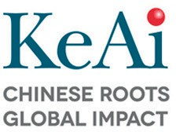[Artificial Intelligence in Agriculture 2 (2019) 13–27](https://doi.org/10.1016/j.aiia.2019.06.002)

Contents lists available at [ScienceDirect](http://www.sciencedirect.com/science/journal/25897217)

Artificial Intelligence in Agriculture

journal homepage: [http://www.keaipublishing.com/en/j ournals/artificial- intelligence-in-agriculture/](http://www.keaipublishing.com/en/journals/artificial-intelligence-in-agriculture/)

[](http://crossmark.crossref.org/dialog/?doi=10.1016/j.aiia.2019.06.002&domain=pdf)Improvement of energy efficiency and environmental impacts of rainbow trout in Iran

Behzad Elhami ⁎, Saeid Shahvarooghi Farahani, Afshin Marzban

*Department of Agricultural Machinery and Mechanization Engineering, Agriculture Science and Natural Resources University of Khuzestan, Mollasani, Iran*

a r t i c l e i n f o

*Article history:*

Received 23 April 2019

Received in revised form 23 May 2019

Accepted 11 June 2019

Available online 20 June 2019

*Keywords:*

Life cycle assessment Energy ratio

Data envelopment analysis Rainbow trout

a b s t r a c t

Combination of Life Cycle Assessment (LCA) and other management tools can help production units to improve economic productivity and environmental protection. In this study, a combination of LCA and Data Envelopment Analysis (DEA) was applied in order to improve the energy efficiency and reduce the environmental burdens of rainbow trout farm in Ardal and Lordegan regions located in Chaharmahal and Bakhtiari Province of Iran. The re- quired data were collected from 60 rainbow trout farms in Ardal region and 38 rainbow trout farms in Lordegan region through face-to-face questionnaire method. In Ardal region, total energy inputs, rainbow trout yield and Energy Ratio (ER) were estimated as 60,483.50 MJ ton−1, 281.78 ton ha−1 and 0.40, respectively, while for Lordegan region, these estimates were obtained as 77,183.63 MJ ha−1, 210.50 kg ha−1 and 0.33, respectively. The results of LCA revealed that rainbow trout production in Ardal region had lower environmental burdens than Lordegan region in all impact categories. Accordingly, Environmental Emissions Final Score (EEFS) in Ardal and Lordegan regions were 1638.88 and 3484.31 ppt ton−1, respectively. The normalized results also showed that Marine Aquatic Ecotoxicity (MAE) had the highest value among all impact categories in both re- gions. The DEA results showed that in Ardal and Lordegan regions about 29.28% and 9.59% of the total energy can be saved without reducing the yield, respectively. The highest potential for saving energy was related to feed in both Ardal (24.74%) and Lordegan (9.12%) regions. The results of LCA coupled with DEA also revealed that there is a higher potential for reduction of environmental impacts in Ardal region compare to Lordegan re- gion. Accordingly, the EEFS value in Ardal and Lordegan regions were reduced by 27.34% and 8.85%, respectively. Generally, rainbow trout production in Ardal region had higher energy efficiency, lower environmental burdens and also higher potential to improve energy consumption and reduce the environmental impacts compared to Lordegan region.

© 2019 The Authors. Production and hosting by Elsevier B.V. on behalf of KeAi Comm[unications Co., Ltd. This is an](http://creativecommons.org/licenses/by-nc-nd/4.0/)

open access article under the CC BY-NC-ND license (<http://creativecommons.org/li>[censes/by-nc-nd/4.0/](http://creativecommons.org/licenses/by-nc-nd/4.0/)).

1. Introduction

Globally, aquaculture is an important economic activity which plays a role in improving feeding and economic development in developing countries such as Iran (Cacho, 1990). Among aquatic animals, fish pro- vides about 20% of total animal protein and has high quality protein,

*Abbreviations:* AC, Acidification; AD, Abiotic Depletion; CRS, Constant Returns to Scale; DEA, Data Envelopment Analysis; DMU, Decision Making Unit; EEFS, Environmental Emissions Final Score; ER, Energy Ratio; EP, Eutrophication Potential; EPr, Energy Productivity; ESTR, Energy saving target ratio; FAE, Fresh water Aquatic Ecotoxicity; FAO, Food and Agriculture Organization; FU, Functional Unit; GHG, Greenhouse Gas; GW, Global Warming; HT, Human Toxicity; ISO, International Standardization Organization; LCA, Life Cycle Assessment; LCI, Life Cycle Inventory; LCIA, Life Cycle Impact Assessment; MAE, Marine Aquatic Ecotoxicity; OLD, Ozone Layer Depletion; PhO, Photochemical oxidation; PTE, Pure Technical Efficiency; SE, Specific Energy; SEf, Scale Efficiency; TE, Terrestrial Ecotoxicity; TEf, Technical Efficiency; VRS, Variable Returns To Scale.

* Corresponding author.

*E-mail address:* [elhami.b@ut.ac.ir](mailto:elhami.b@ut.ac.ir) (B. Elhami).

fat, and high amounts of vitamins and minerals (Bureau et al., 2002). Ac- cording to reports by FAO (2018), total fisheries and aquaculture pro- duction was about 171 million tons in 2016. The shares of fisheries and aquaculture were about 47% (80 million tons) and 53% (91 million tons), respectively. Additionally, FAO (2018) reported Iran as the largest producer of trout fish species, producing 167,830 tons of rainbow trout (Onchorhynchus mykiss). In Iran, about 40% of rainbow trout fish has been produced in Chaharmahal and Bakhtiari (22,803 tons), Lorestan (22,106 tons) and Kohgiluyeh-o-Boyer-Ahmad (19,500 tons) provinces (Anonymous, 2018).

Limitations in fishing and lack of access to the some potential water resources resulted in the maximum utilization of available resources in aquaculture (Aubin et al., 2006). However, higher utilization of non- renewable resources could reduce energy efficiency and lead to further environmental problems. Any measure for managing and reducing en- ergy consumption of inputs such as chemical fertilizers, agricultural ma- chineries, labor, water, electricity and other inputs to improve energy efficiency is the energy saving which is one of the easiest and the

https://doi.org/10.1016/j.aiia.2019.06.002

[2589-7217/© 2019 The Authors. Product](https://doi.org/10.1016/j.aiia.2019.06.002)ion and hosting by Elsevier B.V. on behalf of KeAi Communications Co., Ltd. This is an open access article under the CC BY-NC-ND license (http:// creativecommons.org/licenses/by-nc-nd/4.0/).

most cost-effective methods to prevent climate change. Also, improve- ment of the energy efficiency by energy saving would lead to a reduc- tion in production costs which is very important to consumers. For these reasons, improvement of energy efficiency has been included in the strategy of production (Schnapp, 2012).

Increase in energy efficiency could be achieved by using methods like data envelopment analysis (DEA). The first DEA model was intro- duced by Charnes et al. (1978). DEA is a nonparametric method and is commonly used to estimate energy efficiency and environmental issues based on decision making units (DMUs) (Zhou et al., 2008). This method is a data-driven frontier analysis technique that considers a piecewise linear surface to rest on top of the observations as efficient frontier (Adler et al., 2002). Unlike the parametric methods, DEA does not require a function to relate inputs to outputs (Seiford and Thrall, 1990). There is difference between DEA and evolutionary algorithms such as genetic algorithm. DEA approach is not capable of calculating global optimum values. In DEA approach, the optimum values are deter- mined on the basis of production units under consideration and in this way global optimum values are not calculated. In the other words, the objective of a DEA study is to select the DMU which is most efficient DMU compared to all DMUs under consideration (Shamshirband et al., 2015). However, genetic algorithm does not always ensure that always an optimal result.

In the other hand, the environmental problems could be assessed by Life Cycle Assessment (LCA) method. LCA is a standard, organized and comprehensive method to assess the environmental impacts related to a product or process throughout its life cycle (ISO 14040, 2006; Shahvarooghi Farahani and Asoodar, 2017). Recently, LCA has been a common tool to evaluate greenhouse gas (GHG) emissions and a wide range of the environmental impacts of agricultural systems (Goglio et al., 2015). Therefore, combination of LCA and DEA, known as LCA

+ DEA methodology, has been introduced as a valuable method that avoids concerns related to standard deviation (Iribarren et al., 2010). In recent years, different researchers have indicated that the LCA+ DEA methodology led to optimal use of the inputs in agricultural sys- tems in order to reduce energy consumption and environmental im- pacts without a reduction in output. For instance, Mohseni et al. (2018) conducted a study in Arak county of Iran, in which 58 grape pro- ducers were analyzed by LCA + DEA methodology. They reported that a range of 0.25 to 18% reduction among environmental impact categories was observed. Mohammadi et al. (2013) used a combination of LCA and DEA to assess the eco-efficiency of 94 soybean producers in Iran. Their results indicated that LCA + DEA methodology reduced the average global warming by 11%. Nabavi-Pelesaraei et al. (2017) conducted a study using LCA + DEA methodology to assess the levels of operational efficiency of 240 paddy farms. They indicated that global warming could be reduced by 24% only if farmers operate based on the recommended 98 efficient frontier values recommended by LCA + DEA. Increasing en- ergy efficiency and reducing environmental impacts of production sys- tems in order to achieve sustainable development goals is necessary and the combined application of LCA and DEA could be a sensible option to assess production systems and provide suggestions to decrease energy consumption (Khoshnevisan et al., 2015). In the present study, LCA was used as a tool for analyzing environmental burdens and DEA allowed to optimize the inputs and consequently reduce the environ- mental burdens.

Although, there are several studies in the literature which have in- vestigated environmental impacts of fish farms (Aubin et al. (2006); Bozoglu and Ceyhan (2009); Ayer and Tyedmers (2009); Aubin et al. (2009); Vázquez-Rowe et al. (2011); Samuel-Fitwi et al. (2013); Efole Ewoukem et al. (2012); Chen et al. (2015); Medeiros et al. (2017) that is shown the summary of these researches in Table 1), but there is no

Table 1

Summary of previous researches.

References Study country (s)

Fish species Research summery Energy LCA LCA

+ DEA

Bozoglu & Ceyhan (2009)

Turkey Rainbow trout (*Oncorhynchus mykiss*) Current energy balance, energy conversion efficiency, and

farm-level efficiency of trout production in the Black Sea, Turkey.

√ × ×

Aubin et al. (2006)

France Turbot

(*Scophthalmus maximus*)

The environmental impacts of a water re-circulating system for fish farming were studied through the case study of an inland turbot farm located in Brittany, France.

× √ ×

Ayer &

Tyedmers (2009)

Canada Salmonid culture systems Life cycle assessment (LCA) quantify and compare the

potential environmental impacts of culturing salmonids in a conventional marine net-pen system.

× √ ×

Aubin et al. (2009)

France- Greece

Rainbow trout (*Oncorhynchus mykiss*) in freshwater raceways in France, sea-bass (*Dicentrarchus labrax*) in sea cages in Greece, and turbot (*Scophtalmus maximus*) in an inland re-circulating system

The LCA method is well suited for evaluating the environmental impacts of finfish production systems: rainbow trout in France, sea-bass in Greece, and turbot in France. Two main characteristics differentiated the three farm systems: feed use and energy use.

× √ ×

Samuel-Fitwi et al. (2013)

Efole Ewoukem et al. (2012)

Chen et al. (2015)

Germany Rainbow trout (Oncorhynchus mykiss) Consequential life cycle assessment (LCA) is used to analyze

the environmental impact of rainbow trout production using extensive system (ES), intensive system (IS) and recirculating aquaculture systems (RAS).

Cameroon Tilapia (*Oreochromis niloticus*) The study analyzed four farms that integrated fish farming

with other agricultural production, and in which fish ponds were fertilized either by pig manure and/or crop by-products, in two regions of the western highlands of Cameroon.

France Rainbow trout (Oncorhynchus mykiss) Describes a system to classify trout farms based on

environmental impacts calculated by life cycle assessment and technical and economic indicators.

× √ ×

× √ ×

× √ ×

V.Mederios Brazil Fish tambaqui (*Colossoma macropomum*) and the Amazon

River prawn (*Macrobrachium amazonicum*)

Applied LCA to evaluate and compare environmental impacts of Two omnivorous native Brazilian species: the fish tambaqui and the Amazon River prawn.

× √ ×

Vázquez-Rowe et al. (2011)

Spain Coastal fish Coupling LCA with DEA to evaluate the environmental impacts of coastal fish production in Spain

× √ √

Current study Iran Rainbow trout (Oncorhynchus mykiss) A combination of LCA and Data Envelopment Analysis (DEA)

was applied in order to improve the energy efficiency and reduce the environmental burdens of rainbow trout farm.

√ √ √

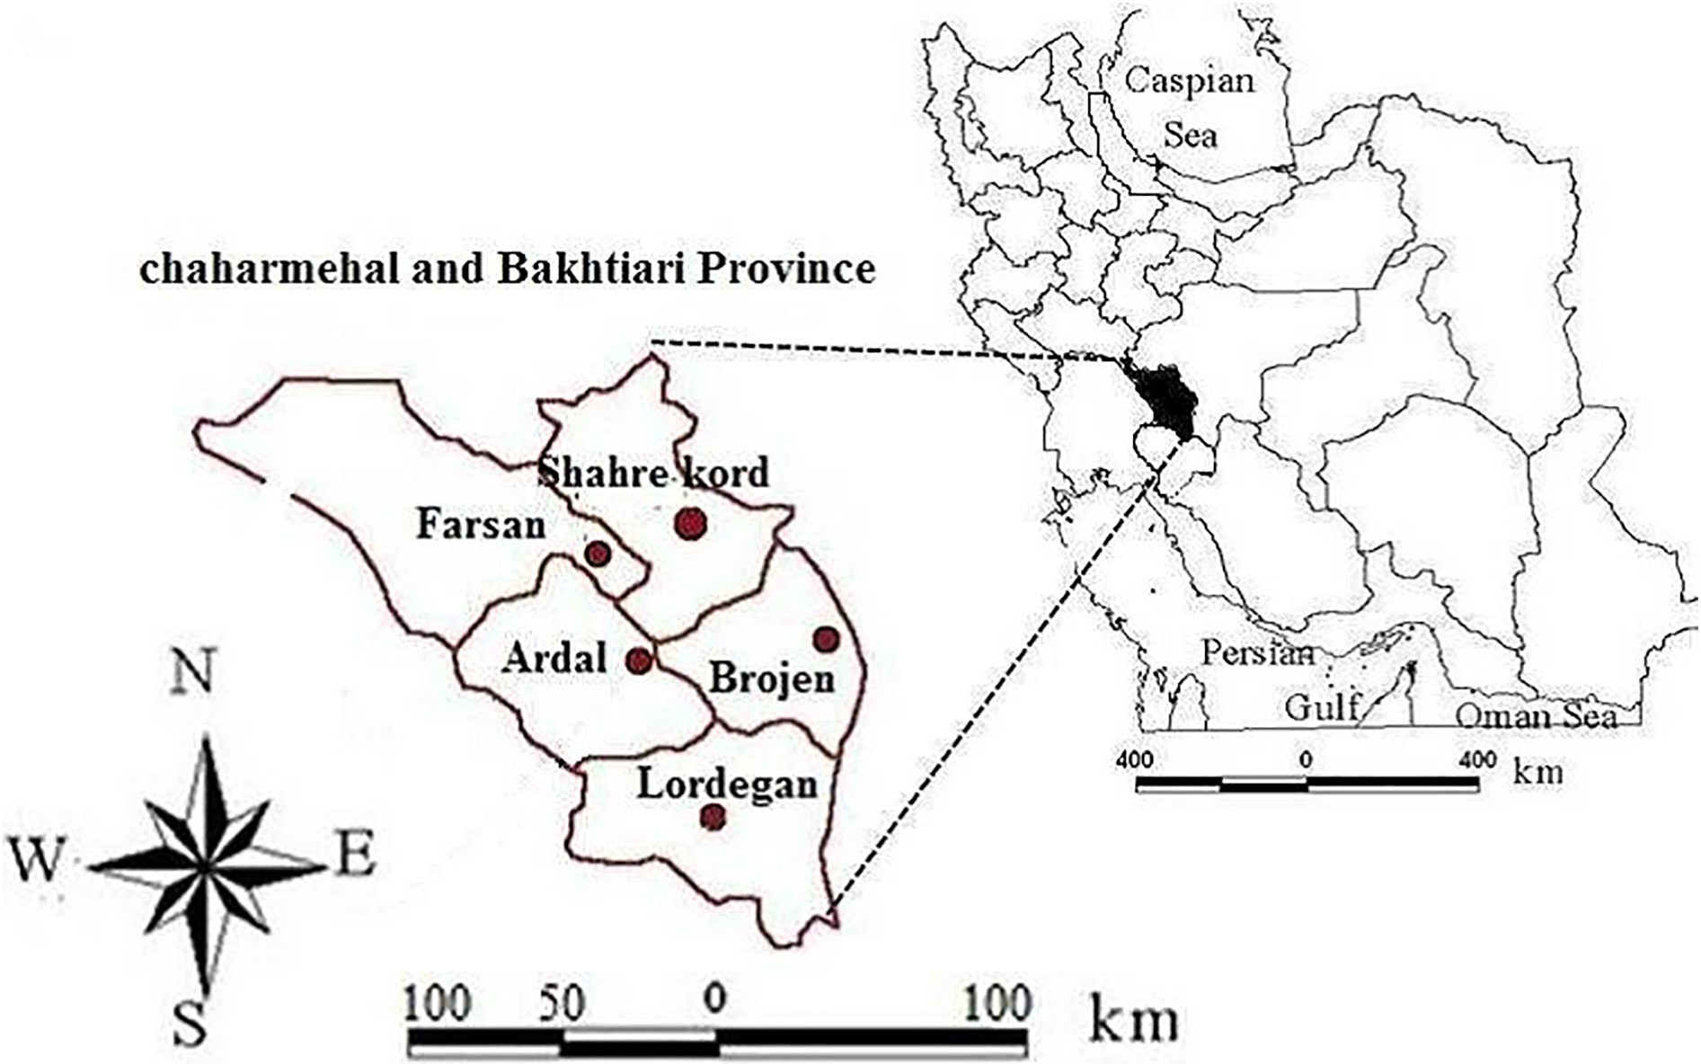

Fig. 1. Geographic location of Chaharmahal and Bakhtiari province in Iran (Anonymous, 2017).

study to improve input energies and consequently reduce environ- mental impacts of trout farm using a combination of LCA and DEA. On other hand, considering that Chaharmahal and Bakhtiari prov- ince ranked first in trout production in Iran, conducting this study seemed to be necessary. The main objectives of this study are as follows:

1. Energy flow analysis of trout production;
2. Assessment and analysis of environmental impacts of trout pro- duction by LCA;
3. Evaluation of energy efficiency and identification of inefficiency reasons of the energy in trout farms by DEA;
4. Provide the improved pattern to reduce energy consumption in trout farms based on efficient units which are introduced by DEA;
5. A coupled LCA + DEA approach to reduce environmental bur- dens through the improved energy consumption pattern.
6. Materials and methods
   1. *Site of study and data collection*

Area of Chaharmahal and Bakhtiari province area has been esti- mated as 16,421 km2, which is 1% of total Iran's area. This province is 2153 m above the sea level located at 31° 9′ to 32° 38´ North latitude and 49° 30′ to 51° 26′East longitude and has the largest share of Iran's water resources (about 10%) (Fig. 1) (Anonymous, 2016). Chaharmahal and Bakhtiari province has 404 trout farms and known as one of the most important region of rainbow trout production in the world. Ardal and Lordegan regions located at Chaharmahal and Bakhtiari prov- ince have 113 and 72 trout farms, respectively, the highest share of the province trout farms (45% of total trout breeding of the province) (Anonymous, 2017).

Considering the number of trout farms in Ardal and Lordegan re- gions, simple random sampling was used and the size of sample was cal- culated using Cochran's formula (Eq. (1)) (Cochran, 1977).

*Z*2*pq*

2

1)

*n d*

!

= (

1 1 *Z*2*pq* −1 *N d*

+ 2

where N is the number of trout farms in each region (113 trout farms in Ardal region and 72 trout farms in Lordegan region), Z is the reliability coefficient (1.96 which denotes 95% reliability), p is the possibility of success for an adjective in the population (equal to 0.5), q is the possibil- ity of failure for an adjective in the population (equal to 0.5), d is the permitted error from the average population (with a value of 0.05) and n stands for the sample size of each region.

Table 2

A brief summary of sample questionnaire.

Questionnaire No: .... Date: ....

Total area of pond (ha): ....

Duration of the production (day): ....

Type, weight and distance of transportation in various stages (tkm) Number of fixed labors: ....

Number of variable labors: ....

Amount of water consumed in each period (m3) Type and amount of feed consumption (kg)

Total electricity consumption for water pomp and aeration system (kwh)

Total natural gas consumption (m3) Number and total weight of Fry (kg) Total diesel fuel consumption (L) Total weight of trout (kg):

Table 3

Amounts average of inputs and yield in trout farms of the studied regions.

Inputs/yield (Unit) Energy equivalent (MJ unit−1) Average consumption (Unit ton−1)

Lordegan Ardal

References

- Inputs

|  |  |  |  |  |
| --- | --- | --- | --- | --- |
| 1. Fry (kg) | 20.5 | 57.78 | 70.30 | (Askari Sari and Mohammadi, 2015) |
| 2. Electricity (kwh) | 11.93 | 888.21 | 1014.96 | (Mousavi-Avval et al., 2011a) |
| 3. Diesel fuel (L) | 47.8 | 19.58 | 57.76 | (Elhami et al., 2016) |
| 4. Water (m3) | 1.02 | 8.82 | 29.72 | (Fathollahi et al., 2018) |
| 5. Natural gas (m3) | 49.5 | 27.54 | 26.23 | (Khoshnevisan et al., 2014a) |
| 6. Transportation machine (tkm) | 1.6 | 10.03 | 7.23 | (Kitani, 1999) |
| 7. Human labor (h) | 1.96 | 201.55 | 193.21 | (Fathollahi et al., 2018) |
| 8. Feed (kg) |  |  |  |  |
| 8.1. Fish meal | 15.4 | 954.24 | 1744.3 | (Hossain et al., 1997) |
| 8.2. Fish oil | 18.32 | 763.39 | 1067.93 | (Hossain et al., 1997) |
| 8.3. Wheat gluten | 13 | 272.64 | 213.58 | (Kitani, 1999) |
| 8.4. Corn gluten | 14.7 | 218.41 | 177.99 | (Houshyar et al., 2012) |
| 8.5. Rapeseed Meal | 25 | 163.58 | 106.79 | (Mousavi-Avval et al., 2011a) |
| 8.6. Soybean Meal | 25 | 190.84 | 142.39 | (Mousavi-Avval et al., 2011b) |
| 8.7. Beans powder | 14.9 | 109.05 | 71.19 | (Koocheki et al., 2011) |
| 8.8. Sweet sorghum | 1.2 | 54.52 | 35.59 | (Kitani, 1999) |
| - Yield Rainbow trout (ton ha−1) | 20.5 | 281.78 | 210.507 | (Askari Sari and Mohammadi, 2015) |

According to Cochran's formula, the sample size for Ardal and Lordegan regions were calculated as 60 and 38 farms, respectively. Thus, 60 and 38 trout farms were selected randomly from Ardal and Lordegan regions, respectively. The required data were collected based on one ton rainbow trout using face-to-face questionnaire method. This method is conducted by an interviewer asking questions of a re- spondent in person. Also, this tool was found useful to gather contextual

output energies were calculated by multiplying the quantities of the in- puts and output by their energy equivalents. According to the input en- ergy, the quantity of the yield and the output energy, the energy indices were calculated using the following equations (Elhami et al., 2016; Fathollahi et al., 2018):

Output Energy MJ ha−1

2)

insights, especially when key organization representatives were interviewed (e.g. farmers union, local authorities and community groups). The required data includes fry, electricity, diesel fuel, natural gas, water, fish feed (fish meal, fish oil, wheat gluten, corn gluten, rape-

Energy Ratio (ER) =

Input Energy MJha−1 (

Trout output ton ha−1

seed meal, soybean meal, sweat sorghum and bean powder), labor and transportation. A brief summary of sample questionnaire is provided in

Table 2.

Energy Productivity (EPr) =

Input Energy MJ ha−1

(3)

* 1. *Energy balance evaluation*

To analyze energy flow and optimize energy consumption in a pro-

Specific Energy (SE) =

input Energy MJ ha−1

Trout output ton ha−1

(4)

duction system, it is necessary to calculate the input–output energies in the first step. Then, energy equivalents are used for transforming all inputs and outputs to their energy equivalent (Mousavi-Avval et al., 2011a). The average of the consumed inputs (per ton of trout) and the yield for the two studied regions is shown in Table 3. The input and

Energy indices help to assess the status of a system according to the total energy input and the yield (or energy output). However, it cannot help to find out how the system would be improved. For instance, En- ergy Ratio (ER) of a system could be improved by 2 times more yield and 1.5 times more energy input. In spite of more ER, more energy



Goal and Scope

DEA

Inventory Analysis

Impact Assessment

Interpretation

Traditional Framework

New Framework

Fig. 2. LCA framework with regard to DEA technique (indeed, inventory and impacts of LCA, Interpreted by DEA) (Adapted from Khoshnevisan et al. (2015)).

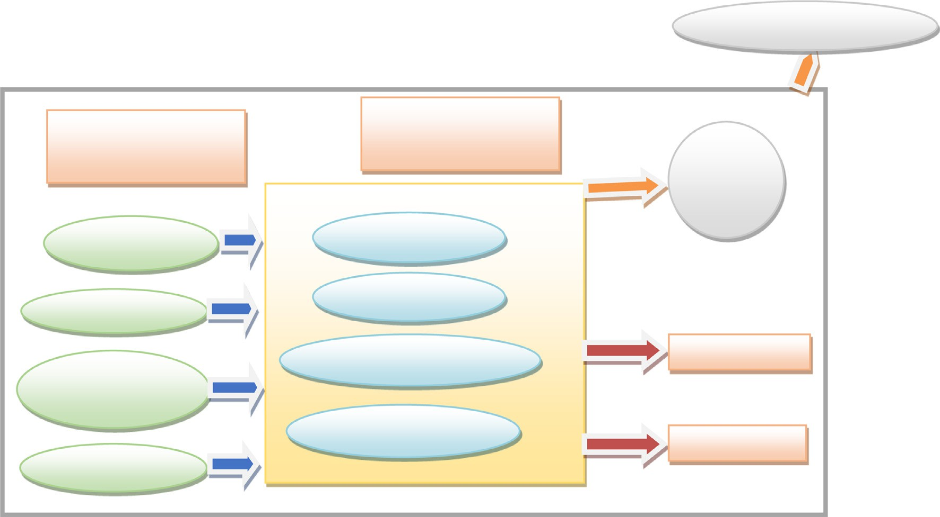

**System boundary**

Background Processes

Foreground Processes

Pond

gate

Energy production

Pond operation

Raw materials

Processes

Energy Consumption

Trout

Infrastructure production

Energy Carriers

Emissions

Transportation

Fig. 3. System boundaries of rainbow trout farms.

input would result in lower sustainability. Therefore, it seems to be nec- essary to use other scientific methods such as DEA to evaluate the effi- ciency and sustainability of the systems (Houshyar et al., 2012).

* 1. *Life cycle assessment*

LCA approach follows the instructions provided by ISO 14040 (2006) and ISO 14044 (2006). LCA allows identifying all the energy inputs, nat- ural resources and the environmental burdens related to production, transportation, utilization and disposal of a product (Guinée et al., 2011). A LCA study consists of four main stages including definition of goal and scope (system boundaries, functional unit, final product and assumptions), inventory analysis, impact assessment and interpretation (Fig. 2). Combination of different stages of LCA and DEA is explained in the following sections.

* + 1. *Goal and scope definition*

Generally, in a LCA study, explicit expression of study goals repre- sents how a study is carried out. LCA must be defined based on desired applications (ISO 14040, 2006). The aim of this study is to evaluate the actual and improved environmental impacts of trout farms. In the study scope definition, functional unit (FU) and system boundaries should be clearly defined. In this study, the FU which is defined as a brief description of the production process (Rebitzer et al., 2004) con- sidered as one ton of produced trout. LCA is a “cradle to the grave” ap- proach but it is possible to define the system boundaries in a way in

which only a part of the production system is considered and the results are reported based on the system boundaries (Khoshnevisan et al., 2013). This study focused on the stages from the cradle (production of the inputs) to the pond gate (trout production) (Fig. 3).

* + 1. *Life cycle inventory (LCI)*

The LCI represents a detailed compilation of the inputs (energy and materials) and outputs (product and emissions to water, soil and air). Data related to the foreground system (trout farm practices) were col- lected using face-to-face questionnaire (Table 3) and data from the background system (production of inputs) were taken from the Ecoinvent database and the previous studies (Table 4) (EPA, 1998; Nemecek and Kagi, 2007; Mousavi-Avval et al., 2017; Bureau et al., 2002). To calculate the emissions from the inputs, the quantities of the inputs and outputs were entered into SimaPro software. The Ecoinvent database consists of the emissions (into water, air and soil) from differ- ent production stages of different products and is defined for most countries in the world. This database also could be used for LCA studies in Iran (Khoshnevisan et al., 2014a; Mousavi-Avval et al., 2017). Elec- tricity was used for water pumps and aeration system. Considering that N98% of electricity in Iran generated by natural gas (94.4%) and hy- dropower (4.9%) and other energy resources generate limited and var- iable amounts of electricity (Anonymous, 2012), it was assumed that all amounts of electricity is generated by natural gas and hydropower. Inventory data for the production of electricity from natural gas and hy- dropower at reservoir were taken from Ecoinvent database. Natural gas

Table 4

Emission factors for 1 unit from diesel fuel based on Ecoinvent (Nemecek and Kagi, 2007), human labor (Mousavi-Avval et al., 2017) and natural gas based on EPA (1998).

|  |  |  |  |
| --- | --- | --- | --- |
| Direct emissions | Emission factors of diesel fuel (kg MJ−1) | Emission factors of natural gas (kg MJ−1) | Emission factors of human labor (kg man-h−1) |
| 1. Carbon dioxide | 7.45E-02 | 3.87E-02 | 7.00E-01 |
| 2. Sulfur dioxide | 2.41E-05 | 1.93E-07 | – |
| 3.Methane | 3.08E-06 | 7.4E-07 | – |
| 4. Dinitrogen monoxide | 2.86E-06 | 7.11E-07 | – |
| 5.Ammonia | 4.77E-07 | – | – |
| 6. Hydrocarbons | 7.85E-08 | – | – |
| 7. Nitrogen oxides | 1.06E-03 | – | – |
| 8. Carbon monoxide | 1.50E-04 | – | – |
| 9. Particulates (b2.5*μ*m) | 1.07E-04 | 2.45E-06 | – |

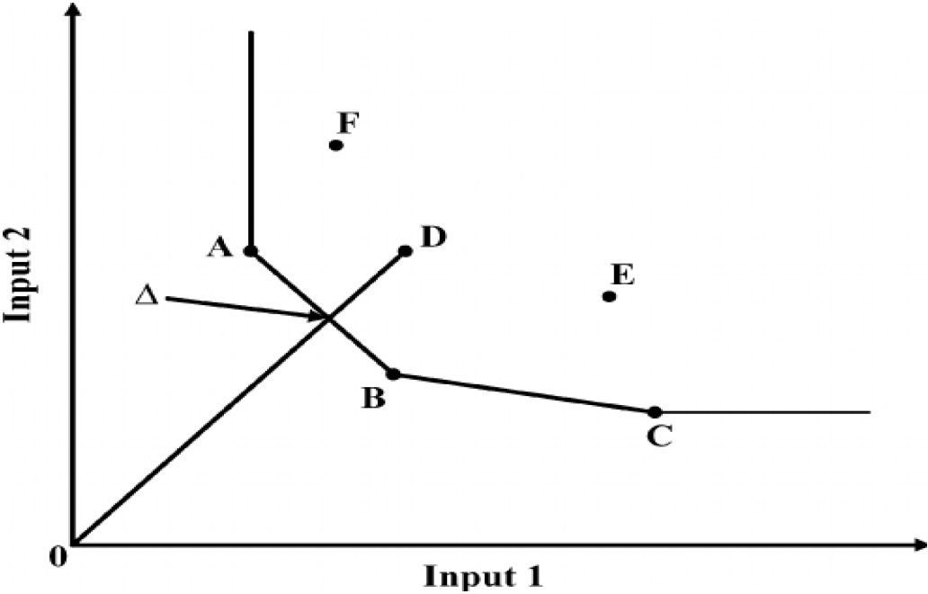

Fig. 4. A scheme of DEA efficient frontier for 2 inputs and 1 output with 6 DMUs.

was used as a fuel for heating system. The emission from diesel fuel combustion, natural gas burning and carbon dioxide emitted during labor activities considered as the direct emissions and their emissions coefficients are shown in Table 4.

Emissions from nutrients to local environments associated with fish growth were estimated by using nutrient-balance modeling (Cho and Kaushik, 1990). This method has been adapted and validated for model- ing rainbow trout (Bureau et al., 2002), and it has been previously used for establishing an emissions inventory of rainbow trout (Papatryphon et al., 2004). The N, P and solids emissions was calculated based on the difference between the amount of nutrients provided to trout and the amount assimilated as fish weight-gain. Solid and dissolved frac- tions of emitted N and P was calculated based on digestibility of the nu- trients, fish body-composition, and the non-ingested part of the provided feed (estimated at 5% based on the expert opinion). The nutri- ents release and theoretical oxygen demand (calculated using the chemical oxygen demand of protein, carbohydrates, lipids, ash and fiber emitted) per ton of trout is shown in section of the results.

* + 1. *Life cycle impact assessment (LCIA)*

It is impossible to evaluate and compare the emissions from each the inputs without categorizing the emissions. So, the results from LCI were

categorized in the different environmental impact categories (ISO 14040, 2006). There are different methods to define the environmental impact categories. In this study, CML2 baseline 2000 was considered for categorizing. Ten impact categories based on CML2 baseline 2000 in- clude Abiotic Depletion (AD), Acidification (AC), Global Warming (GW), Eutrophication (EU), Ozone Layer Depletion (OLD), Human Tox- icity (HT), Freshwater Aquatic Ecotoxicity (FAE), Marine Aquatic Ecotoxicity (MAE), Terrestrial Ecotoxicity (TE) and Photochemical Oxi- dation (PhO). (Anonymous, 2003). These categories have different units and it is impossible to compare them to each other. Therefore, nor- malization was used to make the categories non-dimensional (Mousavi-Avval et al., 2017). For this purpose, SimaPro software which has the coefficients for normalization was used.

* + 1. *Interpretation of the results*

In interpretation phase, the results obtained from the preceding phases of the LCA are interpreted. Normalization and weighting are optional steps used to solve the incompatibility of units and to sim- plify the interpretation of the results. Normalization allows to better understanding the contributions of impact categories to the global environmental effects. Therefore, in order to development a rela- tionship between normalization and weighting, Environmental Emissions Final Score (EEFS) was introduced as following eq. 5 (Brentrup et al., 2004):

*EEFS* = X *Ni* × *Wi* (5)

where *Ni* stands for the normalized amount of each category and *Wi* is the weight of the normalized amounts of each category. The coef- ficients for weighting were taken from Simapro software V.8.0.3.

* 1. *Data envelopment analysis*

According to Table 3, the amounts of inputs and output in trout farms were different from each other in the both regions and a high standard deviation was observed. This means that there are high po- tential to improve the inputs, increase the energy efficiency and re- duce the environmental impacts by using combination of LCA and DEA. Generally, DEA is a data mining method to estimate productiv- ity of the inputs and rank the production units based on their perfor- mance. In DEA, each production unit is known as a decision making

Table 5

Actual, improved and saved (%) energy use in trout farms based on VRS model.

Items Actual energy average Improved energy average ESTR (%)⁎

* ESTR (Energy Saving Target Ratio) = (

|  |  |  |  |  |  |  |  |  |  |  |  |
| --- | --- | --- | --- | --- | --- | --- | --- | --- | --- | --- | --- |
|  | | | Ardal | Lordegan |  | Ardal | Lordegan |  | Ardal | Lordegan |  |
|  | A. Input energy (MJ ton−1) |  | 60,483.50 | 77,183.63 |  | 42,769.71 | 69,777.69 |  | 29.28 | 9.59 |  |
|  | 1. Fry |  | 1184.59 | 1,441.23 |  | 894.76 | 1,194.15 |  | 24.46 | 17.14 |  |
|  | 2. Electricity |  | 10,596.47 | 12,108.5 |  | 5,598.54 | 1,145.31 |  | 47.16 | 7.95 |  |
|  | 3. Diesel fuel |  | 936.18 | 2,761.4 |  | 527.03 | 2174.42 |  | 43.70 | 21.25 |  |
|  | 4. Water |  | 8.99 | 30.32 |  | 6.13 | 24.44 |  | 31.78 | 19.37 |  |
|  | 5. Natural gas |  | 1,363.51 | 1,298.77 |  | 819.81 | 1,145.31 |  | 39.87 | 13.39 |  |
|  | 6. Transportation |  | 16.05 | 11.57 |  | 10.44 | 9.95 |  | 34.92 | 13.97 |  |
|  | 7. Human labor |  | 395.04 | 378.70 |  | 309.99 | 350.03 |  | 21.52 | 7.57 |  |
|  | 8. Feed |  | 45,982.60 | 59,177.03 |  | 34,602.95 | 53,754.47 |  | 24.74 | 9.12 |  |
|  | 8.1. Fish meal |  | 14,695.40 | 26,886.20 |  | 11,058.61 | 24,410.65 |  | – | – |  |
|  | 8.2. Fish oil |  | 13,985.40 | 1,9564.6 |  | 10,524.35 | 17,779.08 |  | – | – |  |
|  | 8.3. Wheat gluten |  | 3,544.33 | 2,776.64 |  | 2667.19 | 2,523.23 |  | – | – |  |
|  | 8.4. Corn gluten |  | 3,206.26 | 2,616.44 |  | 2412.78 | 2,377.61 |  | – | – |  |
|  | 8.5. Rapeseed meal |  | 4,089.62 | 2,669.84 |  | 3077.53 | 2,426.18 |  | – | – |  |
|  | 8.6. Soybean meal |  | 4,771.22 | 3,559.79 |  | 3590.45 | 3,234.91 |  | – | – |  |
|  | 8.7. Beans powder |  | 1624.94 | 1060.81 |  | 1222.80 | 964.00 |  | – | – |  |
|  | 8.8. Sweet sorghum |  | 65.43 | 42.71 |  | 49.24 | 38.81 |  | – | – |  |
| B. Output energy (MJha−1) | | 5,776,149.8 | | 4,315,399.1 | – – – – | | | | | | |
| C. Energy indices  1. Energy productivity (ton MJ−1) | | 19.72E-06 | | 16.40 E-06 | 23.38E-06 18.20 E-06 18.56 10.61 | | | | | | |
| 2. Specific Energy (MJ ton−1) | | 5,0721.71 | | 60,749.66 | 4,2769.71 5,4920.59 −15.67 −9.59 | | | | | | |

*Actual energy value*−*Improved energy value Actual energy value* ).

unit (DMU). The distance between each DMU and the production frontier refers to this fact that there is the possibility for improve- ment of energy efficiency in that DMU. In Fig. 4, A, B, and C are shown as the efficient frontiers, whereas D, E, F and their combina- tions are inefficient (Stokes et al., 2007).

In DEA model, an inefficient DMU can become efficient through reducing the quantities of the inputs without a reduction in the out- put (input-based model), or through increase in the quantity of out- put while the quantities of the inputs is kept the same as before (output-based model) (Mousavi-Avval et al., 2011a). Considering that the quantities of the inputs are controlled by trout producers and different factors affecting the output, input-based model was se- lected for this study. DEA based on constant returns to scale (CRS) and variable returns to scale (VRS) models is expressed by technical efficiency (TEf), pure technical efficiency (PTE) and scale efficiency (SEf).

* + 1. *Technical efficiency*

Technical efficiency (TEf) is defined as the ratio between the sum of weighted outputs to the sum of weighted inputs that is shown in Eq. (6). The value of TEf varies between zero and one in which the

where *θ* is the TEf and i represents ith DMU (it will be fixed in Eq. (6); while j increases in Eq. (8)). The above model is known as the CRS model which is a linear programming model. This model assumes that there is no significant relationship between the scale of production units and efficiency (Avkiran, 2001). Therefore, the large units are con- sidered as efficient as small ones in converting inputs to output.

* + 1. *Pure technical efficiency*

When variable returns to scale (VRS) model introduced by Banker, Charnes & Cooper is used, PTE is considered to score and rank DMUs (Banker et al., 1984). In other words, PTE is TEf which is affected by the variation in scale efficiency. PTE compares efficient and inefficient DMUs in the same environment and geographical conditions and it is its advantage in comparison with TEf (Barnes, 2006). This model is cal- culated on the basis of the following equation (Mohammadi et al., 2013):

*Max z* = *uyj* −*uj* (9)

Subject to:

value of one represents that the DMU is a best performer located on the production frontier and has no potential for improvement. A TEf value less than one means that DMU is inefficient (Mousavi-

*vXi* = 1; −*vX* + *uY*−*u*0*e* ≤ 0

*v* ≥ 0; *u* ≥ 0 *and u*0 is unconstrained in sign

(10)

Avval et al., 2011b).

*u*1*y*1 *j* + *u*2*y*2 *j* + … + *unynj*

=

*TEj* = *v*1*x*1 *j* + *v*2*x*2*j* + … + *vmxmj*

∑*s* (*urkyrk*)

∑*m* (*vikxik*)

*i*=1

where *z* and *u*0 are scalar and free in sign. *u* and ‘*v*’ are output and input weight matrixes, and *Y* and *X* are corresponding output and input ma- trixes, respectively. The letters xi and yj refer to the inputs and output of jth DMU.

where *k* is the DMU being evaluated in the set of j = 1, 2, …, *n*; *x* is the amount of input; *y* is the output; *m* and *n* represent the number of in- puts and outputs produced by the DMUs, respectively; urk and vik are the matrix of weights assigned to outputs and inputs, respectively. Charnes, Cooper & Rhodes introduced a linear program (Eq. (7)) to solve Eq. (6) (Charnes et al., 1978):

*n*

* + 1. *Scale efficiency*

*r*=1

The small size of trout farms and improper use of the inputs could be considered as the main reasons for inefficiency of DMUs. CRS model cal- culates TEf and SEf while VRS model only considers PTE. In this study, first, the values for TEf and PTE were calculated for CRS and VRS models, respectively. Then, SEf was calculated using the following equation (Chauhan et al., 2006):

*Maximize θ* = X *urkyrk* (7)

*r*=1

= PTE (

)

SEf

TE 11

Subject to:

∑*s* (*u y* )

*r*=1 *rk rk* ≤ 1; *j* = 1; ….; *nurk*; *yrk* ≥ 0; *r* = 1; …; *s*; *i* = 1; …; *m* (8)

∑*m* (*vikxik*)

*i*=1

Moreover, PTE is desired efficiency and SEf is the ratio between ac- tual efficiency and desired efficiency. TEf is a combination of both SEf and PTE. In brief, it can be said that SEf is the ratio between the efficiency in CRS and VRS models.

80

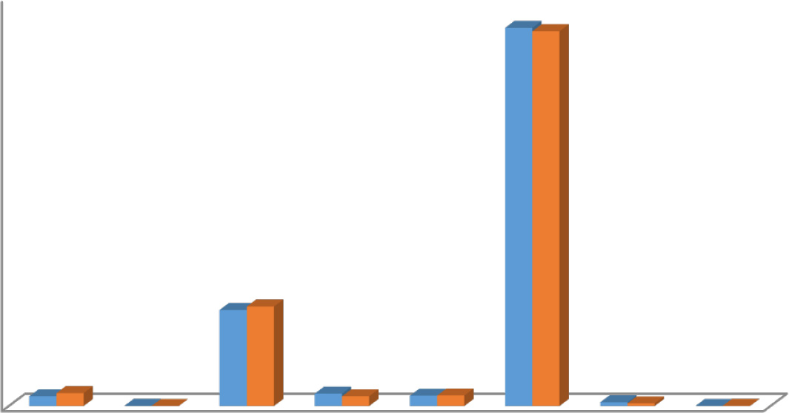

70

60

Percentage (%)

50

40

30

20

10

0



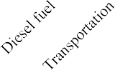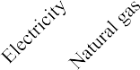

Fig. 5. Share of the inputs within the total energy inputs in the studied regions.

Ardal Lordegan

30

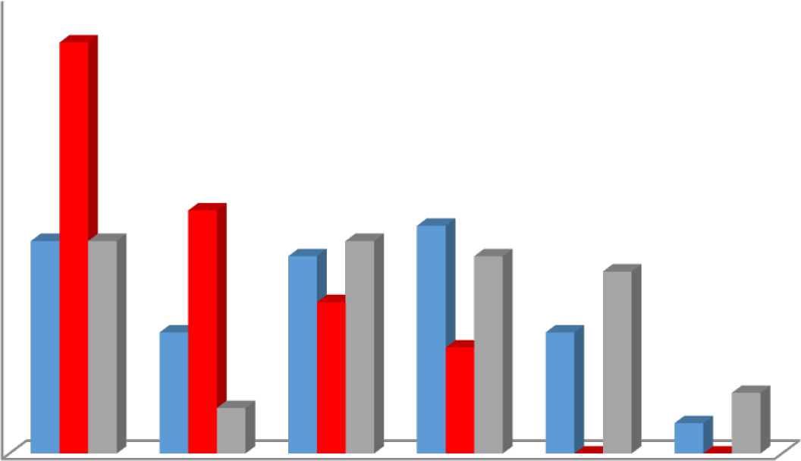

25

20

Frequency of trout farm

 SEf

15  PTE

10  TE

5

0

efficient 0.8-0.99 0.6-0.79 0.4-0.59 0.2-0.39 0-0.19

Efficiency score (decimal)

Fig. 6. Distribution of trout farms based on the efficiency score in Ardal region.

In order to detect the most efficient DMUs, they should be ranked ac- cording to their importance based on the efficient frontier. The bench- mark ranking method as the most common technique in DEA studies was used in the present study. The number of times each efficient DMU is observed in a referent set given by software show how similar the efficient DMUs are in comparison with inefficient DMUs. Efficient DMUs that appear more frequently in the referent set are considered su- perior and achieve a higher rank (Khoshnevisan et al., 2014b).

* 1. *LCA+ DEA*

In this study, the aim is to improve the inputs to conserve the energy resources and reduce the environmental burdens of trout farms without a significant reduction in the output. To achieve this goal, first, the data was stored into Excel spreadsheets. EMS V1.3 software was used to compute the improvements potential for each input. Hence, the PTE was calculated for each DMU, and all DMUs were benchmarked based on the Eq. (9). Then, SimaPro software was used to evaluate the envi- ronmental burdens of the trout farms based on both the actual data and the data modified by DEA (According to Fig. 2). Finally, efficient and inefficient DMUs were specified and the quantities of the input en- ergies and the environmental burdens of the two regions were calcu- lated based on both the actual data and the data modified by DEA.

1. Results and discussions
   1. *Input-output energy analysis*

It is necessary in trout farms to know about the importance of each factor in the production process and their influence on the output. Al- though, there are many unpredictable natural and climate factors affect- ing the production process and the output, but, the factors like the quantities of the inputs could be controlled by the producers and their quantities could be decided based on their influence on the performance.

The average of the input energies needed for producing one ton of trout in a 8 to 10 months breeding period are brought in Table 5. It should be mentioned that the size of the farms was less than a hectare and differences between the farms size seemed to be negligible. Therefore, it was decided to consider a ton as the FU for calculations. According to Table 5, the total energy inputs in Ardal and Lordegan regions were obtained as 60,438.50 MJ ton−1 and 77,183.63 MJ ton−1, respectively. In a previous study, Bozoglu and Ceyhan (2009) reported the total energy use per cubic meter was

46.57 MJ in Turkey's trout farms.

To compare the two regions from an energy efficiency point of view, the energy indices were used. The ER and EPr in Ardal region calculated as 0.40 and 19.72E-06 ton MJ−1, while in Lordegan region,

30

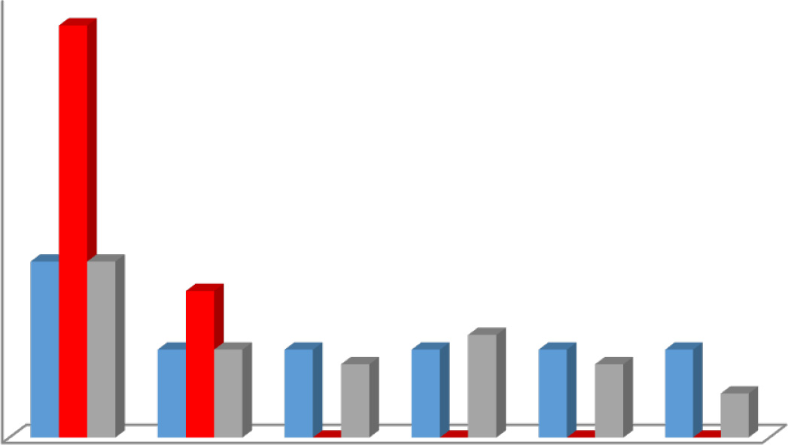

25

Frequency of trout farm

20

15  SEf

 PTE

10  TE

5

0

efficient 0.8-0.99 0.6-0.79 0.4-0.59 0.2-0.39 0-0.19

Efficiency score (decimal)

Fig. 7. Distribution of trout farms based on the efficiency score in Lordegan region.

Table 6

Average of efficiency items for trout farms in the studied regions.

14 efficient DMUs in CRS model are efficient in VRS model, and that is the reason behind the same number of efficient DMUs in TE and SEf. It

Items Technical

efficiency

Pure technical efficiency

Scale efficiency

should be mentioned that 13 DMUs difference between TEf and PTE could be attributed to inappropriate production scale. Also, it worth to mention that TEf scores of 46 DMUs and PTE scores of 33 DMUs were in the range of 0.4 to 0.99.

According to Fig. 7, 28 of 38 DMUs in Lordegan region had PTE score as 1, and 12 DMUs had full TEf and SEf scores. 26 and 10 DMUs had ef- ficiency scores in the ranges of 0.4 to 0.99 for TEf and PTE, respectively. It should be noticed that full PTE score doesn't assure full TEf score.

|  |  |  |  |  |  |  |  |  |  |
| --- | --- | --- | --- | --- | --- | --- | --- | --- | --- |
|  | Ardal | Lordegan |  | Ardal | Lordegan |  | Ardal | Lordegan |  |
| Average | 0.59 | 0.69 |  | 0.86 | 0.98 |  | 0.66 | 0.70 |  |
| Standard deviation | 0.28 | 0.1 |  | 0.16 | 0.04 |  | 0.24 | 0.29 |  |
| Minimum | 0.07 | 0.29 |  | 0.45 | 0.84 |  | 0.16 | 0.10 |  |
| Maximum | 1 | 1 |  | 1 | 1 |  | 1 | 1 |  |

The average and standard deviation of TEf, PTE and SEf of the DMUs

the ER and EPr were obtained as 0.33 and 16.40E-06 ton MJ−1, re- spectively. These indices showed that the energy consumption in Ardal region was more efficient. The SE in Ardal region was 50,721.48 MJ ton−1, while in Lordegan region, the SE was obtained as 60,749.57 MJ ton−1. According to the results, it is clear that Lordegan region needs more attention to improve the total energy needed for trout production. The main reason for difference between the energy consumption results between two studied regions could be attributed to the quantities and the shares of feed consumption. To produce 1 ton trout in Ardal and Lordegan regions, 2727 and 3560 kg of feed were consumed, respectively.

Fig. 5 shows the shares of the inputs from the total energy inputs in the studied regions. The share of feed in both region was about 74% of the total energy inputs. In both regions, feed consisted of fish meal, fish oil, rapeseed meal, wheat gluten, soybean meal, corn gluten, sweet sorghum and bean powders. Fish meal and fish oil as animal sources had the highest share among the feed ingredients in both re- gions as 63% for Ardal region and 79% for Lordegan region. Therefore, further researches to materialize the use of alternative sources of pro- tein are necessary to replace the standard fishmeal-based feed. This is in agreement with the results of Bozoglu and Ceyhan (2009) who re- ported that the budget of energy for trout farms strongly depends on the share of consumed feed. Also, electricity had the secondary share of the total energy inputs in both regions with about 19%. The high share of electricity used in trout farms in both regions could be attrib- uted to inefficient aeration systems, worn electro pumps and lack of the producers awareness of the required flow and volume of water. So, it is suggested that worn and old aeration systems and electro pumps be checked and inspected.

* 1. *DEA for improving the energy inputs*

In DEA, DMU being efficient or inefficient depends on the ratio be- tween the output and the inputs compared to other DMUs. As it is shown in Fig. 6, 27 of 60 DMUs in Ardal region were identified as effi- cient (PTE value as 1) based on VRS model. Also, based on CRS model, 14 of 60 DMUs were recognized as efficient with TEf and SEf as 1. All

(trout farms) in the two regions are shown in Table 6. The average scores of PTE, TEf and SEf for DMUs in Ardal regions were 0.86, 0.59 and 0.66, respectively. In Lordegan region, the average scores of PTE, TEf and SEf for DMUs were calculated as 0.98, 0.69 and 0.70, respec- tively. As it can be seen from Table 6, the maximum and minimum scores for TEf, PTE and SEf were calculated. The standard deviation of TEf is higher than PTE which indicates that trout producers have less awareness of the appropriate breeding methods and the optimal amounts of the inputs. In other words, it indicated that the breeders used the energy inputs more that the optimal amounts or applied in an improper time. The scores of SEf in Ardal (0.66) and Lordegan (0.70) regions revealed that the inefficient DMUs in Ardal and Lordegan regions could increase their efficiency by following the suggestions which result in optimal scale efficiency, up to 24 and 20%, respectively. Abedi et al. (2011) conducted a study to optimize the efficiency of trout farms in Fars province, Iran and reported the average of TE, PTE and SEf as 0.93, 0.97 and 0.95, respectively.

The required energy inputs in the optimal condition, the percentage

of the saved energy for each input, the energy indices in the optimal condition and the percentage of changes for the energy indices are shown in Table 5. As it can be seen from Table 4, the total required en- ergy inputs in the optimal condition in Ardal and Lordegan regions were obtained as 42,769.71 MJ ton−1 (29.28% saved energy) and 69,777.69 MJ ton−1 (9.59% saved energy), respectively. It was revealed that DMUs in Ardal region had higher potential to save energy com- pared to Lordegan region. In Ardal region, electricity (47.16%) and diesel fuel (43.70%) had highest shares of the saved energy, while in Lordegan region, diesel fuel (21.25%) and water (19.35%) showed the highest po- tential for saving energy. According to Table 4, the EPr in Ardal region after improving the energy inputs increased from 19.72E-06 to

23.38E-06 ton MJ−1 (18.56% increase), while in Lordegan region, the

EPr increased from 16.40E-06 to 18.20E-06 ton MJ−1 (10.61% increase). In other studies that DEA used to improve the energy inputs of crops in Iran, an increase in the EPr was reported for alfalfa from 120.00E-06 to 130.00E-06 (10.6%) (Ghasemi Mobtaker et al., 2012), for kiwi from 800.04E-06 to 920.00E-06 (13.86% increase) (Mohammadi et al., 2011) and for orange from 970.00E-06 to 1110.00E-06 (14.4% increase)

45

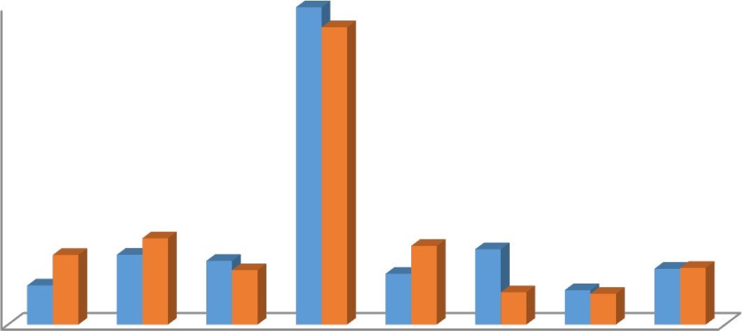

40

Contribution of saved energy (%)

35

30

25

20 Ardal

15 Lordegan

10

5

0

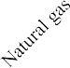

Fig. 8. Contribution of the inputs of the total saved energy in rainbow trout farms in the studied regions.

(Nabavi-Pelesaraei et al., 2014). As it is shown in Fig. 8, in both regions, fish feed had the highest share of the total saved energy with 44.85% (Ardal region) and 42.03% (Lordegan region). The suggestions for im- proving feed were provided in the previous section.

As it was discussed in the previous section, benchmark ranking method is a valuable method to detect the most appropriate DMUs in the group. The ranking of the 60 DMUs in Ardal region and 38 DMUs in Lordegan region are presented in Table 7 and Table 8. As it is shown in Table 7, the DMU 3 with 19 repetitions (see Table 7; Fre- quency in referent set) was obtained as the top ranking in Ardal re- gion. It means that this unit in addition to being efficient, is close to input–output levels of the most inefficient units in the group and it was followed by DMU 41 and DMU 57 with 18 and 14 repetitions, re- spectively. The most important conclusion that can be taken from these results is that, inefficient DMUs can improve their energy use efficiency by following the best practices of the efficient DMUs. It

means an inefficient DMU can be efficient by following the some ef- ficient DMUs instead of using a single DMU as a benchmark. For ex- ample, DMU 48 as an inefficient unit that had the lowest PTE with

0.45 should follow the practices of DMU 15, 21 and 29 as composite DMU which means that DMU 48 is close to the efficient frontier formed by these efficient DMUs.

As it is shown in Table 8, the DMU 5 with 6 repetitions was obtained as the top ranking in Lordegan region. To clarify benchmarking, consider DMU 16 with PTE calculated as 0.935. To improve efficiency score of DMU 16, it should be changed according to a composite DMU. The com- posite DMU that represents the best practice is formed by the combina- tion of DMU 5, DMU 7 and DMU 20. The number in the parentheses known as intensity vector indicate that the inputs and output of ineffi- cient DMU 16 is closer to DMU 7 compared to other two farms (DMU 5 and 20). Using intensity vectors and composite DMU, the optimum amount of energy for DMU 16 can be worked out.

Table 7

The source wise actual and optimum energy total for most efficient and inefficient producers in the Ardal region (based on VRS model).

|  |  |  |  |  |  |  |  |
| --- | --- | --- | --- | --- | --- | --- | --- |
| DMU | PTE | Most frequency in  referent set | Benchmarks |  | Actual energy total (MJ  ton−1) | Optimum energy total (MJ  ton−1) | ESTR (%)⁎ |
| A. truly most efficient producers |  |  |  |  |  |  |  |
| 3 | 1 | 19 |  | – | 39,760.41 | 39,760.41 | 0 |
| 41 | 1 | 18 |  | – | 32,620.31 | 32,620.31 | 0 |
| 57 | 1 | 14 |  | – | 25,054.37 | 25,054.37 | 0 |
| 40 | 1 | 13 |  | – | 46,344.37 | 46,344.37 | 0 |
| 2 | 1 | 9 |  | – | 52,980.45 | 52,980.45 | 0 |
| 28 | 1 | 7 |  | – | 33,713.74 | 33,713.74 | 0 |
| 12 | 1 | 6 |  | – | 39,749.13 | 39,749.13 | 0 |
| 38 | 1 | 5 |  | – | 38,177.68 | 38,177.68 | 0 |
| 15 | 1 | 5 |  | – | 37,694.85 | 37,694.85 | 0 |
| 17 | 1 | 4 |  | – | 34,063.33 | 34,063.33 | 0 |
| Average of efficient producers | 1 | – |  | – | 38,015.86 | 38,015.86 | 0 |
| B. Inefficient producers |  |  |  |  |  |  |  |
| 6 | 0.574 | – 3(0.07)- 12(0.10)- 28(0.59)- 57(0.24) | | | 58,817.89 | 32,702.17 | 44.40 |
| 8 | 0.730 | – 3(1.00) | | | 32,585.10 | 39,759.19 | 36.47 |
| 11 | 0.884 | – 3(0.15)- 12(0.33)- 28(0.16)- 38(0.36) | | | 59,097.25 | 38,210.79 | 35.34 |
| 14 | 0.904 | – 3(0.06)- 13(0.29)- 41(0.05) | | | 61,350.19 | 45,431.28 | 25.94 |
| 16 | 0.571 | – 1(0.08)- 12(0.53)- 28(0.025)- 57(0.13) | | | 81,506.62 | 38,683.19 | 52.53 |
| 18 | 0.750 | – 12(0.69)- 28(0.31) | | | 58,224.49 | 38,887.70 | 34.96 |
| 19 | 0.622 | – 3(0.39)- 4(0.19)- 28(0.01)- 57(0.41) | | | 56,467.93 | 34,393.79 | 39.09 |
| 20 | 0.913 | – 2(0.10)- 17(0.13)- 28(0.66)- 30(0.02)- 57(0.09) | | | 41,907.17 | 34,878.47 | 16.77 |
| 22 | 0.914 | – 2(0.15)- 12(0.16)- 38(0.46)- 57(0.23) | | | 58,067.46 | 37,597.14 | 35.25 |
| 23 | 0.738 | – 3(0.55)- 5(0.04)- 41(0.41) | | | 92,435.56 | 37,753.07 | 59.15 |
| 24 | 0.950 | – 2(0.04)- 3(0.22)- 15(0.61)- 41(0.13) | | | 45,430.78 | 38,093.87 | 16.14 |
| 25 | 0.546 | – 2(0.17)- 15(0.06)- 40(0.10)- 41(0.13)- 57(0.53) | | | 64,496.09 | 33,801.44 | 47.59 |
| 26 | 0.464 | – 3(0.68)- 40(0.30)- 41(0.01) | | | 116,069.40 | 41,637.82 | 64.12 |
| 27 | 0.809 | – 15(0.09)- 40(0.20)- 41(0.17)- 57(0.44) | | | 44,731.96 | 33,073.14 | 26.06 |
| 31 | 0.732 | – 3(0.33)- 37(0.42)- 40(0.17)- 41(0.08) | | | 57,266.8 | 41,433.24 | 27.64 |
| 33 | 0.880 | – 12(0.22)- 41(0.73)- 57(0.05) | | | 48,308.71 | 33,782.82 | 30.06 |
| 34 | 0.810 | – 3(0.37)- 5(0.60)- 41(0.03) | | | 92,535.66 | 53,203.7 | 42.50 |
| 35 | 0.823 | – 3(0.94)- 5(0.02)- 41(0.04) | | | 66,400.48 | 40,005.09 | 39.75 |
| 36 | 0.994 | – 1(0.02)- 2(0.43)- 41(0.55) | | | 45,499.9 | 42,256.11 | 7.12 |
| 39 | 0.914 | – 3(0.13)- 30(0.04)- 38(0.32)- 40(0.33)- 41(0.10)- 57 | | | 42,994.11 | 39,185.84 | 8.85 |
|  |  | (0.09) | | |  |  |  |
| 42 | 0.773 | – 3(0.03)- 28(0.02)- 38(0.14)- 57(0.81) | | | 35,779.05 | 27,530.46 | 23.05 |
| 45 | 0.872 | – 37(0.42)- 40(0.22)- 41(0.36) | | | 46,078.66 | 39,814.05 | 13.59 |
| 46 | 0.629 | – 3(0.05)- 40(0.19)- 41(0.76) | | | 90,328.73 | 35,670.75 | 60.51 |
| 47 | 0.983 | – 1(0.01)- 2(0.08)- 40(0.64)- 41(0.29) | | | 45,038.59 | 42,970.34 | 4.59 |
| 48 | 0.450 | – 15(0.21)- 21(0.15)- 29(0.64) | | | 137,034.00 | 39,103.91 | 71.47 |
| 49 | 0.451 | – 15(0.32)- 29(0.68) | | | 157,714.20 | 22,697.02 | 85.60 |
| 50 | 0.503 | – 3(0.11)- 40(0.65)- 41(0.24) | | | 134,281.50 | 42,321.41 | 68.48 |
| 51 | 0.915 | – 3(0.15)- 5(0.72)- 41(0.13) | | | 106,533.8 | 55,235.32 | 48.15 |
| 52 | 0.780 | – 3(0.25)- 40(0.31)- 41(0.44) | | | 87,502.99 | 39,629.93 | 55.85 |
| 53 | 0.885 | – 17(0.19)- 40(0.34)- 57(0.48) | | | 68,917.63 | 33,910.06 | 50.79 |
| 54 | 0.752 | – 2(0.26)- 17(0.04)- 40(0.22)- 57(0.48) | | | 54,008.86 | 37,296.69 | 30.94 |
| 56 | 0.784 | – 2(0.18)- 3(0.34)- 17(0.04)- 57(0.44) | | | 45,890.22 | 35,392.48 | 22.87 |
| 58 | 0.859 | – 38(0.09)- 57(0.91) | | | 41,157.18 | 26,201.24 | 36.33 |
| 59 | 0.857 | – 2(0.05)- 3(0.23)- 40(0.72) | | | 54,028.24 | 45,147.25 | 16.43 |
| Average of Inefficient | 0.765 | – – | | | 68,484.92 | 38,167.38 | 44.26 |
| producers |  |  | | |  |  |  |

*Actual energy value*−*Improved energy value*

ESTR = (

*Actual energy value* )

Table 8

The source wise actual and optimum energy total for most efficient and inefficient producers in the Lordegan region (based on VRS model).

|  |  |  |  |  |  |  |  |
| --- | --- | --- | --- | --- | --- | --- | --- |
| DMU | PTE | Most frequency in referent set | Benchmarks |  | Actual energy total (MJ ton−1) | Optimum energy total (MJ ton−1) | ESTR (%)⁎ |
| A. truly most efficient producers |  |  |  |  |  |  |  |
| 5 | 1 | 6 |  | – | 50,916.93 | 50,916.93 | 0 |
| 14 | 1 | 5 |  | – | 120,935.10 | 120,935.10 | 0 |
| 26 | 1 | 5 |  | – | 94,216.31 | 76,166.01 | 0 |
| 36 | 1 | 5 |  | – | 48,194.38 | 48,194.38 | 0 |
| 1 | 1 | 4 |  | – | 47,649.48 | 47,649.48 | 0 |
| 7 | 1 | 4 |  | – | 45,624.76 | 45,624.76 | 0 |
| 2 | 1 | 3 |  | – | 48,217.61 | 48,217.61 | 0 |
| 18 | 1 | 2 |  | – | 53,947.56 | 53,947.56 | 0 |
| Average of efficient producers | 1 | – |  | – | 63,712,70 | 63,712,70 | 0 |
| B. Inefficient producers |  |  |  |  |  |  |  |
| 6 | 0.932 | – 1(0.40)- 5(0.57)- 26(0.01)- 36(0.01) | | | 58,503.25 | 51,233.58 | 12.42 |
| 11 | 0.9819 | – 1(0. 56)- 2(0.24)- 5(0.08)- 14(0.12) | | | 60,623.76 | 58,768.24 | 3.06 |
| 13 | 0.9724 | – 5(0.77)- 9(0.05)- 12(0.02)- 14(0.16) | | | 59,730.94 | 55,991.23 | 6.26 |
| 15 | 0.982 | – 5(0.08)- 9(0.31)- 14(0.33)- 26(0.14)- 29 (0.14) | | | 104,786.40 | 82,899.05 | 20.88 |
| 16 | 0.935 | – 5(0.22)- 7(0.69)- 20(0.09) | | | 61,372.38 | 48,572.89 | 20.85 |
| 17 | 0.850 | – 2(0.10)- 14(0.14)- 26(0.41)- 36(0.35) | | | 69,933.55 | 58,188.69 | 16.79 |
| 19 | 0.894 | – 1(0.03)- 7(0.02)- 20(0.31)-36(0.47)- 38(0.16) | | | 50,841.98 | 44,433.39 | 12.60 |
| 22 | 0.951 | – 1(0.28)- 5(0.40)- 7(0.18)- 18(0.06)- 36(0.08) | | | 52,020.50 | 48,565.09 | 6.64 |
| 23 | 0.841 | – 2(0.14)- 8(0.01)- 18(0.02)- 26(0.13)- 36(0.71) | | | 56,058.04 | 46,024.37 | 17.89 |
| 25 | 0.982 | – 3(0.01)- 7(0.06)- 14(0.84)- 26(0.08) | | | 116,056.20 | 96,202.24 | 17.10 |
| Average of Inefficient producers |  | – – | | | 68,992.70 | 59,087.88 | 13.44 |

*Actual energy value*−*Improved energy value*

*ESTR* = (

*Actual energy value* )

The PTE, actual and optimum amount of required energy from differ- ent energy sources, for most efficient and inefficient units in Ardal and Lordegan regions are shown in Tables 7 and 8, respectively. Using the obtained information, it is possible to help a producer by providing sug- gestions regarding the better operating practices by following his target energy requirement from different inputs to reduce the input energy levels to the target values without reduction in its output. So, dissemina- tion of these results would be helpful to improve efficiency in rainbow trout farms in the surveyed regions. For example, in the last column of Table 7, the Energy Saving Target Ratio (ESTR) percentage for 33 ineffi- cient farms in Ardal region are presented. As it can be seen, for ineffi- cient DMUs, ESTR was varied in the range between 4.59% (DMU 47) to 85.60% (DMU 49), with the average of 44.26% that indicate between

inefficient DMUs, DMU 47 was the best, and DMU 49 was the most inef-

ficient unit.

* 1. *LCA results*

The contributions of the inputs to each impact category for trout pro- duction in the regions are shown in Figs. 9 and 10. The emissions from electricity generation in power plants had a contribution of 29% on the MAE in both regions. In Ardal region, the fish meal had the share of 75%, 72%, 72%, 63% and 42% on the AD, AC, GW, Pho and EP, respectively, while in Lordegan region, the fish meal had the share of 82%, 81%, 78%, 44% and 55% on the AD, AC, GW, Pho and EP, respectively. Also, fish oil in Ardal region had a contribution of 73%, 62% and 60%, on the HT, FAE

100%

90%

80%

70%

Contribution of inputs

60%

50%

40%

30%

20%

10%

0%

Natural gas Transportation Diesel

Water

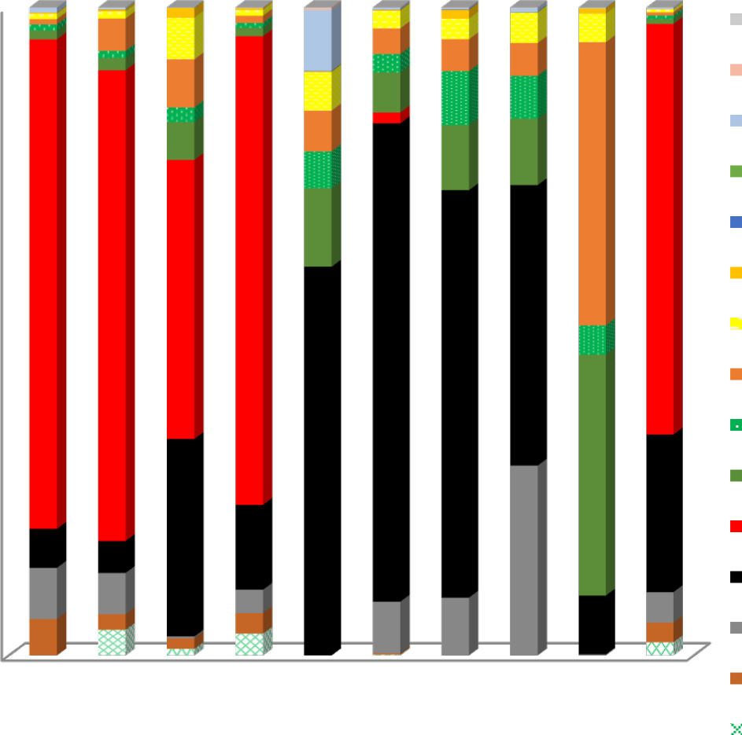

AD AC EP GW OLD HT FAE MAE TE PhO

Bagasse, from sweet sorghum

Beans

Soybean Rape seed Corn gluten Wheat gluten fish meal fish oil Electricity Fry

Direct emissions

Fig. 9. Contribution of the inputs in environmental impact categories of trout farms in Ardal region.

100%

90%

80%

70%

Contribution of inputs

60%

50%

40%

30%

20%

10%

0%

AD AC EP GW OLD HT FAE MAE TE PhO

Natural gas Transportation Diesel

Water

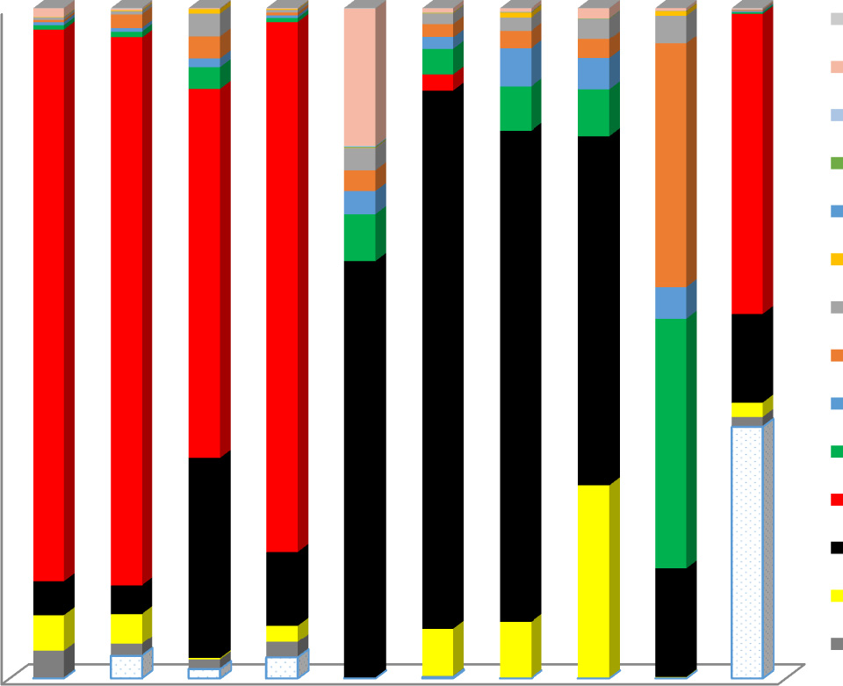

Bagasse, from sweet sorghum

Beans

Soybean Rape seed Corn gluten Wheat gluten fish meal fish oil Electricity Fry

Fig. 10. Contribution of the inputs in environmental impact categories of trout farms in Lordegan region.

and OLD, respectively, while in Lordegan region, fish oil had the share of 80, 73% and 62% on the HT, FAE and OLD, respectively. Also, in Ardal re- gion, wheat gluten and rapeseed meal had the share of 37% and 43% of total contribution to TE, respectively, while in Lordegan region, these two inputs had the share of 16% and 36% of total contribution to TE, re- spectively. Finally, In Lordegan region, the direct emissions from feed consumption, diesel fuel, natural gas and labor had the share of 24% of total contribution to PhO.

Considering that about 7 million tons fish meal and 1 million tons fish oil are produced per year (International fish meal and fish oil orga- nization (FAO, 2006)), the increase in production of aquaculture prod- ucts makes an important challenge for diversification of protein and lipid sources. Using feeds containing high levels of wild-fish protein in raising carnivorous fish is greatly under debate in aquaculture, particu- larly when it comes to comparison of fish farming with commercial fish- ing (Ellingsen and Aanondsen, 2006). In a study conducted in Greece, it was reported that feed in trout farms had 73% and 68% of total contribu- tion to GW and AC, respectively (Aubin et al., 2009). Researches focused on identifying plant-based alternatives to fish meal and oil (FAO, 2006), and there is optimistic outlook to find high-quality inputs to replace them. The use of fish by-products as a complementary the nutritional inputs to plant-based diets seems an interesting way. In this way, de- pendence on the stocks which are needed for producing fish meal and the environmental burdens associated with the fish feed can be de- creased (Papatryphon et al., 2004). However, the availability of these by-products is a problem and they are available only in certain markets, which does not make them a global solution. Considering that most of electricity in Iran is generated from fossil fuels and has a significant

emissions, it is clear that using more efficient electro pumps and aware- ness about the amount of water needed in the different production phases would cause a considerable reduction in the environmental burdens.

The values of characterization, normalization and weighting of the impact categories for a ton produced trout in the regions are shown in Table 9. These values consist of the direct (the emission during trout production) and indirect emissions (the inputs production). The GW as the most important category in Ardal and Lordegan region were cal- culated as 617.61 and 1379.89 kg CO2 per ton of trout, respectively. The main reason for this difference is higher direct emissions in Lordegan re- gion. In similar studies, the value of GW per a ton of trout produced in Germany, Greece and Canada were reported as 2239 kg CO2 (Samuel- Fitwi et al., 2013), 2753 kg CO2 (Aubin et al., 2009) and 2073 kg CO2 (Ayer and Tyedmers, 2009), respectively. Samuel-Fitwi et al. (2013) conducted a LCA study to evaluate different production systems includ- ing extensive, intensive and recirculating aquaculture systems in rain- bow trout production and reported that recirculating aquaculture systems had the largest impact on GW and AC, while its impact on EP was the lowest compared to two other systems. Also, the emissions from feed production had the highest contribution to the GW as 96% and 46% in extensive and intensive system, respectively, while, their contributions to AC were 97% and 73%, respectively. In another study in Canada, LCA approach was used to quantify and compare the poten- tial environmental impacts of culturing salmonids in a conventional ma- rine net-pen system with those of three reportedly environmentally- friendly alternatives; a marine floating bag system; a land-based saltwa- ter flow through system; and a land-based freshwater recirculating

Table 9

The values of characterization, normalization and weighting of the impact categories per ton of trout in the studied regions.

Impact categories Units Characterization (units) Normalization Weighting (pPt)

|  |  |  |  |  |  |  |  |  |  |  |
| --- | --- | --- | --- | --- | --- | --- | --- | --- | --- | --- |
|  | | Ardal | Lordegan |  | Ardal | Lordegan |  | Ardal | Lordegan |  |
| AD | kg Sb eq. | 2.342 | 5.643 |  | 1.417E-09 | 3.183E-09 |  | 141.784 | 317.968 |  |
| AC | kg SO2 eq. | 3.348 | 7.856 |  | 5.186E-09 | 1.135E-08 |  | 518.683 | 1127.58 |  |
| EU | kg PO−3 4 eq. | 0. 954 | 1.183 |  | 1.904E-09 | 3.649E-09 |  | 190.481 | 364.369 |  |
| GW | kg CO2 eq. | 617.61 | 1379.898 |  | 2.443E-09 | 5.463E-09 |  | 244.394 | 546.473 |  |
| OLD | kg CFC11 eq. | 5.12 E-06 | 9.25 E-06 |  | 5.222E-12 | 9.433E-12 |  | 0.522 | 0.943 |  |
| HT | kg 1,4-DB eq. | 77.660 | 134.600 |  | 4.137E-10 | 7.136E-10 |  | 41.370 | 71.288 |  |
| FAE | kg 1,4-DB eq. | 24.680 | 39.891 |  | 3.301E-9 | 5.315E-09 |  | 108.964 | 175.208 |  |
| MAE | kg 1,4-DB eq. | 27,660.551 | 43,030.852 |  | 8.686E-9 | 1.351E-08 |  | 286.645 | 445.882 |  |
| TE | kg 1,4-DB eq. | 1.404 | 1.709 |  | 1.139E-9 | 1.204E-09 |  | 37.594 | 39.540 |  |
| PhO | kg C2H4 eq. | 0.205 | 0.714 |  | 1.134E-9 | 3.932E-09 |  | 113.439 | 393.052 |  |
| Total weighting (EES) |  |  |  |  |  |  |  | 1683.882 | 3484.310 |  |

100

90

80

70

Environmental impacts (%)

60

50

40

30

20

10

0

AD AC EP GW OLD HT FAE MAE TE PhO

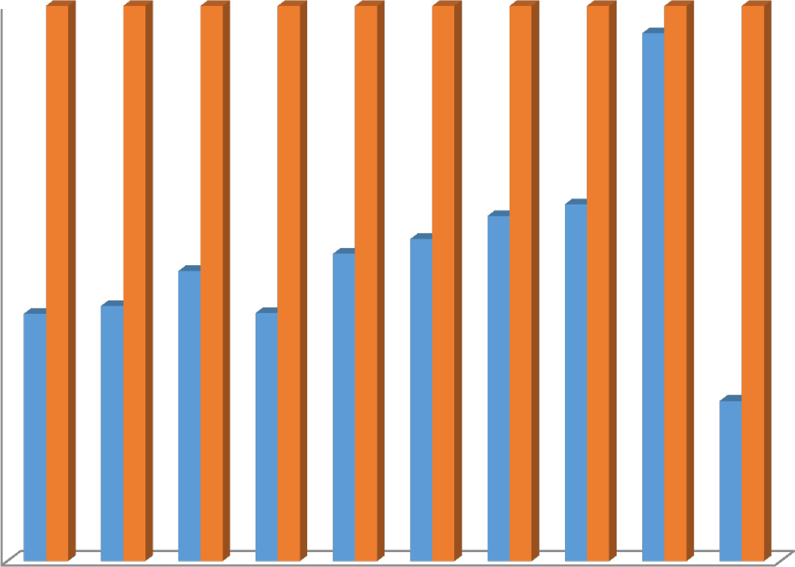

Ardal Lordegan

Fig. 11. The comparative normalization results of trout farms in the studied regions.

system. Their results showed that while the use of these closed- containment systems may reduce the local ecological impacts typically associated with net-pen salmon farming, the increase in material and energy demands may result in a significantly increase in several envi- ronmental impacts of global concern, including GW, AD and AC (Ayer and Tyedmers, 2009).

The normalization values were calculated by SimaPro software which contains the special coefficients for each category. The normaliza- tion values of MAE, AC and FAE were higher than other impact catego- ries. The all normalized impact categories related to Lordegan region were higher in comparison with Ardal region (Fig. 11). More uses of the inputs are the main reason for this difference between the regions. In the final section of the environmental impacts analysis, EEFS was calculated by summing up the values of the weighting column. The EEFS values for a ton of trout produced in Ardal and Lordegan regions were calculated as 1683.88 PPt and 3484.31 PPt, respectively. As it was ex- pected, fish meal had the highest contribution to EEFS in Ardal and

Lordegan regions with 48% and 57%, respectively.

The direct emissions for a ton of trout are presented in Table 10. The direct emissions from diesel fuel, natural gas and human labor were cal- culated based on Table 4. The direct emissions from the feed were esti- mated using nutrient-balance modeling (Cho and Kaushik, 1990). As it can be seen from Table 10, diesel fuel had the highest contribution to

the direct emissions into air. Fish feed, although, had no direct emissions into air but was the only input that had the direct emissions to water.

* 1. *LCA + DEA results*

Based on the PTE scores for the inefficient DMUs calculated by EMS software, the improved inputs was obtained and new LCA analysis con- ducted with the new modified LCI. The ten impact categories computed through SimaPro software based on the optimal condition and com- pared to the impact categories computed based on the actual data (Table 11). According to the LCA + DEA results, in Ardal region, despite the lower environmental impacts, there were more potential to reduce the environmental impacts compared to Lordegan region. Also, there were more potential to reduce the energy inputs in Ardal region com- pared to Lordegan region. The optimal uses of the inputs in Ardal region had the highest potential to reduction of AD and TE as 45.47% and 44.14%, while in Lordegan region, the results showed that TE had the highest reduction potential as 38.49%. The LCA + DEA results showed that improvements of fish meal and wheat gluten had the highest con- tribution to AD and TE, respectively. Moreover, based on LCA + DEA, GW was reduced as 26.43% (454.36 kg CO2 eq per ton of trout) in Ardal region, while in Lordegan region, the reduction of GW was calcu- lated as 8.78% (1258.65 kg CO2 eq. per ton of trout). Finally, the LCA

Table 10

Direct emissions from diesel combustion, natural gas, human labor and feed consumption for 1 ton trout fish.

Direct emissions (kg ton−1) Diesel fuel Natural gas Human labor Feed consumption

Ardal Lordegan Ardal Lordegan Ardal Lordegan Ardal Lordegan

|  |  |  |  |  |  |  |  |
| --- | --- | --- | --- | --- | --- | --- | --- |
| 1. Carbon dioxide 690.745 | 2050.724 | 31.316 | 42.967 | 15.11E-03 | 13.63E-03 | – | – |
| 2. Sulfur dioxide 22.56E-03 | 66.54E-03 | 1.56E-03 | 2.14E-03 | – | – | – | – |
| 3.Methane 28.83E-03 | 85.05E-03 | 6.07E-03 | 8.32E-03 | – | – | – | – |
| 4. Dinitrogen monoxide 26.77E-03 | 78.97E-03 | 5.82E-03 | 7.79E-03 | – | – | – | – |
| 5.Ammonia 44. 6E-04 | 10.37E-03 | – | – | – | – | – | – |
| 6. Hydrocarbons 73.00 E-05 | 21.67E-04 | – | – | – | – | – | – |
| 7. Nitrogen oxides 99.23E-01 | 29.27 E-00 | – | – | – | – | – | – |
| 8. Carbon monoxide 14.04E-01 | 41. 42E-01 | – | – | – | – | – | – |
| 9. Particulates 10.01E-01 | 350.237 | 2.01E-02 | 2.76E-02 | – | – | – | – |
|  |  |  |  |  |  |  | (b2.5 *μ*m) |
| B. Emissions to water |  |  |  |  |  |  |  |
| 10. Dissolved N – | – | – | – | – | – | 46.56 | 69.84 |
| 11. Dissolved P – | – | – | – | – | – | 3.12 | 4.78 |
| 12. Solid N waste – | – | – | – | – | – | 8.65 | 12.97 |
| 13. Solid P waste – | – | – | – | – | – | 5.50 | 9.25 |
| 14. Theoretical O2 demand – | – | – | – | – | – | 110.35 | 155.45 |

A. Emissions to air

Table 11

The values of the impacts categories per a ton trout based on the inputs optimized by DEA in the studied regions.

Impact categories Units Calculated with LCA + DEA Values of improvement Reduction percentage (%)

|  |  |  |  |  |  |  |  |  |  |  |
| --- | --- | --- | --- | --- | --- | --- | --- | --- | --- | --- |
|  | | Ardal | Lordegan |  | Ardal | Lordegan |  | Ardal | Lordegan |  |
| AD | (kg Sb eq) | 1.277 | 4.593 |  | 1.065 | 1.105 |  | 45.47 | 18.60 |  |
| AC | (kg SO2 eq) | 2.353 | 6.288 |  | 0.995 | 1.568 |  | 29.71 | 19.95 |  |
| EP | (kg PO−3 4 eq) | 0.715 | 1.166 |  | 0.239 | 0.017 |  | 25.05 | 1.43 |  |
| GW | (kg CO2 eq) | 454.368 | 1258.652 |  | 163.242 | 121.246 |  | 26.43 | 8.78 |  |
| OLD | (kg CFC 11 eq) | 3.76E-06 | 8.59E-06 |  | 1.36E-06 | 6.64E-07 |  | 26.55 | 7.18 |  |
| HT | (kg 1,4-DB eq) | 57.804 | 124.443 |  | 19.856 | 10.157 |  | 25.56 | 7.54 |  |
| FAE | (kg 1,4-DB eq) | 18.616 | 37.637 |  | 6.064 | 2.254 |  | 24.57 | 5.65 |  |
| MAE | (kg 1,4-DB eq) | 18,954.89 | 40,698.55 |  | 8705.66 | 2332.03 |  | 31.47 | 5.41 |  |
| TE | (kg 1,4-DB eq) | 0.782 | 1.101 |  | 0.618 | 0.689 |  | 44.14 | 38.49 |  |
| PhO | (kg C2H4 eq) | 0.152 | 0.616 |  | 0.053 | 0.098 |  | 25.85 | 13.72 |  |
| EES | pPt | 1223.500 | 3173.909 |  | 460.374 | 308.400 |  | 27.340 | 8.856 |  |

+ DEA results showed that the EEFS value in Ardal and Lordegan re- gions was reduced by 27.34% and 8.85%, respectively. Vázquez-Rowe et al. (2011) coupled LCA with DEA to evaluate the environmental im- pacts of coastal fish production in Spain. Their results showed that using LCA coupled with DEA led to a reduction in diesel fuel consump- tion which had the largest contribution to all impact categories. They re- ported that using LCA coupled with DEA resulted in an increase in operational efficiency, reducing input costs and the environmental burdens.

1. Conclusions

The main aim of this study was to improve the energy efficiency and consequently reduce the environmental impacts in rainbow trout farms in Ardal and Lordegan regions located at Chaharmahal and Bakhtiari Province of Iran. For this purpose, the required data were collected from rainbow trout farms in Ardal and Lordegan regions. Based on the DEA results, the total required energy inputs in Ardal and Lordegan re- gions were calculated as 42,769.71 MJ ton−1 (29.28% saved energy) and 69,777.69 MJ ha−1 (9.59% saved energy), respectively. Also, LCA tool was used to assess the environmental impacts of rainbow trout farms. The LCA results revealed that fish meal, fish oil and electricity in produc- tion stage were the major contributors to the impact categories in the studied regions. Based on LCA + DEA, GW was reduced by 26.43% and 8.78% in Ardal and Lordegan regions, respectively.

Finally, it can be said that DEA is used to show the hot spots in crop production meaning that the producers are informed that for which input there is a higher potential for better management in terms of en- ergy and environmental performance. Then they focus on those inputs with higher potential. In other words, we were not meant to practically reduce energy consumption but we were aimed at finding the sources of energy with higher energy saving potential. When a system is opti- mized, we do not force the production system to reduce all application rates but we are meant to combine different application of inputs in order to reduction of production costs as direct (reduction in the cost of the inputs) and indirect (reduction in the environmental cost). Con- sidering the high feed costs, government could help trout producers by controlling the feed costs especially through providing alternative sources of protein that are necessary to replace the standard fishmeal- based feed and identification of plant-based alternatives to fish meal and oil. Leveling pond bottom and creating a uniform slope could lead to a considerable reduction in water use and electricity. The electricity generation in fossil-based power plants has significant environmental problems. Considering solar potential in Iran, it is suggested that some study be conducted to evaluate the potentials for developing solar power plants and generate more environmentally friendly electricity. Moreover, government measures to use clean energies would also en- courage farmers to use more clean energy technologies. Consequently, quantify the environmental impacts associated with the different

production phases using LCA method can help to identify potential im- provement options that could significantly reduce environmental im- pacts and enhance environmental efficiency of a production system or a product. Also, it could help to identify the underlying problems of the different impacts which is important in finding solutions for achiev- ing sustainability in aquaculture.

Acknowledgment

The authors would like to acknowledge from the Agriculture Sci- ences and Natural Resources University of Khuzestan, Mollasani, Iran for providing financial support for this research.

References

Abedi, M., Mohammadi, H., Ghaffari, M., 2011. Efficiency and profitability of trout breed- ing units in Fars province. Agric. Econ. 5, 93–123 [In Persian with abstract english] b[https://www.sid.ir/fa/journal/ViewPaper.aspx?id=167424](https://www.sid.ir/fa/journal/ViewPaper.aspx?id=167424%3e)N.

Adler, N., Friedman, L., Sinuany-Stern, Z., 2002. [Review of ranking methods in the data en-](http://refhub.elsevier.com/S2589-7217(19)30020-0/rf0005) [velopment analysis context. Eur. J. Oper. Res. 140 (2), 249–26](http://refhub.elsevier.com/S2589-7217(19)30020-0/rf0005)5.

Anonymous, 2003. [PRé Consultants. SimaPro 5 Database Manua](http://refhub.elsevier.com/S2589-7217(19)30020-0/rf0010)l.

Anonymous., 2012. Energy balance sheet, P: 34. Ministry of Energy. b[www.energyconf.ir/](http://www.energyconf.ir/pdf/3.pdf) [pdf/3.pdf](http://www.energyconf.ir/pdf/3.pdf)N.

Anonymous., 2016. Statistical Yearbook of Charmahal Va Bakhtiary province in Iran [In persian]. b[Amar.org.ir/Iran-Statistical-Yearbook](http://Amar.org.ir/-Statistical-Yearbook)N.

Anonymous., 2017. Annual agricultural statistics. of Charmahal Va Bakhtiary province in Iran [In Persian]. b [https://chb-agri-jahad.ir](https://chb-agri-jahad.ir/)N.

Anonymous., 2018. Iran Fisheries Organization [In Persian]. b ([http://shilat.com/site/](http://shilat.com/site/vahed%3e) [vahed](http://shilat.com/site/vahed%3e)N.

Askari Sari, A., Mohammadi, M., 2015. [Evaluation and comparison of arsenic metal in](http://refhub.elsevier.com/S2589-7217(19)30020-0/rf0015) [muscle and liver of farmed fish of silver carp, common carp, grass carp, carp and rain-](http://refhub.elsevier.com/S2589-7217(19)30020-0/rf0015) [bow trout in Ahvaz and Shahrekord. Wetland Ecol. 6, 69–76](http://refhub.elsevier.com/S2589-7217(19)30020-0/rf0015).

Aubin, J., Papatryphon, E., Van der Werf, H.M.G., Petit, J., Morvan, Y.M., 2006. [Characteri-](http://refhub.elsevier.com/S2589-7217(19)30020-0/rf0020) [sation of the environmental impact of a turbot (Scophthalmus maximus)](http://refhub.elsevier.com/S2589-7217(19)30020-0/rf0020) [recirculating production system using Life Cycle Assessment. Aquaculture. 261 (4),](http://refhub.elsevier.com/S2589-7217(19)30020-0/rf0020) [1259–126](http://refhub.elsevier.com/S2589-7217(19)30020-0/rf0020)8.

Aubin, J., Papatryphon, E., Vander Werf, H.M.G., Chatzifotis, S., 2009. [Assessment of the en-](http://refhub.elsevier.com/S2589-7217(19)30020-0/rf0025) [vironmental impact of carnivorous finfish production systems using life cycle assess-](http://refhub.elsevier.com/S2589-7217(19)30020-0/rf0025) [ment. J. Clean. Prod. 17, 354–36](http://refhub.elsevier.com/S2589-7217(19)30020-0/rf0025)1.

Avkiran, N.K., 2001. [Investigating technical and scale efficiencies of Australian universities](http://refhub.elsevier.com/S2589-7217(19)30020-0/rf0030) [through data envelopment analysis. Socio Econ. Plan. Sci. 35 (1), 57–80](http://refhub.elsevier.com/S2589-7217(19)30020-0/rf0030).

Ayer, N.W., Tyedmers, P.H., 2009. [Assessing alternative aquaculture technologies: life](http://refhub.elsevier.com/S2589-7217(19)30020-0/rf0035) [cycle assessment of salmonid culture systems in Canada. J. Clean. Prod. 17, 362–373](http://refhub.elsevier.com/S2589-7217(19)30020-0/rf0035).

Banker, R., Charnes, A., Cooper, W., 1984. [Some models for estimating technical and scale](http://refhub.elsevier.com/S2589-7217(19)30020-0/rf0040) [inefficiencies in Data Envelopment Analysis. Manag. Sci. 30, 1078–109](http://refhub.elsevier.com/S2589-7217(19)30020-0/rf0040)2.

Barnes, A.P., 2006. [Does multi-functionality affect technical efficiency? A non-parametric](http://refhub.elsevier.com/S2589-7217(19)30020-0/rf0045) [analysis of the Scottish dairy industry. J. Environ. Manag. 80, 287–294](http://refhub.elsevier.com/S2589-7217(19)30020-0/rf0045).

Bozoglu, M., Ceyhan, V., 2009. [Energy conversion efficiency of trout and sea bass produc-](http://refhub.elsevier.com/S2589-7217(19)30020-0/rf0050) [tion in the Black Sea, Turkey. Energy. 34, 199–204](http://refhub.elsevier.com/S2589-7217(19)30020-0/rf0050).

Brentrup, F., Küsters, J., Kuhlmann, H., Lammel, J., 2004. [Environmental impact assessment](http://refhub.elsevier.com/S2589-7217(19)30020-0/rf0055) [of agricultural production systems using the life cycle assessment methodology. I.](http://refhub.elsevier.com/S2589-7217(19)30020-0/rf0055) [Theoretical concept of a LCA method tailored to crop production. Eur. J. Agron. 20,](http://refhub.elsevier.com/S2589-7217(19)30020-0/rf0055) [247–26](http://refhub.elsevier.com/S2589-7217(19)30020-0/rf0055)4.

Bureau, D.P., Gunther, S., Cho, C.Y., 2002. [Chemical composition and preliminary theoret-](http://refhub.elsevier.com/S2589-7217(19)30020-0/rf0060) [ical estimates of waste outputs of rainbow trout reared in commercial cage culture](http://refhub.elsevier.com/S2589-7217(19)30020-0/rf0060) [operations in Ontario. N. Am. J. Aquac. 65, 33–38](http://refhub.elsevier.com/S2589-7217(19)30020-0/rf0060).

Cacho, O.J., 1990. [Protein and fat dynamics in fish: a bioenergetic model applied to aqua-](http://refhub.elsevier.com/S2589-7217(19)30020-0/rf0065) [culture. Ecol. Model. 50, 33–56](http://refhub.elsevier.com/S2589-7217(19)30020-0/rf0065).

Charnes, A., Cooper, W.W., Rhodes, E., 1978. [Measuring the efficiency of decision making](http://refhub.elsevier.com/S2589-7217(19)30020-0/rf0070) [units. Eur. J. Oper. Res. 2 (6), 429–44](http://refhub.elsevier.com/S2589-7217(19)30020-0/rf0070)4.

Chauhan, N.S., Mohapatra, P.K.J., Pandey, K.P., 2006. [Improving energy productivity in](http://refhub.elsevier.com/S2589-7217(19)30020-0/rf0075) [paddy production through benchmarking an application of Data Envelopment Anal-](http://refhub.elsevier.com/S2589-7217(19)30020-0/rf0075) [ysis. Energy Convers. Manag. 47, 1063–1085.](http://refhub.elsevier.com/S2589-7217(19)30020-0/rf0075)

Chen, X., Samson, S., Tocqueville, A., Aubin, J., 2015. [Environmental assessment of trout](http://refhub.elsevier.com/S2589-7217(19)30020-0/rf0080) [farming in France by life cycle assessment: using bootstrapped Principal Component](http://refhub.elsevier.com/S2589-7217(19)30020-0/rf0080) [Analysis to better define system classification. J. Clean. Prod. 87, 87–95](http://refhub.elsevier.com/S2589-7217(19)30020-0/rf0080).

Cho, C.Y., Kaushik, S.J., 1990. [Nutritional energetics in fish: energy and protein utilization](http://refhub.elsevier.com/S2589-7217(19)30020-0/rf0085) [in rainbow trout (Salmo gairdneri). World Rev. Nutr. Diet. 61, 132–17](http://refhub.elsevier.com/S2589-7217(19)30020-0/rf0085)2.

Cochran, W.G., 1977. [Sampling Techniques. third ed. John Wiley & Sons, New York. US](http://refhub.elsevier.com/S2589-7217(19)30020-0/rf0090)A. Efole Ewoukem, T., Aubin, J., Mikolasek, M.S., Corson, M., Tomedi-Eyango, J., Tchoumboue, H.M.G., Vander Werf, D., Ombredane, D., 2012. [Environmental impacts of farms inte-](http://refhub.elsevier.com/S2589-7217(19)30020-0/rf0095)

[grating aquaculture and agriculture in Cameroon. J. Clean. Prod. 28, 208–21](http://refhub.elsevier.com/S2589-7217(19)30020-0/rf0095)4.

Elhami, B., Akram, A., Khanali, M., 2016. [Optimization of energy consumption and envi-](http://refhub.elsevier.com/S2589-7217(19)30020-0/rf0100) [ronmental impacts of chickpea production using data envelopment analysis (DEA)](http://refhub.elsevier.com/S2589-7217(19)30020-0/rf0100) [and multi objective genetic algorithm (MOGA) approaches. IPA. 3 (3), 190–205](http://refhub.elsevier.com/S2589-7217(19)30020-0/rf0100).

Ellingsen, H., Aanondsen, S.A., 2006. [Environmental impacts of wild caught cod and](http://refhub.elsevier.com/S2589-7217(19)30020-0/rf0105) [farmed salmon – a comparison with chicken. Int. J. Life Cycle Assess. 11 (1), 60–65](http://refhub.elsevier.com/S2589-7217(19)30020-0/rf0105).

EPA (Environmental Protection Agency), 1998. Emission Factor Documentation for AP-42 Section 1.4-Natural Gas Combustion, Technical Support Division, Office of Air Quality Planning and Standards, Research Triangle Park, NC. [http://www3.epa.gov/ttnchie1/](http://www3.epa.gov/ttnchie1/ap42/ch01/bgdocs/b01s04.pdf) [ap42/ch01/bgdocs/b01s04.pdf](http://www3.epa.gov/ttnchie1/ap42/ch01/bgdocs/b01s04.pdf).

FAO (Food and Agriculture Organisation), 2006. [State of world aquaculture. Fisheries](http://refhub.elsevier.com/S2589-7217(19)30020-0/rf0115) [technical paper no. 50](http://refhub.elsevier.com/S2589-7217(19)30020-0/rf0115)0.

FAO (Food and Agriculture Organisation), 2018. The State of World Fisheries and Aqua- culture (SOFIA). b<http://www.fao.org/3/i9540en/I9540EN.pdf>N.

Fathollahi, H., Mousavi-Avval, S.H., Akram, A., Rafiee, S., 2018. [Comparative energy, eco-](http://refhub.elsevier.com/S2589-7217(19)30020-0/rf0120) [nomic and environmental analyses of forage production systems for dairy farming.](http://refhub.elsevier.com/S2589-7217(19)30020-0/rf0120)

[J. Clean. Prod. 182, 852–862](http://refhub.elsevier.com/S2589-7217(19)30020-0/rf0120).

Ghasemi Mobtaker, H., Akram, A., Keyhani, A., 2012. [Energy use and sensitivity analysis of](http://refhub.elsevier.com/S2589-7217(19)30020-0/rf0125) [energy inputs for alfalfa production in Iran. Energy Sustain. Develop. 16, 84–89](http://refhub.elsevier.com/S2589-7217(19)30020-0/rf0125).

Goglio, P., Smith, W.N., Grant, B.B., Desjardins, R.L., McConkey, B.G., Campbell, C.A., Nemecek, T., 2015. [Accounting for soil carbon changes in agricultural life cycle assess-](http://refhub.elsevier.com/S2589-7217(19)30020-0/rf0130) [ment (LCA): a review. J. Clean. Prod. 104, 23–39](http://refhub.elsevier.com/S2589-7217(19)30020-0/rf0130).

Guinée, J.B., Heijungs, R., Huppes, G., Zamagni, A., Masoni, P., Buonamici, R., Ekvall, T., Rydberg, T., 2011. [Life cycle assessment: past, present, and future. Environ. Sci.](http://refhub.elsevier.com/S2589-7217(19)30020-0/rf0135) [Technol. 45 (1), 90–96](http://refhub.elsevier.com/S2589-7217(19)30020-0/rf0135).

Hossain, M.A., Rahman, M.M., Chakraborty, S.C., 1997. [Digestible protein and energy value](http://refhub.elsevier.com/S2589-7217(19)30020-0/rf0140) [of fish meal, dextrin, fish oil and soybean oil for Thai sharpunti (Puntius gonionotus](http://refhub.elsevier.com/S2589-7217(19)30020-0/rf0140) [Bleeker). Bangladesh. Fish. Res. 1 (1), 65–72](http://refhub.elsevier.com/S2589-7217(19)30020-0/rf0140).

Houshyar, E., Azadi, H., Almasi, M., Sheikh Davoodi., M.J., 2012. Sustainable and efficient energy consumption of corn production in Southwest Iran: combination of multi- fuzzy and DEA modeling. Energy. 44, 672–681.

Iribarren, D., Vázquez-Rowe, I., Moreira, M.T., Feijoo, G., 2010. [Further potentials in the](http://refhub.elsevier.com/S2589-7217(19)30020-0/rf0145) [joint implementation of life cycle assessment and data envelopment analysis. Sci.](http://refhub.elsevier.com/S2589-7217(19)30020-0/rf0145) [Total Environ. 408 (22), 5265–5272](http://refhub.elsevier.com/S2589-7217(19)30020-0/rf0145).

ISO 14040, 2006. [Environmental management life cycle assessment principles and frame-](http://refhub.elsevier.com/S2589-7217(19)30020-0/rf0150) [work. Int. J. Life Cycle Assess. 11 (2), 36](http://refhub.elsevier.com/S2589-7217(19)30020-0/rf0150).

ISO 14044, 2006. [Environmental management–life cycle assessment—requirements and](http://refhub.elsevier.com/S2589-7217(19)30020-0/rf0155) [guidelines. Eur. Comm. Stand. Int. Orga](http://refhub.elsevier.com/S2589-7217(19)30020-0/rf0155)n.

Khoshnevisan, B., Rafiee, S., Mousazadeh, H., 2013. [Environmental impact assessment of](http://refhub.elsevier.com/S2589-7217(19)30020-0/rf0160) [open field and greenhouse strawberry production. Eur. J. Agron. 50, 29–37](http://refhub.elsevier.com/S2589-7217(19)30020-0/rf0160).

Khoshnevisan, B., Rafiee, S., Mousazadeh, H., 2014a. [Application of multi-layer adaptive](http://refhub.elsevier.com/S2589-7217(19)30020-0/rf0165) [neuro-fuzzy inference system for estimation of greenhouse strawberry yield. Mea-](http://refhub.elsevier.com/S2589-7217(19)30020-0/rf0165) [surement. 47, 903–91](http://refhub.elsevier.com/S2589-7217(19)30020-0/rf0165)0.

Khoshnevisan, B., Motamed Shariati, H., Rafiee, S., Mousazadeh, H., 2014b. [Comparison of](http://refhub.elsevier.com/S2589-7217(19)30020-0/rf0170) [energy consumption and GHG emissions of open field and greenhouse strawberry](http://refhub.elsevier.com/S2589-7217(19)30020-0/rf0170) [production. Renew. Sust. Energ. Rew. 29, 316–32](http://refhub.elsevier.com/S2589-7217(19)30020-0/rf0170)4.

Khoshnevisan, B., Bolandnazar, E., Barak, S., Shamshirband, S., Maghsoudlou, H., Torki, A., Abdullah, G., 2015. [A clustering model based on an evolutionary algorithm for better](http://refhub.elsevier.com/S2589-7217(19)30020-0/rf0175) [energy use in crop production. Stoch. Environ. Res. Risk. Assess. 29 (8), 1921–1935](http://refhub.elsevier.com/S2589-7217(19)30020-0/rf0175). Kitani, O., 1999. [Energy and Biomass Engineering, CIGR Handbook of Agricultural Engi-](http://refhub.elsevier.com/S2589-7217(19)30020-0/rf0180)

[neering. ASAE Publications, St Joseph, MI, p. 35](http://refhub.elsevier.com/S2589-7217(19)30020-0/rf0180)1.

Koocheki, A., Ghorbani, R., Monadi, F., Alizadeh, Y., Moradi, R., 2011. [Pulses production](http://refhub.elsevier.com/S2589-7217(19)30020-0/rf0185) [Systems in Term of energy use efficiency and economical analysis in Iran. IJEEP. 4](http://refhub.elsevier.com/S2589-7217(19)30020-0/rf0185) [(1), 95–10](http://refhub.elsevier.com/S2589-7217(19)30020-0/rf0185)6.

V.Medeiros, M., Aubin, J., Camargo, A., 2017. Life cycle assessment of fish and prawn pro- duction: comparison of monoculture and polyculture freshwater systems in Brazil. J. Clean. Prod. 156, 528–537.

Mohammadi, A., Rafiee, S., Mohtasebi, S.S., Mousavi-Avval, S.H., Rafiee, H., 2011. [Energy](http://refhub.elsevier.com/S2589-7217(19)30020-0/rf0190) [efficiency improvement and input cost saving in kiwifruit production using data en-](http://refhub.elsevier.com/S2589-7217(19)30020-0/rf0190) [velopment analysis approach. Renew. Energy 36, 2573–2579.](http://refhub.elsevier.com/S2589-7217(19)30020-0/rf0190)

Mohammadi, A., Rafiee, S., Jafari, A., Dalgaard, T., Knudsen, M. T., Keyhani, A., Mousavi- Avval., S.H., Hermansen, J.E., 2013. Potential greenhouse gas emission reductions in soybean farming: a combined use of life cycle assessment and data envelopment analysis. J. Clean. Prod. 54, 89–100.

Mohseni, P., Borghei, A.M., Khanali, 2018. [Application of data envelopment analysis ap-](http://refhub.elsevier.com/S2589-7217(19)30020-0/rf0195) [proach to reduce environmental impacts and increase energy efficiency in grape pro-](http://refhub.elsevier.com/S2589-7217(19)30020-0/rf0195) [duction. J. Clean. Prod. 197 (1), 939–94](http://refhub.elsevier.com/S2589-7217(19)30020-0/rf0195)7.

Mousavi-Avval, S.H., Rafiee, S., Jafari, A., Mohammadi, A., 2011a. [Improving energy use ef-](http://refhub.elsevier.com/S2589-7217(19)30020-0/rf0200) [ficiency of canola production using data envelopment analysis (DEA) approach. En-](http://refhub.elsevier.com/S2589-7217(19)30020-0/rf0200) [ergy. 36, 2765–2772.](http://refhub.elsevier.com/S2589-7217(19)30020-0/rf0200)

Mousavi-Avval, S.H., Rafiee, S., Jafari, A., Mohammadi, A., 2011b. [Optimization of energy](http://refhub.elsevier.com/S2589-7217(19)30020-0/rf0205) [consumption for soybean production using Data Envelopment Analysis (DEA) ap-](http://refhub.elsevier.com/S2589-7217(19)30020-0/rf0205) [proach. Appl. Energy 88, 3765–3772.](http://refhub.elsevier.com/S2589-7217(19)30020-0/rf0205)

Mousavi-Avval, S.H., Rafiee, S., Sharifi, M., Hosseinpour, S., Shah, A., 2017. [Combined appli-](http://refhub.elsevier.com/S2589-7217(19)30020-0/rf0210) [cation of life cycle assessment and adaptive neuro-fuzzy inference system for model-](http://refhub.elsevier.com/S2589-7217(19)30020-0/rf0210) [ing energy and environmental emissions of oilseed production. J. Renew. and Sustain.](http://refhub.elsevier.com/S2589-7217(19)30020-0/rf0210) [Energy. 78, 807–82](http://refhub.elsevier.com/S2589-7217(19)30020-0/rf0210)0.

Nabavi-Pelesaraei, A., Abdi, R., Rafiee, S., Ghasemi-Mobtaker, H., 2014. [Optimization of en-](http://refhub.elsevier.com/S2589-7217(19)30020-0/rf0215) [ergy required and greenhouse gas emissions analysis for orange producers using data](http://refhub.elsevier.com/S2589-7217(19)30020-0/rf0215) [envelopment analysis approach. J. Clean. Prod. 65, 311–317](http://refhub.elsevier.com/S2589-7217(19)30020-0/rf0215).

Nabavi-Pelesaraei, A., Rafiee, S., Mohtasebi, S.S., Hosseinzadeh-Bandbafha, H., Chau, K.W., 2017. [Energy consumption enhancement and environmental life cycle assessment in](http://refhub.elsevier.com/S2589-7217(19)30020-0/rf0220) [paddy production using optimization techniques. J. Clean. Prod. 162, 571–586](http://refhub.elsevier.com/S2589-7217(19)30020-0/rf0220).

Nemecek, T., Kagi, T., 2007. Life cycle inventories of agricultural production systems. Ecoinvent report No. 15, Dübendorf, CH: Swiss Centre for Life Cycle Inventories ([www.EcoInvent.org/documentation/reports](http://www.EcoInvent.org/documentation/reports)).

Papatryphon, E., Petit, J., van der Werf, H.M.G., 2004. [The development of life cycle assess-](http://refhub.elsevier.com/S2589-7217(19)30020-0/rf0225) [ment for the evaluation of rainbow trout farming in France. Life cycle assessment in](http://refhub.elsevier.com/S2589-7217(19)30020-0/rf0225) [the agri-food sector. In: Halberg, N. (Ed.), Proceedings from the 4th International](http://refhub.elsevier.com/S2589-7217(19)30020-0/rf0225) [Conference. Danish Institute of Agricultural Sciences, Horsens, Denmark, pp. 73–80](http://refhub.elsevier.com/S2589-7217(19)30020-0/rf0225).

Rebitzer, G., Ekvall, T., Frischknecht, R., Hunkeler, D., Norris, G., Rydberg, T., Schmidt, W.P., Suh, S., Weidema, B.P., Pennington, D.W., 2004. [Life cycle assessment: part 1: frame-](http://refhub.elsevier.com/S2589-7217(19)30020-0/rf0230) [work, goal and scope definition, inventory analysis, and applications. Environ. Int. 30,](http://refhub.elsevier.com/S2589-7217(19)30020-0/rf0230) [701–72](http://refhub.elsevier.com/S2589-7217(19)30020-0/rf0230)0.

Samuel-Fitwi, B., Nagel, F., Meyer, S., Schroeder, J.P., Schulz, C., 2013. [Comparative life](http://refhub.elsevier.com/S2589-7217(19)30020-0/rf0235) [cycle assessment (LCA) of raising rainbow trout (Oncorhynchus mykiss) in different](http://refhub.elsevier.com/S2589-7217(19)30020-0/rf0235) [production systems. Aquac. Engin. 54, 85–92](http://refhub.elsevier.com/S2589-7217(19)30020-0/rf0235).

Schnapp, R., 2012. [Energy statistics for energy efficiency indicators. Joint Rosstat—IEA En-](http://refhub.elsevier.com/S2589-7217(19)30020-0/rf0240) [ergy Statistics Workshop Moscow.](http://refhub.elsevier.com/S2589-7217(19)30020-0/rf0240)

Seiford, L,M., Thrall, R.M., 1990. Recent developments in DEA: the mathematical program- ming approach to frontier analysis. J. Econom. 46,7–38.

Shahvarooghi Farahani, S., Asoodar, M.A., 2017. [Life cycle environmental impacts of](http://refhub.elsevier.com/S2589-7217(19)30020-0/rf0245) [bioethanol production from sugarcane molasses in Iran. Environ. Sci. Pollut. Res. 24](http://refhub.elsevier.com/S2589-7217(19)30020-0/rf0245) [(11), 1–10](http://refhub.elsevier.com/S2589-7217(19)30020-0/rf0245).

Shamshirband, S., Khoshnevisan, B., Yousefi, M., Bolandnazar, E., Anuar, N.B., Abdol Wahab, A.W., Rehman Khan, S.U., 2015. [A multiobjective evolutionary algorithm for](http://refhub.elsevier.com/S2589-7217(19)30020-0/rf0250) [energy management of agricultural systems – a case study in Iran. Renew. Sust. En-](http://refhub.elsevier.com/S2589-7217(19)30020-0/rf0250) [ergy Rev. 44, 457–46](http://refhub.elsevier.com/S2589-7217(19)30020-0/rf0250)5.

Stokes, J.R., Tozer, P.R., Hyde, J., 2007. [Identifying efficient dairy producers using data en-](http://refhub.elsevier.com/S2589-7217(19)30020-0/rf0255) [velopment analysis. J. Dairy Sci. 90 (5), 2555–256](http://refhub.elsevier.com/S2589-7217(19)30020-0/rf0255)2.

Vázquez-Rowe, I., Iribarren, D., Hospido, A., Moreira, M.T., Feijoo, G., 2011. [Computation of](http://refhub.elsevier.com/S2589-7217(19)30020-0/rf0260) [operational and environmental benchmarks within selected Galician fishing fleets.](http://refhub.elsevier.com/S2589-7217(19)30020-0/rf0260) [(NW Spain). J. Ind. Ecol. 15 (5), 776–79](http://refhub.elsevier.com/S2589-7217(19)30020-0/rf0260)5.

Zhou, P., Ang, B.W., Poh, K.L., 2008. [Measuring environmental performance under differ-](http://refhub.elsevier.com/S2589-7217(19)30020-0/rf0265) [ent environmental DEA technologies. Energy Econom. 30 (1), 1–14](http://refhub.elsevier.com/S2589-7217(19)30020-0/rf0265).