[Applied Computing and Informatics 15 (2019) 19–26](https://doi.org/10.1016/j.aci.2017.09.004)

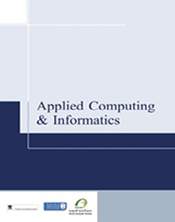

Contents lists available at [ScienceDirect](http://www.sciencedirect.com/science/journal/22108327)

Applied Computing and Informatics

journal homepage: [www.sciencedirect.com](http://www.sciencedirect.com/)

Original Article

Integrating educational theories into a feasible digital environment



Zois Koukopoulos ⇑, Dimitrios Koukopoulos

*Dept. of Cultural Heritage Management & New Technologies, University of Patras, Agrinio, Greece*

# a r t i c l e i n f o

*Article history:*

Received 8 May 2017

Revised 28 June 2017

Accepted 16 September 2017

Available online 19 September 2017

*Keywords:*

Cultural heritage teaching Learning objects

Mobile learning Collaborative learning Content crowd-sourcing

# a b s t r a c t

Nowadays there is a tremendous effort to enhance educational procedure with the incorporation of new technologies aiming at the better understanding of educational material from students. In this direction many theories have been developed, some of which have been implemented into digital systems. A chal- lenge here is to develop a system that integrates more than one of such theories in a harmonic way for the benefit of student community. In this work we attempt to give an answer to this challenge proposing a novel system that integrates the main characteristics of three well-known educational theories: learning objects, collaborative learning and mobile learning in the context of cultural heritage teaching and learn- ing. Evaluation results suggest that such an attempt is technically feasible, the integrated characteristics of the educational theories remain visible to educators of cultural heritage courses, while cultural her- itage educators positively accept the potential incorporation of the platform in the educational procedure.

© 2017 The Authors. Production and hosting by Elsevier B.V. on behalf of King Saud University. This is an

open access article under the CC BY-NC-ND license (<http://creativecommons.org/licenses/by-nc-nd/4.0/>).

1. Introduction

Education is a field where Information Technology (IT) has made significant impact in the last 20 years [1,5,10–12,18,20]. School curricula all over the world include IT courses that intro- duce modern technology to students helping them to develop new skills, necessary for their later life. In addition, teachers and professors of traditional courses like history, mathematics or geog- raphy try to use computers, mobile devices and educational soft- ware to connect with their students more efficiently and profoundly and enhance the quality of educational procedure [6,20,21,25–27]. Cultural heritage related courses could not ignore this new reality. Computers and educational software invaded teaching and learning of cultural heritage related courses adding value to cultural heritage pedagogy, education and learning [33]. Such courses bare their own unique combination of characteristics like the capability to be conducted outside the classroom on a cul- tural heritage site or monument and the high level of interactivity

* Corresponding author at: Dept. of Cultural Heritage Management & New Technologies, University of Patras, 2 G. Seferi, 30100 Agrinio, Greece.

*E-mail addresses:* [zkoukopu@upatras.gr](mailto:zkoukopu@upatras.gr) (Z. Koukopoulos), dkoukopoulos@ upatras.gr (D. Koukopoulos).

Peer review under responsibility of King Saud University.

**Production and hosting by Elsevier**

among the teacher and her/his students [7]. As authors in [33] indi- cate ‘‘The possibility of examining the context and the landscape where a Cultural Heritage artifact was/is located has important consequences on the study of the artifact itself and on its analysis and evaluation”. Moreover, cultural heritage courses attempt to disseminate large amounts of knowledge. Thus, teachers of such courses tend to ask from their students to form collaborative teams and explore cultural heritage content together in order to come in contact with as much knowledge as possible through their own studying or the discoveries of their classmates [7]. Furthermore, cultural heritage courses share common knowledge regardless of the time and place of the educational process. Cultural heritage content has a universal scope and can be used by teachers and stu- dents all over the world [33].

The integration of the above characteristics to a unified educa- tional digital environment for cultural heritage courses would not have a solid background without the guidance of approved educa- tional theories. Collaborative learning theory promotes student collaboration and active participation, mobile learning theory explains how to effectively use mobile technology for teaching and learning inside and outside the classroom and learning objects theory guides the creation of re-usable, aggregation-ready, inde- pendent and meta-data enrichable educational content. More specifically, collaborative learning theory [5] guides the formation of small teams in which students work together to reach a com- mon educational goal. Every student participates actively and she/he is responsible to fulfil her/his assigned task in order to help the team. Mobile learning [12,24] provides unique characteristics

<https://doi.org/10.1016/j.aci.2017.09.004>

2210-8327/© 2017 The Authors. Production and hosting by Elsevier B.V. on behalf of King Saud University.

This is an open access article under the CC BY-NC-ND license (<http://creativecommons.org/licenses/by-nc-nd/4.0/>).

like portability, user mobility, pervasiveness, ubiquity and imme- diate interaction with the external environment making learning experience more engaging and interesting for young students. Learning objects theory [10] uses small, independent, reusable, aggregation-ready educational units as the main element of educa- tional procedure. Such units can be designed and implemented easily with the help of digital means and can become available to students during learning process regardless of the digital environ- ment or tools they use. Those educational theories can be easily implemented in IT applications, since they have guided the imple- mentation of numerous educational software applications [1,6,7,23,31,32].

In this context some fundamental questions arise. Could a dig- ital educational environment for cultural heritage efficiently inte- grate the main characteristics of learning objects, collaborative and mobile learning theories into a feasible unified framework in technical terms? How can the basic characteristics of those educa- tional theories remain visible to educators and students when they are incorporated in a single educational platform? Will cultural heritage management educators accept such an environment?

The above IT-ready educational theories have guided the design and implementation of an educational platform for cultural her- itage courses. The platform provides a fully personalized learning environment, implements various services that promote collabora- tion among students and uses mobile applications to disengage the educational process from the classroom transferring it to the field and thus providing an immersive and pervasive learning experi- ence. Moreover, the system organizes information in learning objects that can be used independently or in collections and it also gives users the opportunity to provide personalized tagging and metadata to each learning object. The platform supports a user- friendly and interactive environment that collects and presents cultural heritage information spanning in various cultural disci- plines. Registered users are able to contribute primitive or existing cultural content and create their personal learning units, working alone or in teams. Teachers can monitor student interaction with the system in real-time guiding students to construct collective knowledge through collaboration and co-dependent tasking and checking students’ contributions for validity and soundness. In order to measure the acceptability of the proposed platform, we performed a qualitative evaluation with the help of undergraduate university students who have the potential to become educators of cultural heritage courses in the near future at primary or secondary schools. Evaluation results suggest that the integration of the main characteristics of certain educational theories has been success- fully performed.

1. State of the art

The integration and adaptation of characteristics from collabo- rative learning theory or mobile learning theory or learning objects theory to the implementation of educational software applications have been proven feasible in numerous cases [1,6,11,16,19,23]. Wang [1] introduces the design of a collaborative learning environ- ment that focuses on making collaboration friendlier among stu- dents. Chen and Choi [6] present the design of an online collaborative location-aware platform for history learning. Dorca et al. [23] present an efficient approach for personalization of the teaching process using learning objects. A thorough discussion about various technical aspects of mobile learning including usability, user experience and accessibility is provided in [11].

Various platforms have been introduced in the field of cultural heritage education [2,3,17,22]. WebQuests [2] is an educational environment that promotes inquiry-oriented educational activities based on online resources providing numerous cultural heritage

lessons. MedcGame [3] is a collaborative cultural heritage interac- tive software that attempts to engage students in an active learn- ing process. The MusEd Platform [17] offers an online learning repository of reusable cultural heritage content, organized in learn- ing objects. Castle Route [22] urges students to reflect, investigate, disseminate and share cultural heritage and historical content cre- ating a collaborative environment.

Some platforms achieved in implementing characteristics from two of the above theories [7,31,32]. The aCME system is a general- purpose mobile infrastructure that aims at enhancing mobile seamless learning and promotes collaboration among teachers and students [32]. Students and teachers engage in online discus- sions included in predefined courses. The system is platform- independent as it can be accessed through any device and from any location and tailorable as it supports the integration of new functionalities in order to meet personalized user needs. While aCME is tailor-made for usage inside an educational environment, the proposed platform is a participatory cultural environment which can be used as an educational tool for seamless learning offering more features comparing to aCME. aCME uses conversa- tion as a basic educational tool. Teachers initiate discussions offer- ing related information and students participate in the conversation through their mobile devices. In the proposed plat- form a teacher can invite her/his students to participate in a course providing their own material. This material can be captured from the students through the Collector application. The teacher can author the student-contributed material proposing the necessary modifications and checking students throughout the procedure. In the proposed platform all the contributed material can be visu- alized through an interactive cultural map service. Students can incorporate material contributed by other users (colleagues or not) in their coursework. A discussion forum feature is also pro- vided as a complementary tool for the conduct of conversations among teachers and students.

The COLLAGE platform [31] implements the characteristics of various IT-ready educational theories like mobile learning, game- based learning and collaborative learning. The COLLAGE platform and the proposed platform resemble in various features. Both sys- tems allow students to create their own content and share, reuse, evaluate and comment educational material. Both systems offer rich multimedia content and support mobile educational activities outside the classroom. Students in both platforms can collaborate in a project. Both platforms are intended for use by both students and teachers. However the two platforms have some fundamental differences. The presented platform promotes learning through the management of cultural heritage content, while COLLAGE uses educational interactive games. The proposed platform organizes content following the principles and standards of Learning Objects theory. Even though COLLAGE supports content reuse and meta- data enrichment, it does not obviously follow a specific established Learning Objects standard. The presented platform’s design was guided by the acceptable IEEE 1484.12.1-2002 standard for Learn- ing Object Metadata version 1.3 (LOM Standard) [28]. Furthermore, the COLLAGE platform supports mainly mobile users and outdoor learning. On the other hand, the presented platform works equally well for indoor and outdoor classroom activities. The proposed platform allows public content contribution, while in the COLLAGE platform contributions are made by students and teachers. Lastly, the COLLAGE platform is intended for use by secondary school students and teachers, while our platform targets students of all grades from elementary school to academic students and professors.

The LAMP/Pulu platform [7] is a mobile digital guiding and learning platform that implements characteristics from mobile learning and collaborative learning. LAMP/Pulu urges students to engage in the learning procedure by exploring a cultural heritage

site in real-time using mobile devices. The platform allows stu- dents and teachers to contribute personal content based on their experiences or take part in educational discussions. In LAMP/Pulu platform, students learn and construct personal experiences through group work, collaboration and interaction in small groups. The LAMP/Pulu platform makes a primitive step towards the orga- nization of educational information in units. Those units are re- usable within the context of the project, but they are neither plat- form independent as they can be only used within the LAMP plat- form, nor aggregation-ready or metadata enrichable as a typical learning object should be.

Many researchers attempted to measure or evaluate the accep- tance of educational systems [15,18,20]. Gan et al. [15] examine the positive effect of interactive digital media on collaborative learning in higher education for both instructors and students. Domingo and Gargante [20] investigate the impact of using mobile learning applications in primary education from teachers’ percep- tion. Sung et al. found that the application of mobile devices to education has a moderate mean effect size extracting benefits and drawbacks of mobile learning [18].

1. Proposed educational platform

The proposed system is an educational participatory digital platform for gathering and disseminating cultural heritage content, which can be used during the educational procedure. The platform has been designed to integrate the main characteristics of three different educational theories: learning objects, collaborative learning and mobile learning, while also offering features found in other educational theories like constructivism and multimedia learning.

* 1. *Educational content*

Guided by learning objects theory, the system has been designed to organize educational content in units. Each unit retains the main characteristics of a learning object as they have been declared by learning objects theory [10]. More specifically, each unit contains a small amount of information and it can be used by one or more individuals simultaneously. Each unit is semanti- cally independent from other ones and it can be used on its own or be aggregated in a collection with other units, which share a

common semantical feature. A unit can be reused as many times as desired without losing its value and it can be enriched by addi- tional information in a personalized manner.

In order to achieve those design goals we relied on the widely acceptable LOM Standard [28]. In this specification, educational metadata are divided into nine top level categories: general, life cycle, meta-metadata, technical, educational, rights, relation, anno- tation, and classification. Each one of those categories is refined in various fields giving semantics to each learning object. We imple- mented the above specifications by adding the appropriate fields to the database table that stores system educational content. Each unit appears as a table record with a significant number of fields reflecting the various top level categories of the standard. Meta- data information appears in the xml file which is exported by the database table and contains system’s educational content. The xml file can be reused in other educational platforms. Moreover, since xml is a platform-independent scripting language, system’s educational content can be exploited by various applications achieving a high level of interoperability like IMS Editor Vimse

[29] and LOM-Editor [30].

Learning objects are aggregated in collections based on general and educational elements as they are described in their metadata. More specifically, educational units can be aggregated in collec- tions per cultural discipline, keyword, interactivity type and level, context, age range, difficulty, learning time and semantic density. If a teacher wants to create a specific collection, she/he can download the corresponding xml file with filtered content based on her/his needs.

All content is provided by platform users, which retain owner- ship over their contributions and they are allowed to manage their own content (edit or delete it). Users can contribute content through a user-friendly screen (Fig. 1) or via platform’s dedicated mobile application (Fig. 2) in a single unit each time. Each unit con- sists of information in the form of text, audio, images, video and multimedia like notes, descriptions, historical background infor- mation, theatrical plays and scripts, literary works or reviews and references, drawings, pictures, notes, sketches, animations, narrations, storytelling, interviews and vocal guides. Multimedia files can be a full demo package with all kinds of data types. Espe- cially multimedia content has been proven that improves student understanding [13]. The teacher is responsible to insert additional information required by the LOM Standard, when she/he authors contributed content by her/his students.

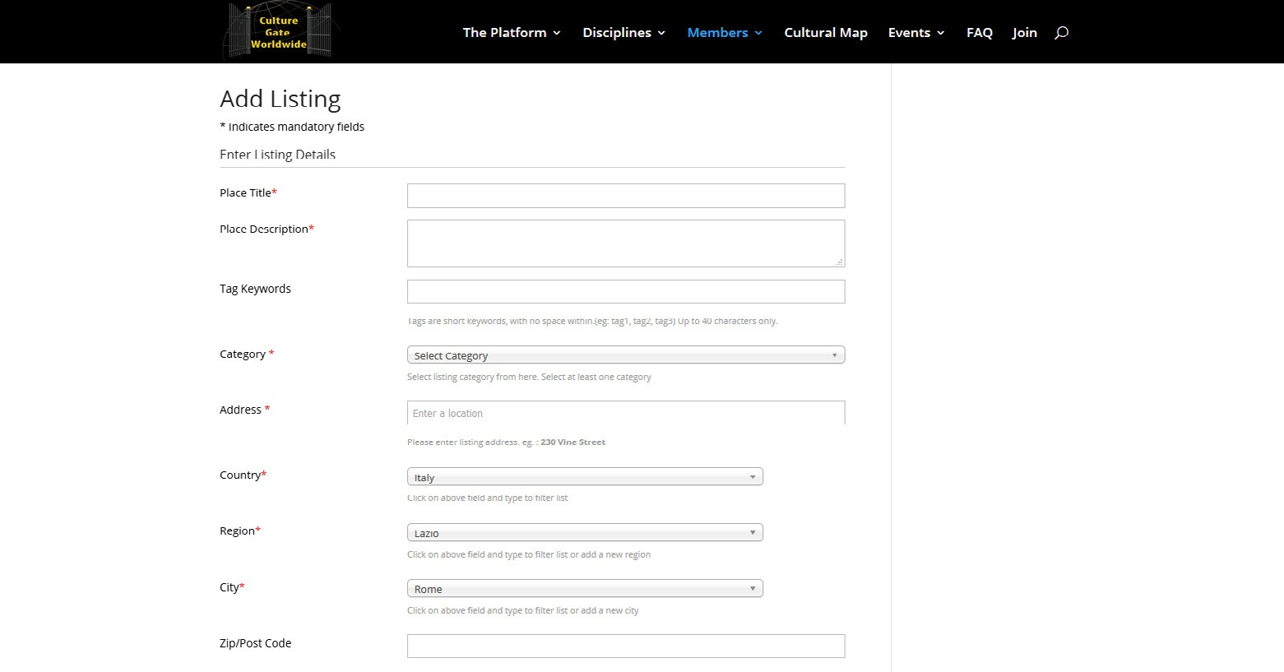

Fig. 1. Platform screen for content contributions.

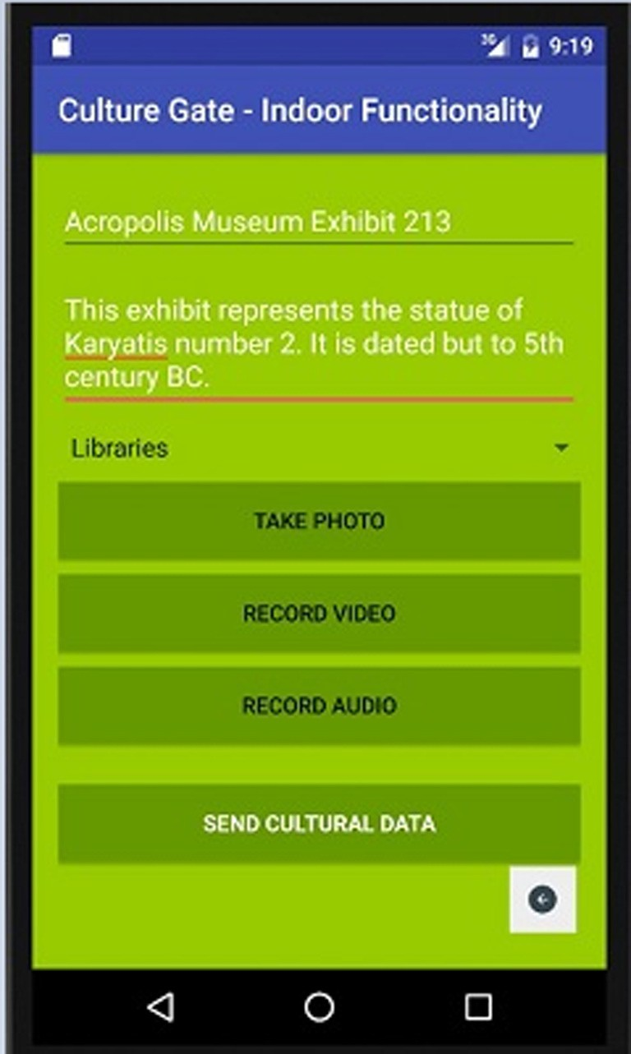

Fig. 2. Dedicated mobile application for collecting educational content.

Students are able to interact with the system searching and viewing educational content as many times as they desire concur- rently with other students. Also students can review a unit. Stu- dent contributions lead in constructing new personal knowledge and sharing it with other students, which is a key feature in educa- tional theories like constructivism [9].

* 1. *Educational services*

The features of mobile and collaborative learning theories guided the design and implementation of platform’s educational services. The presented platform classifies the offered educational services in three categories: generic, student collaborative learning and mobile learning services. More specifically:

* + 1. *Generic services*
       - Search educational content: The platform offers several user-friendly and interactive ways to search content like search bars and interactive options on geographical maps that are located in various sections around the platform (Fig. 3). Users can search for educational content by providing the appropriate search terms in the form of keywords or phrases in the search bars or by selecting the available filtering options on the geographical map.
       - View educational content: In order to be as user-friendly, easy- to-use, attractive and interactive as possible the platform pro- vides two different ways to present educational units. The first way is an interactive geographical map where all educational units appear in the form of pins (Fig. 4). When a user desires to view the information a pin hosts, she/he can click on the pin to read item’s title and a brief description or she/he can navigate to the item’s dedicated web page for more information and mul- timedia content. The second way is the presentation of educa- tional units in lists per cultural discipline (Fig. 5). Each unit is represented as a list item that redirects user to a dedicated web page.
       - Content contribution: The platform allows registered users to easily upload primitive or existing educational content. Both students and teachers can contribute content related to a speci- fic course or general educational cultural content.
       - Content authoring: Teachers can ask from platform modera- tors to allow them to check their students’ contributions before they are published to the broad public. If a permission is granted, teachers check student contributions and inform them whether something needs change. During this procedure teach- ers enrich content with the appropriate metadata information required by the LOM Standard.

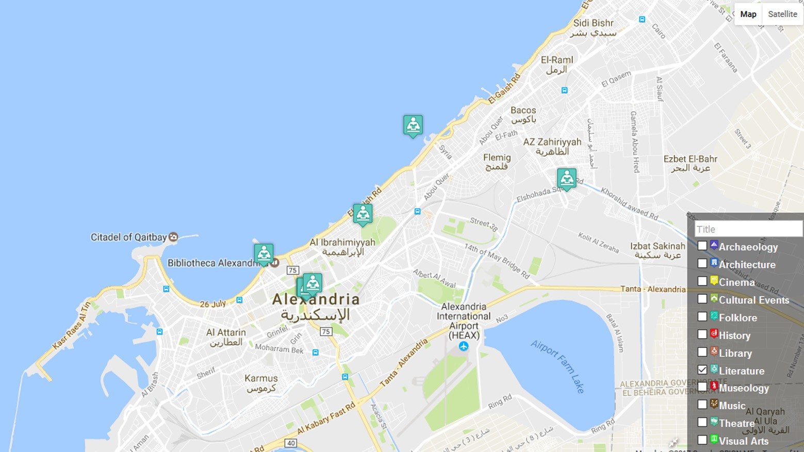

Fig. 3. Interactive choosing of cultural discipline on geographical map.

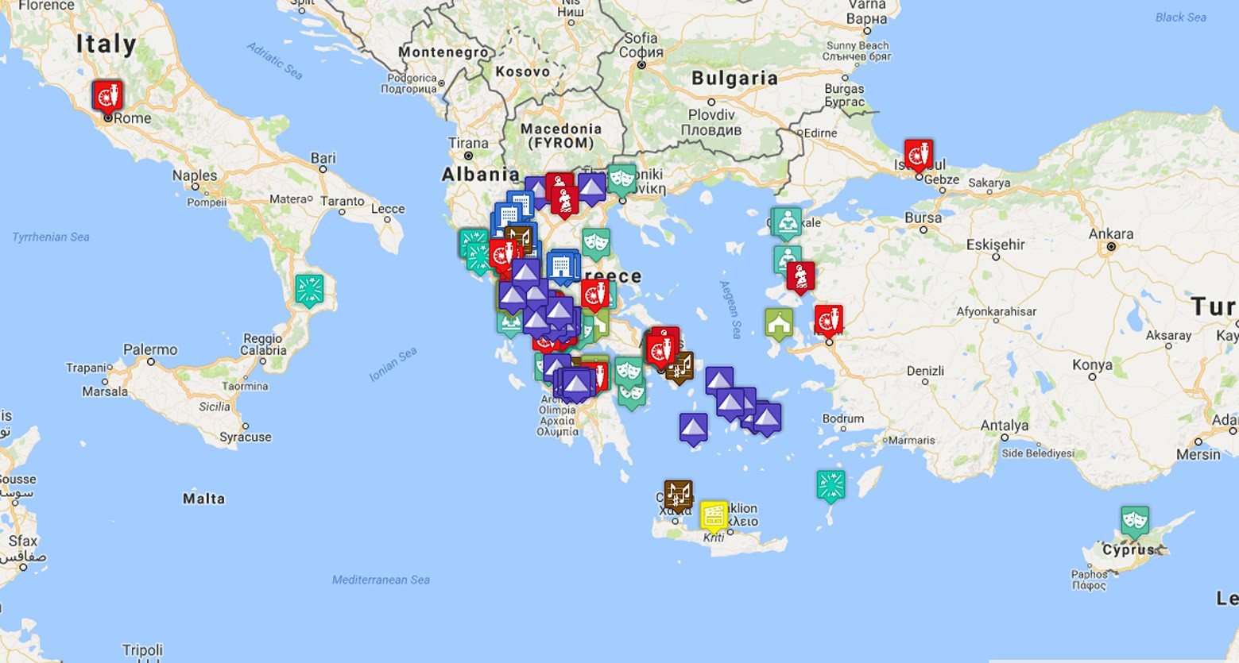

Fig. 4. Educational geographical map with content represented as pins.

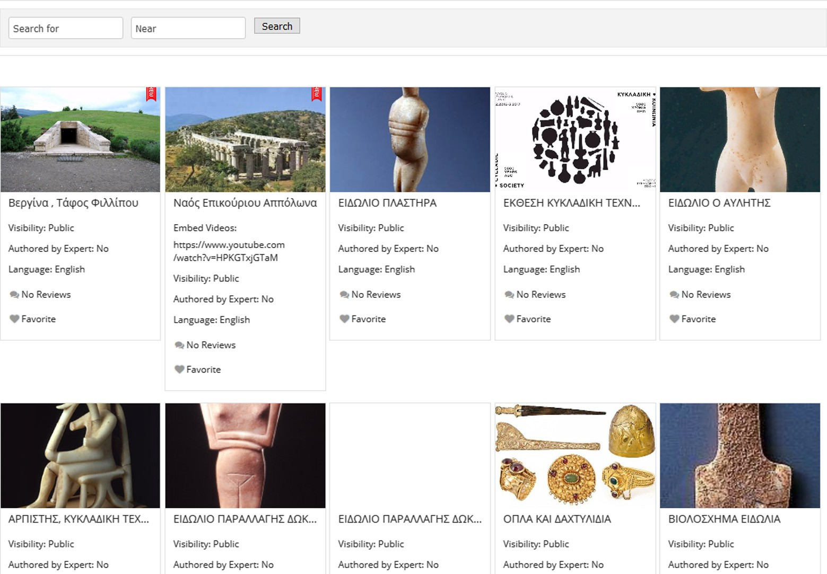

Fig. 5. Viewing content in list per cultural discipline.

* + 1. *Student collaborative learning services*
       - Student group formation: A teacher can request from platform moderators the creation of a private user group in which she/he will be the leader. Group members can share private educa- tional content that is only visible within the group.
       - Collaborative projects: Teachers can create a specific educa- tional project, set a final goal and intermediate tasks, provide hints and solutions for each task and assign the project to a specific student group. Students collaborate with their team- mates to complete project tasks. After completing each task, the system unlocks the next task until the final goal is reached. The system organizes potential projects in four distinct cate- gories following an extended Contextual Model of Learning

(CML) [34]. Teachers can create projects and tasks of personal, physical and socio-cultural context as dictated by the CML but also, other projects and tasks based on teacher’s personal expe- rience. Projects and tasks of personal context are designed to adapt on the students’ interests, motivations, preferences, prior knowledge and experience. Teachers can find in the platform ready-to-use examples of personal context projects and tasks. Moreover, the system provides guidelines and links to help teachers create such projects on-the-fly. Projects and tasks of physical context are designed to help students link educational concepts with objects and experiences from the real world. Pro- jects and tasks of socio-cultural context are designed to help students create knowledge by adjusting an educational concept to the external social and cultural environment with which the

concept interacts. Teachers can allow the system to present their own projects and tasks to other teachers for usage. Project and task creation is supported through user-friendly screens. Teachers can use the pre-made project samples provided by the platform, which have been created by other teachers.

* Content commenting: Students and teachers collaborate to check educational units contributed by users. All users are allowed to comment on an educational unit in the form of a public review.
  + 1. *Mobile learning services*

Along with the main modules of the platform, we have imple- mented two dedicated mobile applications that offer different learning services. *Collector* is a dedicated mobile application that users can utilize to capture an image, audio or video file, add a per- sonal annotation and send it to the system. *Guide* is a dedicated mobile application that presents information concerning education units in real-time on-demand and offers guiding services. The only requirement to use *Collector* and *Guide* is to download, install and enable it in each user’s android device.

* + - * Mobile lesson service: Teachers can transfer the lesson outside classroom with the use of *Guide*. If a teacher wants to revitalize a lesson, then she/he can guide students outside and present through *Guide* various cultural points of interest. The teacher can start conversations with the students and urge them to make reviews or start searching more information about any cultural point.
      * Real-time contributions service: Students and teachers can create personal educational content by capturing audiovisual content in real-time and storing it directly to the platform through *Collector*.
  1. *System users and permitted operations*

The proposed platform adapts an extended role based access control model for authorization purposes concerning content access. The implemented access control model supports three user types/roles with different scopes and permission levels. Users are separated in registered users that have created an account and they are able to use the full potential of the platform and non- registered users that do not have an active account on the system and they can use only a part of the offered educational services.

* Teachers: Registered users that can search public content, view both public and private content, create and assign tasks and projects. Teachers can formulate private groups and include students in them. Also teachers check content contributed by students and make their own contributions.
* Students: Registered users that can search public content, view both public and private content and contribute content. Stu- dents can participate in private groups, comment on public con- tributions and share public content on their social media.
* Guests: Nomadic users who view and search public content.

Depending on their role, users have various capabilities and they can perform operations like adding, deleting, editing, search- ing, viewing, commenting content and managing projects and tasks.

* Add: Registered users can contribute educational units over which they have complete ownership and responsibility.
* Edit/Delete: Registered users can modify or delete their own units.
* Search: There are multiple searching levels for all users: (i) Sim- ple searching: Users can search for educational content provid-

ing keywords corresponding to thematic attributes (like title, description or discipline). (ii) Map searching: A user searches educational content interacting with pins on a geographical map. (iii) Location-based searching: *Guide* detects user’s geo- graphical position and proposes nearby cultural points in a user specified range.

* View: There are multiple viewing levels for all users: (i) Cultural map viewing: A user views cultural content as pins on a geo- graphical map. (ii) List viewing: A user views cultural content in a list of descriptive thumbnails. (iii) Private content viewing: Users that are members of a private group can view private content.
* Comment: Registered users can make comments about any public contribution.
* Create/Modify/Delete Project: Teachers can create a new pro- ject and modify or delete an existing one, if they have created it. They, also, assign students on the project explicitly.
* Create/Assign/Check Task: Teachers create intermediate tasks on specific projects and provide hints and solutions. A task can be assigned to one or more students. Student answers to each task are checked by the teacher.
* Answer Task: Students provide answers to their assigned tasks.

1. Evaluation

In order to evaluate the educational strength of the proposed platform we performed an evaluation with the use of appropriately designed questionnaires. We attempted to measure how users responded to specific services and whether the main requirements of the utilized educational theories have been successfully met.

* 1. *Research methodology*

For the assessment process we designed a questionnaire and distributed it to undergraduate students of the Department of cul- tural heritage management and new technologies of the University of Patras. 12 students where used in the experiment, 5 men and 7 women between the ages of 20 and 25. Our methodology guided us to first give a thorough explanation of system scope, features and services and afterwards we urged students to use the system through a specific educational usage scenario. More specifically, we classified students in 6 teams consisting of two users and asked them to collaborate within their team in order to search and con- tribute information about Greek poets to the platform. Each stu- dent was obligated to contribute content through her/his personal account on the platform in order to actively participate in the procedure. Every contribution concerned specific informa- tion about the life and work of a certain Greek poet. When all teams fulfilled their task, they collaborated to create a collection of information about the history of poetry in Greece. Each student had the opportunity to make a comment on a colleague’s contribu- tion. The procedure was monitored by course’s professor, who started a conversation about Greek poetry using information from student contributions. The conversation was recorded through *Col- lector* and uploaded to the platform as a part of the collection. In the end, users were asked to repeat the same procedure using Europeana [8], a well-known platform that organizes and dissem- inates cultural heritage information (without using mobile services for conversation recording). Finally, we distributed the appropriate questionnaire and gave students enough time to answer the ques- tions according to their experience.

As an assessment tool we chose to work with questionnaires based on the Likert scale [4]. We used the typical five-level Likert scale consisting of five available answers in each question: Strongly Agree (5), Agree (4), Neither Agree nor Disagree (3), Disagree (2), Strongly Disagree (1). For the last question concerning the

Table 1

Qualitative evaluation results.

|  |  |  |  |  |
| --- | --- | --- | --- | --- |
| Question | Min | Max | Mean | Std. deviation |
| *Q1. Can you use cultural information provided by the proposed platform independently?* | 3 | 5 | 4 | 0.55 |
| *Q2. Can you use cultural information provided by the proposed platform over and over again?* | 3 | 5 | 4.083 | 0.64 |
| *Q3. Can you use cultural information provided by the proposed platform in collections with common semantic content?* | 2 | 4 | 3.25 | 0.56 |
| *Q4. Does the proposed platform allow users to improve each item’s content quality?* | 2 | 5 | 4.083 | 0.95 |
| *Q5. Does the proposed platform integrate effectively mobile technology in educational procedure?* | 1 | 5 | 3.33 | 1.03 |
| *Q6. Do you believe that the proposed platform promotes collaborative learning?* | 1 | 5 | 3.42 | 0.95 |
| *Q7. Do you believe that the proposed platform promotes students’ active participation to the educational procedure?* | 2 | 5 | 3.83 | 0.99 |
| *Q8. How could you evaluate the proposed platform as an educational tool?* | 3 | 5 | 4 | 0.71 |
| *Q9. Would you positively see the integration of platform’s services into a course’s educational procedure?* | 3 | 5 | 4 | 0.58 |

comparison between the proposed system and Europeana we asked the students to simply choose one of the two systems. For the data analysis, we followed the methodology of assessing ques- tionnaire data proposed in [14] and calculated the mean and pop- ulation standard deviation of the answers to each question drawing conclusions.

* 1. *Results and discussion*

Table 1 displays the results from the analysis of student answers to the distributed questionnaires. The calculated Cron- bach’s alpha measure concerning the reliability of the question- naire produced an acceptable value of 0,75.

Evaluation results reveal that the integration of features from learning objects theory to the proposed platform was successful. Students comprehended the independent, reusable and improv- able nature of educational content while they remained positively sceptical about items’ ability to be aggregated in collections with common semantic content. Students’ answers about the integra- tion of mobile devices are moderately positive. The platform appears to achieve the goals of collaborative learning and active student participation. The notable dispersion of answers suggests that even though the majority of students comprehended student collaboration services well, a small percentage of students remains skeptical and aspires for more efficient collaboration services. Finally, students evaluated platform’s use as an educational tool very positively without many variations and they would like to use platform services during a course’s educational procedure.

Attempting a rough comparison of the proposed platform with Europeana, we asked students which of the two platforms they would prefer to use as an educational tool. Our purpose was to get an indication of the acceptance that the proposed platform had as an educational tool in comparison to an established cultural heritage platform like Europeana that collects and disseminates European originated cultural heritage content. Europeana has a clear educational role offering students the capability to view cul- tural collections and search for specific tangible or intangible cul- tural content. Furthermore, Europeana periodically asks from the public to contribute cultural heritage information in specific fields. Comparison results between the proposed system and Europeana (Table 2) revealed that students evaluate both systems almost equally with respect to their educational usage, but favor the pro- posed system slightly better with 7 students preferring it instead of Europeana. Even if this comparison is not an analytical one, it gives

Table 2

Rough comparison of the proposed platform and Europeana.

a first glimpse of the successful integration of educational services to the proposed platform.

Overall, the platform seems to accomplish its design goals which included the integration of characteristics from specific edu- cational theories. Students found platform content, services and modules rather compliant with the main characteristics of learning objects, mobile learning and collaborative learning theories. Last but not least, students would be eager to use the proposed plat- form as a main part of the educational procedure and strongly comprehended its educational strength.

1. Conclusions

In this work we designed and implemented a unified educa- tional platform, which manages to incorporate the main character- istics of learning objects, collaborative learning and mobile learning theories benefiting both teachers and students. Teachers can use the platform to present relevant information, upload content, cre- ate projects, urge students to complete learning tasks individually or in small teams and perform teaching sessions outside the class- room. Students can use platform’s interactive services to contribute primitive or existing cultural content and collaborate in teams with other students to complete educational tasks. Platform can be the starting point for students searching information about a specific topic. The platform supports seamless learning providing a mobile application that allows students to capture and annotate cultural heritage educational content in real-time outside the classroom and engage in discussions about it with their teacher. Also, teachers and students can create reusable, independent, aggregation-ready and meta-data enrichable cultural heritage educational content. Such content, organized in learning objects based on the LOM Stan- dard, can become available to the broad educational community. The presented evaluation results provide a first insight towards the acceptance of the proposed platform from the cultural heritage educational community. As future work we plan to further evaluate the proposed system acceptability and satisfiability from students in primary and secondary schools. Moreover, we plan to conduct a thorough comparison between the proposed platform and Euro- peana addressing the issues of user-friendliness, user satisfaction and personalization in more depth.

References

1. [Q. Wang, Design and evaluation of a collaborative learning environment,](http://refhub.elsevier.com/S2210-8327(17)30159-X/h0005) [Comput. Educ. 53 (2009) 1138–1146](http://refhub.elsevier.com/S2210-8327(17)30159-X/h0005).
2. WebQuests. Available at <[http://webquest.org/index.php>](http://webquest.org/index.php) (Accessed at 26/06/ 2017).
3. Medcgame. Available at <[https://www.cnr.it/en/focus/102-18/medcgame-un-](https://www.cnr.it/en/focus/102-18/medcgame-un-gioco-in-rete-per-supportare-attivita-di-classi-gemellate-di-diversi-paesi) [gioco-in-rete-per-supportare-attivita-di-classi-gemellate-di-diversi-paesi](https://www.cnr.it/en/focus/102-18/medcgame-un-gioco-in-rete-per-supportare-attivita-di-classi-gemellate-di-diversi-paesi)> (Accessed at 26/06/2017).

Question Proposed

platform

Europeana

1. [R. Likert, A technique for the measurement of attitudes, Arch. Psychol. 140](http://refhub.elsevier.com/S2210-8327(17)30159-X/h0020) [(1932) 1–55](http://refhub.elsevier.com/S2210-8327(17)30159-X/h0020).
2. J. Laister, A. Koubek, 3rd Generation learning platforms requirements and

*Q1. Do you prefer the use of the proposed platform or* 7 5

*Europeana during educational procedure?*

motivation for collaborative learning, Eur. J. Open, Distance E-Learning, 2001. Available at <[http://www.eurodl.org/materials/contrib/2001/icl01/laister.pdf>](http://www.eurodl.org/materials/contrib/2001/icl01/laister.pdf) (Accessed at 04/05/2017).

1. [X. Chen, J. Choi, Designing collaborative location-aware platform for history](http://refhub.elsevier.com/S2210-8327(17)30159-X/h0030) [learning, J. Educ. Technol. Develop. Exchange 3 (2010) 13–26](http://refhub.elsevier.com/S2210-8327(17)30159-X/h0030).
2. K. Uotila, I. Huvila, J.-P. Paalassalo, Learning, access and moBility in cultural heritage education: developments, lessons and findings from the project, in: 38th Conference on Computer Applications and Quantitative Methods in Archaeology Granada, Spain, 2010, pp. 423–426.
3. [J. Purday, Think culture: Europeana.eu from concept to construction, Electron.](http://refhub.elsevier.com/S2210-8327(17)30159-X/h0040) [Libr. 27 (2009) 919–937](http://refhub.elsevier.com/S2210-8327(17)30159-X/h0040).
4. [M. Gail Jones, L. Brader-Araje, The impact of constructivism on education:](http://refhub.elsevier.com/S2210-8327(17)30159-X/h0045) [language, Discour., Mean., Am. Commun. J. 5 (2002) 1–10](http://refhub.elsevier.com/S2210-8327(17)30159-X/h0045).
5. [R. McGreal, Online education using learning objects,](http://refhub.elsevier.com/S2210-8327(17)30159-X/h0050) [Routledge, New York NY,](http://refhub.elsevier.com/S2210-8327(17)30159-X/h0050) [2004](http://refhub.elsevier.com/S2210-8327(17)30159-X/h0050).
6. A. Kukulska-Hulme, J. Traxler, Mobile Learning: A Handbook for Educators and Trainers, Routledge London and New York, 2005.
7. [Y. Park, A pedagogical framework for mobile learning: categorizing](http://refhub.elsevier.com/S2210-8327(17)30159-X/h0060) [educational applications of mobile technologies into four types, Int. Rev. Res.](http://refhub.elsevier.com/S2210-8327(17)30159-X/h0060) [Open Distrib. Learn. 12 (2011) 78–102](http://refhub.elsevier.com/S2210-8327(17)30159-X/h0060).
8. [R. Mayer, R. Moreno, Aids to computer-based multimedia learning, Learn.](http://refhub.elsevier.com/S2210-8327(17)30159-X/h0065) [Instruct. 12 (2002) 107–119](http://refhub.elsevier.com/S2210-8327(17)30159-X/h0065).
9. [S. Gorard, Revisiting a 90-year-old debate: the advantages of the mean](http://refhub.elsevier.com/S2210-8327(17)30159-X/h0070) [deviation, Brit. J. Educ. Stud. 53 (2005) 417–430](http://refhub.elsevier.com/S2210-8327(17)30159-X/h0070).
10. [B. Gan, T. Menkhoff, R. Smith, Enhancing students’ learning process through](http://refhub.elsevier.com/S2210-8327(17)30159-X/h0075) [interactive digital media: New opportunities for collaborative learning,](http://refhub.elsevier.com/S2210-8327(17)30159-X/h0075) [Comput. Hum. Behav. 51 (2015) 652–663](http://refhub.elsevier.com/S2210-8327(17)30159-X/h0075).
11. [M.R. Gruber, The role of e-learning in arts and cultural heritage education, in:](http://refhub.elsevier.com/S2210-8327(17)30159-X/h0080)

[V. Hornung-Prähauser,](http://refhub.elsevier.com/S2210-8327(17)30159-X/h0080) [M. Luckmann (Eds.), Creativity and Innovation](http://refhub.elsevier.com/S2210-8327(17)30159-X/h0080) [Competencies in the Web, EduMedia Fachtagung, 2009, pp. 343–350](http://refhub.elsevier.com/S2210-8327(17)30159-X/h0080).

1. V. Ferrara, A. Macchia, S. Sapia, F. Lella, Sharing and reuse of museum objects in learning environments, in: N. Proctor, R. Cherry, Museums and the Web 2013, 2014, MD, Silver Spring
2. [Y.-T. Sung, K.-E. Chang, T.-C. Liu, The effects of integrating mobile devices with](http://refhub.elsevier.com/S2210-8327(17)30159-X/h0090) [teaching and learning on students’ learning performance: a meta-analysis and](http://refhub.elsevier.com/S2210-8327(17)30159-X/h0090) [research synthesis, Comput. Educ. 94 (2016) 252–275](http://refhub.elsevier.com/S2210-8327(17)30159-X/h0090).
3. [M. Sarrab, M. Elbasir, S. Alnaeli, Towards a quality model of technical aspects](http://refhub.elsevier.com/S2210-8327(17)30159-X/h0095) [for mobile learning services: an empirical investigation, Comput. Hum. Behav.](http://refhub.elsevier.com/S2210-8327(17)30159-X/h0095) [55 (2016) 100–112](http://refhub.elsevier.com/S2210-8327(17)30159-X/h0095).
4. [M.G. Domingo, A.B. Garganté, Exploring the use of educational technology in](http://refhub.elsevier.com/S2210-8327(17)30159-X/h0100) [primary education: teachers’ perception of mobile technology learning](http://refhub.elsevier.com/S2210-8327(17)30159-X/h0100) [impacts and applications’ use in the classroom, Comput. Hum. Behav. 56](http://refhub.elsevier.com/S2210-8327(17)30159-X/h0100) [(2016) 21–28](http://refhub.elsevier.com/S2210-8327(17)30159-X/h0100).
5. [C. Crisan, S. Lerman, P. Winbourne, Mathematics and ICT: a framework for](http://refhub.elsevier.com/S2210-8327(17)30159-X/h0105) [conceptualizing secondary school mathematics teachers’ classroom practices,](http://refhub.elsevier.com/S2210-8327(17)30159-X/h0105) [Technol., Pedag. Educ. 16 (2007) 21–39](http://refhub.elsevier.com/S2210-8327(17)30159-X/h0105).
6. G. Magro, J. Ramos de Carvalho, M. J. Marcelino, Improving history learning through cultural heritage, local history and technology, in: 10th International Conference on Mobile Learning, Madrid, Spain, 2014, pp. 34–40.
7. [F.A. Dorca, R.D. Araujo, V.C. de Carvalho, D.T. Resende, R.G. Cattelan, An](http://refhub.elsevier.com/S2210-8327(17)30159-X/h0115) [automatic and dynamic approach for personalized recommendation of](http://refhub.elsevier.com/S2210-8327(17)30159-X/h0115) [learning objects considering students learning styles: an experimental](http://refhub.elsevier.com/S2210-8327(17)30159-X/h0115) [analysis, Inform. Educ. 15 (2016) 45–62](http://refhub.elsevier.com/S2210-8327(17)30159-X/h0115).
8. [Z.L. Berge, L.Y. Muilenburg, Handbook of Mobile Learning, Routledge, New](http://refhub.elsevier.com/S2210-8327(17)30159-X/h0120) [York, 2013](http://refhub.elsevier.com/S2210-8327(17)30159-X/h0120).
9. [A. Goldberg, Computer-assisted instruction: the application of theorem-](http://refhub.elsevier.com/S2210-8327(17)30159-X/h0125) [proving to adaptive response analysis, ACM SIGCUE Outlook 7 (1973)](http://refhub.elsevier.com/S2210-8327(17)30159-X/h0125).
10. [H. Tüzün, M.](http://refhub.elsevier.com/S2210-8327(17)30159-X/h0130) [Yılmaz-Soylu, T. Karaku](http://refhub.elsevier.com/S2210-8327(17)30159-X/h0130) s[, Y.](http://refhub.elsevier.com/S2210-8327(17)30159-X/h0130) I_[nalb, G.](http://refhub.elsevier.com/S2210-8327(17)30159-X/h0130) [Kızılkay,](http://refhub.elsevier.com/S2210-8327(17)30159-X/h0130) [Comput. Educ. 52](http://refhub.elsevier.com/S2210-8327(17)30159-X/h0130)

[(2009) 68–77](http://refhub.elsevier.com/S2210-8327(17)30159-X/h0130).

1. [R. Sutherland, V. Armstrong, S. Barnes, R. Brawn, N. Breeze, M. Gall, S.](http://refhub.elsevier.com/S2210-8327(17)30159-X/h0135) [Matthewman, F. Olivero, A. Taylor, P. Triggs, J. Wishart, P. John, Transforming](http://refhub.elsevier.com/S2210-8327(17)30159-X/h0135) [teaching and learning: embedding ICT into everyday classroom practices, J.](http://refhub.elsevier.com/S2210-8327(17)30159-X/h0135) [Comput. Assist. Learn. 20 (2004) 413–425](http://refhub.elsevier.com/S2210-8327(17)30159-X/h0135).
2. IMS Global Learning Consortium, IMS meta-data best practice guide for IEEE 1484.12.1-2002 standard for learning object metadata version 1.3 final specification. Available at: <[https://www.imsglobal.org/metadata/mdv1p3/](https://www.imsglobal.org/metadata/mdv1p3/imsmd_bestv1p3.html) [imsmd_bestv1p3.html>](https://www.imsglobal.org/metadata/mdv1p3/imsmd_bestv1p3.html).
3. M. Nilsson, M. Palmér, ImseVimse: The IMS Editor Vimse, 2002. Retrieved August 14, 2004 from <[http://kmr.nada.kth.se/imsevimse>](http://kmr.nada.kth.se/imsevimse).
4. KOM, LOM-Editor Version 1.0, Technische Universität Darmstadt, 2001.

Retrieved August 20, 2004 from <[http://www.multibook.de/lom/en/index.](http://www.multibook.de/lom/en/index.html) [html>](http://www.multibook.de/lom/en/index.html).

1. [E. Chryssafidou, S. Sotiriou, P. Koulouris, M. Stratakis, A. Miliarakis, M. Barajas,](http://refhub.elsevier.com/S2210-8327(17)30159-X/h0155)

[M. Milrad, D. Spikol, Developing tools that support effective mobile and game](http://refhub.elsevier.com/S2210-8327(17)30159-X/h0155) [based learning: the COLLAGE platform, in:](http://refhub.elsevier.com/S2210-8327(17)30159-X/h0155) [S. Caballe,](http://refhub.elsevier.com/S2210-8327(17)30159-X/h0155) [F. Xhafa,](http://refhub.elsevier.com/S2210-8327(17)30159-X/h0155) [T. Daradoumis,](http://refhub.elsevier.com/S2210-8327(17)30159-X/h0155)

[A. Juan (Eds.), Architectures for Distributed and Complex M-Learning Systems:](http://refhub.elsevier.com/S2210-8327(17)30159-X/h0155) [Applying Intelligent Technologies,](http://refhub.elsevier.com/S2210-8327(17)30159-X/h0155) [IGI Global, 2010, pp. 1–34](http://refhub.elsevier.com/S2210-8327(17)30159-X/h0155).

1. [D. Malandrino, I. Manno, G. Palmieri, V. Scarano, A tailorable infrastructure to](http://refhub.elsevier.com/S2210-8327(17)30159-X/h0160) [enhance mobile seamless learning, IEEE Trans. Learn. Technol. 8 (2015) 18–30](http://refhub.elsevier.com/S2210-8327(17)30159-X/h0160).
2. [M. Ott, F. Pozzi, Towards a new era for Cultural Heritage Education: Discussing](http://refhub.elsevier.com/S2210-8327(17)30159-X/h0165) [the role of ICT, Comput. Hum. Behav. 27 (2011) 1365–1371](http://refhub.elsevier.com/S2210-8327(17)30159-X/h0165).
3. [J. Falk, L. Dierking, Learning From Museums: Visitor Experiences and the](http://refhub.elsevier.com/S2210-8327(17)30159-X/h0170) [Making of Meaning, Altamira, Walnut Creek, CA, 2000](http://refhub.elsevier.com/S2210-8327(17)30159-X/h0170).