[Array 18 (2023) 100285](https://doi.org/10.1016/j.array.2023.100285)



Contents lists available at [ScienceDirect](https://www.elsevier.com/locate/array)

Array

journal homepage: [www.elsevier.com/locate/array](http://www.elsevier.com/locate/array)

IoT-MAC: A Channel Access Mechanism for IoT Smart Environment

Md. Arifuzzaman Mondal a,∗, Nurzaman Ahmed b,1, Md. Iftekhar Hussain a,1

a *Department of Information Technology, North-Eastern Hill University, Shillong, 793022, India*

b *Dartmouth College, USA*

A R T I C L E I N F O A B S T R A C T

*Keywords:*

IoT

IEEE 802.11ah

Smart environment MAC protocol

Restricted access window

A large number of sensor and actuator devices are being deployed for sensing and automation in a smart environment. While enabling communication for a large number of stations with RAW in IEEE 802.11ah, the state-of-the-art solutions for channel access are deficient in dealing with both periodic uplink and event- driven downlink actuation at the same time, as per the application’s criteria. In this paper, we propose *IoT-MAC*, a downlink traffic-aware Medium Access Control (MAC) protocol for automation in smart spaces. The proposed scheme uses new RAW frames to schedule downlink actuation traffic, considering the periodicity and freshness of uplink traffic. IoT-MAC identifies the periodicity of uplink traffic and schedules a frame without further contention. It then prioritizes critical downlink traffic without losing fresh uplink data. The performance analysis of the proposed scheme shows significant improvement in terms of throughput, delay, power consumption and packet loss for running different IoT applications.

# Introduction

The evolution of Machine-to-Machine (M2M) communication al- lowed machines to exchange instructions or information without the need for human intervention. A massive number of devices can be grouped together to form an M2M network by having an interconnected link with the network that is deployed over a large area. It is expected that M2M networks will be widely used in a range of smart space applications [1], including those for the home, workplace, health- care, smart city, industrial automation, smart parking, etc. A wireless network technology for M2M communication is necessary for these extensive IoT applications in order to manage the system efficiently and effectively.

The IEEE 802.11ah standard (also called Wi-Fi HaLow) is expected to be the solution for M2M communications in the future. Exciting features of IEEE 802.11ah consist of: (i) transmission range of up to 1 km in outdoor areas, which is much longer than Wireless Personal Area Network (WPAN), (ii) data rate of at least 100 kbps for IEEE 802.11ah, that is higher than Low-Power Wide Area Network (LPWAN), and (iii) it can associate up to 8191 numbers of devices with an Access Point (AP) [2]. Theoretically, the signal coverage range of an IEEE 802.11ah AP is up to 1 km. A hierarchical identifier structure, also known as an Association Identifier (AID), is adopted to handle a huge number of stations (STAs). By using these AIDs, all the stations of an AP are detached into several segments, known as Traffic Indication Map

(TIM) segments. Due to these features, IEEE 802.11ah has been widely used for smart space implementation.

However, such applications require a massive volume of automation based on context or commands, consequently involving both uplink and downlink traffic. The gap between Wireless Personal Area Networks (WPAN) and Low-Power Wide Area Networks (LPWAN) is filled by IEEE 802.11ah, which compromises range and throughput. It offers higher throughput compared to the existing LPWAN technologies and also provides both range and throughput to WPAN technologies. There are severe downlink traffic restrictions for LoRa and SigFox. Because of this limitation, bidirectional communication (i.e., uplink and downlink communication) becomes inconvenient. IEEE 802.11ah offers a simi- lar data rate for both uplink and downlink traffic and fills the gap. However, most of the proposed algorithms improve the performance for only traditional Wireless Sensor Networks (WSN) monitoring traf- fic. Most of the research [3–5] which are available for the standard 802.11ah focus on use cases with uplink traffic, and less concentration has been given to the use cases with downlink traffic.

As shown in Fig. 1, IoT deploys a large number of sensor and actuator nodes for providing the required services as controllers from the cloud or the fog. Traffic in actuation, sensing, uplink, and downlink is increased by the presence of various types of sensor nodes. Although a few technologies, such as LoRa and SigFox [6] offer solutions, but the uplink and downlink traffic issues still need to be resolved. Hence, we need a solution for IEEE 802.11ah for traffic handling situations.

∗ Corresponding author.

*E-mail address:* [arifphd18@gmail.com](mailto:arifphd18@gmail.com) (M.A. Mondal).

1 Member IEEE.

<https://doi.org/10.1016/j.array.2023.100285>

Received 2 January 2023; Received in revised form 18 February 2023; Accepted 26 February 2023

Available online 28 February 2023

2590-0056/© 2023 The Authors. Published by Elsevier Inc. This is an open access article under the CC BY license (<http://creativecommons.org/licenses/by/4.0/>).

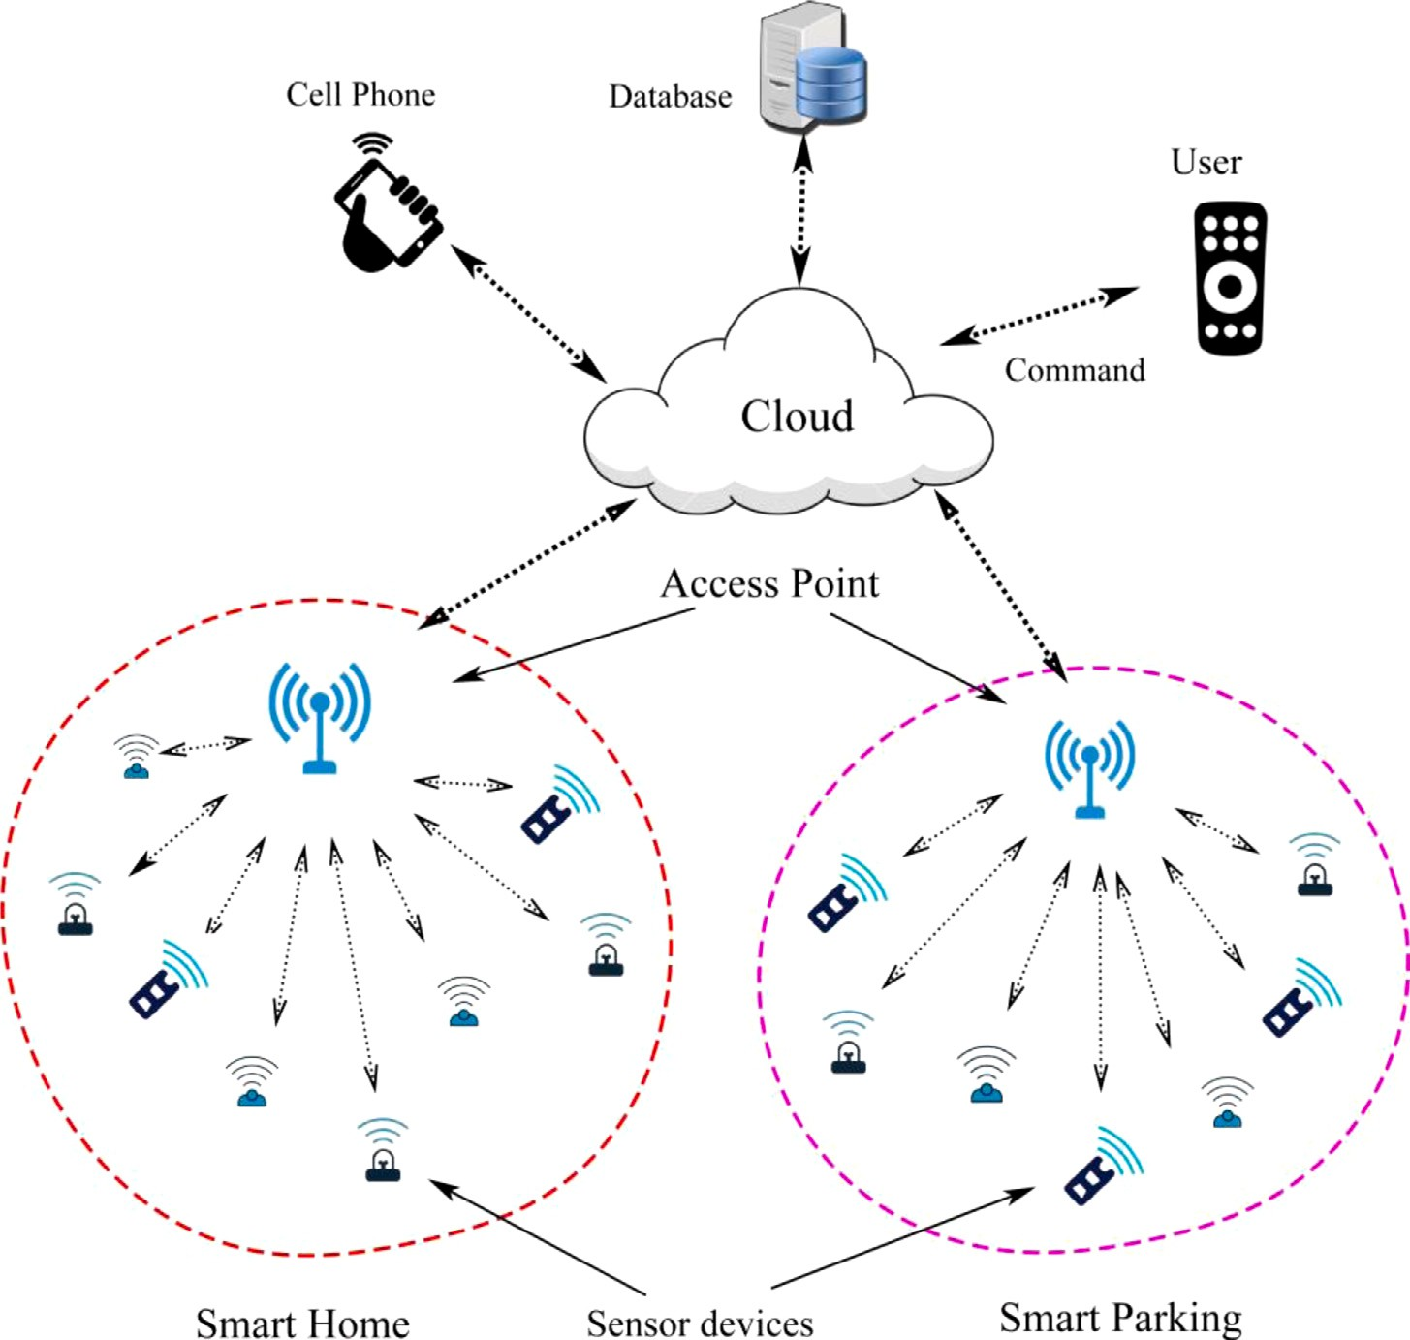

**/ig. 1.** IEEE 802.11ah based network architecture for smart environment.

In this work, we propose a scheduling algorithm for uplink and downlink traffic. The proposed scheme solves the issues of event- driven downlink and homogeneous uplink traffic over an optimized RAW frame subject to improved latency and throughput. The key *contributions* of this work are as follows:

1. We propose a RAW architecture for IoT networks having both uplink and downlink traffic for monitoring and taking actions for automation.
2. A traffic prediction model is developed for homogeneous uplink traffic in an IoT scenario where IoT nodes sense the environ- ment and periodically send the information to the cloud server through AP.
3. A conflict resolution scheme is proposed for scheduling critical downlink traffic over uplink traffic to improve reliability and reduce latency in taking action.

The remaining paper is organized into four different sections. Some related works of IEEE 802.11ah are discussed in Section 2. Section 3 explains the proposed model to optimize the RAW for bidirectional traffic. Performance evaluation of our proposed scheme is presented in Section 4. Finally, Section 5 concludes the paper.

# Related works

In spite of its novelty, many provisions of IEEE 802.11ah have been effectively concentrated in the literature. The improvement of the 802.11ah network’s performance has drawn the attention of various research-oriented organizations. Many researchers have been made a lot of work to enhance the RAW performance of the network. Some of the existing research for the optimization of MAC layers is presented in Table 1.

**Table 1**

Most of the available research focus on optimization of RAW for IEEE 802.11ah with uplink traffic only.

References Traffic types Objectives Simulation tools

|  |  |  |  |
| --- | --- | --- | --- |
| This Article | UL/DL | Throughput, latency, | ns-3 |
|  |  | packet delivery ratio, and |  |
|  |  | energy consumption |  |
| [7] | UL/DL | Throughput and power | Mathematical model |
|  |  | consumption |  |
| [8] | UL/DL | Throughput | ns-3 |
| [9] | UL/DL | Throughput and energy | Unknown |
| [3] | UL | Energy and latency | Matlab |
| [4] | UL | Throughput | Analytical |
| [5] | UL | Energy | Matlab |
| [10] | DL | Latency | Unknown |
| [11] | UL | Hidden node mitigation | Matlab |
| [12] | UL | Throughput and energy | Analytical |
| [13] | DL | Hidden node mitigation | Matlab |
| [14] | UL | Hidden node mitigation | Unknown |
| [15] | UL | Throughput | Unknown |
| [16] | UL | Throughput | Analytical |

RAW is one of the most popular MAC features to improve network performance. Though RAW can be used to improve scalability for large networks, its performance depends on network conditions. In that matter, Delay and Energy-Aware RAW Formation (DEARF) scheme is developed by [3] for supporting delay-sensitive devices. However, they considered only uplink traffic. Regarding throughput optimization, Nawaz et al. [4] proposed a method to choose RAW slot duration based on the size of the group for increasing uplink throughput. For improv- ing the system performance, the author of [7] proposed a mathematical model for finding RAW parameters. Considering a novel retransmission mechanism to improve the uplink energy efficiency, Wang et al. [5]





**/ig. 2.** Bidirectional RAW frame structure for IEEE 802.11ah.

proposed an efficient window control algorithm that utilizes the next empty slot for uplink retransmission. Badihi et al. [10] investigated an actuation case and checked the performance of the network, tak- ing power consumption and latency at the actuator side. The author of [11] predicted a method consisting of a saturated network with uplink traffic conditions, and all the stations are grouped based on their geographical positions. Hazmi et al. [12] examined the network performance considering RAW features in non-cross slot boundary use cases for various schemes. Kureev et al. [9] considered the throughput and energy efficiency of IEEE 802.11 ah considering a heterogeneous network and a faultless mathematical model proposed for evaluating energy consumption and average throughput of the network.

By assuming a saturated network with downlink traffic (having transmission limited to each device once a RAW), Damayanti et al. [13] proposed a RAW grouping method based on the carrier-sensitivity table, which was constructed earlier, whereas the author of [14] recognizes all the hidden nodes in the uplink transmission by non- acknowledging Power-Saving-Poll (PS–Poll) transmissions. Predicting the traffic condition of each station known by Access Point (AP), Chang et al. [15] proposed a load-balancing device grouping RAW method. A mathematical model was developed by [16], which is used to find the time required for any station to transmit its frames in a RAW slot, assuming that there are no hidden nodes and transmission errors and AP transmits only acknowledgments (ACKs). Quality of service

transmission state send a frame (PS–Poll frame) by using Distributed Co-ordination Function (DCF) in the contention phase (which is also called *PS–Poll* phase). For a station, if the contention is successful, a

*𝑠𝑙𝑜𝑡* ∈ [*𝑆𝑙𝑜𝑡*1*, 𝑆𝑙𝑜𝑡*2*, 𝑆𝑙𝑜𝑡*3*,* … *, 𝑆𝑙𝑜𝑡𝑁* ]

is assigned on the reservation period based on traffic nature of STAs. After receiving the *PS–Poll* frames from the stations, AP allocates a RAW slot to only the stations which have successfully transmitted the *PS– Poll* frames. The beacon frames containing the RAW parameter set are transmitted to the stations. Our proposed protocol reduces contention by permitting STAs to sleep based on their traffic nature. The pro- posed protocol uses two algorithms for scheduling uplink and downlink traffic. Algorithm 1 finds periodic stations and schedules them with minimal contention. It also ensures fairness to the stations that failed to transmit previously. In the case of downlink traffic, we propose Algorithm 2 to reliably schedule a frame with a conflict resolution method.

* 1. *Slot duration*

ments is *𝑁𝑆𝑈𝐿* and *𝑁𝑆𝐷𝐿* respectively. The length of each slot is equal The number of slots contained in Uplink and Downlink RAW seg-

minimum contention window *𝐶𝑊𝑚𝑖𝑛*, data rate *𝑟*, and a guard time *𝑡𝑔* , to the number of successful transmissions in addition to the time of

+

(QoS)-aware priority grouping and RAW scheduling algorithm were

proposed by [8] for the real-time event-driven traffic. Event-driven

equal to *𝐿𝑟𝑡𝑠 𝑡*

*𝑟*

+

*𝐷𝐼𝐹 𝑆*

in the Uplink case and *𝐿𝑃𝑆*–*𝑃 𝑜𝑙𝑙 𝑡*

*𝑟*

*𝐷𝐼𝐹 𝑆*

in the

traffic was prioritized over periodic traffic and assigned stations to RAW accordingly. The stations have a higher priority to get access at the beginning of a RAW.

Various algorithms have been proposed for IEEE 802.11ah to im- prove the performance of the network, which is shown in Table 1. The state-of-the-art solutions on this standard focus on either uplink traffic or downlink traffic. But, in the actual IoT network, which requires bidi- rectional traffic support for the applications having high throughput, frequent actuation use cases (i.e., control loops), etc. Therefore, we can say that a channel access mechanism considering both uplink and downlink traffic is needed for the better performance of the network.

# The proposed scheme

In this work, we propose a RAW scheduling scheme for uplink and downlink traffic, considering various network requirements in the case of an IoT environment. The proposed solution uses – (i) up- link/downlink prediction and (ii) RAW frame structure for better traffic scheduling over the network. A hybrid MAC mechanism is proposed with two different phases called the *Contention* phase and *Reservation* phase to ensure that all the stations are properly assigned to respective

Downlink case. This guard time allows the network to detect up to one collision in each slot without reducing the number of packets able to be transmitted.

The characteristics of the Downlink (DL) and Uplink (UL) cases are given below:

1. *𝐷𝑜𝑤𝑛𝑙𝑖𝑛𝑘* ∶ If AP has some packets for an STA then the corre-

sponding TIM group will be added to the respective DTIM map and that

map, STA will be able to determine its *𝐷𝐿* slot. Then STAs contend STA will be added to its corresponding TIM map. After receiving this

for the channel using Distributed Co-ordination Function, by sending a PS–Poll frame to get the corresponding data.

1. *𝑈 𝑝𝑙𝑖𝑛𝑘* ∶ STAs that want to send data to AP must receive the

corresponding TIM beacon. After that, STA will randomly choose one

of the uplink slots and perform data transmission. Contention in the uplink slots is also based on DCF.

* 1. *Prediction of uplink and downlink traffic pattern*

is connected to an AP. All sensor nodes are divided into *𝛽* number The IEEE 802.11ah network consists of a set of sensor nodes *s* which

groups *𝑔*1*, 𝑔*2*, 𝑔*3*, 𝑔*4*,* … *, 𝑔𝛽 𝜖 n*. A slot is assigned in each RAW group, of groups. A network (i.e, sensor network) *n* is divided into different

=

RAWs. The station in the contention phase can effectively inform the

and RAW duration (*𝑡*

*𝑟𝑎𝑤*

*𝑡𝑏* ; where *𝑡*

*𝛽*

*𝑏*

represents beacon interval).

AP about the presence of their buffered data. In the reservation phase, stations successfully transmit their frames. As shown in Fig. 2, the proposed RAW is a union of uplink RAW (UL–RAW) and downlink RAW (DL–RAW). Again UL–RAW and DL–RAW are divided into two parts, namely the *Contention* and *Reservation* phase. The STAs in the

Initially, all the STAs are connected with the AP, which divides them into several groups based on their traffic characteristics. The AP cumu- lative the information received from the frames and identified the STAs traffic nature, and arranged them in respective RAW groups. The RAW grouping procedure is accomplished based on their packet arrival time.

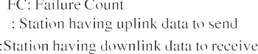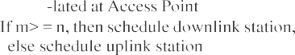

**/ig. 3.** Illustration of the proposed bidirectional transmission procedures in IEEE 802.11ah.

node and grouping the STAs in RAW by observing the initial *𝛾* number The AP calculates the packet interval (*i*) of each incoming packet of a

of packets received at a specific time interval. The *i* value at any time

*𝑡𝑖* from the same type of traffic can be calculated in [17] as

but when the collision occurs between any two uplink transmissions, AP immediately checks the failure count and accordingly schedules in the next slot for the node which has a higher failure count (FC). It is

shown in Fig. 3 that the station having FC = *𝑞* and *𝑞 > 𝑝* is scheduled

(*𝑡𝑝* − *𝑡𝑝* ) + (*𝑡𝑝* − *𝑡𝑝* ) + ⋯ + (*𝑡𝑝* − *𝑡𝑝* )

*𝑖* = *𝑎*2 *𝑎*1 *𝑏*2 *𝑏*1 *𝑚*2 *𝑚*1

*𝛾*

(1)

to transmit in the next RAW frame as it has a higher failure count value. The proposed scheme has given priority to the critical downlink traffic, which is event-driven in nature over uplink traffic. For any

where *𝑡𝑝* holds the time duration of a packet *𝑝* calculated by an AP

node and (*𝑎1, 𝑎2*)*,* (*𝑏1, 𝑏2*)*,* … *,* (*𝑚1, 𝑚2*) are sequentially received packets from the stations *𝐴*1, *𝐴*2, . . . , *𝐴𝑚* respectively. Stations are categorized

depending on the *i* value. These method helps to perceive the traffic nature of the network. All the homogeneous traffic is assumed to be periodic, and event-driven traffic is assumed to be critical. The stations having downlink traffic are given preference without losing sufficient information for making decisions.

**Algorithm 1** Uplink traffic scheduling and smart environment activity

# Initialize:

*𝐼* ← periodicity of flows, *𝐹𝑢* ← uplink frames, i/j=1, 2, 3. . .

1: **for** Uplink frames *𝐹𝑢* **do**

2: *𝐼𝑖*= calculate periodicity of flow *𝑖* as in Eq. (1)

3: **for** *𝑠𝑙𝑜𝑡𝑠* ∈ RAW **do**

4: **if** *𝐹𝑢𝑖* at AP **then**

5: Schedule next frame without further contention

6: Schedule *𝐹𝑢𝑖* in *𝑠𝑙𝑜𝑡* after interval *𝐼*

7: **if** *𝐹𝑢𝑖* and *𝐹𝑢𝑗* in same *𝑠𝑙𝑜𝑡* **then**

8: Schedule *𝐹* with highest failure count

9: **else**

10: Wait for next frame

11: **end if**

12: **end if**

13: **end for**

14: **end for**

Algorithm 1 presents the uplink scheduling of traffic. After iden- tifying the periodicity for uplink frames from a station, AP allocates dedicated slots for future transmission. The AP creates a list of slots for all such types of stations in the network. Our scheme allows uplink and downlink transmission at the same time. Fig. 3 shows the illustration of the proposed bidirectional transmission procedures in IEEE 802.11ah. This scheme allows all the uplink transmission in the UL-RAW slots,

maximum tolerable consecutive miss (say *𝑚*) and failure count (say *𝑛*). collision between uplink traffic and downlink traffic, AP will check the If *𝑚 >*= *𝑛* (in this case), then AP will schedule downlink traffic in the

next RAW frame.

In many cases of a smart environment use case, the cloud/fog sends commands or actuation based on the content of fresh data after comparing with a threshold value. Then the AP receives a downlink command from the cloud/fog node, which needs to schedule immedi- ately to take action. However, there might be a conflict, so there is a collision between uplink and downlink traffic in normal RAW. We solve this issue by immediately checking tolerable consecutive misses and failure counts (as shown in Fig. 3). Our scheme clearly depicts both the transmission without mistreating each other. We calculated

a maximum tolerable consecutive miss factor *𝑥𝑚*, based on fresh data,

where a decision required *𝑚* number of fresh data. Our scheme solves

the conflicting problem occurring at the same time by giving the pref-

erences to downlink traffic based on some criteria, which is explained

station with the *𝑥𝑚* value, it is considered an invalid frame. in Algorithm 2. If there is any downlink command/alert to the same

Our protocol uses a two-phase priority scheduling scheme, when- ever there are downlink frames (command/alert), based on the appli- cation traffic’s priority. First, it uses a priority queue scheduling scheme to keep the most critical or least deadline frames to process. Second, it uses a dedicated downlink RAW scheduling scheme. A deadline-aware downlink packet scheduling is proposed without or less affecting uplink transmission.

* 1. *Analytical model*

Assume a fixed *𝑛* number of contending stations are there in the network. In saturated conditions, each station has a packet available

transmission. Let *𝑠*(*𝑡*) be the stochastic process representing the backoff for transmission immediately, after the completion of each successful stage of the station at time *𝑡* and *𝑏*(*𝑡*) be the stochastic process rep- resenting the backoff time counter for a given station. Let *𝑚* be the ‘‘maximum backoff stage’’ value such that *𝐶𝑊𝑚𝑎𝑥* = 2*𝑚𝑊* , and let us adopt the notation *𝑊 𝑖* = 2*𝑖𝑊* where *𝑖* ∈ (0*, 𝑚*) is called ‘‘backoff

**Algorithm 2** Conflict resolution scheme for downlink traffic

# Initialize:

*𝑥𝑚*= maximum tolerable consecutive miss, *𝑡𝑥* ←transmission, *𝐹𝑑* ←

downlink frames, i/j=1, 2, 3. . .

**Table 2**

Various modulation and coding scheme for 2 MHz channel.

|  |  |  |  |  |
| --- | --- | --- | --- | --- |
| MCS | Modulation | Coding rate | Bits per OFDM symbol | Data rate (Mbps) |
| MCS 0 | BPSK | 1/2 | 52 | .65 |
| MCS 1 | QPSK | 1/2 | 104 | 1.30 |
| MCS 2 | QPSK | 3/4 | 104 | 1.95 |
| MCS 3 | 16 QAM | 1/2 | 208 | 2.60 |
| MCS 4 | 16 QAM | 3/4 | 208 | 3.90 |
| MCS 5 | 64 QAM | 2/3 | 312 | 5.20 |
| MCS 6 | 64 QAM | 3/4 | 312 | 5.85 |
| MCS 7 | 64 QAM | 5/6 | 312 | 6.50 |
| MCS 8 | 256 QAM | 3/4 | 416 | 7.80 |

1: **for** downlink frames *𝐹𝑑* **do**

2: Schedule *𝐹𝑑 𝑖* in first come first service

3: **for** *𝑠𝑙𝑜𝑡𝑠* ∈ RAW **do**

4: **if** station has a uplink frame *𝑓* at *𝑠𝑙𝑜𝑡𝑗* **then**

5: Find *𝑥*: previous consecutive up-link tx failure count

6: **if** *𝑥* ≤ *𝑥𝑚* **then**

7: Reject *𝑓* and Schedule *𝐹𝑑 𝑖*

8: **else**

9: Schedule *𝐹𝑑 𝑖*

*𝑃𝑡𝑟𝑃*

*𝑇 ℎ𝑟*

*𝐸*[*𝑃* ], since a successful transmission occurs in a slot time with

10: **end if**

11: **else**

12: Schedule *𝐹𝑑 𝑖*

13: **end if**

14: **end for**

probability *𝑃𝑡𝑟𝑃𝑇 ℎ𝑟*. The average length of a slot time is readily obtained

considering that, with probability 1 − *𝑃𝑡𝑟*, the slot time is empty; with probability *𝑃𝑡𝑟𝑃𝑇 ℎ𝑟* it contains a successful transmission, and with probability *𝑃𝑡𝑟*(1 − *𝑃𝑇 ℎ𝑟*) it contains a collision. Hence, Eq. (7) becomes:

*𝑃𝑡𝑟𝑃𝑇 ℎ𝑟𝐸*[*𝑃* ]

15: **end for**

*𝑇 ℎ𝑟* = (1 − *𝑃* )*𝜎* + *𝑃 𝑃 𝑇*

+ *𝑃* (1 − *𝑃*

)*𝑇*

(8)

*𝑡𝑟*

*𝑡𝑟*

*𝑇 ℎ𝑟 𝑇 ℎ𝑟*

*𝑡𝑟*

*𝑇 ℎ𝑟 𝑐*

Here, *𝜎* indicates an empty slot duration, and *𝑇𝑇 ℎ𝑟* is the average

duration.

stage’’. However, for convenience *𝑊* = *𝐶𝑊𝑚𝑖𝑛*. At each transmission

attempt, and regardless of the number of retransmissions suffered, each

Here, *𝑇*

*𝑇 ℎ𝑟*

is the average time the channel is sensed busy (i.e., the

packet collides with constant and independent probability *𝑝*, *𝑝* will be

referred to as conditional collision probability, meaning that this is the

channel. The bi-dimensional process *𝑠*(*𝑡*)*, 𝑏*(*𝑡*) is a discrete-time Markov probability of a collision seen by a packet being transmitted on the

Chain model.

Now, we can express the probability *𝜏* that a station transmits in a

randomly chosen slot time. When the backoff time counter is equal to

zero, and any transmission occurs regardless of the backoff stage, it is given [18] as:

slot time lasts) because of a successful transmission, and *𝑇𝑐* is the

average time the channel is sensed busy by each station during a

collision.

We have theoretically analyzed the performance considering MCS0 as the modulation and coding scheme, 2 MHz channel bandwidth, and 650 Kbps data rate settings (as shown in Table 3) in the proposed protocol. The RTS/CTS access is not necessary for IoT use cases as the payload size is relatively smaller (256 bytes) than the traditional network frame sizes. [19].

*𝜏* = 2(1 − 2*𝑝*)

(1 − 2*𝑝*)(*𝑊* + 1) + *𝑝𝑊* (1 − (2*𝑝*)*𝑚*)

(2)

* + 1. *Maximum throughput*

When m = 0, that is no exponential backoff is considered, the probability *𝜏* results to be independent of p, and Eq. (2) becomes:

The theoretical maximum throughput (*𝑇 ℎ𝑟𝑚𝑎𝑥*) of the proposed

protocol is defined as the maximum quantity of MAC layer Service Data

*𝜏* = 2

(*𝑊* + 1)

1. ​

Units (MSDU) per unit of time. If we know the size of MSDU (*𝐿𝑚𝑠𝑑𝑢*) and transmission (Tx) delay per MSDU (*𝑇𝑚𝑠𝑑𝑢*), then:

However, *𝜏* depends on the conditional probability *𝑝*. The probabil- ity *𝑝* that a transmitted packet encounters a collision is the probability

that, in a time slot, at least one of the (n–1) remaining stations transmit. At a steady state, each remaining station transmits a packet with

probability *𝜏*, which provides:

*𝑝* = 1 − (1 − *𝜏*)*𝑛*−1 (4)

Let the normalized throughput (*𝑇 ℎ𝑟*) be defined as the fraction of

*𝑇 ℎ𝑟* = *𝐿𝑚𝑠𝑑𝑢*

*𝑚𝑎𝑥 𝑇𝑚𝑠𝑑𝑢*

Where,

*𝑇𝑚𝑠𝑑𝑢* = *𝑇𝑑𝑖𝑓 𝑠* + *𝑇𝑏𝑜* + *𝑇𝑑𝑎𝑡𝑎* + *𝑇𝑠𝑖𝑓 𝑠*

+ *𝑇𝑎𝑐𝑘*

Where, *𝑇* ← Tx delay per DIFS, *𝑇*

(9)

← Tx delay per backoff, *𝑇* ←

time for the channel used to transmit payload bits successfully. Let

*𝑑𝑖𝑓 𝑠*

*𝑏𝑜*

*𝑑𝑎𝑡𝑎*

the probability *𝑃*

*𝑡𝑟*

be present at least once in the transmission of the

Tx delay per DATA, *𝑇𝑠𝑖𝑓 𝑠* ← Tx delay per SIFS, and *𝑇𝑎𝑐𝑘* ← Tx delay per

ACK.

considered slot time. If stations (say *𝑛*) contend on the channel having

transmission probability *𝜏* for each of the stations is given by:

The duration of data and control frame can be calculated by the equation mentioned in [19].

*𝑃𝑡𝑟* = 1 − (1 − *𝜏*)*𝑛* (5)

*⌈* ×

8 × (

*𝐿𝑝𝑎𝑦𝑙𝑜𝑎𝑑*

+ *𝑀𝐴𝐶*)

Let *𝑃𝑇 ℎ𝑟* be the probability for a successful transmission in a slot on

the channel, which can be determined as:

*𝑇𝑑𝑎𝑡𝑎* = *𝑅 𝐿*

*𝑏𝑎𝑠𝑖𝑐*_*𝑑𝑎𝑡𝑎*_*𝑟𝑎𝑡𝑒*

*𝑏𝑎𝑠𝑖𝑐*_*𝑑𝑎𝑡𝑎𝑟𝑎𝑡𝑒*_*𝑠𝑦𝑚 ⌉*

*𝑃𝑇 ℎ𝑟* =

*𝑛𝜏*(1 − *𝜏*)*𝑛*−1

*𝑃𝑡𝑟*

= *𝑛𝜏*(1 − *𝜏*)*𝑛*−1 (6)

1 − (1 − *𝜏*)*𝑛*

× *𝑇𝑠𝑦𝑚* + *𝑃 𝐻𝑌* (10)

8 × *𝐿𝑐𝑜𝑛𝑡𝑟𝑜𝑙*

Now, we are able to express *𝑇 ℎ𝑟* as the ratio of:

*𝑇𝑐𝑜𝑛𝑡𝑟𝑜𝑙* = *⌈ 𝐿*

*𝑏𝑎𝑠𝑖𝑐*_*𝑑𝑎𝑡𝑎𝑟𝑎𝑡𝑒*_*𝑠𝑦𝑚*

*⌉* × *𝑇𝑠𝑦𝑚* + *𝑃 𝐻𝑌*

*𝐸*[payload information transmitted in a slot time]

*𝑇 ℎ𝑟* =

*𝐸*[length of a slot time]

(7)

Where, *𝑅* is the rate of DATA packet based on the MCS available and *𝐿𝑏𝑎𝑠𝑖𝑐*_*𝑑𝑎𝑡𝑎𝑟𝑎𝑡𝑒*_*𝑠𝑦𝑚* represents the number of OFDM symbols data bits

*𝐸*[*𝑃* ] is the average packet payload size that is the average amount

of payload information successfully transmitted in a slot time is

with constant duration (*𝑇𝑠𝑦𝑚*) to be transmitted. Various data rates are

mentioned in Table 2. From Eqs. (9) and (10), *𝑇 ℎ𝑟𝑚𝑎𝑥* = 311*.*33 Kbps

* + 1. *Average delay*

In IoT, the primary delay issue is channel access as a huge number of devices try to contend for the channel. When many stations try to contend for the channel choosing the same backoff slot, a collision occurs. With the assumption of very low frame drop probability, the

average frame delay *𝐸𝑑* is calculated in [20,21] as-

*𝐸𝑑* = *𝐸𝑥* × *𝐸𝑠𝑙𝑜𝑡*_*𝑠𝑖𝑧𝑒* (11)

where,

*𝑠*−1

**Table 3**

Simulation parameters used in our study. Parameters Value

Data rate 650 Kbps

Bandwidth 2 MHz

Payload size 256 Bytes

Modulation and coding scheme MCS 0 Traffic types UDP

MAC header Legacy

Radio propagation model Outdoor (Macro) [24]

OFDM symbols time (*𝑇𝑠𝑦𝑚* ) 40 μs

*𝐸* = *∑*(*𝑃* × *𝑊𝑖* + 1 ) + *𝑃𝑠* × *𝑊𝑠* + 1

(12)

PHY header 6 × *𝑇𝑠𝑦𝑚*

*𝑥 𝑖* 2

1 − *𝑃* 2

*𝐶𝑊𝑚𝑖𝑛* 15

*𝑖*=0

*𝐶𝑊*

*𝑚𝑎𝑥*

1023

*𝐸𝑥* is the required time period for empty slots before transmitting a

frame successfully. *𝑃𝑖* is the probability that a STA transmits in stage *𝑖*

of the backoff window (*𝑊𝑖*). Bianchi et al. [18] calculates the value of

*𝑃* as-

*𝑃* = 1 − (1 − *𝜏*)*𝑛*−1

Again, *𝜏* (i.e., probability of an STA transmitting a packet) is de- pendent on the number of STAs (*𝑛*) and duration of collision *𝑇𝑐* , and

1

Slot time 52 μs

Initial backoff window 64

Backoff time (*𝑊𝑚𝑖𝑛* ∕2) × Slot time

SIFS 16 μs

DIFS SIFS+2 × Slot time

Simulation area 1000 m × 1000 m (Flat-grid)

Beacon interval 100 ms.

No. of nodes (Max.) 1000

RAW size 3 (Min.) and 15 (Max.)

RAW groups 2–5

*𝜏* =

*√*

*𝑛*

*𝑇𝑐* . For 100 STAs in a group, *𝜏* ≈ 0*.*001. Also, as we have used

2

RAW slot duration 3 ms.

Traffic Interval 1 Sec.

64 as the initial backoff window size, m = 6, from Eq. (11), for 100

STAs, *𝐸𝑑* = 0*.*6047 Sec.

* + 1. *Power consumption*



Let *𝑡𝑡𝑥, 𝑡𝑟𝑥, 𝑡𝑖𝑑 ,* and *𝑡𝑠𝑙* be the time duration of transmitting, receiving,

idle, and sleeping modes for the IEEE 802.11 ah transceiver within a

consumption (*𝐸*) can be determined by multiplying these time dura- DTIM, respectively. Now, for an STA within a DTIM, the total energy

tions of a transceiver for each operation to their corresponding power consumptions as [22]:

*𝐸* = *𝑡𝑡𝑥𝑝𝑡𝑥* + *𝑡𝑟𝑥𝑝𝑟𝑥* + *𝑡𝑖𝑑 𝑝𝑖𝑑* + *𝑡𝑠𝑙 𝑝𝑠𝑙*

where *𝑝𝑟𝑥, 𝑝𝑡𝑥, 𝑝𝑠𝑙* , and *𝑝𝑖𝑑* are the power consumption chosen in Rx, Tx,

sleep, and Idle mode, respectively.

# Performance evaluation

The performance of the proposed scheme is evaluated through sim- ulations using [23]. The parameters which are used in the simulations are presented in Table 3. We evaluate RAW performance in terms of *throughput*, *latency*, *energy consumption*, and *packet delivery ratio*.

* 1. *Performance metrics*
     + Throughput: We calculate the amount of data received by AP (for uplink traffic) or STA (for downlink traffic) per second. We use this metric to see how much uplink and downlink traffic data it can support over time.
     + Latency: We calculate the average uplink and downlink traffic latency. We are mostly interested in the downlink latency during an actuation.
     + Packet delivery ratio: The ratio between the number of success- fully sent frames and over 100 frames sent.
  2. *Benchmarks*

The proposed scheme is compared with traditional 802.11ah, and PTS–MAC [17] in terms of throughput, delay, energy consumption, and packet delivery ratio. Compared to 802.11ah, PTS–MAC uses a hybrid channel access mechanism to find the number of periodic uplink stations and their periodicity. Later, as per their periodicity, a slot is assigned without further contention. PTS–MAC shows better per- formance in terms of uplink throughput, delay, and energy consump- tion, as compared to traditional 802.11ah. The proposed MAC proto- col (i.e., IoT–MAC) additionally considers downlink traffic scheduling, along with periodic uplink traffic scheduling, while enabling a novel conflict resolution method.



**/ig. 4.** Packet delivery ratio with considering 30% downlink traffic.

* 1. *Simulation results*

Our assumption is based on some smart environments like smart homes, where there are continuous flows of uplink traffic from sensors and downlink traffic generated from apps or based on human activity. We created a scenario in ns-3 having multiple smart home devices, then calculated the average number of downlink and uplink traffic amount. We found that there are approximately 30% downlinks, and the remaining are uplink traffic. Fig. 4 shows the packet delivery ratio with an increasing number of uplink and downlink traffic flows. As a single device is used to connect multiple sensors and actuation in smart space, there can be multiple flows from the same device. The proposed scheme shows better PDR as compared to the existing state-of-the-art solutions. Our solution uses the periodicity of traffic to reserve a slot for uplink transmission. At the same time, it ensures downlink transmission using the proposed conflict resolution scheme, as discussed in Section 3. We analyze the delay performance of the proposed scheme in the same network scenarios. As our method reduces contention of up- link transmission and ensures downlink transmission, the delay in our method reduces significantly (can be seen in Fig. 5). For the same reason, the throughput performance of the proposed scheme has been

increased too (refer Fig. 6).

We also analyze the performance of the proposed scheme consid- ering only downlink traffic. Figs. 7 and 8 show the PDR and delay for downlink traffic, respectively, compared with the PTS–MAC and 802.11ah. There is no specific measure to deal with the downlink traffic

       



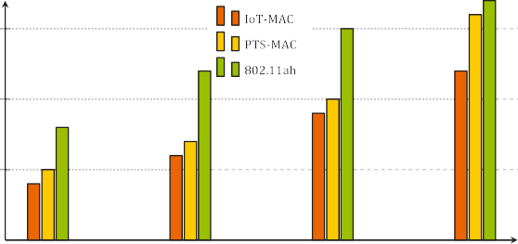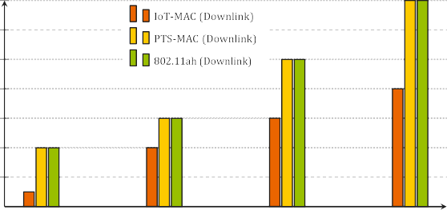**/ig. 5.** Delay incurs with increasing number of streaming flows.

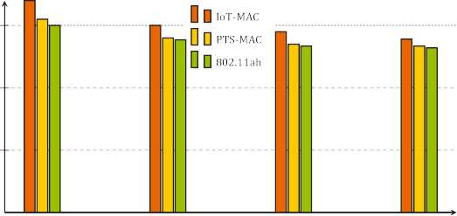



**/ig. 6.** Throughput analysis of streaming data flows.



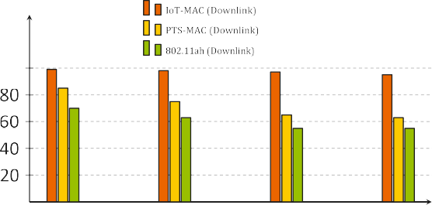

   



**/ig. 7.** Packet delivery ratio considering downlink traffic.

in PTS–MAC and 802.11ah; they show almost similar performance. However, due to the conflict-aware downlink scheduling in our scheme, it shows better PDR and delay.

Fig. 9 shows energy consumption for our proposed scheme. As our scheme uses conflict resolution for both uplink and downlink traffic, the number of retransmissions has been reduced significantly. Consequently, the energy consumption is also reduced in the case of both types of traffic in an IoT environment. In PTS and traditional IEEE 802.11ah, downlink traffic is not considered explicitly for scheduling, causing contention, which reduces the sleeping time of the nodes and degrades the overall performance. Our proposed method solves this issue and improves energy consumption.

# Conclusion

This paper presented a RAW mechanism for an IEEE 802.11ah net- work having uplink and downlink traffic (i.e., bidirectional traffic). The proposed scheme considers challenges related to finding optimal RAW size over event-driven downlink and periodic uplink traffic. Our scheme can predict the traffic accurately and schedule appropriately with less

**/ig. 8.** Delay incurs with increasing number of streaming flows.



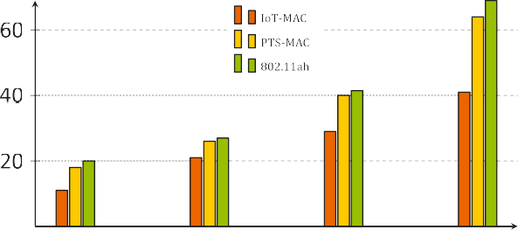**/ig. 9.** Average energy consumption with the increasing number of streaming flows.

contention. Also, efficient downlink traffic is proposed without losing the content of fresh data. It improves the performance of throughput, latency, packet delivery ratio, and energy consumption to a great extent as compared to the existing state-of-the-art. The experimental analysis clearly depicts its importance for extensive and latency-aware saturated networks. We consider various decisions for actuation in a smart environment based on only fresh data; however, the growing complex activities, which combine decisions based on historical data. In the future, we plan to work on optimizing the RAW size by considering historical data over heterogeneous application scenarios.

# Ethical approval

This article does not contain any study with human participants or animals performed by any of the authors.

# CRediT authorship contribution statement

**Md. Arifuzzaman Mondal:** Conceptualization, Methodology, Soft- ware, Analysis and interpretation of data, Writing – original draft, Edit- ing. **Nurzaman Ahmed:** Conceptualization, Methodology, Validation, Writing – reviewing. **Md. Iftekhar Hussain:** Supervision,Validation, Conceptualization.

# Declaration of competing interest

No author associated with this paper has disclosed any potential or pertinent conflicts which may be perceived to have impending conflict with this work.

# Data availability

No data was used for the research described in the article.

# References

1. [Zhang Y, Yu R, Nekovee M, Liu Y, Xie S, Gjessing S. Cognitive machine-to-](http://refhub.elsevier.com/S2590-0056(23)00010-3/sb1) [machine communications: Visions and potentials for the smart grid. IEEE Netw](http://refhub.elsevier.com/S2590-0056(23)00010-3/sb1) [2012;26(3):6–13.](http://refhub.elsevier.com/S2590-0056(23)00010-3/sb1)
2. [Qiao L, Zheng Z, Cui W, Wang L. A survey on Wi-Fi HaLow technology for](http://refhub.elsevier.com/S2590-0056(23)00010-3/sb2) [Internet of Things. In: 2018 2nd IEEE conference on energy internet and energy](http://refhub.elsevier.com/S2590-0056(23)00010-3/sb2) [system integration. IEEE; 2018, p. 1–5.](http://refhub.elsevier.com/S2590-0056(23)00010-3/sb2)
3. Charania NF, Giluka MK, Tamma BR, Franklin A. DEARF: Delay and energy aware RAW formation scheme to support delay sensitive M2M traffic in IEEE

802.11 ah networks. 2017, arXiv preprint [arXiv:1709.03723](http://arxiv.org/abs/1709.03723).

1. [Nawaz N, Hafeez M, Zaidi SAR, McLernon DC, Ghogho M. Throughput enhance-](http://refhub.elsevier.com/S2590-0056(23)00010-3/sb4) [ment of restricted access window for uniform grouping scheme in IEEE 802.11](http://refhub.elsevier.com/S2590-0056(23)00010-3/sb4) [ah. In: IEEE international conference on communications. IEEE; 2017, p. 1–7.](http://refhub.elsevier.com/S2590-0056(23)00010-3/sb4)
2. [Wang Y, Chai KK, Chen Y, Schormans J, Loo J. Energy-aware restricted access](http://refhub.elsevier.com/S2590-0056(23)00010-3/sb5) [window control with retransmission scheme for IEEE 802.11 ah (Wi-Fi HaLow)](http://refhub.elsevier.com/S2590-0056(23)00010-3/sb5) [based networks. In: 13th annual conference on wireless on-demand network](http://refhub.elsevier.com/S2590-0056(23)00010-3/sb5) [systems and services. IEEE; 2017, p. 69–76.](http://refhub.elsevier.com/S2590-0056(23)00010-3/sb5)
3. [Šljivo A, Kerkhove D, Tian L, Famaey J, Munteanu A, Moerman I, et al.](http://refhub.elsevier.com/S2590-0056(23)00010-3/sb6) [Performance evaluation of IEEE 802.11 ah networks with high-throughput](http://refhub.elsevier.com/S2590-0056(23)00010-3/sb6) [bidirectional traffic. Sensors 2018;18(2):325.](http://refhub.elsevier.com/S2590-0056(23)00010-3/sb6)
4. [Khorov E, Krotov A, Lyakhov A, Yusupov R, Condoluci M, Dohler M, et al.](http://refhub.elsevier.com/S2590-0056(23)00010-3/sb7) [Enabling the Internet of Things with Wi-Fi Halow—Performance evaluation of](http://refhub.elsevier.com/S2590-0056(23)00010-3/sb7) [the restricted access window. IEEE Access 2019;7:127402–15.](http://refhub.elsevier.com/S2590-0056(23)00010-3/sb7)
5. [Ahmed N, De D, Hussain MI. A QoS-aware MAC protocol for IEEE 802.11 ah-](http://refhub.elsevier.com/S2590-0056(23)00010-3/sb8) [based Internet of Things. In: 2018 fifteenth international conference on wireless](http://refhub.elsevier.com/S2590-0056(23)00010-3/sb8) [and optical communications networks. IEEE; 2018, p. 1–5.](http://refhub.elsevier.com/S2590-0056(23)00010-3/sb8)
6. [Kureev A, Bankov D, Khorov E, Lyakhov A. Improving efficiency of heteroge-](http://refhub.elsevier.com/S2590-0056(23)00010-3/sb9) [neous Wi-Fi networks with joint usage of TIM segmentation and restricted access](http://refhub.elsevier.com/S2590-0056(23)00010-3/sb9) [window. In: 2017 IEEE 28th annual international symposium on personal, indoor,](http://refhub.elsevier.com/S2590-0056(23)00010-3/sb9) [and mobile radio communications. IEEE; 2017, p. 1–5.](http://refhub.elsevier.com/S2590-0056(23)00010-3/sb9)
7. [Badihi B, Del Carpio LF, Amin P, Larmo A, Lopez M, Denteneer D. Performance](http://refhub.elsevier.com/S2590-0056(23)00010-3/sb10) [evaluation of IEEE 802.11 ah actuators. In: IEEE 83rd vehicular technology](http://refhub.elsevier.com/S2590-0056(23)00010-3/sb10) [conference. IEEE; 2016, p. 1–5.](http://refhub.elsevier.com/S2590-0056(23)00010-3/sb10)
8. [Dong M, Wu Z, Gao X, Zhao H. An efficient spatial group restricted access](http://refhub.elsevier.com/S2590-0056(23)00010-3/sb11) [window scheme for IEEE 802.11 ah networks. In: 2016 sixth international](http://refhub.elsevier.com/S2590-0056(23)00010-3/sb11) [conference on information science and technology. IEEE; 2016, p. 168–73.](http://refhub.elsevier.com/S2590-0056(23)00010-3/sb11)
9. [Hazmi A, Badihi B, Larmo A, Torsner J, Valkama M, et al. Performance](http://refhub.elsevier.com/S2590-0056(23)00010-3/sb12) [analysis of IoT-enabling IEEE 802.11 ah technology and its RAW mechanism](http://refhub.elsevier.com/S2590-0056(23)00010-3/sb12) [with non-cross slot boundary holding schemes. In: 2015 IEEE 16th international](http://refhub.elsevier.com/S2590-0056(23)00010-3/sb12) [symposium on a world of wireless, mobile and multimedia networks. IEEE; 2015,](http://refhub.elsevier.com/S2590-0056(23)00010-3/sb12)

[p. 1–6.](http://refhub.elsevier.com/S2590-0056(23)00010-3/sb12)

1. [Damayanti W, Kim S, Yun J-H. Collision chain mitigation and hidden](http://refhub.elsevier.com/S2590-0056(23)00010-3/sb13) [device-aware grouping in large-scale IEEE 802.11 ah networks. Comput Netw](http://refhub.elsevier.com/S2590-0056(23)00010-3/sb13) [2016;108:296–306.](http://refhub.elsevier.com/S2590-0056(23)00010-3/sb13)
2. [Yoon S-G, Seo J-O, Bahk S. Regrouping algorithm to alleviate the hidden node](http://refhub.elsevier.com/S2590-0056(23)00010-3/sb14) [problem in 802.11 ah networks. Comput Netw 2016;105:22–32.](http://refhub.elsevier.com/S2590-0056(23)00010-3/sb14)
3. [Chang T-C, Lin C-H, Lin KC-J, Chen W-T. Load-balanced sensor grouping for IEEE](http://refhub.elsevier.com/S2590-0056(23)00010-3/sb15)

[802.11 ah networks. In: 2015 IEEE global communications conference. IEEE;](http://refhub.elsevier.com/S2590-0056(23)00010-3/sb15) [2015, p. 1–6.](http://refhub.elsevier.com/S2590-0056(23)00010-3/sb15)

1. [Khorov E, Krotov A, Lyakhov A. Modelling machine type communication in IEEE](http://refhub.elsevier.com/S2590-0056(23)00010-3/sb16)

[802.11 ah networks. In: 2015 IEEE international conference on communication](http://refhub.elsevier.com/S2590-0056(23)00010-3/sb16) [workshop . IEEE; 2015, p. 1149–54.](http://refhub.elsevier.com/S2590-0056(23)00010-3/sb16)

1. [Ahmed N, Hussain MI. Periodic traffic scheduling for IEEE 802.11 ah networks.](http://refhub.elsevier.com/S2590-0056(23)00010-3/sb17) [IEEE Commun Lett 2020;24(7):1510–3.](http://refhub.elsevier.com/S2590-0056(23)00010-3/sb17)
2. [Bianchi G, et al. Performance analysis of the IEEE 802. 11 distributed](http://refhub.elsevier.com/S2590-0056(23)00010-3/sb18) [coordination function. IEEE J Sel Areas Commun 2000;18(3):535–47.](http://refhub.elsevier.com/S2590-0056(23)00010-3/sb18)
3. [Raeesi O, Pirskanen J, Hazmi A, Levanen T, Valkama M. Performance evaluation](http://refhub.elsevier.com/S2590-0056(23)00010-3/sb19) [of IEEE 802.11 ah and its restricted access window mechanism. In: IEEE](http://refhub.elsevier.com/S2590-0056(23)00010-3/sb19) [international conference on communications workshops. IEEE; 2014, p. 460–6.](http://refhub.elsevier.com/S2590-0056(23)00010-3/sb19)
4. [Chatzimisios P, Vitsas V, Boucouvalas AC. Throughput and delay analysis of](http://refhub.elsevier.com/S2590-0056(23)00010-3/sb20) [IEEE 802.11 protocol. In: Proceedings 3rd IEEE international workshop on](http://refhub.elsevier.com/S2590-0056(23)00010-3/sb20) [system-on-chip for real-time applications. IEEE; 2002, p. 168–74.](http://refhub.elsevier.com/S2590-0056(23)00010-3/sb20)
5. [Leon A, Cesar J. Evaluation of IEEE 802.11 ah Technology for Wireless Sensor](http://refhub.elsevier.com/S2590-0056(23)00010-3/sb21) [Network Applications [Master’s thesis], Tampere, Finland: Tampere University](http://refhub.elsevier.com/S2590-0056(23)00010-3/sb21) [of Technology; 2015.](http://refhub.elsevier.com/S2590-0056(23)00010-3/sb21)
6. [Fan Q, Fan J, Li J, Wang X. A multi-hop energy-efficient sleeping MAC](http://refhub.elsevier.com/S2590-0056(23)00010-3/sb22) [protocol based on TDMA scheduling for wireless mesh sensor networks. J Netw](http://refhub.elsevier.com/S2590-0056(23)00010-3/sb22) [2012;7(9):1355–61.](http://refhub.elsevier.com/S2590-0056(23)00010-3/sb22)
7. What is NS-3. <https://www.nsnam.org/overview/what-is-ns-3/>, online.
8. [Bellekens B, Tian L, Boer P, Weyn M, Famaey J. Outdoor IEEE 802.11 ah range](http://refhub.elsevier.com/S2590-0056(23)00010-3/sb24) [characterization using validated propagation models. In: GLOBECOM 2017-2017](http://refhub.elsevier.com/S2590-0056(23)00010-3/sb24) [IEEE global communications conference. IEEE; 2017, p. 1–6.](http://refhub.elsevier.com/S2590-0056(23)00010-3/sb24)