Available online at [www.sciencedirect.com](http://www.sciencedirect.com/)



AASRI Procedia 3 (2012) 107 – 112

2012 AASRI Conference on Modelling, Identification and Control

Layered metal-intermetallic composites in Ti-Al system: strength under static and dynamic load

Patselov A.a,*, Greenberg B.a, Gladkovskii S.b, Lavrikov R.a, Borodin E.b

*aInstitute of Metal Physics, Ural Branch of RAS, 18 S. Kovalevskaya Str., 620990 Ekaterinburg, Russia*

*bInstitute of Engineering Science, Ural Branch of RAS, 34 Komsomolskaya Str., 620049 Ekaterinburg, Russia*

**Abstract**

Metal intermetallic laminated (MIL) composites are fabricated upon reaction sintering of titanium and aluminum foils of various thicknesses. The intermetallic phase of Al3Ti forming during the above processing gives high hardness and stiffness to the composite, while unreacted titanium provides the necessary high strength and ductility. Some results of studies of microstructure and some mechanical properties of layered composites are presented on the example of Ti-Al system. Static and dynamic tests results are discussed for the case when the intermetallic reaction was interrupted in the course of intermetallic sintering and also for the case when it was completed.

© 2012 The Authors. Published by Elsevier B.V. Open access under [CC BY-NC-ND license.](http://creativecommons.org/licenses/by-nc-nd/3.0/)

© 2012 The Authors. Published by Elsevier B.V.

Selection and/or peer review under responsibility of American Applied Science Research Institute

Selection and/or peer review under responsibility of American Applied Science Research Institute

*Keywords*: layered composites; intermetallic; impact toughness; static compression; microhardness

# Introduction

One of the ways to overcome low ductility and toughness of intermetallics is creation of composites with a metal constituent responsible for improvement of the above properties. Layered metal-intermetallic composites is a new class of construction and multifunctional materials production of which is based on open

* Corresponding author. Tel.: +7-343-378-3829; fax: +7-343-374-5244.

*E-mail address:* [patselov@imp.uran.ru.](mailto:patselov@imp.uran.ru)

2212-6716 © 2012 The Authors. Published by Elsevier B.V. Open access under [CC BY-NC-ND license.](http://creativecommons.org/licenses/by-nc-nd/3.0/) Selection and/or peer review under responsibility of American Applied Science Research Institute doi:10.1016/j.aasri.2012.11.019

air reaction sintering of chemically active metal foils under pressure [1]. The work results [2] show that the main factor enhancing toughness of a composite material is layered morphology; fiber and particle morphology comes next. The advantages of layered composite materials are not limited to high values of strength and stiffness of intermetallic phase and high toughness of the metal constituent. Geometry of the layered structure allows, by changing the ratio between thicknesses of metallic and intermetallic constituents, achieving desired levels of the composite material mechanical properties. Required ratio between thicknesses in a layered metal-intermetallic composite is, in its turn, ensured by such selection of thicknesses of initial metal foils when one of the components would be completely consumed for forming the intermetallic. The remaining volume of the second component would be responsible for ductility and toughness of the composite metal component.

The purpose of this paper is to present the part of our results obtained in investigating the structure and mechanical properties of metalintermetallic laminated composites in Ti-Al system synthesized both under interrupted [3] and completed intermetallic reaction conditions.

# Experimental

To fabricate metalintermetallic laminated composites, we used commercial titanium (wt % 99.3 Ti, 0.16 Fe, 0.08 Si, 0.05 C, 0.10 O) and aluminum (98.2 Al, 0.8 Fe, 0.5 Si, 0.1 Cu, 0.1 Zn, 0.1 Mn) foils with different thickness. Before sintering titanium foils were etched in (87% HNO3+10% HF+3% H2O) solution. Aluminum foils also were etched in 20% NaOH solution. All the foils then were water flushed, and dried before assembling. The above procedures are needed to remove surface contaminations and oxide films. Unfortunately very thin oxide films stay on the surface in any way. An assembly of alternating foil layers was subjected to open air sintering under controlled heat and pressure loading (Fig.1). Initial thicknesses of metal foils as well as layers quantity are summarized in Table 1.

Table 1. Composite preparation parameters

|  |  |  |
| --- | --- | --- |
| An example of a column heading | Interrupted reaction | Completed reaction |
| Initial Al foil thickness, | 80 | 500 |
|  | 100 | 300 |
| Number of Al layers | 69 | 29 |
| Number of Ti layers | 70 | 30 |

Compression tests for (20 × 20 × 10) mm and (30 × 10 × 10) specimens were performed at a load applied both along and across composite layers on a universal FP-100/1 testing machine at a testing speed of 2 mm/min.

To evaluate the structure of composites, we used scanning (Quanta FEI equipped with a microanalyzer) electron microscopes. X-ray diffraction (XRD) analysis of phase composition was performed with a DRON-3 diffractometer using monochromatized Cu*K* radiation. The microhardness was measured on a PMT-3 microhardness tester at a load of 0.5 N.

Impact bending tests were carried out at room temperature on V-notched specimens (10 × 10 × 55) mm using a Tinius Olsen IT 542 (United States) instrumented pendulum impact testing machine. The maximum stored energy of the machine was 542 J, and the impact speed was 5.47 m/s. Two types of specimens were prepared: specimens with the crack arrester and crack divider orientation. The works of crack nucleation and

propagation were determined from loaddisplacement impact loading diagrams using a special purpose software package.

# Results and Discussions

In the process of solid diffusion of components at interfaces the clusters of intermetallic phase are nucleate and grow in. Titanium oxides at a temperature 873 K may be reduced by aluminum according to reactions (1, 2):

2O3 + 3Ti *(1)*

3TiO2 2O3 + 3Ti *(2)*

Such local perforation of the surface layer of titanium oxides [4] may take place, followed by formation and growth of Al3Ti in the same place. Scanning electron microscopy (SEM) reveals the shape of titanium tri- aluminide clusters and their spatial distribution at the interface of the initial metals. As can be observed from

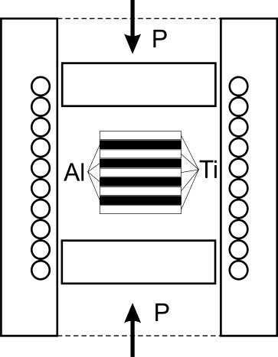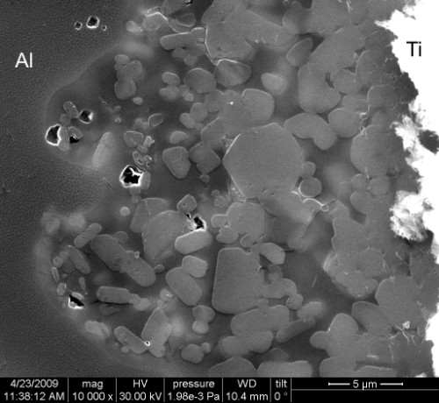

Fig. 1. Sintering setup Fig. 2. Al3Ti clusters in structure of composite

Fig.2 grain size of Al3Ti from aluminum side is much smaller then for titanium side. When temperature approaches the melting point of aluminum and a thin layer of aluminum melt appears, the reaction rate increases rapidly and formation of a tri-aluminide layer is controlled by the exothermic reaction (3):

3Al + Ti  Al3Ti + Q *(3)*

Presentation of strength properties for layered composites is discussed for only two cases. First case we have when the reaction is interrupted (Fig. 3a - interrupted reaction structure) and sintered composite has about 15-17% of intermetallic together with the rest of unconsumed aluminum and residual titanium. Second case we have when the reaction is completed (Fig. 3b - complete reaction structure) and for our choice of initial foil thickness relation MIL - composite has 15-17% of residual titanium and 83-85% of Al3Ti phase.

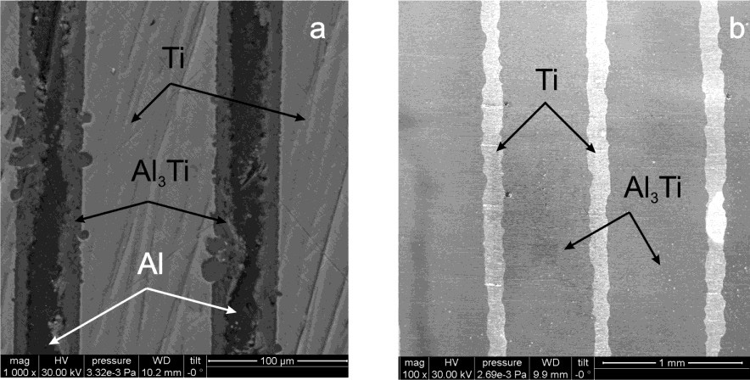

Fig. 3. Micrographs of Ti-Al composites (SEM): (a) - incomplete reaction structure; (b) - complete reaction structure

XRD data demonstrate that the laminated composite samples fabricated by interrupting an intermetallic reaction in sintering contain the  phases of titanium and aluminum, the Al3Ti phase with space group D022, and a certain amount of oxide Al2O3 at the centreline of aluminum. After completion of the intermetallic reaction, X-ray diffraction patterns have no aluminum lines, which indicate that it was fully consumed in sintering.

Results of microhardness measurements for laminated composites showed that titanium microhardness is 1750-1860 MPa while tri-aluminide microhardness is about 5000 MPa.

The results for static load indicated that the MIL composites exhibited anisotropic features both for mechanical properties and fracture behavior. It should be noted a significant difference in mechanical properties determined by static compression for the load application directions along and across the layers (see Table 2). For example, proportional limit differ by a factor of about 1.5 and the shortening at a peak load differ by a factor of 7. A pronounced anisotropic character of the mechanical properties is also observed during impact bending tests. It is established that the impact strength and total energy of fracture, depend strongly on the orientation of the notch. For the samples with arrester orientation, the crack propagation energy is higher than that in the case of divider orientation samples by a factor of about 4 (see Table 2).

That is, the anisotropy of composite structure is clearly evident in its mechanical properties both under static and dynamic loading.

Table 2. Mechanical properties of MIL - composite samples (interrupted reaction, 15% of intermetallic phase)

|  |  |  |
| --- | --- | --- |
| Properties (average per set of 3-4 measurements) | Along layers load | Across layers load |
| Static compre B, MPa | 410 | 512 |
| Shortening at maximum load, % | 3.5 | 25.1 |
| 0.05, MPa | 261 | 185 |
| Total fracture energy, J | 3.93 | 12.02 |
| Crack propagation energy, J | 2.81 | 10.87 |
| Impact toughness, kJ/m2 | 86.7 | 265.5 |

As for the second case when we have MIL - composite after completed reaction with 85% of intermetallic fraction anisotropy of mechanical properties does not observed in such a way like for above first case. For example, according to static compression tests ductility presented here by shortening at peak load practically the same for both load directions (see Table 3).

Table 3. Mechanical properties of MIL - composite samples (completed reaction, 85% of intermetallic phase)

|  |  |  |
| --- | --- | --- |
| Properties (average per set of 3-4 measurements) | Along layers load | Across layers load |
| B, MPa | 464 | 451 |
| Shortening at maximum load, % | 3.5 | 3.4 |
| 0.05, MPa | 423 | 391 |
| Total fracture energy, J | 10.02 | 8.36 |
| Crack propagation energy, J | 7.1 | 5.1 |
| Impact toughness, kJ/m2 | 120.0 | 100.0 |

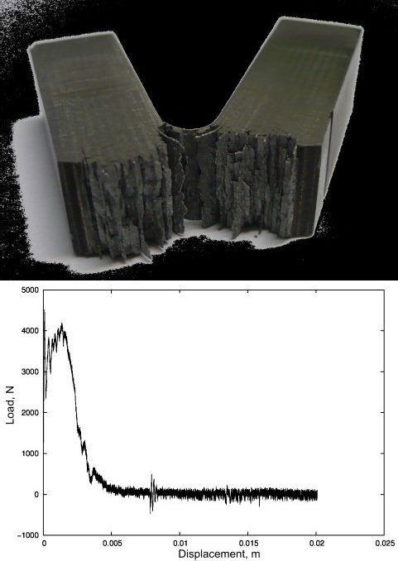Loaddisplacement impact loading diagrams are also indicating to the high energetic intensity of the crack passing process through the composite layers. Presence of load oscillations before its maximum points to additional absorption of impact energy when a deflection of crack by interface of layers is occurred. In spite of different character of fracture behavior for crack arrester (Fig. 4a) and crack divider (Fig. 4b) oriented samples visible on load-displacement impact loading diagrams (Fig. 4b, 5b) there is no significant discrepancy in dynamic strength values.

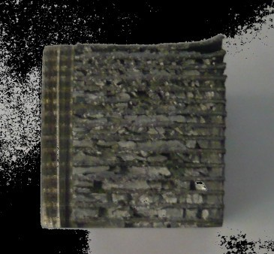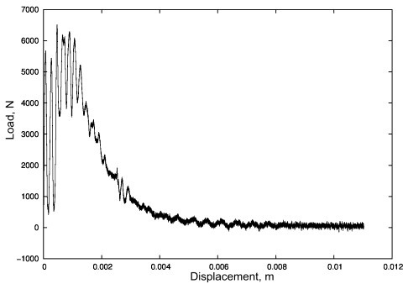

a a

b b

Fig. 4. Fracture surface (a) and impact loading diagram (b) for crack arrested oriented sample

Fig. 5. Fracture surface (a) and impact loading diagram (b) for crack divided oriented sample

According to the results of dynamic loading (see Table 3) there is no such apparent anisotropy of properties for MIL composites with high volume fraction of aluminide.

# Acknowledgements

Electron microscopic studies were performed at the Electron Microscopy Center of Collaborative Access, Ural Branch, Russian Academy of Sciences. Measurement of the mechanical properties were performed at the Center of Collaborative Access "Testing Center of Advanced Materials and Nanotechnology", Ural Branch, Russian Academy of Sciences. Measurement of the impact toughness were performed at the Center of Collaborative Access "Plastometriya", Institute of Engineering Science, Ural Branch, Russian Academy of Sciences.

This work was financially supported by project 12-U-2-1011 of the Ural Division of the Russian Academy of Sciences and by project 12-P-2-1053 of the Presidium of the Russian Academy of Sciences and by project 10-02-96041 of the Russian Foundation for Basic Research.

# References

1. Vecchio K. Synthetic Multifunctional Metallic-Intermetallic Laminate Composites. JOM 2005;3:25-31.
2. Soboyejo WO, Ye F, Chen L-C, Bahtishi N, et al. Effects of reinforcement morphology on the fatigue and fracture behavior of MoSi2/Nb composites. Acta Materialia 1996;44:2027-41.
3. Patselov AM, Rybin VV, Grinberg BA, Ivanov MA, and Eremina OV. Synthesis and Properties of TiAl Laminated Composites with an Intermetallic Layer. Russian Metallurgy (Metally) 2011;4:356360.
4. Kral J, Ferdinandy M, Liska D. Formation of TiAl3 on titanium alloys. Mat Sci Eng 1991;A140:479-85.