[Array 7 (2020) 100032](https://doi.org/10.1016/j.array.2020.100032)

 

Contents lists available at [ScienceDirect](http://www.sciencedirect.com/science/journal/25900056)

Array

journal homepage: [www.elsevier.com/journals/array/2590-0056/open-access-journal](http://www.elsevier.com/journals/array/2590-0056/open-access-journal)

Learning Interpersonal Stance in Voice

Daniel Formolo a,*, Tibor Bosse b

a *Vrije Universiteit, Amsterdam, the Netherlands*

b *Radboud University Nijmegen, Nijmegen, the Netherlands*

A R T I C L E I N F O

*Keywords:* Interpersonal stances Training

Serious games Classification algorithm

A B S T R A C T

This work presents a simulation-based training application to enhance people’s ability to express interpersonal stance using their voice. The results show that the application helps people to learn the principles of Leary’s interpersonal stance theory, and distinguish between the eight basic stances. Nevertheless, it remains difficult for people to express them without mixing the categories. Although the increase was small, the training application improved the users performance in expressing interpersonal stance in their voices after three days of training. The results also indicate that one of the main barriers of the learning process is that people need time to incorporate or refine interpersonal stances.

1. Introduction

We live in an interconnected world where people are in constant contact with each other. Consequently, the communication style we as- sume in front of others is relevant to build positive bonds and better relations. How we show ourselves to others is commonly known as interpersonal stance. Moreover, the style adopted in each situation has an impact on the behaviour and stances of others [7]. There are many def- initions of interpersonal stance. According to Ref. [2], most of them refer to social components, self-interest and emotional aspects.

It is not totally clear how people react to others attitudes. Neverthe- less, an influential theory that was initially proposed by Timothy Leary defines eight basic stances that can be performed by humans as well as the interpersonal dynamics associated with those eight basic stances [8]. Knowing how we react to each basic stance is useful to improve our re- lations in our social life and at work.

An example applied to work is related to employee-client in- teractions. Typically, the behaviour of staff members can have a big positive or negative impact on others. Hence, the outcome of such in- teractions depends on how well the employees master interpersonal communication [6]. Another example is described in Ref. [10], where Leary’s theory about interpersonal stances is used to train policemen to interrogate suspects better.

Using computers to teach people to gain a better understanding of and perform interpersonal stances is a valuable tool to enhance human re- lations. It can also improve the effectiveness of staff’s intervention in safety-critical circumstances, for example in law enforcement, as done in

Ref. [10] or [9]. Training soft skills in this way can be useful to teachers in classrooms, speakers in interviews or presentations, sellers in negoti- ations, and even to managers in companies to manage teams, avoiding conflicts and motivating employees.

This work presents a simulation-based training application that aims to improve people’s awareness of how to communicate interpersonal stances through voice signals. It measures the knowledge gain of people in better expressing interpersonal stances and their understanding about Leary’s theory after three days of training. It measures the knowledge gain of people in better express interpersonal stances and the under- standing about Leary’s theory. Section 2 introduces the basic concepts of Leary’s theory and presents other works related to training and inference of interpersonal stances. Section 3 presents the system. In Section 4 the experiment is described, while Section 5 presents the results and Section 6 discusses the results and future works.

1. Literature review

Although it is a theory, Leary’s interpersonal stances [8] theory is widely accepted and used in training processes. The theory states that the behaviour of humans during interpersonal communication can be rep- resented according to a two-dimensional circumplex, as shown in the right side of Fig. 1. The circumplex is defined by the dimensions affilia- tion (positive versus hostile or together versus opposed) and control (dominant versus submissive or above versus below). It can be divided into discrete categories in several ways: into two halves (above-below or opposed-together), four quadrants or eight octants (Cooperative,

* Corresponding author.

*E-mail addresses:* [d.formolo@vu.nl](mailto:d.formolo@vu.nl) (D. Formolo), [t.bosse@ru.nl](mailto:t.bosse@ru.nl) (T. Bosse).

<https://doi.org/10.1016/j.array.2020.100032>

Received 18 December 2019; Received in revised form 11 May 2020; Accepted 15 May 2020

Available online 27 May 2020

2590-0056/© 2020 The Authors. Published by Elsevier Inc. This is an open access article under the CC BY license (<http://creativecommons.org/licenses/by/4.0/>).

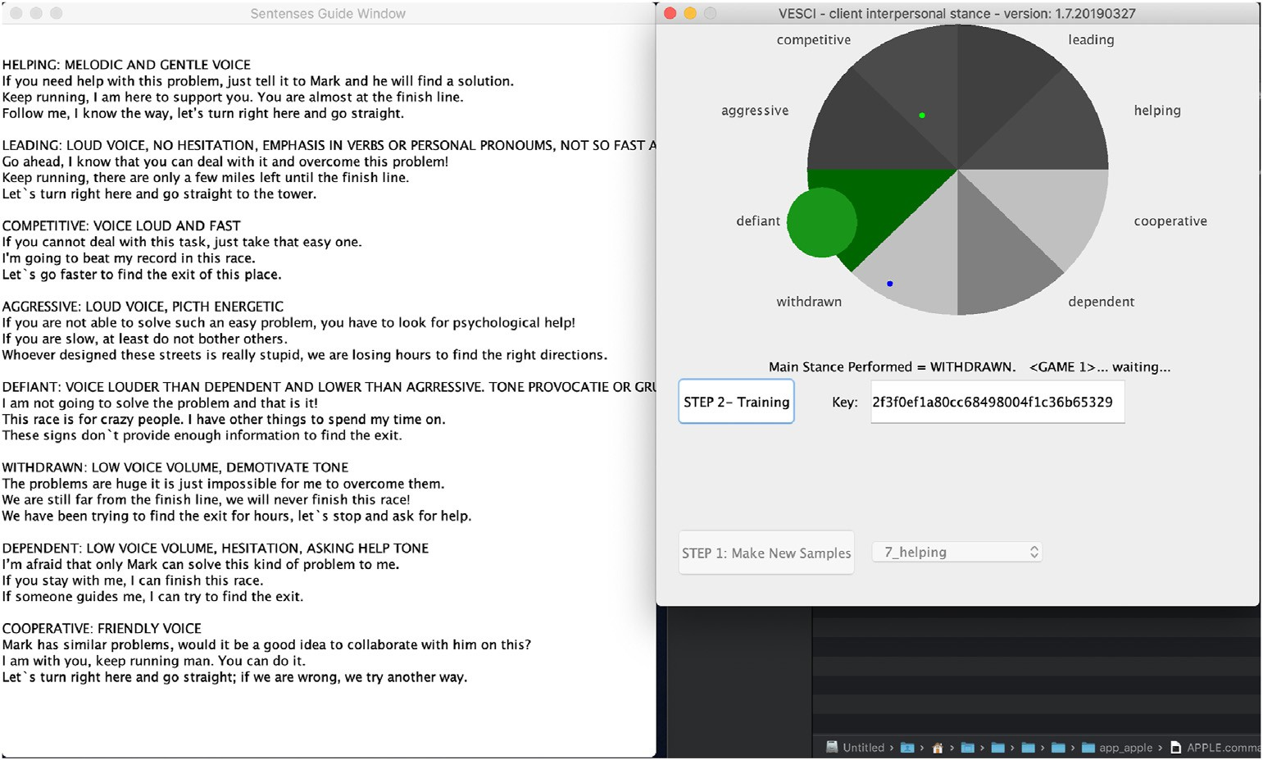

Fig. 1. Simulation-training software interface.

Dependent, Withdrawn, Defiant, Aggressive, Competitive, Leading, Helping).

When interacting with another person, a person’s behaviour is assumed to be represented by a point in the circumplex. For instance, above behaviour is typically associated with a dominant attitude in which the individual takes the initiative. Moreover, the theory states that the stance taken by someone influences the stance taken by the inter- locutor. For instance, if a person shows above behaviour, the other per- son tends to adopt a submissive stance (and vice versa). Conversely, the stance taken according to the horizontal axis triggers the same stance: together behaviour triggers together behaviour, and opposed behaviour triggers opposed behaviour [16]. A similar trend occurs in the eight basic categories, for example, if a person shows a Leading stance, the partner tends to take a Dependent stance. Since the creation of Leary’s Inter- personal Stances theory, it has been refined [16] and applied to several modalities, such as spoken and written content and non-verbal commu- nication such as facial expressions, body gestures and voice signals. For all modalities, the categories and their relations are the same.

Due to its importance in improving human relations in families and at work, a number of authors have developed systems to automatically recognise the interpersonal stance (often operationalised via the Inter- personal Circumplex). Chollet et al. [3] developed a multi-layer frame- work that combines various multi-modal signals such as gaze, head orientation, facial expression, dialogue sequences and a computational model, to infer interpersonal stance. Although the system covers many modalities, voice is only addressed in a limited sense (i.e. the system uses the moment in which the user is speaking rather than specific features of the voice).

In [1], certain nonverbal signals, in particular, body posture, gestures and facial expressions, are inputs to measure interpersonal stances, with the aim of using this in the context of a police interrogation training game. The results show that professional actors are better at acting the different stances than non-actors. Furthermore, the authors found that, in general, it is very difficult to act a stance and that observers often disagree about which stance is acted. In linguistics, researchers have explored interpersonal stances in written and spoken interactions.

Ranganath et al. [11] developed a system to detect interpersonal stances in prosody using four classes: flirtatious, friendly, awkward, and assertive. They used prosodic, lexical and dialogue features of non-acted prosody fragments. Several analyses were applied, including gender performance, comparison of lexical and prosodic features and a

combination of them. Support vector machines (SVM) and logistic regression were used to classify the samples into categories. The system achieved up to 59% accuracy when classifying the stance of new speakers (where the baseline was 48%). Similar to Ranganath et al. s work, we used SVM to classify stances on voice signals. In Ref. [4], the algorithm successfully classified samples into two categories (above-below). In Ref. [5], we extended this to eight categories. The results of a general model were not good enough for practical applications; however, indi- vidual models achieved an average accuracy of 81%.Based on the results of [4,5], a game to enhance interpersonal skills of elderly was created, with the specific goal of training them how to prevent doorstep scams. It uses the same approach of classifying the user’s voice into Dominant and Submissive attitudes (above-below stances) in combination with serious games mechanisms that include several storylines, user feedback and multiple choice menus [14].

The deLearyous project uses natural language processing to classify fragments of text into the various parts of Leary’s Rose [12]. The highest accuracy the authors obtained using four quadrants was 48.1% (by using an SVM with error-correcting output coding), while for eight octants an accuracy of 31.3% was obtained (using an SVM multiclass algorithm). In a more recent work, using unconstrained text, they achieved an accuracy of 55% and 42.6% respectively, despite low F-Scores of 38% and 18.5% [13]. In Ref. [10], the authors analysed turn-taking in conversations among policemen and suspects to understand the relation between turn-taking and interpersonal stances and then built models of systems and serious games that include interpersonal stances on turn-taking in conversations.

Other works focused on developing systems for training people to improve their skills in interpersonal stances. In Ref. [13], the authors built a simulator-training game to teach interpersonal stances by using text inputs. Unfortunately, the accuracy of the system is low, which limits the training effect of the game.

Linssen et al. [9] developed a serious game to improve social awareness related to Leary’s theory of interpersonal stances. The game provides feedback to the users about how the virtual agents interpret the user’s stance and what reaction the user sparks in the virtual agent. No clear improvement in the users interpersonal stance skills was found. The authors speculate that the reason for this is that the players were more adapted to (unconsciously) translating such situations into knowledge without explicitly reflecting on it.

The current work uses individual voice models to train people in

understanding Leary’s theory of interpersonal stances. It also focuses on promoting awareness about the eight basic categories described in the theory. In the next section, the training application is detailed.

1. The system

The simulation-based training game comprises two parts. The first part is the software interface in which the users can record voice samples. The software guides the user to record sentences. It indicates which sentences have to be spoken and gives some general hints on how to perform them.

Based on the recorded samples, unique voice models of each user are generated and used in the software interface. The model is built on a server through an automatic process that uses an SVM algorithm. See Ref. [4,5] for more details about the backend server, the algorithm, and how the model is generated.

The second part of the software allows users to play a game in which they need to apply Leary’s theory, taking into account the voice styles recorded in the first part. Fig. 1 shows the software and an example of the game. The game represents an interaction between the user (blue dot) and a conversation partner (green dot), where the goal of the user is to move the conversation partner to a target location by effectively using Leary’s interpersonal stances theory.

The software selects a random target stance for each new game. It guarantees that after eight games, all stances will have been played. In Fig. 1, the stance Defiant is the target. The blue dot represents the last identified stance performed by the user, while the green dot represents the current status of the interlocutor, which in this case is simulated by the computer. The green dot responds in consonance with Leary’s interpersonal stances theory. It moves incrementally, according to Equation (1).

awareness of interpersonal stances and to evaluate whether they can improve their knowledge of Leary’s interpersonal stances theory by playing the simulator-training game.

To reach these objectives, this research follows the FEDS Framework for Evaluation in Design Science Research [15]. Following the framework and considering the aim of the work, we decided to use a combination of an Artificial and a Formative evaluation approach, moving from a Formative to a Summative approach in 3 phases. Artificial evaluation refers to a situation when experiments are done in the laboratory, to isolate the system’s influence on the participants from other factors. In this case it was important to avoid other relevant factors that we present in real world situations, as these might affect the results of the proposed system. Before running a broad experiment with a big group, the system was tested with 1 and 2 users, respectively. In each of these phases the interaction with the system was tuned to make it pleasant, intuitive, and difficult enough to play the game. In Phase 2 the whole experiment was executed as a pilot, to fix small unforeseen problems. For example, mis- understandings in the questionnaires and problems with collecting data due to delay in the system interaction. After that, in phase 3 (Summative) the whole experiment was run with a bigger group of participants without further changes or updates.

Only the results of phase 4 are reported in this paper. The samples

were collected from 20 English speakers. Their average age was 28 years with a standard deviation of 8.69; 75% was male and 25% female. From this population, 30% were recruited in the university and 70% via the crowdsourcing platform Prolific. Four of the participants had already used the software several times before the experiment. These participants will be called experienced participants. Sixteen participants did not have any experience with the software before the experiment. These partici- pants will be called non-experienced participants.

Participants were asked to follow the steps described on the website of the experiment and summarised in Fig. 2. First, they watched videos

*x* = *cos*(θ)· *r*/2

*y* = *sin*(θ)· *r*/2

where:

θ = the angle between the x axis and c + (cn/2)

c = the current coordinates of the blue dot on the circumplex

(1)

that explain the experiment and Leary’s interpersonal stances theory. The videos also give general hints about what is expected in each category. Moreover, participants have access to examples of voice fragments for each category. However, the hints and voice samples only guide them, as they are free to perform according to their own style. In Phase I, the participants were asked to record 15 sentences per category. The soft- ware guided them in which sentences should be spoken and reminding

cn = coordinates in the circumplex of the accuracy of the new

instance played according to the Leary’s theory r = radius of the circumplex

In summary, with two precise attempts, one can reach the border of the circumplex and if it is the right category, one achieves the goal. The goal is positioning the computer status (green dot) into the big green circle. The user has eight attempts to do that. If the user performs well, in two attempts he/she achieves the goal. The left window shows some examples of sentences to be spoken and general hints to guide users on how to perform each stance.

After the button (STEP 2- Training) is pressed, the software records the users voice and sends the fragment to the server. The server is responsible for classifying the voices stance based on the personal model of that specific individual (which was recorded in part 1, and is identified by an exclusive hash code). A SVM algorithm running in the server classifies the submitted voice fragment and calculates a probability score for each category.

Subsequently, the software computes the new status of the user, in blue, and of the computer, in green. The whole communication process between the software interface and the server lasts less than 5 s. For each interaction, the user receives feedback on his/her own stance and the reaction of the computer to it.

1. Methodology

The aim of the experiment is to evaluate whether users increase their

them about the general hints for each category. The task of recording sentences is itself part of the training.

Then, participants were questioned about their knowledge of Leary’s

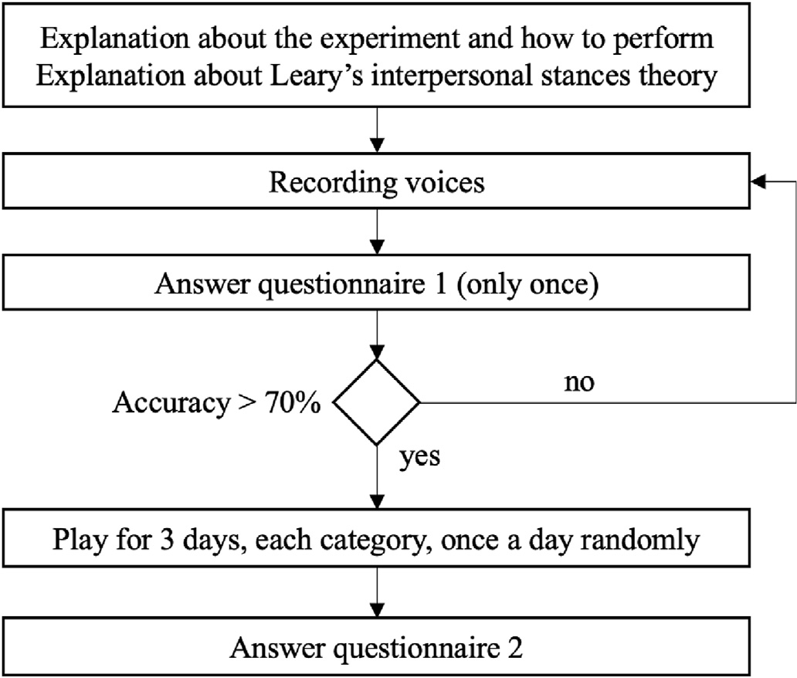

Fig. 2. Overview of the protocol. Tasks of the participants step-by-step.

Table 1

Main questions of questionnaires 1 and 2.

Question

How confident are you in performing each category? How clear is the meaning of each category to you?

How familiar are you with Leary’s interpersonal stances theory?

interpersonal stances theory and the eight categories before (question- naire 1) and after the experiment in (questionnaire 2). Table 1 shows the three main questions presented in questionnaires 1 and 2. All these questions require answers in a five-point Likert scale. Other questions in questionnaire 1 are related to habits, gender and age, while in ques- tionnaire 2 they focused on user experience with the game and the user’s impression about the transfer-learning after the experiment. Both ques- tionnaires are accessible at the experiment web-page.1

After that, a personal model of the users voice was built in the server. If the model did not achieve 70% accuracy, the participant was asked to record again the categories that are not clear or mixed with others. Note that the questionnaire 1 is answered only once. This process went on until the model achieved 70% accuracy or above. Usually, one extra round of recordings was sufficient (30% of participants). In rare cases (10% of participants), a second extra round was required.

With the model created, Phase II started. The participants played for three days with the game described in the previous section. Each day, the participants played each category once (in random order). For each game, the number of attempts to achieve the goal was intentionally fixed between a minimum of two, to guarantee that at least the participants reproduced the correct stance more than once, and a maximum of eight. The limit of eight is to guarantee a sufficient number of attempts to reach the goal and at the same time, to not make the game too long, preventing demotivation. On average, participants took around 2 min to perform eight attempts. At the end of each game, a score of the participant’s performance was shown to give feedback to the participant. The score is based on the number of attempts to achieve the goal.

After the three days of training, participants completed a second questionnaire that inquired about their current knowledge of interper- sonal stances and their awareness of the eight basic categories.

The dependent variables in the study are related to the performance of the participants in understanding Leary’s interpersonal stances theory, selecting the proper stance according to the status of the game and clearly reproducing it. We do not use the number of attempts to measure the performance of the participants. Instead, the software measures the percentage of hits per game (e.g. in a game completed in six attempts with three hits and three misses, this results in a performance of 50%). The advantage of this approach is that it avoids false positives, when a user still wins a game by acting incorrect categories that are adjacent to the target category and consequently still move the green dot to the target category. Another reason is that, because of characteristics of a software, if a user plays incorrectly in three out of eight times, it is difficult to win a game, even if the wrong stances are neighbour stances. In these situations, playing the next five attempts correctly does not guarantee a win. This undesirable characteristic can mask the real per- formance of a participant.

Each user’s play and its performance are recorded during a game. To analyse the participants performance, the evolution over the days is compared, as are the answers provided by the participants in the two questionnaires.

1 Experiment Description: [https://formolo.wixsite.com/is-experiment?wi](https://formolo.wixsite.com/is-experiment?wix-vod-video-id=3d044e8eac8d4e42a50c6845f84adf81&amp%3Bwix-vod-comp-id=comp-jsm9np5d) [x-vod-video-id](https://formolo.wixsite.com/is-experiment?wix-vod-video-id=3d044e8eac8d4e42a50c6845f84adf81&amp%3Bwix-vod-comp-id=comp-jsm9np5d)=[3d044e8eac8d4e42a50c6845f84adf81](https://formolo.wixsite.com/is-experiment?wix-vod-video-id=3d044e8eac8d4e42a50c6845f84adf81&amp%3Bwix-vod-comp-id=comp-jsm9np5d)&[amp;wix-vod-comp-id](https://formolo.wixsite.com/is-experiment?wix-vod-video-id=3d044e8eac8d4e42a50c6845f84adf81&amp%3Bwix-vod-comp-id=comp-jsm9np5d)

=[comp-jsm9np5d](https://formolo.wixsite.com/is-experiment?wix-vod-video-id=3d044e8eac8d4e42a50c6845f84adf81&amp%3Bwix-vod-comp-id=comp-jsm9np5d).

1. Results

The results are divided into two parts. The first part relates to the performance of the users in playing with the software, as described at the end of Section 4, where the percentage of hits per game is used to measure the participant’s performance. The second part relates to qual- itative data collected from the participants in the two questionnaires.

The heatmap of Fig. 3 is built based on the Pearson Distance between the categories, it shows the average of the cumulative results of all par- ticipants during the three days of training, i.e. when a certain category was the target (row), what was the performed category (column) by the users. Pearson Distance is a weighted type of Euclidean distance. It is a classical measurement to observe how different clusters or categories are distant of each other. In this case, we opted to take the square of the correlation to provide only positive values between categories. The closer to zero the more correlated are the categories. It is expected that the distances in the main diagonal will be small, and that the distance in- creases the further the coordinates are from the main diagonal.

As an example, if we look at the Dependent x Dependent cell, we see that the distance equals zero. The distances of the neighbour categories increase a little but are also close to the Dependent category (columns Withdrawn and Cooperative). The Distance continues to increase for the next categories. It should also be noted that in the circumplex, the stance Cooperative is a neighbour of Helping even if in the correlation matrix these categories are displayed far from each other. In this case, the concept of far might be observed in terms of Leary’s circumplex, as shown on the right in Fig. 1.

Although participants mix up stances from time to time, the data in Fig. 3 show that even when they played incorrectly, in most cases they played close to the target stance. In particular, the cluster of stances Helping, Leading, Dependent and Cooperative follows this trend, while other stances have a different interrelation. Competitive and Aggressive are also close to each other, showing a tendency to mix up these two stances. In other words, people tend to show ‘aggressive’ components in their voice when trying to play competitive behaviour and vice-versa. This is explainable because fast and highly energetic speech are com- mon characteristics present in both stances. Leading also shows these characteristics, but usually not simultaneously and in a lower frequency than the Competitive and Aggressive stances. While most stances can be identified well, the Defiant stance demonstrates to be very hard to distinguish from other categories (as shown by the relatively small Pearson distances). Although it is hard to find an explanation for this, we speculate that people have not a clear concept of Defiant in mind. Also,

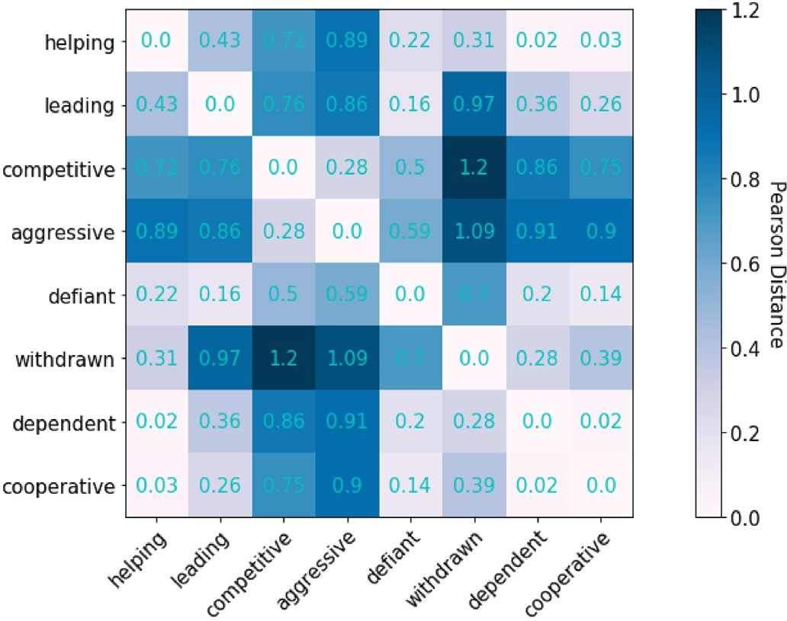

Fig. 3. Correlation matrix of the average results over three days of training for all participants.

due to social rules, there may be several subtle ways to express the Defiant stance, combining characteristics present in all other stances. In contrast, Withdrawn presented a rather unique vocal pattern, but still shares some characteristics with Dependent, Cooperative and Helping, three stances on the right side of Leary’s Circumplex.

The graph of Fig. 4 shows the average performance of all participants over the three days in terms of the average number of attempts per category.

Whilst the correlation matrix in Fig. 3 shows trends close to the tar- gets, the results achieved by the participants shown in the graph of Fig. 4 look less promising. This can be explained by the fact that the scoring mechanism (with a maximum of 8 attempts) masked the participants real progress (because, as mentioned earlier, it is very difficult to still win the game after a bad start).

These results probably also affected the perception of the participants regarding their learning abilities of how to perform the different stances. The questionnaires applied before and after playing the game asked how confident the participants are in performing each individual category and how clear the categories are to them (see first two questions of Table 1). The results show that for both questions, the perception of the partici- pants about their performance and the understanding of each separate category did not significantly change.

Nevertheless, when looking at our most important outcome variable, the participants hit rate, to see if the game improved the participants’ ability to perform interpersonal stances with their voice, it turns out that they still made significant improvements over the days. Considering the two groups separately, i.e., the non-experienced players (16 participants who played only for three days) and the experienced players (four par- ticipants who played and recorded interpersonal stances already several times before the experiment), the results are promising (see the graph of Fig. 5). For the non-experienced group, a paired t-test between days 1 and 3 indicates a significant improvement from 0.26 to 0.32 (P = .045). The graph in Fig. 5 shows the performance of both groups measuring the hit rate per day. It is clear that the experienced group did not make any improvement yet, but still achieved the best performance, while the performance of the non-experienced group improved over the three days. Finally, the two questionnaires also asked about how familiar the participants were with Leary’s interpersonal stances theory before and after the training (see last question of Table 1). The knowledge of the participants about the dynamics of Leary’s theory increased from 1.84 to

3.74 on the 5-point Likert scale. A paired t-test confirmed that this in- crease was significant (P = .002).

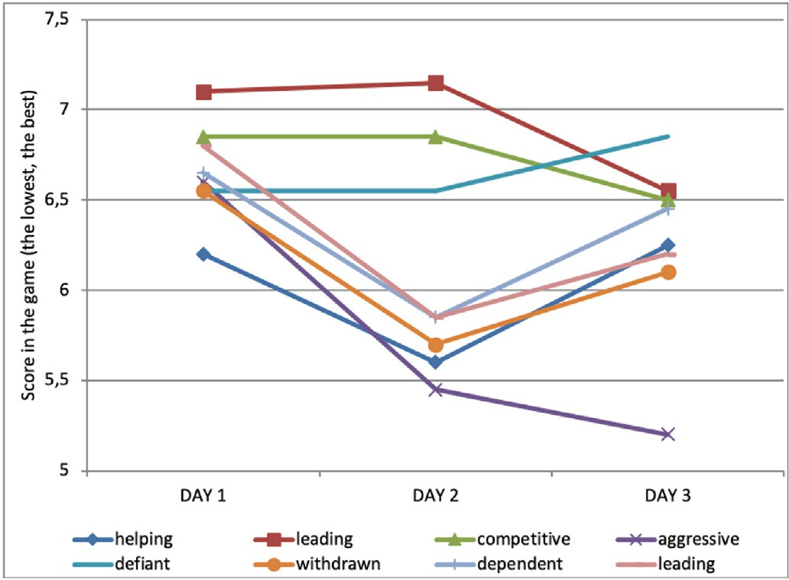

Fig. 4. Average of the participants performance per day.

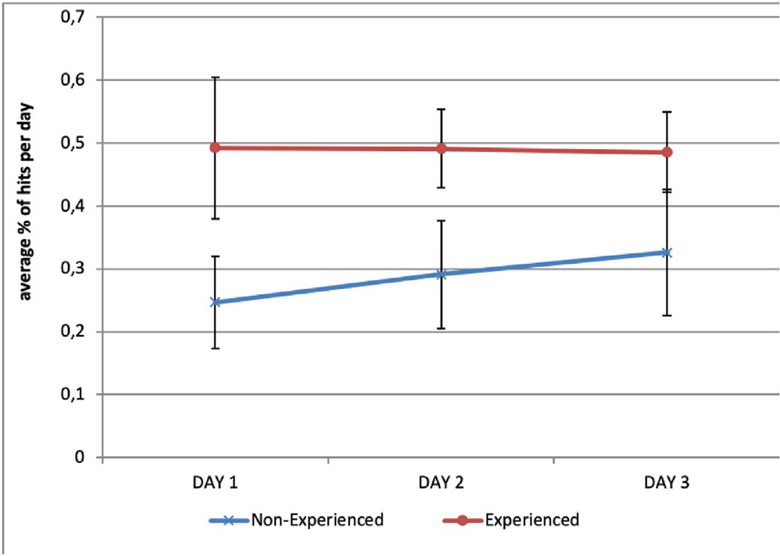

Fig. 5. Average of the participants performance per day.

1. Discussion

Starting with the second part of the research question as put forward in Section 4, it became clear from the answers to the questionnaires that after using the software, people feel they have become more familiar with the dynamics of the Leary’s interpersonal stances theory.

In accordance with previous works on inferring interpersonal stances in voice [4,5,11]and text [12,13], it is difficult to build models that are able to accurately classify the eight basic stances, at least with the current datasets. It is even more difficult to teach people using such models, as also shown in Refs. [9].

Our results suggest that people are able to understand the concept of each basic stance, but can vary the style of how they perform them, as no participant achieved an accuracy of 75% or above in their personal models. Even when using the same hardware in the same environmental conditions and with good accuracy, they fail in many cases in copying their own style to each stance. Other factors that probably influenced the reduction in performance are the lack of motivation and the lack of engagement in a real situation to really perform a stance. Considering this we can infer that a better interface and story-line can promote more engagement and consequently better results.

It is necessary to point out that the number of participants in the experiment is small, especially when analysing results of 2 subgroups of 20 people. This said, rather than providing a final answer, we might consider that the results presented in this work provide us a trend that can be confirmed only with an extension of the experiment, recruiting more participants.

Nevertheless, regarding the first part of the research question, the results show interesting patterns regarding the learning curve of the participants. The system helped the participants to improve their skills related to interpersonal stances in voice. According to the graph of Fig. 5, the non-experienced participants have made a clear improvement at the end of day 3. The increase in standard deviation over the three days can possibly be explained by the fact that some of them were more motivated to achieve the goal and put more effort in repeating the voice patterns used to build the models. The same patterns were not observed in the experienced group, who did not make any improvements. These results demonstrate that there could be an improvement among non- experienced participants if they were given training on more days. At the same time, there is a limit to the extent to which the system can improve people’s skills. When asking participants to provide feedback on the experiment, 50% of them reported frustration in not achieving the goal. The results indicate that the game did not clearly show the real progress of the participants during the training sessions well, which could have demotivated them over the three days. Moreover, the game could be tuned for users to reach the goal more easily than in the current setup. It

is also not clear to what extent the participants improved their style as a result of an increased awareness about the stances during the training process. Hence, there are no guarantees that the same styles would be performed in real situations.

Moreover, the results of the questionnaires completed before and after the training show that people are more confident about their own understanding of the stances than about performing them. Participants spontaneously reported confusion in performing stances, for example, (Aggressive, Competitive and Leading), (Aggressive and Competitive) or (Helping and Cooperative), the game helped them to reflect about the different categories, refining their concepts about them.

All those aspects of performing interpersonal stances should be considered in follow-up research to explore how people understand each of the categories. In future work, we are planning to extend the experi- ment to more participants to confirm the tendencies presented in this work and investigate the relation between the stances in more detail. More evidence needs to be found indicating that interpersonal stances in voice can be improved by using simulation-based training games and we need to better understand how people perceive and use interpersonal stances in practice. It is also important to determine to what extent people really recognise them as separate categories when they are interacting with others or whether they group them in clusters.

Declaration of competing interests

The authors declare that they have no known competing financial interests or personal relationships that could have appeared to influence the work reported in this paper.

CRediT authorship contribution statement

Daniel Formolo: Conceptualization, Methodology, Software, Visu- alization, Formal analysis, Investigation, Data curation, Writing - original draft, Writing - review & editing. Tibor Bosse: Conceptualization, Methodology, Writing - original draft, Investigation, Validation, Writing - review & editing.

Acknowledgments

This research was supported by the Brazilian scholarship program

Science without Borders - CNPq reference: 233883/2014–2.

References

1. [Bruijnes M, op den Akker R, Spitters S, Sanders M, Fu Q. The recognition of acted](http://refhub.elsevier.com/S2590-0056(20)30017-5/sref1) [interpersonal stance in police interrogations and the influence of actor proficiency.](http://refhub.elsevier.com/S2590-0056(20)30017-5/sref1) [Journal on multimodal user interfaces 2015;9(4):353](http://refhub.elsevier.com/S2590-0056(20)30017-5/sref1)–[76](http://refhub.elsevier.com/S2590-0056(20)30017-5/sref1).
2. [Chindamo M, Allwood J, Ahlsen E. Some suggestions for the study of stance in](http://refhub.elsevier.com/S2590-0056(20)30017-5/sref2) [communication. In: 2012 international conference on privacy, security, risk and](http://refhub.elsevier.com/S2590-0056(20)30017-5/sref2) [trust and 2012 international confernece on social computing. IEEE; 2012.](http://refhub.elsevier.com/S2590-0056(20)30017-5/sref2)

[p. 617](http://refhub.elsevier.com/S2590-0056(20)30017-5/sref2)–[22](http://refhub.elsevier.com/S2590-0056(20)30017-5/sref2).

1. [Chollet M, Ochs M, Pelachaud C. Interpersonal stance recognition using non-verbal](http://refhub.elsevier.com/S2590-0056(20)30017-5/sref3) [signals on several time windows. 2012](http://refhub.elsevier.com/S2590-0056(20)30017-5/sref3).
2. [Formolo D, Bosse T. Human vs. computer performance in voice-based recognition of](http://refhub.elsevier.com/S2590-0056(20)30017-5/sref4) [interpersonal stance. In: International conference on human-computer interaction.](http://refhub.elsevier.com/S2590-0056(20)30017-5/sref4) [Springer; 2017. p. 672](http://refhub.elsevier.com/S2590-0056(20)30017-5/sref4)–[86](http://refhub.elsevier.com/S2590-0056(20)30017-5/sref4).
3. [Formolo D, Bosse T. Extracting interpersonal stance from vocal signals. In:](http://refhub.elsevier.com/S2590-0056(20)30017-5/sref5) [Proceedings of the 4th international workshop on multimodal analyses enabling](http://refhub.elsevier.com/S2590-0056(20)30017-5/sref5) [arti](http://refhub.elsevier.com/S2590-0056(20)30017-5/sref5)fi[cial agents in human-machine interaction. ACM; 2018. p. 19](http://refhub.elsevier.com/S2590-0056(20)30017-5/sref5)–[25](http://refhub.elsevier.com/S2590-0056(20)30017-5/sref5).
4. [Formolo D, Bosse T, van der Wal N. Studying the impact of trained staff on](http://refhub.elsevier.com/S2590-0056(20)30017-5/sref6) [evacuation scenarios by agent-based simulation. In: International conference on](http://refhub.elsevier.com/S2590-0056(20)30017-5/sref6) [social informatics. Springer; 2018. p. 85](http://refhub.elsevier.com/S2590-0056(20)30017-5/sref6)–[96](http://refhub.elsevier.com/S2590-0056(20)30017-5/sref6).
5. [Hogan K. Can’t get through: eight barriers to communication. Pelican Publishing;](http://refhub.elsevier.com/S2590-0056(20)30017-5/sref7) [2003](http://refhub.elsevier.com/S2590-0056(20)30017-5/sref7).
6. [Leary T. Interpersonal diagnosis of personality: a functional theory and](http://refhub.elsevier.com/S2590-0056(20)30017-5/sref8) [methodology for personality evaluation. Wipf and Stock Publishers; 2004](http://refhub.elsevier.com/S2590-0056(20)30017-5/sref8).
7. [Linssen J, Theune M, Bruijnes M, et al. Beyond simulations: serious games for](http://refhub.elsevier.com/S2590-0056(20)30017-5/sref9) [training interpersonal skills in law enforcement. In: Social simulation conference;](http://refhub.elsevier.com/S2590-0056(20)30017-5/sref9) [2014](http://refhub.elsevier.com/S2590-0056(20)30017-5/sref9).
8. [op den Akker R, Bruijnes M, Peters R, Krikke T. Interpersonal stance in police](http://refhub.elsevier.com/S2590-0056(20)30017-5/sref10) [interviews: content analysis. Computational linguistics in the Netherlands journal](http://refhub.elsevier.com/S2590-0056(20)30017-5/sref10) [2013;3:193](http://refhub.elsevier.com/S2590-0056(20)30017-5/sref10)–[216](http://refhub.elsevier.com/S2590-0056(20)30017-5/sref10).
9. [Ranganath R, Jurafsky D, McFarland DA. Detecting friendly,](http://refhub.elsevier.com/S2590-0056(20)30017-5/sref11) fl[irtatious, awkward,](http://refhub.elsevier.com/S2590-0056(20)30017-5/sref11) [and assertive speech in speed-dates. Comput Speech Lang 2013;27(1):89](http://refhub.elsevier.com/S2590-0056(20)30017-5/sref11)–[115](http://refhub.elsevier.com/S2590-0056(20)30017-5/sref11).
10. [Vaassen F, Daelemans W. Automatic emotion classi](http://refhub.elsevier.com/S2590-0056(20)30017-5/sref12)fi[cation for interpersonal](http://refhub.elsevier.com/S2590-0056(20)30017-5/sref12) [communication. In: Proceedings of the 2nd workshop on computational approaches](http://refhub.elsevier.com/S2590-0056(20)30017-5/sref12) [to subjectivity and sentiment analysis. Association for Computational Linguistics;](http://refhub.elsevier.com/S2590-0056(20)30017-5/sref12) [2011. p. 104](http://refhub.elsevier.com/S2590-0056(20)30017-5/sref12)–[10](http://refhub.elsevier.com/S2590-0056(20)30017-5/sref12).
11. [Vaassen F, Wauters J, Van Broeckhoven F, Van Overveldt M, Daelemans W,](http://refhub.elsevier.com/S2590-0056(20)30017-5/sref13) [Eneman K. delearyous: training interpersonal communication skills using](http://refhub.elsevier.com/S2590-0056(20)30017-5/sref13) [unconstrained text input. Proc. of ECGBL 2012:505](http://refhub.elsevier.com/S2590-0056(20)30017-5/sref13)–[13](http://refhub.elsevier.com/S2590-0056(20)30017-5/sref13).
12. [van der Lubbe LM, Gerritsen C, Formolo D, Otte M, Bosse T. A serious game for](http://refhub.elsevier.com/S2590-0056(20)30017-5/sref14) [training verbal resilience to doorstep scams. In: International conference on games](http://refhub.elsevier.com/S2590-0056(20)30017-5/sref14) [and learning alliance. Springer; 2018. p. 110](http://refhub.elsevier.com/S2590-0056(20)30017-5/sref14)–[20](http://refhub.elsevier.com/S2590-0056(20)30017-5/sref14).
13. [Venable J, Pries-Heje J, Baskerville R. Feds: a framework for evaluation in design](http://refhub.elsevier.com/S2590-0056(20)30017-5/sref15) [science research. Eur J Inf Syst 2016;25(1):77](http://refhub.elsevier.com/S2590-0056(20)30017-5/sref15)–[89](http://refhub.elsevier.com/S2590-0056(20)30017-5/sref15).
14. [Wiggins JS. An informal history of the interpersonal circumplex tradition. J Pers](http://refhub.elsevier.com/S2590-0056(20)30017-5/sref16) [Assess 1996;66(2):217](http://refhub.elsevier.com/S2590-0056(20)30017-5/sref16)–[33](http://refhub.elsevier.com/S2590-0056(20)30017-5/sref16).