[](Journal%20logo)[Artificial Intelligence in Agriculture 10 (2023) 13–25](https://doi.org/10.1016/j.aiia.2023.09.002)

Contents lists available at [ScienceDirect](http://www.sciencedirect.com/science/journal/)

Artificial Intelligence in Agriculture

journal homepage: [http://www.keaipublishing.com/en/journa ls/artificial- intelligence- in-agriculture/](http://www.keaipublishing.com/en/journals/artificial-intelligence-in-agriculture/)

[](http://crossmark.crossref.org/dialog/?doi=10.1016/j.aiia.2023.09.002&domain=pdf)Machine learning for weed–plant discrimination in agriculture 5.0: An in-depth review

Filbert H. Juwono a,⁎, W.K. Wong b, Seema Verma c, Neha Shekhawat c, Basil Andy Lease b, Catur Apriono d,⁎

a *Department of Electrical and Electronic Engineering, Xi'an Jiaotong-Liverpool University, Suzhou 215123, China*

b *Dpartment of Electrical and Computer Engineering, Curtin University Malaysia, Miri 98009, Malaysia*

c *School of Physical Sciences, Banasthali Vidyapith, Rajasthan 304022, India*

d *Department of Electrical Engineering, Universitas Indonesia, Depok 16424, Indonesia*

# a r t i c l e i n f o

*Article history:*

Received 12 March 2023

Received in revised form 25 July 2023 Accepted 11 September 2023

Available online 19 September 2023

*Keywords:* Agriculture 5.0 Machine learning

Unmanned aerial vehicle Weed-plant discrimination

Contents

# a b s t r a c t

Agriculture 5.0 is an emerging concept where sensors, big data, Internet-of-Things (IoT), robots, and Artificial In- telligence (AI) are used for agricultural purposes. Different from Agriculture 4.0, robots and AI become the focus of the implementation in Agriculture 5.0. One of the applications of Agriculture 5.0 is weed management where robots are used to discriminate weeds from the crops or plants so that proper action can be performed to remove the weeds. This paper discusses an in-depth review of Machine Learning (ML) techniques used for discriminating weeds from crops or plants. We specifically present a detailed explanation of five steps required in using ML algorithms to distinguish between weeds and plants.

© 2023 The Authors. Publishing services by Elsevier B.V. on behalf of KeAi Communications Co., Ltd. This is an open access article under the CC BY-NC-ND license (<http://creativecommons.org/licenses/by-nc-nd/4.0/>).

1. Introduction 14
   1. Automated weed control: A technological progress 14
   2. Contributions and structure 15
2. Data acquisition 15
3. Image pre-processing: Background removal 15
   1. Excess Green Index (ExGI) 16
   2. Ratio Vegetation Index (RVI) and Vegetation Index Number (VIN) 16
   3. Normalized Difference Vegetation Index (NDVI) 16
      1. Otsu threshold 17
      2. Modified Otsu threshold 17
   4. Transformed Vegetation Index (TVI), corrected TVI (CTVI), and Thiam's TVI (TTVI) 17
   5. Perpendicular Vegetation Index (PVI) 17
4. Feature-based recognition 18
   1. Biological morphology features 18
   2. Spectral features 18
   3. Texture features 19
5. Classification algorithms 20
   1. ML-based algorithms 20
   2. Ensemble learning 20
   3. DL-based algorithms 21
6. Publicly available datasets 22
7. Challenges and opportunities 23

* Corresponding authors.

*E-mail addresses:* [Filbert.Juwono@xjtlu.edu.cn](mailto:Filbert.Juwono@xjtlu.edu.cn) (F.H. Juwono), [weikitt.w@curtin.edu.my](mailto:weikitt.w@curtin.edu.my) (W.K. Wong), [seemaverma3@yahoo.com](mailto:seemaverma3@yahoo.com) (S. Verma), [shekhawatneha37@gmail.com](mailto:shekhawatneha37@gmail.com) (N. Shekhawat), [basil.lease@curtin.edu.my](mailto:basil.lease@curtin.edu.my) (B.A. Lease), [catur@eng.ui.ac.id](mailto:catur@eng.ui.ac.id) (C. Apriono).

<https://doi.org/10.1016/j.aiia.2023.09.002>

2589-7217/© 2023 The Authors. Publishing services by Elsevier B.V. on behalf of KeAi Communications Co., Ltd. This is an open access article under the CC BY-NC-ND license (<http://creativecommons.org/licenses/by-nc-nd/4.0/>).

1. Conclusion 23

Declaration of Competing Interest 23

Acknowledgements 23

References 23

1. Introduction

Recently, Information and Communication Technology (ICT) has been immersed in agricultural practises. Agriculture 4.0, which is also known as data-driven agriculture or smart farming or digital farming, uses telematics, data management, and precision agriculture to increase the quality of the crops (Saiz-Rubio and Rovira-Más, 2020). The Na- tional Research Council (1997) defines precision agriculture as *the ap- plication of modern information technologies to provide, process and analyze multisource data of high spatial and temporal resolution for deci- sion making and operations in the management of crop production*. It is clear that precision agriculture focuses on applying inputs (e.g., fertilizers, pesticides) when necessary in the specific quantities. This will optimize the resources and make the plants receive what they really need. The researchers in this area focus on creating systems that can make operational and strategical decisions using the data sup- plied. Traditionally, farmers go around the farms to check the conditions of the crops and make decisions based on the acquired experience. This conventional method is no more feasible as the size of fields has grown immensely and traditional methods demand more working resources.

Agriculture 5.0 has evolved as ICT has advanced. Different from Ag- riculture 4.0, Agriculture 5.0 employs precision agriculture and un- manned and autonomous equipment (Saiz-Rubio and Rovira-Más, 2020). In other words, robots and Artificial Intelligence (AI) play impor- tant roles in this field. Technologically, computer vision, Machine Learn- ing (ML), and Unmanned Aerial Vehicles (UAVs), or commonly known as drones, have been utilized to build Agriculture 5.0 system.

Moreover, computer vision has recently played a vital role in en- abling the digital world to interact with the physical world. In general, the technology exploits cameras coupled with computer, rather than the human eyes, to identify, track, and estimate targets for image pro- cessing. It plays a critical role in technology by powering object detec- tion, classification, and tracking of objects in all domains. Recently, smart agriculture tasks (Neupane and Baysal-Gurel, 2021) that include plant ailment detection, weed detection, crop yield prediction, identifi- cation of plant species, are achieved through computer vision technology.

UAVs are recently taking up considerably space in research domain so as to make the industry less labor-intensive. Applications of com- puter vision to drone technology makes it be able to interpret and inter- act with surroundings, including buildings, trees, and diverse terrain. The use of data from UAVs for farming applications has been gaining an enormous popularity in both research and industry. Compared to human-based monitoring, UAV is considered to be cheaper and more convenient with shorter inspection time needed. The optimal control of the UAV in the presence of obstacles is commendable, which is a crit- ical factor while working with two crop rows.

The initial step in Agriculture 5.0 is data collection, followed by au- tonomous decision making and its implementation. The data collected from physical sources such as sensors and cameras contains valuable in- formation, which is directly relevant to the process of decision making. The connection between the data and the decision stage involves filter- ing routines and AI algorithms for getting only the right data and help- ing the farmer make correct decisions. The last step of physical execution of the decision, also referred as actuation, is carried out by ad- vanced equipment coupled with computer control units.

The exponential growth of robotic applications in smart farming shows its efficiency in handling workforce and cost of production. The

advanced level of precision agriculture deals with applying the above principles using unmanned operated equipment and systems that in- volve autonomous decisions. The use of autonomous and semi- autonomous robots in the field of agriculture has immensely increased in last decades. They possess arms that can detect weeds and can spray chemicals on the affected areas specifically, thus reducing the overall cost.

* 1. *Automated weed control: A technological progress*

In general, weeds hinder the movement of irrigation water, disrupt the process of applying pesticides, and serve as a breeding ground for pathogens. Thus, weed detection and control play a vital role in overall crop productivity and farming expenses. Effective weed control plays a crucial role in agriculture by minimizing crop yields, dramatically esca- lating production costs, negatively impacting crops, and significantly compromising product quality. Note that weeds compete with produc- tive crops for essential resources such as water, nutrients, and light, thereby diminishing overall agricultural output.

Traditional weed management methods include chemical means i.e., uniform application of herbicides throughout the field using me- chanical means or physical elimination. The former method leads to the overuse of chemicals as the weed spatial density varies across the field which ends up in environmental apprehension and formation of herbicide-resistant weeds. The latter results in labor intensive farming methods in turn causing a steep increase in production cost. The above issues can be solved by applying concept of Site-Specific Weed Management (SSWM) (Lati et al., 2021). SSWM involves detection of patches of weeds across the field and carrying out spot spraying or me- chanical removal ways which can be broadly classified into two catego- ries: 1) prescription maps-based methods (De Castro et al., 2018) where the areas of weed emergence are detected to focus the application of weedicide, and 2) real time monitoring method (Xu et al., 2018) that simultaneously detects and controls weeds by spraying weedicide on the spot.

Existing techniques for image processing provide extremely promis- ing outcomes under optimal imaging conditions, even though they can be quite challenging under real time conditions. The overlap of plant leaves and weeds at different stages of growth makes them synony- mous to each other. In addition, the leaves are often occluded, discol- ored or damaged by undesired materials which alter the morphological as well as spectral characters of the leaves. As the light- ing conditions change during different times in a day, the shadows formed by the plant canopy and the solar inclination can directly impact the colour of vegetation. Furthermore, different plant growth stages also result in variations of the morphological, textural, and spectral attri- butes to leaves.

This paper focuses on the discrimination between crop and weed using ML approaches. Note that traditional image processing techniques like Hough transform can also be used to discriminate crop and weed (Bah et al., 2017). However, these approaches are not of our interest. In- stead, we commonly use image processing techniques to extract the features like color, shape, etc. to be fed to the ML algorithms. The effi- ciency of these methods mostly depends on the manually designed fea- tures and have high dependence on image acquisition methods, pre- processing methods, and the standard of features extracted. Earlier studies in this category primarily used color co-occurrence matrix- based texture analysis for images (Chang et al., 2012). With

advancement in technology, optical sensor coupled with image process- ing algorithms has been implemented for variable rate weedicide appli- cations. The major challenge in classification of weeds from crops is caused by their similar spectral signature.

Image processing-based weed control is usually performed through several steps. After the images are required, they may not be suitable for further processing. For example, it is required to discriminate the vege- tation from the soil. The steps will be further discussed in this paper. Note that this paper can be seen as a complementary to a few related works, such as (Wang et al., 2019; Hasan et al., 2021).

* 1. *Contributions and structure*

As previously discussed, discriminating weeds from plants is neces- sary in weed management, regardless the method that is chosen, i.e., using chemical or non-chemical. In this paper, we focus on the dis- cussion of weed control applications, their recent advances, and also challenges. The steps to do weed-crop discrimination can be simply ex- plained as follows. Initially, the images are captured using robots or UAVs equipped with cameras. The images must be free from any back- ground interference (e.g., soil). Trained experts can be employed to label and distinguish between the weeds and the crops in the images. If any challenges arise during image acquisition, publicly available datasets with annotations can be utilized as an alternative. Afterward, the classification task begins by selecting the features, which can be per- formed either manually or automatically. ML algorithms use the se- lected features for learning the patterns, while Deep Learning (DL), which is a subset of ML, can be utilized to perform both automatic fea- ture selection and classification. This concept is depicted in Fig. 1.

The review of the state-of-the-art technology for weed-crop dis- crimination will be discussed in the following structure. The paper starts by examining the motivation behind weed-crop recognition task in Section 1. Moreover, various data acquisition methods and preprocess- ing strategies aimed at distinguishing between vegetation and the back- ground (background removal) are presented in Section 2 and Section 3, respectively. Subsequently, feature-based weed-crop recognition tech- niques are presented in Section 4. Next, ML and DL approaches for clas- sification tasks are elaborated in Section 5. The publicly available datasets are discussed briefly in Section 6. The challenges and opportu- nities can be found in Section 7. Finally, the paper concludes the discus- sion in Section 8.

1. Data acquisition

Mobile robots (Xu et al., 2019) or UAVs (Tripicchio et al., 2015) are preferred to be used to capture images of the plantation. The robots and UAVs should be equipped with either multispectral or hyperspectral cameras. A multispectral camera can capture several bands, usually R (red), G (green), B (blue), and NIR (Near-Infrared). In

Sankaran et al. (2013), the authors used two types of cameras, each camera had three different bands. The first camera had G, B, and NIR bands while the second one had R, G, and NIR bands.

On the other hand, a hyperspectral sensor may provide hundreds or thousands of bands. A MicroHyperspec sensor which captures images using 325 bands in the visible band and NIR band was used in Lu et al. (2019). In the paper, it is also said that hyperspectral images were in limited supply. In terms of the vegetation properties estimation, the au- thors concluded that hyperspectral images produced a comparable per- formance compared with the multispectral images.

Hyperspectral sensors can be classified into point-scan, area-scan, and line-scan categories based on the scanning method they use to ob- tain 3D-hyperspectral cubes (*x*, *y*, λ) (Patrício and Rieder, 2018; Qin et al., 2013). Point-scanning cameras are designed to capture a singular point along two-dimensional area. Spectrum of a single pixel is obtained using this method. An area-scanning camera captures a 2-D grayscale image *x*, *y* of a single band. Finally, a line-scanning camera, which can be considered as the extension of the point-scanning type, gener- ates a 2-D image (*y*, λ). The difference can be seen in Fig. 2.

( )

The quality of captured images is influenced by various environmen- tal factors, including lighting conditions (such as day time, night time, and shadows) and humidity levels (wet vs dry crops) (Jakubczyk et al., 2023). In Manea and Calin (2015), it has been clearly proved that illumination conditions plays an important role for determining the quality of the images. High light intensity leads to a loss of informa- tion, while low light intensity introduces dark current noise. Further- more, the quality of images captured using line-scan method is affected by the attitude and position changes of the UAV (Xue et al., 2021).

1. Image pre-processing: Background removal

Image enhancement is required to improve image quality so that it is suitable for feature extraction and classification tasks. The manually taken images sometimes contain disturbances, such as shadows, stones, water, and soil (Gée et al., 2008; Lease et al., 2020). The images are typ- ically multispectral images which may contain the following four chan- nels: Red - R (630–690 nm), Green - G (510–580 nm), Blue - B (450–510 nm), Mid-Infrared - MIR (300–500 nm), and Near-Infrared - NIR (700–1100 nm). Vegetation Indices (VIs) are usually used to sepa- rate the vegetation from the disturbances. Note that each component has different reflectance to a specific band. For example, soil may have low reflectance to the red spectrum. Using this principle, we can differ- entiate vegetation from the disturbances.

According to the bands, VIs can be categorized into VIs without infra- red channels (RGB) and with infrared channels (RGB + NIR/MIR). Ac- cording to the method of obtaining the mathematical formula, VIs can be categorized into first and second generation (Bannari et al., 1995). First generation VIs are obtained using empirical method without

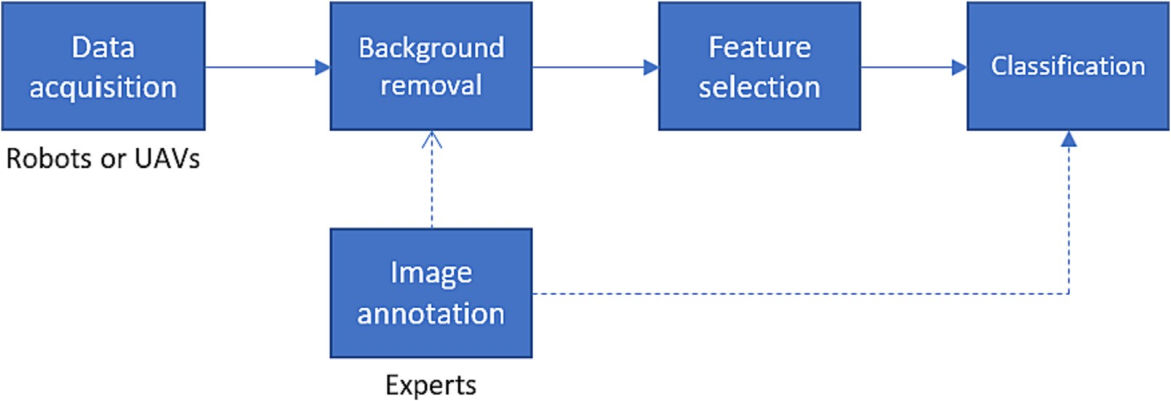

Fig. 1. Concept of weed detection.

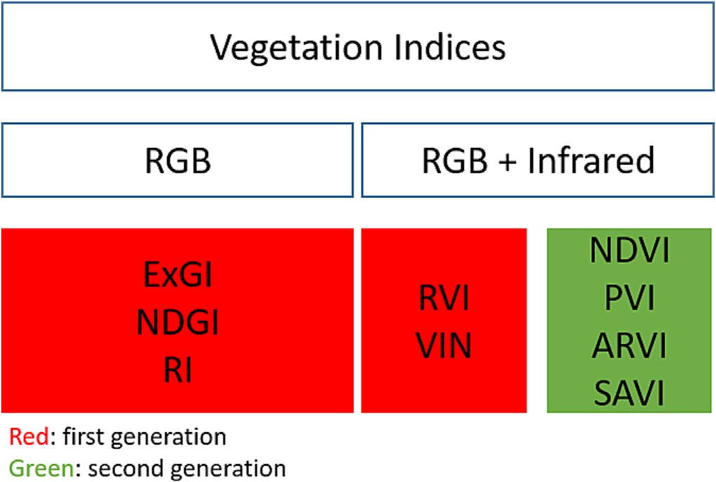

|  |  |  |  |
| --- | --- | --- | --- |
| *ExGI* = 2*g* — *r* — *b*,  where | (1) | *NIR* — *R* | (10) |
| *Gn*  *g* = ,  *r* = *Rn* , | (2)  (3) | or using the *VIN* term  *VIN* — 1 | (11) |

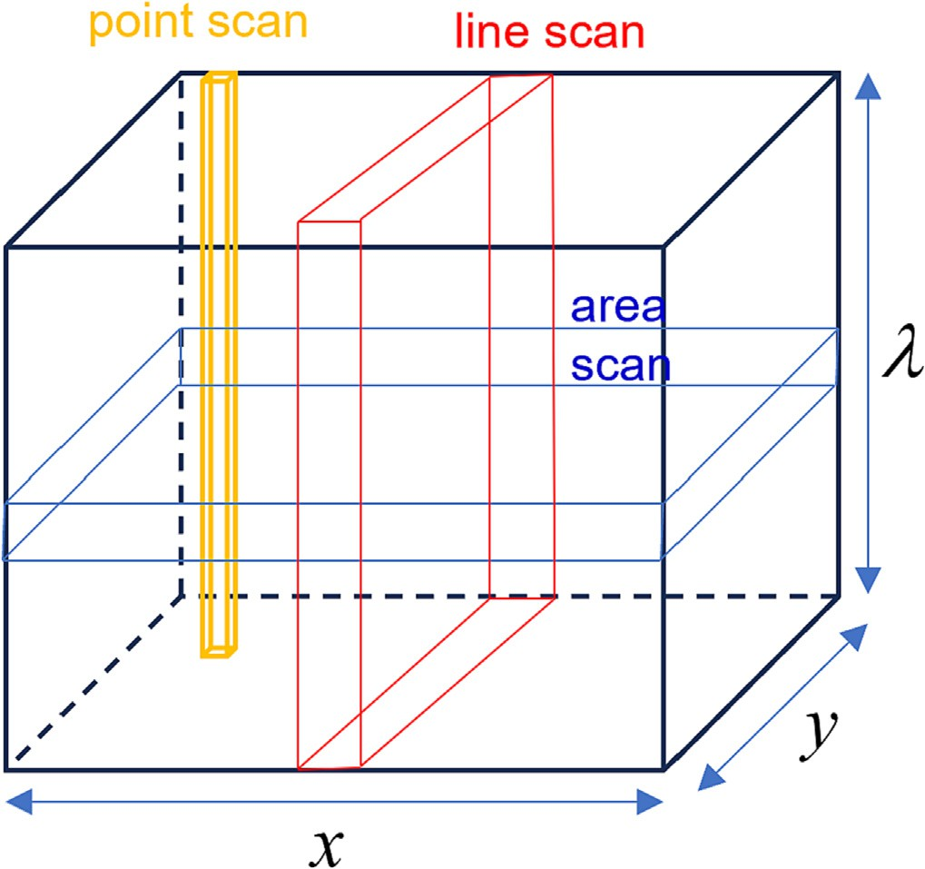Fig. 2. Hyperpectral sensor scanning methods.

considering atmospheric effects, soil brightness, and soil color. Mean- while, second generation VIs are obtained through mathematical and physical reasoning, logical experiment, and simulation. Furthermore, according to the method, VIs can be grouped into (Mróz and Sobieraj, 2004):

1. Slope-based: This method uses the ratio of NIR and R. This method includes Ratio Vegetation Index (RVI), Vegetation Index Number (VIN), and Normalized Difference Vegetation Index (NDVI). They may have some variants that have been proposed by various re- searchers.
2. Distance-based: This method uses soil line as the reference and then measures the perpendicular distance of each pixel point to this soil line. This method includes Perpendicular Vegetation Index 1 and 2 (PVI1 and PVI2, respectively), Difference Vegetation Index (DVI), and Soil Adjusted Vegetation Index (SAVI) and its variants.
3. Orthogonal transformation: This group uses orthogonal transforma- tion to create new uncorrelated bands.
4. Red Edge Inflection Point (REIP): This method observes the red edge, which is a fast shift in reflectance found in green plant spectrum at the transition between visible and near-infrared wavelengths, using Gaussian, polynomial, and Lagrangian models.

We notice from the above discussion, there are many well-known VIs in practice. Thorough review papers of VIs can be found in Xue and Su (2017), Bannari et al. (1995), and Mróz and Sobieraj (2004). Here, we revisit some VIs as shown in Fig. 3.

* 1. *Excess Green Index (ExGI)*

The *ExGI* is defined by Gée et al. (2008) and Woebbecke et al. (1995)

*Rn* + *Gn* + *Bn*

*Rn* + *Gn* + *Bn*

Fig. 3. VIs discussed in this paper.

*b*  *Bn* , 4

= ( )

*Rn* + *Gn* + *Bn*

*Rn*, *Gn*, and *Bn* are the normalized RGB coordinates ranging between 0 and 1. The normalized coordinates are given by

*Gn* = *G* , (5)

*Gm*

*Rn* = *R* , (6)

*Rm*

*Bn* = *B* , (7)

*Bm*

where *R*, *G*, and *B* are the true coordinates and *Rm*, *Gm*, and *Bm* are the maximum true coordinates. Note that *Rm Gm Bm* 255 for 24-bit color images. Fig. 4 shows the images before and after ExGI preprocessing.

= = =

* 1. *Ratio Vegetation Index (RVI) and Vegetation Index Number (VIN)*

RVI and VIN are the two first VIs (Bannari et al., 1995). They use the reflectance of the red, *R* and near-infrared, *NIR*. The RVI is mathemati- cally given by

*RVI R* , 8

= ( )

*NIR*

while *VIN* is expressed by

*VIN* = 1 = *NIR* . (9)

*RVI R*

* 1. *Normalized Difference Vegetation Index (NDVI)*

NDVI is the most popular VI used in the literature (Bosilj et al., 2018). NDVI measures the spectral reflectance difference between near- infrared and red spectrum. Mathematically, NDVI is expressed by

*NVDI* = *NIR* + *R* ,

*NVDI* = *VIN* + 1 ,

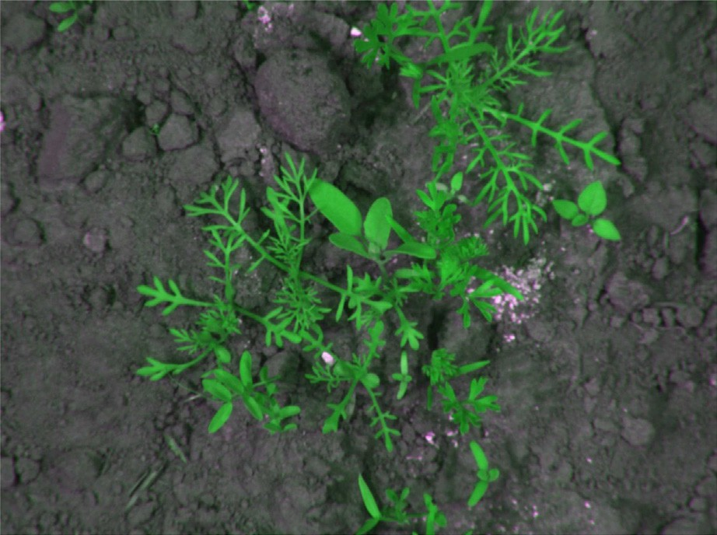 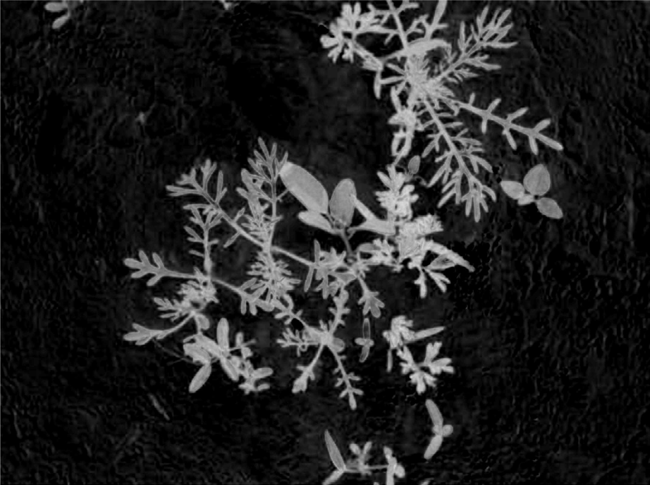

# (a) Original image (b) ExGI image

Fig. 4. Before and after ExGI Preprocessing.

where *NIR* is the near-infrared spectrum reflectance and *R* is the red or spectrum reflectance. It is worth mentioning that NIR can be replaced

2

by mid-infrared (MIR) (Bannari et al., 1995). This process indirectly

σ 2(*T*) = [μ*T* ω(*T*) — μ(*T*)] . (18)

converts the image into grey scale with most, but not all, background *B*

pixels removed. Subsequently, the image is converted into black and white as a binary mask using Otsu threshold (Otsu, 1979), that will be

ω(*T*)[1 — ω(*T* )]

described briefly below. The binary mask is then applied to the gray- scale image to remove the background.

* + 1. *Otsu threshold*

Let us assume that a grayscale image has *L* pixel levels. We would like to separate the image into two classes, background (class *C*0) and

* + 1. *Modified Otsu threshold*

Otsu threshold is not the only means to separate the background and the objects. For example, a modified Otsu threshold was proposed in Somasundaram and Genish (2012). Instead of using the class mean values, the standard deviation values are used in Eq. (17). The modified between-class variance is then given by

object (class *C*1). Class *C*0 is a group of pixels with level [1, ⋯, *T* ] and 2 2

*C*1 is a group of pixels with level *T* 1, ⋯, *L* , where *T* is the threshold. The probabilities for class occurrence are given by

[ + ]

*T*

ω0 = ω(*T*) = *Pr*(*C*0) = ∑ *pi* , (12)

*i*=1

and

*L*

ω1 = 1 — ω(*T* ) = *Pr*(*C*1) = *i* ∑ *pi* . (13)

=*T* +1

The class mean levels are given by

*T*

μ0 = ∑ *ipi* /ω0 = μ(*T*)/ω(*T*), (14)

*i*=1

and

*L*

μ1 = *i* ∑ *ipi* /ω1 = (μ*T* — μ(*T*))/(1 — ω(*T*)), (15)

=*T*+1

where μ(*T*) = ∑*T* 1*pi* and μ*T* = μ(*L*) = ∑*L* 1*ipi* = ω0μ0 + ω1μ1.

σ *B* (*T*) = ω0ω1(*SB* — *SO*) , (19)

where *SB* and *SO* are standard deviation values for the background pixels and the object pixels, respectively.

* 1. *Transformed Vegetation Index (TVI), corrected TVI (CTVI), and Thiam's TVI (TTVI)*

TVI, CTVI, and TTVI are three VIs that are derived from NDVI (Mróz and Sobieraj, 2004). The TVI is given by

*TVI* = p*N*ﬃﬃﬃﬃ*D*ﬃﬃﬃ*V*ﬃﬃﬃ*I*ﬃﬃ+ﬃﬃﬃﬃﬃ0ﬃﬃﬃ.ﬃ5ﬃﬃﬃ, (20)

for *NDVI* ≥−0.5 . To solve the problem of *NDVI <* −0.5 , CTVI was proposed. CTVI is given by

*CTVI* = *NDVI* + 0.5 p∣ﬃﬃ*N*ﬃﬃﬃ*D*ﬃﬃﬃ*V*ﬃﬃﬃ*I*ﬃﬃﬃ+ﬃﬃﬃﬃﬃ0ﬃﬃ.ﬃﬃ5ﬃﬃ∣ﬃ, (21)

∣*NDVI* + 0.5∣

where ,∣ﬃﬃ*N*ﬃﬃﬃ*D*ﬃﬃﬃ*V*ﬃﬃﬃ*I*ﬃﬃﬃ+ﬃﬃﬃﬃ0ﬃﬃﬃ.ﬃﬃ5ﬃﬃ∣ﬃ is the TTVI.

* 1. *Perpendicular Vegetation Index (PVI)*

*i*

=

The optimal threshold, *T*∗

*i*=

is the threshold which satisfies

The original PVI takes into account the difference between bare soil

*T*\* = arg max σ (*T* ), (16)

2

*B*

1 ≤ *T* < *L*

where σ 2(*T*) is the between-class variance given by

*B*

reflectance and vegetation reflectance. In particular, it measures the “greenness” level of the vegetation which includes the bare soil and then subtract the bare soil reflectance to obtain the vegetation index. The formula uses two bands, i.e. red channel and NIR channel. The for-

2 2 mula is given by Bannari et al. (1995)

σ (*T*) = ω0ω1(μ1−μ0 ) , (17)

*B*

*PVI* =

qﬃ(ﬃ*R*ﬃﬃﬃ*s*ﬃﬃﬃ—ﬃﬃﬃﬃﬃ*R*ﬃﬃﬃ*v*ﬃﬃ)ﬃﬃ2ﬃﬃﬃ+ﬃﬃﬃﬃﬃ(ﬃﬃ*N*ﬃﬃﬃ*I*ﬃﬃ*R*ﬃﬃ*s*ﬃﬃﬃﬃ—ﬃﬃﬃﬃﬃ*N*ﬃﬃﬃ*I*ﬃ*R*ﬃﬃﬃ*v*ﬃﬃ)ﬃﬃ2ﬃﬃ, (22)

Søgaard (2005) used active shape models to classify weed species. The database of the shape model consisted of 19 major weed species in Danish fields. The database holds the information of leaf and plant

where subscripts *s* and *v* refer to soil and vegetation, respectively.

An improved PVI formula is given by Bannari et al. (1995)

*PVI* = *NIR* —ﬃﬃﬃ *aR* —ﬃﬃ *b* , (23)

,*a*2ﬃﬃﬃ+ﬃﬃﬃﬃﬃ1ﬃ

where *a* is the slope of the bare soil line and *b* is the y-axis intercept of the bare soil line.

1. Feature-based recognition

As previously stated in Section 1.2, ML algorithms require features for their operation. In particular, features extracted from the image, such as color, texture, and shape, are fed to the ML algorithms. Conven- tionally, these methods require manual design of features (engineered features) and heavily depend on image acquisition methods, prepro- cessing techniques, and the accuracy of feature extraction. For engineered features, researchers have used biological morphology, spectral, or texture features of the field images for the classification of weed and crops. Note that traditional ML methods typically require a smaller sample size and a shorter training time when compared to their DL counterparts due to less computational requirements and com- plexity. However, the type of features used, the selection, and tuning of those features play a critical role in determining the ability of the classi- fier to discriminate between crops and weeds.

* 1. *Biological morphology features*

The physical characteristics of plants are referred to as morphology features. It is obvious that each plant has unique physical traits, such as leaf shape and size. For example, the leaves of *Pluchea indica* have the form of *abovatus*, i.e., round shape like eggs (Susetyarini et al., 2020). Therefore, shape abstraction in regard to plant geometry and structure would give sufficient information on the plant's identity. The approach is mainly based on shape features from leaf edge patterns which includes leaf curvature or lobe. Often, multiple features which contribute to the recognition of the plant are used, such as area, dimen- sionless ratios, length, perimeter, moments and width of either the leaf or the plant are used. In general, there are many morphological features that can be used: geometry, shape, size, and color of plant organs (e.g., root, stem, leaf and flower) (Speck and Speck, 2021).

features. The features included the shape and structure definition of the plants. The database was formed from seedling growth to two true leaves. Color images were taken from individual seedings. A plastic dif- fuser was used to prevent image overexposure. The images were then categorized using template matching, where each species was discrim- inated against based on template deformation against the optimal fit. Fig. 5 shows the model applied on weed images.

Ahmed et al. (2012) used the feature vector of shape, color, and mo- ment. An ML model was validated with 224 images consisting of chilli, pigweed, marsh herb, lamb's quarters, cogon grass, and bur cucumber. The authors noted that the method was dependent on a large number of images to ensure a more robust model. They also noted that plant holes and image noise affected the model.

The biological morphology approach to various machine vision methods mentioned previously achieved high recognition rates under optimal conditions. This shows the theoretical feasibility of using such methods in environments where plants are in controlled, damage- free, and unoccluded environment.

* 1. *Spectral features*

Previous studies by other researchers have employed the reflection of light from plants to identify their types. This feature operates based on the color or spectral reflectance exhibited by the leaves. Remarkably, this technique can effectively identify the plant type even when there is partial occlusion of the plant. The unique cellular characteristics of a leaf lead to distinct responses when exposed to specific wavelengths of elec- tromagnetic waves. For example, there is a significant difference in NIR reflectance between dicotyledonous and monocotyledonous plants (Kim and Reid, 2006). Moreover, other than NIR, some authors have used visible waveband spectrum and water absorption waveband spec- trum as features (Kim and Reid, 2006; Hatfield and Pinter, 1993).

Woebbecke et al., 1995 proposed the use of color features in stan- dard color slide images to discriminate weeds from the soil. Light reflected from the leaves of the plants were captured and used for clas- sification based on the reflectance wavelength in red, NIR, green, and blue. Their system classified leaves from soybeans, giant foxtail, ivy leaf, morning-glory, and velvetleaf. Reflectances from the other edges of the leaves were used to compute mean, variance, and skewness which were used to determine the type of plant. They experimented with the classifier by either including or excluding leaf orientation in

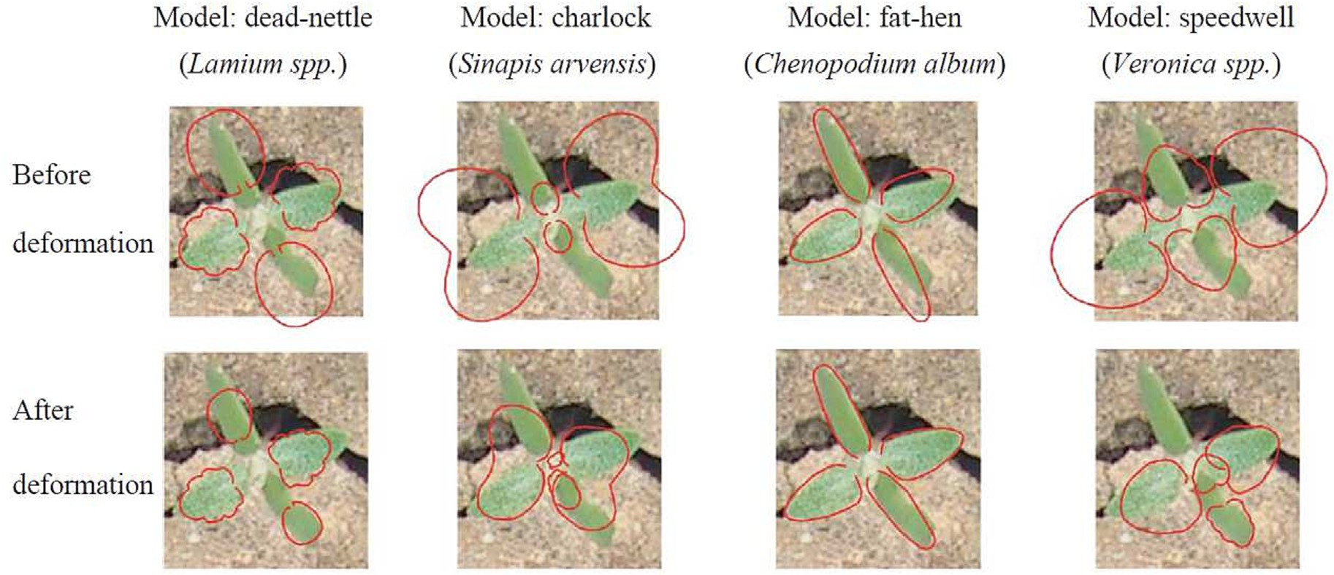

Fig. 5. Example of active shape models by Søgaard (2005).

the classifier. It was found that by excluding leaf orientation features, the classifier managed to obtain a higher classification rate than when including leaf orientation. The researchers also concluded that color im- ages could distinguish between plants and the background but were not sufficient to determine the plant species. It was noted that this tech- nique was affected by leaf orientation as the reflected wavelength changes with the orientation of the leaf.

Another example of using spectral feature for classifying carrots, cabbage, and weeds can be found in Hemming and Rath (2001). The classifier was based on weighted fuzzy classification. It was shown that color features could discriminate plants from the soil, and the clas- sifier showed an improvement in terms of classification accuracy when color features were used in addition to morphology features. Their method resulted in good classification rates depending on the growth and density of the weeds. They noted that this technique is susceptible to occluded leaves.

Spectral features have also been used in Feyaerts and Van Gool (2001). In particular, blue-NIR spectral was observed to discriminate sugar beet plants from weeds. It cannot be denied that crop and weed exhibit comparable spectral signatures. Therefore, Object-Based Image Analysis (OBIA) techniques can improve classification results (De Castro et al., 2018). OBIA works by segmenting images into clusters of neighboring pixels with similar spectral values, referred to as “objects.”

* 1. *Texture features*

Texture features are defined as a collection of metrics used to quan- tify the apparent texture of an image. The texture provides information on the spatial arrangements of pixels in a region or the entire image. The metrics represent properties such as coarseness, smoothness, and regularity (Bakhshipour et al., 2017).

A texture may be considered as clusters of similarities in an image. There are four types of texture, namely statistical features, structural features, model-based features, and transformation-based features. Sta- tistical features involve calculating the local features of each point in the image, obtaining a collection of statistical data from the distribution of local features, and evaluating the spatial distribution of grey values. Sta- tistical moments are computed through the image or the region's inten- sity histogram, and the extracted information are sets of statistics that provide properties such as skewness, flatness, and contrast. The Grey Level Co-occurrence Matrix (GLCM) is a common approach for obtaining statistical characteristics (Haralick et al., 1973).

The structural texture is primarily described as a collection of well- defined texture components. The structural texture is defined by the characteristics and placement rules of texture components. Structural textures are rarely utilized in agricultural applications since they can only represent highly regular textures. The texture image is represented as a linear combination of a probability model or a collection of basis functions for model-based textures, and the model coefficients are uti- lized as texture features (Rallabandi and Sett, 2005).

Model-based texture characteristics, such as structural texture, are rarely utilized in the literature for plant recognition. The converted fea- tures are retrieved by converting the image into a new space where the coordinate system has a near interpretation of texture characteristics. For transformation-based features, curve and wavelet transformation are two commonly utilized transformation techniques (López- Granados, 2011). These transformations are typically carried out before the feature extraction process. The Fourier transform method is rarely utilized because of the lack of spatial location. Several wavelet families, including Haar and Gabor, have been utilized to detect specific novel characteristics that are difficult to describe in the spatial domain. Gabor filters improve spatial positioning approaches and have been uti- lized in a wide range of weed and crop recognition applications.

The authors in Chaki et al. (2015) used the Gabor filter to convolve a

grey image of plant leaves with empirically established parameters to create a collection of complex signals, resulting in real and imaginary

portions. GLCM was calculated based on the virtual signal following the Gabor filter, followed by a collection of GLCM-based features. In an- other study, Kumar and Prema (2016) used rotation-invariant wavelet features for weed identification. For acquiring these characteristics, the radon transform approach was used. It substantially lowered the number of characteristics and identified images in a variety of directions rapidly. The impact of rotation on the input and output images might be shown through Radon transform. The wavelet function was then used to split the Radon transform output into distinct sub-bands, and the tex- tural characteristics, such as energy and uniformity of each sub-band, were calculated. Curvelet transform decomposes the image at multiple sizes and angles, making feature extraction easier.

The authors in Bakhshipour et al. (2017) executed a single-level Haar discrete wavelet decomposition on a grey image to get four sub- images representing approximation images, vertical details, horizontal details, and diagonal details. The GLCM texture was then extracted from the four sub-images. Local Binary Pattern (LBP) is a single channel and rotational invariant texture encoder first proposed by He and Wang (1990) describing the spatial structure of the local image texture. The effectiveness of LBP was later proven and described by Ojala et al. (2002). LBP is often used as a visual texture descriptor for many classi- fication problems. Some of the common uses of LBP are in applications of face detection (Jin et al., 2004), facial recognition (Liu et al., 2016), vi- sual inspection (Tajeripour et al., 2008), motion analysis (Zhao and Pietikainen, 2006), and texture analysis (Mäenpää and Pietikäinen, 2005). Literature has shown that LBP is a powerful texture visual de- scriptor in many applications; thus its use can be further explored in smart agriculture applications, such as weed classification tasks.

The authors in Ahmed et al. (2011) proposed an automated weed classification with LBP-based template matching. The study evaluated the feasibility of using LBP-based texture patterns to classify weed im- ages into broadleaf and grass categories. This is to note that the classifi- cation is of the entire image rather than pixel-level classification (i.e., classify the whole image rather than pixel-level labelling). The im- ages used were colored images comprised of 100 broadleafs and 100 grass weeds samples. LBP features were extracted from the images and were trained with two classifiers. The authors concluded that the rotation invariant LBP had strong discriminative abilities, given the correct parameter setting was chosen for LBP.

In the follow-up work, the authors in Ahmed et al. (2014) proposed using local pattern-based texture descriptors, which includes LBP for the classification of broadleaf and grass weeds. Again, the classification was of the entire image rather than pixel-level classification. The re- searchers experimented with three local texture operators with varying parameter configurations. From their findings, rotation invariant local patterns could provide stable performance in the presence of orienta- tion variations, illumination variations, image noise, and lower memory and computational cost compared with wavelet methods. The desirable characteristics saved considerable computational power as no prepro- cessing was needed for illumination normalisation and data augmenta- tion in terms of orientation. It showed that that LBP was able to achieve robust performance in uncontrolled natural environment.

The authors in Le et al. (2019) studied on combining multiple LBP features with a classifier to classify canola, corn maize, and radish. The images used were in a lab controlled environment, where only individ- ual plant species were captured at a given time without including other species. Similar to the previous, the classification was of the entire image rather than pixel-level classification. The authors suggested that in plant classification, the accuracy metric itself was not a sufficient in- dicator to determine its acceptable performance for plant classification. They suggested that the Precision, Recall, and F1-score metrics were suitable to validate the performance of the model for plant classification. From their findings, it was noticed that when visualising the texture fea- ture distribution, corn leaves' texture features were distinct compared to leaves of canola and radish. Their results showed that combining LBP features could achieve accuracy greater than 91% for corn, canola,

and radish plants and background. The authors concluded that combin- ing multiple robust LBP features greatly improved the accuracy and F1 scores in the validation sets.

The authors in Samarajeewa et al. (2018) examined the identifica- tion of flower patches in the aerial images using two techniques, namely LBP classification and CIELAB color space threshold classification. In the paper, LBP set pixel intensity thresholds based on the surrounding envi- ronment, allowing high-intensity values to be displayed, effectively dis- tinguishing the plants from the background. The CIELAB threshold algorithm determined a threshold value for each RGB channel based on the histogram. Then, in both approaches, erosion was used to elimi- nate any remaining noise.

Existing research work has shown that there are only few research papers discussing LBP applications in weed classification tasks. Most of the papers utilize LBP to classify entire images or image patches rather than pixel-level classification (Ahmed et al., 2014, 2011; Le et al., 2019; Samarajeewa et al., 2018). Despite the advantages and desirable properties of LBP described in the literature for entire image weed clas- sification, LBP has yet to be applied in pixel-level weed classification. The main challenge of pixel-level classification is the computational cost required when computing multiple LBP feature sets over each image window that contain plant pixels. Each image window represents a plant pixel label (i.e., crop pixel or weed pixel). The high computa- tional cost hinders the advancement of LBP for pixel-level classification. With the current advancement of Application Specific Integrated Circuit (ASIC)-based real-time chip-based LBP extractor, the implementation of a real-time pixel-level weed classification becomes easier. Table 1 shows a summary of the three features.

1. Classiﬁcation algorithms
   1. *ML-based algorithms*

ML-based classifiers are coupled with various features to increase the accuracy of the system for precision agriculture. These traditional methods, once again, require to be designed on hand crafted features and are highly depended on the image quality, pre-processing, and learning algorithms. Advantages of ML-based techniques are advocated on grounds of small sample sizes required to train the system and low requirements on graphics processing units, thus, making agricultural machinery and equipment inexpensive. Traditional ML methods could give efficient performance in research, given the soil conditions and illu- mination remain the same throughout. These conditions make the real- time applications difficult to be implemented.

In this subsection, we elaborate several ML classification algorithms that are commonly used for crop/weed discrimination task, such as *k*- Nearest Neighbor (KNN) (Ahmad et al., 2011), Artificial Neural Net- works (ANNs) (Jeon et al., 2011), decision trees (Goel et al., 2003), and Support Vector Machine (SVM) (Shahbudin et al., 2017; Le et al., 2019). KNN belongs to a non-parametric algorithm, i.e., it does not have the knowledge of the data distribution (lazy learner). It works by calculating the distance (similarity) of a new data sample with its *k* neighbours. Following that, the new data sample will be classified to

the class with the shortest distance. Note that *k* is usually an odd num- ber to avoid a tie.

ANN is an ML algorithm that is designed to mimic the principle of human brain. An ANN consists of layers of linked artificial neurons. The fundamental ANN structure is known as a perceptron. A perceptron works by receiving input signals, weighting and summing them. Subse- quently, it passes the sum to a nonlinear activation function to produce the output. ANN is trained to adjust the weights that minimize the dif- ference between the target output and the resulted output. The backpropagation algorithm is usually used to optimize the weights.

SVM is considered as a linear classifier. Suppose that we have two classes, SVM creates a hyperplane that optimally separates the two clas- ses. For multiclass classification problem, we can extend the concept by using Error-Correcting Output Coding (ECOC) with either One vs. All (OVA), One vs. One (OVO), Dense Random (DR), or Sparse Random (SR) configuration (Wong et al., 2021). If the data samples are not dis- tributed linearly, a kernel approach, such as the Radial Basis Function (RBF), can be employed to increase the dimension.

A decision tree is supervised ML algorithm with tree-like structure that can be used for both classification and regression. A decision tree consists of a root node, splitting nodes, branch/sub-tree nodes, decision nodes, and terminal nodes. Several algorithms have been used for build- ing the decision tree. In general, entropy measure is used to find the appropriate feature to split the data at each node of the tree.

* 1. *Ensemble learning*

Ensemble learning methods employ social learning behaviours like those observed in human social interactions, such as working in a group, receiving peer feedback, and voting before deciding. Working in a group allows each member to have various perspectives and repre- sentations of the data, which aids in getting a more reliable prediction (Kuncheva, 2014). As a result, ensemble learning approaches are intended to increase the prediction performance of a particular statisti- cal learner or model by combining basic base learners. An interesting characteristic of ensemble learning is that it encourages diversity among simple base learners (Bishop, 2006). Individual learners create independent errors; therefore, diversity would minimize the error gen- erated by the learners. There are several techniques for building an en- semble model. However, it has been discovered that utilizing various learning sets increases variety within the ensemble (Torres Sospedra et al., 2011).

While the notion of combining classifiers is not new, research into various combination techniques, features, classifiers, and innovative ap- plications is still ongoing. The authors in Fumera and Roli (2005) offered a theoretical and experimental study of linear combiners for multi- classifier models. Their study focused on basic and weighted averaging at the categorization decision level. The research revealed that the out- put of linear combinations was affected by the accuracy and correlation of the individual classifiers. Weighted averaging outperformed basic av- eraging, according to the data. Weight optimization for classifiers was still an unresolved issue. The authors suggested that future studies might involve the use of metaheuristic optimization techniques.

Table 1

Summary of feature types.

Morphology Spectral Textural

Characteristics Physical characteristics Reflection of light Spatial arrangements of pixels

Examples Leaf shape, stem color NIR, infrared LBP, GLCM

Pros Rotation and scale invariant Rich information Discriminative power Useful in segmentation tasks Discriminative power Robust to noise Visible to human

Cons Noise sensitivity High dimesionality High computational Limited contextual information Limited in spatial information No spatial information

More complex

The authors in Kittler et al. (1998) presented a theoretical structure for classifier combinations that is universal. While the authors focused on ensembles with unique feature sets, in their comparable work (Kittler, 1998), both unique and common characteristics were investi- gated. It was created as a mathematical framework using the sum and product rules. The rules serve as the foundation for others, such as max- imum, minimum, median, and majority voting. Moreover, the authors ran extensive tests on the handwritten digits dataset. The sum rule outperformed other rules despite their most stringent assumptions. It demonstrates that the prediction error have a considerably less impact on the sum rule; hence, the theoretical paradigm established is consis- tent with their previous experimental results.

In the study of Torres-Sospedra and Nebot (2014), the authors utilized an ensemble of NN classifiers combined with noisy statistical characteristics of HSL (hue, saturation, brightness) color images in orange groves to classify weeds. Their implementation included boosting techniques and was tested on 130 images of orange trees with weeds, resulting in a good classification accuracy. The authors discovered that the ensemble is appropriate for weed detection with noisy characteristics. The authors in Ahmad et al. (2018) uti- lized AdaBoost with Nave Bayes, a boosted ensemble technique com- bined with statistical visual characteristics, to categorize wide and grass weed images in another study. Their technique correctly iden- tified 250 images with a classification accuracy ranging from 94.72% to 98.40%. The authors discovered that utilising ensemble techniques improved overall accuracy by 4.7% compared to using simply an individual classifier in difficult classification tasks such as weed classification.

Combining different perspectives, forecasts, or models to minimize

uncertainty is not a novel concept. Around 200 years ago, Laplace offi- cially stated that he had demonstrated that the correct combination of two probabilistic techniques would produce better results than com- pared to only one (Laplace, 1820). Numerous methods have been devel- oped with the ensemble technique in combining various models, including aggregation, combination, committee, and fusion (Drucker et al., 1994; Lam and Suen, 1995; Kittler et al., 1998; Polikar et al., 2008).

* 1. *DL-based algorithms*

DL algorithms use a large number of images to train and validate for recognition and classification. With further progress in computational power as well as the availability of data, DL algorithms have gained pop- ularity due to their capability to extract multidimensional and multiscale spatially essential information of crops and weeds using Convolutional Neural Networks (CNNs) (Dyrmann et al., 2016). The basis of CNN is a stack of convolutional layers which basically perform filtering process (Albawi et al., 2017). Each convolutional layer accepts input data, transform as required and transfers them to the next layer. The convolutional operation finally helps in simplifying the data for bet- ter processing and feature extraction.

In specific tasks like image classification and object detection and recognition, DL algorithms possess many advantages over conventional learning approaches. The disadvantages of the conventional human in- tervened feature extraction methods are usually overcome by its capa- bility of enhanced data expression by automated feature extraction. Recently, a lot of research articles on DL-based weed detection and clas- sification have been published.

As implicitly mentioned in the previous section, there are two types of weed-crop discrimiation approaches that are investigated: pixel- level (or pixel-wise) and image-wise classifications. This subsection mainly focuses on pixel-wise classification. In the pixel-wise classifica- tion, each pixel in an image is segmented and marked as weed or crop pixel. Pixel-wise approaches offer the advantage of being able to esti- mate the yield of each individual pixel. In applications that specifically require this level of information, using a pixel-wise implementation would be advantageous.

The authors in Di Cicco et al. (2017) used a pixel-wise classification CNN model SegNet. The SegNet model uses an encoder-decoder net- work structure and the fully connected layer is a softmax layer which enables pixel classification. The author used a synthetic dataset gener- ated by procedural generative model with real world plant textures in a virtual environment to train the classification model. The method was able to reduce efforts on manual pixel annotation of real world im- ages by a human. The synthetic dataset was used to train SegNet for crop-weed pixel classification and was able to achieve per-class average accuracy of 91.3%.

The authors in McCool et al. (2017) proposed the use of leveraging Deep CNN (DCNN) to learn lightweight models for pixel level crop- weed classification problems. The authors proposed three stages to train the classification model. The first stage used a pre-trained DCNN model which provides cutting edge classification performance but at a high computational cost. In mobile automated field robotics application, this model was not suitable with low frame rate of 0.12 fps. Thus, the second stage used the pre-trained DCNN model as a teacher model to train a lightweight DCNN student model. This method was known as model compression which results in lower accuracy, but much lower complexity. The third stage involved multiple lightweight model com- bined as a mixture of models which resulted in higher classification per- formance. The classification rate of the combination of lightweight models was 88.9%. The research found that while cutting edge DCNN model was able to achieve 93.9% classification accuracy, it was only able to process at 0.12 fps. The mixture of combined lightweight DCNN was able to compute at between 1.07 and 1.83 fps which is faster with less parameters.

The authors in Haug and Ostermann (2015) proposed a plant classi- fication model without the use of segmentation. Often, in the agricul- ture field, crop and weeds grow too close together and overlapping is a common occurrence. Thus, the authors proposed the use of a Random Forest classifier with statistical features to classify pixels rather than segments. The classification of pixels eliminated the challenges which were associated with segmentation methods such as overlapping and complex background. The classifier was used to estimate the spatial pixel location based on features of overlapping neighborhood pixels. The model was further spatially smoothed with Markov Random Field. A sample of the prediction from this model is shown in Fig. 6. The model was able to achieve an average classification accuracy of 85.9% in the CWFID benchmark dataset on binary classification.

One of the most prominent DL approach that is specific for segmen- tation is U-Net. U-Net has commonly been applied for medical images segmentation as demonstrated in Arun et al. (2020). The authors in Subeesh et al. (2022) applied various pre-trained models for distin- guishing bell peppers and weeds. The overall accuracy of the investi- gated models ranged from 94.5% to 97.7% with InceptionV3 outperformed the other models with 97.7% accuracy, 98.5% precision, and 97.8% recall at 30-epoch and 16-batch size. Furthermore, the false-positive for this Inception3 model was 1.4% and the false- negative was 0.9%. The approaches detected the entire vegetation object into either weed or crop class and they are not based on segmentation. In Farooq et al. (2019), remote sensing vegetation patches were evaluated and classified as weed or crops. Because of high spectral sim- ilarity between weeds and crops, patch-based classification approaches were used in the paper. Furthermore, the methods of CNN and Histo- gram of Oriented Gradients (HoG) were assessed and compared. In Brilhador et al. (2019), the authors investigated the impact of individual data augmentation transformations on the pixel-level classification of crops and weeds when using a DL model. The research focused on im- plementation of the image augmentation approach to increase training image sets similar to the Generative Adversarial Networks (GAN) ap- proaches in generating synthetic images. In Wang et al. (2020), an encoder-decoder DL network was investigated for pixel-wise semantic crop and weed segmentation. To optimize the network's input, different input representations, including different color space transformations

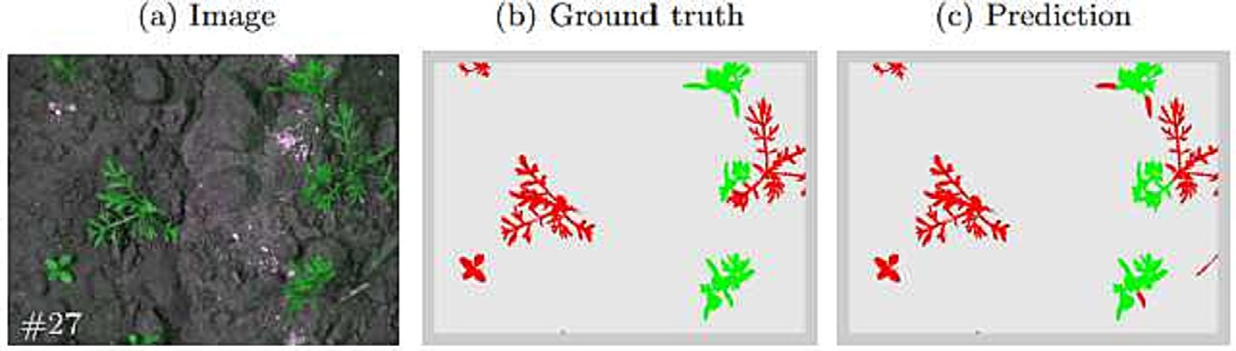

Fig. 6. Example pixel based classification without segmentation by Haug and Ostermann (2015).

and color indices, were compared. In Sa et al. (2018), the authors pro- posed a method for dense semantic weed categorization using multi- spectral Micro Aerial Vehicle (MAV) images. In particular, the authors employed SegNet, a recently designed encoder-decoder cascaded CNN, to infer dense semantic classes in sugar beet and weed datasets.

The authors in Jiang et al. (2020) proposed a CNN-based Graph Convolutional Network (GCN). Based on semi-supervised learning, the GCN graph exploited labelled and unlabeled features to enrich the model, and testing samples obtained label information from labelled weed data via propagating through the network. GCN-ResNet-101 ob- tained 97.80%, 99.37%, 98.93%, and 96.51% recognition accuracies on four separate weed datasets, outperforming state-of-the-art networks (AlexNet, VGG16 and ResNet-101). In Dyrmann et al. (2016), the au- thors used a CNN to classify seedlings of 22 plant species. Plants were accurately classified 86.2% of the time. In dos Santos Ferreira et al. (2017), a DL method was proposed for soybean weed detection. In par- ticular, CNN was used on SLIC superpixels-segmented images and UAV photos formed a picture database. This experiment obtained 97% weed detection accuracy using CNN.

In Bah et al. (2018), UAV images were collected and an attempt was made to classify into crop/weed pixels. Instead of manual annotation of pixels which is time consuming, the authors proposed an unsupervised approach. The procedure contains multiple steps. First, crop rows were detected to identify inter-row weeds. Inter-row weeds formed the training dataset in the second phase which was to distinguish from the weed. CNNs on this dataset were used to build a model which was able to detect the crop and the weeds in the images. The results ob- tained were comparable to those of traditional supervised training data labeling, with differences in accuracy of 1.5% in the spinach field and 6% in the bean field when compared with supervised approach (hand annotation).

In Chavan and Nandedkar (2018), AlexNet and VGGNET were com- bined in AgroAVNET for crop weed classification. Incremental learning used a system to learn new weeds and crops more successfully.

Performance was compared to AlexNet, VGGNET, and other approaches. The proposed approach was evaluated using seedling dataset. The im- plementation yielded 98.21% (7 species detection) and 93.64% (12 spe- cies detection). In Hu et al. (2020), the authors proposed a graph-based DL architecture that recognizes weeds from RGB photographs of range lands, called Graph Weeds Net (GWN). GWN collects regional patterns and creates multi-scale graph representations for weed classification. GWN also suggests key regions for robotic in-field actions. The architec- ture achieved state-of-the-art performance with top-1 accuracy (98.1%).

Another category of DL algorithms is Recurrent Neural Networks (RNNs) (Hochreiter and Schmidhuber, 1997; Verma and Dubey, 2021). The feedback loop available in RNNs allows them to perform as an expert forecasting machine rather than recognition by CNNs. The networks try to make an influence of previous inputs in current inputs and outputs, which helps in increasing the overall performance. They provide a pixel-level classification for all the multispectral images avail- able. The generator in the network works in creating photo-realistic im- ages, aiming for extra training data.

Table. 2 summarizes some significant research exploration involving DL. The literature review has revealed that the majority of implementations have utilized CNN as the foundational approach for ei- ther segmentation-(or pixel-wise) or annotation (or image-wise)- based classification.

1. Publicly available datasets

Acquiring crop/weed images using UAV is not an easy task. Fortu- nately, there exist various public domain datasets that enable re- searchers to explore implementation of ML algorithm. We also divide the datasets into two types: segmentation and annotation. Due to the morphology of the plants, pixel-wise classification is more complex as they are mostly in green spectrum. Most of these datasets provide a logical mask to indicate if the referred pixel is weed or crop category.

Table 2

DL implementation on weed crop recognition.

|  |  |  |  |  |
| --- | --- | --- | --- | --- |
| Authors | Approaches | Application | Achievement (Accuracy) | Segmentation/Annotation |
| Subeesh et al., 2022 | Pre-trained DL models | Bell pepper vs. Weed | 94.5%--97.7% | Annotation |
| Arun et al., 2020 | U-net | Carrot vs weed (CWFID) | 95.34% | Segmenttion |
| Farooq et al., 2019 | CNN | Remote sensing vegetation patches | 94.72% | Segmentation |
| Brilhador et al., 2019 | CNN/data augmentation | Carrot vs weed (CWFID) | 83.44% (average dice | Segmentation |
| Wang et al., 2020 | Coder/encoder | Sugar beet vs weed (sugar beet dataset) | similarity)  96.12% | Segmentation |
| Sa et al., 2018 | Coder/encoder CNN | Sugar beet vs weed (sugar beet dataset) | ∼0.8 for F1/ 0.78 for AUC | Segmentation |
| Jiang et al., 2020 | GCN | Multiple public dataset | 96.51%--99.37% | Segmentation |
| Dyrmann et al., 2016 | CNN | 22 Species of seedling | 86.2% | Annotation |
| dos Santos Ferreira et al., | CNN | Weed vs soybean | 97% | Segmentation |
| 2017  Bah et al., 2018 | Unsupervised method/CNN | Spinach/bean vs weed | 94%/88.73% | Segmentation |
| Chavan and Nandedkar, 2018 | Hybrid ResNet/AlexNet(Pre-trained CNN) | Dataset of seedlings from various species. | 98.21% (7 species)  93.64% (12 species) | Segmentation |
| Hu et al., 2020 | Graph deep learning | DeepWeeds dataset | 98.21% | Segmentation |

Table 3

Details on publicly available dataset.

|  |  |  |  |  |
| --- | --- | --- | --- | --- |
| Name | Author | No of samples | Application | Segmentation/Annotation |
| CWFID | Haug and Ostermann, 2015 | 60 | Carrot-weed | Segmentation |
| Cowpea dataset | LR et al., 2021 | 150 | Southern pea-weed | Segmentation |
| Carrot-Weed dataset | Lameski et al., 2017 | 39 | Carrot-weed | Segmentation |
| Crop-weed discrimination dataset | Bosilj et al., 2020 | 20 | Onion-weed | Segmentation |
| Paddy crops-weeds digital image dataset | Kamath and Balachnadra, | 300 | Paddy-weed | Segmentation |
| Rice seedling and weed image | 2021  Ma et al., 2019 | 224 | Rice seedling-weed | Segmentation |

segmentation

Food crops and weed images Sudars et al., 2020 1118 6 food crops-8 weed species Annotation

Weed species classification Skovsen et al., 2019 261 Vegetation biomass Segmentation Plant seedling classification Giselsson et al., 2017 961 12 species at several growth stages Annotation

DeepWeeds Olsen et al., 2019 17509 8 species of weeds native to Australia in situ with neighboring

flora

Annotation

For pixel-based implementation, dataset normally consist of several High Definition (HD) images in the order of 20–100 as the images can be divided into smaller sections for evaluations/training. For the annota- tion type, the object plants are segmented using green index. Subse- quently, the entire image can be categorized as either weed or crop. This category normally carries more images as most implementation applies some forms of DL approach such as CNN. The summary of the datasets is shown in Table 3.

1. Challenges and opportunities

The problem of identifying background from vegetation (crop or weed) is much more straightforward. However, this still presents a challenge. Agricultural scenes often have cluttered and textured back- grounds, which can interfere with the accurate segmentation of weed and crop regions. Shadows, soil variations, and other artifacts can ob- scure plant boundaries. Environmental conditions, such as soil type, hu- midity, and temperature, can affect plant appearances. Models trained in one environment may not generalize well to different conditions.

The key challenge in crop-weed classification for annotation- based techniques is the construction of the classification model and the optimization of the model parameters. The classifier model, like any other image classification issue, is created for specific applica- tions, and its parameters must be fine-tuned and optimized. Classi- fier optimization necessitates the use of several algorithms in order to attain a high classification rate while minimizing false positives and data overfitting.

Pixel-wise segmentation for weed–crop discrimination is also a challenging task. The most apparent is the high expense of resources and computation. Each pixel must be identified to either a crop or a weed pixel, which is a difficult task. This also has an impact on the anno- tation task for each pixel, which may result in incorrect annotation. It is also worth noting that the majority of agriculture segmentation takes use of UAV datasets. It is evident that weed pixels would be substan- tially smaller than crop pixels. This is known as a class imbalance situa- tion in machine learning. Models may become biassed in favour of the dominant class (crops), resulting in poor weed segmentation. Finally, we see that some weeds, in terms of color, texture, and shape, strongly resemble certain crops. Therefore, distinguishing between these visu- ally similar classes becomes challenging, especially when the plants are in early growth stages.

In general, a few key challenges are listed out in the following:

* The vegetation images obtained for the training of the ML model are often obtained at different growth stages of the vegetation with vary- ing vegetation orientation and size.
* In a natural growing environment, crop and weed tend to overlap

each other, thus applying image segmentation methods to separate crops and weeds is difficult.

* When using too many features, clustering or forming of the relation- ship between observations becomes more difficult and complex for the model or, in other words, the “curse of dimensionality” issue is the challenge.

One essential to encouraging development is the use of edge devices rather than offline or cloud-based alternatives. High quality images can be difficult to create and store. The majority of the ideas presented here are computationally demanding and unsuitable for edge devices. More research work using techniques with reduced computation complexity or low energy consumption, such as FPGA-based approaches, may be in- cluded. Because the majority of these systems are linked to the Internet of Things (IoT), edge devices can further optimize data transmission and reduce the number of data packets delivered.

1. Conclusion

Various techniques employing ML have been investigated in this paper. We present an overview of crop and weed recognition or dis- criminating algorithms. The biggest problem is how the technology is used, followed by the ways used owing to crop and weed morphology. As a result, determining which techniques are preferable on a “apple-to- apple” basis is extremely challenging. In this regard, stakeholders may consider implementing ways that are most comparable in order to ben- efit from proven outcomes. We expect that this paper may give a com- plete overview of crop-weed detection in Agriculture 5.0 point of view.

Declaration of Competing Interest

The authors declare that they have no known competing financial interests or personal relationships that could have appeared to influ- ence the work reported in this paper.

Acknowledgements

This research was supported partly by ASEAN-India Collaborative R&D scheme under ASEAN-India S&T Development Fund (AISTDF), File Number: CRD/2020/000248 and partly by Universitas Indonesia's Inter- national Indexed Publication (PUTI) Q2 Grant, year 2023, number: NKB- 803/UN2.RST/HKP.05.00/2023.

References

Ahmad, I., Siddiqi, M.H., Fatima, I., Lee, S., Lee, Y.-K., 2011. [Weed classification based on](http://refhub.elsevier.com/S2589-7217(23)00036-3/rf0005) [haar wavelet transform via k-nearest neighbor (*k*−nn) for real-time automatic](http://refhub.elsevier.com/S2589-7217(23)00036-3/rf0005) [sprayer control system. Proceedings of the 5th International Conference on Ubiqui-](http://refhub.elsevier.com/S2589-7217(23)00036-3/rf0005) [tous Information Management and Communication, ICUIMC ’11, New York, NY, US](http://refhub.elsevier.com/S2589-7217(23)00036-3/rf0005)A. Ahmad, J., Muhammad, K., Ahmad, I., Ahmad, W., Smith, M.L., Smith, L.N., Jain, D.K., Wang, H., Mehmood, I., 2018. [Visual features based boosted classification of weeds for real-](http://refhub.elsevier.com/S2589-7217(23)00036-3/rf0010)

[time selective herbicide sprayer systems. Comput. Ind. 98, 23–33](http://refhub.elsevier.com/S2589-7217(23)00036-3/rf0010).

Ahmed, F., Bari, A.H., Shihavuddin, A., Al-Mamun, H.A., Kwan, P., 2011. [A study on local](http://refhub.elsevier.com/S2589-7217(23)00036-3/rf0015) [binary pattern for automated weed classification using template matching and sup-](http://refhub.elsevier.com/S2589-7217(23)00036-3/rf0015) [port vector machine. 2011 IEEE 12th International Symposium on Computational In-](http://refhub.elsevier.com/S2589-7217(23)00036-3/rf0015) [telligence and Informatics (CINTI), pp. 329–334](http://refhub.elsevier.com/S2589-7217(23)00036-3/rf0015).

Ahmed, F., Al-Mamun, H.A., Bari, A.H., Hossain, E., Kwan, P., 2012. [Classification of crops](http://refhub.elsevier.com/S2589-7217(23)00036-3/rf0020) [and weeds from digital images: a support vector machine approach. Crop Prot. 40,](http://refhub.elsevier.com/S2589-7217(23)00036-3/rf0020) [98–10](http://refhub.elsevier.com/S2589-7217(23)00036-3/rf0020)4.

Ahmed, F., Kabir, M.H., Bhuyan, S., Bari, H., Hossain, E., 2014. [Automated weed classifica-](http://refhub.elsevier.com/S2589-7217(23)00036-3/rf0025) [tion with local pattern-based texture descriptors. Int. Arab J. Inform. Technol. 11 (1),](http://refhub.elsevier.com/S2589-7217(23)00036-3/rf0025) [87–94](http://refhub.elsevier.com/S2589-7217(23)00036-3/rf0025).

Albawi, S., Mohammed, T.A., Al-Zawi, S., 2017. [Understanding of a convolutional neural](http://refhub.elsevier.com/S2589-7217(23)00036-3/rf0030) [network. 2017 International Conference on Engineering and Technology (ICET),](http://refhub.elsevier.com/S2589-7217(23)00036-3/rf0030)

[pp. 1–](http://refhub.elsevier.com/S2589-7217(23)00036-3/rf0030)6.

Arun, R.A., Umamaheswari, S., Jain, A.V., 2020. [Reduced u-net architecture for classifying](http://refhub.elsevier.com/S2589-7217(23)00036-3/rf0035) [crop and weed using pixel-wise segmentation. 2020 IEEE International Conference](http://refhub.elsevier.com/S2589-7217(23)00036-3/rf0035) [for Innovation in Technology (INOCON), pp. 1–](http://refhub.elsevier.com/S2589-7217(23)00036-3/rf0035)6.

Bah, M.D., Hafiane, A., Canals, R., 2017. [Weeds detection in uav imagery using slic and the](http://refhub.elsevier.com/S2589-7217(23)00036-3/rf0040) [hough transform. 2017 Seventh International Conference on Image Processing The-](http://refhub.elsevier.com/S2589-7217(23)00036-3/rf0040) [ory, Tools and Applications (IPTA), pp. 1–](http://refhub.elsevier.com/S2589-7217(23)00036-3/rf0040)6.

Bah, M., Hafiane, A., Canals, R., 2018. [Deep learning with unsupervised data labeling for](http://refhub.elsevier.com/S2589-7217(23)00036-3/rf0045) [weed detection in line crops in uav images. Remote Sensing 1](http://refhub.elsevier.com/S2589-7217(23)00036-3/rf0045)0.

Bakhshipour, A., Jafari, A., Nassiri, S.M., Zare, D., 2017. [Weed segmentation using texture](http://refhub.elsevier.com/S2589-7217(23)00036-3/rf0050) [features extracted from wavelet sub-images. Biosyst. Eng. 157, 1–12](http://refhub.elsevier.com/S2589-7217(23)00036-3/rf0050).

Bannari, A., Morin, D., Bonn, F., Huete, A.R., 1995. [A review of vegetation indices. Remote](http://refhub.elsevier.com/S2589-7217(23)00036-3/rf0055) [Sens. Rev. 13 (1–2), 95–120](http://refhub.elsevier.com/S2589-7217(23)00036-3/rf0055).

Bishop, C.M., 2006. [Pattern Recognition and Machine Learning](http://refhub.elsevier.com/S2589-7217(23)00036-3/rf0060).

Bosilj, P., Duckett, T., Cielniak, G., 2018. [Connected attribute morphology for unified veg-](http://refhub.elsevier.com/S2589-7217(23)00036-3/rf0065) [etation segmentation and classification in precision agriculture. Comput. Indus. 98,](http://refhub.elsevier.com/S2589-7217(23)00036-3/rf0065) [226–240](http://refhub.elsevier.com/S2589-7217(23)00036-3/rf0065).

Bosilj, P., Aptoula, E., Duckett, T., Cielniak, G., 2020. [Transfer learning between crop types](http://refhub.elsevier.com/S2589-7217(23)00036-3/rf0070) [for semantic segmentation of crops versus weeds in precision agriculture. J. Field](http://refhub.elsevier.com/S2589-7217(23)00036-3/rf0070) [Robot. 37 (1), 7–19](http://refhub.elsevier.com/S2589-7217(23)00036-3/rf0070).

Brilhador, A., Gutoski, M., Hattori, L.T., de Souza Inácio, A., Lazzaretti, A.E., Lopes, H.S., 2019. [Classification of weeds and crops at the pixel-level using convolutional neural](http://refhub.elsevier.com/S2589-7217(23)00036-3/rf0075) [networks and data augmentation. 2019 IEEE Latin American Conference on Compu-](http://refhub.elsevier.com/S2589-7217(23)00036-3/rf0075) [tational Intelligence (LA-CCI), pp. 1–](http://refhub.elsevier.com/S2589-7217(23)00036-3/rf0075)6.

Chaki, J., Parekh, R., Bhattacharya, S., 2015. [Plant leaf recognition using texture and shape](http://refhub.elsevier.com/S2589-7217(23)00036-3/rf0080) [features with neural classifiers. Pattern Recogn. Lett. 58, 61–68](http://refhub.elsevier.com/S2589-7217(23)00036-3/rf0080).

Chang, Y.K., Zaman, Q.U., Schumann, A.W., Percival, D.C., Esau, T.J., Ayalew, G., 2012. [Development of color co-occurrence matrix based machine vision algorithms for](http://refhub.elsevier.com/S2589-7217(23)00036-3/rf0085) [wild blueberry fields. Smart Agric. Technol 28 (3), 315–32](http://refhub.elsevier.com/S2589-7217(23)00036-3/rf0085)3.

Chavan, T.R., Nandedkar, A.V., 2018. [Agroavnet for crops and weeds classification: a step](http://refhub.elsevier.com/S2589-7217(23)00036-3/rf0090) [forward in automatic farming. Comput. Electron. Agric. 154, 361–372](http://refhub.elsevier.com/S2589-7217(23)00036-3/rf0090).

De Castro, A.I., Torres-Sánchez, J., Peña, J.M., Jiménez-Brenes, F.M., Csillik, O., López- Granados, F., 2018. [An automatic random forest-obia algorithm for early weed map-](http://refhub.elsevier.com/S2589-7217(23)00036-3/rf0095) [ping between and within crop rows using uav imagery. Remote Sens. (Basel) 10 (2)](http://refhub.elsevier.com/S2589-7217(23)00036-3/rf0095).

Di Cicco, M., Potena, C., Grisetti, G., Pretto, A., 2017. [Automatic model based dataset gen-](http://refhub.elsevier.com/S2589-7217(23)00036-3/rf0100) [eration for fast and accurate crop and weeds detection. 2017 IEEE/RSJ International](http://refhub.elsevier.com/S2589-7217(23)00036-3/rf0100) [Conference on Intelligent Robots and Systems (IROS), pp. 5188–5195](http://refhub.elsevier.com/S2589-7217(23)00036-3/rf0100).

dos Santos Ferreira, A., Matte Freitas, D., Gonçalves da Silva, G., Pistori, H., Theophilo Folhes, M., 2017. [Weed detection in soybean crops using convnets. Comput. Elect.](http://refhub.elsevier.com/S2589-7217(23)00036-3/rf0105) [Agric. 143, 314–324](http://refhub.elsevier.com/S2589-7217(23)00036-3/rf0105).

Drucker, H., Cortes, C., Jackel, L.D., LeCun, Y., Vapnik, V., 1994. [Boosting and other ensem-](http://refhub.elsevier.com/S2589-7217(23)00036-3/rf0110) [ble methods. Neural Comput. 6 (6), 1289–1301](http://refhub.elsevier.com/S2589-7217(23)00036-3/rf0110).

Dyrmann, M., Karstoft, H., Midtiby, H.S., 2016. [Plant species classification using deep](http://refhub.elsevier.com/S2589-7217(23)00036-3/rf0115) [convolutional neural network. Biosyst. Eng. 151, 72–80](http://refhub.elsevier.com/S2589-7217(23)00036-3/rf0115).

Farooq, A., Hu, J., Jia, X., 2019. [Analysis of spectral bands and spatial resolutions for weed](http://refhub.elsevier.com/S2589-7217(23)00036-3/rf0125) [classification via deep convolutional neural network. IEEE Geosci. Remote Sens. Lett.](http://refhub.elsevier.com/S2589-7217(23)00036-3/rf0125) [16 (2), 183–18](http://refhub.elsevier.com/S2589-7217(23)00036-3/rf0125)7.

Feyaerts, F., Van Gool, L., 2001. [Multi-spectral vision system for weed detection. Pattern](http://refhub.elsevier.com/S2589-7217(23)00036-3/rf0130) [Recogn. Lett. 22 (6), 667–67](http://refhub.elsevier.com/S2589-7217(23)00036-3/rf0130)4.

Fumera, G., Roli, F., 2005. [A theoretical and experimental analysis of linear combiners for](http://refhub.elsevier.com/S2589-7217(23)00036-3/rf0135) [multiple classifier systems. IEEE Trans. Pattern Anal. Mach. Intell. 27 (6), 942–95](http://refhub.elsevier.com/S2589-7217(23)00036-3/rf0135)6.

Gée, C., Bossu, J., Jones, G., Truchetet, F., 2008. [Crop/weed discrimination in perspective](http://refhub.elsevier.com/S2589-7217(23)00036-3/rf0140) [agronomic images. Comput. Elect. Agric. 60 (1), 49–59](http://refhub.elsevier.com/S2589-7217(23)00036-3/rf0140).

Giselsson, T., Jørgensen, R., Jensen, P., Dyrmann, M., Midtiby, H., 2017. [A Public Image](http://refhub.elsevier.com/S2589-7217(23)00036-3/rf0145) [Database for Benchmark of Plant Seedling Classification Algorithms](http://refhub.elsevier.com/S2589-7217(23)00036-3/rf0145).

Goel, P., Prasher, S., Patel, R., Landry, J., Bonnell, R., Viau, A., 2003. [Classification of](http://refhub.elsevier.com/S2589-7217(23)00036-3/rf0150) [hyperspectral data by decision trees and artificial neural networks to identify weed](http://refhub.elsevier.com/S2589-7217(23)00036-3/rf0150) [stress and nitrogen status of corn. Comput. Elect. Agric. 39 (2), 67–93](http://refhub.elsevier.com/S2589-7217(23)00036-3/rf0150).

Haralick, R.M., Shanmugam, K., Dinstein, I.H., 1973. [Textural features for image classifica-](http://refhub.elsevier.com/S2589-7217(23)00036-3/rf0155) [tion. IEEE Trans. Syst. Man Cybern. 6, 610–621](http://refhub.elsevier.com/S2589-7217(23)00036-3/rf0155).

Hasan, A.S.M.M., Sohel, F., Diepeveen, D., Laga, H., Jones, M.G., 2021. [A survey of deep](http://refhub.elsevier.com/S2589-7217(23)00036-3/rf0160) [learning techniques for weed detection from images. Comput. Elect. Agric. 184,](http://refhub.elsevier.com/S2589-7217(23)00036-3/rf0160) [106067](http://refhub.elsevier.com/S2589-7217(23)00036-3/rf0160).

Hatfield, P., Pinter, P., 1993. [Remote sensing for crop protection. Crop Prot. 12 (6),](http://refhub.elsevier.com/S2589-7217(23)00036-3/rf0165) [403–413](http://refhub.elsevier.com/S2589-7217(23)00036-3/rf0165).

Haug, S., Ostermann, J., 2015. [A crop/weed field image dataset for the evaluation of com-](http://refhub.elsevier.com/S2589-7217(23)00036-3/rf0170) [puter vision based precision agriculture tasks. Computer Vision - ECCV 2014 Work-](http://refhub.elsevier.com/S2589-7217(23)00036-3/rf0170) [shops](http://refhub.elsevier.com/S2589-7217(23)00036-3/rf0170).

He, D.-C., Wang, L., 1990. [Texture unit, texture spectrum, and texture analysis. IEEE Trans.](http://refhub.elsevier.com/S2589-7217(23)00036-3/rf0175)

[Geosci. Remote Sens. 28 (4), 509–51](http://refhub.elsevier.com/S2589-7217(23)00036-3/rf0175)2.

Hemming, J., Rath, T., 2001. [Pa—precision agriculture: computer-vision-based weed](http://refhub.elsevier.com/S2589-7217(23)00036-3/rf0180) [identification under field conditions using controlled lighting. J. Agric. Eng. Res. 78](http://refhub.elsevier.com/S2589-7217(23)00036-3/rf0180) [(3), 233–24](http://refhub.elsevier.com/S2589-7217(23)00036-3/rf0180)3.

Hochreiter, S., Schmidhuber, J., 1997. [Long short-term memory. Neural Comput. 9 (8),](http://refhub.elsevier.com/S2589-7217(23)00036-3/rf0185) [1735–1780](http://refhub.elsevier.com/S2589-7217(23)00036-3/rf0185).

Hu, K., Coleman, G., Zeng, S., Wang, Z., Walsh, M., 2020. [Graph weeds net: a graph-based](http://refhub.elsevier.com/S2589-7217(23)00036-3/rf0190) [deep learning method for weed recognition. Comput. Elect. Agric. 174, 105520](http://refhub.elsevier.com/S2589-7217(23)00036-3/rf0190).

Jakubczyk, K., Siemiatkowska, B., Wieckowski, R., Rapcewicz, J., 2023. [Hyperspectral imag-](http://refhub.elsevier.com/S2589-7217(23)00036-3/rf0195) [ing for mobile robot navigation. Sensors 23 (1)](http://refhub.elsevier.com/S2589-7217(23)00036-3/rf0195).

Jeon, H.Y., Tian, L.F., Zhu, H., 2011. [Robust crop and weed segmentation under uncon-](http://refhub.elsevier.com/S2589-7217(23)00036-3/rf0200) [trolled outdoor illumination. Sensors 11 (6), 6270–6283.](http://refhub.elsevier.com/S2589-7217(23)00036-3/rf0200)

Jiang, H., Zhang, C., Qiao, Y., Zhang, Z., Zhang, W., Song, C., 2020. [Cnn feature based graph](http://refhub.elsevier.com/S2589-7217(23)00036-3/rf0205) [convolutional network for weed and crop recognition in smart farming. Comput.](http://refhub.elsevier.com/S2589-7217(23)00036-3/rf0205) [Elect. Agric. 174, 105450](http://refhub.elsevier.com/S2589-7217(23)00036-3/rf0205).

Jin, H., Liu, Q., Lu, H., Tong, X., 2004. [Face detection using improved lbp under bayesian](http://refhub.elsevier.com/S2589-7217(23)00036-3/rf0210) [framework. Third International Conference on Image and Graphics (ICIG’04),](http://refhub.elsevier.com/S2589-7217(23)00036-3/rf0210)

[pp. 306–30](http://refhub.elsevier.com/S2589-7217(23)00036-3/rf0210)9.

Kamath, R., Balachnadra, M., 2021. [Paddy Crop and Weeds Digital Image Dataset](http://refhub.elsevier.com/S2589-7217(23)00036-3/rf0215).

Kim, Y., Reid, J.F., 2006. [Spectral sensing for plant stress assessment - a review. Agric.](http://refhub.elsevier.com/S2589-7217(23)00036-3/rf0220)

[Biosyst. Eng. 7 (1), 27–41](http://refhub.elsevier.com/S2589-7217(23)00036-3/rf0220).

Kittler, J., 1998. [Combining classifiers: a theoretical framework. Pattern. Anal. Applic. 1](http://refhub.elsevier.com/S2589-7217(23)00036-3/rf0225) [(1), 18–27](http://refhub.elsevier.com/S2589-7217(23)00036-3/rf0225).

Kittler, J., Hatef, M., Duin, R.P., Matas, J., 1998. [On combining classifiers. IEEE Trans. Pattern](http://refhub.elsevier.com/S2589-7217(23)00036-3/rf0230) [Anal. Mach. Intell. 20 (3), 226–23](http://refhub.elsevier.com/S2589-7217(23)00036-3/rf0230)9.

Kumar, D.A., Prema, P., 2016. [A novel wrapping curvelet transformation based angular](http://refhub.elsevier.com/S2589-7217(23)00036-3/rf0235) [texture pattern (wctatp) extraction method for weed identification. ICTACT](http://refhub.elsevier.com/S2589-7217(23)00036-3/rf0235)

[J. Image Video Process. 6 (3)](http://refhub.elsevier.com/S2589-7217(23)00036-3/rf0235).

Kuncheva, L.I., 2014. [Combining Pattern Classifiers: Methods and Algorithms. John Wiley](http://refhub.elsevier.com/S2589-7217(23)00036-3/rf0240) [& Son](http://refhub.elsevier.com/S2589-7217(23)00036-3/rf0240)s.

Lam, L., Suen, C.Y., 1995. [Optimal combinations of pattern classifiers. Pattern Recogn. Lett.](http://refhub.elsevier.com/S2589-7217(23)00036-3/rf0245)

[16 (9), 945–95](http://refhub.elsevier.com/S2589-7217(23)00036-3/rf0245)4.

Lameski, P., Zdravevski, E., Trajkovik, V., Kulakov, A., 2017. [Weed Detection Dataset with](http://refhub.elsevier.com/S2589-7217(23)00036-3/rf0250) [RGB Images Taken Under Variable Light Conditions. pp. 112–11](http://refhub.elsevier.com/S2589-7217(23)00036-3/rf0250)9.

Laplace, P.S., 1820. [Théorie analytique des probabilités. Courcier](http://refhub.elsevier.com/S2589-7217(23)00036-3/rf0255).

Lati, R.N., Rasmussen, J., Andujar, D., Dorado, J., Berge, T.W., Wellhausen, C., Pflanz, M., Nordmeyer, H., Schirrmann, M., Eizenberg, H., Neve, P., Jørgensen, R.N., Christensen, S., 2021. [Site-specific weed management—constraints and opportunities for the](http://refhub.elsevier.com/S2589-7217(23)00036-3/rf0260) [weed research community: insights from a workshop. Weed Res. 61 (3), 147–153](http://refhub.elsevier.com/S2589-7217(23)00036-3/rf0260).

Le, V.N.T., Apopei, B., Alameh, K., 2019. [Effective plant discrimination based on the combi-](http://refhub.elsevier.com/S2589-7217(23)00036-3/rf0265) [nation of local binary pattern operators and multiclass support vector machine](http://refhub.elsevier.com/S2589-7217(23)00036-3/rf0265) [methods. Inform. Process. Agric. 6 (1), 116–131](http://refhub.elsevier.com/S2589-7217(23)00036-3/rf0265).

Lease, B.A., Wong, W.K., Gopal, L., Chiong, C.W.R., 2020. [Pixel-level weed classification](http://refhub.elsevier.com/S2589-7217(23)00036-3/rf0275) [using evolutionary selection of local binary pattern in a stochastic optimised ensem-](http://refhub.elsevier.com/S2589-7217(23)00036-3/rf0275) [ble. SN Comput. Sci. 1 (337), 1–13](http://refhub.elsevier.com/S2589-7217(23)00036-3/rf0275).

Liu, L., Fieguth, P., Zhao, G., Pietikäinen, M., Hu, D., 2016. [Extended local binary patterns for](http://refhub.elsevier.com/S2589-7217(23)00036-3/rf0280) [face recognition. Inform. Sci. 358, 56–72](http://refhub.elsevier.com/S2589-7217(23)00036-3/rf0280).

López-Granados, F., 2011. [Weed detection for site-specific weed management: mapping](http://refhub.elsevier.com/S2589-7217(23)00036-3/rf0285) [and real-time approaches. Weed Res. 51 (1), 1–11](http://refhub.elsevier.com/S2589-7217(23)00036-3/rf0285).

LR, V.N., Krishnan, A., Krishnan, K.V., P, H, Haritha, Z.A.S.A., 2021. [Southern pea/weed field](http://refhub.elsevier.com/S2589-7217(23)00036-3/rf0290) [image dataset for semantic segmentation and crop/weed classification using an](http://refhub.elsevier.com/S2589-7217(23)00036-3/rf0290) [encoder-decoder network. Proceedings of the International Conference on Systems,](http://refhub.elsevier.com/S2589-7217(23)00036-3/rf0290) [Energy & Environment (ICSEE) 202](http://refhub.elsevier.com/S2589-7217(23)00036-3/rf0290)1.

Lu, B., He, Y., Dao, P.D., 2019. [Comparing the performance of multispectral and](http://refhub.elsevier.com/S2589-7217(23)00036-3/rf0295) [hyperspectral images for estimating vegetation properties. IEEE J. Select. Topics](http://refhub.elsevier.com/S2589-7217(23)00036-3/rf0295) [Appl. Earth Observ. Remote Sensing 12 (6), 1784–1797](http://refhub.elsevier.com/S2589-7217(23)00036-3/rf0295).

Ma, X., Deng, X., Qi, L., Jiang, Y., Li, H., Wang, Y., Xing, X., 2019. [Fully convolutional network](http://refhub.elsevier.com/S2589-7217(23)00036-3/rf0300) [for rice seedling and weed image segmentation at the seedling stage in paddy fields.](http://refhub.elsevier.com/S2589-7217(23)00036-3/rf0300) [PloS One 14 (4), 1–13](http://refhub.elsevier.com/S2589-7217(23)00036-3/rf0300).

Mäenpää, T., Pietikäinen, M., 2005. [Texture analysis with local binary patterns. Handbook](http://refhub.elsevier.com/S2589-7217(23)00036-3/rf0305) [of Pattern Recognition and Computer Vision, pp. 197–21](http://refhub.elsevier.com/S2589-7217(23)00036-3/rf0305)6.

Manea, D., Calin, M.A., 2015. [Hyperspectral imaging in different light conditions. Imaging](http://refhub.elsevier.com/S2589-7217(23)00036-3/rf0310) [Sci. J. 63 (4), 214–21](http://refhub.elsevier.com/S2589-7217(23)00036-3/rf0310)9.

McCool, C., Perez, T., Upcroft, B., 2017. [Mixtures of lightweight deep convolutional neural](http://refhub.elsevier.com/S2589-7217(23)00036-3/rf0315) [networks: applied to agricultural robotics. IEEE Robot. Automat. Lett. 2 (3),](http://refhub.elsevier.com/S2589-7217(23)00036-3/rf0315) [1344–1351](http://refhub.elsevier.com/S2589-7217(23)00036-3/rf0315).

Mróz, M., Sobieraj, A., 2004. [Comparison of several vegetation indices calculated on the](http://refhub.elsevier.com/S2589-7217(23)00036-3/rf0320) [basis of a seasonal spot xs time series, and their suitability for land cover and agricul-](http://refhub.elsevier.com/S2589-7217(23)00036-3/rf0320) [tural crop identification. Technical Report. University of Warmia and Mazury in Olsz-](http://refhub.elsevier.com/S2589-7217(23)00036-3/rf0320) [ty](http://refhub.elsevier.com/S2589-7217(23)00036-3/rf0320)n.

Neupane, K., Baysal-Gurel, F., 2021. [Automatic identification and monitoring of plant dis-](http://refhub.elsevier.com/S2589-7217(23)00036-3/rf0325) [eases using unmanned aerial vehicles: a review. Remote Sens. (Basel) 13 (19)](http://refhub.elsevier.com/S2589-7217(23)00036-3/rf0325).

Ojala, T., Pietikäinen, M., Mäenpää, T., 2002. [Multiresolution gray-scale and rotation in-](http://refhub.elsevier.com/S2589-7217(23)00036-3/rf0330) [variant texture classification with local binary patterns. IEEE Trans. Pattern Anal.](http://refhub.elsevier.com/S2589-7217(23)00036-3/rf0330) [Mach. Intel. 7, 971–987](http://refhub.elsevier.com/S2589-7217(23)00036-3/rf0330).

Olsen, A., Konovalov, D.A., Philippa, B., Ridd, P., Wood, J.C., Johns, J., Banks, W., Girgenti, B., Kenny, O., Whinney, J., Calvert, B., Azghadi, M.R., White, R.D., 2019. [Deepweeds: a](http://refhub.elsevier.com/S2589-7217(23)00036-3/rf0335) [multiclass weed species image dataset for deep learning. Sci. Rep. 9, 2058](http://refhub.elsevier.com/S2589-7217(23)00036-3/rf0335).

Otsu, N., 1979. [A threshold selection method from gray-level histograms. IEEE Trans. Syst.](http://refhub.elsevier.com/S2589-7217(23)00036-3/rf0340)

[Man Cybern. 9 (1), 62–66](http://refhub.elsevier.com/S2589-7217(23)00036-3/rf0340).

Patrício, D.I., Rieder, R., 2018. [Computer vision and artificial intelligence in precision agri-](http://refhub.elsevier.com/S2589-7217(23)00036-3/rf0345) [culture for grain crops: a systematic review. Comput. Elect. Agric. 153, 69–81](http://refhub.elsevier.com/S2589-7217(23)00036-3/rf0345).

Polikar, R., Topalis, A., Parikh, D., Green, D., Frymiare, J., Kounios, J., Clark, C.M., 2008. [An](http://refhub.elsevier.com/S2589-7217(23)00036-3/rf0350) [ensemble based data fusion approach for early diagnosis of Alzheimer’s disease.](http://refhub.elsevier.com/S2589-7217(23)00036-3/rf0350) [Inform. Fusion 9 (1), 83–95](http://refhub.elsevier.com/S2589-7217(23)00036-3/rf0350).

Qin, J., Chao, K., Kim, M.S., Lu, R., Burks, T.F., 2013. [Hyperspectral and multispectral imag-](http://refhub.elsevier.com/S2589-7217(23)00036-3/rf0355) [ing for evaluating food safety and quality. J. Food Eng. 118 (2), 157–17](http://refhub.elsevier.com/S2589-7217(23)00036-3/rf0355)1.

Rallabandi, V.S., Sett, S., 2005. [Unsupervised texture classification and segmentation.](http://refhub.elsevier.com/S2589-7217(23)00036-3/rf0360)

[WEC. 5, pp. 299–302](http://refhub.elsevier.com/S2589-7217(23)00036-3/rf0360).

Sa, I., Chen, Z., Popović, M., Khanna, R., Liebisch, F., Nieto, J., Siegwart, R., 2018. [Weednet:](http://refhub.elsevier.com/S2589-7217(23)00036-3/rf0365) [dense semantic weed classification using multispectral images and mav for smart](http://refhub.elsevier.com/S2589-7217(23)00036-3/rf0365) [farming. IEEE Robot. Automat. Lett. 3 (1), 588–59](http://refhub.elsevier.com/S2589-7217(23)00036-3/rf0365)5.

Saiz-Rubio, V., Rovira-Más, F., 2020. [From smart farming towards agriculture 5.0: a review](http://refhub.elsevier.com/S2589-7217(23)00036-3/rf0370) [on crop data management. Agronomy 10 (2)](http://refhub.elsevier.com/S2589-7217(23)00036-3/rf0370).

Samarajeewa, T., Suduwella, C., Jayasuriya, N., Kumarasinghe, P., Gunawardana, K., De Zoysa, K., Keppitiyagama, C., 2018. [Identification of lantana camara distribution](http://refhub.elsevier.com/S2589-7217(23)00036-3/rf0375) [using convolutional neural networks. 2018 18th International Conference on Ad-](http://refhub.elsevier.com/S2589-7217(23)00036-3/rf0375) [vances in ICT for Emerging Regions (ICTer), pp. 221–22](http://refhub.elsevier.com/S2589-7217(23)00036-3/rf0375)8.

Sankaran, S., Khot, L.R., Maja, J.M., Ehsani, R., 2013. [Comparison of two multiband cameras](http://refhub.elsevier.com/S2589-7217(23)00036-3/rf0380) [for use on small uavs in agriculture. 2013 5th Workshop on Hyperspectral Image and](http://refhub.elsevier.com/S2589-7217(23)00036-3/rf0380) [Signal Processing: Evolution in Remote Sensing (WHISPERS), pp. 1–](http://refhub.elsevier.com/S2589-7217(23)00036-3/rf0380)4.

Shahbudin, S., Zamri, M., Kassim, M., Abdullah, S.A.C., Suliman, S.I., 2017. [Weed classifica-](http://refhub.elsevier.com/S2589-7217(23)00036-3/rf0385) [tion using one class support vector machine. 2017 International Conference on](http://refhub.elsevier.com/S2589-7217(23)00036-3/rf0385) [Electrical, Electronics and System Engineering (ICEESE), pp. 7–10](http://refhub.elsevier.com/S2589-7217(23)00036-3/rf0385).

Skovsen, S., Dyrmann, M., Krogh Mortensen, A., Laursen, M., Gislum, R., Eriksen, J., Farkhani, S., Karstoft, H., Jørgensen, R., 2019. [The Grassclover Image Dataset for](http://refhub.elsevier.com/S2589-7217(23)00036-3/rf0390) [Semantic and Hierarchical Species Understanding in Agriculture. pp. 2676–2684](http://refhub.elsevier.com/S2589-7217(23)00036-3/rf0390).

Søgaard, H.T., 2005. [Weed classification by active shape models. Biosyst. Eng. 91 (3),](http://refhub.elsevier.com/S2589-7217(23)00036-3/rf0395) [271–281](http://refhub.elsevier.com/S2589-7217(23)00036-3/rf0395).

Somasundaram, K., Genish, T., 2012. [Modified otsu thresholding technique. Commun.](http://refhub.elsevier.com/S2589-7217(23)00036-3/rf0400)

[Comput. Inform. Sci. 283, 445–44](http://refhub.elsevier.com/S2589-7217(23)00036-3/rf0400)8.

Speck, O., Speck, T., 2021. [Functional morphology of plants – a key to biomimetic applica-](http://refhub.elsevier.com/S2589-7217(23)00036-3/rf0405) [tions. New Phytol. 231 (3), 950–95](http://refhub.elsevier.com/S2589-7217(23)00036-3/rf0405)6.

Subeesh, A., Singh, B., Chandel, N.S., Rajwade, Y.A., Rao, K.V.R., Kumar, S.P., Jat, D., 2022. [Deep convolutional neural network models for weed detection in polyhouse grown](http://refhub.elsevier.com/S2589-7217(23)00036-3/rf0410) [bell peppers. Artif. Intel. Agric. 6, 47–54](http://refhub.elsevier.com/S2589-7217(23)00036-3/rf0410).

Sudars, K., Jasko, J., Namatevs, I., Ozola, L., Badaukis, N., 2020. [Dataset of annotated food](http://refhub.elsevier.com/S2589-7217(23)00036-3/rf0415) [crops and weed images for robotic computer vision control. Data Brief 31, 105833](http://refhub.elsevier.com/S2589-7217(23)00036-3/rf0415).

Susetyarini, E., Wahyono, P., Latifa, R., Nurrohman, E., 2020. [The identification of morpho-](http://refhub.elsevier.com/S2589-7217(23)00036-3/rf0420) [logical and anatomical structures of pluchea indica. J. Phys. Conf. Ser. 1539 (1),](http://refhub.elsevier.com/S2589-7217(23)00036-3/rf0420) [012001](http://refhub.elsevier.com/S2589-7217(23)00036-3/rf0420).

Tajeripour, F., Kabir, E., Sheikhi, A., 2008. [Fabric defect detection using modified local](http://refhub.elsevier.com/S2589-7217(23)00036-3/rf0425) [binary patterns. EURASIP J. Adv. Signal Process. 2008, 60](http://refhub.elsevier.com/S2589-7217(23)00036-3/rf0425).

Torres Sospedra, J., et al., 2011. [Ensembles of artificial neural networks: Analysis and](http://refhub.elsevier.com/S2589-7217(23)00036-3/rf0430) [development of design methods. PhD thesisUniversitat Jaume](http://refhub.elsevier.com/S2589-7217(23)00036-3/rf0430) I.

Torres-Sospedra, J., Nebot, P., 2014. [Two-stage procedure based on smoothed ensembles](http://refhub.elsevier.com/S2589-7217(23)00036-3/rf0435) [of neural networks applied to weed detection in orange groves. Biosyst. Eng. 123,](http://refhub.elsevier.com/S2589-7217(23)00036-3/rf0435) [40–55](http://refhub.elsevier.com/S2589-7217(23)00036-3/rf0435).

Tripicchio, P., Satler, M., Dabisias, G., Ruffaldi, E., Avizzano, C.A., 2015. [Towards smart](http://refhub.elsevier.com/S2589-7217(23)00036-3/rf0440) [farming and sustainable agriculture with drones. 2015 International Conference on](http://refhub.elsevier.com/S2589-7217(23)00036-3/rf0440) [Intelligent Environments, pp. 140–14](http://refhub.elsevier.com/S2589-7217(23)00036-3/rf0440)3.

Verma, T., Dubey, S., 2021. [Prediction of diseased rice plant using video processing and](http://refhub.elsevier.com/S2589-7217(23)00036-3/rf0445) [LSTM-simple recurrent neural network with comparative study. Multimed. Tools](http://refhub.elsevier.com/S2589-7217(23)00036-3/rf0445) [Appl. 80, 29267–29298](http://refhub.elsevier.com/S2589-7217(23)00036-3/rf0445).

Wang, A., Zhang, W., Wei, X., 2019. [A review on weed detection using ground-based ma-](http://refhub.elsevier.com/S2589-7217(23)00036-3/rf0450) [chine vision and image processing techniques. Comput. Elect. Agric. 158, 226–240](http://refhub.elsevier.com/S2589-7217(23)00036-3/rf0450).

Wang, A., Xu, Y., Wei, X., Cui, B., 2020. [Semantic segmentation of crop and weed using an](http://refhub.elsevier.com/S2589-7217(23)00036-3/rf0455) [encoder-decoder network and image enhancement method under uncontrolled out-](http://refhub.elsevier.com/S2589-7217(23)00036-3/rf0455) [door illumination. IEEE Access 8, 81724–81734](http://refhub.elsevier.com/S2589-7217(23)00036-3/rf0455).

Woebbecke, D.M., Meyer, G.E., Bargen, K.V., Mortensen, D.A., 1995. [Color indices for weed](http://refhub.elsevier.com/S2589-7217(23)00036-3/rf0460) [identification under various soil, residue, and lighting conditions. Trans. ASAE 38 (1),](http://refhub.elsevier.com/S2589-7217(23)00036-3/rf0460) [259–269](http://refhub.elsevier.com/S2589-7217(23)00036-3/rf0460).

Wong, W.K., Juwono, F.H., Apriono, C., 2021. [Vision-based malware detection: a transfer](http://refhub.elsevier.com/S2589-7217(23)00036-3/rf0470) [learning approach using optimal ecoc-svm configuration. IEEE Access 9,](http://refhub.elsevier.com/S2589-7217(23)00036-3/rf0470) [159262–159270](http://refhub.elsevier.com/S2589-7217(23)00036-3/rf0470).

Xu, Y., Gao, Z., Khot, L., Meng, X., Zhang, Q., 2018. [A real-time weed mapping and precision](http://refhub.elsevier.com/S2589-7217(23)00036-3/rf0475) [herbicide spraying system for row crops. Sensors 18 (12)](http://refhub.elsevier.com/S2589-7217(23)00036-3/rf0475).

Xu, X.-k, Li, X.-m, Zhang, R.-h, 2019. [Remote configurable image acquisition lifting robot](http://refhub.elsevier.com/S2589-7217(23)00036-3/rf0480) [for smart agriculture. 2019 IEEE 4th Advanced Information Technology, Electronic](http://refhub.elsevier.com/S2589-7217(23)00036-3/rf0480) [and Automation Control Conference (IAEAC). vol. 1, pp. 1545–1548.](http://refhub.elsevier.com/S2589-7217(23)00036-3/rf0480)

Xue, J., Su, B., 2017. [Significant remote sensing vegetation indices: a review of develop-](http://refhub.elsevier.com/S2589-7217(23)00036-3/rf0485) [ments and applications. J. Sensors 2017](http://refhub.elsevier.com/S2589-7217(23)00036-3/rf0485).

Xue, Q., Yang, B., Wang, F., Tian, Z., Bai, H., Li, Q., Cao, D., 2021. [Compact, uav-mounted](http://refhub.elsevier.com/S2589-7217(23)00036-3/rf0490) [hyperspectral imaging system with automatic geometric distortion rectification.](http://refhub.elsevier.com/S2589-7217(23)00036-3/rf0490) [Opt. Express 29 (4), 6092–6112](http://refhub.elsevier.com/S2589-7217(23)00036-3/rf0490).

Zhao, G., Pietikainen, M., 2006. [Local binary pattern descriptors for dynamic texture rec-](http://refhub.elsevier.com/S2589-7217(23)00036-3/rf0495) [ognition. 18th International Conference on Pattern Recognition (ICPR’06). vol. 2,](http://refhub.elsevier.com/S2589-7217(23)00036-3/rf0495)

[pp. 211–21](http://refhub.elsevier.com/S2589-7217(23)00036-3/rf0495)4.