Available online at [www.sciencedirect.com](http://www.sciencedirect.com/)



AASRI Procedia 3 (2012) 118 – 126

2012 AASRI Conference on Modeling, Identification and Control

Modeling and Simulation of Astronaut Motions during Extravehicular Activity: A Complex System Based Method

Hao Li, Ying Jin, Chunhui Wang*

*National Key Laboratory of Human Factors Engineering, China Astronaut Research and Training Center,*

*P. O. Box 5132-26, Beijing 100094, China*

**Abstract**

and build the guideline for astron

extravehicular activities is developed under the complex system theory. The astronaut in space suit with the backpack is described with a complex system model. Then a coupled forward-inverse dynamics model is present to calculate the motions of every subsystem and the whole system dynamically without introducing additional variables for multi results problem; and a sensor-actor model is built for analyzing the torque on the joints generated by the space suit which expands the analytical space from two dimensions to three dimensions. Finally, in order to show the effectiveness and feasibility of the method, application examples of the constrained operations are presented.

© 2012 The Authors. Published by Elsevier B.V. Open access under [CC BY-NC-ND license.](http://creativecommons.org/licenses/by-nc-nd/3.0/)

© 2012 Published by Elsevier B.V. Selection and/or peer rev[iew under responsi](http://creativecommons.org/licenses/by-nc-nd/3.0/)bility of American Applied Science Research Institute

Selection and/or peer review under responsibility of American Applied Science Research Institute

*Keywords:* astronaut; spacesuit; extravehicular activity; model

# Introduction

Extravehicular Activity (EVA) is one of the basic technologies for manned space missions. Many important tasks, such as construction and maintenance of space stations, repair of important space equipment,

* Corresponding author. Tel.: +86-010-66365692; fax: +86-010-66365691.

*E-mail address:* [chunhui_89@yahoo.com.cn.](mailto:chunhui_89@yahoo.com.cn)

2212-6716 © 2012 The Authors. Published by Elsevier B.V. Open access under [CC BY-NC-ND license.](http://creativecommons.org/licenses/by-nc-nd/3.0/) Selection and/or peer review under responsibility of American Applied Science Research Institute doi:10.1016/j.aasri.2012.11.021

even rescue for spaceflight accidents, need to be implemented by astronauts outside the space vehicles. However, EVA is also a type of difficult and expensive task, for it must be completed with limited time, work space and energy by astronauts wearing special space suits with heavy backpack in microgravity environment [1]. Therefore, each task needs a particular design before implementation and each astronaut needs hundreds of hours for training before launched to space [2]. All of the preparations need to be carried out under the conclusions from studies on the motions of suited astronauts in microgravity. Modeling and Simulation (M&S) is chosen as a good method for studies on EVA for the reasons that physical microgravity simulators have inherent limitations, even today it cannot recreate the same microgravity environment as that in space yet, and differences between operations in space and on the ground will shade some important information [3][4][5][6][7].

Many computational analyses had been put in practice, such as the simulations about STS-49 and STS-63 missions [8][9][10]. These studies mainly focused on three aspects about EVA according to engineering applications. The first is that modeling suited astronauts with multi-body dynamics methods such as Newton- Euler, Lagrangian, and Kane, in order to describe the suited astronaut with a set of dynamical equations and

[3]. The second is mainly about modeling

complex way, so descriptive models and physics-based models are developed for analyses in two dimensions space [11] motions [12], etc. Although these works had well supported many EVA missions before, there are still some limitations, which can be summarized as follows:

 Indeterminations of limbs. The dynamics equations of the multi-body system with redundant DOFs (Degree of Freedoms) such as human body have indeterminate resolutions, which cause indeterminations of limbs [see Fig. 1 (a)].

 Coupled suit-induced torques on one joint. Current models of the space suit generated torques are only applied for joints with a single DOF. If a joint has more than one DOF, the interaction between torques on different orientations is omitted [see Fig. 1 (b)].

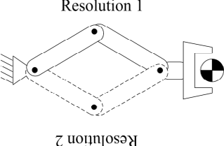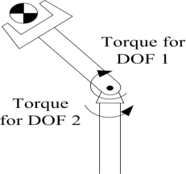

(a) (b)

Fig. 1. Limitations of Current Computational Studies on EVAs

In fact, these limitations can be solved by only one method: torques can be viewed as constrains among different bodies in the system, while relationships between bodies can be viewed as behaviors of bodies.

In next section, a novel method for M&S of the motions of astronauts during EVA is discussed in details. Then in section 3, some applications on preparations for space station mission are introduced, in order to show how to use the method. At last, discussion and recommendation for future work are presented respectively.

# Method

The method includes three parts: basic model, the whole system model, and torque model for space suit.

* 1. *Framework and Fundamental*

A tree structure configuration of the suited astronaut with links and joints is shown in Fig. 2, which is designed on the base of an improved Hanavan model [12]. The head and the backpack are isolated bodies in the configuration although there are zero DOF between them and the torso for the reason that if the three bodies are combined as one part, some characters about the inertia tensor will be left out. And in order to describe motion of the whole body in the reference frame, there is a 6 DOFs joint (J11) between the torso and the environment (L00) which is the so- 

recognize clearly on the right of Fig. 2.

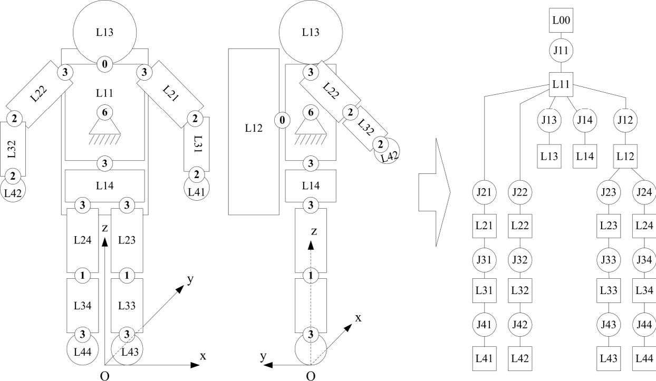

Fig. 2. Configuration of the Suited Astronaut

The Newton-Euler model is chosen as the fundamental for the study, because it need not induce additional variables, and all of the models can be created on vector mechanics.

* 1. *A Coupled Forward-Inverse Dynamics Model for System*

There are two basic ways to construct dynamics model of the motion: forward and dynamics. In forward dynamics, a set of joint forces/torques is given to determine the motions of joints and limbs; while in inverse dynamics, a set of joint motions is given to determine the joint forces/torques to create the motions [12].

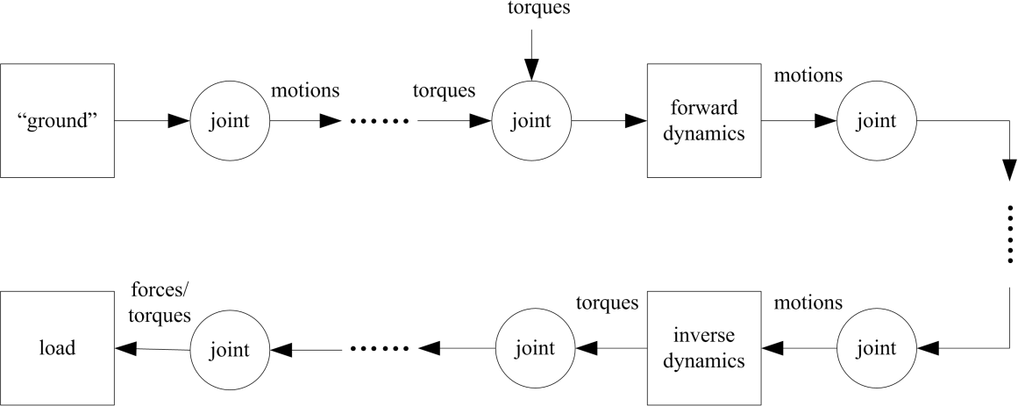

Fig. 3. A coupled Forward-Inverse Dynamics Model

In practice, the types of given information for different parts of the astronaut are different, for example, it may be easy to the force on the hand but difficult to catch its motion, while for the elbow, it is easy to get its angle but difficult to have the torque on it. Therefore a method is formulated by integrating forward and inverse dynamics in one framework, as shown in Fig. 3. There are two types of elements in the model: the link

point. The link is a transducer with forward or inverse dynamics, which has a united formation defined in Eq. (1):

*L = <ID, CG, m, IT, SP, SZ, PoJ, * *, MT > (1)*

Where, *ID* is the name of the link to identify with others, *CG* is the center of gravity, *m* is the mass, *IT* is the inertia tensor, *SP* is an enumerative value describing the shape of the limb, *SZ* describes the size of the limb, *PoJ* is a subset for describing the joints connected to the link,  is a subset of torques/forces on the link, and *MT* is also a subset for describing the motion of the limb with position, velocity, acceleration, etc.

The joint is a connector to pass motions and forces/torques, which also has a united formation defined in Eq. (2):

*J = <ID, DOF, B, F, P, O, R, M, * *> (2)*

Where, *ID* is the name of the joint, *DOF* is the degree of freedoms of the joint, *B* is the base link of the joint, *F* is the follower link of the joint, *P* is the position, *O* is the orientation, *R* describes the range of every DOF, *M* is a subset for describing the motion of the joint with angle, angular velocity, angular acceleration, etc., and  is the torques/forces on the joint, which has two parts:

 *= p + a (3)*

Where, *p* is the passive torques/forces exerting on the joint, which will be discussed in the following section, and *a* is the active torques/forces generated by the astronaut.

With the united models of links and joint, it is simply to get the motions and forces/torques of every element, as well as calculate the information of the whole suited astronaut dynamically.

* 1. *A Sensor-Actor Model for Joint Torque of Space Suit*

It had been shown that the torque-angle characteristics of space suit joints are hysteretic [13], or non-linear

[14], i. e. the output torques depends on both the current value and the history of the input angles:

 *= f* ( *, h*) *(4)*

Where *h* is the history of the angle . In fact, torques generated by space suit passively depends not only on the history of the input, but many information about the joint. If there are one more DOFs on the joint, torques in different orientations will affect each other. And the angular velocity will affect the torque too. So the torque generated by space suit is:

*f* (,

*h* , ,{})

*(5)*

Where  is the angle on different DOF. For the number of DOFs in the joints of the suited astronaut is less than four (as shown in Fig. 2), the models of joints with different DOFs are shown in Fig. 4: 1 DOF in (a), 2 DOFs in (b), 3 DOFs in (c). In the models, the sensor to get the motions of the joint and the actor to exert torques on the joint are included as basic elements, and between them there is a computational element with the function in Eq. (5). The memorizers are included in the computational element to restore the history of the angle. A set of weighted sum functions is used for Eq. (5), and the values of weights *qi*,*j* can be got from physical experiments.

*q n q *  *q * *q*



 if  0

*f* (,

*h* , ,{})

1,1

*q*2,1

*j* 1

*q*2,2 

1,( *j *1) *j*

1,( *j n* 1) 1,( *j n* 2)

if  0

*(6)*

*q n q *  *q * *q*



 if  0

3,1

*j* 1 3,( *j *1) *j*

3,( *j n* 1) 3,( *j n* 2)

Where *n* is the number of the memorizers.

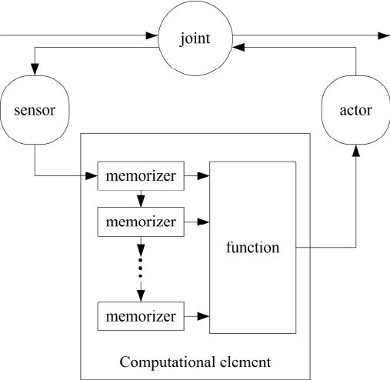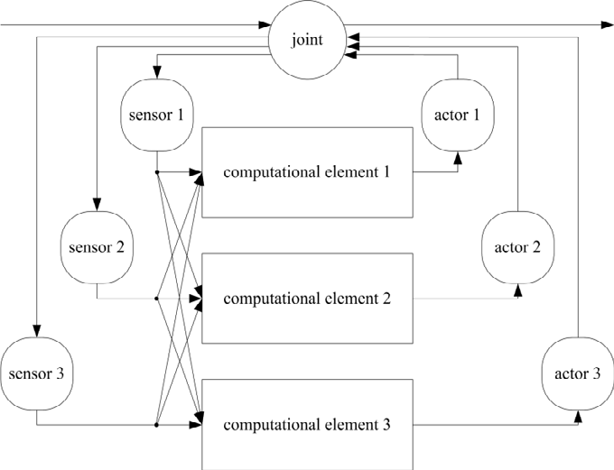

(a) (b)

Fig. 4. A Sensor-Actor Model for the Joint Torque

* 1. *Summary*

The process of the method can be divided into four steps:

1. Set the geometric and physical parameters for every link and joint according to the tree structure configuration;
2. Construct the sensor-actor model for every joint, set every weight *qi*,*j*, and choose adequate *n* for the history;
3. 
4. Analysis dynamics of links and joints one in turn by using the Coupled Forward-Inverse Dynamics Model. Then the resolutions we are interested can get from step 4, such as the position of a selected link.

Furthermore, with these resolutions we can calculate all the information for the whole system even output them to a graphical model for 3D animation.

# Applications

Examples of the astronaut pulling a load under different constrain conditions are introduced for the simpleness and typicality in order to demonstrate the applications of the method.

* 1. *Task Introduction*

During the task, the astronaut pulls the handle by his left hand to move a load in direction to himself. There are three constrain conditions in the task which is typical for almost all of the EVA operations. The first is operating without constrain as shown in Fig. 5 (a); it is common for many primary EVAs because the tether for security seems never frapped. The second is working with the feet constrained, as shown in Fig. 5 (b). For more and more complex EVA tasks, the portable foot restraint is used commonly. The third is operating on a suspension which is designed for emplace the space suit on the ground. There are several rigid connections between the suspension and the backpack, which means only the left arm can move during the operation.

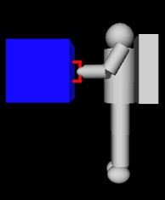 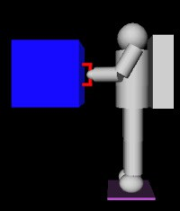 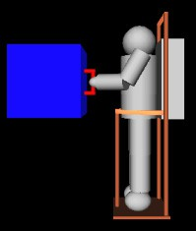

* + 1. (b) (c) Fig. 5. Examples of the Astronaut Pulling a Load
  1. *Modeling and Simulation*

It is very easy to model the system on the base of the configuration present in section 2.1. For the first condition, the model can be got only by connecting a link to L41 by a 3 DOFs joint. For the second condition,

which is shown in Fig. 6 (a). And for the third condition, the model can be got by deleting more than half of the basic configuration as shown in Fig. 6 (b), for it is not necessary to analyze the parts of the body except the left arm.

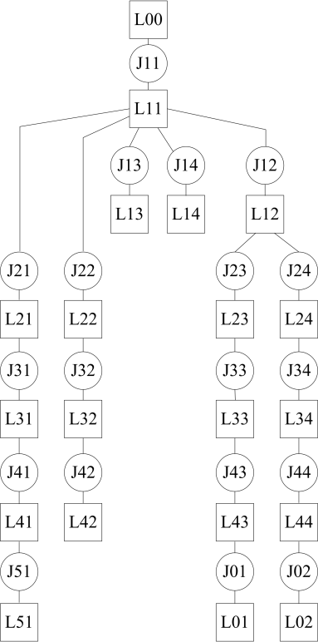 

(a) (b)

Fig. 6. Configuration with Feet Constrained and Backpack Constrained

A prismatic joint model is used to restrain the motion of the load, so the load can be moved only along the rod, which keeps the output force from the suited astronaut simple.

Then the simulation experiments can be carried out following the steps listed in section 2.4. And the simulations will be repeated several times for choosing different parameters.

* 1. *Results and Demonstration*

Some result trajectories and animations for the first condition (i.e. the astronaut is operating without constrain) are shown in Fig. 7 for demonstration. On the left, the torque at the elbow is selected to be shown,

operation are shown the right.

* 1. *Conclusion*

By comparing the trajectories of torques and observing the animations from the simulations, some conclusions can be drawn as follows:

 When moving the same load, the torque without constrain is the biggest, while the torque with backpack constrain is the smallest.

   e in order to make the center of gravity of the body lie on the extend line of the output force. For example, the lower limbs bend to move the center of gravity up.

 When operating with constrain on the feet, it will be easier for the astronaut, because the counterforce get from the foot restrain which is used commonly for many EVAs.

 The most ideal condition is setting constrain on the backpack, for it is the heaviest part in the whole system.

However, it is very difficult for most EVAs to exert constrain on the backpack.

These conclusions will be the guidelines for designing the EVAs, and many quantitative indexes can be drawn from data and the simulations in order to get optimized plans.

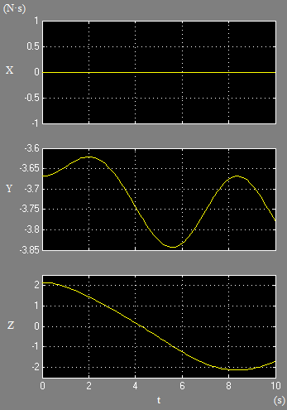 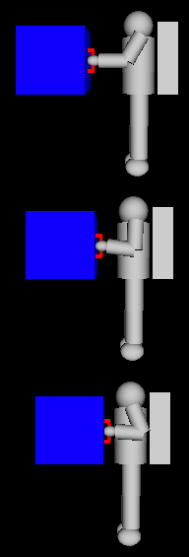

Fig. 7. Result Trajectories and Animation for Demonstration

# Discussion and Future Work

The method introduced in the paper is based on complex system theories, in which the suited astronaut is divided into many subsystems, and then organizes the system model according a tree structure configuration. Then the coupled forward-inverse dynamics model is used to avoid indeterminations of limbs; and the sensor- actor model is used for modeling the torques generated by the space suit in three dimensions space. With the method, we can analyze more complex EVAs to be implemented in the future. But there are still many limitations in the method:

 Functions with higher accuracy are needed for calculating the torques of the space suit.  Models of the torques/forces generated by the astronaut are needed for the method.

 Some joints such as the wrist and waist are more complex than those used in the models, which need to be rebuilt according to their physical characters.

Future work will be focused on these problems. Furthermore, both the method and its applications need to be certified by data got from ground physical experiments even from actual missions including EVAs.

# Acknowledgements

This study was supported by the National Basic Research Program of China (973 Program) (No.

2011CB711005).

# References

1. Nicole C. Jordan, Joseph H. Salch, Dava J. Newman. The Extravehicular Mobility Unit: A Review of Environment, Requirements, and Design Changes in the US Spacesuit. Acta Astronautica 59 (2006) 1135- 1145.
2. Pierre J. Thuot and Gregory J. Harbaugh. Extravehicular Activity Training and Hardware Design Consideration. Acta Astronautica. Vol. 36, No. 1, 1995.
3. 

Massachusetts Institute of Technology, June 1995.

1. Jason R. Norcross et al. Characterization of Partial-Gravity Analog Environments for Extravehicular Activity Suit Testing. NASA/TM-2010-216139, December 2010.
2. Norman I. Badler et al. Dynamic Simulation for Zero-Gravity Activities. International Space Human Factors Workshop, June 1999.
3. Man-Systems Integration Standards (NASA-STD-3000), Revision B. NASA, Washington, DC, July 1995.
4. Jeff Dutton. Extravehicular Activity Hardware for International Space Station. Journal of Aerospace Engineering, April 1997.
5. Grant Schaffner and Dava J. Newman. Computational Simulation of Extravehicular Activity Dynamics During a Satellite Capture Attempt. J. GUIDANCE. Vol. 23, No. 2, June 1999.
6. Dava J. Newman and Grant Schaffner. Computational Dynamic Analysis of Extravehicular Activity: Large-Mass Handling. Journal of Spacecraft and Rockets. Vol. 35, No. 2, March-April 1998.
7. G. Schaffner, D. J. Newman. Inverse Dynamic Simulation and Computer Animation of Extravehicular Activity (EVA). AIAA, Aerospace Sciences Meeting & Exhibit, 35th, Reno, NV, January, 1997.
8. Patricia Barrett Schmidt. An Investigation of Space Suit Mobility with Applications to EVA Operations. Doctorial Dissertation, Massachusetts Institute of Technology, September 2001.
9. Leia Abigail Stirling. Development of Astronaut Reorientation Methods: A Computational and Experimental Study. Doctorial Dissertation, Massachusetts Institute of Technology, June 2008.
10. David B. Rahn. A Dynamic Model of the Extravehicular Mobility Unit (EMU): Human Performance

 of Technology, June 1997.

1. Christopher E. Carr, Dava J. Newman. Characterization of a Lower-body Exoskeleton for Simulation of Space-suited Locomotion. Acta Astronautica 62 (2008) 308-323.