[Array 8 (2020) 100044](https://doi.org/10.1016/j.array.2020.100044)

 

Contents lists available at [ScienceDirect](http://www.sciencedirect.com/science/journal/25900056)

Array

journal homepage: [www.elsevier.com/journals/array/2590-0056/open-access-journal](http://www.elsevier.com/journals/array/2590-0056/open-access-journal)

Multi-area economic dispatch with stochastic wind power using Salp Swarm Algorithm☆

Vishal Chaudhary a, Hari Mohan Dubey a, Manjaree Pandit a, Jagdish Chand Bansal b,*

a *Department of Electrical Engineering, M.I.T.S., Gwalior, India*

b *Department of Mathematics, South Asian University, New Delhi, India*

A R T I C L E I N F O

*Keywords:*

Salp Swarm Algorithm

Multi-area economic dispatch Ramp rate limits

Valve point loading effects Prohibited operating zones Wind-thermal system

A B S T R A C T

Salp Swarm Algorithm (SSA) is a newly developed swarm intelligence based optimization method. Its analytical model mimics self-organized swarming and foraging behavior of salps. Salps are found in the ocean and they form a swarm called *salp chain* for their organized movement and foraging. Since its inception in 2017, SSA has been applied to many engineering domains. This paper presents the solution of complex constrained multi-area eco- nomic dispatch problem of power system with and without stochastic wind integration using SSA. Simulation analysis has been carried on four different constrained test cases with diverse dimensions/complexity level. They are (i) four area system with sixteen thermal units (ii) four area system with forty thermal units (iii) two area system with forty thermal units and (iv) two area forty-unit system with wind integration. Comparison of simulation results obtained by SSA with other methods reported in the recent literature has proven SSA’s capability of constrained handling and offered promising and efficient solutions.

1. Introduction

Due to rising complexity and the size of real-world optimization problems Bio-inspired optimization approaches became very popular in past decade among researchers of almost all application domains. The Bio-inspired optimization techniques are stochastic in nature and they apply randomness for searching the solution. The randomness helps in the development of a gradient-free search mechanism. Most of these optimization techniques are inspired by natural phenomena and they can be grouped either based on evolution, collective behaviour (swarm- based), ecological phenomenon, physical science. These algorithms have proven their great potential to deal with real-world optimization prob- lems. The classification of Bio-inspired optimization methods is pre- sented in Fig. 1.

Evolution based algorithm utilises the concept of natural evolution such as reproduction, mutation, recombination and selection. Some of the popular optimization method in this category are genetic algorithms (GA) [1], differential evolution (DE) [2] and backtracking search algo- rithm(BSA) [3].

In fact among bio-inspired optimization methods swarm intelligence

based optimization approaches are quite popular and efficient. The key features of swarm intelligence (SI) based algorithms are self-organization and division of work to achieve a given task. For Example, Particle swarm optimization (PSO) [4] simulates biological behaviour of fish schooling and bird flocking, artificial bee colony (ABC) [5] optimization simulates collective foraging behaviour of honey bees, whale optimization algo- rithm (WOA) [6] follows behaviour of humpback whales, grasshopper optimization (GOA) [7] follows their unique swarming behaviour, spider monkey optimization(SMO) [8] mimics the fission-fusion social structure of spider monkeys, grey wolf optimizer (GWO) [9] mimics the hunting behaviour and social leadership of grey wolf, TLBO [10] models the ef- fect of the influence of a teacher on the output of students in the class- room and many others.

The next class of bio-inspired optimization methods belongs to opti- mization methods inspired by the concept of physical Sciences. The most popular and efficient optimization methods in this class are simulated annealing (SA) [11] inspired by annealing process of metal, Harmony search (HS) [12] follows the concept of jazz’s improvisation process and then the search of the perfect state of harmony by musician, Gravitation search algorithm(GSA) [13] utilises the concept of Newton’s law of gravitation and laws of motion, chemical reaction optimization (CRO)

☆ The editorial process for this manuscript was handled independently from the Author of this article who is also a member of the editorial board. The editor was blinded from the process and the manuscript was subject to the Journal's usual peer review process.

* Corresponding author.

*E-mail addresses:* [vishal.chaudhary30@gmail.com](mailto:vishal.chaudhary30@gmail.com) (V. Chaudhary), [harimohandubeymits@gmail.com](mailto:harimohandubeymits@gmail.com) (H.M. Dubey), [drmanjareep@gmail.com](mailto:drmanjareep@gmail.com) (M. Pandit), [jcbansal@sau.ac.in](mailto:jcbansal@sau.ac.in) (J.C. Bansal).

<https://doi.org/10.1016/j.array.2020.100044>

Received 9 April 2020; Received in revised form 23 July 2020; Accepted 31 August 2020

Available online 11 September 2020

2590-0056/© 2020 The Authors. Published by Elsevier Inc. This is an open access article under the CC BY license (<http://creativecommons.org/licenses/by/4.0/>).



Nomenclature

*fij* (*Pij*)

*N*

*Mt*

*nij*

fuel cost of *jth* thermal unit in *ith*area number of area

Number of thermal power generator Fuel cost Coefficients

*jth*poz of generating unit for*ith* area

*Pu lim* ,*Pl lim* upper and lower limits of (*m* — 1)*th*and *mth*POZ

*ij*;*m*—1 *ij*;*m*

*m*

*P*0

*ij*

*Pwr*

numbers of POZs of *jth* unit in area*i*

Previous hour output by*jth*power generating unit rated wind power

*Pwav*;*ij fwij*(P *ij*) *bw*

*Mw*

V

*c k*

*CDF*

PDF

V *in*

V *out*

V *r*

*ij ij*

*URij*; *DRij PDi*

T *il*

U*b*; L*b*

*Pmin* ; *Pmax* upper and lower limits of thermal generators

*Pwij* ; *Pwij*

F*S*

*w*0

P

P *sij*

*min max*

F *Cost*

available power of *jth* wind generator in *ith*area Cost of *jth* wind generator in *ith* area

Direct cost coefficient of wind generator Number of wind power generator

wind speed (m/sec) shape factor

scale factor

cumulative distribution function probability density function

cut in speed cut out speed

rated wind speed

upper and lower limits of wind generators position of food source

initial speed

wind Power at any time

scheduled power of *jth*wind generator in *ith*area

*t*

up and down ramping rate limits active power demand in area *i*

tie-line power flow from area *i*to *l*

upper and lower limits

total Operating Cost

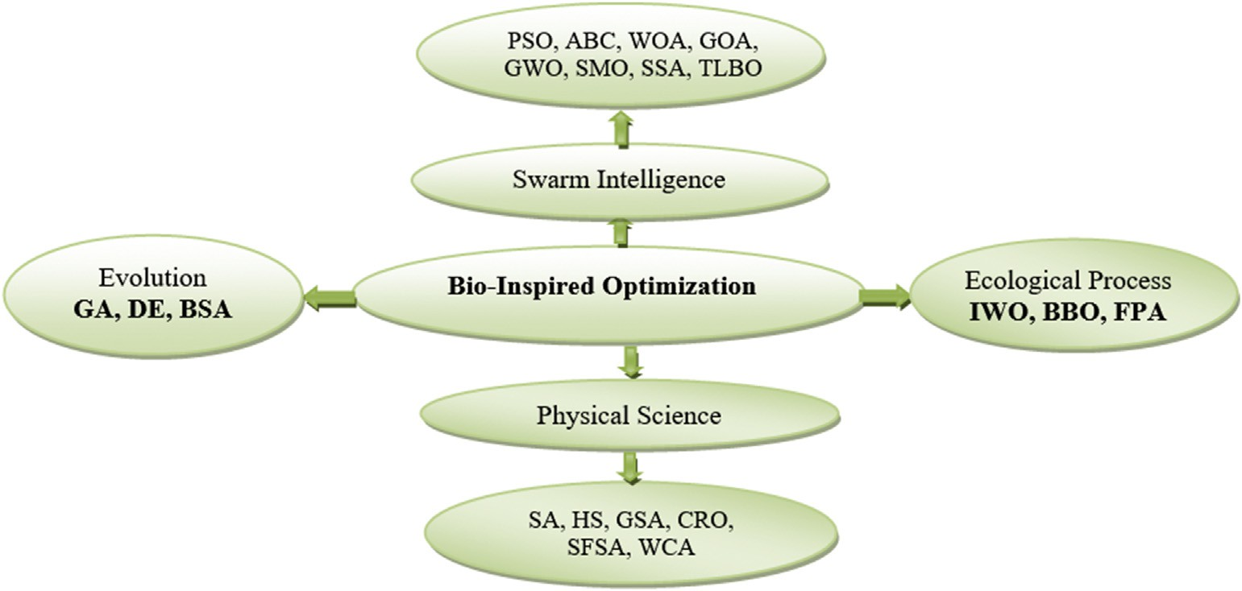

Fig. 1. Classification of Bio-inspired optimization methods.

[14] utilises the concept how molecules interact with each other through the sequence of reaction and are finally converted to state of minimum energy, stochastic fractal search algorithm(SFSA) [15] imitates the nat- ural phenomenon of growth and utilises process based on random frac- tals, water cycle algorithm(WCA) [16] is inspired by nature and based on the observation of hydrologic cycle, how rivers and water streams flow to the sea.

Invasive weed optimization (IWO) [17] is inspired from weed colo- nization, Biogeography based optimization(BBO) [18] follows the concept of migration of species among different habitats, Flower polli- nation algorithm (FPA) [19] simulate pollination process of the flowering plant. These are the popular algorithms that belong to the family of ecological process-based optimization.

A detailed review and applications of bio-inspired techniques for the solution of different types of constrained complex practical optimization problems can be found in Ref. [20–24]. These include applications related to medical science, job shop scheduling, image processing, parameter estimation, power, and energy. Economic dispatch (ED) is one of the most complex constrained optimization problems of the integrated power system [25]. The main aim of ED is to allocate the power demand among the committed generator units in the most economical manner

while satisfying all the physical and operational constraints. The practical ED problem is highly non-linear and non-convex with multiple minima due to practical operational constraints like valve point loading (VPL) effects, discontinuous due to prohibited operating zones (POZ) and ramp rate limits (RRL). Over the past decades various single area ED problems considering VPL effect [26–31], RRL [27,30,32,33] and POZ [32,34](#_bookmark62)–[36] were solved without considering transmission constraints.

However, many utilities have their own limitations for power flows among different areas/regions over transmission lines. Every area/region has its own load pattern and power generation characteristics. Multi-area economic dispatch (MAED) is an extension of ED, where the objective is to calculate power generation as well as the exchange of power between different areas at minimum cost while satisfying additional power transmission capacity constraints along with all equality and inequality constraints associated with ED problems. Due to the additional trans- mission line power flow limit constraints, MAED problem becomes more complex to solve. Therefore, for the solution of such a complex con- strained optimization problem a latest and efficient bio-inspired opti- mization approach is required.

Various bio-inspired optimization algorithms were reported in the literature for the solution of MAED problems [37–50]. The solution of a

single objective MAED problem with different dimension and complexity levels are found in Ref. [37–47]. They are harmony search (HS) [37,38], differential evolution(DE) [39], artificial bee colony (ABC) [40], flower pollination algorithm(FPA) [42], particle swarm optimization (PSO) [44], hybrid cuckoo search algorithm(HCSA) [45], hybrid differential evolution based PSO (DEPSO) [41] and moth-flame optimization(MFO) [43]. Considering clean air policy and global warming concept, solution of multi-objective MAED problems are also presented using PSO [48], chaotic artificial bee colony (CABC) [49] and improved Jaya algorithm (IJA) [50].

In the present scenario, the Integration of wind and solar energy among renewable energy resources is gaining wide acceptance due to their emission-free low-cost operation. However, as wind speed is un- certain therefore, uncertainty associated with wind power is incorpo- rated in objective function using a mathematical model called probabilistic density function (pdf). Out of many pdf models, Weibull distribution [21,51,52], beta distribution [53] and gamma distribution

[54] are used by researchers to calculate cost due to random wind power. The effect of large wind power integration in MAED problems is investigated for a combined wind-thermal system for Taiwan power system using a direct search approach (DSA) in Ref. [55], where 52 unit

thermal systems were used with cost function as a second-order poly-

Practically due to VPL effects ripples are introduced in the cost function, which can be modelled by adding rectified sine function in it, and represented as:





(3)

* 1. *Wind power modeling*’

Wind power is a stochastic variable due to uncertain wind speed. Therefore power generation by wind farm includes three types of costs:

(i) direct cost, (ii) overestimation cost/reserve cost which is included due to deficit in wind power and (iii) the underestimation cost/penalty cost which is taken into account due to more wind power generation than the scheduled power [21,51–56]. Therefore the cost of *jth* wind generator in *ith*area can be represented as

}

*fwij* P *ij* = *bw*;*ij* × P *ij* + *kp Pwav*;*ij* — P *sij* + *kr* P *sij* — *Pwav*;*ij* (4) Reserve cost/overestimation cost of wind power is represented as:

0

nomial in nature. Using all complexity of practical thermal generator unit as VPL, RRL and POZ, the impact of wind integration was analyzed using

*kr* P *sij* —

*Pwav*;*ij*

= *kr* ×

Z P *sij*

P *sij* — P *ij*

*fw*(P )*d*P

(5)

the backtracking search algorithm (BSA) in Refs. [56].

Even though various optimization techniques are proposed for the solution of MAED problems, according to No Free Lunch Theorem [57], none of the algorithms can guarantee to solve all optimization problems. There is always a chance of improvement; keeping that in mind, this paper presents the Salp Swarm Algorithm (SSA) for the solution of MAED

as:

The penalty cost/underestimation cost of wind power is represented

 (6)



Here Weibull probability density function (PDF) is used for wind

problem.

Application of a novel swarm intelligence based SSA algorithm for the

speed distribution as the wind speed is uncertain and irregular.

solution of MAED problems is the significant and major contribution of

*f v k c*

*k*

*v* *k*—1

exp

*v* *k* (7)

this paper. The paper also presents Weibull pdf model for the calculation of wind power. In order to validate the performance of SSA over MAED problem, four cases with different dimensions and complexity levels which possess non-linear, multimodal, non-convex, discontinuous and probabilistic modal due to wind integration are evaluated. The obtained results using SSA are also compared with recently reported results in the

literature.

( ; ; )= *c* × *c* × — *c*

The corresponding cumulative distribution function (CDF) can be represented as:

*F v*; *k*; *c* 1 exp *v* *k* (8)

(

)=

—

—

*c*

Rest of the paper is organized as follows: formulation of the problem that combines the concept behind MAED, wind power modeling and the related constraints are described in section 2. Section 3 presents the concept behind the SSA, its foraging behavior using an analytical model and implementation procedure for the solution of MAED problem. Description of test cases, effect of control parameters, simulation results and their discussion are presented in section 4. Finally, conclusions are drawn in section 5.

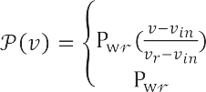

For each wind power generating unit, the power output at given wing speed can be expressed as [21,51]:



 (9)



Probability of wind power is 0 to  can be calculated as below:

1. Problem formulation

*fw*(P

) {P

= 0} =

1 — *exp* —

*vin* *k*

*c*

*exp*

*vout* *k* (10)

The key objective of MAED problem is to minimize total operating cost in all areas in such a manner that it will satisfy all operational constraints associated with it, i.e. power balance, minimum and maximum power generation limits, RRL, POZ and area wise capacity constraints of tie-line/transmission line.

*c*

+

—

The objective function of MAED problem with wind integration can be expressed as:

Wind power in the range *vin* < *v* < *vr* is given by:





(11)

Minimize F *Cost* =

*t*

X*N* " X*Mt*

*fij* *Pij*

*Mw*

+ *fwij* P *ij*

X

#

(1)

(12)

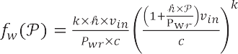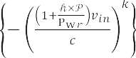

*i*=1



*j*=1

*j*=1

(13)

The fuel cost function of *jth* thermal power generating unit in *ith* area can be represented as:



*fij* *Pij* = *aijP*2 + *bijPij* + *cij* (2)

*ij*

(14)

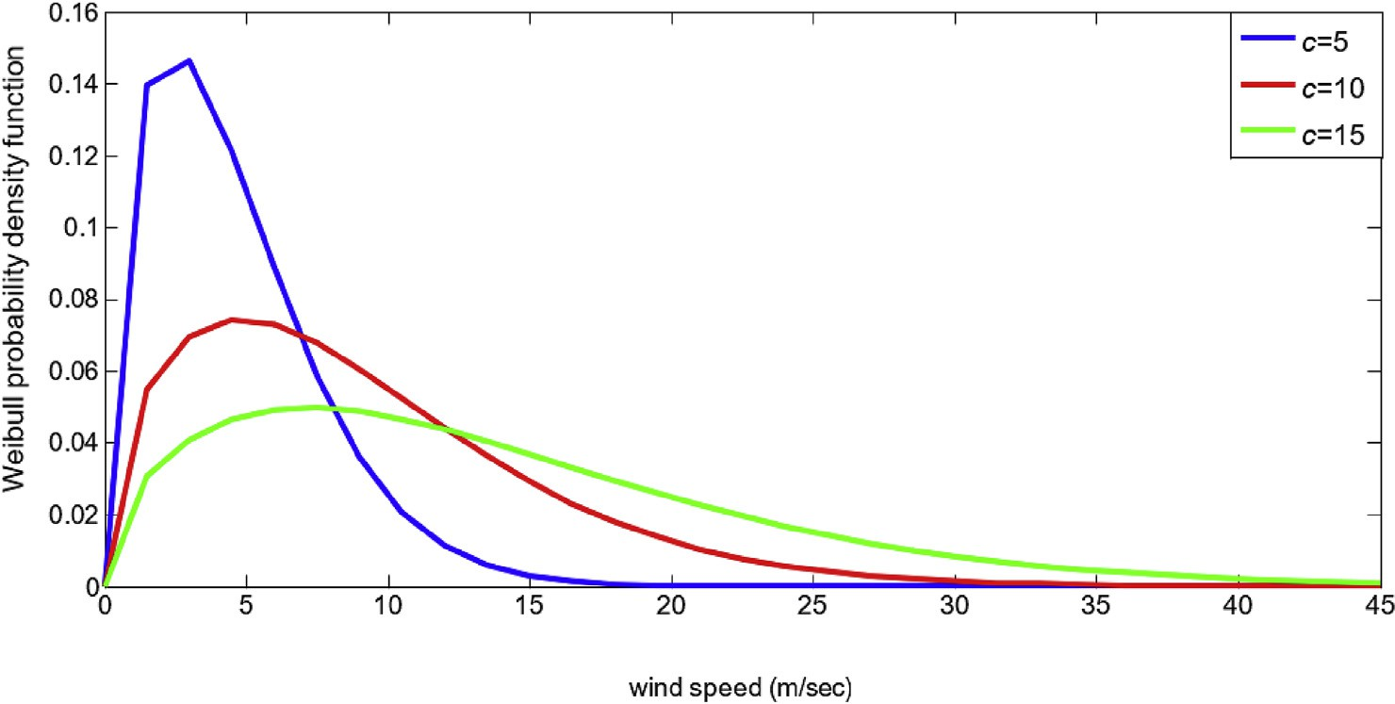

Fig. 2. Weibull Probability density function for *k*=1.5 and *c*=5, 10 and 15.

—T *max* ≤ T *il* ≤ T *max*

(20)

A typical Weibull PDF with shape factor 1.5 and scale factor *c*of 5, 10, *il il*

and 15 is shown in Fig. 2.

The total cost F *Cost* given in (1) is minimized subject to following operational constraints:

*t*

* 1. *Area wise power balance*

It needs to satisfy power balance in each area, neglecting transmission loss it can be represented as:

*Mt Mw*

*Pij* + P *ij* = *PDi* + T *il* ; *i* ∈ *N* (15)

1. Salp swarm algorithm

Salp Swarm Algorithm (SSA) is a recent bio-inspired optimization technique [58], inspired by navigation and foraging behaviour of salp chain, generally found in deep oceans. In its mathematical model, salp population is divided into two groups called leader and followers. The best salp (best solution) is considered as the food source to be followed by the salp chain. After every iteration, the leader salp changes its position with respect to the food sources. The leader explores and exploits the search space around the best solution and the follower salps move

*j*=1

X X X

*j*=1

*l*;*l*/=*i*

gradually towards the leader. This process helps salps in converging to the global optima quickly while preventing from being trapped in local

* 1. *Power generation limit*

*Pmin* ≤ *Pij* ≤ *Pmax*

*ij ij*

(16)

optima. Fig. 3 depicts the salp chain. The front salp of the chain is called leader while other salps of the chain are called followers. The leader salp guides the follower salps.

The salp locations are defined in the *n*-dimensional search space.

Where *n*is the number of decision variables in the problem.

*Pmin* ≤ P *ij* ≤ *Pmax*

(17)

Let us assume there is a food source F*S*in the search space as swarm’s

*wij*

*wij*

target. As per the location of the food source, leader updates its position

* 1. *Ramp rate limits of the generator*

For RRL consideration, (16) can be modified and written as below

using the equation (21) as below:

*x*1 = F*Sj* + *C*1 × U*bj* — L*bj* *C*2 + L*bj* ; *C*3 ≥ 0

*j*

F*Sj* — *C*1 ×

U*bj* — L*bj* *C*2 + L*bj* ; *C*3 < 0

(21)

[39]:

*Max* *Pmin*; *P*0 — *DRij* ≤ *Pij* ≤ *Min* *Pmax*; *P*0 + *URij* (18)

*ij*

*ij*

*ij*

*ij*

* 1. *Prohibited operating zones*

Due to some physical limitations of generating units, their operations are restricted in specified operating zones and it makes input-output characteristics discontinuous in nature. It can be represented as below [39]:

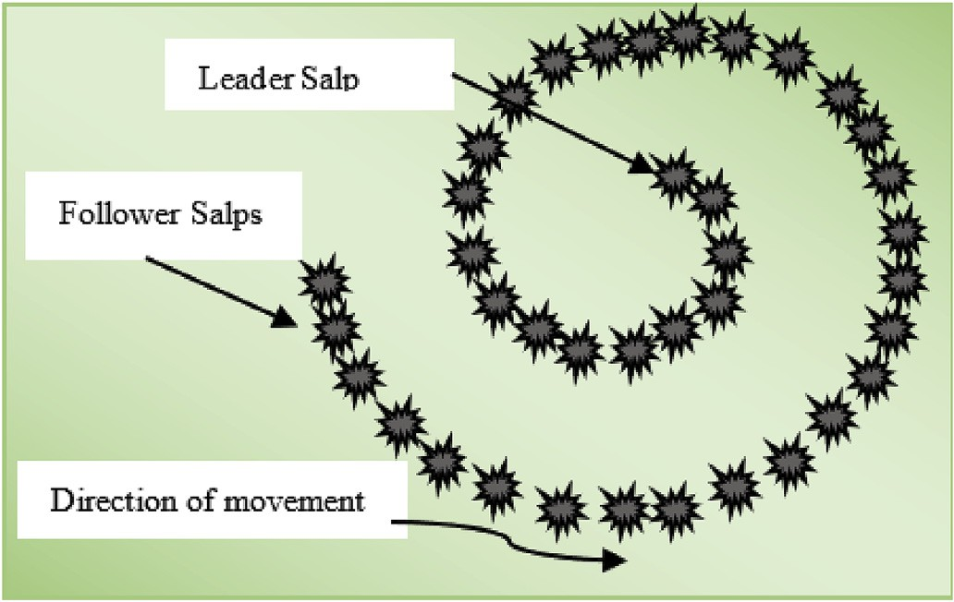*Pmin* ≤ *Pij* ≤ *Pl lim*

The balance between exploration and exploitation during optimiza- tion is maintained by coefficient *C*1defined as:

*ij ij*;1

*Pu lim* ≤ *Pij* ≤ *Pl lim*

; *m* = 2; 3; —— —*nij*

(19)

*ij*;*m*—1 *ij*;*m*

*Pu lim* ≤ *Pij* ≤ *Pmax*

*ij*;*nij ij*

* 1. *Tie-line limits*

The real power flow over the transmission line (T *il*) form area *i*to *k*must remain within the maximum (T *max*) and minimum ( — T *max*)

*il il*

operating limits of the tie line [40,41]:

Fig. 3. Salp chain in nature.

2 In SSA, followers update their positions as per Newton’s law of mo-

—

4×*iter c iter max*

*C*1 = 2 × *e*

(22)

tion [58]:

Here, *iter c*stands for the current iteration number and *iter max* is

*xi* = 1 *αt*2 + *w t*; *i* ≥ 2 (23)

the maximum number of iterations allowed, *C* and*C* are the uniformly 2 0

*j*

2 3

distributed random numbers in the interval [0, 1].

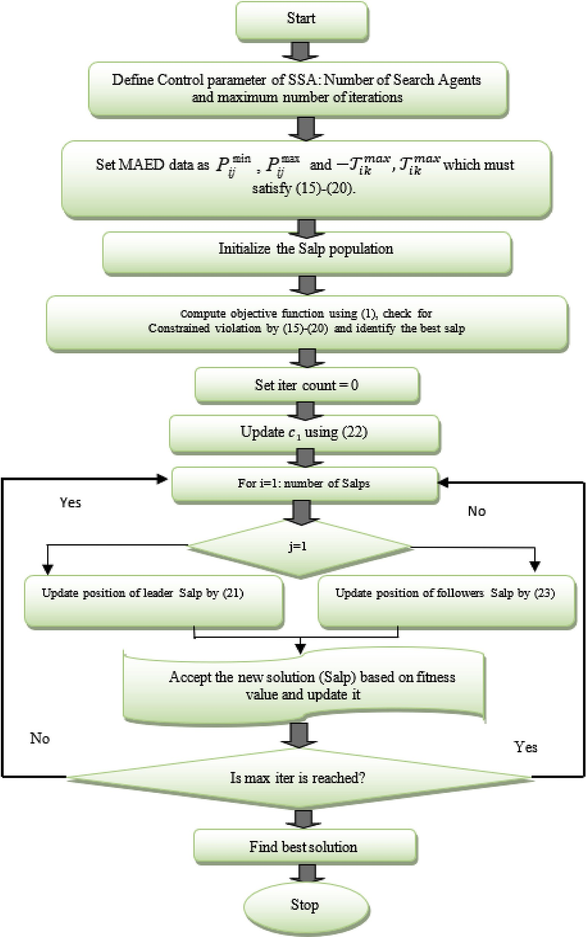

Fig. 4. Flowchart for the solution of MAED problem using SSA.

Where; *α* = *wfinal*

*w*0

and *w* = *x* — *x*0

*t*

Considering, *w*0

(24)

(25)

= 0and since the difference between any two

Table 1

Optimal generation scheduling for four area system with sixteen units (Test case I).

consecutive time steps is 1, therefore

|  |  |  |  |  |  |
| --- | --- | --- | --- | --- | --- |
| Output (MW) |  | IHS [38] | HSLSO [41] | MFO [43] | SSA |
| Area1 | P11 | 149.9997 | 150 | 150 | 150 |
|  | P12 | 99.9985 | 100 | 100 | 100 |
|  | P13 | 66.1206 | 67.3848 | 67.008 | 67.0081 |
|  | P14 | 99.9964 | 100 | 100 | 100 |
| Area2 | P21 | 56.9908 | 57.0625 | 57.0081 | 57.0081 |
|  | P22 | 96.2944 | 96.1749 | 96.2603 | 96.2602 |
|  | P23 | 41.6731 | 41.8472 | 41.8802 | 41.8801 |
|  | P24 | 72.459 | 72.4505 | 72.507 | 72.5068 |
| Area3 | P31 | 50.0009 | 50 | 50 | 50 |
|  | P32 | 36.4301 | 36.3190 | 36.2534 | 36.2534 |
|  | P33 | 37.647 | 38.5911 | 38.5042 | 38.5041 |
|  | P34 | 38.1545 | 37.3719 | 37.3108 | 37.3108 |
| Area4 | P41 | 149.9998 | 150 | 150 | 150 |
|  | P42 | 99.9984 | 100 | 100 | 100 |
|  | P43 | 57.7173 | 56.9272 | 57.0079 | 57.0082 |
|  | P44 | 96.5195 | 95.8709 | 96.2601 | 96.2602 |
| Tie Line Power | T1,2 | 0.004 | 0 | 0 | 0 |

*xi* 1 *xi* + *xi*—1 ; *i* ≥ 2 (26)

*j* = 2 ×

*j*

*j*

The MAED problem given in section 2 is solved using above explained SSA algorithm. The implementation process of SSA to solve MAED problems is depicted with the help of flowchart given in Fig. 4.

1. Description of test cases and simulation results

The performance of SSA is evaluated and validated on four standard test cases of MAED problems with different dimensions and complexity levels. SSA has been implemented in MATLAB13 environment and executed on 2.40GHz, i5 processor with 8GB RAM and is simulated over 30 independent runs for all test cases. Description of test cases and the outcome of simulation results obtained by SSA are presented below.

Test Case I: This test case has four areas. Each area consists of four power generating unit systems connected using six tie lines [37]. The fuel cost coefficient data, tie-line power flow limits along with area wise power demands are listed in Table A1. The network topology used in this test case with four areas consisting of sixteen power generating units system is shown in Fig. 5.

The simulation results obtained by SSA in terms of area wise optimum generation scheduling are listed in Table 1 and the comparison of costs with other metaheuristics is summarized in Table 2. The optimum gen- eration cost obtained by SSA is 7337.0139 $/hr. Fig. 6 shows the smooth and stable cost convergence characteristic obtained by SSA.

Test Case II: It is a comparatively large dimension test case with forty power generator units having non-convex fossil fuel cost characteristics with multiple minima. Transmission loss is not considered here. The fuel cost coefficients data and power generation limits are listed in Table A2 as reported in Ref. [26]. The total load demand is set at 10500 MW. Here forty power generating units are segregated in four areas. Each area with ten power generating units shares power demand as 1575MW (15%) in area one, 4200MW (40%) in area two, 3150MW (30%) in area three, and 1575MW (15%) in area four respectively [40].

The tie-line power flow limitations are considered as follows: (i) be- tween area 1 to area 2 or from area 2 to area 1 is 200MW, (ii) between

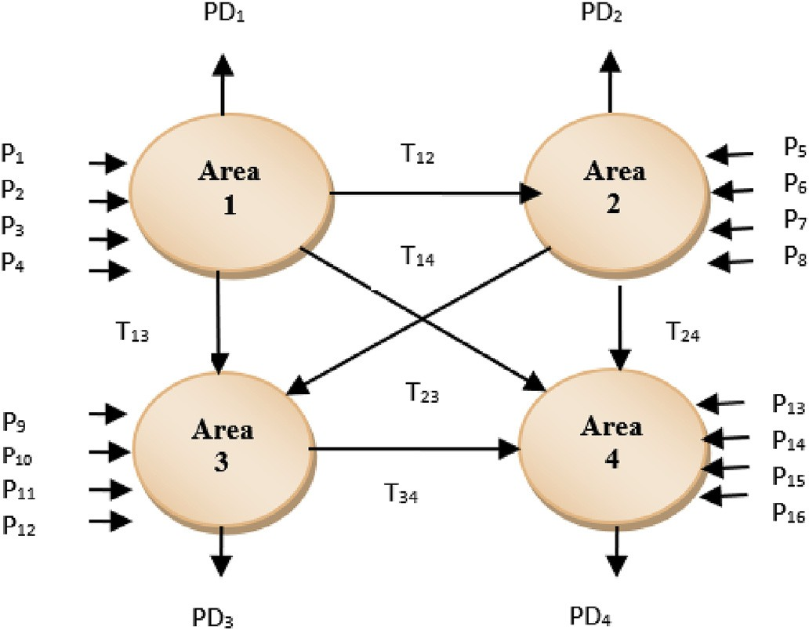

Fig. 5. Four area network with sixteen power generating units.

|  |  |  |  |  |  |
| --- | --- | --- | --- | --- | --- |
| Flow | T3,1 | 16.11 | 17.4643 | 17.9508 | 18.319 |
|  | T3,2 | 71.658 | —0.0795 | —0.9428 | —1.3109 |
|  | T4,1 | 0.004 | 70.2537 | 69.9808 | 69.6127 |
|  | T4,2 | 4.236 | —2.7186 | —2.3252 | —1.9575 |
|  | T4,3 | 99.994 | —100 | —100 | —100 |

*Pg* 1250.000 1250.00 1250.00 1250.00

Cost($/hr) 7337.275 7337.0299 7337.0139 7337.0139

P

Table 2

Comparison of results for four area sixteen unit system (Test case I).

Method Generation cost ($/hr)



|  |  |  |  |  |  |
| --- | --- | --- | --- | --- | --- |
|  | Best | Mean | Worst | SD |  |
| HHS [37] | 7329.85 | 7334.01 | 7337.21 | – |  |
| IFEP [38] | 7337.51 | – | – | – |  |
| IHS [38] | 7337.275 | – | – | – |  |
| HLSO [41] | 7337.024 | 7338.5734 | – | 0.4008 |  |
| IDEPSO4 [41] | 7338.2339 | 7339.9968 | – | 1.7621 |  |
| MFO [43] | 7337.0139 | 7341.2738 | – | 3.5499 |  |
| SSA | 7337.0139 | 7340.6698 | 7344.1745 | 5.544 |  |

|  |  |  |  |  |  |  |  |  |  |  |
| --- | --- | --- | --- | --- | --- | --- | --- | --- | --- | --- |
|  |  |  | |  |  |  |  |  | | |
|  |  |  | |  |  |  |  |  |  |  |
|  |  |  | |  |  |  |  |  |  |  |
|  |  |  | |  |  |  |  |  |  |  |
|  |  |  | |  |  |  |  |  |  |  |
|  |  |  |  |  |  |  |  |  |  |  |
|  |  |  |  |  |  |  |  |

Fig. 6. Convergence characteristic of SSA for four area system with sixteen generating units. (Test Case I).

area 1 to area 3 or from area 3 to area 1 is 200MW, (iii) between area 3 to area 2 or from area 2 and area 3 is 200MW, (iv) between area 4 to area1 or from area1 to area 4 is 100MW,(v) between area 4 to area 2 or from area 2 to area 4 is 100MW and (vi) between area 3 to area 4 or from area 4 to area 3 considered as 100MW.

Here the best cost obtained by SSA is 122471.666 $/hr, the corre- sponding generation schedule is presented in Table 3 and its statistical results are summarized in Table 4. The smooth and stable cost

Table 3

Optimal generation scheduling for four areas forty unit system (Test case II).

|  |  |  |  |  |  |  |  |
| --- | --- | --- | --- | --- | --- | --- | --- |
| Output (MW) | ABCO [40] | FPA [42] | SSA | Power(MW) | ABCO [40] | FPA [42] | SSA |
| P1,1 | 111.102 | 112.6745 | 114 | P3,4 | 542.3424 | 542.271 | 523.2794 |
| P1,2 | 109.9774 | 111.3751 | 114 | P3,5 | 520.2448 | 520.1734 | 523.2794 |
| P1,3 | 100.9238 | 101.6238 | 60 | P3,6 | 533.6389 | 533.5675 | 523.2794 |
| P1,4 | 190 | 190.7 | 179.7331 | P3,7 | 10 | 10 | 10 |
| P1,5 | 96.939 | 97.639 | 97 | P3,8 | 10 | 10 | 10 |
| P1,6 | 96.9675 | 97.6675 | 105.4 | P3,9 | 10 | 10 | 10 |
| P1,7 | 259.695 | 260.395 | 259.5997 | P3,10 | 96.7699 | 96.6985 | 87.8 |
| P1,8 | 276.8725 | 276.7 | 284.5997 | P4,1 | 190 | 190 | 190 |
| P1,9 | 300 | 300.7 | 284.5997 | P4,2 | 168.6841 | 168.7555 | 164.7616 |
| P1,10 | 130.6977 | 130.7 | 130 | P4,3 | 173.6165 | 173.6879 | 159.7331 |
| P2,1 | 245.1007 | 244.4007 | 168.7998 | P4,4 | 186.374 | 186.4454 | 164.7999 |
| P2,2 | 94 | 93.3 | 168.7998 | P4,5 | 200 | 200 | 164.7999 |
| P2,3 | 125 | 124.3 | 304.5196 | P4,6 | 164.957 | 165.0284 | 164.7999 |
| P2,4 | 434.8062 | 434.1062 | 394.2794 | P4,7 | 92.5627 | 92.6341 | 89.1142 |
| P2,5 | 390.6743 | 389.9743 | 394.2794 | P4,8 | 96.9911 | 97.0625 | 89.1142 |
| P2,6 | 395.0043 | 394.3043 | 394.2794 | P4,9 | 109.8153 | 109.8153 | 89.1142 |
| P2,7 | 500 | 499.3 | 489.2794 | P4,10 | 431.4011 | 431.4725 | 511.2794 |
| P2,8 | 500 | 499.3 | 489.2794 | T1,2 | 191.7078 | 198.6246 | 173.925 |
| P2,9 | 530.7889 | 530.0889 | 511.2794 | T3,1 | 6.674 | 6.424 | —7.4764 |
| P2,10 | 514.409 | 513.709 | 511.2794 | T3,2 | 183.1852 | 182.9355 | —112.5164 |
| P3,1 | 527.1989 | 527.1275 | 523.2794 | T4,1 | 86.859 | 87.1918 | —100 |
| P3,2 | 502.0795 | 502.0081 | 523.2794 | T4,2 | 95.3237 | 95.4904 | —100 |
| P3,3 | 530.3657 | 530.2943 | 523.2794 | T4,3 | 57.2192 | 57.219 | 0 |
|  |  |  |  |  | 10500.000 | 10500.000 | 10500.000 |
| Cost($/hr) |  |  |  |  | 124009.4 | 123999.2 | 122471.666 |

PPg

Table 4

Comparison of results for four area forty unit system (Test case II).

Method Generation cost ($/hr) SD

|  |  |  |  |  |
| --- | --- | --- | --- | --- |
|  | Best | Mean | Worst |  |
| RCGA [40] | 129911.8 | – | – | – |
| EP [40] | 124574.5 | – | – | – |
| DE [40] | 124544.1 | – | – | – |
| ABCO [40] | 124009.4 | – | – | – |
| FPA [42] | 123999. 2 | – | – | – |
| CSA [45] | 125719 | 127360 | 128403 | 565.3690 |
| JAYA-TLBO [46] | 121694.4 | – | – | – |
| SSA | 122471.666 | 122572.9690 | 122737.9965 | 88.5323 |

convergence characteristic for a larger test system obtained by SSA is presented in Fig. 7.

Test Case III: It has a two-area system with forty thermal power generating units. Each area consists of twenty generating units, con- nected using a tie line with capacity 1500MW. This test case is much complex and highly nonlinear, multimodal and discontinuous with many local minima as all practical complexities like VPL effects, RRL, and POZ are considered here. The fuel cost coefficient data is taken as in Ref. [39]

and are also listed in Table A3. The total power demand is considered as 10500MW. The area wise power demands are set at 7500MW and 3000MW respectively. The network topology is shown in Fig. 8.

Here the best cost solution obtained by SSA is 124647.0508 $/hr for tie line limit (TLLL) of 1500MW. Fig. 9 depicts the steady and stable cost convergence characteristic of SSA for the two area networks. The opti- mum power generation schedules are listed in Table 5, which shows the potential of SSA to satisfy associated operational constraints for larger and complex test case too and comparison of results in terms of cost with other methods are presented in Table 6.

Test case IV: It is a two area network with combined wind-thermal (WT) system having forty generating units [39]. The WT system is con- structed by replacing three thermal units of Test case III by the wind generators. These thermal units are 27, 28, and 29. The parameter used for wind generators are Weibull scale and shape factor as *c*1 = *c*2 = *c*3 =

15and *k*1 = *k*2 = *k*3 = 1.5.The penalty cost due to underestimation and

overestimation of stochastic wind power is considered as *kp*1 = *kp*2 = *kp*3 = 5, and *kr*1 = *kr*2 = *kr*3 = 5respectively. The cut-in speed(*vin*), cut out speed(*v*0), and rated wind speed (*vr* )are 5 m/s, 15 m/s, and 45 m/s similar to Ref. [51]. The rated wind power of three generators are considered as *Pwr*1 = *Pwr*2 = *Pwr*3 = 110*MW* . For the TLL capacity of 1500MW, the best total cost solution obtained by SSA is 120857.2447

$/hr, out of which the thermal cost is 120164.95424 $/hr and the wind over estimation cost 692.2903 $/hr. The Stochastic variation of wind velocity and corresponding wind power of three wind generators is plotted in Fig. 10. The optimum generation scheduling of generators is presented in Table 7 and the stable and steady cost convergence

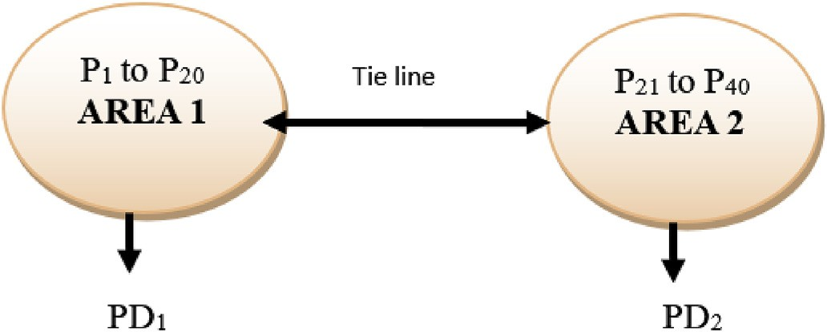



Fig. 7. Convergence characteristic of SSA for four area system with forty

generating units. (Test Case II). Fig. 8. Two area network with forty power generating units.

* 1. *Comparative analysis*



* + 1. *Solution quality*

For the test case I, the optimal generation schedule and comparison of costs are made in Tables 1 and 2, respectively. Here it is observed that

Fig. 9. Convergence characteristic of SSA for Two Area system with forty generating units. (Test Case III).

characteristic for combined WT obtained by SSA is presented in Fig. 11.

*4.1. Effect of control parameter*

SSA is a population-based algorithm. Apart from population size, termination criteria and other common parameters it has only one con- trol parameter *C*1. To get optimum value, simulation analysis has been carried out with different population (search agent) sizes keeping maximum number of iterations 500 as the stopping criteria. Performance of SSA over 30 repeated trials is analyzed on Test Case I and the outcome of results are presented in Fig. 12 and Fig. 13, respectively. Here it is observed that with population size of 200, SSA attained minimum cost with less standard deviation. However, with further increase in popula- tion size there is no improvement in operational cost but average CPU time increases. Therefore, population size of 200 is considered for simulation analysis of MAED problems.

Now to find the optimal value of control parameter *C*1which is coupled with current iteration and maximum iteration by exponential term as defined in (22) and plotted in Fig. 14. Here it is observed that the value of *C*1exponentially decreases as iteration progresses, which shows the exploration in the initial stage and then exploitation in the later stage.

Table 6

Comparison of results for two area forty-unit system (Test case III).

Method Generation cost ($/hr)

Best Mean Worst SD DEC2 [39] 131549.6080 – – 1.7634

DEPSO1 [41] 125299.5631 125474.4525 – 173.9205

DEPSO2 [41] 125179.5581 125421.1636 – 157.2532

DEPSO3 [41] 127386.3364 128757.9549 – 860.0746

DEPSO4 [41] 128641.7046 128957.7981 – 263.9482

HSLSO [41] 125100.2621 125384.4464 – 104.2493

MFO [43] 124746.0610 124843.3515 – 90.2025

SFS [47] 124750.5796 124975.1366 125209.4607 125.5477

ISFS [47] 124683.0977 124818.1031 125062.6706 86.1173

SSA 124647.0508 124688.4065 124888.862 88. 1322

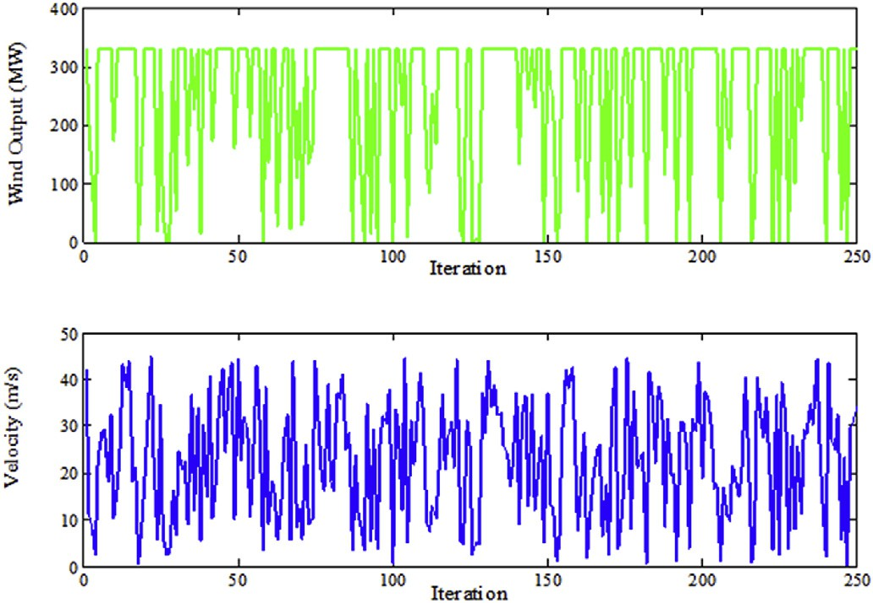

Fig. 10. Stochastic variation of wind velocity and corresponding wind power.

Table 5

Optimal generation scheduling for two area forty unit system (Test case III).

|  |  |  |  |  |  |  |  |  |
| --- | --- | --- | --- | --- | --- | --- | --- | --- |
|  | AREA1(PD=7500MW) |  |  |  | AREA2(PD=3000MW) |  | | |
| unit HSLSO [41] | ISFS [47] | SSA |  | unit HSLSO [41] | ISFS [47] | SSA |  |
|  | P1,1 110.8012 | 113.9058 | 114 |  | P2,1 523.2792 | 433.4200 | 523.2794 |  |
|  | P1,2 113.9997 | 114.0000 | 111.6554 |  | P2,2 523.2791 | 523.0749 | 523.2795 |  |
|  | P1,3 120.0 | 119.9864 | 120 |  | P2,3 523.2794 | 523.2439 | 433.5195 |  |
|  | P1,4 179.7331 | 179.9941 | 179.7331 |  | P2,4 523.2794 | 523.2985 | 523.2794 |  |
|  | P1,5 95.551 | 97.0000 | 90.4583 |  | P2,5 523.2795 | 433.3512 | 433.5194 |  |
|  | P1,6 140.0 | 140.0000 | 140 |  | P2,6 254.0 | 433.4643 | 433.5198 |  |
|  | P1,7 300.0 | 300.0000 | 300 |  | P2,7 10.0001 | 10.0034 | 10 |  |
|  | P1,8 284.5997 | 291.3401 | 284.6 |  | P2,8 10 | 10 | 10 |  |
|  | P1,9 284.5997 | 287.0178 | 284.6 |  | P2,9 10 | 10 | 10 |  |
|  | P1,10 270.0 | 200.0000 | 279.5995 |  | P2,10 87.7997 | 87.8100 | 87.7999 |  |
|  | P1,11 94.0 | 230.0000 | 168.7996 |  | P2,11 188.5959 | 159.6862 | 159.7338 |  |
|  | P1,12 300.0 | 168.8385 | 168.7999 |  | P2,12 159.7331 | 189.3811 | 159.7333 |  |
|  | P1,13 304.5195 | 394.2548 | 394.2794 |  | P2,13 159.733 | 159.7251 | 159.7328 |  |
|  | P1,14 394.2797 | 394.2946 | 394.2794 |  | P2,14 164.8002 | 164.6679 | 164.7999 |  |
|  | P1,15 484.0395 | 484.0588 | 484.0391 |  | P2,15 164.7998 | 164.8266 | 164.7999 |  |
|  | P1,16 484.0391 | 483.9991 | 484.0392 |  | P2,16 164.7998 | 164.6281 | 90.0001 |  |
|  | P1,17 489.2794 | 489.3491 | 489.2794 |  | P2,17 89.1143 | 89.1646 | 89.1144 |  |
|  | P1,18 489.2796 | 489.3036 | 489.2795 |  | P2,18 89.114 | 89.1364 | 103.0144 |  |
|  | P1,19 549.9998 | 511.3242 | 511.2794 |  | P2,19 89.1134 | 89.1093 | 89.1142 |  |
|  | P1,20 511.2791  T12 | 511.3414 | 511.2794 |  | P2,20 242.0001  —1500.000  10500.000 | 242.0000  —1499.9915  10500.0000 | 331.7598  —1500.000  10500.000 |  |
|  | Cost ($/hr.) |  |  |  | 125100.2621 | 124683.0977 | 124647.0508 |  |

PPg

Table 7

Optimal generation scheduling for two area forty unit wind-thermal system (Test case IV).

|  |  |  |  |  |
| --- | --- | --- | --- | --- |
|  | AREA1(PD=7500MW) | AREA2(PD=3000MW) |  |  |
| unit SSA | unit | SSA |
|  | P1,1 113.9998 | P2,1 | 523.2795 |  |
|  | P1,2 113.9996 | P2,2 | 343.7598 |  |
|  | P1,3 120 | P2,3 | 254 |  |
|  | P1,4 179.7331 | P2,4 | 523.2794 |  |
|  | P1,5 96.0324 | P2,5 | 523.2793 |  |
|  | P1,6 140 | P2,6 | 523.2793 |  |
|  | P1,7 300 | PW2,7 | 109.9999 |  |
|  | P1,8 284.5995 | PW2,8 | 109.9999 |  |
|  | P1,9 284.6002 | PW2,9 | 110 |  |
|  | P1,10 269.9999 | P2,10 | 87.7998 |  |
|  | P1,11 168.7999 | P2,11 | 159.733 |  |
|  | P1,12 350.0002 | P2,12 | 159.733 |  |
|  | P1,13 394.2794 | P2,13 | 159.7331 |  |
|  | P1,14 394.2793 | P2,14 | 90 |  |
|  | P1,15 304.5197 | P2,15 | 164.8 |  |
|  | P1,16 484.0391 | P2,16 | 164.8 |  |
|  | P1,17 489.2794 | P2,17 | 72.296 |  |
|  | P1,18 489.2796 | P2,18 | 89.114 |  |
|  | P1,19 511.2794 | P2,19 | 89.114 |  |
|  | P1,20 511.2793  T12  Total cost($/hr) | P2,20 | 242  —1500.0000  120857.2447 |  |
|  | Wind over estimation cost ($/hr) |  | 692.2903 |  |
|  | Wind under estimation cost ($/hr) |  | 0.0002 |  |
|  | Optimum Thermal cost ($/hr) |  | 120164.95424 |  |

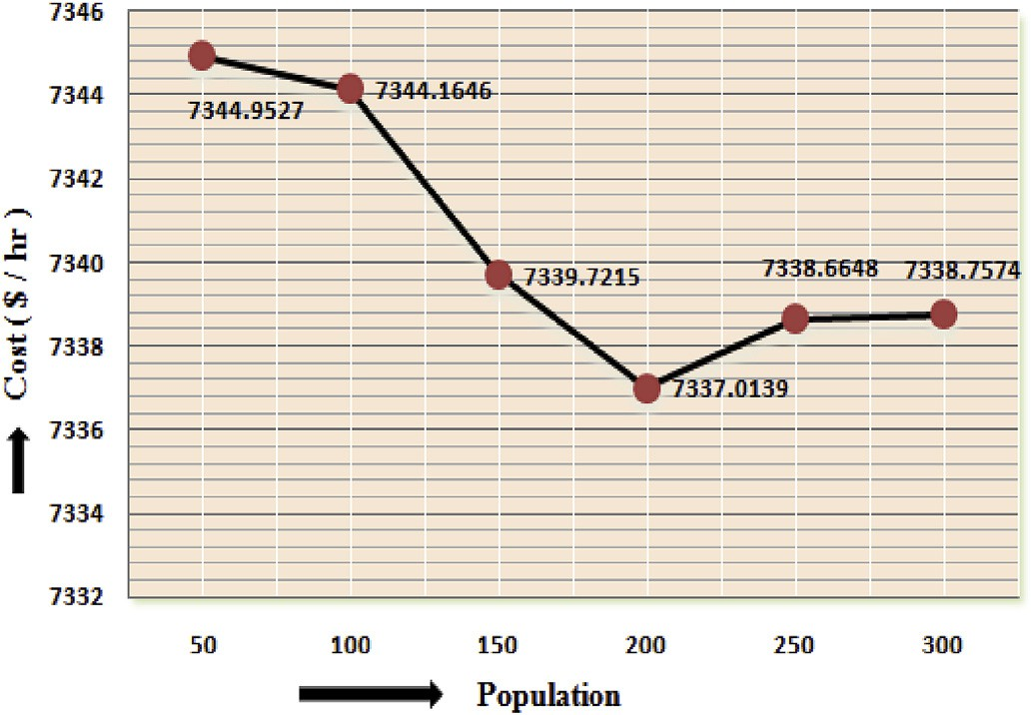

Fig. 12. Effect of population on optimum generation cost (Test Case I).

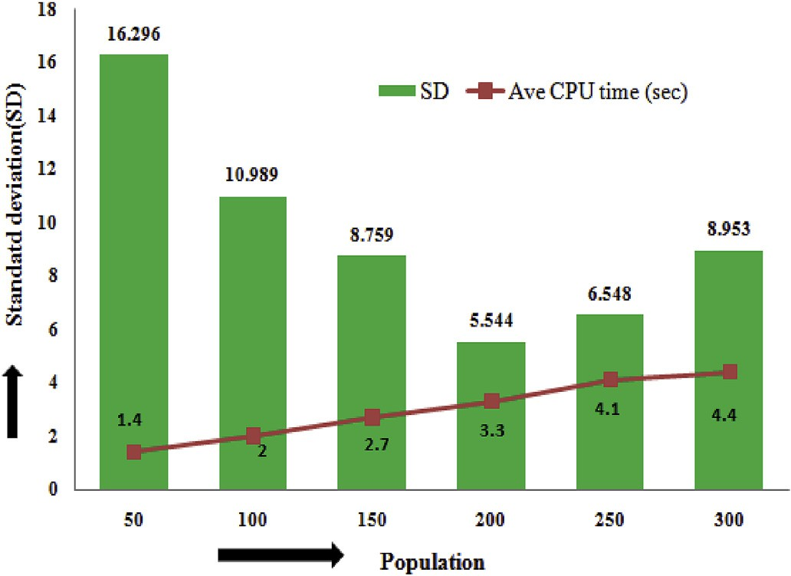

Fig. 13. Effect of population size on Standard deviation and average CPU time (Test Case I).

Fig. 11. Convergence characteristic of SSA for Two Area system with forty generating units with wind integration (Test Case IV).



optimum cost obtained by SSA 7337.0139 $/hr is found to be compa- rable with MFO [43], HLSO [41] and better than IHS [38], IFEP [38] and IDEPSO4 [41], reported in the recent literature.

For large dimension problem (Test Case II), the optimal generation schedule and statistical results in terms of costs are summarized in Ta- bles 3 and 4 respectively. By comparison of costs reported by other metaheuristics it is observed that SSA can acquire lowest cost 122471.666 $/hr as compared to real coded genetic algorithms (RCGA) [40], differential evolution (DE) [40], evolutionary programming (EP) [40], artificial bee colony optimization (ABCO) [40], cuckoo search al- gorithm (CSA) [45] and flower pollination algorithm (FPA) [42]. Also the mean cost 122507.5003 $/hr obtained by SSA is found to be superior as compared to the best cost reported by other methods, which supports to claims the global search capability of SSA.

For two area network (Test case III) which has non-convex as well as discontinuous fuel cost characteristics due to VPL effect and POZ both are considered here. The minimum cost solution obtained by SSA is

124647.0508 $/hr and corresponding generation schedule is listed in Table 5. While comparing its statistical results in terms of cost with other methods in Table 6, such as stochastic fractal search (SFS) [47], hybrid DEPSO with different mutation strategy of DE, DEPSO1 to DSPSO4 [41], Hybrid sum local search optimizer (HLSO) [41] and MFO [43] and DEC2 [39], it is observed that the minimum cost obtained by SSA is better.

Test case IV is a modified version of Test case III, and modification has been done by replacing three thermal generators by the wind generators. It has highest complexity among all cases considered for simulation analysis. It includes complexity like probabilistic constraints due to wind integration in addition to VPL, RRL and POZ of the thermal system, makes the objective function multimodal as well as discontinuous in nature and hence finding global minima solution for such a complex constrained problem has become quite difficult task. For such a complex and highly constrained test case also SSA is able to obtain optimum generation cost of 120857.2447 $/hr which is found to be lower by 3789.8061 $/hr as compared to Test Cast III. Its detail solution which is listed in Table 7, shows the better constrained handling capability of SSA.

Therefore, we can say SSA has a strong ability to find a better quality of the solution.

But for two test cases, it is observed that minimum cost of SSA is found to be inferior as compared to hybrid version meta-heuristics re- ported in the literature listed in Tables 2 and 4, respectively. They are (i) for test case I, the best cost reported using a hybrid harmony search

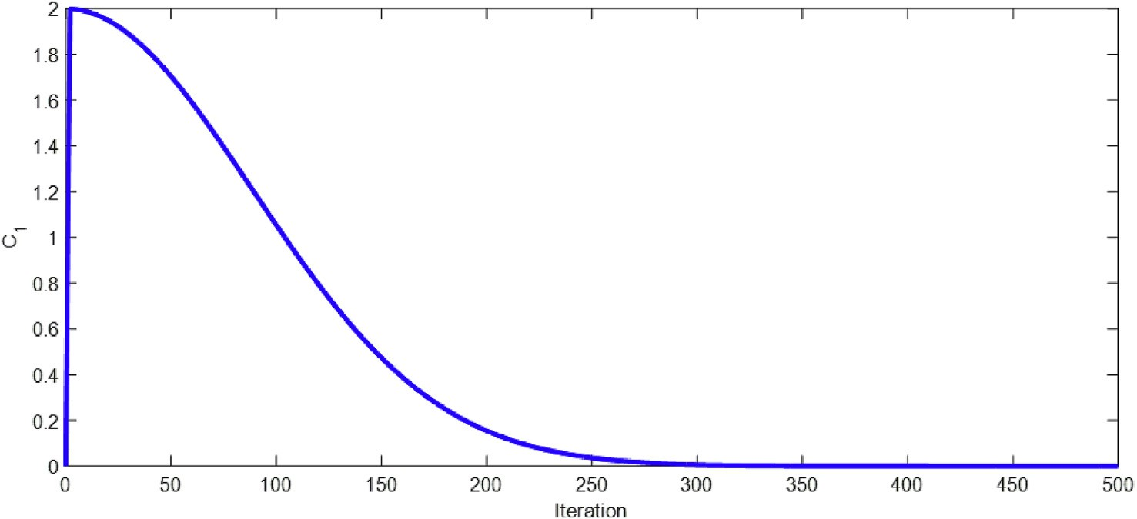

Fig. 14. Variation of the Control parameter *C*1with iteration (Test Case I).

(HHS) [37] is 7329.85$/hr, while SSA has 7337.0139 $/hr. (ii) for test case II the best cost obtained using JAYA-TLBO [46] is 121694.4 $/hr while using SSA it is 122471.666 $/hr.

* + 1. *Computational efficiency*

The best cost solution achieved by SSA and corresponding generation schedule for different cases are presented in Tables 1, 3, 5 and 7 show the ability to satisfy constraints for complex constrained optimization prob- lems. The average CPU time required to converge into the optimum so- lution for all four test cases are shown in Fig. 15. Considering dimensions and complexity levels of problems taken under consideration, such computational times are quite justified. Therefore, it can be said that SSA is computationally efficient also.

* + 1. *Robustness*

The statistical results in terms of cost simulated over 30 independent runs of all four test cases having different dimensions/complexity are summarized in Table 2, Table 4, Table 6, and Table 8. The robustness of the algorithm is analyzed on the basis of mean cost and standard devi- ation (SD). For test case I, the mean cost of SSA is found to be inferior to hybrid/improved version of metaheuristics reported in literature as hybrid sum-local search optimizer (HLSO) [41], DEPSO4 [41] but su- perior to MFO [43]. Here the SD of cost for SSA is also higher as compared to others.

For large dimension test case II, even the worst cost solution of SSA 122737.9965 $/hr is found to be superior to the best cost reported by EP [40], DE [40], ABCO [40], FPA [42] and CSA [45] listed in Table 4.

For two area system test case III, with the nonlinear, multimodal and discontinuous objective function, the mean cost 124688.4065 $/hr of SSA is better as compared to other bio-inspired methods as variants of DE

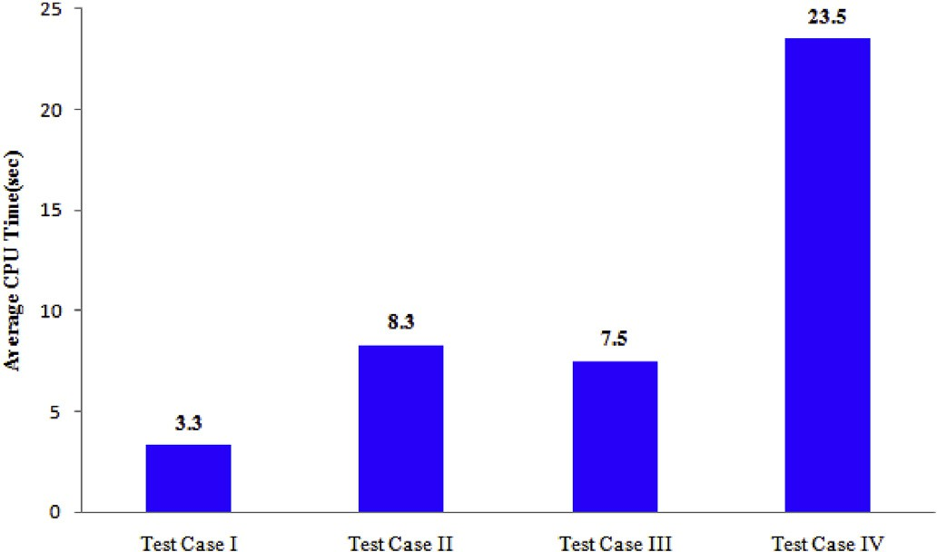

Fig. 15. Average CPU time of SSA for different test cases.

Table 8

Statistical results for two area forty-unit wind-thermal system over 30 Trail.

|  |  |  |  |  |  |
| --- | --- | --- | --- | --- | --- |
|  | Generation cost ($/hr) |  | | | |
| Best | Mean | Worst | SD |  |
|  | 120857.2447 | 120944.6006 | 121365.6097 | 140.8637 |  |

[41], MFO [43], SFS [47] and ISFS [47] listed in Table 6. Here also it is observed that SD of cost 88.1322 for SSA is either superior or almost comparable to other reported methods except DEC2 [39].

Comparing the results of Test case III and Test case IV, i.e. MAED problem of thermal system and then MAED problem of wind-thermal system as presented in Tables 6 and 8, it has been observed that cost is reduced significantly by wind integration but due to additional proba- bilistic constraints, standard deviation of the cost is found to be large. Based on this discussion, we can say SSA is a robust optimization approach.

1. Conclusion

In this paper, a salp swarm algorithm is implemented to solve MAED problems with different dimensions and operational complexity. By analyzing the generation schedule, it has been observed that all opera- tional constraints are fully satisfied for all the test cases having different dimensions and complexity level. It proves that SSA can efficiently handle the constraints. Through comparison of best cost solution with other metaheuristics, SSA is found to be effective in terms of solution quality too. The average CPU time required to converge into the optimum solution has also been analyzed, considering the dimension and complexity of problems. SSA is found to be sufficiently fast converging algorithm. Despite providing good results, it has been observed that SSA suffers from premature convergence especially for test cases having objective function non-convex, discontinuous and probabilistic in nature. It may be due to parameter *C*1, which decreases exponentially and is responsible for exploration and exploitation during the optimization process. Therefore a more extensive research on the sensitivity analysis of parameter *C*1can further improve SSA.

Vishal Chaudhary: Writing - original draft, Software. Hari Mohan Dubey: Data curation, Conceptualization. Manjaree Pandit: Supervision.

J. C. Bansal: Methodology

Declaration of competing interest

The authors declare that they have no known competing financial interests or personal relationships that could have appeared to influence the work reported in this paper.

Acknowledgment

The authors would like to thank reviewers for providing constructive comments to improve the quality of this paper. The authors also sincerely

acknowledge the financial support provided by AICTE-RPS project File No. 8–228/RIFD/RPS/POLICY-1/2018-19 dated 20 March 2020. Au-

thors also thanks the Director and the Management of M.I.T.S Gwalior, India for providing necessary facilities for carrying out this work.

Appendix A

Table A1

Cost coefficient and generator limit data of 16 unit system [37] (Test Case I)

|  |  |  |  |  |  |
| --- | --- | --- | --- | --- | --- |
| Unit | *Pmin* (MW) | *Pmax* (MW) | *ai* ($/*MW*2) | *bi* ($/MW) | *ci* ($) |
| Area1 1 | 50 | 150 | 0.00 | 4 | 0.01 |
| 2 | 25 | 100 | 0.00 | 2 | 0.03 |
| 3 | 25 | 100 | 0.00 | 3 | 0.05 |
| 4 | 25 | 100 | 0.00 | 1 | 0.04 |
| Area2  5 | 50 | 150 | 0.00 | 4 | 0.05 |
| 6 | 25 | 100 | 0.00 | 2 | 0.04 |
| 7 | 25 | 100 | 0.00 | 3 | 0.08 |
| 8 | 25 | 100 | 0.00 | 1 | 0.06 |
| Area3  9 | 50 | 150 | 0.00 | 4 | 0.10 |
| 10 | 25 | 100 | 0.00 | 2 | 0.12 |
| 11 | 25 | 100 | 0.00 | 3 | 0.10 |
| 12 | 25 | 100 | 0.00 | 1 | 0.13 |
| Area4  13 | 50 | 150 | 0.00 | 4 | 0.01 |
| 14 | 25 | 100 | 0.00 | 2 | 0.03 |
| 15 | 25 | 100 | 0.00 | 3 | 0.05 |
| 16 | 25 | 100 | 0.00 | 1 | 0.04 |
| For all tie lines  *Tij*(MW) | 0 | 100 | 0.00 | 1 | 0.00 |

Table A2

Cost coefficient and generator limit data of 40-unit system [26] Test Case II

|  |  |  |  |  |  |  |  |
| --- | --- | --- | --- | --- | --- | --- | --- |
| Unit | *Pmin* (MW) | *Pmax* (MW) | *ai* ($/*MW*2) | *bi* ($/MW) | *ci* ($) | *di* ($/MW) | *ei* (*rad* /*MW*) |
| 1. | 36 | 114 | 0.00690 | 6.73 | 94.705 | 100 | 0.084 |
| 2. | 36 | 114 | 0.00690 | 6.73 | 94.705 | 100 | 0.084 |
| 3. | 60 | 120 | 0.02028 | 7.07 | 309.54 | 100 | 0.084 |
| 4. | 80 | 190 | 0.00942 | 8.18 | 369.03 | 150 | 0.063 |
| 5. | 47 | 97 | 0.0114 | 5.35 | 148.89 | 120 | 0.077 |
| 6. | 68 | 140 | 0.01142 | 8.05 | 220.33 | 100 | 0.084 |
| 7. | 110 | 300 | 0.00357 | 8.03 | 287.71 | 200 | 0.042 |
| 8. | 135 | 300 | 0.00492 | 6.99 | 391.98 | 200 | 0.042 |
| 9. | 135 | 300 | 0.00573 | 6.60 | 455.76 | 200 | 0.042 |
| 10. | 130 | 300 | 0.00605 | 12.9 | 722.82 | 200 | 0.042 |
| 11. | 94 | 375 | 0.00515 | 12.9 | 635.20 | 200 | 0.042 |
| 12. | 94 | 375 | 0.00569 | 12.8 | 654.69 | 200 | 0.042 |
| 13. | 125 | 500 | 0.00421 | 12.5 | 913.40 | 300 | 0.035 |
| 14. | 125 | 500 | 0.00752 | 8.84 | 1760.40 | 300 | 0.035 |
| 15. | 125 | 500 | 0.00708 | 9.15 | 1728.30 | 300 | 0.035 |
| 16. | 125 | 500 | 0.00708 | 9.15 | 1728.30 | 300 | 0.035 |
| 17. | 220 | 500 | 0.00313 | 7.97 | 647.85 | 300 | 0.035 |
| 18. | 220 | 500 | 0.00313 | 7.95 | 649.69 | 300 | 0.035 |
| 19. | 242 | 550 | 0.00313 | 7.97 | 647.83 | 300 | 0.035 |
| 20. | 242 | 550 | 0.00313 | 7.97 | 647.81 | 300 | 0.035 |
| 21. | 254 | 550 | 0.00298 | 6.63 | 785.96 | 300 | 0.035 |
| 22. | 254 | 550 | 0.00298 | 6.63 | 785.96 | 300 | 0.035 |
| 23. | 254 | 550 | 0.00284 | 6.66 | 794.53 | 300 | 0.035 |
| 24. | 254 | 550 | 0.00284 | 6.66 | 794.53 | 300 | 0.035 |
| 25. | 254 | 550 | 0.00277 | 7.10 | 801.32 | 300 | 0.035 |
| 26. | 254 | 550 | 0.00277 | 7.10 | 801.32 | 300 | 0.035 |
| 27. | 10 | 150 | 0.52124 | 3.33 | 1055.1 | 120 | 0.077 |
| 28. | 10 | 150 | 0.52124 | 3.33 | 1055.1 | 120 | 0.077 |
| 29. | 10 | 150 | 0.52124 | 3.33 | 1055.1 | 120 | 0.077 |
| 30. | 47 | 97 | 0.01140 | 5.35 | 148.89 | 120 | 0.077 |
| 31. | 60 | 190 | 0.00160 | 6.43 | 222.92 | 150 | 0.063 |
| 32. | 60 | 190 | 0.00160 | 6.43 | 222.92 | 150 | 0.063 |

(*continued on next column*)

Table A2 (*continued* )

|  |  |  |  |  |  |  |  |
| --- | --- | --- | --- | --- | --- | --- | --- |
| Unit | *Pmin* (MW) | *Pmax* (MW) | *ai* ($/*MW*2) | *bi* ($/MW) | *ci* ($) | *di* ($/MW) | *ei* (*rad* /*MW*) |
| 33. | 60 | 190 | 0.00160 | 6.43 | 222.92 | 150 | 0.063 |
| 34. | 90 | 200 | 0.0001 | 8.95 | 107.87 | 200 | 0.042 |
| 35. | 90 | 200 | 0.0001 | 8.62 | 116.58 | 200 | 0.042 |
| 36. | 90 | 200 | 0.0001 | 8.62 | 116.58 | 200 | 0.042 |
| 37. | 25 | 110 | 0.0161 | 5.88 | 307.45 | 80 | 0.098 |
| 38. | 25 | 110 | 0.0161 | 5.88 | 307.45 | 80 | 0.098 |
| 39. | 25 | 110 | 0.0161 | 5.88 | 307.45 | 80 | 0.098 |
| 40. | 242 | 550 | 0.00313 | 7.97 | 647.83 | 300 | 0.035 |

Table A3

Cost coefficient and generator limit data of 40 unit system with ramp rate limit and Prohibited operating Zones (Test Case III and IV)

|  |  |  |  |  |  |  |  |  |  |  |
| --- | --- | --- | --- | --- | --- | --- | --- | --- | --- | --- |
| Unit | *Pmin* (MW) | *Pmax* (MW) | *ai* ($/*MW*2) | *bi* ($/MW) | *ci* ($) | *di* ($/MW) | *ei* (*rad* /*MW*) | *P*0 | *UR*(MW/hr) | *DR*(MW/hr) |
| 1. | 36 | 114 | 0.00690 | 6.73 | 94.705 | 100 | 0.084 | 100 | 114 | 114 |
| 2. | 36 | 114 | 0.00690 | 6.73 | 94.705 | 100 | 0.084 | 100 | 114 | 114 |
| 3. | 60 | 120 | 0.02028 | 7.07 | 309.54 | 100 | 0.084 | 90 | 120 | 120 |
| 4. | 80 | 190 | 0.00942 | 8.18 | 369.03 | 150 | 0.063 | 150 | 100 | 150 |
| 5. | 47 | 97 | 0.0114 | 5.35 | 148.89 | 120 | 0.077 | 80 | 97 | 97 |
| 6. | 68 | 140 | 0.01142 | 8.05 | 220.33 | 100 | 0.084 | 120 | 80 | 125 |
| 7. | 110 | 300 | 0.00357 | 8.03 | 287.71 | 200 | 0.042 | 280 | 165 | 200 |
| 8. | 135 | 300 | 0.00492 | 6.99 | 391.98 | 200 | 0.042 | 200 | 165 | 200 |
| 9. | 135 | 300 | 0.00573 | 6.60 | 455.76 | 200 | 0.042 | 230 | 165 | 200 |
| 10. | 130 | 300 | 0.00605 | 12.9 | 722.82 | 200 | 0.042 | 240 | 155 | 190 |
| 11. | 94 | 375 | 0.00515 | 12.9 | 635.20 | 200 | 0.042 | 210 | 150 | 185 |
| 12. | 94 | 375 | 0.00569 | 12.8 | 654.69 | 200 | 0.042 | 210 | 150 | 185 |
| 13. | 125 | 500 | 0.00421 | 12.5 | 913.40 | 300 | 0.035 | 230 | 206 | 235 |
| 14. | 125 | 500 | 0.00752 | 8.84 | 1760.40 | 300 | 0.035 | 355 | 260 | 290 |
| 15. | 125 | 500 | 0.00708 | 9.15 | 1728.30 | 300 | 0.035 | 350 | 186 | 215 |
| 16. | 125 | 500 | 0.00708 | 9.15 | 1728.30 | 300 | 0.035 | 350 | 186 | 215 |
| 17. | 220 | 500 | 0.00313 | 7.97 | 647.85 | 300 | 0.035 | 460 | 240 | 270 |
| 18. | 220 | 500 | 0.00313 | 7.95 | 649.69 | 300 | 0.035 | 470 | 240 | 268 |
| 19. | 242 | 550 | 0.00313 | 7.97 | 647.83 | 300 | 0.035 | 500 | 290 | 315 |
| 20. | 242 | 550 | 0.00313 | 7.97 | 647.81 | 300 | 0.035 | 500 | 290 | 315 |
| 21. | 254 | 550 | 0.00298 | 6.63 | 785.96 | 300 | 0.035 | 510 | 335 | 360 |
| 22. | 254 | 550 | 0.00298 | 6.63 | 785.96 | 300 | 0.035 | 520 | 335 | 360 |
| 23. | 254 | 550 | 0.00284 | 6.66 | 794.53 | 300 | 0.035 | 520 | 335 | 362 |
| 24. | 254 | 550 | 0.00284 | 6.66 | 794.53 | 300 | 0.035 | 450 | 350 | 378 |
| 25. | 254 | 550 | 0.00277 | 7.10 | 801.32 | 300 | 0.035 | 400 | 350 | 380 |
| 26. | 254 | 550 | 0.00277 | 7.10 | 801.32 | 300 | 0.035 | 520 | 350 | 380 |
| 27. | 10 | 150 | 0.52124 | 3.33 | 1055.1 | 120 | 0.077 | 20 | 95 | 145 |
| 28. | 10 | 150 | 0.52124 | 3.33 | 1055.1 | 120 | 0.077 | 20 | 95 | 145 |
| 29. | 10 | 150 | 0.52124 | 3.33 | 1055.1 | 120 | 0.077 | 25 | 98 | 145 |
| 30. | 47 | 97 | 0.01140 | 5.35 | 148.89 | 120 | 0.077 | 90 | 97 | 97 |
| 31. | 60 | 190 | 0.00160 | 6.43 | 222.92 | 150 | 0.063 | 170 | 90 | 145 |
| 32. | 60 | 190 | 0.00160 | 6.43 | 222.92 | 150 | 0.063 | 150 | 90 | 145 |
| 33. | 60 | 190 | 0.00160 | 6.43 | 222.92 | 150 | 0.063 | 190 | 90 | 145 |
| 34. | 90 | 200 | 0.0001 | 8.95 | 107.87 | 200 | 0.042 | 190 | 105 | 150 |
| 35. | 90 | 200 | 0.0001 | 8.62 | 116.58 | 200 | 0.042 | 150 | 105 | 150 |
| 36. | 90 | 200 | 0.0001 | 8.62 | 116.58 | 200 | 0.042 | 180 | 105 | 150 |
| 37. | 25 | 110 | 0.0161 | 5.88 | 307.45 | 80 | 0.098 | 60 | 110 | 110 |
| 38. | 25 | 110 | 0.0161 | 5.88 | 307.45 | 80 | 0.098 | 40 | 110 | 110 |
| 39. | 25 | 110 | 0.0161 | 5.88 | 307.45 | 80 | 0.098 | 50 | 110 | 110 |
| 40. | 242 | 550 | 0.00313 | 7.97 | 647.83 | 300 | 0.035 | 512 | 290 | 315 |
| Unit | Prohibited operating Zones (MW) | | | | |  | |  | | |
| 10 | [130 150] | | | | | [200 230] | | [270 299] | | |
| 11 | [100 140] | | | | | [230 280] | | [300 350] | | |
| 12 | [100 140] | | | | | [230 280] | | [300 350] | | |
| 13 | [150 200] | | | | | [250 300] | | [400 450] | | |
| 14 | [200 250] | | | | | [300 350] | | [450 490] | | |

References

1. [Goldberg DE, Holland JH. Genetic algorithms, and machine learning. Mach Learn](http://refhub.elsevier.com/S2590-0056(20)30029-1/sref1) [1988;3:95](http://refhub.elsevier.com/S2590-0056(20)30029-1/sref1)–[9](http://refhub.elsevier.com/S2590-0056(20)30029-1/sref1).
2. [Storn R, Price K. Differential evolution: a simple and efficient heuristic for global](http://refhub.elsevier.com/S2590-0056(20)30029-1/sref2) [optimization over continuous spaces. J Global Optim 1997;11(4):341](http://refhub.elsevier.com/S2590-0056(20)30029-1/sref2)–[59](http://refhub.elsevier.com/S2590-0056(20)30029-1/sref2).
3. [Civicioglu P. Backtracking search optimization algorithm for numerical](http://refhub.elsevier.com/S2590-0056(20)30029-1/sref3) [optimization problems. Appl Math Comput 2013;219:8121](http://refhub.elsevier.com/S2590-0056(20)30029-1/sref3)–[44](http://refhub.elsevier.com/S2590-0056(20)30029-1/sref3).
4. [Eberhart RC, Kennedy J. A new optimizer using particle swarm theory. In:](http://refhub.elsevier.com/S2590-0056(20)30029-1/sref4) [Proceedings of the sixth international symposium on micro machine and human](http://refhub.elsevier.com/S2590-0056(20)30029-1/sref4) [science (MHS 95); 1995. p. 39](http://refhub.elsevier.com/S2590-0056(20)30029-1/sref4)–[43](http://refhub.elsevier.com/S2590-0056(20)30029-1/sref4).
5. [Karaboga D, Basturk B. A powerful and efficient algorithm for numerical function](http://refhub.elsevier.com/S2590-0056(20)30029-1/sref5) [optimization: arti](http://refhub.elsevier.com/S2590-0056(20)30029-1/sref5)fi[cial bee colony (ABC) algorithm. J Global Optim 2007;39:](http://refhub.elsevier.com/S2590-0056(20)30029-1/sref5) [459](http://refhub.elsevier.com/S2590-0056(20)30029-1/sref5)–[71](http://refhub.elsevier.com/S2590-0056(20)30029-1/sref5).
6. [Mirjalili S, Lewis A. The whale optimization algorithm. Adv Eng Software 2016;95:](http://refhub.elsevier.com/S2590-0056(20)30029-1/sref6) [51](http://refhub.elsevier.com/S2590-0056(20)30029-1/sref6)–[67](http://refhub.elsevier.com/S2590-0056(20)30029-1/sref6).
7. [Shahrzad S, Seyedali M, Andrew L. Grasshopper optimisation algorithm: theory and](http://refhub.elsevier.com/S2590-0056(20)30029-1/sref7) [application. Adv Eng Software 2017;105:30](http://refhub.elsevier.com/S2590-0056(20)30029-1/sref7)–[47](http://refhub.elsevier.com/S2590-0056(20)30029-1/sref7).
8. [Bansal JC, Sharma H, Jadon SS, Clerc M. Spider Monkey Optimization algorithm for](http://refhub.elsevier.com/S2590-0056(20)30029-1/sref8) [numerical optimization. Memetic Comp 2014;6:31](http://refhub.elsevier.com/S2590-0056(20)30029-1/sref8)–[47](http://refhub.elsevier.com/S2590-0056(20)30029-1/sref8).
9. [Mirjalili S, Mirjalili SM, Lewis A. Grey wolf optimizer. Adv Eng Software 2014;69:](http://refhub.elsevier.com/S2590-0056(20)30029-1/sref9) [46](http://refhub.elsevier.com/S2590-0056(20)30029-1/sref9)–[61](http://refhub.elsevier.com/S2590-0056(20)30029-1/sref9).
10. [Rao RV, Savsani VJ, Vakharia DP. Teaching](http://refhub.elsevier.com/S2590-0056(20)30029-1/sref10)–[learning-based optimization: a novel](http://refhub.elsevier.com/S2590-0056(20)30029-1/sref10) [method for constrained mechanical design optimization problems. Comput Aided](http://refhub.elsevier.com/S2590-0056(20)30029-1/sref10) [Des 2011;43(3):303](http://refhub.elsevier.com/S2590-0056(20)30029-1/sref10)–[15](http://refhub.elsevier.com/S2590-0056(20)30029-1/sref10).
11. [Kirkpatrick S, Gelatt CD, Vecchi MP. Optimization by simulated annealing. Science](http://refhub.elsevier.com/S2590-0056(20)30029-1/sref11) [1983;220:671](http://refhub.elsevier.com/S2590-0056(20)30029-1/sref11)–[80](http://refhub.elsevier.com/S2590-0056(20)30029-1/sref11).
12. [Geem ZW, Kim JH, Loganathan G. A new heuristic optimization algorithm:](http://refhub.elsevier.com/S2590-0056(20)30029-1/sref12) [harmony search. Simulation 2001;76:60](http://refhub.elsevier.com/S2590-0056(20)30029-1/sref12)–[8](http://refhub.elsevier.com/S2590-0056(20)30029-1/sref12).
13. [Rashedi E, Nezamabadi-pour H, Saryazdi S. GSA: a gravitational search algorithm.](http://refhub.elsevier.com/S2590-0056(20)30029-1/sref13) [Inf Sci 2009;179:2232](http://refhub.elsevier.com/S2590-0056(20)30029-1/sref13)–[48](http://refhub.elsevier.com/S2590-0056(20)30029-1/sref13).
14. [Lam AYS, Li VOK. Chemical-reaction-inspired metaheuristic for optimization. IEEE](http://refhub.elsevier.com/S2590-0056(20)30029-1/sref14) [Trans Evol Comput 2010;14(3):381](http://refhub.elsevier.com/S2590-0056(20)30029-1/sref14)–[99](http://refhub.elsevier.com/S2590-0056(20)30029-1/sref14).
15. [Salimi H. Stochastic Fractal Search: a powerful metaheuristic algorithm. Knowl](http://refhub.elsevier.com/S2590-0056(20)30029-1/sref15) [Base Syst 2015;75:1](http://refhub.elsevier.com/S2590-0056(20)30029-1/sref15)–[18](http://refhub.elsevier.com/S2590-0056(20)30029-1/sref15).
16. [Hadi E, Ali S, Ardeshir B, Mohd H. Water cycle algorithm](http://refhub.elsevier.com/S2590-0056(20)30029-1/sref16) – [a novel metaheuristic](http://refhub.elsevier.com/S2590-0056(20)30029-1/sref16) [optimization method for solving constrained engineering optimization problems.](http://refhub.elsevier.com/S2590-0056(20)30029-1/sref16) [Comput Struct 2012;110](http://refhub.elsevier.com/S2590-0056(20)30029-1/sref16)–[111:151](http://refhub.elsevier.com/S2590-0056(20)30029-1/sref16)–[66](http://refhub.elsevier.com/S2590-0056(20)30029-1/sref16).
17. [Mehrabian AR, Lucas C. A novel numerical optimization algorithm inspired from](http://refhub.elsevier.com/S2590-0056(20)30029-1/sref17) [weed colonization. Ecol Inf 2006;1(4):355](http://refhub.elsevier.com/S2590-0056(20)30029-1/sref17)–[66](http://refhub.elsevier.com/S2590-0056(20)30029-1/sref17).
18. [Simon D. Biogeography-based optimization. IEEE Trans Evol Comput 2008;12(6):](http://refhub.elsevier.com/S2590-0056(20)30029-1/sref18) [702](http://refhub.elsevier.com/S2590-0056(20)30029-1/sref18)–[13](http://refhub.elsevier.com/S2590-0056(20)30029-1/sref18).
19. [Yang XS. Flower pollination algorithm for global optimization. In: Unconventional](http://refhub.elsevier.com/S2590-0056(20)30029-1/sref19) [computation and natural computation 2012, lecture notes in computer science;](http://refhub.elsevier.com/S2590-0056(20)30029-1/sref19) [2012. p. 240](http://refhub.elsevier.com/S2590-0056(20)30029-1/sref19)–[9. 7445](http://refhub.elsevier.com/S2590-0056(20)30029-1/sref19).
20. [Kar AK. Bio-inspired computing - a review of algorithms and scope of applications.](http://refhub.elsevier.com/S2590-0056(20)30029-1/sref20) [Expert Syst Appl 2016;59:20](http://refhub.elsevier.com/S2590-0056(20)30029-1/sref20)–[32](http://refhub.elsevier.com/S2590-0056(20)30029-1/sref20).
21. [Dubey HM, Pandit M, Panigrahi BK. An overview and comparative analysis of](http://refhub.elsevier.com/S2590-0056(20)30029-1/sref21) [recent bio-inspired optimization techniques for wind integrated multi-objective](http://refhub.elsevier.com/S2590-0056(20)30029-1/sref21) [power dispatch, Swarm, and Evol. Comp 2018;38:12](http://refhub.elsevier.com/S2590-0056(20)30029-1/sref21)–[34](http://refhub.elsevier.com/S2590-0056(20)30029-1/sref21).
22. [Qu BY, Zhu YS, Jiao YC, Wu MY, Suganthan PN, Liang JJ. A survey on multi-](http://refhub.elsevier.com/S2590-0056(20)30029-1/sref22) [objective evolutionary algorithms for the solution of the environmental/economic](http://refhub.elsevier.com/S2590-0056(20)30029-1/sref22) [dispatch problems, Swarm and Evol. comp 2018;38:1](http://refhub.elsevier.com/S2590-0056(20)30029-1/sref22)–[11](http://refhub.elsevier.com/S2590-0056(20)30029-1/sref22).
23. [Bah SM, Ming F. An improved face recognition algorithm and its application in](http://refhub.elsevier.com/S2590-0056(20)30029-1/sref23) [attendance management system. Array 2020;5:100014](http://refhub.elsevier.com/S2590-0056(20)30029-1/sref23).
24. [Miri M, Darmani Y, Mohamedpour K, Tummala RL, Sarkar M. A distributed](http://refhub.elsevier.com/S2590-0056(20)30029-1/sref24) [algorithm for vertex coloring problems in wireless networks. Array 2020;5:100023](http://refhub.elsevier.com/S2590-0056(20)30029-1/sref24).
25. [Wood AJ, Wollenberg BF. Power generation operation, and control. 2nded.](http://refhub.elsevier.com/S2590-0056(20)30029-1/sref25) [Newyork: Wiley; 1996](http://refhub.elsevier.com/S2590-0056(20)30029-1/sref25).
26. [Sinha N, Chakrabarti R, Chattopadhyay PK. Evolutionary programming techniques](http://refhub.elsevier.com/S2590-0056(20)30029-1/sref26) [for economic load dispatch. IEEE Trans Evol Comput 2003;7(1):83](http://refhub.elsevier.com/S2590-0056(20)30029-1/sref26)–[94](http://refhub.elsevier.com/S2590-0056(20)30029-1/sref26).
27. [Park JB, Jeong YW, Shin JR. An improved particle swarm optimization for](http://refhub.elsevier.com/S2590-0056(20)30029-1/sref27) [nonconvex economic dispatch problems. IEEE Trans Power Syst 2010;25(1):](http://refhub.elsevier.com/S2590-0056(20)30029-1/sref27) [156](http://refhub.elsevier.com/S2590-0056(20)30029-1/sref27)–[66](http://refhub.elsevier.com/S2590-0056(20)30029-1/sref27).
28. [Delshad MM, Abd Rahim N. Solving non-convex economic dispatch problem via](http://refhub.elsevier.com/S2590-0056(20)30029-1/sref28) [backtracking search algorithm. Energy 2014;77(1):372](http://refhub.elsevier.com/S2590-0056(20)30029-1/sref28)–[81](http://refhub.elsevier.com/S2590-0056(20)30029-1/sref28).
29. [Zhan J, Wu QH, Guo C, Zhou X. Economic dispatch with non-smooth objectives-Part](http://refhub.elsevier.com/S2590-0056(20)30029-1/sref29) [II: dimensional steepest decline method. IEEE Trans Power Syst 2015;30(2):722](http://refhub.elsevier.com/S2590-0056(20)30029-1/sref29)–[33](http://refhub.elsevier.com/S2590-0056(20)30029-1/sref29).
30. [Yu JQ, Li VOK. A social spider algorithm for solving the non-convex economic load](http://refhub.elsevier.com/S2590-0056(20)30029-1/sref30) [dispatch problem. Neurocomputing 2016;171(1):955](http://refhub.elsevier.com/S2590-0056(20)30029-1/sref30)–[65](http://refhub.elsevier.com/S2590-0056(20)30029-1/sref30).
31. [Al-Betar MA, Awadallah MA, Khader AT, Bolaji AL, Almomani A. Economic load](http://refhub.elsevier.com/S2590-0056(20)30029-1/sref31) [dispatch problems with valve-point loading using natural updated harmony search.](http://refhub.elsevier.com/S2590-0056(20)30029-1/sref31) [Neural Comput](http://refhub.elsevier.com/S2590-0056(20)30029-1/sref31) &[Appl 2018;29:767](http://refhub.elsevier.com/S2590-0056(20)30029-1/sref31)–[81](http://refhub.elsevier.com/S2590-0056(20)30029-1/sref31).
32. [Qin Q, Chang S, Chu X, Lei X, Shi Y. Solving non-convex/non-smooth economic](http://refhub.elsevier.com/S2590-0056(20)30029-1/sref32) [load dispatch problems via an enhanced particle swarm optimization. Appl Soft](http://refhub.elsevier.com/S2590-0056(20)30029-1/sref32) [Comput 2017;59:229](http://refhub.elsevier.com/S2590-0056(20)30029-1/sref32)–[42](http://refhub.elsevier.com/S2590-0056(20)30029-1/sref32).
33. [Wang C, Shahidehpour SM. Effects of ramp rate limits on unit commitment and](http://refhub.elsevier.com/S2590-0056(20)30029-1/sref33) [economic dispatch. IEEE Trans Power Syst 1993;8(3):1341](http://refhub.elsevier.com/S2590-0056(20)30029-1/sref33)–[50](http://refhub.elsevier.com/S2590-0056(20)30029-1/sref33).
34. [Jayabarathi T, Raghunathan T, Adarsh BR, Suganthan PN. Economic dispatch using](http://refhub.elsevier.com/S2590-0056(20)30029-1/sref34) [hybrid grey wolf optimizer. Energy 2016;111:630](http://refhub.elsevier.com/S2590-0056(20)30029-1/sref34)–[41](http://refhub.elsevier.com/S2590-0056(20)30029-1/sref34).
35. [Gaing ZL. Particle swarm optimization to solving the economic dispatch considering](http://refhub.elsevier.com/S2590-0056(20)30029-1/sref35) [the generator constraints. IEEE Trans Power Syst 2003;18(3):1187](http://refhub.elsevier.com/S2590-0056(20)30029-1/sref35)–[95](http://refhub.elsevier.com/S2590-0056(20)30029-1/sref35).
36. [Bhattacharjee K, Bhattacharya A, Dey SH. Chemical reaction optimization for](http://refhub.elsevier.com/S2590-0056(20)30029-1/sref36) [different economic dispatch problems. IET Gener, Transm Distrib 2014;8(3):](http://refhub.elsevier.com/S2590-0056(20)30029-1/sref36) [530](http://refhub.elsevier.com/S2590-0056(20)30029-1/sref36)–[41](http://refhub.elsevier.com/S2590-0056(20)30029-1/sref36).
37. [Fesanghary M, Ardehali MM. A novel meta-heuristic optimization methodology for](http://refhub.elsevier.com/S2590-0056(20)30029-1/sref37) [solving various types of economic dispatch problem. Energy 2009;34:757](http://refhub.elsevier.com/S2590-0056(20)30029-1/sref37)–[66](http://refhub.elsevier.com/S2590-0056(20)30029-1/sref37).
38. Pandi VR, Panigrahi BK, Mallick MK. Improved harmony search for economic power dispatch. In: IEEE 9th inter conf on hybrid intelligent systems; 2009. [https://](https://doi.org/10.1109/HIS.2009.294) [doi.org/10.1109/HIS.2009.294](https://doi.org/10.1109/HIS.2009.294). HIS.
39. [Sharma M, Pandit M, Srivastava L. Reserve constrained multi-area economic](http://refhub.elsevier.com/S2590-0056(20)30029-1/sref39) [dispatch employing differential evolution with time-varying mutation. Int J Electr](http://refhub.elsevier.com/S2590-0056(20)30029-1/sref39) [Power Energy Syst 2011;33(3):753](http://refhub.elsevier.com/S2590-0056(20)30029-1/sref39)–[66](http://refhub.elsevier.com/S2590-0056(20)30029-1/sref39).
40. [Basu M. Artificial bee colony optimization for multi-area economic dispatch. Energy](http://refhub.elsevier.com/S2590-0056(20)30029-1/sref40) [2013;49:181](http://refhub.elsevier.com/S2590-0056(20)30029-1/sref40)–[7](http://refhub.elsevier.com/S2590-0056(20)30029-1/sref40).
41. [Ghasemi M, Aghaei J, Akbari E, Gha S, Li L. A differential evolution particle swarm](http://refhub.elsevier.com/S2590-0056(20)30029-1/sref41) [optimizer for various types of multi-area economic dispatch problems. Energy 2016;](http://refhub.elsevier.com/S2590-0056(20)30029-1/sref41) [107:182](http://refhub.elsevier.com/S2590-0056(20)30029-1/sref41)–[95](http://refhub.elsevier.com/S2590-0056(20)30029-1/sref41).
42. Vijayaraj S, Santhi RK. Multi-area economic dispatch using flower pollination algorithm. IEEE Inter Conf.ICEEOT 2016. [https://doi.org/10.1109/](https://doi.org/10.1109/ICEEOT.2016.7755541) [ICEEOT.2016.7755541](https://doi.org/10.1109/ICEEOT.2016.7755541).
43. Ali MA, Dubey HM, Pandit M. Moth-flame optimization for multi-area economic dispatch: a novel heuristic paradigm. IEEE Inter. Conf. Energy, Communication, Data Analytics, and Soft Computing (ICECDS 2017. [https://doi.org/10.1109/](https://doi.org/10.1109/ICECDS.2017.8389602) [ICECDS.2017.8389602](https://doi.org/10.1109/ICECDS.2017.8389602).
44. [Pandit M, Jain K, Dubey HM, Singh R. Large scale multi-area static/dynamic](http://refhub.elsevier.com/S2590-0056(20)30029-1/sref44) [economic dispatch using nature-inspired optimization. J. Inst. Eng. India Series. B.](http://refhub.elsevier.com/S2590-0056(20)30029-1/sref44) [2017;98(2):221](http://refhub.elsevier.com/S2590-0056(20)30029-1/sref44)–[9](http://refhub.elsevier.com/S2590-0056(20)30029-1/sref44).
45. Nguyen KP, Dinh ND, Fujita G. Multi-area economic dispatch using hybrid cuckoo search algorithm. In: 50th IEEE power engg inter conf UPEC; 2015. [https://doi.org/](https://doi.org/10.1109/UPEC.2015.7339777) [10.1109/UPEC.2015.7339777](https://doi.org/10.1109/UPEC.2015.7339777).
46. [Mokarram MJ, Niknam T, Aghaei J, Kha HMS, Catalao JPS. Hybrid optimization](http://refhub.elsevier.com/S2590-0056(20)30029-1/sref46) [algorithm to solve the nonconvex multiarea economic dispatch problem. IEEE](http://refhub.elsevier.com/S2590-0056(20)30029-1/sref46) [Systems Journal 2019;13(3):3400](http://refhub.elsevier.com/S2590-0056(20)30029-1/sref46)–[9](http://refhub.elsevier.com/S2590-0056(20)30029-1/sref46).
47. [Lin J, Wang ZJ. Multi-area economic dispatch using an improved stochastic fractal](http://refhub.elsevier.com/S2590-0056(20)30029-1/sref47) [search algorithm. Energy 2019;166:47](http://refhub.elsevier.com/S2590-0056(20)30029-1/sref47)–[58](http://refhub.elsevier.com/S2590-0056(20)30029-1/sref47).
48. [Wang L, Singh C. Reserve-constrained multiarea environmental/economic dispatch](http://refhub.elsevier.com/S2590-0056(20)30029-1/sref48) [based on particle swarm optimization with local search. Eng Appl Artif Intell 2009;](http://refhub.elsevier.com/S2590-0056(20)30029-1/sref48) [22(2):298](http://refhub.elsevier.com/S2590-0056(20)30029-1/sref48)–[307](http://refhub.elsevier.com/S2590-0056(20)30029-1/sref48).
49. [Secui DC. The chaotic global best artificial bee colony algorithm for the multi-area](http://refhub.elsevier.com/S2590-0056(20)30029-1/sref49) [economic/emission dispatch. Energy 2015;93(2):2518](http://refhub.elsevier.com/S2590-0056(20)30029-1/sref49)–[45](http://refhub.elsevier.com/S2590-0056(20)30029-1/sref49).
50. [Abarghooe RA, Dehghanian P, Terzija V. Practical multi-area bi-objective](http://refhub.elsevier.com/S2590-0056(20)30029-1/sref50) [environmental economic dispatch equipped with a hybrid gradient search method](http://refhub.elsevier.com/S2590-0056(20)30029-1/sref50) [and improved Jaya algorithm. IET Gener, Transm Distrib 2016;10(14):3580](http://refhub.elsevier.com/S2590-0056(20)30029-1/sref50)–[96](http://refhub.elsevier.com/S2590-0056(20)30029-1/sref50).
51. [Hetzer J, Yu DC, Bhattarai K. An economic dispatch model incorporating wind](http://refhub.elsevier.com/S2590-0056(20)30029-1/sref51) [power. IEEE Trans Energy Convers 2008;23:603](http://refhub.elsevier.com/S2590-0056(20)30029-1/sref51)–[11](http://refhub.elsevier.com/S2590-0056(20)30029-1/sref51).
52. Biswas PP, Suganthan PN, Qu BY, Amaratunga GAJ. Multiobjective economic- environmental power dispatch with stochastic wind-solar-small hydropower. Energy 2018. <https://doi.org/10.1016/j.energy.2018.03.002>.
53. [Guo F, Wen C, Mao J, Song YD. Distributed economic dispatch for smart grids with](http://refhub.elsevier.com/S2590-0056(20)30029-1/sref53) [random wind power. IEEE Trans. Smart Grid 2016;7:1572](http://refhub.elsevier.com/S2590-0056(20)30029-1/sref53)–[83](http://refhub.elsevier.com/S2590-0056(20)30029-1/sref53).
54. [Chen F, Zhou J, Wang C, Li C, Lu P. A modified gravitational search algorithm based](http://refhub.elsevier.com/S2590-0056(20)30029-1/sref54) [on a non-dominated sorting genetic approach for hydro-thermal-wind economic](http://refhub.elsevier.com/S2590-0056(20)30029-1/sref54) [emission dispatching. Energy 2017;121:276](http://refhub.elsevier.com/S2590-0056(20)30029-1/sref54)–[91](http://refhub.elsevier.com/S2590-0056(20)30029-1/sref54).
55. [Chen CL, Chen ZY, Lee TY. Multi-area economic generation and reserve dispatch](http://refhub.elsevier.com/S2590-0056(20)30029-1/sref55) [considering large-scale integration of wind power. Int J Electr Power Energy Syst](http://refhub.elsevier.com/S2590-0056(20)30029-1/sref55) [2014;55:171](http://refhub.elsevier.com/S2590-0056(20)30029-1/sref55)–[8](http://refhub.elsevier.com/S2590-0056(20)30029-1/sref55).
56. Dubey HM, Pandit M, Tyagi N. Wind integrated multi-area economic dispatch using backtracking search algorithm. In: IEEE 6thInter conf on power systems ICPS; 2016. <https://doi.org/10.1109/ICPES.2016.7584188>.
57. [Wolpert DH, Macready WG. No free lunch theorems for optimization. IEEE Trans](http://refhub.elsevier.com/S2590-0056(20)30029-1/sref57) [Evol Comput 1997;1:67](http://refhub.elsevier.com/S2590-0056(20)30029-1/sref57)–[82](http://refhub.elsevier.com/S2590-0056(20)30029-1/sref57).
58. [Mirjalili S, Gandomi AH, Mirjalili SZ, Saremi S, Faris H, Mirjalili SM. Salp Swarm](http://refhub.elsevier.com/S2590-0056(20)30029-1/sref58) [Algorithm: a bio-inspired optimizer for engineering design problems. Adv Eng](http://refhub.elsevier.com/S2590-0056(20)30029-1/sref58) [Software 2017;114:163](http://refhub.elsevier.com/S2590-0056(20)30029-1/sref58)–[91](http://refhub.elsevier.com/S2590-0056(20)30029-1/sref58).