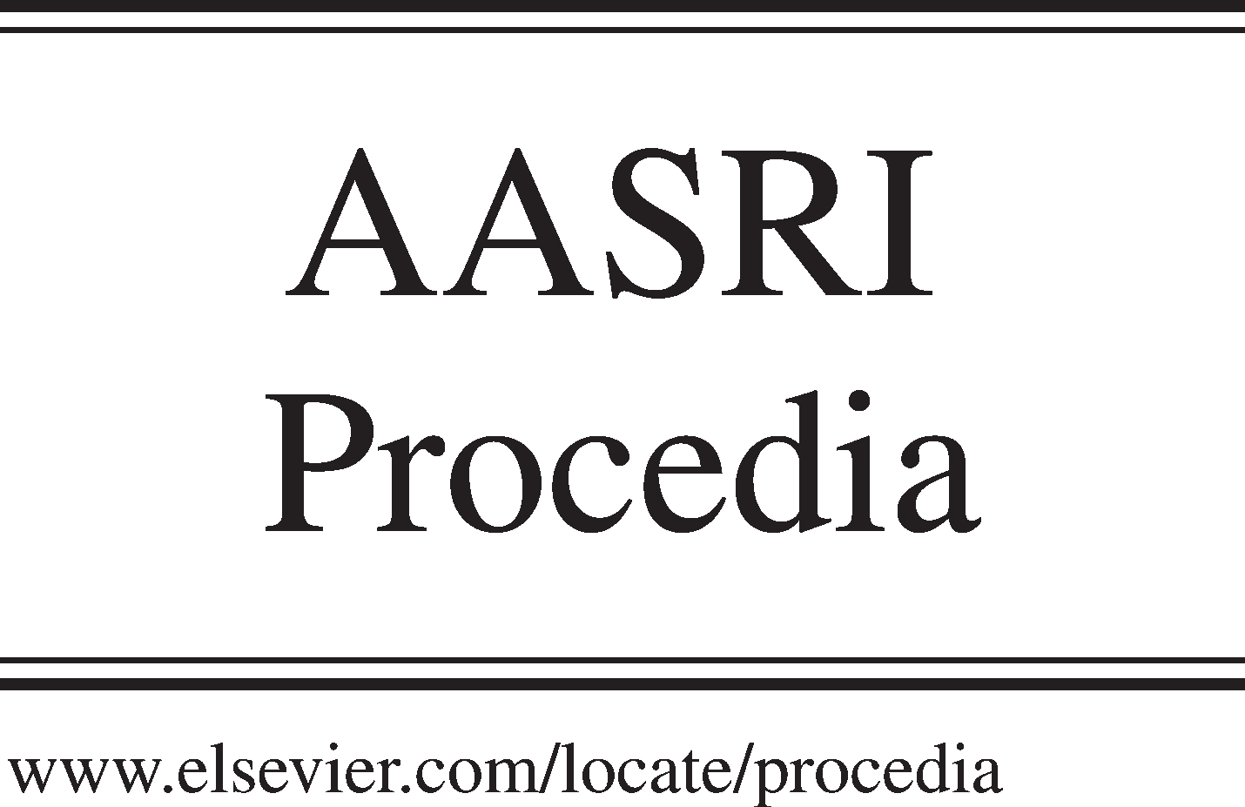Available online at [www.sciencedirect.com](http://www.sciencedirect.com/)

**ScienceDirect**

AASRI Procedia 4 (2013) 118 – 124

2013 AASRI Conference on Intelligent Systems and Control

Qualities of Interest for Spontaneous Networked Organizations

Saad Alqithami* , Henry Hexmoor

*Department of Computer Science, Southern Illinois University, Carbondale, IL 62901, USA*

**Abstract**

In spontaneous networked organizations, or any dynamic open organizations, autonomous agents must interact among themselves to achieve their goals. Agents usually interact, with which they have no experience, due to the scale and dynamism in these organizations. Each agent must, therefore, achieve certain qualities of interests in order to be capable of amalgamating fast. In light of this, we construct qualities of interest for a spontaneous networked organization. Theoretical aspects will be described including social harmony, coherence and spontaneity and their effect on the interaction process among agents inside such a collaborative organization. This study helps to improve the social capital of any networked organization.

© 2013 The Authors. Published by Elsevier B.V. Open access under [CC BY-NC-ND license.](http://creativecommons.org/licenses/by-nc-nd/3.0/)

© 2013 Published by Elsevier B.V.

Selection and/or peer review under responsibility of American Applied Science Research Institute

Selection and/or peer review under responsibility of American Applied Science Research Institute

*Keywords: Social network; Organizations; Social capital; Collaboration; SNO*

# Introduction

We are witnessing increased interest

in cross-organization service-oriented

computing that aims to

amalgamate computational resources dynamically across organizational boundaries. An ad hoc organization of networked organizations may form to rally around a specific problem suggested by an agent. A model of such an ad hoc organization was introduced in [1] as spontaneous networked organizations (SNO). We aim to further define SNO in this paper by exploring qualities that help elaborate nature of a SNO.

* Corresponding author. Tel.: +1-202-468-8498; fax: +1-618-453-6044.

*E-mail address:* [alqithami@siu.edu.](mailto:alqithami@siu.edu)

2212-6716 © 2013 The Authors. Published by Elsevier B.V. Open access under [CC BY-NC-ND license.](http://creativecommons.org/licenses/by-nc-nd/3.0/) Selection and/or peer review under responsibility of American Applied Science Research Institute doi:10.1016/j.aasri.2013.10.019

Considering social capital may transcend issues surrounding heterogeneity of agent affiliations. When a SNO generates positive social capital, constituent agents gain benevolence and behave in trusting manner. Agent based modeling is suitable to explore scenarios through simulation that include the skills of the boundary and the rules for interactions in the agents’ mechanism. They have to be compared according to their impact on some sustainability signs of a SNO, a wide range of collaboratively generated organization maintain by agents, who share affinities and possess similar objectives or ideologies that are socially connected via social online mediums, spontaneously decide and act locally. This work develops the idea of controlling a

SNO

through multiple measurements, such as social

harmony, cohesion and

spontaneity,

for that the

predictions are not sensitive to the absence or failure of any one of these measurements.

This article captures general qualities of the SNO. This amounts to transforming what was intended to be a traditional organization into a spontaneous more elaborative one. We have developed a set of lightweight qualities of interest among agents inside the SNO. This method works by capturing types of interaction and their effect on the social capital inside SNO. The remainder of this article is structured as follows. Section 2 presents our methods for generating prototypical SNO. Section 3 evaluates the spontaneously generated connections by presenting the way of computing the three qualities of interest. Further description of these parameterizations is in section 4. We finally present related work in section 5, and conclude in section 6.

# SNO MODEL

When agents dwell in an open social environment, they are interconnected through their communication

links whether implicitly or

explicitly. Thereby, they

inform one

another of

pertinent events of their

environment, which we define as a Bayesian game. With each communication, agents update their information partition to be more consistent with one another and to closer approximation of actual state of the Bayesian game. SNO assumes agents or the leader of the organization operates with incomplete information about the environment. Since decisions are made locally, exchanges of information produce locally consistent partitions

that

are adequate for rational decision making. This

uncertain nature of partial information about the

environment is a radical departure from traditional organization models.

The salient properties that set SNO apart from other organizations are: a. Openness, b. Evolving charter, c. Selfish allegiances and community social power, and d. ad-hoc network topology. A SNO can be a small team of two or more agents working on a common, quick goal that is possibly faster than human perceptual threshold or a collection set of agents working on long term objectives that are possibly beyond a single human cognitive capacity. SNO is inspired from the ongoing change in the world, such as the Arab Spring, to illustrate a new type of online organizations. This new type facilitates the modeling of spontaneous exigencies of a networked organization that account for rapid rates of dissemination in ad-hoc networks. The SNO has a live cycle that starts from formation until dissolution going through different stages like viral spreading, bifurcation, steadiness, etc. In particular, the SNO has a structure (i.e., leadership, designer, coordinator, and a set of agents) that helps it to assign tasks. These stages are depicted in Figure 1.

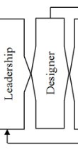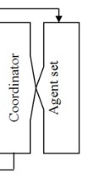

Figure 1. the life cycle of a SNO

Leadership

Designer

Coordinator

Agent set

As known in any social networks, agents perform actions, which in order produce different types of connections. These actions have more impact on a broad range virtually than in the real life. This is because these spontaneous actions that the agents perform are not usually linked in the organization with a sorted type of structure, such as hierarchy, holarchy or others. In light of this, a SNO becomes the best fit to describe such style of organizations. Further attributes contributing to this type of organization are characterized by describing salient qualities of interest in order to measure the quality of interactions and their effect on the social capital of the organization.

# Qualities of interest

There are many simplified features that have been used in order to study the structure of existing organizations [9][10]. Nevertheless, these proposed features lack the presentational power of representing the SNO. Therefore, we propose three important qualities of interest in order to measure the structure of the SNO, in this section. These properties are social harmony, cohesion, and spontaneity.

* 1. *Social harmony:*

For a SNO, social harmony is an important attribute. Social balance exists when relationships among a group in a social network are congenial [7]. Heider in [7] presented a theory that suggests certain combinations of relationships are harmonious whereas others are not. For example, two pairs of friends who may have a pair of enemies produce an imbalance.

**Definition 1:** *social harmony is the balanced state of the existing connections among agents to the total connections inside the organization.*

Since SNO is formed with like-minded individuals, we assume a nontrivial degree of social balance. Imbalanced relationships are divisive and fall apart. In contrast, balanced relationships lead to increased positive interactions that will lead to strengthening dyadic ties, and new positive ties. Therefore, SNO will function better with greater balance. A balance metric is suggested in Equation 1.

*(1)*

Here    donates the number of balanced interactions (i.e., triadic balanced interactions in Heider style analysis) in SNO while    donates the total number of interactions in the whole SNO.

* 1. *Cohesion*

Cohesion is another important property for organizations as well as societies [5]. For an organization, cohesion is produced by repeated interactions in the group to measures triadic closure in a sociogram that is a graph or any other measures (aka, clustering coefficient).

**Definition 2:** *The cohesion of the organization can be reach by frequent connections among the agents through bonding or bridging.*

Cohesion can be measured with 1) a bonding metric [13]. Bonding measure in SNO is proportional to social capital.

*(2)*

In equation 2,  is the length of total vectors (  ) that has been formed through the agents’ connections (i.e. triangle paths in the graph,) and  is the length of two paths (. 2) When the group size is large enough to have disparate units, it becomes important for an organization to have connections among

these units measured by the *bridging* metric 3.

*(3)*



Here,  is the betweenness measure that is averaged over all agents. Betweenness is the number of shortest paths from all vertices to all others that pass through that agent [13]. It can be calculated for the agent  using the following expression, where  is starting point,  is ending point of the network and  is the number of those paths that pass through :

*(4)*



* 1. *Spontaneity*

Actions of an organization are largely in response to interactions with sources outside the organizations that are external stimuli (i.e., reactions denoted with ) where the organization attempts to achieve its goals with actions. However, a proportion of actions are strictly generated from internal decision making relying on internal interactions (i.e., internal actions denoted with ).

**Definition 3:** *Spontaneity property a SNO lies in its propensity to initiate unprovoked actions. We take this to mean the SNO is generating internal initiative and plans to promote independent agenda.*

Spontaneity metric (i.e., ) is suggested that measures the ratio of internally provoked actions over all actions in the organization. All networked organizations may exhibit spontaneity as the need arise.

*(5)*

The use of these properties is beneficial to refine study the SNO. However, each one of them has different characteristics that have to be identified in order to be measured inside the organization. The structure of the organization may change depending on the different percentage they have that differ from 0 to 1, on which it has a huge impact. We discuss more about these measurements in the following section.

# Functionality of the Parameterization

After proposing the three main qualities of interests, we simplify the functionalities of them by exemplify their effect on the organization. The following, Figure 2, will present more description.



+ +

+ -

+ -



a. Social harmony =1 b. Cohesion =1 c. Spontaneity =1

Figure 2. The notion of capturing three key properties, with the maximal or near-maximal values of their associated parameters

In Figure 2a, presents a structure where the social harmony is highest among the agents, which we presented as network nodes. The positive or negative signs present the type of social harmony whether balanced or not-balanced. We assume that the social harmony is equal to 1 when the network is balanced, as exemplified in our earlier discussion. Figure 2b shows two types of cohesion, where the solid line presents the bridging and in contrast the dashes present the bonding. The cohesion is equal to 1 when the organization has a fair amount of interactions whether inside through bonding or with outside the organization through

bridging. Spontaneity, as in Figure 2c, links different type of agents who may behave irrationally, where the different shapes in the graph state the different kinds of agents, actions, or future interest. It can be satisfied and presented by 1 when any of the agents link with another type. All these qualities of interest differentiate from 0 (minimum) to 1 (maximum). Any organization may reach the maximum value when it is in the full functionality of these qualities of interests.

The SNO has been deliberated here since the leadership does not have a huge impact of its functionality. In fact, leadership and connections are inversely related to many open social environments, Equation 6.





Thus, leadership affects more than the social harmony among the agent to further impacts the cohesion of the organization. Spontaneity indicates that separate agents may have implicit communications with one another indirectly based on shared affinities or interest. In various ways, these parameters help to measure the social capital discussed next.

# Social Capital

S*ocial capital* (SC) in the network can be defined as the cooperative nature of agents who belong to myriad networked organizations who operate independently yet in unison from their organizational origins when they perform actions together. In other words, it can be characterized as the collocated or virtual collaboration to produce successful outcomes and successful connections [2]. There are two major perspectives on SC in networks. In the macroscopic perspective, SC for the entire network is considered. In this view individuals do not incrementally add to the system or withdraw units of SC. Instead, the foci are on the system principles like norms and conventions that provide resources for overall social welfare. In contrast, the microscopic perspective, adopted here, explores how individuals can gain access to resources by their positions and connections in the network.

Definition 4: Social capital in a link is measured from accumulation of positive values of social flow and *trust plus abundance of communication over the common topic of SNO. At this point we treat all three attributes equally*.

The previous definition captured a few main elements of the SC, which have a proportional relationship to one another. Topologically speaking, high bonding rates provide more opportunities for interaction and growth of social capital. However, network structure by itself is inadequate for determination of SC. We must examine the contents of interaction and dispositions that create social forces that attract or repel individuals. At the level of a single link, the nature of social flow in the link leads to accumulation of SC. Social flows can be benevolent and positive or negative and lack benevolence. Whereas positive flow leads to net positive gain in SC, negative flow leads to loss of SC. Apart from social flow; dyadic ties may harbor trust or promote distrust [6]. Trust supports SC whereas distrust erodes SC. If the topic of interaction between the pair is centered on the main problem for the SNO, that link positively contributes to SC. In sum, flow, trust, and topic are link attributes that are proportional determinants for SC.

# Related work

There have been numerous discussions of network qualities for organizations [12][3]. Although relevant to qualities we discuss herein, much of literatures prior to 2010 are applicable to human organizations and there is no clear migration connection to online organizations targeted by us. Social networks can be considered as a useful tool to describe the interaction in online organizations. Online organizations typically connect with each other through different types of ties that in sequence will affect the social capital of each one of them.

There are two types of connections among the agents, which are implicit and explicit. Implicit affinities

*(6)*

can be seen inside the organization where the member has more than one interest to share. However, if any of those members has a connection with any other members of another organization, this connection will immediately be considered as explicit affinities, as proposed by [11]. These types of connections have studies various social networks structures. Even though bonding and bridging must exist together or not at all, bonding, however, refers to homogeneous clusters while bridging refers to heterogeneous clusters. Bonding helps to enlarge the organization to have more focus of the attentions and to oversimplify the efforts. Conversely, bridging helps the organization to further extension of the organization to be able to reach more others in order to take advantage of on jointly valuable collaboration.

Macindoe and Richards [8] propose three features of leadership, bonding, and diversity to compare organizations for their network topology. They called it “the network’s fine structure”. To judge the similarities between networks, they developed a technique of graph edit-distance to explore the use of hierarchical clustering on several networks based on a variety of sources including social interaction data. In interaction, the distance among agents can affect cooperation and persuasion negatively. These problems can be overcome by successive connections among the agents. The effect on the agents’ sociality is the combination of the ties among them as well as both physical and sequential distance [4]. Thus, the interaction style can affect the outcome performance and process in the organization.

# Conclusion

In open environments, such as the environments envisioned for SNO, agents are integrated dynamically across their organizational and geographical boundaries, to justify each other needs. Thus, SNO model should adapt dynamically to changing circumstances by improving the social harmony, coherence and spontaneity to encounter both agents and organization goal. In light of this, the paper has been argued that the agents amalgamate better in the SNO while in traditional organizations lack the potential power to adopt some of these properties of interaction. In particular, such agents must be able to assess these measurements with their peers, so that they will maintain a sense of continuity toward the goal of their organization.

# References

1. Alqithami, S. and Hexmoor, H. (2012a), Spontaneous organizations: Collaborative computing model of a networked organization, In *the 8th Int. Conf. on Collaborative Computing: Networking, Applications and Worksharing,* 643-650.
2. Alqithami, S. and Hexmoor, H. (2012b). Social Capital in Virtual Organizations, In the 4th International Conference on Intelligent Networking and Collaborative Systems, pp. 682-687, Bucharest, Romania.
3. Anderson, Brigham S., Carter Butts & Kathleen M. Carley, (1999). The Interaction of Size and Density with Graph-Level Measures” to Social Networks. In Social Networks. 21: 239-267, Springer.
4. Bradner, E., & Mark, G. (2002). *Why distance matters: effects on cooperation, persuasion and deception*. In *the 2002 ACM conference on Computer supported cooperative work* , 226-235.
5. Chidester, D., Dexter, P., James, W., (2004). What Holds Us Together: Social Cohesion in South Africa, Human Sciences Research Council.
6. Fukuyama, F. (1995). Social capital and the Global Economy, in Foreign Affairs, vol. 74, No. 5, pp. 89- 103.
7. Heider, F. (1958). The Psychology of Interpersonal Relation. John Wiley & Sons.
8. Macindoe, O., Richards, W. (2011). Comparing networks using their fine structure, In Int. J. Social Computing and Cyber-Physical Systems, Vol. 1, No. 1.
9. Newman, M. E. J. (2003). The structure and function of complex networks, SIAM Review, Vol. 45,

pp.167–256.

1. Richards, W. and Wormald, N. (2009). Representing small group evolution, In *IEEE Conf. on Social Comp.*, p.232.
2. Smith, M., (2008). Social Capital in Online Communities, in PIKM 2008: pp.17-24.
3. Tichy, N. and Fombrun, C. (1981). Network Analysis in Organizational Settings, In Human Relations, 32(11), 923-965, Sage Pub.
4. Wasserman, S. and Faust, K. (1994). Social Network Analysis: Methods and Applications, Cambridge Univ. Press.