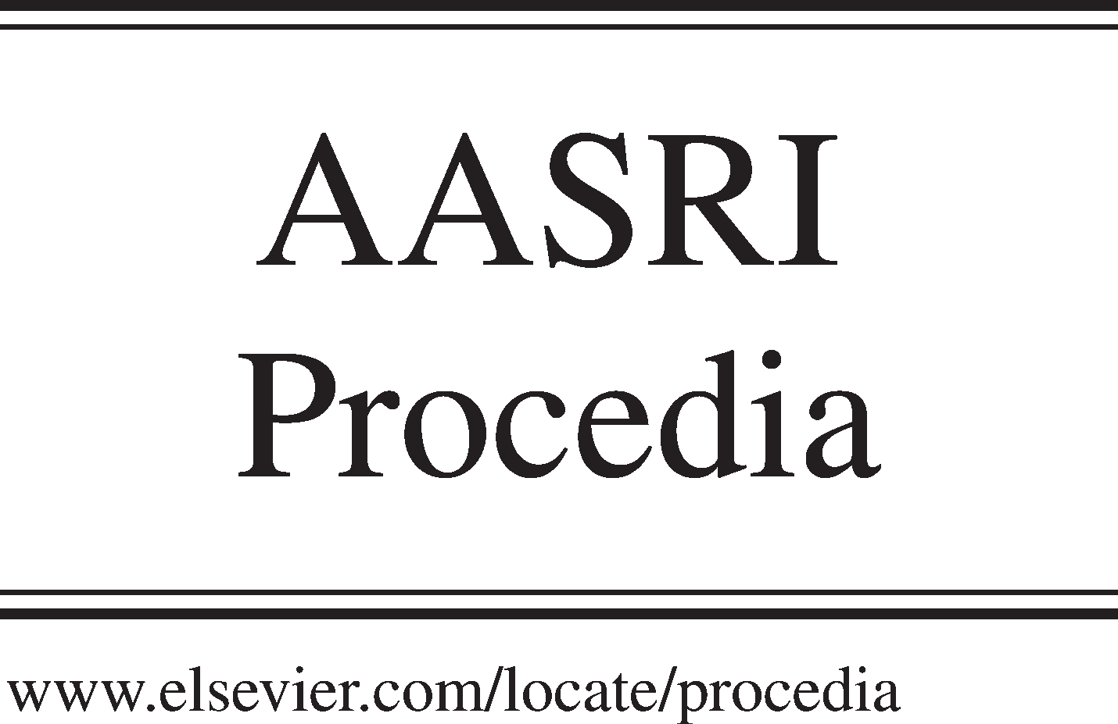Available online at [www.sciencedirect.com](http://www.sciencedirect.com/)

**ScienceDirect**

AASRI Procedia 5 (2013) 21 – 31

2013 AASRI Conference on Parallel and Distributed Computing and Systems

Research of AODV Routing Protocol for Ad Hoc Networks1

Sheng Liu, Yang Yang, Weixing Wang

*School of Information Engineering, Chang’an University, Xi’an, 710064*

**Abstract**

Firstly, this paper describes the basic characteristic, key techniques of Ad Hoc networks, and compared with other mobile communication systems. Through analyzing and comparing with DSR, TORA, ABR, AODV, it researched on-demand routing protocol for Ad Hoc networks. It introduces AODV routing protocol in details. It presents an optimized protocol: B-AODV, based on the shortage of routing finding and routing repair of AODV. In B-AODV, first through reverse request by sending BRREQ replace of RREP, it reduces the time of routing finding. Second, two hops IP record in control messages and route table can improve the rate of routing repair and reduces the times of routing findings. And it improves the function of Ad Hoc network. This simulation experiment is based on NS2 and compared the performance of AODV and B-AODV. And it compared the differences of control packets, ratio of packets, end to end delay for AODV and B- AODV. It shows that B-AODV is better than AODV.

© 2013 The Authors. Published by Elsevier B.V. Open access under [CC BY-NC-ND license.](http://creativecommons.org/licenses/by-nc-nd/3.0/)

© 2013 The Authors. Published by Elsevier B.V.

Selection and/or peer review under responsibility of American Applied Science Research Institute

Selection and/or peer review under responsibility of American Applied Science Research Institute

*Keywords:*Ad Hoc Network, on-demand Routing, AODV

In recent years, the research of routing protocol for Ad Hoc Network[1] has caused public concern widely. Based on the multi-hop[2] characteristic of Ad Hoc, the classic routing protocol has failed to meet the needs of the unpredictable and frequently network topology. The Ad Hoc routing protocol must maintain timely and

* Corresponding author. Tel.: +0-139-91256322

*E-mail* [*address:*thgpc@163.com.](mailto:thgpc@163.com)

2212-6716 © 2013 The Authors. Published by Elsevier B.V. Open access under [CC BY-NC-ND license.](http://creativecommons.org/licenses/by-nc-nd/3.0/) Selection and/or peer review under responsibility of American Applied Science Research Institute doi:10.1016/j.aasri.2013.10.054

restructure routing, and it must consider the bandwidth and high error rate. As the other network routing protocol not meet, the new routing protocol suitable for Ad Hoc Networks is needed designing.

# AODV protocol

* 1. *Introduction of AODV protocol*

AODV(Ad hoc on-demand distance vector routing) is a Source drive type[3] routing protocol. When a source node sent message to a target node without the routing, it sent RREQ first. When the adjacent node received RREQ with the addresses of source node and target node, it judged if it was same with the target node’s address. If it was, sent RREP to source node, otherwise, checking the routings in the rout table that could reach the target node, then send RREP to source node, or continue to flooding send RREQ. AODV protocol can maintain routing nodes through broadcasting hello message regularly. If one link break, it sent ERROR message to nodes, meanwhile deleted broken records or repaired the routing.

* 1. *The shortage of AODV[4]*

AODV protocol created the routing between two nodes in the network based on route discovery and route maintenance.. In the route require process, it broadcasted RREQ message to target node in the form of flooding; In the route response process, target node preferentially chose the first-arrived RREP and sent RREP message. As the node strenuous exercise during finding routings, the route was easy to break, which would lead to the loss of RREP packet. In the routing maintaining process, the broken node would discard error packet and notice the source node to resend request message when broadcasting RERR packets, which would lead time delay of subsequent packet; in order to eliminate loopback caused by new touring, local repair may cause that the RREP sent by downstream node could be discarded, which reduced the probability of routing recovery. In addition, despite with routing maintenance mechanism, the node is mobile, the route may not be repaired timely or failed to repair, which reduced the utilization of network control information, and could increase the routing delay, thus affecting the performance of the network..

# Design of B-AODV protocol

For the shortage of AOFV protocol, a better protocol is needed to avoid route breaking, reduce message lose rate and decrease network delay. An improved approach B-AODV based on AODV was designed, assuming that the network link was bidirectional, that was the source node and the destination node could reach each other through one route .

* 1. *Routing construct*

For AODV, if a node moved fast, in the reverse routing it may cause the loss of packets when RREP sent reply message through unicast, and RREP unicast back to the source node, so in the B-AODV, a control message B-RREQ similar to RREQ was devised when the reverse route was built. The source node also undertook the task of routing discovery as the target node, and after receiving RREQ it reversely sent flooding B-RREQ message to find the source node,. When the source node got first B-RREQ, it started to transmit data, and recorded the information of both front and next two-hop nodes in RREQ and B-RREQ for rapidly rebuilding routings.

The route discovery process was detailed as following. When the source node had no routing to the destination node and had to send data to the destination node, it broadcast RREQ message to neighbors. The RREQ message’s format was shown in table 1.

This format added front and next two-hop nodes addresses, that showed RREQ recorded not only the addresses of the current node's neighbours but also that of two-hop nodes. When one node broadcast RREQ control message, the counter of RREQ added 1 automatically. The source node IP address and RREQ ID could uniquely identify a RREQ control message. A node checked ID when receiving same RREQ control message, if that were the same, one of that was discard. This process was completely same with AODV. After getting RREQ, the intermediate node compared with its own routing information, and updated the related information in the routing table, thus relevant bytes were added: front and next two-hop nodes' addresses. The format of routing table is shown in table 2.

If the intermediate node had no routing to target node, it continued to sending RREQ and constructed reverse routing. When RREQ packet reached the target node, the target node created a packet B-RREQ similar to RREQ. Table 3 showed the B-RREQ message format.

Tab.1 message format of RREQ Tab.2 New Routing table Tab.3 B-RREP message format

Type Reserved Hip hop RREQ ID

Type Reserved Hip hop RREQ ID

Target node IP address

Next one-hop node address Front one-hop node address

Next two-hop node address Front two-hop node address

Next one-hop node address Front one-hop node address

Next two-hop node address Front two-hop node address

Target node serial number

Target node serial number tag Next one-hop node address Next two-hop node address

Source node IP address

Source node serial number Target node IP address Target node serial number

Source node IP address of RREQ Source node serial number of RREQ

Routing request time

Source node IP address

Source node serial number Target node IP address Target node serial number

Source node IP address of RREQ Source node serial number of RREQ

Routing reply time

Front one-hop node address Front two-hop node address Hop number

Lifetime

Front two-hop node address

Having created B-RREQ, the target node broadcast it to neighbor nodes immediately, same with the process that the source broadcast RREQ, which is to build reverse routing. When the intermediate node received the packet, it would check there was the same packet or not, if it was yes, then the same packet would be discarded. Otherwise it would be sent to neighbor nodes. The neighbor node received the packet, recorded the addresses of next and front two-hop nodes, and set the routing lifetime until it got the target node. The source node transmitted data immediately when receiving first B-RREQ. The routing reply process was shown in figure 1.

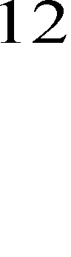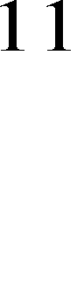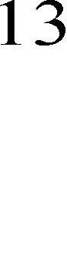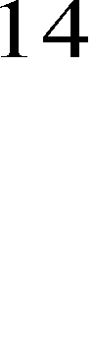

Fig.1 Send B-RREQ

Unlike that RREP returned to the source node with one-hop and unicast, as Rĺ4ĺ3ĺ2ĺ1ĺS, in B- AODV, B-RREQ was broadcast with many routings to choose, Rĺ5ĺ6ĺ7ĺ8ĺ9ĺS,Rĺ14ĺ13ĺ12ĺ11ĺ10ĺS and so on. The source node S could transmit data in a routing with most energy. The problem that RREP often lost as the intermediate nodes moved in AODV can be solved.

The routing discovery flow was shown in figure 2(a),(b).

If the node was found

Y

N

N

If there was the routing from Its next one-hop node to target node

Y

The upstream node sent RREQ to find routing to target node

N

If the routing was broken

Y

RREQ from upstream nodes can reach intermediate node of next two-hop nodes

Continue to send data

Transmit data

The intermediate node

replied RREP, and built routing

If the node was found

Y

N

If there was the routing from Its next one-hop node to target node

N

Y

The upstream node sent RREQ to find routing to target node

If the routing was broken

N

Y

RREQ from upstream nodes can reach intermediate node of next two-hop nodes

Continue to send data

Transmit data

The intermediate node

replied RREP, and built routing

(a) (b)

Fig.2 Send RREQ of B-AODV

* 1. *Control routing message computation*

In B-AODV, it seems that routing overhead was added for sending B-RREQ, however, it was reduced indeed by proving.

A network environment was set here:

There were N nodes in the Ad Hoc network;

In the AODV protocol, the number of transmitting control message during routing discovery was AONV(N);

In the B-AODV protocol, the number of transmitting control message during routing discovery was B- AONV(N);

Assuming that there were m nodes transmitting message during routing discovery, as the AODV protocol

says, if the first routing discovery was right, the routing node number of transmitting control message is:

*AODV(m)=m-1+t (1)*

Where, t is the number of nodes transmitting routing reply message.

If there was more than 1 time during routing discovery in AODV, then it should be:

*AODV(m)=c(m-1+t) (2)*

Where c meant the number of routing discovery process.

If data transmitted following B-AODV, there was at least 1 stable routing to be found to transmit data during routing discovery, so only 2m-2 nodes were deeded to transmit data:

*B-AODV(m)=o(2m-2) (3)*

From this we can draw the conclusion: when c>1, AODV protocol produces much more Routing overhead in the routing building process.

* 1. *Routing maintenance*

Shown in figure 3, in the AODV algorithm, if the link between nodes 2 and 3 had been broken, node 2 need to repair local routing, send RREQ, and find routing to the target node R. RREQ was forwarded to node 4 through node F, until reaching node R, then R replied RREP back to node 2 along the reverse routing. Thus a new effective routing was built. If routing repair failed within certain repair time, it sent RRER message to source node, and the source node resent RREQ to find routing.

In the new algorithm, each routing table maintained the addresses of adjacent two-hop nodes, when the next node 3 in the routing table that it would arrive to target node lost effectiveness, meaning that the routing was invalid and it need local repairing. Different from the AODV, node 2 didn’t wait for the RREQ message of target node R, as next two-hop nodes’ addresses were initially recorded in the routing table, node 2 looked for the next two-hop node 4, then 2 sent RREQ message to node 4. When RREQ reached node 4 through F, meanwhile node 4 owned active path to target node, so node 4 could send RREP directly to node F, then node

2. Thus a valid routing from node 2 to node R was built, as shown in figure 3.



**1**

**2**

**3**

**4**

**S**

**F**

**R**



**1**

**2**

**3**

**4**

**S**

**H**

**R**

Fig.3 Routing repair: find 2 and 4,build new routing Fig.4 Routing repair:find 2 and 3,build new routing

If there was no common neighbor node between node 2 and 3, shown in figure 4, node 3 could not escape next-hop range of node 2. So node 3 was likely to be one of node 2’s next two-hop nodes. In this case, after receiving RREQ from node 2, node H found that there was no node 4 but node 3 in its neighbors, then node H sent RREP to node 2, aiming to notice that it was the common neighbor node with node 3, thus node 2 would rebuild a new routing through node H and 3 to the target node.

If the node 3 and the node 4 lost efficiency, shown in figure 5, node 2 sent RREQ finding the target node R, to find new routing of broken path; if routing discovery failed, node 2 sent RRER to neighbor nodes until back to source node S, S resent RREQ to start a new round of routing discovery, which was same with AODV protocol. Due to the movement speed of nodes was limited, there will be less in reality. This reduced the cost of routing maintenance as well as routing delays.

If the case was special, node 4 was the target node, completely same with original AODV algorithm, it sent RREQ to find the next two-hop nodes, i.e. the target node. When node 3 being the target node, send RREQ do find the target node directly.

Above that, the downstream neighbor nodes of the fracture was more closer than the target node to the upstream nodes of the fracture, so the finding speed would be faster, that was to say, the finding time was shorter than AODV routing algorithm, so the new protocol is more optimized.



**M**

**1**

**2**

**3**

**4**

**S**

**M**

**R**

Fig.5 Routing repair failure: the next two jump node is invalid

* 1. *Time of routing recovery*

Set the time sending RREQ to the target node 4 and replying RREP to be S1, the time from sending RREQ to the target node R and returning RREP to be S2, it can be known from above narrate[5]:

*S* 1  *S* 2 (when node 4 was same with node R , the equation was valid) *(4)*

Set the probability tha2t a node was not valid to be p (p<1), then the probability of both nodes at the same time were not valid as *p* , one node was not valid while another node was valid with a probability of p (1-p)

For AODV routing algorithm, when node 3 was invalid, the time node 2 refound routing was:

*S(AODV)=S2*  *p (5)*

For the improved B-AODV routing algorithm, when node 3 was invalid, the time node 2 refound routing was:

*S(B-AODV)=Sl*  *p*  *(1-p)+ S2*  *p2 (6)*

From (6)-(5),

*S(B-AODV)—S(AODV)=p (1-p)*  *( Sl – S2) (7)*

From the above, (7)<0, that is , compared to AODV, the finding time of the improved algorithm was much shorter, and node 3 was much more closer to node 2 than node R, thus the required time would be shorter.

# Experimental analysis

The performance of the routing protocol depended on[6]: the Routing overhead, the ability to send packets, the delay from node to node and the packet posted success rate, etc.

Moreover different scenes had a big impact to the routing protocol. Same routing protocols in different simulated scenarios, its routing performance also had a great deal of difference. The main factors of the ad hoc network scenes: the number of network nodes, the changing speed and the movement speed of the network. Therefore, when comparing and analyzing different routing protocols, the network scene must be taken into account.

The simulink environment here was: windows xp+fedora core4+NS2. 29.

* 1. *Set network parameters and configure main parameters of routing protocol*

Set network parameters as following:

The number of nodes: 10,20,30,40,50; the simulink environment: 1000m*1000m; the node’s communication range: 250m; the node’s movement speed: 0~MAXSPEED.

The maximum speed respectively: 2,5,10,25,50,75m/s; radio model: Two-Rav; network service: CVR service flow; MAC layer model: 8.2.11; packet sending rate: 8packets/s.

* 1. *Performance indicators of routing protocol*

Performance indicators of routing protocol were as follows[7][8[9]:

* + 1. Successful packets posted rate

*successful packets posted rate =*

*(number of sent packets – number of discarded packets) / number of sent packets (8)*

* + 1. Average delay from node to node

*Average delay from node to node =*

1 *N*



*N i*1

*rti*

− *sti*

*(9)*

Where N represented the number of successfully-transmit packets, rt was the time of packets reaching the target node, st was the time of packets being sent.

* + 1. Routing overhead

Routing overhead can compare adaptation capacity and efficiency of different routing protocols. The formula was:

*Routing overhead = total number of routing control packets (10)*

* 1. *Results analysis*

Through the simulation of AODV and B-AODV, compare their performance in the number of nodes and maximum speed of node movement.

* + 1. Packet delivery ratio

1. Packet delivery ratio of different nodes

Ratio(%)

Fig.6 Packet delivery ratio comparison of different nodes

90

80

70

60

50

Number of Nodes

80

70

60

50

40

30

20

10

0

40

AODV B–AODV

1. Packet delivery ratio of different speeds

Ratio(%)

Fig.7 Packet delivery ratio comparison of different speed

95

90

85

80

75

70

65

60

55

80

70

60

50

40

Node Max Speed

30

20

10

0

50

AODV B–AODV

From figure 6, it can be seen that the packet delivery ratio of the improved protocol was almost same with that of the original protocol when there were less nodes, for which the probability of routing repair was low after the routing broke. When there were much more nodes, the delivery ratio cut down obviously, for which with more nodes, the nodes moved frequently thus the probability of routing breaking was higher.

From figure 7, the speed faster, the packet delivery ratio lower. Obviously, when the nodes moved with high-speed, packet loss would increase. However the packet delivery ratio of B-AODV was seriously higher than that of AODV.

* + 1. Average delay from node to node

a Average delay from node to node of different nodes b Average delay from node to node of different speeds

0.4

0.35

0.3

0.25

0.2

0.15

0.1

0.05

Number of Nodes

80

70

60

50

40

30

20

10

0

0

B–AODV AODV

Dalay(s)

Fig.8 End-to-end delay of different nodes

0.6

0.5

0.4

0.3

0.2

0.1

Number of Nodes

80

70

60

50

40

30

20

10

0

0

B–AODV AODV

Dalay(s)

Fig.9 End-to-end delay of different speed

The delay of B-AODV was lower. Because for the original protocol the RREP reply must be limited during routing finding, on the other hand, when the routing broke, AODV must send RREQ to the target node then rebuild routing through returning RREP, however for B-AODV, it only sent RREP to the front two-hop nodes then built forward routing, so the delay would be lower.

* + 1. Routing overhead comparison

Control Packets

Fig.10 Routing overhead

8000

7000

6000

5000

4000

3000

2000

1000

0

0

10

20

30

40

50

60

70

80

Number of Nodes

B–AODV AODV

From figure 10, when there were less nodes, the numbers of two control packets were similar, but when the number of nodes added, B-AODV protocol was clearly optimized than AODV protocol.*.*

# Conclusion

Some of the features in the Ad Hoc network increase the difficulty of routing technology, such as ad-hoc, multi-hop as well as the variability of the network structure, so the key to designing Ad Hoc routing protocol is to solve the problem that fast node movement makes complex changes in network structure. On the basis of the comparing and analyzing AODV routing protocol, this article introduced an improved B-AODV protocol, which ameliorated the routing finding and local repair for rebuilding new routing. The new protocol improves the routing repair capacity and packet successfully-posted ratio, reduces the delay from node to node, and decreases the routing overload. Nonetheless, the nodes in the network do not only have a two-way link, the single link protocol optimization is the goal of future research.

# Acknowledgements

The National Natural Science Foundation of China (61170147).

# References

1. Y.Kim,J.Jung,S.Lee,C.Kim,A Belt-Zone Method for Decreasing Control Messages in Ad Hoc Netowkrs.ICCSA.2006:42-46.
2. Ankit Sggarwal, Bhumika Garg. Survey on secure AODV for Ad Hoc networks routing mechanism. J International Journal of Advanced Research in Computer Science and Software Engineering, 2012;2(3):203- 206.
3. L. Abusalah, A. Khokhar, and M. Guizani, A survey of secure mobile ad hoc routing protocols,. Commun. Surveys Tuts., 2008;10(4):78–93.
4. Marchang Ningrinla. Light-weight trust-based routing protocol for mobile ad hoc networks. J IET Information Security, 2012;6(2):77-83.
5. Kum Dong-Won. An efficient on-demand routing approach with directional flooding for wireless mesh networks. J Journal of Communications and Networks, 2010;12(1):67-73.
6. Nakayama Hidehisa, Kurosawa, Satoshi, etc. a dynamic anomaly detection scheme for AODV-Based mobile ad hoc networks. J IEEE Transactions on Vehicular Technology, 2009; 58(5):2471-2481.
7. Lee Breslau Deborah Estrin etc. Advances in Network Simulation. IEEE Computer,2000;5:78-85.
8. Wing Chung Hung, K L Eddie Law, A Leon-Garcia. A Dynamic Multi-Channel MAC for Ad Hoc LAN. In 21st Biennial Symposium on Communications. Kingston. Canada. 2002;7:132-138.
9. R. Choudhary, S. Bhandhopadhyay and K. Paul. A Distributed Mechanism for topology discovery in Ad Hoc Wireless Networks Using Mobile Agents.2000;(5):96-101.