[Array 3-4 (2019) 100010](https://doi.org/10.1016/j.array.2019.100010)

 

Contents lists available at [ScienceDirect](http://www.sciencedirect.com/science/journal/25900056)

Array

journal homepage: [www.elsevier.com/journals/array/2590-0056/open-access-journal](http://www.elsevier.com/journals/array/2590-0056/open-access-journal)

Response activation and inhibition after exposure to virtual reality

Shamus P. Smith a,*, Elizabeth L. Burd b

a *School of Electrical Engineering and Computing, University of Newcastle, Callaghan, 2308, Australia*

b *Academic Division, University of Newcastle, Callaghan, 2308, Australia*

A R T I C L E I N F O

*Keywords:*

Virtual reality

Head mounted display Exposure impact Reaction time

Human factors

A B S T R A C T

The widespread availability of affordable head-mounted displays and easy access to virtual reality (VR) appli- cations and games has significantly increased the use of such technology by the general public. Thus there is increasing interest in determining any risks of using such technology and any aftereffect from exposure. Head- mounted display manufacturers provide general usage guidance but this is ad hoc and there is limited recent evidence comparing early virtual environment studies with experiences from modern head-mounted displays. The primary objective of this study was to explore response activation and inhibition after participants experienced a typical virtual environment in a head-mounted display. Reaction times were collected with a robust cued go/nogo

test as pre- and post-tests. Participants (n ¼ 22, female ¼ 11) played Minecraft VR for 15 minutes using an Oculus

Rift headset. In contrast to other studies, the results showed no significant impact on reaction times across

response activation or inhibition. However, evidence of participant fatigue in the reaction time tests was found. This work confirms safe use of virtual reality experiences in modern head-mounted displays for short duration exposures and identifies issues with reaction time testing that are in need of further investigation.

1. Introduction

There is increasing use of virtual reality technology and the immer- sive experiences that such technology can provide. Much of this has been driven by the advent of affordable, commercially available virtual reality (VR) head-mounted displays (HMDs) [1]. HMDs encapsulate the visual senses and provide the user with altered, i.e. virtual, experiences. These experiences can be very realistic and many users experience states of presence and immersion [2]. However, a significant portion of the pop- ulation suffer negative effects from VR technology use, commonly referred to as cybersickness [3]. This can happen in situ and linger post usage. Cybersickness is associated with feelings of illness, discomfort, dizziness and unease [4]. With the widespread availability of VR tech- nology there is a need to quantify any negative impacts and consider health and safety implications [5,6], even for short exposures. Although there is considerable research on cybersickness, there has been less attention paid to the impact on behavioural control, inhibitory effects [7] and reaction time, or “speed of action” [8]. Our concern is the impact on post VR exposure activities that rely on such activation mechanisms for information processing, for example driving vehicles or cycling.

Inhibitory effects have been researched over numerous substance exposures, for example alcohol [7], cocaine [9] and energy drinks with

and without alcohol [10]. The current work explores HMD usage for immersive virtual environments as the exposure condition. Our research follows Fillmore’s protocol [7] with two primary measures of interest being participant’s failures to inhibit responses (failures of response in- hibition) and their speed of responding (response activation) after experiencing a short exposure (15 min) to an immersive virtual envi- ronment. The aim is not to define new HMD guidelines but to provide an evidence-based approach to measuring the impact of short duration HMD usage. Contributions of this work include (i) measuring HMD impact in a realistic real-world use of VR technology, in this case use of commercial off-the-shelf (COTS) hardware and software, and duration of use within VR manufacturers’ guidelines, and (ii) use of a robust reaction time test and protocol [7] to determine the impact of VR technology on activation mechanisms for information processing.

1. Background
   1. *Guidance on the use of virtual reality technology*

Currently there are no definitive recommendations for duration use of VR technologies and the makers of HMD technology note a variety of advice. Often recommendations are that users should limit their time in

* Corresponding author.

*E-mail addresses:* [shamus.smith@newcastle.edu.au](mailto:shamus.smith@newcastle.edu.au) (S.P. Smith), [liz.burd@newcastle.edu.au](mailto:liz.burd@newcastle.edu.au) (E.L. Burd).

<https://doi.org/10.1016/j.array.2019.100010>

Received 24 June 2019; Received in revised form 19 September 2019; Accepted 10 October 2019

Available online 16 October 2019

2590-0056/© 2019 The Authors. Published by Elsevier Inc. This is an open access article under the CC BY-NC-ND license ([http://creativecommons.org/licenses/by-](http://creativecommons.org/licenses/by-nc-nd/4.0/)

[nc-nd/4.0/](http://creativecommons.org/licenses/by-nc-nd/4.0/)).

HMDs and take frequent breaks. However, what constitutes a good “limit” is unclear as the impact of VR technology can depend on the technology used, the nature of the environment being experienced [11] and the physical, cognitive and emotional state of the user [4]. An ad hoc time guide of 15 minutes for initial exposure to new VR environments is typically used. Example guidance with common HMD technology include:

* Oculus Rift: “Ease into the use of the headset to allow your body to adjust; use for only a few minutes at a time at first, and only increase

the amount of time using the headset gradually as you grow accus- tomed to virtual reality.” “Take at least a 10–15 min break every 30 min, even if you don’t think you need it. Each person is different, so take more frequent and longer breaks if you feel discomfort. You should decide what works best for you.” [12].

* HTC VIVE: “Prolonged, uninterrupted use of the product should be

avoided. It may negatively impact hand-eye coordination, balance,

and/or cause other negative effects. While using the product frequently and for prolonged periods of time, you may experience tiredness or soreness in your muscles, joints, or other body parts. Take regular breaks from using the product. The length and frequency of necessary breaks may vary from person to person.” [13].

* Samsung Gear VR: “Ease into the use of the Gear VR to allow your

body to adjust; use for only a few minutes at a time at first, and only

increase the amount of time using the Gear VR gradually as you grow accustomed to virtual reality.” “Take at least a 10–15 min break every 30 min, even if you don’t think you need it. Each person is different, so take more frequent and longer breaks if you feel discomfort. You should decide what works best” [14].

* Google Daydream: “Take the time to get adjusted to the virtual reality

experience before using Daydream View extensively. Begin by using

Daydream View for only a few minutes at a time. Use that time to get adjusted to how the device reacts to your movements. As you become accustomed to the virtual reality experience, you can begin increasing the amount of time you use Daydream View. Take frequent breaks while using Daydream View. If you experience nausea, discomfort, eye strain, or disorientation, immediately discontinue using Daydream View. Each person reacts differently to virtual reality so you should base the frequency and length of breaks on what is right for you.” [15].

* Sony PlayStationVR: “Avoid prolonged use of PS VR. Take frequent

breaks.” “Avoid prolonged use of PS VR. Take a 15-min break during

each hour of play.” [16].

* 1. *Virtual reality exposure impact*

The negative impact of VR use has received the most attention in areas which traditionally had high use of the technology, for example virtual environment flight simulators and early VR entertainment cen- tres. In the former, many air force bases have mandatory grounding policies for pilots after virtual environment simulation use from 12 to 24 hours. In the later, VR entertainment centres often require users not to drive for at least 30–45 minutes after exposure [17]. However, the dif- ference between these two environments is the length of exposure time with entertainment users only spending minutes in the VR experience compared to potentially hours for pilots. However, the recent widespread availability of affordable HMD technology has increased public use and exposure to VR experiences.

The negative impact of engagement with virtual reality technology and virtual environments is typically considered in the context of cybersickness, which include symptoms of nausea, eye strain, pale skin, cold sweats, vomiting, disorientation, headache, increased salivation and fatigue [3,11,17].

Cybersickness as a result of HMD use has been an ongoing research topic (recent reviews on cybersickness include Davis et al. [11] and Rebenitsch and Owen [3]). Early work in this area also noted aftereffects

[18–20]. Stanney et al. [20] explored HMD-based VR exposure durations of 15, 30, 45 and 60 minutes and found that if a 95% HMD-based solution was required, virtual environment duration would need to be limited to less than 15 minutes. So and Lo [18] found that “In the absence of scene oscillation, viewing a stationary virtual environment for up to 15 minutes is not likely to cause a significant increase in the nausea level.” Although using significantly different technology, Virtual Research V6 with Virtual iO! Tracker [20] and VR4 LCD HMD with Polhemus FastTrack head tracking [18], these thresholds are similar to those promoted by current VR technology manufacturers.

Most cybersickness research measures the effect by use of question- naires, e.g. the simulator sickness questionnaire (SSQ) [21], postural instability [22], or more recently biometric and physiological states [23, 24]. Recent work has also explored impacts on cognitive performance [4, 24,25].

Nalivaiko et al. [24] and Nesbitt et al. [25] found a significant relation between reaction time and cybersickness. They found prolongation of simple reaction time of 20–50 ms after up to 14 minutes in a virtual re- ality roller-coaster (the 14 minutes was an upper limit on exposure as subjects could terminate the experience early due to nausea sensations). However, both these studies used intentionally provocative VR envi- ronments, i.e. roller-coaster simulations, to elicit cybersickness symp- toms; used environments that had limited interaction, e.g. the roller-coaster experience was “on rails” with only head tracking; used a relatively old HMD, in this case an Oculus Rift Development Kit 1 (DK1); and applied a simple 40 trial/2 minute reaction time test, i.e. the Deary-Liewald reaction time task [26].

Mittelstaedt, Wacker and Stelling [1] also found simple reaction times and choice reaction times deteriorated after VR exposure. They used the most recent Oculus Rift Commercial Version 1 (CV1) HMD and interac- tion was closer to realistic use with participants using either a physical bike ergometer (bike/HMD) or an Xbox One Controller (gamepad/HMD) for HMD conditions. The Deary-Liewald reaction time task [26] was used to collect reaction time data. Participants completed three 90 second biking tasks followed by a simulator sickness questionnaire (SSQ) symptom rating task. The participants spent a total of “about 10 minute in VR” [1].

In the work reported here, we have explored a more real-world, or ecological valid [27], use of VR HMD through the use of COTS hardware and software. This is representative of the more widespread use of VR HMD technology as might be found at a trade show, gaming convention, shop demonstration or causal home use. Our interest is in short duration (15 minutes) HMD use and exploring any inhibition impact or delayed response activation in this context. Thus the aim is to pair a real-world VR HMD interactive experience, across travel, selection and manipulation interactions, with a robust reaction time test.

1. Method
   1. *Participants*

Participants were recruited until 22 volunteers (11 female) completed the HMD task. Three additional male volunteers could not complete 15 minutes in the HMD and were excluded from the study (see the Results section). The 22 volunteers that completed the HMD task had a mean age

of 24.59 years (SD ¼ 5.05). All participants had normal or corrected to

normal vision with contact lenses. Participants with glasses were

excluded as some glasses frames do not fit under the HMD. The study was approved by the University of Newcastle Human Research Ethics Com- mittee (HREC #H-2017-0170).

* 1. *Apparatus*
     1. *Hardware*

The virtual environment was presented on an Oculus Rift CV1 HMD. The CV1 has two separately rendered displays with a screen resolution of

1080 × 1200 pixels for each eye and a refresh rate of 90 Hz. It allows stereoscopic vision with a 110◦ horizontal field of view. Head tracking is

integrated into CV1 use as the device includes an accelerometer, a gy- roscope, and a magnetometer, and is tracked with a constellation tracking camera.

The Oculus Rift and all software in the experiment was run on an Alienware 15 R3 laptop (Intel Core i7-6700HQ 2.60Ghz, 32 GB RAM, 64- bit Windows10, NVIDIA GeForce GTX 1070 graphics card). The laptop’s Wi-Fi was disabled for the duration of all the experiments so that there were no software updates (for example for Windows10 or Oculus prod- ucts) across the duration of all the experiments.

* 1. *Virtual reality task*

Minecraft VR version 1.1.5 (Mojang, [www.minecraft.net](http://www.minecraft.net/)) was used as the base environment for the VR task. The aim was to provide a virtual environment that (i) had a low entry level for the participants, so they could spend more time doing the task rather than learning the environ- ment; (ii) was an environment with active interaction [28], rather than

passive, e.g. travel “on rails” or just 360◦ viewing, but (iii) was not overly

provocative to cybersickness effects, i.e. not a VR roller-coaster [25].

Minecraft is an open-world 3D video game that can be played in first- person perspective where players can travel over a 3D cartoon like landscape and utilise tools to both create and destroy environmental components and thus modify the virtual environment. Interaction in the experiments described here was via a wired Xbox controller (gamepad). Minecraft was run in single player Creative mode (i.e. no mobs/monsters or falling damage), on easy difficulty and with “always day” mode. The other primary Minecraft mode is Survival where there is a day/night cycle and at night enemy computer-controlled mobs, or monsters, spawn and can attack players.

A template Minecraft world was cloned for each participant so they all started in the same environment and consisted of an island environment and an example house (see Fig. 1). The VR task was for participants to build their own version of a house. They were given a time limit of 15 minutes. The house construction process required participants to utilise travel, selection and manipulation interaction techniques while using the HMD and gamepad.

Participants had a pre-populated building material interface with all the necessary building components in the standard Minecraft tool menu (see bottom of Fig. 1) and were encouraged to verbally discuss their design and progress while in the virtual environment. The conversation

during the VR session allowed the evaluator to subtly monitor the com- fort level of participants and consider terminating the session if signs of distress, e.g. cybersickness, occurred [6].

* 1. *Reaction time measurement*

A cued go/no-go task was used to measure failures of response inhi- bition and response activation as pre and post VR exposure tests. Inquisit

5 Lab (Millisecond Software, [www.millisecond.com](http://www.millisecond.com/)) was run on the Alienware laptop with a script implementing the cued go/no-go task described in Fillmore et al. [9]. Participants were asked to press the

laptop spacebar when they saw a green rectangle (¼go) but refrain from pressing the spacebar when they saw a blue rectangle (¼nogo). The blue and green rectangles were vertical or horizontal. The vertical rectangle

had a high probability of being green (a go trial) and the horizontal rectangle had a high probability of being blue (a nogo trial). Participants

got information about the orientation of the rectangle (¼cue) shortly

before the colour of the rectangle was revealed. The default Inquisit 5 Lab

script was used for pre and post reaction time measures and provides a factorial design with:

* 5 x Stimulus-Onset Asynchrony (SOA) (100 ms, 200 ms, 300 ms, 400

ms, 500 ms)

* 2 x Cue (1 ¼ vertical, 2 ¼ horizontal)
* 2 x Target (Go, No-Go)

The vertical cue go/nogo ratio is 4:1 (80% go trials, 20% no-go trials)

with a higher probability of go trials after a vertical cue and the hori- zontal cue go/no-go ratio is 1:4 (20% go trials, 80% no-go trials) with a higher probability of nogo trials after a horizontal cue. The minimum number of trials required to fulfil the above conditions is 50 and the default script runs 250 trials, i.e. each factor combination is repeated 5 times.

* 100 vertical cue-go targets (20 for each SOA); 25 vertical cue-nogo targets (5 for each SOA)
* 100 horizontal cue-nogo targets (20 for each SOA); 25 horizontal cue- go targets (5 for each SOA)

For each trial, Inquisit 5 Lab logs raw data across date, time, subject, blocknum, blockcode, trialcount, trialcode, cuetype, targettype, target- condition, SOA, cuepic, targetpic, response, latency, correct, and error

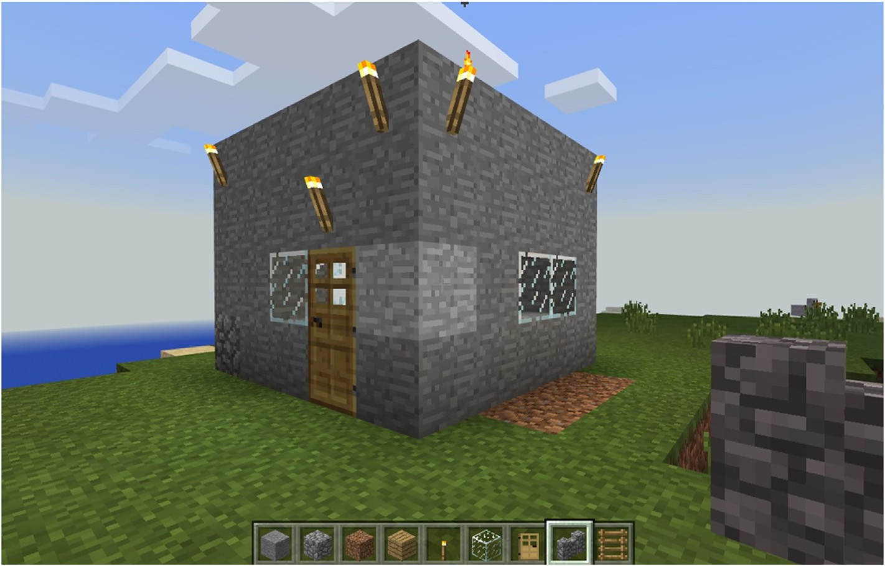

Fig. 1. Target house for VR task in Minecraft VR.

data. Each pre- and post-test of 250 cued go/no-go trials took approxi- mately 12 minutes.

* 1. *Procedure*

Each session took approximately 90 minutes and were held individ- ually. Firstly, the research team collected signed consent forms. Secondly, the participant was given a short tutorial on the use of the Xbox gamepad which was to be used to interact with the Minecraft environment. Par- ticipants used the gamepad controller to briefly move around the laptop (non-VR) version of Minecraft. All participants showed aptitude in navigating and using the gamepad in less than 5 minutes.

To confirm that participants could easily determine the stimulus colours of the cued go/no-go task, they performed a colour vision test that required them to pick out the stimulus colours (green and blue) from an array of 12 colours. All participants successfully identified green and blue coloured rectangles.

Participants were then seated at the laptop and performed a practice test on the cued go/no-go task of 15 sample trials. Participants were instructed to press the space key as fast as possible when the green target appeared and not to respond to the blue target. Participants were given no information on the relation between the rectangle orientation and the target colours. After the 15 trials, participants verbally confirmed that they understood the task and then competed a full 250 trial test.

The participants were then shown a picture of the target house to be built (Fig. 1). Minecraft VR was then run on the Alienware laptop and the participants fitted with the Oculus Rift HMD and the first-person mode of Minecraft VR activated (see Fig. 2). A 15 minute countdown timer was set and participants then had 15 minutes to build in Minecraft VR. Partici- pants sat in a swivel chair and the evaluator ensured free movement by managing the Oculus Rift and gamepad controller cables during the session.

After playing Minecraft VR, the participants removed the HMD and repeated the full 250 trial cued go/no-go task with the Inquisit 5 Lab script. Finally, they completed a demographic survey and a questionnaire to determine their susceptibility to motion sickness, i.e use of the revised motion sickness susceptibility questionnaire (MSSQ) [29]. At the end of the session, each participant waited while their pre and post VR experi- ence reaction times were compared. If the raw reaction times between tests were significantly different, i.e. a percentage change of greater than 5% from baseline reaction time [7], the participants were advised not to

drive or cycle for the next 30 min. Participants were given A$60 in su- permarket vouchers to compensate them for their time.

* 1. *Analysis*

Fillmore’s [7] protocol had two primary measures of interest being participant’s failures to inhibit responses to no-go targets (failures of response inhibition) and their speed of responding to go targets (response activation).

Failure of response inhibition: This was measured as the proportion of no-go targets in which a participant failed to inhibit a response during a reaction time trial, i.e. the participant reacted to a no-go target as if it was a go-target. Also no-go cues should support response inhibition of no-go targets. The p-inhibition failure scores were calculated for each cue condition (go and no-go) on each test.

Response activation: This was measured by the reaction time to go targets. The reaction time was collected as latency (ms) from the Inquisit 5 Lab raw data logs of each trial.

Response times of < 100 ms and > 900 ms were excluded from the

raw data as the former indicates pre-emptive activation and the latter indicates loss of concentration/boredom and neither are indicative of accurate reaction times. Only 5 trials < 100 (0.09%) and 9 trials > 900 (0.16%) were removed across the 5500 go trials analysed. Data was

cleaned and graphs produced in Excel (Office Professional Plus 2016) and all statistical analysis performed in SPSS (version 24.0.0.1). As reaction times are not normally distributed, non-parametric Wilcoxon signed- ranks test was used to analyse the pre- and post-test data pairs.

In comparison to previous work with reaction time measures [4,24, 25], the cued go/no-go task used here is significantly longer in duration and trials, i.e. the 40 trial/2 min Deary-Liewald reaction time task versus 250 trial/12 min cued go/no-go task. Also as previous work [19] has shown duration effects of VR exposure, in addition to full duration re- sults, we have split the pre-test and post-test results into four time pe- riods, namely pre-first (trials 1–126), pre-second (trials 127–250), post-first (trials 1–126) and post-second (trials 127–250).

* 1. *Hypotheses*

Our hypotheses consider response activation and inhibition scores across both the general pre- and post-tests and the two time periods, first 126 trails and second 126 trials, within each test.

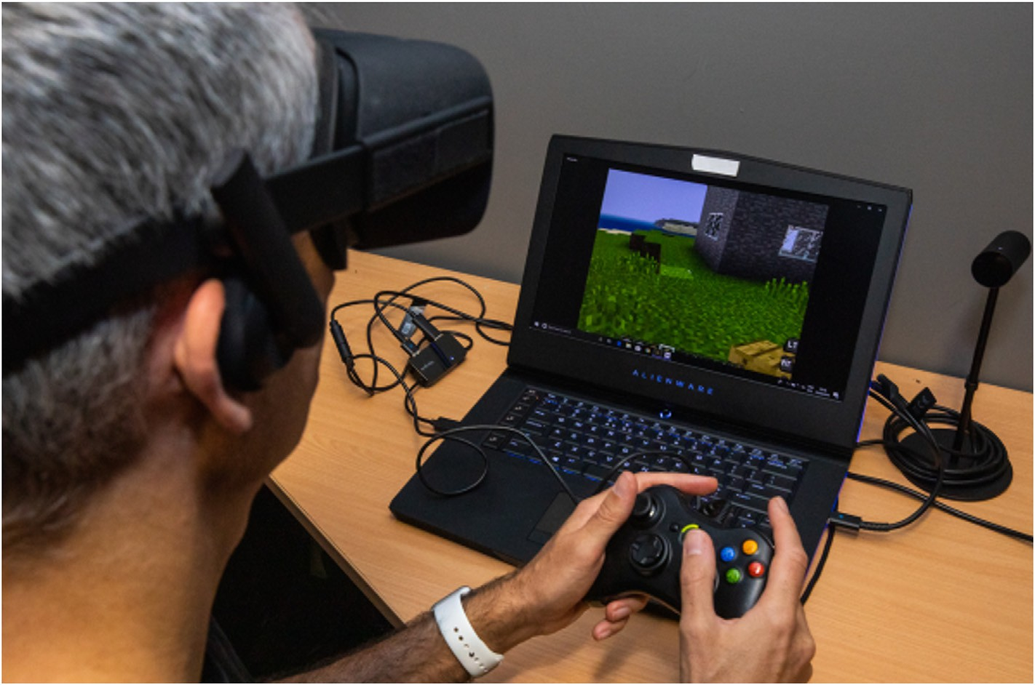

Fig. 2. Minecraft VR setup with Oculus Rift CV1 and Xbox wired controller [Photographer: George Hyde. IG: dualityimages.].

* H1: Pre-Post scores will show response activation impact. We expect decreased response activation after HMD exposure.
* H2: Pre-Post scores will show failure of response inhibition impact. We expect increased failure of response inhibition after HMD

exposure.

* Pre-first and pre-second trials will show no difference. We expect response activation (H3a) and response inhibition (H3b) to be

consistent across the pre-test trials.

* Post-first and post-second trials will show a difference. We expect the response activation (H4a) to increase, i.e. improve, and response in-

hibition to decrease (H4b) across the post-test trials. The HMD exposure should decrease over time out of the VR experience and return to normal.

1. Results

Twenty-two participants (female = 11) completed the VR task and the Oculus Rift CV1 HMD. An additional three participants (male = 3) completed the house building task in Minecraft VR with 15 minutes in did not complete the VR task and exited the virtual environment at 4, 7.3

and 11.5 minutes into the experience.

* 1. *Motion sickness susceptibility questionnaire (MSSQ)*

The mean MSSQ score across the participants (n = 22) was 21.63 (SD

= 17.03). Golding [29] noted a mean MSSQ score of 45.5 (SD = 37.6, n

= 147) as an adult reference norm. The results reported here may indi- cate that the participants are less susceptible to motion sickness than a

general population. However, this could be due to selection bias as par- ticipants self-selected their participation based on the study description that mentioned virtual reality and computer games. Also an exclusion criterion was for conditions that may be aggravated by use of a HMD, including vertigo, claustrophobia or epilepsy. The mean MSSQ scores of

the participants (n = 3) who did not complete the VR task were calcu- lated at 21.67 (SD = 17.40) and thus not indicative of difference from the other participants.

* 1. *Response activation*

For the pre-test and post-test analysis (n = 22) there was no signifi- cant difference between Go cue (p = 0.36) or the NoGo cue (p = 0.57) in terms of response activation. Also reaction time activation was reduced

(i.e. faster reaction times) in the post-tests than in the pre-tests (See Fig. 3 and Table 1). Therefore, H1 is refuted.

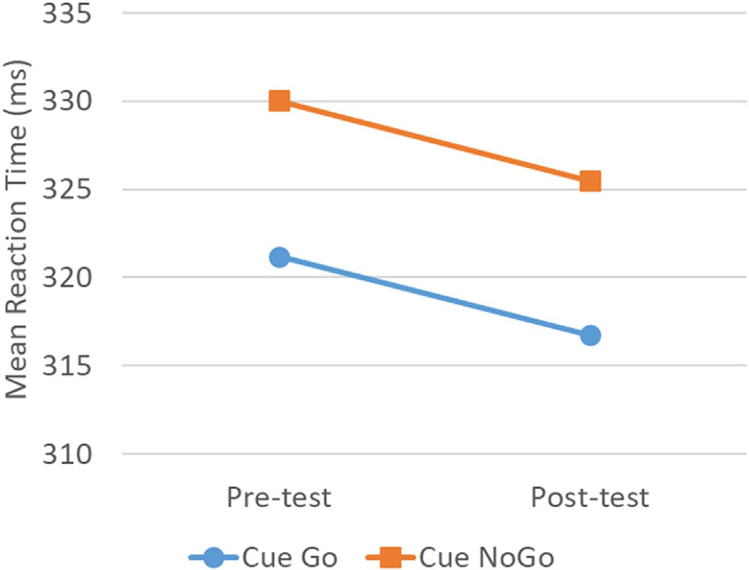In the pre-test (n = 22) for the Go cue, the second half trials (Mean =

Fig. 3. Response activation for full Pre-test and Post-test results.

Table 1

Pre-test and Post-test data for response activation (RA) and response inhibition (RI).

|  |  |  |
| --- | --- | --- |
| Condition | Pre-test [Mean (std.)] | Post-test [Mean (std.)] |
| Go cue (RA) | 321.21(38.72) | 316.73(34.06) |
| NoGo cue (RA) | 330.02(37.83) | 325.46(33.42) |
| Go cue (RI) | 0.0016(0.00236) | 0.0016(0.00236) |
| NoGo cue (RI) | 0.0018(0.00268) | 0.0020(0.00321) |

in the first half trials (Mean = 316.84), T = 6, p = 0.013, r = —0.37. This was also true for the NoGo cue with the second half trials (Mean = 325.96) were significantly higher (i.e. slower response activation) than 337.45) significantly higher than in the first half trials (Mean = 323.88), T = 6, p = 0.022, r = —0.35 (see Fig. 4). Therefore, H3a is refuted. In the post-test (n = 22) only the NoGo cue was significantly different between the second half trials (Mean = 331.99) and the first half trials (Mean = 319.83), T = 5, p = 0.24,r = —0.34 (see Fig. 5). Therefore H4a is refuted for NoGo cues.

* 1. *Response inhibition*

For the pre-test and post-test analysis (n = 22) there was no signifi- cant difference between Go cue (p = 1) or the NoGo cue (p = 0.80) in terms of response inhibition (also see Table 1). Therefore, H2 is refuted.

(p = 0.71), NoGo cue (p = 1)] or second trials [Go cue (p = 0.26), NoGo cue (p = 0.76)] in terms of response inhibition. Therefore, H3b is There was also no significant difference across the first trials, [Go cue

confirmed and H4b is refuted.

1. Discussion

The full group results (pre-test to post-test) showed no significant differences in response activation or response inhibition of the partici- pants after brief exposure to the Minecraft VR environment using an Oculus Rift CV1 HMD. From one perspective this validates the health and safety advice from VR hardware companies that there should be no ill effects after short duration use of VR technology (see Section 2.1). Our results are evidence that this is valid for response activation and inhibi- tion in a participant population that is not generally susceptible to motion sickness. However, this conclusion does need to be contextualised with

the small participant group (n = 22), although the participant group was balanced for gender (female = 11) which contributes to it being repre- sentative of general users. A statistical power analysis was conducted

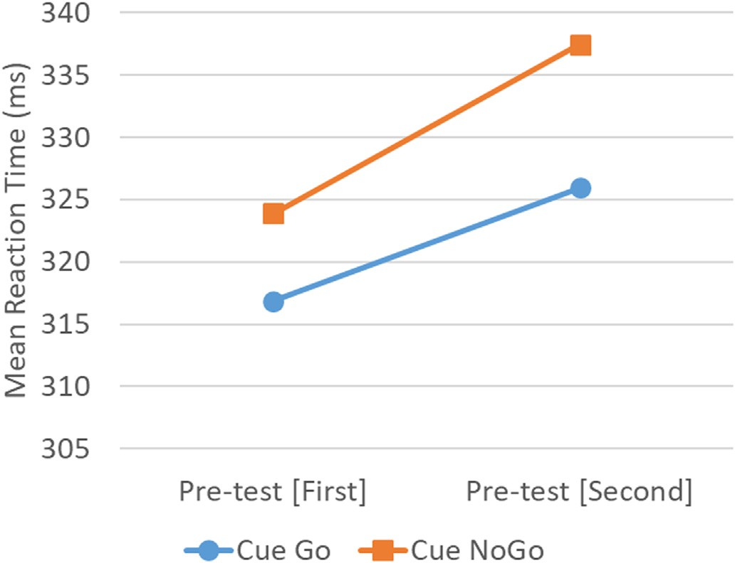

Fig. 4. Response activation for Pre-test across trials 1–125 (first) and 126–250 (second).

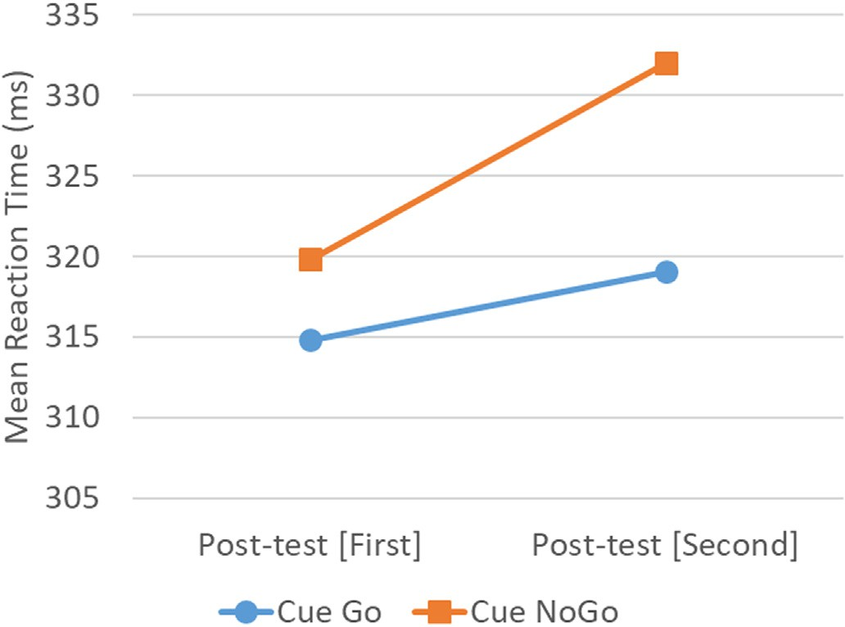

Fig. 5. Response activation for Post-test across trials 1–125 (first) and 126–250 (second).

using G*Power (v3.1.9.4) [30] to define the sample size requirements for

a standard significance level (α error probability, *p* ≤ 0.05) and level of power (1 — *β* = 0.8) [31], to demonstrate a large effect (*r* ≤ 0.50) the the Wilcoxon signed-ranks test as used in the analysis reported here. With suggested sample size ranges from n = 23 (Laplace parent distribution) to n = 35 (normal parent distribution). The results presented here fall just outside this range but only by one participant pair (i.e. one female/male

pair). However, follow-on work should explore female/male balanced sample sizes within this range.

Also it should be noted that 3 participants (all male) did not complete the HMD component of the study. Although we were not explicitly measuring cybersickness, all three participants verbally indicated increased head temperature, which is indicative of cybersickness [24], and were unwilling to continue with the Minecraft VR task. Their removal was part of the study protocol but this did bias the reaction time results to only participants that could complete the 15 minute VR task. However, self-exclusion like this is what typically happens with HMD usage. Users who encounter obvious negative effects stop using, and typically avoid future use of, the technology. It is interesting to note that these participants did self-select to participate and did not have indica- tive MSSQ scores. Nevertheless, our interest here was in exploring potentially hidden negative HMD impacts, i.e. on activation mechanisms for information processing, that might come from brief VR use. Measuring the reaction time impact on participants that had experienced explicit cybersickness symptoms was out of the scope of the current research but would be a useful avenue for further work.

In contrast to previous research [4,24,25], the results here showed an improvement in reaction times (although not statistically significant, see Section 4). There were a number of differences in our study where the aim was to provide a more ecologically valid VR usage experience. Other studies with reaction time impact had more provocative cybersickness invoking environments [24,25], more limited interaction and used a much shorter duration reaction time task [4,24,25]. However, our results did show that the longer cued go/no-go test had evidence of participant fatigue during the test. This was evident in both the pre- and post-tests. As this was present in the pre-test, this indicates that the longer dura- tion of the reaction test could be the cause.

Increases in test length times can result in cognitive fatigue [32], where the length of the test is taxing the participants’ mental functions to the point that is causing a decrease in their performance. This can be mental fatigue, boredom, and reduced attention over time [33,34]. Cognitive fatigue is a topic of continued importance in applied psy- chology [35] and specifically how individual differences in personality or

other traits can impact cognitively fatiguing conditions. Cognitive fatigue is commonly measured through changes in test performance and sub- jective reports via questionnaires [35] or course/test evaluations [32]. Duration of testing and any physical conditions of the test environment are also relevant, for example movement time [33]. In our reaction time trials the participants were seated for the test duration and any physical duress was limited to concentrating on the reaction time trials. Also the go/no-go trials are very repetitive and it is possible that boredom and/or reduced attention is what we have detected as fatigue. Adding a post-session question to capture subjective experiences of the reaction time task, in the context of reported fatigue, would be useful for future work in this area. However, to mitigate potential cognitive fatigue, repeated short tests with rest times between may be better than single short (as in previous work [4,24,25]) or single long (as reported here) reaction time tests.

Given the use of reaction time measures in VR experience and cybersickness research and the results from the work described here, there may be considerable benefit in factoring in cognitive fatigue and the measures that contribute to this, i.e. personality or other traits [35], in order to increase the relevance of the reaction time data for aftereffect analysis. This is a focus for future work.

1. Conclusion

The widespread availability of COTS HMD and easy access to VR applications and games has significantly increased the use of such tech- nology by the general public. With more users, risk exposure from this technology is increasing. VR technology manufacturers provide guide- lines for usage but this guidance can be overly general and there is a limited evidence base for these recommendations.

Explicit negative effects of HMD use, such as cybersickness, often lead to self-selection as users who experience negative effect stop using or avoid the technology. However, activation mechanisms for information processing, such as response activation and inhibition, are more difficult to determine ad hoc and can have significant impact on response critical activities, such are driving vehicles or cycling.

The research reported here has explored response activation and in- hibition in pre- and post-tests after participants experienced a typically VR experience, in this case Minecraft VR using an Oculus Rift CV1 HMD,

for 15 minutes. Participants (n = 22) experienced no significant reaction-

based negative effects. This provides evidence in support of current VR

technology use approaches, at least for response activation and inhibition impact. Participants did however demonstrate trial fatigue during the reaction test process and this should be factored into future studies involving reaction time measures.

Declaration of Competing Interest

The authors declare no conflict of interest.

References

1. Mittelstaedt J, Wacker J, Stelling D. Effects of display type and motion control on cybersickness in a virtual bike simulator. Displays 2018;51:43–50. [https://doi.org/](https://doi.org/10.1016/j.displa.2018.01.002) [10.1016/j.displa.2018.01.002](https://doi.org/10.1016/j.displa.2018.01.002).
2. Cummings JJ, Bailenson JN. How immersive is enough? A meta-analysis of the effect of immersive technology on user presence. Media Psychol 2016;19(2): 272–309. <https://doi.org/10.1080/15213269.2015.1015740>.
3. Rebenitsch L, Owen C. Review on cybersickness in applications and visual displays. Virtual Real 2016;20(2):101–25. <https://doi.org/10.1007/s10055-016-0285-9>.
4. Mittelstaedt JM, Wacker J, Stelling D. VR aftereffect and the relation of cybersickness and cognitive performance. Virtual Real 2019;23(2):143–54. [https://](https://doi.org/10.1007/s10055-018-0370-3) [doi.org/10.1007/s10055-018-0370-3](https://doi.org/10.1007/s10055-018-0370-3).
5. Nichols S, Patel H. Health and safety implications of virtual reality: a review of empirical evidence. Appl Ergon 2002;33(3):251–71. [https://doi.org/10.1016/](https://doi.org/10.1016/S0003-6870(02)00020-0) [S0003-6870(02)00020-0](https://doi.org/10.1016/S0003-6870(02)00020-0).
6. [North MM, North SM, Coble JR. Virtual reality therapy: an effective treatment for](http://refhub.elsevier.com/S2590-0056(19)30010-4/sref6) [psychological disorders. In: Riva G, editor. Virtual reality in neuro-psycho-](http://refhub.elsevier.com/S2590-0056(19)30010-4/sref6) [physiology: cognitive, clinical and methodological issues in assessment and](http://refhub.elsevier.com/S2590-0056(19)30010-4/sref6)

[rehabilitation, studies in health technology and informatics. IOS Press; 1997.](http://refhub.elsevier.com/S2590-0056(19)30010-4/sref6)

[p. 59](http://refhub.elsevier.com/S2590-0056(19)30010-4/sref6)–[70](http://refhub.elsevier.com/S2590-0056(19)30010-4/sref6).

1. Fillmore MT. Environmental dependence of behavioral control mechanisms: effects of alcohol and information processing demands. Exp Clin Psychopharmacol 2004; 12(3):216–23. <https://doi.org/10.1037/1064-1297.12.3.216>.
2. [Logan GD. On the ability to inhibit thought and action: a users’ guide to the stop](http://refhub.elsevier.com/S2590-0056(19)30010-4/sref8) [signal paradigm. In: Dagenbach D, Carr TH, editors. Inhibitory processes in](http://refhub.elsevier.com/S2590-0056(19)30010-4/sref8) [attention, memory, and language. San Diego, CA, US: Academic Press; 1994.](http://refhub.elsevier.com/S2590-0056(19)30010-4/sref8)

[p. 189](http://refhub.elsevier.com/S2590-0056(19)30010-4/sref8)–[239](http://refhub.elsevier.com/S2590-0056(19)30010-4/sref8).

1. Fillmore MT, Rush CR, Hays L. Acute effects of cocaine in two models of inhibitory control: implications of non-linear dose effects. Addiction 2006;101(9):1323–32. <https://doi.org/10.1111/j.1360-0443.2006.01522.x>.
2. Marczinski CA, Fillmore MT. Energy drinks mixed with alcohol: what are the risks? Nutr Rev 2014;72(Suppl 1):98–107. <https://doi.org/10.1111/nure.12127>.
3. Davis S, Nesbitt K, Nalivaiko E. A systematic review of cybersickness. In: Proceedings of the 2014 conference on interactive entertainment (IE2014). New York, USA: ACM; 2014. 8:1–8:9. <https://doi.org/10.1145/2677758.2677780>.
4. Oculus Health and Safety Warnings. [https://www.oculus.com/legal/health-and-](https://www.oculus.com/legal/health-and-safety-warnings) [safety-warnings](https://www.oculus.com/legal/health-and-safety-warnings). [Accessed 18 April 2019].
5. VIVE safety and regulatory guide. <https://www.vive.com/au/legal/>. [Accessed 18 April 2019].
6. Mobile device health & safety and warranty guide. [https://www.samsung.com/us/](https://www.samsung.com/us/support/owners/product/gear-vr-with-controller) [support/owners/product/gear-vr-with-controller](https://www.samsung.com/us/support/owners/product/gear-vr-with-controller). [Accessed 18 April 2019].
7. Daydream View health and safety information. [https://g.co/daydream/safetywarr](https://g.co/daydream/safetywarrantyreg-safety) [antyreg-safety](https://g.co/daydream/safetywarrantyreg-safety). [Accessed 29 April 2019].
8. PlayStationVR instruction manual. [https://www.playstation.com/en-us](https://www.playstation.com/en-us/support/manuals/psvr)

[/support/manuals/psvr](https://www.playstation.com/en-us/support/manuals/psvr). [Accessed 18 April 2019].

1. LaViola Jr JJ. A discussion of cybersickness in virtual environments. SIGCHI Bull 2000;32(1):47–56. <https://doi.org/10.1145/333329.333344>.
2. So RHY, Lo WT. Cybersickness: an experimental study to isolate the effects of rotational scene oscillations. In: Proceedings of IEEE virtual reality; 1999.

p. 237–41. <https://doi.org/10.1109/VR.1999.756957>.

1. Stanney KM, Kennedy RS. Aftereffects from virtual environment exposure: how long do they last? Proc Hum Factors Ergon Soc Annu Meet 1998;42(21):1476–80. <https://doi.org/10.1177/154193129804202103>.
2. Stanney KM, Kingdon KS, Kennedy RS. Dropouts and aftereffects: examining general accessibility to virtual environment technology. Proc Hum Factors Ergon Soc Annu Meet 2002;46(26):2114–8. [https://doi.org/10.1177/](https://doi.org/10.1177/154193120204602603) [154193120204602603](https://doi.org/10.1177/154193120204602603).
3. Kennedy RS, Lane NE, Berbaum KS, Lilienthal MG. Simulator sickness questionnaire: an enhanced method for quantifying simulator sickness. Int J Aviat Psychol 1993;3(3):203–20. <https://doi.org/10.1207/s15327108ijap0303_3>.
4. Dennison MS, D’Zmura M. Cybersickness without the wobble: experimental results speak against postural instability theory. Appl Ergon 2017;58:215–23. [https://](https://doi.org/10.1016/j.apergo.2016.06.014) [doi.org/10.1016/j.apergo.2016.06.014](https://doi.org/10.1016/j.apergo.2016.06.014).
5. Gavgani AM, Nesbitt KV, Blackmore KL, Nalivaiko E. Profiling subjective symptoms and autonomic changes associated with cybersickness. Auton Neurosci 2017;203: 41–50. <https://doi.org/10.1016/j.autneu.2016.12.004>.
6. Nalivaiko E, Davis SL, Blackmore KL, Vakulin A, Nesbitt KV. Cybersickness provoked by head-mounted display affects cutaneous vascular tone, heart rate and reaction time. Physiol Behav 2015;151:583–90. [https://doi.org/10.1016/](https://doi.org/10.1016/j.physbeh.2015.08.043) [j.physbeh.2015.08.043](https://doi.org/10.1016/j.physbeh.2015.08.043).
7. Nesbitt K, Davis S, Blackmore K, Nalivaiko E. Correlating reaction time and nausea measures with traditional measures of cybersickness. Displays 2017;48:1–8. <https://doi.org/10.1016/j.displa.2017.01.002>.
8. Deary IJ, Liewald D, Nissan J. A free, easy-to-use, computer-based simple and four- choice reaction time programme: the Deary-Liewald reaction time task. Behav Res Methods 2011;43(1):258–68. <https://doi.org/10.3758/s13428-010-0024-1>.
9. McMahan RP, Ragan ED, Leal A, Beaton RJ, Bowman DA. Considerations for the use of commercial video games in controlled experiments. Entert Comput 2011;2(1): 3–9. <https://doi.org/10.1016/j.entcom.2011.03.002>.
10. Weech S, Moon J, Troje NF. Influence of bone-conducted vibration on simulator sickness in virtual reality. PLoS One 2018;13(3):1–21. [https://doi.org/10.1371/](https://doi.org/10.1371/journal.pone.0194137) [journal.pone.0194137](https://doi.org/10.1371/journal.pone.0194137).
11. Golding JF. Motion sickness susceptibility questionnaire revised and its relationship to other forms of sickness. Brain Res Bull 1998;47(5):507–16. [https://doi.org/](https://doi.org/10.1016/S0361-9230(98)00091-4) [10.1016/S0361-9230(98)00091-4](https://doi.org/10.1016/S0361-9230(98)00091-4).
12. Faul F, Erdfelder E, Lang A-G, Buchner A. G*Power 3: a flexible statistical power analysis program for the social, behavioral, and biomedical sciences. Behav Res Methods 2007;39(2):175–91. <https://doi.org/10.3758/BF03193146>.
13. [Cohen J. Statistical power analysis for the behavioral sciences. 2nd Edition.](http://refhub.elsevier.com/S2590-0056(19)30010-4/sref31) [Hillsdale, NJ: Erlbaum; 1988](http://refhub.elsevier.com/S2590-0056(19)30010-4/sref31).
14. Jensen JL, Berry DA, Kummer TA. Investigating the effects of exam length on performance and cognitive fatigue. PLoS One 2013;8(8):1–9. [https://doi.org/](https://doi.org/10.1371/journal.pone.0070270) [10.1371/journal.pone.0070270](https://doi.org/10.1371/journal.pone.0070270).
15. Healy AF, Kole JA, Buck-Gengler CJ, Bourne LE. Effects of prolonged work on data entry speed and accuracy. J Exp Psychol Appl 2004;10(3):188–99. [https://doi.org/](https://doi.org/10.1037/1076-898X.10.3.188) [10.1037/1076-898X.10.3.188](https://doi.org/10.1037/1076-898X.10.3.188).
16. Steinborn MB, Flehmig HC, Westhoff K, Langner R. Differential effects of prolonged work on performance measures in self-paced speed tests. Adv Cognit Psychol 2009; 5:105113. <https://doi.org/10.2478/v10053-008-0070-8>.
17. Ackerman PL, Kanfer R. Test length and cognitive fatigue: an empirical examination of effects on performance and test-taker reactions. J Exp Psychol Appl 2009;15(2): 163–81. <https://doi.org/10.1037/a0015719>.