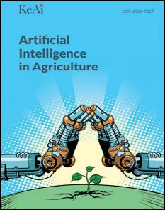[Artificial Intelligence in Agriculture 6 (2022) 10–22](https://doi.org/10.1016/j.aiia.2022.01.001)

Contents lists available at [ScienceDirect](http://www.sciencedirect.com/science/journal/)

Artificial Intelligence in Agriculture

journal homepage: [http://www.keaipublishing.com/en/journa ls/artificial- intelligence- in-agriculture/](http://www.keaipublishing.com/en/journals/artificial-intelligence-in-agriculture/)

[](http://crossmark.crossref.org/dialog/?doi=10.1016/j.aiia.2022.01.001&domain=pdf)Review of agricultural IoT technology

Jinyuan Xu a, Baoxing Gu a, Guangzhao Tian a,b,⁎

a *College of Engineering, Nanjing Agricultural University, Nanjing 210031, PR China*

b *Key Laboratory of intelligent agricultural equipment in Jiangsu Province, Nanjing 210031, PR China*

a r t i c l e i n f o

*Article history:*

Received 6 December 2021

Received in revised form 10 January 2022 Accepted 12 January 2022

Available online 17 January 2022

*Keywords:* Agricultural IoT System architecture Typical application Key technology

Contents

a b s t r a c t

Agricultural Internet of Things (IoT) has brought new changes to agricultural production. It not only increases ag- ricultural output but can also effectively improve the quality of agricultural products, reduce labor costs, increase farmers' income, and truly realize agricultural modernization and intelligence. This paper systematically summa- rizes the research status of agricultural IoT. Firstly, the current situation of agricultural IoT is illustrated and its system architecture is summarized. Then, the five key technologies of agricultural IoT are discussed in detail. Next, applications of agricultural IoT in five representative fields are introduced. Finally, the problems existing in agricultural IoT are analyzed and a forecast is given of the future development of agricultural IoT.

© 2022 The Authors. Publishing services by Elsevier B.V. on behalf of KeAi Communications Co., Ltd. This is an open access article under the CC BY license (<http://creativecommons.org/licenses/by/4.0/>).

1. Introduction 11
2. Development and system architecture of agricultural IoT 11
   1. Development of agricultural IoT sensors 11
   2. Application of agricultural IoT 11
   3. System architecture of agricultural IoT 11
3. Key technologies of agricultural IoT 11
   1. Sensor perception technology 11
   2. Information transmission technology 12
      1. Node location technology 12
      2. Wireless communication technology 12
   3. Information processing technology 13
   4. Radio-frequency identification 13
   5. 3S technology 15
      1. RS technology 15
      2. GNSS technology 15
      3. GIS technology 15
4. Typical applications of agricultural IoT 16
   1. Water-saving irrigation 16
   2. Crop growth environment monitoring 16
   3. Animal and plant life information monitoring 16
      1. Animal life information monitoring 16
      2. Plant life information monitoring 17
   4. Intelligent agricultural machinery 17
   5. Agricultural product quality safety and traceability 18
5. Problems 20
6. Prospection 20

References 20

* Corresponding author at: College of Engineering, Nanjing Agricultural University, Nanjing 210031, PR China.

*E-mail address:* [tgz@njau.edu.cn](mailto:tgz@njau.edu.cn) (G. Tian).

<https://doi.org/10.1016/j.aiia.2022.01.001>

2589-7217/© 2022 The Authors. Publishing services by Elsevier B.V. on behalf of KeAi Communications Co., Ltd. This is an open access article under the CC BY license ([http://](http://creativecommons.org/licenses/by/4.0/) [creativecommons.org/licenses/by/4.0/](http://creativecommons.org/licenses/by/4.0/)).

1. Introduction

Agricultural Internet of Things (IoT) refers to a network in which physical components, such as animals and plants, environmental ele- ments, production tools, and various virtual “objects” in the agricultural system, are connected with the internet through agricultural informa- tion perception equipment under certain protocols to perform informa- tion exchange and communication. It intends to realize the intelligent identification, positioning, tracking, monitoring, and management of agricultural objects and processes. The “human-machine-things” inter- connection of agricultural IoT can help humans recognize, manage, and control various agricultural elements, processes, and systems in a more refined and dynamic way. It can also greatly enhance human's under- standing of the essential parts of the lives of agricultural animals and plants, help with the ability to control complex agricultural systems, and assist in handling agricultural emergencies. At present, worldwide research on agricultural IoT technology is both extensive and intensive, but applications are generally in the experimental demonstration stage. This paper systematically summarizes the research status of agricultural IoT. First, the current situation of agricultural IoT is illustrated and its system architecture is summarized. Then, the five key technologies of agricultural IoT are discussed in detail. Next, applications of agricultural IoT in five representative fields are introduced. Finally, the problems existing in agricultural IoT are analyzed and a forecast is given of future development of agricultural IoT.

1. Development and system architecture of agricultural IoT
   1. *Development of agricultural IoT sensors*

With the wide application of IoT technology in agriculture, driven by the development of the Internet, digital technology, and sensing tech- nology, sensors made using new technologies are constantly emerging and developing towards the direction of being embedded, intelligent, integrated, and miniaturized. At present, the United States, Japan, and Germany are ahead of other countries in sensor technology and manufacturing processes, and they occupy a dominant position (He et al., 2009). The functions of agricultural sensors are becoming increas- ingly diversified, including soil sensors, meteorological sensors, water sensors, and plant sensors. These sensors detecting various objects pro- vide powerful support for agricultural production data collection.

* 1. *Application of agricultural IoT*

The Zigbee wireless network of agricultural IoT realizes wireless self- organized data transmission. Through effective integration with wired data transmission, it ensures convenient and stable remote data trans- mission. In terms of intelligent control, research and development of IoT microprocessors have made significant progress. The microproces- sor has integrated wireless sensing, control, communication, and data processing functions. In terms of real-time monitoring in agricultural production, European and American countries have been using satel- lites to conduct precise operation and monitoring of field cultivation as well as the intelligent monitoring of water and fertilizer. Meanwhile, complete production processes have already been established. The de- velopment of information technology promotes the optimization of the application of agricultural IoT in developed countries. Artificial intel- ligence (AI) technology can be integrated based on monitoring and in- telligent management, which improves the utilization of the sensor data. Combined with expert systems, agricultural IoT helps planters en- rich their planting experience and conduct precise management of crops (Liu, 2016). In China, IoT has been applied to many aspects of ag- ricultural production, such as farmland irrigation, environmental moni- toring in agricultural production, agricultural product safety traceability, and it has been used in fields like farmland planting, aqua- culture, and animal husbandry. Moreover, China has also developed

high-precision information monitoring and diagnostic equipment, which has promoted the application of IoT in agriculture. At present, the equipment that has been developed and used mainly includes equipment for obtaining crop and plant information, monitoring envi- ronmental information, and monitoring animal behaviors (Shan, 2019).

* 1. *System architecture of agricultural IoT*

The system architecture is the primary foundation for the design and realization of an agricultural IoT system. For this reason, researchers at home and abroad have conducted extensive and in-depth research on architectural IoT and proposed different architectures. The EU's Seventh Framework Program specifically set up two projects on IoT architecture. One project is SENSEI (Presser et al., 2009). This project regards the In- ternet as an infrastructure that connects the physical world and the dig- ital world. Its goal is to integrate radio-frequency identification (RFID), wireless sensing and execution networks, and network embedded de- vices to establish an open and business-driven real-world Internet structure, which can provide services using a unified interface. The other project is IoT-A (Walewski, 2011). Its goal is to establish a refer- ence structure model for IoT and define its key components. The refer- ence structure model is an abstraction of the mechanism of IoT instead of the structure of a specific application. Therefore, it provides the best example for researchers in different application fields to de- velop more compatible IoT structures. Most researchers divide the IoT architecture into three layers: a perception layer, a transport layer, and an application layer. This general division method has two main drawbacks: one is that it cannot characterize the characteristics and dif- ferences of IoT technology in specific industrial applications; the other is that it cannot reflect the characteristics and differences of specific users. To overcome this shortcoming, we divide the agricultural IoT system ar- chitecture into five layers, namely, the user layer, application layer, transport layer, perception layer, and object layer. The function, compo- sition, and logical relationship of each layer (Zhang et al., 2014a, 2014b) are shown in Fig. 1. To study agricultural IoT architecture, the following steps should be taken: (i) Abstract the application types and scenarios of IoT. (ii) Propose the general principles and overall requirements of the IoT architecture. (iii) Further divide the basic architecture of IoT in detail and define the general framework and functional structure.

1. Key technologies of agricultural IoT
   1. *Sensor perception technology*

The information in agricultural IoT is mainly obtained through many sensors. In agriculture, sensors are mainly used for environmental infor- mation monitoring, animal and plant life perception, and quality safety and traceability. Currently, there are three types of sensors that are widely used in agriculture: physical property sensors, biosensors, and micro electro-mechanical sensors (You and Tang, 2013). Physical prop- erty sensors realize signal conversion through sensor-sensitive physical changes; biosensors use biological sensitive components to transmit in- formation based on the response to the outside world; micro electro- mechanical sensors are products of new technology, and they have excellent characteristics, such as low power consumption and high reliability (Li et al., 2015). The information sensing mechanism of the sensor includes electrochemical sensing, optical sensing, electrical sens- ing, and remote sensing. Optical sensing mechanisms mainly include the fluorescence quenching effect and spectrophotometry, which are used for soil inspection and chlorophyll content determination (Li et al., 2017). Each chlorophyll sensor also has different advantages and disadvantages, as shown in Table 1.

According to application principles, electrical sensors include many types, such as capacitive, resistive, inductive, and eddy cur- rent, which are used to sense soil moisture and greenhouse temper- ature in agricultural IoT. Photoelectric sensors are used for crop

|  |
| --- |
|  |
|  |
|  |
|  |
|  |

Fig. 1. Architecture of agricultural IoT.

planting and transplantation, pesticide spraying and terrain moni- toring, soil structure analysis, and so on. The electrochemical method is based on the electrochemical properties of the sub- stances in the solution and their change rules, which can be used for the analysis of soil chemical composition, crop growth and development, and so on (Adamchuk et al., 2004).

* 1. *Information transmission technology*
     1. *Node location technology*

Node location technology relies on a small number of nodes with known locations in the WSN to determine the locations of all unknown nodes through limited communication between neighboring nodes and a certain positioning mechanism. In agricultural WSNs, the location in- formation of nodes is very important to the monitoring activities of the sensor network. Monitoring data without location information is

Table 1

Chlorophyll sensor comparison.

generally meaningless. Determining the location of the problem by de- termining the location of the node is of great significance to prevent the occurrence of agricultural diseases and disasters. According to whether the distance between nodes needs to be measured, WSN node position- ing algorithms can be divided into two categories: one is range-based positioning algorithms, including TOA, TDOA, AOA, and RSSI; the other is range-free algorithms, including centroid positioning algorithm, con- vex programming positioning algorithm, and DV-Hop positioning algo- rithm (Qin, 2016) Given the premature convergence problem of the traditional genetic algorithm, Chang et al. improved the traditional ge- netic algorithm and proposed a new forestry WSN node positioning al- gorithm (Chang et al., 2018). Chen et al. also applied the genetic algorithm to sensor node positioning in crop areas, which helped sensor performance, improved the positioning accuracy, and better served crop planning (Chen et al., 2015). Liu et al. [20] improved the sensor lo- cation algorithm for forest fire monitoring and introduced a weighted centroid location algorithm. It provided a strong positioning basis for the fire location of fire monitoring and prevented and reduced forest fires and their damages to the greatest extent. Yao et al. designed an im- proved positioning algorithm for precision irrigation based on the gen- eral DV-HOP algorithm, which reduced the positioning error and made

Chlorophyll sensor type

Advantage Disadvantage

the precision irrigation more accurate (Yao et al., 2010).

Spectrophotometric chlorophyll sensor

Live chlorophyll meter chlorophyll sensor

Polarographic chlorophyll sensor

High precision and wide application

High real-time performance, low power consumption and less damage

High sensitivity, real-time, lossless

Time-consuming and laborious, destroying the leaf tissue

Low accuracy and high price

High cost

* + 1. *Wireless communication technology*

Data transmission is a vital part of agricultural IoT, and WSN is an important information transmission means. The data trans- mission technology commonly used in agricultural IoT is shown in Fig. 2. Different sensor networks have different characteristics, as shown in Table 2. Communication technology should not be used randomly when transmitting agricultural IoT information,

Photoelectric chlorophyll sensor

|  |  |  |  |
| --- | --- | --- | --- |
|  |  |  |  |

Low price, lossless Poor environmental adaptability

but rather it should be selected according to the specific project characteristics.

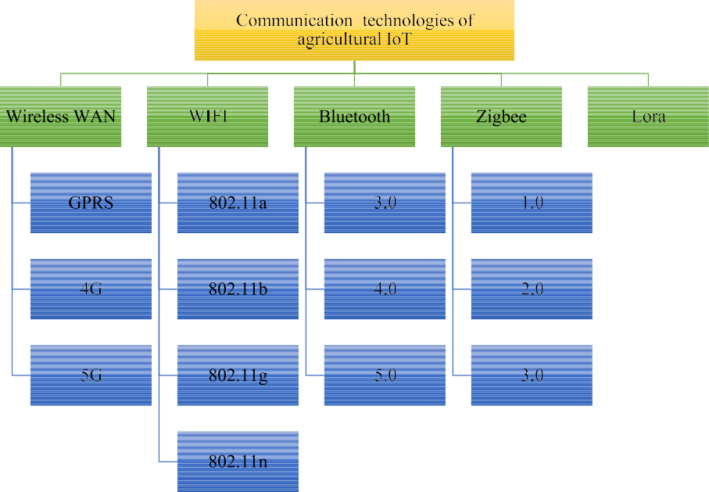

Fig. 2. Data transmission technology commonly used in agricultural IoT.

Yang et al. adopted ZigBee technology in the design of greenhouse WSNs to realize the transmission of greenhouse temperature and hu- midity information (Yang et al., 2013). In one study, based on a ZigBee and the CC2530 protocol stack, transceiver hardware and wireless networked sensor nodes were designed for an agricultural irrigation system, and good results were achieved (Xu et al., 2012; Zhang et al., 2011). Sheng et al. proposed applying the wireless remote sensing net- work based on ZigBee and 3G technology to facility agriculture to con- struct an efficient facility agriculture remote precision measurement and control system (Sheng et al., 2012). Using GPRS and WEB technol- ogy, Wang and Sun et al. proposed using GPRS and WEB to establish a greenhouse environmental information collection system (Wang et al., 2009; Sun et al., 2006). Using WiFi-based image sensors, Otoniel et al. designed a new automatic sensing system for agricultural pests and dis- eases, which periodically senses and sends information to the service center (Otoniel et al., 2012). The underlying sensors are connected to the on-site host computer using an RS485 bus. The on-site monitoring system is connected to the Internet through GPRS wireless communica- tion technology. The real-time sensing information is sent to the WEB data server. Based on ZigBee and GPRS, Chen and Gao et al. realized data transmission between the sensor network and the telecommunica- tions network in a water-saving irrigation system (Chen et al., 2011; Gao et al., 2010). In the future, the main direction of agricultural sensor networking will be LPWAN (represented by LoRa and NBIoT) supple- mented by 4G and 5G to enable the transmission of large files like agri- cultural images and audio files. A general summary of the way of data transmission is made nowadays, as shown in Fig. 3 for the structure of the data transmission system.

* 1. *Information processing technology*

The ultimate purpose of information processing is to collect and an- alyze the acquired data. In the process of agricultural production moni- toring, much production data is collected, and they have the characteristics of being in real-time, dynamic, and massive. Using IoT technology, the production data can be stored and analyzed to a certain degree, and corresponding data patterns can be found. Cloud computing technology is mainly used for information processing, and it can effec- tively solve the problem of storage, calculation, and the related process- ing of massive agricultural production data. Many emerging cloud

service platforms can realize the storage, searching, and analysis of mas- sive agricultural information. Cloud computing technology includes data mining, data analysis, AI, and other technologies. Data mining tech- nology can be used to meet the requirements of data integrity, accuracy, and standardization, and to support follow-up expert systems and users for further operations. Data mining technology can clean and extract the agricultural big data, discover the internal connections among the data, and store and manage them in different categories. Artificial intelligence technology has powerful information analysis capabilities in controlling irrigation, identifying pests and diseases, crop harvesting, and so on. Using machine vision, image recognition, and other technologies, AI can perform accurate judgment and prediction based on the obtained agricultural information, thus achieving intelligent decision-making. The current theoretical methods of AI technology include dynamic Bayesian networks, Kalman filtering, D–S evidence theory, and rough set theory.

Glaroudis et al. researched IoT messaging protocols that were

regarded as major options for IoT applications in smart farming (Glaroudis et al., 2019). They presented seven protocols, and compared with respect to their performance, and measured in terms of relevant key indicators. Farooq et al. constructed a smart farming with relevant technologies (Cloud and Edge Computing, Big Data analytics and ma- chine learning, communication networks and protocols, and robotics), and analyzed application domains, relevant smartphone, sensor-based applications, and security and privacy issues in IoT-based agriculture (Farooq et al., 2019). Erlangga et al. aimed to create a mobile learning that provides information and interactive communication about vegeta- ble production needed by farmers using internet and mobile cloud com- puting concept, for better communication, sharing of information and profitability in agriculture (Erlangga et al., 2020).

With the development of technology, the combination of cloud com- puting technology and artificial intelligence technology will be more ap- plied to the agricultural IoT. At the same time, data security and standardization problems also emerge, which need to be continuously improved.

* 1. *Radio-frequency identification*

Radio-frequency identification is a non-contact automatic identifica- tion technology for specific targets, and it is the main technology for IoT

Table 2

Comparison of typical communication technology parameters of agricultural Internet of Things.

|  |  |  |  |  |  |
| --- | --- | --- | --- | --- | --- |
| Type | Wireless WAN (GPRS/4G/5G) | WiFi | Bluetooth | ZigBee | Lora |
| Application | Voice, data | Media | Media, cable alterative | Monitoring, sensos | Data transparent transmission |
| Power | High | High | Low | Low | Low |

consumption Transmission

distance

Long distance Within 100 m

Within 10 m 10–100 m Up to 2–5 km in towns and 15 km in suburbs

Advantage Large coverage good service quality

High

flexibility

Low price and simple configuration

Low power consumption, flexible network topology

Strong immunity and stable operation

to perceive individual objects. Once a tag enters the magnetic field, it re- ceives the radio frequency signal from the reader. Using the energy ob- tained by the induced current, it transmits its product information stored in the chip to the receiver or actively transmits signals at a certain frequency. After the information is received by the reader, it is decoded and then sent to the central information system for relevant processing (Qu and Yang, 2011). Combined with related network communication technology, RFID can realize long-distance automatic identification of objects, which makes it very suitable for agricultural IoT and realizes real-time monitoring of agricultural-related objects. Radio-frequency

identification is waterproof, and it has a fast-scanning speed, simple in- formation modification, large data storage capacity, and high security. Compared with traditional bar code and magnetic card technology, RFID is more efficient and can transmit more information, which meets the large-scale identification needs of agricultural IoT (Luis and Loredana, 2011). Radio-frequency identification is mainly applied to agricultural areas such as agricultural product safety and traceability, especially in the field of food safety, which mainly includes agricultural product circulation, crop growth, livestock breeding, and meat food sup- ply. Ampatzidis et al. applied RFID technology in fruit tree monitoring to

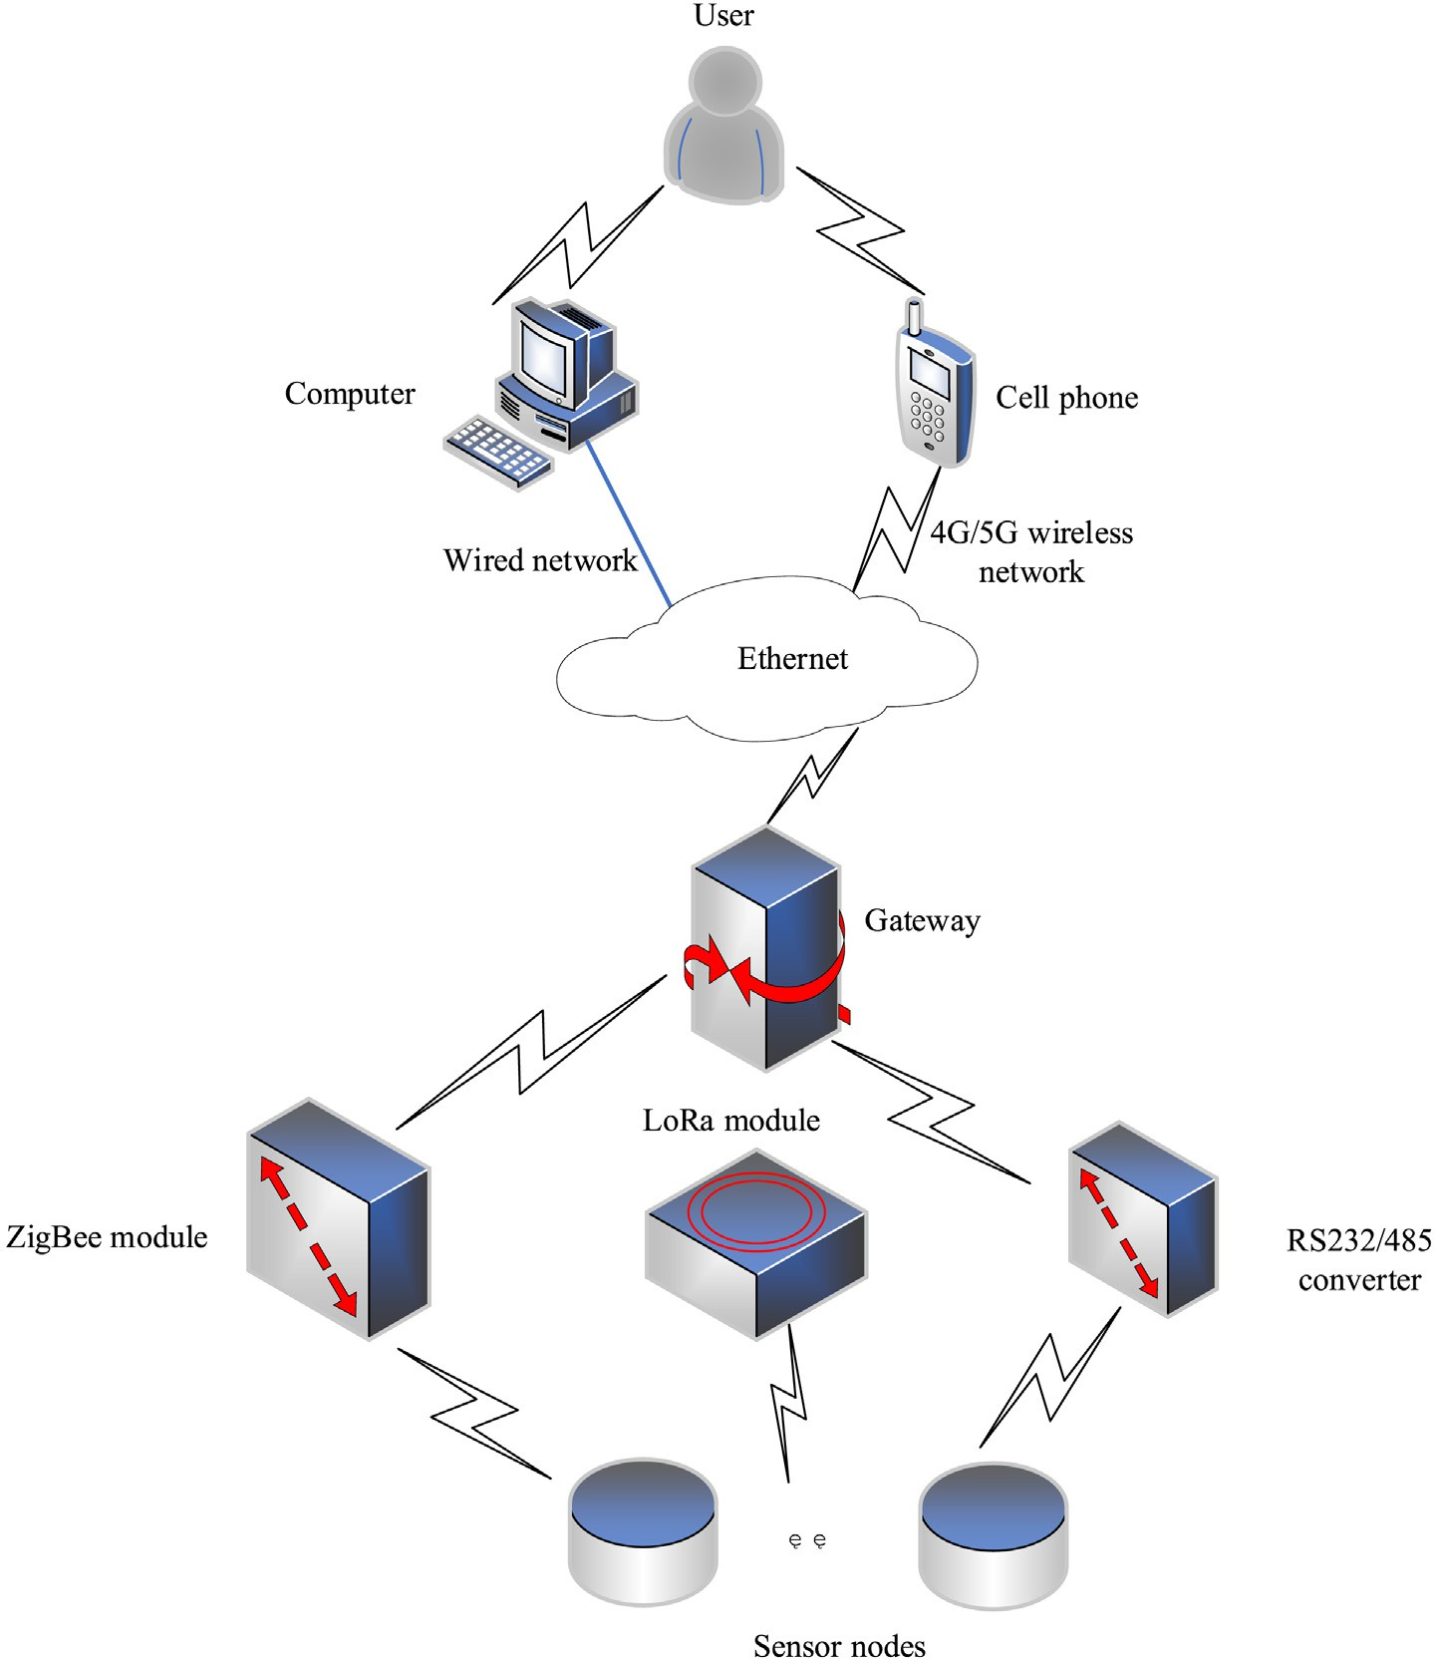

Fig. 3. Data transmission system structure.

analyze the growth status of the fruit (Ampatzidis and Vouqioukas, 2009; Bowman, 2010). Research on identification methods based on RFID has been expanding. Accurate location identification, positioning, and navigation are the research hotspots. These applications focus on in- tegrating RFID information with location information from other tech- nologies, such as ZigBee, global positioning system (GPS), and wireless sensor network (WSN) (Yue et al., 2018). He designed a wireless RFID system based on ZigBee technology, which improved the sensing and processing capabilities of the RFID system (He, 2020).

* 1. *3S technology*

3S is a collective term for remote sensing (RS), global navigation sat- ellite system (GNSS), and geographic information system (GIS). It is a comprehensive technology that combines the three to realize fast, accu- rate, and reliable collection, analysis, and updating of agricultural infor- mation. The schematic diagram of the complementary effects of the three is shown in Fig. 4.

* + 1. *RS technology*

Remote sensing technology uses different forms of sensors to re- ceive various electromagnetic wave information of ground objects from RS platforms at different heights and processes the received in- formation to detect and identify different ground objects and their characteristics from a distance. It can solve the problem of monitoring crops that are scattered and geographically complex. At present, RS technology has formed a three-dimensional earth observation sys- tem including aerial photography and satellite remote sensing. It has leaped from local observation to global quasi-synchronous obser- vation and is gradually expanding from visible light to infrared, far- infrared, and even microwave and ultra-long wave (Li and Yang, 2018). Agricultural RS technology has a unique effect on the monitor- ing and management of large-area open-air agricultural production. It can monitor crops that are scattered in type and located in complex terrain. It has four research directions: agricultural resource investi- gation, crop yield estimation, agricultural disaster forecasting, and precision agriculture (Gao et al., 2020). Nowadays, RS technology is playing an important role in the management and protection of farm- land water conservancy projects (Ma et al., 2019), ecological environ- ment monitoring (Chui, 2017), and real-time decision-making on agricultural fertilization (Li, 2017).

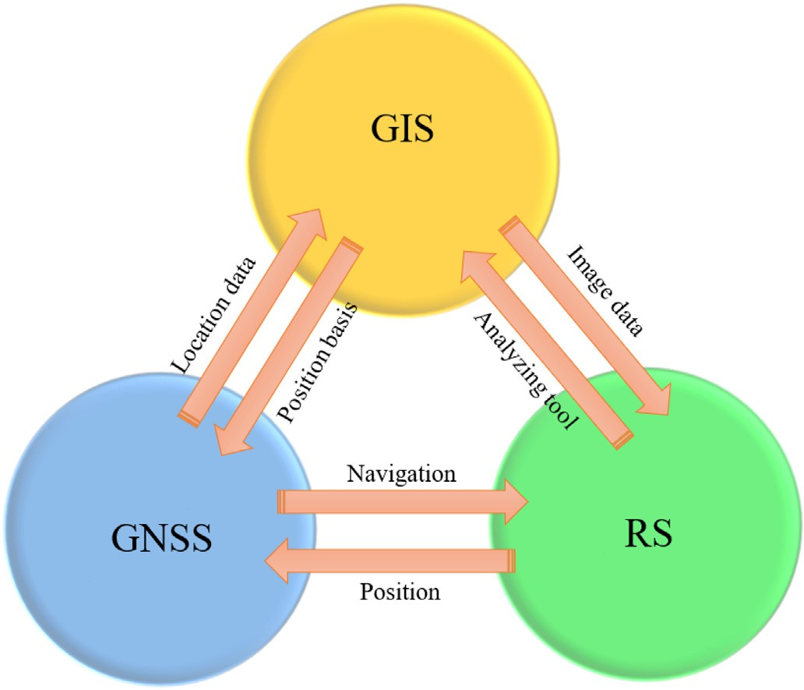

Fig. 4. Schematic diagram of 3S complementation.

* + 1. *GNSS technology*

A GNSS is mainly composed of three parts: satellite equipment, ground monitoring stations, and user receiver equipment. GNSS is a global positioning system with three-dimensional positioning and navigation functions. It has the characteristics of being all-weather, omni-directional, and high-precision. GNSS technology can correct and supplement the temporal influence of RS technology and accurately grasp the dynamic location information of a certain region. The applica- tion of GNSS technology to precision seeding and fertilization, agricul- tural machinery, and pest control can provide farmers with effective help and improve operational efficiency and agricultural output. In pre- cision seeding and fertilization, GNSS technology is matched with the computer system to obtain the sowing amount and the fertilizer amount. After receiving the corresponding instruction, the planter is driven to control the fertilizer amount. In the joint operation of agricul- tural machinery, the output sensor and GNSS technology can be com- bined to obtain the distribution data of the output of each crop in the farmland. These data can then be used to generate the output distribu- tion map by computers. With the map, factors affecting the crop output can be analyzed and harmful factors can be eliminated, which helps in- crease crop yield (Chi, 2017). Moreover, unmanned automatic driving of agricultural vehicles can also benefit from GNSS technology. For exam- ple, the location of agricultural vehicles can be obtained in real-time and their driving paths can be corrected timely. In terms of agricultural product transportation, Liu et al. built an NFC-GPS based agricultural product vehicle temperature control and tracking system, which can track and locate agricultural products in real-time during vehicle trans- portation and provide real-time temperature and humidity control for the storage of agricultural products in the vehicle to ensure fresh- ness (Liu et al., 2016). With GNSS technology locating pests and diseases through computers, users can have a direct understanding and determine the required pesticide dosage. Furthermore, drugs can be accurately sprayed, resulting in cost savings and environmental damage reduction.

* + 1. *GIS technology*

Using GIS, the intricate data collected by RS and GNSS can be screened to obtain characteristic image information related to agricul- tural production. The emergence of GIS has laid a solid foundation for the collection, storage, analysis, and management of agricultural pro- duction information. GIS has developed rapidly in recent years. For ex- ample, Gu et al. built a GIS-based agricultural big data visualization platform to provide comprehensive agricultural data (Gu and Qi, 2020). The agricultural information data presented on this platform is very clear and the visualization effect is excellent. To improve the anal- ysis effect of farmland soil nutrients, Li et al. introduced GIS technology and sampling robot technology into the design of the nutrient analyzer and used GIS technology to draw a nutrient distribution map of the farmland (Li et al., 2021). The visual presentation effect is good, and it can provide reliable data support for fertilizer management personnel. In regional agricultural planning, there are problems, such as data being scattered and disordered, a lack of spatial quantitative analysis, accurate implementation difficulty, and a lack of dynamic analysis. Aiming at these problems, Zhou et al. introduced the powerful data management and spatial analysis functions of GIS to realize standard- ized storage of agricultural planning data, the quantitative analysis of spatial data, and the drawing of auxiliary plans (Zhou et al., 2019). In this way, standardization, rationality, and the accuracy of the planning are effectively improved. Zhao designed an agricultural information col- lection system based on mobile GIS (Zhao, 2018). The system uses PDA as the basic hardware platform, which can effectively meet the needs of real-time positioning, collection, and transmission of agricultural information.

In practical application, the above technologies are often not used in- dependently, but mixed with a variety of technologies. Generally speak- ing, it is improved on the basis of traditional technology and combined

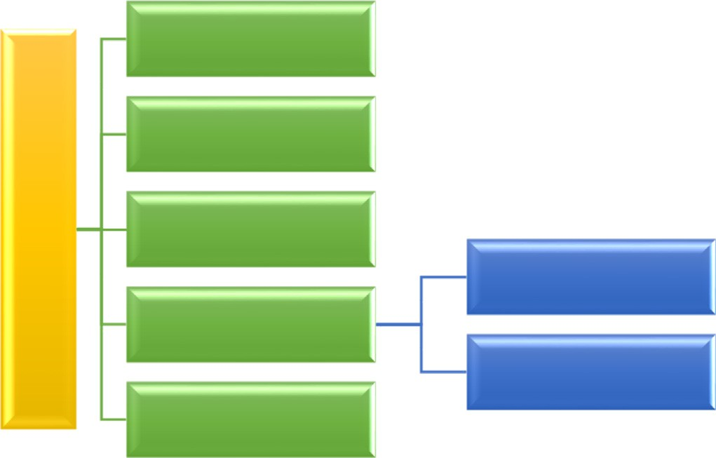

Fig. 5. The mainly typical applications of agricultural IoT.

with the latest technology. After improvement, the system using these technologies has higher efficiency, more reliability and lower energy consumption.

1. Typical applications of agricultural IoT

With the continuous maturity of agricultural IoT technology, it has been widely used in agricultural technology research and applications. The following is a brief introduction to some typical applications. Fig. 5 depicts the mainly typical applications of agricultural IoT.

* 1. *Water-saving irrigation*

In today's world, water resources are increasingly scarce. As a neces- sary condition for the growth and development of crops, water resources have a great impact on agricultural production. Owing to the different growth cycles of crops, their actual water requirements are also different. Using IoT technology, appropriate irrigation methods can be chosen, which changes the traditional flood irrigation method and effectively solves the problem of water shortage. At the same time, it can improve the lodging resistance of crops and help increase crop yields. In research on the design of an intelligent water-saving irrigation system based on the neural network, Yang et al. used a neural network as the basic net- work for water-saving irrigation (Yang et al., 2020). This system im- proved irrigation efficiency, reduced human intervention and waste caused by large amounts of drainage, and protected ecological agricul- ture. Wang et al. designed a set of GPRS DTU-based intelligent agricul- tural irrigation control systems that can implement irrigation according to the needs of crop growth (Wang et al., 2013). Srbinovska et al. pro- posed a WSN architecture for vegetable greenhouses (Srbinovska et al., 2015). Combined with expert system guidance and appropriate mea- sures, such as remote control of drip irrigation, energy efficiency was im- proved. Considering both the large-scale development model of modern orchards and the requirements of precision agriculture construction, Hou et al. designed a remote intelligent irrigation system for orchards (Hou et al., 2012). The system used a combination of GPRS and ZigBee WSNs. Song and Zhang et al. designed an intelligent water-saving irriga- tion system based on a CAN bus (Song et al., 2012; Zhang, 2010). The sys- tem was economical, small-sized, stable, and easy to promote. It had a far-reaching significance to solve the current problem of excessive waste of agricultural water and improved the level of agricultural water management.

* 1. *Crop growth environment monitoring*

The monitoring of the growth environment of crops is to regulate and control the growth environment of crops by constructing

agricultural IoT to sense, transmit, and calculate various environmental information. The use of various sensors can realize the real-time collec- tion of agricultural environmental information, such as air temperature, air humidity, CO2 concentration, light intensity, soil temperature and humidity, and soil PH value (Bu et al., 2009; Lv et al., 2009). Zhang et al. used a 433 MHz radio frequency for information transmission and MSP430F149 and LPC2478 respectively for the microcontrollers of the wireless sensor nodes and aggregation nodes to realize real-time collection, aggregation, and fusion of greenhouse environmental infor- mation (Zhang et al., 2014a, 2014b). Chen designed a WSN that worked in the 780 MHz Chinese dedicated frequency band and was compatible with the IEEE 802.15.4c standard for environmental monitoring of mil- let farmland (Chen, 2015). Lin et al. designed a self-sufficient wireless environment monitoring system that used soil energy to realize low- cost remote monitoring of farmland environment (Lin et al., 2015). Hamrita et al. used RFID technology to monitor in real-time key param- eters, such as soil moisture and temperature, that affect crop growth, and they developed a soil analysis and monitoring system, which pro- vided a reliable data source for subsequent research on plant growth (Hamrita and Hoffacker, 2005). By integrating WSN technology, GPS technology, and solar power technology, Hwang et al. built a field envi- ronment monitoring system for the collection, transmission, storage, and analysis of production environment information to improve agri- cultural production efficiency (Hwang et al., 2010). Xia et al. designed an IoT system for the diagnosis and management of wheat seedling con- ditions (Xia et al., 2013). By collecting wheat growth information and accurately sensing the wheat field environment, they obtained a better production management plan. Du et al. established an agricultural envi- ronment monitoring system that integrates the monitoring data of IoT and the spatial data of Web GIS to realize the dynamic monitoring of the agricultural environment from point to surface (Du et al., 2016). Wang and Li et al. used ZigBee ad hoc network technology to realize in- formation aggregation of various sensing nodes in the sensor network, which can realize the real-time collection and upload of environmental data, such as ambient temperature, humidity, and carbon dioxide con- centration in the air (Wang and Fang, 2018; Li, 2019).

* 1. *Animal and plant life information monitoring*

The information monitoring of animals and plants is very important and necessary in agricultural production. It can significantly improve agricultural production efficiency and quality.

* + 1. *Animal life information monitoring*

Monitoring animal information (body temperature, food intake, dis- eases, and so on) enables people to promptly understand the physiolog- ical and nutritional status of animals and ensure their healthy growth. Usually, an animal information monitoring system is composed of sen- sors, actuators, wireless link and terminal equipment (Fig. 6).

Through sports collars and GPS sensors installed on cows, González et al. observed and recorded the cows' foraging, ruminating, walking, resting, and other activities (including rubbing with objects, shaking their head, and combing the fur) and developed a method to perform unsupervised behavior classification (González et al., 2015). Kumar et al. developed an animal health monitoring system based on ZigBee, which can sense vital information, such as chewing, body temperature, heart rate, and growth environment information of the monitored ani- mal and analyzed the monitored object according to the temperature and humidity index (Kumar and Hancke, 2014). Using a pulse oximeter, respiration sensor, body temperature sensor, environmental sensor, and GPS module, Nagl et al. built a bovine animal mobile observation sys- tem, which provided a monitoring method to prevent the spread of dis- ease in the herd (Nagl et al., 2003). By installing electronic tags on Colorado sheep and deploying IoT, Parsons et al. realized refined man- agement (identification, intelligent monitoring, and so on) of the sheep (Parsons et al., 2005). In research by Meng, the body temperature

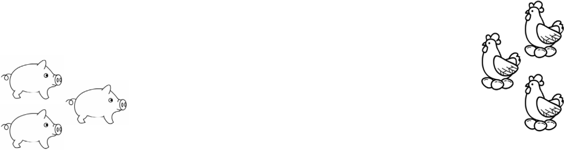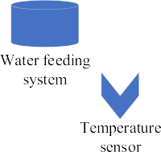

Fig. 6. Typical animal information monitoring system.

of pigs was automatically measured based on infrared technology (Meng, 2018). Timely observation of body temperature can effectively prevent the occurrence of diseases. To improve the efficiency of wildlife rescue centers on rehabilitation, quarantine monitoring, and scientific release, Jia used sensors and RFID technology combined with modern biometric technology to collect state data of wild animals and transmit them to the terminal through wireless transmission technology based on the ZigBee protocol (Jia, 2020).

* + 1. *Plant life information monitoring*

Plant life information to be collected mainly includes visual informa- tion (diseases and pests, fruit enlargement status, leaf area, and so on) and internal information (chlorophyll content, crop nitrogen, photosyn- thetic rate, and so on). A typical plant life information monitoring sys- tem is shown in Fig. 7.

By fully investigating the specific conditions of the citrus growing environment, Porto et al. designed a citrus traceability system based on IoT technology (Porto et al., 2011). This system can prevent and con- trol the spread of plant diseases so that citrus growth is promoted. He et al. summarized plant nutrient monitoring, disease, insect pest sens- ing, and the acquisition of plant life information along with spectro- scopic technology and nuclear magnetic resonance imaging

technology for plant information perception (He et al., 2013). Park et al. deployed WSNs to calculate the dew point on the leaves of plants in a greenhouse based on the sensed information (Park and Park, 2011). Then, through automatic adjustment of the greenhouse environment, plant diseases that may be caused by condensation were effectively prevented and controlled. Through computer vision technology, Li et al. realized successful non-destructive monitoring of the growth of plants in a greenhouse and collected the leaf crown projection area and plant height information (Li et al., 2003).

* 1. *Intelligent agricultural machinery*

Intelligent agricultural machinery enables efficient, standard, com- fortable, and interactive agricultural machinery operations. It can inde- pendently complete cultivation, sowing, transplanting, fertilization, drug spraying, feeding, irrigation, picking, harvesting, and other opera- tions. It can also collect information on soil, water quality, crops, and aquatic products, which provides technical support for the implementa- tion of precision agriculture and healthy breeding (Ma and Sun, 2020). Fast, accurate, and comprehensive agricultural machinery service infor- mation can be provided by introducing IoT into agricultural machinery applications and using technologies like sensing, positioning, and

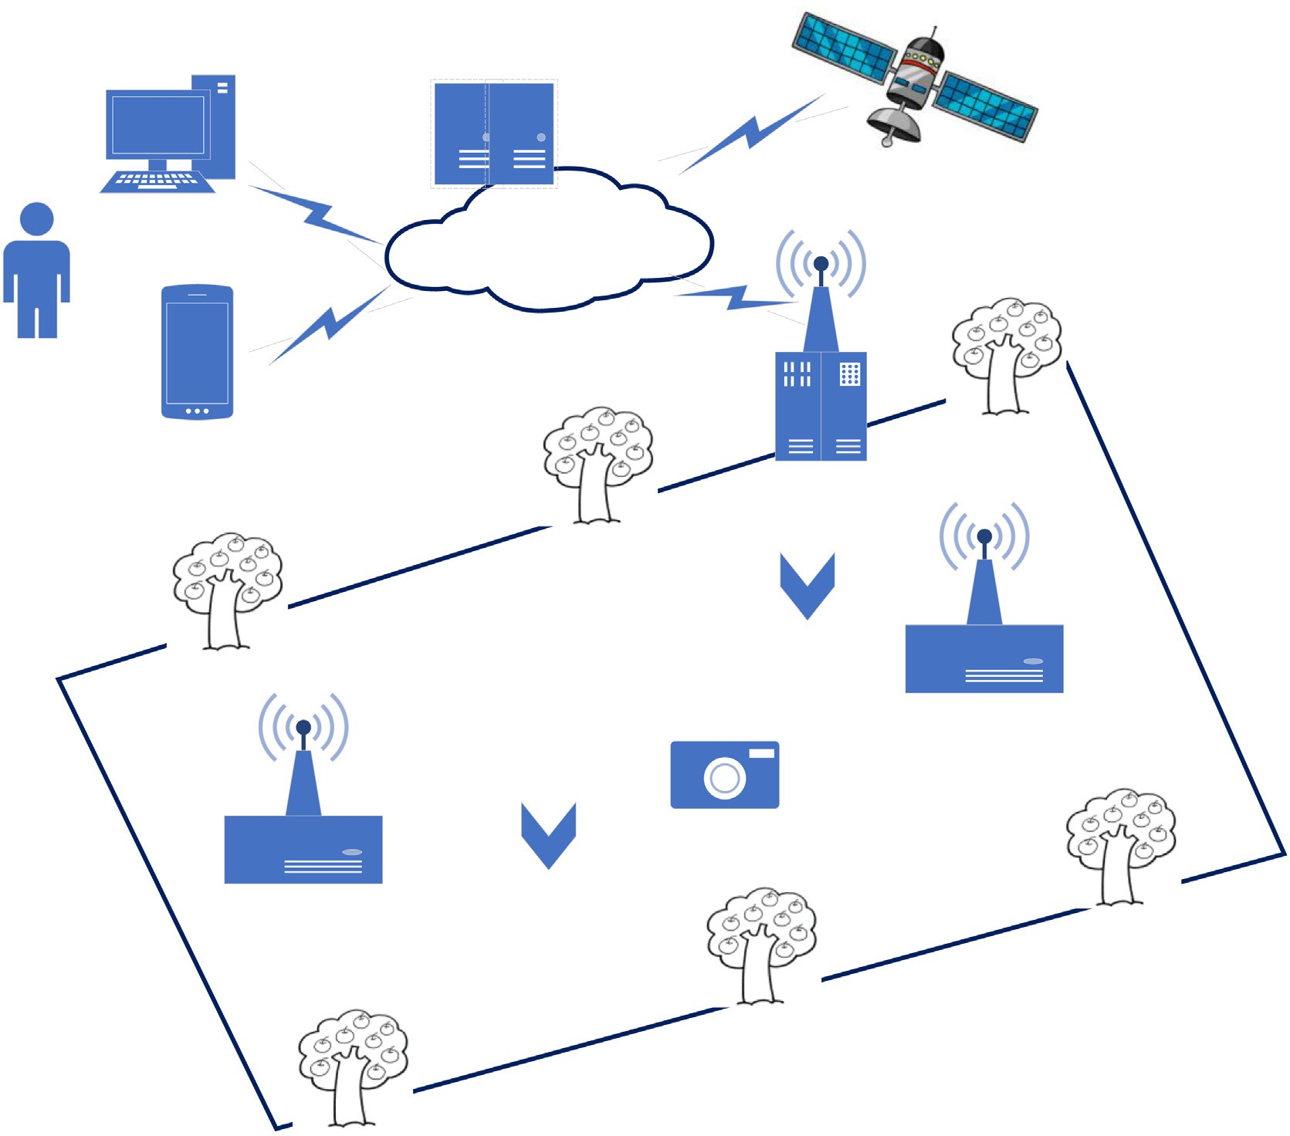

Fig. 7. Typical plant life information monitoring system.

wireless networks to form a vehicle-mounted intelligent terminal and a remote service platform for agricultural machinery.

Researchers designed a remote monitoring and management sys- tem and an automatic driving system for construction vehicles based on microprocessors (STM32) (Xu, 2017; Liu, 2019). These systems real- ize functions like vehicle positioning data collection, automatic obstacle avoidance, data transmission and reception, vehicle control, and status self-checking. Hu et al. analyzed the research status and existing prob- lems of agricultural machinery automatic navigation technology and made a prospect for the future development of agricultural machinery navigation technology (Hu et al., 2015). They pointed out that the main trends in the development of modern agricultural machinery au- tomatic navigation technology include satellite navigation technology- based agricultural machinery automatic steering control and obstacle detection; advanced navigation technology research, such as active ob- stacle avoidance and multi-machine coordinated navigation; and adopting advanced IoT technology. Sowjanya et al. designed a multi- functional automatic agricultural robot vehicle that can be controlled by Bluetooth for farming, seeding, and irrigation (Sowjanya et al., 2017). Lin et al. designed an agricultural machinery monitoring system using Bluetooth technology combined with embedded technology to re- alize data collection, processing, and wireless transmission (Lin et al., 2015). For fruit picking, Onishi et al. designed an apple-picking robot (Onishi et al., 2019). The robot uses a single-lens multi-box detection method to detect fruits and a stereo camera to detect the three- dimensional position of the fruits. Wang et al. designed an agricultural machinery operation parameter collector based on IoT technology, which realizes the combination of data collectors and IoT (Wang et al.,

2020). It can not only save manpower, overcome subjective operating errors, and improve the reliability of data but also promote the scientific management and scheduling of agricultural machinery. Aiming at the lack of systematic standard system guidance in the standardization work of China's intelligent agricultural machinery and equipment, Hu et al. studied and constructed a framework of China's intelligent agricul- tural machinery and equipment standard system (Hu et al., 2020).

Intelligent agricultural machinery IoT includes internal IoT, cluster IoT and remote IoT. Internal IoT refers to the communication and control between sensors, actuators and central processing unit in agricultural machinery. Cluster IoT refers to the communication and control be- tween the same or different kinds of agricultural machinery operating in the same area. Remote IoT refers to the communication and control between the operation site and remote terminals and servers. The struc- ture of intelligent agricultural machinery IoT is shown in Fig. 8.

* 1. *Agricultural product quality safety and traceability*

In terms of agricultural product quality safety and traceability, agri- cultural IoT is mainly applied to agricultural product warehousing, lo- gistics, and distribution. Through electronic data exchange, bar codes, RFID electronic tags, and other technologies, automatic identification and the input and output of warehouse of goods can be achieved. Using WSNs, storage workshops and logistics distribution vehicles can be monitored in real-time to achieve the goal of traceability of the source and destination of the main agricultural products. Many devel- oped countries have conducted in-depth research on agricultural prod- uct traceability systems and have already had relatively mature

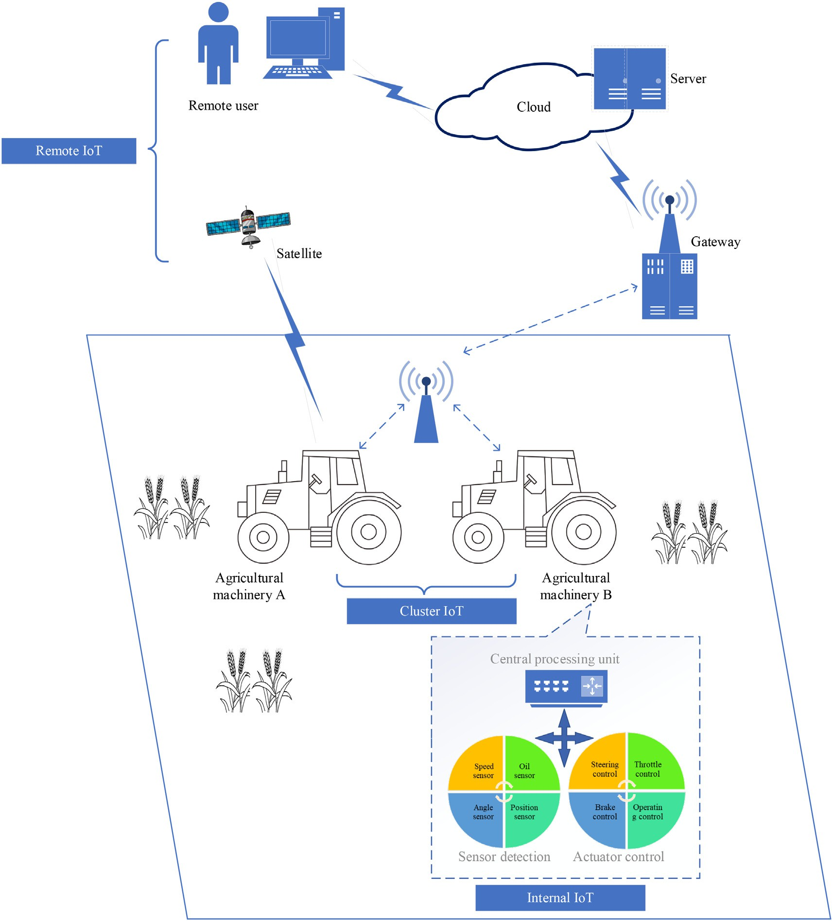

Fig. 8. Structure of intelligent agricultural machinery IoT.

applications, such as the American agricultural product traceability sys- tem, the European beef traceability system, the Swedish agricultural traceability system, the Japanese food traceability system, and the Australian livestock traceability system. To meet the needs of agricul- tural product modernization, intelligence, and informatization, Pinto et al. applies TIC manageable tools to traceability in the food industry (Pinto et al., 2006). Jiang et al. established a complete agricultural prod- uct safety traceability platform, which realizes real-time automatic col- lection, processing, and display of agricultural product data; improves the traceability of agricultural products; and reduced the cost of agricul- tural products tracking and monitoring (Jiang and Sun, 2017). Based on the GS1 coding framework, Cui, Liu, and Xiong et al. coded dairy prod- ucts, sea cucumbers, and pork uniformly, which realized precise posi- tioning of products in each processing stage and provided consumers with a product traceability query platform (Cui et al., 2015; Liu et al., 2017; Xiong and Zhao, 2018). Sun et al. designed a citrus traceability system using key technologies like RFID, QR code codes, and [asp.net](http://asp.net/) components (Sun et al., 2009). In prior studies (Huang, 2015; Chen, 2018; Tan, 2020), vegetable quality and safety supervision systems

were designed based on RFID technology, which can manage the infor- mation at each key stage of the vegetable life cycle from production, cir- culation, sales to after-sales, realizing the monitoring of vegetables from the source to the final consumer. The safety and quality of vegetables were greatly improved. Diao et al. built a web and GIS-based vegetable quality and safety early warning and traceability platform based on the actual needs of vegetable quality and safety supervision and traceability (Diao and Nie, 2015). This platform visually displayed the information at each stage of vegetable production and sales and improved the level of vegetable quality and safety management. Gu et al. used RFID to design electronic tags and coded individual pigs, carcasses, and seg- mentation parts, which included all the information in the entire life cycle, including the slaughter, processing, and sales stages of individual pigs (Gu et al., 2018).

Fig. 9 depicts head count of various topics of interest related to research articles discussed in current study from 2011 to 2021. The head count depicts that there is a lot of inclination towards the term “Animal and plant life information monitoring” in comparison to any other topic.

Fig. 9. Topics of interest related to research articles for existing study.

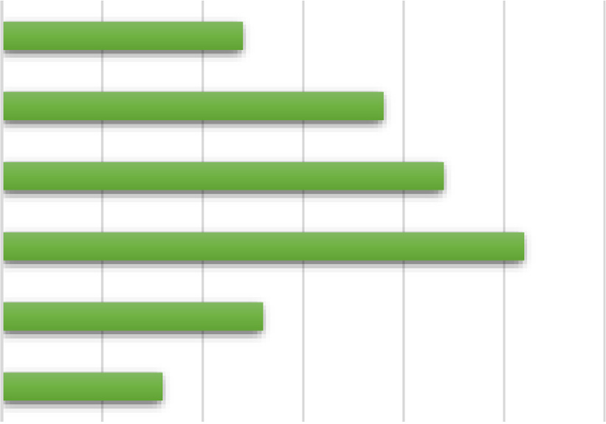

1. Problems

From the above-mentioned agricultural IoT system architecture, technology, and application, it is obvious that agricultural IoT has achieved some remarkable results in recent years. However, some diffi- culties require unremitting efforts to overcome.

1. Currently, IoT is generally divided into three layers: the percep- tion layer, the transport layer, and the application layer. While research on a single layer is relatively in-depth, research and dis- cussion on the entire IoT system structure are relatively lacking. This results in unstable data transmission, difficulties in data sharing, potential safety hazards in transmission, and poor posi- tioning accuracy and stability, which reduces the timeliness of data transmission by IoT.
2. There are many types of sensors with different communication interfaces and incompatible communication protocols, which re- quire a lot of software and hardware and make later expansion difficult. The research and application of embedded gateway middleware at the core of IoT are not enough, and most of them are only in the experimental stage.
3. Research on monitoring and perception of agricultural IoT mainly focus on data acquisition and single-machine processing, while research on complete application systems is lacking. The research and application of intelligent agricultural machinery IoT have fo- cused more on the optimization of a few single technologies.
4. The agricultural IOT relies on high-speed wireless WAN for data transmission. However, in the remote agricultural environment, the wireless communication signal is weak, so it is unrealistic to realize high-speed data transmission. Therefore, we can only im- prove the data coding efficiency to ensure the real-time perfor- mance of the system.
5. Prospection
6. Agricultural IoT system structure and perception node deploy- ment and management need to be researched. The architecture should be distributed, open, and resource-service sharable. By this, interconnections of various heterogeneous systems and resource sharing can be realized, and more detailed and specific agricultural information can be obtained.
7. Complete information perception standards need to be devel- oped, more research on embedded gateways is needed, and multi-protocol conversion gateways need to be designed. The purpose is to solve the problems of inconsistent device interface and protocol, making the connection between things faster, more convenient, and more capable of multiple data analysis and processing.
8. Make full use of 5G communication technology, virtual reality technology and augmented reality technology to establish an integrated network system integrating agricultural machinery, agronomy, crops and farmers, realize the digital twin of the whole production process, and facilitate intelligent decision- making, process monitoring and multi factor intelligent traceability.

Declaration of Competing Interest

The authors declare that they have no know competing financial in- terests or personal relationships that could have appeared of influence the reported in this paper.

References

Adamchuk, V.I., Hummel, J.W., Morgan, M.T., et al., 2004. On-the-go soil sensors for pre- cision agriculture. Comput. Electron. Agric. 44 (1), 71–91. [https://doi.org/10.1016/j.](https://doi.org/10.1016/j.compag.2004.03.002) [compag.2004.03.002](https://doi.org/10.1016/j.compag.2004.03.002).

Ampatzidis, Y.G., Vouqioukas, S.G., 2009. Field experiments for evaluating the incorpora- tion of RFID and barcode registration and digital weighing technologies in manual fruit harvesting. Comput. Electron. Agric. 66 (2), 166–172. [https://doi.org/10.1016/j.](https://doi.org/10.1016/j.compag.2009.01.008) [compag.2009.01.008](https://doi.org/10.1016/j.compag.2009.01.008).

Bowman, K.D., 2010. Longevity of radio frequency identification device microchips in cit- rus trees. Hortscience 45 (3), 451–452. <https://doi.org/10.21273/HORTSCI.45.3.451>.

Bu, T.R., Lv, L.X., Wang, W., 2009. Design of agriculture environment monitoring system based on tiny OS wireless sensor network. Agric. Netw. Inform. 2009 (02), 23–26. <https://doi.org/10.3969/j.issn.1672-6251.2009.02.008>.

Chang, P.F., Zhang, J.F., Zhang, W., 2018. Point localization technology for forestry wireless sensor network. J. N. For. Univ. 46 (08), 102–105. [https://doi.org/10.13759/j.cnki.](https://doi.org/10.13759/j.cnki.dlxb.2018.08.019) [dlxb.2018.08.019](https://doi.org/10.13759/j.cnki.dlxb.2018.08.019).

Chen, X.D., 2015. [Study on Growth Condition Monitoring and Management Techniques of](http://refhub.elsevier.com/S2589-7217(22)00001-0/rf0030) [Millet Field Based on Internet of Things. Shanxi Agricultural Universit](http://refhub.elsevier.com/S2589-7217(22)00001-0/rf0030)y.

Chen, Y.X., 2018. [Analysis and Design of Vegetable Quality and Security Management Sys-](http://refhub.elsevier.com/S2589-7217(22)00001-0/rf0035) [tem Based on RFID Technology. Jiangxi University of Finance and Economics](http://refhub.elsevier.com/S2589-7217(22)00001-0/rf0035).

Chen, Q., Han, B., Qin, W., et al., 2011. [Design and implementation of the IOT gateway](http://refhub.elsevier.com/S2589-7217(22)00001-0/rf0040) [based on Zigbee/GPRS protocol. J. Comput. Res. Dev. 48 (Suppl), 367–372](http://refhub.elsevier.com/S2589-7217(22)00001-0/rf0040).

Chen, X.Y., Yao, G.W., Zhang, K., et al., 2015. The application of wireless sensor node local- ization based on genetic algorithm in agriculture. Software 36 (04), 1–5. [https://doi.](https://doi.org/10.3969/j.issn.1003-6970.2015.04.001) [org/10.3969/j.issn.1003-6970.2015.04.001](https://doi.org/10.3969/j.issn.1003-6970.2015.04.001).

Chi, R.X., 2017. [Research on the application of GPS technology in agricultural machinery](http://refhub.elsevier.com/S2589-7217(22)00001-0/rf0050) [and related issues. Agric. Technol. Serv. 34 (03), 162](http://refhub.elsevier.com/S2589-7217(22)00001-0/rf0050).

Chui, W., 2017. Ecological environment monitoring in Xiangyang region based on RS technology. Agric. Extens. 48 (19), 46–47. [https://doi.org/10.3969/j.issn.1672-3872.](https://doi.org/10.3969/j.issn.1672-3872.2017.19.034)

[2017.19.034](https://doi.org/10.3969/j.issn.1672-3872.2017.19.034).

Cui, X.Y., Zhang, L.J., Yue, C.L., 2015. Dairy quality and safety traceability based on GS1. Appl. Technol. 10, 104–107. <https://doi.org/10.3969/j.issn.1674-9146.2015.10.104>.

Diao, H.T., Nie, Y.M., 2015. Platform construction of vegetable safety warning and trace- ability based on modern information technology. Sci. Agric. Sin. 48 (03), 460–468. <https://doi.org/10.3864/j.issn.0578-1752.2015.03.06>.

Du, K.M., Chu, J.X., Sun, Z.F., et al., 2016. Design and implementation of monitoring system for agricultural environment based on web GIS with internet of things. Trans. Chin. Soc. Agric. Eng. 32 (4), 171–178. [https://doi.org/10.11975/j.issn.1002-6819.2016.](https://doi.org/10.11975/j.issn.1002-6819.2016.04.024)

[04.024](https://doi.org/10.11975/j.issn.1002-6819.2016.04.024).

Erlangga, Wihardi, Y., Nugraha, E., 2020. Development mobile learning for vegetable farming in Indonesia based on mobile cloud computing. 2020 6th International Con- ference on Science in Information Technology (ICSITech), pp. 6–10 [https://doi.org/10.](https://doi.org/10.1109/ICSITech49800.2020.9392074) [1109/ICSITech49800.2020.9392074](https://doi.org/10.1109/ICSITech49800.2020.9392074).

Farooq, M.S., Riaz, S., Abid, A., et al., 2019. A survey on the role of IoT in agriculture for the implementation of smart farming. IEEE Access 7, 156237–156271. [https://doi.org/10.](https://doi.org/10.1109/ACCESS.2019.2949703) [1109/ACCESS.2019.2949703](https://doi.org/10.1109/ACCESS.2019.2949703).

Gao, J., Feng, G.Y., Hang, C.M., et al., 2010. Water-saving irrigation control system based on wireless sensor network. Modern Electron. Tech. 33 (1), 204–206. [https://doi.org/10.](https://doi.org/10.3969/j.issn.1004-373X.2010.01.063) [3969/j.issn.1004-373X.2010.01.063](https://doi.org/10.3969/j.issn.1004-373X.2010.01.063).

Gao, K.Q., Xu, P.L., Niu, Y.J., 2020. [Application of RS technology in urban land intensive use.](http://refhub.elsevier.com/S2589-7217(22)00001-0/rf0090)

[Geomat. Spatial Inform. Technol. 43 (4), 143–14](http://refhub.elsevier.com/S2589-7217(22)00001-0/rf0090)7.

Glaroudis, D., Iossifides, A., Chatzimisios, P., 2019. Survey, comparison and research chal- lenges of IoT application protocols for smart farming. Comput. Netw. 168, 107037. <https://doi.org/10.1016/j.comnet.2019.107037>.

González, L.A., Bishop-Hurley, G.J., Handcock, R.N., et al., 2015. Behavioral classification of data from collars containing motion sensors in grazing cattle. Comput. Electron. Agric. 110, 91–102. <https://doi.org/10.1016/j.compag.2014.10.018>.

Gu, Y., Qi, X.M., 2020. Construction of agricultural big data visualization platform based on GIS in Nanjing City. J. Shandong Agric. Univ. (Nat. Sci. Ed.) 51 (04), 702–704. [https://](https://doi.org/10.3969/j.issn.1000-2324.2020.04.024) [doi.org/10.3969/j.issn.1000-2324.2020.04.024](https://doi.org/10.3969/j.issn.1000-2324.2020.04.024).

Gu, H.W., Zhang, X.Y., Qin, X., et al., 2018. Construction of pork trace ability system. Hei- longjiang Agric. Sci. 2018 (05), 46–49. [https://doi.org/10.11942/j.issn1002-2767.](https://doi.org/10.11942/j.issn1002-2767.2018.05.0046)

[2018.05.0046](https://doi.org/10.11942/j.issn1002-2767.2018.05.0046).

Hamrita, T.K., Hoffacker, E.C., 2005. Development of a smart wireless soil monitoring sen- sor prototype using RFID technology. Appl. Eng. Agric. 21 (1), 139–143. [https://doi.](https://doi.org/10.13031/2013.17904) [org/10.13031/2013.17904](https://doi.org/10.13031/2013.17904).

He, T., 2020. Design of RFID system structure based on Zigbee technology. Integr. Circ.

Appl. 37 (08), 12–13. <https://doi.org/10.19339/j.issn.1674-2583.2020.08.004>.

He, Z.G., Ji, X.B., He, J.G., 2009. Some ideas on establishing the arbitration system of forest ownership disputes. Modern Agric. Technol. 2009 (3), 94–95. [https://doi.org/10.](https://doi.org/10.3969/j.issn.1007-5739.2009.03.057) [3969/j.issn.1007-5739.2009.03.057](https://doi.org/10.3969/j.issn.1007-5739.2009.03.057).

He, Y., Nie, P.C., Liu, F., 2013. Advancement and trend of internet of things in agriculture and sensing instrument. J. Agric. Mach. 44 (10), 216–226. [https://doi.org/10.6041/j.](https://doi.org/10.6041/j.issn.1000-1298.2013.10.035) [issn.1000-1298.2013.10.035](https://doi.org/10.6041/j.issn.1000-1298.2013.10.035).

Hou, J.L., Hou, R., Gao, D.S., et al., 2012. The design and implementation of orchard long- distance intelligent irrigation system based on Zigbee and GPRS. Adv. Mater. Res. 588-589, 1593–1597. [https://doi.org/10.4028/www.scientific.net/AMR.588-589.](https://doi.org/10.4028/www.scientific.net/AMR.588-589.1593)

[1593](https://doi.org/10.4028/www.scientific.net/AMR.588-589.1593).

Hu, J.T., Gao, L., Bai, X.P., et al., 2015. Review of research on automatic guidance of agricul- tural vehicles. Trans. Chin. Soc. Agric. Eng. 31 (10), 1–10. [https://doi.org/10.11975/j.](https://doi.org/10.11975/j.issn.1002-6819.2015.10.001) [issn.1002-6819.2015.10.001](https://doi.org/10.11975/j.issn.1002-6819.2015.10.001).

Hu, X.L., Liang, X.X., Zhang, J.N., et al., 2020. [Construction of standard system framework](http://refhub.elsevier.com/S2589-7217(22)00001-0/rf0145) [for intelligent agricultural machinery in China. Smart Agric. 2 (3), 1–](http://refhub.elsevier.com/S2589-7217(22)00001-0/rf0145)8.

Huang, Q.G., 2015. [Research on the traceability system of vegetable food safety based on](http://refhub.elsevier.com/S2589-7217(22)00001-0/rf0150) [RFID techno logy. Sci. Chin. 2015 (11Z), 6–](http://refhub.elsevier.com/S2589-7217(22)00001-0/rf0150)7.

Hwang, J., Shin, C., Yoe, H., 2010. Study on an agricultural environment monitoring server system using wireless sensor networks. Sensors 10 (12), 11189–11211. [https://doi.](https://doi.org/10.3390/s101211189) [org/10.3390/s101211189](https://doi.org/10.3390/s101211189).

Jia, L.R., 2020. Design of wildlife monitoring system based on internet of things technol- ogy. Inform. Rec. Mater. 21 (04), 175–176. [https://doi.org/10.16009/j.cnki.cn13-](https://doi.org/10.16009/j.cnki.cn13-1295/tq.2020.04.113) [1295/tq.2020.04.113](https://doi.org/10.16009/j.cnki.cn13-1295/tq.2020.04.113).

Jiang, L., Sun, K., 2017. Research on security traceability platform of agricultural products based on internet of things. 7th International Conference on Mechatronics, Computer and Education Informationization <https://doi.org/10.2991/mcei-17.2017.31>.

Kumar, A., Hancke, G.P., 2014. A Zigbee-based animal health monitoring system. IEEE Sen- sors J. 15 (1), 610–617. <https://doi.org/10.1109/JSEN.2014.2349073>.

Li, J.J., 2017. Research on real-time decision system of agricultural fertilization based on Beidou and RS technology. Sci. Technol. Vis. 2017 (02), 282–283. [https://doi.org/10.](https://doi.org/10.3969/j.issn.2095-2457.2017.02.216) [3969/j.issn.2095-2457.2017.02.216](https://doi.org/10.3969/j.issn.2095-2457.2017.02.216).

Li, Y., 2019. [Design of Intelligent Greenhouse Monitoring System. Tarim Universit](http://refhub.elsevier.com/S2589-7217(22)00001-0/rf0180)y.

Li, D.L., Yang, H., 2018. State-of-the-art review for internet of things in agriculture. Trans. Chin. Soc. Agric. Mach. 49 (1), 1–20. [https://doi.org/10.6041/j.issn.1000-1298.2018.](https://doi.org/10.6041/j.issn.1000-1298.2018.01.001)

[01.001](https://doi.org/10.6041/j.issn.1000-1298.2018.01.001).

Li, C.Y., Teng, G.H., Zhao, C.J., et al., 2003. Development of non-contact measurement on plant growth in greenhouse using computer vision. Trans. Chin. Soc. Agric. Eng. 19 (3), 140–143. https://doi.org/10.3321/j.issn:1002-6819.2003.03.033.

Li, J., Guo, M.R., Gao, L.L., 2015. Application and innovation strategy of agricultural internet of things. Trans. Chin. Soc. Agric. Eng. 31 (S2), 200–209. [https://doi.org/10.11975/j.](https://doi.org/10.11975/j.issn.1002-6819.2015.z2.031) [issn.1002-6819.2015.z2.031](https://doi.org/10.11975/j.issn.1002-6819.2015.z2.031).

Li, J., Li, M.M., Sun, L.P., et al., 2017. Polarization-maintaining microfiber-based evanescent-wave sensors. Acta Phys. Sin. 66 (7), 191–200. [https://doi.org/10.7498/](https://doi.org/10.7498/aps.66.074209) [aps.66.074209](https://doi.org/10.7498/aps.66.074209).

Li, X.G., Hu, S.P., Wen, F., 2021. Design of nutrient analyzer based on GIS for spatial vari- ability of soil nutrients. Agric. Mech. 43 (06), 227–230. [https://doi.org/10.13427/j.](https://doi.org/10.13427/j.cnki.njyi.2021.06.043) [cnki.njyi.2021.06.043](https://doi.org/10.13427/j.cnki.njyi.2021.06.043).

Lin, F., Kuo, Y., Hsieh, J., et al., 2015. A self-powering wireless environment monitoring system using soil energy. IEEE Sensors J. 15 (7), 3751–3758. [https://doi.org/10.](https://doi.org/10.1109/JSEN.2015.2398845) [1109/JSEN.2015.2398845](https://doi.org/10.1109/JSEN.2015.2398845).

Liu, J., 2016. Development and application of agricultural internet of things technology.

Agric. Technol. 36 (19), 179–180. <https://doi.org/10.11974/nyyjs.20161032065>.

Liu, J.Q., 2019. [Design and Implementation of Agricultural Machinery Automatic Driving](http://refhub.elsevier.com/S2589-7217(22)00001-0/rf0225) [System Based on stm32. North China Institute of Aerospace Engineering](http://refhub.elsevier.com/S2589-7217(22)00001-0/rf0225).

Liu, W., Cheng, Z.J., Zhang, Y.H., 2016. The construction of agricultural vehicle temperature control tracking system based on NFC and GPS. Comput. Knowl. Technol. 12 (27), 208–210. <https://doi.org/10.14004/j.cnki.ckt.2016.3590>.

Liu, H.R., Liu, X.L., Yuan, Y., 2017. Design and implementation of traceability system for stichopus japonicus products. Res. Agric. Modern. 38 (5), 869–876. [https://doi.org/](https://doi.org/10.13872/j.1000-0275.2017.0092) [10.13872/j.1000-0275.2017.0092](https://doi.org/10.13872/j.1000-0275.2017.0092).

Luis, R., Loredana, L., 2011. The role of RFID in agriculture: applications. Limit. Challeng. 79 (1), 42–50. <https://doi.org/10.1016/j.compag.2011.08.010>.

Lv, L.X., Wang, W., Bu, T.R., 2009. Design of precision agriculture environment monitoring system based on wireless sensor network. Comput. Syst. Appl. 18 (08), 5–9. [https://](https://doi.org/10.3969/j.issn.1003-3254.2009.08.002) [doi.org/10.3969/j.issn.1003-3254.2009.08.002](https://doi.org/10.3969/j.issn.1003-3254.2009.08.002).

Ma, Y.Q., Sun, X., 2020. [Intelligent agricultural machinery equipment and technology.](http://refhub.elsevier.com/S2589-7217(22)00001-0/rf0250)

[Agric. Equip. Technol. 46 (01), 4–](http://refhub.elsevier.com/S2589-7217(22)00001-0/rf0250)6.

Ma, H.R., Luo, Z.Q., Chen, P.T., et al., 2019. Application of remote sensing technology in construction and management of irrigation and drainage engineering. Hubei Agric. Sci. 58 (23), 16–20. <https://doi.org/10.14088/j.cnki.issn0439-8114.2019.23.003>.

Meng, Z.Q., 2018. [Research on the Automatic Temperature Detection of Pig Temperature](http://refhub.elsevier.com/S2589-7217(22)00001-0/rf0260) [Based on Infrared Technology. Tianjin Agricultural Academy](http://refhub.elsevier.com/S2589-7217(22)00001-0/rf0260).

Nagl, L., Schmitz, R., Warren, S., et al., 2003. Wearable sensor system for wireless state-of- health determination in cattle. Proceedings of the 25th Annual International Confer- ence of the IEEE Engineering in Medicine and Biology Society (IEEE Cat. No. 03CH37439). vol. 4. IEEE, pp. 3012–3015. [https://doi.org/10.1109/IEMBS.2003.](https://doi.org/10.1109/IEMBS.2003.1280774)

[1280774](https://doi.org/10.1109/IEMBS.2003.1280774).

Onishi, Y., Yoshida, T., Kurita, H., et al., 2019. An automated fruit harvesting robot by using deep learning. ROBOMECH J. 6 (1), 13–14. [https://doi.org/10.1186/s40648-019-](https://doi.org/10.1186/s40648-019-0141-2)

[0141-2](https://doi.org/10.1186/s40648-019-0141-2).

Otoniel, L., Miguel, R., Hector, M., et al., 2012. Monitoring pest insect traps by means of low-power image sensor technologies. Sensors 12 (11), 15801–15819. [https://doi.](https://doi.org/10.3390/s121115801) [org/10.3390/s121115801](https://doi.org/10.3390/s121115801).

Park, D.H., Park, J.W., 2011. Wireless sensor network-based greenhouse environment monitoring and automatic control system for dew condensation prevention. Sensors 11 (4), 3640–3651. <https://doi.org/10.3390/s110403640>.

Parsons, J., Kimberling, C., Parson, G.V., et al., 2005. [Colorado sheep ID project: using RFID](http://refhub.elsevier.com/S2589-7217(22)00001-0/rf0285) [or tracking sheep. J. Anim. Sci. 83, 119–12](http://refhub.elsevier.com/S2589-7217(22)00001-0/rf0285)0.

Pinto, D.B., Castro, I., Vicente, A.A., 2006. The use of TIC’s as a managing tool for traceability in the food industry. Food Res. Int. 39 (7), 772–781. [https://doi.org/10.1016/j.foodres.](https://doi.org/10.1016/j.foodres.2006.01.015) [2006.01.015](https://doi.org/10.1016/j.foodres.2006.01.015).

Porto, S.M.C., Arcidiacono, C., Cascone, G., 2011. Developing integrated computer-based information systems for certified plant traceability: case study of Italian citrus-plant nursery chain. Biosyst. Eng. 109 (2), 120–129. [https://doi.org/10.1016/j.](https://doi.org/10.1016/j.biosystemseng.2011.02.008) [biosystemseng.2011.02.008](https://doi.org/10.1016/j.biosystemseng.2011.02.008).

Presser, M., Barnaghi, P.M., Eurich, M., et al., 2009. The SENSEI project: integrating the physical world with the digital world of the network of the future. IEEE Commun. Mag. 47 (4), 1–4. <https://doi.org/10.1109/MCOM.2009.4907403>.

Qin, X.Q., 2016. Analysis of wireless sensor network positioning technology. Comput.

Knowl. Technol. 12 (19), 42–43. <https://doi.org/10.14004/j.cnki.ckt.2016.2568>.

Qu, Y., Yang, P., 2011. RFID technology and its application in agricultural internet of things.

J. Hebei Agric. Sci. 15 (4), 94–95. [https://doi.org/10.3969/j.issn.1088-1631.2011.](https://doi.org/10.3969/j.issn.1088-1631.2011.04.030)

[04.030](https://doi.org/10.3969/j.issn.1088-1631.2011.04.030).

Shan, S.S., 2019. [Research on the development status and countermeasures of agricultural](http://refhub.elsevier.com/S2589-7217(22)00001-0/rf0315) [internet of things. Publ. Invest. Guide 2019 (11), 220–222](http://refhub.elsevier.com/S2589-7217(22)00001-0/rf0315).

Sheng, P., Guo, Y.Y., Li, P.P., 2012. Intelligent measurement and control system of facility agriculture based on Zigbee and 3G. Trans. Chin. Soc. Agric. Mach. 43 (12), 229–233. <https://doi.org/10.6041/j.issn.1000-1298.2012.12.041>.

Song, J., Li, W., Li, Q.F., 2012. [Research on intelligent water saving irrigation system based](http://refhub.elsevier.com/S2589-7217(22)00001-0/rf0325) [on CAN bus. Water Saving Irrigat. 2012 (11), 64–66](http://refhub.elsevier.com/S2589-7217(22)00001-0/rf0325).

Sowjanya, K.D., Sindhu, R., Parijatham, M., et al., 2017. Multipurpose autonomous agricul- tural robot. 2017 international conference of electronics. Commun. Aerospace Technol. 2, 696–699. <https://doi.org/10.1109/ICECA.2017.8212756>.

Srbinovska, M., Gavrovski, C., Dimcev, V., et al., 2015. Environmental parameters monitor- ing in precision agriculture using wireless sensor networks. J. Clean. Prod. 88 (2), 297–307. <https://doi.org/10.1016/j.jclepro.2014.04.036>.

Sun, Z.F., Gao, H.T., Li, H.L., et al., 2006. [GPRS and web-based data acquisition system for](http://refhub.elsevier.com/S2589-7217(22)00001-0/rf0340) [greenhouse environment. Trans. CSAE 22 (6), 131–134](http://refhub.elsevier.com/S2589-7217(22)00001-0/rf0340).

Sun, X.D., Zhang, H.L., OuYang, A.G., et al., 2009. Implementation method of citrus quality and security trace ability system design. Agric. Mech. 31 (12), 162–164. [https://doi.](https://doi.org/10.3969/j.issn.1003-188X.2009.12.048) [org/10.3969/j.issn.1003-188X.2009.12.048](https://doi.org/10.3969/j.issn.1003-188X.2009.12.048).

Tan, Y., 2020. Design of vegetable quality and safety supervision system based on RFID. Modern Inform. Technol. 4 (04), 197–198. [https://doi.org/10.19850/j.cnki.2096-](https://doi.org/10.19850/j.cnki.2096-4706.2020.04.060)

[4706.2020.04.060](https://doi.org/10.19850/j.cnki.2096-4706.2020.04.060).

Walewski, J.W., 2011. [Internet-of-things architecture, report on project deliverable D1.2–](http://refhub.elsevier.com/S2589-7217(22)00001-0/rf0355) [initial architectural reference model for IoT. Project Co-funded by the European Com-](http://refhub.elsevier.com/S2589-7217(22)00001-0/rf0355) [mission within the Seventh Framework Program Grant agreement, 2011 (257521)](http://refhub.elsevier.com/S2589-7217(22)00001-0/rf0355).

Wang, X.F., Fang, Y.F., 2018. [Design and implementation of greenhouse vegetable produc-](http://refhub.elsevier.com/S2589-7217(22)00001-0/rf0360) [tion management system based on internet of things. J. Zhengzhou Normal Educ. 7](http://refhub.elsevier.com/S2589-7217(22)00001-0/rf0360) [(04), 28–33](http://refhub.elsevier.com/S2589-7217(22)00001-0/rf0360).

Wang, F.Y., Zhao, Y.M., Zhang, X.Y., et al., 2009. [Intelligent measure-control system design](http://refhub.elsevier.com/S2589-7217(22)00001-0/rf0365) [based on sectional-control strategy in greenhouse. Trans. Chin. Soc. Agric. Mach. 40](http://refhub.elsevier.com/S2589-7217(22)00001-0/rf0365) [(5), 178–18](http://refhub.elsevier.com/S2589-7217(22)00001-0/rf0365)1.

Wang, Y.T., Wu, Y.Y., Li, J.C., et al., 2013. Research on agricultural irrigation fertilization in- telligent control system based on GPRS DTU. China Rural Water Conserv. Hydro- power 2013 (12), 93–97. <https://doi.org/10.3969/j.issn.1007-2284.2013.12.023>.

Wang, Z.Q., Yun, Y.L., Qin, Z.Z., 2020. Design and test of data collector for agricultural ma- chine operation parameters based on internet of things. Agric. Mech. 42 (01), 75–79. <https://doi.org/10.13427/j.cnki.njyi.2020.01.014>.

Xia, Y., Sun, Z.F., Du, K.M., et al., 2013. Design and realization of IoT-based diagnosis and management system for wheat production. Trans. Chin. Soc. Agric. Eng. 29 (5), 117–124. <https://doi.org/10.3969/j.issn.1002-6819.2013.05.016>.

Xiong, Y.H., Zhao, S.X., 2018. [Research on pork traceability system based on GS1 standard.](http://refhub.elsevier.com/S2589-7217(22)00001-0/rf0385)

[Light Indus. Sci. Technol. 34 (01), 30–31](http://refhub.elsevier.com/S2589-7217(22)00001-0/rf0385).

Xu, J.F., 2017. [Remote Monitoring System of Construction Vehicle Based on STM32. East](http://refhub.elsevier.com/S2589-7217(22)00001-0/rf0390) [China University of Science and Technology](http://refhub.elsevier.com/S2589-7217(22)00001-0/rf0390).

Xu, Z.Y., Lou, B.D., Shao, G.C., 2012. [In: Wang, Y.H., Zhang, X.M. (Eds.), An Intelligent](http://refhub.elsevier.com/S2589-7217(22)00001-0/rf0395) [Irrigation System for Greenhouse Jonquil Based on ZigBee Wireless Sensor Networks.](http://refhub.elsevier.com/S2589-7217(22)00001-0/rf0395) [Internet of Things. Springer, Berlin Heidelberg](http://refhub.elsevier.com/S2589-7217(22)00001-0/rf0395).

Yang, M.T., Chen, C.C., Kuo, Y.L., 2013. Implementation of intelligent air conditioner for

fine agriculture. Energ. Build. 60 (3), 364–371. [https://doi.org/10.1016/j.enbuild.](https://doi.org/10.1016/j.enbuild.2013.01.034)

[2013.01.034](https://doi.org/10.1016/j.enbuild.2013.01.034).

Yang, B., Wei, W.Z., Chen, M., et al., 2020. Research on design of intelligent water-saving irrigation system base d on neural network. Water Conserv. Tech. Supervis. 2020 (05), 44–48. <https://doi.org/10.3969/j.issn.1008-1305.2020.05.013>.

Yao, Y., Xu, C., Li, X.H., et al., 2010. [Localization technology on application of wireless sen-](http://refhub.elsevier.com/S2589-7217(22)00001-0/rf0410) [sor networks to precision irrigation. Comput. Eng. Appl. 46 (5), 221–22](http://refhub.elsevier.com/S2589-7217(22)00001-0/rf0410)3.

You, W.J., Tang, S.Y., 2013. Research on the related techniques of precision agriculture electronic system. J. Chin. Agric. Mech. 34 (3), 233–236. [https://doi.org/10.3969/j.](https://doi.org/10.3969/j.issn.2095-5553.2013.03.057) [issn.2095-5553.2013.03.057](https://doi.org/10.3969/j.issn.2095-5553.2013.03.057).

Yue, Y.J., Yue, X.F., Zhong, Y.Y., 2018. Research progress on system structure and key tech- nology of agricultural internet of things. J. Agric. Sci. Technol. 21 (4), 79–87. [https://](https://doi.org/10.13304/j.nykjdb.2018.0313) [doi.org/10.13304/j.nykjdb.2018.0313](https://doi.org/10.13304/j.nykjdb.2018.0313).

Zhang, H., 2010. [Intelligent Farmland Irrigation System Based on CAN Bus. Weifang](http://refhub.elsevier.com/S2589-7217(22)00001-0/rf0425) [University, Shandong Province, pp. 11–26](http://refhub.elsevier.com/S2589-7217(22)00001-0/rf0425).

Zhang, W.C., Yu, X.W., Li, Z.C., 2011. [Wireless network sensor node design based on](http://refhub.elsevier.com/S2589-7217(22)00001-0/rf0430) [cc2530 and Zigbee protocol stack. Comput. Syst. Appl. 20 (7), 184–187](http://refhub.elsevier.com/S2589-7217(22)00001-0/rf0430).

Zhang, Y., Zhang, K., Yan, X.Q., 2014a. Agricultural internet of things: architecture, appli- cation, social and economic effectiveness. Agric. Mech. Res. 36 (10), 1–5. [https://](https://doi.org/10.13427/j.cnki.njyi.2014.10.001) [doi.org/10.13427/j.cnki.njyi.2014.10.001](https://doi.org/10.13427/j.cnki.njyi.2014.10.001).

Zhang, C.S., Zhang, T.J., Zhang, M., et al., 2014b. Remote environmental monitoring system for greenhouse based on WSN. J. China Agric. Univ. 19 (05), 168–173. [https://doi.org/](https://doi.org/10.11841/j.issn.1007-4333.2014.05.23) [10.11841/j.issn.1007-4333.2014.05.23](https://doi.org/10.11841/j.issn.1007-4333.2014.05.23).

Zhao, X., 2018. [Agricultural information collection system based on mobile GIS. Agric. Eng.](http://refhub.elsevier.com/S2589-7217(22)00001-0/rf0445)

[8 (05), 31–34](http://refhub.elsevier.com/S2589-7217(22)00001-0/rf0445).

Zhou, C.F., Liu, X., Yu, H.R., et al., 2019. [Decision making support system of regional agri-](http://refhub.elsevier.com/S2589-7217(22)00001-0/rf0450) [cultural planning: development based on GIS. Chin. Agric. Sci. Bull. 35 (20), 143–14](http://refhub.elsevier.com/S2589-7217(22)00001-0/rf0450)9.