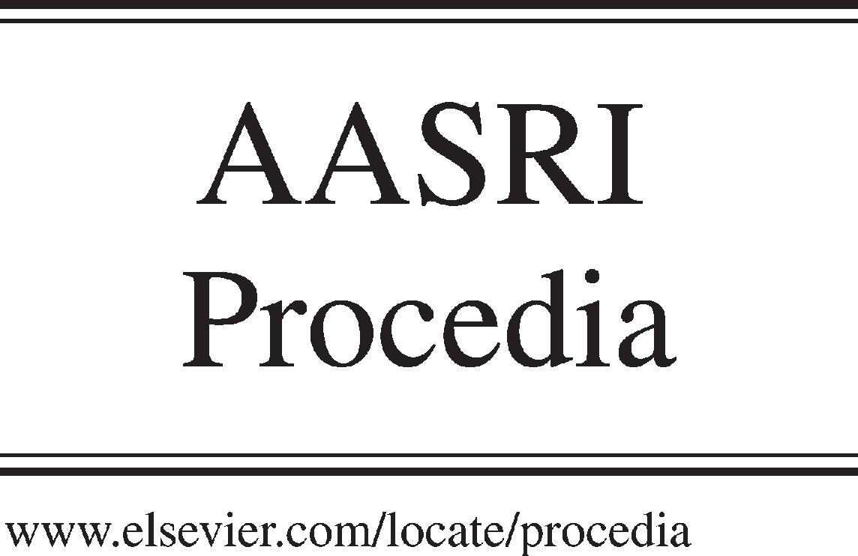Available online at [www.sciencedirect.com](http://www.sciencedirect.com/)



AASRI Procedia 3 (2012) 307 – 312

2012 AASRI Conference on Modeling, Identification and Control

The Characteristics of Taiwan Domestic Wastewater Sludge and the feasibility of Reusing for Growing Edible Crops

Shu-Fen Cheng*,a, Jyh-Woei Chenb, Hui-Min Yenb, Chih-Ming Kaoc, Yao-Ting Tuc,

Chin-Yuan Huangd, Jia-Rong Chena

*aDepartment of Environmental Engineering and Management, Chaoyang University of Technology, Taichung City, 413, Taiwan*

*bConstruction and Planning Agency Ministry of Interior (CPAMI), Taiwan*

*cInstit*ute of Environmental Engineering, National Sun Yat-Sen University, Kaohsiung City, Taiwan

*dDepartment of Bioinformatics, Asia University, Taichung City, Taiwan*

**Abstract**

The popularity of municipal sewage sewers system leads to producing a massive quantity of domestic wastewater sludge; how to treat and dispose of the sludge is becoming an environmental problem. The sludge is rich in nutrients, and it is often applied to soil as fertilizer or soil conditioner in many developing and developed nations. However, the influence of heavy metals contained in sludge on the crop growth and quality is a major concern when the sludge is reused on farmland for growing edible crops. The objectives of this research are to analyze the municipal sewage sludge for heavy metal contents and their bond fractions, and to conduct crop growth experiments to evaluate the influence on crop growth and quality by applying the sludge as soil additives for growing crop. The experimental sludge samples were collected from Taichung Fu-Tien wastewater treatment plants. The sludge contains Cu, Zn, Ni and Cd with concentrations exceeding the maximum levels legally allowed in Taiwan farmland soil. Most Cu exists in organic bond fraction; Zn is in Fe-Mn oxides bond fraction, Ni is in organic bond fraction, and Cd is in Fe-Mn oxides bond fraction. Three batches of plant growing and harvesting were carried. The crop growth results reveal that the growth of plants grown in the second batch of planting is obviously suppressed, and the extent of influence increases with higher ratios of sludge applied to the soil.

© 2012 The Authors. Published by Elsevier B.V. Open access under [CC BY-NC-ND license.](http://creativecommons.org/licenses/by-nc-nd/3.0/)

© 2012 Published by Elsevier B.V. Selection and/or peer rev[iew under responsi](http://creativecommons.org/licenses/by-nc-nd/3.0/)bility of American Applied Science Research Institute

Selection and/or peer review under responsibility of American Applied Science Research Institute

*Keywords:* sludge; reuse; heavy metal; soil; bioavailability

* Corresponding author. Tel.:+886-4-23323000-4237; fax:+886-4-23742365.

*E-mail address:* [shufen@cyut.edu.tw.](mailto:shufen@cyut.edu.tw)

2212-6716 © 2012 The Authors. Published by Elsevier B.V. Open access under [CC BY-NC-ND license.](http://creativecommons.org/licenses/by-nc-nd/3.0/) Selection and/or peer review under responsibility of American Applied Science Research Institute doi:10.1016/j.aasri.2012.11.049

# Introduction

The municipal wastewater treatment system is an important infrastructure to treat domestic wastewater for protecting the receiving body and the environment; the system generates a large quantity of biological wastewater sludge that must be properly treated and disposed of in order to prevent secondary pollution problems [1]. Many developed and developing nations tend to dispose of sludge by reusing it as fertilizer or soil conditioner [1], e.g. about 60 % in UK and USA, and 53 % in Europe [2] Wong and Selvam (2006) [2] asserted that sludge reuse by applying the composted sludge to land is the most economic method for treating domestic wastewater sludge because resources recovery from the sludge is also achieved. However, domestic wastewaters contain as high as 0.5~2 % [2] or even 4% [3,4] of heavy metals on a dry weight basis. The metals contained in Hong Kong Tai Po municipal wastewater sludge include 112 mg/kg Cu, 110 mg/kg Mn,

44.5 mg/kg Ni, 52.5 mg/kg Pb, and 1009 mg/kg Zn [2]. In Taipei, the sludge collected at either Bali or Mingshen municipal wastewater treatment plant contains 1980~2290 mg/kg Zn, 155~162mg/kg Pb,

2.22~3.68 mg/kg Cd, 455~533 mg/kg Ni, 929~1090 mg/kg Cu, 4.85~10.80 mg/kg As, 289~357 mg/kg Cr and 0.277~0.681 mg/kg Hg [5]. These concentrations are higher than the stipulated maximum concentrations for use on farmland to grow edible crops. Hence, there are serious risks for applying the sludge as soil conditioner because the metals may potentially contaminate the environment and/or food chain [6].

The objectives of this research are to analyze the municipal sewage sludge for heavy metal contents and their bonding fractions, and to conduct crop growth experiments using the soil with addition of various portions of the sludge in order to evaluate the influence on crop growth and quality by applying the sludge as soil additives for growing edible crop.

# Experimental Methods

Sludge samples used in this study were collected from Fu-Tien Water Resources Recovery Center in Taichung Municipal Wastewater Treatment Plant (Central Taiwan) from November 2010 to June 2012. The Plant receives and treats 55000 M3/d of domestic wastewater, and produces 14 tons of sludge per day. The samples were analyzed for water content, total heavy metal contents of Cu, Cr, Pb, Zn, Cd, Ni and their bonding fractions. The total amount of heavy metal in sludge was analyzed by using the aqua regia digestion method. The bonding fractions of heavy metals in sludge were determined with the sequential extraction procedure proposed by Tessier et al. (1979) [7] for exchangeable carbonate, Fe-Mn oxides and organic fractions. Finally, the metal residual fraction was extracted by applying the BCR sequential extraction method using the aqua regia digestion method, which is commonly used in EU [8]. Plant growth studies were carried out by growing Chinese cabbage in pots (36 cm L × 9 cm W × 13 cm H) filled with the soil/sludge mixture. The sludge samples collected in November 2010 was added to the soil without any prior drying and treatment. A sandy loam soil, which had been collected from Taichung Wufong region (Taiwan), was mixed with the sludge to prepare four sets of sludge/soil mixtures, i.e. sludge/soil of 0:1 (the control set), 1:5, 1:3, and 1:1. About 6 kg of the thoroughly mixed soil/sludge mixture was placed in each pot; after seeded with a total of about 400 seeds, all pots were subject to the same growth conditions. One month later, the plants were cropped for analyses of heavy metals. After the first batch of cabbage had been cropped, the soil in each pot was loosened and mixed; the same procedures and conditions were repeated for growing the second and third batches of cabbage, and the crop were harvested after one month. The second batch of Chinese cabbage planting started in March 2011, and third batch started in June 2011.

# Results and discussion

* 1. *Concentrations of Heavy Metals Contained in Sludge*

The sludge collected from Fu-Tien Water Resources Recovery Center contains on average 76% water content. Analyses of metals contained in the dry sludge are shown in Figure 1. Among these metals, concentrations of Ni and Cd vary over a wide range. The current limitations on metals contained in farm land are 200 mg/kg for Cu, 250 mg/kg for Cr, 5 mg/kg for Cd, 500 mg/kg for lead, 200 mg/kg for Ni and 600 mg/kg for Zn in Taiwan. Hence, Cu and Zn contained in all sludge samples have concentrations exceeding the limitations. All sludge samples contain Zn twice the legal limitation of Zn in soil; half of the samples contain Ni exceeding the limitation. Cd is the easiest among all metals to be absorbed by plants; rice plant has a specially capability of absorbing Cd from soil. Although Cd has the lowest concentration in sludge, for some of the sludge samples, Cd exceeds the limitation. The analysis results show that applying the domestic sludge on farm land for growing crops has a potential risk of contaminating the soil.

1400

1200

1000

**heavy metals conc. (mg/kg)**

800

600

450

400

350

300

250

200

150

100

50

0

2010/11

2011/01

2011/03

2011/05

2011/07

2011/09

2011/12

2012/03

2012/06

**Cu Cr Cd Pb Ni Zn**

100

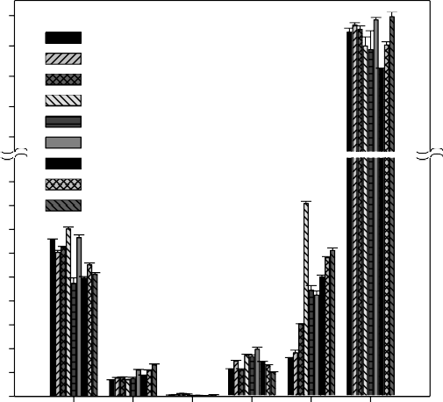80

**Heavy metal bond fraction %**

60

40

20

0

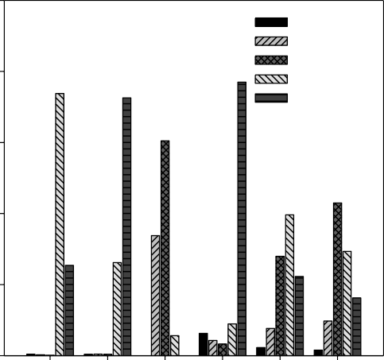

Exchangeable Carbonate

Fe-Mn oxide Organic Residual

**Cu Cr Cd Pb Ni Zn**

Figure 1 Heavy metal content (dry basis) in sludge samples collected from Fu-Tian Wastewater Treatment Plants.

Figure 2 The bond fractions of metals Cu, Cr, Cd, Pb, Ni and Zn contained in the sludge.

* 1. *Bonding Fractions of Heavy Metals Contained in Sludgs*

The bonding fractions of various metals contained in the sludge are shown in Figure 2. For Cu, the majority (74 %) exists in the sludge in organic bond fraction, about 73 % of Cr exists as residual fraction. Cd about 60 % and 34 %, respectively exist in Fe-Mn oxide and carbonate fraction. About 77 % of Pb as residual fraction, 40 % of the Ni distributes in the organic bonding fraction, followed by Fe-Mn oxide bonding (28%) and residual fractions (22%). Most Zn exists in Fe-Mn oxide bonding (43 %) followed by organic bonding form (29 %) and residual fraction (16 %). Among the five bonding fractions, the exchangeable and the carbonate bonding fractions are the most easily absorbed by plants, followed by Fe-Mn oxides and organic bonding fractions; the residual fraction is the least absorbable [9]. The results also indicate that heavy metals contained in the sludge are low percent in exchangeable and carbonate bonding fractions thus alleviating the

adverse impact of applying the sludge on the soil environment. Among the six metals, Cd has the lowest concentration; however, it is the most easily absorbable metal by plant. Hence, Cd is more strictly controlled in the soil of farmland for growing edible crops; its maximum allowable concentration is limited to only 5 mg/kg in Taiwan. Zn has the highest concentration among the six metals in sludge; its concentration is higher than twice the allowable maximum concentration (600 mg/kg) for soil used to grow crops. The exchangeable and carbonate bonding fractions of Zn account for 12 % of the total Zn contained in the sludge; the Fe-Mn oxides and organic bonding fractions account for 72 %. Although plants have weak absorption toward Zn in Fe-Mn oxides and organic bonding forms, the accumulated long-term influence caused by the soil complicate chemical and biochemical reactions cannot be ignored [3,4,9]. Similar observation is also seen for copper; the soil contains copper with 74 % in organic bond form; the risk associated with copper on the soil environmental and plant growth cannot be ignored either.

* 1. *Influence of the Sludge Added to Soil on the Growth of Chinese Cabbage*

Three batches of series studies have been carried out to determine the influence of various quantities of sludge added to soil on the growth of Chinese cabbage. Figure 3 shows the growth height of plants one month after they were planted for these three batches. In Figure 3 differences among plants grown in different batches of the control set (without the addition of domestic sludge) are mainly caused by the environment temperature i.e. average 16.5oC for the first batch in December and January (winter), 20.7oC for the second batch in March and April (spring), and 29.0oC for the third batch in June and July (summer). The gradual increase of temperature from the first batch until the third batch favors the growth of Chinese cabbage. In the first batch, plants grown in soil with more sludge addition are higher indicating that the nutrient contained in the sludge stimulates the growth. Additionally, the appearance of plants shows no adverse impact by the addition of sludge. In the second batch, however, the results are entirely different; more addition of sludge results in proportionally lower plant height. The plant grown in soil with 1:1 addition of sludge is obviously lower than plants grown in soils with less addition of sludge. In the third batch, the plant grown in soil with 1:5 addition of sludge is the tallest; plants grown in soils with 1:3 and 1:1 addition of sludge are obviously shorter than the plant in control set. Especially, the height of plants grown in the soil with 1:1 sludge addition is about 1/4 of that in control set. The observations clearly show the negative impact, which is not seen in the first batch, of sludge addition on plant growth in the second and third batches. Soils with more than 1:3 sludge additions are seen to inhibit the plant growth in the second and third batches possibly due to the following reasons: (1) During the first batch, the rich nutrients provided by the sludge masks the adverse impact brought about by the sludge; (2) The bonding form of heavy metals contained in sludge is mostly in Fe-Mn oxide bonding fraction, organic bonding fraction and residual fraction that have not been released in large quantities in the first batch so that the influence of heavy metals on the plant growth is not obvious.

* 1. *Influence of Sludge Added to Soil on Heavy Metals Content in the Chinese Cabbage*

Results of analyzing metal contents in the edible spots of Chinese cabbage grown for 30 days in the soil containing various portions of sludge are showed in Figure 4. For the first batch, the edible spots of Chinese cabbage show no obvious differences in metal contents among plants whether they are grown soils with or without sludge addition. On average, all fresh plants have similar metal contents, i.e. 0.4 ~ 0.5 mg/kg for copper, 0.16 ~ 0.22 mg/kg for chromium, 0.38 ~ 0.43 mg/kg for nickel, 15.4 ~ 24.0 mg/kg for zinc, 0.06 ~ 0.1 mg/kg for cadmium, and 0.32 ~ 0.62 mg/kg for lead.

25

20

**Chinese cabbage average hight (cm)**

25.0

20.0

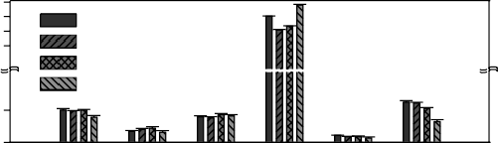

0:1

1:5

1:3

1:1

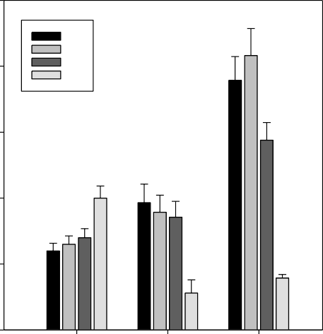

0:1

1:5

1:3

1:1

15.0

10.0

5.0

1.0

0.5

**heavy metal conc. (mg/kg)**

0.0

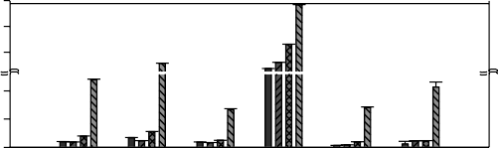150

15 100

50

10

5

0

**1st round 2nd round 3rd round**

10

5

0

300

150

15

10

5

0

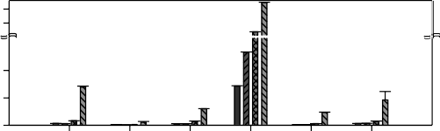

**Cu Cr Ni Zn Cd Pb**

Figure 3 The growth heights of the plant in the 30th day in the potted soil containing various portions of sludge.

Figure 4 Heavy metals content in Chinese cabbage grown for 30 days in the potted soil containing various portions of sludge.

However, in the second batch, plants grown in the soils added sludge contain more heavy metals than those harvested in the first batch, and the metal content shows a tendency to increase with higher portions of sludge addition. Chinese cabbage plants grown in soil with 1:1 sludge addition have the highest metal contents; 12.0 mg/kg Cu that is 12 times the amount in the control set, 28.9 mg/kg Cr that is 16.8 times the amount in the control set, 6.7 mg/kg nickel that is 7.3 times the amount in control set, 141.9 mg/kg Zn that is 7.6 times the amount in control set, 7.0 mg/kg Cd that is 21.3 times the amount in control set, and 10.9 mg/kg lead that is

17.4 times the amount in control set. Both the cadmium and lead concentrations are 35 times the current limitations of 0.2 ppm cadmium and 0.3 ppm contained in Chinese cabbage. In the third batch, zinc concentration in the plant grown in the soil with 1:1 sludge addition further increases to 368.4 mg/kg whereas all other metal contents are lower than those in the second batch. The plants grown in sludge with 1:5 sludge addition and in the control set have lower metal contents than those grown in the first batch indicating that except zinc that is continuously released because of its high concentration in the biological sludge, the release of all other metals has reached the maximum level. As shown in Figure 2, most metals exist in the sludge mostly in Fe-Mn oxides, organic bonding form or residual form that are not easily absorbed by the plant. Based on the analyses of heavy metals bonding forms, the metals contained in the sludge have not been dissolved in large quantities so that the plants in the first batch are taller with increasing sludge addition as shown in Figure 3. Hence, the adverse impact of heavy metals on plant growth is not seen in the first batch (Figure 4).

Results of all three batches show that the cabbage grown in both control without sludge addition and in soil with 1:5 sludge addition do not show much difference in metal content. Fig. 3 shows that except in the second batch that the cabbage plant height for the soil with 1:5 sludge addition is slightly shorter, in the first and third batches, the plants grown in the soil with 1:5 sludge addition are obviously taller than the control set. Therefore, addition of adequate quantities of sludge to farm land has definite benefits, and as shown by the results obtained in this study, the sludge addition of 1:5 (sludge/soil ratio) or less is not expected to cause problems of high heavy metal concentrations in the crop.ection headings should be left justified, with the first letter capitalized and numbered consecutively, starting with the Introduction. Sub-section headings should be

in capital and lower-case italic letters, numbered 1.1, 1.2, etc, and left justified, with second and subsequent lines indented. You may need to insert a page break to keep a heading with its text.

# 4 Conclusions

Concentrations of heavy metals, i.e. Cu Zn and Cd, contained in domestic wastewater sludge often have reached the levels that adversely impact a direct application of the sludge on farmland for growing edible crops. However, heavy metals exists in sludge mostly in the form of Fe-Mn bonding fraction, organic bonding fraction, and residual fraction that cause little or no obvious on the metal content in the crop during the initial stage of sludge application. With increasing cycles of planning, watering and plant rhizosphere metabolism cause the metals contained in the soil to be released gradually so that the plant growth is adversely affected by heavy metal contained in the sludge. However, adding adequate amount of sludge to soil shows some benefit to stimulate the plant growth. Results of laboratory studies suggest that the addition of sludge should not exceed 1:5 (sludge/soil). When the sludge addition exceeds 1:3 (sludge/soil), both the growth and heavy metal content in Chinese cabbage will be adversely affected. Future application of domestic wastewater sludge depends on farm should emphasize the development of advanced technology to remove heavy metals from the sludge in addition to regulating the practice through legislation of relevant laws and regulations.

# Acknowledgements

The authors acknowledge the administrative and financial support by Sewage Systems Office, Construction and Planning Agency, Ministry of the Interior (Taiwan) (Project No.: Construction and Planning Agency 101-4000-0107-0000-1160.

# References

1. Fuentes A, Llorens M, Saez J, Aguilar MI, Perez-Marin AB, Ortuno JF, and Meseguer VF. Ecotoxicity, phytotoxicity and extractability of heavy metals from different stabilised sewage sludges. Environmental pollution 2006; 143: 355-360.
2. Wong JWC, and Selvam A. Speciation of heavy metals during co-copposting of sewage sludge with lime. Chemosphere 2006; 6: 3980-986.
3. Tyagi RD, Couillard D, and Grenier Y. Effects of medium composition on the bacterial leaching of metals from digested sludge. Environ. Pollut. 1991; 71: 57-67.
4. Jain DK, and Tyagi RD. Leaching of heavy metals from anaerobic sewage sludge by sulfur-oxidizing bacteria. Enzyme Microb. Technol. 1992; 14: 376-383.
5. Public Works Department of Taipei City Government, Sludge treatment plan of Taipei area Sewage treatment plant, Project report, Sinotech Engineering Consultants, LTD. (2002).
6. Hospido A, Carballa M, Moreira M, and Omil F. Environmental assessment of anaerobically digested sludge reuse in agriculture: Potential impacts of emerging micropollutants. Wat. Res. 2010; 44: 3225-3233.
7. Tessier AP, Campbell GC, and Bisson M. Sequential extraction procedure for the speciation of particulate trace metals. Analytical Chemistry 1979; 51: 844-850.
8. Nyamangara J. Use of sequential extraction to evaluate zinc and copper in a soil amended with sewage sludge and inorganic metal salts. Agriculture Ecosystems and Environment1998; 69: 135-141.
9. Shrivastava SK, and Banerjee DK. Operationally determined speciation of copper and zinc in sewage sludge. Chem. Speciation Bioavailability 1998; 10: 137-143.