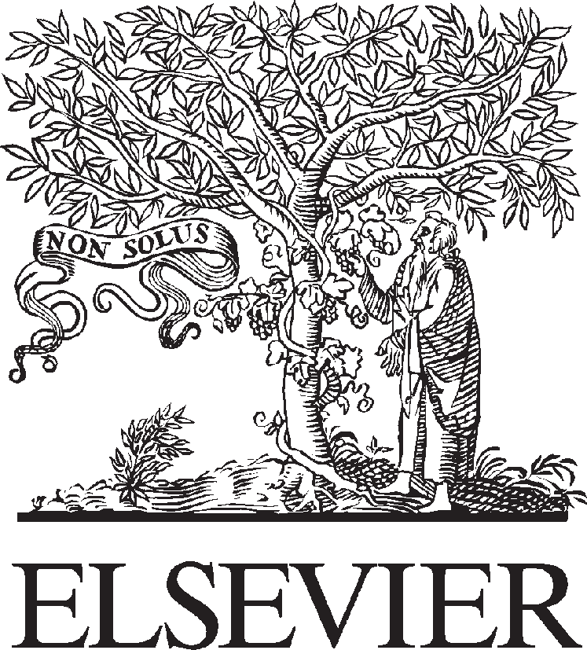Available online at [www.sciencedirect.com](http://www.sciencedirect.com/)

**ScienceDirect**

AASRI Procedia 4 (2013) 167 – 172

2013 AASRI Conference on Intelligent Systems and Control

The Characteristics of University Journal Information Resources and It’s Development and Management

Ruili Wang a, Fucai Zhaob*

*aEditoroal Department of Liaocheng University Journal, Liaocheng, 252059, China*

*bDepartment of Psychology, Liaocheng University, Liaocheng 252059, China*

**Abstract**

The basic features and unique superiority of knowledge creativity of university journal information resources provide scientific basis for building a management system of university journal information resources. To set up an effective a management system of university journal Information Resources, develop rationally journal information resources, make it participate in scientific researches, become a part of college teaching and scientific researches, remote the wide spread of information, and pay attention to the transference and expanding of information. To set up competitive conceptions, change the introversion of journals; and promote spreading of information by network and plural patterns with an open and creative conception.

© 2013 The Authors. Published by Elsevier B.V. Open access under [CC BY-NC-ND license.](http://creativecommons.org/licenses/by-nc-nd/3.0/)

© 2013. Published by Elsevier B.V.

Selection and/or peer review under responsibility of American Applied Science Research Institute

Selection and/or peer review under responsibility of American Applied Science Research Institute

*Keywords:* University journal resource; characteristics; information development and management

# Introduction

University journal is not only an important support of technology innovation but also the main participants of process innovation and concept innovation in college teaching and scientific research. It has unique

* Corresponding author. Tel.: +86-635-8238606; fax: +86-635-8239109.

*E-mail address:* [zfclc@163.com.](mailto:zfclc@163.com)

2212-6716 © 2013 The Authors. Published by Elsevier B.V. Open access under [CC BY-NC-ND license.](http://creativecommons.org/licenses/by-nc-nd/3.0/) Selection and/or peer review under responsibility of American Applied Science Research Institute doi:10.1016/j.aasri.2013.10.026

advantages and play an irreplaceable role in providing information services for knowledge innovation activities and the cultivation of innovative talents. Higher requirements were put forward for the scientific management of information resources especially in the era of knowledge economy, due to the proliferation of computer technology, network technology and other high-tech, the emerging of cross-disciplinary, interdisciplinary, new disciplines and knowledge innovation, the significant shortening of knowledge update cycle. This paper explores the rational development and scientific management methods of university journal information resources, so as to establish a scientific management system of university journal information resources, according to the basic characteristics of university journal information resources and the advantage of knowledge innovation.

# The basic characteristics of university journal information resources

University journal information resources are available information collection, one of support systems of commitment to the college teaching, scientific research, talents training, information development and dissemination activities. The characteristics of university journal information resources and other social information resource characteristics are basically the same, with the following basic features: (1) Practicality. Information resources meet the demands of teaching and research staff and readers. (2) Scarcity and rarity. The ownership of a particular teaching, research projects demand information resource is scarce and rare in a given time , space or other constraints. (3) Selectivity. The purpose and direction of the use of literature information can be selected. (4) Dependence, that is the inseparability to it’s carrier. (5) Conversion. Information resources has the basic characteristics of the conversion , processing and transfer vector. (6) Transitivity. (7) Sharing, that is information resources can be enjoyed by all people. (8) Effectiveness. The use value of the of information is directly proportional to its transfer speed, and inversely proportional to the backlog. (9) Infinity. The information resources are inexhaustible. (10) Value-adding. The investment of information resources can add not only the value of material resources and energy, but also their own value of information resources.

Of course, university journal information resources has its own inadequacies. Firstly, the publishing cycle of university journal is longer. Currently, the majority of Chinese Universities Journal is published quarterly or bimonthly, the publishing cycle is longer than the other foreign and domestic academic journals. Secondly, university journal is of introversion. The major authors are college teachers. Particularly many of the papers and report are written by the teachers from the University which the journal belongs to. The sources and use of information is inevitable with introversion, sometimes even with a closed and limitations.

# The university journal is of the unique advantages of the knowledge innovation

University journal accumulated a very rich literature information in the long-term scientific research and teaching activities, as well as domestic and international academic exchange activities. It is characterized by a complete disciplines, a wide range covering, rich knowledge content and a strong academic nature. It can directly reflect the development state of university research and teaching with the information resources superiorities of dissemination, application and production of knowledge. The teachers and researchers are not only the user, but also the innovator of knowledge. They have quick thinking, innovative spirit and the conditions of linking theory with practice. Universities have the information environment of intensive knowledge, information interchange and rich academic atmosphere which constitute the unique advantages of knowledge innovation.

Universities are the important places of knowledge innovation. University journal can produce immportant innovations and be a window of reflecting college teaching and research achievements, and at the same time,

carry the burden of propagating innovation information, finding and cultivating the innovative talents. University journal is not only the main component of knowledge innovation, but also most sensitive and agile to knowledge innovation. The scientific researches in university journals are the creation and processing of science and technology information. The university journals constantly stimulate inspiration of scientific research, enlighten creative thinking, encourage people to know new scientific principles, open up new research areas, and guide the trend of science and technology. University journal has a contingent of scholars and experts as the main body of authors with high level, and the reliable talent and discipline superiority. This is the never dried up source of innovation and development of the journal. Moreover, the knowledge economy provides favorable conditions for the development of university journals and knowledge innovation.The authority and synthesization of university journal information provide strong support for teachers and scientific research personnel to consulting literature, absorbing knowledge nutrition, constantly studying and innovating knowledge.

# Developing university journal information resources reasonably

* 1. *Strengthening the information consciousness and cultivating the information ability*

The scientific management of information resources is a complicated and professional system engineering. The information management personnel need not only professional information knowledge, but also a wide range of all kinds of professional knowledge, and higher information consciousness and professional ethics, then they can handle the information resources management work. They must take the professional road of information, enhance the information consciousness, cultivate information ability, develop and utilize information resources positively.

At present, the information consciousness of many journal librarians is relatively weak. It has greatly hindered the development, processing and transmission of the information. Therefore, the journal librarians must improve the ideological understanding, establish and strengthen the information consciousness, be dedicated to their own work as the "paving stone" of teaching and scientific research. The journal librarians need more fully understand the journal information values, suggest ways and means for better development and utilization of the valuable information resources of journals. In the era of knowledge economy, the journal librarians should renew their ideas, strengthen the information consciousness constantly, grasp the trends of academic development and teaching reform, expand and find their own services, provide timely and accurately the most refined, the most systematic and the most orderly informations to the readers, and improve the utilization ratio of information resources. Only having new understanding, deep mining and dynamic processing of knowledge, they can improve the rate of receiving and utilization of information resources, so as to enhance their competitiveness and creativity. One of the journal librarians’ important responsibility is to strengthen the systematicness, pertinence and availability of journal information resources, in order to maximize the development of journal resources, improve the utilization rate of the journal, offer good service positively to the teaching, scientific research staff, and the editoris, and promote the development of higher education and social economic and cultural prosperity.

Information ability is a comprehensive ability of collecting information, processing information and transmiting information etc, which is the basic quality that the journal librarians must have. The contemporary science and technology have been developing rapidly, and a lot of interdisciplinary and subject arise, the literature material accumulates rapidly and numerously, the journal literature material also becomes more diverse, complicated and comprehensive. The journal librarians face the various types of professional users who have their own information needs. And the combination and mutual infiltration of teaching and scientific research aggravate the diversity of the need for the information. Therefore, only having good information

ability, can the journal librarians maximize the development and utilization of journals and other literature resources, synthesize the new information and new ideas into teaching and scientific research, adapt to the demands of teaching and scientific research and social development.

* 1. *Carry out various kinds of information services*

We must carry out various kinds of information services, so as to maximize the development and utilization of journal information resources.

Firstly, strengthen the management of the learned journal, adopt agile service way. The Journal Reference Room collects all of the university journals. In the face of so such journal literatures, only use scientific library management methods for the classification management, make all kinds of journal literature orderly, can we make the teachers and students find the needed journals quickly and effectively, so as to improve the utilization rate of journal literature. At the same time, the service mode should show greater flexibility according to the continuous reform of teaching and research and the development and change of the teachers and students demand. Such as combining the service for all teachers and students with the service for key users, combining the information consultation service with active developing user education, combining the first time service with the second time service, etc. The Journal Reference Room should bring convenience to the teachers and students for the use of journal literature, build the connection between the librarian readers, so as to maximizing the development of journal resources.

Secondly, do a good job of collecting and collating of journal literature. The collecting and collating of literature is the material foundation of playing the function of information intelligence of journal literature and carrying out the information service work. The journal librarians at least do the following work in collecting and collating of journal literature: (1) Establishment of titles of the academic journals. The titles of the academic journals are the retrieval tools for readers to understand the journal content rapidly. The establishment of titles of the journals is grouped into two: one is to establish the table of content titles of academic journals, the other is to establish the special subject catalogue of the journals. It make analysis and screening of the original documents in the journal according to the special subject, then make classification arrangement and sorting into order in according with the special subject, according to the need of teaching and scientific research. (2) Compilation of the journal key words index. The journal key words index is intuitive, it can show the data from different disciplines together. The compilation of the journal key words index can make the readers search from specific keywords, and get the needed information in a very short time. (3) Prepare highlights of paper abstracts. Abstracts are the miniature of papers. It reflects accurately the main idea of the paper, and make the reader get quickly the argument, evidence and conclusion in a very short time.

Thirdly, carry out the intelligence research, do a good job of the deep-seated intelligence service work. There are many kinds of academic journals with a sharp rise of literatures. It is very difficult for the teaching and research staff to get their needed document and information, just like looking for a needle in a haystack. So only the deep-level processing of document and information, many ways to reveal the contents of the documents, carrying out a variety of services, can we change the dead material into living information, so as to improve the utilization rate of the journal data. (1) The first time literature service and the latest information services. The first time literature service is to maximize the transforming of static knowledge information into intelligence information for all users. Large amount of information accuracy are the characteristics of the first time literature service. The latest information services is to prompt the new arrivals of the journal literature through the forms of information consulting and information columns and so on, and pass them to teachers and researchers at the fastest speed to serve the teaching and research. Being new in document and fast in transmission speed is the the characteristics of the latest information services. (2) The second and third times literature services. The fundamental task of the journal information work is to make

the literature material of good order and intelligence, in order to be used for teaching, research and editorial staff. This requires the journal librarians to process the information in a deep level, i.e. the second and third times literature services. (3) Regular tracking service for teaching and research staff according to the teaching and research needs.

# Strengthen the scientific management of information resources and establish a management system of journal information resources

The scientific management of information resources is a complex and professiona systemetic engineering. It requires the information management staff to have not only the theory and knowledge of the intelligence information, but also a wide range of various types of expertise and knowledge, as well as a high awareness of information and professional ethics in order to be competent for the management of information resources.

* 1. Cultivate good information management consciousness and information management ability

The information management consciousness of the journal librarians mainly in three aspects: First, the master consciousness of information systems. The journal librarians should have the strong desire of information and the information development mission to put themselves in the information tides, search and take advantage of all the valuable information on human development, and become the organize and builders of the literature information system. Second, the awareness of information dissemination and utilization. The journal librarians should be fully aware of the importance of information dissemination and utilization, take online information dissemination and utilization as a good way of educating information users. Make full use of the advantages of online information for the service of teaching and research. Third, the open and shared consciousness. The journal librarians should have more wide field of vision, place oneself on the environment of a whole university and social information system, push the mining information to the user and even the social information market with the concept of open information, so as to achieve common development and sharing of information resources in a joint network.

In today's network information age , a journal librarian with high-quality must have a wide range of information management capabilities. First, the ability to obtain information. The flow of network information is fast with strong timeliness and widespread content. The user without professional training is not easy to obtain useful information from the Internet, which restricts the users to use the online information resources. In the face of disordered information world, the librarian should guide users timely, make use of their good ability of gathering intelligence, professional advantages of information and the keen insight to the information, to acquire information accurately and rapidly from the sea of information. Second, the capability of information processing. A journal librarian with high-quality can use their own ability of classification and subject indexing to do analysis, screening, classification, induction and sorting on the collected network information, make a lot of disordered information resources into orderly, high speeding and transfering information, and thus avoid the loss of important information, minimize the time and effort of processing information for the users. Third, the ability to use information. A journal librarian’s ability of using information includes at least three aspects: One is the use of network information to serve the users, such as the ability of information directory data retrieval for the user, providing information resource network information consultation and service, etc for remote users. The second is the ability of using information resources to develop new business work, such as the deep processing and innovation of network information, improving the value of information. The third is the ability of using the information to establish a online database.

* 1. *Pay equal attention to information management and research*

Scientific management of information resources is not only the management of information, but also to participate directly in the process of scientific research, to become part of university teaching and research. The characteristics of university journal as a form of information carrier are professional, targeted and extensive amount of information. The task of a journal librarian is not only the literature management, but also offering all kinds of services for the teachers and editors. The journal librarian should provide the latest information, report timely the trend of subject development, establish the special subject database, do a good job of consultation, compile more and faster the high-quality second times and the third times literature, make full use of the information function of all the professional literature resources to ensure editing, teaching and scientific research work smoothly.

* 1. *The scientific managements of information resources promote the spread, transfer and diffusion of information*

The task of scientific management of information resources is to promote the transfer and diffusion of knowledge and information and find demanders. The scientific managements of information make the literature information in disorder into order, make the curing knowledge into activation, through the collection, processing and finishing of literature information, and make the knowledge information spread across space and time with the help of modern communication technology. That not only provides powerful information security for university and college to cultivate useful professionals, but also creates conditions for vocational training and continuing education in order to improve the quality of citizens. At the same time, cultural information can be transformed into implicit knowledge assets, and then into productive forces, through the information consultation and the popularization and introduction of information and other activities.That promote the development of social economy. This is the core task of scientific management of information. To set up competitive conceptions, change the introversion of journals; and promote spreading of information by network and plural patterns with an open and creative conception.

# References

1. Liu Shumei. A brief discussion of the quality training of librarians. Information Material Work; 2000, (4)
2. Cheng Tiebiao. High-effective service of professional information of university journal reference room. Journal of Shijiazhuang College; 2003, (1)
3. Jin Hongxian. The development and utilization of literature material in the university journal editorial department. Journal of Zhejiang Normal University; 2002, (4)
4. Wang Ruili. The quality structure of university journal librarian From the plight of the university journal reference room. The Modern Information; 2002, (10)
5. Wang Ruili. The development and management of university journal information. Journal of liaocheng university (social sciences); 2004 (6)