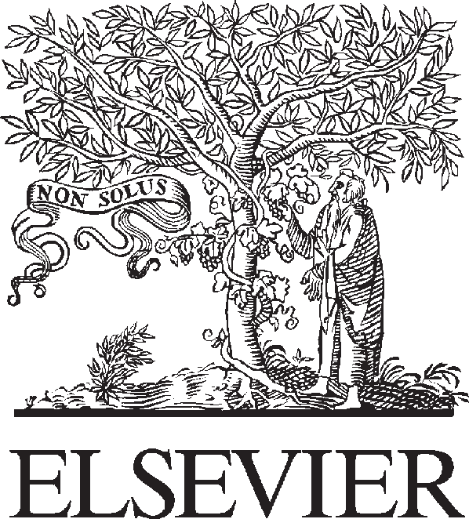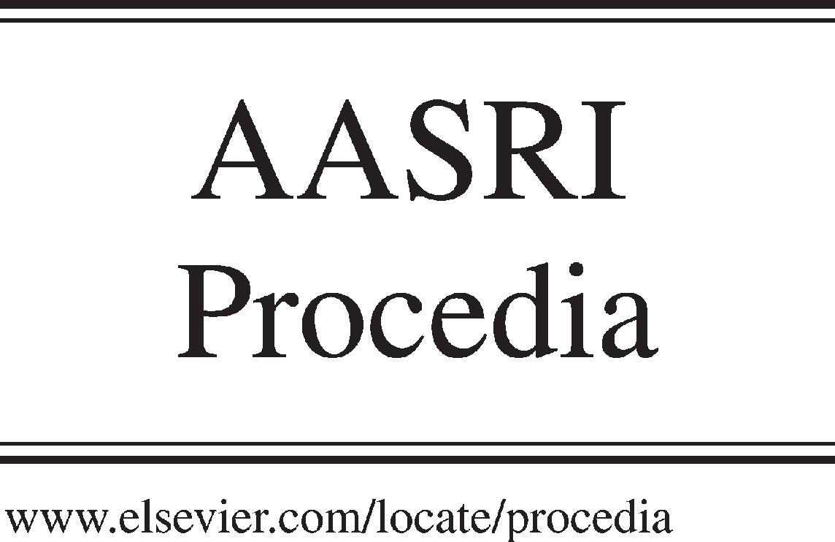Available online at [www.sciencedirect.com](http://www.sciencedirect.com/)



AASRI Procedia 3 (2012) 427 – 434

2012 AASRI Conference on Modeling, Identification and Control

The Influence of Oxygen Concentration and Equivalence Ratio on Pyrolysis Gas in Oxygen-Enriched Pyrolysis by Theoretical Calculation

Haoran Yuana, *, Tao Lua, Noriyuki Kobayashib, Hongyu Huang a, Yong Chen c

*aGuangzhou Institute of Energy Conversion, Chinese Academy of Sciences, Guangzhou 510640, China*

*bEcoTopia Science Institute, Nagoya University, Nagoya 464-8603, Japan*

*cGuangzhou Division Academy, Chinese Academy of Sciences, Guangzhou 510070, China*

Abstract

Oxygen-enriched pyrolysis for the treatment of municipal solid waste (MSW) was proposed in this paper. Its advantages with respect to air pyrolysis, such as high efficiency, lower heat loss and emissions, have been described based on mechanism analysis and thermodynamic calculations. Effects of oxygen concentration, equivalence ratio (ER) on gas products and their heat values were investigated by theoretical calculation. It was found that with the increase of oxygen concentration the gas yield and heat values decrease, with the increase of ER, the content of CO and CH4 decrease, while the content of H2 varied from increase into decrease with ER=0.27 as the turning point. When ER exceeded 0.30, the pyrolysis controlled reaction became into the combustion controlled reaction. The most suitable ER for oxygen-enriched pyrolysis ranges from 0.20 to 0.30 and water content of MSW should be controlled in the range from 15% to 25%.

Therefore, choice of ER was very important in oxygen-enriched pyrolysis process. ER could control the components and heat values of gas products. In addition gas product quality could be improved owing to the increase of oxygen concentration within a certain ER range.

© 2012 The Authors. Published by Elsevier B.V. Open access under [CC BY-NC-ND license.](http://creativecommons.org/licenses/by-nc-nd/3.0/)

© 2012 Published by Elsevier B.V. Selection and/or peer rev[iew under responsib](http://creativecommons.org/licenses/by-nc-nd/3.0/)ility of American Applied Science Research Institute

Selection and/or peer review under responsibility of American Applied Science Research Institute

Keywords: MSW, oxygen-enriched, pyrolysis;

* Corresponding author. Tel.:86-020-87013241; fax: 86-020-87013240.

*E-mail address:* [yuanhr@ms.giec.ac.cn.](mailto:yuanhr@ms.giec.ac.cn)

2212-6716 © 2012 The Authors. Published by Elsevier B.V. Open access under [CC BY-NC-ND license.](http://creativecommons.org/licenses/by-nc-nd/3.0/) Selection and/or peer review under responsibility of American Applied Science Research Institute doi:10.1016/j.aasri.2012.11.067

1. Introduction

Solid wastes include general solid waste and hazardous solid waste. Municipal solid waste (MSW) included in general solid waste means the solid waste, semi-solid or liquid waste produced by activities of living in the city or services for urban households. Ways of dealing with MSW are roughly divided into solid waste landfill, part recovery, part fermentation and heat disposal. Due to many advantages of MSW heat disposal, such as high efficiency, large volume reduction rate, part of the energy available and without taking up a lot of land resources, particularly increasing the calorific value, many developed countries have used heat treatment to dispose MSW. [1-4] Heat disposal technology is divided into thermal incineration and pyrolysis, the former technology is more mature, and the latter is a new technology developed in recent years.

Many efforts have been dedicated to improving MSW heat disposal technology and some valuable theories and methods have been achieved by current studies. Guo et al. [5] investigated the combustion kinetics of MSW and found that complex combustible waste materials summed into fiber and polymer substances two categories, established a mathematical model of MSW pyrolysis and combustion, and proposed that pyrolysis and combustion could inhibit generation theory of dioxin. Galvagno et al [6] and Dai et al [7] researched into the mechanism and technology of pyrolysis of used tires. Li et al. [8] proposed the migration rules and controls of heavy metals in the combustion process based on fly ash heavy metal analysis. Buekens et al. [9] studied dioxin formation mechanism and control methods during the MSW combustion process. In addition, Wang et al. [10] and McLachlan et al. [11] studied combustion mechanism and features of MSW derived fuel and agricultural waste, respectively. However, these studies are mainly focused on the combustion process or a single component. Recently, MSW pyrolysis has drawn many attentions ascribed to many advantages, such as converting the solid waste with uneven scales, physical properties and heating values into uniformly mixed combustible gases for a variety of uses, high energy recovery and low pollution. Theoretical and experimental researches on pyrolysis have been paid more attention by domestic and foreign experts and scholars, [12-14] and a series of research results have been obtained. However, there is still a long distance away from the actual application. Oxygen-enriched technology proposed by Horne and Steinburg in 1981 [15] possesses many advantages, such as sufficient combustion, substantially emissions reduction, high efficiency and so on. Oxygen-enriched technology has been currently used in main boiler of power station, the magnetic fluid power technology, fuel cells, IGCC and combined energy production systems. The combustion objects have pulverized coal, natural gas and coke oven gas. Liang et al. and Hunsinger et al. investigated the fluidized bed combustion technology and oxygen-enriched combustion characteristics of MSW. [16, 17]

Table 1. Elemental Analysis of Experimental Materials

|  |  |  |  |
| --- | --- | --- | --- |
| elements (%) | dry combustible components | dry basis | as-fired basis |
| C | 43.79% | 29.25% | 13.06% |
| H | 5.87% | 3.92% | 1.75% |
| N | 0.60% | 0.40% | 0.18% |
| S | 0.39% | 0.26% | 0.12% |
| O | 21.53% | 14.38% | 6.42% |

Many issues, such as high inert gases content, the low heat value, large amount of smoke and so on, still exists in simple pyrolysis or combustion. The simple oxygen-enriched combustion technology can not fundamentally solve these issues, solid phase (non-homogeneous) combustion control and production of secondary pollution. In order to solve the above problems, oxygen-enriched pyrolysis technology for the treatment of MSW was proposed. The mechanism of MSW oxygen-enriched pyrolysis was explored, and the associated systematic study was carried out, which could provide the theoretical basis for the conversion of

MSW into multi-purpose gas.

In order to make the theoretical calculation have universality and industrial applicability, the parameters of MSW are obtained from Wuhu Nanling County Urban Waste Recycle Bin. The chosen MSW (p= 520 kg/m3) was a mixture of irregular shaped substances, whose main components were plastic, paper, cloth, vegetation, white plastic, food waste, etc. after screening. Elemental analysis was shown in Table 1, where ash component has not been included in the dry combustible components elemental analysis and the sum of its components in the table was the difference between 1 and the ash content.

1. Mechanism of Oxygen-Enriched Pyrolysis of MSW
   1. *Oxygen-enriched pyrolysis reaction of MSW*

MSW is mainly constituted by C, H and O elements, accompanied with minor N, S and other elements. The volatile component and fixed carbon have high content in MSW and N, S elements form a relatively small amount of pollution emissions in the thermal conversion process, which are more appropriate to determine the gasification of MSW. The whole process of MSW oxygen-enriched pyrolysis can be divided into four steps: drying, pyrolysis, oxidation and reduction, and the chemical reaction steps are as follows [12]:

*C*(*s*)  *O*2  *CO*2 *C*(*s*)  *CO*2  2*CO*

*C*(*s*)  *H*2*O*  *CO*  *H*2 *CO*  *H*2*O*  *CO*2  *H*2 *C*(*s*)  2*H*2  *CH*4

*CH*4  *H*2*O*  *CO*  *H*2

(1)

(2)

(3)

(4)

(5)

(6)

Organic components of MSW are distilled in the dry distillation layer generating CnHm gases in which CH4 is the main component. Water-gas reaction and reduction reaction of CO2 coming from the oxide layer mainly occurs at the carbon materials layer in reduced layer The oxidation reaction of waste carbon and oxygen occurs in the oxide layer. Therefore, the produced gases are mainly composed by CO, H2, CnHm and so on [18]. In dry region MSW is dried and dehydrated by the high-temperature walls of the pyrolysis device and high- temperature gas produced in other reaction regions, which makes preparation for further crack of

macromolecules [14].

MSW pyrolysis section is a region of strong chemical reaction. The heat required for pyrolysis process is mainly supplied by the oxidation of partial fuel available. Pyrolysis reaction includes cracking and dehydrogenation reactions etc.

*C*2*H*6  *C*2 *H*4  *H* 2 *C*2*H* 4  *CH* 4  *C CH* 4  *C*  2*H* 2

(7)

(8)

(9)

In pyrolysis process, chemical bonds of organic compounds in MSW rupture into small molecules and solid residues. At high temperature polymers can accelerate the motion of polymer molecules and their chemical bonds can be broken producing free radicals. These highly unstable free radicals can react with the surrounding various types of molecules or radicals to form more free radicals, causing the polymer degradation and crosslinking. The chemical bonds with a low binding energy can be easily broken when

heated and the corresponding element or group is the structural weaknesses and become an active point of pyrolysis. Pyrolysis reactions eventually transform MSW into a variety of carbon materials, including hydrocarbons with 1 to 5 carbon atoms, H2, CO-based combustible gas, hydrocarbon and tar substances with 5 or more carbon atoms, solid carbon and ash.

* 1. *Related theoretical calculations of MSW oxygen-enriched pyrolysis*

The calculation of theoretical temperature for MSW oxygen-enriched pyrolysis was obtained by adding enthalpy of the combustible products of gasification process and checking drawn against. And the actual furnace temperature will be lower than the theoretically calculated temperature. When using air as oxidant, excess cold air coming into the furnace and nitrogen contained in the air with the content of 79% make the furnace temperature reduced, increase the heat loss, while produce excessive smoke emission. And there are still inert N2 and incompletely reacted O2 retaining in the produced gases.

However oxygen-enriched pyrolysis technology uses enriched oxygen gas (less inert components) as oxidant. Accordingly, the reactions could react adequately accompanied by small smoke emission. The resulting gasification products include a small amount of N2 and oxygen-enriched pyrolysis technology exhibits less heat loss relative to the air pyrolysis. The heat input of the reactor is generally composed by three parts: low calorific value of fuels, caloric from external heat source to heat the oxidants and caloric from the steam injected into the furnace. The calculation of the three compositions is shown as below:

*d k k*

where *Q y *Fuel calorific, kJ/kg(m3)

*d*

*t*  (*Q y*  *Crtr*  *C t La* ) / *CyVy*

(10)

*Cr * Heat capacity of fuel, kJ/(kg·°C)

*C *Heat capacity of oxidant, kJ/(Nm3)

*k*

*C *Heat capacity of gasification products, kJ/(Nm3·°C)  Reaction temperature, °C

*y*

*tr tk*

 Temperature of fuel and oxidant, respectively, °C

*V *Volume of smoke generated by gasification, m3

*y*

*L *Oxidant for unit of fuel consumption, m3/kg

*a*

It could be seen from Eq. (10) that *Vy* of oxygen-enriched pyrolysis is much smaller; correspondingly, the

fraction is greater. Therefore, oxygen-enriched pyrolysis is propitious to pyrolysis and energy-saving. According to thermodynamic Calculation Standard of China, the heat loss during reactions is calculated by the following formula. [19]

where *I py*

** *py Iik q*4 *Qdw*

(*I py*  ** *py Iik* )(100  *q*4 ) / *Qdw*

 Enthalpy of gasification products  Excess air coefficient at the exit Enthalpy of cold air

Loss of incomplete gasification  Fuel calorific

(11)

It can be seen from Eq. (11) that enthalpy of pyrolysis products contains enthalpy of the inert N2 which causes heat loss only without any reactivity. Therefore, attributed to the input of enriched oxygen gas (less inert N2), the heat loss of oxygen-enriched pyrolysis caused by inert N2 is much smaller than that of air gasification conducing to excellent energy-saving.

* 1. *Thermodynamics of MSW oxygen-enriched pyrolysis*

Equilibrium constant method and Gibbs minimum free energy method are usually used to evaluate the complex chemical equilibriums in thermodynamics. Herein we use the Gibbs minimum free energy method, namely use the system's Gibbs minimum free energy under the isothermal isobaric conditions as an equilibrium criterion. When conducting oxygen-enriched pyrolysis, oxygen-enriched air and MSW are fed into the experimental device under a certain condition (certain temperature and pressure) for complex chemical reactions. The device is considered to be a closed ideal reaction system. When the system reaches chemical equilibrium, the Gibbs free energy of entire system reaches minimum [20, 21] which can be calculated according to the formula shown as below:

 *G* 



*i* *n* 

(12)

 *i* *ni* *nj*

where *i* is the chemical potential energy of component ( *i* ), *G* is the Gibbs free energy, *ni* is the amount

of substance for component ( *i* ). With the transformation of Eq. (12), the Gibbs minimum free energy can be expressed as below:

*Min*(*G*)  *Min*( *Gi* )   (*ni i* )

(13)

The parameters of various substances in the calculation are determined in the light of thermodynamic data reference manual. [22, 23] And chemical reactions participated in the pyrolysis process are calculated according to Eq. (1) - (6). The temperature and pressure of the system are set as constant. The pressure is set at 1.013×105 Pa ascribed to that the actual equipment is working under atmospheric pressure. The reaction temperature can be calculated in accordance with the first law of thermodynamics [24]:

*Qsystem*  *HP*  *HR*

(14)

where *HP* is the enthalpy of resultant, *HR* is the enthalpy of reactant. During the reaction process, it is

confirmed that the reaction temperature maintains the uniform value. Because other substances only suffer the enthalpy changes at different final temperatures, besides the MSW combustion heat release effects. The reaction temperature can be calculated by the MSW release heat through calculating its low calorific value. Herein, the effects of the equivalence ratio (ER, the ratio of input oxygen to the oxygen required for complete combustion of the substances) and oxygen concentration on the composition of gas products were investigated. Oxygen concentrations were 20%, 40%, 60%, 80% and 100%, and ERs were selected in the range from 0.20 to 0.40, respectively. The results are shown in Figure 1 and 2.

Figure 1 shows the relationship between ER and the gas product composition under pure oxygen condition. As shown in the figure, the contents of CO and CH4 decrease with the increase of ER, while H2 content increases with the increase of ER. H2 content reaches the maximum at the ER of 0.25, and then starts to decline. CO2 content rises slowly before the ER of 0.25 and increases rapidly until the ER arrives at 0.35. When ER is greater than 0.35, the changes of various compositions of the gas product slow down. The main reason for this result is that the reaction changes from pyrolysis control into combustion control with the increasing ER. The ER of 0.25 is the transition point during the process.

Figure 2 shows the relationship between the changes in calorific value of the gas product, ER, and oxygen

concentration. It could be observed that the heat value of the gas product has a rapid increase with the increased oxygen level, which is the result of the interaction between the increase of combustible gases and decrease of nitrogen content. The heat value of gasification products decreases with the increase of ER, especially when ER is greater than 0.30 the heat value gas product declines rapidly. This is attributed to that the increase of CO2 content and the decrease of CO and CH4 contents as a result of the increase of ER. When ER transcends the transition point (ER=0.25), H2 content begins to decline, leading to rapid decline in heat value.

50

CO CO2

H

2

CH

4

Oxygen concentration = 100%

Percentage of gas contained in the product (%)

45

40

35

30

25

20

15

10

5

0

0.20 0.25 0.30 0.35

ER

Figure 1. Effect of ER on composition of the gas products.

3200

|  |  |  |
| --- | --- | --- |
|  |  | 100%  80%  60%  40%  20% |
|  |
|  |
|  |

3000

2800

Heating value kcal/Nm3

2600

2400

2200

2000

1800

1600

1400

1200

1000

0.20 0.25 0.30 0.35 0.40

ER

Figure 2. Effect of oxygen concentration on the heating values of the gas products.

To sum up the above theoretical calculations and analysis, the value of ER between 0.20 and 0.30 is propitious to pyrolysis and the composition of gas product can be controlled directionally through control ER. Increase of oxygen content is conducive to the improvement of heat value, but oxygen cost and energy consumption is also increasing with the increase of oxygen concentration, therefore, a balance should be required in the practical application process.

1. Conclusions

Through the theoretical analysis and calculation of the MSW pyrolysis, it could be found that increase of the amount of oxygen enriched is available to a substantial increase of gas production and gas heating value. With the increase of ER, the contents of CO and CH4 decreased, while the content of H2 changed from the increase into reduction with ER= 0.27 as the apparent transition point. When ER is greater than 0.30, the reaction controlled by the pyrolysis changed into combustion controlling. So ER ranging from 0.20 to 0.30 is the most suitable to oxygen-enriched pyrolysis and the water content during oxygen-enriched MSW pyrolysis should be controlled at 15% to 25%.

In short, the choice of ER is crucial in the MSW pyrolysis process. It can not only control the heat value of gas products, but also directionally control the component of the products. To a certain equivalence ratio extent, increase of the oxygen concentration can improve grade of gas products.

Acknowledgements

This work is financially supported by National 973 project of China (2011CB201501), Projects of International Cooperation and Exchanges NSFC (51161140330), Knowledge Innovation Program of the Chinese Academy of Sciences (NKSCX2-EW-G-1-5), and The Program of Guangdong Province - Chinese Academy of sciences strategic cooperation (2010A090100035).

References

1. Cheng, H. F.; Hu, Y. A. Municipal solid waste (MSW) as a renewable source of energy: Current and future practices in China. *Bioresour. Technol.* 2010, 101, 3816-3824.
2. McKay, G. Dioxin characterization, formation and minimization during municipal solid waste (MSW) incineration: review. *Chem. Eng. J.* 2002, 86, 343–368.
3. Ruth, L. A. ENERGY FROM MUNICIPAL SOLID WASTE: A COMPARISON WITH COAL COMBUSTION TECHNOLOGY. *Prog. Energy Combust. Sci.* 1998, 24, 545-564.
4. Lisk, D. J. Environmental implications of incineration of municipal solid waste and ash disposal. *Sci. Total Environ.* 1988, 74, 39-66.
5. Guo, X. F.; Yang, X. L.; Li, H. B.; Wu, C. Z.; Chen, Y. Release of Hydrogen Chloride from Combustibles in Municipal Solid Waste. *Environ. Sci. Technol.* 2001, 35, 2001–2005.
6. Galvagno, S.; Casu, S.; Casabianca, T.; Calabrese, A.; Cornacchia, G. Pyrolysis process for the treatment of scrap tyres: preliminary experimental results. Waste Manage. 2002, 22, 917-923.
7. Dai, X. W.; Yin, X. L.; Wu, C. Z.; Zhang, W. N.; Chen, Y. Pyrolysis of waste tires in a circulating fluidized-bed reactor. Energy 2001, 26, 385-399.
8. Li, J. X.; Yan, J. H.; Jin, Y. Q.; Ni, M. J.; Cen, K. F. Characteristic analysis of heavy metals in MSWI fly ash. Journal of Zhejiang University (Engineering Science) 2004, 38, 48-52.
9. Wang, Z.; Huang, H.; Li, H.; Wu, C.; Chen, Y.; Li, B. Pyrolysis and Combustion of Refuse-Derived Fuels in a Spouting-Moving Bed Reactor. Energy & Fuels 2002, 16, 136-142.
10. Buekens, A.; Huang, H. Comparative evaluation of techniques for controlling the formation and emission of chlorinated dioxins/furans in municipal waste incineration. Journal of Hazard. Mater. 1998, 62, 1-33.
11. McLachlan, M. S. Accumulation of PCCD/F in an agricultural food chain. Organohalogen Comp., 1995, 26, 105-108.
12. Yan, J. H.; Zhu, H. M.; Jiang, X. G. Pyrolysis and gasification characteristic of multi-component medical waste. Journal of Zhejiang University (Engineering Science), 2008, 42, 885-889.
13. Liu, K.; Ma, X. Q.; Xiao, H. M. Experimental and kinetic modeling of oxygen-enriched air combustion of paper mill sludge. Waste Manage. 2010, 30, 1206-1211.
14. Bao, X. J.; Cai, J. J.; Luo, G. Q.; Qi, L. J. The new regenerating technology of municipal refuse pyrolysis. Metallurgy and Energy. 2003, 22, 44-48.
15. Horn, F. L.; Steinberg, M. (1981). Control of carbon dioxide emissions from a power plant (and use in enhanced oil recovery), FUEL 1982, 61, 415-422.
16. Liang, Z. Y.; Ma, X. Q. Mathematical modeling of MSW combustion and SNCR in a full-scale municipal incinerator and effects of grate speed and oxygen-enriched atmospheres on operating conditions. Waste Manage. 2010, 30, 2520-2529.
17. Frey, H. H.; Peters, B.; Hunsinger, H.; Vehlow, J. Characterization of municipal solid waste combustion in a grate furnace. Waste Manage. 2003, 23, 689-701.
18. Zhang, Y.; Tao, H. Waste Treatment Technology and Projects. Bei Jing: Chemical Industry Press, 2002, 106.
19. Department of Thermal Engineering, Xi'an Jiaotong University, Boiler[M]. Bei Jing: Water Resources and Electric Power Press, 1977.
20. Flemming, F. Trace elements from coal combustion [D], Copenhagen: Technical University of Denmark, 1995.
21. Xu, Z. H; Wang, L. S. Inorganic thermochemical database[M]. Bei Jing: Science Press, 1987.
22. Barin, I. Thermochemical Data of Pure Substances [M], New York: VCH, 1995.
23. Malcolm, W.; Chase, Jr. NIST-JANAF Thermochemical Tables [M], Washington DC: American Chemical Society; Wood-bury New York; American Institute of Physics for the Nation-al Institute of Standards and Technology, 1998.
24. Potter, M.C.; Somerton, C.W. Schanms's outline of theory and problems of thermodynamics for engineers [M], McGraw-Hill, Inc., 1998.