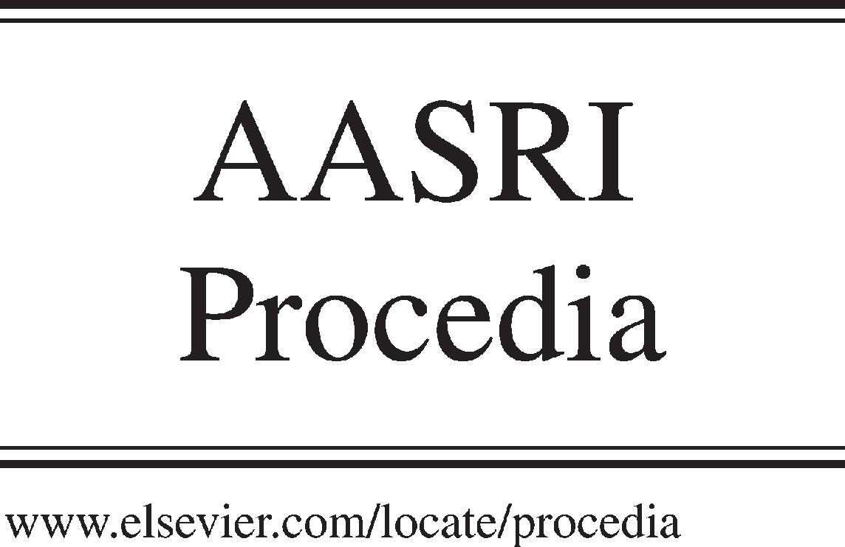Available online at [www.sciencedirect.com](http://www.sciencedirect.com/)



AASRI Procedia 3 (2012) 36 – 42

huo 2012 AASRI Conference on Modeling, Identification and Control

The Modeling of Needle for Hybrid Suspension Drive and Researching on Needle Motion Control

Xiaoguang Wu1*, Guozhen Zhang2, Shuang Li3, Zhen Huang4, Li Zhu5

*Wuhan Textile University, Wuhan, 430073, China*

Abstract

To the theory of jacquard knitting machine, this paper has proposed a new needle drive model of magnetic suspended needles. This model, based on hybrid suspension of electromagnets and permanent magnets theory, discussed needle model in the specific motion trail,through theoretical analysis and simulation of motion trail, revealed that realize the specific motion trail by maglev drive needle is available, and provide a new researching method of drive needle model for displace traditional knitting principle of mechanical multi-stage transmission. In theory, the model discussed the knitting principle of maglev drive needle in detail, and through the simulation and theory model of the trail, proved that the jacquard efficient is higher, and the structure is simpler and programmable. The electromagnetic and permanent model that the paper involved provide the basic theory for further discussing experimental program of drive needle, set relevant parameters.

© 2012 The Authors. Published by Elsevier B.V. Open access under [CC BY-NC-ND license.](http://creativecommons.org/licenses/by-nc-nd/3.0/)

© 2012. Published by Elsevier B.V. Selection and/or peer re[view under respons](http://creativecommons.org/licenses/by-nc-nd/3.0/)ibility of American Applied Science Research Institute

Selection and/or peer review under responsibility of American Applied Science Research Institute

*Keywords:* Needle section, hybrid suspension, needle trail, equivalent magnetic circuit

1. Perface

Magnetic suspension technique is a new technology in the twentieth century. It is characteristic of non-contact, without friction and wear between objects, so as to increase the life of device in the process and improve the running condition of device. It thus has been widely used in the area of traffic, mechanical, air craft and so on.

Nomenclature

* Corresponding author Xiaoguang Wu. Tel.: 13477088899; fax: +0-000-000-0000 . E-mail address: [2006wist@163.com.](mailto:2006wist@163.com)

2212-6716 © 2012 The Authors. Published by Elsevier B.V. Open access under [CC BY-NC-ND license.](http://creativecommons.org/licenses/by-nc-nd/3.0/) Selection and/or peer review under responsibility of American Applied Science Research Institute doi:10.1016/j.aasri.2012.11.007

This paper combines the jacquard knitting needle selection mechanism to build the needle model of magnetic suspension-type drive by using hybrid system that combines electromagnet and permanent magnet. Through researching the model, a non-mechanical drive needle pattern is put forward. The hybrid suspension-type drive makes needle motion change from “multiple-stage drive” to “zero drive” to replace the traditional jacquard needle selection (multiple-stage drive), and get rid of relying on triangular cam without rigid shock and use the function of programmableness to realizing kinds of technical knit.

1. Researching on needle that magnetic suspension-type drives
   1. *Principle of needle that magnetic suspension-type drive*

The device of needle that suspension-type drive uses is the electromagnets and permanent magnets drive. As shown in Figure1, the figure shows that there is no mechanical transmission, and the drive principle is using electromagnetism and permanent magnet theory. Through the suction and repulsive force caused by electromagnetic device and permanent magnet control the needle reciprocating motion in the radial direction, the needle's linear motion in axial suspension is realized. While up-and-down motion of the needle is realized by changing the parameter of size, direction, mode of the current in the electromagnet device, it can change the force and its direction, and then control its height and velocity.

Based on the electromagnetism theory, the force between electromagnet and permanent magnet is:

*F*  *d*1

*dx*1

*d*1  *x**d*2 3** *NB r*2*r*2*n*(*x*  *x* )

*dx*2*I*  *CI*

*(1)*

0 *d* *h*

*r* 1 2 2 1

1

2*d*1[(*x*2  *x*1 )

2  *r*2 ]2.5

2

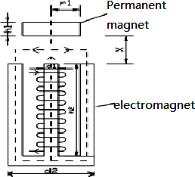Where: n is the coil turns of electromagnet, N the magnetic induction magnification factors which is produced by iron core, Br remanence rate of permanent magnet, I the current in coil, x gap, d1 and r1 the thickness and radius of permanent magnet, d2 and r2 the thickness and radius of electromagnet, and *C* the power coefficient.

Fig.1. Electromagnet and permanent magnets between parameters

According to Formula 1, the force between electromagnet and permanent magnet has a close relationship with current, distance of needle, size of electromagnet and permanent magnet. It can fix the size of electromagnetism and permanent magnet through backward reasoning of gravity of needle, distance and the designed current.

1. kinematic analysis of magnetic suspension-type needle
   1. *Movement rule of needle*

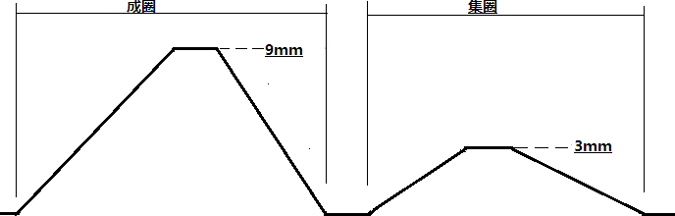The Figure 2 is the development of needle motion trail in triangle cam. The motion trail of magnetic suspension-type needle also need realize loop formation, tucking and floating threads as traditional needle dose. It should guarantee the loop formation height is 9mm, tucking height is 3mm and the floating threads is the starting point in the radial direction.

Fig.2 Motion train of suspension knitting

Based on electromagnetic and permanent magnet speciality, the force between electromagnet and permanent magnet would jump when the current turns its direction. In other words, the force on the permanent magnet would jump to the opposite direction, when electromagnet is the reference. On that basis, the laws of needle's acceleration, velocity and displacement are studied. As the polynomial movement rule is applied to high-speed occasion, the law is used to study the needle's loop formation and tucking motion in the system. And the size of acceleration can be adjusted discretionarily by change the current, so it can setting initial acceleration discretionarily, and find the most suitable curve.

* 1. *The suspension-type needle's movement rule simulation of loop formation and tucking*

Based on needle's actual motion and force analysis in the suspension system, needle motion is divided into two stages in loop formation motion: rise phase and decline phase. The direction of acceleration of permanent magnet is upward in the rise phase, and it is downward in the decline phase. As shown in Figure 2, there is a short silent period in radial direction; the time is used for hooking the yarn and the acceleration and velocity of needle is zero at the position.

Formula 2 shows the displacement, velocity and acceleration of the needle. Based on the known conditions, the displacement equation is quintic polynomial.

 *a*  *a* * *t*  *a* * *t* 2  *a* * *t* 3  *a* * *t* 4 + *a*

* *t* 5  *s*

*(2)*

 0 1 2 3 3 4

 *a*  2* *a* * *t*  3 * *a* * *t* 2  4 * *a* * *t* 3 +5* *a* * *t* 4  v

1 2 3 3 4

 2* *a*  6* *a* * *t*  12 * *a* * *t* 2 + 20 * *a* * *t* 3  a



3 4

2 3

The initial condition is:*t11*=0*s,t12=*0.003*s,s11=*0*m,s12=*0.004*m,a11=*800*m/s2,a12=*100*m/s2,v11=*0*m/s ,*Where: *t11*is initial time, *t12* finish time, *s11* initial displacement,*s12* finish displacement,*a11* initial acceleration,*a12* finish acceleration,*v11* initial velocity. Figure 4 is the curve of displacement, velocity, and acceleration in the first stage.

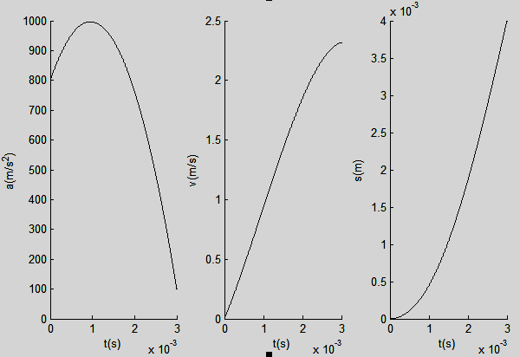

Fig.3. Acceleration, speed and displacement curve of the first stage in knitting looping raise phase

In the second stage, Formula 3 shows the displacement, velocity and acceleration of the needle. Based on the known conditions, the displacement equation is 6-th polynomial.

 *a*  *a* * *t*  *a* * *t* 2  *a* * *t* 3  *a* * *t* 4 + *a* * *t* 5 + *a* * *t* 6  *s*

0 1 2 3 3 4 5



(3)

 *a*  2\**a* * *t*  3* *a* * *t* 2  4\**a* * *t* 3 +5 * *a* * *t* 4 +6\**a* * *t* 5  v

1 2 3 3 4 5

 2* *a*  6* *a* * *t*  12* *a* * *t* 2 +20\**a* * *t* 3 +30 \**a* * *t* 4  a

 2 3 3 4 5

The initial condition in the second stage is:*t21=*0.00*3s ,t22=*0.007*s ,s21=*0.004*m ,s22=*0.009*m ,a21=*-100*m/s2 ,a22=*0m*/s2 ,v21=*23167*m/s ,v22=*0*m/s* Where: *t21* is initial time, *t22* finish time, *s21* initial displacement, *s22* finish displacement, *a21* initial acceleration, *a22* finish acceleration, *v21* initial velocity, *v22* the finish time. Figure 5 is the curve of displacement, velocity, and acceleration in the first stage.

Figure 4.(a) is the curve of displacement, velocity, and acceleration in the second stage. Figure 4.(b) is the curve of displacement, velocity, and acceleration in the rise phase of loop formulation stage.

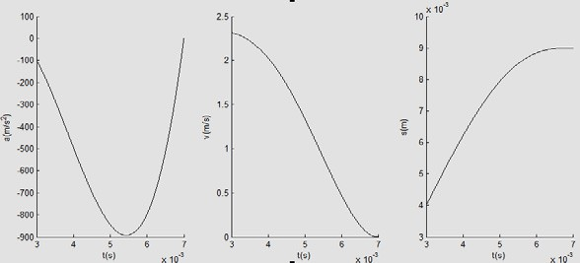 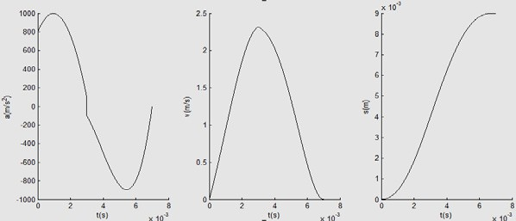

Fig.4. (a)first picture; (b)second picture

Figure4.(b) shows the curve of the total rise phase of loop formulation. The acceleration is jumping from positive to negative directly, and the size is from increscent to decreasing. It illustrates the current changed its direction at 3ms, and makes the force between electromagnet and permanent magnet from mutually exclusive to mutual attraction and the size of current is variational with the change of acceleration.

In the decline phase of tucking, it can also be divided into two stages: the direction of acceleration in the first stage is downward, and in the second stage upward. Formula 4 and Formula 5 are the curve of displacement, velocity and acceleration in the total tucking stage (make the displacement equations are quintic polynomial and 6-th polynomial).

 *a*  *a* * *t*  *a* * *t* 2  *a* * *t* 3  *a* * *t* 4 + *a*

* *t* 5  *s*

*(4)*

 0 1 2 3 3 4

 *a*  2\**a* * *t*  3\**a* * *t* 2  4 * *a* * *t* 3 +5 * *a*

* *t* 4  v

1 2 3 3 4

 2* *a*  6* *a* * *t*  12 * *a* * *t* 2 + 20\**a* * *t* 3  a



3 4

2 3

 *a*  *a* * *t*  *a* * *t* 2  *a* * *t* 3  *a* * *t* 4 + *a* * *t* 5 + *a*

* *t* 6  *s*

*(5)*

 0 1 2 3 3 4 5

 *a*  2* *a* * *t*  3* *a* * *t* 2  4 * *a* * *t* 3 +5 * *a* * *t* 4 +6 * *a* * *t* 5  v

1 2 3 3 4 5

 2* *a*  6 * *a* * *t*  1 2* *a* * *t* 2 +2 0 * *a* * *t* 3 + 3 0 * *a* * *t* 4  a

 2 3 3 4 5

The first stage: *t11*=0*s,t12=*0.003*s,s11=*0.009*m,s12=*0.004*m,a11=-*800*m/s2,a12=-*100*m/s2,v11=*0*m/s*,Where: *t11* is initial time, *t12* finish time, *s11* initial displacement, *s12* finish displacement,*a11* initial acceleration,*a12* finish acceleration,*v11* initial velocity.

The second stage: *t21=*0.00*3s ,t22=*0.006*s ,s21=*0.004*m ,s22=*0*m ,a21=*100*m/s2 ,a22=*0m*/s2 ,v21=-*23432*m/s ,v22=*0*m/s*,Where: *t21* is initial time, *t22* finish time, *s21* initial displacement, *s22* finish displacement, *a21* initial acceleration, *a22* finish acceleration, *v21* initial velocity, *v22* the finish time. Figure 5 is the curve of displacement, velocity, and

acceleration in the decline phase of loop formation.

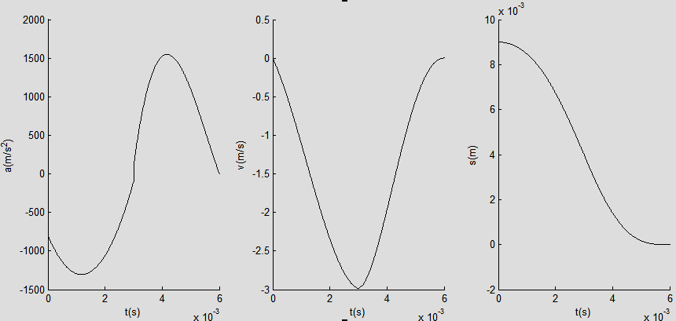

Fig.5.Acceleration, speed and displacement curve of the knitting looping decline phase

Figure 5 shows that with the displacement from 9mm to Omm, the velocity became zero at last and the acceleration from negative to positive, that illustrate current turn to reverse direction at the point of 3ms.

In the tucking stage, the principle is similar to the loop formation.

Figure 6(a), (b), (c) is the curve of acceleration, velocity and displacement in the total motion trail of te needle.

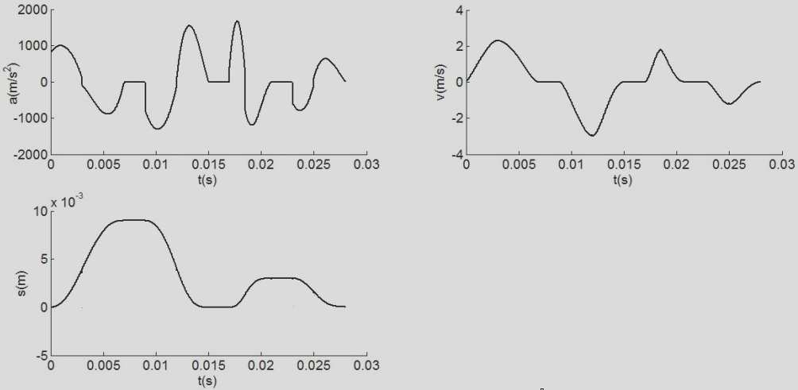

Fig.6.(a)first picture;(b)second picture;(c)third picture

From Figure 6(c), it shows in the whole braiding process, the acceleration is hopping ceaselessly. It illustrates the current turn to reverse direction with the hopping of acceleration. After get the movement rule of the needle, it can get the default trail shown above by adjust the current.

1. System model analysis of magnetic suspension-type needle
   1. *System analysis of equivalent magnetic circuit*

The method of equivalent magnetic circuit is used to analysis the hybrid suspension model.

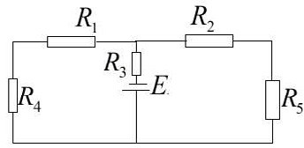

Fig.7Magnetic equivalent circuit

In Figure 7, R1,R2 are air reluctance, and R1 =R2, R3 is reluctance of the permanent magnet, R4 and R5 reluctance of iron core, and R4 =R5. E is the magnetic potential, and is the sum of the electromagnet and permanent magnet when they are mutual attraction, and is the difference when they are mutual repulsion.

Based on magnetic ohm's law and Figure 1, it can get the magnetic reluctances:*R1=*(*h1+*3*x*)/*u0s ,R3=h1*/(*uru0s*) ,*R4*=(2*h2+d2/*2)/*umu0s,*The total magnetic reluctance is:*R*=1/[1/(*R1+R4*)+ 1/(*R2+R5*)]+*R3*,Magnetic potential can be divided into two cases, when the electromagnet and permanent magnet are mutual attraction: *E=Hc*\**h1*+*n*\**I*. When the electromagnet and permanent magnet are mutual repulsion: *E=Hc*\**h1*-*n*\**I*.

When Leaving out leakage flux, the magnetic flux that passed the coil and permanent magnet is:*Φ*(*x,i*)*=E*/*R*,And the applied force the permanent magnet gets is:*F*=*Φ2*/*u0s*=*E2s*/*R2u0*,Where: *s* is the sectional area of magnetic circuit, *u0* the relative permeability of the air, and *um* the relative permeability of the iron core.

* 1. *Discussion of the parameters of the electromagnet and permanent magnet*

About the loop formation stage: 0~3ms, the friction is ignored while the needle is moving.

Figure 3 is the curve of acceleration of loop formation stage, based on the mechanical formula:*F=ma*. It can get the curve like the figure 8.

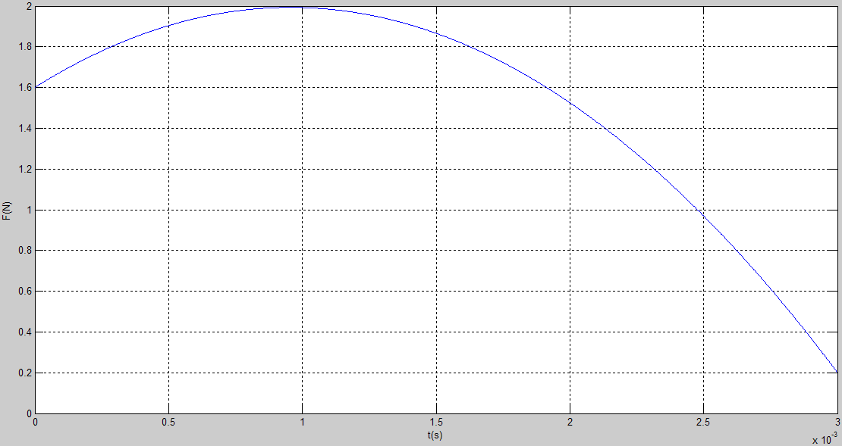

Fig.8 the curve of force F in the loop formation stage

During the period 0~3ms, only the displacement x is variable in the reluctance expression, and only the current I is variable in the magnetic potential, other parameters are the size of the electromagnet and permanent magnet or their nature.

Figure 3 shows the curve of the displacement s, after confirm the parameters of the electromagnet and permanent magnet, it can get the curve of current I based on *F*=*E2s/R2u0,*and through adjusting the size of parameters continually, to make the curve of current I reaching optimization.

1. Conclusion

Based on traditional jacquard knitting needle selection mechanism, the paper puts forward a drive theory of hybrid suspension that put direct drive replaced multi-drive by using electromagnetic to act on the needle directly. According to the analysis simulation of motion trail of the needle, it get the curve of displacement, velocity and acceleration of the needle, and the model by using the method of equivalent magnetic circuit, finally get the acting force relationship between electromagnet and permanent magnet. These theses aim at providing a sound theoretical base for confirming each parameters of current, electromagnet and permanent magnet.

Acknowledgement

The paper is funded by National Natural Science Foundation: Study on High-speed Magnetic Suspension-type Needle Driving Mechanism and Its Application in Jacquard Knitting Machine (Serial number: 51175384), and funded by Hubei Science Foundation(Serial number: 2011CDB216 ).

The corresponding author is XiaoguangWu  1954-  Wuhan, hubei province Professor/doctoral Mainly engaged in digital textile equipment and key technology research.Telephone 13477088899.Email :2006 [wist@163.com.](mailto:wist@163.com)

Reference

1. Shaohui Xu. Research on Electromagnetic and permanent magnet hybrid system suspension control. Beiji ng: Institute of Electrical Engineering, Chinese Academy of Sciences. 2005.
2. Jie Hu, Hongpan Niu. The Experimental Study on Vibration Control of Viscoelasticity Electromagnetic A ctive Dynamic Absorber. Journal of Experimental Mechanics. 2006.21(6):735-740.
3. Wenbin Zhu, Xiaoguang Wu. Theory research and design of Magnetic suspension needle driven device. J ournal of Wuhan Textile University. 2011(6)