Available online at [www.sciencedirect.com](http://www.sciencedirect.com/)



AASRI Procedia 3 (2012) 236 – 241

2012 AASRI Conference on Modelling, Identification and Control

The Morphology of the Hollow PAN Fibers through Electrospinning

Xiaochao Zhang1, a, Yanping Wang 2,b*, Dongbo Guo1,c and Yimin Wang2,d

*1 College of Material Science and Engineering, Donghua University, Shanghai 201620, China*

*2 State Key Laboratory for Modification of Chemical Fibers and Polymer Materials, Donghua University, Shanghai 201620, China*

*a* [*zxc19880607@163.com,*](mailto:zxc19880607@163.com) *b* [*wyp@dhu.edu.cn,*](mailto:wyp@dhu.edu.cn) *c* [*taipingguanji@163.com,*](mailto:taipingguanji@163.com) *d* [*ymw@dhu.edu.cn*](mailto:ymw@dhu.edu.cn)

**Abstract**

The method to produce the hollow micro/nano fibers through the bicomponent spinneret of electrospinning was introduced and the influence of the process parameters on the morphology of the micro/nano fibers was presented in the paper. The result revealed that the PAN fibers with uniform hollow construction could be collected while the feed rate of the inner solution was set at 0.08ml/h (single hollow fibers) or 0.06ml/h (double hollow fibers). Meanwhile, the morphology was in good condition with 15kv voltage and 20cm receiving distance.

© 2012 The Authors. Published by Elsevier B.V. Open access under [CC BY-NC-ND license.](http://creativecommons.org/licenses/by-nc-nd/3.0/)

© 2012 Published by Elsevier B.V. Selection and/or peer rev[iew under responsi](http://creativecommons.org/licenses/by-nc-nd/3.0/)bility of American Applied Science Research Institute

Selection and/or peer review under responsibility of American Applied Science Research Institute

***Keywords:*** hollow micro/nano fibers; bicomponent spinneret; electrospinning; PAN; morphology

# Introduction

The electrospinning is a technology to fabricate continuous micro/nano fibers, with advantages such as the simple device, the wide range of optional materials, the controllable morphology and the high specific surface area etc. At the same time, the fibers have potential application in the fields of tissue engineering scaffolds, health care, filter material, electromagnetic shielding materials, etc[1].

Electrospinning machine is usually composed of spinneret and solution supply system, fiber collection plate and high voltage power supply. The traditional spinneret, with a circular cross section, helps to produce the circular solid fibers which possess limited use[2,3]. At present, the researchers have developed co-axial elecrospinning device which can produce single and hollow micro/nano fibers through electrospinning[4,5,6].

2212-6716 © 2012 The Authors. Published by Elsevier B.V. Open access under [CC BY-NC-ND license.](http://creativecommons.org/licenses/by-nc-nd/3.0/) Selection and/or peer review under responsibility of American Applied Science Research Institute doi:10.1016/j.aasri.2012.11.039

In order to widen their application fields, the spinneret can be revised to produce multi-component fibers and even multi-hollow fibers. Compared with solid structure, hollow structure may possess more advantages such as better mechanic stability, independent addressable channels, and larger surfaceto-volume area[7].

In this paper, the single and double hollow PAN micro/nano fibers were fabricated. The influence of the process parameters on the morphology of the micro/nano fibers was studied.

# Experiments

* 1. *Materials and instruments*

PAN(MW=50000) was provided by Petro-chemicals Jinshan CO., Ltd; N,N-dimethylformamide (DMF) and polyvinylpyrrolidone K-30 (PVP) were purchased from Sinopharm Chemical Reagent Co., Ltd. A high voltage power supply and a trace syringe pump were used in the experiments, which were purchased from the Kansai Electronics (Su zhou) Co., Ltd, and TECH-Knowledge International, Inc, respectively. The morphology of the fibers was characterized by scanning electron microscopy (SEM) (HitachiS-3000N).

* 1. *Solution Preparation*

PAN powder was dissolved in DMF with magnetic stirring for 6h at 60  . PVP solution was used as inner solution with 30wt% in DMF as well.

* 1. *Fabrication of micro/nanofibers*

The PAN micro/nano fibers could be fabricated by vertical electrospinning system. The experiment voltage was (10-20)kv, and the distance between spinneret and collector was(10-20)cm. The aluminium foil was used as the accept device.

The PAN hollow fibers were fabricated through the spinnerets (as shown in Fig. 1). Also the number and arrangement of the inner channels in a spinneret could be adjusted according to the practical requirement. At the experimental conditions, the cortex solution dropped down by gravity and the inner solution fell down by the force of the trace syringe pump. Eliminating the core layer, the hollow fibers were made with the diameter ranging from nanometer to micrometer. Citing the single hollow and double hollow fibers as examples, the section of the fibers might be changed based on the process parameters. Now the influence of the process parameters on the morphology of the micro/nano fibers was analyzed and the result was shown as follow.



Fig. 1 The cross section view of the bicomponent spinneret

* 1. *Post treatment*

Non-woven fabrics were placed in water at ambient temperature for more than 24 h to remove the core layer, and then dried in 80  for six hours to remove moisture. Next the PAN fibers were pre-oxidized to

250  in the muffle furnace. Finally, the morphology of the fibers could be observed by SEM.

# The results and discussion

* 1. *The influence of the feed rate of the inner solution*

In conditions of certain spinning voltage (15kv) and receiving distance (20cm), the fibers with different inner diameters were obtained by adjusting the feed rate of the inner solution. For the single hollow fibers, the feed rate was respectively 0.02 ml/h, 0.04 ml/h, 0.06 ml/h and 0.08ml/h. The SEM photos of the fibers were clearly shown in Fig. 2.

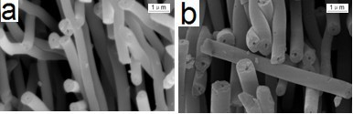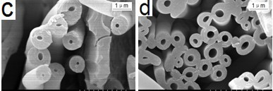

 (a) 0.02 ml/h, (b) 0.04 ml/h, (c) 0.06 ml/h, (d) 0.08 ml/h

It could be seen from the Fig. 2 that the inner diameters increased along with the feed rate of the inner solution. When the feed rate of the inner solution was less than 0.04 ml/h, the production ratio of the hollow construction was too small to put into practical use. Increasing the feed rate of the inner solution to 0.08ml/h, the ratio of the hollow construction presented a better state. The feed rate could not be too fast, or the core layers were fractured at risk.

As for the double hollow fibers, the variation of hollow construction showed the similar trend with the  from Fig.2 and Fig. 3. When the feed rates of the inner solution were too small, the fibers of ideal section could not be achieved. Increasing the rate to 0.06 ml/h (As shown in figure 3 (b) shows),

 of hollow construction were considered in a better condition. Continuing to increase the feed rate, the double hollow would merge and the cortices tended to fracture. As a result, the feed rate should not be too fast when fabricating the double or triplicate hollow fibers.

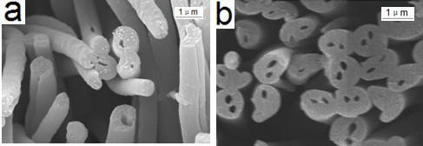

Fig. 3 The SEM photos of the double hollow fibers w (a) 0.02 ml/h, (b) 0.06 ml/h

It was likely that the inner diameters were liner with the outer diameters as for hollow fibers, so next the paper studied 

* 1. *The influence of voltage*

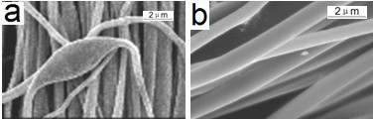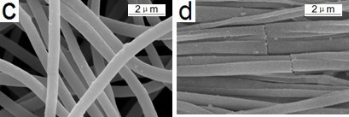

Fig. 4 The SEM photos of the hollow fibers with the different voltage: (a) 10kv, (b) 12kv, (c) 15kv, (d) 20kv

According to the above research, we adjusted the spinning voltage arranging from 10kv to 20kv to fabricate the hollow fibers when the suitable feed rate of the inner solution was 0.08ml/h and the receiving distance was

1. When the voltage was small, the fibers were discontinuous, meanwhile there were beadlike structures called slub PAN filament yarn. High voltage was the best way to decrease the diameters (the higher the voltage, the smaller the diameters), but high voltage should be controlled to a certain range. When the voltage kept increasing, the continuity of the fibers became worsen, and the diameter distribution greater. The research found the optimal condition of the voltage would be 15kv. Meanwhile, the diameters of the fibers could be optimized in the process of after- drawing.

*3.3. The influence of receiving distance*

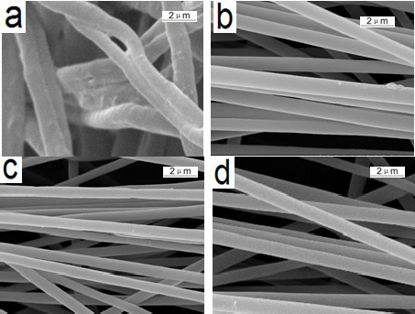

Fig. 5 The SEM photos of the hollow fibers with the receiving distance: (a) 10cm, (b) 15cm, (c) 20cm, (d) 25cm

Different diameters fibers were produced by adjusting the receiving distance, at the feed rate of 0.08 ml/h,

volatilize completely at the receiving distance of 10cm. Along with increasing the distance, the solvent volatilized fully and the solution solidified well, finally the uniform diameter fibers with smooth surface could be collected in the plate (Fig. 5(b) and (c)). When it reached to 25cm, there was larger diameter distribution because of unstable dynamic whip. Judging from these, it was 20cm that was the best receiving distance for collecting the fibers.

ss section views were shown as Fig. 6 with the feed rate of 0.08ml/h (single hollow fibers) or 0.06ml/h (double hollow fibers) of the inner solution, voltage of 15kv and receiving distance of 20cm. In this condition, the outer diameters of fibers ranged from 800 nm to 1  m with the inner diameters being about 300nm-400nm (single hollow fibers) or 100nm-200nm (double hollow fibers).

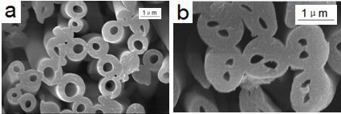

Fig. 6 The cross section views of the fibers: (a) The single hollow fibers, (b) double hollow fibers

# Summary

With the help of the bicomponent spinneret, single hollow fibers and double hollow fibers had been fabricated. This research analyzed the influence of the process parameters on the morphology of the micro/nano fibers. It revealed that the fibers with uniform hollow construction could be fabricated in the plate while the feed rate of the inner solution was set at 0.08ml/h (single hollow fibers) or 0.06ml/h (double hollow fibers). Meanwhile, the surface morphology was in good condition with 15kv voltage and 20cm receiving distance. Also the number and arrangement of the inner channels in a spinneret could be adjusted according to the practical requirement.

# Acknowledgement

This work was supported by the Fundamental Research Funds for the Central Universities.

# References

1. Yuya Ishii, Heisuke Sakai, Hideyuki Murata. A new electrospinning method to control the number and a diameter of uniaxially aligned polymer fibers[J]. Materials Letters, 2008(62): 3370-3372.
2. CHANG GuoQing, ZHENG Xi, CHEN RiYao, CHEN Xiao CHEN LiQin: CHEN Zhen. Silver Nanoparticles Filling in TiO2 Hollow Nanofibers by Coaxial Electrospinning[J]. Wuli Huaxue Xuebao, 2008, 24(10):1790-1796.

[3]V Maneeratana, WM Sigmund. Continuous hollow alumina gel fibers by direct electrospinning of an alkoxide-based precursor[J]. Chemical Engineering Journal. 2008 (137): 137-143.

[4]Vasana Maneeratana, Wolfgang M. Sigmund, Continuous hollow alumina gel fibers by direct electrospinning of an alkoxide-based precursor[J]. Chemical Engineering Journal, 2008(137):137-143.

[5]CUI Qizheng, DONG Xiangting, WANG Jinxian, LIMei. Direct fabrication of cerium oxide hollow nanofibers by electrospinning[J]. RARE EARTHS, 2008,10(5):664-669.

[6]S Tao, Y Zhang, TJ Zhou. Eancapsulation of self-assembled Feet magnetic nanoparticles in PCL nanofibers by coaxial electrospinning[J], Chem. Phy. Let. 2005, (415):317-322.

[7]Yong Zhao, Xinyu Cao, Lei Jiang. Bio-mimic Multichannel Microtubes by a Facile Method[J]. J. AM. CHEM. SOC. 2007(129):764-765.