Available online at [www.sciencedirect.com](http://www.sciencedirect.com/)



AASRI Procedia 3 (2012) 2 – 7

2012 AASRI Conference on Modelling, Identification and Control

The Non-fragile Controller Design Based on Quadratic Performance Optimization

Yang Changweia, Chen Jieb*

*aThe 365 institute, Northwestern Polytechnical University, People's Republic of China*

*bSchool of Aeronautics, Northwestern Polytechnical University, People's Republic of China*

Abstract

This paper presents a non-fragile controller design method based on system quadratic performance optimization. For the additive controller gain variations, the necessary and sufficient conditions for the existence of non-fragile state feedback controller are given and transformed to the LMI problems, which simplifies the solutions to obtain non-fragile state feedback controllers. The flight control simulation results prove the reliability and validity of the method.

© 2012 The Authors. Published by Elsevier B.V. Open access under [CC BY-NC-ND license.](http://creativecommons.org/licenses/by-nc-nd/3.0/)

© 2012 The Authors. Published by Elsevier B.V.

Selection and/or peer review under responsibility of American Applied Science Research Institute

Selection and/or peer review under responsibility of American Applied Science Research Institute

*Keywords*: non-fragile control, robust control, quadratic performance optimization, Linear Matrix Inequality (LMI);

1. Introduction

System modelling can never describes the engineering plant exactly, and lots of scholars showed interesting on the system optimal problems with system and external uncertainty [ZHOU et al., 1996, YU et al., 2002, WU et al., 2006]. The Guaranteed Cost Control presented by Chang [Sheldon et al., 1972] tackled this problem, and can be seemed as the linear quadratic optimal problem's extension to system uncertainty. But such feedback controller which tackles the uncertainty of controlled plant and the closed-loop performance

* Corresponding author. Tel.: 13389254083; fax: 02988492344.

*E-mail address:* [shuimujie@mail.nwpu.edu.cn.](mailto:shuimujie@mail.nwpu.edu.cn)

2212-6716 © 2012 The Authors. Published by Elsevier B.V. Open access under [CC BY-NC-ND license.](http://creativecommons.org/licenses/by-nc-nd/3.0/) Selection and/or peer review under responsibility of American Applied Science Research Institute doi:10.1016/j.aasri.2012.11.002

optimization needs to be implemented exactly. This demand seems validity, but actually, because of the inevitable uncertainty in advanced controller operation, it's impossible in the actual engineering. The controller uncertainty is composed by environment temperature variation, the digital device's word capacity, data transform error, etc.

As the analysis and synthesis of closed system which is composed of plant and controller, the robust control approach has the consideration of the control fragile problem. And the fruitful results of robust control theory are helpful to tackle the non-fragile problem. Theoretical research and engineering practice show that, if we divide the uncertainty of plant and controller, the robust and non-fragile are interactive. When the robust from the closed system to the uncertainty is stronger, then the closed system is fragile or sensitive to the uncertainty of controller. Keel et al., 1997 concludes that the fragile of controller will be worse as the order of controller become higher. So it's important to consider the controller's uncertainty during the controller design and synthesis, e.g. non-fragile control.

Over recent years, many remarkable achievements have been achieved in developing advanced non-fragile controller [Famularo et al., 1998, Yang et al., 2000], but the common approaches with operator theory or Riccati inequality are complex. According to the additive controller gain uncertainty, this paper presents the non-fragile controller synthesis problem based on the optimal performance control, which controller will be tackled using the LMI toolbox in Matlab® software. A mathematical simulation of flight controller design is presented to show the validity of the method above.

1. Problem statements

Lemma 1 [WU et al., 2006] For given proper dimension matrix *Y* , *D* and *E* , in which the *Y* is symmetric,

*Y*  *DFE*  *ET FT DT*  0 ,

is existed for all the matrix *F* which satisfy *FT F*  *I* , if and only if there exists the constant **  0 and

*Y*  ** *DDT*  ** 1*ET E*  0 .

Lemma 2 [WU et al., 2006] With the given symmetric matrix

*S*   *S*11 *S*12  ,

*ST S* 

 12 22 

in this matrix, *S*11 , *S*22 is nonsingular invertible matrix, then the three conditions below is equivalent:

1. *S*  0 ;
2. *S*11  0 , *S*

*T* 1

22 12 11 12

− *S S S*

 0 ;

1. *S*  0 , *S*  *ST S* 1*S*

 0 ;

22 11 12 22 12

Consider linear continuous time-invariable equation

*x*˙(*t*)  ( *A*  *A*)*x*(*t*)  (*B*  *B*)*u*(*t*) , *(1)* where *x*(*t*) c R*n* is the state vector, *u*(*t*)  R*m* is the control input vector, *A* , and *B* is the matrices with proper dimension. The matrices uncertainty satisfy

[A*A*(*t*)

A*B*(*t*)] = *DF* (*t*)[*E*1

*E*2 ]. *(2)*

The optimal controller *u*(*t*)*=Kx*(*t*) makes the performance index

*J* = ∞ F *xT* (*t*)*Qx*(*t*) + *uT* (*t*)*Ru*(*t*)l*dt* , *(3)*

∫

reach the minimum.

*0* IL I⎦

For the given quadratic performance index and system uncertainty, the closed system with state feedback controller *u*(*t*)*=Kx*(*t*) is optimal, if the symmetric matrix *P* and *K* exist which satisfy

*P*[ *A* + *BK* + *DF* (*E* + *E K* )]+[ *A* + *BK* + *DF* (*E* + *E K* )]*T P* + *KT RK+Q<O* , *(4)*

1 2 1 2

and then system performance upper bound is *J*∗

= *xT Px* .

Consider the controller has parameter perturbation

0 0

*K* = *K*0 +A*K=K*0 + *Dk Fk* (*t*)*Ek* , *(5)*

the non-fragile controller design approach with optimal performance can be given as follows.

1. Main results
   1. *Non-fragile controller design with robust performance optimal*

Theorem 1 For system (1) with uncertainty (2), the necessary and sufficient condition to the optimal performance index (3) with non-fragile feedback control strategy is that, if there exists positive define matrix *X* , *W* , and real constant **  0 that satisfy the LMIs below

1 2

(AX  BW)  ( *AX*  *BW* )*T*  ** *DDT*



(*E X*  *E W* )*T X WT*

** *BD XET* 

*k k* 

(*E X*  *E W* )*T*

** *I O O*

** *E D O*

 1 2 2 *k* 

 *X O*

*Q*1

*O O O* 

*(6)*



 *W O O*

*R*1

*Dk O*

  0



 (*BD* )*T*

(*E D* )*T*

*O * *DT*

** *I O* 

 *k* 2 *k k* 

 *Ek X O O O O* ** *I* 

Moreover, if the feasible solution for the inequality (6) above exists, then the control strategy

0 0

*u*(*t*)  *WX* 1*x*(*t*) is the controller for the system (1), and the performance upper bound is *J*

∗

= *xT Px* .

Proof. According to the Eq. (4), the necessary and sufficient condition for minimizing the performance index

(3) with system uncertainty is

*Y*  *PDF* (*E*  *E K* )  (*E*  *E K* )*T FT* (*PD*)*T =Y*  ** *PD*(*PD*)*T*  ** (*E +E K* )*T* (*E +E K* )  *O* ,

1 2 1 2

where *Y=Q*  *KT RK*  *P*( *A*  *BK* )  ( *A*  *BK* )*T P* .

1 2

1 2 1 2

*P*( *A*  *BK* )  ( *A*  *BK* )*T P+* *PDDT P*



(*E*  *E K* )*T*

*I KT* 



*M*  

(*E*1  *E*2 *K* )

** *I O O*

  *O*

 *I O* *Q*1 *O* 



*K O O*

*R*1 

 

Substitute the Eq. (3) into the equation above, then we can get the results by Lemma 1

*P*( *A*  *BK* )  ( *A*  *BK* )*T P+* *PDDT P*

(*E*  *E K* )*T*

*I KT* 



*M*  



(*E*1  *E*2 *K*0 )

1 2 0 0

** *I O O* 

 *I O* *Q*1 *O* 

 1 





 *K*0 *O O* *R* 

*PBDk*   *Ek* 

 *E D*   *O* 

  2 *k*  *F* *E O O O*    *FT* (*PBD* )*T*

(*E D* )*T*

*O DT* 

 *O*  *k k*

 *O*  *k k*

2 *k k*

 *D*  *D* 

 *k*   *k* 

*P*( *A*  *BK* )  ( *A*  *BK* )*T P+* *PDDT P* (*E*  *E K* )*T I KT* 

 0 0 1 2 0 0 

  (*E*1  *E*2 *K*0 )

** *I 0 0* 

 *I 0* *Q*1 *0* 

 1 





 *K*0 *0 0* *R* 

*PBD*  *PBD* *T*

*k*

*k*

*ET* 

   

 *k* 

**  *E*2 *Dk*   *E*2 *Dk* 

 ** 1  *0* *E 0 0 0*

 *0*   *0* 

 *D*   *D* 

 *0*  *k*

 

*0*

 *k*   *k*   

By the Lemma 2, *M*  *0* is equal to

*P*( *A*  *BK* )  ( *A*  *BK* )*T P*  ** *PDDT P* (*E*  *E K* )*T I KT * *PBD ET* 

 0 0 1 2 0 0 *k k* 

 (*E*1  *E*2 *K*0 )

** *I 0* *0*

*E*2 *Dk 0* 

 *I* *0*

*Q*1

*0 0 0*  .



 *K*0 *0* *0*

*R*1

*Dk* *0*

  *0*



 (*PBD* )*T*

(*E D* )*T*

*0 DT*

*I 0* 

 *k* 2 *k k* 

 *Ek*

*0 0 0 0*

** *I* 

Multiply the inequality above right and left with *diag* *P*1, *I* , *I* , *I* , *I* , *I* respectively.

( *A*  *BK* ) *X*  *X* ( *A*  *BK* )*T*  ** *DDT X* (*E*  *E K* )*T X XKT * *BD XET* 

 0 0 1 2 0 0 *k k* 

 (*E*1  *E*2 *K*0 ) *X*

** *I 0* *0*

** *E*2 *Dk 0* 

 *X* *0*

*Q*1

*0 0 0*  .



 *K*0 *X 0* *0*

*R*1

** *Dk* *0*

  *0*



 (*BD* )*T*

(*E D* )*T*

*0 * *DT*

*I 0* 

 *k* 2 *k k* 

 *Ek X 0 0 0 0* *I* 

Let *X*  *P*1 , *K X*  *W* , then the Eq. (6) can be got. If the feasible solution to the LMIs (6) is existed, the control strategy *u*(*t*) = *W* ∗ ( *X* ∗ )—1 *x*(*t*) is the non-fragile state feedback controller.

0

* 1. *Non-fragile controller design based on Linear Quadratic Regulator (LQR)*

If the system uncertainty doesn't exist, then this problem regresses to the non-fragile control with conventional linear quadratic performance index, e.g.

A*A* = *0* , A*B* = *0*

Theorem 2 For system (1), the necessary and sufficient condition to the optimal performance index (3) with non-fragile feedback control strategy is that, if the positive define matrix *X* , *W* exist, and real constant **  0 that satisfy the following LMIs

( *AX*  *BW* )  ( *AX+BW* )*T*



*X WT*

** *BD XET* 

*k k* 

 *X T*

*Q*1

0 0 0 

 *W*

 (*BD* )*T*

*k k*



0 *R*1 ** *D*

*k*

0 ** *DT* ** *I*

0   0 , *(7)*



0 

 *Ek X*

0 0 0

*I* ✗

then *K* = *KW* —1 is the feedback control solution for control system (1).

Proof: According to the Eq. (4), the necessary and sufficient condition for minimizing the performance index

(3) with system uncertainty is

( *A*  *BK* )*T P+P*( *A*  *BK* ) *I KT* 

 *0 0 0* 

*L=*  *I* *Q*1 *0* 

 *K0*

*PBD* 

*k*

*0*

(*E* )*T* 

*R*1 

   *k* 

 *0 F* (*t*)*E 0 0*  *0 FT* (*t*) (*PBD* )*T*

*0* (*D* )*T* 

  *k k*

  *k* 

*k k* 

 *Dk* 

 *0* 

( *A+BK* )*T P*  *P*( *A*  *BK* ) *I KT PBD ET* 

 *0 0 0 k k* 

  *I*

*Q*1

0 0 0 

 *K* 0 *R*1 ** *D* 0   0 .

 *0 k* 

 **(*PBD* )*T*

0 *DT*

*I* 0 

 *Ek*

*k k*

0 0 0

** *I* 

Multiply the inequality above right and left with *diag* *P*1, *I* , *I* , *I* , *I* respectively.

 *X* ( *A+BK* )*T*  ( *A*  *BK* ) *X X XKT * *BD XET* 

 *0 0 0 k k* 

 *X* *Q*1 0 0 0 

 *K X*

0 *R*1 ** *D*

0   0 .

 *0 k* 

 **(*BD* )*T*

*k k*

0 ** *DT* ** *I* 0 

 *Ek X*

0 0 0

** *I* 

Let *X*  *P*1 , *K X*  *W* , then the Eq. (7) can be got.

0

1. Simulation examples

Consider the following flight model

*x*˙(*t*)  *Ax*(*t*)  *Bu*(*t*) , *(8)*

0.0316

6.9739 1.0087 9.8036

 0 

 0.002 0.6256 0.9128 0  , 0.0873 ,

*A*    *B*   

0.0027 0.4 0.8845 0  4.1063

 0 0 1 0   0 

   

the corresponding system states are: flight velocity *V* , attack angle ** , pitch rate *q* , and pitch angle ** , aircraft system input is elevator angle *e* .

System controller addictive gain perturbation can be written as the Eq. (5)

*Ek*  1 , *Fk*  0.1 0.1 0.1 0.1, *k* (*t*)  1

Using the inequality (7) above, the controller can be solved as

*K*  2.3685 83.6093 3.536 45.6491

For examining the control strategy, the flight system response with controller is given. Fig. 1 to 4 show the state curves with perturbation.

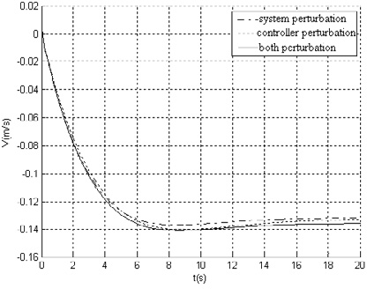 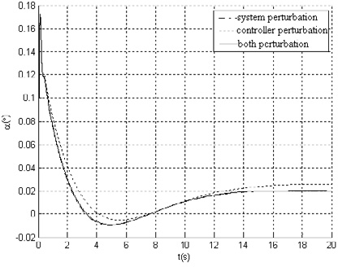

Fig. 1. (a) flight velocity  V response curves; (b) angle of attack  a response curves

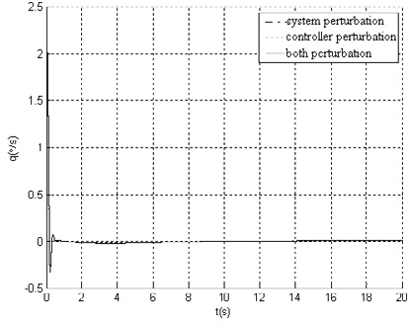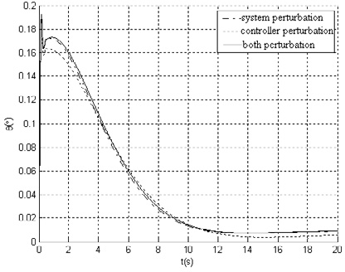

Fig. 2. (a) pitch rate  q response curves; (b) pitch angle  θ response curves

1. Conclusions

Using the Quadratic performance optimization method, the control stability problem with controller additive gain perturbation is discussed, and then the stability theorem and state feedback control approach are derived in this paper. In Section 4, the flight system performance of aircraft has been verified by mathematical simulation to validate the controller design approach.

References

1. Zhou K, Doyle J C, Glover K. Robust and optimal control. New Jersey: Prentice Hall Englewood Cliffs, 1996.
2. Sheldon. S. L. Chang. Adaptive Guaranteed cost control of systems with uncertain parameters. IEEE Trans on Automatic control, 1972;17:474-483.

[3]L.H. Keel, S .P. Bhattacharyya, Robust, Fragile or Optimal? Proceedings of the American Control Conference Albuquerque, New Meixco, June 1997:1307-1313.

[4]D. Famularo, P. Dorato, C. T. Abdallah, W. M. Haddad, and A. Jadbabaie. Robust non-fragile LQ controllers: the static state feedback case. International Journal of control, 1998, 1109-1113.

1. G.H. Yang, J.L. Wang, C Lin. H control for linear systems with additive controller gain variations, International Journal of control, 2000;73:1500-1506.
2. YU Li. Robust control. Beijing: tsinghua university press, 2002.
3. WU Ming, GUI Wei-hua, HE Yong. Modern robust control. Changsha: Central South university press, 2006.