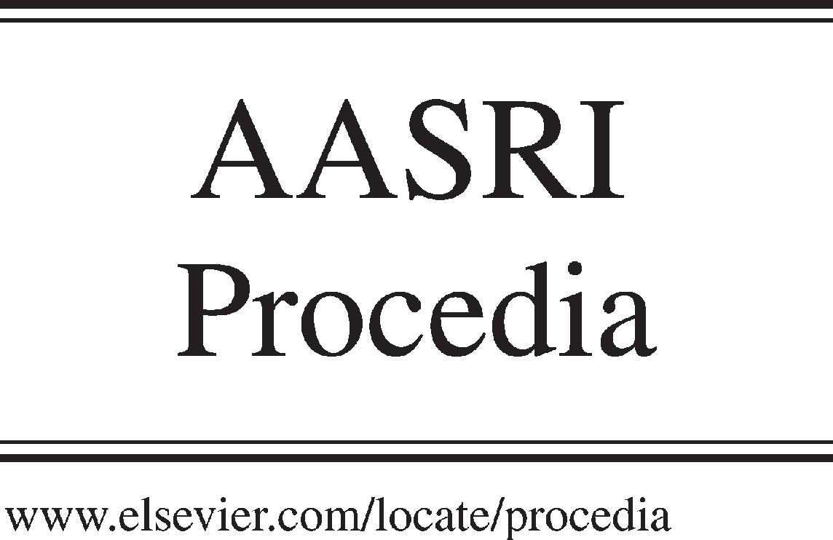Available online at [www.sciencedirect.com](http://www.sciencedirect.com/)



AASRI Procedia 3 (2012) 66 – 72

2012 AASRI Conference on Modelling, Identification and Control

The Processes of Fragmentation, Intermixing and Fusion upon Explosion Welding

B.A. Greenberga,*, M.A. Ivanovb, A.M. Patselova, Yu.P. Besshaposhnikovc

*aInstitute of Metal Physics, Ural Branch of RAS, 18 S. Kovalevskaya Str., Ekaterinburg, 620990, Russia*

*bKurdyumov Institute of Metal Physics, National Academy of Sciences of Ukraine, Vernadskogo blvd. 36, Kiev, 03680, Ukraine*

*cUral Chemical Machine Building Plant, 33 Khibinogorskii Lane, Ekaterinburg, 620010, Russia*

Abstract

On the basis of the results obtained for joints of dissimilar metals such as copper-tantalum, iron-silver, it has been cleared out the reason of immiscible suspensions mixing upon explosion welding. It has been found that the interface (waveless or wavy) is not smooth and contains inhomogeneities, namely, cusps and local melting zones. The role of granulating fragmentation providing partitioning of initial materials as a main channel of input energy dissipation has been revealed. It has been shown that in joints of metals possessing normal solubility the local melting zones are true solutions, but if metals possess no mutual solubility the local melting zones are colloidal solutions. During the solidification emulsion is a danger to the joint continuity because of possible delamination, and suspension, by contrast, can contribute to the dispersion hardening of joint.

© 2012 The Authors. Published by Elsevier B.V. Open access under [CC BY-NC-ND license.](http://creativecommons.org/licenses/by-nc-nd/3.0/)

© 2012 The Authors. Published by Elsevier B.V. Selection a[nd/or peer review](http://creativecommons.org/licenses/by-nc-nd/3.0/) under responsibility of American Applied Science Research Institute

Selection and/or peer review under responsibility of American Applied Science Research Institute

*Keywords:* explosion welding; mutual solubility; intermixing; melting; fragmentation; colloidal solution

* Corresponding author. Tel.: +7-343-378-3572; fax: +7-343-374-5244.

*E-mail address:* [bella@imp.uran.ru.](mailto:bella@imp.uran.ru)

2212-6716 © 2012 The Authors. Published by Elsevier B.V. Open access under [CC BY-NC-ND license.](http://creativecommons.org/licenses/by-nc-nd/3.0/) Selection and/or peer review under responsibility of American Applied Science Research Institute doi:10.1016/j.aasri.2012.11.012

1. Introduction

Explosion welding process is very high-velocity and a little similar to other ways of materials junction, but some of joints could not be obtained in other manner. The characteristic times: duration of the welding approximately 10-6 s, rate of deformation 104-107 s-1, cooling rate 105 K/s. This process, being outwardly simple one, has a very complex physical nature, and thus requires not only a detailed structural analysis, but also a new approach.

Welded joints of metal-intermetallic possessing a normal mutual solubility in both liquid and solid states had been investigated previously [1-4]. Commercially pure titanium was chosen as a metal, and orthorhombic titanium aluminide based alloys (“aluminide” for short) were selected as an intermetallic compound. Depending on welding conditions, different joints have been obtained and for convenience are entitled as follows: (Aw), (Ap), (Bw), (Bp), where the subscript indicates the interface shape (waveless or wavy). Orthorhombic alloys containing 16 at.% Nb and 23 at.% Nb were used in joints of A type and B type, correspondingly. In some joints a melting along entire interface was observed, while the local melting zones with vortex structure take place for others. In any case, the melts are true solutions with the intermixing at atomic level.

To find out how important is the presence of mutual solubility of the starting materials for explosion welding, metals (copper-tantalum, iron-silver), possessing little or no mutual solubility in normal conditions and forming immiscible suspension in liquid state, were selected. "Why the intermixing of immiscible suspensions occurs?" is the question which we try to answer in this paper.

1. Experimental

The welding was carried out using different schemes and parameters, and on the basis of the results obtained, joints to be studied had been selected. We restrict our considerations by giving only the basic welding parameters here: γ, the collision angle; Vc, collision velocity, Vi, impact velocity.

(Cp) copper-tantalum, γ = 5.22°, Vc=2680 m/s, Vi=234 m/s; waveless interface; (Cw) copper-tantalum, γ = 11.8°, Vc=2125 m/s, Vi= 440 m/s; wavy interface; (Dw) iron-silver, γ = 15.6°, Vc=1910 m/s, Vi= 520 m/s; wavy interface;

(Ep) aluminum-tantalum, γ = 8.6°, Vc=2000 m/s, Vi=300 m/s; waveless interface;

The choice of parameters (Cp) corresponds to the lower limit of domain of weldability, while (Cw) parameters fall into it. The joint (Ep) of aluminum-tantalum metals, which possess normal mutual solubility, is used for comparison with joint (Cp) copper-tantalum metals which possess no mutual solubility. Waveless interface was observed for both joints. The metallographic analysis was carried out using an Epiquant optical microscope equipped with a computing system SIAMS. The study of the microstructure was performed employing JEM 200CX and SM-30 Super Twin transmission electron microscopes, Quanta 200 3D and Quanta 600 scanning electron microscopes.

1. Results
   1. *(Cp) copper-tantalum joint (waveless interface)*

The interface of (Cp) joint is not wavy; thus, the interface is not corrugated. Instead of image, which for the corrugated surface would consist of parallel bands, we can see an image, consisting of spots of three shades (Fig. 1a). It means that the transition zone is composed by randomly distributed regions of three types. The observation of these three types of regions is a convincing proof of the existence of cusps on the transition

zone. The cusps are visible in transverse section also (Fig. 1b). For the first time cusps had been found in titanium-aluminide joint [2]. The depth of their penetration from one material to another is about tens of microns. The cusps are believed to be the typical inhomogeneities of the interface which play an important role in the adhesion of materials. Profilometer was used to measure the surface roughness of metals prepared for welding. The average roughness is approximately 0.61 µm for tantalum and 0.41 µm for copper. It means the size of cusps on the surfaces after welding is 10-20 times greater than the initial roughness.

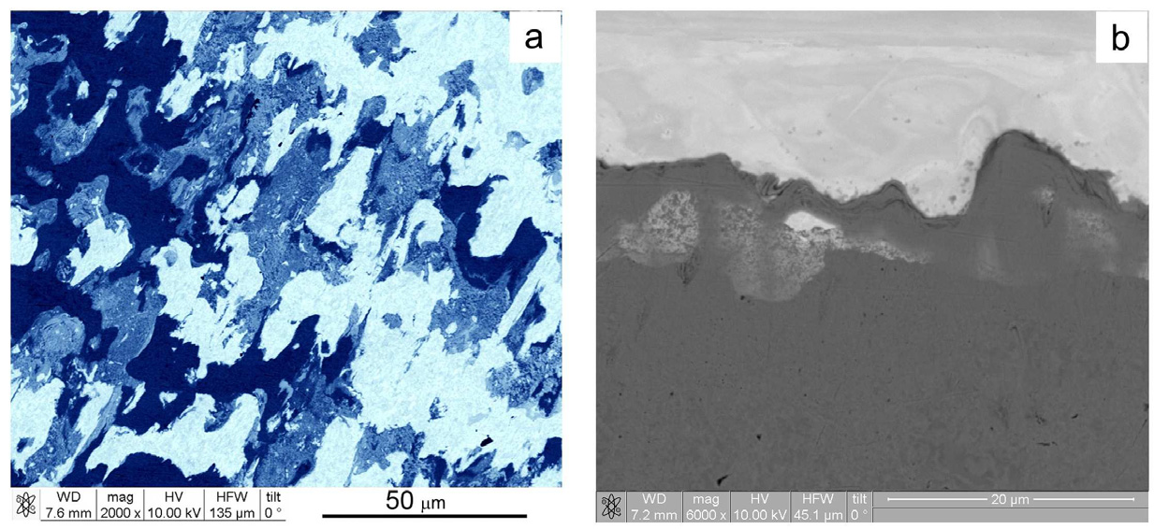

Fig. 1.Sections of the interface in (Cp) copper-tantalum joint (SEM): (a) longitudinal section, white spots correspond to Ta; blue spots to Cu; intermediate spots to a mixture of Ta and Cu; (b) transverse section, cusps of three shades

Chemical composition of three types of areas forming a transition zone was obtained by numerous SEM- measurements. It has been shown that the white shade corresponds to the zone of tantalum; the black shade, to the zone of copper. Special attention was paid to regions having grey shade on SEM-micrographs ("grey zone" for short). To elucidate the structure of grey zone, Fig. 2 is extremely important, because it shows a longitudinal section of the transition zone obtained after the copper was completely etched away. Tantalum particles, poured out of the grey zone during copper etching, are visible on the surface of tantalum. A meltdown during the explosion welding of refractory metal such as tantalum possessing a melting point of about 3300 K is unlikely; thereby the formation of particles occurs in the solid state. Therefore, the formation of tantalum particles can be a direct evidence of special type fragmentation [3, 5] which was named granulating fragmentation.

The zone will appear grey, if the higher magnification is not used. In the higher magnification micrographs (Fig. 3) is clearly visible microheterogeneous structure of the grey zone. In the bright-field image (Fig. 3b) a lot of dark particles are presented. Their dimensions are approximately 30-50 nm. In the diffraction pattern (Fig. 3c) a ring system consisting of individual reflections, belonging to tantalum, according to further identification, is observed. The strong point reflections belong to copper.

In addition to the grey zone the transition one contains zones of copper and tantalum. According to TEM analysis, these zones do not experience melting and have typical structure produced by severe plastic deformation. Cellular structure, stripped structure, high dislocation density and recrystallized areas are observed.

The local melting zone (grey zone) is not a true solution, but it is a solidified colloidal solution of two immiscible phases. The dispersed phase is tantalum nanoparticles with linear dimensions considerably smaller 100 nm, and a dispersion medium is a homogeneous material (copper) in which the dispersed phase is distributed.

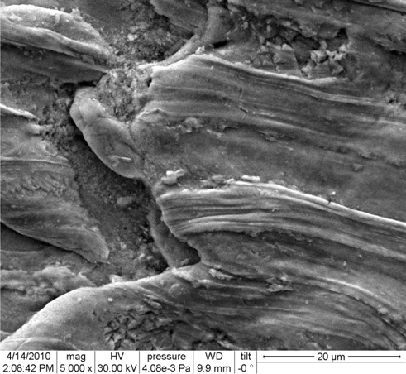 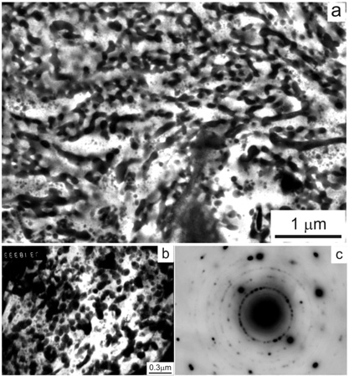

Fig. 2. Longitudinal section of a Cu–Ta interface in (Cp) copper-tantalum joint with copper etched away (SEM)

Fig. 3. Microstructure of the grey zone in (Cp) Cu–Ta interface:

(a) (SEM); (b) bright-field image (TEM), (c) microdiffraction pattern (TEM)

* 1. *(Ep) aluminum-tantalum joint (waveless interface)*

Explosive welding was carried out near lower limit of domain of weldability. The longitudinal section of the transition zone in (Ep) joint of aluminum-tantalum metals, possessing normal mutual solubility, is given in Fig. 4. Like in (Cp) joint, the transition zone is composed by randomly distributed regions of three types: aluminum, tantalum, and grey zone containing both of metals. In case of cusps appearing (such as a cone with the acute or planarized apex) the surface does not remain smooth (Fig. 5).

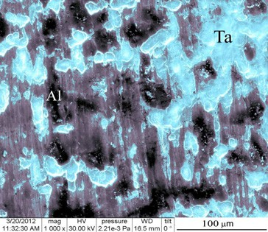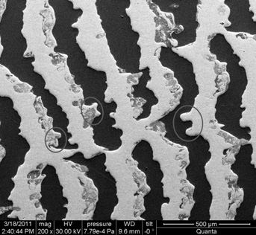

Fig. 4. Transition zone in (Ep) aluminum-tantalum joint (SEM): Al, Ta and mixture of Ta and Al

Fig. 5. The longitudinal section of interface in (Cw) copper-tantalum joint: bands of Cu and Ta, cusps and zones of local melting

* 1. *(Cw) copper-tantalum joint (wavy interface)*

The longitudinal section of the interface is given in Fig. 5. Wavy interface is corrugated, its longitudinal section exhibiting a set of alternating bands of copper and tantalum with parallel boundaries. At the interface, cusps are observed. The size of cusps is a few tens of microns. Large tantalum cusps depicted in Fig. 5 has a size of about 100 µm. One can clearly see many local melting zones having vortex structure. In both Cu-Ta joints, irrespective of the interface shape, the local melting zone is composed by colloidal solution.

The employment of different welding regimes for the same copper-tantalum pair was extremely useful. The interface has a different shape: waveless in one case, wavy in the other. But in both cases, the interface is not smooth, because it contains cusps and local melting zones.

1. Discussion

The granulating fragmentation (GF) in principle differs from well-known one, the existence of which is proved by many observations of material structure produced by severe plastic deformation. The traditional fragmentation includes dislocation and twin generation, formation of different structures, and recrystallization. Similar structures were observed in titanium-aluminide joints [6]. Taking into account the two types of fragmentation is the basis of new approach to welded joint structure describing. Both types of fragmentation occur at different distances from the interface. GF takes place near the interface, while traditional fragmentation proceeds a bit farther from the interface.

The fragmentation upon explosion welding is believed to be analogue to fragmentation upon explosion studied by Mott [7]. The flying away of particles is clearly visible in Fig. 6 and remarkably similar to flying away of fragments upon explosion, but of another scale. The flying away of fragments upon explosion occurs in open space, as opposed to flying away of particles upon explosion welding which occurs in close space between plates. In fact, GF corresponds to fragmentation and consolidation of particles. The micrographs illustrate the consequence of separation, consolidation and flying away processes are given in Figs. 6.

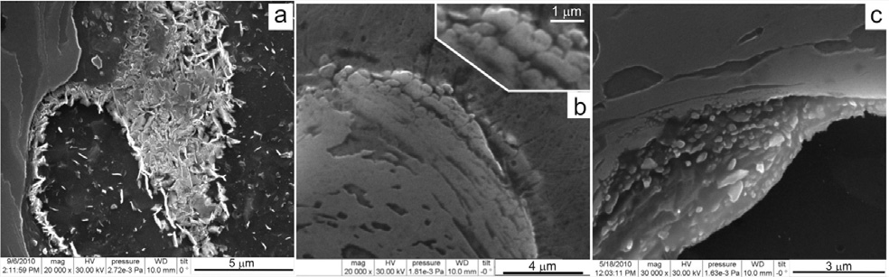

Fig. 6. Fragmentation of aluminide in (Aw) titanium-aluminide joint: (a) flying away of aluminide particles; (b) fragmented layer, (c) aluminide particles inside Ti band

We suppose that the GF has time to occur about of order of impact action time, i.e., GF is a much more rapid process than traditional fragmentation. The characteristic times could be evaluated as 1 microsecond for GF and 108–109 (time of structural relaxation) microseconds for the traditional fragmentation which takes place under residual stresses and temperatures. Fragmentation is apparently to be accompanied by high increasing of total surface area and due to this an intense discharging of input energy. Therefore GF is a powerful dissipative channel. Fragmentation is a process of material partitioning into weakly bonded

microvolumes and is opposite to fracture. GF improves the survivability of material and prevents it from failure even upon such a strong external action as explosion welding.

The chemical reactor vessel scheme is made of carbon steel-copper-tantalum composite material by means of explosion welding [8]. The inner shell consists of tantalum, corrosion resistance of which is the key moment of the reactor design. The outer shell consists of carbon steel. The direct welding of carbon steel and tantalum is difficult due to the brittle phase formation, and copper is used as a interlayer. As shown in [8], both of the interfaces have wavy shape. Welding parameters used in [8] somewhat differs from that used in current investigation for (Cw) joint obtaining.

The structural data presented above allow to formulate the probable reasons of good quality Cu-Ta joint formation. Firstly, wavy interface contains cusps and local melting zones. The interface inhomogeneities promote the adhesion of materials. Cusps act like “wedges” and bond contacting metals. Due to the fact, that initial metals possess no mutual solubility, the true solution and chemical compound obtaining, as a consequence, is not possible. Thus, the brittle intermetallic phase formation is avoided. Only the colloidal solution obtaining is possible, but the emulsion layering danger arises. On the basis of the results obtained it may be assumed that only copper melting occurs due to the fact that tantalum has a higher melting temperature (approximately 3300 K). Tantalum particles appeared as a result of granulating fragmentation form the dispersed phase in copper matrix melted in the beginning and then congealed. The danger of suspension layering does not exist, and local melting zones act like “inserts” contributing to joint strengthening.

Acknowledgements

Electron microscopic studies were performed at the Electron Microscopy Center of Collaborative Access, Ural Branch, Russian Academy of Sciences.

This work was financially supported by the Russian Foundation for Basic Research, project no. 10-02- 00354, projects 12-2-006-UT, 12-U-2-1011, 12-2-2-007 of the Ural Division of the Russian Academy of Sciences, and by the National Target Program of Ukraine "Nanotechnologies and Nanomaterials", no. 1.1.1.3_4/10_D.

References

1. Rybin VV, Greenberg BA, Antonova OV, Elkina OA, Ivanov MA, Inozemtsev AV, et al. Formation of vortices during Explosion Welding (Titanium–Orthorhombic Titanium Aluminide). Phys Met Metallogr 2009;108:353–64.
2. Rybin VV, Greenberg BA, Ivanov MA, Kuz'min SV, Lysak VI, Elkina OA, et al. Structure of the Welding Zone between Titanium and Orthorhombic Titanium Aluminide for Explosion Welding: I. Interface. Russian Metallurgy (Metally) 2011;10:1008–15.
3. Greenberg BA, Ivanov MA, Rybin VV, Kuz'min SV, Lysak VI, Elkina OA, et al. Structure of the Welding Zone between Titanium and Orthorhombic Titanium Aluminide for Explosion Welding: II. Local Melting Zones. Russian Metallurgy (Metally) 2011;10:1016–25.
4. Rybin VV, Greenberg BA, Ivanov MA, Patselov AM, Antonova OV, Elkina OA, et al. Nanostructure of Vortex During Explosion Welding. Journal of Nanoscience and Nanotechnology 2011;11:8885-95
5. Grinberg BA, Elkina OA, Antonova OV, Inozemtsev AV, Ivanov MA, Rybin VV, et al. Peculiarities of formation of structure in the transition zone of the Cu-Ta joint made by explosion welding. The Paton Welding Journal 2007;7:20-5.
6. Greenberg BA, Rybin VV, Antonova OV. Microstructure of bimetallic joint of titanium and orthorhombic titanium aluminide (explosion welding). In: monograph Severe Plastic Deformation: Toward Bulk

Production of Nanostructured Materials, New-York: Nova Science Publishers Inc.; 2005, p.533-544.

1. Grady D. Fragmentation of Rings and Shells. The Legacy of N.F. Mott. Berlin: Springer-Verlag; 2006.
2. Frey D, Banker J. Recent Successes in Tantalum Clad Pressure Vessel Manufacture: A New Generation of Tantalum Clad Vessels. In: Proceedings of Corrosion Solutions Conference. USA, Wah Chang. 2003, p.163- 169.