Available online at [www.sciencedirect.com](http://www.sciencedirect.com/)



AASRI Procedia 1 (2012) 207 – 212

AASRI

Procedia

[www.elsevier.com/locate/procedia](http://www.elsevier.com/locate/procedia)

2012 AASRI Conference on Computational Intelligence and Bioinformatics

# Thermal Analysis and Experimental Study on the Spindle of the High-Speed Machining Center

Changlong Zhaoa* ,Xuesong Guanb

*aCollege of Mechanical Engineering, Changchun University, Jilin, Changchun,China*

*bCollege of Mechanical Science and Engineering, Jilin University, Jilin, Changchun, China*

**Abstract**

By taking the spindle system of high speed and high precision machining center as the research object, the finite element method is used to make the thermal analysis and the thermal-structure coupling analysis. In this paper, the heat dissipating capability of cooling system of spindle system is simulated and the thermal deformation is predicted. The result of simulation can provide reference for the solid design of spindle system.

© 2012 Published by Elsevier B.V. Open access under [CC BY-NC-ND license.](http://creativecommons.org/licenses/by-nc-nd/3.0/)

Selection and/or peer review under responsibility of American Applied Science Research Institute

*Keyword*s: Spindle system, machining, finite element method, thermal analysis, thermal deformation.

## Introduction

With the development of manufacture technology towards high precision, high efficiency and high automation, the thermal deformation control of machine tool in process has become a key issue to ensure the precision of machine tool. The thermal deformation is the expansive deformation of the components of the machine tool caused by the heat which is produced by friction and movement in working process of machine tool, it is the mainly embodies of thermal deformation of the technology system.

*Changlong Zhao. Tel.:+86-13596107734.

*E-mail address:* [zhao19790204@126.com.](mailto:zhao19790204@126.com)

2212-6716 © 2012 Published by Elsevier Ltd. Open access under [CC BY-NC-ND license.](http://creativecommons.org/licenses/by-nc-nd/3.0/)

doi:10.1016/j.aasri.2012.06.032

The machine tool is affected by many kinds of heat sources in working process and the heat is transferred to the machine tool by different ways. In working process, the heat resources which affect the processing precision can be divided in two categories, the first is internal heat resources and the other is outside heat resources [1, 2]. The practice shows that the internal heat resources are the main reasons which cause the thermal deformation, which include cutting heat and the heat which is caused by internal friction.

In this paper, the designed spindle system of machining center mainly includes spindle, sleeve with cooling system, bearing and other accessories such as distance sleeve and so on, which is shown in Fig 1. The main heat source of spindle system is friction heat caused by spindle and bearing, the higher is the rotating speed of the spindle, the bigger is the thermal value and the heat dissipation mode is to bring the heat by coolant in the cooling system with convection heat transfer. The finite element method is used to simulate the bearing heating and the temperature distribution and result of thermal deformation is obtained by analyze steady state analysis, thus guides the design of spindle system.

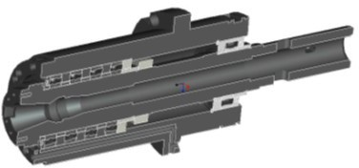 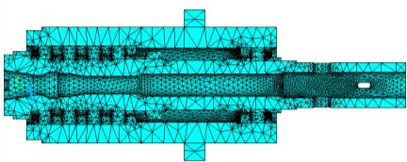

Fig.1 . Solid model of the spindle system Fig. 2. The finite element model of spindle system

## Finite Element Modelling and Analysis of The Spindle system

* 1. *Finite element modelling*

First, the solid model of spindle system is built by using Pro/E and the structure which has no effects on the analysis result such as thread hole, keyhole, chamfer, fillet and so on are simplified. Considering the high rotational speed of spindle, the ball in bearing can be replaced by a circular ring with constant cross section. Importing the simplified solid model to ANSYS, the Solid70 element of ANSYS and the free meshing method are adopted. The finite element model is shown as Fig 2.

* 1. *The thermal analysis of spindle system*

The emphases of thermal characteristic analysis using finite element method are the determination of heat source, heat transfer type and heat transfer coefficient. Because the motor of spindle of this machining center is far away from the spindle, the effect of motor heat on spindle can be ignored. The cutting heat is taken away by coolant and chip, the main heat source is the friction heat of bearing. The thermal transfer types needed to be considered are the forced convection heat transfer of coolant in sleeve and the forced convection heat transfer caused by the flow of the air around spindle. The thermal value of rolling bearing is calculated by the following equation:

*Q*  0.105  106 *M*  *v*

*Q* is the heat (KW), *M* is the friction torque (Nmm) and *n* is the speed (r/min). The friction torque is calculated by the following equation:

*(1)*

*M*  *M* 0  *M*1

*(2)*

*M0* (Nmm) is the friction torque which is related with lubrication, it is shown as follows:

*M*  *f*  ( *yn*)2/3 *d* 3

0 0 *m*

*M1* (Nmm) is the friction torque which is related with load, it is shown as follows:

*(3)*

*M*1 

*f*1  *p*1  *dm*

*(4)*

*dm* is the mean diameter, f0 is the lubrication factor of bearing, ** is the kinematical viscosity of lubrication,

*f1* is the load factor of bearing and *P1* (N) is the calculating load which can determinate the friction torque

The forced convection heat transfer is mainly considered heat transfer type in this paper. The law and effect of heat transfer of different flow pattern of fluid is different, the different empirical formulae are used to calculate the heat transfer coefficient. The Reynolds number (*Re*) is calculated to judge the flow pattern, then, the empirical formula is selected. *Re* is regarded as the criterion which can judge the fluid is laminar or turbulence, and it is dimensionless. *Re* of coolant in sleeve is calculated by as follows [3,4]:

*Re*  (*u*  *D*) / *v*

*(5)*

*D* is the size of geometric feature (m), *u* is the velocity of fluid (m/s), *v* is the kinematical viscosity (m2/s).

*Re* of air is calculated by the following equation:

*Re*  (**  *ds* 2 ) / *v*

*(6)*

** is the angular rate of the spindle (rad/s), *v* is the kinematical viscosity of air (m2/s)and *ds* is the equivalent diameter (m), which is shown as follows:

*ds*  (*d*1*l*1  *d*2*l*2  ⋯  *dnln* )*l* , *l*  *l*1  *l*2  ⋯  *ln*

*li* (*i=1, 2, …, n*) is the length according to different diameter *di* (*i=1, 2, …, n*).

*(7)*

In this spindle system, the coolant is water, the diameter of cooling hole is 8mm, the flow of coolant is 0.625l/min, the temperature is 25 centigrade and the speed of spindle is 8000r/min. The result of calculation is *Re* of coolant is 0.165×104 and *Re* of air is 2.92×105. *Re* of coolant and air are both more than the critical value of the steady state. According to literature [5,6], correlation equation for the forced convection heat transfer of steady state is shown as follows:

*Nu=C×Ren×P m (8)*

*r*

**  ( *Nu*  ** ) / *D*

*(9)*

*Nu* is the Nusselt number, *Pr* is the Prandtl number of fluid, *α* is the coefficient of convection heat transfer and *λ* is the thermal conductivity of fluid.

*Nu* of the coolant in sleeve is calculated by the following formula:

*Nu=0.023× Re0.8× P 0.4 (10)*

*r*

*Nu* of air is calculated by the following formula:

*Nu=0.133× Re2/3× P 1/3 (11)*

*r*

All the results are shown in Table 1.

Table 1. Results of calculation

Q of the front

bearing (W)

Q of the rear

bearing (W)

** of

coolant (W/m2.K)

** of air (W/m2.K)

results 2045.6 325.2 1401.2 186

The heat of bearing is used to treat the essential boundary in condition in the form of heat generation rate. The comparative analysis of spindle with cooling system and spindle without cooling system is made to ensure the designed spindle system satisfy the practical needs. At the room temperature, the temperature field distribution of spindle without coolant is shown in Fig. 3. The highest temperature appears at the front bearing end, because the front bearing is angular contact ball bearing and the heat is bigger, the highest temperature is

29.84? and the biggest temperature rise is 4.84?.

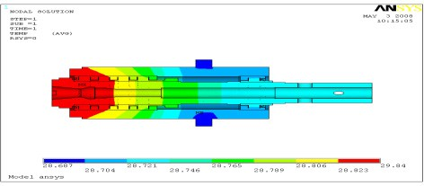 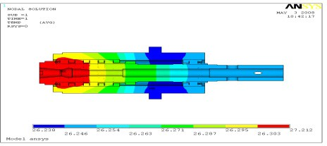

Fig. 3. Temperature field distribution of spindle system without coolant Fig. 10. Temperature field distribution of spindle system

with coola nt

Under the same condition, the temperature field distribution of spindle with coolant is shown in Fig. 4 and the temperature field slightly decreases comparing with the spindle system without coolant. The highest temperature is 27.212*?*, and the biggest temperature rise is 2.212? which is decreased by 2.628? comparing with the spindle system without coolant. The coolant has a good effect on heat dissipation of spindle system.

## Thermal-structure Coupling Analysis of The Spindle System

The above two temperature field distribution is regarded as load and the thermal-structure coupling analysis of spindle system is made. The nephogram of thermal deformation of spindle system without coolant is shown in Fig. 5-Fig. 7, the biggest deformation in radial direction is 0.0126mm and 0.0767 in axial direction, the synthetic deformation is 0.771mm. The nephogram of thermal deformation of spindle system with coolant is shown in Fig. 8-Fig. 10, the biggest deformation in radial direction is 0.00859mm and 0.0521mm in axial direction, the synthetic deformation is 0.0524mm. The deformation of spindle with coolant is smaller.

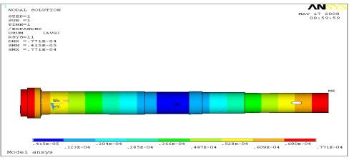 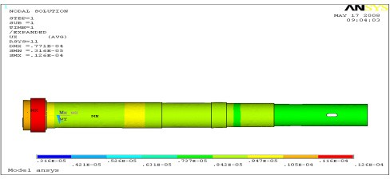

Fig. 5. Synthetic thermal deformation of spindle system without coolant Fig. 6. Radial thermal deformation of spindle system

without coolant

## Experimental Validation

The data acquisition experimental of temperature field and thermal deformation is carried to better understand the change of temperature field and the thermal deformation of spindle in practical situation and verify the reliability of analysis result. The spindle is free running on the rotational speed of 8000r/min and the sampling period is 5 minutes at room temperature. References are cited in the text just by square brackets [7].

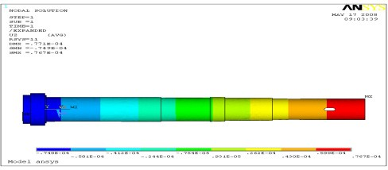 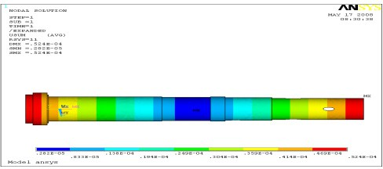

Fig. 7. Axial thermal deformation of spindle system without coolant Fig. 8. Synthetic thermal deformation of spindle system

with coolant

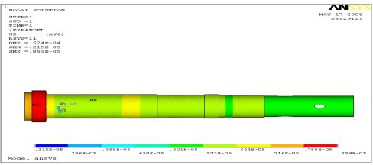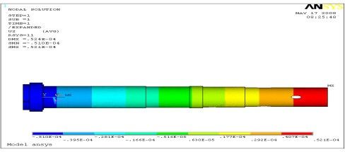

Fig. 9. Radial thermal deformation of spindle system with coolant Fig. 10. Axial thermal deformation of spindle system with

coolant

The measuring system is composed of 8 intelligent temperature sensors DS18B20, a development board based on 89C51 chip, serial port line and computer. The distribution of temperature sensors is shown in Fig.

11. Generally, the more the sensors, the more the measuring system could reflect an actual situation of temperature field. Considering the actual structure of the spindle of the machining center, the 8 sensors are installed on the spindle at equal distance. The first sensor is located at the front bearing and the last sensor is located at the rear bearing, the sensors can reflect the change of temperature of the whole spindle. The temperature data obtained by the sensor DS18B20 is transferred to computer real-time by the development board and serial port line and the data is stored in the computer to process the data later. The data acquisition interface is shown in Fig. 12.

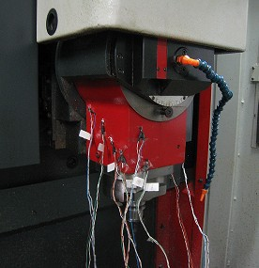 

Fig. 11. Example of a figure caption Fig. 12. Data acquisition interface

Every sensor selects 30 values of temperatures every 5 minutes. Then, the deformation in axial direction is measured. The biggest temperature rise appears around the front bearing which is proved to be the biggest heat source, as shown in Fig. 13. It is the same as the analysis result. In initial stage of experimental, temperature changes greatly, then the change of temperature becomes flat. The temperature of front bearing gets the highest temperature first and the farther from the heat source, the more slowly the temperature rises. The biggest error in axial direction is 0.0556mm, as shown in Fig 14, and the biggest error does not appear at the highest temperature but appears a period of time after reaching the highest temperature.

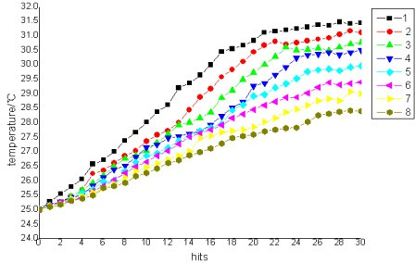 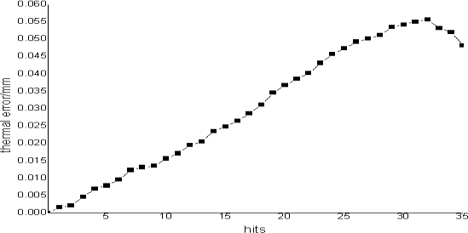

Fig. 13. Temperature of the spindle Fig. 14. Deformation of spindle in axial direction

## Conclusion

In this paper, a high speed and high precision machining center is taken as the research object. The finite element analysis method is adopted to make the thermal analysis and the distribution of temperature field and the thermal deformation are predicted effectively. In the experimental, the data of temperature field and axial error are captured according to the actual processing situation. The results prove the reliability of the finite element analysis which can provide reference for design of spindle system and thermal error compensation.

## Acknowledgements

Supported by Special feature of major national scientific(2009ZX04014-013-01).

## References

1. Z.H. Yan, J.Y.Yu. The survey of thermal deformation for machine tools. Nautral Science Journal of Jilin University of Technology 2002; 31 (3): 95–97.
2. C. Zhao. Neural network approach to identify thermal deformation of machining center. Proc. Int. IFIP WG5.3 Conf., Tokyo, Japan, 1992: 1–13.

[3]X. M. Zhang. Heat Transfer. Beijing: China building industry press 2001; 4(12): 146-151.

[4]S. S. Zhou, J. W. Fan. Research of FEM in the analysis of the thermal deformation on CNC machines. Microcomputer Information 2005; 21(8): 58-60.

[5]Zhang Minghua,Yuan Songmei. Research on Thermal Characteristics for High Speed Motorized Spindle Based on Finite Element Analysis. High Speed Machining Technology 2008; 29-31. [6]Niu.Shuangxia,Ho.S.L,Edd. Current Reduction in High-Speed Machines and Eddy Current Loss Analysis With Multislice Time-Stepping Finite-Element. IEEE Transactions on Magnetics 2012; 48(2):1007-1010. [7]Y. W. Hong. Modeling and Optimization of the Thermal Characteristic of Machine Tool Spindle System. Nanjing: Southeast Univeristy 2005;30-31.