Available online at [www.sciencedirect.com](http://www.sciencedirect.com/)



AASRI Procedia 2 (2012) 14 – 19

AASRI

Procedia

[www.elsevier.com/locate/procedia](http://www.elsevier.com/locate/procedia)

2012 AASRI Conference on Power and Energy Systems

# Thermal Bonds of Buildings Structures in Energy Conservation – A Case Study

Katarina Kosutova, Ondrej Sikula*, Josef Plasek

*Brno University of Technology, Faculty of Civil Engineering, Institute of Building Services, Veveri 331/95, Brno 602 00, Czech Republic*

Abstract

From energy point of view, very actual topic in Czech Republic is redevelopment of concrete constructions in buildings. The article describes theoretical and experimental evaluation of chosen thermal joints of particular building built from reinforced concrete skeleton. The building stands in the central Europe in Brno. Problematic joints of reinforced concrete construction with filling construction were identified using thermo-graphic method. Consequently method of numerical simulation of steady state of heat transfer in 2D was used in software CalA. The aim was to evaluate linear coefficient of heat transfer and to identify critically low temperatures on internal surfaces and the energy losses of chosen details.

© 2012 Published by Elsevier B.V. Selection and/or peer review under responsibility of American Applied Science Research Institute

© 2012 Published by Elsevier B.V. Selection and/or peer review under responsibility of American Applied Science Research Institute

© 2012 The Authors. Published by Elsevier B.V.

Selection and/or peer review under responsibility of American Applied Science Research Institute

Open access under [CC BY-NC-ND license.](http://creativecommons.org/licenses/by-nc-nd/3.0/)

Keywords: thermal bonds, thermo-graphic method, numerical simulations

1. Introduction

The article deals with theoretical and experimental evaluation of chosen thermal bonds of Primary school building in Brno - Nový Lískovec. Surface temperatures were found in two horizontal and two vertical sections. These values were consequently experimentally verified using numerical simulation in software

* Corresponding author. Tel.: +420 541 147 923; fax: +420 541 147 922.

*E-mail address*: [sikula.o@fce.vutbr.cz.](mailto:sikula.o@fce.vutbr.cz)

2212-6716 © 2012 Published by Elsevier B.V. Selection and/or peer review under responsibility of American Applied Science Research Institute

Open access under [CC BY-NC-ND license.](http://creativecommons.org/licenses/by-nc-nd/3.0/) doi:10.1016/j.aasri.2012.09.007

CalA. Results were processed in graph which shows temperature behavior in panel surface and it also shows problematic parts of construction.

Nomenclature

**

*U L*

thermal conductivity [W/(m·K)]

heat thermal transmittance coefficient [W/(m2·K)] linear thermal transmittance [W/(m·K)]

* 1. *Description of the object*

Chosen building of primary school with dimensions 12 x 48 m and height 10.8 m is situated in Brno – Nový Lískovec. It is complex of several building, for simulation was used only pavilion C. Load-bearing construction is reinforced concrete mounted skeleton for civic building (MS-OB). Axial distance of columns is 6 m and construction height is 3.6 m. Object is founded on prefabricated reinforced concrete pads and cased by peripheral panels. Partitions are made of hollow ceramic bricks. Window fillings are made of double wooden windows. There was not any major reconstruction of the building since 1989 when it was built. For details, see [1].

1. Thermo-graphic measurement

Thermo-graphic images were done in 12th December 2011 at 9:00 am using thermo-graphic camera Flir with resolution 320 x 240 pixels. Due to climatic data, temperature of external air was 5 °C, temperature of internal air was 18 °C. Surface temperature distribution on peripheral panel was in a range from 1.3 °C and

3.4 °C. Higher temperatures are in connection of two panels and lower temperatures are in the middle of panel.

(a) (b)

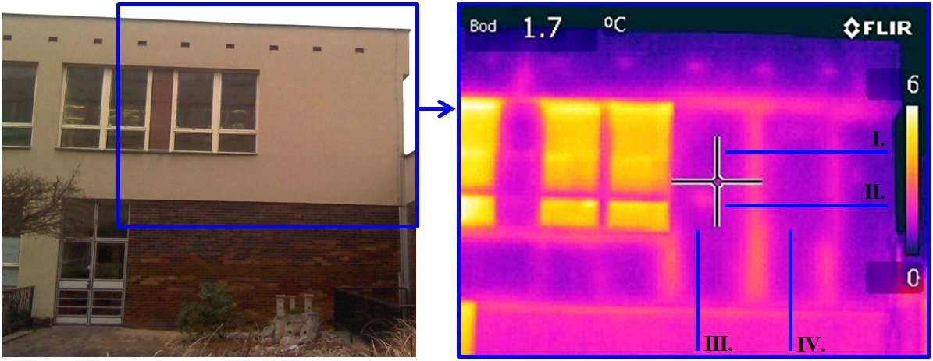

Fig. 1. (a) visible picture; (b) thermo-graphic picture

1. Numerical simulation in software CalA

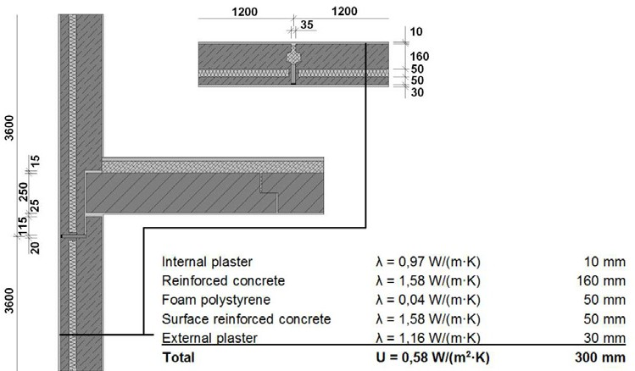Software CalA allows solving of 2D non-steady state of temperature field using method of control volumes. For details, see [2] and [3]. In this software, there was created computational geometry in vertical and also horizontal section. Result gives surface temperature distribution in peripheral panel, which allows comparison with thermo-graphic image. Obtained temperature field also allows evaluation of thermal bridges in peripheral prefabricated panel, mainly in a place of connection. By using thermal fluxes it is also possible to determine linear coefficient of thermal bridges.

Fig. 2. Layers in current prefabricated peripheral panel

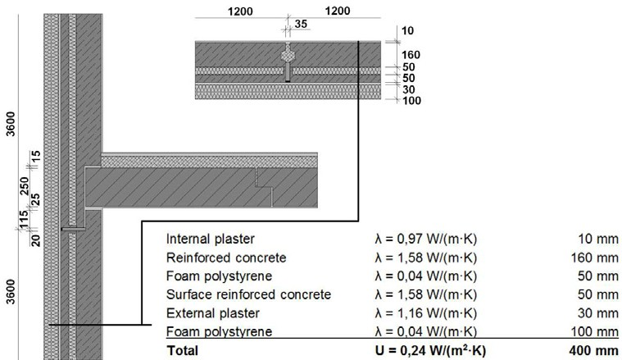Prefabricated peripheral panel of dimensions 3550 x 1170 x 260 mm is made of reinforced concrete load- bearing parts of thickness 160 mm, insulated by foam polystyrene 50 mm thick and provided by surface reinforced concrete layer of thickness 50 mm. Connection of peripheral panel on the height is done by vertical drain and in opposite direction connection is done by tooth. Contact joints are sealed by microspore rubber and imbedded by asphalt known as permanently flexible sealant. Computational geometry of prefabricated peripheral panel was made in squared computational web with dimensions 5 x 5 mm.

Fig. 3. Layers in redeveloped prefabricated peripheral panel

Geometry



Thermal field



Fig. 4. Current prefabricated peripheral panel - horizontal section

Geometry



Thermal field



Fig. 5. Redeveloped prefabricated peripheral panel - horizontal section

1. Comparison of thermo-graphic measurement with numerical simulation

In the following chapter there is a comparison of numerical simulation with thermo-graphic image. The figures below compare curves of surface temperature distribution on peripheral wall obtained from thermo- graphic camera and numerical simulation in software CalA.

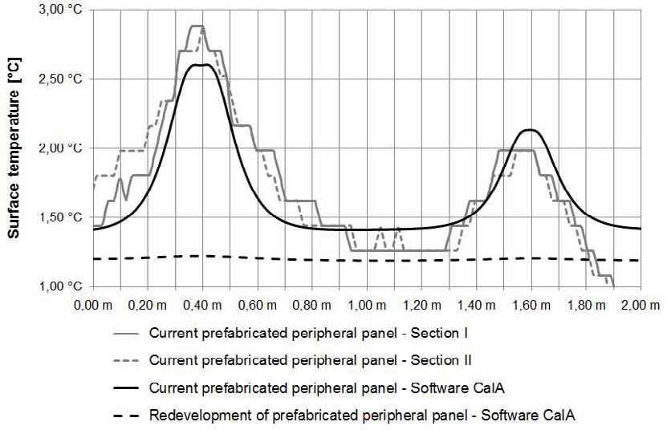

Fig. 6. Surface temperature distribution - horizontal section

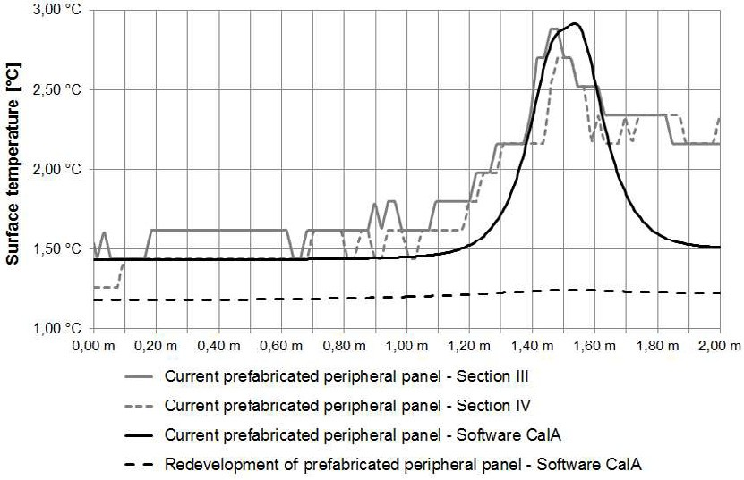

Fig. 7. Surface temperature distribution - vertical section

There is a good correspondence between experimental and numerical approach – see fig 6 and 7, except of the deviation in levels around 2.0 meters in vertical section – which is clear from the figure 7. This can be caused by geometrical imperfections on upper part of reinforced concrete panels.

1. Conclusion

Using experimental thermo-graphic measurement, strong thermal bridges were found in reinforced concrete skeleton MS-OB. The most problematic part of peripheral wall is horizontal and vertical connection of peripheral prefabricated panels. This panel connection was simulated in software CalA as steady two dimensional thermal field. Obtained surface temperatures were compared with surface temperatures from thermo-graphic measurement.

The results show that these thermal bridges are caused by construction joint, thus additional contact insulation of peripheral wall by foamed polystyrene with minimal thickness of 100 mm is designed. This arrangement meets the requirements of relevant standards [4] and sufficiently decreases heat losses by linear thermal transmittance *L* [W/(m·K)] and meets appropriate surface temperature at internal surface of the wall. The combination of used thermo-graphic and numerical method can be generally recommended for designing of reconstruction of similar building structures as [5].

Acknowledgements

This work has been supported from the state budget of the Czech Republic, through the Specific research at universities of the Ministry of education, youth and sports, the grant No. FAST-J-12-1781. This article originates also with the financial support of the European Union's "Operational Programme Research and Development for Innovations", No. CZ.1.05/2.1.00/03.0097, as an activity of the regional Centre AdMaS "Advanced Materials, Structures and Technologies".

References

1. KOŠÚTOVÁ K. Energy assessment of building for education: Diploma thesis, Brno 2011, 136 pages, Brno University of Technology, Faculty of Civil Engineering, Department of building services. Supervisor of the diploma thesis: Jiri Hirs.
2. ŠIKULA O. Manual of CalA, software, This edition Tribun EU s.r.o., 43 pages, Brno 2009, ISBN: 978- 80-7399-879- 0.
3. ŠIKULA, O.; PLÁŠEK, J.: CalA 3. 2 v 1024; Calculation Area (CalA) 3.2 v 1024. (authorized software). <http://www.fce.vutbr.cz/TZB/sikula.o/cala_uvod.html>
4. ČSN 73 0540-2 Thermal protection of buildings – part 2: Requirements, 35 pages, CNI Praha 2002 (Czech technical standard)
5. KALOUSEK, M. Thermal radiation inside the perforations of the lightweight insulating brick. ZI, Ziegelindustrie International/ Brick and Tile Industry International, 2002, roč. 2002, č. 3, s. 38-42. ISSN: 0341- 0552.