[Applied Computing and Informatics 15 (2019) 109–113](https://doi.org/10.1016/j.aci.2017.12.001)



Contents lists available at [ScienceDirect](http://www.sciencedirect.com/science/journal/22108327)

Applied Computing and Informatics

journal homepage: [www.sciencedirect.com](http://www.sciencedirect.com/)

Original Article

[](http://crossmark.crossref.org/dialog/?doi=10.1016/j.aci.2017.12.001&domain=pdf)Towards integration of remote sensing and GIS to manage primary health care centers

Ahmed Ibrahim Ramzi a,⇑, Magda Abdl-Latif El-Bedawi b

a *National Authority for Remote Sensing and Space Sciences, NARSS, Cairo, Egypt*

b *El-Salam Awel Medical Region, Ministry of Health and Population MOHP, Cairo, Egypt*

# a r t i c l e i n f o

*Article history:*

Received 21 August 2017

Revised 18 December 2017

Accepted 19 December 2017

Available online 20 December 2017

*Keywords:*

Primary health care centers Population

Remotely sensed data GIS1

# a b s t r a c t

The aim of this research is to study, monitor, mapping, planning, distribute and locate Government PHCCs in the selected study area. This information is to be held on a database. The paper also focuses on following-up supply and demand in PHCCs; managing various health care (HC) facilities in accordance to the criteria and standards of Ministry of Health and Population (MOHP) on the integration of remote sensing data and geographic information system GIS from geographic and HC view, for the best treatment service. El-Salam medical region, Cairo, Egypt has been selected as a study area to perform this research. It is a densely populated urban area. The proposed methodology involved many procedures, based on using satellite images, GIS, demographic, health data and field data. The obtained results showed that there was shortage in PHC centers in the selected study area. This shortage is more theoretical than prac- tical, as the research concluded that there are many other governorate and private health service, which should be studied in details.

© 2017 The Authors. Production and hosting by Elsevier B.V. on behalf of King Saud University. This is an

open access article under the CC BY-NC-ND license (<http://creativecommons.org/licenses/by-nc-nd/4.0/>).

1. Introduction

Health is a prerequisite for all mankind. Indeed, it is a critical component of individuals’ social needs. Equal access to primary healthcare services for low socioeconomic groups is an aim for governments to meet social justice policy agenda. In response to this policy agenda, governments’ investments give priority for monitoring and evaluating health care services (HCS) [1]. PHCCs are an approach to health beyond the traditional HC system that focuses on health equity-producing social policy (World Health Organization. Declaration of Alma-Ata, Adopted at the Interna- tional Conference on PHCCs [2]. A health system defined as a struc- tured group of resources, actors and institutions according to the financing, regulation and provision of health actions that provide HC to a given population. Health services in Egypt have a highly pluralistic HC, with many public and private providers.

* Corresponding author.

*E-mail address:* [dr.eng.ramzi@narss.sci.eg](mailto:dr.eng.ramzi@narss.sci.eg) (A. Ibrahim Ramzi).

Peer review under responsibility of King Saud University.

**Production and hosting by Elsevier**

The Egyptian HC faces multiple challenges in improving and ensuring the health and wellbeing of the Egyptian citizens. The growth of population with a longer life expectancy leads to the population pressure on the health system. Lack of full knowledge and awareness of duties and responsibilities leads to a feeling of frustration and aggression or oppositely reluctance towards what- ever the individual is performing. The PHC system main aims are to optimize the health status of an entire population throughout the life cycle.

Primary care concentrated on the patient and considers all determinants of health. Primary care addresses most important issues in the community by providing preventive, curative and rehabilitative services. In Egypt, PHC centers are considered one of the vital support systems for effective high-quality health ser- vices [3].

The collection of information and the necessary data about PHC centers is to in hence the HC and to provide a plan for monitoring the change. PHCS constructed as needed without sustainable development plans using the traditional methods. Usually, the locations of the PHC centers selected on the available location of the state lands does not take into consideration the raped growth of urban areas and population. Within the health sector, the PHCCs have been an area of researches.

This includes: what PHC services should be offered, how PHC can linked via referral mechanisms to other levels of care and a

<https://doi.org/10.1016/j.aci.2017.12.001>

2210-8327/© 2017 The Authors. Production and hosting by Elsevier B.V. on behalf of King Saud University.

This is an open access article under the CC BY-NC-ND license (<http://creativecommons.org/licenses/by-nc-nd/4.0/>).

vision of health in its social context [4]. The World Health Organi- zation (WHO) is a specialized agency of the United Nations (UN) that is concerned with international public health. It was estab- lished on 7 April 1948 in Geneva, Switzerland. WHO is a member of the UN development group? Declaration of the international conference on PHCCs meeting in Aima-Ata on 13/9/1978 express- ing the need for urgent action by all governments n, all health and developments workers, and the world community to project and promote the health of the of all the people of the world [5]. PHCCs includes all services such as income, housing, education, and environment.

Primary care is the element within PHCCs that focuses on HCS, including health promotion, illness and injury prevention, and the diagnosis and treatment of illness and injury, advocacy and com- munity development. International standards and guidelines are used to check HCS are based on two points which are; a PHCCs unit should serve a certain number of persons and a PHC should cover an area of a certain radius. The MOHP in Egypt considers the inter- national guidelines within the international standards.

In PHC centers there is a need of many continuing medical edu- cation, local and international manuals, workshops, and seminars on how to make use of these guidelines would improve doctors’ performance [6]. In Egypt the period from 2006 to 2011 has been accredited PHC centers at 2006 PHC centers was 837 unit and at 2011 was 2159 unit [7]. Fig. 1 shows accredited PHC centers From (2006–2011). A study has been performed to evaluate the perfor- mance of PHCCs in Nigeria and also to highlight the management to draw lessons for other actors in the health sector [8].

The PHCCs Program in USA, the Texas Department of State Health serves women, children, and men whose income is at or below 200% of the Federal Poverty Level (FPL) and who are unable to access the same care through insurance or other programs [9]. In Malaysia, they control, monitor and systematically plan the rapid development of the town due to the increase in the population and economic growth to face the uncontrolled planning process. The findings showed the implementation of GIS in town planning can improve the result based on quality of town planning process for saving time and costs and data can be obtained faster [10]. Many researchers concluded that the use of electronic medical records was functionally aiming to ensure the applicability and convenience of the medical record and optimizing HCS introduced to our patients [11,12].

Since the successful launch of satellites with very high resolu- tion sensors such as IKONOS-II with 1 m resolution and QuickBird with 0.61 m resolution, many researchers have considered them as possible substitutes of the traditional airborne aerial photos used for producing large scale maps and in many applications [13–15]. Also, the increase in the availability of GIS in governmental health

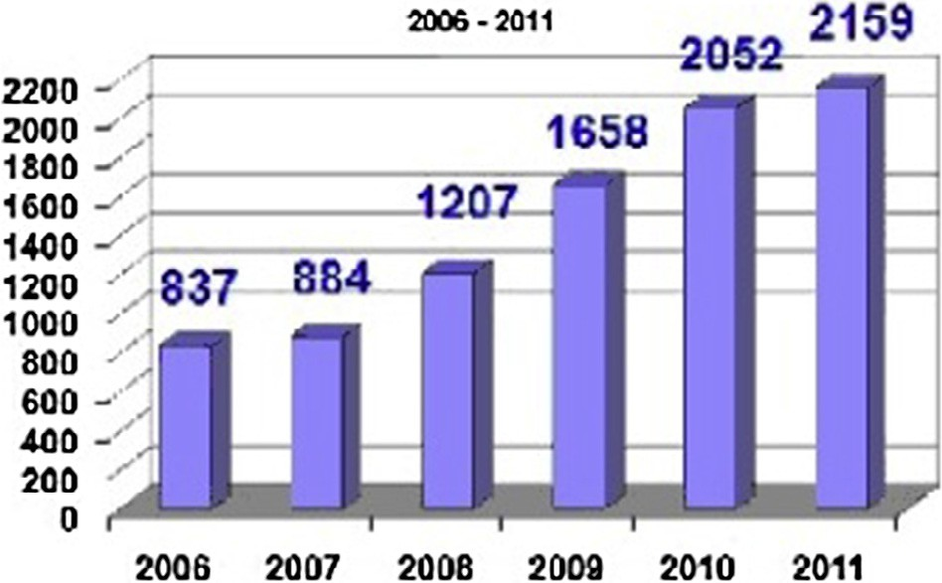

Fig. 1. Accredited PHC centers From (2006–2011).

organizations, together with the proliferation of spatially disaggre- gate data led to a number of researches focused on developing measures of access to HCS [16]. This research is carried out towards integration of remote sensing and GIS to manage PHCCs and health planners and decision makers can use continues advanced remote sensing to manage various HC facilities in all fields of knowledge.

The main objectives of this research is to present a methodology to analysis the information from different sources as application to a particular case applied on El-Salam Awel Medical Region, Cairo, Egypt. To manage, evaluate, study, calculate served/un-served cit- izens and area supply/demand of PHC centers, analysis the geo- graphic distribution and locations of governmental PHCCs and for the purpose of improving the health services.

1. Guidelines and standards of PHC centers

The MOHP in Egypt considers the international guidelines within the international standards. A PHC unit in Egypt should serve 20,000 persons and area of 2.5 km radius [3]. Also, According to the rules of Egyptian MOHP: (1) the area of PHC unit should not be more than 1200 square meters. (2) The construction of PHCCs must be on land owned by the state or an area of ??land donated by the citizens. This donation must accepted by the officials of the MOHP. As example, in Emirate of Dubai, one health center or clinic served 30,000 individuals [17].

1. Levels of health in Egypt

Levels of Health Care in Egypt [18,19]:

* 1. PHC
     + The ‘‘first” level of contact between the individual and the health system.
     + Essential health care PHC is provided.
     + A majority of prevailing health problems can be satisfacto- rily managed.
     + The closest to the people.
     + Provided by the PHCCs.
  2. Secondary health care
     + More complex problems are dealt with.
     + Comprises curative services
     + Provided by the district hospitals
     + The 1st referral level
  3. Tertiary health care
     + Offers super-specialist care
     + Provided by regional/central level institution.
     + Provide training programs.

1. Study area

The study was conducted in 8 PHCCs related to El-Salam med- ical Region, MOHP, Cairo Governorate.

These 8 PHCCs are located in El-Salam El-Shakia, El-Salam El- Gharbia, Barket El-Nasr El-Shakia and Barket El-Nasr El-Gharbia according to the administration border. 8 PHC centers named; El- Salam Awel, El-Salam Than, El-Delta, El–Abd, El-Sad El-Ali, El–Hir- afeen, El-Toriki and Sder El-Salam. Also, El-Salam hospital located in the same selected study area as a high level of health service. El-Salam Awel medical region located in the study area, it controls all of the activities of the PHC centers either medical or non- medical. It is characterized with densely urban and populated area, low level income and considered as sprawl area. Fig. 2 shows loca- tion map of the study area.

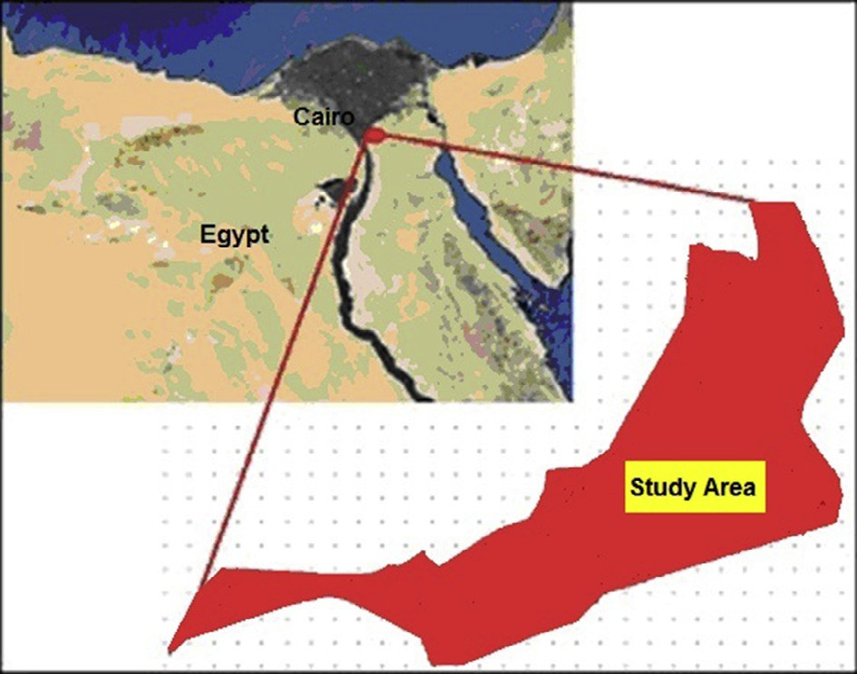

Fig. 2. Location map of the study area.

1. Data collection

The following data have been collected: Administration borders according to central agency for public mobilization and statistics CAPMS [20]; Satellite data: Very high resolution satellite Dubi- sat2 image; Ground Control Points GCPs and check points CPs has been collected using GPS; Clinic data: from records and field; finally Demographic or population data: from census and from local records [21].

Table 1 shows administration borders and census data (popula- tion), El-Shiakha of Qism El-Salam at 2006.

1. Methodology

The proposed methodology at beginning stage is based on sim- plicity and to be applicable to serve the different health fields. In the upcoming stages, the method will rely on advanced techniques in remote sensing science, computer science and population pre- diction will based on different models such as exponential models and census data. The following steps have been proposed: Data col- lection (satellite images, maps, administration borders) covering the study area; Acquisition of GCPs, CPs and location of PHC using Handheld GPS from field; Pre-processing of satellite images; Regis- tration satellite image; Accuracy assessment of rectified satellite image registration based on RMS; Image subset; Database design of PHC centers should includes types of clinics, labs, staff, medical facilities and others; Distribution and locations of government PHCCs. Producing vectors layers; Projecting of population to 2015; Calculating supply of PHC centers; Applying international and Egypt guidelines of PHC centers; Calculating demand of PHC centers and served/un-served citizens and area; And evaluate the results.

Table 1

Administration borders and census data (population), El-Shiakha of Qism El-Salam at 2006. Sources: Central Agency for Public Mobilization and Statistics administration border CAMPS [20,21].

|  |  |  |  |
| --- | --- | --- | --- |
| S. No. | El-Shiyakha | Area (km2) | Population 2006 |
| 1 | El-Salam El-Shakia | 6.632 | 125,001 |
| 2 | El-Salam El-Gharbia | 4.217 | 74,462 |
| 3 | Barket El-Nasr El-Shakia | 8.465 | 69,857 |
| 4 | Barket El-Nasr El-Gharbia | 3.991 | 171,124 |
| 6 | Total | 23.305 | 440,444 |

1. Results

Proposed methodology applied step by step. Pre-processing of satellite images carried out to overcome the distortions due to the earth curvature, relief displacement and the acquisition geom- etry of the satellites (i.e. variations in altitude, aspect, velocity, panoramic distortion). Well defined GCPs has been collected from GPS measurements to register the QuickBird image using second order polynomial function. Accuracy assessment of the produced geo-images has been done based on the total RMS on easting and northing. The results showed that the produced rectified image meet map scale 1:5000.

Based on clinic data: from rectified image, records and field. PHC centers provide medical examination and treatment services at different clinics for a nominal fees of one Egyptian pound and free fees for vaccination. Generally PHCC clinics includes Internal medicine; Gynecology; Ante natal care; Pediatrics; Dental; Vacci- nation; Emergency; Delivery; Family planning; Laboratory and Pharmacy. PHC Sader El-Salam center provide only chest clinic, X-ray and treatment.

Vector map has been produced Administration border of the study area and geographical distribution of PHC centers (Fig. 3).

The results showed that good geographical distribution of 4 PHC centers (El-Salam Awel, El-Salam Than, El- Sad Ali and El –Hir- afeen) relative to each others over the study area. Also, the results showed bad geographical distribution of 4 PHC centers (Sader El Salam, El Delta, El–Abd and El-Toriki|) where the distance between PHC Sader El Salam and PHC El Delta is 165 m and the distance between PHC El–Abd and PHC El-Toriki is 228 m. Main concept of PHCC is easy accessibility of patients to them by walking. The accessibility of the different PHC centers mainly depends on the location of the center relative to the home of the patient and pov- erty level. The poverty line is defined as the minimum income deemed adequate for an individual to meet his basic needs. According to CAPMAS 27.8 percent of Egyptian population lives below poverty line. The CAPMAS survey pointed out that the urban population poverty line in Cairo differs from one area to another depending on the prices of apartments and living in each area. Urban areas in Cairo witnessed increased levels of inequality and poverty during the last two years.

Most of PHCC are located in main road where there was public transportation. The road network in El-Salam urban area consists of two types of roads paved and unpaved roads. Paved roads are designed to carry buses and cars. Unpaved roads are narrow roads used by citizens to access to their apartments. Access to any health center will be through various ways such as walking, public trans- portation, Taxi and private cars to the nearest point to the location of the center. Public transportation move only in main road.

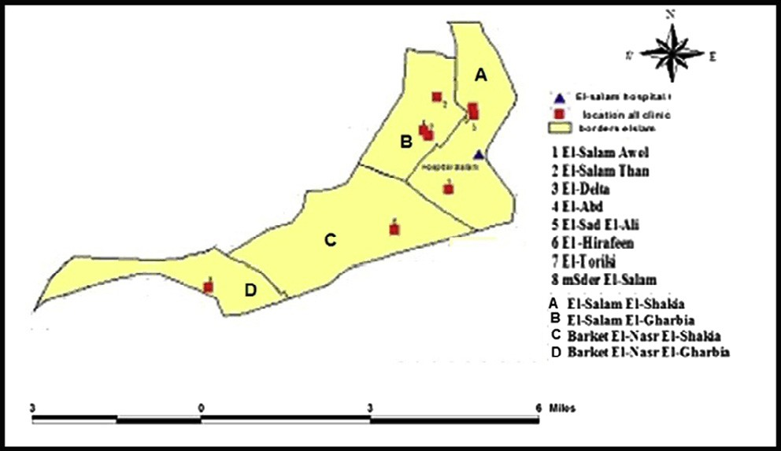

Fig. 3. Vector map: Administration border of the study area and geographical distribution of PHC centers.

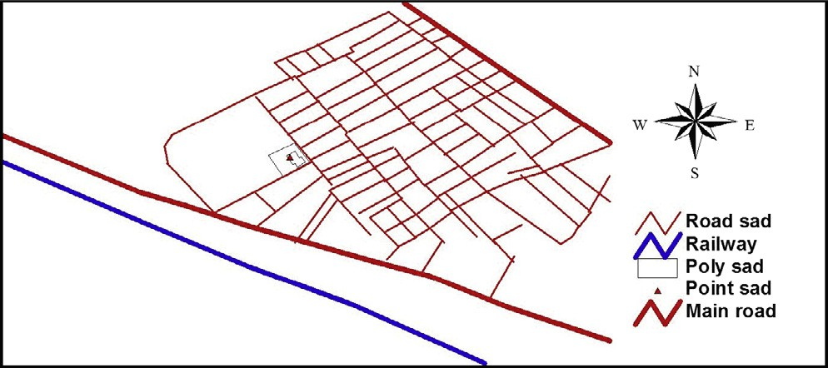

Fig. 4. Example of enlarged road network - PHC Sad Ali extracted from rectified image.

Easy accessibility of patients to all PHCC location by walking or by public transportation to the nearest bus station unless: PHCC El–Hirafeen is located in densely industrial area and unpaved road faraway from public transportation; PHCC El-Sad Ali and El-Toriki were located in unpaved road faraway from public transportation. To access to these centers is by walking, Taxi, mini- three wheel motor car (Toktok) or private car. Toktok move in narrow roads for 5 Egyptian pounds. PHCC El-Sad Ali has been taken as example to explain access to it. There is a Railway considers as an obstacles for patients to move from side to another side where PHCC El-Sad Ali exists. Fig. 4 shows example of enlarged road network - PHC Sad Ali extracted from rectified image.

Database has been designed, it included attribute data of PHC center such as Name, area, address, telephone, date of construction, different type of clinics, were maintained in different fields. Administration borders and serviced area by each PHC center are represented with the polygon. Also, location of PHC center has been presented by point data type in the database (Table 2).

Population has been projected from 2006 to 2015 based on cen- sus data using average growth rate of population per year. Popula- tion at 2006 was 440,444 Capita and average growth rate/year was 2% in Cairo governorate according to the Central Agency for Public Mobilization and Statistics [21]. Hence, predicted population 2015 was 519,723 Capita.

Demand of PHCCs has been calculated based on guidelines and standards of Egyptian MOHP. There were two criteria: (1) PHC cen- ter should serve 20,000 Capita: Results showed that total number of un-serviced population 359,723 Capita, so required number of PHC = 18 centers to achieve criteria number 1. (2) Area covered by circle 2.5 km radius (Fig. 5): Results showed that according to criteria 2 required number of PHC = 2 centers. Hence, there is not deficit in the number of health centers. The final conclusions the deficit on PHC centers is mainly related to total number of population.

Fig. 5. overlay circle with 2.5 km for each PHC centers over administration border.

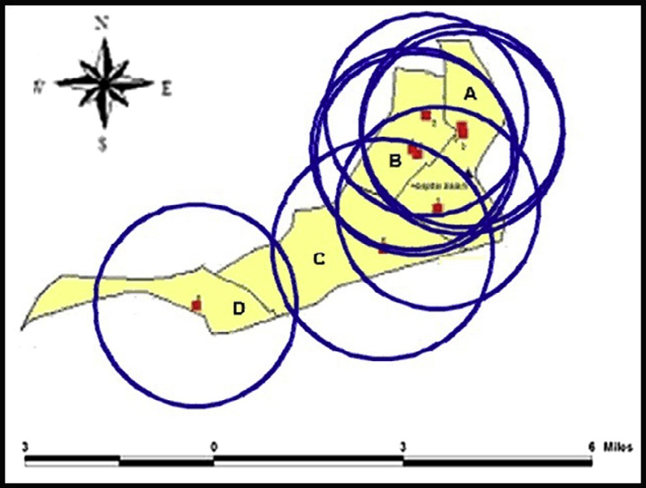The total area of the selected study area is approximately ser- viced. At year 2015 theoretically un-serviced population = 359,72 3 Capita, which represent 81.7% of the total number of population. Hence, the required numbers of PHC centers to cover the shortage are 18 centers according to the criteria of Egyptian MOHP.

To construct a new PHCC the situation has been studied and reported that there is no piece of land in the range of area = 120 0 m2 that belongs to the state inside the study area. So, the solution is searching for donators to solve the problem or re-plan and re- allocation of state lands. The shortage in the number of PHCC is more theoretical than practical due to the study explored that there are many other governorate and private health services. The Governorate health services such as public hospital and heath insurance clinics. Private health services such as private hospitals and private clinics.

The directors of the centers, there is a pressure from the audi- tors on the centers that can be avoided by developing the centers, especially by increasing the number of clinics and by working extra hours or two shifts. MOHP needs further steps in planning for new PHC facilities considering changes in the MOHP guidelines and uses development in knowledge and sciences when planning upcoming PHC centers.

Many researchers concluded that the use of electronic medical records was functionally aiming to ensure the applicability and convenience of the medical record and optimizing HCS introduced to our patients such as in Dubai [16]. PHCCs could be very different depending on the organization of the system. All mentioned solu- tion should be taken into consideration and studied in details in the next researches.

Table 2

Easting and northing, area, constriction date, telephone No. and address of PHC centers - El-Salam Awel region.

|  |  |  |  |  |  |
| --- | --- | --- | --- | --- | --- |
| S.N. PHCC | Easting E (m) | Northing N (m) | Area (m2) | Constriction date (year) | Telephone No. and Address |
| 1 El-Salam Awel | 347,199 | 3,337,265 | 4000 | 1981 | 22806046, Masaken Atlas 1 |
| 2 El-Salam Than | 346,977 | 3,339,657 | 5000 | 1989 | 22806990, Masaken El-Abd El-Kadim |
| 3 El-Delta | 347,721 | 3,339,126 | 5050 | 1995 | 22814457, Masaken El-Delta |
| 4 El-Abd | 346,676 | 3,338,829 | 5000 | 1995 | 22786804, Masaken El-Abd El-Gedid |
| 5 El-Sad Ali | 341,837 | 3,334,901 | 1600 | 1999 | 22962234, Segal comany |
| 6 El- Hirafeen | 345,985 | 3,336,287 | 1200 | 1989 | 26971968, El-Herfiin city |
| 7 El-Toriki | 346,734 | 3,338,637 | 600 | 1997 | 22787752, Masaken El-Kahera |
| 8 Sader El-Salam | 347,774 | 3,339,362 | 600 | 2005 | 26266903m, Masaken Askendria |
| 9 El-Salam Hospital | 347,888 | 3,338,188 | 7000 | 1980 | El-Salam |
| 10 El-Salam Awel Medical Region | 347,278 | 3,337,717 | 450 | 1981 | 22803076, Masaken El-Niel 1 |

1. Conclusions

Traditional method is not capable dynamically to mange PHC centers and it is costly and time consuming. The obtained result showed that health planners and decision makers can use contin- ues advanced fields of knowledge’s such as remote sensing, GIS and computer science in studying, monitoring, mapping, planning, following-up supply and demand in PHCCs to manage various HC facilities according to the criteria and standards of MOHP of Egypt. The study found that the population is considered as the active cri- teria due to the high population growth. Theoretically, the PHC centers cover the serviced area but it doesn’t cover the serviced population according to the criteria of Egyptian MOHP. Moreover, the study explored that there are many other governmental and private health services that were used by some patients instead of PHC centers. So, this point should be taken into consideration in the next study.

Acknowledgement

The Authors gratefully thanks and acknowledge the Reviewers of the manuscripts for their valuable comments.

References

1. A. Ahmed, A. Mohamad, GIS for health services, J. Eng. Sci. 41(2) (2013) (Assiut University, Faculty of Engineering).
2. World Health Organization, Declaration of Alma-Ata. Adopted at the International Conference on Primary Alma-Ata, USSR, 6–12 September 1978.
3. Y.A. Nagwa, A. Soha, A.Z. Ashraf, HC providers’ views on supervisory visits in family health centers and units in Alexandria, Egypt, Egypt Pubic Health Assoc. 85(3 & 4) (2010).
4. Final Report May 1999, The Integration of PHCCs Services: A systematic literature review, Commissioned and Published by the Health Systems Trust Health, [http://www.hst.org.za](http://www.hst.org.za/)
5. Report of the international conference on primary HC Alma-Ata, USSSR, 6-12 September 1978.
6. Omaima Hussein, Egyptian Accreditation Program, 1997.
7. [D.O. Adeyemo, Local Government and HC delivery in Nigeria: a case study, J.](http://refhub.elsevier.com/S2210-8327(17)30246-6/h0035) [Human Ecol. 2 (2005) 149–160](http://refhub.elsevier.com/S2210-8327(17)30246-6/h0035).
8. Texas Department of State Health Services-<https://www.dshs.state.tx.us/phc/>
9. [H. Selamat, A. Selamat, S. Othman, N. Shamsuddin, N. Zukepli5, A review on](http://refhub.elsevier.com/S2210-8327(17)30246-6/h0045) [Geographical Information System (GIS) in town planning: Malaysia](http://refhub.elsevier.com/S2210-8327(17)30246-6/h0045) [Experience, Geoinformatica: Int. J. (GIIJ) 2 (2) (2012)](http://refhub.elsevier.com/S2210-8327(17)30246-6/h0045).
10. M.A. Samir, S.A. Magdy, M.E. Nasreldin, Designing and Implementing of Electronic Health Record System in KSA using SQL & ASP.NET Weber Mathematics & Computer Science 1-1 (2015).
11. [I. Mona, M. Arwa, M. Nesreen, Designing a comprehensive Medical Electronic](http://refhub.elsevier.com/S2210-8327(17)30246-6/h0055) [Database for Cairo University Hospitals: phase I, J. Health Inform. Develop.](http://refhub.elsevier.com/S2210-8327(17)30246-6/h0055) [Countries 7 (1) (2013)](http://refhub.elsevier.com/S2210-8327(17)30246-6/h0055).
12. A.A. Mostafa, A.S. Laila, M.A. Sameh, R. Mohamed, Knowledge and practice of PHC physicians toward the detection and management of hypertension and other CVD risk factors in Egypt, Int. J. Hypertension 2011 (2011), [https://doi.](https://doi.org/10.4061/2011/983869) [org/10.4061/2011/983869](https://doi.org/10.4061/2011/983869) 983869.
13. [S. Kay, P. Spruyt, K. Alexandrou, Geometric quality assessment of](http://refhub.elsevier.com/S2210-8327(17)30246-6/h0065) [orthorectified VHR space image data, Photogramm. Eng. Remote Sensing 69](http://refhub.elsevier.com/S2210-8327(17)30246-6/h0065)

[(5) (2003) 484–491](http://refhub.elsevier.com/S2210-8327(17)30246-6/h0065).

1. L.K. Mohamed, Geometric quality assessment of various sensor modeling techniques, M.Sc. Thesis, Faculty of Engineering, Cairo University, 2006.
2. [S.M. Mahmoud, 2004 Updating Maps using High Resolution Satellite Imagery](http://refhub.elsevier.com/S2210-8327(17)30246-6/h0075) [as an Alternative to Traditional Techniques,](http://refhub.elsevier.com/S2210-8327(17)30246-6/h0075) [Zagazig University Faculty of](http://refhub.elsevier.com/S2210-8327(17)30246-6/h0075) [Engineering, 2004](http://refhub.elsevier.com/S2210-8327(17)30246-6/h0075).
3. Website of Emirate of Dubai, One Health Centre or Clinic Served 30,000 Individuals [https://www.dha.gov.ae/EN/Facilities/HealthCenters/Pages/](https://www.dha.gov.ae/EN/Facilities/HealthCenters/Pages/default.aspx) [default.aspx](https://www.dha.gov.ae/EN/Facilities/HealthCenters/Pages/default.aspx)
4. [G. Higgs, A literature review use of GIS-based measures of access to health care](http://refhub.elsevier.com/S2210-8327(17)30246-6/h0085) [services, Health Services Outcomes Res. Methodol. 5 (2004) 119–139](http://refhub.elsevier.com/S2210-8327(17)30246-6/h0085).
5. Ministry of Health and Population MOHP, Cairo, Egypt-Book 2001.
6. Ministry of Health and Population MOHP, Cairo, Egypt-PHC Book 1999.
7. Central Agency for Public Mobilization and Statistics CAPMS, Administration Border book, 2012.
8. Central Agency for Public Mobilization and Statistics CAPMS, (Statistical year book, 2006).