

Electronic Notes in Theoretical Computer Science

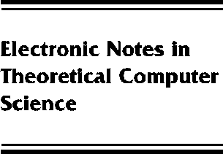[www.elsevier.com/locate/entcs](http://www.elsevier.com/locate/entcs)

A Space Semantics for Core Haskell

BakewellAdam and RuncimanColin

**Abstract**

Haskell currently lacks a standard operational semantics. We argue that such a semantics should be provided to enable reasoning about operational properties of programs, to ensure that im- plementations guarantee certain space and time behaviour and to help determine the source of space faults. We present a small-step deterministic semantics for the sequential evaluation of Core Haskell programs and show that it is an accurate model of asymptotic space and time usage. The semantics is a formalisation of a graphical notation so it provides a useful mental model as well as a precise mathematical notation. We discuss its implications for education, programming and implementation. The basic semantics is extended with a monadic IO mechanism so that all the space under the control of an implementation is included.

1571-0661 *⃝*c Elsevier B.V. Open access under [CC BY NC ND license.](http://creativecommons.org/licenses/by-nc-nd/3.0/)

10.1016/S1571-0661(05)80543-2