[Engineering Science and Technology, an International Journal 44 (2023) 101453](https://doi.org/10.1016/j.jestch.2023.101453)



Contents lists available at [ScienceDirect](http://www.sciencedirect.com/science/journal/22150986)

Engineering Science and Technology, an International Journal

journal homepage: [www.elsevier.com/locate/jestch](http://www.elsevier.com/locate/jestch)

[](http://crossmark.crossref.org/dialog/?doi=10.1016/j.jestch.2023.101453&domain=pdf)A binary chaotic horse herd optimization algorithm for feature selection

Esin Ays e Zaimog˘lu a,⇑, Nilüfer Yurtay a, Hüseyin Demirci a, Yüksel Yurtay a

a *Computer and Information Sciences, Sakarya University, Sakarya 54187, Turkey*

a r t i c l e i n f o

*Article history:*

Received 9 December 2022

Revised 26 April 2023

Accepted 26 May 2023

Available online 12 June 2023

*Keywords:*

Horse herd optimization Feature selection Metaheuristic algorithm Machine learning Artificial intelligence Classification

Chaos map

a b s t r a c t

One of the most challenging and common problems in machine learning is the Feature Selection (FS) pro- cess, which reduces the dataset size by finding optimal subsets of features. The Horse Herd Optimization Algorithm (HOA) is a new metaheuristic algorithm created by modeling the herd behavior of horses and developed for large scale optimization problems. This paper proposes the binary version of the HOA as a wrapper FS method to solve the FS problem. The proposed algorithm is a binary chaotic horse herd op- timization algorithm for feature selection (BCHOAFS). The proposed BCHOAFS is applied to select the op- timal feature combination that maximizes classification accuracy while minimizing the number of selected features. Classifier algorithms from machine learning algorithms were used to test the accuracy of the reduced subsets. The proposed method was named binary horse herd optimization for feature se- lection (BHOAFS) before adding chaotic maps; the k-nearest neighbor (k-NN) and Support Vector Machine (SVM) were tested as separate classifiers. It has been seen that k-NN classification accuracy gives better results than SVM. The BHOAFS-kNN method using the k-NN classification was combined with five chaotic maps and named as BCHOAFS-Logistics, BCHOAFS-Piecewise, BCHOAFS-Singer, BCHOAFS-Sinusoidal, BCHOAFS-Tent. The BCHOAFS versions were run on datasets consisting of 18 differ- ent sizes and quality datasets (i.e., low scale, medium scale, and large scale) taken from the UCI repository and compared with state-of-the-art algorithms in previous studies. The results prove that the proposed version, especially with the BCHOAFS-Piecewise and the BCHOAFS-Singer chaotic map outperforms or competes with well-known methods. The proof of the proposed approach’s statistical significance has been validated using the Friedman Signed Rank test and post hoc Wilcoxon test. The novelty of BCHOAFS is that HOA, which is an optimization algorithm specially designed for large scale data, is the first binary chaotic-based algorithm developed for feature selection problems. It also proposes a new lo- cal search strategy called Similarity Measurement Function (SMF). As a result, versions of the proposed algorithm BCHOAFS can be used for the FS problem.

© 2023 Karabuk University. Publishing services by Elsevier B.V. This is an open access article under the CC

BY license (<http://creativecommons.org/licenses/by/4.0/>).

1. Introduction

With the development of technology, a wide variety of real- world data has emerged in the fields of business, science, health, and engineering [1]. Information in growing raw data is unneces- sary unless patterns are extracted. Therefore, feature selection (FS) algorithms have advantages such as eliminating irrelevant, re- dundant, or noisy data, improving the learning algorithm’s perfor- mance, reducing the computational cost, providing a better understanding of datasets, and reducing the size of the data space requirements [2]. Classification accuracy is greatly affected by the quality of the input features used to construct a learned model. FS

* Corresponding author.

*E-mail addresses:* [esinzaimoglu@sakarya.edu.tr](mailto:esinzaimoglu@sakarya.edu.tr) (E.A. Zaimog˘ lu), [nyurtay@sakar-](mailto:nyurtay@sakarya.edu.tr) [ya.edu.tr](mailto:nyurtay@sakarya.edu.tr) (N. Yurtay), [huseyind@sakarya.edu.tr](mailto:huseyind@sakarya.edu.tr) (H. Demirci), [yyurtay@sakarya.edu.](mailto:yyurtay@sakarya.edu.tr) [tr](mailto:yyurtay@sakarya.edu.tr) (Y. Yurtay).

is an essential preprocessing task that aims to select the most ef- fective subset of features from the original dataset. Therefore, the FS methods are necessary to increase the classification accuracy and reduce the complexity of the constructed model.

FS algorithms have been used in many fields, such as face recog- nition [3], text classification [4], cancer and gene classification [5], text categorization, medical diagnostic decision support systems [6], and network intrusion detection systems [7]. They use random or heuristic search strategies to find the optimal subset of features, reducing the computational cost. FS methods are divided into three main groups, filter, wrapper, and embedded [8]. The filter approach selects attributes using statistical methods without using any learning method. The filter approach’s computational cost is low, but its performance is not at the desired level. There are many fil- tering methods, such as chi-square statistics, t statistics, informa- tion gain, minimum redundancy and maximum relevance, Relief, common information, and correlation scoring [9]. The wrapper ap-

<https://doi.org/10.1016/j.jestch.2023.101453>

2215-0986/© 2023 Karabuk University. Publishing services by Elsevier B.V.

This is an open access article under the CC BY license (<http://creativecommons.org/licenses/by/4.0/>).

proach selects the candidate feature set using a learning algorithm (classification, clustering, etc.) and operates on this set. Although the wrapper approach gives faster and better results than the filter approach, the computational costs are higher [10]. The wrapper- based techniques for classification algorithms have generally out- performed filter-based methods in literature [11]. The classifica- tion algorithms used in wrapper-based FS methods are Decision Trees, k-Nearest Neighbor (k-NN), ANN, and Support Vector Machi- nes (SVM) [12,13]. The third FS approach is hybrid algorithms. To reduce the feature size in hybrid algorithms, a filtering method is applied to the data first, then the most suitable subset is found with the help of a wrapper among the remaining features [14]. The hybrid approach handles the filter and wrapper models as two separate steps. Since the hybrid approach combines the two models, the accuracy may be low [15]. Searching for a solution in a search space is a Non-polynomial Hard (NP-Hard) problem. NP- Hard problems are accepted as multi-objective optimization prob- lems. In recent years, it has been seen that metaheuristic algo- rithms are used successfully in solving many complex optimization problems [16,17]. Also, solving the FS problem with metaheuristic methods has become a popular research topic with the improved computer performances and the emergence of newly developed metaheuristic algorithms. Therefore, research on apply- ing metaheuristic algorithms to the FS problem has increased con- siderably, including theoretical and practical studies [18]. Well- known metaheuristic algorithms commonly used in the FS prob- lem can be listed as Particle Swarm Optimization(PSO) [15], Genet- ic Algorithm (GA) [19], Gravitational Search Algorithm [20], Gray Wolf Optimizer (GWO) [21], Whale Optimization Algorithm (WOA) [22], Krill Herd Algorithm [23], Ant Colony Optimization Al- gorithm [24], Bat Algorithm [25], Grasshopper Algorithm [26], and Aquila Optimizer [27]. In addition to using well-known meta- heuristic optimization algorithms in the FS problem, new opti- mization algorithms proposed in recent years have also been applied. Some of these studies can be summarized as follows, Tu- bishat et al. [28,29] have used Salp Swarm Algorithm (SSA) for FS as a two-way search strategy, then improved with the Singer Chao- tic Map. The designed SSA showed a significant improvement over competing algorithms in statistical analysis. Sheth et al. [6] pro- posed a new multi-purpose FS method using the Jaya Optimization Algorithm for five datasets: lung cancer, breast cancer, diabetes, fertility, and immunotherapy. In another study, single and multi- objective versions of Artificial Butterfly Optimization were applied to the FS problem and tested with well-known algorithms [30]. In- tegrated Artificial Immune System and Artificial Bee Colony (ABC)- based breast cancer diagnosis (IAIS-ABC-CDS) has been proposed by Al- Turjman et al. for parallel processing of effective FS and pa- rameter optimization in ANN [31]. A binary version of the Social Spider Algorithm (BinSSA) with a cross operator (BinSSA-CR) has been proposed by Ülker et al. [32] and compared with a BinSSA without a cross operator. It was observed that BinSSA-CR gave bet- ter results than BinSSA. Two new FS approaches based on PSO with a crossover operator and a feature vector using the k-NN algorithm are proposed by Hichem et al. [33]. In a study proposed by Dasgup- ta et al. [34], classification problems were solved with Random For- est, k-NN, and SVM algorithms using the Penguin Search Optimization algorithm, which was inspired by the random forag- ing behavior of penguins. Performance of the two multi-objective ABC algorithms (Bin-MOABC and Num-MOABC) proposed by Han- cer et al. [35] have been compared with single-target ABC algo- rithms (ABC-ER and ABC-Fit2C), conventional algorithms, and multi-objective algorithms (i.e., NSGAII, NSSABC, and MOPSO). A deep learning-based approach has been used for FS that can be used in the early diagnosis of COVID-19 disease [36]. It has been proven that the proposed approach can assist professionals during COVID-19 diagnostic studies. The new optimization algorithms

proposed in recent years have produced remarkable results by us- ing them together with classical machine learning methods in the FS problem. A binary variant of the recently proposed Sailfish Op- timization called Binary Sailfish [37], and Spider Monkey Opti- mization algorithms have been used for FS and feature reduction problems [7]. The Adaptive Genetics Algorithm developed for the reduction of DNA microarray data used SVM and NB classifier for performance measurement [5]. A new Chaotic Dragonfly Algorithm was proposed, in which chaotic maps were applied to the search parameters of the Dragonfly Algorithm [38]. A wrapper-based bi- nary Sine–Cosine Algorithm has been proposed for FS named WBSCA [39]. In a study using a binary version of the recently re- leased Harris Hawk Optimization Algorithm, the k-NN method was used as a wrapper classifier to generate optimal feature sub- sets [40]. In a study published in 2021, the proposed Dispersed For- aging Slime Mould Algorithm(DFSMA), developed from the Slimy Mold Algorithm, a swarm-based stochastic algorithm, is intro- duced. The proposed algorithm is compared with eleven meta- heuristic algorithms, ten improved algorithms, and three different algorithms introduced recently. In addition, binary-DFSMA (BDFSMA) was obtained using the transform function, and the per- formance of BDFSMA was evaluated on 12 datasets in the UCI repository. Experimental results revealed that BDFSMA outper- forms the original SMA, improves classification accuracy, and re- duces the number of selected features compared to other optimization algorithms [41]. In another study designed based on the Forest Optimization Algorithm, two versions were developed for the FS algorithm using continuous and binary representations. According to the results, both proposed algorithms achieved the same performance as other multi-objective methods and showed even better performance than single-objective methods [42]. In a study published in 2022, a wrapper-based greedy crossover multi-objective Binary Bat Algorithm (BBA) is proposed to reset the sub-optimal solutions obtained due to early convergence. The selected features were evaluated using SVM with 10-fold cross- validation, with benchmark datasets available in the UCI reposito- ry[43].

Also, hybrid versions of metaheuristic algorithms have been de- veloped in recent years for solving FS. It is a well-known fact in the literature that the efficiency of high-dimensional datasets decreas- es, and computational costs increase in wrapper meta-heuristic methods. To solve this problem, a study published in 2022 pro- posed a hybrid FS approach based on the Relief filter method and a new meta-heuristic Equilibrium Optimizer. An interactive filter-wrapper multi-objective evolutionary algorithm named GR- MOEA was proposed in 2021. Unlike other algorithms, the algo- rithm also developed two populations (filter population and wrap- per population) simultaneously and interacted with each other during evolution to obtain a higher-quality final feature subset. Comparison results on different datasets demonstrated the superi- ority of GR-MOEA over the state-of-the-art available in terms of ac- curacy, and the number of features selected [11,12]. Another algorithm (HBCRO-BPSO), developed based on Binary Chemical Re- action Optimization (BCRO) and Binary Particle Swarm Optimiza- tion (BPSO), used the k-NN classifier to optimize the number of features and improve the classification accuracy [44]. In another study [45], hybrid-intelligent phishing website prediction using Deep Neural Networks with evolutionary algorithm-based FS and weighting methods has been proposed to improve phishing web- site prediction. In the proposed approach, the optimum weights of the features are heuristically defined using GA to help improve the accuracy of the phishing website prediction. Another study published in 2021 proposes a new hybrid filter wrapper feature. The proposed algorithm using the Multi-objective WOA, in which the filter and wrapper fitness functions are optimized simultane- ously, has been tested with seven well-known algorithms. Experi-

mental results show the ability of the proposed algorithm to obtain several subsets with fewer features with excellent classification ac- curacy [46].

When the studies above are examined in detail, it is seen that the possibility of developing more efficient techniques for solving the FS problem is still possible. Even though the selection of the best subset of features with the best performance has been greatly developed, studies with newly published optimization techniques are still open to improvement. In recent years, studies on the dis- covery and selection process of the FS problem have encouraged our efforts to present an improved version of the Horse Herd Opti- mization Algorithm (HOA) [47] to solve this problem. In this study, a binary horse herd optimization algorithm, which is a binary ver- sion of HOA, was applied to the FS problem to select the appropri- ate feature subset. The recommended method was called BHOAFS before adding chaotic maps and tested as the k-nearest neighbor (k-NN) and Support Vector Machine (SVM). The experimental re- sults showed that BHOAFS-kNN gave better results than BHOAFS- SVM. Binary Chaotic Horse Herd Optimization Algorithm For Fea- ture Selection (BCHOAFS) is proposed by adding five one- dimensional chaotic maps (Logistic, Tent, Piecewise, Singer, and Si- nusoidal) to BHOAFS-kNN. The proposed chaotic search-based BCHOAFS by adding chaotic maps is adopted to maximize the multi-objective classification accuracy, select the most suitable features that minimize the features of the datasets, and increase the algorithm’s stability. The performance of the proposed FS- based BCHOAFS methods was evaluated using 18 different bench- mark datasets. The results show that the proposed BCHOAFS achieves better results than other similar algorithms (i.e., proposed BHOAFS-kNN, BHOAFS-SVM, and previous studies published in the literature).

Also, the main contributions of this article are as follows:

1. The original HOA is a special algorithm that can also work effectively on large scale data. In the study, the HOA is convert- ed based on the binary search field. Then, the binary horse herd algorithm was applied to the feature selection problem with the wrapper method (BHOAFS). A detailed literature study was con- ducted to convert the HOA to a binary version and apply it to the feature selection problem;
2. Thanks to Age Determination, it is ensured that the horses do a global search in the search space according to their solu- tion. As a local search strategy, the SMF operator was developed to increase both the exploitation and exploration capabilities of BHOAFS;
3. In previous feature selection studies in the literature, low or medium-sized data sets were generally used for testing. Large scale datasets were also tested in this study. The CNAE dataset with a maximum of 856 features was used;
4. In this study, while trying to maximize the classification ac- curacy, it was aimed to minimize the number of selected fea- tures. In this context, many criteria were evaluated (e.g., average fitness values, average accuracy values, average num- ber of selected features, and CPU time).
5. Friedman Signed Rank test and post hoc Wilcoxon test was used to prove that the results were significant.
6. Initial values in feature selection problems in the literature are usually determined randomly. To increase the algorithm’s stability, chaotic maps are used as Random Number Generators. The proposed algorithm was retested on 18 UCI data sets by adding five different chaotic maps;
7. The most important contribution of this work is the propos- al of the BCHOAFS algorithm to increase BHOAFS stability. In addition, although optimization-based feature selection algo- rithms have been proposed before, the version in which a bina- ry chaotic HOA algorithm specially designed for large scale data

is used has not been proposed as far as we know. The rest of this paper is organized as follows: The foundations of the research and the proposed binary BHOAFS method are given in Section 2. The proposed FS-based binary chaotic BCHOAFS methods are described in Section 3. Experimental results and discussions are given in Section 4. Finally, the results and conclusions are presented in Section 5.

1. Material and methods
   1. *Horse herd optimization*

The HOA is an optimization algorithm that was first created in 2021 by imitating the social performance of horses [48]. Horses ex- hibit different behaviors at different ages. The lifespan of a horse is approximately 25–30 years. Horse ages are categorized as 0–5, 5– 10, 10–15, and older than 15. Horses are grouped with the follow- ing names according to various age ranges.

* *d* horses → horses between the ages of 0–5
* *c* horses → horses between the ages of 5–10
* *b* horses → horses between the ages of 10–15
* *a* horses → symbolizes horses older than 15 years

When horses are ranked from best to worst according to their

age, the top 10% are selected as *a* horses. The following 20% are in the group of *b* horses. *d* and *c* horses represent 30% and 40% of the remaining horses, respectively. The algorithm is based on hors-

es’ behavior patterns in their environments and their social perfor- mance at different ages. Behavior patterns of horses generally include Grazing (G), Hierarchy (H), Sociability (S), Imitation (I), De- fense mechanism (D), and Circulation (R) [48].

These six behaviors represent aging in horses. These behaviors are described below.

* Grazing: It is the behavior in which horses spend 16 —20 h a day moving freely.
* Hierarchy: Some horses living in herds are leaders, and the rest is followers. Strong horses are responsible for the horses in the

herd.

* Sociability: It is the behavior in which horses live together and are in contact with other animals. Some horses live in groups,

while others fight with other animals.

* Imitation: Horses imitate each other. In general, young horses need to find the right position of pasture, defense mechanism,

etc. They learn such behaviors from adult horses. These behav- iors allow them to survive safely.

* Defense: The defense mechanism of horses is in 2 ways: Horses

either flee from the attack or live in harmony with the

aggressor.

* Roaming: Horses explore new places out of curiosity and in search of nearby pastures.

The fitness value is calculated according to the positions of the horses in the herd. Since the fitness value represents the age of the horses, their behavior is updated with each iteration in order from

best to worst. As a result, the first 10% of the horses in the ranked population with good fitness values are selected as *a* horses. The following 20% *b* horses, *c*, and *d* horses are made up of 30% and 40% of the remaining horses, respectively. Therefore, this algorithm

is inspired by the X general behaviors of horses at different ages. The movement applied to the horses at each iteration is according to Eq. 1.

*XmIter*;*AGE* = *VmIter*;*AGE* + *Xm*(*Iter*—1);*AGE AGE* = *a*; *b*; *d*; *c* (1)

The following mathematical equations are used to calculate the velocity vector of horses at different ages with the above six behav- ior patterns.

simulating the BHOAFS begins mathematically by initially creating a population of randomly generated horses. In this research area,

each *Xd* = (*Xd*1, *Xd*2, *Xd*3, .. . , *Xdn*) n represents the horse in posi-

tion.*d* = 1, 2, .. . , *N*, *j* = 1, 2, ... , *D*, *U*(0, 1) is a function that gener-

**—**→*t*,*a* —→*t*,*a* **—**→*t*,*a*

*min*

*Vm* = *Gm* + *Dm*

*Gm*

*Dm*

(2)

ates a random value evenly distributed between 0 and 1, *Xj* ve

*Xmax* as the boundaries of the search space in the j position;

*j*

**—**→*t*,*b*

*Vm*

*Hm*

*Sm*

= —→*t*,*b*

+ **—**→*t*,*b*

+ **—**→*t*,*b*

+ —→*t*,*b*

(3)

*X* = *Xmin* + *Xmax* — *Xmin*

# * *U*(0, 1) (9)

*d*,*j j j j*

—→*t*

*V*

= —→*t*

+ —→*t*

+ **—**→*t* + —*t*→ + —*It*→ + —→*t*

(4)

*X* is expressed as in Eq. 9.

,*d*

*G*

*m*

—→*t*,*c*

,*d*

*m*

*D*

—→*t*,*c*

,*d*

*m*

*H*

*S*

*R*

—*t*→,*c*

,*d* ,*d* ,*d* ,*d*

*m m m m*

—→*t*,*c*

*d*,*j*

Solutions in BHOAFS are updated in the discrete search space. In

BHOAFS, the FS is represented as a binary vector with values of 0 or

*Vm* = *Gm* + *Im*

+ *Rm*

(5)

1. A binary bit string of length N for an N-dimensional data set rep- resents the position of the horses. While each bit represents a fea-

* 1. *Binary-Based Horse Herd Optimization Algorithm (BHOAFS)*

S-shaped (sigmoid), V-shaped [49,50], and U-shaped [51] trans- fer functions are commonly used transfer functions. The feature se- lection problem works in a discrete space, while HOA works in a continuous space. To apply the feature selection problem to HOA, continuous space must be converted to discrete space. This trans- formation is done by using the U-Shaped Transfer function in the

proposed algorithm. U-shape transfer function: *d* is the slope of the transfer function, and *a* is the width; the transfer function is calculated as in Eq. 6.

ture, a value of ‘‘1” means that feature is selected, and ‘‘0” means that feature is not selected. Each position vector generated is a sub- set of features generated from the original dataset. A balance must be struck between exploration and exploitation to improve algo- rithm performance and obtain the best solution [53].

*Xi*, *X*2, *X*3, *X*4 ... *Xn* represents a vector array representing the posi-

tion of each X horse, *xjXj* represents the ith bit of *Xj* horse. *xj* is de- fined as in Eq. 7.

*i* *i*

Eq. 7 is used better to present the binary representation of the search space. The solution for *Xi* is represented as

*BinaryXi* = [1, 0, 0, 1, 1, 0, 1] where

*m*.*j*

*t m*.*j*

*U* *X*

,,< 1 *rand* < *U* *X*

= *d*|*Xt*

|*a* (6)

*Xi* = [0.59, 0.170.32, 0.95, 0.85, 0.50, 0.77]. If we explain this repre- sentation of *BinaryXi* more clearly, a new feature subset is created

by selecting the first, fourth, fifth, and seventh features from the 1’s

*t m*.*j*

*X*

*m*.*j* ,

= ,, 0 *rand* P *U* *Xt*

*t*

.

(7)

and 0’s array. However, the second, third, and sixth features should

not be selected. The second, third, and sixth features must be eliminated.

*m*.*j*

where *U Xt* identifies the probability value of the U-shape. The values of the elements are changed to 1’s or 0’s using Eq. 7.

*m*,*j*

The following equation Eq. 8 calculates the movement of horses in BHOAFS in the search space represented as binary.

*xk*+1 = *xk* + *h* * *Xk* — *Xk* *i* = 1, 2, .. . , *N* (8)

*i*

*i*

*BestHorse*

*i*

* 1. *Position update strategy (age determination)*

The Hamming distance between two strings of equal length is the number of positions where the corresponding symbols differ. Therefore, the Hamming distance can be used to measure the dis- tance between two horses. X and Y are binary bit strings represent-

ing the position of two horses; The distance between the X and Y

where *xk* and *x*(*k*+1)*k* + 1 are the positions of the ith horse in itera-

horses is equal to the result of the *X* ⊕ *Y* operation in Eq. 10 [54].

*i* *i*

*k N*

*i*=1

*i*

*i*

tions *k* and *k* + 1, respectively. *xBestHorse*

horse in the search space. *h* is a random number evenly distributed between 0 and 1, and N is the number of horses [52]. The process of

is the position of the best

*h*(*X*, *Y* ) = Σ(*x* ⊕ *y* ) (10)

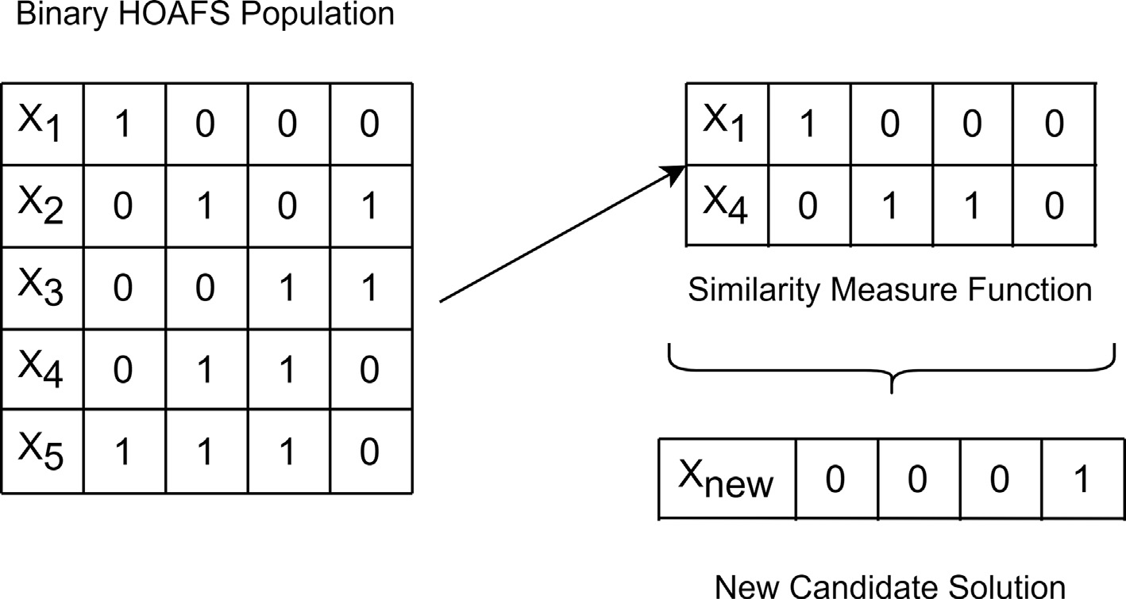

Fig. 1. Similarity Measure Function.

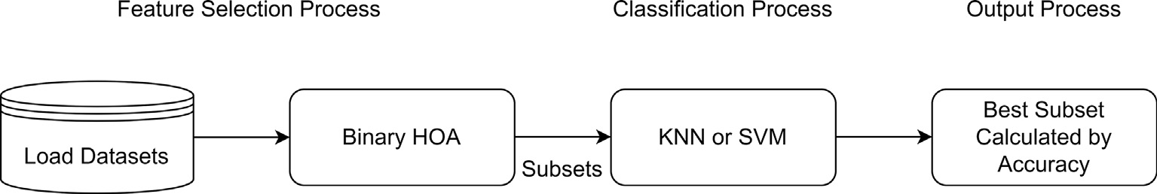

Fig. 2. Using k-NN and SVM Classifier.

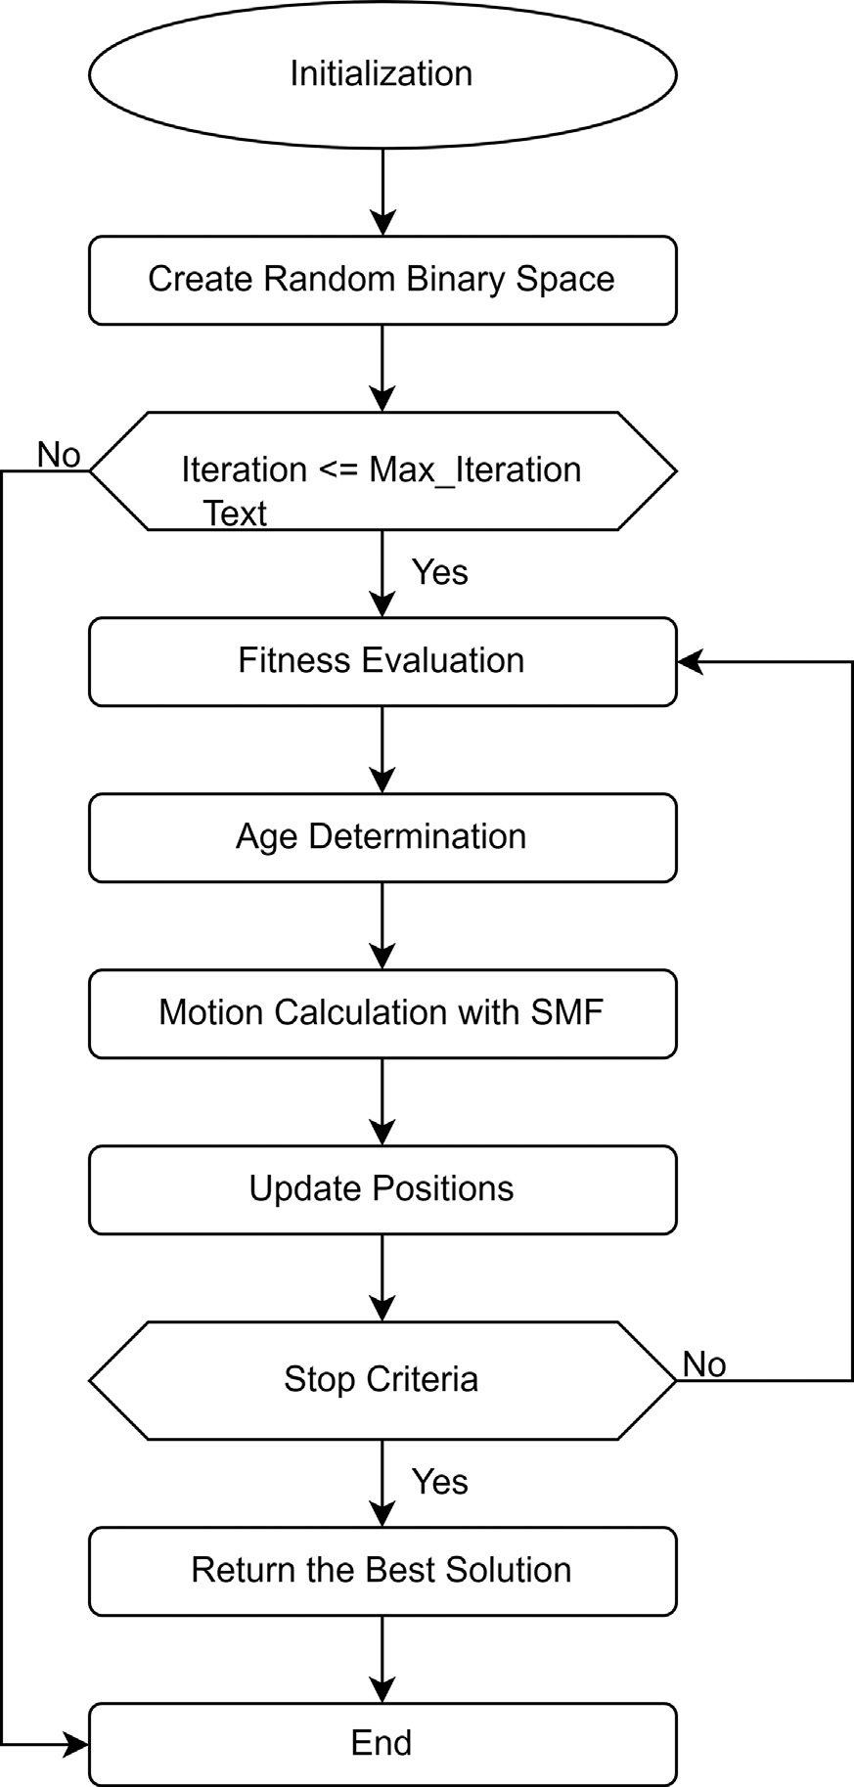

Fig. 3. Proposed Flowchart for BHOAFS.

*X*1, *X*2, .. . *Xn* is a vector array representing the position of each *X* horse, *xjj* to represent the ith bit of *Xj* i of the horse; *Xc* represents the cluster center of n horses and is represented by Eq. 11 below. The created cluster center is used to move horses in the search space.

*i*

# ( 1 Σ*N* *j*

*Xc* = *C*1, *C*2, .. . , *CN*| *If n*

*Xi* > 0.5

*Ci* = 1

*j*=1

Horses start the iteration by randomly positioning. Horses ma- ture as they age and change their positions. The next solution in the search space changes according to each horse’s age. Each horse performs the operations of the behavior (Eq. 1) mentioned above. Thanks to Age Determination, it is ensured that the horses do a global search in the search space according to their solution. The fitness function evaluates these behaviors and determines the next position. In the designed BHOAFS, each horse represents a possible solution to the FS problem. The accuracy of the classification algo- rithm obtained from this solution’s horse position indicates the so- lution’s quality. Each solution is associated with the population’s quality, while horses offer local solutions based on their position. Horses mature as they age and change their positions. The next so- lution in the search space changes according to each horse’s age. Alpha and Beta horses participate in the exploitation process, while Theta and Gamma horses participate in the exploration process.

* + 1. *Similarity measurement function (SMF)*

The SMF, designed for the local search strategy for the proposed algorithm, aims to improve the current positions of the individuals with good positions in the herd and forward them to the next iter- ation. SMF is a function that measures the similarity/proximity of the two candidate horses that make up the population. Its main function is to calculate the distance between solutions. Then, ac- cording to this distance, it generates a candidate horse solution that is different from the existing solutions but is more likely to be in a better position.

If the distance of the two nearest or adjacent sources is less than a specified value of k, the lower fitness value from these sources is reconstructed. (According to the literature, the k value has been

determined as *N*/3 or *N*/2, with the size of the dataset to be select-

ed for FS. In the proposed algorithm, *N*/3 was used for cases where the dataset is high dimensional [55].) This process is done for the selected individuals in each iteration. The aim is to regenerate the available resource during the initialization of the population without losing the potential of the optimal point reached so far, not randomly. Thus, early convergence, the most crucial problem related to the herd, is prevented, and diversity is increased. The SMF process is shown in Fig. 1. In addition, this function provides a more comprehensive local search without reducing the global search capacity. Thus, the probability of finding a better solution by avoiding local pitfalls in the search space of BHOAFS is also in- creased. The balance of the proposed algorithm between explo- ration and exploitation is achieved with SMF.

* + 1. *Fitness function*

In algorithms that convert from continuous search space to bi- nary search space, the number of features in the subset should also be considered when calculating the fitness of a candidate solution to the objective function. However, since it is aimed to reduce the number of features by increasing the classification accuracy in the datasets, the fitness function is created using both the accuracy

and the number of reduced features. Eq. 12 shows the fitness function.

*otherwise Ci* = 0} (11)

The fitness function to be applied for the algorithm is expressed as in the Eq. 12 [56]:

Table 1

The five adapted chaotic maps in the paper.

Map Definition (0,1)

C1 = Logistic Map (BCHOAFS1) *ci*+1 = *wci* (1 — *ci*)

C2 = Tent Map (BCHOAFS2) *ci*+1 = *ci*/0.7, *ci* < 0 10 (1 — *ci*), *ci* P 0

3

C3 = Piecewise Map (BCHOAFS3) *ci*+1 = *ci*/*p* 0 < *ci* < *p*  (*ci* —*p*) , *p* < *ci* < 0.5 (1—*p*—*ci* ) , 0.5 < *ci* < 1 — *p* (1—*ci* ) , 1 — *p* < *ci* < 1, *p* = 0.2

(0.5—*p*) (0.5—*p*) *p*

C4 = Singer Map (BCHOAFS4) *ci*+1 = *l* 7.86*ci* — 23.31*c*2 + 28.75*c*3 — 13.302875*c*4 , *l* = 1.07

*i*

*i*

C5 = Sinusoidal Map (BCHOAFS5) *ci*+1 = *wc*2 sin(*pci*), *w* = 2.3

*i*

*i*

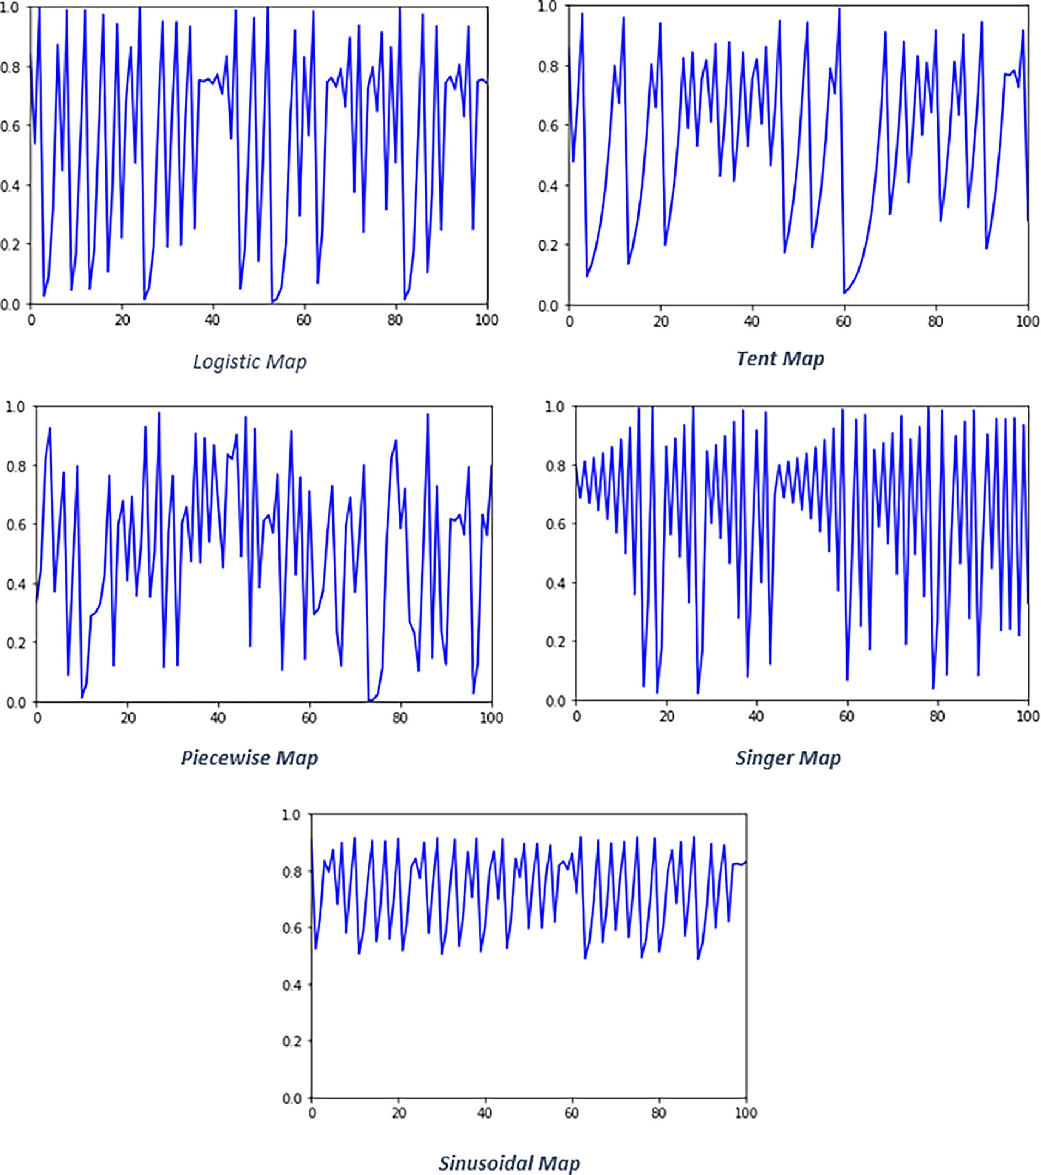

*FitnessFunction* = *S* * *D* + *B* * *C* — *R*

## *C*

Fig. 4. Visualization of Chaotic Maps.

(12) where S is a fixed value between [0,1], D is the accuracy value of the relevant classification algorithm, B is 1-S, C is the total number of

features, and R is the number of selected features, respectively.

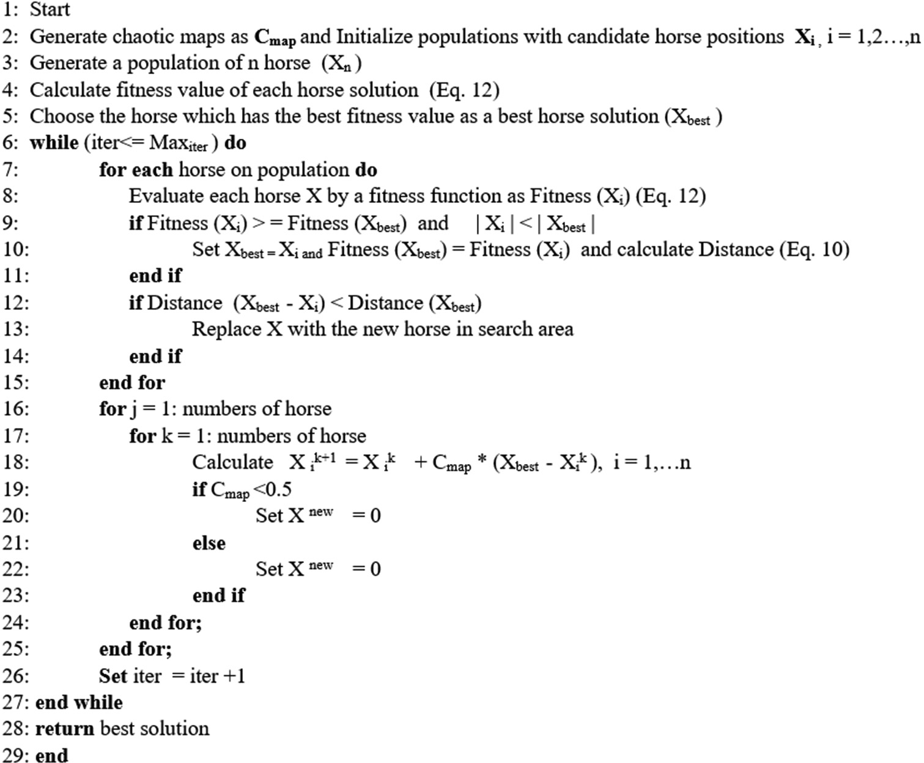

Table 2

Parameter setting for BCHOAFS.

Parameters Values

Population size(n) 20

Maximum iteration 100

Number of runs 20

Fig. 5. The proposed BCHOAFS.

classification method selection can increase the prediction accura- cy of the algorithm and reduce the required computational cost. KNN and SVM, which are widely used in the data mining commu- nity and machine learning, are the most effective classifier algo- rithms [57]. In the studies, different classifiers were used for different data types in feature selection algorithms [58–62]. In re- cent studies, there are algorithms that prefer the SVM if the dataset

Problem dimension (N) Number of features in the dataset

K 5 (K value in K-NN)

SVM RBF Kernel

k 10 (k-value in k-fold)

Search domain [0 1]

Table 3

Parameter setting for experiments.

|  |  |  |
| --- | --- | --- |
| Algorithms | Parameters | Values |
| PSO | w | 2 |
|  | *wmax* | 0.9 |
|  | *wmin* | 0.4 |
|  | c1 and c2 | 2 |
| GWO | *a* | [0 2] |
| ALO | Mutation rate | [0 0.9] |
| SSA | *ra*, *pc* and *pm*  Cross_val and mut_val | 1, 0.7 and 0.1  0.9 and 0.1 |
|  | w | 0.7 |
| GA | Cross_val and mut_val | 0.9 and 0.1 |
| BA | Qmin and Qmax | 0 and 2 |
|  | A and r | 0.5 and 0.5 |
| K-NN | K | 5 |

* + 1. *BHOAFS fundamentals*

In the wrapper-based FS algorithm problem, a classifier is need- ed to evaluate the selected feature. After determining which fea- tures to choose, a classification process is performed. Effective

contains two classes and the k-NN classifier if it contains more than two classes [32].

Therefore, the proposed algorithm BHOAFS is tested separately on low, medium, and large scale well-known datasets in the UCI repository using k-NN and SVM. Thus, the most successful version of BHOAFS in terms of classification performance was tried to be determined.

k-NN Classifier: The data were classified with k = 5 for k-NN classification, and the training set results were obtained by 10- fold cross-validation. SVM Classifier: The Kernel Trick method cal- culates how similar each point is to a certain point by calculating with a normal distribution is called RBF Kernel. For SVM, the RBF Kernel method was used. For multi-class datasets, SVM was ap- plied with a one-versus-all strategy. The basic representation of the BHOAFS is shown in Fig. 2.

The experimental results showed that the classification perfor- mance of k-NN was superior to SVM. The BHOAFS starts with the preprocessing step for the selected datasets. After the relevant data is appropriate, it is divided into two parts, the training set and the test set, and a subset of features is created from the original data- set, as in Fig. 2. The algorithm cycle continues by evaluating the se- lected classification algorithm and fitness function during the determined iteration. As in Fig. 3, when the stopping criterion of the algorithm is met, the most optimal features are accepted, and the reduced version of these features is applied to the test dataset. The size of the test dataset is reduced by the size of the subset pro- duced by the training dataset. The reduced test set is also classified

The UCI benchmark datasets details used for proposed BHOAFS.

|  |  |  |  |  |
| --- | --- | --- | --- | --- |
| Type | Dataset | #Features | #Samples | #Classes |
| Low Dimension | Iris | 5 | 150 | 3 |
|  | Diabetes | 9 | 768 | 2 |
|  | Wine | 13 | 178 | 3 |
|  | Hepatitis | 19 | 155 | 2 |
|  | Vehicle | 18 | 846 | 4 |
|  | Zoo | 16 | 101 | 7 |
|  | Heart | 13 | 270 | 2 |
|  | Breast Cancer | 11 | 699 | 2 |
| Medium Dimension | Ionosphere | 34 | 351 | 2 |
|  | Soybean Small | 35 | 47 | 4 |
|  | Lung-Cancer | 56 | 32 | 3 |
|  | Sonar | 60 | 208 | 2 |
|  | BreastEW | 30 | 569 | 2 |
|  | Movementlibras | 90 | 360 | 15 |
|  | WaveformEW | 40 | 5000 | 3 |
| High Dimension | Arrhythmia | 279 | 452 | 16 |
|  | Hillvalley | 101 | 606 | 2 |
|  | Clean | 166 | 476 | 2 |
|  | Semeion | 256 | 1593 | 10 |
|  | CNAE | 856 | 1080 | 9 |

with the classification algorithm used, and the results were compared.

* 1. *Chaotic maps for BHOAFS*

Chaotic maps are deterministic systems sensitive to initial con- ditions and vary according to disordered/random behavior. Chaos theory, on the other hand, examines deterministic rules and dy- namic system behaviors [63]. According to the initial conditions, chaotic variables can pass all states in certain intervals without re- peating. Configuring and creating chaotic number sequences is quick and easy. Because of these behaviors, chaos search is better at climbing the hill and escaping the local optimum than random search. For this reason, many optimization algorithms have been applied, representing chaos maps to update a basic motion mode or stochastic variables used in equations [64]. In previous studies, chaotic maps were used in optimization algorithms in two ways: Random Number Generator: Values produced from chaotic maps can be used in creating the initial population, as coefficients in in- tuitive equations, or as probability values when selecting individu- als. Local Search Technique: Chaotic search is incorporated into

metaheuristic procedures to enrich the search behavior, improve global convergence, and not get stuck in the local optimum [65].

In our experiments, five chaotic maps were used, namely Logis- tic, Tent, Piecewise, Singer, and Sinusoidal Maps, with the mathe- matical equations shown in Table 1. These chaotic maps are visualized in Fig. 4 for five different chaotic map values. In the pro- posed algorithm, one-dimensional chaotic maps are used as ran- dom number generators at the beginning of the search process to improve the FS performance of BHOAFS, find effective solutions in the search space, and increase the stability of the algorithm. The initial value was set to 0.7 in all chaotic maps selected for the proposed algorithm [66].

1. Proposed binary chaotic horse herd optimization algorithm (BCHOAFS)

The BCHOAFS generates a random number sequence containing N horses using chaotic maps. Each horse represents a solution in the population for the given FS problem. The population is created using Eq. 13:

Table 5

Comparison between the proposed approaches based on accuracy and the number of features for k-NN and SVM classifier of datasets.

|  |  |  |  |  |  |
| --- | --- | --- | --- | --- | --- |
|  | | | BHOAFS-kNN |  | BHOAFS-SVM |
| Benchmark | #Features | MeanAcc | #Selected Features | MeanAcc | #Selected Features |
| Iris | 5 | 0.98000 | 3 | 0.97333 | 3 |
| Diabetes | 9 | 0.77662 | 5 | 0.77623 | 5 |
| Wine | 13 | 0.95556 | 5 | 0.93889 | 7 |
| Hepatitis | 19 | 0.74000 | 5 | 0.76000 | 6 |
| Vehicle | 18 | 0.75529 | 4 | 0.65059 | 6 |
| Zoo | 16 | 0.94545 | 7 | 0.96364 | 6 |
| Heart | 13 | 0.85926 | 3 | 0.85556 | 6 |
| Breast Cancer | 11 | 0.97857 | 6 | 0.97857 | 7 |
| Ionosphere | 34 | 0.93056 | 6 | 0.96944 | 12 |
| Soybean Small | 35 | 1.00000 | 15 | 0.80000 | 23 |
| Lung-Cancer | 56 | 0.97500 | 13 | 0.97500 | 11 |
| Sonar | 60 | 0.94762 | 21 | 0.92857 | 17 |
| BreastEW | 30 | 0.96140 | 11 | 0.95611 | 2 |
| Movementlibras | 90 | 0.83611 | 27 | 0.83333 | 26 |
| WaveformEW | 40 | 0.84580 | 18 | 0.87520 | 26 |
| Arrhythmia | 279 | 0.70000 | 138 | 0.70870 | 83 |
| Hillvalley | 101 | 0.65574 | 14 | 0.48033 | 25 |
| Clean | 166 | 0.95417 | 131 | 0.93958 | 102 |
| Semeion | 256 | 0.98188 | 61 | 0.98063 | 117 |
| CNAE | 856 | 0.99815 | 663 | 0.99815 | 661 |

Comparison between the proposed approaches by means of fitness for k-NN and SVM classifiers of datasets.

|  |  |  |  |  |  |  |  |
| --- | --- | --- | --- | --- | --- | --- | --- |
| Benchmark | BHOAFS-kNN | BHOAFS-SVM | GA | PSO | ALO | GWO | SSA |
| Wine | 0.05015 | 0.06512 | 0.23000 | 0.54000 | 0.37200 | 0.43000 | 0.23000 |
| Hepatitis | 0.26477 | 0.24444 | 1.60000 | 1.50000 | 1.29300 | 2.19500 | 1.26300 |
| Vehicle | 0.25004 | 0.35258 | 2.30000 | 2.10000 | 3.01900 | 2.94500 | 2.39300 |
| Zoo | 0.05963 | 0.04225 | 1.16000 | 2.00000 | 1.87500 | 1.02700 | 0.75800 |
| Heart | 0.14703 | 0.14838 | 1.25000 | 1.85000 | 2.02600 | 1.30100 | 1.34800 |
| Breast Cancer | 0.02576 | 0.02485 | 0.38000 | 0.37000 | 0.42500 | 0.41500 | 0.39900 |
| Ionosphere | 0.07698 | 0.03672 | 1.27000 | 1.76000 | 1.19900 | 1.41500 | 1.21400 |
| Soybean Small | 0.00571 | 0.20143 | 0.60000 | 0.40000 | 0.01900 | 2.91300 | 0.04900 |
| Lung Cancer | 0.03243 | 0.03279 | 1.50000 | 1.72400 | 1.90200 | 2.84400 | 1.29600 |
| Sonar | 0.05836 | 0.07788 | 1.69000 | 3.19000 | 1.76900 | 2.25600 | 0.06900 |
| BreastEW | 0.04454 | 0.05278 | 0.42000 | 0.54000 | 0.56400 | 0.65400 | 0.51200 |
| Movementlibras | 0.16925 | 0.17211 | 2.96000 | 3.33000 | 3.88900 | 2.78400 | 1.74900 |
| WaveformEW | 0.15816 | 0.12705 | 2.18000 | 2.40000 | 2.68100 | 2.64800 | 2.02000 |
| Arrhythmia | 0.30205 | 0.29542 | 0.60000 | 0.90000 | 0.37400 | 0.36300 | 2.93500 |
| Hillvalley | 0.34943 | 0.52200 | 2.45000 | 2.63000 | 4.05200 | 4.08800 | 2.92000 |
| Clean | 0.04748 | 0.06367 | 0.64000 | 0.92000 | 0.16100 | 0.18400 | 0.96500 |
| Semeion | 0.02556 | 0.02461 | - | - | - | - | 7.28600 |
| CNAE | 0.00409 | 0.00411 | 2.67000 | 3.27000 | 1.66200 | 2.00000 | 2.06900 |

Table 7

Comparison of BHOAFS with other well-known optimization algorithms by mean accuracy.

|  |  |  |  |  |  |  |  |
| --- | --- | --- | --- | --- | --- | --- | --- |
| Benchmark | BHOAFS-kNN | BHOAFS-SVM | GA | PSO | ALO | GWO | SSA |
| Wine | 0.95556 | 0.93889 | 0.95700 | 0.92300 | 0.94200 | 0.91200 | 0.97500 |
| Hepatitis | 0.74000 | 0.76000 | 0.87500 | 0.86050 | 0.88250 | 0.84790 | 0.90000 |
| Vehicle | 0.75529 | 0.65059 | 0.71630 | 0.66950 | 0.68140 | 0.61720 | 0.72010 |
| Zoo | 0.94545 | 0.96364 | 0.85400 | 0.82400 | 0.80500 | 0.87500 | 0.96750 |
| Heart | 0.85926 | 0.85556 | 0.82400 | 0.82200 | 0.80200 | 0.80700 | 0.85210 |
| Breast Cancer | 0.97857 | 0.97857 | 0.95500 | 0.95100 | 0.95000 | 0.95300 | 0.96850 |
| Ionosphere | 0.93056 | 0.96944 | 0.82400 | 0.84800 | 0.84300 | 0.81900 | 0.91000 |
| Soybean Small | 1.00000 | 0.80000 | 0.94380 | 0.86480 | 0.90980 | 0.92050 | 1.00000 |
| Lung Cancer | 0.97500 | 0.97500 | 0.48200 | 0.56270 | 0.50560 | 0.50140 | 0.90830 |
| Sonar | 0.94762 | 0.92857 | 0.71700 | 0.72300 | 0.71400 | 0.71400 | 0.93750 |
| BreastEW | 0.96140 | 0.95611 | 0.93500 | 0.94900 | 0.94200 | 0.94900 | 0.95200 |
| Movementlibras | 0.83611 | 0.83333 | 0.69020 | 0.64660 | 0.65970 | 0.68660 | 0.82220 |
| WaveformEW | 0.84580 | 0.87520 | 0.76200 | 0.76200 | 0.76900 | 0.76500 | 0.80080 |
| Arrhythmia | 0.70000 | 0.70870 | 0.58020 | 0.57070 | 0.54620 | 0.56410 | 0.68280 |
| Hillvalley | 0.65574 | 0.48033 | 0.56270 | 0.55070 | 0.57090 | 0.55440 | 0.66580 |
| Clean | 0.95417 | 0.93958 | 0.76480 | 0.77840 | 0.80980 | 0.79530 | 0.90680 |
| Semeion | 0.98188 | 0.98063 |  |  |  |  | 0.20750 |
| CNAE | 0.99815 | 0.99815 | 0.82460 | 0.81470 | 0.79620 | 0.84070 | 0.79000 |

Table 8

Comparison of BHOAFS with other well-known binary optimization algorithms by mean accuracy.

|  |  |  |  |  |  |  |  |
| --- | --- | --- | --- | --- | --- | --- | --- |
| Benchmark | BHOAFS-kNN | BHOAFS-SVM | BGA | BPSO | BALO | BGWO | BSSA |
| Wine | 0.95556 | 0.93889 | 0.95700 | 0.92300 | 0.94200 | 0.91200 | 0.97500 |
| Hepatitis | 0.74000 | 0.76000 | 0.87500 | 0.86050 | 0.88250 | 0.84790 | 0.90000 |
| Vehicle | 0.75529 | 0.65059 | 0.71630 | 0.66950 | 0.68140 | 0.61720 | 0.72010 |
| Zoo | 0.94545 | 0.96364 | 0.85400 | 0.82400 | 0.80500 | 0.87500 | 0.96750 |
| Heart | 0.85926 | 0.85556 | 0.82400 | 0.82200 | 0.80200 | 0.80700 | 0.85210 |
| Breast Cancer | 0.97857 | 0.97857 | 0.95500 | 0.95100 | 0.95000 | 0.95300 | 0.96850 |
| Ionosphere | 0.93056 | 0.96944 | 0.82400 | 0.84800 | 0.84300 | 0.81900 | 0.91000 |
| Soybean Small | 1.00000 | 0.80000 | 0.94380 | 0.86480 | 0.90980 | 0.92050 | 0.10000 |
| Lung Cancer | 0.97500 | 0.97500 | 0.48200 | 0.56270 | 0.50560 | 0.50140 | 0.90830 |
| Sonar | 0.94762 | 0.92857 | 0.71700 | 0.72300 | 0.71400 | 0.71400 | 0.93750 |
| BreastEW | 0.96140 | 0.95611 | 0.93500 | 0.94900 | 0.94200 | 0.94900 | 0.95200 |
| Movementlibras | 0.83611 | 0.83333 | 0.69020 | 0.64660 | 0.65970 | 0.68660 | 0.82220 |
| WaveformEW | 0.84580 | 0.87520 | 0.76200 | 0.76200 | 0.76900 | 0.76500 | 0.80080 |
| Arrhythmia | 0.70000 | 0.70870 | 0.58020 | 0.57070 | 0.54620 | 0.56410 | 0.68280 |
| Hillvalley | 0.65574 | 0.48033 | 0.56270 | 0.55070 | 0.57090 | 0.55440 | 0.66580 |
| Clean | 0.95417 | 0.93958 | 0.76480 | 0.77840 | 0.80980 | 0.79530 | 0.90680 |
| Semeion | 0.98188 | 0.98063 |  |  |  |  | 0.20750 |
| CNAE | 0.99815 | 0.99815 | 0.82460 | 0.81470 | 0.79620 | 0.84070 | 0.79000 |

*xk*+1 = *xk* + *Cmap* * *xk* — *xk* *i* = 1, 2, .. . , *N* (13)

*i*

*i*

*BestHorse*

*i*

duced by the chaotic map. In order to obtain good results in the ex-

where *xk* and *xk*+1are the positions of the ith horse in iterations k

ploration and exploitation stages and to improve the performance

*i*

*i*

of the proposed algorithm while finding the optimal global solution,

and k + 1, respectively. *xk*

*BestHorse*

is the position of the best horse in

the *h* parameter was replaced with the Cmap value (Eq. 13) ob-

space, and N is the number of horses. Cmap is the value ∈ [0, 1] pro-

Comparison of BHOAFS with other well-known binary optimization algorithms by the number of selected features.

|  |  |  |  |  |  |  |
| --- | --- | --- | --- | --- | --- | --- |
| Benchmark | BHOAFS-kNN | BHOAFS-SVM | BSSA | BBA | BGWO | BPSO |
| Wine | 5 | 7 | 5 | 5 | 6 | 5 |
| Hepatitis | 5 | 6 | 9 | 7 | 8 | 7 |
| Vehicle | 4 | 6 | 8 | 9 | 11 | 8 |
| Zoo | 7 | 6 | 6 | 6 | 6 | 7 |
| Heart | 3 | 6 | 5 | 6 | 6 | 5 |
| Breast Cancer | 6 | 7 | 4 | 4 | 4 | 4 |
| Ionosphere | 6 | 12 | 14 | 17 | 15 | 14 |
| Soybean Small | 15 | 23 | 14 | 14 | 18 | 16 |
| Lung Cancer | 13 | 11 | 24 | 28 | 25 | 28 |
| Sonar | 21 | 17 | 28 | 27 | 28 | 29 |
| BreastEW | 11 | 2 | 12 | 13 | 20 | 17 |
| Movementlibras | 27 | 26 | 40 | 39 | 54 | 40 |
| WaveformEW | 18 | 26 | 23 | 22 | 30 | 23 |
| Arrhythmia | 138 | 83 | 147 | 146 | 144 | 142 |
| Hillvalley | 14 | 25 | 49 | 49 | 65 | 51 |
| Clean | 131 | 102 | 87 | 87 | 111 | 86 |
| Semeion | 61 | 117 | 137 | 133 | 152 | 134 |
| CNAE | 663 | 661 | 421 | 428 | 482 | 433 |

Table 10

Comparison of BHOAFS with other well-known binary optimization algorithms by means of CPU time (in minutes)

|  |  |  |  |  |  |  |
| --- | --- | --- | --- | --- | --- | --- |
| Benchmark | BHOAFS-kNN | BHOAFS-SVM | BSSA | BGWO | BPSO | BGA |
| Wine | 124.95 | 112.57 | 215.85 | 198.80 | 103.87 | 431.30 |
| Hepatitis | 306.15 | 175.48 | 224.77 | 228.27 | 102.90 | 375.33 |
| Vehicle | 344.40 | 1397.18 | 239.95 | 228.87 | 158.47 | 262.27 |
| Zoo | 238.55 | 185.73 | 192.67 | 192.07 | 100.93 | 188.13 |
| Heart | 180.75 | 71.93 | 336.83 | 266.53 | 128.30 | 225.00 |
| Breast Cancer | 148.97 | 59.27 | 310.47 | 334.03 | 122.53 | 217.87 |
| Ionosphere | 872.15 | 601.52 | 55.38 | 56.70 | 110.00 | 191.93 |
| Soybean Small | 170.75 | 121.18 | 420.03 | 1575.87 | 1567.47 | 2966.07 |
| Lung-Cancer | 323.55 | 597.77 | 181.48 | 260.87 | 98.63 | 183.60 |
| Sonar | 1541.08 | 504.73 | 131.42 | 271.37 | 105.53 | 195.90 |
| BreastEW | 329.85 | 3894.30 | 532.42 | 148.90 | 142.47 | 217.43 |
| Movementlibras | 1320.32 | 1727.52 | 700.43 | 439.20 | 109.27 | 651.70 |
| WaveformEW | 8570.32 | 34783.03 | 2610.60 | 315.33 | 100.80 | 609.37 |
| Arrhythmia | 5920.42 | 9302.28 | 126.60 | 680.03 | 116.03 | 401.37 |
| Hillvalley | 2101.37 | 1647.02 | 367.88 | 272.40 | 103.57 | 188.83 |
| Clean | 3700.52 | 6417.77 | 550.62 | 2781.57 | 1416.17 | 3044.73 |
| Semeion | 10828.32 | 9146.60 | 292.02 | 106.13 | 189.40 | 405.83 |
| CNAE | 26083.58 | 21789.80 | 887.27 | – | – | – |

Table 11

The accuracy comparison of different variations of BCHOAFS.

|  |  |  |  |  |  |
| --- | --- | --- | --- | --- | --- |
| Benchmark | BCHOAFS1 | BCHOAFS2 | BCHOAFS3 | BCHOAFS4 | BCHOAFS5 |
| Wine | 0.95556 | 0.95556 | 0.95556 | 0.95556 | 0.95556 |
| Hepatitis | 0.72667 | 0.72667 | 0.72667 | 0.74000 | 0.72667 |
| Vehicle | 0.73882 | 0.75765 | 0.75765 | 0.75529 | 0.75765 |
| Zoo | 0.96364 | 0.96364 | 0.96364 | 0.94545 | 0.96364 |
| Heart | 0.86296 | 0.86296 | 0.86296 | 0.85926 | 0.86296 |
| Breast Cancer | 0.97857 | 0.97857 | 0.97857 | 0.97857 | 0.97857 |
| Ionosphere | 0.93056 | 0.93056 | 0.92778 | 0.92500 | 0.92222 |
| Soybean Small | 1.00000 | 1.00000 | 1.00000 | 1.00000 | 1.00000 |
| Lung-Cancer | 0.97500 | 0.97500 | 0.97500 | 0.97500 | 0.97500 |
| Sonar | 0.93810 | 0.93333 | 0.93810 | 0.92857 | 0.93810 |
| BreastEW | 0.96140 | 0.96140 | 0.96140 | 0.96140 | 0.96140 |
| Movementlibras | 0.83611 | 0.83333 | 0.84167 | 0.82778 | 0.83333 |
| WaveformEW | 0.84680 | 0.84540 | 0.84580 | 0.84840 | 0.84880 |
| Arrhythmia | 0.73478 | 0.70217 | 0.70435 | 0.70217 | 0.69783 |
| Hillvalley | 0.64098 | 0.63607 | 0.63443 | 0.65082 | 0.65410 |
| Clean | 0.94792 | 0.93542 | 0.94375 | 0.94375 | 0.93958 |
| Semeion | 0.98000 | 0.98000 | 0.98063 | 0.97938 | 0.97938 |
| CNAE | 0.99815 | 0.99815 | 0.99815 | 0.99815 | 0.99815 |

Table 12

The number of selected features comparison of different variations of BCHOAFS.

|  |  |  |  |  |  |
| --- | --- | --- | --- | --- | --- |
| Benchmark | BCHOAFS1 | BCHOAFS2 | BCHOAFS3 | BCHOAFS4 | BCHOAFS5 |
| Wine | 5 | 6 | 5 | 5 | 5 |
| Hepatitis | 8 | 5 | 4 | 5 | 8 |
| Vehicle | 11 | 4 | 4 | 4 | 4 |
| Zoo | 6 | 6 | 6 | 7 | 6 |
| Heart | 4 | 4 | 4 | 3 | 4 |
| Breast Cancer | 6 | 6 | 7 | 6 | 6 |
| Ionosphere | 6 | 7 | 6 | 6 | 9 |
| Soybean Small | 17 | 13 | 15 | 19 | 16 |
| Lung-Cancer | 15 | 17 | 16 | 16 | 15 |
| Sonar | 21 | 28 | 32 | 26 | 29 |
| BreastEW | 7 | 14 | 12 | 12 | 5 |
| Movementlibras | 39 | 33 | 46 | 50 | 33 |
| WaveformEW | 21 | 15 | 18 | 22 | 18 |
| Arrhythmia | 160 | 177 | 158 | 150 | 142 |
| Hillvalley | 28 | 28 | 49 | 21 | 24 |
| Clean | 107 | 123 | 120 | 130 | 135 |
| Semeion | 87 | 93 | 58 | 59 | 82 |
| CNAE | 666 | 659 | 676 | 674 | 676 |

Table 13

According to the mean of accuracy and number of selected features, a comparison of BHOAFS with different variations of BCHOAFS. Benchmark BCHOAFS1 BCHOAFS2 BCHOAFS3 BCHOAFS4 BCHOAFS5

|  |  |  |  |  |  |  |  |  |  |  |
| --- | --- | --- | --- | --- | --- | --- | --- | --- | --- | --- |
|  | MeanAcc | MeanFea | MeanAcc | MeanFea | MeanAcc | MeanFea | MeanAcc | MeanFea | MeanAcc | MeanFea |
| Wine | 0.95556 | 6.0 | 0.95556 | 6.2 | 0.95500 | 6.0 | 0.95556 | 5.8 | 0.95500 | 6.1 |
| Hepatitis | 0.71933 | 8.6 | 0.72333 | 7.8 | 0.71867 | 7.6 | 0.72067 | 7.7 | 0.70733 | 7.6 |
| Vehicle | 0.72954 | 10.3 | 0.73753 | 8.6 | 0.73612 | 9.0 | 0.73447 | 9.5 | 0.73965 | 9.0 |
| Zoo | 0.94727 | 7.9 | 0.93273 | 8.7 | 0.94364 | 8.9 | 0.93273 | 7.8 | 0.94182 | 9.2 |
| Heart | 0.86111 | 4.5 | 0.86185 | 4.3 | 0.86185 | 4.3 | 0.85926 | 3.4 | 0.86111 | 4.5 |
| Breast Cancer | 0.97857 | 6.6 | 0.97857 | 6.0 | 0.97857 | 7.0 | 0.97814 | 6.0 | 0.97857 | 6.2 |
| Ionosphere | 0.91972 | 7.0 | 0.91528 | 8.2 | 0.91806 | 8.1 | 0.91472 | 6.8 | 0.91444 | 8.4 |
| Soybean Small | 1.00000 | 23.2 | 1.00000 | 22.9 | 1.00000 | 22.8 | 1.00000 | 22.2 | 1.00000 | 22.0 |
| Lung-Cancer | 0.97250 | 24.7 | 0.97500 | 24.2 | 0.97500 | 22.6 | 0.97500 | 24.0 | 0.97000 | 19.9 |
| Sonar | 0.92190 | 25.1 | 0.91714 | 25.2 | 0.91952 | 28.0 | 0.91667 | 28.1 | 0.91667 | 27.7 |
| BreastEW | 0.96088 | 14.8 | 0.96070 | 15.8 | 0.96140 | 14.1 | 0.96070 | 15.0 | 0.96053 | 15.2 |
| Movementlibras | 0.82472 | 36.4 | 0.82222 | 32.7 | 0.82056 | 35.9 | 0.82056 | 35.6 | 0.82139 | 39.6 |
| WaveformEW | 0.84320 | 19.3 | 0.84322 | 20.1 | 0.84240 | 18.7 | 0.84220 | 22.5 | 0.84378 | 19.2 |
| Arrhythmia | 0.68783 | 155.1 | 0.68761 | 157.8 | 0.69022 | 158.3 | 0.68783 | 155.3 | 0.68630 | 154.2 |
| Hillvalley | 0.62721 | 27.1 | 0.62525 | 30.5 | 0.62492 | 37.7 | 0.62918 | 39.0 | 0.63098 | 29.1 |
| Clean | 0.94062 | 114.5 | 0.92813 | 109.2 | 0.93125 | 106.9 | 0.93354 | 108.5 | 0.93042 | 108.0 |
| Semeion | 0.97606 | 91.6 | 0.97625 | 85.5 | 0.97550 | 91.9 | 0.97594 | 77.1 | 0.97506 | 103.7 |
| CNAE | 0.99815 | 687.1 | 0.99815 | 682.3 | 0.99815 | 687.7 | 0.99815 | 688.1 | 0.99815 | 684.6 |

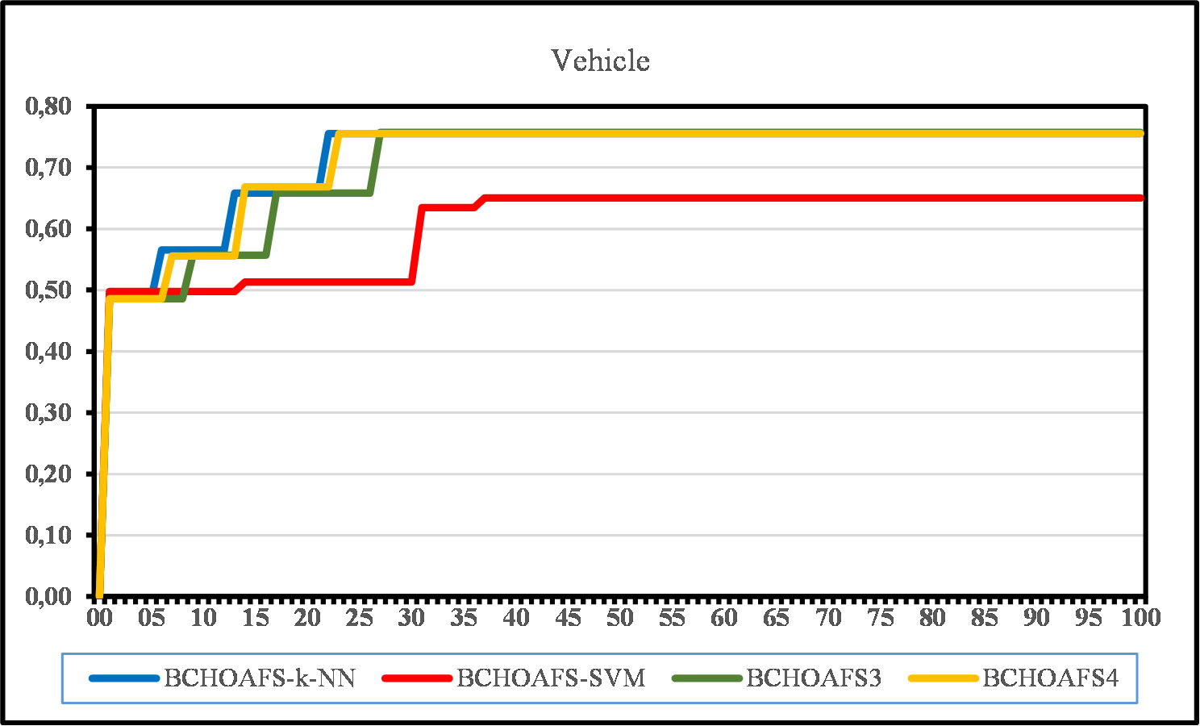

Fig. 6. Convergence Graphic for Vehicle Dataset.

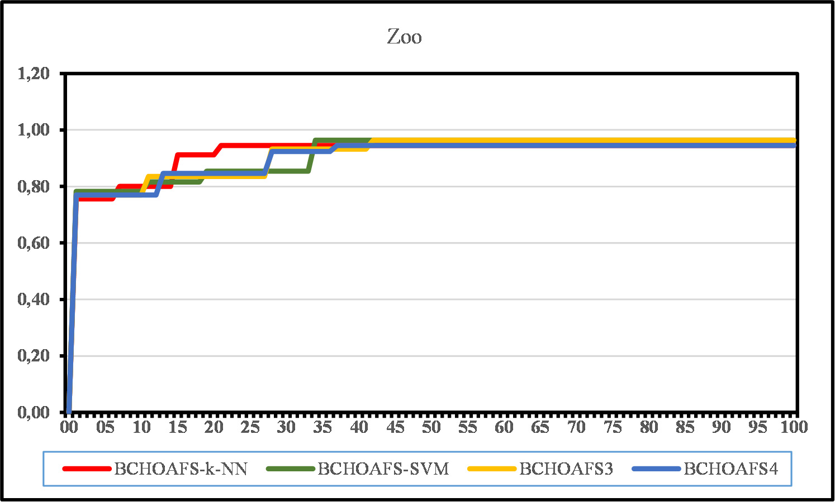

Fig. 7. Convergence Graphic for Zoo Dataset.

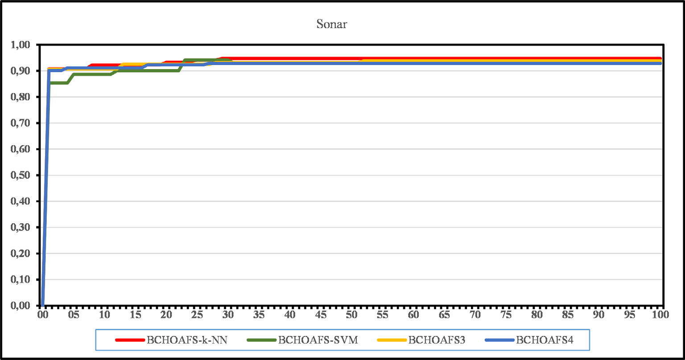

Fig. 8. Convergence Graphic for Sonar Dataset.

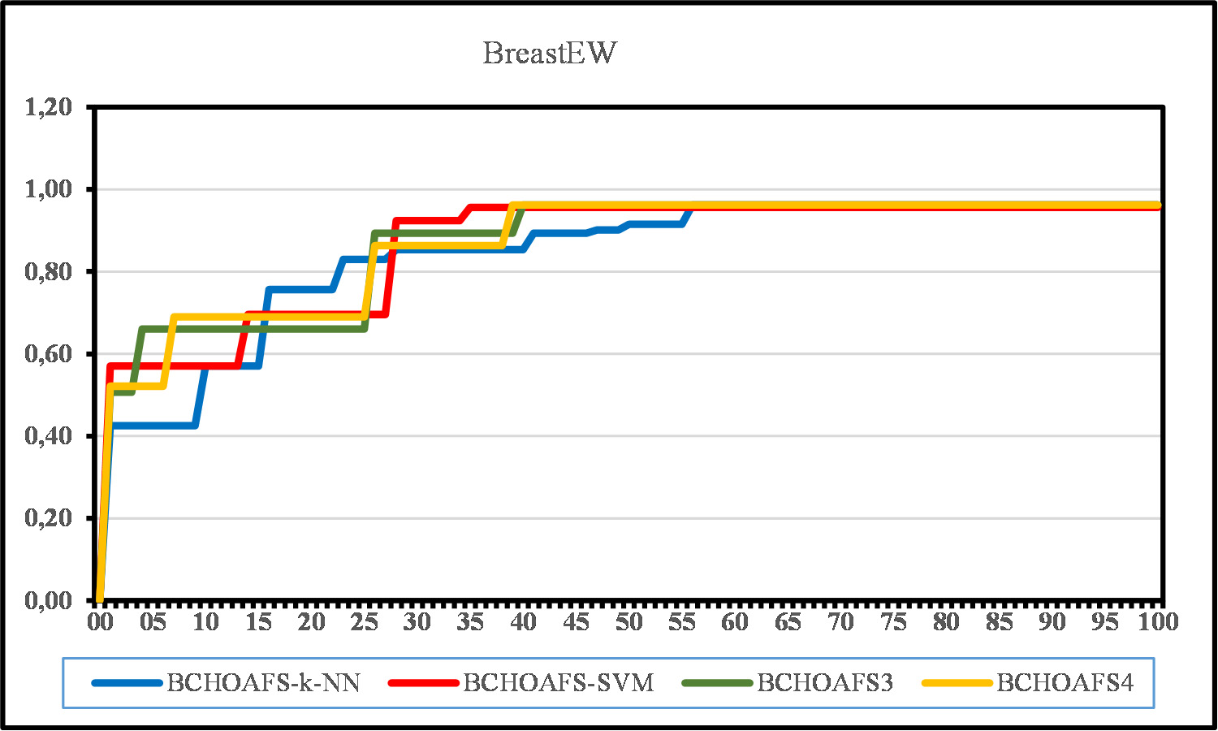

Fig. 9. Convergence Graphic for BreastEW Dataset.

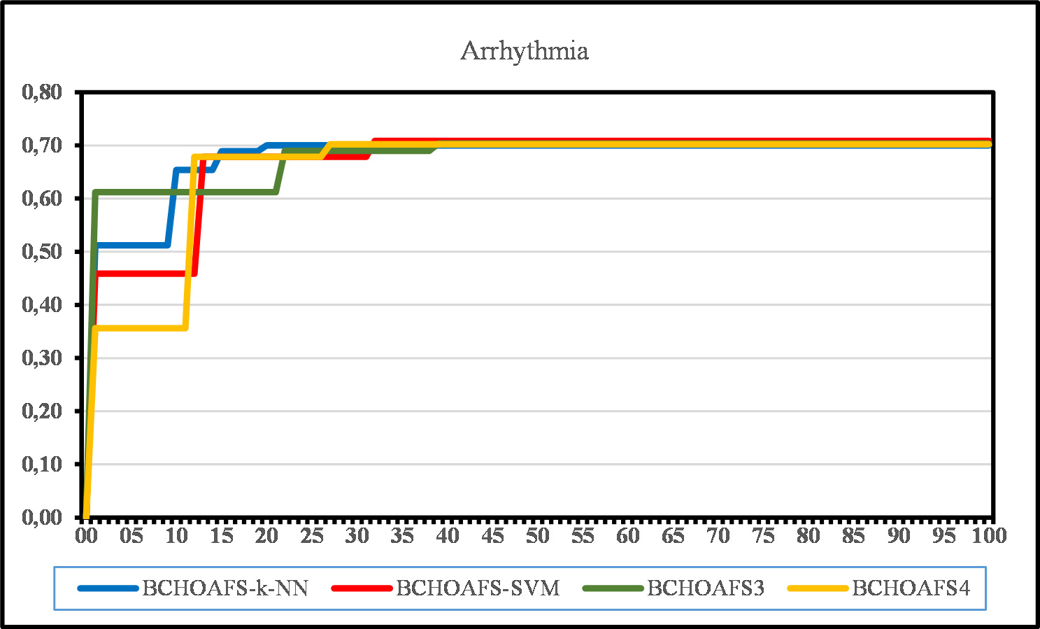

Fig. 10. Convergence Graphic for Arrhythmia Dataset.

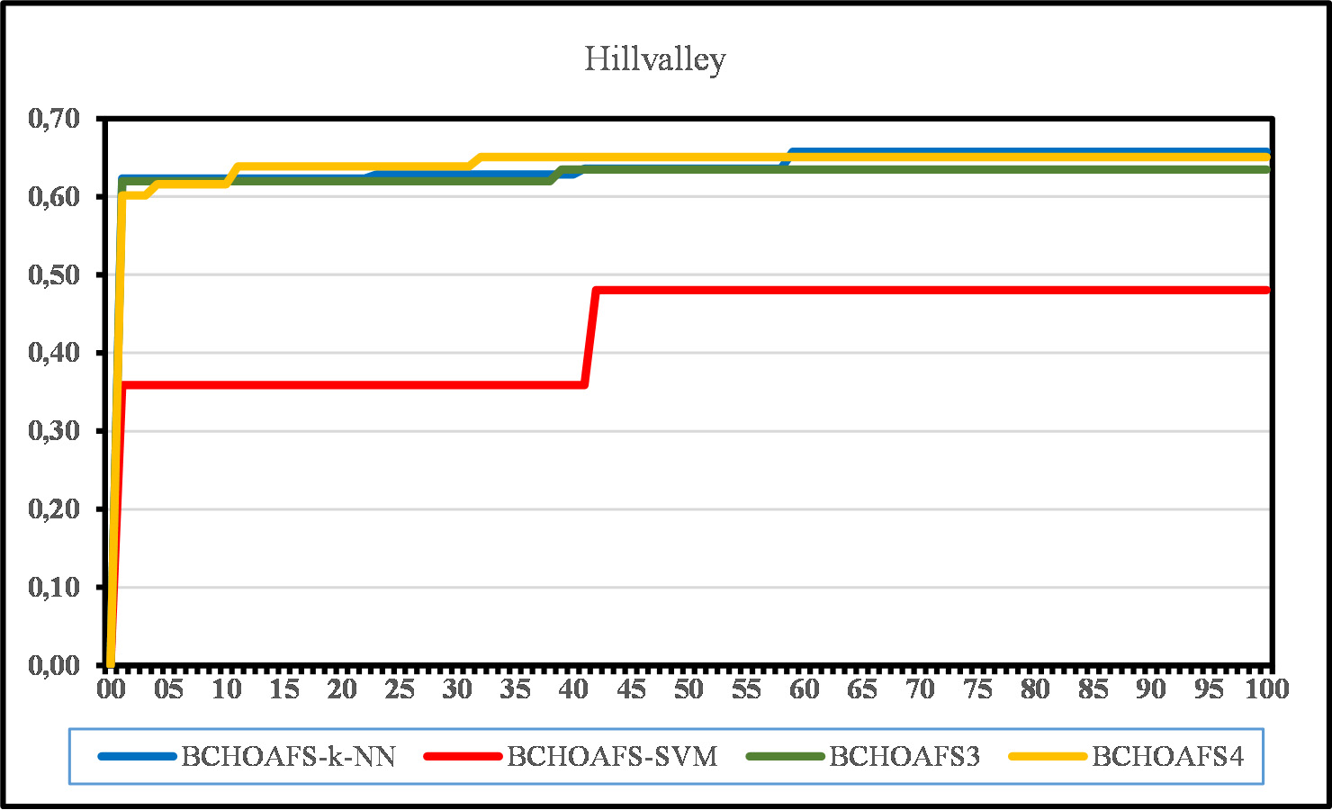

Fig. 11. Convergence Graphic for Hillvalley Dataset.

tained from the chaotic map. Five chaotic maps were used to ma- nipulate the values of the random parameters of the BHOAFS. Fig. 5 shows the pseudo-code of the proposed BCHOAFS.

1. Experiments
   1. *Experimental initializations and parameter settings*

Random population generation is provided by using Pareto Law rules in FS. According to this rule, the binary vector array is initially set to 80% zero and 20% one. 90% of the datasets were reserved for training and 10% for testing. k-NN and SVM classifiers were used as classifiers by randomly selecting the data in the training and test set. Results for the test set were obtained by ten-fold cross- validation. The accuracy average of this classifier was used. The fit- ness function in the FS problem depends not only on the classifica- tion accuracy but also on the number of selected features. The one

with the higher accuracy value is preferred of the two subsets of features obtained. However, if two subsets have the same accuracy value, the solution with fewer features is preferred. Since the accu- racy value is more important than the number of features, the S co- efficient used in the fitness function (Eq. 12) was determined as

0.005 [32]. The termination condition of the algorithm can be achieved by reaching the maximum number of iterations or by ob- taining the same feature reduction result three times in a row [67]. The size of all algorithms is fixed to the number of features in the original dataset and the number of populations to 10. 90% of the datasets are reserved for training and 10% for testing. The data in the training and test set were randomly selected. BHOAFS was clas- sified with k-NN (k = 5) and SVM, and the results for the training set were obtained by ten-fold cross-validation, as shown in Table 2. Since BHOAFS classified with k-NN gives better results than SVM, only the k-NN classifier was used for BCHOAFS. While creating the BCHOAFS, five chaotic maps were used to manipulate the val-

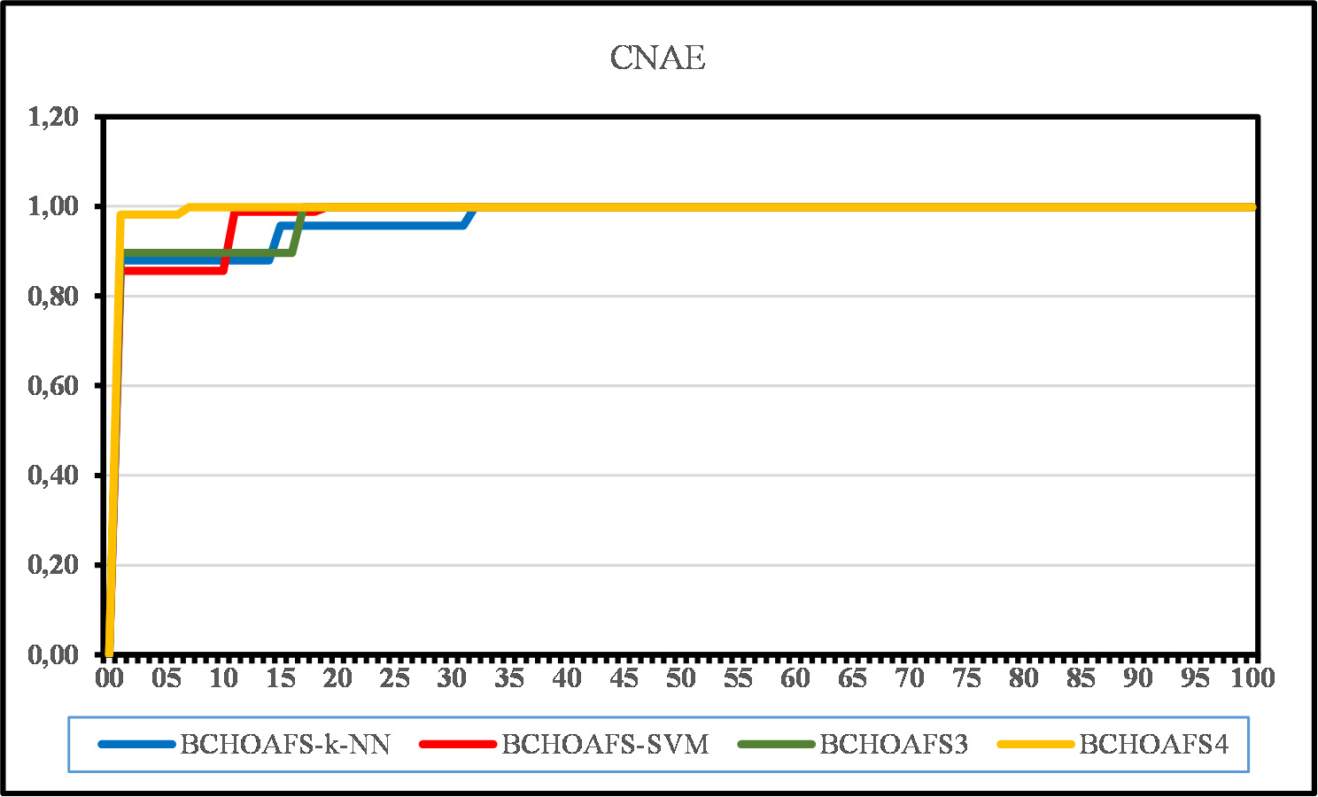

Fig. 12. Convergence Graphic for CNAE Dataset.

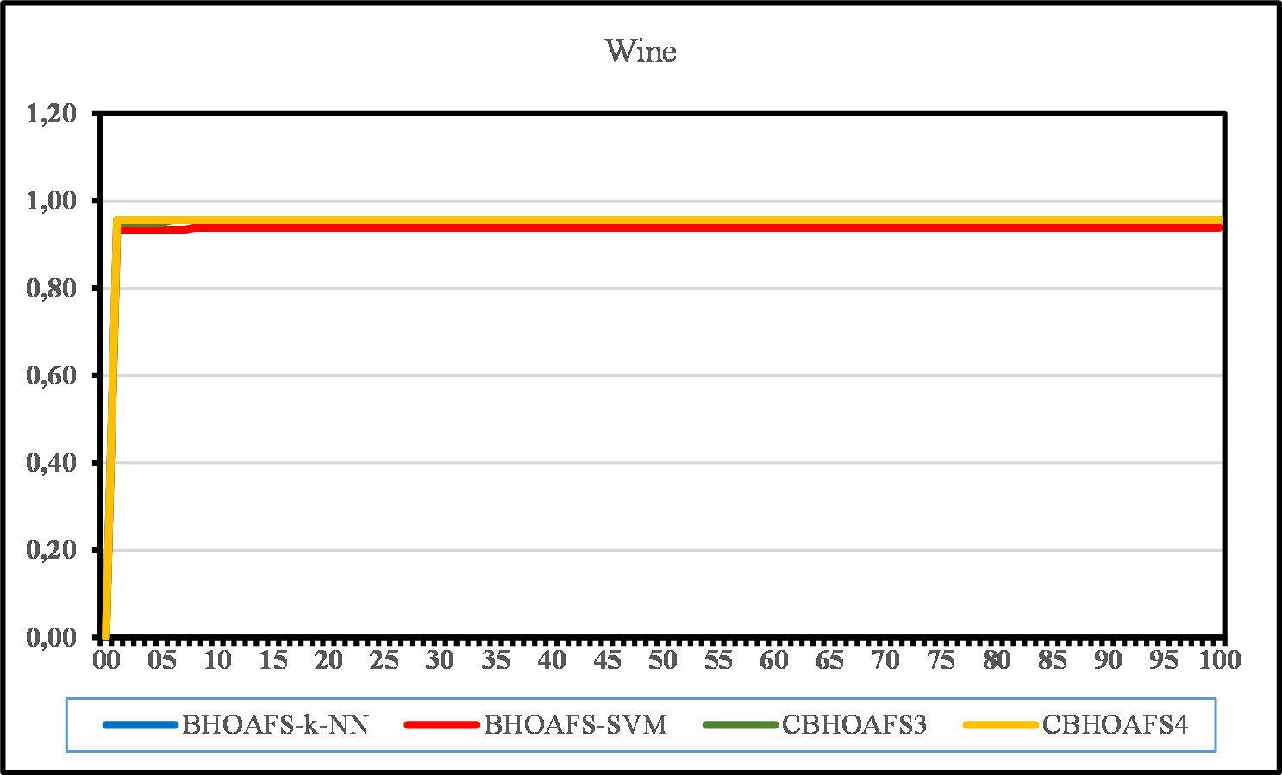

Fig. 13. Convergence Graphic for Wine Dataset.

ues of the random parameters of the BHOAFS. The proposed BHOAFS and BCHOAFS were run using a computer with 4 GB RAM, Intel(R) Core(TM) i5-2450 M 2.5 GHz CPU, coded with Python version 3.9, according to the initial conditions that stated in Table 2. The proposed algorithm has been compared with other well- known optimization algorithms. The applied parameters are the same as their own parameter settings, as stated in Table 3 [68,69].

* 1. *Datasets*

BHOAFS was run for datasets of 20 different sizes and qualities

* 1. *Evaluation measures*

The datasets are randomly divided into two parts (i.e., training and test datasets). The data splitting is repeated many times to en- sure the robustness and measurability of the results. The following statistical measures are tested from validation data at each run.

* + 1. *Mean of classification accuracy*

When the algorithm is run N times, the selected feature set is an indicator of how accurate the given classifier is and is calculated as follows in Eq. 14:

1 Σ*N* *k*

taken from the UCI data repository. Eighteen of these data sets were used for the BCHOAFS. The definitions of datasets are shown in Table 4.

*MeanAcc* = *N*

*i*=1

*Acc*

# (14)

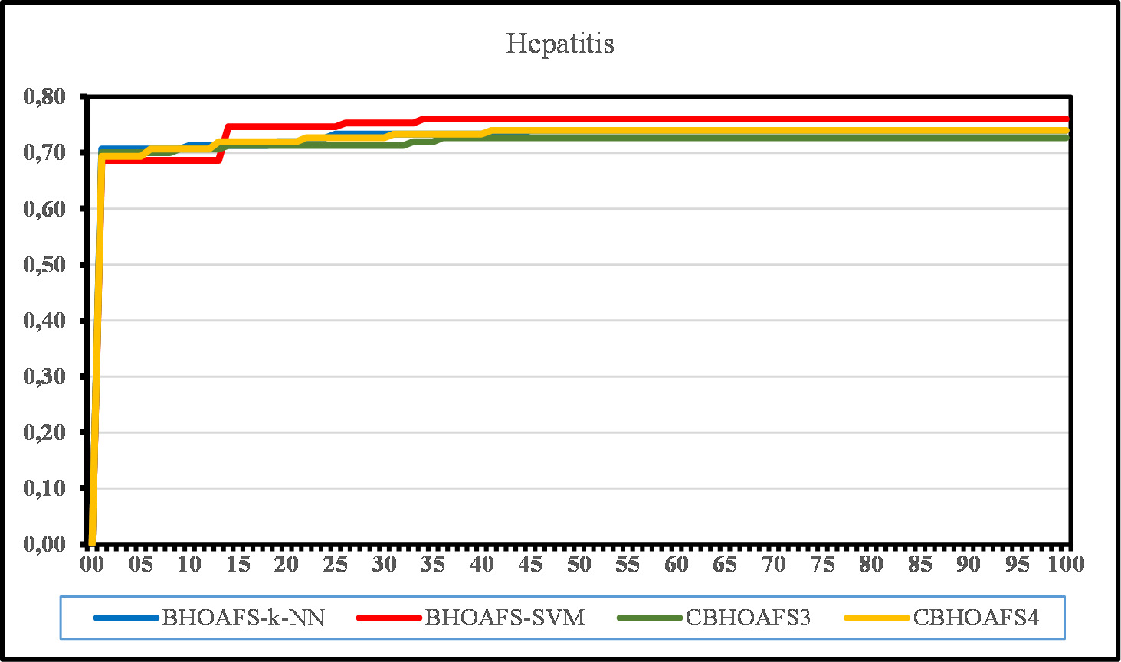

Fig. 14. Convergence Graphic for Hepatitis Dataset.

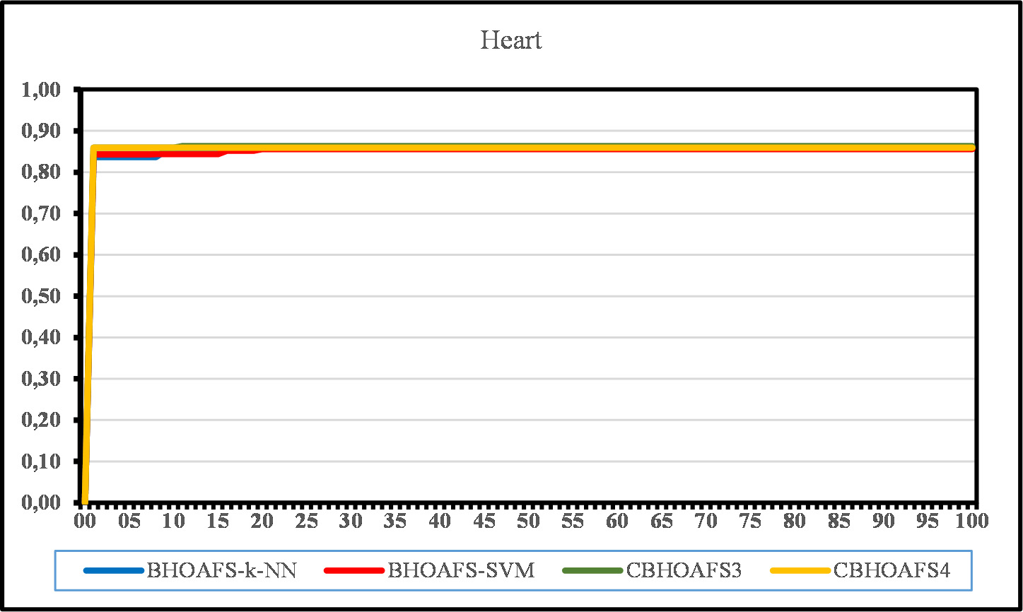

Fig. 15. Convergence Graphic for Heart Dataset.

* + 1. *Mean of selected features*

According to Eq. 15, MeanFea is an indicator of the average of the selected features. When the algorithm is run N times, MeanFea is calculated as follows:

1 Σ*N* *MeanFeak*!

It is an indicator of the average value of the fitness function ob- tained when the algorithm is run N times and is calculated as in Eq.

16. *Fitk* represents the fitness function in the kth iteration.

* 1. *Comparisons between the proposed optimizers*

## *MeanFea* = *N*

*i*=1 *D*

# (15)

* + 1. *BHOAFS results*

where *MeanFeak* is the selected features at run k, and D shows the dataset’s total number of features.

*4.3.3. Mean of fitness value*

.

*MeanFit* = 1 Σ(*fit* ) (16)

*N*

*k*

*N i*=1

The proposed algorithm was run for 20 datasets from the UCI repository. However, eighteen of 20 datasets are compared with well-known algorithms in the literature. [32]. According to the al- gorithm results in Table 5, the BHOAFS produced similar results for both k-NN and SVM for most of the datasets. It was observed that k-NN gave better results for Iris, Diabetes, Wine, Vehicle, Heart, Soybean Small, Sonar, BreastEW, Movementlibras, Hillvalley, Clean, and Semeion datasets. For Hepatitis, Zoo, Ionosphere, Wave- formEW, and Arrhythmia datasets, SVM produced better accuracy. For the Breast Cancer, Lung-Cancer, and CNAE datasets, both k-NN

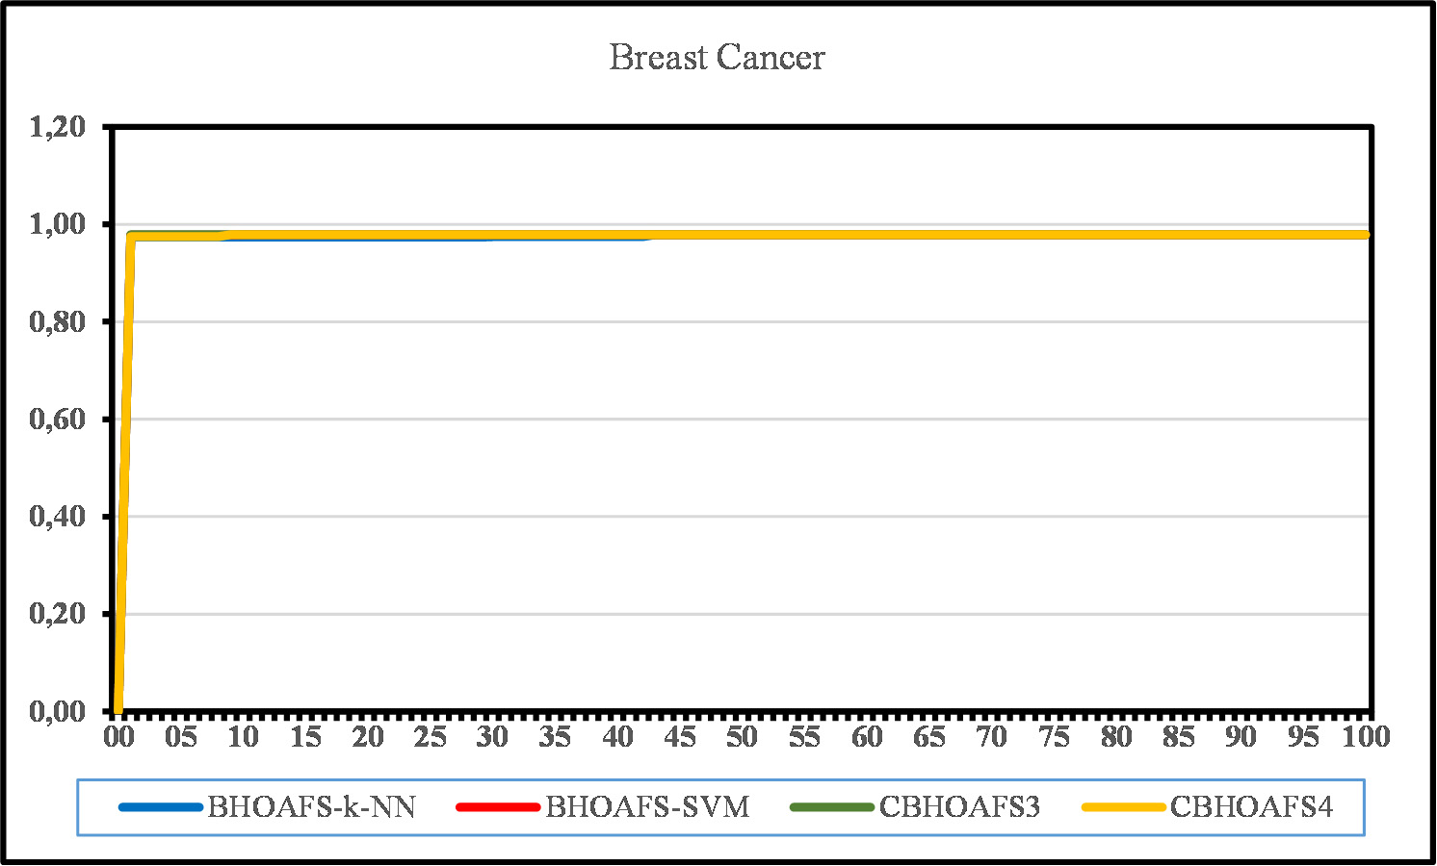

Fig. 16. Convergence Graphic for Breast Cancer Dataset.

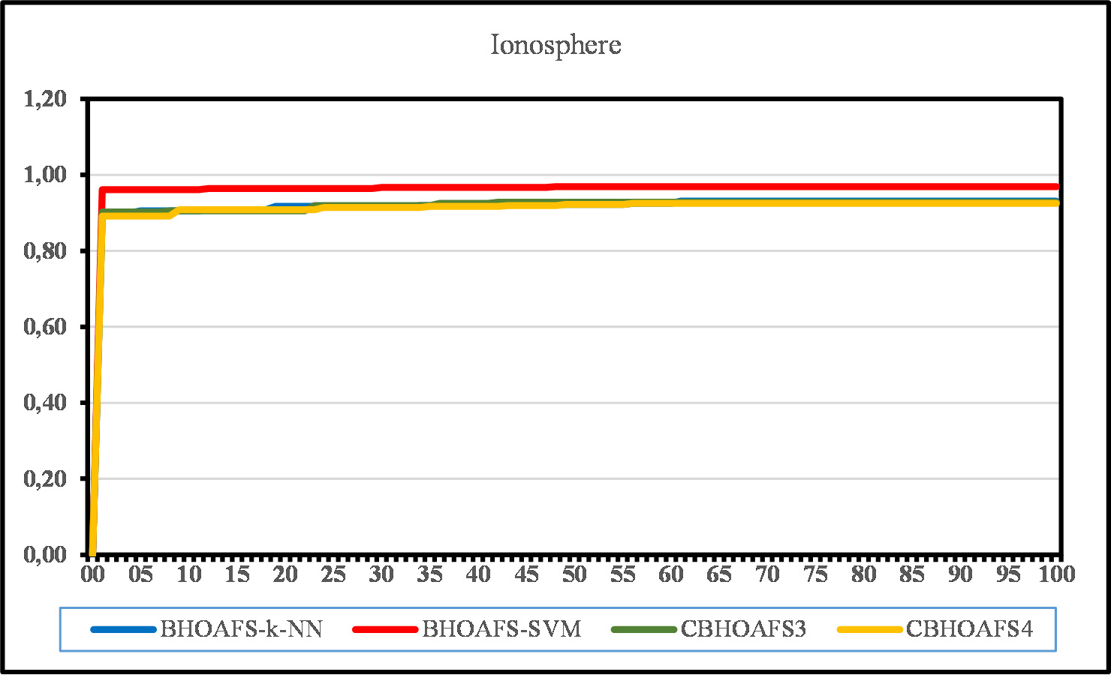

Fig. 17. Convergence Graphic for Ionosphere Dataset.

and SVM produced the same results. According to the results seen in Table 5, BHOAFS-kNN is more effective for large scale data.

The mentioned performance measure has a higher accuracy val- ue and a lower number of FS. This situation can be clearly seen in Table 6, which shows the fitness values calculated according to Eq.

16. Table 6 shows the fitness function comparison of the BHOAFS with the well-known optimization methods (GA, PSO, ALO, GWO, SSA) in the literature [69,68] for both k-NN and SVM classifiers. Wine, Vehicle, Heart, Soybean Small, Lung-Cancer, Sonar, Breast- EW, Movementlibras, Hillvalley, Clean, and CNAE datasets for BHOAFS-kNN produced lower fitness results. For BHOAFS-SVM, Hepatitis, Zoo, Breast Cancer, Ionosphere, WaveformEW, Arrhyth- mia, and Semeion datasets produced lower fitness results.

Similarly, the accuracy values of these fitness values are shown in Table 7. As can be seen in Table 7, for Vehicle, Heart, Breast Can- cer, Soybean Small, Lung-Cancer, Sonar, BreastEW, Movementli-

bras, Clean, Semeion, CNAE datasets, BHOAFS-kNN produced good results among other compared algorithms. BHOAFS-SVM pro- duced the best results for Breast Cancer, Ionosphere, Lung-Cancer, WaveformEW, Arrhythmia, and CNAE datasets.

Table 8 shows the proposed algorithm’s comparison with well- known binary optimization methods in the literature (i.e., BGA, BPSO, BALO, BGWO, BSSA). As can be seen in Table 8, for Vehicle, Heart, Breast Cancer, Soybean Small, Lung Cancer, Sonar, BreastEW, Movementlibras, Clean, Semeion, and CNAE datasets, BHOAFS-kNN produced good results among other compared algorithms. BHOAFS-SVM produced the best results for Breast Cancer, Iono- sphere, Lung-Cancer, WaveformEW, Arrhythmia, and CNAE datasets. Experimental results proved that the BHOAFS classified by k-NN (BHOAFS-kNN) outperformed the BHOAFS version classi- fied by SVM (BHOAFS-SVM).

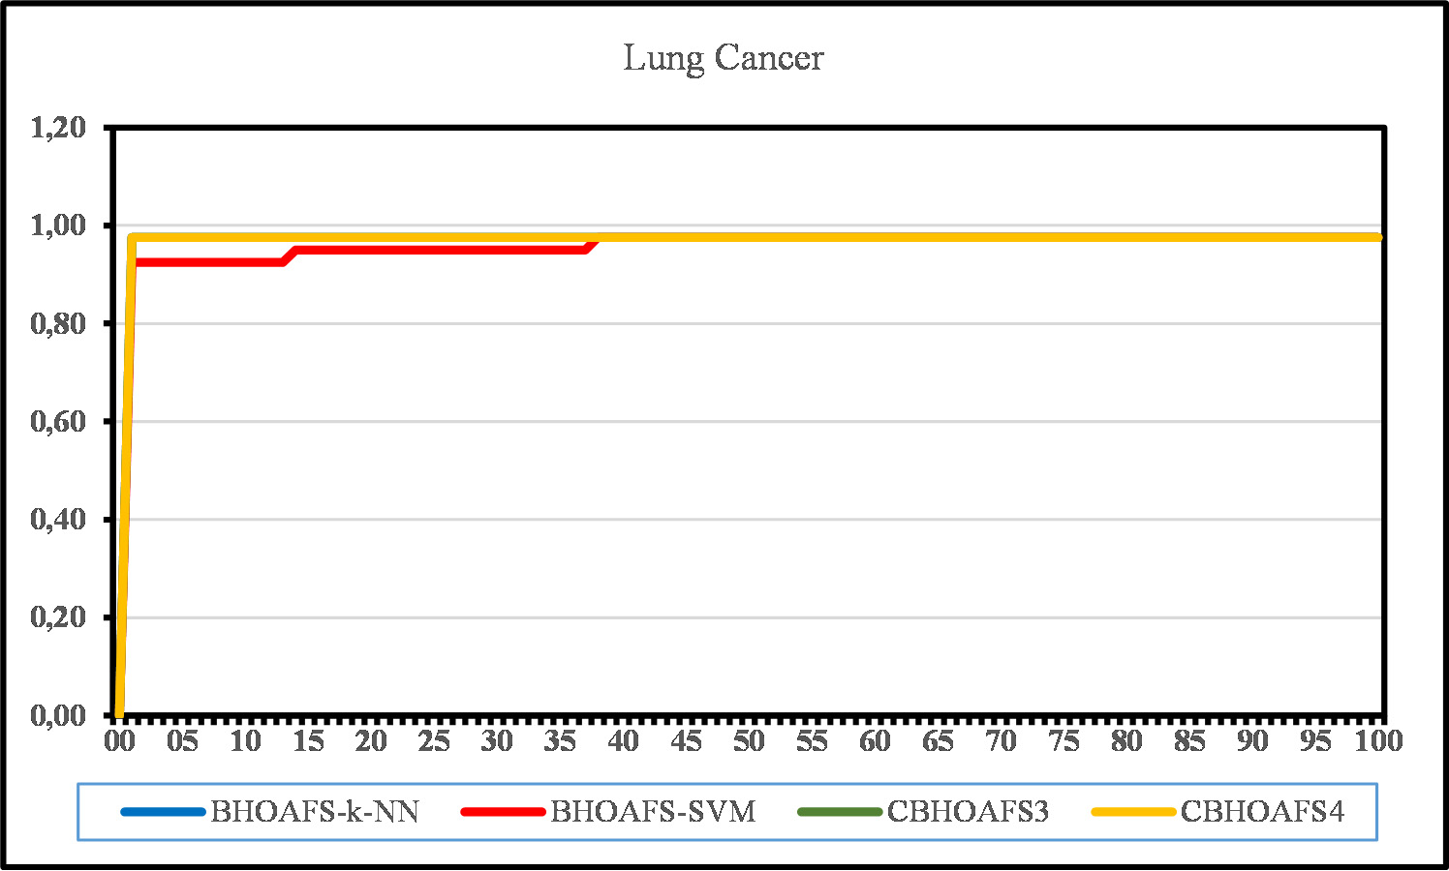

Fig. 18. Convergence Graphic for Lung Cancer Dataset.

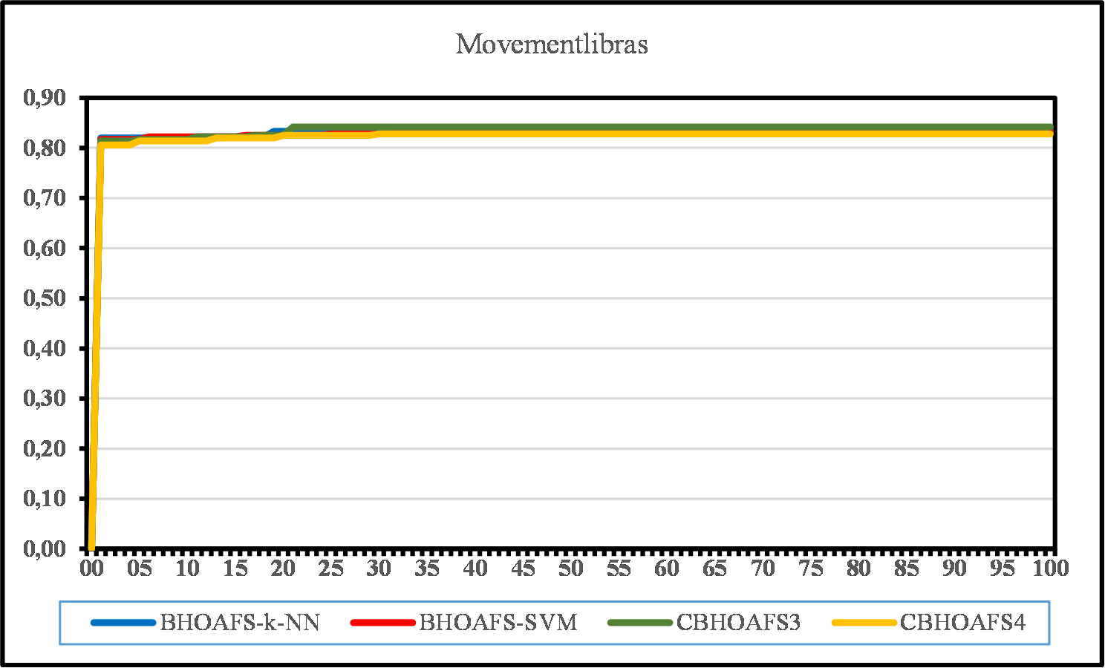

Fig. 19. Convergence Graphic for Movementlibras Dataset.

In Table 9, the comparison of the selected features of the algo- rithm can be seen in Table 10, where the running time of the algo- rithm is shown for k-NN and SVM. As can be seen in Table 9, BHOAFS-kNN has the least feature selection among the other com- pared algorithms for Wine, Hepatitis, Vehicle, Heart, Ionosphere, WaveformEW, Hillvalley, and Semeion datasets. For Zoo, Lung Can- cer, Sonar, BreastEW, Movementlibras, and Arrhythmia datasets, BHOAFS-SVM made the least feature selection. Table 10 shows that BHOAFS-SVM for Datasets for Heart, Breast Cancer, and Soybean Small datasets produces better results in less time. It was observed that the study time for some datasets was lower than previous studies [32,69]. The best results in the tables are boldfaced.

As the accuracy value increases and the number of features de- creases, the run time for some data sets is also lower than the run

times in the literature [32,69,68]. This shows that the proposed al- gorithm is multi-objective.

* + 1. *BCHOAFS results*

The performance of the five chaotic optimizers proposed in this section Logistics BHOAFS (BCHOAFS1), Tent BHOAFS (BCHOAFS2), Piecewise BHOAFS (BCHOAFS3), Singer BHOAFS (BCHOAFS4), Sinu-

soidal BHOAFS (BCHOAFS5) is given for 18 datasets. The five pro- posed algorithms are designed separately and compared with the BHOAFS-kNN proposed in the previous section with well-known optimization algorithms that solve FS problems. In this study, all experiments are performed with similar initial conditions. Table 11 shows the best accuracy values obtained during the entire iteration of the proposed BCHOAFS (i.e., BCHOAFS1, BCHOAFS2, BCHOAFS3,

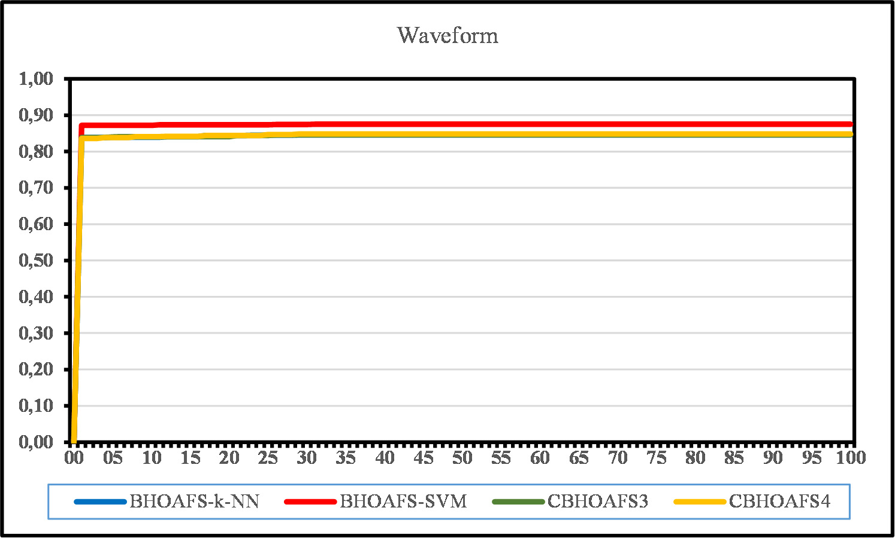

Fig. 20. Convergence Graphic for Waveform Dataset.

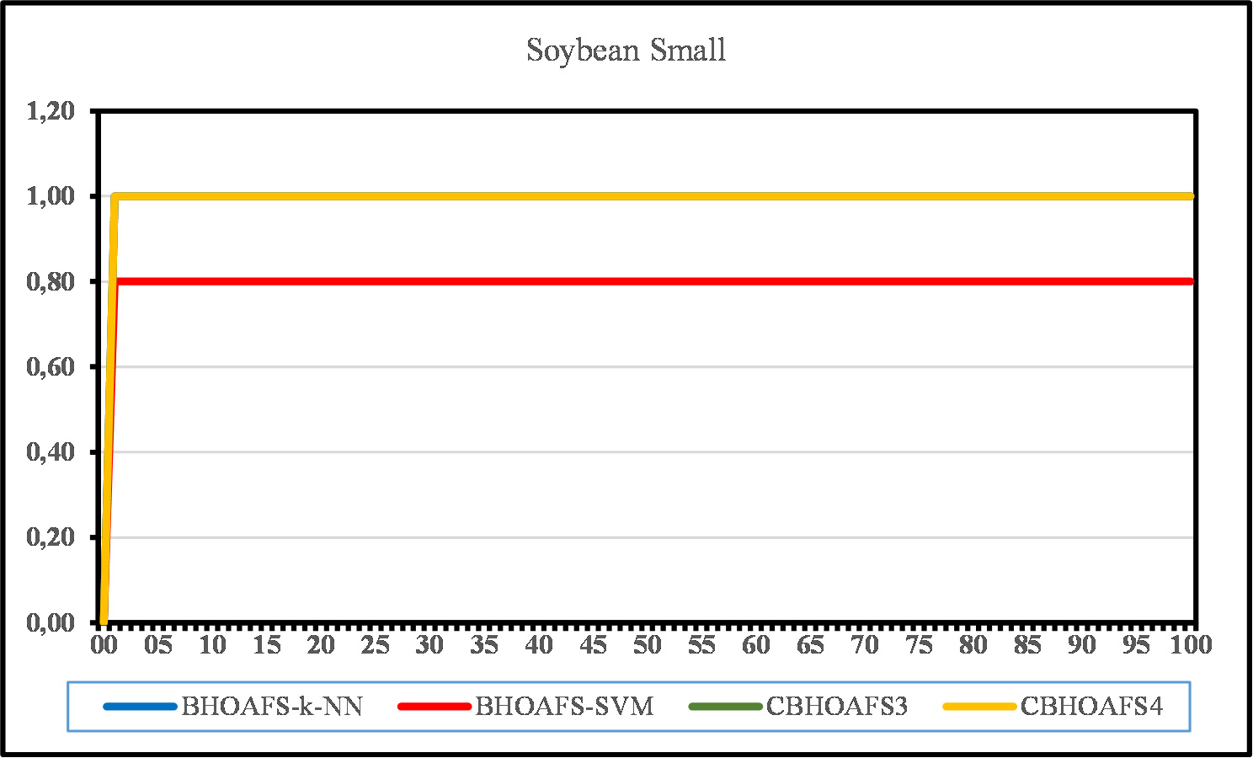

Fig. 21. Convergence Graphic for Soybean Small Dataset.

BCHOAFS4, BCHOAFS5). In approximately 70% of the datasets, the BCHOAFS3 and BCHOAFS4 yielded either better or the same results as BHOAFS-kNN. Table 12 gives information about the selected fea- ture numbers of the BCHOAFS versions. The average accuracy and the number of selected features of the BCHOAFS can be seen in Table 13. In Table 11–13, the best results are boldfaced.

When chaotic maps are ranked in terms of obtained accuracy, and the number of selected features, Piecewise and Singer chaotic maps gave the best results. In contrast, Logistic, Tent, and Sinu- soidal maps followed them. All these results prove that Piecewise and Singer Map-based BCHOAFS (BCHOAFS3 and BCHOAFS4) re- duces the number of selected features while increasing the quality compared to the proposed BCHOAFS versions.

Convergence graphics of the datasets can be shown in Fig. 6–23.

* + 1. *Friedman test results*

Hypothesis testing has been used extensively to infer the algo- rithms’ comparability [70]. To draw a conclusion, it is essential to identify the alternative hypothesis H1 and the null hypothesis H0. A claim known as the null hypothesis frequently indicates that there are no differences between the algorithms under compari- son. On the other hand, the alternative hypothesis reflects the vari- ations. For our needs: H0: The compared algorithms do not differ from one another. H1: The compared algorithms differ from one another. The statistical test probability value, which determines

ance threshold of *a* = 0.05. whether the hypothesis is rejected or not, is *a*. Our test has a toler-

*a* = 0.05 is 18.31. The null hypothesis can be rejected if the calcu- If we look at the [71] for the expected *X*2 value for df = 10 and lated value of *X*2 is higher than the expected value and the p-value

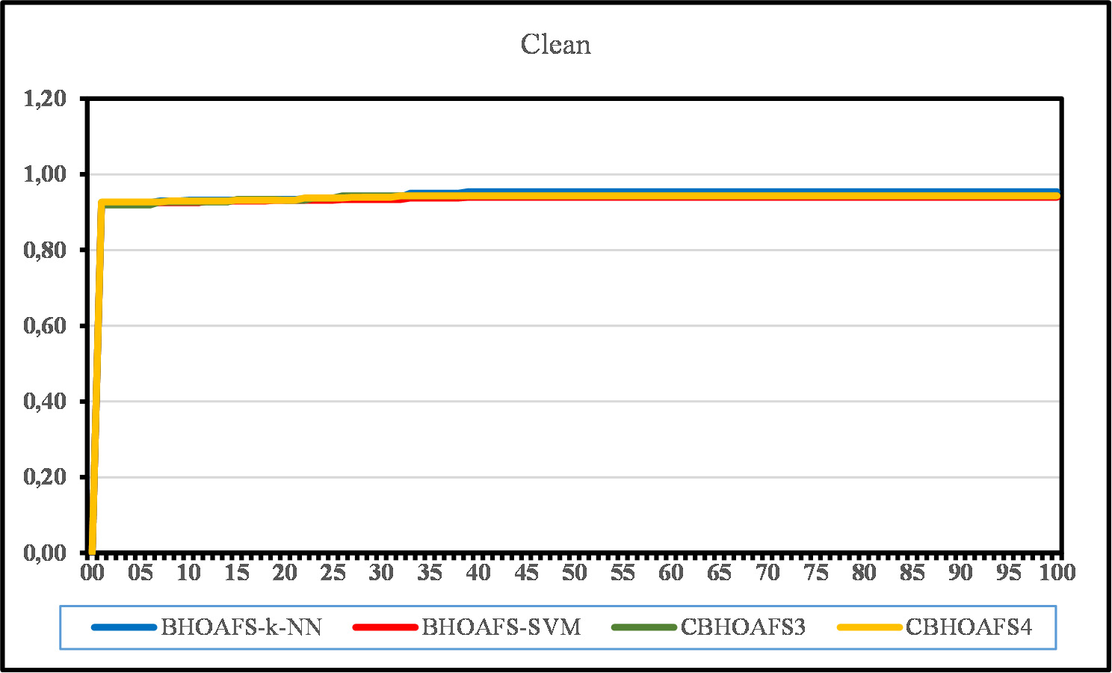

Fig. 22. Convergence Graphic for Clean Dataset.

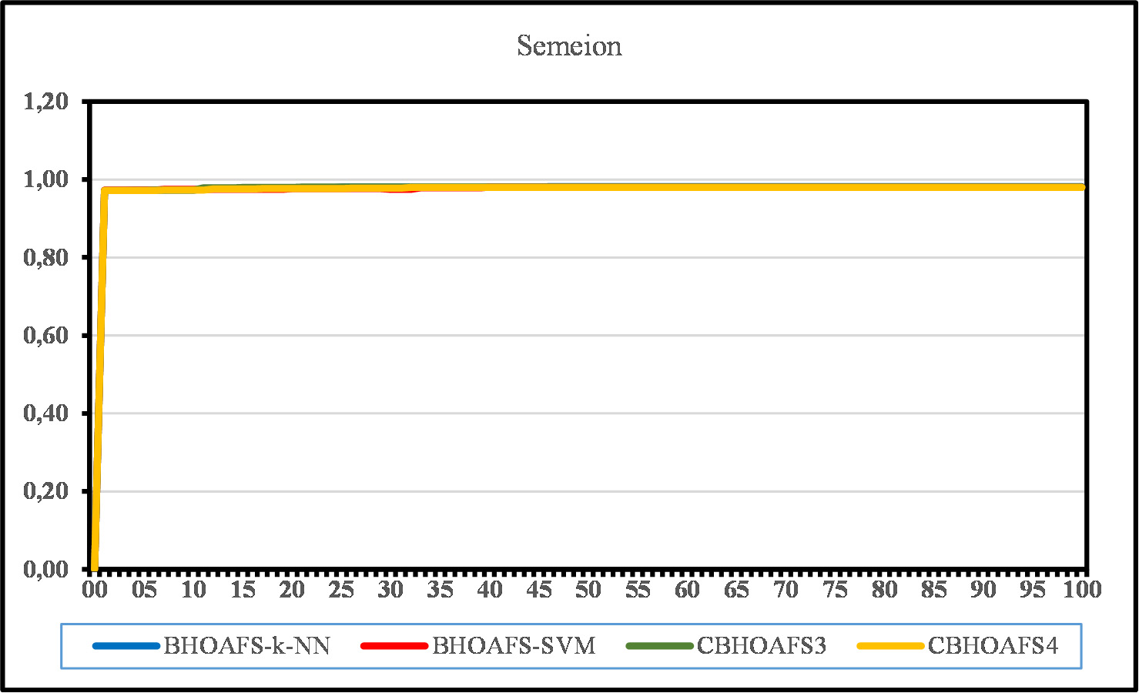

Fig. 23. Convergence Graphic for Semeion Dataset.

Table 14

Friedman test statistics of the algorithms.

Friedman test statistics

|  |  |
| --- | --- |
| N | 17 |
| Chi-Square *X*2 | 55.611 |
| df | 10 |
| p | 2.4274*E* — 8 |

is smaller than the *a* = 0.5. We can see in Table 14 the calculated value of *X*2 is 55.611 and *p* = 2.4274*E* — 8, which the calculated *X*2 is higher than the expected value and p is smaller than the *a*.

That means the null hypothesis must be rejected. We can say that our proposed algorithms are different than the compared algorithms.

* + 1. *Wilcoxon test results*

For the Wilcoxon test, the differences in the algorithms are de- scribed by p values. If the p-value is lower than the significance

value *a* = 0.05, we can say that the results of the algorithms are

different from the compared algorithms. If the p-value is higher,

that means the algorithm has similar results.

significance value *a* = 0.05, which means that our proposed algo- We can see in the Table 15 that p values are smaller than the rithm has different results than most of the compared algorithms.

In the case of the BSSA algorithm, the proposed algorithm has sim- ilar results. However, if we look at the accuracy results in Table 7 and Table 11, we can see our proposed algorithm has yielded better results.

Table 15

p-Values for the Wilcoxon signed-rank test.

|  |  |  |  |  |  |  |  |  |  |  |  |
| --- | --- | --- | --- | --- | --- | --- | --- | --- | --- | --- | --- |
| Algorithm | BHOAFS-kNN | BCHOAFS1 | BCHOAFS2 | BCHOAFS3 | BCHOAFS4 | BCHOAFS5 | BGA | BPSO | BALO | BGWO | BSSA |
| BHOAFS-kNN | 1 | 0.646 | 0.328 | 0.594 | 0.050 | 0.388 | 0.022 | 0.006 | 0.010 | 0.009 | 0.177 |
| BCHOAFS1 |  | 1 | 0.176 | 0.484 | 0.433 | 0.674 | 0.017 | 0.004 | 0.010 | 0.007 | 0.149 |
| BCHOAFS2 |  |  | 1 | 0.161 | 0.790 | 0.612 | 0.025 | 0.006 | 0.011 | 0.010 | 0.163 |
| BCHOAFS3 |  |  |  | 1 | 0.328 | 0.398 | 0.019 | 0.006 | 0.010 | 0.010 | 0.163 |
| BCHOAFS4 |  |  |  |  | 1 | 0.534 | 0.022 | 0.007 | 0.015 | 0.011 | 0.227 |
| BCHOAFS5 |  |  |  |  |  | 1 | 0.022 | 0.006 | 0.011 | 0.009 | 0.136 |

1. Conclusions

This article proposes the binary version of HOA, which mimics the life cycles and searching behaviors of horses, has been applied to a wrapper-based FS problem using classification algorithms (BHOAFS-kNN and BHOAFS-SVM). Experimental results show that BHOAFS-kNN results outperform BHOAFS-SVM. Then BHOAFS- kNN was combined with five chaotic maps and named as BCHOAFS-Logistics (BCHOAFS1), BCHOAFS - Tent (BCHOAFS2), BCHOAFS - Piecewise (BCHOAFS3), BCHOAFS - Singer (BCHOAFS4),

and BCHOAFS - Sinusoidal (BCHOAFS5). The Age Determination process used in the proposed algorithm allows the horses to do a global search in the search space. The SMF operator, which is pro- posed as a local search technique, has been developed to overcome the disadvantages, such as early convergence while preserving population diversity. A comprehensive study was conducted using 18 standard datasets from the UCI repository of varying sizes and characters to evaluate the effectiveness of the proposed BHOAFS and BCHOAFS versions. The performance of the proposed methods was compared with various methods such as well-known opti- mization algorithms in the literature such as GA, PSO, ALO, GWO, SSA [69], and binary optimization algorithms such as BGA, BPSO, BALO, BGWO, and BSSA [68]. When the FS problem is considered a multi-objective problem, the classification accuracy should be at the highest level, and the number of selected features should be at the lowest level. When the results were examined, the best performance among the recommended algorithms was found to belong to BCHOAFS3 and BCHOAFS4 algorithms (BCHOAFS- Piecewise and BCHOAFS-Singer) in terms of classification accuracy and FS.

In general, applying chaotic maps to optimization algorithms is easy and practical. According to this study, chaotic maps can im- prove results when applied to previously proposed algorithms. The main reason for this improvement is that the algorithm can be compared more accurately since the initial conditions are de- signed in advance. Thus, bit-changing operations during the itera- tion will result in more specific exploitation and exploration, and a balance will be established between the algorithm’s local and glob- al search operations. Taking full advantage of this situation, our proposed algorithm proves that chaotic maps are one of the best enhancement options for currently proposed algorithms when the results obtained are examined. Based on the promising results of BCHOAFS, there is enough evidence to compare its performance with similar methods.

Finally, the results show that the proposed BCHOAFS achieves high competitive results and can be expressed as a multi- objective optimization problem. The most important result of this study is that BCHOAFS versions are useful in systems that require FS preprocessing, as it is the first chaotic-based algorithm designed specifically for large scale data among optimization-based feature selection algorithms. When the SMF operator designed as a local search strategy and chaotic maps are combined, the results prove the novelty of the proposed algorithm.

Declaration of Competing Interest

The authors declare that they have no known competing finan- cial interests or personal relationships that could have appeared to influence the work reported in this paper.

References

1. J.N.P., R. Aruna, Big data analytics in health care by data mining and classification techniques, ICT Express 8 (2) (2022) 250–257. doi: 10.1016/j. icte.2021.07.001. URL: [https://linkinghub.elsevier.com/retrieve/pii/](https://linkinghub.elsevier.com/retrieve/pii/S2405959521000849) [S2405959521000849](https://linkinghub.elsevier.com/retrieve/pii/S2405959521000849).
2. B.H. Nguyen, B. Xue, M. Zhang, A survey on swarm intelligence approaches to feature selection in data mining, Swarm Evolut. Comput. 54 (2020), [https://doi.](https://doi.org/10.1016/j.swevo.2020.100663) [org/10.1016/j.swevo.2020.100663](https://doi.org/10.1016/j.swevo.2020.100663). URL: [https://linkinghub.elsevier.com/](https://linkinghub.elsevier.com/retrieve/pii/S2210650219303104) [retrieve/pii/S2210650219303104](https://linkinghub.elsevier.com/retrieve/pii/S2210650219303104) 100663.
3. H.R. Kanan, K. Faez, An improved feature selection method based on ant colony optimization (ACO) evaluated on face recognition system, Appl. Math. Comput.

205 (2) (2008) 716–725, <https://doi.org/10.1016/j.amc.2008.05.115>. URL:

<https://linkinghub.elsevier.com/retrieve/pii/S0096300308003500>.

1. H. Uguz, A two-stage feature selection method for text categorization by using information gain, principal component analysis and genetic algorithm, Knowl.- Based Syst. 24 (7) (2011) 1024–1032, [https://doi.org/10.1016/](https://doi.org/10.1016/j.knosys.2011.04.014) [j.knosys.2011.04.014](https://doi.org/10.1016/j.knosys.2011.04.014). URL: [https://linkinghub.elsevier.com/retrieve/pii/](https://linkinghub.elsevier.com/retrieve/pii/S0950705111000803) [S0950705111000803](https://linkinghub.elsevier.com/retrieve/pii/S0950705111000803).
2. A.K. Shukla, P. Singh, M. Vardhan, A hybrid gene selection method for microarray recognition, Biocybern. Biomed. Eng. 38 (4) (2018) 975–991, <https://doi.org/10.1016/j.bbe.2018.08.004>. URL: [https://linkinghub.](https://linkinghub.elsevier.com/retrieve/pii/S0208521618302316) [elsevier.com/retrieve/pii/S0208521618302316](https://linkinghub.elsevier.com/retrieve/pii/S0208521618302316).
3. P.D. Sheth, S.T. Patil, M.L. Dhore, Evolutionary computing for clinical dataset classification using a novel feature selection algorithm, J. King Saud Univ. – Comput. Inform. Sci. 34 (8) (2022) 5075–5082, [https://doi.org/10.1016/j.](https://doi.org/10.1016/j.jksuci.2020.12.012) [jksuci.2020.12.012](https://doi.org/10.1016/j.jksuci.2020.12.012). URL: [https://linkinghub.elsevier.com/retrieve/pii/](https://linkinghub.elsevier.com/retrieve/pii/S1319157820306200) [S1319157820306200](https://linkinghub.elsevier.com/retrieve/pii/S1319157820306200).
4. N. Khare, P. Devan, C. Chowdhary, S. Bhattacharya, G. Singh, S. Singh, B. Yoon, SMO-DNN: Spider Monkey Optimization and Deep Neural Network Hybrid Classifier Model for Intrusion Detection, Electronics 9 (4) (2020) 692, [https://](https://doi.org/10.3390/electronics9040692) [doi.org/10.3390/electronics9040692](https://doi.org/10.3390/electronics9040692). URL: [https://www.mdpi.com/2079-](https://www.mdpi.com/2079-9292/9/4/692) [9292/9/4/692](https://www.mdpi.com/2079-9292/9/4/692).
5. A. Jovic, K. Brkic, N. Bogunovic, A review of feature selection methods with applications, in: 2015 38th International Convention on Information and Communication Technology, Electronics and Microelectronics (MIPRO), IEEE, Opatija, Croatia, 2015, pp. 1200–1205. doi: 10.1109/MIPRO.2015.7160458.

URL: <http://ieeexplore.ieee.org/document/7160458/>.

1. N. Sánchez-Maroño, A. Alonso-Betanzos, M. Tombilla-Sanromán, Filter Methods for Feature Selection – A Comparative Study, in: H. Yin, P. Tino, E. Corchado, W. Byrne, X. Yao (Eds.), Intelligent Data Engineering and Automated Learning – IDEAL 2007, vol. 4881, Springer, Berlin Heidelberg, Berlin, Heidelberg, 2007, pp. 178–187. doi: 10.1007/978-3-540-77226-_19. URL:

<http://link.springer.com/10.1007/978-3-540-77226-2_19>.

1. R. Kohavi, G.H. John, Wrappers for feature subset selection, Artif. Intell. 97 (1– 2) (1997) 273–324, <https://doi.org/10.1016/S0004-3702(97)00043-X>. URL:

<https://linkinghub.elsevier.com/retrieve/pii/S000437029700043X>.

1. Z. Liu, B. Chang, F. Cheng, An interactive filter-wrapper multi-objective evolutionary algorithm for feature selection, Swarm Evolut. Comput. 65 (2021), <https://doi.org/10.1016/j.swevo.2021.100925>. URL: [https://](https://linkinghub.elsevier.com/retrieve/pii/S2210650221000869) [linkinghub.elsevier.com/retrieve/pii/S2210650221000869](https://linkinghub.elsevier.com/retrieve/pii/S2210650221000869) 100925.
2. H. Liu, H. Motoda, R. Setiono, Z. Zhao, Feature Selection: An Ever Evolving Frontier in Data Mining, in: Proceedings of the Fourth International Workshop on Feature Selection in Data Mining 10, 2010, pp. 4–13. URL: [https://](https://proceedings.mlr.press/v10/liu10b.html) [proceedings.mlr.press/v10/liu10b.html](https://proceedings.mlr.press/v10/liu10b.html).
3. H. Faris, A.A. Heidari, A.M. Al-Zoubi, M. Mafarja, I. Aljarah, M. Eshtay, S. Mirjalili, Time-varying hierarchical chains of salps with random weight networks for feature selection, Expert Syst. Appl. 140 (2020), [https://doi.org/](https://doi.org/10.1016/j.eswa.2019.112898) [10.1016/j.eswa.2019.112898](https://doi.org/10.1016/j.eswa.2019.112898). URL: [https://linkinghub.elsevier.com/retrieve/](https://linkinghub.elsevier.com/retrieve/pii/S0957417419306141) [pii/S0957417419306141](https://linkinghub.elsevier.com/retrieve/pii/S0957417419306141) 112898.
4. S. Garg, K. Kaur, N. Kumar, G. Kaddoum, A.Y. Zomaya, R. Ranjan, A Hybrid Deep Learning-Based Model for Anomaly Detection in Cloud Datacenter Networks,

IEEE Trans. Netw. Serv. Manage. 16 (3) (2019) 924–935, [https://doi.org/](https://doi.org/10.1109/TNSM.2019.2927886) [10.1109/TNSM.2019.2927886](https://doi.org/10.1109/TNSM.2019.2927886). URL: [https://ieeexplore.ieee.org/document/](https://ieeexplore.ieee.org/document/8758843/) [8758843/](https://ieeexplore.ieee.org/document/8758843/).

1. P. Moradi, M. Gholampour, A hybrid particle swarm optimization for feature subset selection by integrating a novel local search strategy, Appl. Soft Comput. 43 (2016) 117–130, <https://doi.org/10.1016/j.asoc.2016.01.044>. URL: <https://linkinghub.elsevier.com/retrieve/pii/S1568494616300321>.
2. X. Xia, L. Gui, F. Yu, H. Wu, B. Wei, Y.L. Zhang, Z.H. Zhan, Triple Archives Particle Swarm Optimization, IEEE Trans. Cybern. 50 (12) (2020) 4862–4875, [https://](https://doi.org/10.1109/TCYB.2019.2943928) [doi.org/10.1109/TCYB.2019.2943928](https://doi.org/10.1109/TCYB.2019.2943928). URL: [https://ieeexplore.ieee.](https://ieeexplore.ieee.org/document/8866749/) [org/document/8866749/](https://ieeexplore.ieee.org/document/8866749/).
3. B. Wei, X. Xia, F. Yu, Y. Zhang, X. Xu, H. Wu, L. Gui, G. He, Multiple adaptive strategies based particle swarm optimization algorithm, Swarm Evolut. Comput. 57 (2020), <https://doi.org/10.1016/j.swevo.2020.100731>. URL:

<https://linkinghub.elsevier.com/retrieve/pii/S2210650220303849> 100731.

1. L. Brezocnik, I. Fister, V. Podgorelec, Swarm Intelligence Algorithms for Feature Selection: A Review, Appl. Sci. 8 (9) (2018) 1521, [https://doi.org/10.3390/](https://doi.org/10.3390/app8091521) [app8091521](https://doi.org/10.3390/app8091521). URL: <https://www.mdpi.com/2076-3417/8/9/1521>.
2. P. Ghamisi, J.A. Benediktsson, Feature Selection Based on Hybridization of Genetic Algorithm and Particle Swarm Optimization, IEEE Geosci. Remote Sens. Lett. 12 (2) (2015) 309–313, [https://doi.org/10.1109/](https://doi.org/10.1109/LGRS.2014.2337320) [LGRS.2014.2337320](https://doi.org/10.1109/LGRS.2014.2337320). URL: <https://ieeexplore.ieee.org/document/6866865>.
3. X. Han, X. Chang, L. Quan, X. Xiong, J. Li, Z. Zhang, Y. Liu, Feature subset selection by gravitational search algorithm optimization, Inf. Sci. 281 (2014) 128–146, <https://doi.org/10.1016/j.ins.2014.05.030>. URL: [https://linkinghub.](https://linkinghub.elsevier.com/retrieve/pii/S0020025514005829) [elsevier.com/retrieve/pii/S0020025514005829](https://linkinghub.elsevier.com/retrieve/pii/S0020025514005829).
4. S. Medjahed, T. Ait Saadi, A. Benyettou, M. Ouali, Gray Wolf Optimizer for hyperspectral band selection, Appl. Soft Comput. 40 (2016) 178–186, [https://](https://doi.org/10.1016/j.asoc.2015.09.045) [doi.org/10.1016/j.asoc.2015.09.045](https://doi.org/10.1016/j.asoc.2015.09.045). URL: [https://linkinghub.elsevier.com/](https://linkinghub.elsevier.com/retrieve/pii/S1568494615006250) [retrieve/pii/S1568494615006250](https://linkinghub.elsevier.com/retrieve/pii/S1568494615006250).
5. Q. Al-Tashi, S.J. Abdul Kadir, H.M. Rais, S. Mirjalili, H. Alhussian, Binary Optimization Using Hybrid Grey Wolf Optimization for Feature Selection, IEEE Access 7 (2019) 39496–39508, <https://doi.org/10.1109/ACCESS.2019.2906757>.

URL: <https://ieeexplore.ieee.org/document/8672550/>.

1. [L. Mohammad, Q. Abualigah, Feature selection and enhanced krill herd](http://refhub.elsevier.com/S2215-0986(23)00131-3/h0115) [algorithm for text document clustering,](http://refhub.elsevier.com/S2215-0986(23)00131-3/h0115) [Springer, Berlin Heidelberg, New](http://refhub.elsevier.com/S2215-0986(23)00131-3/h0115) [York, NY, 2019](http://refhub.elsevier.com/S2215-0986(23)00131-3/h0115).
2. M.M. Kabir, M. Shahjahan, K. Murase, A new hybrid ant colony optimization algorithm for feature selection, Expert Syst. Appl. 39 (3) (2012) 3747–3763, <https://doi.org/10.1016/j.eswa.2011.09.073>. URL: [https://linkinghub.](https://linkinghub.elsevier.com/retrieve/pii/S0957417411013960) [elsevier.com/retrieve/pii/S0957417411013960](https://linkinghub.elsevier.com/retrieve/pii/S0957417411013960).
3. R.Y.M. Nakamura, L.A.M. Pereira, D. Rodrigues, K.A.P. Costa, J.P. Papa, X.S. Yang, Binary Bat Algorithm for Feature Selection, in, Swarm Intelligence and Bio- Inspired Computation, Elsevier (2013) 225–237, [https://doi.org/10.1016/](https://doi.org/10.1016/B978-0-12-405163-8.00009-0) [B978-0-12-405163-8.00009-0](https://doi.org/10.1016/B978-0-12-405163-8.00009-0). URL: [https://linkinghub.elsevier.com/](https://linkinghub.elsevier.com/retrieve/pii/B9780124051638000090) [retrieve/pii/B9780124051638000090](https://linkinghub.elsevier.com/retrieve/pii/B9780124051638000090).
4. M. Mafarja, I. Aljarah, H. Faris, A.I. Hammouri, A.M. Al-Zoubi, S. Mirjalili, Binary grasshopper optimisation algorithm approaches for feature selection problems, Expert Syst. Appl. 117 (2019) 267–286, [https://doi.org/10.1016/j.](https://doi.org/10.1016/j.eswa.2018.09.015) [eswa.2018.09.015](https://doi.org/10.1016/j.eswa.2018.09.015). URL: [https://linkinghub.elsevier.com/retrieve/pii/](https://linkinghub.elsevier.com/retrieve/pii/S0957417418305864) [S0957417418305864](https://linkinghub.elsevier.com/retrieve/pii/S0957417418305864).
5. L. Abualigah, D. Yousri, M. Abd Elaziz, A.A. Ewees, M.A. Al-qaness, A.H. Gandomi, Aquila Optimizer: A novel meta-heuristic optimization algorithm, Comput. Ind. Eng. 157 (2021), <https://doi.org/10.1016/j.cie.2021.107250>. URL: <https://linkinghub.elsevier.com/retrieve/pii/S0360835221001546> 107250.
6. M. Tubishat, N. Idris, L. Shuib, M.A. Abushariah, S. Mirjalili, Improved Salp Swarm Algorithm based on opposition based learning and novel local search algorithm for feature selection, Expert Syst. Appl. 145 (2020), [https://doi.org/](https://doi.org/10.1016/j.eswa.2019.113122) [10.1016/j.eswa.2019.113122](https://doi.org/10.1016/j.eswa.2019.113122). URL: [https://linkinghub.elsevier.com/retrieve/](https://linkinghub.elsevier.com/retrieve/pii/S0957417419308395) [pii/S0957417419308395](https://linkinghub.elsevier.com/retrieve/pii/S0957417419308395) 113122.
7. M. Tubishat, S. Ja’afar, M. Alswaitti, S. Mirjalili, N. Idris, M.A. Ismail, M.S. Omar, Dynamic Salp swarm algorithm for feature selection, Expert Syst. Appl. 164 (2021), <https://doi.org/10.1016/j.eswa.2020.113873>. URL: [https://linkinghub.](https://linkinghub.elsevier.com/retrieve/pii/S0957417420306801) [elsevier.com/retrieve/pii/S0957417420306801](https://linkinghub.elsevier.com/retrieve/pii/S0957417420306801) 113873.
8. D. Rodrigues, V.H.C. de Albuquerque, J.P. Papa, A multi-objective artificial butterfly optimization approach for feature selection, Appl. Soft Comput. 94 (2020), <https://doi.org/10.1016/j.asoc.2020.106442>. URL: [https://linkinghub.](https://linkinghub.elsevier.com/retrieve/pii/S1568494620303823) [elsevier.com/retrieve/pii/S1568494620303823](https://linkinghub.elsevier.com/retrieve/pii/S1568494620303823) 106442.
9. P.S., F. Al-Turjman, T. Stephan, An automated breast cancer diagnosis using feature selection and parameter optimization in ANN, Comput. Electr. Eng. 90 (2021) 106958. doi: 10.1016/j.compeleceng.2020.106958. URL: [https://](https://linkinghub.elsevier.com/retrieve/pii/S0045790620308041) [linkinghub.elsevier.com/retrieve/pii/S0045790620308041](https://linkinghub.elsevier.com/retrieve/pii/S0045790620308041)
10. E. Bas, E. Ülker, An efficient binary social spider algorithm for feature selection problem, Expert Syst. Appl. 146 (2020), [https://doi.org/10.1016/j.](https://doi.org/10.1016/j.eswa.2020.113185) [eswa.2020.113185](https://doi.org/10.1016/j.eswa.2020.113185). URL: [https://linkinghub.elsevier.com/retrieve/pii/](https://linkinghub.elsevier.com/retrieve/pii/S0957417420300117) [S0957417420300117](https://linkinghub.elsevier.com/retrieve/pii/S0957417420300117) 113185.
11. H. Hichem, M. Rafik, M.T. Mesaaoud, Pso with crossover operator applied to feature selection problem in classification, Informatica 42(2) (2018) 189–198. URL: <https://www.informatica.si/index.php/informatica/article/view/1373>.
12. [A. Dasgupta, A. Banerjee, A.G. Dastidar, A. Barman, S. Chakraborty, A Study and](http://refhub.elsevier.com/S2215-0986(23)00131-3/h0170) [Analysis of a Feature Subset Selection Technique Using Penguin Search](http://refhub.elsevier.com/S2215-0986(23)00131-3/h0170) [Optimization Algorithm,](http://refhub.elsevier.com/S2215-0986(23)00131-3/h0170) [Data Science, CRC Press, in, 2019, pp. 47–65](http://refhub.elsevier.com/S2215-0986(23)00131-3/h0170).
13. E. Hancer, B. Xue, M. Zhang, D. Karaboga, B. Akay, Pareto front feature selection based on artificial bee colony optimization, Inf. Sci. 422 (2018) 462–479,

<https://doi.org/10.1016/j.ins.2017.09.028>. URL: [https://linkinghub.](https://linkinghub.elsevier.com/retrieve/pii/S0020025516312609) [elsevier.com/retrieve/pii/S0020025516312609](https://linkinghub.elsevier.com/retrieve/pii/S0020025516312609).

1. M. Canayaz, MH-COVIDNet: Diagnosis of COVID-19 using deep neural networks and meta-heuristic-based feature selection on X-ray images, Biomed. Signal Process. Control 64 (2021), [https://doi.org/10.1016/j.](https://doi.org/10.1016/j.bspc.2020.102257) [bspc.2020.102257](https://doi.org/10.1016/j.bspc.2020.102257). URL: [https://linkinghub.elsevier.com/retrieve/pii/](https://linkinghub.elsevier.com/retrieve/pii/S1746809420303840) [S1746809420303840](https://linkinghub.elsevier.com/retrieve/pii/S1746809420303840) 102257.
2. K.K. Ghosh, S. Ahmed, P.K. Singh, Z.W. Geem, R. Sarkar, Improved Binary Sailfish Optimizer Based on Adaptive *b*) -Hill Climbing for Feature Selection, IEEE Access 8 (2020) 83548–83560, [https://doi.org/10.1109/](https://doi.org/10.1109/ACCESS.2020.2991543) [ACCESS.2020.2991543](https://doi.org/10.1109/ACCESS.2020.2991543). URL: <https://ieeexplore.ieee.org/document/9082591/>.
3. G.I. Sayed, A. Tharwat, A.E. Hassanien, Chaotic dragonfly algorithm: an improved metaheuristic algorithm for feature selection, Appl. Intell. 49 (1) (2019) 188–205, <https://doi.org/10.1007/s10489-018-1261-8>. URL: [http://](http://link.springer.com/10.1007/s10489-018-1261-8) [link.springer.com/10.1007/s10489-018-1261-8](http://link.springer.com/10.1007/s10489-018-1261-8).
4. Shokooh Taghian, M.H. Nadimi-Shahraki, A Binary Metaheuristic Algorithm for Wrapper Feature Selection, Int. J. Comput. Sci. Eng. (IJCSE). doi: 10.13140/ RG.2.2.34937.90722. URL: <http://rgdoi.net/10.13140/RG.2.2.34937.90722>.
5. J. Piri, P. Mohapatra, An analytical study of modified multi-objective Harris Hawk Optimizer towards medical data feature selection, Comput. Biol. Med.

135 (2021), <https://doi.org/10.1016/j.compbiomed.2021.104558>. URL:

<https://linkinghub.elsevier.com/retrieve/pii/S0010482521003528> 104558.

1. J. Hu, W. Gui, A.A. Heidari, Z. Cai, G. Liang, H. Chen, Z. Pan, Dispersed foraging slime mould algorithm: Continuous and binary variants for global optimization and wrapper-based feature selection, Knowl.-Based Syst. 237 (2022), <https://doi.org/10.1016/j.knosys.2021.107761>. URL: [https://](https://linkinghub.elsevier.com/retrieve/pii/S0950705121009850) [linkinghub.elsevier.com/retrieve/pii/S0950705121009850](https://linkinghub.elsevier.com/retrieve/pii/S0950705121009850) 107761.
2. B. Nouri-Moghaddam, M. Ghazanfari, M. Fathian, A novel multi-objective forest optimization algorithm for wrapper feature selection, Expert Syst. Appl.

175 (2021), <https://doi.org/10.1016/j.eswa.2021.114737>. URL: [https://](https://linkinghub.elsevier.com/retrieve/pii/S0957417421001780)

[linkinghub.elsevier.com/retrieve/pii/S0957417421001780](https://linkinghub.elsevier.com/retrieve/pii/S0957417421001780) 114737.

1. S. Akila, S. Allin Christe, A wrapper based binary bat algorithm with greedy crossover for attribute selection, Expert Syst. Appl. 187 (2022), [https://doi.org/](https://doi.org/10.1016/j.eswa.2021.115828) [10.1016/j.eswa.2021.115828](https://doi.org/10.1016/j.eswa.2021.115828). URL: [https://linkinghub.elsevier.com/retrieve/](https://linkinghub.elsevier.com/retrieve/pii/S0957417421011933) [pii/S0957417421011933](https://linkinghub.elsevier.com/retrieve/pii/S0957417421011933) 115828.
2. P. Srinivasa Rao, A. Sravan Kumar, Q. Niyaz, P. Sidike, V.K. Devabhaktuni, Binary chemical reaction optimization based feature selection techniques for machine learning classification problems, Expert Syst. Appl. 167 (2021), <https://doi.org/10.1016/j.eswa.2020.114169>. URL: [https://linkinghub.](https://linkinghub.elsevier.com/retrieve/pii/S0957417420309076) [elsevier.com/retrieve/pii/S0957417420309076](https://linkinghub.elsevier.com/retrieve/pii/S0957417420309076) 114169.
3. W. Ali, A.A. Ahmed, Hybrid intelligent phishing website prediction using deep neural networks with genetic algorithm-based feature selection and weighting, IET Inf. Secur. 13 (6) (2019) 659–669, [https://doi.org/10.1049/iet-](https://doi.org/10.1049/iet-ifs.2019.0006) [ifs.2019.0006](https://doi.org/10.1049/iet-ifs.2019.0006). URL: [https://onlinelibrary.wiley.com/doi/10.1049/iet-ifs.2019.](https://onlinelibrary.wiley.com/doi/10.1049/iet-ifs.2019.0006) [0006](https://onlinelibrary.wiley.com/doi/10.1049/iet-ifs.2019.0006).
4. A. Got, A. Moussaoui, D. Zouache, Hybrid filter-wrapper feature selection using whale optimization algorithm: A multi-objective approach, Expert Syst. Appl.

183 (2021), <https://doi.org/10.1016/j.eswa.2021.115312>. URL: [https://](https://linkinghub.elsevier.com/retrieve/pii/S0957417421007417)

[linkinghub.elsevier.com/retrieve/pii/S0957417421007417](https://linkinghub.elsevier.com/retrieve/pii/S0957417421007417) 115312.

1. Y. Zhang, D.w. Gong, X.z. Gao, T. Tian, X.y. Sun, Binary differential evolution with self-learning for multi-objective feature selection, Inform. Sci. 507 (2020) 67–85. doi: 10.1016/j.ins.2019.08.040. URL: [https://linkinghub.elsevier.com/](https://linkinghub.elsevier.com/retrieve/pii/S0020025519307819) [retrieve/pii/S0020025519307819](https://linkinghub.elsevier.com/retrieve/pii/S0020025519307819).
2. F. MiarNaeimi, G. Azizyan, M. Rashki, Horse herd optimization algorithm: A nature-inspired algorithm for high-dimensional optimization problems, Knowl.-Based Syst. 213 (2021), [https://doi.org/10.1016/](https://doi.org/10.1016/j.knosys.2020.106711) [j.knosys.2020.106711](https://doi.org/10.1016/j.knosys.2020.106711). URL: [https://linkinghub.elsevier.com/retrieve/pii/](https://linkinghub.elsevier.com/retrieve/pii/S0950705120308406) [S0950705120308406](https://linkinghub.elsevier.com/retrieve/pii/S0950705120308406) 106711.
3. A. Chaudhuri, T.P. Sahu, Binary Jaya algorithm based on binary similarity measure for feature selection, J. Ambient Intell. Humaniz. Comput. 13 (12) (2022) 5627–5644, <https://doi.org/10.1007/s12652-021-03226-5>. URL:

<https://link.springer.com/10.1007/s12652-021-03226-5>.

1. A. Chaudhuri, T.P. Sahu, A hybrid feature selection method based on Binary Jaya algorithm for micro-array data classification, Comput. Electr. Eng. 90 (2021), <https://doi.org/10.1016/j.compeleceng.2020.106963>. URL: [https://](https://linkinghub.elsevier.com/retrieve/pii/S0045790620308089) [linkinghub.elsevier.com/retrieve/pii/S0045790620308089](https://linkinghub.elsevier.com/retrieve/pii/S0045790620308089) 106963.
2. M. Abdel-Basset, K.M. Sallam, R. Mohamed, I. Elgendi, K. Munasinghe, O.M. Elkomy, An improved binary grey-wolf optimizer with simulated annealing for feature selection, IEEE Access 9 (2021) 139792–139822, [https://doi.org/](https://doi.org/10.1109/ACCESS.2021.3117853) [10.1109/ACCESS.2021.3117853](https://doi.org/10.1109/ACCESS.2021.3117853).
3. M.A. Awadallah, A.I. Hammouri, M.A. Al-Betar, M.S. Braik, M.A. Elaziz, Binary Horse herd optimization algorithm with crossover operators for feature selection, Comput. Biol. Med. 141 (2022), [https://doi.org/10.1016/](https://doi.org/10.1016/j.compbiomed.2021.105152) [j.compbiomed.2021.105152](https://doi.org/10.1016/j.compbiomed.2021.105152). URL: [https://linkinghub.elsevier.com/retrieve/](https://linkinghub.elsevier.com/retrieve/pii/S001048252100946X) [pii/S001048252100946X](https://linkinghub.elsevier.com/retrieve/pii/S001048252100946X) 105152.
4. O.S. Qasim, N.A. Al-Thanoon, Z.Y. Algamal, Feature selection based on chaotic binary black hole algorithm for data classification, Chemometr. Intell. Labor. Syst. 204 (2020), <https://doi.org/10.1016/j.chemolab.2020.104104>. URL:

<https://linkinghub.elsevier.com/retrieve/pii/S0169743920303075> 104104.

1. Y. Chen, Q. Zhu, H. Xu, Finding rough set reducts with fish swarm algorithm, Knowl.-Based Syst. 81 (2015) 22–29, [https://doi.org/10.1016/](https://doi.org/10.1016/j.knosys.2015.02.002) [j.knosys.2015.02.002](https://doi.org/10.1016/j.knosys.2015.02.002). URL: [https://linkinghub.elsevier.com/retrieve/pii/](https://linkinghub.elsevier.com/retrieve/pii/S0950705115000337) [S0950705115000337](https://linkinghub.elsevier.com/retrieve/pii/S0950705115000337).
2. E.A. Zaimoglu, N. Celebi, N. Yurtay, Binary-Coded Tug of War Optimization Algorithm for Attribute Reduction Based on Rough Set, Journal of Multiple-

Valued Logic and Soft Computing. URL: [https://acikerisim.sakarya.edu.tr/](https://acikerisim.sakarya.edu.tr/handle/20.500.12619/96117) [handle/20.500.12619/96117](https://acikerisim.sakarya.edu.tr/handle/20.500.12619/96117).

1. E.A. Zaimoglu, N. Çelebi, N. Yurtay, An Intelligent Feature Selection Method for Finding Rough Set Reducts Based on Tug of War Optimization Algorithm, in: C. Kahraman, S. Cebi, S. Cevik Onar, B. Oztaysi, A.C. Tolga, I.U. Sari (Eds.), Intelligent and Fuzzy Techniques in Big Data Analytics and Decision Making, Advances in Intelligent Systems and Computing, Springer International Publishing, Cham, 2020, pp. 1225–1234. doi: 10.1007/978-3-030-23756- 1_144.
2. X. Wu, V. Kumar, J. Ross Quinlan, J. Ghosh, Q. Yang, H. Motoda, G.J. McLachlan,

A. Ng, B. Liu, P.S. Yu, Z.H. Zhou, M. Steinbach, D.J. Hand, D. Steinberg, Top 10 algorithms in data mining, Knowl. Inform. Syst. 14(1) (2008) 1–37. doi: 10.1007/s10115-007-0114-2. URL: [http://link.springer.com/10.1007/s10115-](http://link.springer.com/10.1007/s10115-007-0114-2) [007-0114-2](http://link.springer.com/10.1007/s10115-007-0114-2).

1. D. Albashish, A.I. Hammouri, M. Braik, J. Atwan, S. Sahran, Binary biogeography-based optimization based SVM-RFE for feature selection, Appl. Soft Comput. 101 (2021), <https://doi.org/10.1016/j.asoc.2020.107026>. URL:

<https://linkinghub.elsevier.com/retrieve/pii/S1568494620309650> 107026.

1. S. Sahran, D. Albashish, A. Abdullah, N.A. Shukor, S. Hayati Md Pauzi, Absolute cosine-based SVM-RFE feature selection method for prostate histopathological grading, Artif. Intell. Med. 87 (2018) 78–90, [https://doi.org/10.1016/j.](https://doi.org/10.1016/j.artmed.2018.04.002) [artmed.2018.04.002](https://doi.org/10.1016/j.artmed.2018.04.002). URL: [https://linkinghub.elsevier.com/retrieve/pii/](https://linkinghub.elsevier.com/retrieve/pii/S0933365717302026) [S0933365717302026](https://linkinghub.elsevier.com/retrieve/pii/S0933365717302026).
2. S. Sarafrazi, H. Nezamabadi-pour, Facing the classification of binary problems with a GSA-SVM hybrid system, Math. Comput. Modell. 57 (1–2) (2013) 270– 278, <https://doi.org/10.1016/j.mcm.2011.06.048>. URL: [https://linkinghub.](https://linkinghub.elsevier.com/retrieve/pii/S089571771100389X) [elsevier.com/retrieve/pii/S089571771100389X](https://linkinghub.elsevier.com/retrieve/pii/S089571771100389X).
3. X. Sun, Y. Liu, J. Li, J. Zhu, H. Chen, X. Liu, Feature evaluation and selection with cooperative game theory, Pattern Recogn. 45 (8) (2012) 2992–3002, [https://](https://doi.org/10.1016/j.patcog.2012.02.001) [doi.org/10.1016/j.patcog.2012.02.001](https://doi.org/10.1016/j.patcog.2012.02.001). URL: [https://linkinghub.elsevier.com/](https://linkinghub.elsevier.com/retrieve/pii/S0031320312000623) [retrieve/pii/S0031320312000623](https://linkinghub.elsevier.com/retrieve/pii/S0031320312000623).
4. S.F. Da Silva, M.X. Ribeiro, J.D.E. Batista Neto, C. Traina-Jr., A.J. Traina, Improving the ranking quality of medical image retrieval using a genetic feature selection method, Decision Support Syste. 51(4) (2011) 810–820. doi:

10.1016/j.dss.2011.01.015. URL: [https://linkinghub.elsevier.com/retrieve/pii/](https://linkinghub.elsevier.com/retrieve/pii/S0167923611000443) [S0167923611000443](https://linkinghub.elsevier.com/retrieve/pii/S0167923611000443).

1. H.M. Zawbaa, E. Emary, C. Grosan, Feature Selection via Chaotic Antlion Optimization, PLOS ONE 11 (3) (2016), [https://doi.org/10.1371/journal.](https://doi.org/10.1371/journal.pone.0150652) [pone.0150652](https://doi.org/10.1371/journal.pone.0150652). URL: <https://dx.plos.org/10.1371/journal.pone.0150652> e0150652.
2. O. Abdel-Raouf, M. Abdel-Baset, I. El-henawy, An Improved Chaotic Bat Algorithm for Solving Integer Programming Problems, Int. J. Modern Educ. Comput. Sci. 6 (8) (2014) 18–24, <https://doi.org/10.5815/ijmecs.2014.08.03>. URL: <http://www.mecs-press.org/ijmecs/ijmecs-v6-n8/v6n8-3.html>.
3. A.A. Ewees, M.A. El Aziz, A.E. Hassanien, Chaotic multi-verse optimizer-based feature selection, Neural Comput. Appl. 31 (4) (2019) 991–1006, [https://doi.](https://doi.org/10.1007/s00521-017-3131-4) [org/10.1007/s00521-017-3131-4](https://doi.org/10.1007/s00521-017-3131-4). URL: [http://link.springer.com/10.1007/](http://link.springer.com/10.1007/s00521-017-3131-4) [s00521-017-3131-4](http://link.springer.com/10.1007/s00521-017-3131-4).
4. G.I. Sayed, A.E. Hassanien, A.T. Azar, Feature selection via a novel chaotic crow search algorithm, Neural Comput. Appl. 31 (1) (2019) 171–188, [https://doi.](https://doi.org/10.1007/s00521-017-2988-6) [org/10.1007/s00521-017-2988-6](https://doi.org/10.1007/s00521-017-2988-6). URL: [http://link.springer.com/10.1007/](http://link.springer.com/10.1007/s00521-017-2988-6) [s00521-017-2988-6](http://link.springer.com/10.1007/s00521-017-2988-6).
5. L. Abualigah, A. Diabat, Chaotic binary Group Search Optimizer for feature selection, Expert Syst. Appl. 192 (2022), [https://doi.org/10.1016/j.](https://doi.org/10.1016/j.eswa.2021.116368) [eswa.2021.116368](https://doi.org/10.1016/j.eswa.2021.116368). URL: [https://linkinghub.elsevier.com/retrieve/pii/](https://linkinghub.elsevier.com/retrieve/pii/S0957417421016626) [S0957417421016626](https://linkinghub.elsevier.com/retrieve/pii/S0957417421016626) 116368.
6. E. Bas, E. Ülker, An efficient binary social spider algorithm for feature selection problem, Expert Syst. Appl. 146 (2020), [https://doi.org/10.1016/j.](https://doi.org/10.1016/j.eswa.2020.113185) [eswa.2020.113185](https://doi.org/10.1016/j.eswa.2020.113185). URL: [https://linkinghub.elsevier.com/retrieve/pii/](https://linkinghub.elsevier.com/retrieve/pii/S0957417420300117) [S0957417420300117](https://linkinghub.elsevier.com/retrieve/pii/S0957417420300117) 113185.
7. S. Arora, P. Anand, Binary butterfly optimization approaches for feature selection, Expert Syst. Appl. 116 (2019) 147–160, [https://doi.org/10.1016/j.](https://doi.org/10.1016/j.eswa.2018.08.051) [eswa.2018.08.051](https://doi.org/10.1016/j.eswa.2018.08.051). URL: [https://linkinghub.elsevier.com/retrieve/pii/](https://linkinghub.elsevier.com/retrieve/pii/S0957417418305669) [S0957417418305669](https://linkinghub.elsevier.com/retrieve/pii/S0957417418305669).
8. [W.J. Conover, Practical nonparametric statistics, vol. 350, john wiley & sons,](http://refhub.elsevier.com/S2215-0986(23)00131-3/h0350) [1999](http://refhub.elsevier.com/S2215-0986(23)00131-3/h0350).
9. [D.J. Sheskin, Handbook of parametric and nonparametric statistical](http://refhub.elsevier.com/S2215-0986(23)00131-3/h0355) [procedures,](http://refhub.elsevier.com/S2215-0986(23)00131-3/h0355) [Chapman and Hall/CRC, 2003](http://refhub.elsevier.com/S2215-0986(23)00131-3/h0355).