[Egyptian Journal of Basic and Applied Sciences 5 (2018) 54–62](https://doi.org/10.1016/j.ejbas.2018.01.002)

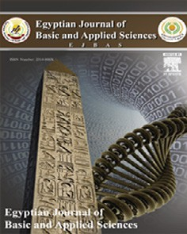

Contents lists available at [ScienceDirect](http://www.sciencedirect.com/science/journal/2314808X)

Egyptian Journal of Basic and Applied Sciences

journal homepage: [www.elsevier.com/locate/ejbas](http://www.elsevier.com/locate/ejbas)

Full Length Article

[](http://crossmark.crossref.org/dialog/?doi=10.1016/j.ejbas.2018.01.002&domain=pdf)A comparative study on larvicidal potential of selected medicinal plants over green synthesized silver nano particles

Syed Zameer Ahmed Khader a, Sidhra Syed Zameer Ahmed a,⇑, Jagadeeswari Sathyan a,

Mohamed Rafi Mahboob b, Kisore P. Venkatesh a, Kishore Ramesh a

a *Department of Biotechnology, K.S. Rangasamy College of Technology, K.S.R. Kalvinagar, Tiruchengode 637 215, Tamil Nadu, India*

b *Department of Science & Humanities, Kingston Engineering College, Katpadi, Vellore, Tamil Nadu 632059, India*

# a r t i c l e i n f o

*Article history:*

Received 26 September 2017

Received in revised form 8 January 2018 Accepted 8 January 2018

Available online 1 February 2018

*Keywords:*

Larvicidal

Silver nanoparticle Green synthesis Folklore

# a b s t r a c t

Larvicidal activity was assessed for alcoholic extracts of *Phyllanthus amarus*, *Annona squamosa*, *Coccinia grandis* and *Eclipta prostrata* extracted using solvents of various polarity. Third instar stage larvae of *Dengue-vector, Aedes aegypti* and Japanese encephalitis (JE) causing mosquito *Culex tritaeniorhynchus* were subjected to larvicidal bioassay at various concentrations (1000, 500, 250 ppm). The results explored that the phytoconstituents and secondary metabolites present in all the plants elucidated potent larvicidal activity. Among the tested extract ethyl acetate, petroleum ether and hexane extract expressed significant larvicidal activity. Similarly, these plants were subjected to green synthesis of silver nanoparticles, characterized and subjected for its larvicidal activity against *Anopheles stephensi* causing malaria. The synthesized silver nanoparticles were characterized by UV–VIS spectroscopy, Fourier Transform Infra-Red spectroscopy, Scanning Electron Microscopy respectively. The FTIR analysis strongly supported the capping behaviour of bio-reduced synthesized silver nanoparticles which in turn imparted the high stability of the synthesized silver nanoparticles. The average size of synthesized nanoparticles was less than 1 mm, most spherical in shape with SEM analysis. The findings revealed that *Eclipta prostrata*

and *Annona squamosa* has effective larvicidal activity, whereas all the synthesised nanoparticles demon-

strated dose dependent activity even at very low concentration and the findings reveals that these extracts and nanoparticles can be a better remedy against these mosquitoes.

© 2018 Mansoura University. Production and hosting by Elsevier B.V. This is an open access article under

the CC BY-NC-ND license (<http://creativecommons.org/licenses/by-nc-nd/4.0/>).

1. Introduction

Mosquito borne diseases is a major universal health problem causing malaria, dengue fever, Japanese encephalitis, chikungunya fever and lymphatic filariasis which are more prevalent in India. It has been reported that 2.5 million cases have been reported with malaria and India alone contributed 76% of the cases [1]. *Anopheles stephensi* is the malaria causing mosquito of plasmodium genus. About 400 known *Anopheles* species are normally found everywhere except cold temperate regions. *Anopheles stephensi* is a major insect vector in the world has been shown directly respon- sible for about 40–50% of the annual malarial incidence [2]. Simi- larly, *Aedes aegypti* a vector of Dengue fever has created a serious public health problem globally. Among the arbovirus in India, spreading all the dengue virus types is constantly increasing [3]. It has been reported that around 50–200 million cases of Dengue fever infection worldwide every year [4]. It is difficult task to

* Corresponding author.

*E-mail address:* [Sidhrazameer@gmail.com](mailto:Sidhrazameer@gmail.com) (S. Syed Zameer Ahmed).

control breeding of *Aedes aegypti* as it is a fresh water breeding mosquito.

Whereas JE (Japanese encephalitis) is caused by mosquito vector *Culex tritaeniorhynchus* distributed mostly in south Asia and southeast Asia [5] and has reported a mortality of about 30,000–50,000 annually. These vectors breeds especially in irriga- tion waters of rice field and uses pigs as their amplification host. The symptoms of Japanese Encephalitis infections are mild, with or without apparent symptoms, but many reports suggest that cer- tain patients results in severe disease characterized by raise in body temperature, headache, neck stiffness, disorientation, coma, seizures, spastic paralysis and death. Control of mosquito is some- thing important in the present day with rise in number of illness caused by mosquito and it is a major sources for death in develop- ing countries.

Bioactive compounds from plant origin plays a major role as a defence agent against various insects. A diversity of plants have been reported with insecticidal compounds and the use of products of plants origin to control mosquito larvae has been shown to be an exciting alternative to traditional methods of larval

<https://doi.org/10.1016/j.ejbas.2018.01.002>

2314-808X/© 2018 Mansoura University. Production and hosting by Elsevier B.V.

This is an open access article under the CC BY-NC-ND license (<http://creativecommons.org/licenses/by-nc-nd/4.0/>).

controlling, as they are not associated with the problems [6]. Sev- eral research has been carried out to make eco-friendly repellents and larvicidal activity using plants [7,8]. Medicinal plants are found to be the alternative medicine used since ancient times to cure many diseases due to their therapeutic values. Medicinal plants have many characteristics which make them useful for treatments, they are synergic medicine, supportive medicine and preventive medicine [9].

Nanotechnology finds application in different areas like health care, cosmetics, drug-gene delivery, energy science, optoelectron- ics, photo-catalyst property [10,11] etc. Nanoparticles provides solutions to technological and environmental problems and also provides high surface area to volume ratio. Green synthesis of nanoparticles helps to develop a clean, nontoxic, and eco-friendly

methods. They also find place in the insecticides like nanomaterials-based insecticides. They provide green and efficient alternatives for pest management without harming the nature. The atom by atom arrangement of nanoparticle influences their size, shape and orientation to act specifically on the targeted site. The nanoparticle possess more strength, chemical reactivity and a high electrical conductivity, along with their physical, biological and chemical properties.

It has been reported that Silver nanoparticles possess anti- bacterial activity [12] similarly, antiviral [13], anti-fungal activity [14]. Nano particles synthesized from microorganism or plants sources acts can potentially to eliminate the problem by making the nanoparticles more bio-compatible, hence many researchers are working on plants, algae, fungi, bacteria, and viruses to produce

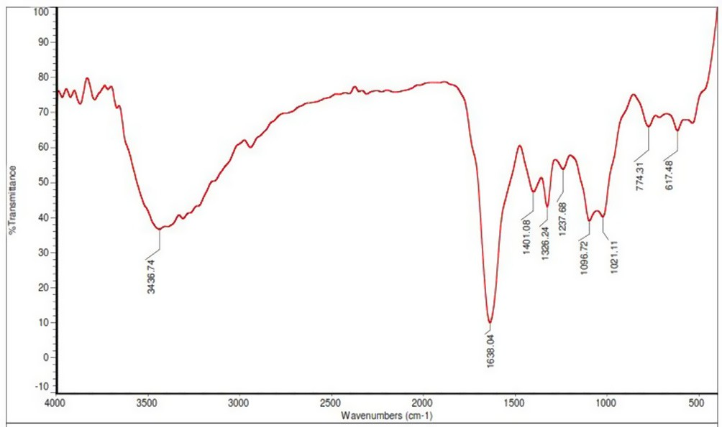 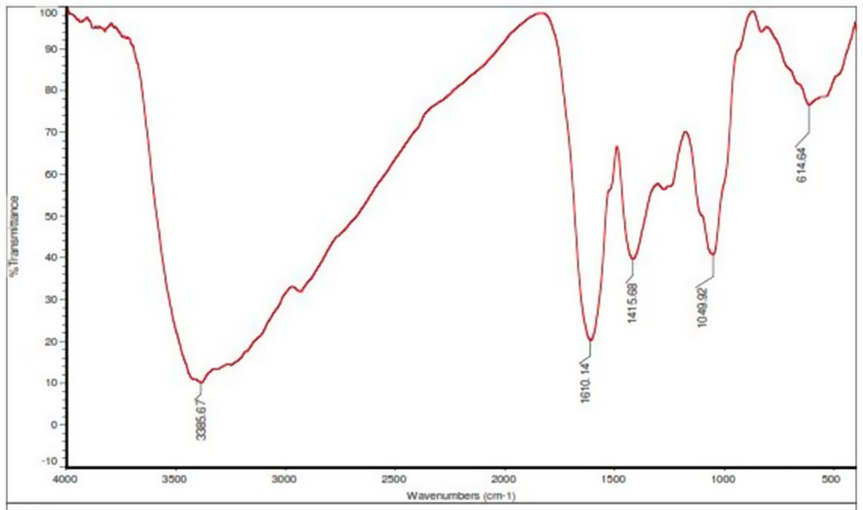

Fig. 1. FTIR spectrum of synthesized silver nanoparticles using extracts of *Phyllan- thus amarus.*

Fig. 3. FTIR spectrum of synthesized silver nanoparticles using extracts of *Eclipta prostrata.*

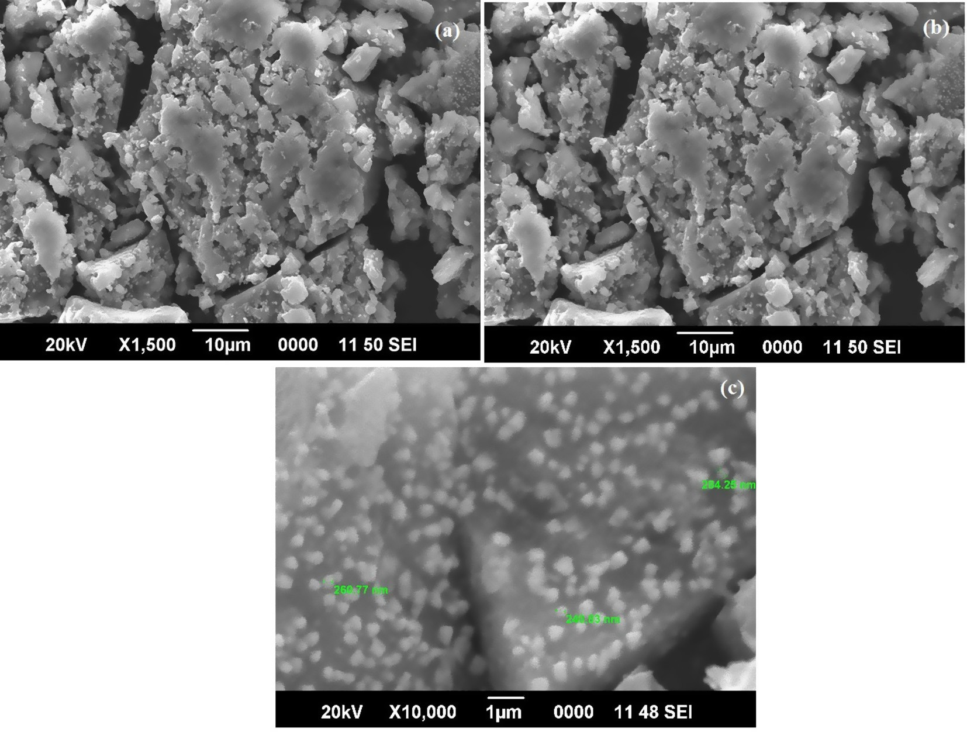

Fig. 2. (a-c) SEM micrograph a) ×1 500 10 mm; B) ×5000 5 mm; C) ×10,000 1 mm showing the silver nanoparticles synthesized using extract of *Phyllanthus amarus.*

low-cost, energy-efficient, and nontoxic production of metallic nanoparticles [15].

The silver nanoparticle efficacy depends on the particle size and their shape. The previous studies shows that reducing agents like borohydride gave smaller monodisperse silver nanoparticles. The use of less reducing agent like citrate gave a slower reducing rate. The chemical synthesis of nanoparticle resulted in toxic and less effective nanoparticles. Green synthesis of nanoparticle is eco-friendly and less toxic. The green synthesis of nanoparticle depends on the selection of substances which are nontoxic, solvents and reducing agent for stability of silver nanoparticles. The experiment is designed to validate the applications of folklore medicine to control the prevalence of diseases.

1. Materials and method
   1. *Collection and processing of plant material*

The whole plant samples of *Phyllanthus amarus*, *Annona squa- mosa*, *Coccinia grandis* and *Eclipta prostrata* were collected from bottom of Kolli Hills, Namakkal District. These scientific names of these plants were morphologically identified using the database and classified based on their family and authenticated. The fresh leaves were collected, washed and shade dried. The leaves were coarsely powdered by using electric blender and stored separately in an air tight container for further use.

* 1. *Chemicals and solvents*

All the chemicals and solvents were of analytical grade and obtained from S.D. Fine Chemicals, Mumbai and Fischer Inorganic and Aromatic Limited, Chennai, India.

* 1. *Preparation of extract*

Dried powdered samples of *Phyllanthus amarus*, *Annona squa- mosa*, *Coccinia grandis* and *Eclipta prostrata* were taken separately and mixed with different polar and non-polar and then magneti- cally stirred in a separate container for overnight at room temper- ature. The residue was removed by filtration. The filtrate was concentrated under reduced pressure in a rotary evaporator at 6

0 ± 10 °C to yield concentrated crude extract and the extracts were

stored at 4 °C for future use without deterioration [16].

* 1. *Synthesis of silver Nano particle*

AgNPs were synthesized from the whole plant material (*Phyl- lanthus amarus*, *Annona squamosa*, *Coccinia grandis* and *Eclipta pros- trata)* by the method explained by Rajakumar and Rahuman, [17].

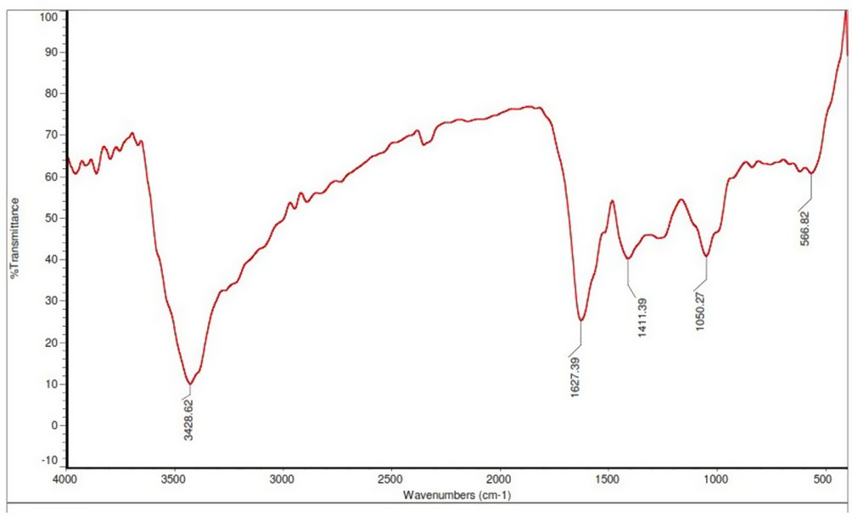

Fig. 5. FTIR spectrum of synthesized silver nanoparticles using extracts of *Annona squamosa.*

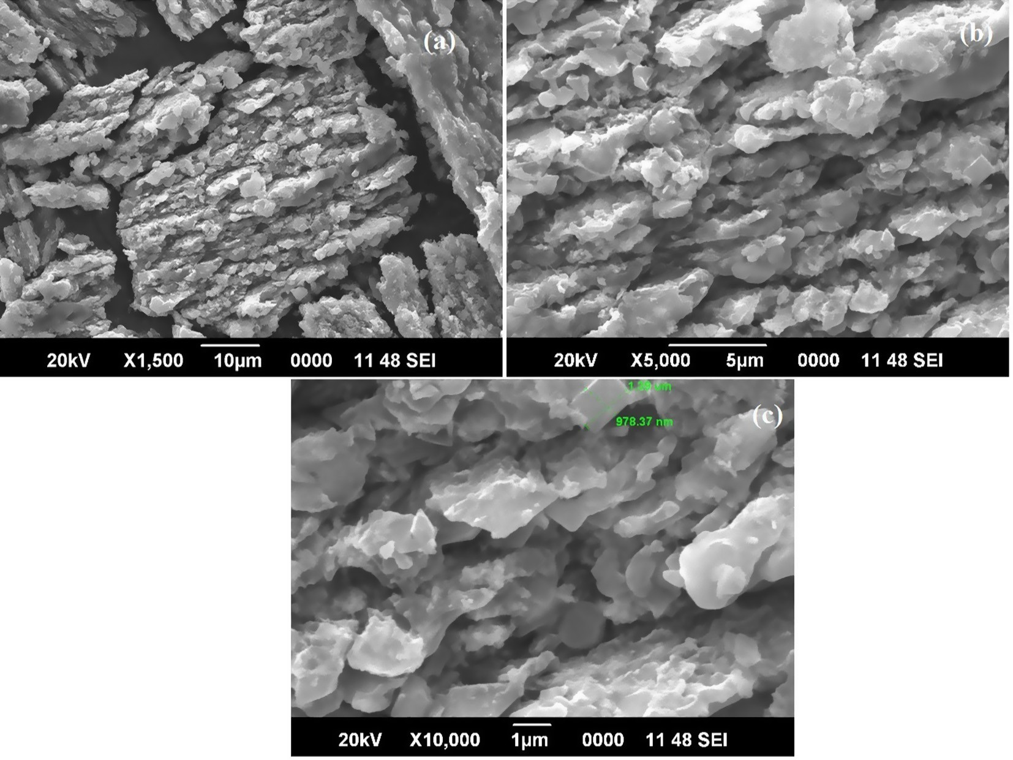

Fig. 4. (a-c) SEM micrograph a) ×1500 10 mm; B) ×5000 5 mm; C) ×10,000 1 mm showing the silver nanoparticles synthesized using extract of *Eclipta prostrata.*

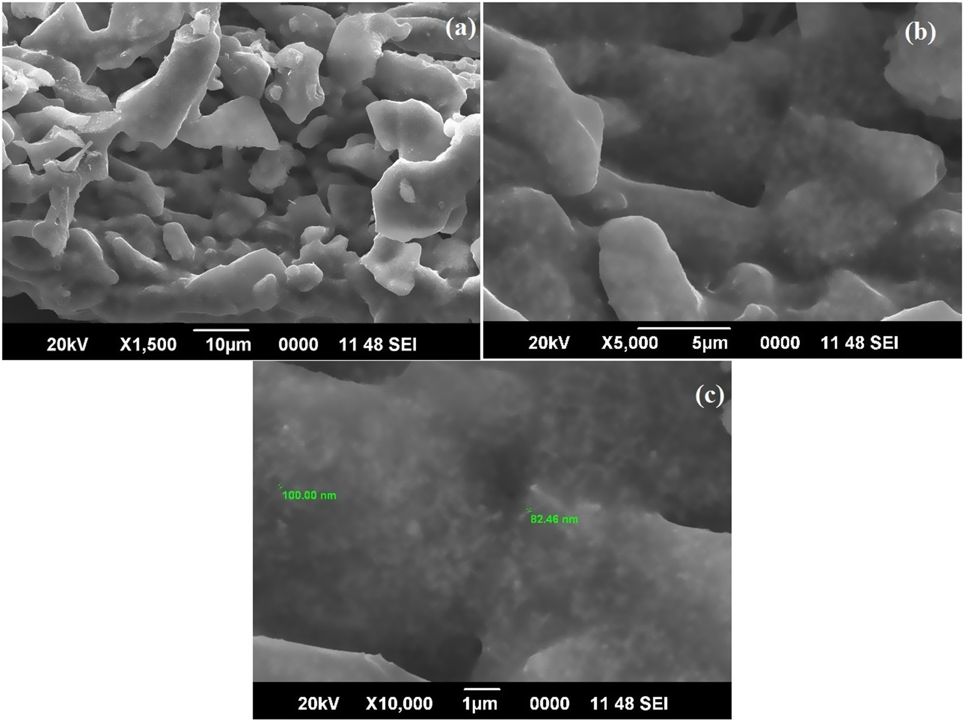

Fig. 6. (a-c) SEM micrograph a) ×1500 10 mm; B) ×5000 5 mm; C) ×10,000 1 mm showing the silver nanoparticles synthesized using extract of *Annona Squamosa.*

* 1. 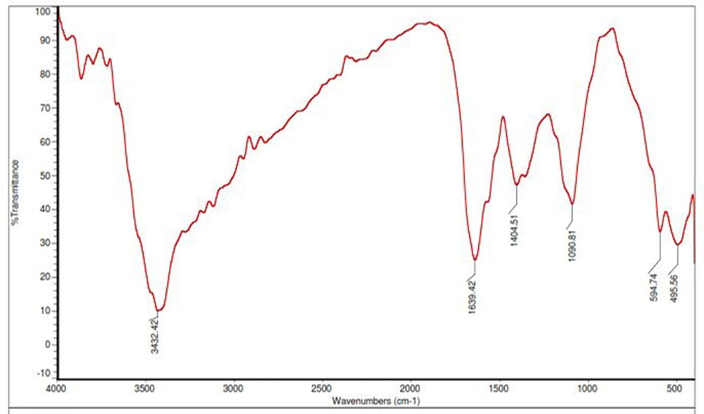*Collection of mosquito larvae*

The third instar stage larvae of *Anopheles stephensi*, *Aedesaegypti* and *Culex tritaeniorhynchus* were collected from Medical Entomo- logical Centre, ICMR (field station), Virudhachalam, Cuddalore District. The larvae were maintained in aplastic tray containing water with sufficient feed. The tray was covered with muslin cloth to avoid contamination. The larvae were provided with suitable

environmental condition of 25–27 °C and 75–85% humidity and

the egg rafts were collected from each cage for maintaining next generation.

* 1. *Bioassay for larvicidal activity*

The assay was carried out according to guidelines of WHO (1996), larvae are added to 249 ml of water and 1.0 ml of prepared plant extracts by maintaining five replicates. The control will be maintained without extract and the replicates are left for exposure for 24 h. Then the number of viable larvae will be reported for assessment of mortality rate from the mean of triplicates. The extracts showing higher activity will be considered for further studies.

Percentage mortality = (No of dead larva/No of larva intro duced) × 100

Study involves 5 larvae for each sample. The stock solution

(1000 ppm) was prepared by combination of 100 ml of distilled water, 0.4 ml of acetone, 100 mg of extract and 0.02 ml of Tween 20 (for complete dissolution of extract). By diluting further, solu- tions of concentration 1000, 500, 250 ppm was obtained. Negative control was maintained for all the samples containing only solvent without extract. A commercial liquidator was used as positive con- trol at three concentrations.

Fig. 7. FTIR spectrum of synthesized silver nanoparticles using extracts of *Coccinia grandis.*

* 1. *Dose-response bioassay*

The synthesized Nano particles were subjected to larvicidal activity against larvae of *Anopheles stephensi* following the method of Rajakumar and Rahuman, 2011 [18].

1. Results
   1. *Characterization of silver nanoparticles*

Synthesis of silver nanoparticles was confirmed by the values and from characterization of the particle using UV, FTIR and SEM analysis.

* + 1. *FTIR and SEM analysis of Phyllanthus amarus*

FTIR measurement was carried out to identify the possible biomolecules responsible for capping and efficient stabilization of

Ag nanoparticle synthesized by plant leaf extract. FTIR analysis showed the presence of different functional groups corresponding to proteins, alkaloids, tannins, saponins and other plant metabo- lites. The FT-IR spectrum of AgNPs from *P. amarus* is shown in Fig. 1. The characteristics absorbance bands due to aldehydic

CAH stretch at 2930 cm—1. The band at 1638 cm—1 is due to CAO stretch and the band at 1401 cm—1 is for NAO stretch of amines. The band at 1326 cm—1 is due to the CAO stretch of dialkyl, and 1049 cm—1 is for the CAN. The band at 614 cm—1 is due to aromatic CAH stretch. The broad band which appeared at 3436 cm—1 is the characteristic absorption for OAHAO of water.

The SEM of silver nanoparticles of *P. amarus* which showed the synthesis of monodisperse spherical Ag NPs (Fig. 2). The SEM image showing silver nanoparticles synthesized using plant extract confirmed the development of silver nanostructures by *P. amarus*. The shape of Ag NPs was spherical and size was less than 300 nm synthesized from *P. amarus.*

* + 1. *FTIR and SEM analysis of Eclipta prostrata*

The FT-IR spectrum of AgNPs from *Eclipta prostrata* is shown in Fig. 3. The band at 3385 cm—1 for Hydroxy group, H-bonded OH stretch. The band at 1610 cm—1 was assigned to amide. The peak at 1415 cm—1 which expose symmetric stretching of COO— from

an amino group. The peak at 1049 cm—1 is for Phosphate ion and the peak at 617 cm—1 for Alcohol. The IR band proved the presence of amines, alcohols, phenols, and aromatic groups and strongly proposes the presence of certain proteins in *Eclipta prostrata* that act as reducing/capping agents and may be responsible for the syn- thesis of AgNPs using leaves of *E. Prostrata*.

SEM analysis provided further detailed insight into the mor- phology and size details of the silver nanoparticles. The SEM con- firmed the development of silver nanostructures and gave clear image of silver nanoparticles from *Eclipta Prostrata* (Fig. 4). The

image showed the particle size of about 1 mm as well the crystal structure of the nanoparticles.

* + 1. *FTIR and SEM analysis of Annona squamosa*

The FT-IR spectrum of AgNPs from *Annona squamosa* is shown in Fig. 5. The peak at 3428 cm—1 is due to the NAH group of amines. The C@O and CAH group are appeared at 1627 cm—1 of esters and alkenes. The NAH and CAH group is appeared at 1411 cm—1 is for

amines and alkanes. The C@O for esters are appeared at 1050 cm—1.

The C„C group appeared at 566 cm—1 is for alkynes.

The SEM image showing the high intensity of silver nanoparti- cles synthesized by *Annona squamosa* extract further confirmed the development of silver nanostructures. The synthesized Ag NPs were monodispersed, spherical in shape with size range between 100 and 200 nm and they are quite well distributed without any agglomeration (Fig. 6). The synthesized nanoparticles were fine stabilized by capping agent (plant phytochemicals) thus they were not in direct contact even within the aggregates as seen in SEM image.

* + 1. *FTIR and SEM analysis of Coccinia grandis*

The FT-IR spectrum of AgNPs from *Coccinia grandis* is shown in

Fig. 7. The peaks observed for Ag nanoparticles formed through reduction by *C. grandis*, at 1090 cm—1 (ether linkages), 1404 cm—1 (@NH) and 1639 cm—1 (amide I) suggest the existence of ter-

penoids and alkaloids attached on the surface of silver nanoparti-

cles. The analysis of IR spectrum also provided an idea about biomolecules containing different functional groups which are pre- sent in the underlying system.

The micrograph showed the particle size of about 200 nm as well the crystal structure of the nanoparticles, with uniformly dis- tributed silver nanoparticles on the surface of the cells is observed. However, it does not indicate that all the nanoparticles are

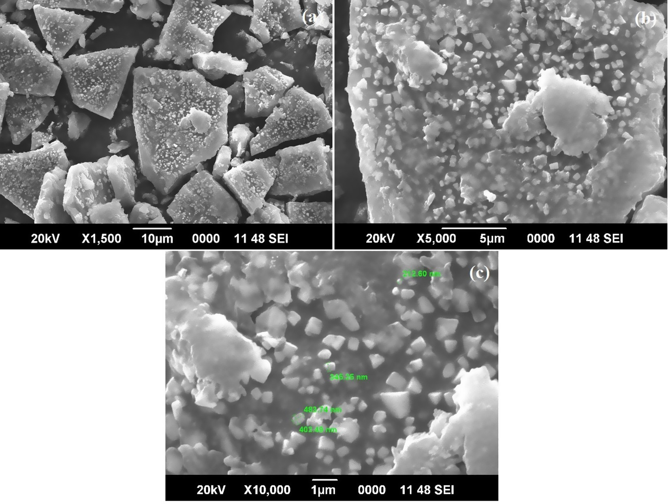

Fig. 8. (a-c) SEM micrograph a) ×1500 10 mm; B) ×5000 5 mm; C) ×10,000 1 mm showing the silver nanoparticles synthesized using extract of *Coccinia grandis.*

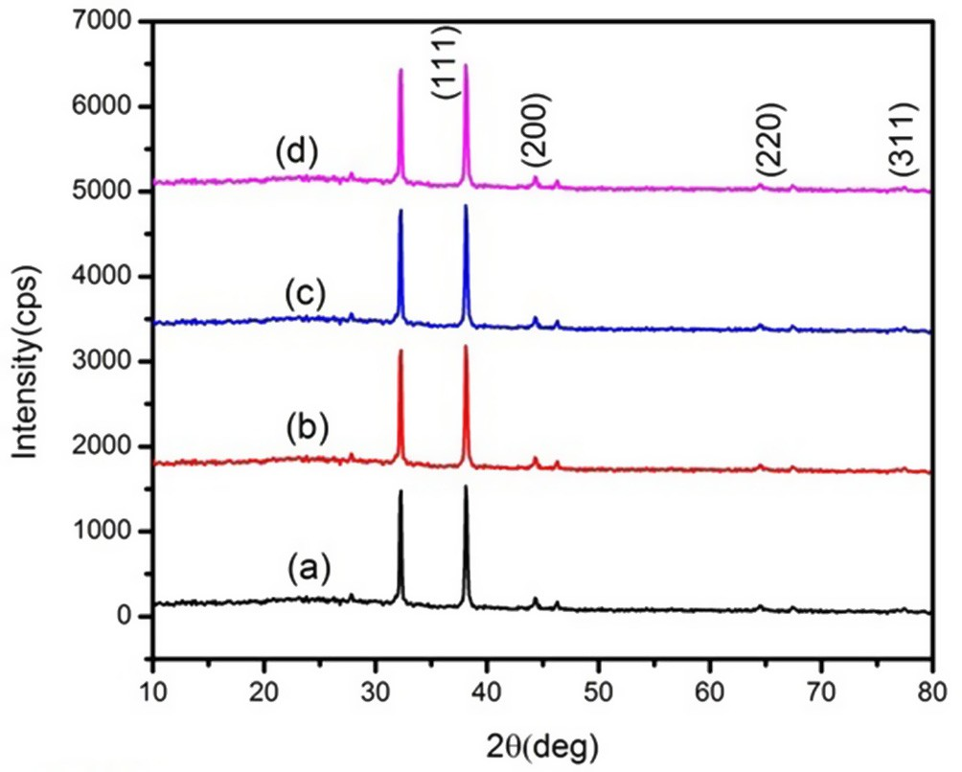

Fig. 9. (a-d) XRD pattern of synthesized AgNPs (a-Phyllanthus amarus, b-*Eclipta prostrata,* c-*Annona Squamosa*, d-*Coccinia grandis*) exhibiting the facets of crystalline silver.

attached to the surface of the cells, since those dispersing in the solution may also deposit onto the surface of the cells. The SEM results (Fig. 8) represented that synthesized AgNPs were cubic in shape with 300–1 mm size and found to be well dispersed in aque-

ous medium of *Coccina grandis* extract.

* + 1. *X-ray diffraction analysis*

The XRD patterns of AgNPs with *Phyllanthus amarus, Eclipta*

*prostrata, Annona squamosal, Coccinia grandis* are shown in Fig. 9 (a-d). The diffraction image shows two peaks appeared with 2h val-

ues and these peaks are corresponding to the (1 1 1) and (2 0 0) planes of face cantered cubic structure of silver which are well matched with the standard card (JCPDS 89–3722). The unexpected peaks could be due to the crystallisation of bioorganic phase that occurs on the surface of the AgNPs.

* 1. *Larvicidal bioassay of terrestrial plants against Aedes aegypti*

The larval mortality of *Phyllanthus amarus, Annona squamosa, Eclipta prostrata and Coccinia grandis* against *Aedes aegypti* are given in Fig. 10. Analysis with *Phyllanthus amarus* demonstrated a maxi- mum activity of 46.66% and 39.33% of mortality in petroleum ether and benzene extracts at 1000 ppm, whereas hexane extract repre- sented minimum activity of 2.6%. Similarly, Hexane extract of *E. prostrata* posed maximum 100% activity at 500 ppm and ethyl acetate extract at 1000 ppm represented 93.33%. Its minimum activity was observed in methanol and water extracts of about 6.66%. Meanwhile, petroleum ether and ethyl acetate extracts of *Annona squamosa* illustrated maximum of 66.66 and 73.33% of mortality respectively. Its water and benzene extracts showed minimal activity of 13.33%. Only the methanolic leaf extract of *C. grandis* showed 33.33% mortality at 1000 ppm. The plant showed no activity at 250 and 500 ppm concentration of hexane, methanol and benzene extracts.

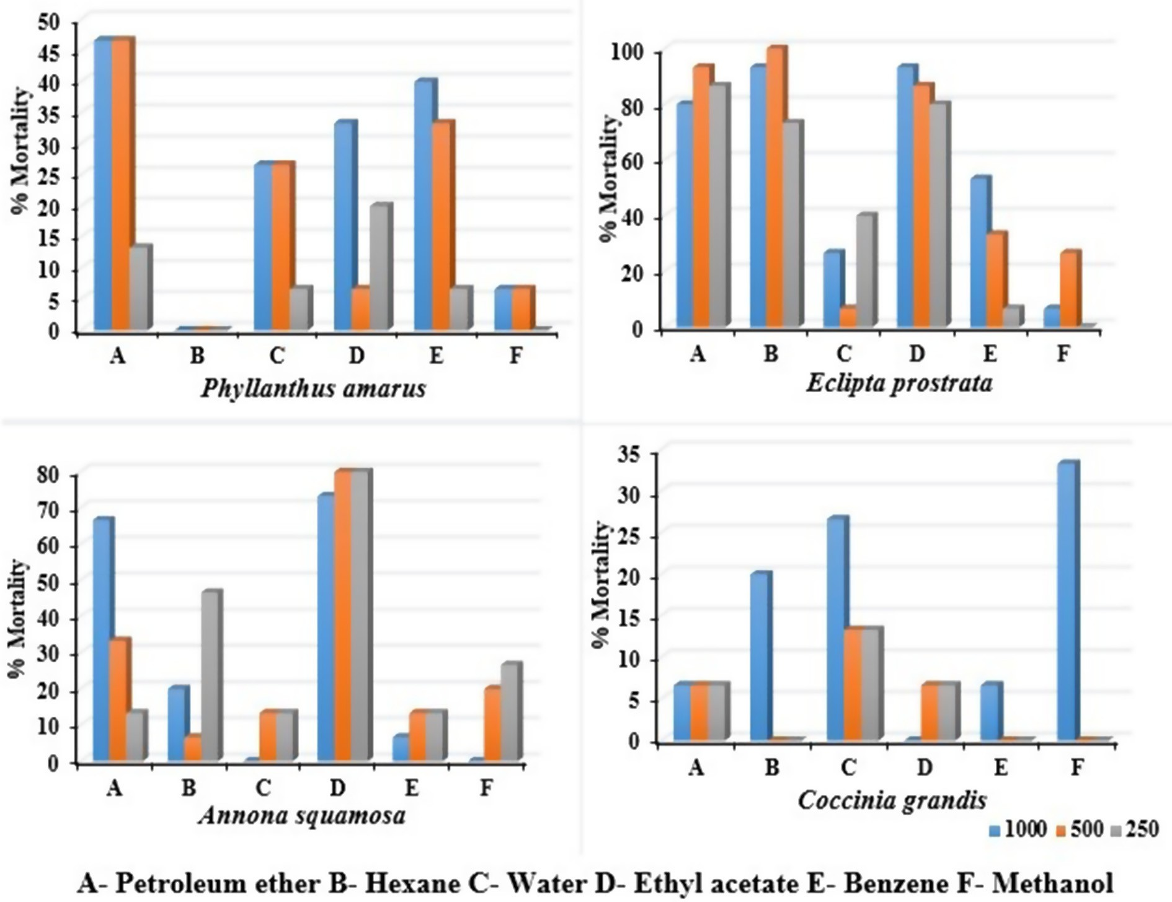

Fig. 10. Mortality rate of *Aedes aegypti* larvae against terrestrial plant extracts.

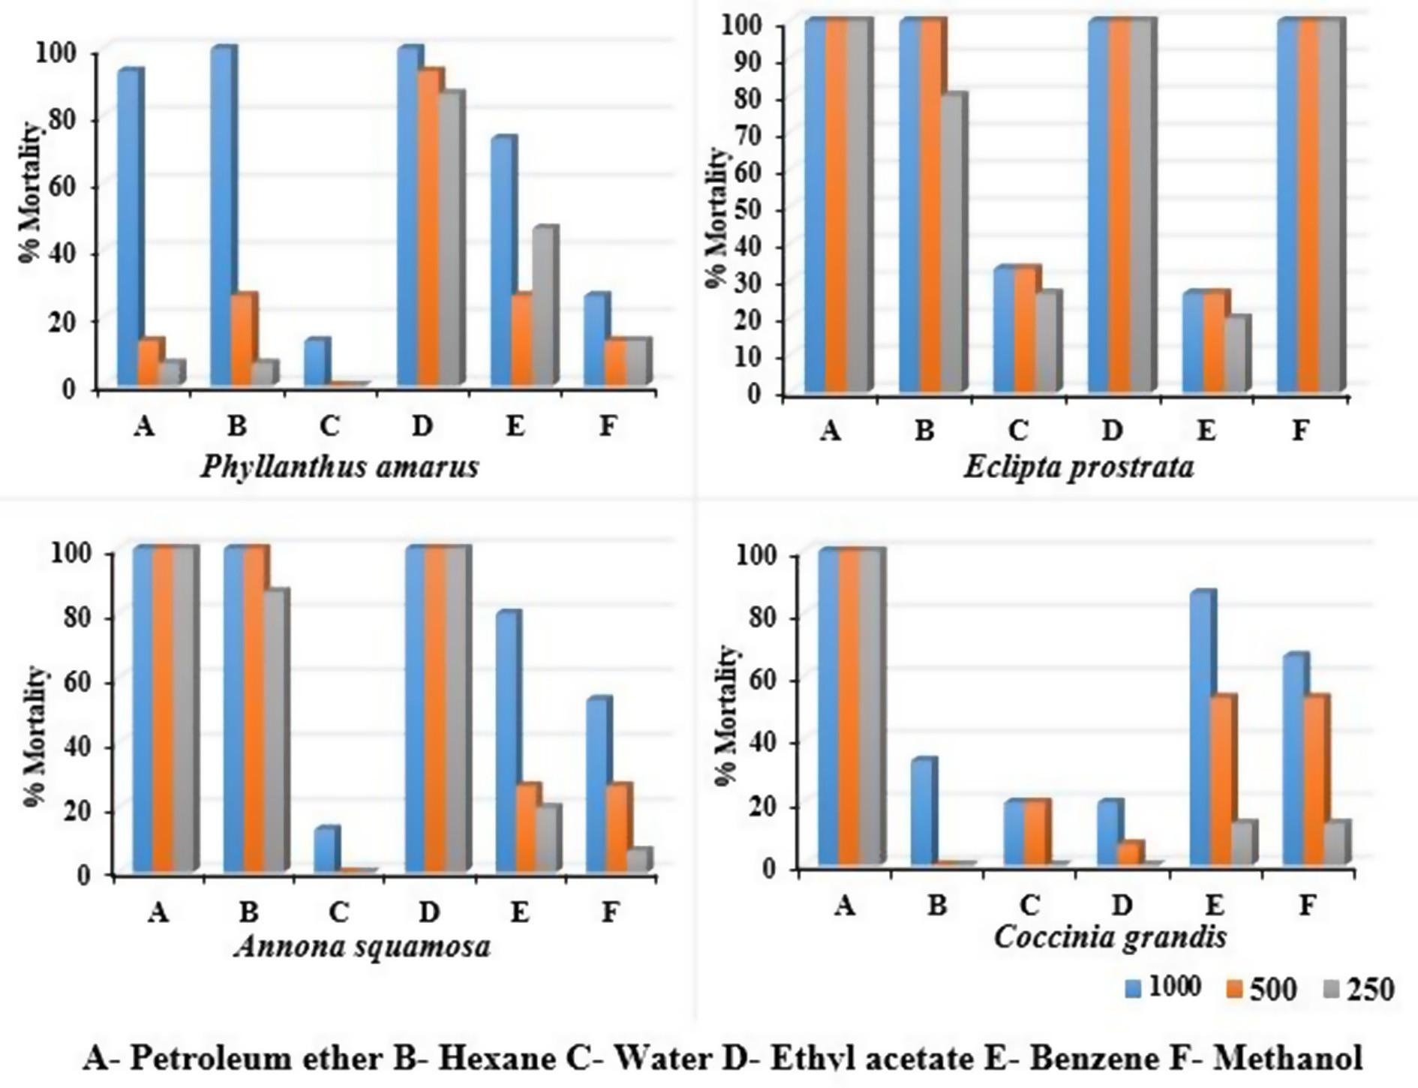

Fig. 11. Mortality rate of *Culex tritaeniorhynchus* larvae against terrestrial plant extracts.

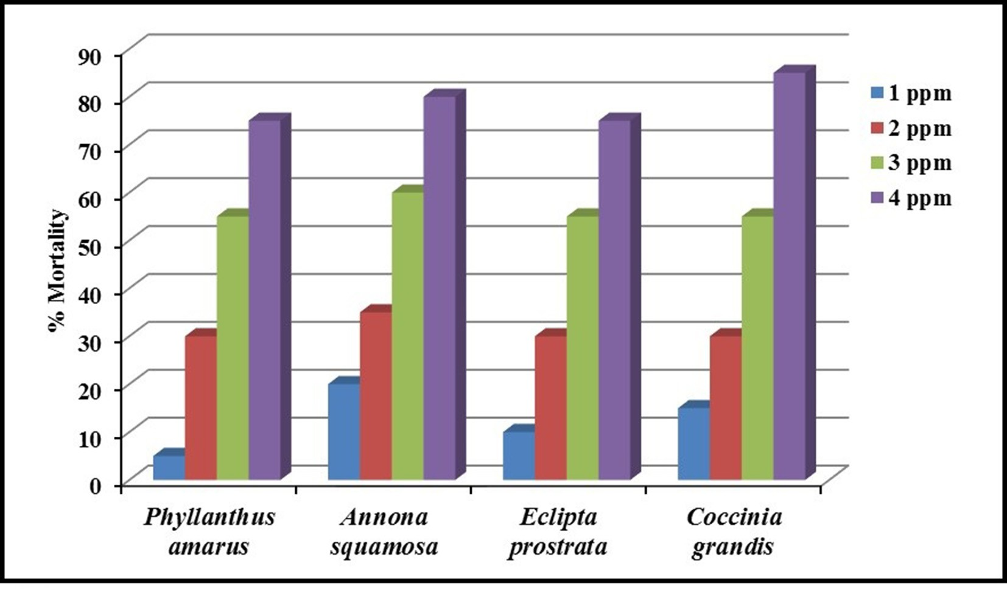

Fig. 12. Larvicidal activity of synthesized Ag NPs against *Anopheles stephensi.*

Table 1

Larvicidal activity of synthesized AgNPs against *Anopheles stephensi.*

|  |  |  |  |
| --- | --- | --- | --- |
| Nanoparticles | LC50 (UCL-LCL) | LC90(UCL-LCL) | v2 (df = 5) |
| *Pa* AgNPs | 2.819 (3.362–2.447) | 6.204 (10.798–4.731) | 0.331 |
| *As* AgNPs | 2.332 (2.809–1.937) | 6.279 (12.545–4.569) | 1.813 |
| *Ep* AgNPs | 2.735 (3.246–2.370) | 6.291 (10.307–4.648) | 2.256 |
| *Cg* AgNPs | 2.509 (2.967–2.152) | 5.843 (10.014–4.461) | 3.881 |

Control – nil mortality. Significant at P < .05 level. LC50: lethal concentration that

kills 50% of the exposed larvae, LC90 lethal concentration that kills 90% of the exposed larvae, UCL upper confidence limit, LCL lower confidence limit, v2 chi-

square; df degree of freedom.

* 1. *Larvicidal bioassay of terrestrial plants against Culex tritaeniorhynchus*

The larval mortality of *Phyllanthus amarus, Annona squamosa, Eclipta prostrata and Coccinia grandis* against *Culex tritaeniorhynchus* are given in Fig. 11. Analysis demonstrates that *Phyllanthus amarus* was highly effective with 100% mortality in ethyl acetate and hex- ane extracts at 1000 ppm concentration, but petroleum ether extract revealed around 93.33% mortality. Its water and methanol extract explicated lowest activity around 6.6 to 13%. *E. prostrata* showed 100% mortality in petroleum ether, ethyl acetate, hexane and methanol extracts at 250, 500 & 1000 ppm. Its benzene and water extract explicated minimum activity of 26% and 33.3% respectively. *Annona squamosa* exhibited 100% mortality in petro- leum ether, ethyl acetate and hexane extracts. Meanwhile its ben- zene and methanol extracts were moderately active with mortality rate of 80% and 53% respectively. *Coccinia grandis* demonstrated 100% mortality in petroleum ether extract and 86.66% mortality in benzene extract. Benzene extract showed moderate activity of 66%. Its water and ethyl acetate extract showed minimum activity of 20% at 1000 ppm concentration.

* 1. *Larvicidal bioassay for different concentration of nanoparticle against Anopheles stephensi*

Illustration from Fig. 12 demonstrates larvicidal activity of syn- thesized Nanoparticles against *Anopheles stephensi*. Exposure of *Phyllanthus amarus* nanoparticles at 4 ppm concentration pre- sented 73% mortality where as 3 ppm demonstrated 53% activity, similarly *Annona squamosa* based nanoparticle explicated effective activity of 80% mortality at 4 ppm concentration and 60% mortality at 3 ppm. *Eclipta prostrata* at 4 ppm exposed groups represented 73% mortality and at 3 ppm showed 52% activity. Meanwhile *Coc- cinia grandis* NPs at a dose of 4 ppm showed a maximum activity with 83%, and 52% at 3 ppm exposure. All the tested NPs demon- strated potent larvicidal activity even at lower concentration and the results are represented in Table 1.

1. Discussions
   1. *Characterization of silver nanoparticles*

IR spectroscopy study has confirmed that the carbonyl group of amino acid residues and peptides of proteins has a stronger ability to bind metal, so that the proteins could most possibly form a coat covering the metal nanoparticles (i.e. capping of Ag NP) to prevent the agglomeration of the particles, and thus, the nanoparticles are stabilized in the medium [19].

A small dip was obtained at 450–500 nm showing the absorp- tion spectra of Ag NPs synthesized by *Phyllanthus amarus*. FTIR con- firms the presence of different functional groups absorb characteristic frequencies of IR radiations [20].

SEM analysis which constitutes a large number of uniform sized nanoparticles revealed that the Ag nanoparticles produced by

reduction of Ag+ ions with leaf extract are predominantly spherical in shape they are quite well distributed without any agglomeration [9]. At low magnification SEM image shows monodispersed NPs with the size ranging from 200 to 300 nm.

The XRD patterns clearly demonstrates that the AgNPs formed in the current synthesis were crystalline in nature. The sharpening of the peaks clearly specifies that the particles are in the nanore- gime. Nanoparticle XRD patterns exhibit several different size- dependent features leading to anomalous peak positions, intensity and widths. Appearances of these peaks are due to the presence of phytochemical compounds in the extracts. The stronger planes indicate Ag NPs as a key element in the biosynthesis. The minor shift in the peak positions in all the samples indicated the presence of some strain present in the crystal structure [21].

* 1. *Larvicidal activity*

It is evident that there is a global alarm is in raise against vector control due to the development of resistance in vector mosquitoes over conventional insecticides. Hence the present study focuses on the development of larvicides using medicinal plants like *Phyllan- thus amarus*, *Annona squamosa*, *Coccinia grandis* and *Eclipta pros- trata* and to validate its traditional usage. An attempt is made to green synthesize silver nanoparticles from whole plant and to identify its lethal effect over mosquito larva.

* + 1. *Larvicidal activity of terrestrial plants against Aedes aegypti*

Larvicidal activity was evaluated against *Aedes aegypti* and the results revealed that ethyl acetate and petroleum ether extracts of all the terrestrial plants were effective. The *Eclipta prostrata* extract exhibited higher mortality when ethyl acetate, petroleum ether and hexane were used as solvents. *Annona squamosa* demon- strated does dependent activity against *Aedes* larvae. Only petro- leum ether and ethyl acetate extracts of *Phyllanthus amarus* explicated considerable activity. The least activity on *Aedes* species was seen in *Coccinia grandis.* Our study is in line with the previous study representing larvicidal activity using medicinal plants [22]. Also it was found that the extracts demonstrated concentration dependent activity, ie. increase in mortality rate with increase in concentration of extract. The results are in coincidence with the previous reports exploring dose dependent activity supported by the presence of phytochemicals which have insecticidal property [22,23].

* + 1. *Larvicidal bioassay of terrestrial plants against Culex tritaeniorhynchus*

During the trail with *Culex* larvae the petroleum ether, ethyl acetate extracts of the terrestrial plants were effective. The highest activity was observed in petroleum ether, ethyl acetate, hexane and methanol extracts of *E. prostrata*. Similarly, *Annona squamosa* and *Phyllanthus amarus* ethyl acetate and petroleum ether extracts represented effective mortality against *Culex* larvae. Previous reports suggest that the biological activity of plant extracts might be due to the presence of various compounds, including phenolics, terpenoids, and alkaloids present in plants [24]. The finding of the present study revealed that these phytoconstituents present in the plant extracts has represented pronounced effect over mosquito larvae. Among the tested plant extract *Eclipta prostrata* and *Annona squamosa* demonstrated effective larvicidal activity against *Culex* larvae and are quite comparable with previous reports of Raheli et al., [25] representing larvicidal activities of leaf extracts of *Indigofera arrecta*.

* 1. *Larvicidal activity of nanoparticle extract of terrestrial plants* *against Anopheles stephensi*

The results of morality rate of *Anopheles stephensi* at different concentration of nanoparticle extracts were illustrated in Fig. 6. Coccinia grandis AgNPs represented maximum mortality rate against Anopheles stephensi whereas, *Annona squamosa* AgNPs explicted activity moderate than *Phyllanthus amarus* and *Eclipta prostrata* AgNPs*.* The results demonstrated that maximum mortal- ity even at very low concentration of 4 ppm.

Researchers has reported that synthesized AgNPs may have sig- nificant impact on malaria causing vectors and our results are in line with the previous results [17,18,26] similarly, Velayutham et al., [27] reported silver nanoparticles synthesized using bark aqueous extract of *F. racemosa* represented maximum larvicidal activity against the larvae of disease spreading vectors which is agrement with our study.

1. Conclusion

The results of our present study reveals that the folklore medici- nes have synergistic effect and can also be used for various ailment without any side effects. Among the tested plants, all plants expressed activity in different solvents may be due to the presence of phytoconstituents in them. Similarly usage of plant based Nano materials represented dose dependent mortality even at a lower concentration and hence it would be an advantage for the develop- ment of clean, nontoxic and environmentally acceptable ‘‘green approach” to produce metal nanoparticles for betterment of life and can stop spreading of adverse diseases caused by mosquito larvae.

Acknowledgement

Authors are thankful to the Management and Principal of K.S. Rangasamy College of Technology, Tiruchengode for providing infrastructure and facilities to carry out this research work successfully.

References

1. [Kumar A, Valecha N, Jain T, Dash AP. Burden of malaria in India: retrospective](http://refhub.elsevier.com/S2314-808X(17)30453-0/h0005) [and prospective. Am J Trop Med Hyg 2007;77(6):69–78](http://refhub.elsevier.com/S2314-808X(17)30453-0/h0005).
2. Bashir A, Javid A. Evaluation of larvicidal activity of *Hippophae rhammoides* L. Leaves extracts on *Aedes aegypti* and *Anopheles stephensi* (Diptera: Culicidae). Middle-East. J Sci Res 2013;13(5):703–9. doi: [https://doi.org/10.5829/idosi.](https://doi.org/10.5829/idosi.mejsr.2013.13.5.2939) [mejsr.2013.13.5.2939](https://doi.org/10.5829/idosi.mejsr.2013.13.5.2939).
3. [Fulmali PV, Walimbe A, Mahadev PV. Spread, establishment and prevalence of](http://refhub.elsevier.com/S2314-808X(17)30453-0/h0015) [dengue vector Aedes aegypti (L.) in Konkan region, Maharashtra, India. Indian J](http://refhub.elsevier.com/S2314-808X(17)30453-0/h0015) [Med Res 2008;127:589–601](http://refhub.elsevier.com/S2314-808X(17)30453-0/h0015).
4. [Murray NE, Quam MB, Wilder Smith A. Epidemiology of dengue: past, present](http://refhub.elsevier.com/S2314-808X(17)30453-0/h0020) [and future prospects. Clin Epidemiol 2013;5(1):299–309](http://refhub.elsevier.com/S2314-808X(17)30453-0/h0020).
5. [Keiser J, Maltese MF, Erlanger TE, Bos R, Tanner M, Singer BH, et al. Effect of](http://refhub.elsevier.com/S2314-808X(17)30453-0/h0025) [irrigated rice agriculture on Japanese encephalitis, including challenges and](http://refhub.elsevier.com/S2314-808X(17)30453-0/h0025) [opportunities integrated vector management. Acta Trop 2005;95(1):40–57](http://refhub.elsevier.com/S2314-808X(17)30453-0/h0025).
6. [Borase HP, Patil CD, Salunkhe RB, Narkhede CP, Salunke BK, Patil SV. Phyto-](http://refhub.elsevier.com/S2314-808X(17)30453-0/h0030) [synthesized silver nanoparticles: a potent mosquito biolarvicidal Agent. J](http://refhub.elsevier.com/S2314-808X(17)30453-0/h0030) [Nanomedine Biotherapeutic Discov 2013;3:111](http://refhub.elsevier.com/S2314-808X(17)30453-0/h0030).
7. Madhumitha G, Rajakumar G, Mohana Roopan S, Abdul Rahuman A, Mohana Priya K, Mary Saral A, et al. Acaricidal, insecticidal, and larvicidal efficacy of

fruit peel aqueous extract of Annona squamosa and its compounds against blood-feeding parasites. Parasitol Res 2012;111:2189–99. doi: [https://doi.org/](https://doi.org/10.1007/s00436-011-2671-2) [10.1007/s00436-011-2671-2](https://doi.org/10.1007/s00436-011-2671-2).

1. [MohanaRoopan S, Elango G. Exploitation of *Cocos nucifera* a non-food toward](http://refhub.elsevier.com/S2314-808X(17)30453-0/h0040) [the biological and nanobiotechnology field. Ind Crops Prod 2015;67:130–6](http://refhub.elsevier.com/S2314-808X(17)30453-0/h0040).
2. [Rasool Hassan BA. Medicinal plants (importance and uses). Pharma Anal Acta](http://refhub.elsevier.com/S2314-808X(17)30453-0/h0045) [2012;3(10):e139](http://refhub.elsevier.com/S2314-808X(17)30453-0/h0045).
3. Goudarzi Mojgan, Salavati-Niasari Masoud, Ghanbari Davood, Ahmadi Amin. Synthesis and characterization of Al(OH) nanoparticles and polymeric nanocomposites. J Clust Sci 2016;27:25–38. doi: [https://doi.org/10.1007/](https://doi.org/10.1007/s10876-015-0895-5) [s10876-015-0895-5](https://doi.org/10.1007/s10876-015-0895-5).
4. Goudarzi Mojgan, Mousavi-Kamazani Mehdi, Salavati Niasari Masoud. Zinc oxide nanoparticles: solvent-free synthesis, characterization and application as heterogeneous nanocatalyst for photodegradation of dye from aqueous phase. J Mater Sci Mater Electron 2017. doi: [https://doi.org/10.1007/s10854-](https://doi.org/10.1007/s10854-017-6560-z) [017-6560-z](https://doi.org/10.1007/s10854-017-6560-z).
5. [Sathishkumar M, Sneha K, Won SW, Cho CWS, Kim Yun YS. *Cinnamon*](http://refhub.elsevier.com/S2314-808X(17)30453-0/h0060)[*zeylanicum* bark extract and powder mediated green synthesis of nano-](http://refhub.elsevier.com/S2314-808X(17)30453-0/h0060) [crystalline silver particles and its bactericidal activity. Colloids Surf. B:](http://refhub.elsevier.com/S2314-808X(17)30453-0/h0060) [Biointerfaces 2009;73:332–8](http://refhub.elsevier.com/S2314-808X(17)30453-0/h0060).
6. [Rogers JV, Parkinson CV, Choi YW, Speshock JL, Hussain SM. A preliminary](http://refhub.elsevier.com/S2314-808X(17)30453-0/h0065) [assessment of silver nanoparticle inhibition of *monkey pox* virus plaque](http://refhub.elsevier.com/S2314-808X(17)30453-0/h0065) [formation. Nanoscale Res Lett 2008;3(4):129–33](http://refhub.elsevier.com/S2314-808X(17)30453-0/h0065).
7. [Panacek A, Kolar M, Vecerova R, Prucek R, Soukupova J, Krystof V, et al.](http://refhub.elsevier.com/S2314-808X(17)30453-0/h0070) [Antifungal activity of silver nanoparticles against Candida spp. Biomater](http://refhub.elsevier.com/S2314-808X(17)30453-0/h0070) [2009;30:6333–40](http://refhub.elsevier.com/S2314-808X(17)30453-0/h0070).
8. [Thakkar KN, Mhatre SS, Parikh RY. Biological synthesis of metallic](http://refhub.elsevier.com/S2314-808X(17)30453-0/h0075) [nanoparticles. Nanomed Nanotechnol Biol Med 2009;6:257–62](http://refhub.elsevier.com/S2314-808X(17)30453-0/h0075).
9. [Syed Zameer Ahmed K, Sidhra S, Senthil Kumar B, Thanga Kumar A, Geetha K,](http://refhub.elsevier.com/S2314-808X(17)30453-0/h0080) [Mohamed Rafi M, et al. Modulatory effect of dianthrone rich alcoholic flower](http://refhub.elsevier.com/S2314-808X(17)30453-0/h0080) [extract of *Cassia auriculata* L. on experimental diabetes. Integr Med Res](http://refhub.elsevier.com/S2314-808X(17)30453-0/h0080) [2017;6:131–40](http://refhub.elsevier.com/S2314-808X(17)30453-0/h0080).
10. [Rajakumar G, Gomathi T, Rahuman AA, Thiruvengadm M, Mydhili G, Kim](http://refhub.elsevier.com/S2314-808X(17)30453-0/h0085) [Seung-Hyun, et al. Biosynthesis and biomedical applications of gold](http://refhub.elsevier.com/S2314-808X(17)30453-0/h0085) [nanoparticles using *Eclipta prostrata* leaf extract. Appl Sci 2016;6:222](http://refhub.elsevier.com/S2314-808X(17)30453-0/h0085).
11. [Rajakumar G, Rahuman AA. Larvicidal activity of synthesized silver](http://refhub.elsevier.com/S2314-808X(17)30453-0/h0090) [nanoparticles using *Eclipta prostrata* leaf extract against *filariasis* and malaria](http://refhub.elsevier.com/S2314-808X(17)30453-0/h0090) [vectors. Acta Trop 2011;118:196–203](http://refhub.elsevier.com/S2314-808X(17)30453-0/h0090).
12. [Rajeswari A, Sujatha D, Balasaraswathi K, Uthirappan Mani, Rose Chellan,](http://refhub.elsevier.com/S2314-808X(17)30453-0/h0095) [Mandal Asit Baran. Phytosynthesis of silver nanoparticles using *Coccinia*](http://refhub.elsevier.com/S2314-808X(17)30453-0/h0095)[*grandis* leaf extract and its application in the photocatalytic degradation.](http://refhub.elsevier.com/S2314-808X(17)30453-0/h0095) [Colloids Surfaces B Biointerfaces 2012;94:226–30](http://refhub.elsevier.com/S2314-808X(17)30453-0/h0095).
13. [Kalainila P, Subha V, Ernest Ravindran RS, Sahadevan R. Synthesis and](http://refhub.elsevier.com/S2314-808X(17)30453-0/h0100) [characterization of silver nanoparticles from *Erythrina indica*. Asian J Pharm](http://refhub.elsevier.com/S2314-808X(17)30453-0/h0100) [and Clin Res 2014;7:39–43](http://refhub.elsevier.com/S2314-808X(17)30453-0/h0100).
14. Khushboo Singh, Manju P, Sangeeta K, Uma C, Jaya Parkash Y. Green silver nanoparticles of *Phyllanthus amarus*: as an antibacterial agent against multi drug resistant clinical isolates of *Pseudomonas aeruginosa*. J Nanobiotechnol 2014; 12:40. doi: 10.1186/s12951-014-0040-x.
15. [Baranitharan M, Dhanasekaran S, Mahesh Babu S, Sridhar N, Krishnappa K.](http://refhub.elsevier.com/S2314-808X(17)30453-0/h0110) [Larvicidal activity of *Coleus aromaticus* Benth (Lamiaceae) leaf extracts against](http://refhub.elsevier.com/S2314-808X(17)30453-0/h0110) [three vector mosquitoes. Int J Res Biol Sci 2014;4(2):55–9](http://refhub.elsevier.com/S2314-808X(17)30453-0/h0110).
16. [Pedro G, Aubrey A, Bryle E. Larvicidal activity of selected plant extract against](http://refhub.elsevier.com/S2314-808X(17)30453-0/h0115) [Dengue vector *Aedes aegypti* mosquito international research. J Biol Sci 2014;3](http://refhub.elsevier.com/S2314-808X(17)30453-0/h0115) [(4):23–32](http://refhub.elsevier.com/S2314-808X(17)30453-0/h0115).
17. [Rafael L, Teresinha N, Moritz JC, Maria IG, Eduardo MD, Tania SF. Evaluation of](http://refhub.elsevier.com/S2314-808X(17)30453-0/h0120) [antimicrobial and antiplatelet aggregation effect of *Solidago chilensis* eyen. Int J](http://refhub.elsevier.com/S2314-808X(17)30453-0/h0120) [Green Pharm 2009;3:35–9](http://refhub.elsevier.com/S2314-808X(17)30453-0/h0120).
18. [Raheli Neema M, Ojunga M, Ramesh F. The larvicidal activity of *Indigofera*](http://refhub.elsevier.com/S2314-808X(17)30453-0/h0125)[*arrecta* leaf extract against *culex* mosquito larvae. Int J Bioassays 2015;4](http://refhub.elsevier.com/S2314-808X(17)30453-0/h0125) [(01):3666–9](http://refhub.elsevier.com/S2314-808X(17)30453-0/h0125).
19. Santhosh Kumar T, Rahuman, AA, Rajakumar G, Marimuthu S, Bagavan A, Jayaseelan C, Zahir AA, et al., Synthesis of silver nanoparticles using Nelumbo nucifera leaf extract and its larvicidal activity against malaria and filariasis vectors. Parasitol Res 2011; 108(3): 693–702. doi:10.1007/s00436-010-2115-

4.

1. [Velayutham K, Rahuman AA, Rajakumar G, Mohana Roopan S, Elango G,](http://refhub.elsevier.com/S2314-808X(17)30453-0/h0135) [Kamaraj C, et al. Larvicidal activity of green synthesized silver nanoparticles](http://refhub.elsevier.com/S2314-808X(17)30453-0/h0135) [using bark aqueous extract of *Ficus racemosa* against *Culex quinquefasciatus*](http://refhub.elsevier.com/S2314-808X(17)30453-0/h0135)[and *Culex gelidus*. Asian Pacific J Trop Med 2013;6:95–101](http://refhub.elsevier.com/S2314-808X(17)30453-0/h0135).