 HOSTE D BY

Available online at [www.sciencedirect.com](http://www.sciencedirect.com/science/journal/2314808X)

**ScienceDirect**

journal homepage: [http://ees.elsevier.com/ejbas/default.asp](http://http//ees.elsevier.com/ejbas/default.asp)

**Full Length Article**

**A facile one-pot synthesis and characterization of Ag2Se nanoparticles at low temperature**



***Delele Worku Ayele*** ***\****

*Department of Chemistry, College of Science, Bahir Dar University, P.O.Box 79, Bahir Dar, Ethiopia*

A R T I C L E I N F O A B S T R A C T

*Article history:*

Received 12 October 2015

Received in revised form 10 January 2016

Accepted 27 January 2016

Available online 10 February 2016

*Keywords:*

Silver selenide Nanoparticles Microemulsions Sodium selenosulfate Phase separation Precipitation reaction

A facile one-pot synthesis method has been developed successfully for the preparation of crystalline silver selenide (Ag2Se) nanoparticles at low temperatures (5–7 °C) within few minutes. The method is based on the formation of phase separation and interface- reaction mechanism. During the synthesis, a microemulsion system (water/oleic acid/n- hexane) was used to make Ag2Se nanoparticles. Selenium source (Sodium selenosulfate) used in this synthesis method was prepared by microwave heating due to the fact that the de- veloped method of synthesis could eliminate toxic and expensive selenium sources. The prepared products (oleic acid coated Ag2Se nanoparticles) were characterized by X-ray dif- fraction (XRD), energy-dispersive X-ray analysis (EDX), transmission electron microscopy (TEM), ultraviolet (UV)–visible analysis and photoluminescence (PL) analysis. The developed method became mild, fast, simple and environmentally benign, which would be helpful in scaling up production. Furthermore, the developed synthesis strategy could be used in making other nanoparticles for mass production through simple precipitation reactions.

© 2016 Mansoura University. Production and hosting by Elsevier B.V. This is an open access article under the CC BY-NC-ND license (<http://creativecommons.org/licenses/by->

nc-nd/4.0/).

# Introduction

In past decades, silver selenide (Ag2Se) has received great at- tention due to its special electronic and optical properties as well as potential applications [1–3]. Ag2Se undergoes a poly- morphic phase transition and has two stable solid phases. These

are a low temperature orthorhombic phase (β-Ag2Se) at 0 K, and a high temperature cubic phase (α-Ag2Se) with a phase tran- sition temperature from β to α-Ag2Se taking place at about

135 °C or 409 K [2,4,5]. The low-temperature phase behaves as a semiconductor, while the high-temperature shows the

properties of a metal. A low temperature phase (β-Ag2Se) is a narrow band gap and n-type semiconductor with an energy gap of 0.07 eV at 0 K [5]. β-Ag2Se is used as a photo sensitizer in photographic films or in thermo chromic materials and

thermo electronic application due to its relatively high see back coefficient, low lattice thermal conductivity, and a high elec- trical conductivity [3,4,6–9]. The high-temperature phase (body-

centered cubic), α-Ag2Se, is a metallic compound with super

ionic conductors that has been utilized as a solid electrolyte in photochargable secondary batteries and also used as an ad- ditive in highly conductive composite glasses for batteries, sensors, and displays [3,4,6–9].

* Tel.: +251936749196.

*E-mail addresses:* [delelewww@yahoo.com](mailto:delelewww@yahoo.com), [delelew@bdu.edu.et](mailto:delelew@bdu.edu.et).

<http://dx.doi.org/10.1016/j.ejbas.2016.01.002>

2314-808X/© 2016 Mansoura University. Production and hosting by Elsevier B.V. This is an open access article under the CC BY-NC-ND license ([http://creativecommons.org/licenses/by-nc-nd/4.0/).](http://creativecommons.org/licenses/by-nc-nd/4.0/))

Recently, research reports indicated that a slight tuning of the stoichiometry to Ag2Se could induce a remarkable magneto resistance, which is comparable to the giant magneto resis- tance perovskites [10–12]. Since nanoscale materials have some unique properties (that depend on the size and morphology of the particles) for a unique application [13,14], it would be a great challenge to fabricate Ag2Se nanostructures having uniform size and morphology. A number of methods for the synthesis of Ag2Se nanostructures have been explored [3,4,8,15,16]. All these routes to Ag2Se nanostructures, however, did not satisfy the criteria that the method be simple and fast, i.e., Ag2Se forms at low temperature in one step, and the pre- pared samples had nearly uniform morphology. Most of these Ag2Se synthesis routes have also used expensive and toxic se- lenium sources.

In this report, we employed a single step (the one pot) syn-

thesis strategy to prepare uniform-sized Ag2Se nanoparticles at low temperature by reacting Ag+ with SeSO32− under mild condition. In such synthesis approach, Na2SeSO3 was used as a selenium source since it could easily react with Ag+ ions at

microwave system was employed for the synthesis of sodium selenosulfate (Na2SeSO3).

## *Synthesis of sodium selenosulfate (Na2SeSO3)*

It was prepared in the laboratory using microwave-enhanced methods. The advantages of microwave heating over the con- ventional heating are explained above. Microwave (MW) synthesis was done by using a single-mode CEM Discover System operating at 300 W and 2.45 GHz. The reaction mixture was rapidly cooled with high-pressure air following termina- tion of the reaction. Na2SeSO3 was prepared from sodium sulfite and selenium powder by microwave heating in aqueous so- lution for 30 min at 100 °C. For a typical preparation, selenium powder (0.4 g) and Na2SO3 (0.76 g) were dissolved in distilled water (50 mL); then, they were transferred to the microwave system. The following chemical reaction describes the forma- tion of Na2SeSO3 under microwave system for 30 min reaction time at 100 °C.

room temperature without requiring the use of any other forms of energy [17]. Na2SeSO3 is much more active than Se powder,

Na2SO3  Se

MW100Cand30 min 

Na2SeSO3

and is also less toxic, inexpensive and therefore safer to use than the Na2Se or H2Se [18]. Na2SeSO3 was prepared via microwave-enhanced method. A microwave-enhanced method, as opposed to conventional heating, has been proven to be an excellent technique for preparation of nanoparticles [18].A few of the advantages of microwave-enhanced reactions include: simple to control the properties of the products, high yields of products, easy to control the temperature and pressure profile, the products have high purity levels, short reaction time, and environmental friendliness (e.g., improved safety, repro- ducibility, and selective heating, energy savings, etc.) [18]. A low- temperature microemulsion [19,20] environment was introduced to protect the prepared Ag2Se nanoparticles from aggregation and to direct them into a relatively uniform size. The low tem- perature reaction conditions also helped the formation of nearly monodisperse Ag2Se nanoparticles by slowing the growth speed and decreasing the surface atom activity.

The structure, morphology, elemental composition, and

optical properties of the prepared Ag2Se nanoparticles were characterized by XRD, TEM, EDX, and UV–vis and Fluores- cence spectrophotometer respectively. The developed synthesis method used very simple reagents such as oleic acid, AgNO3 and Na2SeSO3 as precursors; was fast, easy/simple, mild, en- vironmentally benign and of low temperature, which would be useful for large scale production and could be applied for the synthesis of other similar nanostructure materials.

# Experimental section

## *Chemicals*

Selenium powder (Se, 99.70%, <325 mesh), sodium sulfite (Na2SO3, >95%), and n-hexane (>99%) were bought from Acros; ethanol (>99%) and oleic acid (65–88%) were brought from Aldrich; Sliver nitrate (AgNO3, >99%) and sodium hydroxide (NaOH, >95%) were bought from Shimakyus Pure Chemicals.

The chemicals were used without further purification. The

Sodium selenosulfate (Na2SeSO3) was considered to be a greener selenium precursor than organic-based Se sources such as trioctylphosphine/Se or trioctylphosphine oxide/Se or others [18].

## *Synthesis of Ag2Se nanoparticles*

The synthesis of Ag2Se nanoparticles was done in three steps. First step, NaOH (0.12 g) and oleic acid (2 mL) were dissolved in the mixture of deionized water (15 mL), C2H5OH (15 mL), and n-hexane (1.5 mL) to form a transparent microemulsion. Second, AgNO3 (0.23 g) dissolved in deionized water (5 mL) was added to the solution (transparent microemulsion) under vigorous stir-

ring, forming a white Ag+ containing emulsion quickly. Third

and the last step, after the emulsion had been maintained in the temperature range of 5–7 °C in the water bath, Na2SeSO3 solution (5 mL) was injected into it. The prepared solution changed its color from transparent to black in a few seconds, and stirring continued for up to 10 min.

After the reaction, n-hexane (20 mL) was added to destroy the microemulsion and extract the oleic acid-coated Ag2Se nanoparticles into the oil phase, which was centrifuged to give Ag2Se nanoparticles by adding C2H5OH. Then, the samples were washed more than three times by dissolving n-hexane coupled with precipitation from ethanol to remove oleic acid residues on the particle surface. Finally, the as prepared Ag2Se nanoparticles were dispersed in n-hexane for storage. The fol- lowing chemical reaction describes the formation of Ag2Se nanoparticles with simple precipitation reactions.

Na2SeSO3  2AgNO3  H2O  Ag2Ses  2NaNO3  H2SO4

## *Characterization*

Photoabsorption and photoluminescence measurements were performed by using a Jasco 560 UV/Vis Spectrophotometer and a Hitachi F-7000 Fluorescence spectrophotometer, respectively.

X-ray diffraction (XRD) measurements (Rigaku Model Dmax-B, Japan) were recorded using a Cu Kα radiation source that was operated at 40 kV and 100 mA. The X-ray diffractogram was ob- tained at a scan rate of 0.05 deg s−1 for 2θ values. The TEM images were obtained by using a Philips Tecnai 20 G2-field emis-

sion gun with a maximum acceleration voltage of 200 keV. The chemical composition of the Ag2Se nanoparticles was mea- sured by energy-dispersive X-ray spectroscopy (EDX). FTIR

spectra were recorded by using a Digilab FT3500 spectrom- eter (64 scans with a resolution of 4 cm−1).

# Results and discussion

Fig. 1 shows the XRD patterns of Ag2Se nanoparticles ob- tained at the reaction times of 10 min and particle-growth temperatures of 7 °C. As seen in Fig. 1, the as-prepared Ag2Se nanoparticles show characteristic peaks of orthorhombic phase

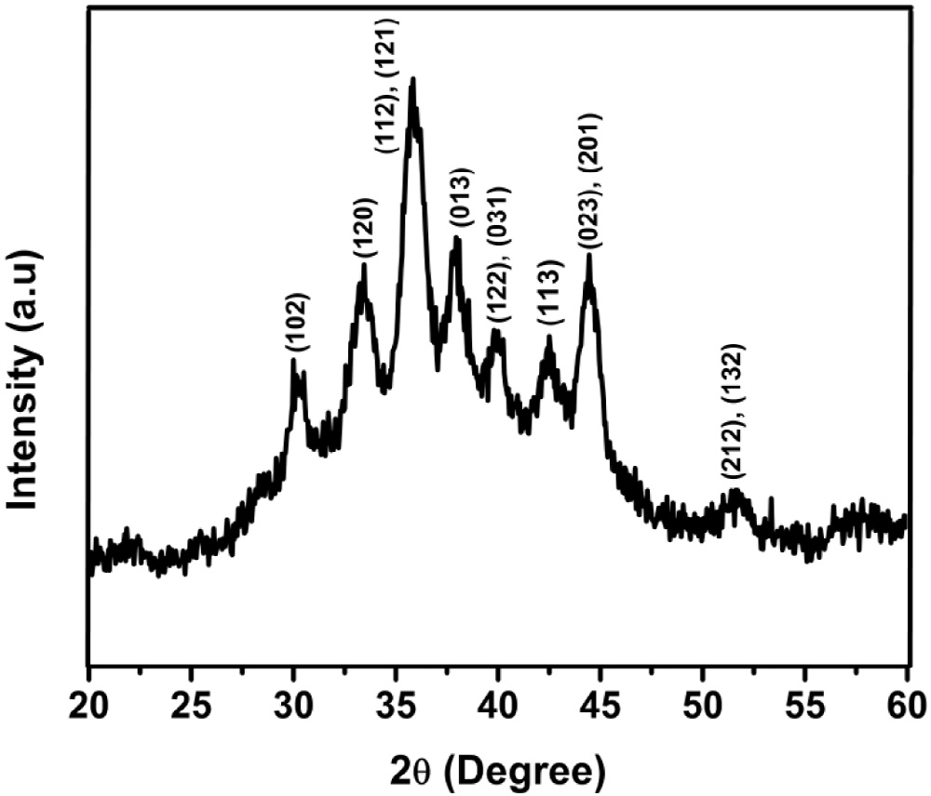

### Fig. 1 – XRD patterns of Ag2Se nanoparticles.

of β-Ag2Se. All the characteristic peaks, seen in Fig. 1, corre- spond to the orthorhombic phase of β-Ag2Se, which is in good agreement with the literature data for β-Ag2Se (the standard

JCPDS card File, 24–1041). As reported in literature [16,21–26], it seems also logical to produce the orthorhombic phase at low temperature since it is a low-temperature stable phase. A slight peak broadening, shown in the XRD patterns, may reflect the smaller particle size (around 8 nm) of the products.

Fig. 2a and b shows the TEM images of the as-prepared prod- ucts at different magnifications. The products are nearly monodisperse without any aggregation with the particle size ranges from 6 to 10 nm. The average particle size is calcu- lated to be 8 nm. The high-resolution transmission electron microscopy (HRTEM) images in the inset of Fig. 2b show the lattice spacing of ~0.24 nm, corresponding to the characteris-

tic of the (013) crystal planes of β-Ag2Se nanoparticles [27,28].

Fig. 3 shows the Energy Dispersive X-ray (EDX) spectrum taken from the selected area of SEM images (seen in the inset figure in Fig. 3). The result of the EDX shows that the atomic ratio of the Ag and Se in this tubular product is 66.33:33.67, close to the stoichiometric composition of the Ag2Se. Thus, the atomic composition of Ag and Se, in the as-prepared prod- ucts, is merely similar to the stoichiometric composition of Ag2Se.

Fig. 4 shows the FTIR spectra of the as-prepared Ag2Se

nanoparticles and the pure oleic acid (OA). FTIR spectroscopy can offer insight about the interaction between the oleic acid

and the Ag2Se nanoparticles. The broad peak between 3500 and 2500 cm−1 was observed in the pure oleic acid spectra, which is clearly due to the O—H stretch of the carboxylic acid [29–33].

Such a broad and intense band at high wave number is a typical characteristic of O—H functional group of the carboxylic acid. However, the as-prepared Ag2Se nanoparticles have no such bands in this region indicating that the oxygen atoms in O—H groups were chemisorbed on the surface of Ag2Se nanoparticles. A pure oleic acid spectra show two sharp bands at 2925 and

2857 cm−1, which were superimposed on the O—H stretch, and

were attributed to the asymmetric CH2 stretch and the sym- metric CH2 stretch of the free OA, respectively [29–31,34]. When oleic acids were chemisorbed on the surface of Ag2Se nanoparticles, the asymmetric CH2 stretch and the symmetric

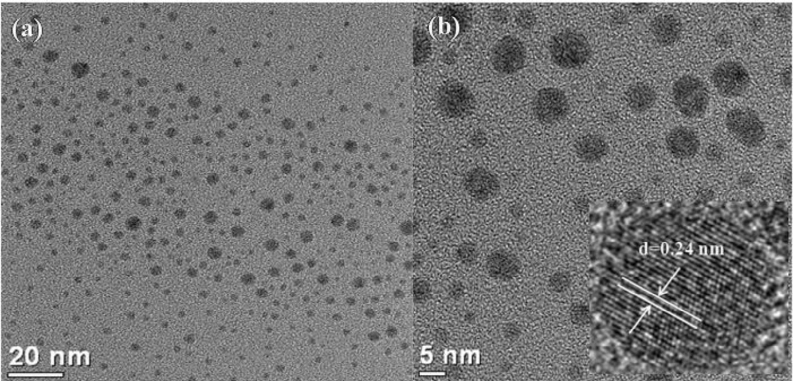

### Fig. 2 – TEM images (a & b at different magnification) of Ag2Se nanoparticles. The inset figure in (b) shows the HRTEM images with the lattice fringe spacing of ~0.24 nm.

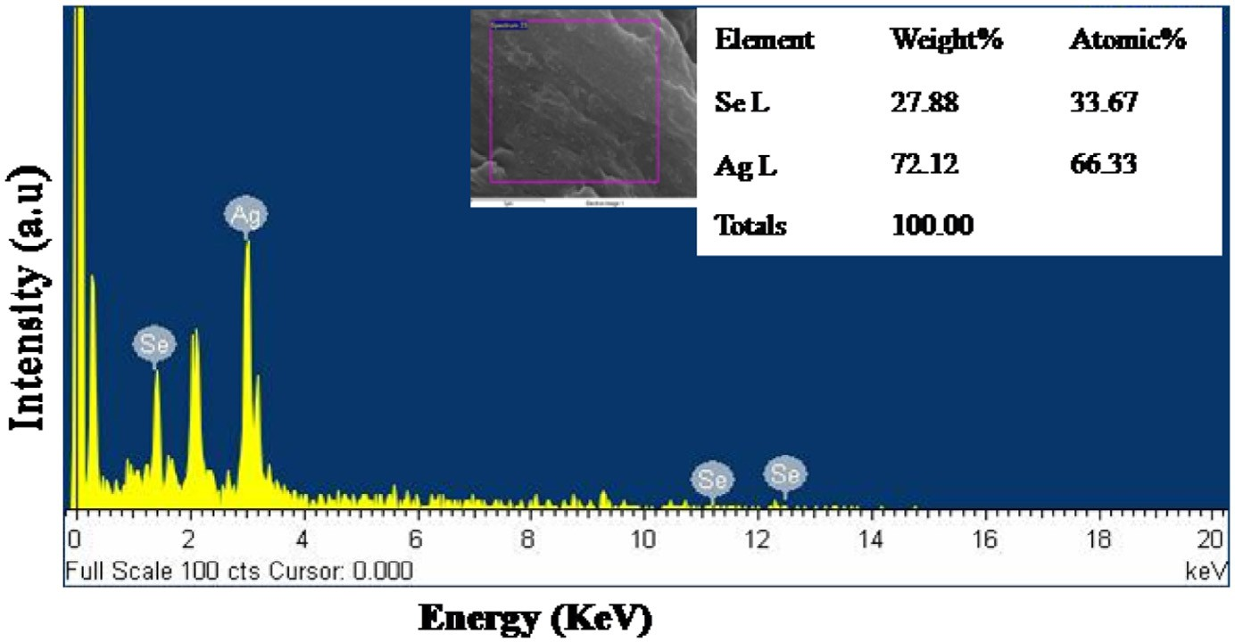

**Fig. 3 – Energy Dispersive X-ray (EDX) spectrum of Ag2Se nanoparticles. The inset figure gives the selected area for EDX measurement and the chemical composition of Ag2Se nanoparticles.**

CH2 stretch shifted to 2919 and 2851 cm−1, respectively, as shown in the FTIR spectra of Ag2Se nanoparticles (Fig. 4).

In the pure oleic acid spectra, the intense peak at 1710 cm−1 was due to the presence of the C=O stretch, and the band at 1285 cm−1 that indicated the presence of the C—O stretch

[29–31]. In addition, the O—H in-plane and out-of-plane bands of the pure oleic acid appeared at 1463 and 934 cm−1, respec- tively [29–31]. These bands disappeared in Ag2Se nanoparticles shown in Fig. 4, instead, two new bands at 1550 and 1440 cm−1 appeared, which are characteristic of the asymmetric *v*as(COO−)

and the symmetric *v*s(COO−) stretching [29–31], respectively. The

results from FTIR spectra in Fig. 4 reveal that oleic acid was

chemisorbed, as a carboxylate ion, onto the surface of the as- prepared Ag2Se nanoparticles (oleic acid capped Ag2Se nanoparticles or OA-capped Ag2Se), and that the two oxygen atoms in the carboxylate were coordinated symmetrically to both the Ag and the Se atoms.

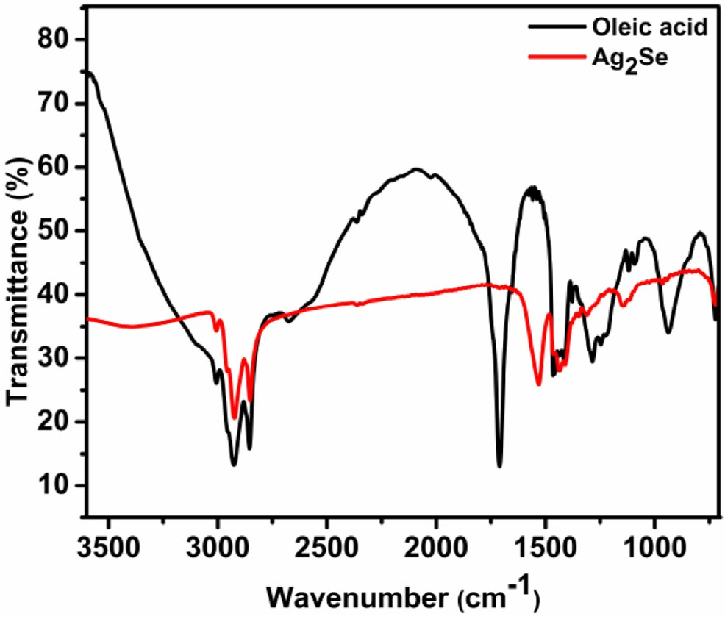

### Fig. 4 – FTIR spectra of pure oleic acid (OA) and Ag2Se nanoparticles.

Based on the aforementioned experimental results, it seems possible to explain the role of oleic acid in such synthesis strat- egy of Ag2Se nanoparticles. First, oleic acid and silver nitrate essentially lead to the formation of a silver oleate intermedi- ated by replacing the nitrate group in the starting materials.

Second, Se−2 is generated by the reaction of SeSO3−2 with OH−. Third, the intermediate silver oleate reacts with Se−2 to form

Ag2Se nanoparticles surrounded by oleate groups. This method protects the nucleation of the tiny particles, as shown in the following schematic diagram below (Scheme 1).

In general, capping ligands could prevent the aggregation of small crystals and influence the morphology of the as- prepared nanoparticles. The dynamics of the surface ligands attached and detached could be varied by controlling the tem- perature and the nature of the ligand. Thus, the reaction temperature could be used to control the growth of nanocrystals.

To further confirm the formation of Ag2Se nanoparticles and understand its optical properties, UV–visible absorption and photoluminescence (PL) measurement of the as-prepared Ag2Se nanoparticles in n-hexane were performed. Fig. 5 shows the UV–visible absorption: (a) photoluminescence; (b) spectra of oleic acid capped Ag2Se nanoparticles.

As seen from Fig. 5a, the absorption edge was determined at around ʎ = 635 nm, which is close to the literature value (ʎ = 629 nm) [21] reported for Ag2Se nanocrystals [21,35]. Ac-

cording to the relationship of the band gap energy (*E*g) with the absorption edge, the *E*g of the as-prepared Ag2Se nanoparticles was calculated as 1.95 eV, and this value agrees well with the value reported [21,35].

Fig. 5b shows the photoluminescence (PL) spectra of oleic acid capped Ag2Se nanoparticles in n-hexane, with the

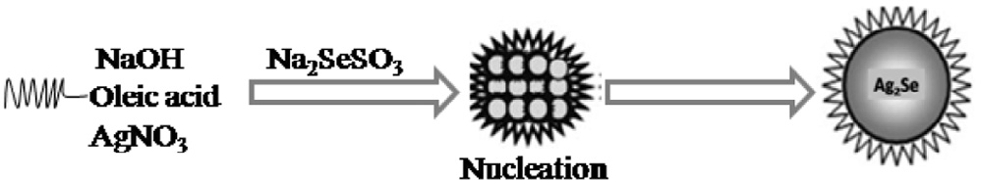

### Scheme 1 – The role of oleic acid in the formation of Ag2Se nanoparticles at low temperature.

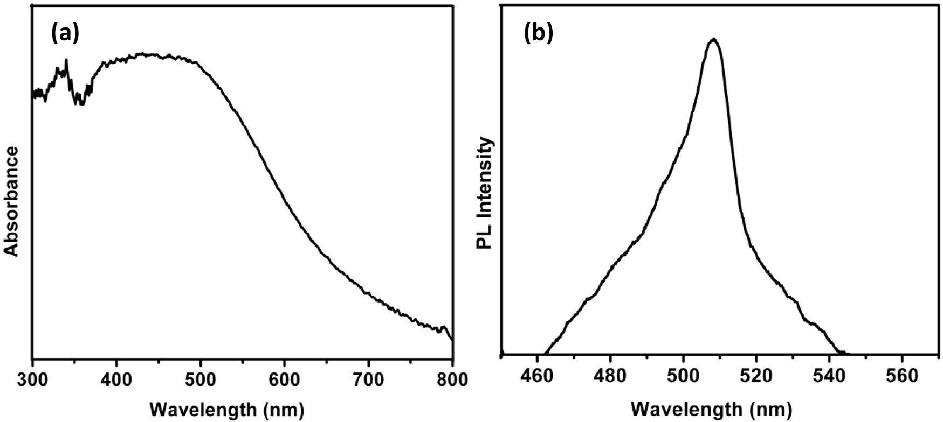

**Fig. 5 – UV–visible absorption (a) and PL spectra (b) of a solution of Ag2Se in n-hexane.**

maximum PL intensity observed at around λmax = 510 nm that

R E F E R E N C E S

may result from the direct interband radiative recombination [1].

# Conclusions

In this work, a low-temperature, facile and fast synthesis strat- egy for nearly monodisperse orthorhombic phase Ag2Se nanoparticles was developed. The optical properties, struc- ture, morphology and other properties of the as-prepared samples were characterized by different instruments such as TEM, FTIR, UV–visible, PL, EDX and XRD. The characterization

results of this instrument supported the formation of oleic acid capped orthorhombic phase β-Ag2Se nanoparticles.

In general, to prepare uniform nanoparticles, the devel- oped synthesis strategy has a number of advantages. Firstly, the synthesis of nanoparticles is completed at lower tempera- ture in one-pot makes the system easy to control and manipulate. Secondly, it is a fast method of synthesis to prepare nanoparticles, and this makes the system economi- cal. Thirdly, it is an ideal and general synthesis strategy in making other uniform nanoparticles for mass production through simple precipitation reactions. Last, but not least, this low temperature synthesis protocol is suitable for appli- cation in many other materials such as sulfides, fluorides, phosphates and so on, provided that high crystallinity is not required.

# Acknowledgement

The author gratefully acknowledges the financial support of Bahir Dar University, Ethiopia, Bahir Dar and National Taiwan University of Science and Technology and their permission for the use of the Precious Instrument Center through the auspice of Chair Professor Bing Joe Hwang.

1. [Zhang S-Y, Fang C-X, Wei W, Jin B-K, Tian Y-P, Shen Y-H,](http://refhub.elsevier.com/S2314-808X(16)00004-X/sr0010)

[et al. Synthesis and electrochemical behavior of crystalline](http://refhub.elsevier.com/S2314-808X(16)00004-X/sr0010) [Ag2Se nanotubes. J Phys Chem C 2007;111:4168–74.](http://refhub.elsevier.com/S2314-808X(16)00004-X/sr0010)

1. [Ge J-P, Xu S, Liu L-P, Li Y-D, Positive-Microemulsion A.](http://refhub.elsevier.com/S2314-808X(16)00004-X/sr0015)

[Method for preparing nearly uniform Ag2Se nanoparticles at](http://refhub.elsevier.com/S2314-808X(16)00004-X/sr0015) [low temperature. Chem Eur J 2006;12:3672–7.](http://refhub.elsevier.com/S2314-808X(16)00004-X/sr0015)

1. [Gates B, Mayers B, Wu Y, Sun Y, Cattle B, Yang P, et al.](http://refhub.elsevier.com/S2314-808X(16)00004-X/sr0020) [Synthesis and characterizations of crystalline Ag2Se](http://refhub.elsevier.com/S2314-808X(16)00004-X/sr0020) [nanowires through a template-engaged reaction at room](http://refhub.elsevier.com/S2314-808X(16)00004-X/sr0020) [temperature. Adv Funct Mater 2002;12:679–86.](http://refhub.elsevier.com/S2314-808X(16)00004-X/sr0020)
2. [Okereke NA, Ekpunobi AJ. Structural and electrical](http://refhub.elsevier.com/S2314-808X(16)00004-X/sr0025) [characteristics of silver selenide thin films. J Optoelectron](http://refhub.elsevier.com/S2314-808X(16)00004-X/sr0025) [Biomed Mater 2011;3:51–5.](http://refhub.elsevier.com/S2314-808X(16)00004-X/sr0025)
3. [Das VD, Karunakaran D. Variations of energy gap, resistivity,](http://refhub.elsevier.com/S2314-808X(16)00004-X/sr0030) [and temperature coefficient of resistivity in annealed beta-](http://refhub.elsevier.com/S2314-808X(16)00004-X/sr0030) [Ag2Se thin films. Phys Rev B 1989;39:10872–8.](http://refhub.elsevier.com/S2314-808X(16)00004-X/sr0030)
4. [Glanville YJ, Narehood DG, Sokol PE, Amma A, Mallouk T.](http://refhub.elsevier.com/S2314-808X(16)00004-X/sr0035)

[Preparation and synthesis of Ag2Se nanowires produced](http://refhub.elsevier.com/S2314-808X(16)00004-X/sr0035)

[by template directed synthesis. J Mater Chem 2002;12:2433–](http://refhub.elsevier.com/S2314-808X(16)00004-X/sr0035) [4.](http://refhub.elsevier.com/S2314-808X(16)00004-X/sr0035)

1. [Ng MT, Boothroyd C, Vittal JJ. Shape and size control of Ag2Se](http://refhub.elsevier.com/S2314-808X(16)00004-X/sr0040) [nanocrystals from a single precursor [(Ph3P)3Ag2(SeC{O}Ph)2].](http://refhub.elsevier.com/S2314-808X(16)00004-X/sr0040) [Chem Comm 2005;3820–2.](http://refhub.elsevier.com/S2314-808X(16)00004-X/sr0040)
2. [Cui Y, Chen G, Ren J, Shao M, Xie Y, Qian Y. Solvothermal](http://refhub.elsevier.com/S2314-808X(16)00004-X/sr0045) [syntheses of beta-Ag2Se crystals with novel morphologies.](http://refhub.elsevier.com/S2314-808X(16)00004-X/sr0045) [J Solid State Chem 2003;172:17–21.](http://refhub.elsevier.com/S2314-808X(16)00004-X/sr0045)
3. [Ferhat M, Nagao J. Thermoelectric and transport properties](http://refhub.elsevier.com/S2314-808X(16)00004-X/sr0050) [of beta-Ag2Se compounds. J Appl Phys 2000;88:813–16.](http://refhub.elsevier.com/S2314-808X(16)00004-X/sr0050)
4. [Xu R, Husmann A, Rosenbaum TF, Saboungi ML, Enderby JE,](http://refhub.elsevier.com/S2314-808X(16)00004-X/sr0055)

[Littlewood PB. Large magnetoresistance in non-magnetic](http://refhub.elsevier.com/S2314-808X(16)00004-X/sr0055) [silver chalcogenides. Nature 1997;390:57–60.](http://refhub.elsevier.com/S2314-808X(16)00004-X/sr0055)

1. [Kreutzbruck M, Mogwitz B, Gruhl F, Kienle L, Korte C, Janek J.](http://refhub.elsevier.com/S2314-808X(16)00004-X/sr0060)

[Magnetoresistance in Ag2+δSe with high silver excess. Appl](http://refhub.elsevier.com/S2314-808X(16)00004-X/sr0060) [Phys Lett 2005;86:072 102.](http://refhub.elsevier.com/S2314-808X(16)00004-X/sr0060)

1. [Abrikosov AA. Coherent versus incoherent resonant](http://refhub.elsevier.com/S2314-808X(16)00004-X/sr0065) [tunneling in high-Tc cuprates. Phys Rev B 1998;58(13):2788–](http://refhub.elsevier.com/S2314-808X(16)00004-X/sr0065) [90.](http://refhub.elsevier.com/S2314-808X(16)00004-X/sr0065)
2. [Moshtaghi S, Zinatloo-Ajabshir S, Salavati-Niasari M.](http://refhub.elsevier.com/S2314-808X(16)00004-X/sr0070) [Preparation and characterization of BaSnO3 nanostructures](http://refhub.elsevier.com/S2314-808X(16)00004-X/sr0070) [via a new simple surfactant-free route. J Mater Sci: Mater](http://refhub.elsevier.com/S2314-808X(16)00004-X/sr0070) [Electron 2016;27:425–35.](http://refhub.elsevier.com/S2314-808X(16)00004-X/sr0070)
3. [Sobhani A, Salavati-Niasari M. Morphological control of](http://refhub.elsevier.com/S2314-808X(16)00004-X/sr0075) [MnSe2/Se nanocomposites by amount of hydrazine through](http://refhub.elsevier.com/S2314-808X(16)00004-X/sr0075) [a hydrothermal process. Mater Res Bull 2013;48:3204–10.](http://refhub.elsevier.com/S2314-808X(16)00004-X/sr0075)
4. [Wang W, Geng Y, Qian Y, Ji M, Xie Y. A novel room](http://refhub.elsevier.com/S2314-808X(16)00004-X/sr0080) [temperature method to nanocrystalline Ag2Se. Mater Res](http://refhub.elsevier.com/S2314-808X(16)00004-X/sr0080) [Bull 1999;34:877–82.](http://refhub.elsevier.com/S2314-808X(16)00004-X/sr0080)
5. [Harpeness R, Palchik O, Gedanken A, Palchik V, Amiel S,](http://refhub.elsevier.com/S2314-808X(16)00004-X/sr0085)

[Slifkin MA, et al. Preparation and characterization of Ag2E](http://refhub.elsevier.com/S2314-808X(16)00004-X/sr0085)

[(E = Se, Te) using the sonochemically assisted polyol method.](http://refhub.elsevier.com/S2314-808X(16)00004-X/sr0085) [Chem Mater 2002;14(5):2094–102.](http://refhub.elsevier.com/S2314-808X(16)00004-X/sr0085)

1. [Ma X-D, Qian X-F, Yin J, Zhu Z-K. Preparation and](http://refhub.elsevier.com/S2314-808X(16)00004-X/sr0090) [characterization of polyvinyl alcohol–selenide](http://refhub.elsevier.com/S2314-808X(16)00004-X/sr0090) [nanocomposites at room temperature. J Mater Chem](http://refhub.elsevier.com/S2314-808X(16)00004-X/sr0090) [2002;12:663–6.](http://refhub.elsevier.com/S2314-808X(16)00004-X/sr0090)
2. [Ayele DW, Chen H-M, Su W-N, Pan C-J, Chen L-Y, Chou H-L,](http://refhub.elsevier.com/S2314-808X(16)00004-X/sr0095) [et al. Controlled synthesis of CdSe quantum dots by a](http://refhub.elsevier.com/S2314-808X(16)00004-X/sr0095) [microwave-enhanced process: a green approach for mass](http://refhub.elsevier.com/S2314-808X(16)00004-X/sr0095) [production. Chem Eur J 2011;17:5737–44.](http://refhub.elsevier.com/S2314-808X(16)00004-X/sr0095)
3. [Quinlan FT, Kuther J, Tremel W. Reverse micelle synthesis](http://refhub.elsevier.com/S2314-808X(16)00004-X/sr0100) [and characterization of ZnSe nanoparticles. Langmuir](http://refhub.elsevier.com/S2314-808X(16)00004-X/sr0100) [2000;16(8):4049–51.](http://refhub.elsevier.com/S2314-808X(16)00004-X/sr0100)
4. [Ingert D, Pileni MP. Limitations in producing nanocrystals](http://refhub.elsevier.com/S2314-808X(16)00004-X/sr0105) [using reverse micelles as nanoreactors. Adv Funct Mater](http://refhub.elsevier.com/S2314-808X(16)00004-X/sr0105) [2001;11(2):136–9.](http://refhub.elsevier.com/S2314-808X(16)00004-X/sr0105)
5. [Xiao J, Xie Y, Tang R, Luo W. Template-based synthesis of](http://refhub.elsevier.com/S2314-808X(16)00004-X/sr0110) [nanoscale Ag2E (E = S, Se) dendrites. J Mater Chem](http://refhub.elsevier.com/S2314-808X(16)00004-X/sr0110) [2002;12:1148–51.](http://refhub.elsevier.com/S2314-808X(16)00004-X/sr0110)
6. [Jiang ZY, Huang RB, Xie SY, Xie ZX, Zheng LS. Synthesis of](http://refhub.elsevier.com/S2314-808X(16)00004-X/sr0115) [silver selenide bicomponent nanoparticles by a novel](http://refhub.elsevier.com/S2314-808X(16)00004-X/sr0115) [technique: laser–solid–liquid ablation. J Solid State Chem](http://refhub.elsevier.com/S2314-808X(16)00004-X/sr0115) [2001;160(2):430–4.](http://refhub.elsevier.com/S2314-808X(16)00004-X/sr0115)
7. [Yan YL, Qian XF, Xu HJ, Yin J, Zhu ZK. A novel solid–liquid](http://refhub.elsevier.com/S2314-808X(16)00004-X/sr0120) [route for the preparation of Cu3Se2 and Ag2Se nanocrystals.](http://refhub.elsevier.com/S2314-808X(16)00004-X/sr0120) [Inorg Chem Commun 2003;6(1):34–7.](http://refhub.elsevier.com/S2314-808X(16)00004-X/sr0120)
8. [Jiang Y, Xie B, Wu J, Yuan S, Wu Y, Huang H, et al. Synthesis](http://refhub.elsevier.com/S2314-808X(16)00004-X/sr0125) [of copper and silver, nanocrystalline chalcogenides in mixed](http://refhub.elsevier.com/S2314-808X(16)00004-X/sr0125) [solvents. J Solid State Chem 2002;167(1):28–33.](http://refhub.elsevier.com/S2314-808X(16)00004-X/sr0125)
9. [Batabyal SK, Basu C, Das AR, Sanyal GS. Micropatterns of](http://refhub.elsevier.com/S2314-808X(16)00004-X/sr0130) [Ag2Se nanocrystals. Cryst Growth Des 2004;4(3):509–11.](http://refhub.elsevier.com/S2314-808X(16)00004-X/sr0130)
10. [Gates B, Wu Y, Yin Y, Yang P, Xia Y. Single-crystalline](http://refhub.elsevier.com/S2314-808X(16)00004-X/sr0135)

[nanowires of Ag2Se can be synthesized by templating](http://refhub.elsevier.com/S2314-808X(16)00004-X/sr0135) [against nanowires of trigonal Se. J Am Chem Soc](http://refhub.elsevier.com/S2314-808X(16)00004-X/sr0135) [2001;123(46):11500–1.](http://refhub.elsevier.com/S2314-808X(16)00004-X/sr0135)

1. [Zhao L-L, Gao Z-M, Liu H, Yang J, Qiaoab S-Z, Du X-W. Modify](http://refhub.elsevier.com/S2314-808X(16)00004-X/sr0140) [the morphology of colloidal Ag2Se nanostructures by laser](http://refhub.elsevier.com/S2314-808X(16)00004-X/sr0140) [irradiation. CrystEngComm 2013;15:1685–8.](http://refhub.elsevier.com/S2314-808X(16)00004-X/sr0140)
2. [Cao H, Xiao Y, Lu Y, Yin J, Li B, Wu S, et al. Ag2Se complex](http://refhub.elsevier.com/S2314-808X(16)00004-X/sr0145) [nanostructures with photocatalytic activity and](http://refhub.elsevier.com/S2314-808X(16)00004-X/sr0145) [superhydrophobicity. Nano Res. 2010;3:863–73.](http://refhub.elsevier.com/S2314-808X(16)00004-X/sr0145)
3. [Ayele DW, Su W-N, Chou H-L, Pan C-J, Hwang B-J.](http://refhub.elsevier.com/S2314-808X(16)00004-X/sr0150) [Composition-controlled optical properties of colloidal CdSe](http://refhub.elsevier.com/S2314-808X(16)00004-X/sr0150) [quantum dots. Appl Surf Sci 2014;322:177–84.](http://refhub.elsevier.com/S2314-808X(16)00004-X/sr0150)
4. [Wu N, Fu L, Su M, Aslam M, Wong KC, Dravid VP. Interaction](http://refhub.elsevier.com/S2314-808X(16)00004-X/sr0155) [of fatty acid monolayers with cobalt nanoparticles. Nano](http://refhub.elsevier.com/S2314-808X(16)00004-X/sr0155) [Lett 2004;4:383–6.](http://refhub.elsevier.com/S2314-808X(16)00004-X/sr0155)
5. [Limaye MV, Singh SB, Date SK, Kothari D, Reddy VR, Gupta](http://refhub.elsevier.com/S2314-808X(16)00004-X/sr0160) [A, et al. High coercivity of oleic acid capped CoFe2O4](http://refhub.elsevier.com/S2314-808X(16)00004-X/sr0160) [nanoparticles at room temperature. J Phys Chem B](http://refhub.elsevier.com/S2314-808X(16)00004-X/sr0160) [2009;113:9070–6.](http://refhub.elsevier.com/S2314-808X(16)00004-X/sr0160)
6. [Moshtaghi S, Zinatloo-Ajabshir S, Salavati-Niasari M.](http://refhub.elsevier.com/S2314-808X(16)00004-X/sr0165) [Nanocrystalline barium stannate: facile morphology-](http://refhub.elsevier.com/S2314-808X(16)00004-X/sr0165) [controlled preparation, characterization and investigation of](http://refhub.elsevier.com/S2314-808X(16)00004-X/sr0165) [optical and photocatalytic properties. J Mater Sci: Mater](http://refhub.elsevier.com/S2314-808X(16)00004-X/sr0165) [Electron 2016;27:834–42.](http://refhub.elsevier.com/S2314-808X(16)00004-X/sr0165)
7. [Zinatloo-Ajabshir S, Salavati-Niasari M, Hamadanian M.](http://refhub.elsevier.com/S2314-808X(16)00004-X/sr0170) [Preparation of nanocrystalline praseodymium oxide with](http://refhub.elsevier.com/S2314-808X(16)00004-X/sr0170) [different shapes via a simple thermal decomposition route.](http://refhub.elsevier.com/S2314-808X(16)00004-X/sr0170) [J Mater Sci: Mater Electron 2016;27:998–1006.](http://refhub.elsevier.com/S2314-808X(16)00004-X/sr0170)
8. [Zinatloo-Ajabshir S, Salavati-Niasari M. Synthesis of pure](http://refhub.elsevier.com/S2314-808X(16)00004-X/sr0175) [nanocrystalline ZrO2 via a simple sonochemical-assisted](http://refhub.elsevier.com/S2314-808X(16)00004-X/sr0175) [route. J Ind Eng Chem 2014;20:3313–19.](http://refhub.elsevier.com/S2314-808X(16)00004-X/sr0175)
9. [Pejova B, Najdoski M, Grozdanov I, Dey SK. Chemical bath](http://refhub.elsevier.com/S2314-808X(16)00004-X/sr0180) [deposition of nanocrystalline (111) textured Ag2Se thin films.](http://refhub.elsevier.com/S2314-808X(16)00004-X/sr0180) [Mater Lett 2000;43(5–6):269–73.](http://refhub.elsevier.com/S2314-808X(16)00004-X/sr0180)