[Egyptian Informatics Journal 23 (2022) 437–446](https://doi.org/10.1016/j.eij.2022.04.001)

Contents lists available at [ScienceDirect](http://www.sciencedirect.com/science/journal/11108665)

Egyptian Informatics Journal

journal homepage: [www.sciencedirect.com](http://www.sciencedirect.com/)

Full length article

[](http://crossmark.crossref.org/dialog/?doi=10.1016/j.eij.2022.04.001&domain=pdf)A hybrid deep learning-based framework for future terrorist activities modeling and prediction

Firas Saidi a,⇑, Zouheir Trabelsi b

a *RIADI Lab, National School of Computer Science (ENSI), University of Manouba, Tunisia*

b *College of Information Technology, United Arab Emirates University, P.O.Box 17551, Abu Dhabi, United Arab Emirates*

a r t i c l e i n f o

*Article history:*

Received 15 January 2022

Revised 15 March 2022

Accepted 7 April 2022

Available online 21 April 2022

*Keywords:* Terrorist activities Prediction

Deep Learning (DL) CNN-LSTM

DNN GTD

a b s t r a c t

Terrorism has led to massive humanitarian and economic crisis due to dire events that affected many countries and caused thousands of deaths and critical damages. In literature, various Artificial Intelligence (AI) based research works have been proposed and enhanced to counter and predict terrorist activities. Practically, Machine Learning (ML) techniques are the most applied. However, with the increas- ing of the complexity and volume of data, ML algorithms fail to detect and predict accurately terrorist activities. Thus, for understanding the behavior of terrorist actors, we proposed a hybrid Deep Learning (DL) platform based on Convolutional Neural Network (CNN) and Long Short-Term Memory (LSTM) models to learn the temporal features from the Global Terrorism Database (GTD) and to predict future terrorist activities characteristics. The GTD is a well-known database which contains around 190,000 terrorist events and incidents around the world since 1970 until 2020 and incorporates multiple factors, such as the type of weapons used, the attack is successful or not, the kind of attack, and the cat- egory of terrorist. First the CNN is used extract complex features of the data, and then these features are forwarded to LSTM model to learn the temporal relationship of the data. Simulation results show that the CNN-LSTM model achieves superior performance for bi-classification tasks which achieves an accuracy more than 96%, while the DNN outperforms the hybrid aforementioned model with accuracy of 99,2% the multi-classification task of predicting terrorist activities. The proposed model shows also a correla- tion between the occurrence of attacks with the type of weapons used and can accurately predict the type of terrorist attacks with their success rate.

© 2022 THE AUTHORS. Published by Elsevier BV on behalf of Faculty of Computers and Artificial Intel-

ligence, Cairo University. This is an open access article under the CC BY-NC-ND license ([http://creative-](http://creativecommons.org/licenses/by-nc-nd/4.0/)

[commons.org/licenses/by-nc-nd/4.0/](http://creativecommons.org/licenses/by-nc-nd/4.0/)).

1. Introduction

On March 17, 2005, the United Nations (UN) team officially defined terrorism as: ‘‘intended to cause death or physical harm to persons or non-military persons to intimidate the public or force the government or international organization to commit or refrain from committing any act” [1]. One of the leading menaces to mod- ern enlightenment is terrorism. Terrorism undermines the com-

* Corresponding author.

*E-mail addresses:* [firas.saidi@ensi.rnu.tn](mailto:firas.saidi@ensi.rnu.tn) (F. Saidi), [trabelsi@uaeu.ac.ae](mailto:trabelsi@uaeu.ac.ae) (Z. Trabelsi).

Peer review under responsibility of Faculty of Computers and Information, Cairo University.

**Production and hosting by Elsevier**

munity’s law enforcement and influences the people’s attribute of life, deprives them of physical and emotional stress, and robs them of the joy of enjoying life [2,3]. In order to expand one’s understanding of terrorist violence, START of America has launched the Global Terrorism Database (GTD), an open-access international terrorism online database that may be used to successfully study and combat terrorism [4].

As reported by the GTD, in 2019, 1,411 terrorist bombings had taken place, resulting in 6,362 deaths and severely disrupting pub- lic life [2]. Since its inception in the 1970s, significant texts on modern terrorism have contained numerous attempts to predict the future of terrorism. However, most of these efforts are unplanned and have no theoretical basis. The end of terrorist lit- erature is often plagued by a lack of formal thinking on how social change can produce different forms of terrorist and counter- terrorism, leading to persistent patterns of terrorism. It is usually based on observing events related to the addition from the same context while changing the contextual or fundamental elements

<https://doi.org/10.1016/j.eij.2022.04.001>

1110-8665/© 2022 THE AUTHORS. Published by Elsevier BV on behalf of Faculty of Computers and Artificial Intelligence, Cairo University. This is an open access article under the CC BY-NC-ND license (<http://creativecommons.org/licenses/by-nc-nd/4.0/>).

that make up the very places where terrorism grows or refuses to be analyzed appropriately or understood [1].

Machine Learning (ML) classifiers play an essential role [5–8] and contributed significantly in the development of predictive systems with interesting accuracy [9]. As in this paper [10], the author exam- ines the challenges facing terrorism inside India with modeling behavior of anarchist assembly using popular ML techniques such as, the Naıve Bayes, Support Vector Machine (SVM), J48 decision tree, and Instance-Based k (IBK). From Artificial Intelligence (AI) and ML, a new paradigm comes out, which is known as ‘‘Deep Learn- ing” (DL). DL is a subset of ML which is based on multiple hidden lay- ers that can learn the complex patterns in massive data. The DL can be used as a supervised learning or unsupervised learning based on the type of problem. Several facets of terrorism have been studied using ML techniques [11,12]. The objective is to employ AI tech- niques such as classification models, decision trees, and Random Forest to analyze and anticipate future terrorist strikes [13]. This paper proposed a DL model to predict future terrorist activities. The existing literature is limited because it has so far failed to incor- porate various types of factors such as weapon type, region type, etc in predicting the terrorist activities [14], with the results being sen- sitive to terrorist estimations, sample selection, and the mathemat- ical method applied. Therefore, the existing model in [2] does not predict terrorist incidents with an acceptable level of accuracy and is therefore used only to limit the actual formulation of anti- terrorism policy. The researchers have used DL models in predicting terrorist activities. However, there is still a research gap to increase accuracy and classify terrorist activities based on bi-label and multi- label data sets [15]. To address the issue, we proposed a hybrid model which combined two DL models the Convolutional Neural Network (CNN) and the Long Short-Term Memory (LSTM) to predict terrorist attacks. We also proposed an improved DNN model and evaluated that for bi-classification models, CNN-LSTM performed well, and for the multi-classification problems in predicting terrorist activities, DNN performed superior compared to CNN-LSTM.

The key contributions of this paper are summarized as follows:

1. We proposed a DL enabled hybrid CNN-LSTM model to accu- rately predict future terrorist attack activities, such as indicat- ing the category of the attack based on the weapon type used and correlation of type of terrorist attacks with their success rate.
2. The CNN-LSTM model is trained to learn the spatial features of terrorism data set to predict terrorist activities considering multiple factors, such as the type of weapons used, the attack is successful or not, kind of the attack, and the category of ter- rorist for predicting the terrorism activities.
3. For the first time, the incorporation of a hybrid CNN-LSTM DL model for predicting terrorist activities concluded that hybrid CNN-LSTM achieves improved accuracy in bi-classification task, and DNN performs well for multi-label classification tasks com- pared to the benchmark ML techniques.

The paper is organized as follows. Section 2 describes related works to highlight recent advances in this topic and includes a benchmark to evaluate our results. Section 3 detailed the proposed hybrid DL framework and includes analysis and descriptions of the CNN and DNN algorithms used to forecast various aspects. The findings are presented in Section 4. Section 5 summarizes the find- ings and concludes the paper with future research directions.

1. Literature review

Mining the state of the art, various research works have been proposed to analyze and predict terrorist attacks.

In [16], authors proposed a novel ML approach that uses famous and influential learning approaches to mimic the dangers of the terrorist strike around the world in terms of resources, long series and information distributed across the globe. Historical evidence from 1970 to 2015 was endorsed for the training and testing of the ML model. This model has a success rate of more than 96% in predicting places where terrorist attacks are likely to occur in 2015. Furthermore, a model with a modified set of adjustment fac- tors correctly predicted 2,037 terrorist event sites where terrorist attacks had never happened previously. In [17], five ML methods have been used to filter data stored in the object of a terrorist attack to predict terrorist attacks. In this research work, data about terrorist attacks during 2015 and 2016 were used to experiment the Logistic Regression, Decision tree, Gaussian Bayesian Network, AdaBoost, and Random Forests.Experiments shows that Gaussian filter and the Decision Tree algorithm performs well in attacks pre- diction. Authors in [18], proposed a cutting-edge hybrid classifier for the prediction of terrorist attacks from Big data. Practically, a method for predicting terrorist attacks was presented, including data collection, pre-processing, a hybrid of the data classification, and the testing of the classifiers in general. To improve the accu- racy of the hybrid classifier prediction, the weights of the classifier are optimized using a genetic algorithm. Results show that, a hybrid classifier is better than a single classifier in terms of the forecast accuracy. In [19], authors addressed the prediction of ter- rorist groups responsible of the attacks in Egypt between 1970 and 2013. To achieve the targeted goal, authors experimented five clas- sifiers, namely NB, KNN, C-4.5, ID3, and SVM. Simulation results show that SVM performs well in terms of all metrics compared to other benchmark schemes.However, ID3 has the lowest accu- racy compared to other schemes and KNN achieves higher classifi- cation accuracy. In [20], an ESALLOR model was presented to examine relationships and to derive information concerning ter- rorist acts. First, critical features are identified based on a similarity function. After that, a new weighted heterogeneous similarity function for assessing assault relationships is introduced. Further- more, to identify the hazards of an explosion, authors suggested to use graphics to detect the program. Experimental results show the effectiveness of the proposed structure with a high level of accu- racy (more than 90% for the models’ finding) compared to the ter- rorist events in 2014 and 2015. In [21],authors used predictive modelling to analyze Incident data from GTD. In this work, tradi- tional location indication of the algorithm is combined with the multi-source factors and spatial characteristics. The paper used the data for simulation from the terrorist attacks in Southeast Asia from the 1970s to 2016 and has been extensively analyzed in sev- enteen elements, including the social, economic, and natural resource-related factors. In another work [22], authors proposed an advanced recommendation algorithm to construct a three- dimensional model for assessing the risk of a terrorist attack. This model has been verified by simulation and achieved a threshold of 0.4, and an accuracy of 88% with the highest F1 score.In [23], authors studies the prediction of non-state groups that are respon- sible of terrorist attacks which occurred in the Middle East and North Africa from 2009 to 2013. In this paper, a variety of ML methods, namely Naive Bayes, KNN, Decision trees, and SVM are applied. Experiments were carried out with the help of real- world data provided by the GTD. In another work [6], authors pro- posed a CNN-LSTM enabled ensemble technique and deep learning framework for detection the myocardial infarction for the ECG and it was concluded that it performed well compared to the tradi- tional CNN approach.Similarly, authors in [7] proposed a hybrid CNN framework for segmentation and detection of brain tumors of Magnetic Resonance Imaging (MRI) images and achieved higher accuracy. In another work [8], authors proposed a CNN based technique for tumors classification and identification from MR

image. Practically,experiments show that CNN achieved good performance.

Based on the literature review, we noticed that no single ML or DL based approach performs well with undependable manner in predicting terrorist activities for both bi-label and multi-label clas- sification tasks. For example, CNN based models are efficient for the image classification, and others DL techniques performs well in multi-label classification. However, these techniques still not sophisticated when the data size is highly complex and have non-linear features that cannot be learned using a single DL tech- nique. Indeed, these methods present a good accuracy in terrorist activities detection, with small and non-complex data sets. How- ever, existing data sets are massive and have complex features. Thus, these limitations constitute a research gap and bring up a need to increase the accuracy of ML and DL based methods using bi-label and multi-label terrorism data sets. To overcome the afore- mentioned problems, we propose a hybrid DL based framework where we combined two algorithms namely; CNN and LSTM to predict future terrorist attacks.

1. Materials and Methods

In this paper, we proposed a hybrid CNN-LSTM model to predict future terrorist activities. The CNN model learns the local features of the data-sets, and the LSTM extracts the context-dependent fea- tures to improve the model’s accuracy. Fig.1 shows the model’s basic structure which includes an input filtered data set, 1D convo- lution layer, LSTM layer, a fully connected layer, and finally, a soft- max function for the classification task. (See Fig.2).

Initially, the data-set is filtered and applied as input with a size of 33 x 1 matrix for classifying the attack as suicide or not. After the input layer, nodes in the CNN model are connected by weighted edges to learn the data-set features. The learned weights are for- warded to the LSTM layer and then the output layer which decides whether the attack is suicide or not.

Data Analysis

The data-set is thoroughly examined in the next part where we detailed also how data was pre-processed.

* 1. */eature Collection*

The data-set is taken from the Global Terrorism Database (GTD) which includes around 190,000 terrorist attacks from 1970 to 2020 around the world.

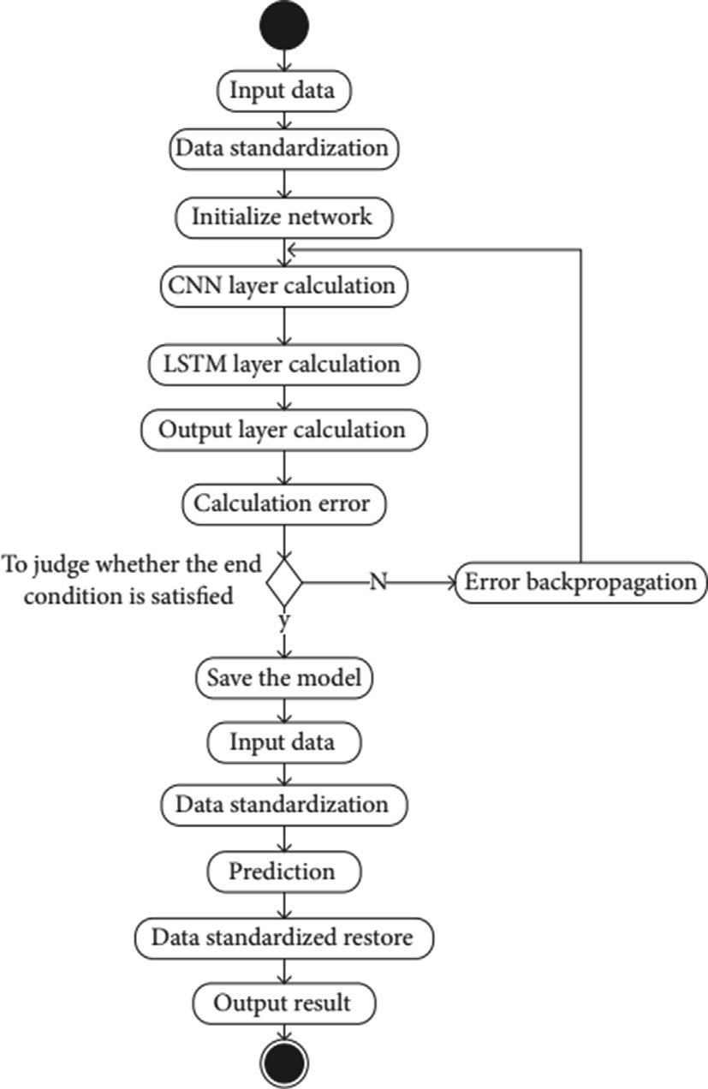

Fig. 2. Training process of CNN-LSTM.

* 1. *Terrorist Activities /actors*

The Neural Network (NN) and Deep Neural Network (DNN) will be used to learn the following five main characteristics:

1. *Self-Destruction:* This category shows whether it is suicide or not. One = ”Yes,” means that the case was self-inflicted suicide. Zero = ”No” means there is no evidence that the incident was a terrorist event against a bomb reference. The size of the Data- base is (350, 116 34). 80% of data was used for training (280093) and 20% (70031) is used for testing. Both classes have 175,058 instances.

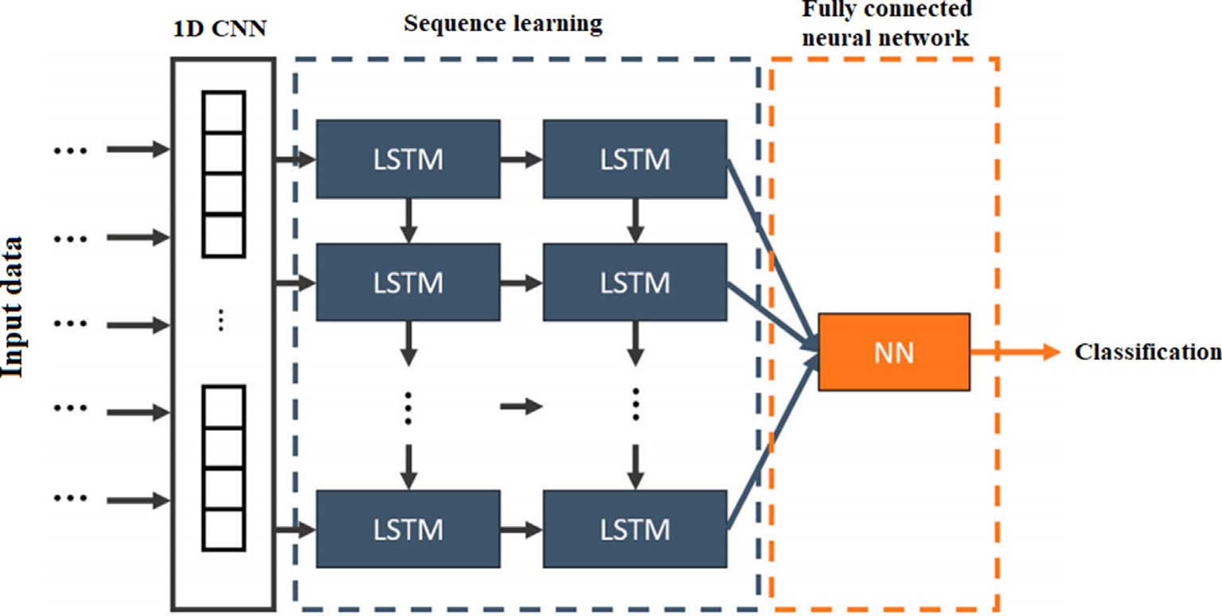

Fig. 1. Proposed CNN-LSTM based framework terrorist activities prediction.

1. *Success:* The success of the Attack is determined by this parameter. One = ” Yes” means that the situation is normal and Zero = ” No ” means that the situation is bad. The data-set has dimension of (323264). 80% of information is used for training and personnel training (258611 cases), and 20% is used for testing (64653 cases). Each individual has 161,632 instances.
2. *Weapon Type:* This category of weapons includes thirteen items in the database, and it is also used to identify different kinds of weapons. One of the living organisms of chemical and radioactive radiation, Explosives, and Fake weapons, Threats, Troubles, Provocations of Resources, Vehicles (except explosives transported by road, a car bomb, or vehicles) and other are unknown. The database size is (1109, 112 34). 80% of the database is used for training (887289), and 20% is used for the testing (221822 cases). Each category has the number 426 92.
3. *Region Type:* There are twelve different regions represented in this area which are North America, East Asia, Southeast Asia, South Asia, South America, Central America and the Caribbean, Europe, Middle East, North Africa, Western Europe, Central Asia,

Africa, Australia, and the Pacific. The database size is (605, 688

1. *Normalization:* Information about the SCHEDULE has spread to a wide range of areas. In some columns, the values are 0 and 1. In others, there may be hundreds or even thousands of them. It is challenging for the learning algorithm to learn the model and converge to a global minimum. Therefore, processing of data plays an important role in the process of learning. The values of normalization are standard, that is, rates from 0 to 1 or from 1 to 1. In this case the MinMaxScalar library sklearn library is useful which subtracts the each value of feature and averages them and divide them by the standard deviation to normalize

the data in the range of —1 to 1. Suspension is a formula that

is expressed in Eq. (1), where *Xi* is all its single function. *X* is the average value of the sample per element and total devia- tions. Then, the filtered data is applied to the input layer of the model and is passed to the next layer compromised of the convolutional layer. We used 64 kernels in layer1 of the convo- lutional layer with 3 x 1 shapes of each convolutional kernel. The activation function for introducing the non-linearity in the proposed model is Rectified Linear Unit (ReLU). The 1D con- volutional layer and activation function can be mathematically represented as:

34). 80% of the database is used for training (484550) and 20% (121137) is used for testing. Each category has a base of 50,474 cases.

; *j* *i*

*Nk*—1

*yk* = q

X

*i*

*j*=1

*Conv*(*wi j*; *xk*—1)+ *bk*!

# (1)

1. *Type of Attack:* In the data sets, nine different labels are used for

where *yk* is the *kth* feature map in the *kth* layer, *xk*—1 shows the *jth*

*i j*

the type of attacks used. The labels are Execution, Car hijacking, Bombings/explosions, abducting captives, Attack is armed, kid- napping, Unsafe attacks, Attack on institution/infrastructure, others.

The data set dimension is (957, 242 34). Practically, 80% of the information (765793 cases) is used for learning, and 20% is used for testing (191448 points). There are 88,255 instances of each class.

1. Proposed Methodology

The proposed CNN-LSTM model for predicting terrorist activi- ties consists of the input layer, one pooling layer, convolutional layer, LSTM layer, fully connected dense layers, and an output layer based on a soft-max function. The first step involves data repro- cessing that is discussed in detail below:

feature map of *k* — 1*th* layer. *wm*;*n* indicates the convolutional ker- nel which is trainable and its weights can be adjusted. *Conv* shows the convolution operation in 1D using the zero-padding

process where *bk* is the bias value of the *kth* feature map used

*i*

in the *kth* layer. The Convolutional layer is used to learn the non-linear features for improving the classification process. The q shows the activation function, ReLU which is used for reducing the over fitting issue and can be mathematically

defined as:

q(*x*)= 0; if*x* 6 1

*x*; *x* > 0

After the convolutional layer, the output is passed to max- pooling layer which can be defined as:

*pb* = *max*(*pb*') (2)

1. *Text to Numbers:* Some aspects in the GTD database are in text *i* *i*

format, such as group name, country name, etc. Processing fea- tures using text data is not possible in NN or DNN. TFIDF, Word2Vec, GloVe, one encoding, and other techniques trans- form text data into numbers. The LabelEncoder part of the sklearn library is utilized in this study to convert non-data con- verted into information data since labels are quicker than num- ber labels.

1. *Missing Numbers:* The dataset has a large number of errors, i.e., cells with no data, resulting in NaN when analyzed by NN. To fill in the gaps, various interpolation techniques can be utilized. SimpleImputer from the sklearn library is used to fill in the gaps in this study. We used the mean to replace the missing values in each column.
2. *Unbalanced Classe:s* During the data analysis, it is evident that the data was not filtered at various stages. In some categories, there are many unknown cases, and some there are very few instances. The training NN and DNN incase of unbalanced data can result in bias. To address the issue, we used the SMOTE: Synthetic Minority Over-sampling Algorithm, presented by

where *pb* shows the *ith* neuron before applying a max-pooling func- tion on the *ith* feature map and *pb*' is the *ith* neuron after applying the max-pooling function, and *s* represents the size of the pooling win- dow. The output features of the max-pooling layer are forwarded to the LSTM to avoid the problem of long-term dependency. The out- put features of the LSTM layer are forwarded to three hidden layers, and finally, a softmax layer is added for the classification task.

Training process

*i*

*i*

The complete process of the training and prediction of CNN- LSTM model is described in the figure below:

In this following part, we will detail step by step the process described above:

* 1. Enter data needed for training the CNN-LSTM prototype.
  2. The z-score standardization approach is used to normalize the data and reducing the wide gap to train the model better, as illustrated in the following formula:

Chawla et al. in 2002 [24] in the Python [25]to balance the data set.

*yi* =

*xi* — *xj*

*s* (3)

*xi* = *yi* * *s* + *xj* (4)

for training the model and weights are updated by calculating the loss function. The training process ends when the optimal value of accuracy is achieved.

In the above equations, the standardized value is *yi* , the data

which is having to enter is *xi*, also take the average of entered data, which is *xj*, and lastly input data which takes the average of entered data, which is *xj*, and lastly, input data that holds the standard deviation is *s*.

* 1. Set the weights and biases of each CNN-LSTM layer.
  2. The input data is transferred via the convolution layer and pooling layer in the CNN layer. The input data is feature extracted, and the output value is obtained.
  3. The output value of the CNN layer is obtained by investigat- ing the matters of the LSTM layer, and at the end, the output value is finding out.
  4. The value of the output layer of the LSTM center, has been introduced to the communication layer for the output value.
  5. The output value is calculated based on the data and com- pared with the data group’s actual value, and its associated error was detected.
  6. The terms and conditions to comply with a certain num- ber of cycles are performed. The weight is lower than a certain threshold, and the prediction error rate is below. As one of the completing terms and conditions is not met, the course may be completed. The entire network is updated with the LSTM, CNN center, and step 10. If this condition is not met it will go to step 9. The expression tomography errors in the opposite direction are used to update the weight and offset of each layer, after that it moves to step 4 to continue training the network. Finally, the trained model parameters are saved and used for prediction.
  7. Enter the input data required for the forecast.
  8. The data obtained were standardized following Eq. (3).
  9. Enter the default data of the trained CNN center-LSTM model, and then, the corresponding output value.
  10. In the output, the value obtained using the CNN-LSTM model is a constant value which is taken as a default value; it is reset to the initial value as shown in the formula (4) below. Where *xi* is the default reconstructed value, *y* is the output value of the CNN center, and the LSTM and *s* are the standard deviations of the original data, and *x* is the mean or average value of the input data.
  11. The output value is used to predict the future terrorist activ- ity considering multiple factors.

The training process of the proposed CNN-LSTM algorithm can be seen in Algorithm 1. The first step is to pre-process the data-set and then to reduce the over-fitting issue, data is nor- malized by using the z-score method. The filtered dataset is pro- vided as an input to the CNN-LSTM model. The weights of the CNN and LSTM layers are initialized, the features are initially learned by the CNN layer, then the learned features from the CNN layer is forwarded to the LSTM model. The LSTM layer learns the temporal features of the data and by adjusting the weights during the training minimize the error. As a result, out- put from the LSTM is used to predict the future terrorist activity. The terrorist activity value is predicted as an output. The max- time of the simulation is defined initially and the loss function. The dataset is divided into training and validation and weights of the CNN-LSTM model is reset. The batch size of 30 is kept

Algorithm 1: Training process of CNN-LSTM

Input: Input values of the GTD Dataset

Output: *TrainedModel*: CNN-LSTM model for predicting the terrorist activities

Begin

while *t* < maxtime and *loss* > target error

for all training set

Prepare the input *xi* and the output *yi* for training and validation.

For training *i* = 1 and *j* = 2 For Validation *i* = 2 and *j* = 3

Reset weights of each CNN-LSTM layer Batch size 30 to train the CNN-LSTM model. Train the model by updating weights *w* Minimize the loss *L* =  1 |*y* — *yi*|2

*N*

End

1. Result and discussion

In this research paper, we compared the proposed CNN-LSTM and the modified DNN with the benchmark paper [2]. The split ratio of the training and testing is kept 80:20 and results are gen- erated. We used accuracy as an evaluation measure to evaluate the model performance and come across exciting results. In Fig. 3 (a), the black curve represents the training results, whereas the red line represents the testing results. Fig. 4 below represents the accuracy of attack success prediction. Practically, Fig.4 (a) shows the accu- racy of the improved DNN model, and Fig. 4 (b) represents the accuracy of the CNN-LSTM model with increasing the number of epochs. Fig. 3 (a) illustrates the model experimentation using the improved DNN model for suicide prediction. We can observe from the given graph in Fig.3 (a) that as the epochs increase during the model configuration, more accuracy is acquired during testing and training the model. Fig.3 (b) represents the model experimentation using CNN-LSTM for suicide prediction. We can observe that CNN- LSTM follows the same trend as DNN. However, it achieves a slightly improved accuracy compared to the proposed DNN. In DNN, the accuracy fluctuates during the training and testing phase, whereas in CNN-LSTM, the accuracy increases linearly.

The DNN model cannot perform well as the feature of the data- set is complex. We can observe from the above figures that CNN- LSTM outperforms the improved DNN model and the benchmark scheme. The CNN-LSTM achieves an accuracy of 99% and has a stable performance at the start of epochs. This is due to the fact that, CNN learns the interdependence of the data and LSTM can further learn the temporal characteristics. Figs. 3 and 4 shows that CNN LSTM performs better compared to the improved DNN, and it can be concluded that for the bi-classification problems, CNN- LSTM achieves superior performance in the prediction of the ter- rorist activities, CNN-LSTM performs best compared to all other models, and hence it can be used for predicting any future terrorist activities. Fig.5 represents the accuracy of the proposed model in detecting the weapon type. The black and red line represents the training and testing results, respectively. It can be seen from

 



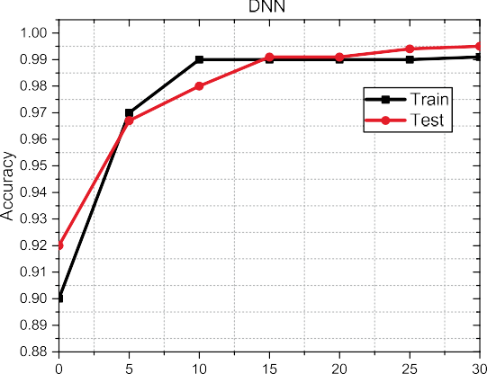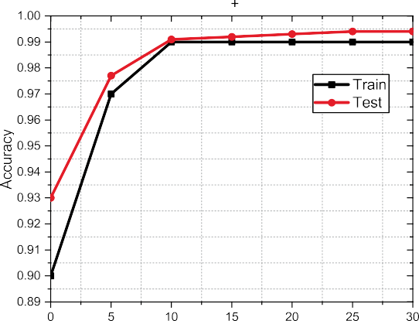Fig. 3. Test and Train Accuracy of Suicide Prediction.

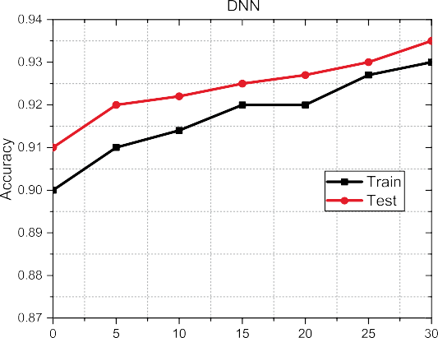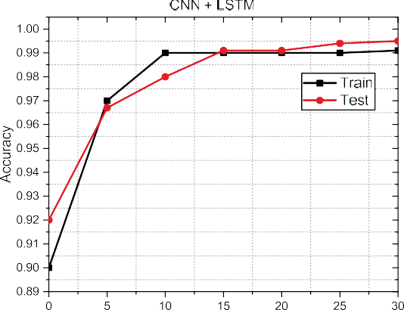

Fig. 4. Test and Train Accuracy of Attack Success Prediction.

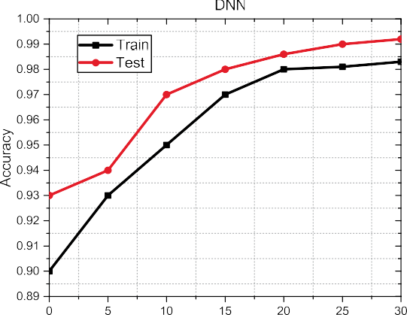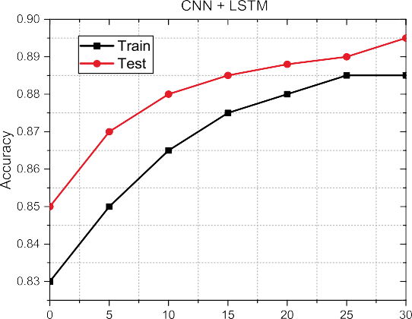

Fig. 5. Test and Train Accuracy for Weapon Type Prediction.





Fig. 6. Test and Train Accuracy for Region Type Prediction.



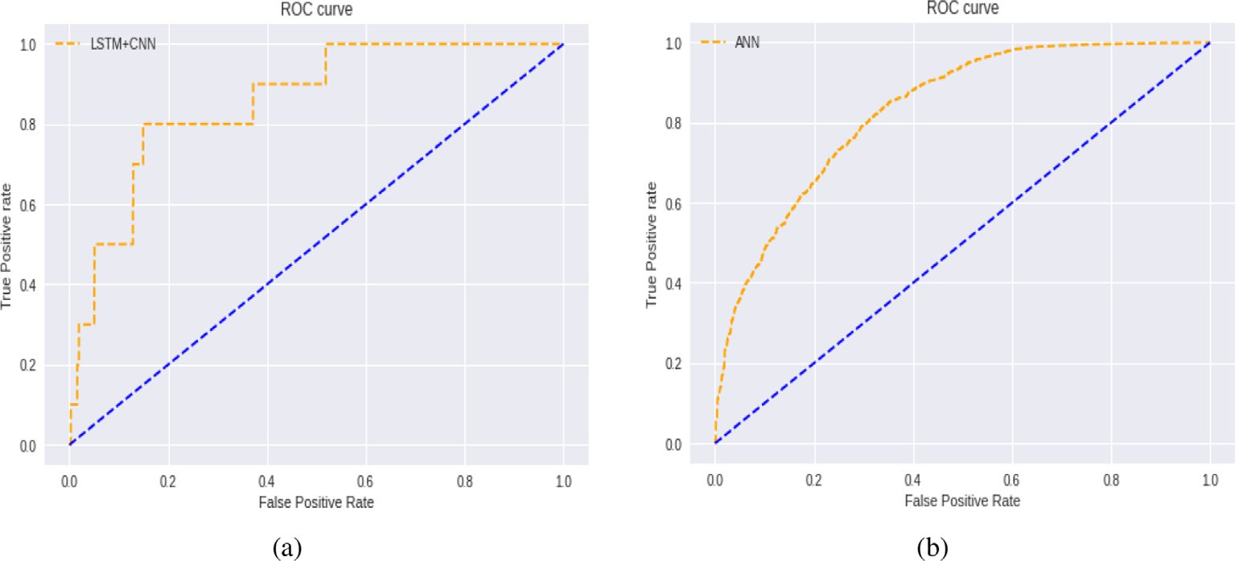

Fig. 7. ROC Curve of Attack Success Prediction.

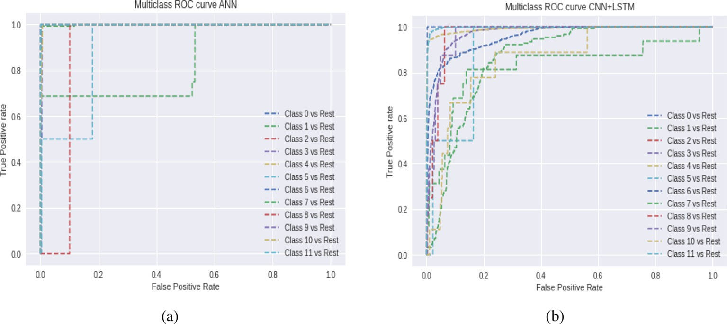

Fig. 8. ROC Curve of weapon type Prediction.

Fig. 5 that the DNN outperforms the CNN-LSTM technique and achieves an accuracy of 99.2% compared to the CNN-LSTM, which performs an accuracy of 89%. This is due to the fact that, DNN can learn the features of the bi-classifications data sets well com-

pared to the CNN-LSTM. Fig. 6 visualizes the test and training accu- racy for region where the attack took place prediction. We can observe from the given figures that improved DNN produces more satisfactory accuracy than CNN-LSTM as DNN achieves above 98%

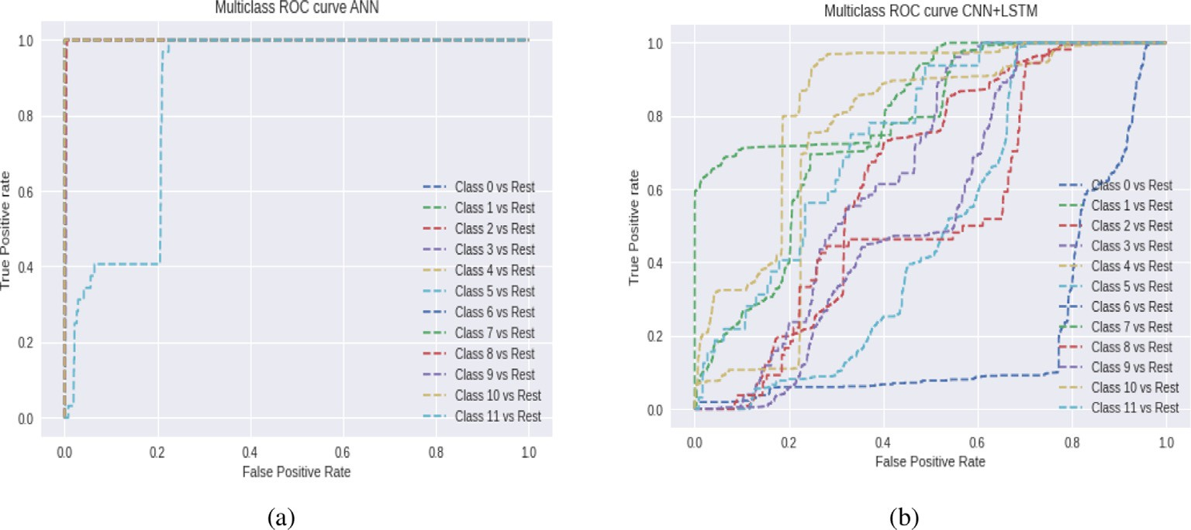

Fig. 9. ROC Curve of region Prediction.

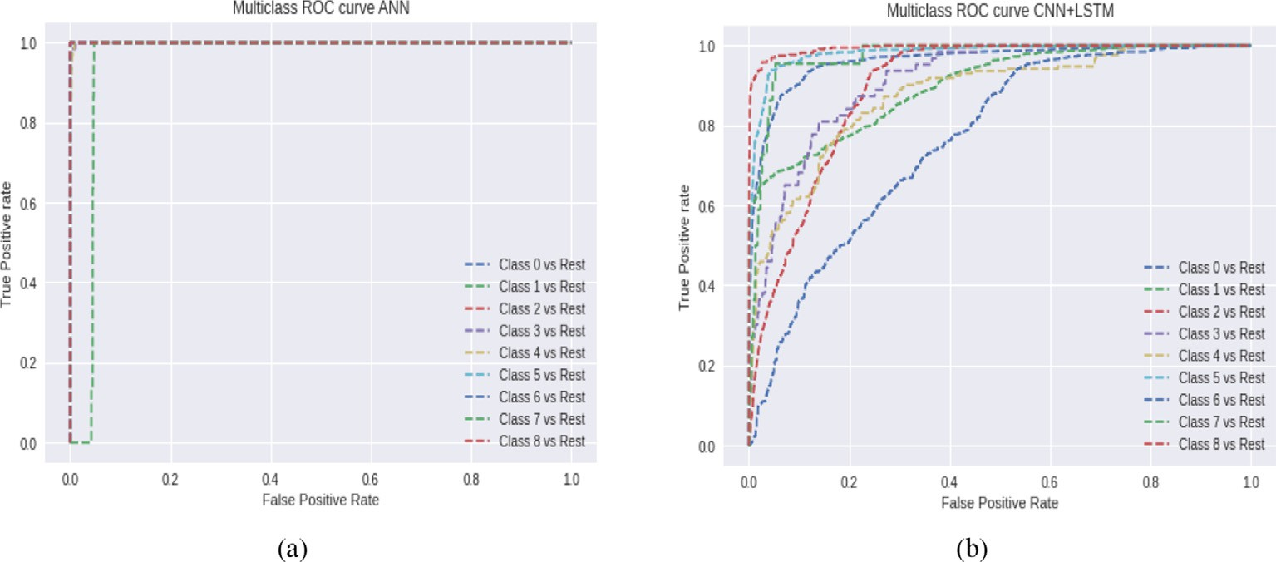

Fig. 10. ROC Curve of Attack Type Prediction.

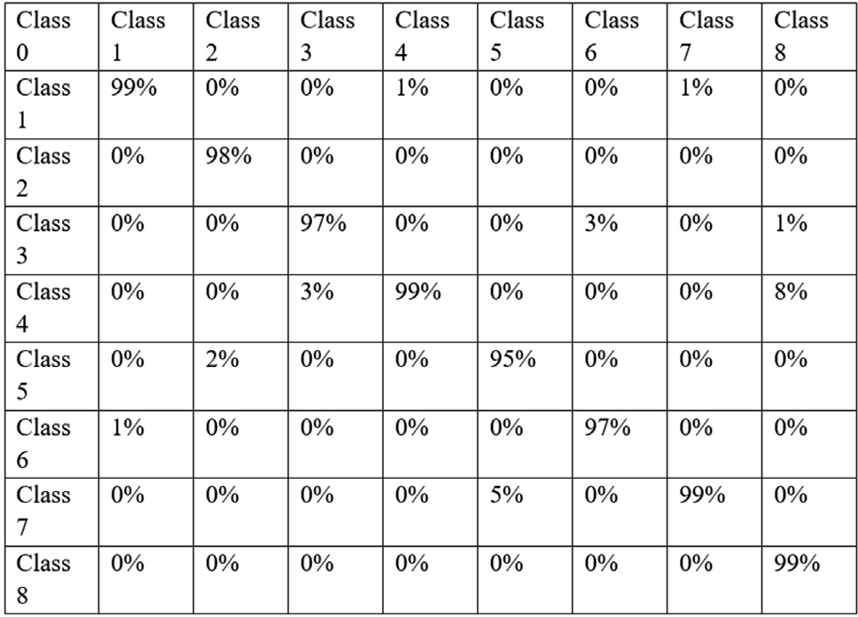

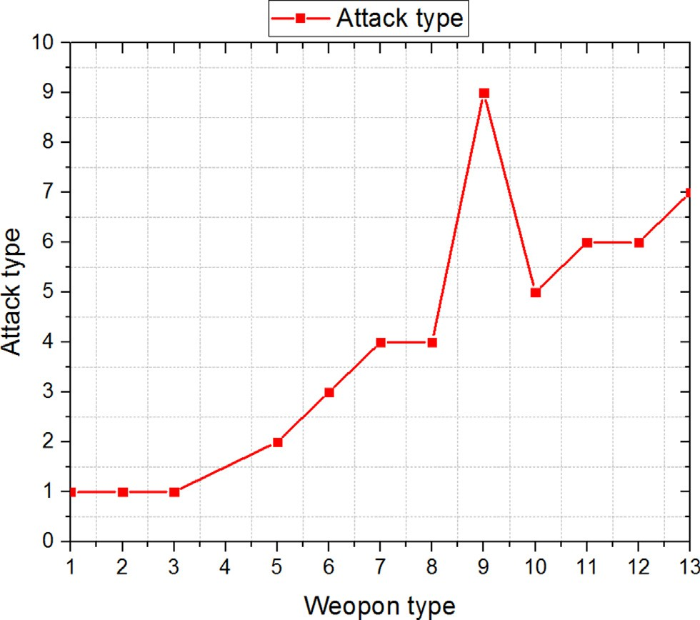Fig. 11. Prediction of weapon types.

accuracy compared to which CNN-LSTM that achieved 71% accu- racy. Hence, the proposed DNN can be used for predicting the region type.

Fig. 12. Confusion matrix.

The above results can be summarized as, for suicide prediction, the standard was settled as 98% of accuracy. The DNN model gen- erated 98.6% accuracy, and CNN-LSTM model yielded the highest accuracy of 99%. Therefore, both models performed well. For attack success prediction, the benchmark was 93%. The DNN model gen- erated 93.6%, and the CNN-LSTM model yielded 94.5% accuracy. Thus, for bi-classification problems in predicting terrorist activi-

Table 1

Accuracy of proposed model with benchmark scheme.

|  |  |  |  |  |
| --- | --- | --- | --- | --- |
| Algorithm | Train accuracy | Test accuracy | Average Re-call | Average F1-score |
| CNN-LSTM | 96.2 | 96.4 | 93.2 | 93.2 |
| Improved DNN | 99.1 | 99.3 | 99.4 | 99.4 |
| Benchmark | 94.6 | 94.8 | 94. 8 | 94.8 |

ties, the CNN-LSTM outperforms the state of the-art algorithms. The benchmark for weapon type prediction was 94%, DNN reached 99.5%, but CNN-LSTM cannot meet the model by only acquiring 89.7% accuracy. Therefore, the same is the case for CNN-LSTM with region and attack type prediction.The CNN-LSTM model can effec- tively improve the performance by extracting data features through CNN. In order to evaluate efficiency the model, We went ahead in studying Receivers Operating Characteristics (ROCs) which are graphs that depict the classification model’s perfor- mance at different categorization criteria. Actual Positive Rate (TPR) and False Positive Rate (FPR) are the two parameters shown on the graph and can be mathematically written as,

sures to mitigate the threat in the future. The confusion matrix of the proposed hybrid model can is visualized by Fig. 12. The class 1 is identified for 99%, class 2 achieves 98%, the proposed algorithm detected the class about 97%, class 4 was identified truly for 99%, class 5 is accurately detected for 95%, class 6 was detected positive for 97%, class 7 was identified true for 99%, and finally the class 8 archives an accurate detection for 99%. As a result, the diagonal ele- ments in the confusion shows a superior results in terms of cor- rectly identifying the true classes.

1. Conclusion and Future Scope

*TPR* = *TP TP* + *FN*

*FPR* = *FP* *FP* + *TN*

(5)

# (6)

In this paper, we proposed a hybrid CNN-LSTM and DL frame- work for predicting future terrorist activities. Compared with ML techniques, the simulation result shows that the CNN-LSTM tech- nique performs well for the bi-classification tasks and achieves higher accuracy in predicting future terrorist activities. It was also

ROC calculated by DNN and CNN-LSTM models to estimate suicide, success, weapon type, area, and type of Attack are given in Figs. 8–

11. Fig. 8 shows the ROC curve of predicting the terrorist attack type for the DNN and CNN-LSTM algorithms. It can be viewed from Figs. 8

(a) and 8 (b) that ROC characteristics for both scenarios are higher and can classify terrorist activities accurately. Fig. 8. (a) and (b) show that the ROC curve for the DNN and CNN-LSTM is higher. However, the DNN performs better in classifying the positive cate- gories in the data sets in success prediction. Figs. 7–10 show the ROC curves for multi-label classification for predicting terrorist activities, and it can be depicted from all figures that DNN achieves higher ROC compared to the CNN-LSTM algorithms. It can justify that DNN performs well for the multi-label classification tasks. In Table 1 we compared the proposed algorithm with the benchmark scheme. It can be seen that improved DNN outperforms the bench- mark and achieves an accuracy of 99%, clearly showing the novel presented research. However, it is also noted that for the bi- classification problems, the CNN-LSTM outperforms all other schemes. As a result, for the scenarios in predicting terrorist activ- ities, CNN-LSTM can be used for indicating the bi-classification tasks, and DNN should be used for predicting multi-classification jobs. Fig. 11 shows the proposed algorithm’s novelty for predicting the terrorist attack type based on the used weapon. It can be seen from Fig. 12 that the model can be effectively used to predict the future attack type by correlating it with the kind of weapons used and can take countermeasures. Fig.11 depicts that if biological, chemical, and radio logical weapons are used by terrorists, the model accurately predicts that the Attack is of assassination type. If the kind of weapon’s used is fake and incendiary, the model pre- dicts the hijacking type of Attack. Moreover, if the vehicle is used as a weapon type, the model can predict that the attack is of hostage type. As a result, the proposed model can be accurately used to pre- dict future terrorist activities based on the kind of weapons’ type used.

Table 3 shows the prediction of success with the type of Attack (detailed in Table 1) used in the proposed model. It can be seen that the highest success rate is of utilizing the kidnap attack. The kidnap attack has a 97% success rate, and similarly, the success rate of other attacks can be seen. Thus, the model can forecast the types of seizures with their success rates and take effective countermea-

observed that improved DNN achieves superior accuracy for the multi-classification job in predicting future terrorist activities. Thus, the hybrid model can be used for the bi-classification and multi-classification tasks to predict future terrorist activities, and countermeasures can be taken to avoid such actions. The features in the GTD data-set may not provide the information at the provin- cial or regional level; as a result, in future work, we will also incor- porate the local geographical features of terrorist activities to have a deeper insight to predict future terrorist activities. The proposed hybrid algorithm performs well on the same data sets, however, on more diverse data sets, this algorithm fails to perform. To address the issue, we like to investigate the ResNet architectures and trans- fer learning in the proposed methodology to further improve the performance of the network.

Declaration of Competing Interest

The authors declare that they have no known competing finan- cial interests or personal relationships that could have appeared to influence the work reported in this paper.

Acknowledgment

This work was supported by the United Arab Emirates (UAE) University UAEU Program for Advanced Research (UPAR) Research Grant Program under Grant 31T122.

References

1. [Lia B. Globalisation and the future of terrorism: Patterns and](http://refhub.elsevier.com/S1110-8665(22)00026-3/h0005) [predictions. Routledge; 2007](http://refhub.elsevier.com/S1110-8665(22)00026-3/h0005).
2. [Uddin MI, Zada N, Aziz F, Saeed Y, Zeb A, Ali Shah SA, Al-Khasawneh MA,](http://refhub.elsevier.com/S1110-8665(22)00026-3/h0010) [Mahmoud M. Prediction of future terrorist activities using deep neural](http://refhub.elsevier.com/S1110-8665(22)00026-3/h0010) [networks. Complexity 2020;2020](http://refhub.elsevier.com/S1110-8665(22)00026-3/h0010).
3. [Futia G, Vetrò A. On the integration of knowledge graphs into deep learning](http://refhub.elsevier.com/S1110-8665(22)00026-3/h0015) [models for a more comprehensible ai–three challenges for future research.](http://refhub.elsevier.com/S1110-8665(22)00026-3/h0015) [Information 2020;11(2):122](http://refhub.elsevier.com/S1110-8665(22)00026-3/h0015).
4. [Xia T, Gu Y. Building terrorist knowledge graph from global terrorism database](http://refhub.elsevier.com/S1110-8665(22)00026-3/h0020) [and wikipedia. In: 2019 IEEE International Conference on Intelligence and](http://refhub.elsevier.com/S1110-8665(22)00026-3/h0020) [Security Informatics (ISI). IEEE; 2019. p. 194–6](http://refhub.elsevier.com/S1110-8665(22)00026-3/h0020).
5. [Jones SG, Doxsee C, Harrington N. The escalating terrorism problem in the](http://refhub.elsevier.com/S1110-8665(22)00026-3/h0026) [united states, 2020](http://refhub.elsevier.com/S1110-8665(22)00026-3/h0026)S.G. Jones, C. Doxsee, and N. Harrington, The escalating terrorism problem in the united states, 2020.
6. [Rai HM, Chatterjee K. Hybrid cnn-lstm deep learning model and ensemble](http://refhub.elsevier.com/S1110-8665(22)00026-3/h0032) [technique for automatic detection of myocardial infarction using big ecg data.](http://refhub.elsevier.com/S1110-8665(22)00026-3/h0032) [Applied Intelligence 2021(2)](http://refhub.elsevier.com/S1110-8665(22)00026-3/h0032).
7. [Rai HM, Chatterjee K, Dashkevich S. Automatic and accurate abnormality](http://refhub.elsevier.com/S1110-8665(22)00026-3/h0035) [detection from brain mr images using a novel hybrid unetresnext-50 deep cnn](http://refhub.elsevier.com/S1110-8665(22)00026-3/h0035) [model. Biomed Signal Processing Control 2021;66:102477](http://refhub.elsevier.com/S1110-8665(22)00026-3/h0035).
8. [Rai HM, Chatterjee K. Detection of brain abnormality by a novel lu-net deep](http://refhub.elsevier.com/S1110-8665(22)00026-3/h0040) [neural cnn model from mr images. Mach Learn Appl 2020;2:100004](http://refhub.elsevier.com/S1110-8665(22)00026-3/h0040).
9. [Sandler T. The analytical study of terrorism: Taking stock. J Peace Res 2014;51](http://refhub.elsevier.com/S1110-8665(22)00026-3/h0045) [(2):257–71](http://refhub.elsevier.com/S1110-8665(22)00026-3/h0045).
10. [Alhamdani R, Abdullah M, Sattar I. Recommender system for global terrorist](http://refhub.elsevier.com/S1110-8665(22)00026-3/h0050) [database based on deep learning. Int J Mach Learn Comput 2018;8(6)](http://refhub.elsevier.com/S1110-8665(22)00026-3/h0050).
11. [Saeed Y, Ahmed K, Zareei M, Zeb A, Vargas-Rosales C, Awan KM. In-vehicle](http://refhub.elsevier.com/S1110-8665(22)00026-3/h0055) [cognitive route decision using fuzzy modeling and artificial neural network.](http://refhub.elsevier.com/S1110-8665(22)00026-3/h0055) [IEEE Access 2019;7:262–72](http://refhub.elsevier.com/S1110-8665(22)00026-3/h0055).
12. [Huamaní EL, Alicia AM, Roman-Gonzalez A. Machine learning techniques to](http://refhub.elsevier.com/S1110-8665(22)00026-3/h0060) [visualize and predict terrorist attacks worldwide using the global terrorism](http://refhub.elsevier.com/S1110-8665(22)00026-3/h0060) [database. Mach Learn 2020;11(4)](http://refhub.elsevier.com/S1110-8665(22)00026-3/h0060).
13. [Chen JH, Asch SM. Machine learning and prediction in medicine–beyond the](http://refhub.elsevier.com/S1110-8665(22)00026-3/h0065) [peak of inflated expectations. New England J Med 2017;376(26):2507](http://refhub.elsevier.com/S1110-8665(22)00026-3/h0065).
14. [Jspm W, Tirwa K. Predictive modeling of terrorist attacks using machine](http://refhub.elsevier.com/S1110-8665(22)00026-3/h0070) [learning. Int J Pure Appl Math 2018;119(15):49–61](http://refhub.elsevier.com/S1110-8665(22)00026-3/h0070).
15. [Gundabathula VT, Vaidhehi V. An efficient modelling of terrorist groups in](http://refhub.elsevier.com/S1110-8665(22)00026-3/h0075) [india using machine learning algorithms. Indian J Sci Technol 2018;11](http://refhub.elsevier.com/S1110-8665(22)00026-3/h0075) [(15):1–10](http://refhub.elsevier.com/S1110-8665(22)00026-3/h0075).
16. [Ding F, Ge Q, Jiang D, Fu J, Hao M. Understanding the dynamics of terrorism](http://refhub.elsevier.com/S1110-8665(22)00026-3/h0080) [events with multiple-discipline datasets and machine learning approach. PloS](http://refhub.elsevier.com/S1110-8665(22)00026-3/h0080) [One 2017;12(6):e0179057](http://refhub.elsevier.com/S1110-8665(22)00026-3/h0080).
17. [Gao Y, Wang X, Chen Q, Guo Y, Yang Q, Yang K, Fang T. Suspects prediction](http://refhub.elsevier.com/S1110-8665(22)00026-3/h0085) [towards terrorist attacks based on machine learning. In: 2019 5th](http://refhub.elsevier.com/S1110-8665(22)00026-3/h0085) [International Conference on Big Data and Information Analytics](http://refhub.elsevier.com/S1110-8665(22)00026-3/h0085) [(BigDIA). IEEE; 2019. p. 126–31](http://refhub.elsevier.com/S1110-8665(22)00026-3/h0085).
18. [Meng X, Nie L, Song J. Big data-based prediction of terrorist attacks. Computers](http://refhub.elsevier.com/S1110-8665(22)00026-3/h0090) [Electr Eng 2019;77:120–7](http://refhub.elsevier.com/S1110-8665(22)00026-3/h0090).
19. [Khorshid MM, Abou-El-Enien TH, Soliman GM. Hybrid classification](http://refhub.elsevier.com/S1110-8665(22)00026-3/h0095) [algorithms for terrorism prediction in middle east and north africa. Int J](http://refhub.elsevier.com/S1110-8665(22)00026-3/h0095) [Emerging Trends Technol Computer Sci 2015;4(3):23–9](http://refhub.elsevier.com/S1110-8665(22)00026-3/h0095).
20. [Tutun S, Khasawneh MT, Zhuang J. New framework that uses patterns and](http://refhub.elsevier.com/S1110-8665(22)00026-3/h0100) [relations to understand terrorist behaviors. Expert Syst Appl 2017;78:358–75](http://refhub.elsevier.com/S1110-8665(22)00026-3/h0100).
21. [Uddin MI, Zada N, Aziz F, Saeed Y, Zeb A, Ali Shah SA, Al-Khasawneh MA,](http://refhub.elsevier.com/S1110-8665(22)00026-3/h0105) [Mahmoud M. Prediction of future terrorist activities using deep neural](http://refhub.elsevier.com/S1110-8665(22)00026-3/h0105) [networks. Complexity 2020;2020](http://refhub.elsevier.com/S1110-8665(22)00026-3/h0105).
22. [Zhang X, Jin M, Fu J, Hao M, Yu C, Xie X. On the risk assessment of terrorist](http://refhub.elsevier.com/S1110-8665(22)00026-3/h0110) [attacks coupled with multi-source factors. ISPRS Int J Geo-Inform 2018;7](http://refhub.elsevier.com/S1110-8665(22)00026-3/h0110) [(9):354](http://refhub.elsevier.com/S1110-8665(22)00026-3/h0110).
23. [Motaz GMAS, Khorshid MH, H.M.Abou-El-Enie Tarek. Hybrid classification](http://refhub.elsevier.com/S1110-8665(22)00026-3/h0114) [algorithms for terrorism prediction in middle east and north africa. ISPRS](http://refhub.elsevier.com/S1110-8665(22)00026-3/h0114) [International Journal of Geo-Information 2015;4](http://refhub.elsevier.com/S1110-8665(22)00026-3/h0114).
24. [Chawla NV, Bowyer KW, Hall LO, Kegelmeyer WP. Smote: synthetic minority](http://refhub.elsevier.com/S1110-8665(22)00026-3/h0120) [over-sampling technique. J Artif Intell Res 2002;16:321–57](http://refhub.elsevier.com/S1110-8665(22)00026-3/h0120).
25. [Lema](http://refhub.elsevier.com/S1110-8665(22)00026-3/h0125)ıˇ[tre G, Nogueira F, Aridas CK. Imbalanced-learn: A python toolbox to](http://refhub.elsevier.com/S1110-8665(22)00026-3/h0125) [tackle the curse of imbalanced datasets in machine learning. J Mach Learn Res](http://refhub.elsevier.com/S1110-8665(22)00026-3/h0125) [2017;18(1):559–63](http://refhub.elsevier.com/S1110-8665(22)00026-3/h0125).