

Cairo University

Egyptian Informatics Journal

[www.elsevier.com/locate/eij](http://www.elsevier.com/locate/eij) [www.sciencedirect.com](http://www.sciencedirect.com/science/journal/11108665)



FULL-LENGTH ARTICLE

A new printed fractal right angled isosceles triangular monopole antenna for ultra-wideband applications



# Manisha Gupta a, Vinita Mathur b,*

a *Department of Physics, JECRC University, Jaipur, India*

b *Department of Electronics and Communication, JECRC University, Jaipur, India*

Received 20 November 2015; revised 2 June 2016; accepted 21 June 2016

Available online 1 August 2016

Abstract In this present work, a different right angled isosceles triangular Microstrip patch antenna (RITMA) for ultra wideband (UWB) utilization is designed. The antenna presented is sim- ple and small in structure. The antenna has a triangular patch with defected ground plane and a notch on the ground surface, which provides a usable bandwidth. By fracturing the antenna a sig- nificant improvement in return loss is seen, and good gain is obtained. Results of the proposed antenna show omnidirectional radiation behavior within the UWB frequency range.

© 2016 Production and hosting by Elsevier B.V. on behalf of Faculty of Computers and Information,

KEYWORDS

Microstrip patch antennas; Fractal antennas;

Koch antennas; Ultra wideband; RITMA

Cairo University. This is an open access article under the CC BY-NC-ND license [(http://creativecommons.](http://creativecommons/)

org/licenses/by-nc-nd/4.0/).

1. Introduction

Various applications are been supported by modern communi- cation systems which are performing at various frequency bands. Several frequency bands are been required by a single antenna for these communication systems. These antennas are stated as multiband antennas. In order to decrease multiple path result and to make the antenna as multi directional, receiving antenna should be circularly polarized. Due to the

* Corresponding author.

E-mail address: [vinitamathur12@gmail.com](mailto:vinitamathur12@gmail.com) (V. Mathur).

Peer review under responsibility of Faculty of Computers and Information, Cairo University.

**Production and hosting by Elsevier**

growth in the area of portable systems Microstrip patch anten- nas have become the core area of investigation in the UWB range.

Performance and miniaturization are the two main issues that need to be achieved in communication systems over UWB band. Salient characteristics such as minimum cost, ease of fabrication, simple structure, increase in bandwidth, and radiation pattern i.e. omnidirectional are achieved by planar printed monopole antennas in UWB systems [1–4].

Different geometries of planar monopole antennas have been described in this range [6,7], and also to achieve optimal planar shape new design methods have been advanced [1,8]. Other schemes to enhance the bandwidth that does not contain an alteration of the structure of the transmitter have been explored in [9,10].

A co-planar waveguide (CPW) feed makes these antennas more applicable for small mobile appliances because of its characteristics such as on-plane geometry, simple manufactur-

<http://dx.doi.org/10.1016/j.eij.2016.06.002>

1110-8665 © 2016 Production and hosting by Elsevier B.V. on behalf of Faculty of Computers and Information, Cairo University. This is an open access article under the CC BY-NC-ND license [(http://creativecommons.org/licenses/by-nc-nd/4.0/).](http://creativecommons.org/licenses/by-nc-nd/4.0/))

ing and circuit combination. Various structures of slots and slits have been added on these antennas to minimize their size. Antenna with slots is used at frequencies from 300 MHz to 24 GHz. These antennas are useful as they can be cut from the surface they are to be embossed on, and they provide omni- directional radiation patterns. The surface currents move through the slot outer surface that increases its electrical length. As such, a slotted antenna that has small size performs equivalent to its larger counterpart.

Fractal antenna arises from this concept. Fractal antennas use a fractal, self-similar structure to increase the length and with this technique we can achieve multiple frequencies since different sections of the aerial are self-similar at distinct scale. Compared to other antennas, fractals have more bandwidths and they have compact size. With fractal antennas we achieve resonant frequencies that are multiband and they do not show harmonics, as stated by Cohen [11].

Fractal antenna made by applying fractal geometry to patch and adding it to antenna, is an efficient technique for designing small, wideband and high-gain aerials that also have small side lobe arrays [12,13]. This fractal antenna geometry has self-similarity and it repeats itself in different dimensions that fill the space properly.

Helge Von Koch was the researcher who has introduced Koch fractal geometry in 1904. This structure is designed by the use of the concept as iterative function system (IFS) which is described by affine transformation [12,14]. A simple folded- slot Koch iteration antenna was presented to obtain two iter- ation versions [15]. A printed Koch antenna was designed to make it applicable for WLAN and WiMax by providing slots to it and CPW-fed [16]. For GSM1800, UMTS, and Hiper- LAN2 a prefractal edge and a U-shaped slot were proposed [17]. A slot was added in the antenna for the filter action. In addition a Koch-curve-shaped slot, with frequency notched function was demonstrated by Lui [18]. For E5–E1 Galileo and WiMax frequency bands a blend of three-band patch was described [19]. Parameters such as bandwidth, efficiency, and electrical size have been analyzed by a multi-objective genetic algorithm (GA) (Code for optimization techniques) in combination with the NEC i.e. numerical electromagnetic code for the development of Koch antennas [20].

Fractal antennas are required due to the below mentioned reasons: wideband and multiband frequency response, small size in comparison with antennas of regular designs, while maintaining good efficiencies and gains, structure easiness and robustness. These features of the fractals are obtained

due to their structure and not by the attachment of discrete components [12].

In this paper we have added a notch to ground plane and then have made the patch fractured, Koch snowflake design is made in this case. With single iteration better gain, return loss, and omnidirectional radiation pattern are achieved. This small size antenna is a good choice for use in the following ranges UWB, PCS, WLAN, WiFi, and WiMAX.

1. Antenna design

This triangular shape antenna for which appropriate matching of 50-X is done is as depicted in Fig. 1, and FR-4 (er = 4.4) is used as a substrate material that has a thickness 0.16 cm, and tand as 0.0018. The Microstrip input line width is 0.6 cm. The main antenna design consists of a patch of right angled isosceles triangular shape, a feed, and a ground surface. The triangle patch has a length 2 cm, and the other side as hypotenuse as

2.8 cm. *W*f and *L*f are width and length of feed and *W*sub, *L*sub and *L*gnd are width and length of substrate and ground respec- tively. A simple triangle without any cut, notch and defect in ground does not give good results in terms of output parameters such as gain, directivity, bandwidth, quality factor and return loss. To enhance broadband characteristics clipping the ground plane plays a significant role as matching is achieved between patch and feed line over an extensive frequency range. The inductive attribute of the patch is balanced by the capacitive load that arises by clipping the ground plane and finally pure resistive input impedance persists [5]. Bandwidth and return loss levels are controlled by this clipping by adjustment in the capac- itance that arises between the patch and ground. To improve the return loss, the patch is fractured and results are observed.

The values of the antenna used are as follows: *W*sub = 3.2 cm, *L*sub = 2.2 cm, *a* = 2 cm, *L*f = 0.5 cm, *W*f = 0.6 cm, *L*s1 = 0.025 cm, *W*S1 = 0.08 cm, *L*gnd = 0.2 cm, *x* = 0.2 cm.

1. Results and discussion

This section discusses the antenna with variations in its design parameters, and the outcomes are obtained by simulating it on CST Microwave Studio Tool. Return loss, gain, bandwidth and radiation pattern are measured. The output criterion of the designed antenna is considered by modifying one design parameter at a time and adjusting the remaining.

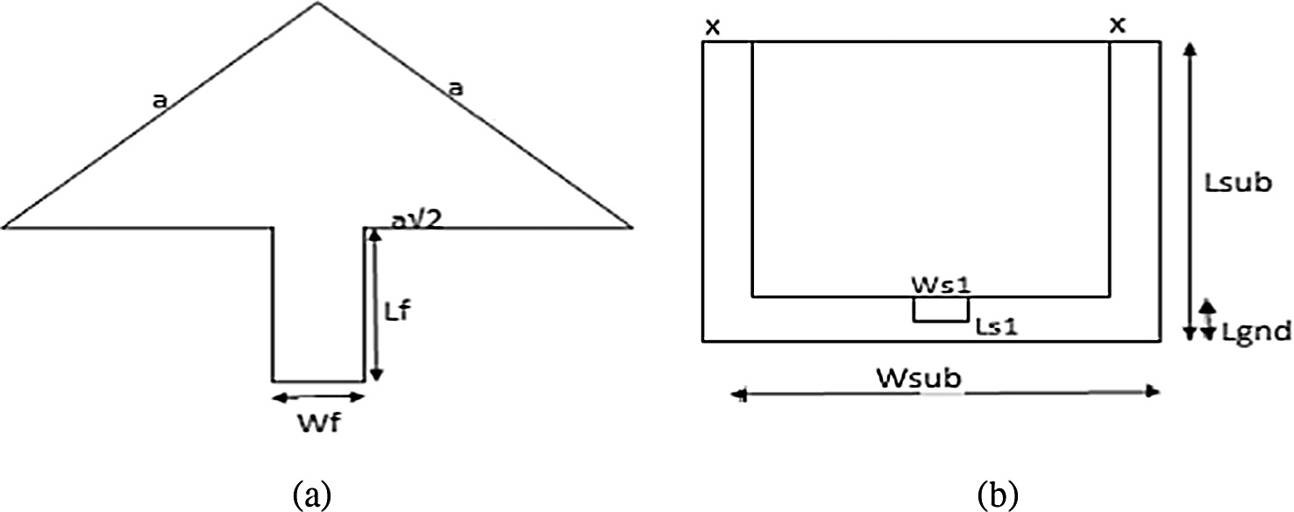

Figure 1 (a) Front view of antenna and (b) back view of antenna.

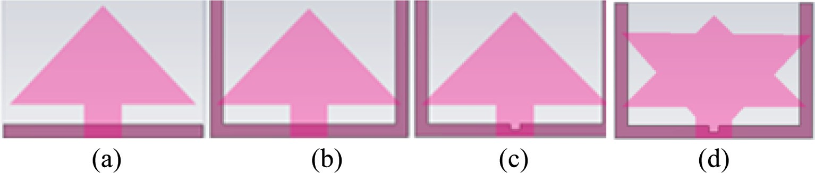

Figure 2 (a) Geometry of ordinary RITMA structure, (b) ground with U shape structure, (c) ground with notch and (d) structure with notch in ground and fractal shape.

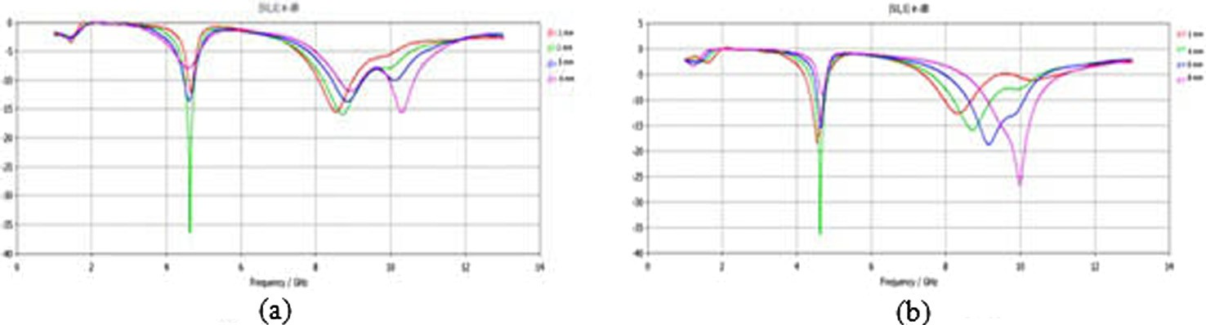

Figure 3 Return loss characteristics of RITMA (a) distinct values of *d* (*x* at 3 mm) and (b) distinct values of *x* (*d* at 2 mm).

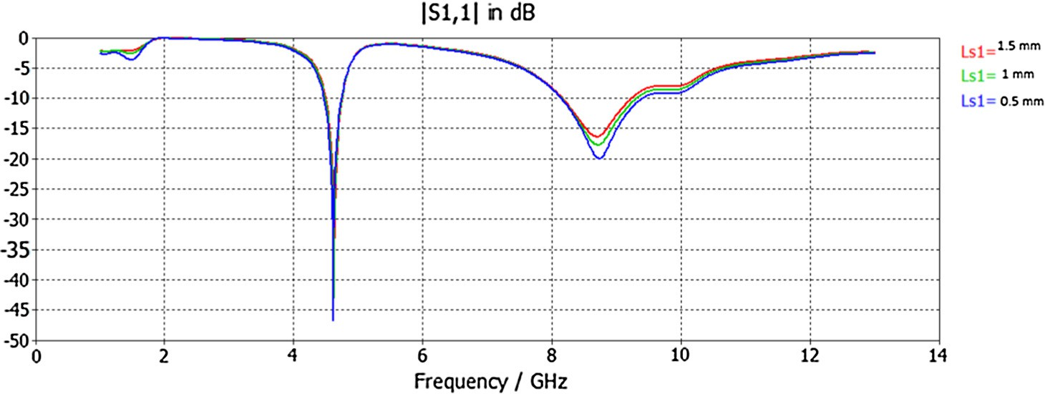

Figure 4 Return loss characteristics of RITMA with variation in *W*s1 and *L*S1.

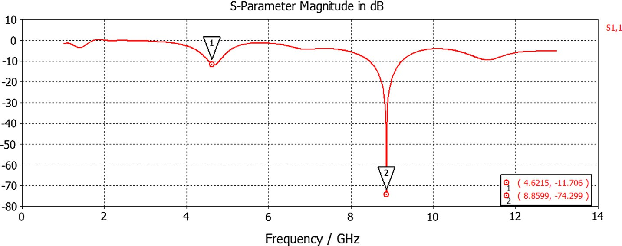

Figure 5 Return loss characteristics of fractal RITMA.

* 1. *Effect of varying d*

The response of changing the distance of feed-gap i.e. (*d* = *L*f *L*gnd) on the bandwidth is analyzed in the first case. For a simple RITMA with varying values of *d* the return loss curves are plotted in Fig. 3(a).

—

—

—

As the separation *d* is increased up to an optimum value the bandwidth and gain are found to be improved as seen from the plot. The lower edge of the resonant frequency attains a value of 36 dB at *d* = 0.2 cm, but for higher values of the band the return loss is at 15 dB. By fixing *d*, the electromagnetic cou- pling amidst the lower side of the patch of the triangular struc- ture and the ground surface can be well under control.

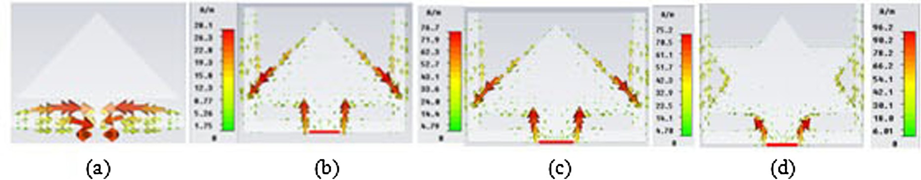

Figure 6 Surface current distributions on the antennas at 4.6 GHz.

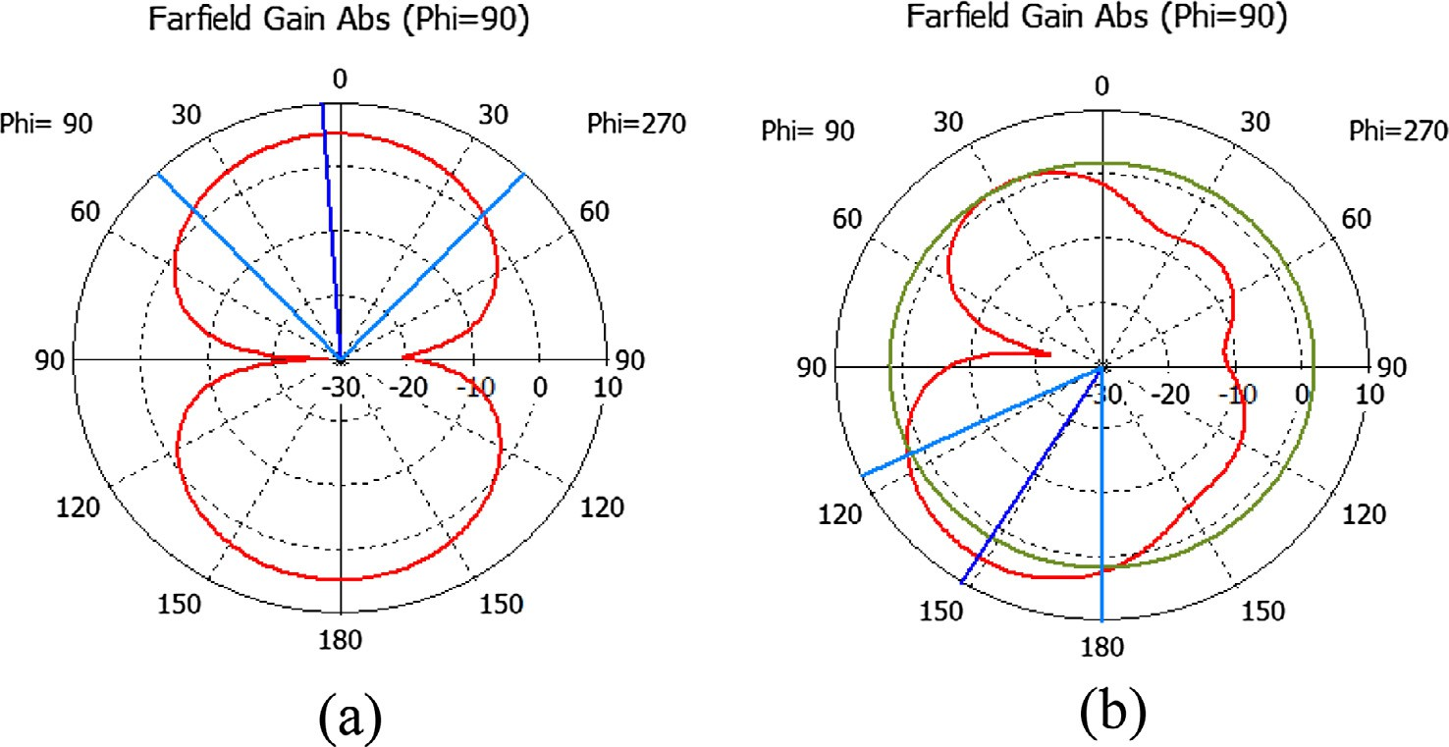

Figure 7 Radiation patterns of fractal RITMA (a) 4.6 GHz and (b) 8.8 GHz.

* 1. *Effect of varying x*

Further keeping *d* fixed as 0.2 cm and varying the value of *x* as shown in Fig. 2(b), an improvement in return loss is observed at higher frequency band.

Bandwidth obtained is 246.3 MHz and 1.0142 GHz for optimum values of *x* and *d*. Gain at these values of antenna design at frequency 3.5 GHz, 5.5 GHz, 8 GHz, and 11 GHz is 3.067 dB, 2.635 dB, 6.105 dB and 5.409 dB respectively.

To lower the physical area of the Microstrip patch antenna and to improve the bandwidth of the antenna, the ground plane is cut as in Fig. 2(c).

* 1. *Effect of varying LS1 and WS1*

By altering the length (*L*s1) and width (*W*s1) of the cut in the ground plane the results of return loss graph are as depicted in Fig. 4. Further improvement is seen at the lower edge of the frequency which comes 47 dB. However the upper reso- nant frequency remains unaffected. Bandwidths at these reso- nant frequencies are 267.9 MHz and 1.151 GHz.

—

* 1. *Effect of fracturing the patch*

By fracturing the triangular patch it becomes Koch Snowflake. Rather than one line, the snowflake in this case starts with a right isosceles triangle. The process of creating this curve is

then repeatedly done on each edge of the triangle, generating

a ‘‘snowflake” shape. The triangle shown in Fig. 2(a) is right

angled triangle with sides as *a*, and the hypotenuse is calcu- lated from Pythagoras theorem and that comes as *a*,2. As

for the equilateral Koch antenna the same concept is done in

this case at each iteration the side length is taken as *a*/3 and hypotenuse side as *a*,2/3.

At each iteration, one side of the figure becomes four sides

in the next stage. For Koch Snowflake the sides are calculated as in Eq. (1)

Sides = 3 * 4*n* (1)

In the *n*th iteration.

The number of sides is 3, 12, 48 and 192, for 0th, 1st, 2nd and 3rd iterations respectively.

First iteration results are observed. Although the area increases by fracturing significant improvement in return loss is attained at higher frequency. Omnidirectional radiation pat- tern are observed.

As seen in Fig. 5 the antenna provides a dual band and bandwidth is 728 MHz. The perimeter of the fractal antenna for iteration *n* is calculated by using Eq. (2)

Perimeter 4*n* 2*a* ,2*a*

= +

3*n* 3*n*

,

4 *n*

= 3 [2*a* + 2*a*] (2)

Fig. 6 depicts the current distributions on the ground for the structure of antennas shown in Fig. 2 at 4.6 GHz. It is noticed from Fig. 6 that the current concentrates on the mar- gin of the patch of the cut at 4.6 GHz. Due to this cut antenna impedance varies at the resonant frequencies.

At higher levels of iteration when effective length of the antenna increases, the resonant frequency decreases.

Gain obtained in case of fractal antenna is better as com- pared with the previous case, at 4.6 GHz is 5.065 dB and at

8.8 GHz is 6.310 dB that provides omnidirectional radiation pattern as in Fig. 7 at resonant frequencies and makes the antenna work at ultra wideband frequency range.

1. Conclusion

A fractal right angled isosceles triangular patch antenna for ultra wideband communication applications (3.1–10.6 GHz) is constructed and conferred. The design specifications of right angled isosceles triangular microstrip (RITMA) fractal antenna with coplanar waveguide-feed have been analyzed in this frequency range. The complete parametric studies of cur- rent distribution, bandwidth, radiation pattern, and return loss have been done to know the antenna behavior. The patch dimensions are maintained to only 20 mm. This structure gives the return loss 74.299 dB for 8.8 GHz that achieves the over- all bandwidth as 728 MHz. Variation in feed gap distance, size of cut, and fracturing the patch makes the antenna obtain the wide bandwidth. Omnidirectional radiation pattern is attained at resonant frequency.

—

References

1. [Foudazi A, Hassani HR, Nezhad SMA. Small UWB planar](http://refhub.elsevier.com/S1110-8665(16)30025-1/h0005) [monopole antenna with added GPS/GSM/WLAN bands. IEEE](http://refhub.elsevier.com/S1110-8665(16)30025-1/h0005) [Trans Antennas Propag 2012;60(6):2987–92](http://refhub.elsevier.com/S1110-8665(16)30025-1/h0005).
2. [Radiom S, Aliakbarian H, Vandenbosch GAE, Gielen GGE. An](http://refhub.elsevier.com/S1110-8665(16)30025-1/h0010) [effective technique for symmetric planar monopole antenna](http://refhub.elsevier.com/S1110-8665(16)30025-1/h0010) [miniaturization. IEEE Trans Antennas Propag 2009;57(10):](http://refhub.elsevier.com/S1110-8665(16)30025-1/h0010) [2989–96](http://refhub.elsevier.com/S1110-8665(16)30025-1/h0010).
3. [Gopikrishna M, Krishna DD, Anandan CK, Mohanan P, Vasude-](http://refhub.elsevier.com/S1110-8665(16)30025-1/h0015) [van K. Design of a compact semi-elliptic monopole slot antenna for](http://refhub.elsevier.com/S1110-8665(16)30025-1/h0015) [UWB systems. IEEE Trans Antennas Propag 2009;57(6):](http://refhub.elsevier.com/S1110-8665(16)30025-1/h0015) [1834–7](http://refhub.elsevier.com/S1110-8665(16)30025-1/h0015).
4. [Abbosh AM, Bialkowski ME. Design of ultra wideband planar](http://refhub.elsevier.com/S1110-8665(16)30025-1/h0020) [monopole antennas of circular and elliptical shape. IEEE Trans](http://refhub.elsevier.com/S1110-8665(16)30025-1/h0020) [Antennas Propag 2008;56(1):17–23](http://refhub.elsevier.com/S1110-8665(16)30025-1/h0020).
5. [Bod M, Hassani HR, Taheri MMS. Compact printed UWB](http://refhub.elsevier.com/S1110-8665(16)30025-1/h0025) [antenna with a tunable extra band. In: International conference](http://refhub.elsevier.com/S1110-8665(16)30025-1/h0025) [on antennas and propagation, Loughborough. p. 1–3](http://refhub.elsevier.com/S1110-8665(16)30025-1/h0025).
6. [Deshmukh A, Kadam A, Agrawal S, Ray KP. Broadband CPW](http://refhub.elsevier.com/S1110-8665(16)30025-1/h0030) [fed hexagonal shape and hexagonal slot cut microstrip antenna.](http://refhub.elsevier.com/S1110-8665(16)30025-1/h0030) [In: International conference on computing communication con-](http://refhub.elsevier.com/S1110-8665(16)30025-1/h0030) [trol and automation, Pune. p. 117–21](http://refhub.elsevier.com/S1110-8665(16)30025-1/h0030).
7. [Li D, Mao JF. A Koch-like sided fractal bow-tie dipole antenna.](http://refhub.elsevier.com/S1110-8665(16)30025-1/h0035) [IEEE Trans Antennas Propag 2012;60(5)](http://refhub.elsevier.com/S1110-8665(16)30025-1/h0035).
8. [Malek F, Shukor MMd, et al. Equilateral triangular microstrip](http://refhub.elsevier.com/S1110-8665(16)30025-1/h0040) [patch antenna with spur lines embedded. In: International](http://refhub.elsevier.com/S1110-8665(16)30025-1/h0040) [conference on antennas and propagation, Loughborough. p.](http://refhub.elsevier.com/S1110-8665(16)30025-1/h0040) [303–6](http://refhub.elsevier.com/S1110-8665(16)30025-1/h0040).
9. [Lin WP, Huang CH. Coplanar waveguide-fed rectangular](http://refhub.elsevier.com/S1110-8665(16)30025-1/h0045) [antenna with an inverted-L stub for ultra wideband communica-](http://refhub.elsevier.com/S1110-8665(16)30025-1/h0045) [tions. IEEE Antennas Wirel Propag Lett 2009;8:228–31](http://refhub.elsevier.com/S1110-8665(16)30025-1/h0045).
10. [Panda JR, Kshetrimayum RS. A planar microstrip-line fed](http://refhub.elsevier.com/S1110-8665(16)30025-1/h0050) [elliptical UWB 5.2 GHz/5.8 GHz notch antenna with U-shaped](http://refhub.elsevier.com/S1110-8665(16)30025-1/h0050) [slot. In: International conference on computer and communica-](http://refhub.elsevier.com/S1110-8665(16)30025-1/h0050) [tion technology 2010. p. 806–11](http://refhub.elsevier.com/S1110-8665(16)30025-1/h0050).
11. Cohen N. Fractal antennas and fractal resonators; 2008.
12. [Reddy VV, Sarma NVSN. Triband circularly polarized Koch](http://refhub.elsevier.com/S1110-8665(16)30025-1/h0060) [fractal boundary microstrip antenna. IEEE Antennas Propag Lett](http://refhub.elsevier.com/S1110-8665(16)30025-1/h0060) [2014;13:1057–60](http://refhub.elsevier.com/S1110-8665(16)30025-1/h0060).
13. [Krishna DD, Gopikrishna M, et al. Compact wideband Koch](http://refhub.elsevier.com/S1110-8665(16)30025-1/h0065) [fractal printed slot antenna. IET Microwaves Antennas Propag](http://refhub.elsevier.com/S1110-8665(16)30025-1/h0065) [2009:782–9](http://refhub.elsevier.com/S1110-8665(16)30025-1/h0065).
14. [Orazi H, Soleimani H. Miniaturization of the triangular patch](http://refhub.elsevier.com/S1110-8665(16)30025-1/h0070) [antenna by the novel dual-reverse-arrow fractal. IET Microwaves](http://refhub.elsevier.com/S1110-8665(16)30025-1/h0070) [Antennas Propag 2014:1–7](http://refhub.elsevier.com/S1110-8665(16)30025-1/h0070).
15. [Sundaram S, Maddela M, Ramadoss R. Koch-fractal folded-slot](http://refhub.elsevier.com/S1110-8665(16)30025-1/h0075) [antenna characteristics. IEEE Antennas Wirel Propag Lett](http://refhub.elsevier.com/S1110-8665(16)30025-1/h0075) [2007;6:219–22](http://refhub.elsevier.com/S1110-8665(16)30025-1/h0075).
16. [Krishna DD, Gopikrishna M, Anandan CK, Mohanan P,](http://refhub.elsevier.com/S1110-8665(16)30025-1/h0080) [Vasudevan K. CPW-fed Koch fractal slot antenna for WLAN/](http://refhub.elsevier.com/S1110-8665(16)30025-1/h0080) [WiMAX applications. IEEE Antennas Wirel Propag Lett](http://refhub.elsevier.com/S1110-8665(16)30025-1/h0080) [2008;7:389–92](http://refhub.elsevier.com/S1110-8665(16)30025-1/h0080).
17. [Guterman J, Moreira AA, Peixeiro C. Microstrip fractal antennas](http://refhub.elsevier.com/S1110-8665(16)30025-1/h0085) [for multi standard terminals. IEEE Antennas Wirel Propag Lett](http://refhub.elsevier.com/S1110-8665(16)30025-1/h0085) [2004;3](http://refhub.elsevier.com/S1110-8665(16)30025-1/h0085).
18. [Lui WJ, Cheng CH, Zhu HB. Compact frequency notched ultra-](http://refhub.elsevier.com/S1110-8665(16)30025-1/h0090) [wideband fractal printed slot antenna. IEEE Microwave Wirel](http://refhub.elsevier.com/S1110-8665(16)30025-1/h0090) [Compon Lett 2006;16(4):224–6](http://refhub.elsevier.com/S1110-8665(16)30025-1/h0090).
19. [Azaro R, Zeni E, Rocca P, Massa A. Synthesis of a Galileo and](http://refhub.elsevier.com/S1110-8665(16)30025-1/h0095) [Wi-Max three-band fractal-eroded patch antenna. IEEE Anten-](http://refhub.elsevier.com/S1110-8665(16)30025-1/h0095) [nas Wirel Propag Lett 2007;6:510–4](http://refhub.elsevier.com/S1110-8665(16)30025-1/h0095).
20. [Pantoja MF, Ruiz FG, Bretones AR, Martin RG, Arbesu JMG,](http://refhub.elsevier.com/S1110-8665(16)30025-1/h0100) [Romeu J. GA design of wire pre-fractal antennas and comparison](http://refhub.elsevier.com/S1110-8665(16)30025-1/h0100) [with other Euclidean geometries. IEEE Antennas Wirel Propag](http://refhub.elsevier.com/S1110-8665(16)30025-1/h0100) [Lett 2003;2:238–41](http://refhub.elsevier.com/S1110-8665(16)30025-1/h0100).