[Egyptian Informatics Journal 18 (2017) 123–131](http://dx.doi.org/10.1016/j.eij.2016.11.002)

Contents lists available at [ScienceDirect](http://www.sciencedirect.com/science/journal/11108665)

Egyptian Informatics Journal

journal homepage: [www.sciencedirect.com](http://www.sciencedirect.com/)

Full length article

A novel reduced complexity optimized PTS technique for PAPR reduction in wireless OFDM systems



M.V.R. Vittal a,⇑, K. Rama Naidu b

a *Dept. of ECE, G. Pulla Reddy Engineering College, Kurnool 518007, India*

b *Dept. of ECE, JNTUA, Ananthapuram 515002, India*

# a r t i c l e i n f o

*Article history:*

Received 16 April 2016

Revised 24 October 2016

Accepted 3 November 2016

Available online 19 November 2016

*Keywords:* OFDM PAPR CCDF

PTS CCRR

# a b s t r a c t

In this paper, we propose a novel low complexity Partial Transmit Sequence (PTS) technique employing Random phase sequence matrix (RPSM) for peak to average power ratio (PAPR) reduction in orthogonal frequency division multiplexing (OFDM) systems. The main goal of our suggested scheme is to achieve the optimum phase sequence matrix to minimize PAPR and simultaneously reduce the computational complexity by decreasing the number of Inverse Fast Fourier Transform (IFFT) operations required. Lower PAPR reduces the complexity of Digital to Analog converters (DAC) and increases the efficiency of power amplifiers. Analytical expressions for Complementary Cumulative Distribution Function (CCDF), Number of subcarriers, subblocks and Total computational complexity are derived. Simulation results match closely with the analytical results. It is demonstrated that a favorable tradeoff can be achieved between the reduction of PAPR and computational complexity. It is observed that the suggested modified PTS technique outperforms the traditional PTS (T-PTS) technique.

© 2016 Production and hosting by Elsevier B.V. on behalf of Faculty of Computers and Information, Cairo

University. This is an open access article under the CC BY-NC-ND license ([http://creativecommons.org/](http://creativecommons.org/licenses/by-nc-nd/4.0/)

[licenses/by-nc-nd/4.0/](http://creativecommons.org/licenses/by-nc-nd/4.0/)).

1. Introduction

The increase in demand for multimedia services and high data rates needs the use of prominent transmission techniques. Orthog- onal Frequency Division Multiplexing is a scheme best suited to mitigate frequency selective fading [1]. Hence OFDM is applied in different wireless environments such as Worldwide Interoperabil- ity for Microwave Access (WiMAX), Long term evolution (LTE), Dig- ital video Broadcasting (DVB) and HIPERLAN/2. But one of the major disadvantages of OFDM signals is high Peak to Average power ratio of the signal transmitted. High value of PAPR increases the complexity of Digital to Analog converters (DAC) and results in power amplifier efficiency degradation. The transmission of high PAPR signal through non-linear power amplifier results in spectral broadening increasing the dynamic range of the Digital to Analog

* Corresponding author.

*E-mail addresses:* [vittalgprec@gmail.com](mailto:vittalgprec@gmail.com) (M.V.R. Vittal), [k.ramanaidu@gmail.](mailto:k.ramanaidu@gmail.com) [com](mailto:k.ramanaidu@gmail.com) (K.R. Naidu).

Peer review under responsibility of Faculty of Computers and Information, Cairo University.

**Production and hosting by Elsevier**

converters and there by increases the cost of the system. The main goal of the wireless OFDM system is to achieve minimum PAPR. In this paper, we develop novel Partial Transmit Sequence technique with Random phase sequence matrix which results in PAPR reduc- tion with reduced complexity.

To overcome the problem of PAPR, several techniques for decreasing the PAPR have been proposed. The authors of [8] pre- sented an approach which processes the data using Modified SLM technique after the IFFT operations to decrease the PAPR of OFDM systems. A low complexity PAPR reduction for OFDM sys- tems using modified widely linear SLM scheme is suggested in [9]. However this system does not achieve significant reduction in complexity and the PAPR reduction performance is poorer com- pared to that of the conventional scheme. Novel selected mapping schemes with reduced complexity are developed in [10]. Even though the computational complexity is substantially reduced, PAPR reduction performance is inferior to that of traditional SLM scheme. SLM scheme for reduction in PAPR without the need of side information is proposed in [12]. But SLM technique requires more IFFT operations which increases the implementation com- plexity. Reduction of PAPR in OFDM systems using Tone Reserva- tion is proposed in [13–15] while PAPR reduction using clipping technique is cited in [16–18]. Low complexity Tone reservation with null subcarriers to decrease PAPR in WiMAX system is sug- gested in [13].

<http://dx.doi.org/10.1016/j.eij.2016.11.002>

1110-8665/© 2016 Production and hosting by Elsevier B.V. on behalf of Faculty of Computers and Information, Cairo University. This is an open access article under the CC BY-NC-ND license (<http://creativecommons.org/licenses/by-nc-nd/4.0/>).

However the searching complexity increases for this scheme with the increase in number of subcarriers. A tone reservation algorithm based on Cross-Entropy method for decreasing PAPR is proposed in [14]. Here Cross-Entropy method is introduced to determine the suboptimum values of the peak reduction carriers. But this scheme does not reduce PAPR and complexity at the same time. A non-linear optimization approach to search the optimal combination of peak reduction tone sets is presented in [15]. The authors of [16] proposed PAPR reduction techniques with low complexity for clipping and quantization noise cancellation in direct detection O-OFDM systems. But the searching complexity is not considered in this technique and it does not achieve signifi- cant reduction in PAPR. PAPR reduction using an optimization method based adaptive iterative clipping is proposed in [17] while PAPR reduction using pre-coding with clipping and filtering is sug- gested in [18]. Both of these schemes do not consider the complex- ity reduction. Even though clipping is easy to implement, it may result in-band and out-of-band interferences while eliminating the orthogonality among the subcarriers.

PAPR reduction methods using coding techniques are suggested in [19–22]. Mahmudul Hasan proposed a technique for PAPR reduction in [19] using Linear predictive coding (LPC) which uses signal whitening property of LPC as a pre-processing step in OFDM systems. PAPR reduction using Zadoff-chu matrix transform (ZCMF) pre-coding based OFDM system is presented in [20] to allow the Radio frequency amplifier to operate near its saturation level. PTS algorithm using Reed-Muller (RM) codes for error correc- tion and PAPR reduction is proposed in [21] which shows that RM codes in cyclic ordering achieve better performance than RM codes in natural ordering. Reduction in PAPR by integrating SLM, Constel- lation extension and RM codes to construct a Modified SLM tech- nique is presented in [22]. This technique has the capability of error correction and also does not need extra side information to be transmitted. However, the bandwidth efficiency of the coding techniques discussed in [19–22] is decreased by reducing the code rate. For obtaining the better codes and preparing huge look up tables for encoding and decoding, complexity becomes more. Moreover the aspect of computational complexity is not consid- ered in the coding techniques. PAPR reduction using Modified Active Constellation Extension (ACE) in generalized multicarrier

signals is suggested in [23]. A residue number system (RNS) based

ﬃﬃﬃﬃﬃ

ity is reduced using this scheme, the reduction in the number of IFFT operations is not considered. The reduction in PAPR of OFDM signals by using PTS with real valued genetic approach is proposed in [5]. But this scheme yields the same PAPR performance as that of exhaustive PTS scheme. Low density parity check coded OFDM sys- tems using PTS scheme for PAPR reduction are developed in [6]. The drawback of this scheme is that it does not consider the com- putational complexity. PTS subblocking technique using only par- tial IFFT’s for complexity reduction is cited in [7]. Though it achieves complexity reduction, the PAPR performance is same as that of original PTS scheme which results in increase in the com- plexity of power amplifiers which in turn reduces their efficiency which is a drawback.

In this paper, a novel reduced complexity PTS technique which makes use of Random phase sequence matrix is proposed. A signif- icant feature is that the analytical expressions for certain impor- tant parameters such as complementary cumulative distribution function, total complexity are derived. The analytical results derived accurately match with the simulation results. Our contri- bution to this paper aims at achieving simultaneously good PAPR reduction and reduced computational complexity.

This paper is organized as follows: In Section 3, wireless OFDM system is characterized and PAPR, CCDF are formulated. The pro- posed PTS technique is discussed in Section 4 and in Section 5, the theoretical analyses are carried out by deriving the expressions for CCDF, number of subcarriers, subblocks and total computational complexity for the suggested scheme. Results and discussions are presented in Section 6 while Section 7 concludes the paper.

1. Characterization of wireless OFDM system and formulation of PAPR, CCDF
   1. *OFDM system characterization*

In OFDM systems, modulation of OFDM symbols is performed in the transmitter section and next Inverse FFT operation is carried out to obtain time domain signals. In the receiver section, FFT oper- ation is performed to convert the signals into frequency domain followed by demodulation to convert into the original signals. The baseband signal can be formulated as

X

OFDM parallel transmission scheme for reducing PAPR is proposed

1 *M*—1

*j*2*pnk*

in [24]. But the hardware complexity of the methods suggested in

[23,24] increases due to repeated search. PAPR reduction using Hadamard Transform is presented in [25] which does not reduce PAPR to the desirable level and so it may result in degradation in the power amplifier efficiency.

*s*(*n*)=

*S*(*k*) exp

*M*

; 0 6 *n* 6 *M* — 1 (1)

1. Related work

PTS technique is an efficient way to reduce PAPR as it uses an iterative routine to find the phase factors which are optimum with- out the restriction on the amount of subcarriers. PTS scheme oper-

, *k*=0

where *S*(*k*) is the modulated data signal expressed in frequency domain, M is the number of subcarriers. PAPR finds its significance for enabling power amplifier to operate in linear region, for gener- ating error free OFDM symbols at the transmitted output.

*M*

* 1. *Peak to average power ratio*

For getting better approximation of PAPR, oversampling by ‘L’ times is performed for OFDM symbols. The oversampled signal in time domain is formulated as

ates generally in time domain while SLM scheme operates in frequency domain. PAPR reduction employing various PTS tech- niques are discussed in [2–7]. Decrease in PAPR of OFDM signals

*LM*

1 *M*—1

,ﬃ*M*ﬃﬃﬃﬃ *k*=0

X

*s*(*n*)=

*S*(*k*) exp

*j*2*pnk* ; 0 6 *n* 6 *LM* — 1 (2)

employing partial transmit sequences is proposed in [2]. But the conventional or traditional PTS algorithm requires an exhaustive search of the allowed phase factors which increases the complex- ity. PAPR reduction employing Interleaved PTS scheme which makes use of conjugate property of DFT is suggested in [3]. How-

The peak to average power ratio of the OFDM signal is defined as the ratio of maximum instantaneous power to the average power. It is formulated mathematically as

max h|*s*(*n*)|2 i

ever the PTS scheme using random phase sequence has better per- formance in reducing PAPR compared to the interleaved scheme. A PAPR reduction algorithm based on tree-structured searching tech- nique which uses PTS scheme is proposed in [4]. Though complex-

*PAPR*[*s*(*n*)] = 0 6 *n* 6 *LM* — 1

[| ( )| ]

*E s n* 2

Here E [·] specifies the expectation operator.

(3)

* 1. *Complementary cumulative distribution function*

If the distribution of power of output OFDM signals is found, the probability that the instantaneous power exceeds the predefined threshold value can be obtained. It is done by finding the CCDF for various values of PAPR.

The CCDF is formulated and expressed as

*CCDF* = *Pr*(*PAPR* > *PAPR*0) (4)

1. Proposed PTS technique
   1. *Review of conventional PTS scheme*

The partial transmit sequence scheme is a probabilistic tech- nique in time domain to obtain minimum PAPR for transmission. The traditional PTS scheme is discussed in [2].

Let S denote the random signal in frequency domain. Now S is partitioned into U disjoint subblocks represented by {*S*(*u*), *u* = 1, 2, ... *U*} where *S*(*u*) is given by

Here M values are computed U times periodically and the rows of modified phase matrix have distinct values. The values are cho- sen from the allowed phase factors in random manner. For the pro- posed technique, we follow different approach of finding the optimized phase factors. Let W be the number of phase factors that are allowed.

Assuming U subblocks, to find the optimization parameter, we perform repeated search for a total of (*U* 1) phase factors as the unity phase factor remains fixed in all cases. Since W is the phase factor allowed, the number of iterations ‘Q’ required for the proposed PTS scheme is given by

—

*Q* = *BWU*—1 (12)

B is an important parameter that specifies the trade-off between PAPR and computational complexity. Higher value of B leads to higher PAPR reduction while lower value of B results in smaller PAPR reduction. The traditional scheme offers good perfor- mance for reducing the PAPR but requires repeated search for com- puting the optimum factors relating to phase and hence the complexity becomes higher by increasing the number of

subcarriers.

*S*(*u*) = h*S*(*u*)*S*(*u*) ... *S*(*u*)

### i (5)

The Random phase sequence matrix is generated by augment-

Now S can be expressed as

0

1

*M*—1

## X

*U*

ing the matrix in (11). It is given by

2 *c*1,1 ··· *c*1,*M* 3

*S* =

*u*=1

*S*(*u*) (6)

. . .

. . .

.

.

.

### 6 7

=

The phase rotation factors are given by

*cu* = *ejhu* , *u* = 1, 2 .. . *U* (7)

In conventional PTS scheme, the elements of every row of phase

^*c cU*,1 ··· *cU*,*M cU*+1,1 ... *cU*+1,*M*

### 64 75

.

.

.

. . .

66 77

(13)

factor matrix *c* possess the equal value. It is expressed as

### 2 *c*1 ·· · *c*1 3

*cQ* ,1 ... *cQ* ,*M*

where the matrix specified in (13) has the order *Q M*. The aug- mented Interleaved and Adjacent phase sequence matrices are

×

### *c* = 64 . .

.

.

.

. 75 (8)

given by

*cU* ·· · *cU*

The matrix specified in (8) has the order *U M*. Usually, *c* is assumed to be known at both transmitter and receiver. The ele-

×

ments of the matrix in (8) are applied to the U subblocks and the

### *c*1,1, ··· ,

.

6

2

.

### 6

*c*1,*M*/*Q* ·· ·

.

.

### *c*1,1, ·· · ,

.

.

*c*1,*M*/*Q* 3

### 7

7

.

.

.

corresponding signals in frequency domain are given by

^*c* = 6

*cU*,1, ··· , *cU*,*M*/*Q* ·· · *cU*,1, ·· · , *cU*,*M*/*Q cU*+,1,1, ··· , *cU*+1,*M*/*Q* .. . *cU*+1,*M* , ·· · , *cU*+1,*M*/*Q* 7

### (14)

## *S*' = X

*U*

*cuS*

(*u*)

### (9) 64 . .

### . 75

*u*=1

Next IFFT operations are applied to each subblock and the appropriate signals in time domain are obtained as

*U*

*cQ*,1, ··· , *cQ*,*M*/*Q* ·· · *cQ*,1, ·· · , *cQ*,*M*/*Q*

### 2 *c*1,1, ··· , *c*1,1 ·· · *c*1,1, ··· , *c*1,*M*/*Q* 3

*S*' =

#### *IFFT*

*U*

*u*=1

(X

*cu S*(*u*)) =

X*u*=1

*cus*(*u*) (10)

^*c* = 6

*cU*,1

.

.

### , ··· , *c*

*cU*+,1,1, ··· , *cU*+1,1 ·· · *cU*+1,*M*/*Q* , ··· , *cU*+1,*M*/*Q*

*U*,1

.

.

### ·· · *c*

*U*,*M*/*Q*

.

.

### , ··· , *c*

*U*,*M*/*Q* 7

6

### 7

7

### (15)

mization parameter is determined next and the time domain signal having the least value of PAPR is transmitted.

The phase vector is selected so as to reduce the PAPR. The opti-

64 *c*

.

.

## *Q*,1, ··· ,

×

.

.

*cQ*,1 ·· ·

.

.

*cQ*,*M*/*Q* , ··· ,

*cQ* ,*M*/*Q* 75

* 1. *Novel modified PTS technique with RPSM*

The suggested novel PTS technique is based on determining a total values of ‘M’ from the given phase factors. The modified phase sequence is represented in the matrix form as

*c*1,1 ·· · *c*1,*M*

2 3

### ^*c* = . . . (11)

.

.

.

64 75

*cU* 1 ·· · *cU M*

,

,

The matrices in (14) and (15) have order *Q M*. The RPSM in

(13) takes into account the lesser number of iterations ‘Q’ for searching the optimum phase factors compared to the traditional PTS and is simpler to implement. The PAPR reduction performance using RPSM is better compared to that using Interleaved and Adja- cent phase sequence matrices. Hence we make use of RPSM in the simulation of the proposed PTS technique. The low complexity Fractional subblocking scheme for PTS for PAPR reduction sug- gested in [7] only reduces the computational complexity but PAPR

reduction performance is almost same as the traditional PTS

scheme. But in our suggested scheme, we observe that the PAPR reduction performance is improved and simultaneously, the total computational complexity is also reduced.

Fig. 1 shows the block diagram for the proposed PTS technique. The incoming samples are converted into parallel form and parti- tioned into subblocks. S denotes the random signal in frequency

domain partitioned into U subblocks as represented using (6). The subsequent signals of the subblock partitioned frequency

proposed method. The amplitude of an OFDM signal follows Ray- leigh distribution while the power has chi-square distribution hav- ing zero mean and two degrees of freedom. Let M be the number of subcarriers for the OFDM system. The cumulative distribution function (CDF) of the system expressed as

Z *z*

*F*(*z*)=

0

*f S* (*s*)*ds* (19)

domain signals are transformed into time domain by applying IFFT operations. These signals are multiplied with the modified phase

sequence and the resultant signal is expressed as

where fS(s) is the Rayleigh distributed Probability density function. So, (19) can be represented as

( ) Z *z s*

*U*

*U*

^*s* = *IFFT*

X

=

X

^*cus*(*u*) (16)

*F*(*z*)=

*r*

2 exp —

*ds* (20)

^*cu S*(*u*)

0

*s*2

2*r*

2

*u*=1

*u*=1

where *r*2 is the variance and *r* is the standard deviation of the ran-

The time domain symbols are then applied to the weighting fac- tor optimization block that gives the optimum parameter. The weighting factor optimization process is carried out in this block and the optimization parameter is chosen with the following con- dition specified as

## " X #

*U*

dom variable ‘S’.

The integral in (20) can be evaluated by making the appropriate substitution as

*s*2

2*r*2 = *k* (21)

The integral in (20) becomes

argmin max ^*cus*(*u*)(*n*)

[~*c*1 ... ~*cU* ]=

*u*=1

### (17)

Z *z*2

0 6 *n* 6 *LM* — 1

2*r*

Finally multiplication of the optimized parameter is performed with the input signal such that the resultant signal with minimum

PAPR is transmitted. The corresponding signal is expressed as

2

*F*(*z*)= exp(—*k*)*dk* (22)

*k*=0

Evaluating the integral in (22) yields the result as

*F z* 1 exp *z*2 23

*U*

~*s* =

X*u*=1

~*cUs*(*u*) (18)

( )= — — 2*r*2 ( )

or

1. Analytical expressions for the proposed PTS scheme
   1. *Analytical expression for CCDF*

In this section, we derive the analytical expressions for CCDF, number of subcarriers, subblocks and the total complexity for the

### *F*(*z*)= 1 — exp(—*p*0) (24)

where *p*0 = 2*r*2 represents the PAPR threshold. Assuming that the signal samples are mutually independent, the CDF of an OFDM data block with M subcarriers is given by

*z*2

### *F*(*z*)= [1 — exp(—*p*0)]M (25)

.



.

.

.

.

( )

Time domain conversion (IFFT)

( )

Time domain Conversion (IFFT)

( )

Time domain Conversion (IFFT)

Input Data

Serial to Parallel Conversion and Partition Into subblocks

Optimization of weighting factor

.

.

.

Figure 1. Block diagram of proposed PTS technique with RPSM.

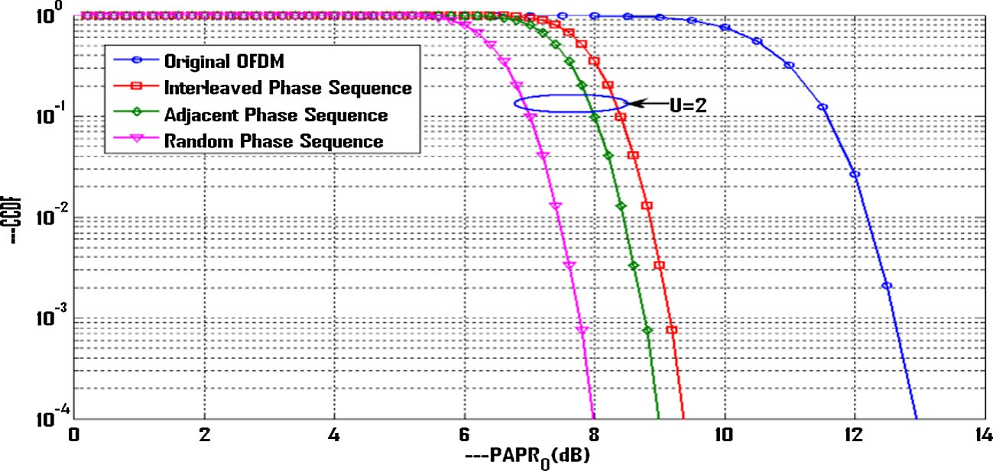

Figure 2. CCDF vs. PAPR threshold using random, interleaved and adjacent phase sequences.

From (25), the CDF can be expressed as

*P*(*PAPR* 6 *p*0 )= [1 — exp(—*p*0)]M (26)

The number of subcarriers ‘M’ from (34) can be expressed as

*q* exp(*p* )

The complementary CDF(CCDF) is given by

*M* = *a* 0

### (35)

*P*(*PAPR* > *p*0)= n1 — [1 — exp(—*p*0 )]Mo (27)

The CCDF of PAPR for oversampled signal as suggested in [26] can be written as

*P*(*PAPR* > *p*0)= n1 — [1 — exp(—*p*0 )]*a*Mo (28)

We see that (35) specifies the relation between the number of subcarriers and PAPR threshold.

Next consider the proposed PTS technique whose analytical expression for CCDF is derived in (31). Designating *q*' as the CCDF,

(31) can be expressed as

n o*c*U

In (28) a is a parameter related to oversampled signal. It is also specified in [26] that a = 2.8 is a good approximation for the over-

*q*' = 1 — [1 — exp(—*p*0)]*a*M (36)

As specified in (33) and (34), (36) can be approximated as

sampling factor of 4.

For T-PTS scheme with U subblocks, if the phase rotated data blocks of OFDM are independent and uncorrelated, the CCDF of PAPR of the OFDM signal after applying PTS technique is given by

U

*q*' = [*aM* exp(—*p*0)]*c*U (37)

Now (37) can be represented as

*aM*)*cU* = *q*' exp(*p*0*cU*) (38)

*P*(*PAPRPTS*(*U*) > *p*0 )= n1 — [1 — exp(—*p*0)]*a*Mo

Now (29) can be represented as

### (29)

(

Applying logarithms on both sides of (38), we obtain

*cU* ln(*aM*)= ln(*q*')+ *p*0 *cU* (39)

#### *CCDF*

*PTS*

= n1 — [1 — exp(—*p* )]*a*MoU (30)

which implies that (39) can be expressed as

Since we make use of a modified phase sequence in the opti-

0

ln *a*

ln(*q*')

mization of weighting factor, the CCDF of the proposed PTS tech- nique can be expressed as

( *M*)=

*cU* + *p*0 (40)

#### *CCDF*

= n1 — [1 — exp(—*p* )]*a*Mo*c*U (31)

Therefore the expression for number of subcarriers is

*proposed PTS* 0

where the parameter c in (31) is a parameter whose value lies in the

1 ln(*q*')

range 0–1. This parameter is used in plotting the analytical results in Figs. 3–6.

We see from (41) that number of subcarriers increases if PAPR increases. From (40), the expression for PAPR can be expressed as

*M* = *a* exp

*cU* + *p*0

(41)

* 1. *Analytical expression for the number of subcarriers and number of subblocks*

*p* = ln(*aM*)— ln(*q*')

### (42)

Consider an OFDM system with M subcarriers and U subblocks. The CCDF in terms of PAPR from (28) by designating CCDF as *q* is represented as

*cU*

0

### *q* = n1 — [1 — exp(—*p*0)]*a*Mo (32)

which denotes that reduction of PAPR occurs if the number of sub- carriers decreases by fixing the number of subblocks U and CCDF *q*'. From (42), if the number of subcarriers M and CCDF *q*' are fixed,

PAPR decreases as the number of subblocks increases.

The expression for the number of subblocks from (42) is

Since exp(—*p*0)] 1 (as *p*0 > 0), (32) can be approximated as

*U* = 1

ln(*q*')

### (43)

*q* = {1 — [1 — *aM* exp(—*p*0)]} (33)

or

*q* = *aM* exp(—*p*0) (34)

*c* ln(*aM*)— *p*0

The analytical expressions derived in (41) and (43) specify the relation among PAPR, number of subcarriers and number of subblocks.

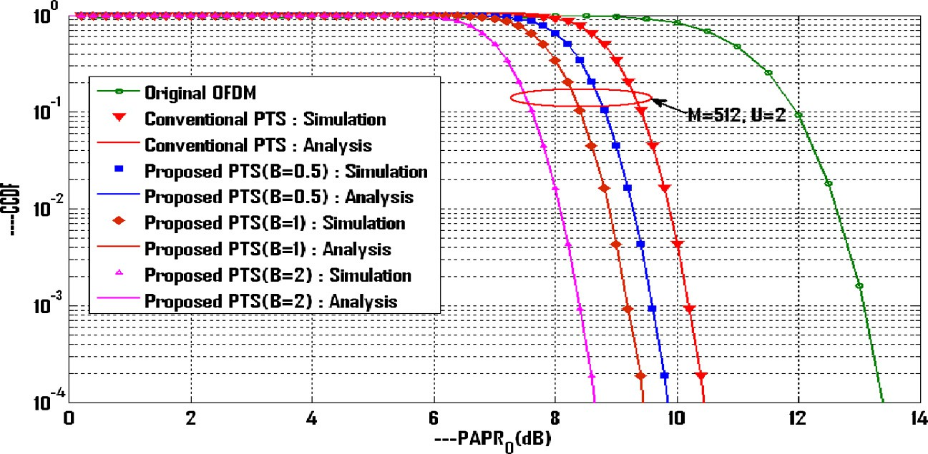

Figure 3. PAPR performance for traditional PTS and proposed PTS schemes for M = 512, U = 2.

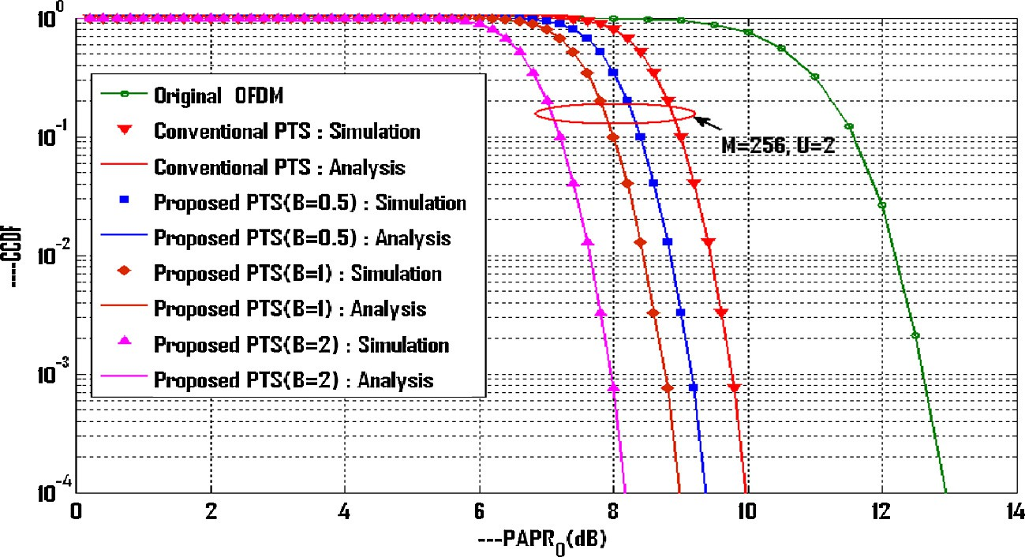

Figure 4. PAPR performance for traditional PTS and proposed PTS schemes for M = 256, U = 2.

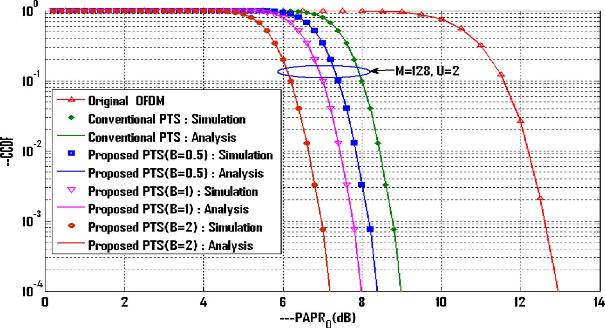

Figure 5. PAPR performance for traditional PTS and proposed PTS schemes for M = 128, U = 2.

* 1. *Analytical expression for total computational complexity*

Consider the proposed PTS scheme that has M subcarriers and U subblocks. The total computational complexity is always equal to the sum of the total number of IFFT operations required and the complexity of the searching method.

The total number of IFFT operations required for our suggested method is the sum of number of complex additions and complex

multiplications. We know that for a standard IFFT flow graph, the number of complex additions required for an IFFT length of M is *M*log2*M* and the number of complex multiplications are *M*log2 *M* . For U subblocks, the number of complex additions and multiplica-

tions required are *UM*log2*M* and *UM*log2 *M* respectively. Since the pro-

2

2

posed method requires exactly half of the total complex additions and multiplications, this factor is given by

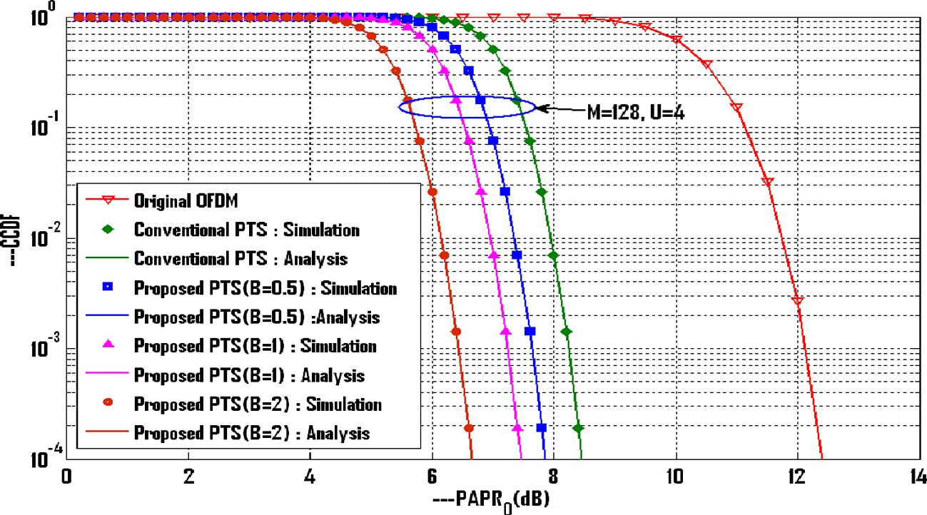

Figure 6. PAPR performance for traditional PTS and proposed PTS schemes for M = 128, U = 4.

*T*1 = 3*UM*log2*M*

4

### (44)

Fig. 3 shows the CCDF vs. PAPR plot with M = 512, U = 2. The simulation is performed for generating the CCDF vs. PAPR plot

As the proposed scheme requires the iterations as specified in (12), the total complexity of the searching method taking into account the number of subcarriers and subblocks is

*T*2 = (*BWU*—1)(*UM*) (45)

Substituting (12) in (45), we obtain

*T*2 = *QUM* (46)

The total computational complexity of our suggested PTS scheme is obtained by adding (44) and (46). If T denotes the total computational complexity, it is given by

*T* = *T*1 + *T*2 = 3*UM*log2*M* + *QUM* (47)

4

We make use of (47) in the computation of total complexity in Section 6.2.

1. Results and discussion
   1. *PAPR performance*

In order to observe the performances of the proposed PTS and traditional PTS schemes, simulations have been performed using MATLAB software by considering an OFDM system employing Quadrature phase shift keying (QPSK) modulation. The number of subcarriers ‘M’ is set to 128,256,512. The number of subblocks ‘U’ is considered as 2, 4 and the number of OFDM symbols gener- ated is 50,000. For the proposed PTS scheme, the PAPR is evaluated for three values of trade-off factors, B = 0.5, 1, 2. The oversampling factor ‘L’ is set to 4. To validate the accuracy of the analytical expressions derived, analytical CCDF’s are plotted along with the simulation results in Figs. 3–6. The expressions for CCDF of tradi- tional PTS and proposed PTS schemes derived in Section 5.1 using

(30) and (31) are used for analysis. Different parameters in the analysis are a = 2.8, c = 0.52, 0.76, M = 128, 256, 512 and U = 2, 4. The CCDF of PAPR of original OFDM is plotted first in Figs. 3–6.

The simulation results are compared with that of analytical results for conventional PTS and proposed PTS schemes for B = 0.5, 1, 2.

Fig. 2 shows the CCDF vs. PAPR plot using Interleaved, Adjacent and Random phase sequences respectively for the number of sub- blocks U = 2. It is clear from the figure that the PAPR performance using Random phase sequence is superior compared to that of Interleaved and Adjacent phase sequences. Hence we employ Ran- dom phase sequence in further simulation results.

for conventional and Proposed PTS schemes with B = 0.5, 1, 2. The CCDF of original OFDM is plotted first. We observe that the PAPR reduces as B increases. The PAPR values at CCDF of 10—4 for B = 0.5, 1, 2 are 9.8 dB, 9.3 dB and 8.4 dB respectively.

Fig. 4 shows the CCDF vs. PAPR plot for M = 256, U = 2 for tradi- tional PTS and proposed PTS schemes with B = 0.5, 1, 2. The simu- lation results denote that the PAPR decreases as B increases. The PAPR at a CCDF of 10—4 for B = 0.5, 1, 2 are 9.3 dB, 8.9 dB and

8.1 dB. We see that analytical results closely match with simula- tion results for both traditional PTS and proposed PTS techniques. The proposed method reduces PAPR effectively compared to that of traditional PTS and also reduction in PAPR is improved compared to that of T-PTS scheme.

The CCDF vs. PAPR plot for M = 128, U = 2 is shown in Fig. 5. The analytical results are validated with that of simulation results for conventional PTS scheme and proposed PTS scheme for B = 0.5, 1,

2. For plotting the analytical results, we consider c = 0.52 for

Figs. 3–5 and c = 0.76 for Fig.6.

From Fig. 5, the PAPR values at CCDF of 10—4 are 0.7 dB, 1.1 dB and 2.1 dB lower than those for traditional PTS. Fig. 6 shows the CCDF vs. PAPR plot for M = 128, U = 4 for the same set of values of B. Here also PAPR decreases as B increases. We see from Figs. 5 and 6 that PAPR performance is improved for our proposed method compared to that of traditional PTS scheme. It is clear that the sim- ulation results closely coincide with the analytical results. The decrease in PAPR in Fig. 6 is better than that in Fig. 5 which denotes that PAPR decreases with the increase in the number of subblocks. For example for M = 256, U = 2 and B = 1, the PAPR at CCDF of 10—4 is 9.0 dB in Fig. 4 where as for M = 128, U = 2 and B = 1, the PAPR is 8.1 dB in Fig. 5. The expression derived in (41) justifies these results. For M = 128, U = 4 and B = 1, the PAPR value is

7.5 dB in Fig. 6. The expression derived in (43) justifies this result. The relation between PAPR and number of subcarriers is derived in Section 5.2 using (41). From the results presented in Figs. 3–5, the PAPR values with different subcarriers for T-PTS and Proposed PTS schemes with B = 0.5, 1 and 2 are shown in Table 1. Here we observe that PAPR decreases as the number of subcarriers decreases. We also observe from Table 1 that PAPR

reduces with the increase in the trade-off factor B.

* 1. *Computational complexity*

Here, Computational complexity reduction ratio (CCRR) is defined and formulated first and then the computational complex-

Table 1

PAPR values for M = 128, 256, 512 at CCDF of 10—4.

|  |  |  |  |  |  |
| --- | --- | --- | --- | --- | --- |
| Number of subcarriers (M) | PAPR0 (dB) |  | | | |
|  | T-PTS | Proposed PTS (B = 0.5) | Proposed PTS (B = 1) | Proposed PTS (B = 2) |  |
| 128 | 9.2 | 8.5 | 8.1 | 7.1 |  |
| 256 | 10 | 9.3 | 8.7 | 8.1 |  |
| 512 | 10.4 | 9.8 | 9.3 | 8.5 |  |

Table 2

Complexity of T-PTS and proposed PTS with M = 128, 256, 512 and U = 2.

|  |  |  |  |  |  |
| --- | --- | --- | --- | --- | --- |
| Number of subcarriers (M) | Total complexity |  | | | |
|  | T-PTS | Proposed PTS (B = 0.5) | Proposed PTS (B = 1) | Proposed PTS (B = 2) |  |
| 128 | 3712 | 1600 | 1856 | 2368 |  |
| 256 | 8192 | 3584 | 4096 | 5120 |  |
| 512 | 17,920 | 7936 | 8960 | 11,008 |  |

Table 3

CCRR for proposed PTS with M = 128, 256, 512 and U = 2.

with B = 0.5, 1, 2 compared to that of T-PTS scheme. For M = 256,

the complexity is reduced by 4608, 4092 and 3072 respectively for the proposed method with B = 0.5, 1, 2 compared to that of T-

Number of

|  |  |  |  |  |
| --- | --- | --- | --- | --- |
| subcarriers (M) | Proposed PTS (B = 0.5) (%) | Proposed PTS (B = 1) (%) | Proposed PTS (B = 2) (%) |  |
| 128 | 56.89 | 50 | 36.21 |  |
| 256 | 56.25 | 50 | 37.48 |  |
| 512 | 55.71 | 50 | 38.57 |  |

CCRR

PTS scheme. We observe that the complexity decreases as B decreases and lower complexity is obtained for lower values of B.

Table 3 shows the computational complexity reduction ratio for the suggested PTS technique for B = 0.5, 1, 2 for the number of sub- carriers M = 128, 256 and 512. For CCRR calculations, we use the equation specified in (48). It is clear from Table 3 that CCRR improves as B decreases. For example for M = 256 and U = 2, CCRR

ity and CCRR for the proposed method are determined and com- pared with that of T-PTS technique.

* + 1. *Computational complexity reduction ratio (CCRR)*

An important parameter which is related to the computational complexity is the computational complexity reduction ratio which is defined as

= — × % ( )

##### *CCRR* 1 *complexity of the proposed scheme* 100 48

*complexity of the C* — *PTS scheme*

It gives the reduction in percentage of complexity by employing the proposed scheme with respect to the traditional PTS scheme. Using CCRR we can estimate the performance of a system. Higher percentage of CCRR specifies good performance of the proposed scheme compared to the traditional scheme. It is also used to com- pare the complexity of the proposed scheme.

It is also used to compare the complexity of the proposed scheme for different values of the trade-off factor.

For T-PTS technique, we use the following equation for com- plexity calculations specified in [11] as

*T* = 3*UM*log2 *M* + 2U*WU*—1*M* (49)

2

The first term in (49) represents the number of IFFT operations which is the sum of total number of complex additions and com- plex multiplications. The second term in (49) represents searching complexity of the algorithm. For the proposed PTS technique, we use the total complexity equation specified in (47) derived in Sec- tion 5.3 to perform the complexity calculations.

Total complexity and CCRR computations are shown in Tables 2 and 3 respectively.

Table 2 shows the total computational complexity for the tradi- tional PTS and suggested method for B = 0.5, 1, 2. It shows the reduction in complexity for the suggested method compared to that of T-PTS with M = 128, 256, 512 and U = 2. For M = 512, the com- plexity is reduced by 9984, 8960 and 6912 for the proposed method

values are 56.25%, 50% and 37.48% for proposed PTS scheme with B = 0.5, 1, 2. For M = 128 and U = 2, the CCRR values are 56.89%, 50% and 36.21% respectively for the proposed scheme with B = 0.5, 1, 2. CCRR percentage is improved for lower values of the tradeoff factor and CCRR percentage is lower for higher values of B.

1. Conclusion

A novel low complexity optimized PTS technique with RPSM for reducing PAPR in wireless OFDM systems is proposed in this paper. By applying the proposed technique, simultaneously PAPR reduc- tion and computational complexity reduction are achieved com- pared to that of traditional PTS scheme. A favorable trade-off is obtained between reduction of PAPR and computational complex- ity by choosing the optimum value of the trade-off factor. PAPR reduces with the reduction in the number of subcarriers and increase in the number of subblocks. The analytical results closely matched with the simulation results. It is clear that our suggested PTS technique performs much better than traditional PTS tech- nique in reduction of PAPR and computational complexity. The proposed technique improves the efficiency of the power amplifier and can be applied to the current wireless systems such as WiMAX and LTE.

References

1. [Jiang Tao, Wu Yiyan. An overview: PAPR reduction techniques for OFDM](http://refhub.elsevier.com/S1110-8665(16)30049-4/h0005) [signals. IEEE Trans Broadcast 2008;54(2):257–68](http://refhub.elsevier.com/S1110-8665(16)30049-4/h0005).
2. [Cimini LJ, Sollenberger NR. Peak-to-average power ratio reduction of an OFDM](http://refhub.elsevier.com/S1110-8665(16)30049-4/h0010) [signal using partial transmit sequences. IEEE Commun Lett 2000;4(3):86–8](http://refhub.elsevier.com/S1110-8665(16)30049-4/h0010).
3. Wu Xinchun, Wang Jinxiang, Mao Zhigang, Zhang Jianwei. Conjugate interleaved partitioning PTS scheme for PAPR reduction of OFDM signals. Circuits Syst Signal Process 2010;29(3):499–514. [http://dx.doi.org/10.1007/](http://dx.doi.org/10.1007/s00034-010-9157-9) [s00034-010-9157-9](http://dx.doi.org/10.1007/s00034-010-9157-9).
4. Lee Byung Moo, de Figueiredo Rui JP, Kim Youngok. A computationally efficient tree-PTS technique for PAPR reduction of OFDM signals. Wirel Pers Commun 2010;62(2):431–42. <http://dx.doi.org/10.1007/s11277-010-0062-0>.
5. Lain Jenn-Kaie, Wu Shi-Yi, Yang Po-Hui. PAPR reduction of OFDM signals using PTS scheme: a real valued genetic approach. EURASIP J Wirel Commun Netw 2011;126:1–8. [http://dx.doi.org/10.1186/1687- 1499-2011-126](http://dx.doi.org/10.1186/1687-1499-2011-126).
6. Li Li, Qu Daiming. Joint decoding of LDP codes and phase factors for OFDM systems with PTS PAPR reduction. IEEE Trans Veh Technol 2013;62(1):444–9. <http://dx.doi.org/10.1109/TVT.2012.2222455>.
7. [Ghassemi A, Gulliver TA. Fractional subblocking for partial transmit sequence](http://refhub.elsevier.com/S1110-8665(16)30049-4/h0035) [OFDM. IEICE Trans Commun 2008;E91-B(10):3166–73](http://refhub.elsevier.com/S1110-8665(16)30049-4/h0035).
8. Taher M Abas, Singh Mandeep Jit, Ismail M, Samad S Abdul, Islam MT, Mahdi HF. Post-IFFT modified selected mapping to reduce PAPR of an OFDM system. Circuits Syst Signal Process 2015;34(2):535–55. [http://dx.doi.org/10.1007/](http://dx.doi.org/10.1007/s00034-014-9868-4) [s00034-014-9868-4](http://dx.doi.org/10.1007/s00034-014-9868-4).
9. [Yang L, Siu YM, Soo KK, Leng SW. Low complexity PAPR reduction for OFDM](http://refhub.elsevier.com/S1110-8665(16)30049-4/h0045) [systems using modified widely linear SLM scheme. Int J Electron Commun](http://refhub.elsevier.com/S1110-8665(16)30049-4/h0045) [2012;66(12):1006–10](http://refhub.elsevier.com/S1110-8665(16)30049-4/h0045).
10. Li Chih- Peng, Wang Sen-Hung, Wang Chin-Liang. Novel low complexity SLM schemes for PAPR reduction in OFDM systems. IEEE Trans Signal Process 2010;58(5):2916–21. <http://dx.doi.org/10.1109/TSP.2010.2043142>.
11. Baxley Robert J, Zhou G Tong. Comparing selected mapping and partial transmit sequence for PAPR reduction. IEEE Trans Broadcast 2007;53 (4):797–803. <http://dx.doi.org/10.1109/TBC.2007.908335>.
12. [Kojima T, Iwamoto S, Shida Y, Fujino T. A novel SLM PAPR reduction of OFDM](http://refhub.elsevier.com/S1110-8665(16)30049-4/h0060) [signals without side information. In: Proc IEEE int symp signal process and info](http://refhub.elsevier.com/S1110-8665(16)30049-4/h0060) [technology. p. 321–5](http://refhub.elsevier.com/S1110-8665(16)30049-4/h0060).
13. Hu Su, Wu Gang, Wen Qingsong, Xiao Yue, Li Shaoqian. Non- linearity reduction by tone reservation with null subcarriers for WiMAX system. Wirel Pers Commun 2010;54(2):289–305. [http://dx.doi.org/10.1007/s11277-009-](http://dx.doi.org/10.1007/s11277-009-9726-z) [9726-z](http://dx.doi.org/10.1007/s11277-009-9726-z).
14. Chen JC, Chiu Min-Han, Yang YS, Li Chih-Peng. A sub optimal tone reservation algorithm based on cross-entropy method for PAPR reduction in OFDM systems. IEEE Trans Broadcast 2011;57(3):752–6. [http://dx.doi.org/10.1109/](http://dx.doi.org/10.1109/TBC.2011.2127590) [TBC.2011.2127590](http://dx.doi.org/10.1109/TBC.2011.2127590).
15. Hung Ho- Lung, Cheng Chung- Hsen, Huang Yung-Fa. PAPR reduction of OFDM using invasive weed optimization based PRT set selection. EURASIP J Wirel

Commun Netw 2013;244:1–12. [http://dx.doi.org/10.1186/1687-1499-2013-](http://dx.doi.org/10.1186/1687-1499-2013-244) [244](http://dx.doi.org/10.1186/1687-1499-2013-244).

1. [Nadal L, Moreolo MS, Fabrega JM. Low complexity PAPR reduction techniques](http://refhub.elsevier.com/S1110-8665(16)30049-4/h0080) [for clipping and quantization noise mitigation in direct detection O-OFDM](http://refhub.elsevier.com/S1110-8665(16)30049-4/h0080) [systems. J Opt Fiber Technol 2014;20(3):208–16](http://refhub.elsevier.com/S1110-8665(16)30049-4/h0080).
2. Nandalal V, Sophia S. PAPR reduction of OFDM signals via custom conic optimized iterative adaptive clipping and filtering. Wirel Pers Commun 2014;78(2):867–80. <http://dx.doi.org/10.1007/s11277-014-1788-x>.
3. [Islam Mohammad Rakibul. PAPR reduction using precoding with clipping and](http://refhub.elsevier.com/S1110-8665(16)30049-4/h0090) [filtering. In: Proc IEEE int conf computer and info technology. p. 573–8](http://refhub.elsevier.com/S1110-8665(16)30049-4/h0090).
4. Mahmudul Hasan Md. A new PAPR reduction technique in OFDM systems using linear predictive coding. Wirel Pers Commun 2014;75(1):707–21. [http://](http://dx.doi.org/10.1007/s11277-013-1387-2) [dx.doi.org/10.1007/s11277-013-1387-2](http://dx.doi.org/10.1007/s11277-013-1387-2).
5. Baig Imran, Jeoti V. A ZCMT precoding based multicarrier OFDM system to minimize high PAPR. Wirel Pers Commun 2013;68(3):1135–45. [http://dx.doi.](http://dx.doi.org/10.1007/s11277-012-0501-1) [org/10.1007/s11277-012-0501-1](http://dx.doi.org/10.1007/s11277-012-0501-1).
6. Chen H, Liang H. PAPR reduction of OFDM signals with partial transmit sequences and Reed-Muller codes. IEEE Commun Lett 2007;11(6):528–30. <http://dx.doi.org/10.1109/LCOMM.2007.070172>.
7. Liang HY. Integrating CE and SLM to reduce PAPR of OFDM systems. Wirel Pers Commun 2015;80(2):709–22. [http://dx.doi.org/10.1007/ s11277-014-2036-0](http://dx.doi.org/10.1007/s11277-014-2036-0).
8. Kliks A, Bogucka H. Improving effectiveness of the active constellation extension method for PAPR reduction in generalised multi-carrier signals. Wirel Pers Commun 2011;61:323–34. [http://dx.doi.org/10.1007/s11277-010-](http://dx.doi.org/10.1007/s11277-010-0025-5) [0025-5](http://dx.doi.org/10.1007/s11277-010-0025-5).
9. Yao Yi, Hu Jianhao, Ma Shang. A PAPR reduction scheme with residue number system for OFDM system. EURASIP J Wirel Commun Netw 2013;156:1–11. <http://dx.doi.org/10.1186/1687-1499-2013-156>.
10. [Park M, Jun H, Cho J, Cho N, Kang C. PAPR reduction in OFDM transmission](http://refhub.elsevier.com/S1110-8665(16)30049-4/h0125) [using Hadamard transform. In: Proc IEEE int conf communications, 1. p. 430–3](http://refhub.elsevier.com/S1110-8665(16)30049-4/h0125).
11. [van Nee R, Prasad Ramjee. OFDM for wireless multimedia](http://refhub.elsevier.com/S1110-8665(16)30049-4/h0130) [communications. Boston (MA): Artech House; 2000](http://refhub.elsevier.com/S1110-8665(16)30049-4/h0130).