[](http://crossmark.crossref.org/dialog/?doi=10.1016/j.eij.2019.11.004&domain=pdf)A novel solution for a Wireless Body Sensor Network: Telehealth elderly people monitoring

Contents lists available at [ScienceDirect](http://www.sciencedirect.com/science/journal/11108665)

Egyptian Informatics Journal

journal homepage: [www.sciencedirect.com](http://www.sciencedirect.com/)

K. Dhakal a, Abeer Alsadoon a,⇑, P.W.C. Prasad a, Rasha S. Ali b, Linh Pham a, Amr Elchouemi c

a *School of Computing and Mathematics, Charles Sturt University, Sydney, Australia*

b *Department of Computer Techniques Engineering, AL Nisour University College, Baghdad, Iraq*

c *Colorado State University Global Campus, United States*

a r t i c l e i n f o

*Article history:*

Received 21 June 2019

Revised 17 October 2019

Accepted 16 November 2019

Available online 10 December 2019

*Keywords:*

Tele-monitoring chronic heart patients Data transmission

WBSN

a b s t r a c t

Event-based data transfer through Wireless Body Sensor Networks (WBSN) for monitoring the health of the elderly has so far not been successfully implemented due to limitations arising forms unreliable data, end-to-end delay during data transmission and the high energy consumption by sensors. This paper aims to improve reliability and latency and to reduce energy consumption by sensors during data transmission in WSBN. The proposed system consists of an Enhanced Reliability, Energy-Efficient and Latency (EREEAL) algorithm to reduce data losses and end-to-end delay as well as improve the transmission reliability in WBSN by sending the sensor data during different time slots using Time Division Multiple Access (TDMA) analysis and by minimizing redundant sensitive data. The result shows that the new algorithm improves reliability to 98% over the data bits generated within 8 ~ 12 min and reduces latency to 0.635 compared to 0.875 ms in the ‘state of the art’ system. Furthermore, the reduction in latency leads to lower power consumption by sensors, reduced to 315.638*10 3JS/bits during patient data transmission using a tele-monitoring process. The proposed system concentrates on reducing interference with data between sensors and focuses on minimizing data loss during transmission. Thus, this study provides an acceptable range of reliability with reduced delay and lower power consumption due to which doctors at a remote site can obtain reliable data value for smooth monitoring.

© 2019 Production and hosting by Elsevier B.V. on behalf of Faculty of Computers and Information, Cairo

University. This is an open access article under the CC BY-NC-ND license ([http://creativecommons.org/](http://creativecommons.org/licenses/by-nc-nd/4.0/)

[licenses/by-nc-nd/4.0/](http://creativecommons.org/licenses/by-nc-nd/4.0/)).

1. Introduction

Health monitoring for the elderly has been a major concern in most countries. In the past, elderly people were taken into nursing homes or hospitals to provide treatment and basic health care solutions and for health treatment [1]. However, it is often chal- lenging to provide such health care because of high expenditure and due to the impact on quality of life. According to Nakrem et al. [2], there is also less focus on health condition of elderly peo- ple in such institutions. Emergency treatment in critical situations

* Corresponding author at: Charles Sturt University, Sydney Campus, Sydney, Australia.

*E-mail address:* [aalsadoon@studygroup.com](mailto:aalsadoon@studygroup.com) (A. Alsadoon).

Peer review under responsibility of Faculty of Computers and Information, Cairo University.

**Production and hosting by Elsevier**

can often not be provided [1]. Such problems can be overcome with the aid of the latest technology in Tele-monitoring which allows health continuous monitoring in private homes using wearable devices as shown in Fig. 1b. With this latest technology, the elderly remain in their homes rather than relocating to costly aged care or nursing homes. In this health monitoring process, the health status is captured through event-based monitoring by comparing the health data obtained from wearable sensors in each data transmis- sion cycle with the data from the previous cycle. This is monitored in real time by a health professional at a remote facility – Fig. 1c. Hence, the elderly people can stay in their homes in a secure envi- ronment with their family without health concerns.

Tele-monitoring using event-based data transfer provides a sophisticated method of data transmission within WSBN in real time constituting a significant advantage for the medical field and for the elderly [3]. But, the transmission of reliable and real- time data in this tele-monitoring technique is still the subject of research due to limitations created by data interference between sensors, data loss and due to the transmission of redundant data. Research is being carried out to overcome these issues. However,

<https://doi.org/10.1016/j.eij.2019.11.004>

1110-8665/© 2019 Production and hosting by Elsevier B.V. on behalf of Faculty of Computers and Information, Cairo University. This is an open access article under the CC BY-NC-ND license (<http://creativecommons.org/licenses/by-nc-nd/4.0/>).

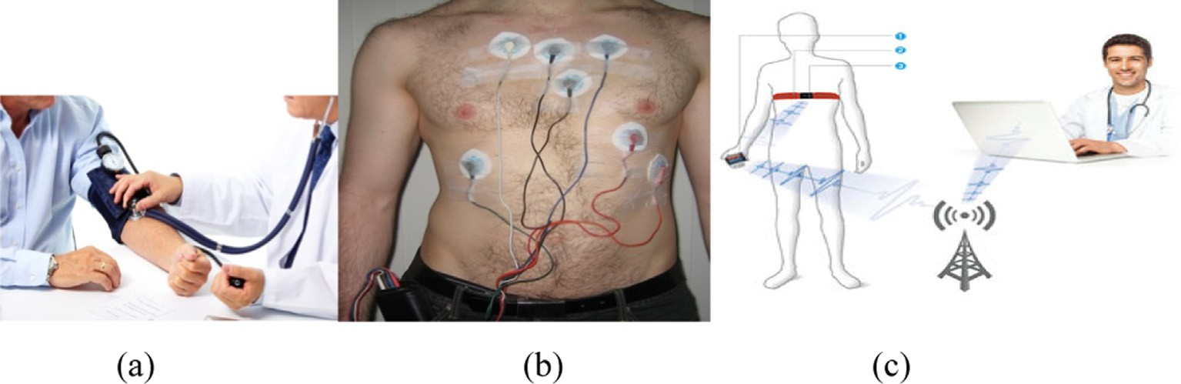

Fig. 1. Traditional method of health check-up of patient at hospital (b) Local people using sensors around their body for remote tele-monitoring (c) Modern tele-monitoring process for health check-up using sensors.

the maximum outcome for reliability is currently 98% measured over 8–12 min. Latency in our proposed solution is 0.635 compared to 0.875 ms in the ‘state of the art’ system during data transmission [3]. Lack of reliability and an increased end to end delay can lead to the health monitoring failure. The purpose of this paper is to reli- ability, reduce end to end delay and save energy during patients data transmission within WBSN. The current Iterative bit calcula- tion algorithm at the sensors has a problem when the sensor sends redundant data during data transmission [3]. This work proposes an Enhanced Reliability, Energy Efficiency and Latency (EREEAL) algorithm to reduce redundancy, data loss, and interference with sensors during data transmission in WBSN, thus reducing sensor energy consumption.

1. Literature review
   1. *Field of research and research organization*

This research focuses on data transmission issues during Tele- monitoring of the Elderly using WBSN. Different data transmission techniques and models are analysed for delivering sensor data with minimum latency, low energy consumption and with high reliability. Initially, this research identifies WBSN problems during tele-monitoring. This is followed by an analysis of algorithms, techniques, and frameworks from related research. Then, the best current solution for data transmission in WBSN is analysed and enhanced to overcome limitations. Mathematical and theoretical justifications for the proposed modifications are provided. Finally, the proposed solution is simulated to check health data transmit- ted within WBSN as part of an event-based scheme. These simula- tion processes are then analysed in terms of reliability, latency and energy consumption.

* 1. *Network latency in tele-monitoring*

Calhan et al. [4] and Li [5] investigated data transmission in WBSN in terms of throughput and end to end delay. They provided a solution to the problem of delay by using an M/G/1 queue model. They reduced delay of only 0.4 s for emergency data and 0.7 s for general patient data. This is an improvement in delay over 0.5 s for emergency data and 11 s for normal data [5]. However, an anal- ysis on Bandwidth utilization, congestion and data collision was not carried out with this solution, which would have brought a reduction in network traffic and reduced end-to-end delay Never- theless, this paper provides a solution for the end-to-end delay from sensor node at the local site to cloud at a remote site, so it is useful to the current project. End-to-End delay was also the main concern of Sahoo et al. [6] and Ma et al. [7] who reduced the packet drop rate, delay, and collisions in WBSN by using a Markov chain

model. After the simulation, the overall system result is 0.056 s delay during transmission. This is an improvement over 0.059 s by considering hidden terminals like WIFI and ZigBee but does not provide the alternative backup path for packets that were interfered with or collided [7]. This paper focuses on improving end to end delay in WBSN, so it may be useful for the current pro- ject. Furthermore, the issue of delay during data transmission in WBSN was also solved by Alfa et al. [8] focused on data transmis- sion beyond Wireless body area networks. This was achieved by means of an incentive compatible technique by scheduling the transmission in electronic health networks so that they obtain

0.03 s delay sensitive medical packets (Queue Model). This is an improvement over the packet with 0.06 s waiting time for medical data and provides a guaranteed high service priority during emer- gencies conditions, but it fails to decrease the complexity of the network during network recoveries. This paper provides significant benefit to our proposed solution but cannot be considered as it causes complexity in the WBSN.

* 1. *Network reliability in tele-monitoring*

Yaakov et al. [9] and Chen et al. [10] introduced a system to curb congestion, which occurs due to the simultaneous flow of data transmission. They presented a solution to the issue using a Relax- ation Theory – Max-Min Fairness (RT – MMF) Progressive filling algorithm, which achieves quality of service (QoS) in WSN, leading to a data throughput of about 900 bps. Whilst this is an improve- ment over the data throughput of 20 bps measured using a CM- RT technique [10], this system does not deal with contention con- trol, as the transmission of data within a shared medium is impor- tant for minimizing the network traffic. Finally, this technique is used in the current solution for providing reliable transmission. Reliability was also the main concern of Lee et al. [11] and Cheng et al. [12] who presented a WBSN system that addresses the issue of interference in inter -WBAN (Wireless Body Area Network). They offered a solution to the issue using an Interference-Aware Traffic- Priority Based Link Scheduling (ITLS) technique. This provided bet- ter throughput and reduced delay by minimizing the interference within WBSN. After simulation of ITLS, the high-priority sensors could access the channel without any interference as well as main- tain better throughput during data transmission when compared to WBAN with high interference in data [12]. However, the addi- tion of multiple sensors with high-priority data in WBSN did not provide better spatial reuse of sensor data causing long waits before transmission for high-priority data. Nevertheless, this solu- tion provided better reliability by mitigating interference, so it has been highly significant for the current project. Similarly, Gao et al.

[13] improved reliability within WBSN together with Zhao et al. [14]. They provided a Link quality aware channel allocation (LACA) technique for identifying the links with high priority and deadlines

due to which the quality of links and congestion during data trans- mission in WSN was improved. This technique provides also an effective method of channel allocation for faulty links and offers an estimated link quality for all the links, which provides 20% improvement in the data delivery ratio when compared with the RTCS technique [14]. However, the movement of body sensor nodes was not considered by this system due to which the entire network and link quality might be changed. This Solution focuses on link quality and transmission of reliable data in WSN, so it is of high importance to the current project.

* 1. *The state of the art*

Fig. 2 presents the all techniques and methods used in Tiwari’s system [3]. The important features of the ‘state of the art’ solution are shown in Blue, whereas the limitations are shown in red (Fig. 2). This model describes an event-based system of data trans- fer in Wireless Body Sensor Networks (WBSN). This data is trans- ferred from multiple sensors in WBSN and sent to the medical professional through a gateway device (coordinator). This model can increase reliability and reduce end-to-end delay during data transmission in WBSN. This model consists of two main stages, which are data transmission from a sensor at a local site and to a gateway device (Coordinator) and data transmission from a gate- way device to a medical professional at a remote site. Fig. 3 shows the logical flow of the state of art.

Data Transmission from Sensor at a Local Site to a Coordinator: In this stage, data transmission is Event Based. The sensors at the local site during Event-based data transmission, measure health data such as heart rate, and blood pressure from patients at regular intervals in different data transmission cycles. These data values are compared with the values in the previous cycle and are sent

to the gateway device. If the sensors find any change in the data values, they send 10 bits of data frames to the gateway device; otherwise they send only the 1 bit to the gateway device (Fig. 2). This change of data using the event-based scheme reduces redun- dant bits during data transmission to the coordinator, which in turn increases the overall reliability of the system. However, this solution has limitations in terms of data interference and data loss. During data transmission in WBSN, the data from multiple sensors may collide. This data collision occurs due to the transmission of high-traffic data from multiple sensors over the WBSN at the same time resulting in the collection of a large number of data by the coordinator which causes data interference on the sensor side. Similarly, the issue with data loss is also a main concern with the state of the art solution. Due to the data interference within WBSN, large numbers of data from a sensor are not sent to the cloud. So, minimizing the interference will make this current solu- tion more reliable.

Data Transmission from a Coordinator Device to a Medical Pro- fessional at a Remote Site: In this stage, the data received by the coordinator from an event-based system at the local site are fur- ther analysed and are sent to the doctor at the remote site through the cloud (Fig. 2). The coordinator for the state of art solution acts as a mediator between the local and the remote site. At the remote site, the coordinator sends the received data to the cloud on the basis of priority. This means that the sensor data which is received first by the coordinator are sent first to the cloud. The data received by the cloud can then be viewed by the remote medical profes- sional through a using web browser. Thus, end to end delay is reduced during data transmission from the coordinator to the end user. However, this ‘state of the art’ solution at the remote site has some limitation in terms of latency and power consumption. The continuous transmission of redundant data within WBSN

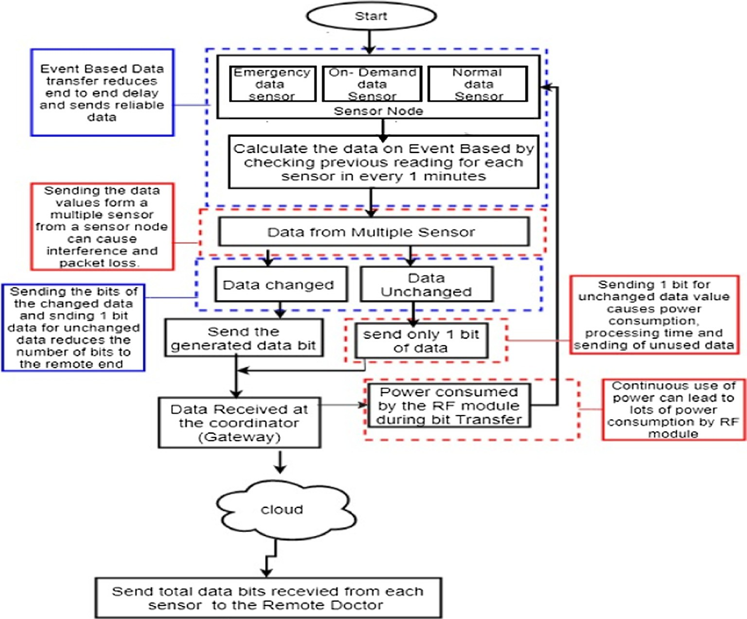

Fig. 2. The workflow of the health data transmission using Event based approach from sensor at source to a doctor at remote site within WBSN (Tiwari, 2017) Fig. 3 [3]. [Blue color refer to the good features of the system, and red color refer to the limitations of it]. Table 1 shows the psedo code of the state of art solution. Table 2 presents the abbreviation of state of art equations.

Table 1

State of Art Algorithm (Event Based Data Transmission Algorithm).

Algorithm: Event Based Data Transfer Algorithm

Input: Emergency data, on demand data, Normal data generated by each sensor Output: total number of data received at cloud from each sensor.

BEGIN

Step 1: Manually Choose the data for Emergency data sensor, On demand data sensor, normal data sensor

Step 2: Perform Event based Calculation by calculating the current value with previous values for all the sensors. Step 3: check for the values received by each sensor

If data values changes, get the data bits ‘B’ generated by each sensor, go to step (5) Else,

Send only 1 bits

Step 5: collect the generated bits at the gateway device from both changed ‘Gc’ and unchanged ‘Guc’ sensors group. Step 6: obtain the data loss’ L’ using equation (2)

Step 7: Calculate the total bits generated at the cloud, using equation (1) END

Table 2

Abbreviation used for state of art algorithm (Event- Based data transfer algorithm).

*L Loss of overall system during data transmission*

*LC Losses while sending data to cloud*

*LE Losses from external sources such as WIFI, Bluetooth*

*L* = *TB* — *LC* — *LE Eq. (2) the data loss occurs during data transmission from sensor to gateway device*

*RT Reliability*

*RT* = *BC* —*L*

*BC*

*Eq. (3) Reliability of WBSN can be obtained by transmitting both changed data and unchanged data from source site to remote site, using Eq. (1) and (2)*

*t* = *B*/*R Eq. (4) Time taken to transmit total bits (B) per data rate (R)*

*Gc Sensor group with changed data bits*

*Guc Sensor group with unchanged data bits*

*Sgc Bits received by the gateway device for changed data value*

*Sguc Bits received by the gateway device for unchanged data value*

*L*' *Latency*

*i*

|*i*=1|e*GUC*

*L*' = P*n*

|*i*=1|e*GC*

*i*

*Sgc* /*R* + P*n*

*Sguc* /*R Eq. (5) the ‘‘latency*” *for overall system is calculated by considering a time taken ‘t* = *B*/*R’ to transmit both changed and*

*unchanged bits from source site to remote site, using Eq. (1) and (2)*

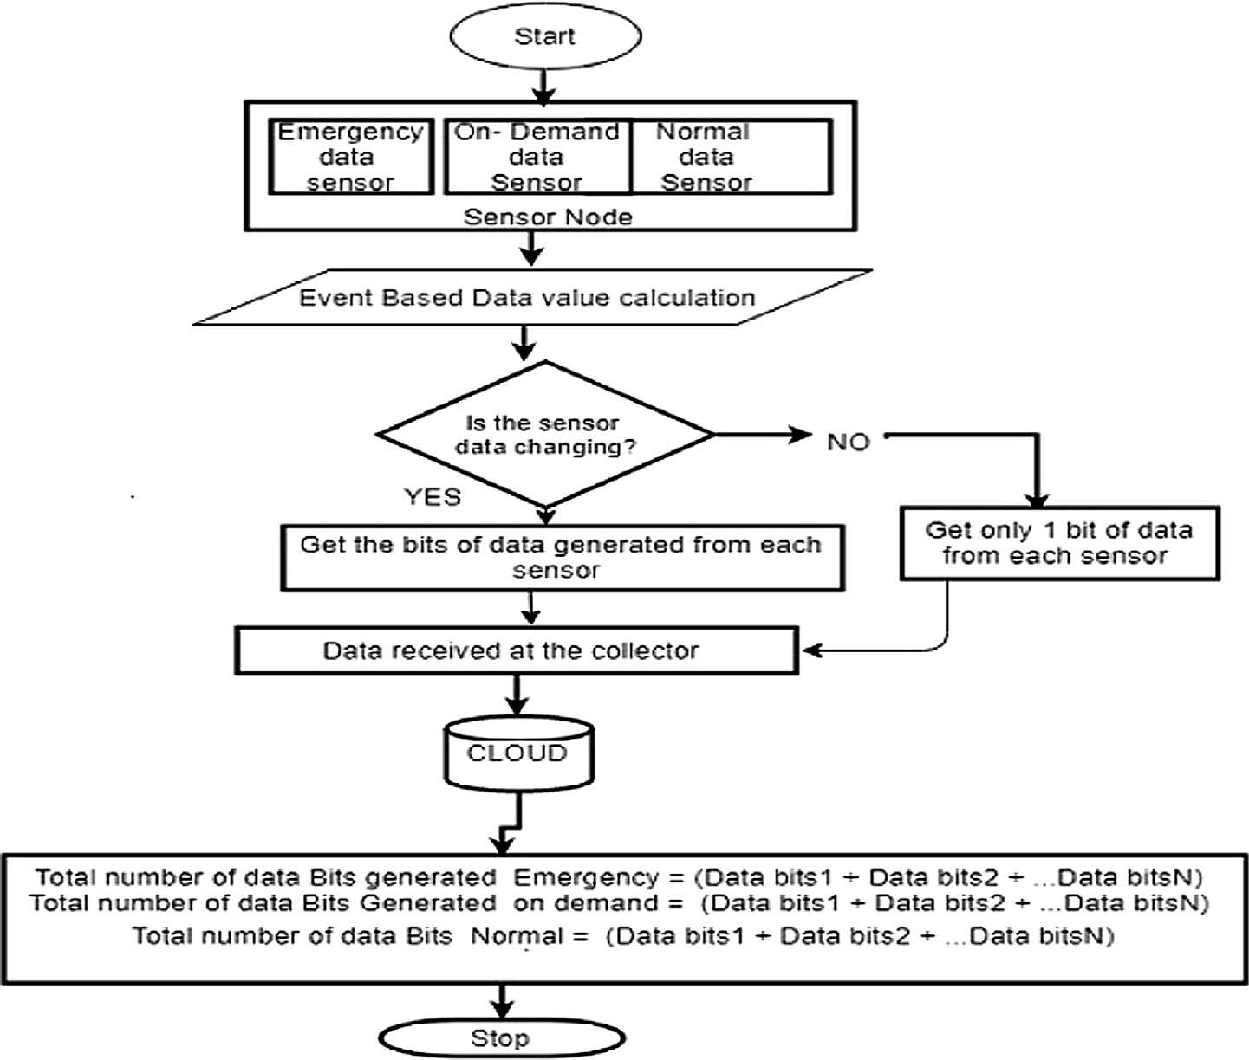

Fig. 3. Logical Flow Diagram of State of Art Solution (Tiwari, 2017) [3].

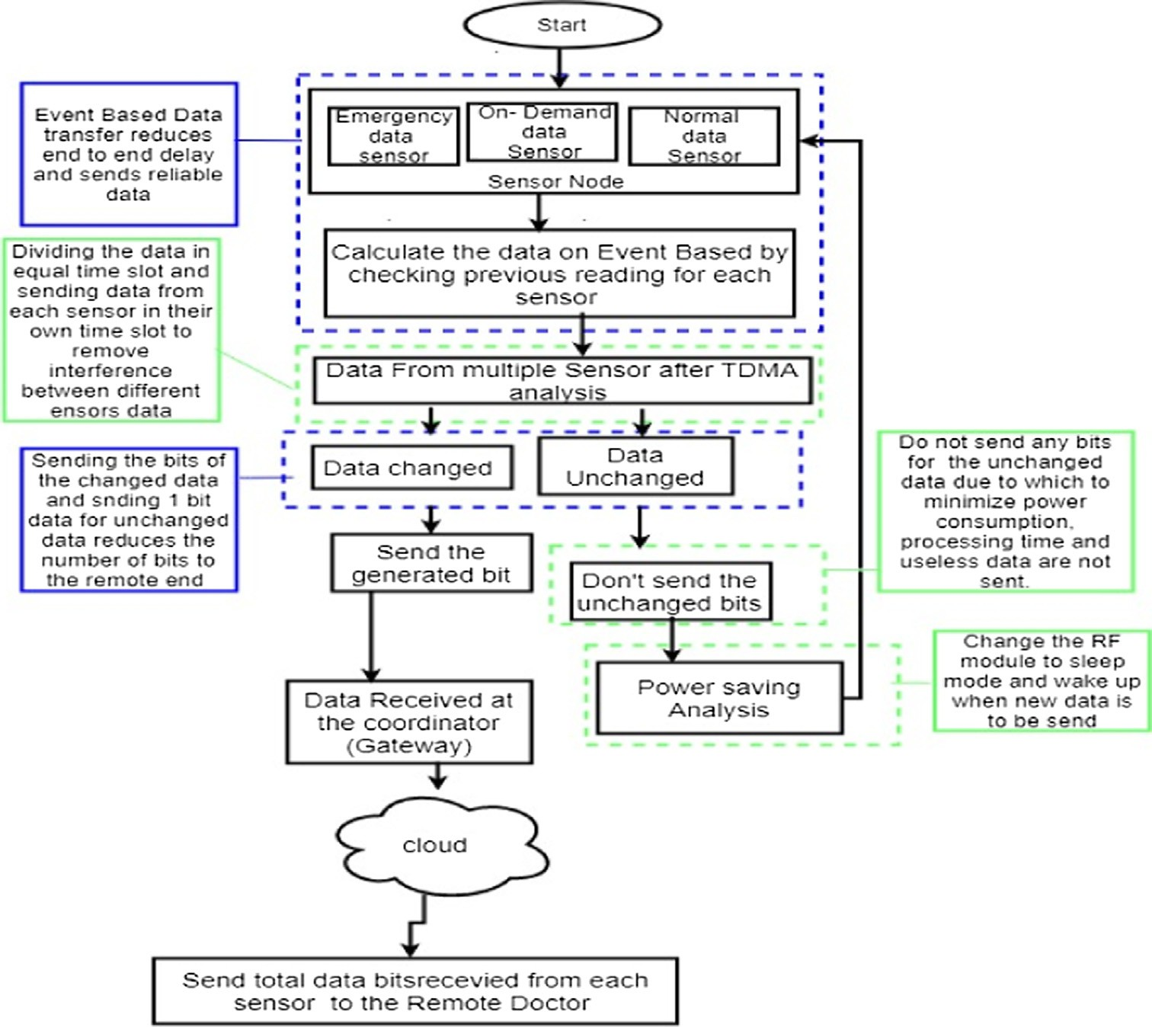

Fig. 4. This figure depicts: (a) the workflow of proposed Tele-monitoring process of Elderly People Using Wireless Body Sensor Network on Event- Based Data Transfer and,

(b) the contribution of this research is shown with a green border.

consumes significant amounts of energy by sensors. Furthermore, this continuous transmission causes data interference, which leads to delay in the overall system. These problems can be overcome by minimizing the reductant data bits during transmission over WBSN. The state of art solution of event-based data transfer mini- mizes end to end delay and provides reliable data transfer com- pared to that of traditional periodic or priority-based data transfer. Similarly, the number of bits data was minimized with the implementation of this model when sending them from local to remote site. However, this solution still causes data loss during transmission of data over WBSN due to the interference of multiple sensors due to the transfer of unused or redundant bits to the remote site. Minimizing this problem, would lead to an improve- ment in the reliability, interference and latency in WBSN. There- fore, it can be concluded that the current solution, though it has great benefits in WSBN has some limits when it comes to power consumption, processing time and reliability. Thus, these have been improved in the proposed solution.

The total number of bits transmitted from sensor to the cloud (Bc) for both changed and unchanged sensor groups is given in Eq. (1) [3]

*BC* = Total data bits transmitted to the cloud. Gc = Sensor group with changed data bits Guc = Sensor group with unchanged data bits i = no. of sensors

g = gateway device uc = unchanged c = changed

1. The proposed system

Tele-monitoring using Wireless Body Sensor Networks (WBSN) during an event-based data transfer is a very important approach to measure the health of the elderly. This allows for the elderly to be regularly monitored by a doctor located in a remote medical facility. But the reliability of networks, end to end delay, power consumption, and interference among multiple sensors has always been a challenge. The use of traditional methods such as, periodic and priority-based data-transfer has provided sophisticated data transmission schemes for small WBSN. However, these methods failed in terms of end-to-end delay, latency, and reliability when data were transmitted over large networks. Similarly, the data

*n*

X

*BC* =

|*i*=1|e*GC*

Where,

*n*

*Sgci* +

X

|*i*=1|e*GUC*

*Sguci* (1)

interference caused by multiple sensors and the transmission of reductant or unused bits were also a major limitation with this tra- ditional method.

Now, Tiwari’s system [3] of Event-Based Data transfer within WBSN has made a significant contribution to data transmission over large networks. This solution provides adequate manage-

*Sgc* =Bits received by the gateway device for changed data value

*Sguc* = Bits received by the gateway device for unchanged data value.

ment of multiple sensors in WBSN by sending the sensor data on an event-based basis. Further improvements were, however, required in terms on processing time, reliability and reduction

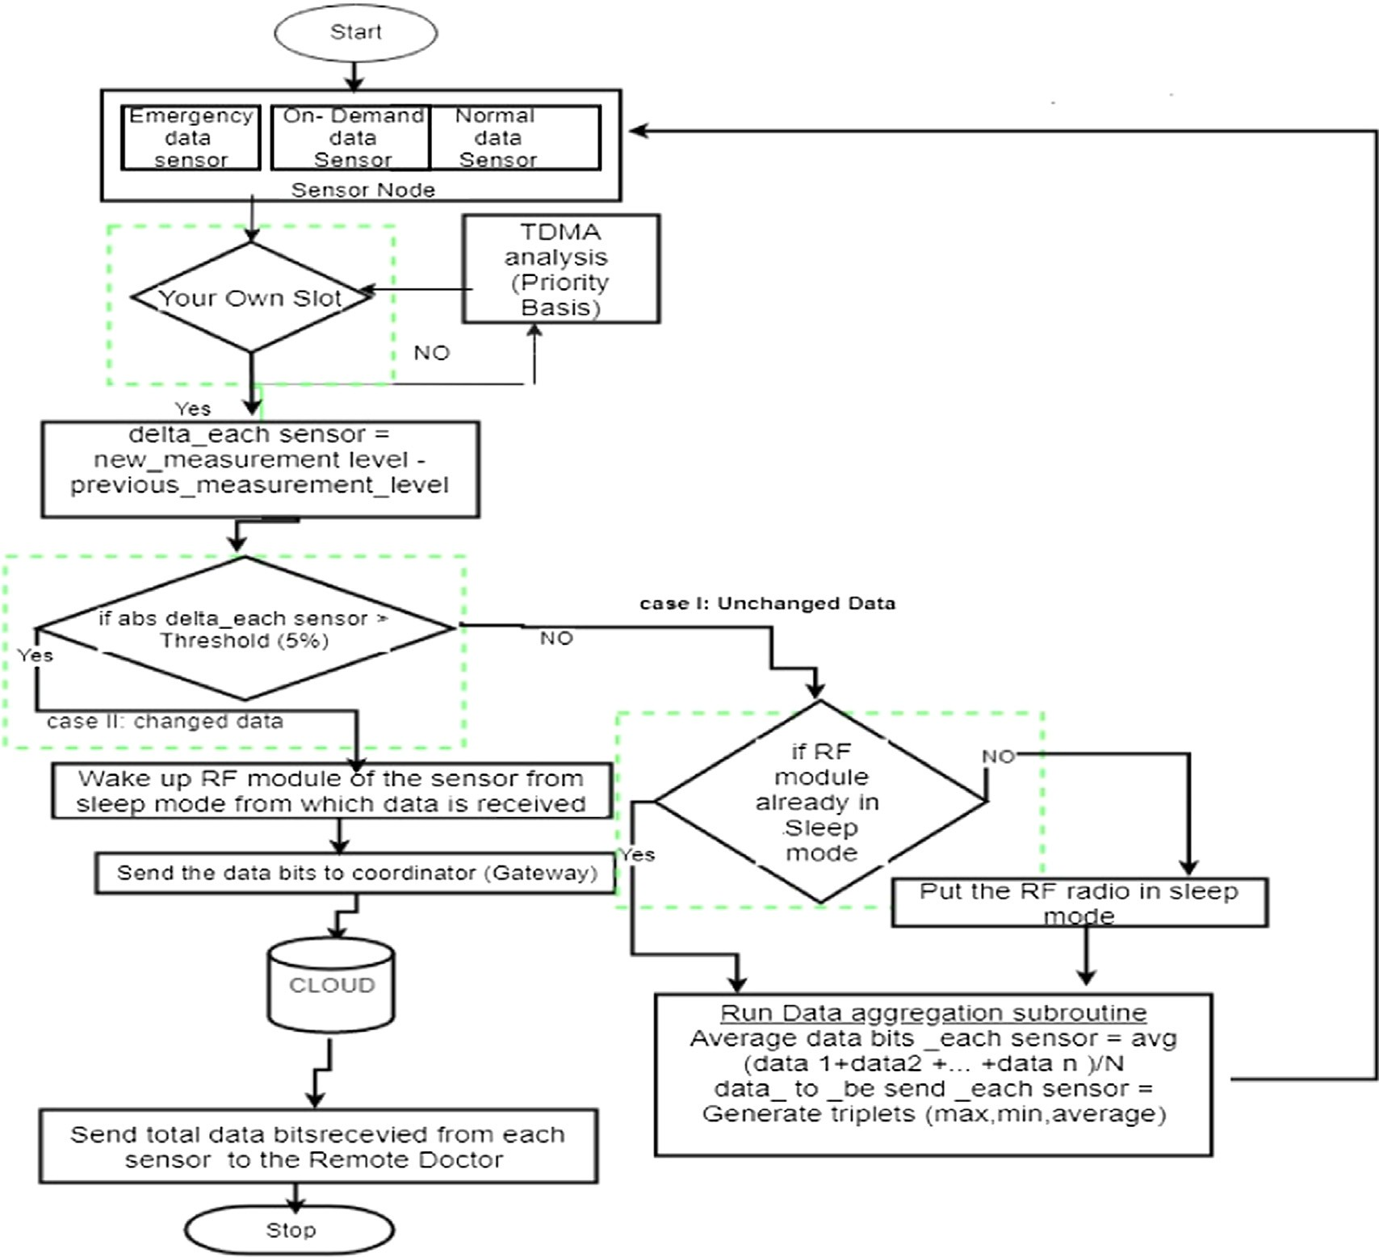

Fig. 5. Logical Diagram of proposed WSBN on Event based data transfer for Elderly people. [The green color refer to the proposed parts of our solution].

of complexity. This was achieved through the introduction of Cal- han’s system [4] which minimized the problem of interference caused by multiple sensors in WBSN. Additionally, the transmis- sion of sensor data based on threshold value and power saving during data transmission has also brought some benefit in over- coming the problem that were inherent in Tiwari’s system. Cal- han’s system [4] minimizes data interference caused by multiple sensors in the ‘start of the art’ solution using a Time Division Multiple Access (TDMA) Technique. With the introduc- tion of TDMA analysis, the health data of patients generated from multiple sensors are sent in time slots. In this process, the total bandwidth is divided into an equal number of different time slots. Therefore, the sensor data with higher priority are sent in the first-time slot, followed by other priority sensor data. Our pro- posed solution consists of cloud-based health data transmission technology, called Tele-monitoring within WBSN. Fig. 4 presents the process steps of sate of art solution. Fig. 5 shows the logical flow of our proposed solution. Table 3 presents the abbriviations of proposed solution equations.

Local Patient Site for Tele-monitoring of Health Data: In this process, the data is transferred from a sensor at the local site to the coordinator device by means of a TDMA analysis and by performing threshold calculation. During this process, the sensor nodes in WBSN always check on the priority level of sensors and compare the generated value with the threshold value.

These sensors are assigned separate slots depending upon their priority. Event-based calculations are carried out for each sensor at the local site, and the value calculated from the even based sys- tem is further compared to the threshold value (Fig. 4). In this case, if the data value generated at sensor level at the local site exceeds the threshold value, the data are directly sent to the gateway device and the doctor on the remote site receives the same data values. On the other hand, if the data value generated at sensor level is below the threshold, then none of the data are sent to the remote site (see Fig. 5).

Remote Doctor’s Site for Tele-monitoring of Health Data: In this process, the data value received from the gateway device is further transmitted to the cloud. After that, cloud data is received by the doctor through a web or mobile application. However, the health information of the elderly is received by the doctor only when the data values of the sensor at the local site have changed or only the health data values above the threshold are sent. Data are not transmitted to the doctor if the sensors generate unchanged or redundant values when compared to values in the previous cycle. These redundant values or unchanged health data values are not required by doctors at the remote end, as unchanged health data signify that there has been no change on the patient’s health. How- ever, during the process, if data from sensors are not sent, sensors automatically go to sleep mode to save energy until changed val- ues are received (see Figs. 6–8).

Table 3

Abbreviation for the term used in (EREEaL) algorithm.

d*th Threshold value*

The Enhanced proposed equation to transmit total data bits to cloud and to determine the reliability and latency of the system are given by Eq. (6),

*MBC*

*Modified Bits transmitted to the cloud*

X X *S*

+ *S* *S*

*ML Modified Loss of the packets during data*

*Pn Time taken packet in each time slot*

*Ss* = *Data bits generated at each sensor node*

*EBC* =

d=d*th* |*i*=1|e*GC*

*n*

*n*

*gci si*

## *Pn*

.

*gci* + *TPrio*

*R* *i*

# {for|(d)|

*Sgc Bits received by the gateway device for* *changed data value*

*Tprio Time taken by the sensor to calculate the priority slot*

# ≥ Threshold} (6)

Where,

*n*

*MBC* = P

d=d*th*

*MRT* = *MBC* —*ML*

*MBC*

*n*

|*i*=1|e*GC*

P

*Sgci* +*Ssi*

*Pn*

*Eq. (13) modified Bits transmitted to the cloud, using eq.* *(6) and (8)*

*Eq. (14) The Modified reliability of data transmission from multiple sensor node to*

*EBC* = Enhanced total data bits transmitted to the cloud Gc = Sensor group with changed data bits

*Sgc* = Bits received by the gateway device for changed data value

*ML* = P*n* P*n*

*the remote server (site), using Eq. (2) and (6)*

(*Sgci* + *TPrio* ) *Eq. (15) the modified latency for overall*

*Pn* = time taken packet in each time slot

*S* = Data bits generated at each sensor

d=d*th*

|*i*=1|e*GC R*

*i system is calculated by considering a time taken ‘t* = *B*/*R’ to transmit both changed and unchanged bits from source site to remote site, using Eq.* *(6)**,* *(7) and (8)*

*s*

i = no. of sensors

gc = gateway device with changed bits R = Data bit rate

*Sbits* = Data bits of changed sensor group

*Tprio* = Time taken by the sensor to calculate the priority slot

The calculation of priority (Tprio) is only performed at the sensor at local site, which consume minimum time during data transmis- sion and send the data bits on the basis of priority, which is given in Eq. (7) [4]

Result of Latency during data transmission from source site to Remote site

1.6

1.4

1.2

1

0.8

0.6

0.4

0.2

0

Patient at rest stage Patient at working stage Patient at Stress Stage

Different stages

State of Art Proposed Solution

*Tprio*

Latency in miliseconds (ms)

|  |  |  |  |  |  |  |  |  |  |
| --- | --- | --- | --- | --- | --- | --- | --- | --- | --- |
|  | | | | | | |  |  | |
|  | | | |  |  | |  | |
|  |  |  | |  |  |  |  |
|  |  |  |  |  |  |
|  |  |  |  |
|  |  |  |  |
|  |  |  |  |

kTc * NTpt

# = 2 * (1 — kTc)

# (7)

Fig 6. Average Latency (in millisecond) obtained during data transmission from source to remote site in three stages of patient using current Event based model (blue) versus EREEaL proposed model (orange).

Where,

*Tprio* = Time taken by the sensor to calculate the priority slot Tc = duration of TDMA entire cycle

k = Poisson Arrival (packets/sec) for the body sensor node

Tpt = packet transmission time N = No of sensor used.

*Prio* = Priority

Similarly, after assigning the priority, it is important to send the data bits on their own time slots which is given by Eq. (8) [4]

*Bs* = *Ss*

Result of Energy consumption by sensor during data transmission from source site to Remote site

700000

600000

500000

400000

300000

200000

100000

0

Patient at rest stage Patient at working Patient at Stress Stage

stage

Different Stages

State of Art Proposed Solution

## *Pn*

Where,

Enegy Consumption in (Joule Second / Bits)

(8)

Fig. 7. Average Energy consumption (in joules second /bits) obtained during data transmission from source to remote site in three stages of patient using current Event based model (blue) versus EREEaL proposed model (orange).

* 1. *Proposed equation*

The proposed solution provides methods for sending less data bits to the remote site by comparing the current values with the Threshold. On the other hand, the data bits from the sensor are not sent to the remote site, whenever the data values from a sensor are not changing or are redundant.

*Bs* = Total number of bits transmitted to cloud

*Pn* = time taken packet in each time slot.

*Ss* = Data bits generated at each sensor node

The threshold is obtained by calculating ‘d’ in every new cycle or when new values are generated from the sensors, by comparing the previous value with current value, which is given in Eq. (9)

d*th* = *Pv* — *Cv* (9)

Where,

dth = Threshold value.

Pv = Previous measurement data value Cv = Current measurement data value

Now, The changed data bit generated from a sensor is sent to cloud, but unchanged data or data value less than threshold values are not sent to cloud and the system undergoes power saving mode, which is given by Proposed Energy saving Eq. (10)

# (PES) = EBS — EAS {for|(d)| 6 threshold} (10)

Fig. 8. Average reliability (in %)obtained during data transmission from source to remote site in three stages of patient using current Event based model (blue) versus EREEaL proposed model (orange).

Result of Reliability(in %) during data transmission from source site to Remote site

99

98

97

96

95

94

Patient at rest stage

Patient at working stage

Different Stages

Patient at Stress Stage

State of Art Proposed Solution

Reliability in Percentage (%)

Where,

PES = Proposed Energy saving

# EBS = E(t) + E(r) (11)

Where, *(‘‘Voltage, Current, Power and Energy*”*, 2018)* as Eqs. 11a and 11b

# E(t)= V * I(tx)* T(tx) (11a)

E(r)= V * I(rx)* T(rx) (11b)

E(t) = Energy transmission by radio E(r) = Energy Receive by radio

EBS = Energy before saving power of Radio module Then, the final proposed equation is presented in Eq. 12.

dant rata at sensor node at the local site is not sent. Thus, during this period the sensor is in power-saving mode at the local site. Overall, the contribution of the proposed solution includes an energy-saving mechanism during data transfer from a sensor at the local site to a doctor at the remote site. This is done by sending the RF module of each sensor to the sleep or wake mode. Due to this, the sensors (Heat sensors. Temperature sensor, Glucose sen- sor) save their power and provide long battery life. Similarly, the chances of device failure during data transmission will also be min- imized, which in turn provides secure monitoring. The main contri- bution of this proposed solution consists of sending the data in an event-based system by minimizing the interference between mul- tiple sensors at the local site due to which the overall system reli- ability can be improved, while the processing time of the system is also minimized. The proposed system is the solution for Event- based data transfer within WBSN in Tiwari’s system. This system improves reliability, processing time and reduces interference and power consumption of sensors. In this method, first the data

EAS

# = V * I(sleep) * T(tx) (12)

from all sensors (Emergency, on demand, and normal) at the local site are sent in their own time slot using TDMA analysis as in the

Where

V is voltage,

I(tx) is transmitter current, I(rx) is receiver current I(sleep)p is sleep current T(tx) is transmission time T(rx) is the reception time

EAS = Energy after saving power of Radio module

* 1. *Area of improvement*

Improvements have been brought about in terms of end-to-end delay and reliability. The additional features include an interfer- ence control system and an energy-saving method. The end-to- end delay can be overcome and reliability improved by minimizing the number of bits from the local site to the remote site during data transmission. In this process, only the bits with emergency data are sent, while the unused or redundant data generated in the sensor in the local site are blocked. Power saving is equally important in this proposed solution. This can be done by sending the RF model of the sensor at the local site to sleep mode, whenever it is not nec- essary to send data. Hence, in this proposed solution, the health data from a patient are sent from a sensor to the cloud only when the sensor data are higher than the threshold value or when the data generated by sensors is not repetitive. Unchanged or redun-

equation below. Then the data values generated at sensors are compared to the threshold value to minimize interference, improve reliability and reduce latency. Hence, the proposed system involves the transmission of health data only when the data values in the sensor are changing. However, the unchanged and redun- dant data values generated by the sensors are not sent, and the sensors go to sleep mode until changes occur.

* 1. *Why threshold calculation and TDMA analysis?*

The ‘state of the art’ solution has limitation because of the pres- ence of multiple sensors at the local site. This causes interference during data transmission from multiple sensors at the local site to the cloud at the remote site. TDMA analysis, during Event- based systems minimizes interference between the multiple sen- sors. Furthermore, there was also some improvement in reliability and processing time in the proposed solution, which was the major limitation of the state of art solution. Similarly, in the proposed system, the asset value generated at the sensors at the local site is compared to the Threshold value. This improves the overall sys- tem reliability and minimizes processing time. In this process, first data from multiple sensors at the local site are assigned to their own time slot, with the first slot assigned to high-priority sensors followed by other lower priority sensors. Event-based calculations are done for each sensor, where these data are sent in their own time slot. Similarly, the value calculated from the even based sys-

tem is further compared to the threshold value. In this case if the value exceeds the threshold value, the data are directly sent from a sensor at the local site to the gateway and is further transmitted to the cloud at the remote site. On the other hand, if the value is below the threshold, the data obtained from the sensors are not sent because it consumes more time, more Bandwidth and adds to the complexity of the network. Hence, in cases where data is not sent, the Energy-saving mode can be activated.

This system minimizes the limitations caused by the state of art solution, where lots of bits were transmitted to the cloud, both during generation of changed values or unchanged values from sensors. Similarly, the main problem of interference due to multi- ple sensors in large networks was also minimized by this proposed solution. The Energy saving is a major factor in this proposed solu- tion where the power of the sensors is very important in this study.

1. Results

Matlab R2018a was used in the implementation and simulation of a model using samples of sensors data measuring the health of elderly people of different age groups. These health data are gener- ated from three sensors, namely heart, blood pressure and temper- ature sensors. The health data from the sensors was captured within different time frames from 8 to 12 min and was converted into bits, depending upon the analog and digital sensors used. For this, samples of 10 bits and 8 bits per data were considered in the data obtained from an analog and digital sensors respec- tively. Similarly, we have also taken a comprehensive sample including different ages and across gender. Three groups have con- sidered for different ages that include 45 ~ 55, 56 ~ 65, and +65 ages. Three samples have taken for each group to be tested. Three stages for each sample have considered and tested. They includes patient at rest, working, and stressful stages. The health data obtained from these three sensors were taken from free online resources - freely available websites for medical students. The emergency data bits were extracted using Matlab, and all were simulated using Simulink. Furthermore, the samples of patients, during rest, working and in stress stages were taken, where the transmission of health data was measured based on ‘events’ and threshold, which is shown Tables 6, 7 and 8.

The results were compared in terms of latency, energy consumption and reliability of the health data generated from the sensors at the local site to the doctor at the remote site as in Table 5. Here, the sensors captured the health data from the elderly by using threshold calculations and performing TDMA analysis sent to the coordinator. The data received by the coordinator was then transmitted to the cloud. Finally, data for the cloud was received by the doctor using a web application or web browser. This provides the most efficient health monitoring care for the elderly in their home.

Samples were collected from the various age groups from males and females who were suffering from heart disease, high blood pressure, and high body temperature. Sample data for heart rate, blood pressure, and temperature, collected from online resources were used in the algorithm simulated in Matlab. Samples com- pared the state of the art solution and the proposed solution based on Latency, Energy consumption and Reliability. This comparison was done with the help of the data reports and graphs that are shown below. The data results generated from the heart rate, blood pressure, and temperature sensors are shown in Tables 4, 6, 7 and

8. All samples obtained in the tables contain the results from the health of the elderly based on various age groups and gender. The result was divided according to the various activities done by the elderly to measure the impact of data transmission on latency, energy consumption and reliability in case of rest, working and under stress. Here the results from the samples are repre- sented in terms of latency, energy consumption, and reliability. 18 tests were conducted total with three test iterations for both males and females for three age groups and each iteration has three cases - rest, work and under stress. The results of Latency, Energy consumption and Reliability have been calculated by mea- suring the average result of each test case. Finally, the result has been calculated by taking the average of all cases in every iteration. The proposed solution has improved the Latency of the WBSN system by reducing the number of bits/seconds during transmis- sion of sensor data, which in turn minimized the energy consump- tion of sensors. Similarly, the reliability also improved by minimizing the loss and interference during data transmission from multiple sensors. This overall process was done in real time (health data transmission from source to the remote site), which

Table 4

Proposed Algorithm (Event Based Data Transfer Algorithm without Interface).

Algorithm: Event Based Data Transfer Algorithm

Input: Emergency data, on demand data, Normal data generated by each sensor

Output: total number of data received at cloud from each sensor without interference and without sending the bits for changed data value.

BEGIN

Step 1: Manually Choose the data for Emergency data sensor, On demand data sensor, normal data sensor

Step 2: In case of there is no own slot, Perform TDMA analysis, and sending the Sensors with their data based on their priority using equation (3) Step 3: In case of there is own slot, Calculate the value of delta (d) by using equation (4) for each sensor, after sending them in their own Time slot Step 4: Compared the value of delta with the threshold value.

Unchanged Data: If |(d)| ≤ Threshold (5%),

Check if RF Module in sleep mode

Run data aggregation subroutine using equation (5a) Go to Step1

Else

Put RF radio in sleep mode

Step 5: Changed Data: If |(d)| > Threshold (5%)

Send, the bits of data directly to the coordinator after generated at the sensor. Else

Go To step 6.

Step 6: Then the RF module wake up to send the data

Step 7: calculate the ‘ML’ to find the losses during data transmission using equation (2)

Step 8: calculate the value received at the cloud, *EBC* , sending only the changed data bits using equation (6) END

Table 5

Implementation Sample of Proposed Technique.

Iterations Sample Time

To generate bit at source

Data bits generate by sensor at source Latency (Milliseconds)s Energy

Consumption (Joules second/bits)

Reliability of system

1 8 min Patients in Rest stage

96 0.635 315,638 98.389

Patients in Motion stage

114 0.719 393,255 97.435

Patients in Anxiety stage

129 0.875 419,126 96.428

Table 6

Results for transmission of health data in different stages obtained from people of age group, 45–55 [Lower Latency results in faster health data received by doctor; Lower energy consumption by sensor results low power utilized by system; Higher data reliability results in lower data loss and accurate health data received by doctor].

Iteration Sample Time To

generate bit at

Data bits generate by sensor at source

State of Art Proposed Solution

source

|  |  |  |  |  |  |  |  |  |
| --- | --- | --- | --- | --- | --- | --- | --- | --- |
|  | | | Latency (Milliseconds) | Energy Consumption (Joules second/bits) | Reliability of system  (%) | Latency (Milliseconds) | Energy Consumption (Joules second/bits) | Reliability of system  (%) |
| 1 | 8 min | *Patient at rest stage* |  |  |  |  |  |  |
|  |  | 96 | 0.958 | 466,044 | 97.878 | 0.635 | 315,638 | 98.389 |
| *Patient at working stage* | | | | | | | | |
| 114 | | | 1.062 | 527,788 | 96.226 | 0.791 | 393,255 | 97.435 |
| *Patient at Stressful Stage* | | | | | | | | |
|  |  | 129 | 1.197 | 595,056 | 95.833 | 0.875 | 419,126 | 96.428 |
| 2 | 10 min | *Patient at rest stage* |  |  |  |  |  |  |
|  |  | 98 | 0.969 | 470,870 | 97.749 | 0.646 | 347,464 | 98.260 |
| *Patient at working stage* | | | | | | | | |
| 115 | | | 1.110 | 561,648 | 96.103 | 0.843 | 411,284 | 97.306 |
| *Patient at Stressful Stage* | | | | | | | | |
|  |  | 131 | 1.237 | 623,146 | 95.621 | 0.903 | 488,114 | 96.318 |
| 3 | 12 min | *Patient at rest stage* |  |  |  |  |  |  |
|  |  | 99 | 0.988 | 497,213 | 97.526 | 0.684 | 384,126 | 98.125 |
| *Patient at working stage* | | | | | | | | |
| 117 | | | 1.184 | 592,648 | 95.872 | 0.878 | 497,151 | 97.163 |
| *Patient at Stressful Stage* | | | | | | | | |
|  | 133 | | 1.310 | 689,261 | 95.471 | 1.093 | 543,016 | 96.243 |
| Average | *Patient at rest stage* | |  |  |  |  |  |  |
|  | 97 | | 0.965 | 470,375 | 97.818 | 0.655 | 336,748 | 98.344 |
| *Patient at working stage* | | | | | | | | |
| 116 | | | 1.119 | 560,695 | 96.200 | 0.837 | 433,897 | 97.334 |
| *Patient at Stressful Stage* | | | | | | | | |
| 132 | | | 1.248 | 635,821 | 95.675 | 0.857 | 483,418 | 96.328 |

will provide medical staff with an effective environment for tele- monitoring health conditions of the elderly in their homes.

1. Discussion

The results show the difference in latency, energy consumption, and reliability between the current and proposed solution with respect to health data captured from the elderly when they are at rest, working and in situations of stress. The proposed algorithm improves reliability to 98 ~ 96% during transmissions of health data from the source site to a remote site, which was calculated based on three stages – rest, working and under stress. Along with the increase in iterations for various age groups, the latency of the overall system was improved to 0.635 ~ 0. 875 ms. Furthermore, with the decrease in a the number of bits, the energy consumption of sensors decreased to 315.638*10 3JS/bits ~ 419.126*10 3JS/bits. Latency, energy consumption, and reliability were calculated by simulating the proposed algorithm in Matlab. The Event-based data transmission improved the performance of the system and reduced the number of unwanted or redundant bits during data transmission. The use of the EMC-MAC (energy-efficient Multi

Constrained QoS aware Medium Access Control) technique ensured the delivery of emergency or useful data within the min- imum available bandwidth. Similarly, Randhawa and Jain’s method

[15] solved the issues of Power consumption. Calhan’s M/G/1 TDMA technique [4] allowed the WBSN system to transmit health data within shorter time periods. Furthermore, the threshold com- parison technique for transmitting health data minimized the data loss and interference and made the tele-monitoring process user- friendly, eliminating a number of unwanted bits.

The proposed system has been tested in a Matlab simulator and has shown to reduce the latency and Energy consumption of the overall system while increasing reliability. Along with this, the pro- posed solution has minimized the data loss and interference among multiple sensors. This helps to reduce the number of bits or eliminate the unwanted bits while transmitting over the WBSN and speed up the transmission and perform high reliability during data transmission in real time network. For these features of the proposed system, health data transmission’s risk will be minimize during the tele-monitoring process. The reason of these good fea- tures, an event-based data transfer technique compares the gener- ated bits in each cycle with the bits generated in the previous cycle

Table 7

Results for transmission of health data in different stages obtained from people of age group, 56–65 [Lower Latency results in faster health data received by doctor; Lower energy consumption by sensor results low power utilized by system; Higher data reliability results in lower data loss and accurate health data received by doctor].

Iteration Sample Time To

Data bits generated

State of Art Proposed Solution

of system

|  |  |  |  |  |  |  |  |  |  |  |
| --- | --- | --- | --- | --- | --- | --- | --- | --- | --- | --- |
| generate bit at by sensor at source  source | | | Latency (Milliseconds) | Energy Consumption (Joules second/bits) | Reliability of system (%) |  | Latency (Milliseconds) | Energy Consumption (Joules second/bits) | Reliability  (%) |  |
| 1 8 min *Patient at rest stage* | | |  |  |  |  |  |  |  |  |
| 98 | | | 0.9479 | 470,870 | 97.849 |  | 0.646 | 310,464 | 98.360 |  |
| *Patient at working stage* | | |  |  |  |  |  |  |  |  |
| 117 | | | 1.042 | 522,614 | 96.190 | 0.799 | | 388,080 | 97.402 | |
| *Patient at Stressful Stage* | | | | | | | | | | |
|  |  | 135 | 1.207 | 589,881 | 95.798 | 0.887 | | 413,952 | 96.385 | |
| 2 | 10 min | *Patient at rest stage* |  |  |  |  | |  |  | |
|  |  | 101 | 0.984 | 512,340 | 97.612 | 0.726 | | 384,423 | 98.268 | |
|  |  | *Patient at working stage* |  |  |  |  |  |  |  |  |
| 118 | | | 1.172 | 552,963 | 96.061 | 0.817 | | 398,195 | 97.058 | |
|  |  | *Patient at working stage* |  |  |  |  |  |  |  |  |
|  |  | 139 | 1.304 | 629,483 | 95.558 | 0.977 | | 473,123 | 96.205 | |
| 3 | 12 min | *Patient at rest stage* |  |  |  |  | |  |  | |
|  |  | 104 | 1.083 | 562,291 | 97.571 | 0.811 | | 417,042 | 98.112 | |
|  |  | *Patient at working stage* |  |  |  |  |  |  |  |  |
| 120 | | | 1.246 | 593,071 | 95.985 | 0.929 | | 438,431 | 96.829 | |
| *Patient at Stressful Stage* | | | | | | | | | | |
|  |  | 140 | 1.471 | 677,924 | 95.371 | 1.104 | | 542,702 | 96.051 | |
| Average | 8–12 min | *Patient at rest stage* |  |  |  |  | |  |  | |
|  |  | 102 | 1.004 | 511,833 | 97.677 | 0.727 | | 370,643 | 98.280 | |
|  |  | *Patient at working stage* |  |  |  |  |  |  |  |  |
| 116 | | | 1.120 | 546,216 | 96.212 | 0.838 | | 422,673 | 97.096 | |
|  |  | *Patient at working stage* |  |  |  |  |  |  |  |  |
| 137 | | | 1.394 | 632,429 | 95.609 | 0.989 | | 476,592 | 96.213 | |

Table 8

Results for transmission of health data in different stages obtained from people of age group, +65 [Lower Latency results in faster health data received by doctor; Lower energy consumption by sensor results low power utilized by system; Higher data reliability results in lower data loss and accurate health data received by doctor]

Iteration Sample Time To

generate bit at source

Data bits generated by sensor at source

State of Art Proposed Solution

1 8 min *Patient at rest stage*

Latency (Milliseconds)

Energy Consumption (Joules second/bits)

Reliability of system (%)

Latency (Milliseconds)

Energy Consumption (Joules second/bits)

Reliability of system (%)

113 1.072 532,963 96.261 0.687 341,510 97.058

*Patient at working stage*

|  |  |  |  |  |  |  |  |  |
| --- | --- | --- | --- | --- | --- | --- | --- | --- |
| 139 | | | 1.343 | 667,496 | 95.555 | 0.875 | 434,649 | 96.590 |
| *Patient at Stressful Stage* | | | | | | | | |
|  |  | 150 | 1.416 | 703,718 | 95.304 | 0.979 | 486,393 | 95.914 |
| 2 | 10 min | *Patient at rest stage* |  |  |  |  |  |  |
|  |  | 116 | 1.242 | 584,728 | 96.123 | 0.733 | 443,241 | 96.816 |
| *Patient at working stage* | | | | | | | | |
| 142 | | | 1.421 | 693,152 | 95.321 | 0.923 | 4,723,674 | 96.370 |
| *Patient at Stressful Stage* | | | | | | | | |
|  |  | 152 | 1.513 | 764,831 | 94.192 | 1.043 | 567,482 | 95.434 |
| 3 | 12 min | *Patient at rest stage* |  |  |  |  |  |  |
|  |  | 118 | 1.302 | 596,140 | 96.102 | 0.784 | 479,722 | 96.798 |
| *Patient at working stage* | | | | | | | | |
| 147 | | | 1.470 | 726,281 | 95.132 | 0.986 | 503,589 | 96.227 |
| *Patient at Stressful Stage* | | | | | | | | |
|  |  | 153 | 1.597 | 823,638 | 94.023 | 1.123 | 598,931 | 95.124 |
| Average | 8–12 min | *Patient at rest stage* |  |  |  |  |  |  |
|  |  | 115 | 1.138 | 557,943 | 96.195 | 0.734 | 388,157 | 97.024 |
| *Patient at working stage* | | | | | | | | |
| 143 | | | 1.352 | 687,091 | 95.680 | 0.912 | 440,962 | 96.535 |
| *Patient at Stressful Stage* | | | | | | | | |
| 151 | | | 1.410 | 743,691 | 95.363 | 1.020 | 503,905 | 96.0153 |

and allows only the changed or useful emergency bits over WBSN network. Then the data are sent from the sensor at the source site to the cloud in their own time slots and is finally received by the doctor at the remote site if changes are significant.

Overall, the got results that we got in our proposed system over the state of art system because of many good features that our pro- posed system has. Our proposed system consist of multiple num- ber of sensors in sensor node that enable the system to deal with

Table 9

Comparison of Proposed and State of Art Solution.

State of Art Proposed Solution

Applied Area Health monitoring in medical field Telemonitoring in Medical field

Numbers of sensors used It deals with less WBSN, due to which consist few number of sensor in sensor nodes

Features Reduces number of bits transmitted to cloud, by sending 1 bits of data for redundant bits

Algorithm This algorithm sends data on Event based, which compares the generated sensors value with the value in previous cycle

It deals with large WBSN, due to which consist of multiple number of sensors in sensor node

Reduces large number of bits to cloud, by not sending the redundant bits

This algorithm sends emergency data by comparing the generated sensor value with the threshold value and hence mitigating data loss and interferences among sensors

At remote site Data received at the receiver are accurate and reliable Data received at the receiver are highly accurate and

reliable, because of less data loss and interference

*Pn*

Equation (Data Transmission) ● The data is transmitted to the cloud for both changed and

unchanged bits

* The data is transmitted to the cloud for only changed bits and in their own time slot Bs *Bs* = *Ss*

*BC* = P*n*

|*i*=1|e*GC*

d=d*th*

|*i*=1|e*GC*

*Pn*

*Sgc* + P*n*

*Sguc*

*MBC* = P*n* P*n*

*Sgci* +*Ssi*

Equation (Reliability) Reliability = *BC* —*L*

*B*

*i*

|*i*=1|e*GUC*

*i*

*C*

* + The time taken to send the data bits from sensor to remote site is given by following Equation,

*L* = P*n Sgc* /*R* + P*n Sguc* /*R*

*MB*

Reliability = *MBC* —*ML*

*C*

The time taken to send the data from the sensor to remote site considering the priority bits *Tprio* and

reducing the unwanted bits,

|*i*=1|e*GC* ( *R*

|*i*=1|e*GC* *i*

2*(1—kTc)

d=d*th*

|*i*=1|e*GUC* *i*

*Tprio* = kTc*NTpt *ML* = P*n* P*n*

*Sgci* + *TPrio* )

*i*

large WBSN compared with the state of art solution. The large number of bits that transmitted to the cloud reduced in our pro- posed system as it is avoid sending the redundant bits. Our pro- posed algorithm sends emergency data by comparing the generated sensor value with the threshold value and hence miti- gating data loss and interferences among sensors, whilst the state of art sends data on Event based, which compares the generated sensors value with the value in previous cycle. Table 9 presents the comparision between state of art and proposed solutions.

1. Conclusion

In conclusion, the combination of different techniques has led to the creation of a greatly improved tele-monitoring technique for the elderly people within WBSN. Event-based data transmission improved the performance of the system and reduced the number of unwanted bits during data transmission. The use of eMC-MAC (energy-efficient MultiConstrained QoS aware Medium Access Control) technique ensures the delivery of emergency or useful data within the minimum available bandwidth. Similarly, Rand- hawa and Jain’s method solved the issue of Power consumption. Calhan’s M/G/1 TDMA technique allows the WBSN system to trans- mit health data within less time by prioritizing the data. Although a range of methods is available to create a tele-monitoring tech- nique, which transmits emergency health data of the elderly over WBSN they have so far failed to provide acceptable latency, energy consumption of sensors and reliability during data transmission. These are the major factors that affect the tele-monitoring process in WBSN. This research has explored opportunities for overcoming the limitations of the current best solutions which are only able to produce overall system latency to 0.958 ~ 1.197 ms. Similarly, the power consumption of sensors is obtained to be 595.056*10 3JS/ bits during data transmission within WBSN. Furthermore, the reli- ability thus obtained is 97 ~ 95% when data were transmitted from multiple sensors. This justifies the addition of proposed EREEaL algorithm to overcome the limitations in the current best solution. The proposed algorithm has been shown (in Matlab simulation) to minimize the data loss, multiple sensor interferences as well as leading to a reduction of redundant bits while transmitting health data over WBSN. Some solutions have been proposed to address this issue, but, so far nothing has been able to provide fewer laten- cies, less power consumption of sensors, and high data reliability in an acceptable range. The proposed algorithm demonstrates

capabilities to eliminate data loss, interference and reduce redun- dant bits, which improves the latency of transmitted data bits to doctor to 635 ~ 0.875 ms and reliability of 98 ~ 96%. Finally, the power consumption by the sensor is reduced to 315.638*10 3JS/ bits. Future research needs to focus on localization and remotely track the elderly people using a tele-monitoring process. This allows monitoring of behaviours and activities, such as walking, standing, lying down, etc. It can be important in emergency situa- tions to continuously track and monitor behaviours. Furthermore, this proposed solution only deals with body sensors which are worn on the body but does not take account of sensors that are implanted in the brain or in any other body part which would be better able to capture internal body workings for more accurate health results.

1. Compliance ethical standard

Funding: No funding.

Conflict of interest: No conflict of interest. Ethical approval: Not Applicable.

Informed consent: Informed consent was obtained from all individual participants included in the study.

References

1. Magana-Espinoza P, Aquino-Santos R, Cárdenas-Benítez N, Aguilar-Velasco J, Buenrostro-Segura C, Edwards-Block A, et al. WiSPH: a wireless sensor network-based home care monitoring system. Sensors 2014;14(4). doi: <https://doi.org/10.3390/s140407096>.
2. Nakrem S. Understanding organizational and cultural premises for quality of care in nursing homes: an ethnographic study. BMC Health Serv Res 2015;15:1–13. doi: <https://doi.org/10.1186/s12913-015-1171-y>.
3. Tiwari V, Keskar A, Shivaprakash NC. A reconfigurable IoT architecture with energy efficient event-based data traffic reduction scheme. Int J Online Eng 2017;13(2):34–52. doi: [https://doi.org/10.3991/ijoe.v13i02.6460’](https://doi.org/10.3991/ijoe.v13i02.6460%26apos%3B).
4. [Calhan ALI. A non-preemptive priority scheduling algorithm for improving](http://refhub.elsevier.com/S1110-8665(19)30144-6/h0020) [priority data transmission delay in wireless body area networks. Adhoc Sensor](http://refhub.elsevier.com/S1110-8665(19)30144-6/h0020) [Wireless Networks 2016;34(1–4):59–75](http://refhub.elsevier.com/S1110-8665(19)30144-6/h0020).
5. Li H, Grace D, Mitchell PD. Throughput analysis of non-persistent carrier sense multiple access combined with time division multiple access and its implication for cognitive radio. IET Commun 2010;4(11):1356–63. doi: <https://doi.org/10.1049/iet-com.2009.0430>.
6. Sahoo PK, Pattanaik SR, Shih-Lin W. A reliable data transmission model for IEEE 802.15.4e enabled wireless sensor network under WiFi interference. Sensors 2017;17(6):1–28. doi: <https://doi.org/10.3390/s17061320>.
7. Ma X, Trivedi KS. Reliability and performance of general two-dimensional broadcast wireless network. Performance Eval 2016;95:41–59. doi: [https://](https://doi.org/10.1016/j.peva.2015.09.005) [doi.org/10.1016/j.peva.2015.09.005](https://doi.org/10.1016/j.peva.2015.09.005).
8. Alfa AS, Cai J. An incentive-compatible mechanism for transmission scheduling of delay-sensitive medical packets in E-health networks. IEEE Trans Mob Comput 2016;15(10):2424–36. doi: [https://doi.org/10.1109/](https://doi.org/10.1109/TMC.2015.250024) [TMC.2015.250024](https://doi.org/10.1109/TMC.2015.250024).
9. Yaakob N, Khalil I. A novel congestion avoidance technique for simultaneous real-time medical data transmission. IEEE J Biomed Health Inf 2016;20 (2):669–81. doi: <https://doi.org/10.1109/JBHI.2015.2406884>.
10. Chen J, Cao X, Cheng P, Xiao Y, Sun Y. Distributed collaborative control for industrial automation with wireless sensor and actuator networks. IEEE Trans Ind Electron 2010;57(12):4219–30. doi: [https://doi.org/10.1109/](https://doi.org/10.1109/TIE.2010.2043038) [TIE.2010.2043038](https://doi.org/10.1109/TIE.2010.2043038).
11. Lee TT, Moh S. An interference-aware traffic-priority-based link scheduling algorithm for interference mitigation in multiple wireless body area networks. Sensors 2016;16(12). doi: <https://doi.org/10.3390/s16122190>.
12. Cheng SH, Huang CY. Coloring-based inter-WBAN scheduling for mobile wireless body area networks. IEEE Trans Parallel Distrib Syst 2013;24

(2):250–9. doi: <https://doi.org/10.1109/TPDS.2012.133>.

1. Gao W, Zhao Z, Min G, Cao Y, Duan H, Liu L, et al. Link quality aware channel allocation for multichannel body sensor networks. Pervasive Mob Comput 2017;41:354–64. doi: <https://doi.org/10.1016/j.pmcj.2017.02.004>.
2. Zhao Z, Dong W, Chen G, Min G, Gu T, Bu J. Embracing corruption burstiness: fast error recovery for ZigBee under Wi-Fi interference. IEEE Trans Mob Comput 2017;16(9):2518–30. doi: <https://doi.org/10.1109/TMC.2016.2630696>.
3. Randhawa S, Jain S. An intelligent PSO-based energy efficient load balancing multipath technique in wireless sensor networks. Turk J Electr Eng Comput Sci 2017;25(4):3113–31. doi: <https://doi.org/10.3906/elk-1606-206>.