 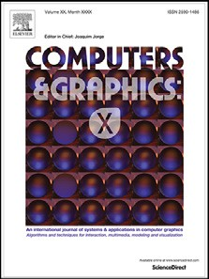

Contents lists available at [ScienceDirect](http://www.ScienceDirect.com/)

Computers & Graphics: X

journal homepage: [www.elsevier.com/locate/cagx](http://www.elsevier.com/locate/cagx)

Special Section on Expressive 2018

Abstract depiction of human figures in impressionist art and children’s picture books

Neil A. Dodgson

*School of Engineering and Computer Science, Victoria University of Wellington, Wellington 6140, New Zealand*

a r t i c l e i n f o a b s t r a c t

*Article history:*

Received 14 November 2018

Revised 13 May 2019

Accepted 14 May 2019

Available online 24 May 2019

*Keywords:* Impressionism Abstraction Representation Perception

The human figure is important in art. I discuss examples of the abstract depiction of the human figure, from both impressionist painting and children’s book illustration, and the challenge faced in algorith- mically mimicking what human artists can achieve. I demonstrate that there are excellent examples in both genres that provide insight into what a human artist sees as important in providing abstraction at different levels of detail. The challenge lies in the human brain having enormous knowledge about the world and an ability to make fine distinctions about other humans from posture, clothing and expres- sion. This allows a human to make assumptions about human figures from a tiny amount of data, and allows a human artist to take advantage of this when creating art. The question for the computer graphics community is whether and how we could algorithmically mimic what a human artist can do. I provide evidence from both genres to suggest possible ways forward.

© 2019 The Author. Published by Elsevier Ltd. This is an open access article under the CC BY-NC-ND license. (<http://creativecommons.org/licenses/by-nc-nd/4.0/>)

# Introduction

Artists and illustrators are able to indicate the presence of a hu- man figure using a few strokes of a brush (Fig. 1). This contrasts with traditional painted portraiture which uses many thousands of strokes to represent a human at a fine level of detail (Fig. 2). Most humans are able to impute a considerable amount of infor- mation into the sketchiest of representations of human figures. The human brain is able to work with incomplete representations and our brains are particularly well-tuned to spotting humans. There is strong evidence that a new-born baby can perform effective facial recognition [1] and children rapidly learn to identify human fig- ures. We train children to recognise abstractions of human figures and faces through cartoons and picture books [2,3].

This paper builds on a presentation at the 2018 Expressive con- ference [4] in which I used examples from two centuries of art to present the challenge: *how could a computer algorithmically mimic the kinds of abstraction of human figures that a human artist is able to achieve?* In that presentation, I suggested that the illustrations in children’s picture books could be a useful source of inspiration for how to achieve appropriate abstraction, because picture books con- tain multiple illustrations of the same figures, by the same artist, at potentially different scales. However, the accompanying paper

*E-mail address:* [neil.dodgson@vuw.ac.nz](mailto:neil.dodgson@vuw.ac.nz)

contained only limited supporting evidence for this suggestion. In this expanded paper, I revisit my exploration of the human figure in impressionist art (Sections 2, 3 and 5), provided a fuller dis- cussion of the related work in non-photorealistic rendering (NPR, Section 4), present a more detailed exploration of the art in chil- dren’s picture books (Section 6), and draw everything together in a concluding discussion (Section 7).

# Motivation: examples from impressionism

Fig. 1 shows details from four paintings created around the turn of the twentieth century. They contain sketchy representations of human beings in four artists’ styles. In each there is limited vi- sual information but most human viewers will impute more mean- ing that might seem justifiable from the limited number of brush strokes.

Gauguin’s figure of a priest with children (Fig. 1, left image) has only sketchy outlines of the people. He provides no details of the faces but still we are able to see that the priest has a beard and that the children are looking to the left as we see the image. Un- derstanding that these are children requires knowledge of the rel- ative heights of children and adults, which we all share. There is an alternative hypothesis, that these figures comprise a tall adult and a group of much shorter adults, but this would be unusual so the consensus amongst most viewers is that this is an adult and children. We are able to identify that the adult wears a hat, has

<https://doi.org/10.1016/j.cagx.2019.100002>

2590-1486/© 2019 The Author. Published by Elsevier Ltd. This is an open access article under the CC BY-NC-ND license. (<http://creativecommons.org/licenses/by-nc-nd/4.0/>)

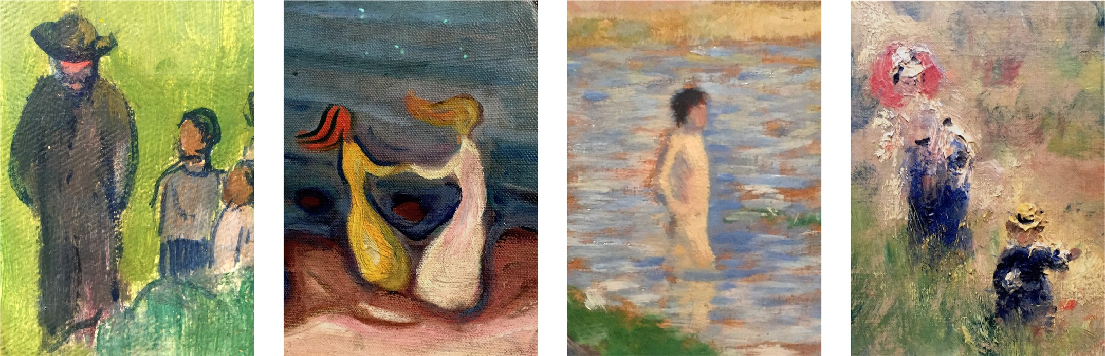

**Fig. 1.** Abstracted human figures. Details taken from, left to right, [Paysage](http://www.musee-orangerie.fr/fr/oeuvre/paysage-0), Paul Gauguin, 1901, oil on canvas; Dans påstranden, Edvard Munch, 1899–1900, oil on canvas; [Ètude pour “Une baignade à Asnières”](http://www.musee-orsay.fr/fr/collections/catalogue-des-oeuvres/notice.html?nnumid=544), Georges Seurat, 1883, oil on wood; [Chemin montant dans les hautes herbes](http://www.musee-orsay.fr/fr/collections/catalogue-des-oeuvres/notice.html?nnumid=1095), Pierre Auguste Renoir, around 1875, oil on canvas. All images are photographs of details of the original works taken by the author.

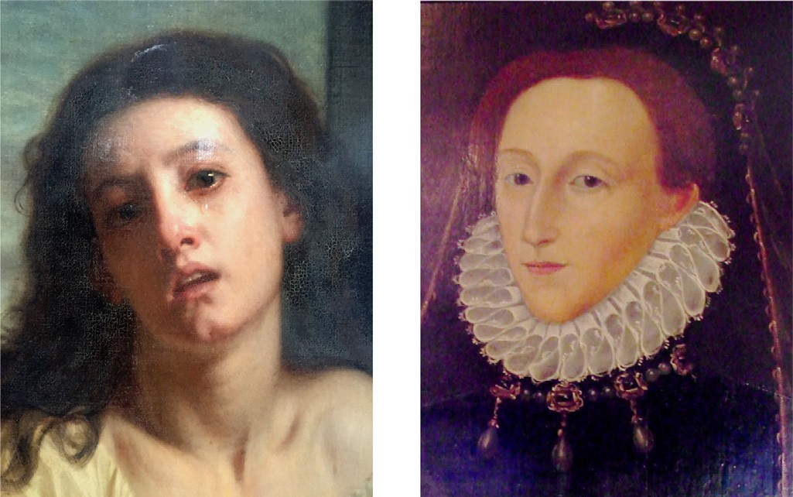

**Fig. 2.** Two examples of detailed portraiture. [Une mendiante](http://www.musee-orsay.fr/fr/collections/catalogue-des-oeuvres/notice.html?nnumid=21109), Hughes Merle, 1861, oil on canvas; [Queen Elizabeth I](https://www.emma.cam.ac.uk/about/paintings/index.cfm), unknown artist, ca. 1570, oil on panel. Both images are photographs of details of the original work taken by the author.

a beard (and is hence male), and wears a long robe that comes down to his feet. Those who understand the historical context will recognise him as a Roman Catholic priest.

Objectively, Munch’s abstracted figures (Fig. 1, second image) are nothing more than filled outlines in yellow and white with wisps of contrasting paint attached to their tops. Subjectively, these are women dancing on the beach. We know “dancing on the beach” from the title of the work. But what tells us that these are women? Both figures appear to be wearing dresses, both have long flowing hair, and the left figure has a waist that is stereotypical for a young woman. This *could* be interpreted as a red-headed young woman dancing with a priest but we tend to make the more likely interpretation that we are seeing two women, joyfully dancing. We are able to impute the emotion “joy” from our understanding of what sorts of emotions would be expressed by dancing on the beach and from the position of the figures: their centres of grav- ity are not above their feet, so they must be balancing using their joined hands, which implies that they are moving rapidly. Compare this with Merle’s *mendiante* (Fig. 2), where the emotion is imputed from the facial expression rather than from posture.

Seurat’s figure (Fig. 1, third image) is a few strokes of variously- shaded pink paint topped by a blob of brown. This all set against a blue, pink and brown background. Despite the paucity of detail, the subtle shading allows us to identify a young man, standing to

mid-thigh in water, with his right hand on his hip and his right leg thrust forward. It takes a lot of implicit knowledge about the world to formulate this interpretation from the limited visual stimulus.

Finally, Renoir creates two figures using more detail than the other three examples (Fig. 1, fourth image). However, the strokes of oil paint are coarse compared with the fine detail of a human face. The rear figure has been granted some facial features, but they are indicated using just three blobs of paint to suggest eyes and a mouth. As with Gauguin’s example, from the relative sizes of the figures, we assume that this is an adult and child. Given suﬃcient knowledge of nineteenth century European dress and so- ciety we can make the assumption that this is two members of a well-off family, probably a mother or nursemaid, looking after a small child. As Doonan says, “...your private and cultural associ- ations will be attaching themselves [to your interpretation of the image]” [2]. These assumptions have taken us a long way from the reality, which is a disordered, meagre image that, at first glance, could be no more than random blobs of paint.

What is it that allows us to say that these blobs donate a hu- man being? a human being of a particular type? expressing a par- ticular emotion? In all these cases, a human observer imputes a great deal of meaning into something that is abstract.

# The challenge for computer graphics

The challenge is whether an automated computer graphics sys- tem can possibly produce *appropriate* abstractions of human fig- ures. We are faced with an immense amount of prior knowledge that humans use both to create and to interpret these images [5]. Even without the necessary cultural understanding of conventions for clothing, most humans can interpret all these images well.

Humans know that an abstract depiction refers to and denotes a thing without being an exact physical likeness of that thing. The abstract representation acts as a symbol that we understand to stand for the thing [2,6]. In the case of these human figures, each observer likely understands that symbol to stand for something slightly different, depending on their personal knowledge. We have a wealth of common understanding, otherwise these abstract images would not make sense to us, but we each also bring our individual background knowledge. Gombrich provides good evidence that “...the way we see and depict depends on and varies with experience, practice, interests and attitides.” [6,7]. Viola and Isenberg note that “If we look at the works of masters of visual arts such as Mondrian or Picasso, their artwork documents

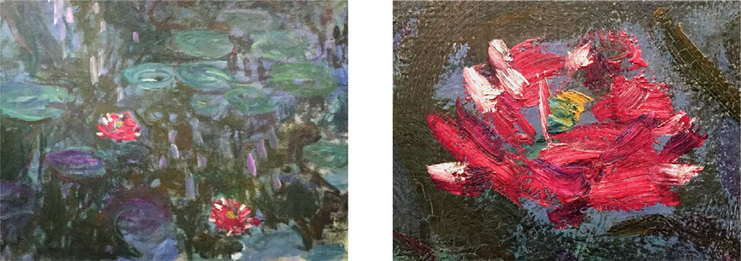

**Fig. 3.** Detail (right) and its context (left) taken from Nympheéas, reflets de saule, Claude Monet, 1916–1919, oil on canvas. The lily flower is 25 strokes of paint. Both images are photographs of details of the original work taken by the author.

experiments with varying levels of visual abstraction” [8]. In terms of using art as the motivator, the NPR community has always been inspired by existing, human, art. Much early NPR research aimed to emulate existing media. More recently, work has been done to emulate style rather than medium. For example, Hall and Song [9] are particularly interested by those abstract artists that use simple geometric shapes and topological structures, such as Kandinsky, Mattise, Miró and Picasso; Gieseke et al. were inspired by Ursus Wehrli’s image rearrangments [10].

We show examples of how human artists and illustrators have abstracted human figures. How could this be transferred to an au- tomated system? We have had level-of-detail methods in computer graphics for decades [11]. For example, cartography developed ab- straction over centuries [12] that led to early active research in appropriate abstractions for computerised cartography [8,13,14], which we see now in a polished form in apps such as Google Maps. Renderers use level-of-detail to allow them to use accurate geometry for nearby objects and approximate geometry for far ob- jects. There are methods for automatically reducing the polygon count in objects, using geometric and perceptual formulae to de- termine what reduction best maintains the geometry, connectivity and look of the object [15].

Artists are also able to do this. Bob Ross recorded over 400 videos of how he produced his landscape paintings [16]. The viewer is able to watch as a few strokes of paint suddenly become, perceptually, a mountain or a tree. Monet, famous for his waterlily paintings [17], became so good at representing the flower that he was able to use just a few strokes of paint to produce an impres- sion of a waterlily. Fig. 3 shows a detail of one of his later paint- ings. There are approximately 25 brush strokes in each lily, using five paint colours. In computer graphics terms, Monet is using a model-based abstraction rather than an image-based abstraction. It would be possible, by contrast, to take a photograph of a waterlily and use appropriate image filters to produce a wide range of ab- stracted effects [18,19] but this is nothing like the stroke-based ap- proach that Monet took. It is plausible that a computer algorithm could generate similar effects from an appropriate geometric rep- resentation of the flower’s structure, perhaps with a little human help in getting that structure well defined [20,21].

For human figures, it is not so plausible that we can approxi- mate what Monet does with his waterlilies. So much more is go- ing on in the human brain when processing human figures. My assessment is that, currently, a human artist needs to be involved to ensure that the result is plausible, as is done in the film in- dustry for both photo-real and stylised animated characters. What hope is there for developing an automated algorithm that can achieve the level of abstraction that human artists can achieve? We will look first at related work, largely in non-photorealistic rendering (Section 4), then at further examples from impression- ist art (Section 5), and finally consider picture book illustration (Section 6), to provide evidence about what can be achieved by human artists and to gain perspective on the challenge.

# Related work

Computer artist Harold Cohen makes the provocative statement “Living as we do in a culture obsessed by appearances, saturated with photographic imagery for a hundred years, it comes as a shock to realize that 95%—I’m guessing—of all the images ever made follow other paradigms, exhibit virtually no interest in the reflection of light off the surfaces of objects, and direct the viewer’s attention to abstractions, not to the appearance of physical objects. I have been much more aligned, as an artist, with this more gen- eral view of representation, and increasingly repelled by the funda- mentally Euro centric view...that underpins the current version of Renaissance perspective rendering: computer graphics.” [22]. The non-photorealistic rendering (NPR) research community addresses this challenge of creating abstract representations.

David Salesin’s keynote at NPAR 2002 described seven grand challenges for non-photorealistic rendering. Gooch et al. followed up with a discussion on progress on each of these at NPAR 2010 [23]. Producing good abstractions of human figures falls un- der Salesin’s second challenge: “abstraction to capture the essence of an image.”

There are two broad categories of input for non-photorealistic rendering: images and models. In image-based NPR, the input im- age is stylised based on the pixel data. At its simplest, this is a filtering operation; at its more complex, it uses computer vision to create some model of the underlying objects being represented. In model-based NPR, the final image is a rendering of a model. This could be a 3D model, as would be used in photorealistic render- ing, but can also be something representational, as in Harold Co- hen’s *AARON* [22], or more abstract as in visualisation of scientific data [8].

At the representational end of model-based NPR, Harold Co- hen’s *AARON* is an automated painting system that was developed over forty years. By 1986, Cohen had endowed *AARON* with suﬃ- cient knowledge of human posture to generate plausible sketches of athletes and he subsequently developed *AARON* to produce coloured sketches of human figures with facial features [22], even though *AARON* has never seen a human. *AARON* does not start from a three-dimensional model of a person, instead *AARON*’s ability to create an image of a human comes from internal representational rules that specify the structure of a human body, the range of movements of the parts, and the way in which a human figure bal- ances and gestures [24].

As Cohen developed the code that would result in *AARON* being able to create plausible faces for his human figures, the human artist found it interesting that many of the make-believe people that *AARON* drew looked distinctly like people that the human artist knew. This is an example of how the human will impute meaning into a sketch, because this is what our brains are wired to do [25].

There has already been considerable progress on abstracting human figures from images, but not down to the levels of abstrac- tion we see in some of the artistic examples here. For example, Gerstner et al. provide a method that can take a high resolution image of a face and produce a plausible pixelated versions [26]. Their best examples reduce a photograph of a human face to 14 × 20 pixels. Gerstner et al. are using the image’s pixel data

to get their reduction, whereas I believe that there is likely to

be a need for a model-based approach for getting the levels of abstraction we see in the human-created art.

Work on portraiture has been undertaken by many researchers. Rosin et al. [27] recently provided a set of benchmark photographs to be used for testing NPR portraiture algorithms. The state-of- the-art algorithms that they showcase are all able to create good abstracted representations of the photographs. However, they do not come close to the level of abstraction demonstrated in this

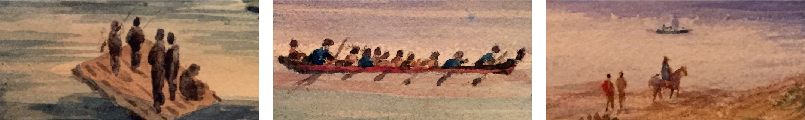

**Fig. 4.** Close up details of abstract human figures taken from mid-nineteenth century watercolours. From left to right: [Mahurangi](https://www.aucklandartgallery.com/explore-art-and-ideas/artwork/1115/mahurangi), Caroline Abraham, 1852; [Taken from the Pier at Auckland](https://www.aucklandartgallery.com/explore-art-and-ideas/artwork/1117/taken-from-the-pier-at-auckland-march-1852), Caroline Abraham, 1852; [Near Mercer, Waikato](https://www.aucklandartgallery.com/explore-art-and-ideas/artwork/9132/near-mercer-waikato), Albin Mercer, ca. 1850. All images are photographs of details of the original works taken by the author.

painterly examples in Figs. 1, 5 and 6, being aimed at portraiture rather than entire figures.

Mi et al. contrast the concepts of abstraction and simplifica- tion [28]. Simplification removes elements, replacing them with simpler elements, based on some measure of error. Abstraction, by contrast, replaces the objects with something that represents the same thing to the human visual system. Mi et al. demonstrate this by building a system that performs a part-based abstraction of 2D shape. While aimed at unshaded shape, it demonstrates a way to use insights from the science of perception to produce re- sults that play better with the human perceptual system than do the results of the simplification algorithms. Viola and Isenberg sug- gest that there is some confusion about these terms, “In the field of computer graphics, abstraction is typically interpreted as sim- plification” [8], and therefore that we need to be careful that we understand what we mean.

In terms of how you achieve abstraction or simplification, there have been many approaches. For example, Nan et al. use the Gestalt principles of perception to allow good abstraction of archi- tectural line drawings [29]. Barla et al. attempt geometric cluster- ing to simplify general line drawings, including those of animals and humans [30]. Mehra et al. produce abstract representations of man-made shapes from models, rather than photographs, using the characteristic curves that they are able to extract from the mod- els [31]. If we base our renderings on models of the characters, it may be possible to produce abstractions of human and animal figures in a similar way, though natural objects do have different features to man-made objects.

The earliest non-photorealistic image rendering work (e.g., [32]) was semi-automatic, as the human had to guide where the strokes were placed and how large the strokes should be. The semi- automatic approach has continued throughout the development of non-photorealistic rendering (e.g., DeCarlo and Satella’s use of gaze tracking [18]). Automating artistic processes is challenging and so we resort to semi-automatic processes, using human input to pro- duce results that are perceptually pleasing. In work based on image segmentation, Mould points out that the most effective techniques depend on manual intervention to create semantically meaningful segmentations [33]. One interesting exception to this is the work of Gieseke et al., where segmentation is used in an automated way to rearrange elements of an image [10]. This was inspired by a hu- man artist, Ursus Wehrli, who creates image decompositions are rearrangements manually but who usually focuses on creating ap- peal through semantic understanding. The automated process of Gieseke et al. does not have such semantic understanding and pro- duces apparently meaningful rearrangements purely by chance. Co- hen hints that this is also true of *AARON*, because Cohen selects which of *AARON*’s works get released: “...every morning...I have to decide which of the hundred or so images to discard and which few to keep and to print” [34]. So even fully automated processes can require manual intervention to judge which outputs are per- ceptually pleasing to the human eye.

Hall and Song [9] point out that in what they call *Simple Art*,

that is the art of children, of Miró and of cave paintings, the defin- ing characteristic is connectivity. Even in a stick figure, we can im- pute meaning. Hall and Song’s implementation is semi-automatic:

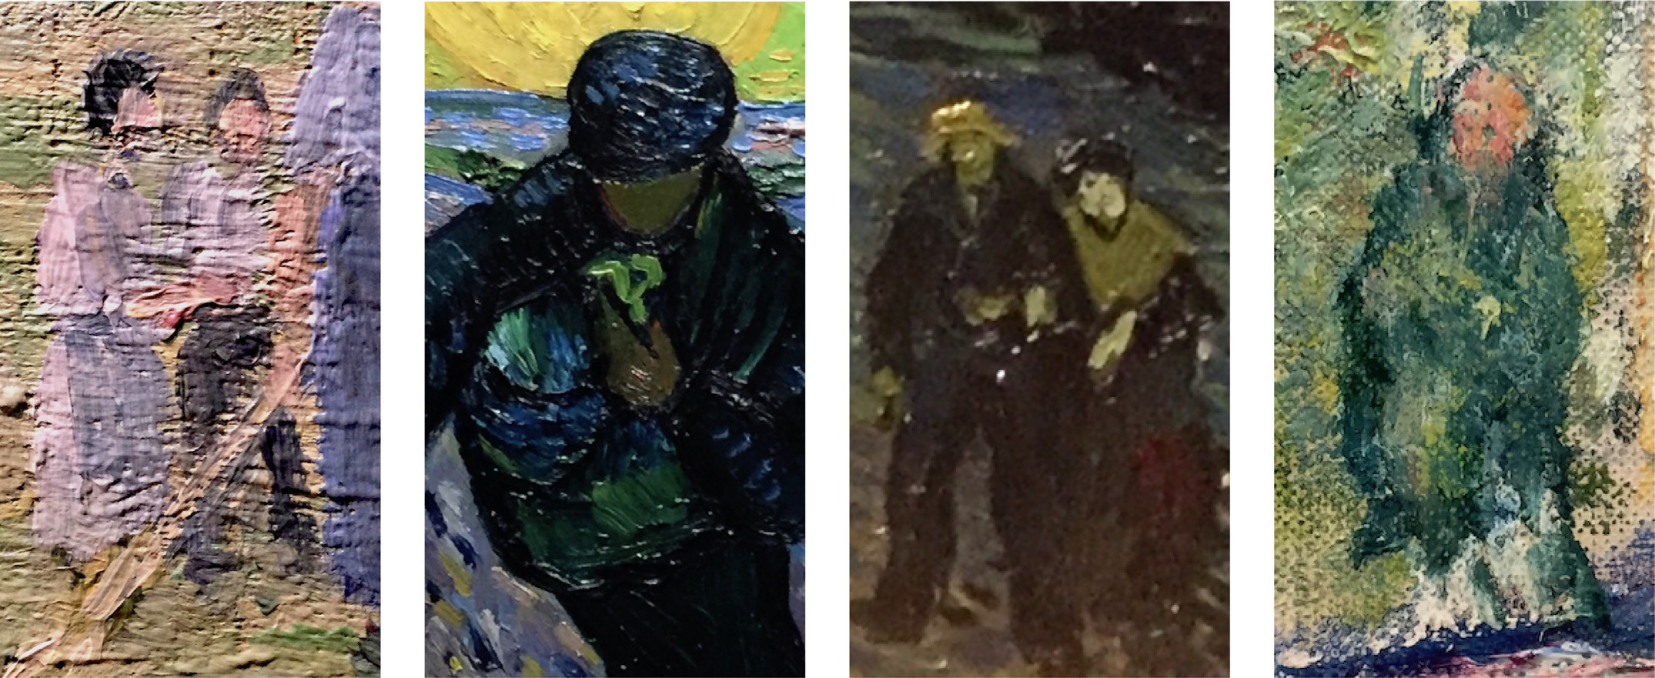

**Fig. 5.** Abstracted human figures. Close up details of human figures taken from, left to right, [Haymaking](http://data.fitzmuseum.cam.ac.uk/id/object/2865), Camille Pissarro, 1874, oil on canvas; [Le Semeur (The Sower)](https://www.vangoghmuseum.nl/en/collection/s0029V1962), Vincent van Gogh, 1888, oil on canvas; [La Nuit étoilée (Starry Night Over the Rhône)](http://www.musee-orsay.fr/fr/collections/catalogue-des-oeuvres/notice.html?nnumid=078696), Vincent van Gogh, 1888, oil on canvas; [Argenteuil](http://www.musee-orangerie.fr/en/artwork/argenteuil), Claude Monet, 1875, oil on canvas. All images are photographs of details of the original works taken by the author.

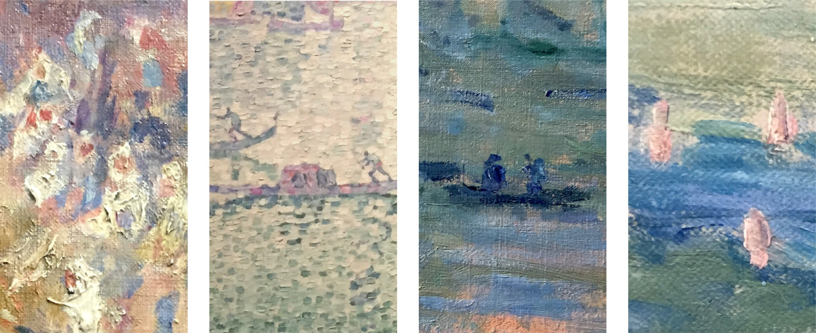

**Fig. 6.** Extremely abstracted human figures. Close up details of human figures taken from, left to right, [La Mosquée](http://www.musee-orsay.fr/fr/collections/catalogue-des-oeuvres/notice.html?nnumid=001156), Pierre Auguste Renoir, 1881, oil on canvas; [La Voile verte](http://www.musee-orsay.fr/fr/collections/catalogue-des-oeuvres/notice.html?nnumid=7997), Paul Signac, 1904, oil on canvas; [Soleil couchant sur la Seine à Lavacourt, effet d’ hiver](http://www.petitpalais.paris.fr/en/oeuvre/sunset-seine-lavacourt-winter-effect), Claude Monet, 1880, oil on canvas; [Le Chemin de Montbuisson à Louveciennes](http://www.musee-orangerie.fr/fr/oeuvre/le-chemin-de-montbuisson-louveciennes), Alfred Sisley, 1875, oil on canvas. All images are photographs of details of the original works taken by the author.

a human being must provide input for the output to be meaning- ful. In similar work, Song et al. [35] modified geometric shapes to create abstract art.

*Sisley* is a computer program that produces abstract paintings from photographs [36]. It is based on “...the psychological princi- ple that abstract arts are often characterized by their greater per- ceptual ambiguities than photographs, which tend to invoke mod- erate mental efforts of the audience for interpretation, accompa- nied with subtle æsthetic pleasures.” *Sisley* parses the image into components, then renders the image at a user-specified level of ambiguity. The user is able to label the identified components to improve the results. For example, bird, fruit, house, sun, human, clothing, face. This can then be referenced against a large ground- truth database of labelled images [37] to allow the software to make appropriate decisions about how much each region should be influenced by its neighbours. This provides a small amount of the contextual information that a human artist would use in de- ciding where and how to blur boundaries. *Sisley*’s output includes plausible abstract human figures, though not at the level of sophis- tication shown by human artist and, as with much previous work, human input was needed to ensure region labels were correct. Si- mon Colton’s *Painting Fool* project is another example of an NPR system that takes images or videos of humans and then renders these in non-photorealistic styles [38,39], but in this case, Colton’s aim was, through use of machine learning, to make the system au- tonomous, requiring no human input.

One question is how far we *could* plausibly automate the ab-

straction process. My hypothesis is that the human figure is the most challenging subject to tackle owing to the enormous amount of expert knowledge that every human has about interpreting hu- man figures.

Kang and Lee say that “the central problem in image abstrac- tion is how to decrease the complexity of the scene while protect- ing important structures” [40]. Their approach is to simplify both shapes and colours based on constrained mean curvature flow and shock filtering. While their algorithm is automatic, they have found it useful to incorporate manual user input for some scenes to pro- duce better visual output. As with Zhao and Zhe’s *Sisley* [36], their few examples of human figures are plausible though not at the level of abstraction achieved by our human artists.

Sarvadevabhatla and Babu have undertaken a similar investi- gation of sketches, working from the observation that, even with minimal stroke detail, the underlying subject of the sketch is of- ten still easily recognisable by a human [41]. This demonstrates an ability of the human brain to handle quite extreme abstraction and to impute meaning into minimal visual data. This work is in the same vein as Cole et al’s investigation of sketches, where they looked at where artists drew lines in order to effectively commu- nicate the shape of 3D objects [42].

In the realm of portraiture, there is excellent existing work on abstracting a human face to a sketch. Berger et al. [43] discuss how artists create abstract line-based sketches of human faces and use this information to synthesise sketches, from photographs, in var- ious artistic styles and at different levels of abstraction, but this only goes so far: to an abstraction of the face but not to the out- lines we see in, for example, Fig. 1 (left) and 5 (right).

There are methods for vectorizing pixel art [44] and convert- ing vectored art to pixels [45]. These could provide insights into appropriate ways to convert 3D models to these more extreme ab- stractions.

Visualization is a field in which we may find useful parallels with what artists and illustrators are trying to achieve with human figures. In their recent survey on abstraction in visualization [8], Viola and Isenberg say “The crucial problem in this context is that it is impossible to know what is important and what is not in a general way.” The relevance for the examples shown here is that we are using human artists’ work to try to get some idea of what is important for the specific case of human figures, as human artists have managed to achieve this successfully so the information must be available, if only subconsciously.

In the realm of visualization, the abstraction “serves the goal of facilitating the understanding of the subject matter” [8]. For our human figures the abstraction is such that it allows the viewer to understand contextual information despite taking away much of the detail.

Rautek et al. distinguish low-level visual abstractions, which in- corporate stylistic rendering techniques but not control over the abstraction process, from high-level visual abstractions that usu- ally require “inherent relevance information (e.g., importance or degree-of-interest) to be defined on the data” [46]. In our case, it

is clear that the distinction of a head and torso is important to perceiving a human figure (see Sections 5 and 7).

Viola and Isenberg suggest a range of propositions for visu- alization that can be usefully applied to our problem [8]. Vi- ola and Isenberg’s Proposition 4 builds on earlier work in sys- tems such as *Pirensi* [47], to make the observation that “Visual abstraction can convey uncertainty associated to the displayed data/information. Photorealistic depictions have virtually no uncer- tainty, while sketchy drawings convey conceptual ideas rather than physical implementations.” This is akin to the goal of impression- ism where we aim for an impression, a mood, a perception, rather than something like a photograph.

Viola and Isenberg suggest that “Visual abstraction of (three dimensional) structures comprises at least two axes of visual ab- straction: the geometric and the photometric one.” (their Proposi- tion 3). They augment this (Proposition 14) with a temporal axis (changes over time) and a scale abstraction axis (changes associ- ated with size). They later propose a fifth axis, that of viewer’s expertise, where the viewer is able to adjust the level of abstrac- tion of the visualization to provide the level of detail appropriate to their needs. In our terms, we propose that human viewers have a large amount of expertise about the abstraction of human fig- ures that is learnt through exposure to the artwork in children’s books (see Section 6). This allows us to understand the abstrac- tions that we see in the impressionist paintings. It may also ex- plain some of why these paintings were met with such hostility when first exhibited: without training in how to interpret them, the viewer has insuﬃcient expertise to be able to understand ef- fectively what they are seeing. Gombrich writes, in 1989, “After the lapse of a century it is hard for us to understand why these [Im- pressionist] pictures aroused such a storm of derision and indig- nation. We realise without diﬃculty that the apparent sketchiness has nothing whatever to do with carelessness but is the outcome of great artistic wisdom. [The Impressionists] knew that the hu-

man eye is a marvellous instrument. You need only give it the right

hint and it builds up for you the whole form which it knows to be there. But one must know how to look at such paintings. The peo- ple who first visited the Impressionist exhibition obviously poked their noses into the pictures and saw nothing but a confusion of casual brushstrokes.” [48, pp.521–2]. It may be relevant that that children’s picture books, to which can be attributed a lot of chil- dren’s training in how to view art [2,3], took off in the mass mar- ket around that same time that Impressionism became accepted.

In terms of understanding art, it is clear that viewers look at art differently depending on their level of expertise. Pihko et al. [49] show that experts look at paintings in a different way to laypersons, having been taught a viewing strategy that assesses the artwork in a more holistic manner. For example, “. untrained

viewers spend more time on areas with recognizable objects and human features than do artists”. However, I argue that even an “untrained viewer” has had considerable training in how to inter- pret art, mediated through the wealth of images that they have seen throughout their lives, starting with the picture books they looked at as children.

In terms of the effect of abstraction on the viewer, Hekkert and van Wieringen [50] performed experiments with two levels of ab- straction. They used relatively unknown post-impressionist paint- ings and then created abstract versions of these using the crys- tallisation filter in Adobe Photoshop, which subdivides the image into irregular pieces of constant colour (they used a cell size of 15), followed by the facet filter to blur the boundaries between cells. The paintings used were of “landscapes, seascapes, harbours or still lifes” with few having any human figures. What human fig- ures there are are already small and abstract. The abstraction pro- cess used by the experimenters rendered the human figures un- recognisable. The results were that all participants preferred the

unmanipulated images but that the difference in preference was markedly more for the naïve viewers than for the expert viewers.

Winston and Cupchik [51] also experimented on naïve and ex- pert viewers of art, finding considerable differences in how the two groups appreciate artwork. One of their conclusions is that “naïve viewers generalize from everyday perception and search for the fa- miliar and the moderately stimulating” whereas experienced view- ers have an approach to art that “is not predicated on the identifi- cation of objects”. They comment that the fundamental difference between their naïve and expert viewers has a parallel in studies of how children process art. Children go through stages of being able to appreciate increasingly complex aspects of art, leading to the temptation to label their naïve adult viewers as somehow “under- developed” æsthetically. As they take pains to point out, the truth is more complex, but it is certainly true that we must learn to un- derstand abstraction for otherwise the early viewers of Impression- ism would not have had such a visceral response to the new style of painting [48].

In summary, we find that abstraction is challenging in practice, that most NPR methods require at least partial human input to produce æsthetically pleasing output, and that there appears to be considerable learned context needed both to create abstraction and to understand abstraction. Section 2 gave four examples that sug- gest that abstracting human figures effectively is particularly chal- lenging, so we next consider illustrative examples from two genres in which professional artists have successfully achieved such ab- stractions: impressionist paintings and children’s picture book il- lustrations, with the expectation that studying these could lead to some general guidelines.

# Abstraction in impressionist art

Impressionism developed as an art movement in the 1860s, starting in Paris and then spreading across Europe. The aim of the artists was to capture the impression rather than the fine detail that would be captured by, for example, portrait painters (cf. Fig. 2). However, the Impressionists were not the first to ab- stract away detail: a decade earlier, watercolourists were producing abstractions of human figures (Fig. 4). Watercolourists today are trained in similar techniques. For example, Michael King demon- strates how to draw a simple figure in three or four strokes: a stroke for a head, one for a body, a third for a shadow [52].

To provide some context for the challenge, we consider the ways in which nine impressionists (and post-impressionists) ab- stracted human figures and consider also an example of a well- known fictional character who is identifiable from just a few strokes of the brush. We have already considered the four exam- ples in Fig. 1. Although abstract, these four examples have human figures that are relatively large (several centimetres high). As we will see, at smaller size, an artist can produce even more extreme abstraction, yet still reliably convey posture and action with only a couple of blobs of paint.

The four examples in Fig. 5 show a range from something that has a reasonable amount of detail to something that is barely recognisable as a human figure. The left two have suﬃcient de- tail that they could be generated from simple 3D models. Consider the images from left to right. Pissarro’s figures are sketchy, but could be generated by conventional computer graphics rendering followed by an appropriate image filter. Van Gogh’s sower is also broadly correct, the only things missing are facial features. The two tiny figures from van Gogh’s *Starry Night* are more challenging to reproduce on a computer; the hands are single blobs of paint and the women’s facial features are indicated by dots. How would you ensure that the computer rendering would produce something that a human would interpret as a hand? an eye? a mouth? Looked at close up, van Gogh’s man has no distinguishable facial features at

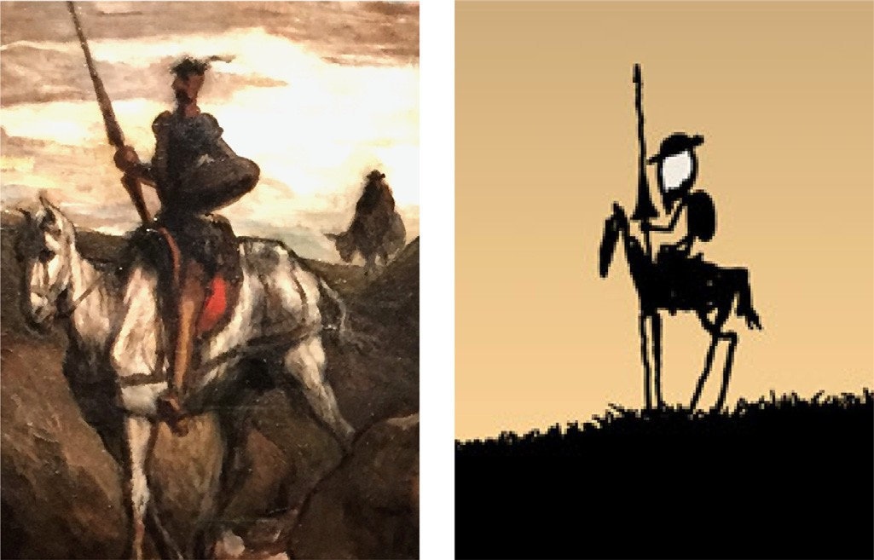

[**Fig. 7.** Details taken from, left to right, Don Quichotte et Sancho se rendant aux noces de Gamaches, Honoré Daumier, around 1850, oil on board, photograph of detail](http://www.daumier-register.org/werkview.php?key=7033) of the painting taken by the author; [Alternative Energy Revolution](https://xkcd.com/556/) (xkcd 556), Randall Munro, 2009, pixels on screen, reproduced under a Creative Commons license.

all but, from a distance, the human brain can be convinced that there are eyes, nose, mouth and beard. Monet’s figure from *Ar- genteuil* is the most challenging of these four examples: a region of shaded green, surmounted by a pink oval with some internal features, itself surrounded by a halo of dark paint. The whole is painted against a lighter green background, again with some inter- nal features. In a first glance at the whole painting, this figure is easy to dismiss as just part of the scenery. It is similar in coloura- tion to a large tree nearby in the background. More detailed ob- servation leads to noticing the pink oval could be a face and the position of the figure (on a boat or on the riverbank just behind a boat) indicates that it cannot be a small tree, so we impute that this must be a human. It is even possible to convince yourself that you perceive eyes and a nose on the face but close observation shows that those flecks of paint in the face do not constitute those facial features.

Fig. 6 shows what happens when you push the abstraction to the limit. My experience is that an artist needs to do considerable experimentation to know which abstractions generate the appro- priate response in a human viewer. Renoir’s crowd of people in *La Mosquée* are vague patches of white and blue paint with small pink circles, yet we perceive a crowd of people dressed in white robes with white head coverings. Signac’s pointillist rendering of Venice includes two tiny silhouettes, whose posture shows that they are working hard to propel their boats. One of the figures has only one arm but we assume that the other is hidden rather than missing. Monet’s impressionist painting of the Seine includes a sketchy out- line in dark blue that we interpret as a boat carrying two people. Finally, Sisley’s scene at Louveciennes, includes several single verti- cal strokes of pink paint on a blue background. Despite any detail, a human viewer can interpret these strokes as bathers in the river. This interpretation also cascades a range of other assumptions, in- cluding that the painting must be of a warm day.

Consider now an example of two human figures where cultural knowledge helps with identification, even with extreme abstrac- tion. Cervantes’ seventeenth century Spanish novel, *Don Quixote* has spawned many depictions of its main characters, the knight Don Quixote, and his faithful sidekick, Sancho Panza [53]. Dau- mier’s 1850 rendition (Fig. 7, left) shows a typical depiction of the knight on horseback, with shield, lance and hat. This stereotype has become so well known that Munro’s 2009 sketch (Fig. 7, right) is recognisable to anyone with the appropriate cultural knowledge. The most eminent abstraction of Don Quixote is [that of Picasso](https://en.wikipedia.org/wiki/Don_Quixote_(Picasso)),

who was exceptional in making brilliant art with a minimum of detail.

The figure of Sancho Panza in Daumier’s painting (Fig. 7, left) is of especial interest to this discussion, because it is nothing more than a grey blob: there are no details other than the silhouette. Despite having only a silhouette to work with, anyone who has identified Don Quixote will see, in this grey blob, a fat man, in a shapeless coat and hat, riding a donkey; because those are the defining visual characteristics of Panza. However, a teenager who had never come across the story identified the silhouette instead as an elderly lady carrying two shopping bags. This shows the im- portance of contextual knowledge.

Our ability to extract such a wealth of meaning from such detail-less abstractions is one of the issues that makes computer vision so challenging: how can you replicate a person’s decades of knowledge about the world? It also makes abstraction hard for computer graphics: can we automate what these artists do?

# Children’s picture book illustrations

I believe that children’s picture books are a useful source for inspiration about how abstraction can be achieved. There are two reasons for this. First, a children’s book illustrator will generally paint the same characters many times in any given book, possibly at different scales, so providing examples of how a human artist achieves this feat. Second, all the commentators on children’s pic- ture books agree that picture books provide training in how to un- derstand abstraction and æsthetics [54–56] meaning that picture books form a substantial part of how those in the Western cul- ture learn to interpret abstraction. Children’s author and illustrator Shirley Hughes goes so far as to assert that picture books are the principal venue for learning this: “...at least in England we are æs- thetically a very backward society. We aren’t taught to look. It’s not a thing you are taught in school. The only time we get it is in the picture book experience.” [3, Ch. 15]. School teacher and university tutor Jane Doonan supports this view: “Every experienced reader is confident with written material, but how pictorial art communi- cates is, for many, unfamiliar territory.” The picture book functions as an art object and its value, beyond the æsthetic experience it- self, is in the “...contribution the picture book can make to our æs- thetic development.” [2].

*Sequence of illustrations:* One of the universal characteristics

of being human is storytelling. Picture books are a subculture of storytelling that combines attributes of the worlds of literature and art [3]. While there is a considerable body of research in formally understanding “free-standing works of art and one-off decorations,” there has been far less study given to sequences of illustrations in books [2, p.9]. In a picture book, the sequence of illustrations tells the story: “We can no more look at a single illustration in [a] book...than we can view 5 minutes of a 2-hour film...and say we have experienced the whole” [57]. This need to have multiple illustrations of the same character gives us evidence for how a human artist achieves the different levels-of-detail required when having to render the same character at different sizes. It also illustrates how human readers are able, quickly, to build up associations from picture to picture so that later pictures, in a single book, are interpreted in the light of earlier ones.

*Characterisation:* The process of creating a sequence of illustra- tions is challenging. Good picture book illustration requires consid- erable skill [54,55]. The artist will prepare by sketching the same figures over and over until happy [58, p.31]. Illustrators Armin Greder and Donna Rawlins both remark that a character must be consistent throughout the book [58, p.38]. Schwarcz, likewise, de- cries inconsistency in depiction: figures must have a recognisable identity regardless of changes in size, proportion and angle. He says “...unity of expression in a book is an essential element in

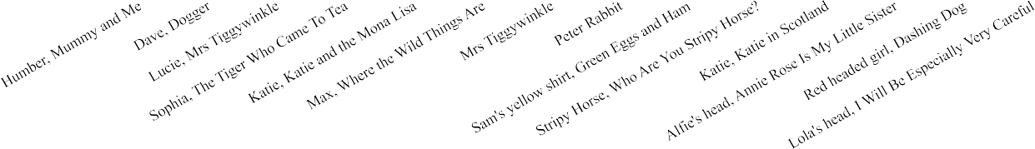

**Fig. 8.** Box and whisker charts for heights of selected characters. The whiskers show the maximum and minimum heights. The boxes are bounded by the upper and lower quartiles, showing the inter-quartile range. The books are different sizes, so you cannot compare *absolute* numbers from one book to another. What is important to compare are the *relative* sizes of the overall ranges and of the inter-quartile ranges. The vertical axis is logarithmic to allow you to make these comparisons. The horizontal axis is ordered by the ratio of upper quartile to lower quartile.

stimulating an æsthetic experience.” [55, p.181]. This means that we can expect good picture books to provide excellent examples of how to produce the same character at different levels of detail and yet have that character recognisable and consistent to the be- holder.

*Process of production:* Picture book illustrators use a variety of media: pastels, watercolours, oils, acrylics, pencil, crayon, ink, col- lage [54, p.58]. The medium affects what can be done. Of particular relevance for our discussion is that the medium affects the small- est features that can be reasonably created. We see this in some of the impressionist and watercolour paintings where the abstrac- tion is partly a response to the size of brush and properties of the medium. Illustrator Ed Young comments “One’s style grows out of the media, and one’s media grows largely out of the content. [My style relates to the media in which I am working] until their lim- itations can’t serve the story any more.” [3, Ch. 28]. Teacher Jane Doonan says that, in understanding illustration, the beholder must look at not just what is being represented but at everything that presents itself: “The movement of the pen or brush and the organ- isational decision, made either consciously or unconsciously, and the medium itself induce an experience in the beholder.” [2, p.12]. That is, in illustration, every mark matters.

*Size and style of painting:* Illustrators normally prepare their images at a larger size than the final printing. Gleeson says that illustrators usually work 25% bigger than the pages of the final book. This is so that they can work more easily on aspects of the fine detail. The work is reduced in the production phase [58, p.47]. There are, of course, illustrators who work in different ways. Peter Sis and Ed Young say that they always work to size, rather than larger, while Ralph Steadman says he always does his pictures “large” to give them a “gutsy feeling” [3]. For our purposes, this means that we cannot assume that the work on the page is at the original size. Indeed, the ability to photographically change the scale means that we must be careful when considering scale

changes in picture books that the changes are due to the artist and not the photographic reduction. The *Charlie and Lola* books, notably, scale Lauren Child’s collages differently as appropriate for each image in the story. However, for most media, one can expect the photographic reduction to be consistent across the whole book because, otherwise, differently reduced illustrations would have different textural characteristics.

*Comparison of specific examples:* To assess the usefulness, or oth- erwise, of children’s picture books as a source for understand- ing abstraction at different scales, I selected picture books from my daughter’s bookshelf choosing thirteen characters from thirteen books by ten illustrators. These include some of the most well- known picture books (those by Beatrix Potter and Maurice Sendak), some that I had previously noted had characters at substantially different scales (*Dashing Dog* and *Stripy Horse*), one example of col- lage (Lauren Child), and three pairs of books by the same author (Beatrix Potter, Shirley Hughes, James Mayhew). Fig. 8 and Table 1 show the range of heights of the selected characters.

We begin by considering illustrations by Beatrix Potter (1866– 1943), who can be credited with starting the trend towards afford- able children’s picture books at the start of the twentieth century. Her [watercolours for her first book, Peter Rabbit](http://www.gutenberg.org/ebooks/14838) have Peter or his equally-sized sisters painted with heights ranging from just under 60 mm to just over 20 mm. This is a difference in scale of three to one. In [Mrs Tiggywinkle](http://www.gutenberg.org/ebooks/15137) the eponymous hero is painted at a height from 39 to 74 mm, a range of less than two to one, and the little girl, Lucie, in that story is painted at a height of 41 to 63 mm, a range of 1.5 to one, with an outlier of 31 mm (on page 15). These small ranges are evidence that Potter steered away from multiple levels of details: her characters are painted at roughly the same size in all instantiations. Informally, this observation generalises to many children’s book illustrators and applies to over half the char- acters in our sample. Potter’s illustrations were drawn at a small size so this might also explain the small ranges that she uses but,

**Table 1**

Statistics for the characters graphed in Fig. 8. All measurements were taken in millimetres to the nearest millimetre. Owing to the different sizes of the books, the absolute values are not comparable between books. What can be compared between books are the ratios in the bottom two rows of the table. UQ/LQ is the ratio between upper and lower quartiles. Max/Min is the ratio between maximum and minimum. The table is sorted on the UQ/LQ ratio. The table is in the same order as the graph in Fig. 8.

|  |  |  |  |  |  |  |  |  |  |  |  |  |  |  |
| --- | --- | --- | --- | --- | --- | --- | --- | --- | --- | --- | --- | --- | --- | --- |
|  | Humber | Dave | Lucie | Sophie | Katie 1 | Max | Tiggywinkle | Peter | Sam’s shirt | Stripy Horse | Katie 2 | Alfie’s head | Red headed girl | Lola’s head |
| Number | 26 | 23 | 14 | 12 | 18 | 14 | 16 | 22 | 18 | 30 | 19 | 19 | 12 | 25 |
| Maximum | 49 | 108 | 63 | 170 | 65 | 97 | 74 | 57 | 45 | 120 | 94 | 70 | 138 | 116 |
| Upper quartile | 41 | 76 | 57 | 110 | 56 | 89 | 59 | 45 | 30 | 54 | 56 | 41 | 101 | 66 |
| Median | 40 | 71 | 52 | 104 | 48 | 72 | 48 | 39 | 27 | 34 | 41 | 32 | 100 | 49 |
| Lower quartile | 37 | 66 | 47 | 89 | 45 | 69 | 44 | 32 | 20 | 30 | 30 | 21 | 52 | 33 |
| Minimum | 32 | 17 | 31 | 82 | 21 | 67 | 39 | 21 | 9 | 8 | 22 | 18 | 8 | 28 |
| Mean | 37.8 | 66.9 | 47.6 | 96.8 | 45.8 | 71.9 | 48.6 | 36.6 | 24.7 | 43.7 | 40.5 | 31.9 | 72.6 | 53.1 |
| Standard deviation | 8.7 | 22.4 | 16.1 | 38.3 | 16.6 | 23.4 | 16.7 | 13.7 | 11.0 | 29.1 | 20.3 | 15.7 | 47.5 | 27.1 |
| UQ/LQ | 1.1 | 1.2 | 1.2 | 1.2 | 1.2 | 1.3 | 1.3 | 1.4 | 1.5 | 1.8 | 1.9 | 1.9 | 1.9 | 2.0 |
| Max/Min | 1.5 | 6.4 | 2.0 | 2.1 | 3.1 | 1.4 | 1.9 | 2.7 | 5.0 | 15.0 | 4.3 | 3.9 | 17.3 | 4.1 |

for example, she almost never draws her characters in the distance. Most of the other children’s books that we consider are a much larger format yet most artists still keep their characters within quite tight ranges (see Fig. 8 and Table 1 captions).

Some characters are drawn even more consistently in size. Humber ([Mummy and Me](https://www.harpercollins.co.nz/9780007273232/mummy-and-me/), 32–49 mm) and Max ([Where the Wild Things Are](https://www.harpercollins.com/9780060254926/where-the-wild-things-are/), 70–97 mm) are drawn with such consistency that only by using a ruler can you tell that they are not the same size as you move from page to page.

However, even as small a range as two to one gives evidence of how effectively to perform abstraction. Tiggywinkle at her largest (page 40) has considerably more detail in the face (defnition of fur, number of prickles) than she does at her smallest (page 47), evi- dence of the limitations of Potter’s watercolours and brushes.

It is the outliers that give most information about how to han- dle abstraction to different scales. [Dave, in Dogger](https://www.penguin.co.uk/books/1003127/dogger/9781782300687.html), is drawn at a size of 50–90 mm, a ratio of 1.8 to one, with two outliers, one of size 17 mm (pages 16–17) and one of size 108 mm (page 10). The largest size has slightly more definition in the hair and in the creases in the clothing than the average sizes. The smallest size, being less than a third the size of the average, has considerably less definition. The artist, Shirley Hughes, chooses here to abstract away the detail of the hair to just four or five internal lines, com- pared with dozens in the average size, and to represent Dave’s striped shirt with fewer stripes than in the larger versions. Even though Dave is tiny in this two-page spread, compared to how he appears in the rest of the book, and despite there being 92 human figures in the illustration, the reader is able to identify Dave and his family from the contextual understanding that they have built up over the previous pages and from the careful composition of the illustration.

As an example of the same character drawn in two books, we measured Katie in two of [James Mayhew’s Katie books](https://www.jamesmayhew.co.uk/) illustrated sixteen years apart: *Katie and the Mona Lisa* and *Katie in Scotland*. The latter is a slightly larger format book (20% taller) and Katie is slightly more consistent in height in the former, but overall the distributions of heights are quite similar.

The widest spread between the upper and lower quartiles in the sample of character heights is that of [Lola in I Will Be Especially Very Careful](https://www.penguin.co.uk/books/600/60097/charlie-and-lola…i-will-be-especially-very-careful/9780141341538.html). However, the illus- trators use collage and all of the original images of Lola are the same size. The differences in this book, as mentioned earlier, are in the photographic reproduction. This example demonstrates one of the challenges of this analysis: knowing that the drawings are not scaled differently on different pages. We use the quality of the fine-level detail (texture, brush stroke size, line width) as evidence that, where the artist has used pens or brushes, the images in a given book have been all produced at the same scale and all photographically reduced by the same proportion.

There are two examples, from our sample, where the illustra- tor has attempted dramatic differences in size: Sarah Garland’s illustrations for Margaret Mahy’s story, [Dashing Dog (2002)](https://www.amazon.com/Dashing-SARAH-GARLAND-ILLUSTRATOR-MARGARET/dp/0711219362/) and [Karen Wall’s illustrations for Jim Helmore’s story Who are you, Stripy Horse? (2007).](http://www.stripyhorse.com/)

In *Dashing Dog*, the principal characters are a family of five and their dog. Garland painted twenty-five illustrations for the book. The older, red-headed girl, in a striped jacket, appears in eleven of the illustrations. In most of these she is painted at about 100 mm high (eight versions, 70–138 mm, mean 102 mm, std. dev. 19 mm). In one illustration, she is 35 mm high with six red stripes on her jacket instead of the nine in the others. This demonstrates that the abstraction does not need to be accurate: we remember her hav- ing a striped jacket, not how many stripes are on the jacket. The most interesting abstractions are in the book’s climax, where the toddler in the family falls off a pier to be rescued by the dog. This is illustrated by four panels, rendered by Garland in the minimum of detail. In these the human figures are less than 10 mm high and clearly demonstrate the limitations of watercolour as a rendering medium. The red-headed girl is now a few blobs of coloured paint, her jacket reduced to just two stripes. The other three members of the family are rendered in an equally sparse way. Yet, having fol- lowed these characters through six previous paintings, the reader is readily able to identify each of them from the colour of their clothing and hair. Moreover, the reader can also identify what they are doing, and something of what they are feeling. Remember that this book is aimed at children aged four to seven, which indicates that humans have developed the ability to understand illustrative abstraction by that age [59].

*Dashing Dog* shows how an artist abstracts away detail to ren-

der the same character at a smaller scale. As a further example of how this can be done, we commissioned an artist to paint a flower at four levels of detail (Fig. 9). While the flower is in the same style in all cases, the level of interior detail differs owing to the constant size of the paintbrush used to produce the strokes. *Stripy Horse*, by contrast, is an example of what happens when an illustrator avoids changing the level-of-detail when changing the scale (Fig. 10). The main character, Stripy Horse, appears in 28 instantiations in four different sizes: small (head length 8–12 mm, 4 instances), medium (20–55 mm, 18 instances), large (80–95 mm, 6 instances), and ex- tra large (head length 120 mm, 1 instance). Stripy Horse has ex- actly the same number of coloured stripes, in the same order, at all sizes. This leads to a paucity of detail in the extra large version and a need to paint very fine detail in the small version. The same happens with computer-rendered 3D characters. If we get too close to them, we begin to see the lack of detail or, if they have fine detail close up, then we either need to generate multiple level-of- detail models for different distances or waste a lot of computing power when the model is in the distance.

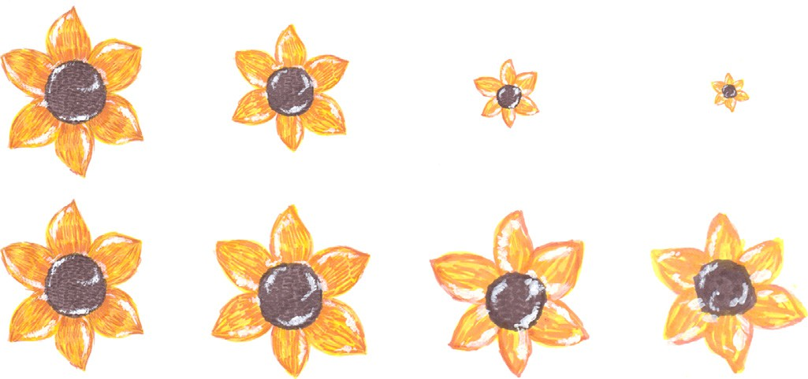

**Fig. 9.** A flower drawn by the same artist at four sizes. Top row: the flowers as drawn by the artist. Bottom row: the flowers scaled up to match the height of the first flower. Notice how the level of detail changes with size. Images created by Šteˇpánka Sýkorová, used with permission.

*Exemplars of abstraction:* What we need are exemplars that allow us to postulate general principles that can guide the de- velopment of algorithms. Given that our evidence indicates that many illustrators are careful to keep their characters at roughly the same scale, we cannot depend on randomly sampling children’s books. Instead we need to seek out examples where illustrators use widely different scales. Sarah Garland’s *Dashing Dog* illustra- tions are an excellent example of using abstraction appropriate to the scale and the medium. The following books provide other ex- amples of what can be done.

In the previously discussed *Who are you, Stripy Horse?*, Stripy Horse does not change with scale, but some other characters in that book do have different levels of detail at different scales. The best example is Hermann, the sausage dog, who is heavily textured but where the scale of the texture does not scale at the same rate as the size of the drawn character. At 400 mm long, Hermann has a spotted texture with spots about 8 mm apart. At 90 mm long, the spots are about 3 mm apart. The character’s size has changed by a factor of over four but the texture by a factor of slightly under three. This is not enough of a difference to notice at a casual glance but does make the illustrator’s job easier in painting the smaller versions of the character.

In [You Are (Not) Small](https://www.hachettechildrens.co.uk/titles/christopher-weyant/you-are-not-small/9781444923193/), Chrisopher Weyant draws abstract bears at four scales: 30 mm, 60 mm, 240 mm, and so large that only the legs of the tallest character fit on the page. A couple of observations can be made about how to achieve the different levels of detail. First, the hair on the top of the character’s heads is represented by a different number of strokes of the pen (between 3 and 12) depending on the character’s size. Second, the outlines of the bears gain increasing detail as the characters get larger. Both effects are similar to how the truffula trees are handled by Kowalski et al. using graftal textures [20]. The challenge is thus not in the outline detail, which we already have methods for, but in aspects such as the facial expression and body posture that are used to convey anger, smugness, arrogance, or delight through just a few strokes of a pen.

Four further examples of books where the human characters are drawn at dramatically different scales are [Cowboys](https://archive.org/details/cowboysroun00roun) (the cow- boys range from 210 mm to 16 mm in height, a range of 13:1), [Farmer Duck](https://www.penguinrandomhouse.com/books/184498/farmer-duck-by-martin-waddell/) (the farmer ranges from 400 mm to 25 mm, a range of 16:1), [The Minpins](https://www.penguin.co.uk/books/412/41218/the-minpins/9780141350554.html) (human figures range from 170 mm to 10 mm, a range of 17:1) and [The Friends of Emily Culpepper](https://archive.org/details/friendsofemilycu00cole) (adult human figures range from 170 mm to 7 mm, a range of 24:1). Each book uses a different artistic style. In *Cowboys*, Glen Rounds uses a style reminiscent of the Lascaux cave paintings. The figures are drawn with heavy pen outlines, filled roughly with pastel. The ab- straction and caricature is extreme yet still the reader can iden- tify the emotions that the characters are expressing through facial expression and body posture. In *Emily Culpepper*, Roland Harvey

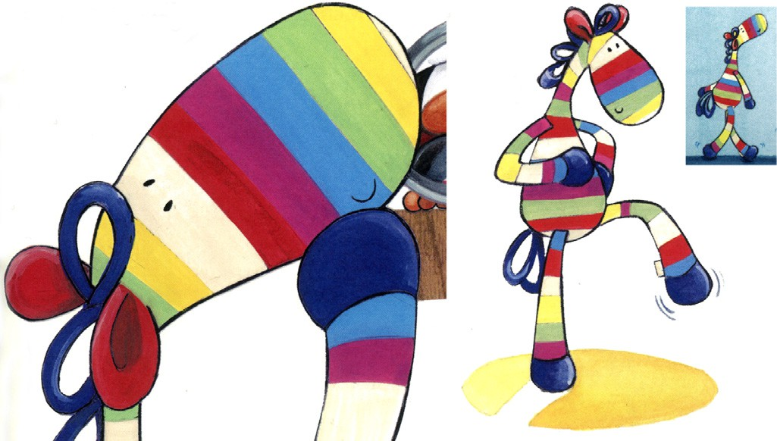**Fig. 10.** Three details from *Who Are You, Stripy Horse?*, illustrated by Karen Wall. Stripy Horse is represented at a range of scales over a range of 15:1. Notice that the level of detail is the same in all three examples. Images created by Karen Wall, used with permission.

uses fine pen drawing with watercolour washes. His smallest fig- ures have fine detail, including facial expressions, drawn in pen, but no textural detail. His larger figures have textural detail but the facial detail, while more substantial than in the smallest fig- ures, is still sparse. In *Farmer Duck*, the human farmer is painted with careful shading at the large scale though, again, with sparse detail in the face. At the small scale, he is reduced almost to an outline. An interesting abstraction is of his hands, which go from a detailed rendition (50 mm across), through an outline of a fist (7 mm), to a suggestion of thumb and fingers (3 mm). The ques- tion for computer graphics here is how to represent a model which can be rendered effectively in such different levels of detail. In *The Minpins*, the most noticeable difference between characters at dif- ferent scales is the internal textures. Patrick Benson uses hatching across all the illustrations, which is of the same physical scale re- gardless of the size of the characters. This leads to heavy textur- ing in characters at large scale, where hatching covers large areas, and light or no texturing on characters at small scale, with areas filled in solid colour. This effect is similar to the changing textural scale in Hermann (*Who are you, Stripy Horse?*), the changing num- ber of stripes on the red-headed girl’s jacket (*Dashing Dog*), and the changing definition in Dave’s hair (*Dogger*). From this we can draw a guiding principle: texture is not sacrosanct. Texture must change depending on the scale.

# Discussion

From the above examples we can extract several lessons. First, the need for and representation of abstraction depends on the medium. Each medium has properties that mean that, for ren- dering figures at small size, abstraction is necessary. Further, each medium limits, in its own way, what abstractions are possible.

Second, understanding or creating an abstraction of a human figure appears to critically depend on human knowledge. Our ex- amples show that human beings are phenomenally good at ex- tracting meaning from a tiny number of brushstrokes. In some cases, specific prior knowledge is needed for a full understanding, as in identifying Gauguin’s figure as a priest or in Munro’s sketch of Don Quixote, where someone with no knowledge of the literary figure would be bemused. This is part of the attraction of Munro’s representation: those who understand the abstraction and hence the joke feel themselves in an inner circle of those-in-the-know. More generally, all cases require prior knowledge for interpreta- tion, whether this is the knowledge built up in our childhood or is

the immediately acquired knowledge built up in the minutes be- fore seeing the new image as one works through a series of im- ages in a picture book. The knowledge required to understand an abstraction is also required to create an abstraction, because it is only through visual feedback that the artist is able to ascertain whether the abstraction achieves the desired effect in the human visual system. For example, it is diﬃcult to imagine any algorithm that could take an unannotated 3D model of Garland’s red-headed girl and create the multiple different renderings at the different scales that Garland produced so effectively.

Third, the textural detail (e.g., the number of stripes on a piece of clothing, the number of hairs on a head) can change consider- ably as the scale changes, without affecting the human’s ability to interpret the imagery. This is Viola and Isenberg’s “scale abstrac- tion axis” [8]. This requires an automated system to understand what details are vital, and so must be kept in some form; what details are optional, and so can be removed; and what details are textural, and so can be rendered at a simplified level of textural detail.

Fourth, the abstractions or simplifications cannot be just in im- age space. There needs to be an understanding of the underlying model, so experience from visualization should help here. Viola and Isenberg’s definitions for visualization can be usefully applied also to our problem. Their Definition 4 (augmented with text from Definition 1) reads “Visual abstraction is a concept-preserving transformation used in visual arts and data visualization, which transforms (digital) information into visual representations by removing details attributed to natural variation, noise, or other aspects that one intentionally wants to disregard from considera- tion.” In the abstractions we are considering, there is the challenge of determining what are “natural variation, noise, etc.” and what are important detail, as the abstractions of human figures are preserving interesting detail that allows the observer to impute a considerable amount of information into a paucity of detail.

The act of depiction can be thought of as an optimisation prob- lem: the artist aims to *maximise* a desired visual response in the viewer [60,61]. In many of our examples, the artist appears to be aiming for a *minimum* stimulus that provokes the appropriate re- sponse.

One way forward would be to concentrate on ways to han- dle this extreme abstraction as a partially manual process. Much previous NPR work has involved human input to guide the auto- mated abstraction (Section 4). Consider, for example, the human figures in our impressionist examples. With the exception of Sis- ley’s bathers in the Seine (Fig. 6, right), all have a distinguishable head and body. The simplest abstraction is therefore a roughly cir- cular blob for the head and a longer blob for the body, as in Abra- ham’s watercolours (Fig. 4). The ability to create abstractions with this paucity of detail is a significant challenge for an automated system. A halfway house is thus to use human input: creating sys- tems that assist in creating of art rather than fully automating it [62]; where the artist’s intent is embedded in the representation from the start [63].

It appears that the real challenge for computer graphics al- gorithmic design is that the same human knowledge required to understand the abstractions is required to create them. It may be that this is an AI-complete problem: that is, a problem that requires the synthesis of human-level intelligence [64]. However, making such abstractions is also a substantial challenge for a human. It takes considerable training and practice to be a good artist, able to effectively abstract detail in the ways shown here. One useful way forward is to create systems, such as that of Kowalski et al. [20], that assist artists to make good abstractions. Not everyone can be Picasso, but with the right tools, perhaps we can aspire to get closer to that level of genius.

# Links to image sources

Images in this paper are *details* taken from the artwork, not the whole work. Hyperlinks in the figure captions are to online records of those works that are in public collections, which include images of the complete artwork. Hyperlinks to the children’s picture books are in the main text and the bibliography.

# Declaration of interests

The authors declare that they have no known competing finan- cial interests or personal relationships that could have appeared to influence the work reported in this paper.

# Acknowledgments

Thanks to the chairs of Expressive 2018 who recommended that this work be submitted to *Computers & Graphics*. Thanks to the re- viewers for their extensive, helpful comments that have improved the paper. Thanks to Rebekah Gibbs for help with the measure- ments of figures in children’s picture books. Thanks to Patricia Stein for helping find good examples of picture books with dra- matic differences in scale of human figures.

Photographs of details of the artwork were taken in the Fitzwilliam Museum and Emmanuel College (both Cambridge, England), Auckland Art Gallery (Auckland, New Zealand), Musée d’Orsay, Musée de l’Orangerie, Musée du Luxembourg, and Petit Palais (all Paris, France).

# Supplementary material

Supplementary material associated with this article can be found, in the online version, at doi:[10.1016/j.cagx.2019.100002](https://doi.org/10.1016/j.cagx.2019.100002).

# Bibliography of picture books referenced

Chichester Clark, Emma. [Mummy and Me](http://www.harpercollins.co.nz/9780007273232/mummy-and-me/). Harper Collins. 2009. Child, Lauren (creator), Starkey, Anna (story), Tiger Aspect

Productions Limited (illustrors). [I Will Be Especially Very Careful](https://www.penguin.co.uk/books/600/60097/charlie-and-lola…i-will-be-especially-very-careful/9780141341538.html). Penguin. 2008.

Coleridge, Ann (author), Harvey, Roland (illustrator).

[The Friends of Emily Culpepper](https://archive.org/details/friendsofemilycu00cole). Roland Harvey Books. 1983 Dahl, Roald (author), Benson, Patrick (illustrator). [The Minpins](https://www.penguin.co.uk/books/412/41218/the-minpins/9780141350554.html).

Puﬃn. 1991

Helmore, Jim (author), Wall, Karen (illustrator). [Who Are You](http://www.stripyhorse.com/), Stripy Horse? Egmont. 2007.

Hughes, Shirley. [Annie Rose Is My Little Sister](https://www.penguin.co.uk/books/100/1002271/annie-rose-is-my-little-sister/9780099408567.html). Red Fox. 2002. Hughes, Shirley. [Dogger](https://www.penguin.co.uk/books/1003127/dogger/9781782300687.html). Red Fox. 1977.

Kang, Anna (author), Weyant, Chrisopher. [You Are (Not) Small](https://www.hachettechildrens.co.uk/titles/christopher-weyant/you-are-not-small/9781444923193/).

Hachette Children’s Group. 2015.

Kerr, Judith. [The Tiger Who Came to Tea](https://www.harpercollins.co.uk/9780008144029/the-tiger-who-came-to-tea/). Collins. 1968.

Mahy, Margaret (author), Garland, Sarah (illustrator). [Dashing Dog](https://www.amazon.com/Dashing-SARAH-GARLAND-ILLUSTRATOR-MARGARET/dp/0711219362/).

Frances Lincoln. 2002.

Mayhew, James. [Katie and the Mona Lisa](https://www.jamesmayhew.co.uk/books/katie-and-the-mona-lisa). Orchard Books. 1998. Mayhew, James. [Katie in Scotland](https://www.jamesmayhew.co.uk/books/katie-in-scotland). Orchard Books. 2014.

Potter, Beatrix. [The Tale of Mrs Tiggywinkle](http://www.gutenberg.org/ebooks/15137). Frederick Warne. 1905. Potter, Beatrix. [The Tale of Peter Rabbit](http://www.gutenberg.org/ebooks/14838). Frederick Warne. 1902.

Rounds, Glen. [Cowboys](https://archive.org/details/cowboysroun00roun), Holiday House. 1991.

Sendak, Maurice. [Where The Wild Things Are](https://www.harpercollins.com/9780060254926/where-the-wild-things-are/). Harper and Row.

1963.

Waddell, Martin (author), Oxenbury, Helen (illustrator).

[Farmer Duck](https://www.penguinrandomhouse.com/books/184498/farmer-duck-by-martin-waddell/). Candlewick Press. 1991.

# References

1. Bushneil IWR, Sai F, Mullin JT. Neonatal recognition of the mother’s face. Br J Dev Psychol 1989;7(1):3–15. doi:[10.1111/j.2044-835X.1989.tb00784.x](https://doi.org/10.1111/j.2044-835X.1989.tb00784.x).
2. [Doonan J. Looking at pictures in picture books. Thimble Press; 1993](http://refhub.elsevier.com/S2590-1486(19)30002-0/sbref0002).
3. [Marantz SS, Marantz KA. Artists of the page: interviews with children’s book illustrators. Jefferson, NC, USA: McFarland & Co Inc; 1992.](http://refhub.elsevier.com/S2590-1486(19)30002-0/sbref0003)
4. Dodgson NA. Abstract depiction of human and animal figures: examples from two centuries of art and craft. In: Proceedings of the joint symposium on computational aesthetics and sketch-based interfaces and modeling and non- photorealistic animation and rendering, Expressive ’18. ACM; 2018. 8:1–8:8. doi:[10.1145/3229147.3229152](https://doi.org/10.1145/3229147.3229152).
5. [Schwarcz JH, Schwarcz C. The picture book comes of age: looking at childhood through the art of illustration. Chicago, IL, USA: American Library Association; 1991.](http://refhub.elsevier.com/S2590-1486(19)30002-0/sbref0005)
6. [Goodman N. Languages of art: an approach to a theory of symbols. Indianapo- lis, IA, USA: Bobbs-Merrill; 1968.](http://refhub.elsevier.com/S2590-1486(19)30002-0/sbref0006)
7. [Gombrich EH. Art and Illusion: a study in the psychology of pictorial represen- tation. Phaidon Press; 1960.](http://refhub.elsevier.com/S2590-1486(19)30002-0/sbref0007)
8. Viola I, Isenberg T. Pondering the concept of abstraction in (illustrative) visual- [ization. IEEE Trans Vis Comput Graph 2018;24(9):2573–88. doi:10.1109/TVCG. 2017.2747545.](https://doi.org/10.1109/TVCG.2017.2747545)
9. Hall P, Song Y-Z. Simple art as abstractions of photographs. In: Proceedings of the symposium on computational aesthetics, CAE ’13. ACM; 2013. p. 77–85. doi:[10.1145/2487276.2487288](https://doi.org/10.1145/2487276.2487288).
10. [Gieseke L, Klingel S, Fuchs M. Shake it up - image decomposition and rear- rangements of its constituents. In: Proceedings of the workshop on computa- tional aesthetics, CAE ’15. Eurographics Association; 2015. p. 141–7.](http://refhub.elsevier.com/S2590-1486(19)30002-0/sbref0010)
11. [Luebke D, Reddy M, Cohen JD, Varshney A, Watson B, Huebner R. Level of detail for 3D graphics. San Francisco, CA, USA: Morgan Kaufmann; 2003.](http://refhub.elsevier.com/S2590-1486(19)30002-0/sbref0011)
12. Rees R. Historical links between cartography and art. Geogr Rev 1980;70(1):61–78. [http://www.jstor.org/stable/214368.](http://www.jstor.org/stable/214368)
13. [Shea KS, McMaster RB. Cartographic generalization in a digital environment: when and how to generalize. In: Proceedings of the Ninth International Sym-](http://refhub.elsevier.com/S2590-1486(19)30002-0/sbref0013) [posium on Computer-Assisted Cartography, Auto-Carto 9; 1989. p. 56–67. Bal- timore, MD, USA](http://refhub.elsevier.com/S2590-1486(19)30002-0/sbref0013)
14. [Jones CB. Geographical information systems and computer cartography. Oxford, UK: Routledge; 2013.](http://refhub.elsevier.com/S2590-1486(19)30002-0/sbref0014)
15. Cignoni P, Montani C, Scopigno R. A comparison of mesh simplifica- [tion algorithms. Comput Graph 1998;22(1):37–54. doi:10.1016/S0097-8493(97) 00082-4.](https://doi.org/10.1016/S0097-8493(97)00082-4)
16. Kalaidjian A, Kaplan CS, Mann S. Automated landscape painting in the style of Bob Ross. In: Proceedings of the symposium on computational aesthetics, CAE ’09; 2009. p. 115–22. doi:[10.2312/COMPAESTH/COMPAESTH09/115-122](https://doi.org/10.2312/COMPAESTH/COMPAESTH09/115-122).
17. [Wildenstein D. Monet’s Giverny. In: Monet’s years at Giverny: beyond impres- sionism. New York, NY, USA: Metropolitan Museum of Art; 1978. p. 15–40.](http://refhub.elsevier.com/S2590-1486(19)30002-0/sbref0017)
18. DeCarlo D, Santella A. Stylization and abstraction of photographs. ACM Trans Graph 2002;21(3):769–76. doi:[10.1145/566654.566650](https://doi.org/10.1145/566654.566650).
19. Kyprianidis JE, Collomosse J, Wang T, Isenberg T. State of the “art”: a taxonomy of artistic stylization techniques for images and video. IEEE Trans Vis Comput Graph 2013;19(5):866–85. doi:[10.1109/TVCG.2012.160](https://doi.org/10.1109/TVCG.2012.160).
20. Kowalski MA, Markosian L, Northrup JD, Bourdev L, Barzel R, Holden LS, et al. Art-based rendering of fur, grass, and trees. In: Proceedings of the 26th annual conference on computer graphics and interactive techniques, SIGGRAPH ’99. ACM; 1999. p. 433–8. doi:[10.1145/311535.311607](https://doi.org/10.1145/311535.311607).
21. Hertzmann A. A survey of stroke-based rendering. IEEE Comput Graph Appl 2003;23(4):70–81. doi:[10.1109/MCG.2003.1210867](https://doi.org/10.1109/MCG.2003.1210867).
22. Cohen H. The further exploits of AARON, painter. Stanf Humanit Rev 1995;4(2):141–58. [https://web.stanford.edu/group/SHR/4-2/text/cohen.html.](https://web.stanford.edu/group/SHR/4-2/text/cohen.html)
23. Gooch AA, Long J, Ji L, Estey A, Gooch BS. Viewing progress in non- photorealistic rendering through Heinlein’s lens. In: Proceedings of the 8th in- ternational symposium on non-photorealistic animation and rendering, ACM; 2010. p. 165–71. doi:[10.1145/1809939.1809959](https://doi.org/10.1145/1809939.1809959).
24. Cohen H. How to draw three people in a botanical garden. In: Proceedings of AAAI; 1988. p. 846–55. [http://www.aaai.org/Papers/AAAI/1988/AAAI88-150.pdf.](http://www.aaai.org/Papers/AAAI/1988/AAAI88-150.pdf)
25. [Bruce V](http://refhub.elsevier.com/S2590-1486(19)30002-0/sbref0025), [Young A. Face Perception. New York: Psychology Press; 2012](http://refhub.elsevier.com/S2590-1486(19)30002-0/sbref0025).
26. Gerstner T, DeCarlo D, Alexa M, Finkelstein A, Gingold Y, Nealen A. Pix- elated image abstraction with integrated user constraints. Comput Graph 2013;37(5):333–47. doi:[10.1016/j.cag.2012.12.007](https://doi.org/10.1016/j.cag.2012.12.007).
27. Rosin PL, Mould D, Berger I, Collomosse J, Lai Y-K, Li C, et al. Benchmarking non-photorealistic rendering of portraits. In: Proceedings of the symposium on non-photorealistic animation and rendering, NPAR). ACM; 2017. 11:1–11:12. doi:[10.1145/3092919.3092921](https://doi.org/10.1145/3092919.3092921).
28. Mi X, DeCarlo D, Stone M. Abstraction of 2D shapes in terms of parts. In: Pro- ceedings of the seventh international symposium on non-photorealistic anima- tion and rendering (NPAR). ACM; 2009. p. 15–24. doi:[10.1145/1572614.1572617](https://doi.org/10.1145/1572614.1572617).
29. Nan L, Sharf A, Xie K, Wong T-T, Deussen O, Cohen-Or D, et al. Conjoin- ing gestalt rules for abstraction of architectural drawings. ACM Trans Graph 2011;30(6) 185:1–185:10. doi:[10.1145/2070781.2024219](https://doi.org/10.1145/2070781.2024219).
30. Barla P, Thollot J, Sillion FX. Geometric clustering for line drawing simplifica- tion. In: Bala K, Dutre P, editors. Proceedings of the Eurographics symposium [on rendering (2005); 2005. p. 183–92. ISBN 3-905673-23-1. doi:10.2312/EGWR/](https://doi.org/10.2312/EGWR/EGSR05/183-192)

[EGSR05/183-192.](https://doi.org/10.2312/EGWR/EGSR05/183-192)

1. Mehra R, Zhou Q, Long J, Sheffer A, Gooch A, Mitra NJ. Abstraction of man- [made shapes. ACM Trans Graph 2009;28(5) 137:1–137:10. doi:10.1145/1618452. 1618483.](https://doi.org/10.1145/1618452.1618483)
2. Haeberli P. Paint by numbers: abstract image representations. SIGGRAPH Com- put Graph 1990;24(4):207–14. doi:[10.1145/97880.97902](https://doi.org/10.1145/97880.97902).
3. Mould D. Region-based abstraction. In: Rosin P, Collomosse J, editors. Image and video-based artistic stylisation.; vol. 42 of Computational imaging and vision. Springer; 2013. p. 125–47. doi:[10.1007/978- 1- 4471-4519- 6_7](https://doi.org/10.1007/978-1-4471-4519-6_7).
4. Cohen H. AARON, colorist: from expert system to expert; 2006. Talk given at the Computer Arts Society, Imperial College London, 14 Nov 2006, text available at <http://www.aaronshome.com/aaron/publications/>, [Accessed 31 Dec 2018].
5. Song Y, Pickup D, Li C, Rosin P, Hall P. Abstract art by shape classification. IEEE Trans Vis Comput Graph 2013;19(8):1252–63. doi:[10.1109/TVCG.2013.13](https://doi.org/10.1109/TVCG.2013.13).
6. Zhao M, Zhu S-C. Sisley the abstract painter. In: Proceedings of the eighth international symposium on non-photorealistic animation and rendering, (NPAR). ACM; 2010. p. 99–107. doi:[10.1145/1809939.1809951](https://doi.org/10.1145/1809939.1809951).
7. Yao B, Yang X, Zhu S-C. Introduction to a large-scale general purpose ground truth database: methodology, annotation tool and benchmarks. In: Proceed- ings of the international workshop on energy minimization methods in com- puter vision and pattern recognition (EMMCVPR 2007), 4679. Berlin, Heidel- [berg: Springer, Lecture Notes in Computer Science; 2007. p. 169–83. doi:10. 1007/978- 3- 540- 74198- 5_14.](https://doi.org/10.1007/978-3-540-74198-5_14)
8. Colton S, Valstar MF, Pantic M. Emotionally aware automated portrait paint- ing. In: Proceedings of the third international conference on digital interac- tive media in entertainment and arts (DIMEA ’08). ACM; 2008. p. 304–11. doi:[10.1145/1413634.1413690](https://doi.org/10.1145/1413634.1413690).
9. Colton S. the painting fool: stories from building an automated painter. In: Mc- Cormack J, d?Inverno M, editors. Computers and creativity. Berlin, Heidelberg: Springer; 2012. p. 3–38. doi:[10.1007/978- 3- 642-31727- 9_1](https://doi.org/10.1007/978-3-642-31727-9_1).
10. Kang H, Lee S. Shape-simplifying image abstraction. Comput Graph Forum 2008;27(7):1773–80. doi:[10.1111/j.1467-8659.2008.01322.x](https://doi.org/10.1111/j.1467-8659.2008.01322.x).
11. Sarvadevabhatla RK, Babu RV. Eye of the dragon: exploring discriminatively minimalist sketch-based abstractions for object categories. In: Proceedings of the 23rd ACM international conference on multimedia, MM ’15; 2015. p. 271–

80. doi:[10.1145/2733373.2806230](https://doi.org/10.1145/2733373.2806230).

1. Cole F, Golovinskiy A, Limpaecher A, Barros HS, Finkelstein A, Funkhouser T, et al. Where do people draw lines? ACM Trans Graph 2008;27(3) 88:1–88:11. doi:[10.1145/1360612.1360687](https://doi.org/10.1145/1360612.1360687).
2. Berger I, Shamir A, Mahler M, Carter E, Hodgins J. Style and abstraction in por- [trait sketching. ACM Trans Graph 2013;32(4) 55:1–55:12. doi:10.1145/2461912. 2461964.](https://doi.org/10.1145/2461912.2461964)
3. Kopf J, Lischinski D. Depixelizing pixel art. Trans Graph 2011;30(4) 99:1–99:8. doi:[10.1145/2010324.1964994](https://doi.org/10.1145/2010324.1964994).
4. Inglis TC, Vogel D, Kaplan CS. Rasterizing and antialiasing vector line art in the pixel art style. In: Proceedings of the symposium on non-photorealistic [animation and rendering, (NPAR). ACM; 2013. p. 25–32. doi:10.1145/2486042. 2486044.](https://doi.org/10.1145/2486042.2486044)
5. Rautek P, Bruckner S, Gröller E, Viola I. Illustrative visualization: new tech- nology or useless tautology? SIGGRAPH Comput Graph 2008;42(3) 4:1–4:8. doi:[10.1145/1408626.1408633](https://doi.org/10.1145/1408626.1408633).
6. Richens P. The Piranesi system for interactive rendering. In: Computers in [Building. Boston: Springer; 1999. p. 381–98. doi:10.1007/978- 1- 4615-5047- 1_](https://doi.org/10.1007/978-1-4615-5047-1_25)

[25.](https://doi.org/10.1007/978-1-4615-5047-1_25)

1. [Gombrich EH. The story of art. fifteenth ed. Phaidon Press; 1989](http://refhub.elsevier.com/S2590-1486(19)30002-0/sbref0048).
2. Pihko E, Virtanen A, Saarinen V-M, Pannasch S, Hirvenkari L, Tossavainen T, et al. Experiencing art: the influence of expertise and painting abstraction level. Front Hum Neurosci 2011;5:94. doi:[10.3389/fnhum.2011.00094](https://doi.org/10.3389/fnhum.2011.00094).
3. Hekkert P, van Wieringen PC. The impact of level of expertise on the evalu- ation of original and altered versions of post-impressionistic paintings. Acta Psychol 1996;94(2):117–31. doi:[10.1016/0001-6918(95)00055-0](https://doi.org/10.1016/0001-6918(95)00055-0).
4. [Winston AS, Cupchik GC. The evaluation of high art and popular art by naive and experienced viewers. Vis Arts Res 1992;18(1):1–14.](http://refhub.elsevier.com/S2590-1486(19)30002-0/sbref0051)
5. [King M. Simple figure drawing in 3–4 strokes; 2016. Video https://youtu.be/ qPufWHc6r28 [Accessed 12 April 2018].](https://youtu.be/qPufWHc6r28)
6. Schmidt R. The romancing of Don Quixote: spatial innovation and visual in- terpretation in the imagery of Johannot, Doré and Daumier. Word Image 1998;14(4):354–70. doi:[10.1080/02666286.1998.10443962](https://doi.org/10.1080/02666286.1998.10443962).
7. [Cianciolo PJ. Illustrations in children’s books. second. W. C. Brown Company Publishers; 1976.](http://refhub.elsevier.com/S2590-1486(19)30002-0/sbref0054)
8. [Schwarcz JH. Ways of the illustrator: visual communication in children’s liter- ature. Chicago, IL, USA: American Library Association; 1982.](http://refhub.elsevier.com/S2590-1486(19)30002-0/sbref0055)
9. [Nodelman P. Decoding the images: how picture books work. In: Hunt P, editor.](http://refhub.elsevier.com/S2590-1486(19)30002-0/sbref0056)

[Understanding children’s literature. Routledge; 2005. p. 138–49.](http://refhub.elsevier.com/S2590-1486(19)30002-0/sbref0056) [9](http://refhub.elsevier.com/S2590-1486(19)30002-0/sbref0056)

1. [Kiefer BZ. The potential of picturebooks: from visual literacy to aesthetic un- derstanding. Englewood Cliffs, NJ, USA: Merrill; 1995.](http://refhub.elsevier.com/S2590-1486(19)30002-0/sbref0057)
2. [Gleeson L. Making picture books. Gosford, NSW, Australia: Scholastic Press; 2003.](http://refhub.elsevier.com/S2590-1486(19)30002-0/sbref0058)
3. DeLoache JS, Pierroutsakos SL, Uttal DH. The origins of pictorial competence. Curr Dir Psychol Sci 2003;12(4):114–18. doi:[10.1111/1467-8721.01244](https://doi.org/10.1111/1467-8721.01244).
4. Durand F. An invitation to discuss computer depiction. In: Proceedings of the second international symposium on non-photorealistic animation and render- ing (NPAR). ACM; 2002. p. 111–24. doi:[10.1145/508530.508550](https://doi.org/10.1145/508530.508550).
5. Hertzmann A. Non-photorealistic rendering and the science of art. In: Proceedings of the eightth international symposium on non-photorealistic [animation and rendering (NPAR). ACM; 2010. p. 147–57. doi:10.1145/ 1809939.1809957.](https://doi.org/10.1145/penalty%20-%40M%201809939.1809957)
6. Winnemöller H. NPR in the wild. In: Image and video-based artistic stylisation. Springer; 2013. p. 353–74. doi:[10.1007/978- 1- 4471-4519- 6_17](https://doi.org/10.1007/978-1-4471-4519-6_17).
7. Goldstein D. Intentional non-photorealistic rendering. ACM SIGGRAPH Comput Graph 1999;33(1):62–3. doi:[10.1145/563666.563689](https://doi.org/10.1145/563666.563689).
8. Yampolskiy RV. Turing test as a defining feature of AI-completeness. In: Yang X-S, editor. Artificial intelligence, evolutionary computing and meta- heuristics: in the footsteps of Alan Turing. Berlin, Heidelberg: Springer; 2013.

p. 3–17. doi:[10.1007/978- 3- 642-29694- 9_1](https://doi.org/10.1007/978-3-642-29694-9_1).