

Electronic Notes in Theoretical Computer Science 253 (2009) 95–110

[www.elsevier.com/locate/entcs](http://www.elsevier.com/locate/entcs)

An Agile MDA Approach for Service-Oriented Components

Simona Motogna,1*,*2 I. Laz˘ar, B. Pˆarv, I. Czibula1*,*3

*Department of Computer Science Babe¸s Bolyai University Cluj-Napoca, Romania*

**Abstract**

Two important principles that drive the agile MDA processes are immediate execution and test first de- velopment. This paper presents a component model, called iComponent, that allows the development of executable models based on agile principles and service orientation. In order to ensure simple and fast definition of component operations, we use a concrete syntax for UML structured activities and a corre- sponding UML profile. The study also includes a mapping of iComponent to some existing service-oriented component frameworks (iPOJO, OSGi, SCA).

The proposed platform-independent component model is part of a framework for component definition, validation and composition.

*Keywords:* agile MDA, service-oriented components, component model, executable UML, component-based development

# Introduction

Component-based approaches lead to applications developed and deployed as a set of components. The main benefits of these approaches consist of loose coupling among the application components, third-party component selection, and increased possibilities for reuse. *Traditional* component-based approaches typically lead to applications which are *statically conﬁgured* as a set of components. This means that benefits outlined above typically extend only to the development part of the software system life-cycle, not to the run-time part [10].

Nowadays there are component models and frameworks which allow components unavailable at the time of application construction to be integrated later into appli- cation’s life-cycle, i.e. after its installation. Most frameworks that support *dynamic*

1 This work was supported by the grant ID 546, sponsored by NURC - Romanian National University Research Council (CNCSIS)

2 Email: [motogna@cs.ubbcluj.ro](mailto:motogna@cs.ubbcluj.ro)

3 Email: [ilazar,bparv,czibula@cs.ubbcluj.ro](mailto:ilazar%2Cbparv%2Cczibula@cs.ubbcluj.ro)

1571-0661© 2009 Elsevier B.V. Open access under [CC BY-NC-ND license](http://creativecommons.org/licenses/by-nc-nd/3.0/).

doi:10.1016/j.entcs.2009.09.030

*availability* of components use the general principles of *service-oriented component models* [9]. These models merge the principles of service-oriented computing [24] into a component model.

A service-oriented component approach to build an application typically includes the following steps: (1) *Decompose the application into a collection of interacting services*. The semantics of each service is described independently of each other, and of any implementations. This way, the service specification will provide a basis for substitutability. (2) *Deﬁne a set of components implementing the application services*. A component may provide and require zero or more services. (3) *De- ﬁne composite components that guide the application execution*. These composite components are described in terms of service specifications, and the concrete imple- mentations of services will be resolved at run-time.

One of the main ideas for simplifying the construction of components is to *sepa- rate the business logic of a component from the non-functional requirements* related to the container in which the component execution will be managed. In such a context, developers concentrate first on implementing the business logic of the com- ponent, then they configure declaratively the deployment of components.

Another important aspect of component models and frameworks refers to the development approach. *Approaches in which modeling is at the core of the develop- ment activities* also simplify the component construction process [1]. Well-known such approaches are based on UML and MDA.

UML 2 [21] established itself as the standard for modeling software systems. However, most commonly, UML models are used as blueprints that are fill in with code, and the current agile development processes (e.g. agile model-driven develop- ment, test-driven development) tend to minimize the modeling phase and the usage of UML models.

MDA framework [19] provides an approach for specifying systems independently of a particular platform and for transforming the system specification into one for a particular platform. MDA is considered the OMG approach to Model Driven Engineering (MDE). MDE approaches cand be based either on MDA, or on Domain Specific Modelling. MDE appeared as a solution to applications that have to deal with increased platform complexity and domain concepts. MDE aims to raise the level of abstraction in program specification and increase automation in program development [1,2]. The system can be developed based on models at different levels of abstractions, and then model transformations partially automate some steps of program development. But development processes based on MDA are not widely used today because they are viewed as heavy-weight processes - they cannot deliver (incrementally) partial implementations to be executed as soon as possible.

In this context, executing UML models became a necessity for development processes based on extensive modeling. For such processes models must act just like code [14], and UML 2 and its Action Semantics [21] provide a foundation to construct executable models. In order to make a model executable, it must contain a complete and precise behavior description. But, creating such a model is a tedious task or an impossible one because of many UML semantic variation points.

Executable UML [14] means an execution semantics for a subset of actions suf- ficient for computational completeness. Two basic elements are required for such subsets: an action language and an operational semantics. The action language specifies the elements that can be used while the operational semantics establishes how the elements can be placed in a model, and how the model can be interpreted. An agile MDA process [13,19] applies the main Agile Alliance principles (e.g. testing first, immediate execution) into a classical MDA process. In other words, in order to make such processes models to act just like code, they must be executable. These approaches represent the driven principle of our framework for Software

Component Definition, Validation, and Composition, ComDeValCo [25]. It con-

stituens are: (1) a modeling language, used to describe components models; (2) a component repository, which stores and retrieves software components and systems, and (3) a toolset, aimed to help developers to define, check, and validate software components and systems, and to provide maintenance operations for the component repository.

This paper proposes an agile MDA development approach for the development of service-oriented components. The component execution is based on the infras- tructure built for executable UML structured activities [11] by adding component

manipulation capabilities to the existing

ComDeValCo

Action Language (AL)

[25]. Component definition uses a platform-independent component model for dy- namic execution environments called iComponent [12], which follows the main idea of iPOJO [10], but at a platform-independent level in the context of agile MDA pro- cesses. The iComponent model is adapted such that it will allow assembling and deploying components and services altogether, using the following basic extensions:

* new stereotype, *provides* and *requires*, with corresponding attributes for service properties, are defined for publishing and requiring services;
* it’s introducing new stereotypes, *Domain* and *Node* in order to configure the system deployment.

The rest of the paper is organized as follows. The next section presents the UML profiles for executable UML components, using structured activities to define components’ operations, and the iComponent model. The third section explains the use of the agile MDA approach based on an example, while the last one contains a comparison between iComponent and other service-oriented component models, and draws some conclusions and future development plans.

# UML Profiles for Executable UML Components

* 1. *Executable UML Structured Activities*

As part of the ComDeValCo framework, we have defined an Action Language (AL) [11,25], that is a concrete syntax for UML structured activities, and graphical notations for some UML structured activity actions. The AL will be used in the proposed approach for defining the bodies of the operations. That’s why it was designed based on simplicity and easiness of use.

The Action Language (AL) was introduced in order to simplify the construction of UML structured activities, in a more concise form:

* it defines a concrete syntax for representing UML structured activity nodes for loops, sequences of actions and conditionals;
* the syntax is also used for writing assignment statements and expressions in structured activity nodes;
* it includes assertion based constructs: *pre, post, assert, loopVariant, loopInvari- ant*, that allow program execution inspection, using OCL expressions.

In order to illustrate the conciseness of AL, we consider a short example, depicted in Figure 1. Figures 1-(a) and 1-(b) show the graphical and textual notations for

the assignment *q := s + 1*. Both notations can be compiled to the same UML

repository model presented in Figure 1-(c). Figure 1-(d) shows the push model for evaluating the expression s+1 and storing the result to an activity variable *q*.

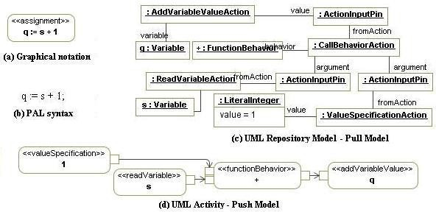

Fig. 1. Assignment: q := s + 1 in AL and corresponding UML activity

The definitions of AL constructs for other UML activities, such as sequence, conditional, and loop, are similar and can be found in [11].

The compatibility between AL and UML, or other tools, is provided by gener- ating a representation which is conformant with the UML metamodel and fUML action subset [22].

* 1. *i* Component *- Injected Components*

iCOMPONENT (injected component) ([12]) has been designed as a platform- independent component model that can be used to develop service-oriented com- ponents for dynamic execution environments. The set of stereotypes used to model

injected components are: *Module, Component, Domain, Node, DynamicExecutio- nEnvironment, provides, requires, validate, invalidate, controller, and config*, as

shown in Figure 2.

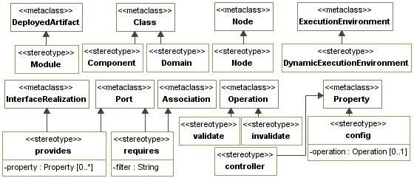

Fig. 2. iComponent stereotypes

**Modules**. The *Module* stereotype extends the UML 2 *DeployedArtifact* meta- class and represents the unit of deployment. A *Module* may contain classes, in-

terfaces, components, component instances, and other resources. The set of model elements that are manifested in the module (used in the construction of the module)

is indicated by the *manifestation* property of the *DeployedArtifact*.

**Component types**. The *Component* stereotype extends the *Class* metaclass (from UML *StructuredClasses*) and represents a component type. A *Component*

may define properties and methods as being a structured class. The configuration properties of a component must be marked with the *config* stereotype, which con-

tains an attribute for indicating a setter operation to be called when the component container injects the value for a given configuration property.

The *provides* stereotype can be used for publishing services and their proper- ties. This stereotype extends both UML *InterfaceRealization* and *Port* metaclasses

in order to allow modeling of published services as simple classes that implement interfaces, as well as components that have attached ports. The *property* attribute can be used to export the service properties, expressed as a set of (key,value) pairs. The *requires* stereotype can be used for requiring services. This stereotype

extends both UML *Association* and *Port* metaclasses in order to allow modeling

the required services as simple classes that have unidirectional associations with interfaces, as well as components that have attached ports. The *filter* attribute can be used to filter the required services, based on their properties.

The UML provided/required interfaces do not contain such attributes, which explains why the provides and requires stereotypes were introduced. The two at- tributes are essential in the component model corresponding to service-oriented

components because they provide the necessary form for expressing the properties associated to a service. For example, let’s consider two components *EnglishDic- tionary* and *FrenchDictionary* implementing the same interface *Dictionary* and an *EnglishSpellChecker* component that requires a *Dictionary*. If the two dictionary

concrete components are adnotated with a property representating the language (*language=English*, respectively *language=French*), then the spell checker compo- nent can choose which interface implementation to use: *filter=(language=English)*.

**Composite components**. UML 2.0 offers two ways of modeling subcompo- nents: *subcomponents as parts* and *subcomponents as nested elements*. The com- posites in iComponent use UML composite structures in order to indicate their internal structure. In this context, subcomponents modeled as parts are shared components which may be referenced by many composite components.

**Component Instances**. The execution environment creates (target) compo- nent instances in two ways: (a) by creating the instances specified by *Modules*, and (b) by creating the instances specified as parts of composite *Component*s. In

the case (a), the module containing the component definition indicates that a cor- responding component instance must be created. In the case (b), if a composite structure diagram attached to the component contains an instance specification with an interface type, then an instance of a component that implements the inter- face will be created when such a component type is available. After creation, the instance is bound to the composite instance. Moreover, if such a bound instance dissapears, another compatible one can be instantiated to replace the missing ser- vice required by the composite. This mechanism is called dynamic substitution of services.

In both cases, the component instances are specified as *InstanceSpecification*

objects of type *Component*. The values of the *InstanceSpecification*’s slots are used

to configure the component instance’s properties (using member field injection).

The component’s required references (services) will be injected by the execution environment as described below.

**Component binding**. The execution environment creates for each component instance a container, wrapping the instance, that automatically manages the ac- tivities of providing or requiring interfaces. When a component is added to the

dynamic execution environment, it enters the *invalid* state. The component enters the *valid* state and its provided interfaces are published into a service registry when

the container resolves its dependencies, i.e. the required interfaces.

**Lifecycle controllers**. iComponent proposes a simple notification mechanism between a component and its container, as shown in Figure 3: (a) After a module is installed it enters the *Installed* state. When all the model elements required by a module (its module dependencies) are available, the module enters the *Resolved* state. A resolved module can be started and the module enters the *Active* state.

(b) The modules configured component instances will be created in the *Active* state and destroyed when the module leaves this state. When a module becomes active, implicitely the components enter the *invalid* state, and become *valid* only afer validation. A *valid* component can require its container to enter the *invalid* state. This is achieved by configuring a component boolean property as controller property using the *controller* stereotype.

**Service registries**. The execution environment offers a *global service registry* in which component instances publish their provided interfaces. Other component instances may acquire references to these global services automatically through their wrapper containers. But, in order to isolate the component instances and services of an application, the instances of a composite are not published globally by default.

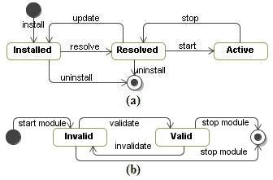

Fig. 3. (a) Module statemachine; (b) Component statemachine

*Each composite component has its own service registry* which is used by all compo- nent instances living in the same composite for providing and requiring services.

Because a composite may contain other composites, a mechanism for importing and exporting services is needed. This way, a composite can export a service to its parent or can import a service from its parent.

**Nodes** and **dynamic execution environments**. *Node* stereotype extends UML *Node* metaclass. A node may deploy several modules, and therefore possible several components instantiated by these modules. The *DynamicExecutionEnviron-*

*ment* stereotype extends *Node*, in which we may use: (a) the properties associated to a service that is published by a component, and (b) dynamic binding using filters for selecting the services required by a component, in a similar way to the iPOJO approach [10].

**Domain**. A *Domain* represents a complete configuration for system deployment,

and consists of nodes and connectors between nodes. It may have several nodes,

each containing several components. Here a node is seen as a process on a computer. The binding of the components in a specific domain is regardless of the nodes in which the components are deployed.

# The Proposed Agile MDA Approach

Any UML case tool can be used to construct the models presented in this section. In order to execute the models the tool should also conform to fUML specification for executable models [22]. Our ComDeValCo workbench is such a tool, being designed according to these requirments [12].

The proposed agile MDA approach consists of applying the following steps in the specified order: (1) the model is described on different layers: services, structure and deployment, then (2) for simple components proceed with test-first component development. Each of the following subsection describes in more details a step of our proposal and exemplifies it on a simple case study.

Let’s consider a case study that prints the product prices of a given store. The store has a *product catalog* representing information about *products* (*code*, *descrip- tion*, and *price* without taxes and discounts). The printing procedure must take into account the *discount strategies* the store may have for each product and the

application of *VAT*.

* 1. *Services model*

The **services model**, typically defined by the system analyst, describes the services that will be provided by the system. The modules that refer to services model may include any data type, such as classes, interfaces, or components. The interfaces contain the operations provided by the services.

Figure 4 presents the model corresponding to our case study, and illustrates the separation of responsibilities. The *StoreService* interface contains the required operations for printing the product prices with taxes and discounts. *StoreService*’s

operations can simply delegate execution to their corresponding operations from *ProductCatalog* and *PriceCalculator*. The *PricingStrategy* interface is designed to represent both discount and VAT price adjustments. The *services* module includes all these interfaces as well as the *Product* business entity.

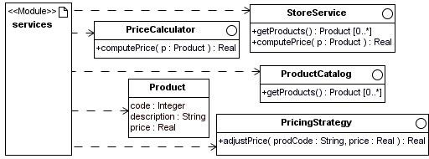

Fig. 4. Services model

* 1. *Structural model - composite components*

The **structural model**, typically defined by the system architect, indicates com- ponent instances that will implement the services. At this stage, the system is decomposed into a set of components, simple or composite. **Composite compo- nents** help the architect to decompose the system functionality in an hierarchical way. Each composite component has attached a composite structure diagram, de- scribing its internal structure, using component parts (simple or composite) and connectors between ports, and specifying which components will be instantiated. The rules for the construction of the diagram are:

* + - the internal structure of a component uses instances of other components, con- nected through ports;
    - the provided and required ports, as well as their multiplicity, should be specified;
    - to select a certain service implementation satisfying some criteria, use the *prop- erty* attribute corresponding to *provides* and *filter* attribute coresponding to *re- quires*;
    - the *InstanceSpecification* objects indicate which components should be created and their corresponding property values.

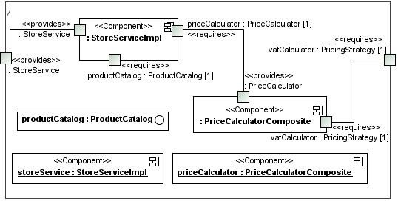

Fig. 5. *Store* composite component - internal structure

Figure 5 shows the composite structure diagram of the *Store* composite compo- nent. *Store* uses three shared subcomponents, of which one, *PriceCalculatorCom- posite*, is a composite too. The provided and required interfaces are represented as

ports and the components are linked using connectors.

Instances will be created according to the rules given in Section 2. When *Store* detects that a type that implements the *ProductCatalog* interface is installed, an instance of a component that implements the *ProductCatalog* interface will be cre- ated and the *ProductCatalog* service will be published into the *Store*’s registry. The *vatCalculator* service will be imported from the global registry. An instance of the

concrete component *StoreServiceImpl* and an instance of *PriceCalculatorComposite*

will be created.

Figure 6 explains how hierarchical composition works: components acquire ser- vices from their parent, and provide services to their parent. The *priceCalculator* composite component takes *vatCalculator* service from its parent, and provides *PriceCalculator* to its parent.

* 1. *Deployment model*

The deployment model is specified using UML *Node* and *DynamicExecutionEnvi- ronment* constructs. The dependencies from Figure 7 represent the required *runtime dependencies* between modules. All monolithic implementations reference only in-

terfaces, but composite components may use other components as parts (see Figure 5).

At this moment the **domain** has to be specified, with its included **nodes**, and

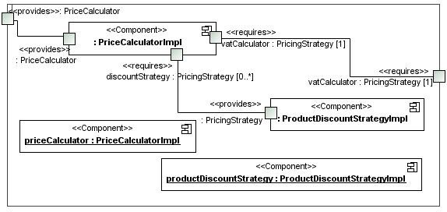

Fig. 6. Price calculator composite component - internal structure

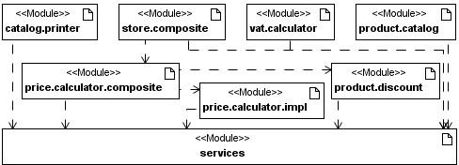

Fig. 7. Module dependencies

the deployment of modules within nodes. Next question refers to which components will be instantiated during execution and to the nodes involved in each instantiation process.

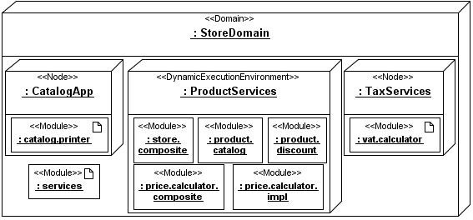

Fig. 8. Domain and nodes

Figure 8 illustrates the domain for our case study and specifies which services will be available in the dynamic execution environment. There are two nodes,

corresponding to *CatalogApp* and *TaxServices*.

Coresponding to the domain specification above, Figure 9 shows the component instances created at runtime their corresponding nodes. *StoreComposite* acquires *vatCalculatorImpl* service and publishes it for its part components, then creates instances for its parts. In a recursive way, *PriceCalculatorComposite* (see Figure 6 for its internal structure) acquires *vatCalculatorImpl* service from its parent and

publishes it.

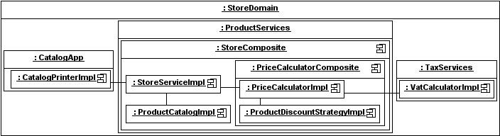

Fig. 9. Component instances

* 1. *Test-ﬁrst component development*

When the decompostion is complete, the next step is to define simple or monolithic components solving the initial problem. For each new feature of the system being developed, our proposed agile MDA process includes the sequence of following test- first design steps [3]:

**Add a test**. Developers write the tests using either graphical or textual nota- tions. Both are compiled into the same UML repository model. During the activity construction process, the framework allows the use of inline expressions, represented and evaluated according to the pull model for actions.

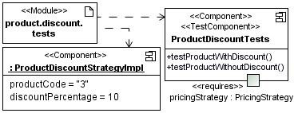

Fig. 10. Product discount tests

Figure 10 shows how tests for *ProductDiscount* module are created, including initialization of the component properties *productCode* and *discountPercentage*.

Using AL, the implementation:

assert 90 = pricingStrategy.adjustPrice(’’3’’,100);

is introduced in *testProductWithDiscount* method, and

assert 100 = pricingStrategy.adjustPrice(’’1’’,100);

is introduced in *testProductWithoutDiscount* method in *ProductDiscountTest*.

**Run the tests**. Developers write pre- and post-conditions expressed as OCL expressions. The syntax of AL includes pre- and post- constructs, which are taken

into account when the system is run. The methods of the components from *Pro- ductDiscount* module (see Figure 10) have an empty body, they are only specified

using pre- and post-conditions.

**Add production code**. The third step is to update the functional code to make it pass the new test. Again, both graphical and textual syntax of AL can be used, favoring the application of design by contract principles. By running the tests shown from Figure 10, the code is updated as presented in Figure 11, namely the *adjustPrice* method is implemented in the following way:

if (productCode = self.productCode)

return (1-discountPercentage/100)* price;

else

return price;

**Run the tests**. This last step means running the tests again. Once the tests pass the next step is to start over implementing a new system feature.

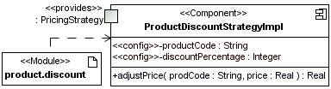

Fig. 11. Product discount

Figure 12 presents *CatalogPrinter* definition, which use the *validate* stereotypes in order to register callback operations invoked when the component enters the *Valid* state.

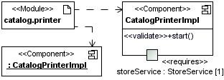

Fig. 12. Catalog printer

# Related Work

As shown in the first section, two important issues for simplifying the construction of components are (1) the separation of the business logic of a component from its non-functional requirements and (2) the application of a model-driven devel- opment (MDD) approach. Both are hot research topics and several academic and commercial solutions targeting component models and service orientation are under development.

Traditional commercial component models such as Component Object Model (COM) [15], Enterprise Java-Beans 2.1 [26], and CORBA Component Model [18] use specific application programming interfaces, and does not offer a clear separation between functional and non-functional requirements. This restricted interface usage decreases the potential reuse degree of the components.

Among the MDA approaches which address the traditional component models (e.g. Corba Component Model) we mention the standard specification for deploy- ment and configuration of component-based distributed applications [20].

Other MDA approaches which refer to embedded systems [6,8] or pervasive systems [4,5,16] address the dynamic execution environment features and the sepa- ration problem.

Academic solutions, such as Fractal [6] and SOFA 2.0 [7] are open component models that provide all dynamic features but do not offer a clear separation of the functional and non-functional requirements.

iPOJO (injected Plain Old Java Objects) [10] is a service-oriented component framework supporting the service-oriented component model concepts and dynamic availability of components, following the POJO approach (Plain Old Java Objects). All service-oriented aspects, such as service publication, the required service dis-

covery and selection are managed by an associated *component container*. The op-

erations in iPOJO are similar to iComponent operations, but our approach is

platform-independent, while iPOJO is restricted to Java.

Also, the current version of iPOJO does not provide a clear separation of the business logic and non-functional requirements for all operations discussed above. More precisely, only dynamic availability of components and composition of compo- nents are supported, while the dynamic reconfiguration of components is performed using the OSGi Configuration Admin service only.

Another framework which supports dynamic availability and reconfiguration of components is the OSGi framework [23], which offers a service-oriented component model. OSGi components are bound using a service-oriented interaction pattern, and their structure is described declaratively. Again, OSGi does not offer a clear separation between business logic and the non-functional requirements.

Service Component Architecture (SCA) Assembly Model specification [17] pro- poses a definition of composite components similar to iPOJO; in addition, the com- ponents may be distributed in several locations/nodes within the same domain. Another remarkable feature of SCA is that it allows specification of component im- plementations which are not necessary classes; they can be bussiness processes also. However, there are also some drawbacks of SCA: it doesn’t indicate any solution for controlling the lifecycle of components and does not allow the user to attach properties to a published service and to filter services specifying some conditions.

Table 1, enumerates the main objects needed to develop service-oriented com- ponents for dynamic execution environments and gives the mapping between these objects from the proposed model, iComponent, and iPOJO and SCA frameworks. As the table suggests, the main difference between iComponent and SCA on one hand, and iPOJO, on the other hand, is that iPOJO does not support dis-

|  |  |  |
| --- | --- | --- |
| iComponent | iPOJO | SCA |
| *Domain* | - | *Domain* |
| *Node* | - | *Node* |
| *DynamicExecutionEnvironment* | OSGi implementation | - |
| *Module* | *Bundle* | *Contribution* |
| *Component* | *Component* | *Component* |
| Composite *component* | *Composite* | *Composite* |
| *provides* | *provides* | *Service* |
| *requires* | *requires* | *Reference* |
| *validate* and *invalidate* | *validate* and *invalidate* | - |
| *controller* | *controller* | - |
| *config* | *Property* | *Property* |

Table 1

iComponent, iPOJO, and SCA mappings

tributed service architecture. iComponent supports it, by distributing the mod- ules in the nodes of the dynamic execution environment, as illustrated in Figure 8.

Comparing iComponent with SCA, one may observe that SCA does not have

lifecycle controllers, i.e. a notification mechanisms between a component and its container such that the component can participate to its lifecycle events.

# Conclusions and Future Work

We have presented iComponent, a platform-independent component model for dynamic execution environments, and extended it for service-oriented component models. We have also introduced an agile MDA approach for constructing ex- ecutable models. The iComponent profile was extended by adding component composition features which allow us to assemble components and services together

and by adding new stereotypes, *Node* and *Domain*, for specifying component de-

ployment locations. We have also shown that it is possible to map our developed

models to specific platforms, like iPOJO and SCA. As a future direction, we intend to build the concrete mappings for these platforms.

The UML profile was defined in such a way that it can be constructed with any UML tool and can be executed in any executable UML tool or with ComDeValCo workbench, which is in progress of extension. In earlier phases of the project,

it was defined for UML structured activities and extended with the definition of platform-independent components based on the proposed UML profile for injected

components.

The approach can be used by a large community of component developers, since it conforms to the standards of UML and MDA and the defined extension provides a complete model driven for service-oriented components.

Another future plan is to include bussiness processes in our approach, in an intension to minimize the differences with SCA approach.

The toolset component of our framework will also be enhanced with model transformation capabilities.

# References

1. Balasubramanian, K., A. Gokhale, G. Karsai, J. Sztipanovits, and S. Neema, *Developing Applications Using Model-Driven Design Environments*, Computer, **39**(2006), 33–40.
2. Batory D. - *Multilevel models in model-driven engi-neering, product lines, and metaprogramming*, Model-Driven Software Development (IBM System Journal), **45**(2006), URL: <http://www.research.ibm.com/journal/sj/453/batory.html>.
3. Beck, Kent, *Test-Driven Development By Example*, Addison Wesley, 2002.
4. Bottaro,A., J. Bourcier, C. Escoffier, and P. Lalanda, *Autonomic Context-Aware Service Composition*. In: IEEE International Conference on Pervasive Services, 223-231(2007).
5. Bourcier,J., A. Chazalet, M. Desertot, C. Escoffier, and C. Marin, *A Dynamic-SOA Home Control Gateway*. In: IEEE International Conference on Services Computing, 463 - 470(2006).
6. Bruneton, E. et al. *An Open Component Model and Its Support in Java*. In: Component-Based Software Engineering, LNCS **3054**(2004), 7-22, Springer, Berlin / Heidelberg.
7. Bures,T. et al., *SOFA 2.0: Balancing Advanced Features in a Hierarchical Component Model*. In: Proceedings SERA (2006), 40-48.
8. Cano,J., N. Martinez, R. Seepold, and F. L. Aguilar, *Model–driven development of embedded system on heterogeneous platforms*. In: Forum on Specification and Design Languages (2007).
9. Cervantes,H. and R. S. Hall, *A Framework for Constructing Adaptive Component-Based Applications: Concepts and Experiences*, Component-Based Software Engineering, LNCS **3054**(2004), 130-137, Springer, Berlin / Heidelberg.
10. Escoffier, C. and R. S. Hall, *Dynamically Adaptable Applications with iPOJO Service Components*. In 6th Conference on Software Composition (SC07), 113-128(2007).
11. Lazar,Ioan, S. Motogna, B. Parv, I-G. Czibula and C-L. Lazar, *An agile MDA approach for executable UML structured activities*. Studia Univ. Babes-Bolyai, **2**(2008), 101–114.
12. Lazar,Ioan, B. Parv, S. Motogna, I-G. Czibula and C-L. Lazar, *iComponent: A Platform-independent Component Model for Dynamic Execution Environments*, In: 10th Int. Symp. SYNASC(2008), accepted.
13. Mellor,Stephen J., *Agile MDA*, Technical report, Project Technology, Inc., 2005.
14. Mellor, Stephen J. and Marc J. Balcer, *Executable UML: A Foundation for Model-Driven Architecture*, Addison Wesley, 2002.
15. Microsoft Co., *Component Object Model* (1995) URL: <http://www.microsoft.com/com/>.
16. Munoz, J., V. Pelechano, and J. Fons, *Model Driven Development of Pervasive Systems*, ERCIM,

**58**(2004), 50-51.

1. OASIS, *SCA Service Component Architecture. Assembly Model Specification*, Version 1.1(2007), URL:

<http://www.oasis-opencsa.org/sca>.

1. Object Management Group, *CORBA Components Specification*, Version 3.0.( 2002), URL:

<http://www.omg.org/technology/documents/formal/components.htm>.

1. Object Management Group. MDA Guide Version 1.0.1. (2003), URL:

<http://www.omg.org/docs/omg/03-06-01.pdf>.

1. Object Management Group, *Deployment and Configuration of Component-based Distributed Applications Specification*, Version 4.0. (2006), URL: <http://www.omg.org/technology/documents/formal/deployment.htm>.
2. Object Management Group, *UML 2.1.1 Superstructure Specification.*, (2007), URL:

<http://www.omg.org/cgi-bin/doc?ptc/07-02-03/>.

1. Object Management Group,*Semantics of a Foundational Subset for Executable UML Models (FUML)*, (2008), URL: <http://www.omg.org/spec/FUML/>.
2. OSGi Alliance, *OSGi Service Platform Core Specification*, Release 4, Version 4.1.(2007), URL:

<http://www.osgi.org/>.

1. Papazoglou,M. and D. Georgakopoulos, *Service-Oriented Computing*, Communications of the ACM,

**46**(2003),25-28.

1. Parv,B., I. Lazar, and S. Motogna, ComDeValCo *Framework–the Modeling Language for Procedural Paradigm*, Int. J. of Computers, Communications Control, **3**(2008),183-195.
2. Sun Microsystems, *Enterprise JavaBeans Specification* (2003), URL:

<http://java.sun.com/products/ejb/docs.html>.