Available online at [www.sciencedirect.com](http://www.sciencedirect.com/)

[Electronic Notes in Theoretical Computer Science 340 (2018) 85–99](https://doi.org/10.1016/j.entcs.2018.09.007)

[www.elsevier.com/locate/entcs](http://www.elsevier.com/locate/entcs)

An Efficient CoMP-based Handover Scheme for Evolving Wireless Networks

Rana R Ahmed1 Demetres D Kouvatsos2

*Networks and Performance Engineering Research Group* *School of Electrical Engineering and Computer Science Faculty of Engineering and Informatics*

*University of Bradford Bradford, BD71DP, UK*

**Abstract**

Inter-Cell Interference (ICI) will be one of main problems for degrading the performance of future wireless networks at the cell edge. This adverse situation will become worst in the presence of dense deployment of micro and macro cells. In this context, the Coordinated Muli-Point (CoMP) technique was introduced to mitigate ICI in evolving wireless networks and increase their network performance at the cell edge. Even though the CoMP technique provides satisfactory solutions of various problems at the cell edge, nevertheless existing CoMP handover schemes do not prevent unnecessary handover initialisation decisions. In this paper, a new CoMP-based handover scheme is proposed in order to minimise unnecessary handover decisions at the cell edge in conjunction with signal measurements such as Reference Signal Received Power (RSRP) and

Received Signal Received Quality (RSRQ). A combination of calculations of RSRP and RSRQ facilitate a credible decision making process of CoMP mode and handover mode at the cell edge. Typical numerical experiments indicate that by triggering the CoMP mode, the overall network performance is constantly increase as the number of unnecessary handovers is progressively reduced.

*Keywords:* Coordinated Multi-Point (CoMP), Unnecessary Handover, Reference Signal Received Power (RSRP), Received Signal Received Quality (RSRQ)

# Introduction

Coordinated Multipoint (CoMP) is an advanced technology of Long Term Evolution-Advance (LTE-A), which comprises many solutions such as Inter-Cell Interference and Intra-Cell Interference [6] [21] [15]. Moreover, it helps to mitigate the aforementioned interferences and increase the cell edge performance. To this end, the CoMP technique plays a vital role in current research towards the reduction of decisions for unnecessary handovers at the cell edge and the follow up improve- ment of network performance [14] [11]. User Mobility is playing an important role

1 Email: [R.R.Ahmed@student.bradford.ac.uk](mailto:R.R.Ahmed@student.bradford.ac.uk)

2 Email: [D.D.Kouvatsos@Bradford.ac.uk](mailto:D.D.Kouvatsos@Bradford.ac.uk)

<https://doi.org/10.1016/j.entcs.2018.09.007> 1571-0661/© 2018 Published by Elsevier B.V.

This is an open access article under the CC BY-NC-ND license (<http://creativecommons.org/licenses/by-nc-nd/4.0/>).

in wireless networks because the network performance is highly depending on it. It became more challenging task for wireless networks when they handle users are moving in fast vehicles or they are present in congested places such as shopping malls and stadiums. For handling mobility problems, cellular technologies intro- duced handover mechanism. Handover is a process in which the control of UE is transferring from one cell to another cell or one sector to another sector[14]. The main purpose of handover is to minimise the disturbance and provide session conti- nuity to UE [16]. Moreover, the handover schemes are more critical and challenging for cell edge users because at the cell edge the reception UE received by serving enhanced NodeB (eNB) is very poor [18]. The main reasons of poor receptions are; UE has long distance from serving eNB and the interference level is very high because of neighbouring cell [6]

The performance of evolving wireless networks highly depends on the mobility of users at the cell edge because the network site consists on many microcells (fem- tocell) and macrocells (eNB). In this context, a User Equipment (UE) presents at the cell edge carries out many times handover from the serving eNB to the target eNB and also attempts handover back to previous serving cell [10] [19] in short time intervals. Consequently, the quality of system (QoS) is degraded because the re- sources are wasted and the probability of handover failure is increased due to a large number of unnecessary handovers at cell edges. It also results in power dissipation of UE battery and lower the throughput gain [2].

The main focus of this paper is to provide a new handover scheme in order to overcome the causes of unnecessary handovers at cell edges by using the CoMP technique and reference signal measurements of eNB. In this paper reference signal measurement are referred to Reference Signal Received Power (RSRP) that is the linear average received power by the UE and Reference Signal Received Quality (RSRQ) that indicates the quality of received signal.

The structure of the paper is as follows. Section 2 presents a literature review, In Section 3 proposed handover scheme is introduced with important calculations, Sections 4 is based on algorithm of proposed scheme, Section 5 contains the per- formance measures of proposed scheme along with simulation environment, section 6 is based on results and discussion of proposed unnecessary handover scheme and finally the last sections gives the conclusions whole paper.

# Literature Review

In wireless networks the values of handover hysteresis and handover margin (HOM) (i.e., two of handover triggers at the UE defined by the network) are mainly con- sidered to reduce the number of unnecessary handovers. Therefore, in LTE-A these values are also widely used in handover algorithms and proposed schemes [14] [12]. In [9] authors presented the grouping algorithm based on adaptive hysteresis value (i.e., based on actual hysteresis value but changing with time). This algorithm consists of two steps, where the predefined threshold are defined for each step to move into next step. To avoid the unnecessary handovers, the algorithm is imple-

mented on whole group without acknowledge the exact location of users, they made group only on the history of base station where users are currently attached. In such cases may be this algorithm avoid unnecessary handovers in some cases but the overheads are increased because this not necessary at a time, everyone in group required handover.

In [2], authors have proposed method to control unnecessary handovers in het- erogeneous network with dense deployment of small cells. In this method, a short- ened candidate (UE) list is introduced on basis of UE actual distance and angle of movement from base station. The simulations results showed that when speed is considered, the proposed method has low probability of unnecessary handover as compare with conventional handover algorithms. Although authors discussed and presented good research work but they have ignored main issues such as load on the serving eNB and interference level at the cell edge in his results. These are main issues of future networks during handover decisions.

Another handover scheme for microcell is presented in [4] based on hysteresis margin value to overcome the redundant handovers. For this purpose they calcu- lated the position of UE to set the hysteresis margin value. Although, the algorithm is much closed to traditional and conventional algorithms but it used good channel quality indicators values to defined the decision parameters. This algorithm is much closed to present research with addition of RSRP and RSRQ.

In present research the handover scheme is proposed to reduce number of han- dover initialisation decisions by introducing CoMP mode along with handover mode. The handover schemes discussed above triggered handover, once UE received power RSRP become lower than threshold level (i.e., minimum value of RSRP set by net- work operator). On other hand in proposed handover scheme, once the received power RSRP goes lower than threshold level but the channel quality RSRQ is ac- ceptable, CoMP mode is triggered in which UE starts receiving data from multiple eNBs without performing any handover. In proposed scheme, the handover mode is only triggered when the received power RSRP and channel quality RSRQ become lower than threshold level.

# Proposed Handover Scheme

A proposed handover scheme of a wireless homogeneous network is presented in Fig.1. consisting of 3 hexagonal macrocells (eNBs). The eNBs antenna is located at the centre of cell and they are operated on same frequency band. In Fig.1. the green area has good range of RSRP and RSRQ values but in brownish area RSRP dropped from threshold level (i.e., a value of RSRP is set by network operator and ranges are given in Table.1) whilst RSRQ depends on conditions such as load, interference etc. More explanations for the proposed scheme can be seen in Fig.1.

The important calculations to facilitate the making of decision to reduce the number of unnecessary handovers can be seen below.

***Received Signal Received Power* :** RSRP is defined as the linear average received power by the UE (or any receiver) from the reference signal resources

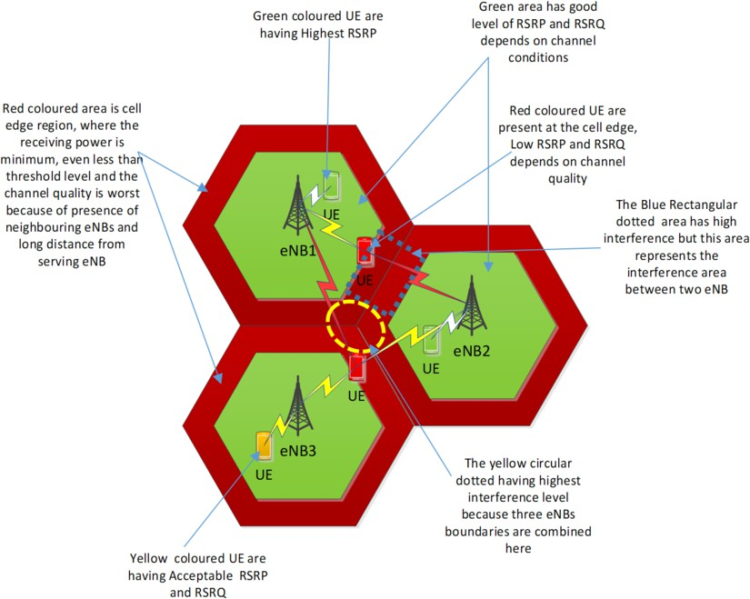

Fig. 1. An overview of Proposed Scheme

elements over desired bandwidth (i.e., 5MHz, 10MHz and 20MHz). The general formula derived from above definition for RSRP is [1];

1

*RSRP* =

*K*

Σ *Prs,k*

*k*=1

*K*

(1)

Where Prs,k is the estimated power (in Watts) of kth Reference Signal (RS) Resource Element (RE) in Physical Resource Block (PRB). Moreover, PRB is a smallest transmission unit of downlink LTE-A. It consist of 12 subcarriers and 7 OFDM as shown in Fig.2. In PRB, There are four RS presents, having fixed position in time domain and that is first and forth OFDM symbols. Following Fig.2. shows that details description of PRB [6] [8].

So for calculations of RSRP these reference signals are important because the UE is measured RSRP value in these RS and feedback to the serving cell. These RS only measure the power excludes the noise and interference. The measured value of RSRP for UE to eNB is determined with help of following formula;

*RSRPue−>eNBi* = *Ptx−>eNBi* + *GeNBi − PiLue,eNBi − εue,eNBi* (2) Where *Ptx−>eNBi* is transmitting power ith eNB (normally a serving eNB) and

*GeNBi* is antenna gain of serving eNB *PiLue,eNBi* path loss between UE and serving

eNB, Σue, eNBi the shadowing fading with log-normal distribution with zero mean and 3dB standard deviation [7].

In equation 2 the path loss calculations are based on following formulas.

***Path Loss Calculations*:** for path loss calculation in formula (2) can find with

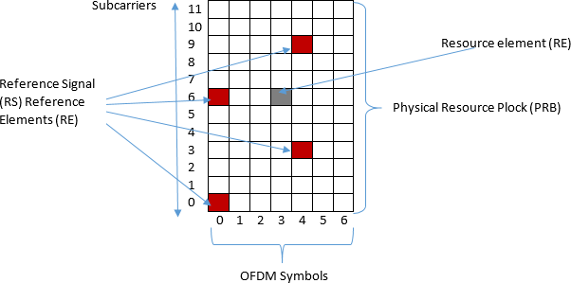

Fig. 2. Overview of Physical Resource Block (PRB)[6][1]

help of following formula [2] [3].

*PiL* = 69*.*55+26*.*16 log (*f* )*−*13*.*82 log (*GeNB*)*−a* (*GUE*)+(44*.*9 *−* 6*.*55 log (*GeNB*)) log (*di*)

(3)

where

*a* (*GUE*)= (1*.*11*log*(*f* ) *−* 0*.*7)*GUE −* (1*.*56*log*(*f* )) *−* 0*.*8)

*di* = *UE distance from eNB in km GeNB* = *eNB*(*transmitter*) *antenna gain GUE* = *UE* (*Receiver*) *antenna gain*

Fig.3. gives the overview of calculations in details. Where UE is located at the cell edge of hexagonal macro cell having Radius *R* and having direction *θ* between (0,2*π*). UE had *di* is distance from eNB. Transmission and Receiver antenna Gains are *GeNB* and *GUE* respectively.

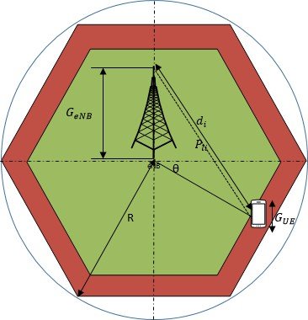

Fig. 3. Calculation of RSRP/Path loss

***Calculations of RSRQ:*** RSRQ indicates the quality of received signal and it

can be measured with help of following formula;

*RSRP*

*RSRQ* = *NRB RSSI* (4)

Where *NRB* total number of resource blocks over which a measurement is conducted. Where RSSI comprises of the linear average of the total received power observed only in OFDM symbols contain the cell specific reference symbols for antenna port over *NRB* resource blocks in the measurement bandwidth by UE from all sources including adjacent channel interference and thermal noise and co-channel serving and non-serving eNB, [1].

# An Algorithm for Proposed Handover Scheme

The main aim of proposed handover scheme is to reduce the number of unnecessary handovers and improve performance of users at the cell edge. For this purpose pro- posed handover scheme is divided into two mode; CoMP mode and handover mode. In CoMP mode, UE receives RSRP from the serving eNB below than threshold level (a value set by network operator) but the level of RSRQ is not bad or dropped from certain level. In such situation, conventional and existing handover schemes, they triggered handover mode, but in proposed scheme CoMP mode is triggered instead of handover initialisation decisions. By triggering CoMP mode, the UE start re- ceiving data from multiple eNBs on basis of CoMP types such as Joint transmission (i.e., UE received data from all nodes in coordinated way) or Beam forming (i.e., the eNBs are coordinated to each other, but UE receive data only from single eNB). On the other hand, when UE receives RSRP below than threshold level from the eNB and RSRQ level is also bad, than handover mode is triggered and handover process will initiate. Mathematically and logically the triggering of CoMP and

handover mode are explained below:

***For Triggering CoMP Mode:*** when following condition become true the CoMP mode will activated.

*Condition* 1: *RSRPserving cell* + *RSRPBoost < RSRPCoMP Th* (5)

Where *RSRPserving cell* measured in **dBm** is power received by UE from the serving eNB and *RSRPBoost* is value set by network provider and it is using to increased bit level of RSRP and RSRQ to take time to decide the handover decision. Similarly *RSRPCoMP Th* measured in dBm is threshold level of RSRP at which CoMP mode is triggering and this value is also decided by network operator. RSRP measured value is range between -44dBm to -140dBm. Following table shows in details RSRP values in different ranges [5].

***For Triggering Handover Process***: When condition 1 and condition 2 are true, than handover process will initiated.

*Condition* 2: *RSRPCoMP Th* + *RSRPoffset < RSRPNeigh Cell* (6)

Measured RSRP Signal Strength

-44dBm to -80dBm Excellent

-81dBm to -90dBm Good

-91dBm to -110dBm Mid Cell

-111dBm to More Cell Edge

Table 1

Table 1:

Different Ranges of RSRP Values [7] [3]

*Condition* 3: *RSRQMin < RSRQServing Cell < RSRQMax* (7)

In condition 2, *RSRPCoMP Th* is same as condition 1, *RSRPoffset* is received power offset value that ranges from *±*2 to *±*3 in our case because all eNBs having same transmitting power. Actually When CoMP mode is activated than UE is connected with more than one eNB, so it receive different received power from eNBs in case of diversity scheme. Therefore this offset value is used to make sure the reported or measured RSRP value is not less than the individual value of RSRP [1]. The selection of value is deepening on the interference level and noise level. Similarly *RSRPNeigh Cell* is received power by UE from neighbouring cells.

Measured RSRQ Channel Quality

-3dBm to -9dBm Excellent

-10dBm to -12dBm Good

-13dBm to -14dBm Acceptable

-15dBm to More Cell Edge, Bad

Table 2

Different Ranges of RSRQ Values [7] [3]

In condition 2, *RSRQserving cell* is channel quality indicator measured by UE in serving eNB and *RSRQMin* and *RSRQMax* are minimum and maximum range of RSRQ set by network operator to decide the channel quality is bad or good. Following table shows most common ideas of RSRQ values [1].

### *Flow Chart*

Fig.4. shows flow chart in details that based on following steps

**Step 1:** Always UE is connected with the eNB having highest RSRP value and good channel conditions.

**Step2:** UE feedbacks measurement reports to serving cell after every transmission time interval (TTI). During the measurement period UE perform the following steps, if the measurement period expired, UE will perform same step 2.

**Step 3:** If the measurement period is not expired and condition 1 given in equation 5 is true, Than CoMP mode will triggered otherwise call termination, if call is not terminated it will go to step 3 and on other hand if call is terminated, it will exist from the network.

**Step 4:** Once the CoMP mode is triggered, Check conditions given in equations 6 and 7. If the condition are true, the handover mode will triggered otherwise it will goes to step 3

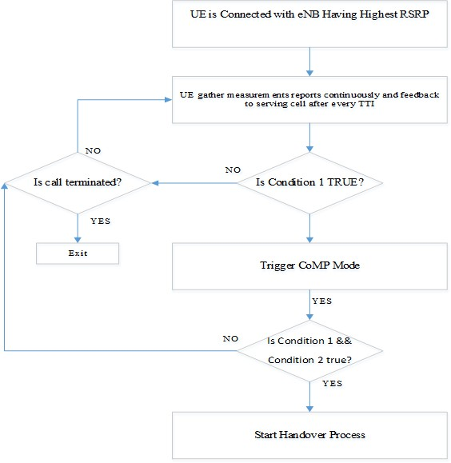

Fig. 4. Flow chart of Proposed Handover Scheme

# Performance Measures for Unnecessary Handovers

The following performance measures for determining the number of unnecessary handovers are presented below.

1. **RSRQ and RSRP measurements:** In proposed handover scheme the value of RSRP and RSRQ plays key role in decision of handover by triggering CoMP mode or handover mode. Thus, the behaviour of these values are anal- ysed against different bandwidth value, load value and by considering external noise.

## Total Number of Handover Decisions in Conventional Handover Schemes (THCS):

Conventionally, the handover process is started, when UE experienced low RSRP than threshold level. In proposed algorithms at same RSRPs threshold level the CoMP mode is triggered. Therefore, following formulas is used to calculate the number of handover in conventional handover schemes

*THCS*1*−>N* = *SumCountif* (1 : *N,* ”*Condtion*1”) (8)

Where THCS is total number of handover decision for N number of users present in the network. The number of handovers are counted, whenever condition 1 is true during the simulation.

## Total Number of Handover Decisions in Proposed handover Scheme (THP):

In proposed algorithms the total number of handover decisions are calculated when conditions 2 and 3 are true.

*THPS*1*−>N* = *SumCountif* (1 : *N,* ”*Condtion*1””*Condtion*2”) (9)

Where THCS is total number of handover decision for N number of users present in the network. Whenever condition 2 and condition 3 are true, it counts and return the sum of numbers.

1. **Percentage of Unnecessary Number of Handover (UNH):** Percentage of unnecessary number of handovers can be calculated with help of following formula;

*UNH*(%) = *THCS*1*−>N − THPS*1*−>N ∗* 100 (10)

*TotalNumberof Handover*

Where total number of handover in conventional system are always higher as compare with the total number of handovers in proposed system. Therefore the difference of THCS and THPS gives UNH in our algorithm.

For measuring performance of proposed scheme following discrete time simulation environment is considered.

### *The Simulation Environment*

The performance of proposed handover scheme is evaluated on numerical results of RSRP and RSRQ, the calculations are based on LTE-A downlink system level simulator [17]. For implementation of proposed handover scheme a single cell is considered that has hexagonal shape. UEs are uniformly distributed over the cell with in the coverage area of eNB. Moreover, the position of eNB is at the centre of cell, and having 3km radius. In addition, there are considered bandwidth of 5MHz, 10MHz and 20MHz with 25RB, 50RB and 100RB respectively. There is also considered 0.5ms duration required for transmitting 7 OFDM with 2GHz carrier frequency. Each RB is receiving equal transmission power of 20mwatt from serving eNB. In addition, the assumptions and parameters value used in numerical

calculations of RSRP and RSRQ for reducing unnecessary handover are listed below.

In addition, the assumptions and parameters value used in numerical calculations of RSRP and RSRQ for reducing unnecessary handover are listed below.

## Assumptions

* Assume eNB is located at the centre of cell
* UEs are uniformly distributed over the cell
* All UEs are located in the cell coverage area. It means no UE is located outside the defined radius of cell
* UE position in the cell is randomly choose from (0, 2) and constant all the time
* The speed of UE is constant inside the cell. Initially they are stationary
* Each reference signal contain equal power without any interference and distur- bance

**Input Data for Simulation Parameters**

# Numerical Experiments and Discussion

This section presents numerical results of the proposed handover scheme and carries out comparisons with conventional handover schemes.

### *The impact of RSRP value at different bandwidth against Distance*

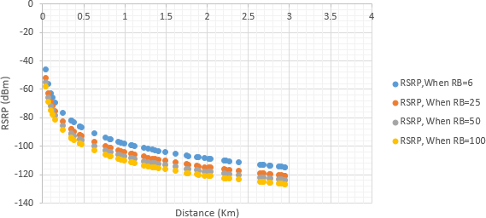

Fig. 5. RSRP at different Bandwidth against Distance

Fig.5. illustrates the relationship between RSRP and distance at different values of resource blocks. As UEs distance is increased from the eNB, the RSRP value is dropping, as seen in above results, when UE has minimum distance from eNB, the RSRP value is at maximum level -39.9dBM (-40dBm) against all cases of RB. On other hand, when distance is maximum about 3km the RSRP dropped

Simulation Parameters Values

Cell Radius 3km

Bandwidth/Resource Block 5 MHz/25RB, 10MHz/50RB, 20MHz/100RB Number of subcarrier per RB 12

Number of OFDM symbols 7

Subcarrier spacing frequency 15kHz Slot duration 0.5ms

Carrier frequency 1800MHz

eNB Transmission Power 20Watt

eNB Antenna Gain 30dBm to 50dBm

UE antenna Gain 1dbm to 10dBm

Sub-carrier frequency 15KHz

Path loss model Cost 231 Hata model

Shadow Fading Log normal distribution

RSSI -75dBm to -90 dBm

*RSRPboost* 3dBm

Time Transmission Interval (TTI) 1ms

No of UE 30 , 50 , 100

Table 3

Input Data for Simulation Parameters[17]

maximum to -120dBm (approximately). This is happened because as UEs distance increased from eNB, he experienced less power and high distortion thats why the received power is reduced at the cell edge. The main reason of decreasing RSRP is large fading (i.e., factor such as multipath, speed of surrounding objects, transmission bandwidth etc.) affecting receiving power [20].

On the other hand, in Fig.5., the RSRPs curves for different number of resource block have minor variations. When RB value is increased the value of RSRP is decreased. That is happened because of interference among resource elements. When we increased number of RBs, the number of resource elements are increased, therefore the interference among resource elements are increased. As a result, the value of RSRP is decreased for high number of RB [13].

### *The impact of RSRQ against load at RSRP, RSRP boost and with*

***External Interference (EI)***

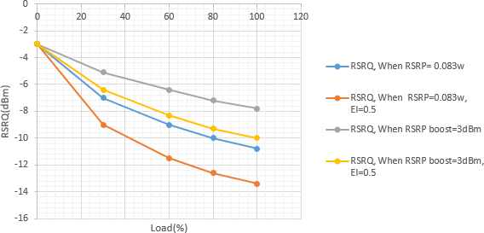

Fig. 6. The impact of RSRQ against Load

Fig. 6. Demonstrates behaviour of RSRQ against load with and without of RSRPboost and External Interference (EI). The EI considered here, because quality of channel is highly effected with this factor and effecting the handover decisions. Initially, when load is 0%, the RSRQ value is maximum at -3dBm in all considered cases. The reason is, in absence of load, the interference is almost negligible in among resource elements, and the value of RSSI and RSRP is almost same, thats why the channel quality is best. But when we increased load to 100%, the value of RSRQ is dropped to maximum level in all considered cases. The reason is the load increased, and RSSI value is also increased and interference level among resource elements become high, thats why the quality of channel is dropped. The best value of RSRQ is observed when there is no external interference and RSRP value is boost, in such case the best value is -3dBm and minimum value is -7.8dBm. So in such case there is no need of any handover until the situation become worst even the RSRP value is at his lowest.

### *Number of Handover Initialisation Decisions (NHID)*

Fig.7. Shows the Number of Handover Initialisation Decisions (NHID) for conventional and proposed algorithms. The NHID are increased when the users are increased in all considered cases. The reason is, when users are increased it means the load is increased and the value of RSRP and RSRQ are decreased and become lower than their threshold level thats why the NHID increased. But by comparing the conventional algorithms, the proposed handover has less number of NHID because proposed algorithms is checking the RSRP value along with RSRQ value.

We observed that in case of 5 MHz Bandwidth, when number of UE are 30 the NHID are 46.6% and 16.6% of total users for conventional and proposed algorithms

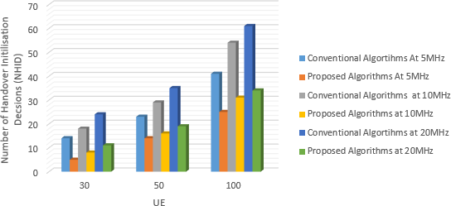

Fig. 7. Number of handover Initialisation Decisions between conventional and proposed handover scheme

respectively. Similarly, in case of 20 MHz Bandwidth for same number of users the NHID are 80% and 36.6% of total users for conventional and proposed algorithms respectively. As a result, the number of handover initialisation decision are decreased in proposed scheme as compare with conventional handover schemes but if compare the results between different bandwidth, the NHID is bit increased in proposed scheme, this is due to the findings present in Fig.6.

### *Percentage of Unnecessary Number of Handovers*

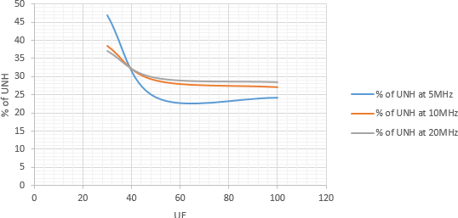

Fig. 8. Percentage of Unnecessary Number of Handovers

Fig.8. Illustrates the percentage of unnecessary handover against no of UE. When number of UE are 30, the conventional handover schemes as compare with proposed handover scheme have 47%, 37.14% and 38.4% (for 5 MHz, 10 MHz, and 20MHz respectively) more unnecessary handover decisions. Similarly, when number of UE are 100, the conventional handover schemes have 24.2%, 28.2% and 28.4% unnecessary handovers as compare with proposed handover scheme. It means with help of proposed handover scheme, the above mentioned unnecessary handover can

reduced. Moreover, that reduction in handover decision lead to system performance.

# Conclusions

A new handover scheme for reducing unnecessary handover decisions is proposed, based on CoMP and signal measurements RSRP and RSRQ of UE. In addition, the CoMP mode is triggered when UE receives signal power RSRP lower than threshold level. In conventional handover schemes, on same threshold level of RSRP, the handover is triggered. In conventional handover scheme during handover, control of UE is transferred from serving eNB to target eNB. In CoMP mode, the control is not transferred to target cell but the UE start progressively receives data from multiple eNBs according to the CoMP technique. Thus, following CoMP mode, the handover mode is activated to further check the RSRP signal power along with RSRQ signal quality to make sure acceptable conditions of network prior to taking final handover decision. Comparisons were carried out on handover initialisation decisions of the proposed handover scheme versus conventional handover schemes. It was observed that the proposed handover scheme is more effective than the earlier ones, having less number of handover decisions and a reduced percentage of unnecessary ones.

# References

1. Ahmadi, S., “LTE-Advanced: A Practical Systems Approach to Understanding 3GPP LTE Releases 10 and 11 Radio Access Technologies,” Academic Press, 2013.
2. Alhabo, M. and L. Zhang, *Unnecessary handover minimization in two-tier heterogeneous networks*, in:

*2017 13th Annual Conference on Wireless On-demand Network Systems and Services (WONS)*, 2017,

pp. 160–164.

1. Atanasov, P. and Z. Kissovski, *Investigations of the signal path loss in 4g lte network*, Bulgarian Journal of Physics **40** (2013), pp. 265–268.
2. Becvar, Z. and P. Mach, *Adaptive hysteresis margin for handover in femtocell networks*, in: *2010 6th International Conference on Wireless and Mobile Communications*, 2010, pp. 256–261.
3. Chilamkurti, N., S. Zeadally and H. Chaouchi, “Next-Generation Wireless Technologies: 4G and Beyond,” Springer Publishing Company, Incorporated, 2013.
4. Ghosh, A. and R. Ratasuk, “Essentials of LTE and LTE-A,” Cambridge Univ. Press, 2011.
5. Jansen, T., I. Balan, J. Turk, I. Moerman and T. Kurner, *Handover parameter optimization in lte self-organizing networks*, in: *2010 IEEE 72nd Vehicular Technology Conference - Fall*, 2010, pp. 1–5.
6. KIROSS, K., “Performance Evaluation Of Channel Estimation Techniques For An Lte Downlink System,” GRIN PUBLISHING, 2017.
7. Lee, H., D. Kim, B. Chung and H. Yoon, *Adaptive hysteresis using mobility correlation for fast* *handover*, IEEE Communications Letters **12** (2008), pp. 152–154.
8. Li, X. W. and J. Wang, *The optimized method of reducing unnecessary handover in lte system*, in: *2013 Third International Conference on Instrumentation, Measurement, Computer, Communication and Control*, 2013, pp. 1224–1227.
9. Lin, C.-C., K. Sandrasegaran, X. Zhu and Z. Xu, *On the performance of capacity integrated comp handover algorithm in lte-advanced*, in: *2012 18th Asia-Pacific Conference on Communications (APCC)*, 2012, pp. 871–876.
10. Lin, C.-C., K. Sandrasegaran, X. Zhu and Z. Xu, *Performance evaluation of capacity based comp handover algorithm for lte-advanced* **The 15th International Symposium on Wireless Personal Multimedia Communications** (2012), p. 236240.
11. Lin, C. C., K. Sandrasegaran, X. Zhu and Z. Xu, *Performance evaluation of capacity based comp handover algorithm for lte-advanced*, in: *The 15th International Symposium on Wireless Personal Multimedia Communications*, 2012, pp. 236–240.
12. Lin, C.-C., K. Sandrasegaran, X. Zhu and Z. Xu, *Limited comp handover algorithm for lte-advanced*, Journal of Engineering **2013** (2013), pp. 1–9.
13. Penttinen, J., “The LTE-advanced deployment handbook,” Wiley, 2016.
14. Pierre, S., “Next generation mobile networks and ubiquitous computing,” IGI Global (701 E. Chocolate Avenue, Hershey,Pennsylvania, 17033, USA), 2011.
15. Ramli, H. A. M., K. Sandrasegaran, R. Basukala and L. Wu, *Modeling and simulation of packet scheduling in the downlink long term evolution system*, in: *2009 15th Asia-Pacific Conference on Communications*, 2009, pp. 68–71.
16. Rumney, M., “LTE and the evolution to 4G wireless : Design and Measurement Challenges,” John Wiley & Sons, Ltd., 2013.
17. Teyeb, O., W. Mu¨ller, K. Dimou and A. Centonza, *Improved handover robustness in cellular radio communications* (2013), wO Patent App. PCT/SE2011/051,271.

URL <https://www.google.co.uk/patents/WO2013019153A1?cl=en>

1. Xian, H., W. Muqing, M. Jiansong and Z. Cunyi, *The impact of channel environment on the rsrp and rsrq measurement of handover performance*, in: *2011 International Conference on Electronics, Communications and Control (ICECC)*, 2011, pp. 540–543.
2. ZHANG, X., “LTE-Advanced Air Interface Technology,” CRC Press, 2016.