

[Egyptian Informatics Journal (2014) 15, 189](http://dx.doi.org/10.1016/j.eij.2014.09.001)–[199](http://dx.doi.org/10.1016/j.eij.2014.09.001)

Cairo University

Egyptian Informatics Journal

[www.elsevier.com/locate/eij](http://www.elsevier.com/locate/eij) [www.sciencedirect.com](http://www.sciencedirect.com/science/journal/11108665)

ORIGINAL ARTICLE

An energy balanced QoS based cluster head selection strategy for WSN



Shilpa Mahajan a,*, Jyoteesh Malhotra b, Sandeep Sharma c

a *ITM University, Gurgaon, India*

b *GNDU Regional Campus, Jalandher, Punjab, India*

c *GNDU, Amritsar, Punjab, India*

Received 24 March 2014; revised 24 August 2014; accepted 29 September 2014

Available online 1 December 2014

Abstract For efficient running of wireless sensor network applications, energy conservation of the sensors becomes a prime paradigm for prolonging lifetime of the network. Taking this aspect into consideration, a cluster head weight selection method called Cluster Chain Weight Metrics approach (CCWM) has been discussed that takes service parameters for enhancing performance of the overall network. In a clustering based approach one of the main concerns is selection of appropriate cluster heads in the network and the formation of balanced clusters. Cluster heads are selected first in a network based on weight metric and then cluster formation takes place. This approach not only aims to conserve energy of sensors but also balances load. A local clustering mechanism is adopted within the cluster to reduce computation and communication cost. Also, a new technique for data transmission is explored. The results of the proposed approach are com- pared through simulation with LEACH, WCA and IWCA. The proposed approach shows an improvement on an average over rounds by 51% over LEACH, 27% from WCA and 18.8% from IWCA in terms of lifetime and energy consumption.

© 2014 Production and hosting by Elsevier B.V. on behalf of Faculty of Computers and Information,

KEYWORDS

Energy efficient; Network lifetime; Node degree; Quality of service; WSN

Cairo University.

1. Introduction

Wireless Sensor Network (WSN) is a hot research topic that finds its usage in a wide spectrum of applications ranging from industrial and military applications to health and

* Corresponding author.

Peer review under responsibility of Faculty of Computers and Information, Cairo University.

**Production and hosting by Elsevier**

<http://dx.doi.org/10.1016/j.eij.2014.09.001>

environmental monitoring. In these, sensors are deployed ran- domly or uniformly to collect data from the environment and pass on the data to the base station. The unique network char- acteristics present several challenges in the design of sensor networks which involves limited battery capacity, limited hard- ware resources, massive and random deployment and dynamic and unreliable environment. Recent advances in WSNs have led to many new protocols specifically designed for sensor net- works where energy awareness is an essential consideration. Most of the attention, however, has been given to the routing protocols as they might differ depending on the application and network architecture. At the network layer, the main aim is to find ways for energy efficient route setup and reliable

1110-8665 © 2014 Production and hosting by Elsevier B.V. on behalf of Faculty of Computers and Information, Cairo University.

relaying of data from the sensor nodes to the base station so that the lifetime of the network is maximized.

A routing protocol finds a route for packet delivery and delivers the packet to the correct destination. Attempts are made to find stable energy efficient routes in WSNs. Routing in sensor networks is very challenging due to several character- istics that distinguish them from contemporary communica- tion and wireless ad-hoc networks. First of all, it is not possible to build a global addressing scheme for the deploy- ment of sheer number of sensor nodes. Therefore, classical IP-based protocols cannot be applied to sensor networks. Sec- ond, contrary to typical communication networks, almost all applications of sensor networks require the flow of sensed data from multiple regions (sources) to a particular base station. Third, the generated data traffic has significant redundancy since multiple sensors may generate same data within the vicin- ity of a phenomenon. Such redundancy needs to be exploited by the routing protocols to improve energy and bandwidth uti- lization. Fourth, sensor nodes are tightly constrained in terms of transmission power, on-board energy, processing capacity and storage and thus require careful resource management. Due to such differences, many new algorithms on routing problems have been proposed in the literature on sensor net- works. These routing mechanisms have considered the charac- teristics of sensor nodes along with the application and architecture requirements. These protocols can be classified as data-centric, hierarchical [1] and location-based networks

[2] but there are only few papers that have considered QoS (Quality of Service) measure along with routing functions.

In this paper, a rank based metric approach is suggested to select clusters from the set of sensors considering network per- formance parameters that distributes load evenly in the cluster and consume minimum energy.

1. Related work

In clustering, Cluster Head (CH) selection criteria and the number of CH selected strongly influence the network behav- ior in terms of communication overhead, latency, inter- and intra-cluster communication.

LEACH is the first cluster based routing protocol that selects CHs based on threshold criteria [3]. In this protocol, CHs are rotated in a cluster with an objective to reduce energy consumption and to distribute load evenly among the nodes. CHs aggregate data from their member nodes in a cluster and pass on the aggregated data to the base station.

Chatterjee in 2002 suggested Weighted Based on demand

erogeneous mobile sensor network environment. The algo- rithm is again run after fixed time interval to include new nodes that results in enhancing the lifetime of the network.

Another technique based on Genetic Algorithm was pro- posed that takes node’s position and CH load into account for deploying nodes [6]. Nodes in the clusters are placed using WCA. This technique works well in ideal load conditions and balances load well among clusters.

An optimized clustering algorithm (OWCA) [7] is proposed based on WCA with additional constraints on CHs selection in mobile WSNs. It takes into account node degree, transmission power, mobility, cumulative time, initial energies and distance from base station to each sensor node. This algorithm behaves better as compare to WCA but overhead involved in CH selec- tion is more. It even ignores interferences in the network.

To distribute load evenly among the clusters, CHs are selected and rotated within the cluster [8]. The relationship between the CHs and the routing techniques is considered. An integrated approach of CH selection and routing in two tier WSN (WSN) is adopted. Genetic Algorithm is used for CH selection and A-Star algorithm is used for routing to extend life of WSN. This approach can lead to significant improvements in the network lifetime over other techniques.

In this paper, CHs are selected first considering perfor- mance parameters in a random network and then the clusters are formed. Number of nodes that can be accommodated in the cluster without degrading network performance is consid- ered. For uniform load distribution, a local clustering mecha- nism is proposed. This mechanism will be called in the cluster so that cluster head rotation can take place within the cluster and that too when some specific condition is met. Data are transmitted through short parallel chains following scheduling mechanism (see Table 1).

* 1. *Energy model*

Hein Zelman proposed the energy model to calculate the

amount of energy consumed by sensor nodes as given in [9]. This model utilizes both channel models of the free space with *d*2 power loss and multipath fading with *d*4 power loss. If dis- tance is less than threshold, free space model is used otherwise multipath model is used. Thus, the equation is used to calcu- late transmission cost and receiver cost to transmit a *k*-bit mes- sage at a distance *d* using this radio model, the radio expends:

( *ETX*(*k*; *d*)= *Eelec* * *k*+∈ *fs* * *k* * *d*2; if (*d* < *d*0)

Distributed Clustering Approach (WCA) for Adhoc WSN [4]. A weight metric is used for CH selection that takes ideal

node degree, node’s transmission and mobility level and its

*ETX*(*k*; *d*)=

*ETX*

(*k*; *d*)= *Eelec*

* *k*+∈ *mp* * *k* * *d*4; if (*d* P *d*0)

(1)

residual energy into consideration. A node having the highest weight value is selected as CH. The algorithm is executed on demand, i.e., when a node is not able to attach itself to any of the existing CHs. The algorithm tries to distribute the load as much as possible. This approach considers realistic param- eters and has the flexibility of adjusting the weight factors based on the application needs.

In 2011, an improvement over Chatterjee’s approach (WCA), IWCA (Improved WCA) [5] was proposed that takes additional constraints viz. energy and transmission rate along with other parameters to select more appropriate CHs in het-

Here threshold, *d*0 = qﬃ∈ﬃﬃ*f*ﬃ*s*ﬃﬃ.

*ERX*(*k*)= *Eelec* * *k* (2)

∈*mp*

Here, energy consumed by the transmitter amplifier for longer

distance, e *mp* = 0.0013pJ/bit/m4. Energy consumed by the transmitter for shorter distance, e *fs* = 10 pj/bit/m2. In addi- tion, *Eelec* = 50 nJ/bit is required to run transmitter and recei- ver circuitry. The energy cost for data aggregation, *EDA* is taken as 5 nJ/bit/message. Radio parameter characteristics are given in Table 2.

* 1. *Energy consumption model*

Less due to local clustering and data transmission process Yes, due to multiple parallel transmissions

In WSN, CHs are selected from all the nodes based on certain parameters. All non-CH nodes join the nearest CH to form clusters. These nodes forward their data to the CH and CH forward this aggregated data to the base station. Let *n* nodes are uniformly distributed in an area of M · M. Assume that there exists *k* clusters in the topology. Thus, on an average there will be *n*/*k* nodes per cluster. In a cluster, there will be

GA based

Cluster based

CH based on genetic Algo and minimum energy

Less as compared to GA-WCA

CCWA

Cluster-chain based Based on rank metric (POS)

one CH and (*n*/*k* — 1) non-CHs.

Energy consumed by a cluster can be found out by calculat-

ing the energy consumed by non-CH in transferring data to the CH and the energy consumed by the CH to transfer the aggre- gated data to the base station.

Energy consumed by one non-CH node in transferring K bits to the CH in a cluster is given as follows:

–

*E*non-CH = *k* · *Eelec* + *Eamp*(*k*; *d*) (3)

GA-WCA

Cluster based

CH selection using genetic algorithm

Improvement over WCA

Balances load well

Energy consumed by the CH involves energy consumed

while receiving data from all the non-CH nodes, energy con- sumed during aggregation of data and forwarding of data to the base station.

*k*

*E*CH

= *n* — 1 · *k* · *E*

*n*

*elec* + *k* · *k* · *EDA*

+ *ETXtoBS*

(*k*; *d*) (4)

Thus, total energy consumed in a cluster

Less compared to IWCA

*k*

*Ecluster*

OWCA

Cluster based Based on weight metric

Stable in nature

= *E*CH

+ *n* — 1 · *E*

non-CH

(5)

* 1. *Description of protocol*

In this section, we first discuss the design philosophy and then provide the various assumptions considered in this protocol.

IWCA

Cluster based Based on weight metrics

Less than WCA

Yes, stable than WCA

* + 1. *Design philosophy*

Choosing an optimal number of CHs that yields high through- put and low latency in a network is still a challenging problem. More CHs add extra number of hops since the packets have to be routed through number of CHs before reaching destined node. It results an increase in latency, more power consump- tion and processing cost. Thus, to maximize resource utiliza- tion, minimum number of CHs should be selected that can cover up the whole geographical area.

WCA

Cluster based Based on weight metric

Less, CH selection procedure is invoked on demand

Yes

It can be clearly seen from Eq. (1), energy consumed by the node is proportional to the transmission distance. If base sta- tion is located far away, CHs will consume more energy in each round during data transfer process. Therefore, uniform distribution of CHs is necessary over the entire area.

Table 1 Comparison table among protocols.

Energy consumption CH sends data directly

to base station

No, as CH selection is random

Another problem arises from non-uniform distribution of nodes over an area. If some part of the area is densely popu- lated, then the CH may not be able to handle all the traffic gen- erated by the nodes as the CH has the limitation of handling some specific number of nodes.

LEACH

Cluster based Based on threshold criteria

Considering all the above issues, CH selection method has been devised that limits the cluster size and selects the best can- didate node as CH based on the rank metric. A mechanism has been devised that selects CH based upon network service parameters such as residual energy, path loss factor and node degree. The overhead involved in CH rotation is less as the process is called again when the same condition is met. The various assumptions that have been taken for implementation are as follows:

Protocol

Approach Leader node selection

Load balancing

|  |  |  |
| --- | --- | --- |
| Table 2 Radio parameters. |  | |
| Operation | Symbol | Energy dissipated |
| Energy consumed in electronics circuit for transmitting and receiving | *Eelec* | 50 nJ/bit |
| Energy consumed by amplifier to transmit at shorter distance i.e. if *dtoBS* 6 *d*0 | ∈*fs* | 10 pJ/bit/m2 |
| Energy consumed by Amplifier to transmit at longer distance i.e. if *dtoBS* P *d*0 | ∈*mp* | 0.0013 pJ/bit/m2 |
| Energy consumed during data aggregation | *EDA* | 5 nJ/bit |
|  |  |  |

Table 3 Information table.

Source ID Hop count Distance_BS Type Position metric

*Source ID:* sending node’s ID.

*Type:* it indicates message type i.e. request (REQ) or acknowledg- ment (ACK) message.

*Distance_BS:* distance of the source node to the base station.

*Hop count:* hop count to base station.

*Position metric:* calculated value of the metric will be saved(dis- cussed below).

1. The description of CCWM

CCWM (Cluster Chain Weight Metrics) approach is distribu- tive in nature. The selection of a set of CHs is done based on the rank/position metric. All the member nodes should be con- nected to only one CH.

* 1. *Setup phase*

The information collection process is accomplished by each node by broadcasting a HELLO message. Each node main- tains two tables viz., Information Table (IT) and Neighbor Table (NT). Each node uses the following message to commu- nicate with each other (See Table 3).

Initially, a message is broadcasted by the source node in its transmission range by setting target equal to NULL. If the

of its member node’s energy in a cluster, 50% of its member node’s energy and 25% of its member node’s energy. It has been found that the best results are obtained, when existing CH energy becomes 75–50% of its member nodes energy. If we delay this process further as shown in figure (Fig. 1) by 25%, CH consumes more energy and instead of lowering the energy consumption, it will increase the energy con- sumption of the network.

1. A CH can support only finite number of nodes (node that can be supported by the CH is limited. In this algorithm the maximum value of node degree is taken as 20) to ensure efficient MAC functioning. If the CH tries to serve more number of nodes than its capacity delay will be induced as more time will be wasted in waiting for their turn to get resources. Thus, for achieving high system throughput there must be a limit to the degree of a CH. This has been proved by Dahnil et al. [10] using *Q* = 5.1774log*N*, an opti- mal node degree between 20 and 30 can be taken to ensure connectivity in a 100 nodes (*N*) network with base station situated at upper right corner in a 100 · 100 field.
2. There can be a possibility that the nodes with higher energy are far away from other nodes whereas the nodes with low energy are near to each other. The optimal CH position is at the center of the cluster, however, it is not always possi- ble to achieve such position. One solution for optimal selec- tion is to calculate the average energy of the nodes and then select those nodes as CH candidates which have their energy greater than average energy (EAVG).

REQ message is received by the sender that is already a neigh- bor, the REQ will be ignored otherwise, a receiver can be added as a neighbor of the sender node. A two way handshake

EAVG*m*

= 1 *E*

*Nm v*' ∈*Nm*

X

*m*

(6)

will be done and ACK message will be send by the sender. The

fields of the IT are designed to accumulate the message received by the node. IT table can also be used to update NT. If a neighbor node does not receive an ACK signal from its registered source node in finite amount of time the entry will be

deleted for its table.

* 1. *Basis of algorithm*

A node’s selection as CH is decided by considering three parameters node degree, average energy and the minimum path loss factor. The following features are considered in our clustering algorithm.

1. CH election procedure is not invoked until existing CH residual energy is more than 75% of its member nodes residual energy in its cluster. This has been found out through simulation by varying rounds against energy con- sumption pattern. The CH selection procedure is called when existing CH residual energy becomes less than 1%

Here, *Ev* is the residual energy of all the neighboring nodes

and *Nv* is the node degree of node *v*.

1. The battery power can be efficiently used within a certain transmission range. Nodes closer to the CH will consume less energy as their distance will be lesser as compare to

25.5

Energy Consumed

24.5

Energy Consumed (J)

23.5

22.5

21.5

20.5

1% 75% 50% 25%

Local Clustering Call

Figure 1 Impact of local clustering over network.

**Round T**

Parallel Data Transmission

|  |  |  |  |  |  |  |  |  |  |
| --- | --- | --- | --- | --- | --- | --- | --- | --- | --- |
| **t1** | **t2** | **-------** | **tn** | **R**  **e**  **c l** **u s t e r** **i n g**  **C**  **a l l** | **t1** | **t2** | **-------** | **tn** | **R**  **e**  **c l u s t e r i n g**  **C**  **a l l** |
| CH1T | CH1R | ------- | CH1R | CH1T | CH1R | ------- | CH1R |
| CH2T | CH2R | ------- | CH2R | CH2T | CH2R | ------- | CH2R |
| CH3T | CH3R | ------- | CH3R | CH3T | CH3R | ------- | CH3R |
|  |  |  |  |  |  |  |  |
| CH1R | CH1T | ------- | CH1T | CH1R | CH1T | ------- | CH1T |
| CH2R | CH2T | ------- | CH2T | CH2R | CH2T | ------- | CH2T |
| CH3R | CH3T | ------- | CH3T | CH3R | CH3T | ------- | CH3T |
|  |  |  |  |  |  |  |  |
| CHxR | CHxT | ------- | CHxT | CHxR | CHxT | ------- | CHxT |

Figure 2 Data transmission process.

other nodes which are at a greater distance. As path loss is proportional to distance (using Eq. (1)), energy consumed by these nodes is also more. With the knowledge of distance and path loss we can find the exact transmit power required to maintain a good link to the receiver without wasting any energy. Using cost 231 Walfisch-Ikegami Propagation Model [11].

LLOS (dB)= 42.6 + 26 log 10*d* (km)+ 20 log 10*f* (MHz) (7)

Or in simpler form, LLOS = 32.4log10 *f* · *d*.

Here, LLOS is the path loss. It can been clearly seen from

(7) that path loss is directly proportional to distance i.e. more the distance more will be the loss.

* 1. *Proposed algorithm*

Based upon the preceding discussion, a Clustered Chain Weight Metrics (CCWM) approach is designed that combines each of the system parameters discussed above with certain weighing factors chosen according to the system needs. The flexibility of changing the weight factor helps us to apply this algorithm to various networks. The output of cluster head selection procedure will be the set of nodes having higher cal- culated value of position metrics (POS). Only one node within its transmission range will be selected as CH i.e. no two CHs are immediate neighbors. There might be a situation when two CHs results in same calculated value of the POS. In such

situation, an optimal solution is to select a node having low path loss value among the competing set of nodes.

* 1. *CH election procedure*

Step 1: Find out neighbors of each node in a network i.e. node which is in its transmission range (txRange). The values can be

found out using NT. Here *v* is the source node and *v*' are the

neighboring nodes. txRange is taken as 25.

*Nm* = {*dist*(*m*, *m*') < txRange} (8)

X

*m*' ∈*Vm*'–*m*

*dist*(*m*, *m*') can be found out using Euclidean distance formula i.e.

*dist*(*m*, *m*')= q(ﬃﬃ(ﬃﬃ*x*ﬃﬃﬃ*m*ﬃﬃﬃ—ﬃﬃﬃﬃ*x*ﬃﬃﬃ*m*ﬃ'ﬃﬃ)ﬃ2ﬃﬃﬃ+ﬃﬃﬃﬃﬃ(ﬃﬃ*y*ﬃﬃﬃﬃﬃ—ﬃﬃﬃﬃﬃ*y*ﬃﬃﬃﬃﬃ)ﬃﬃ2ﬃ)ﬃﬃ

*m*

*m*'

Step 2: Determine for every node *m*, a maximum node

degree (total number of neighbors) a node can handle without compromising on its efficiency. In this algorithm, a maximum node degree is taken as 20.

Step 3: For every node, compute the sum of distances with all its neighbors. Distance between the nodes has been calcu- lated using Euclidean distance formula

X

*Pm* = {*dist*(*m*, *m*')} (9)

*m*' ∈*Nm*

This will help in determining total loss.

Step 4: Compute the average energy of every node

|  |  |
| --- | --- |
| Update Xfactor  Xfactor=Xfactor-1/4 | |
|  | No |

Figure 3 Local clustering procedure.

Yes

Yes

No

No

Yes

Is Energyi Energyi+1

Member nodes compare their POS value using IT

Is Posi Posi+1

Is

½ (member nodes) act as CH in a cluster

Exit

CH checks its remaining energy level (Energy) with member nodes in cluster at the end of cluster cycle

Is

Xfactor(member nodes energy)

Yes

Broadcast REC request containing its remaining energy in its cluster

Continue to be CH for the next cycle

Initially, X factor =3/4

No

Node selected as CH for the next cycle

All member nodes will pass data to newly elected CH

EAVG*m*

= 1 *E*

*Nm m*∈*Nm*

X

*m*

(10)

Step 6: Choose the node with the highest POS as the CH. All the neighbors of the selected CH are now not allowed to take part in the selection procedure.

Here, *Ev* is the residual energy of all the neighboring nodes.

Step 5: Calculate the position function POS, for each node using Eq. (8)

POS*m* = *a* · *Nm* + *b* · EAVG*m* + *c* · (1/*Pm*)

(11)

Where, *a* + *b* + *c* = 1

*a*, *b* and *c* are the weighting factors for the corresponding sys-

tem parameters.

Step 7: Repeat steps 2–6 for all the remaining nodes not yet

added as a CH or assign to any cluster.

* 1. *Data transmission process*

At the end of link formation phase, multiple paths will be saved to forward aggregate data to the base station. In order to avoid collision and better utilization of resources, TDMA

(Time Division Multiple Access) schedule will be followed in which each path will be active for a particular time quanta. In this quantum of time, CH forward aggregates data to the next CH and ultimately to the base station. The process of data aggregation will start from the furthest CH. Meanwhile, CHs in alternate paths will be busy in intra-cluster communi- cation i.e. collecting data from their member nodes in a cluster. This process will continue in a round robin fashion. Thus, inter-cluster and intra-cluster transmission will go hand in hand. Depending upon the number of paths generated (say *n*), the total time *T* will be divided equally into *T*/*n* time slots to each path

i.e. *T* = *t*1 + *t*2 + *t*3 + ··· + *tn*, *T* is one cluster cycle Thus, 1Round = 1cluster cycle + Re clustering time

Here, inter-data transmission starts from the furthest node. At

time *t*1 in path1 as shown in Fig. 2, let us assume that CH1T is the farthest node from the base station. CH1T transmits data to its neighboring CH2T in its range, CH2T transmits data to CH3T and then this process continues until data reach base station. In parallel, in time slot *t*2 in path2 (second path) par- allel intra-cluster transmission takes place, CH1R, CH2R, .. ., CHXR start collecting data from their member nodes in its cluster. It is assumed that the time slots are large enough for collecting and transmitting of data. There is a small gap for clustering call. After one round, paths interchange their roles

i.e. now in *t*1 path1 will perform intra-cluster and in *t*2 path2 will perform inter-cluster transmissions.

* 1. *Local clustering procedure*

Local Clustering or Re-Clustering (REC) procedure is invoked at the end of cluster cycle (round) by all the CHs in their respective clusters. In the preceding discussion, it has been

found out that REC procedure will be called only when CH energy level becomes less than 75% or three fourth of their member node’s residual energy levels.

The procedure is explained with the help of flow diagrams in Fig. 3. Initially, Xfactor is set equal to (3/4) of node’s energy level. When an existing CH energy level becomes less than Xfac- tor, REC procedure will be called. A CH broadcasts a REC message along with its remaining energy in its cluster. Member nodes compare their POS value with in a cluster using IT. Member node having maximum POS value and maximum energy will be elected as new CH. All member nodes will now send their data to the newly elected CH, which will now aggregated data and send it to the base station. This process continues until half of the nodes in their clusters act as CH. The value of the Xfactor will be updated and the same process will be repeated again.

* 1. *Link formation phase*

Once network is deployed, a Route Discovery Message (RDM) is initialized by the base station to all the CH nodes. The base station starts a multiple path discovery phase to cre- ate a set of CHs neighbors that are able to forward data to the base station. In multipath routing, node disjoint paths are usu- ally preferred. When one node receives the RDM, its neighbor- ing CH node information (i.e. hop count to base station) is checked from IT table. The node compares its new received value of hop count to the stored one. If the new value is smal- ler, the old value is replaced with the new one. This process continues until all the CHs have updated their RDM.

1. Feasibility of the approach

In order to check the feasibility of the selection criteria adopted for CH selection, a two dimensional space as in [5]

Table 4 Neighbor table.

Neighbor ID

*Neighbor ID:* neighbor node ID.

Distance

Residual energy

Status (REQ/ACK)

State

*Distance:* distance of a source node to the neighbor node.

*Residual energy:* residual energy of the neighbor node.

*Status:* the neighbor is either in REQ or acknowledged (ACK) status.

*State:* a node can be in CH or a member node state depending upon position metric, POS (discussed below).

|  |  |  |  |  |  |  |
| --- | --- | --- | --- | --- | --- | --- |
| Table 5 Initial factors of sensor nodes. | | | | | | |
| SN | Location | Range | Node degree (*Nv*) | *Pv* | EAVG | POS |
| 1 | (3,3) | 5 | 2 | 8.246 | 1 | 0.9485 |
| 2 | (4,7) | 5 | 3 | 13.36 | 1 | 1.2292 |
| 3 | (4,12) | 5 | 2 | 9.24 | 1 | 0.943 |
| 4 | (7,15) | 5 | 2 | 8.24 | 1 | 0.9485 |
| 5 | (11,15) | 5 | 2 | 8.00 | 1 | 0.95 |
| 6 | (15,20) | 5 | 2 | 9.24 | 1 | 0.943 |
| 7 | (7,4) | 5 | 3 | 12.84 | 1 | 1.2311 |
| 8 | (11,6) | 5 | 2 | 8.94 | 1 | 0.9447 |
| 9 | (15,4) | 5 | 2 | 8.94 | 1 | 0.9447 |
| 10 | (17,8) | 5 | 1 | 4.47 | 1 | 0.689 |
| 11 | (18,17) | 5 | 2 | 7.85 | 1 | 0.950 |
| 12 | (15,15) | 5 | 3 | 12.61 | 1 | 1.2317* |
| * Represent the particular node selected based on calculated value of POS. | | | | | | |

with twelve active sensor nodes with initial factors as shown in Table 5 is taken, here ‘‘SN’’ represents the Series Number of the sensor node, location gives the coordinate position of the sensor node, range gives the transmission range and energy represents the initial energy. For simplicity, we have assumed the maximum transmission range to be 5.

The value of *a*, *b* and *c* is taken as 0.3, 0.3 and 0.4 respec- tively. Each node will calculate its node degree based upon the number of sensor node coming in its range. The cumulative distance of node *v* from its neighboring node is calculated and then path loss, *Pv* = 1/*distv* is calculated. Initial energy of nodes is taken as 1 J. Using Eq. (11), POS value of every node is calculated. The node having the highest POS value is selected as CH. In this example, node 12 (marked *) will be selected as CH as shown in Fig. 3. The chosen CH along with its neighbors (5, 6, 11) is deleted from the set of original sensors.

POS values are recalculated for the remaining nodes till each node is assigned to some cluster (see Table 6).

Only node 4 entry will be changed as it is left with only one neighbor. Now, next node with highest POS value will be selected as CH node. Neighbors of node 7 i.e. 2, 1 and 8 will be deleted as shown in Fig. 4. Same steps are repeated for remaining nodes.

It can be clearly seen from Fig. 5 that the CH selected through proposed method is same as that in IWCA. In IWCA, CHs are selected by taking assumptions for transmission rate and mobility whereas proposed approach is based on actual calculated values. Thus, CH selection metric (POS) proves its feasibility.

1. Simulation result and analysis

In this section, CCWM performance benefits have been evalu- ated through several simulation. For this purpose, we have used MATLAB to compare the results obtained from the pro- posed algorithm with the conventional clustering methods, where in no REC mechanism has been used. The network parameters used for evaluations are described in Table 4.

* Our simulation environment consists of 100 sensor nodes randomly deployed in a field of 100 · 100 m.
* All nodes are identical with transmission range set to 25 m.
* Base station is situated at the upper right corner of the field.
* On an average 20 simulations are performed to get approximately correct values for networking

parameters.

20

19

6

11

4

5

12

3

10

2

8

7

9

1

18

17

16

15

14

13

12

11

10

9

8

7

6

5

4

3

2

11 2 3 4 5 6 7 8 9 10 11 12 13 14 15 16 17 18 19 20

Figure 4 First chosen application node with its neighbors.

20

6

11

4

5

12

3

10

2

8

7

9

1

19

18

17

16

15

14

13

12

11

10

9

8

7

6

5

4

3

2

1 1 2 3 4 5 6 7 8 9 10 11 12 13 14 15 16 17 18 19 20

Figure 5 Final clusters formed with neighbors.

* Sensor nodes are stationary for the lifetime.
* All the nodes have same initial energy (2 J).
  1. *Network life time*

Network lifetime of the protocol is calculated by measuring the time when 10%, 50% and 100% nodes died in the network. A

|  |  |  |  |  |  |  |
| --- | --- | --- | --- | --- | --- | --- |
| Table 6 POS values of remaining nodes are calculated. | | | | | | |
| SN | Location | Range | Node degree (*Nv*) | *Pv* | EAVG | POS |
| 1 | (3,3) | 5 | 2 | 8.246 | 1 | 0.9485 |
| 2 | (4,7) | 5 | 3 | 13.36 | 1 | 1.2292 |
| 3 | (4,12) | 5 | 2 | 9.24 | 1 | 0.943 |
| 4 | (7,15) | 5 | 1 | 4.2426 | 0 | 0.69428 |
| 7 | (7,4) | 5 | 3 | 12.84 | 1 | 1.2311* |
| 8 | (11,6) | 5 | 2 | 8.94 | 1 | 0.9447 |
| 9 | (15,4) | 5 | 2 | 8.94 | 1 | 0.9447 |
| 10 | (17,8) | 5 | 1 | 4.47 | 1 | 0.689 |
| * Represent the particular node selected based on calculated value of POS. | | | | | | |

node is said to be dead when energy becomes less than zero. Fig. 6 shows that CCWM on an average achieves 48% and 41% longer lifetime than WCA and IWCA respectively. The last node in WCA, IWCA and CCWM died in 542, 583 and 895 rounds respectively. All these protocols have been evalu- ated considering same network parameters as described in Table 7. Such improvements justify that in CCWM energy effi- ciency owning to the new CH selection scheme and the use of REC mechanism reduces CH selection overhead.

* 1. *First node dead*

First node dead refers to the death of the first node in rounds. This protocol accounts for the stability of the protocol. CCWM is more stable as compared to IWCA and WCA. It can be seen from Fig. 7. The death of the node is delayed by approximately 39% and 34% in rounds from WCA and IWCA respectively.

* 1. *Energy efficiency*

Energy efficiency is the total energy consumed by all the nodes in the network.

X*N*

Energy =

*Ei* (12)

*i*=1

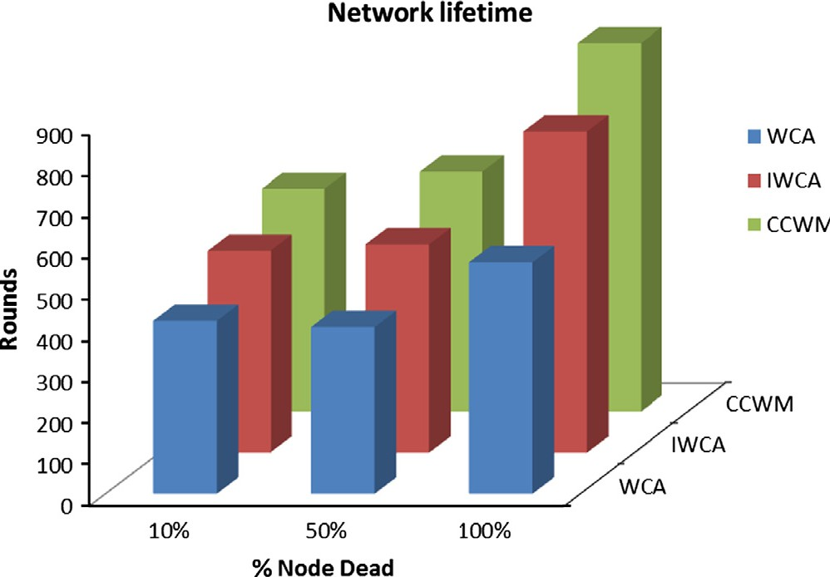Figure 6 Network lifetime.

Table 7 Network specifications.

Parameters Value

Network size 100 · 100 m

Number of sensor nodes 100

Threshold distance, *d*0 70 m

*Eelec* 50 nJ/bit

∈*amp* 100 pJ/bit/m2

Initial energy, *E*0 2J

Base station location (50,175) m

EDA 5 nJ/bit/signal

Data packet size, *k* 2000 bits

Transmission range, txRange 25 m

*a* 0.3

*b* 0.3

*c* 0.4

*Ei* is the energy consumed by the node in rounds. It can be clearly seen from Fig. 8, CCWM reduces energy consumption of the network significantly as compared to WCA and IWCA. This is due to the selection criteria where a path loss factor has been considered along with energy and degree. The role of the CH can be switched dynamically and consequently traffic load among all the nodes in a cluster can be distributed evenly. Data transfer is done through multiple paths using scheduling, thus energy consumed by the nodes will be less. Thus a fair approach is designed that balances well between inter-cluster and intra-cluster approach. This protocol outshines WCA and IWCA on these factors.

* 1. *Impact of local clustering*

Impact of using the local clustering mechanism for CH selec- tion significantly reduces the energy consumption of the net- work. As CH is selected locally an overhead involved in sensing, communication and computation is less and the deci- sion for next CH is taken locally within the cluster. The infor- mation of its member nodes is maintained locally by the cluster head. The re-clustering procedure will be called only when the old CH residual energy becomes less than 75% of its member node energy in the cluster. This leads to an improvement of 14% on an average when compared to the results when no REC is called (see Fig. 9).

From Fig. 10, it can be inferred clearly that with the increase in transmission range, average number of CHs will

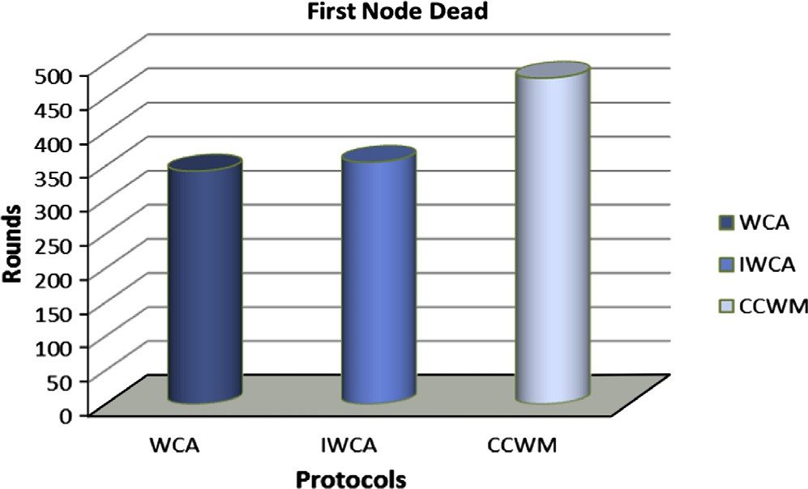

200

Total Energy Consumption over Time

CCWM WCA IWCA LEACH

180

Total Energy Consumption (J)

160

140

120

100

80

60

40

20

0

0 50 100 150 200 250 300 350 400 450 500

Time (s)

Figure 7 First node dead vs. rounds. Figure 8 Total energy consumption over time.

198 S. Mahajan et al.

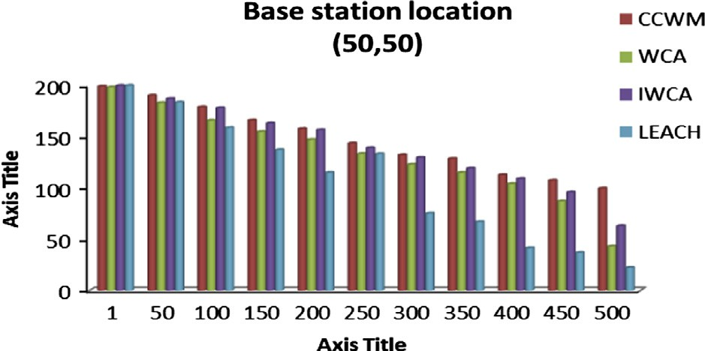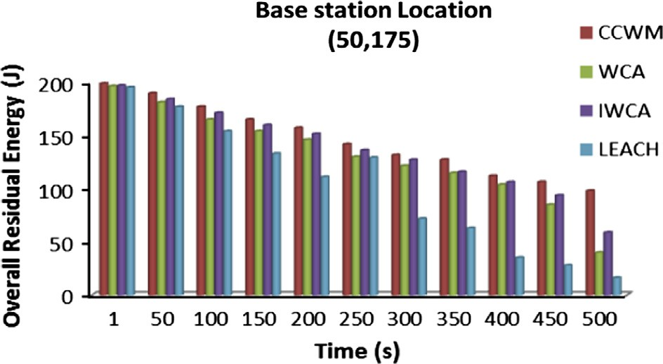

120

100

80

CCWM with no REC mechanism CCWM with REC mechanism

Total Energy Consumed (J)

60

40

Figure 12 Base station location at (50,50).

20

0 0 50 100 150 200 250 300 350 400 450 500

Time (s)

Figure 9 Impact of local clustering.

70

Transmission range Vs clusters

IWCA WCA

CCWM

60

50

Number of clusters

40

30

20

10

0

5 10 15 20 25

Transmission range

Figure 10 Transmission range vs. clusters.

decrease. This is due to the fact that nodes with large transmis- sion range will cover larger area. As a result, the number of disjoint clusters formed will be less. The cluster formation is non-uniform and the maximum nodes that can be accommo- dated by any cluster in CCWM is 20. This shows the number of clusters formed in CCWM is less as compared to the clusters formed in WCA and IWCA.

The impact of varying the transmission range over the pro- tocols can be seen clearly from Fig. 11. Lesser the transmission range more will be the number of clusters. Larger number of

65

Transmission Range Vs Energy consumed in 100 Rounds

WCA IWCA CCWM

60

Total Energy Consumed (J)

55

50

45

40

35

30

25

20

5 10 15 20 25

Transmission Range (m)

Figure 11 Transmission range vs. energy.

Figure 13 Base station location at (97,100).

clusters results in more consumption of energy. In WCA and IWCA, with low transmission range energy consumption is more whereas CCWM consumes energy in a more balanced way. The consumption of energy in WCA and IWCA is more as more CHs will try to send data to the base station using direct link. As link distances increase, energy consumption also increases. In CCWM, data are sent to the base station through short parallel chains.

* 1. *Impact of change of base station location on energy*

Base station locations are changed from upper right corner of the field to the center of the network field and its impact on dif- ferent protocols can be seen in Figs. 12 and 13. In WCA and CCWM, consumption is uniform as compared to LEACH and IWCA since load is evenly balanced. Data are transferred from CH to the base station through parallel chains using short distances. If link distances are less, the energy consumed in transferring data among CHs to base station is also less. LEACH and IWCA show better performance when base sta- tion is at the center of the field. As link distance decreases and it has a profound impact as data are transferred directly from CH to base station.

1. Conclusion

A cluster head selection technique is proposed by limiting the node degree. This method not only reduces energy consump- tion but also balances load by selecting the cluster head nodes first and then forming the well distributed clusters. This approach can be applied to variety of applications by varying performance parameters as per the application environment. Adaptation of local clustering mechanism results in an

improvement of 14% as compared to when no such mecha- nism is used. This not only reduces the overhead of the net- work but also reduces the communication cost. The simulation result shows CCWM outperforms LEACH, WCA and IWCA by achieving higher energy efficiency, better load distribution and extending network lifetime. This can be used for real time traffic.

References

1. Heinzelman WR, Chandrakasan AP, Balakrishnan H. Energy efficient communication protocol for wireless micro sensor networks. In: Proceedings of the Hawaii conference on system sciences; 2002. p. 3005–14.
2. [Kumar K. Principles and protocols for power control in wireless](http://refhub.elsevier.com/S1110-8665(14)00032-2/h0010) [ad hoc network. IEEE J Selected Areas Commun 2005;23:76–88](http://refhub.elsevier.com/S1110-8665(14)00032-2/h0010).
3. [Heinzelman WR, Chandrakasan AP, Balakrishnan H. An appli-](http://refhub.elsevier.com/S1110-8665(14)00032-2/h0015) [cation-specific protocol architecture for wireless micro sensor](http://refhub.elsevier.com/S1110-8665(14)00032-2/h0015) [networks. IEEE Trans Wireless Commun 2002;1(4):660–70](http://refhub.elsevier.com/S1110-8665(14)00032-2/h0015).
4. [Chatterjee M, Das, Turgut. WCA: a weighted clustering algo-](http://refhub.elsevier.com/S1110-8665(14)00032-2/h0020) [rithm for mobile ad hoc networks. Cluster Comput](http://refhub.elsevier.com/S1110-8665(14)00032-2/h0020) [2002;5(2):193–204](http://refhub.elsevier.com/S1110-8665(14)00032-2/h0020).
5. [Hong Tzung-Pei, Wu Cheng-Hsi. An improved weighted cluster-](http://refhub.elsevier.com/S1110-8665(14)00032-2/h0025) [ing algorithm for determination of application nodes in hetero-](http://refhub.elsevier.com/S1110-8665(14)00032-2/h0025) [geneous sensor networks. J Information Hiding Multimedia](http://refhub.elsevier.com/S1110-8665(14)00032-2/h0025) [Signal Process 2011;2(2):173–84](http://refhub.elsevier.com/S1110-8665(14)00032-2/h0025).
6. Nie J. The optimized method of cluster head deployment based on Ga-WCA in WSN. In: International conference on computer application and system modeling. ICCAISM’10; 2010. p. 449– 52.
7. Boregowda S, Puttamadappa C, Davanakatti Shivaraj S. An optimized weight based clustering algorithm in heterogeneous WSNs. ICAITA; 2012. p. 185–95.
8. [Rana K, Zaveri M. Synthesized CH selection and routing for two](http://refhub.elsevier.com/S1110-8665(14)00032-2/h0040) [tier WSN. J Comput Networks Commun 2013;2013](http://refhub.elsevier.com/S1110-8665(14)00032-2/h0040).
9. [Mahajan S, Malhotra J, Sharma S. Improved enhanced chain](http://refhub.elsevier.com/S1110-8665(14)00032-2/h0045) [based energy efficient WSN. WSN J 2013;5(4):84–9](http://refhub.elsevier.com/S1110-8665(14)00032-2/h0045).
10. Dahnil Putri, Singh Yaswant Prasad, Ho Chin Kuan. Connectiv- ity-aware and minimum energy dissipation protocol in wireless sensor networks. Int J Distributed Sensor Networks 2013;2013:1–8. Article ID 153089, [http://dx.doi.org/10.1155/](http://dx.doi.org/10.1155/2013/153089) [2013/153089](http://dx.doi.org/10.1155/2013/153089).
11. Ranvier S. ‘‘Path Loss Models’’. S-72.333 Lectures physical layer methods in wireless communication systems. Radio Laboratory, HUT; 2004.