

[Egyptian Informatics Journal (2011) 12, 9](http://dx.doi.org/10.1016/j.eij.2011.02.006)–[17](http://dx.doi.org/10.1016/j.eij.2011.02.006)

Cairo University

Egyptian Informatics Journal

[www.elsevier.com/locate/eij](http://www.elsevier.com/locate/eij) [www.sciencedirect.com](http://www.sciencedirect.com/science/journal/11108665)

ORIGINAL ARTICLE

An intelligent hybrid scheme for optimizing parking space: A Tabu metaphor and rough set based approach

Soumya Banerjee a,*, Hameed Al-Qaheri b

a *Birla Institute of Technology, CS Dept., Mesra, India*

b *Kuwait University CBA, QMIS Dept., Kuwait*

Received 6 June 2010; accepted November 2010

Available online 24 March 2011

Abstract Congested roads, high traffic, and parking problems are major concerns for any modern city planning. Congestion of on-street spaces in official neighborhoods may give rise to inappropri- ate parking areas in office and shopping mall complex during the peak time of official transactions. This paper proposes an intelligent and optimized scheme to solve parking space problem for a small city (e.g., Mauritius) using a reactive search technique (named as Tabu Search) assisted by rough set. Rough set is being used for the extraction of uncertain rules that exist in the databases of park- ing situations. The inclusion of rough set theory depicts the accuracy and roughness, which are used to characterize uncertainty of the parking lot. Approximation accuracy is employed to depict accu- racy of a rough classification [1] according to different dynamic parking scenarios. And as such, the hybrid metaphor proposed comprising of *Tabu Search* and *rough set* could provide substantial research directions for other similar hard optimization problems.

© 2011 Faculty of Computers and Information, Cairo University. Production and hosting by Elsevier B.V. All rights reserved.

KEYWORDS

Parking space management; Parking space optimization; Tabu Search;

Rough set; Rule extraction

* Corresponding author.

E-mail addresses: [soumyabanerjee@bitmesra.ac.in](mailto:soumyabanerjee@bitmesra.ac.in) (S. Banerjee), [alqaheri@cba.edu.kw](mailto:alqaheri@cba.edu.kw) (H. Al-Qaheri).

1110-8665 © 2011 Faculty of Computers and Information, Cairo University. Production and hosting by Elsevier B.V. All rights reserved.

Peer review under responsibility of Faculty of Computers and Information, Cairo University.

doi:[10.1016/j.eij.2011.02.006](http://dx.doi.org/10.1016/j.eij.2011.02.006)

Production and hosting by Elsevier

1. Introduction

The significant and dramatic increase in demand for parking spaces due to the increase of on the road vehicles in cities and urban areas around the world on one hand and the signif- icant shortage of these parking spaces created a challenging problem for managing these spaces. Although on the road parking spaces in most of the cities are metered, which should reduce the demand, the demand is still significantly high lead- ing also to congested roads and overcrowded transit lines as well as increase in travel time and costs. This demand also leads to economic, social, and environmental losses. And with the continuous increase in the population, the problem be- comes more critical. As such parking space optimization and

10 S. Banerjee, H. Al-Qaheri

control has become a real challenge for city transportation planners and traffic authority. And despite the fact that most of the modern planned cities provide adequate support and guidance to the drivers about the parking slot selection and effective utilization of parking space, in terms of variable mes- sage signs, directional arrows, names of the parking facilities, status, number of available parking spaces, proper entry, exit point of parking, etc. [2], traffic system and drivers face ex- treme difficulties especially during festival time and in unpre- dictable situations of traffic congestion.

This paper proposes a novel software interface to guide and assist the drivers for better parking space utilization and to tackle unpredictable congested traffic situation on road. The interface is based on an intelligent hybrid scheme combining a Tabu metaphor and rough set for parking space optimiza- tion. The interface could be initially tried as off-line decision support system and subsequently it could be incorporated in an on-line traffic network whereby the delivery of instruction could be mobile phone-based audio instruction. To handle unpredictable situation of traffic and assist the driver with a crisp decision of parking guidance, the proposed model uses a customized *Tabu Search* approach metaphorically con- structed and supported by the rough set rules. *Tabu Search* meta-heuristic [3–5] works based on the use of *prohibition- based* techniques and intelligent schemes as a complement to basic heuristic algorithm like local search, with the purpose of guiding it *beyond local optimality*. Subsequently, Rough set is used as a powerful tool for managing uncertainty that arises from inexact, noisy, or incomplete information created due to random traffic conditions. Besides data reduction, rough sets theory [6,30–33] is also suitable for the problems of features dependencies to evaluate the significance of fea- tures, deal with data uncertainty and vagueness, discover cause-effect relationships, generate decision algorithms from data, and approximate classification of data. The proposed model was validate and the interface was test using traffic data related to a medium city (the city Mauritius) as a case study. The result of the simulation is also presented.

The rest of the paper is organized as follows: Section 2 pre- sents a brief review of recent literature. Section 3 formulates

and defines parking space problem in which Tabu Search

Shoup [12] presented a model of how drivers choose between cruising for curbside parking or pay for off-street parking. Teodorovic and Lucic [13] proposed an intelligent parking space inventory system. The system is based on a combination of fuzzy logic and integer programming techniques that would allow making online decisions to accept or reject a new driver’s request for parking. Benenson et al., [14] presented an agent- based system that simulates the behavior of each driver within a spatially explicit model. The system captures, within a non- homogeneous road space, the self-organizing and dynamics of a large collective parking agents. Estimation of parking lots footprint across a four state region is presented in [16]. Feng et al., [17] designed a combined trip network for congested road-use pricing and parking pricing which was based on Lo- git. Using a utility function, combining travel time, search time, waiting time, access time, and parking price, a Probit- based parking pricing is formulated for curb parking pricing [18]. Chou et al., [19] presents an intelligent agent system with negotiable parking pricing for optimum car park for the driver.

1. Problem definition and formulation

A car park consists of *n* numbered spaces in a line. The drivers of *m* cars have independently chosen their favorite parking spaces. Each driver arrives at the car park and proceeds to his chosen space, parking there if it is free. If the chosen space is occupied, the driver continues on toward the larger-num- bered spaces and takes the first available space if any; if no such space is available, the driver leaves the car park. The probability that everybody parks successfully and number of the *nm* sequences of choices by the drivers leading to everyone parking is a mathematical function is known as *parking func- tion* [20].

Hence, for a generalized parking function, the given a se- quence *x* = *x*1, *x*2, .. ., *xn.*

* + An *x*-parking function is a sequence of non negative inte- gers *u* = *u*1, *u*2, .. ., *un*,

such that once sorted as *u*' = *u*' ; *u*' ; .. . *u*' such that *u*' 6 *u*'

and rough set is discussed. In Section 4 results and implications are presented followed by the conclusion in Section 5.

2. Review of literature

one has for all *i*:

X*i*

*u*' <

*i*

*xj*

*j*=1

1 2 *n*

*i i*+1

Parking space problem has been addressed by many research- ers. The following is a review of some of the recent papers.

Caicedo [7] used two different ways to manage space avail- ability information in parking facility within PARC system to reduce search times. Caicedo [15] develops a demand assign- ment model with the intention of reducing the time and dis- tances involved in finding a parking space. Zhao and Collins

[8] developed an automatic parallel parking algorithm for parking in tight spaces using a novel fuzzy logic controller. Space allocation of parking lots was analyzed by Davis et al.

[9] to estimate the supply of parking spaces to potential de- mand. Using a fuzzy knowledge-based Decision Making, Leephakpreeda [10] presented a car-parking guidance. Arnott and Rowse [11] developed an integrated model for curbside parking and traffic congestion control in a downtown area.

* Note that the usual parking functions are (1, 1, 1, .. ., 1)- parkings.

More recently Stanley and Pitman [21] generalized this no- tion by introducing what is called (*a*, *b*)-parking functions. A (*a*, *b*)-parking function of length *n* is defined as a sequence *p* = *p*1, *p*2, .. ., *pn* of non negative integers less than *a* + *bn*

such that, for all *i* we have, pi < (*ai* — 1)*b* + *a*. It is often said such that there exists a permutation *a* = *a*1, *a*2, .. ., *an* of *Gn* that such permutation is a certificate for the sequence *p*. For

instance, 7, 0, 4 is a (4, 2)-parking function, for which 3, 1, 2 is a certificate; but 3, 7, 6 is not. It is easy to check that any sequence obtained by permuting the elements of an (*a*, *b*¯)-park-

ing function is also an (*a*, *b*)-parking function. Hence, an easy way to check that a sequence *p* = *p*1, *p*2, .. ., *pn* is an (*a*, *b*)-

An intelligent hybrid scheme for optimizing parking space: A Tabu metaphor and rough set based approach 11

parking function consists in reordering *p* such that to obtain a weakly increasing sequence.

Drivers around the world pay for using different parking facilities and as such and in some instances, traffic congestion can be significantly reduced as a result of parking price. Hence, different parking pricing strategies could be a part of the com- prehensive solution approach to the complex traffic congestion problems [2]. Parking management system must satisfy the flowing constraints [2]:

* Demand for parking should be considered as variable over time;
* Parking spaces should also be booked against advanced payment;
* Parking lot or garage is limited in space and as such cannot support variable demand;
* Occupancy time should be considered as a variable in parking.
  1. *Tabu metaphor and rough set for handling parking function*

Initially proposed by Glover in 1989 [3], the Tabu Search meth- od as a technique used in combinatorial optimization problems was adopted later in his work in 1997 [4]. Tabu Search can be de- fined as a meta-heuristic procedure, which uses a local search subroutine in order to find local optima. Unlike other local search approaches, Tabu Search stores information on the paths that have been previously visited (previous solutions) by using memory structures known as tabu lists, thereby preventing the search from cycling and becoming trapped in a local search. Since the tabu list is a short-term memory of previously visited solutions in the search, its size greatly determines how many iter- ations cannot be called again in the search (commonly referred to as tabu). This suffices to be one of the limitations of this tech- nique as it may restrict the search too much, thus preventing some promising moves to the most probable solution in the search space. Tabu Search has been applied to a wide range of optimization problems that involve various classes of integer problems.

Using tabu, the simple car parking problem could be pre- sented with the probability that everybody parks successfully and the question of how many of the *nm* sequences of choices by the drivers lead to everyone parking remain to be answered [20]. In the following, we elaborate and coined cases, where a simple parking function is introduced and then the problem is further expanded in the context of rough set guided *Tabu Search* process.

Let *f* be a mapping from cars {1, .. ., *n*} to parking spaces

{0, .. ., *n* — 1} in a one way street. In this case, the situations are:

The cars arrive in order with the *i*th arrival being assigned position *f* (*i*).

If an earlier car already took the spot, then car *i* will try the next place along until it parks or fails at the last parking space and relinquishes as afterward.

If no car is compelled to relinquish, then the corresponding situation becomes only true for the first four sequential cars numbered accordingly and by Cayleey’s formula there are

*nn*—2 labeled trees on *n* vertices. Therefore, the issue of optimiz-

ing the parking space arises.

The bi-jection paradigm could also be correlated.

Considering nine cars in a single situation, the following scheme is derived as also shown in Fig. 1.

Nine cars are not placed in a sequence; therefore, this could be one possible combination:

*A*0 = {2, 5, 7}, *A*2 = B, *A*3 = {4}, *A*4 = B, *A*5 = {1, 6, 8},

*A*6 = B, *A*7 = {9}, *A*8 = B, *A*9 = B; where, *A* denotes car number and B indicates empty set.

Here, we formulate a proposition, where car number 6 is

occupying less time in parking zone and it is about to leave, whereas, car number 9, is just entering into parking queue and it may occupy car number 6’s position. Theoretically, an order (*n* + 1) labeled tree could be obtained, which is also a connected graph with set of vertices {0, 1, 2, 3, .. ., *n*}, and with *n* edges.

In this context, we have been motivated by reactive search [22–24] and introduce a rough set guided Tabu Search, which slowly but steadily improves the solution and could bypass the local minimizer. The typical feature of the proposed model is

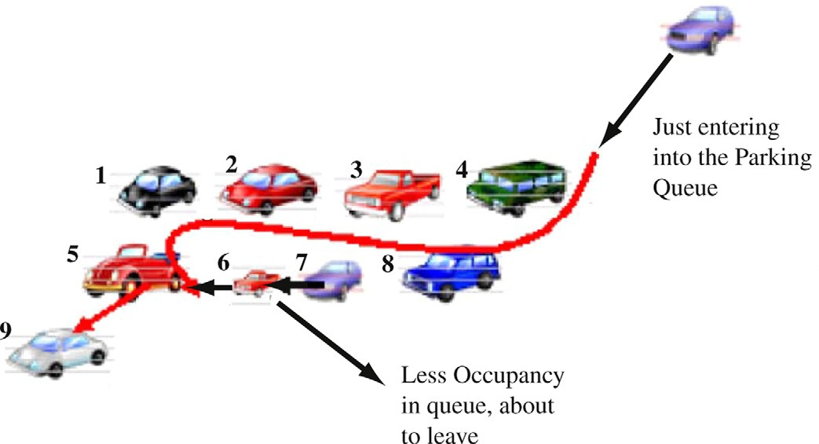

Figure 1 Parking function thematic illustration.

12 S. Banerjee, H. Al-Qaheri

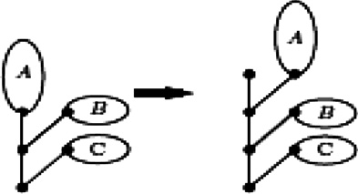

Figure 2 Proposed polytonic positions of parking spaces A, B and C – with different edge length.

to consider all real time attributes related with data assisted by rough set to quantify parking space search process. It has been also suggested to develop control panel software to find out optimum parking space and establish the polytonic attributes in our proposed parking model, where parking function has

been kept generalized. Therefore, the sub graph on original

belong to *X*, and the boundary region of *X* consists of all ele- ments that cannot be classified uniquely to the set or its com- plement, by employing the available knowledge [33]. In the following, the measure proposed for the parking information system has been simplified, where *U* = {*u*1, u2, u24} and *A* = {*a*1; *a*2; *a*3; *a*4 with *a*1 = effective parking slot, *a*2 = aver- age numbers of vehicle to be parked on a day, *a*3 = duration and *a*4 = different parking probabilities for drivers. Let *R* be an equivalence relation defined on *U* and let *R*1 = {*a*1, a2} and *R*2 = {*a*1; *a*2; *a*3} [1].

Let *S* = (*U*, *A*) be an information system and

*U* = *A* = {*X*, *X*2, .. ., *Xm*}

A knowledge granulation of *A* is given by:

*m*

GK(*A*)= |*X* |2

1 X

|*U*|

*i*=1

*i*

parking space, has been defined in the form of di-graph. Final-

ly the searching on di-graph for best or optimum edge is accomplished with the help of rough set rules.

If A, B and C are three interchangeable parking spaces, their arrangements could be made polytonic with different positional digraph orientations with different edge length as shown in Fig. 2.

Similarly, once the different positing of parking spaces have been identified, the other toll rough set is introduced to impro- vise the marginal parking scenario and thus lead toward better optimization.

There are two general kinds of decisional rules in classic rough set theory [25]. The first is the *exact decisional rule*, named also deterministic, where the decisional set (the cost) contains the conditional attributes (area or other features). The second is the *approximate decisional rule* in which only some conditional attributes (area or other features) are in- cluded in the decisional set (price) [5,26]. In this case of park- ing function, the causal relationships between the property features and its value are appraised without any uncertainty. The logical prepositions *if*.. .*then* allow the user to create a

preferential system based on the property market data. The

*granularity* of the system, its uncertainty can be increased in case the information is based on a few observations [5]. An example [26] of rule that may be used for valuation purposes is indicated below:

If near_ parking_dist = *x* ( time_occupancy = ‘‘LESS’’ (

Date ( YEARS = Z → cost of parking is high)

//Sample Parking Map Rule 1

If arrival_time = *y* (not peak hour), then *y* v *Z* ( probability of available parking space → cost of parking is less with high probability of parking space

//Sample Parking Map Rule 2

(*L*,*U*) ∈ *P*(*U*) × *P*(*U*) is called a rough set in *A*, where Let *A* = (*U*, IND (*B*)) be an approximation space. A pair *L* = *A*(*X*), *U* = *A*(*X*) for some *X* c *U* and *P*(*U*) is the power

set of *U*. Due to the granularity of knowledge, rough sets can- not be characterized by using available knowledge. Therefore, for every rough set *X*, we associate two crisp sets, called lower and upper approximation. Intuitively, the lower approximation of *X* consists of all elements that surely belong to *X*, the upper approximation of *X* consists of all elements that possibly

By computing, we have GK (*R*1) = 0:132 and GK

(*R*2) = 0:090. It is the difference between the knowledge of granulation of *R*1 and that of *R*2. In fact, *U*/*R*1 c *U*/*R*2 i.e. *R*2 is finer than *R*1.

Let, *X*1 = {*u*4; *u*5; *u*6; *u*17; *u*23},

*X*2 = {*u*1; *u*2; *u*3; *u*8; *u*11}, *X*3 = {*u*8; *u*11; *u*12; *u*15},

*X*4 = {*u*1; *u*4; *u*5; *u*9; *u*14; *u*19; *u*21; *u*22; *u*23} and *X*5 = {*u*6; *u*7; *u*11; *u*12; *u*15; *u*17; *u*18; *u*21; *u*24}. *X*6 = {*u*25; *u*26; *u*27; *u*28; *u*31}.

Apart from five sets (that follows standard lower and upper approximation similar to [1], (Table 3a), the sixth is a different one, which comprises overlapping parking events (event *u*29 and *u*30. However, these sets may have different Roughness

(*X*) (Table 3b), which has been adopted from [1]. After follow- ing the roughness table from [1], the model identifies the ambiguous parameters.

This is caused by the fact that *R*1 and *R*2 have different knowledge granulations. Thus, under the measure proposed in this paper, the uncertainties of *X* with respect to different equivalence relations are well characterized [1].

Rough set system helps us determine in real time for every parking tariff class, the time moment after which there are no longer vacant parking spaces for the drivers request- ing it. In any time moment *t*, we will know the remaining time interval *T*(*t*) for selling parking spaces to a particular parking tariff class. It is clear that *T*(*t*) depends on the cumulative numbers of drivers requesting a particular tariff class *Di* (*t*), (*i* = 1, 2, 3, ...). The cumulative numbers of dri- ver requests are antecedents, while remaining time period for selling the parking spaces *T*(*t*) is the consequence [2,27]. As such a parking information system is a pair *S* = (*U*; *A*), where,

* + - *U* is a non-empty finite set of objects which is the number of cars *C* here to be under queue of parking; *n* are the parking

slots and *k* are un-parked drivers if any.

* + - For every *a* ∈ *A*, there is a mapping a, a: *U* → *Va*, where *Va*

is called the value set of *a*. Each subset of attributes *P* c *A*

determines a binary indistinguishable relation *Opti(Park)*

as follows:

*Opti*(*Park*)= {(*u*; *v*)∈ *U* × *U*|∀*a* ∈ *P*; *a*(*u*)= *a*(*v*)}

(1)

It can be easily shown that *Opti(Park)* is an equivalence

relation on the set *U* [28]. Similarly, to formulate the *l*, this

|  |  |
| --- | --- |
| Table 1 Parking slot distribution in Mauritius. | |
| Name of parking area | Actual parking slots available |
| Port Louis | 1598 |
| Curepipe | 170 |
| Rose Hill | 230 |
| Quatre Bornes | 127 |
| Data provided by Department of Public Infrastructure, Land and Transport, Govt. of Mauritius. | |

as an information system *S* = (*U*; *C* ∪ *D*)*withC* ∩ *D* = £, is the valid move for parking car, we can define a decision table where, an element of *C* is called a condition attribute, an

element of *D* is called a decision attribute [1]. Table 1 demonstrates the parking area assigned in a small city

e.g. Mauritius and their actual capacity defined in terms of

parking space. Depending on the data provided in Tables 1 and 2 present the effective and functional parking slots available.

|  |  |  |  |  |
| --- | --- | --- | --- | --- |
| Table 2 Statistical snapshot about car parking in Mauritius (weekly data). | | | | |
| Day | Effective parking slots available | Avg. No. of vehicles on a day | No. vehicle parked | Duration (min./max.) |
| 1 | 1590 | 988 | 923 | 30 min/4 h |
| 2 | 1582 | 1005 | 910 | 15 min/3 h |
| 3 | 1587 | 990 | 934 | 30 min/4 h |
| 4 | 1584 | 885 | 780 | 45 min/3 h |
| 5 | 1591 | 1021 | 990 | 311 min/5 h |
| 6 | 1576 | 940 | 880 | 15 min/3 h |
| 7 | 1588 | 970 | 905 | 30 min/4 h |
|  |  |  |  |  |

Table 3a Parking problem parameters against different ambiguous parameters.

Parking events

*u*1 *u*2 *u*3 *u*4 *u*5 *u*6 *u*7 *u*8 *u*9 *u*10 *u*11 *u*12 *u*13 *u*14 *u*15 *u*16 *u*17 *u*17 *u*18 *u*19 *u*20 *u*21 *u*22 *u*23 *u*24 *u*25 *u*26 *u*27 *u*28 *u*31

Effective parking slot

Available Not available Available

Not immediate Not available Available normal Not immediate

Available with time limit Available

Not available in time Not immediate Available normal Available

Not available in time Available

Not immediate

Not available in time Available

Not available in time Available with time Available with time limit Not available in time Not immediate Available

Available

Not immediate Available with time limit

Average density of vehicle to be parked

High High Medium

Moderately med. Moderately avg. Highly dense Moderately high High

Very high Low

Moderately low Very low

High Normal

Not exactly known High

Moderately medium High

Normal High

Not exactly known Low

Moderately low Medium

Very high Moderately low Not exactly known

Duration

Long Short

Moderately short Normal

Avg. Long Timely Avg.

Moderately short Normal

Long May vary Short Long May vary Long Timely Long Long Avg.

May vary Normal Long

Moderately short Moderately short Long

May vary

Parking probabilities

Neal May vary Very high Medium May vary Neal

Low

Very high Neal Very high High Very high May vary Medium Low

Low Neal Neal Medium

Very high Low

Very high High Very high Neal High Low

Available

Overlapping

Medium

Not defined

Moderately short

Not defined

Very high

Not defined

Table 3b Lower and upper bound of the proposed rough model

*X R*1*X* = *R*2*X*

*X*1 {*u*4, *u*5, *u*23}

*X*2 {*u*1, *u*2, *u*3}

*X*3 {*u*11, *u*12}

*X*4 {*u*4, *u*5, *u*9, *u*21, *u*22, *u*23}

*X*5 {*u*6, *u*7, *u*11, *u*12, *u*17, *u*18, *u*24}

*X*6 {*u*25, *u*26, *u*27, *u*28,, *u*31}

*R*¯1*X* = *R*¯2 *X*

{*u*4, *u*5, *u*6, *u*7, *u*17, *u*18, *u*23, *u*24}

{*u*1, *u*2, *u*3, *u*8, *u*10, *u*11, *u*12}

{*u*8, *u*10, *u*11, *u*12, *u*15, *u*16}

{*u*1, *u*2, *u*3, *u*4, *u*5, *u*9, *u*13, *u*14, *u*19, .. .*u*23}

{*u*6, *u*7, *u*11, *u*12, *u*15, *u*16, *u*17, *u*18, *u*21, *u*24}

Marginal resultant of *R*1*X= R*2*X With overlaps*

* + - Statistics of car parking (mostly taxi) of seven continuous days have been recorded (Table 2).
    - Day 5th and 6th (Bold part in Table 2) envisage high den- sity of car arrived and least parking spaces available,

any iteration for searching optimal parking space, the length of the Tabu list is calculated as half of the smallest distance be- tween the Tabu points and the marginal points and could be represented as [24]:

respectively.

*v* = *u*

1 *L*

1 *k j j*

(3)

* + - The duration of parking varies from minimum 15 min to 5 h in a particular day.

*t k*(0—1) 2

min = 2

min 

*j*=1

*xt* — *xu *

* + - Statistically, it is also observed that for each day the parking space is not adequate except the day 5th when only 31 cars

did not get appropriate available parking space in the city.

* + - The statistical data are used for the proposed simulation for finding the optimal space of through intelligent methodology.

The available number of parking spaces must be updated every time a driver is accepted for parking. The algorithm de- scribes the rough set guided *Tabu Search* engine for parking space optimization and control in the following steps:

*Step 1:* Record all cumulative *Ri* (*t*) that are based on a large number of driver requests for parking in the parking slot in a particular area. Similarly, establish an objective function based on the constraints.

*Step 2:* Analyze the area, where the parking slot is located and the following parameters are recorded:

* + - the asymptotical behavior of the parking slot distribution;
    - limiting probability that all parking spaces are occupied;
    - let *a*(*r*,*s*,*k*) denotes the numbers of choices for which *r* spaces remain unoccupied, *s* spaces are occupied at the end, and *k*

people drive home [20];

Where, subscripts *u* and *t* represent the promising points and

the Tabu lists, respectively. The parameter *t* specifies the min- imum Euclidean distance that must exist between each random point and Tabu points. It is important to note that using this scheme, the size of the Tabu list dynamically changes based on the distribution of the uncertain and the Tabu points in the parking solution space [24].

Thus, Eq. (3) is a measurable point to analyze the proposed

algorithm and differs from [24] by a coefficient multiplication factor *uk*(0—1) , which considers all the marginal and near condi-

tions evolved in real parking scenario. The range of this varies

from 0 to 1 units of near ness.

1. Result and implications

The proposed model rough set guided Tabu hybrid metaphor has been implemented on a test data using within MS Win- dows environment using C++. The simulation is supported by 3D plot demonstrating as followings:

* + initial parking space 1 against gradient and number of Tabu iterations;

8> 1 *ifr* = *s* = *k* = 0;

P

><

*a*(*r* — 1; *s*; 0)+

*k*+1 *s* + *k*

(

)· *a*(*r*; *s* — 1; *i*) *ifk* = 0*and*(*r* > 0*ors* > 0);

*a*(*r*; *s*; *k*)=

> P

:

*i*=0

(

*k* + 1 + *i*

)· *a*(*r*; *s* — 1; *i*) *ifk* > 0.

*k*+1 *s* + *k*

*i*=0

*k* + 1 + *i*

(2)

* + this also leads to the fact that there are *n* = *r* + *s* spaces in total, and that *m* = *k* + *s* drivers arrive [20].
  + Hence, *Opti(Park)* is recursive in nature and may be expressed as follows [2,20]:

*Note:* This will not be true when the uncertain distribution is involved.

[according to *Opti*(*Park*)= {(*u*; *v*)∈ *U* × *U*|∀*a* ∈ *P*; *a*(*u*) *Step 3:* Formulate a corresponding optimization problem

= *a*(*v*)}] and find the optimal parking move *l*, for each

generated drive’s assignment for parking comprising of asgd

(*n*, *m*, *k*).

*Step 4:* Based on the statistical data resulting from Steps 1 and 2, use some of the existing algorithms [1] to generate the rough set as upper and lower approximation.

* 1. *Stopping criteria and measurement of optimal parking*

Various stopping conditions can be applied to the proposed algorithm. The algorithm may stop when a maximum number of evaluations; a minimum value of the weighted variance or a maximum number of iterations (without any significant improvement in the objective function) is reached. During

* + - parking space 2 against gradient and number of Tabu iterations;
    - identifying extreme parking space, when the uncertainty dis- tribution in parking function becomes high.

The three parameter sets help to investigate the perfor- mance of the proposed algorithm.

In the post implementation phase of the proposed algo- rithm, a 3D plot is prepared in Fig. 3, which comprises a num- ber of iterations. This plot demonstrates availability and probability of parking space in the first set of iterations. The gradient value is considered under rough set rule. It implies that, in the first set of search optimization, parking space be- comes stiffer and most of the cars were un-parked (similar to the statistics of 4th day given in Table 2 where 105 cars remained un-parked). Only gray colored portion in the plot was facilitated (0.2–0.3 units of parking space 1) with proper parking space. Similarly, the value of gradient becomes stiffer but covers wider parking space. Still the convergence is not able to cover the uncertain and extreme conditions. Therefore, plot of parking space 2 against gradient and Tabu iterations shown in Fig. 4 offers >1.2 units of space in parking slot. This

case is analogous to Cayleey’s formula and there are *nn*—2 la-

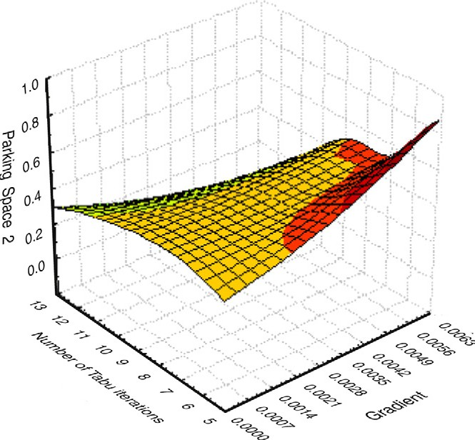

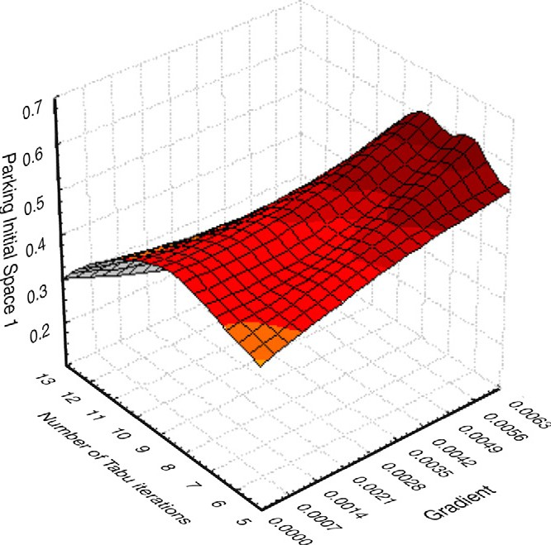Figure 3 Initial parking space and gradient value (under rough set).

Figure 5 Plot of parking function using hybrid metaphor in uncertain and extreme condition.

0.00

**Parking Fraction**

1.0 **0.700**

**0.731**

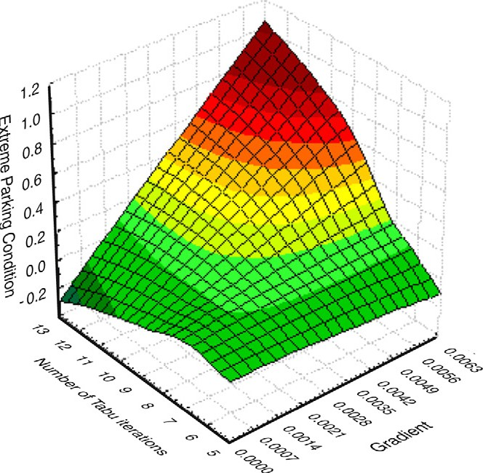0.75

0.50

0.25

0.8

0.6

0.4

**0.756**

**0.781**

0.2

1.00 0.0

0.00 0.25 0.50 0.75 1.00

Medium Tendencey

Figure 6 The snapshot of parking slot under medium and coarse tendency.

Figure 4 Intermediate parking space and gradient value – marginal parking.

beled trees on *n* vertices, where car number 9 is just entering into parking queue expecting car number 6 is coming out of the queue (Fig. 1 in Section 3.2). Hence, it is an example of marginal parking condition.

In Fig. 5 extreme car parking criterion is presented through proposed rough set guided Tabu Search. The performance is satisfactory and covers more confident parking space till 0.4 unit space and still maintains a straight gradient irrespective of uncertain conditions. The uncertain conditions encompass

mainly occupancy time and variable size of parking space and vehicles.

Fig. 6 presents a plot which establishes that real attribute of parking under rough set guided Tabu Search condition could be different under slight variations and could be a prominent examples of *Marginal Set and near set* paradigm. While vary- ing parking fraction from 0.7000–0.781 units, the plot changes and optimum contour of plot is achieved (marked in Red). This also defines the minimum accuracy of {*u*25, *u*26, *u*27, *u*28, *u*31} under the decision variables and co-multiplication factor defined in Eq. (3).

1. Conclusion

In the given optimal parking problem, the problem size is directly correlated with the number of vehicles to be parked. Since large number of vehicles in parking lot usually need large initial tabu privileges, the initial tabu structure is de-

fined as the total number of vehicle multiplied by a coeffi- cient. In the research documented here, a coefficient has been selected based on empirical tests [29]. The upper bound and lower bound of the tenure is set to the maximum of ini- tial tabu space and has been further tuned with rough set rule set. Thus, the upper bound and the lower bound are proportional to the problem size and stay within a reason- able range [29].

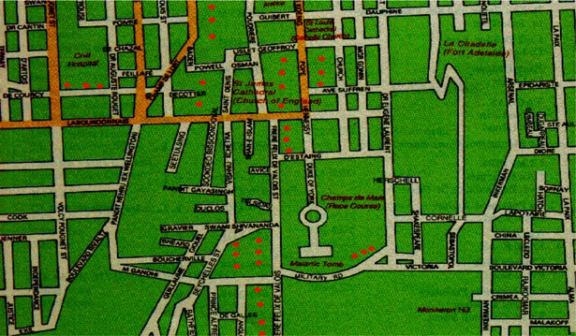

Reactive Tabu Search was used and the memory structure of the tabu was extensively used to control the search and to adjust the search parameters based on the quality of the search [29]. The quality of the search is determined by the frequency of revisiting previously visited solutions and the simplest way to identify the solution is to compare the routes with routes of all previously visited solutions. In order to identify previ- ously visited solutions efficiently, a two-level comparison mechanism was used. The solution history is composed of solution-identity information and visit information. The solu- tion identity information includes the objective function value and its hash value [29].

In contrast to conventional optimization of Tabu Search, in the proposed hybrid intelligent scheme of car parking a rough set methodology is incorporated to tackle the uncertainty pre- vailing in parking function. The asymptotic enumeration behavior of parking function is also studied and most impor- tantly, the nature of traffic for the development of the model has been considered as bi-directional (whereas mostly it refers to unidirectional in recent literature [20]). The intelligent scheme proposed could provide substantial research directions for other similar hard optimization problems.

A software interface for car parking inventory, encapsu- lating the above mentioned intelligent hybrid scheme was developed that could subsequently be used as an intelligent automation for queuing applications. The uncertainty and extreme conditions of car parking have been modeled through *rough set assisted Tabu Search techniques.* With the initial parameters, simulation produces a satisfactory re- sult. The intelligent hybrid scheme was validated using traf- fic data related to a small city and the software interface was tested with the thematic map of a city parking as shown in the Appendix.

Appendix A. Appendix

Partial Traffic thematic map of the capital of Mauritius, *Port Louis* is presented with red dots where parking slots are pro- vided. The simulation of the proposed model has been accom- plished on the sample traffic map. The database is supported

through Microsoft SQL Server and front end is developed using C++ within MS Windows environment.

References

1. Liang J, Wang J, Qian Y. A new measure of uncertainty based on knowledge granulation for rough sets. Inf Sci 2009;179:458–70.
2. Teodorovic D, Lucic P. Parking space inventory control: an artificial intelligence approach. Available at: <[http://www.ia-](http://www.iasi.cnr.it/ewgt/13conference/5_teodorovic.pdf) [si.cnr.it/ewgt/13conference/5_teodorovic.pdf>](http://www.iasi.cnr.it/ewgt/13conference/5_teodorovic.pdf).
3. Glover F. Tabu Search – part 1. ORSA J Comput 1989;3:190–260.
4. Glover F, Laguna M. Tabu Search. Boston, MA: Kluwer Academic Publishers; 1997.
5. Battiti R, Brunato M, Mascia F. Reactive search and intelligent optimization. Technical Report DIT-07-049, Universit‘a di Tren- to, 2007. Available at: <<http://reactive-search.org/>>.
6. Heda A, Wangy J, Fukushima M. Tabu Search for attribute reduction, in rough set theory, p. 1–15, 2006. Available at;

<<http://hedar.info/HedarFiles/TSAR.pdf>>.

1. Caicedo F. The use of space availability information in ‘‘PARC’’ systems to reduce search times in parking facilities. Transp Res Part C 2009;17:56–68.
2. Zhao Y, Collins Jr EG. Robust automatic parallel parking in tight spaces via fuzzy logic. Robot Auton Syst 2005;51:111–27.
3. Davis AY, Pijanowski BC, Robinson K, Engel B. The environ- mental and economic costs of sprawling parking lots in the United States. Land Use Policy 2010;27:255–61.
4. Leephakpreeda T. Car-parking guidance with fuzzy knowledge- based decision making. Build Environ 2007;42:803–9.
5. Arnott R, Rowse J. Downtown parking in auto city. Reg Sci Urban Econ 2009;39:1–14.
6. Shoup DC. Cruising for parking. Transp Policy 2006;13:479–86.
7. Teodorovic D, Lucˇ ic P. Intelligent parking systems. Eur J Oper Res 2006;175:1666–81.
8. Benenson I, Martens K, Birfir S. PARKAGENT: an agent-based model of parking in the city. Comput Environ Urban Syst 2008;32:431–9.
9. Caicedo F. Real-time parking information management to reduce search time, vehicle displacement and emissions. Transp Res Part D 2010;15:228–34.
10. Davisa AY, Pijanowskia BC, Robinsona KD, Kidwellb PB. Estimating parking lot footprints in the Upper Great Lakes Region of the USA. Landscape Urban Plan 2010;96:68–77.
11. Feng S, Yan C, Hengxin L, Lianbo D. Class of comprehensive optimization of congested road-use pricing and parking pricing. J Transp Syst Eng Inf Technol 2009;9:74–9.
12. Zhenyu M, Yiqiang X, Jun C, Wei W. Optimizing model of curb parking pricing based on parking choice behavior. Syst Eng Inf Technol 2010;10:99–104.
13. Chou S, Lin S, Li C. Dynamic parking negotiation and guidance using an agent-based platform. Expert Systems Appl 2008;35:805–17.
14. Cameron PJ, Johannsen D, Prellberg T, Schweitzer P. Counting defective parking functions. Electron J Combinatorics 2008;15:1–15.
15. Stanley RP, Pitman J. A polytope related to empirical distribu- tions, plane trees, parking functions and the associahedron. Discrete Comput Geom 2002;27:603–34.
16. Fukushima M. *Tabu Search* directed by direct search methods for nonlinear global optimization. Eur J Oper Res 2006;170: 329–49.
17. Battiti R, Brunato M, Mascia F. Reactive search, and intelligent optimization. Technical Report DIT-07-049, Universit‘a di Tren- to, July 2007. Available at: <<http://reactive-search.org/>>.
18. Karimi A, Nobahari H, Siarry P. Continuous ant colony system and Tabu Search algorithms hybridized for global minimization

of continuous multi-minima functions. Comput Optim Appl 2010;45:639–61.

1. Qian YH, Liang JY, Li DY, Zhang HY, Dang CY. Measures for evaluating the decision performance of a decision table in rough set theory. Inf Sci 2008;178:181–202.
2. Maurizio D’Amato Maurizio. Comparing RST with MRA as automated valuation methodologies. Int Real Estate Rev. 2007; 2.
3. Zhu W, Wang FY. Topological approaches to covering rough sets. Inf Sci 2007;177:1499–508.
4. Liang J, Shi Z, Li D, Wierman MJ. Information entropy, rough entropy and knowledge granulation in incomplete information systems. Int J Gen Syst 2006;35(6):641–54.
5. Yan M. Using advanced Tabu Search techniques to solve airline disruption management problems. Austin: University of Texas; December 2007, p. 1–111. Available at: <[http://www.lib.utex-](http://www.lib.utexas.edu/etd/d/2007/yangm23467/yangm23467.pdf) [as.edu/etd/d/2007/yangm23467/yangm2](http://www.lib.utexas.edu/etd/d/2007/yangm23467/yangm23467.pdf)3467.pdf>.
6. Pawlak Z. Rough sets: theoretical aspects of reasoning about data. Dordecht: Kluwer Academic Publishers; 1991.
7. Wierman MJ. Measuring uncertainty in rough set theory. Int J Gen Syst 1999;28:283–97.
8. Pawlak Z, Wong SKM, Ziarko W. Rough sets: probabilistic versus deterministic approach. Int J Man Mach Stud 1988;29:81–95.
9. Pawlak Z, Skorwon A. Rudiments of rough sets. Inf Sci 2007;177(1):3–27.