[Egyptian Journal of Basic and Applied Sciences 4 (2017) 332–344](http://dx.doi.org/10.1016/j.ejbas.2017.07.005)

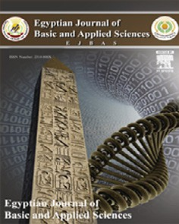

Contents lists available at [ScienceDirect](http://www.sciencedirect.com/science/journal/2314808X)

Egyptian Journal of Basic and Applied Sciences

journal homepage: [www.elsevier.com/locate/ejbas](http://www.elsevier.com/locate/ejbas)

Anti-cancer potential of a mix of natural extracts of turmeric, ginger and garlic: A cell-based study



Satish Kumar Vemuri a,b, Rajkiran Reddy Banala a, G.P.V. Subbaiah a,⇑, Saurabh Kumar Srivastava a,

A.V. Gurava Reddy a, Thekkumalai Malarvili b,⇑

a *Smart Medical Academic and Research Training (SMART), Sunshine Hospitals, Secunderabad, Telangana, India*

b *Rajah Serfoji Government College, Thanjavur, Tamil Nadu, India*

a r t i c l e i n f o

*Article history:*

Received 19 May 2017

Received in revised form 30 June 2017 Accepted 9 July 2017

Available online 29 July 2017

*Keywords:* Breast cancer Antagonists Natural extracts Tamoxifen Turmeric Ginger

Garlic

LC-ESI-MS/MS

a b s t r a c t

Cancer related morbidity and mortality is a major health care concern. Developing potent anti-cancer therapies which are non-toxic, sustainable and affordable is of alternative medicine. This study was designed to investigate the aqueous natural extracts mixture (NE mix) prepared from common spices tur- meric, ginger and garlic for its free radical scavenging potential and anti-cancer property against human breast cancer cell lines (MCF-7, ZR-75 and MDA-MB 231). Qualitative analysis of their bioactive con- stituents from turmeric, ginger and garlic were done using liquid chromatography-ESI- mass spectrom- etry (LC-ESI-MS/MS). To the best of our knowledge, NE mix with and without Tamoxifen has not been tested for its anti-cancer potential. We observed that the NE mix induced apoptosis in all the breast can- cer cell lines, but it was more prominent in MCF-7 and ZR-75 cell lines in comparison to MDA-MB 231 cell line. The extent of apoptosis due to combined treatment with NE mix-Tamoxifen was higher than Tamoxifen alone, indicating a potential role of the NE mix in sensitizing the ER-positive breast cancer cells towards Tamoxifen. In support to MTT assay, cell cycle analysis, our RT-PCR results also prove that the NE mix 10 lg, Tam 20 lg and combination of NE mix 10 lg-Tam 20 lg altered the expression of apoptotic markers (p53 and Caspase 9) leading to apoptosis in all three cell lines. Our data strongly indi- cate that our NE mixture is a potential alternative therapeutic approach in certain types of cancer.

© 2017 Mansoura University. Production and hosting by Elsevier B.V. This is an open access article under

the CC BY-NC-ND license (<http://creativecommons.org/licenses/by-nc-nd/4.0/>).

1. Introduction

Breast cancer is one of the leading cancers affecting women globally. Incidence of breast cancer is on the rise in countries like India, Japan and other Asian countries. In India, over 50,000 women die of breast cancer every year [1]. Even in western countries, where the rate of incidence is reported to be either stabilized or declining, breast cancer still continues to contribute significantly to cancer-related mortality and morbidity. Adding to existing healthcare concerns of breast cancer, its rising incidence in younger (pre-menopausal) women worldwide [2] and its overall morbidity and mortality underscores a need for developing alter- native breast cancer preventive and intervention strategies.

* Corresponding authors at: SMART, Sunshine Hospitals, Secundrabad, Telangana, 500003, India (G.P.V. Subbaiah). Department of Biochemistry, Rajah Serfoji Govt College (Autonomous), Thanjavur, Tamilnadu, India (T. Malarvili).

*E-mail addresses:* [sathishk.vemuri@gmail.com](mailto:sathishk.vemuri@gmail.com) (S.K. Vemuri), subbaiahgoli@ gmail.com (G.P.V. Subbaiah), [malarsai96@gmail.com](mailto:malarsai96@gmail.com) (T. Malarvili).

Apoptosis is a conserved and pivotal process of cell death that is required for host defense, suppression of oncogenesis and for nor- mal development and faulty apoptosis is enhances the tumor development and progression. The hallmark of human cancers is evading apoptosis. p53 gene was initially described as an oncogene in 1979, but later it is to known as tumor suppressor gene whose function is to abolish and hinder abnormal cell proliferation, thus preventing neoplastic development [3,4]. It is found in all human cancers that p53 function in controlling the negative growth regu- lators is lost. Under normal cellular environment, the p53 sig- nalling pathway is always in standby mode in normal cells, but it gets activated in response to cellular stresses, and several autono- mous pathways of p53 which are dependent on distinct upstream regulatory kinases. p53’s pivotal role in mammary carcinogenesis has been acquired from enormous information collected from mechanistic, molecular pathological and transgenic animal studies [5].

The *in vitro* studies on p53 function, and it is found that it con- tinuously suppresses tumorigenesis. Vousden and Lu [6] suggested

<http://dx.doi.org/10.1016/j.ejbas.2017.07.005>

2314-808X/© 2017 Mansoura University. Production and hosting by Elsevier B.V.

This is an open access article under the CC BY-NC-ND license (<http://creativecommons.org/licenses/by-nc-nd/4.0/>).

that p53 might be involved in preventing tumor development especially in humans. The suppression of tumorigenesis is exerted mainly by initiating the apoptosis [7]. Attardi and Jacks [8] demonstrated that loss of p53 activity has accelerated the tumor formation in transgenic mice as a result of apoptosis dysfunction. The integrity and mutation status of p53 decides its qualitative and quantitative activity in different stress-induced signalling pathways. The fact that p53 function is lost due to mutation in breast neoplasia, but its mutation rate is significantly low in other solid tumours [4,9].

Caspases and numerous upstream regulatory factors execute the cell death process by initiating or directing their proteolytic activity, which could act either as tumor suppressors or oncogenes. These regulatory factors do regulate cell survival or repair sig- nalling pathways often in response to cellular stress, apart from being strong apoptotic inducers [10,11]. Hence, loss of function doesn’t mean that tumor formation is a result of apoptosis dys- function due to inactivation of caspases. Any injury to outer mito- chondrial membranes triggers the release of caspase-9 enzyme found in the mitochondrial intermembrane space into the cytosol together with cytochrome *c*, hence it interacts with and activates the apoptosis-activating factor (Apaf-1) in a cytochrome *c* and dATP-regulated manner [12]. Caspase-9 is one of the essential cas- pases which is required for the initiation of apoptosis signalling on the apoptosome complex through mitochondrial pathway and sev- ere pathophysiological events will arise in case of failure to acti- vate caspase-9 [12]. The activation of caspase 9 and downstream caspase cascade usually occur during mitochondrial disruption [13]. Tumor suppressor proteins and proto-oncogenes with a more direct effect on Caspase activity can be found among p53- transregulated genes harbouring apoptosis-specific functions. Despite an obvious central role of p53 and caspases in the hall- marks of cancer, their status is not yet used for the management of breast cancer [9].

Currently, Tamoxifen is one of the strategies in hormone therapy. Tamoxifen is a selective estrogen receptor modulator (SERM) used for in treatment of breast cancers. However, Tamoxifen-based pre- vention strategy is limited to a selective group of women who are Estrogen Receptor (ER) positive. Moreover, prolonged use of the drug predisposes women to ovarian [14] uterine and endometrial cancers [15] apart from causing other serious complications such as retinal vein occlusion [16] deep vein thrombosis, pulmonary embolism [17], stroke [18] and cataracts [19], highlighting an urgent need for developing safer scalable approaches. Strategies to lower the required dose of anti-cancer drugs (sensitization) are useful. Identifying the anti-cancer properties of commonly used dietary products and other household herbs [20,21] may offer probable solutions for prevention. Natural anticancer agents exert signifi- cantly lower toxicity, safe and easily available; hence a combina- tional therapy using natural anticancer drug along with commercially available anticancer drugs should be encouraged in order to reduce the limitations in controlling the metastatic cancers [22]. Such a notion is supported by the observed beneficial impact of natural compounds with anti-cancer treatment modalities [23–25]. A multitude of studies have shown beneficial effects of phyto and marine extracts for intervention and treatment in cancer [26–29]. In view of the above, it may be rationalized that exploiting anti-cancer potential of commonly used food ingredi- ents and easily accessible herbs may be useful in controlling the cancers. Thus in the present study, we have investigated the potential effect of conventional hormone therapy drug i.e. tamoxifen when supplemented with natural extracts mixture made from commonly used dietary spices in inducing cell death and sensitization of immortalized cells i.e. breast cancer cells which are ER-positive (MCF-7 and ZR-75) and ER-negative

(MDA-MB 231).

1. Materials and methods
   1. *Materials*

Human breast cancer cell lines, MCF-7, ZR-75 and melanoma cell line MDA-MB 231 were obtained from a National cell line repository (National Centre for Cell Science, Pune, India). Hi- Gluta XLTM Dulbecco’s Modified Eagle’s Medium (High Glucose) cell culture medium, Hi-Gluta XLTM RPMI-1640 cell culture medium, L- Glutamine-Penicillin-Streptomycin solution, Dulbecco’s Phosphate buffered saline (DPBS), 0.22 lm sterile syringe driven filters, sterile cell scrapers, 0.25% Trypsin-EDTA solution, Bovine serum albumin (BSA) were obtained from Hi-Media, India. Fetal bovine serum was obtained from Seralab, USA. Sterile cell culture plastic ware was purchased from Thermo Fisher, USA. Flow-cytometer BD FACS cal- iber Apoptosis Kit – Annexin V Alexa Fluor 488 and propidium iodide (Thermo fishers) and Ultrapure water was generated using

Millipore RiOs-DI®3 system.

* 1. *Chemicals*

Acetonitrile ULC/MS Grade purchased from Biosolve Chimie SARL (Dieuze, France) and formic acid (Optima LC/MS grade) was purchased from Fisher Scientific (Geel, Beljium, Germany). Metha- nol (LiChrosolv) was purchased from Merck (Darmstadt, Germany). Deionized water was prepared by passing distilled water through a Milli-Q water purification system (Millipore, Milford, MA, USA).

* 1. *Methods*
     1. *Preparation of natural extracts (NE) and tamoxifen solution*

Turmeric, ginger and garlic were brought from local markets and the natural extracts mixture was prepared in-house by adding

20 g of each i.e. turmeric, garlic and ginger paste into 500 ml of ultrapure water and heating it at 60 °C for 6 h. Later the mixture was shaken overnight at room temperature followed by centrifuga- tion at 4 °C for 10 min. The supernatant was then separated and filter-sterilized using a 0.22 mm syringe filters and lyophilized.

Tamoxifen stock solution was prepared by dissolving 10 mg of Tamoxifen into 500 ml of absolute ethanol and then adding 4.5 ml of ultrapure water. The solution was then filter-sterilized using a

0.22 mm syringe filter. The required dosages were prepared from diluting this stock solution.

* 1. *Antioxidant assays*
     1. *Superoxide anion scavenging assay*

The assay for superoxide anion radical scavenging activity was supported by riboflavin-light-NBT system [30]. Briefly, 1 ml of sample was taken at different concentrations (25–500 lg/ml) and mixed with 0.5 ml of phosphate buffer (50 mM, pH 7.6), 0.3 ml riboflavin (50 mM), 0.25 ml PMS (20 mM), and 0.1 ml NBT (0.5 mM). Reaction was started by illuminating the reaction mix- ture using a fluorescent lamp. After 20 min of incubation, the absorbance was measured at 560 nm. Ascorbic acid was used as standard. The scavenging ability of the plant extract was deter- mined by the following equation:

*Sca enging acti ity* [1 — absorbance of sample] 100 1

*v v* (%)= × ( )

# [absorbance of the control]

* + 1. *Phosphomolybdate assay (total anti-oxidant capacity)*

The total anti-oxidant capacity of the fractions was determined by Phosphomolybdate method using ascorbic acid as a standard [31]. An aliquot of 0.1 ml of sample solution was mixed with

1 ml of reagent solution (0.6 M Sulphuric acid, 28 mM sodium phosphate and 4 mM ammonium molybdate). The tubes were capped and incubated in a water bath at 95 °C for 90 min. After the samples had cooled to room temperature; the absorbance of the mixture was measured at 765 nm against a blank. A typical

blank contained 1 ml of the reagent solution and the appropriate volume of the solvent and incubated under the same conditions. Ascorbic acid was used as standard. The anti-oxidant capacity was estimated using following formula:

# [control absorbance — sample absorbance]

night. After 42 h of incubation with crude extracts, the cells were rinsed with 1X PBS and incubated with 100 lL of 0.5 mg/mL MTT

at 37 °C. After 30 min of incubation, the dark blue crystals of for-

mazan (MTT metabolites) were dissolved with 100 lL of DMSO and incubated at 37 °C for 30 min. The level of reduced MTT was

determined by measuring the difference in absorbance at 570 and 650 nm using a microplate reader (Spectra Max M5, Molecular Devices). According to the U.S. NCI plant screening program, a crude extract is generally considered to have *in vitro* cytotoxic

activity with an IC50 value ≤20 lg/mL [33,34].

*Antioxidant effect*(%)=

# × 100

[control absorbance]

(2)

* + 1. *Cell cycle analysis*

Cells were serum starved for 24 h as above, treated with differ- ent extracts and/or Tamoxifen for 42 h, trypsinized and fixed in 70% ethanol overnight. Fixed cells were then treated with a mix-

* + 1. *Hydroxyl radical scavenging assay*

Hydroxyl radical scavenging activity was measured by the abil- ity of the different fractions of plant extracts to scavenge the hydroxyl radicals generated by the Fe3+-ascorbate-EDTA-H2O2 sys- tem (Fenton reaction) [32]. The reaction mixture contained; 500 ll of 2-deoxyribose (2.8 mM) in phosphate buffer (50 mM, pH 7.4), 200 ll of premixed ferric chloride (100 mM) and EDTA (100 mM) solution (1:1; v/v), 100 ll of H2O2 (200 mM) with or without the extract solution (100 ll). The reaction was triggered by adding

100 ll of 300 mM ascorbate and incubated for 1 h at 37 °C.

0.5 ml of the reaction mixture was added to 1 ml of TCA (2.8%; w/v; aqueous solution), then 1 ml of 1% aqueous TBA were added to the reaction mixture. The mixture was heated for 15 min on a boiling water bath. After the mixture being cooled the absorbance at 532 nm was noted against a blank (the same solution but with- out reagent). The scavenging activity on hydroxyl radical was cal- culated as follows:

*Sca enging acti ity* [1 - absorbance of sample] 100 3

*v v* (%)= × ( )

# [absorbance of the control]

* + 1. *Cell culture*

Human breast adenocarcinoma MCF-7 cells and MDA-MB 231 melanoma cells were aseptically cultured in T-25 cell culture flasks or multi-well cell culture plates in Hi-Gluta XLTM Dulbecco’s Modi- fied Eagle’s Medium, (High Glucose) supplemented with 10% Fetal bovine serum (FBS) (Hi-Media or Seralab), 20 mM L-Glutamine, Streptomycin (100 lg/ml) and Penicillin (100 Units/ml). Whereas, breast ductal carcinoma ZR-75 cells were aseptically cultured in HiGluta XLTM RPMI-1640 medium supplemented with 10% FBS Streptomycin (100 lg/ml) and Penicillin (100 Units/ml). The cells were grown in a cell culture incubator (HEPA Class 100-Steri cycle

CO2 incubator), supplied with 5% CO2 and maintained at 37 °C.

* + 1. *Treatment of the cells with natural extracts and Tamoxifen*

Cells at 60% confluency were serum starved for 24 h and the serum-free media was replaced with appropriate media containing 10% FBS. Various amounts of natural extracts mix (5, 10 and 20 mg/ mL) and Tamoxifen (Tam 20 mg/mL) were added to the cells and total volume of each well was made up to 2 ml, using correspond- ing media. Control cells were only treated with respective vehicle solutions without the agents. Experiments were carried out in trip-

licate and the experiments were repeated twice. After 42 h of treat- ment, cells along with the medium were collected into 15 ml polypropylene tubes. The tubes were spin down at 1500 rpm for 5 min at room temperature.

* + 1. *MTT assay/cytotoxic assay*

The MTT assay was used for measuring toxicity as previously described [30,31]. Briefly, cells were seeded in 96-well plates over-

ture of Propidium Iodide, RNAseA and Triton-X-100 and analyzed for DNA content in different phases of the cell cycle in a TALI- Image based cytometer (Thermo Fisher).

* + 1. *Quantification of apoptosis and cell death*

Apoptosis and cell death were determined as described below, using Annexin V Alexa Fluor® 488 conjugate (Apoptosis kit) and propidium iodide (Cell death assay kit), respectively. The treated cells were centrifuged at 1500 rpm for 5 min and the formed pellet was re-suspended in 200 ll of Annexin binding buffer and 10 ll of

added to approximately 5 × 105–5 × 106 cells/ml and mixed well, Annexin-V Alexa Fluor® 488, and 5 ll of propidium iodide (PI) was later the mixture was incubated at room temperature in dark for

20 min. After the incubation cell suspension was analysed by TALI-Image based cytometer (Thermo Fisher). The number and percentage of apoptotic and dead cells were assessed by Annexin-V and PI staining, respectively. For the fluorescent imag- ing of dead and apoptotic cells was done using EVOS Digital inverted fluorescence microscope (Invitrogen) with a 10X LPlanFL PH fluorescence objective was used to image the labelled cells in the plate.

* + 1. *Reverse transcriptase-PCR (RT-PCR) quantitative analysis*

Expression of p53 and Caspase-9 genes was performed by a semiquantitative Reverse transcriptase-PCR technique. Total RNA was extracted from immortal cell lines i.e. MCF-7, ZR-75 and MDA MB 231 using the RNASure mini isolation kit (cat no: #NP- 84105, Nucleo-pore, Genetix Biotech Asia Pvt Ltd, New Delhi), as

per the instructions given by the manufactures. RNA (2 mg) was then converted to cDNA using Verso cDNA synthesis kit (#AB- 1453/A, Thermo scientific) at 42 °C for 30 min, and 95 °C for 2 min. PCR amplification was performed on the cDNA solution with EmeraldAmp® GT PCR Master Mix (Cat# RR310A, Takara) at a final volume of 10 mL. The PCR conditions and primers sequence were as follows: for p53 mRNA amplification: Forward primer- 5_AGTCTAG

AGCCACCGTCCA, Reverse: AGGTCTGAAAATGTTTCCTGACTCA-3 _,

generating a 270-bp PCR product. For Caspase-9 mRNA amplifica- tion: Forward: 5_-CTCAGACCAGAGATTCGCAAAC, Reverse: GCA TTTCCCCTCAAACTCTCAA-3_, generating a 118-bp PCR product. GAPDH primers sequence: Forward primer: 5_-GGCT CTCCAG AACATCATCCCTGC, Reverse: GGGTGTCGCTGTTGAAGTCAGAGG

-3_, is generating a 250-bp PCR product. PCR program for p53: 95 °C for 5 min, 95 for 30 s, 62 °C for 30 s, 72 °C for 30 s for 40 cycles and final extension step at 72 °C for 7 min. PCR program for Cas9: 95 °C for 5 min, 95 for 30 s, 61 °C for 30 s, 72 °C for 30 s for 40 cycles and final extension step at 72 °C for 7 min. PCR pro- gram for GAPDH: 95 °C for 5 min, 95 for 30 s, 66 °C for 30 s, 72 °C for 30 s for 40 cycles and final extension step at 72 °C for 7 min.

RT-PCR products were separated on 1.5% agarose (Lonza).

* 1. *Mass spectrometry*
     1. *Sample preparation*

Lyophilized extracts (10mg/1 ml) of turmeric, ginger and garlic were dissolved in methanol (HPLC grade) and filtered using

0.45 mm PTSC filter.

* + 1. *LC conditions*

The chromatographic analysis was performed on a Shimadzu Nexera X2 UPLC system (Shimadzu Corporation, Nakagyo, Kyoto, Japan) equipped with a Quaternary pump, an online degasser (DGU-20A 5R), a thermostatic auto sampler (SIL-30AC), a thermo- statically controlled column compartment (CTO-20AC), and a diode array detector (DAD) (SPD-M20A) which were communicated through Bus module (CBM-20A). Chromatographic separation was performed on a reverse-phase column Eclipse XDB C18 col-

umn (4.6 × 150 mm, 4.6 lm, Agilent Technologies) maintained at

ambient temperature. The mobile phases consisted of water con-

taining 0.1% formic acid (A) and acetonitrile (B), and the elution was set at Isocratic mode as follows: (40%A: 60%B. The flow rate was set at 1.0 mL/min, and the injection volume was 10 lL [35].

* + 1. *Data processing*

For the LC-ESI-MS experiments, Shimadzu Triple Quadruple mass spectrometer (LCMS 8040) (Shimadzu Corporation, Kyoto, Japan) equipped with an electrospray ionization (ESI) source was

connected to the UPLC instrument. The ESI source parameters were set as follows: ion spray voltage, 4.5 kV; DL temperature, 250 °C; Heat Block Temperature, 400 °C; and Nebulising (N2) and Dry gas (N2) flow rates, 3.0 and 10 L/min, respectively. The mass ana-

lyzer was operated in positive ion mode, with a mass range of 50–900. Similar to the technique described for ESI-MS. Accurate masses were calibrated according to the manufacturer’s guidelines using TQ- Standard Sample (PEG, PPG and Raffinose) (Shimadzu corporation, Kyoto, Japan). The data were recorded and processed using the Lab Solutions 5.60 SP2 software (Shimadzu Corporation, Kyoto, Japan).

* + 1. *Statistical analysis*

Statistical analysis of the data was performed using two way ANOVA and followed by student T-test. Difference between the values was considered significant, if ⁄*p* < 0.05.

1. Results

The anti-cancer potential of the aqueous natural extracts was assessed by treating different ER- positive and negative breast can- cer cell lines (MCF-7, ZR-75 and MDA-MB-231) with the extracts alone and in combination with Tamoxifen, for 42 h (Figs. 2–5). We noted detachment of cells from the substratum, denoting events associated with cell death. The impact was more prominent in MCF-7 cells, followed by ZR-75 and MDA-MB 231 cells.

* 1. *Free radical scavenging capacity of natural extracts*

On comparison of the free radical scavenging and total antioxi- dant capacity of different aqueous extracts (Fig. 1), it is evident that the aqueous extract of the combination seems to be more potent than the individual extracts, from its ability to neutralize oxygen radicals. The total antioxidant and free superoxide neutralizing capacity is similar between turmeric and the extract mixture, but those of ginger and garlic extracts are relatively less compared to the mixture. The combination of extracts clearly shows better capacity to neutralize hydroxyl radicals compared to turmeric and garlic extracts. The ginger extract showed high free hydroxyl

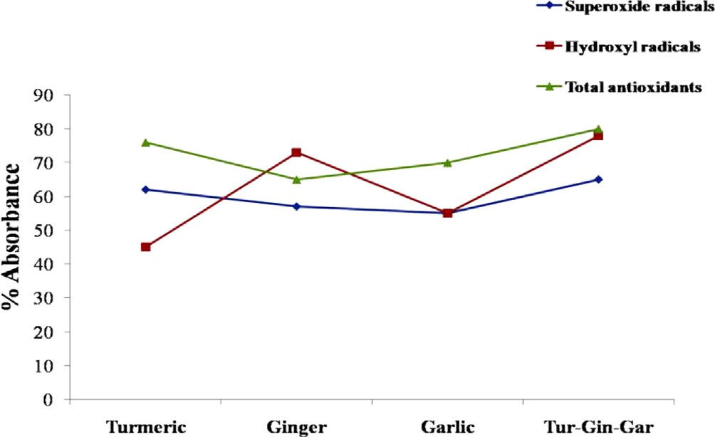

Fig. 1. Free radical scavenging capacity of Natural extracts. The colour code is as follows: 1 Blue: Superoxide free radicals (OD at 560 nm), 2 Red: Total antioxidant (OD at 765 nm), 3 Green: Hydroxyl free radicals (OD at 532 nm), for different estimations.

radical scavenging capability in comparison to turmeric and garlic individually, whereas the turmeric extract has slightly better superoxide neutralizing capacity than other extracts individually.

* 1. *Cell Proliferation/Viability Assay- MTT assay*

Cells were plated at a density of 1 × 104 cells/well in 96-well plate, incubated at 37 °C overnight and treated in triplicate with

increasing concentrations of NE mix or a combination of NE and Tam. After 42 h of treatment, a microtiter plate reader was used to record absorbance at 570 nm, based on the ability of viable cells to convert the yellow tetrazolium MTT (3-(4, dimethylthiazolyl-2)- 2,5-diphenyltetrazolium bromide).

The NE mix (10 mg/mL) with or without Tamoxifen (20 mg/mL) has the ability to control the cell proliferation in comparison to

the individual treatments in ER +ve and ER —ve cell lines. The con-

trol and NE mix (5, 10 and 20 mg/mL) treated samples did not show

any signs of cytotoxicity. MDA MB 231 which is a triple negative cells as shown susceptibility to towards Tamoxifen upon combina- tion treatment with NE mix in dose dependent manner. The results were expressed as percentage of absorbance (Fig. 2).

* 1. *Cell cycle analysis*

The cell cycle analysis reveals the efficiency of natural extract mixture with and without Tamoxifen. The Fig. 3a and b, represents the percentage of cells being arrested in different stages of cell cycle when treated with 10 mg/mL concentration of natural extract

mixture (NE mix 10 mg), Tamoxifen 20 mg/mL and combination of

NE mix 10 mg – Tamoxifen 20 mg/mL. The percentage of cells being arrested in G1 phase is significantly high in all the immortal cell lines when treated with NE mix with and without Tamoxifen.

The efficiency of NE mix has increased the potency of Tamoxifen when the cells were treated simultaneously. The MDA MB 231 cell lines showed less susceptibility towards NE mix, Tamoxifen alone but it’s more susceptible to combinational treatment. The MCF-7 and ZR-75 cell lines showed more susceptibility towards NE mix, Tamoxifen alone and combinational treatment in comparison to MDA MB 231 cell lines.

* 1. *Apoptosis (Annexin V Staining)*

As determined by the Annexin-V binding, Natural extract (NE) mix with or without Tamoxifen has the ability to induce apoptosis in all the three cell lines, though the degree of the impact varied

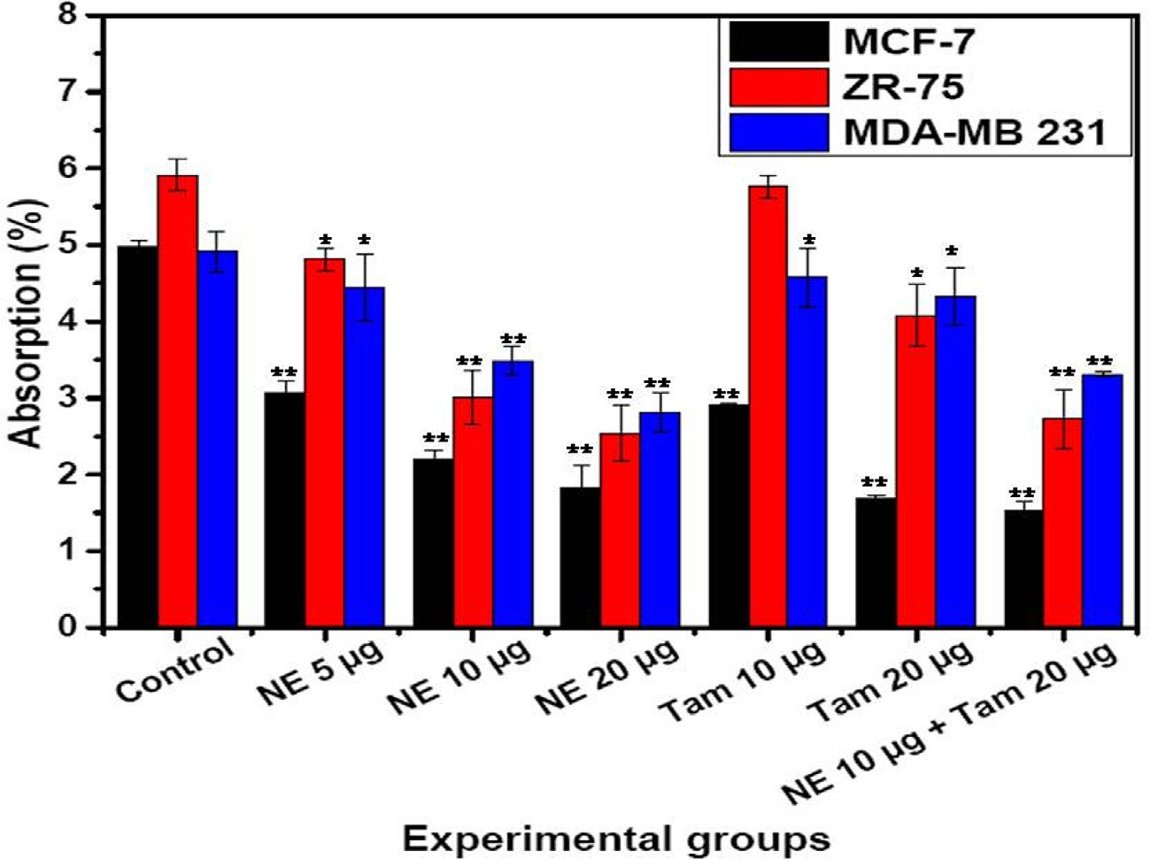

Fig. 2. Cell proliferation in breast cancer cells with NE mix and Tamoxifen treatment. Number of proliferating cells (Average ± SE) is shown as assessed by MTT (3-(4, dimethylthiazolyl-2)-2,5-diphenyltetrazolium bromide) colour formation following the treatment with different concentrations of NE extracts mix and Tamoxifen (Tam). Two way ANOVA followed by student T-test was used for statistical analysis and significance between the groups and the difference was considered significant for *P* values

<0.05 (\**P* < 0.05, \*\**P* < 0.005).

with the treatment and the cell line (Fig. 4). NE mix induced apop- tosis in MCF-7 cells and ZR-75 cells in a dose-dependent manner (NE mix 5–20 mg) but the effect was not similar with MDA-MB

231 cells as apoptosis was minimal and was not found to be

dose-dependent. The effect of NE mix was more prominent in MCF-7 and followed by ZR-75 cells at a dose of 20 mg. The cells underwent apoptosis on Tamoxifen treatment alone, but when

cells were treated with NE mix and Tamoxifen together, the extent of apoptosis was clearly higher except in the case of ZR-75 cells. The total number of cells undergoing apoptosis in MCF-7 and ZR- 75 cells was more compared to MDA-MB 231 cells.

* 1. *Cell death (propidium iodide staining)*

The data presented in Fig. 4 shows an additional measure of apoptosis induced by NE mix, Tamoxifen and NE-Tam in MCF-7, ZR-75 and MDA-MB 231 cell lines at varying concentrations, deter- mined by propidium iodide staining. As shown in Fig. 4, natural extract-induced apoptosis in MCF-7 and ZR-75 cells was dose- dependent. The NE mix concentrations were increased from 5 to 20 mg. Cell death was more intense in MCF-7 cells and ZR-75 cells

when treated with NE mix and this effect was dose dependent (5–

20 mg). However, such a dose dependent increase in cell death was not found in MDA-MB 231 cells. Cell death induced by Tam was lesser across the cell lines when compared to the effect of NE- Tam combination. However, combined treatment of the cells with

NE and Tam showed a higher effect in MCF-7 cells and ZR 75.

* 1. *Fluorescence microscopy*

To investigate the mechanism by which NE mix and tamoxifen induces apoptosis in MCF-7, ZR-75 and MDA-MB 231 cells, the cells were stained using Annexin V Alexa Fluor® 488 conjugate (Apopto-

sis kit) and propidium iodide (Cell death assay kit) (Fig. 6). Alexa Fluor staining of NE mix-treated MCF-7, ZR-75 and MDA-MB 231 cells (NE 10 mg for 42 h) and Tamoxifen (20 mg for 42 h) revealed nuclear fragmentation and chromatin condensation, typical char-

acteristics of apoptosis. The cells undergoing apoptosis was con- firmed by staining with propidium iodide (a membrane impermeable dye) and Annexin V Alexa Fluor® 488 which has high

affinity towards the phospholipid phosphatidylserine. Phos- phatidylserine is normally present in the inner side of the cellular membrane, and is translocated to the outer membrane leaflet in apoptotic cells. The cell lines exposed to NE mix and Tam, stained positive for Annexin V and propidium iodide (Fig. 6a and b), a pat- tern reflecting membrane disruption that is characteristic of later stages of apoptosis. Taken together, these data indicate that NE mix and Tam-induced cell death is at least in part the result of apoptosis.

* 1. *RT-PCR quantification studies – gene expression of apoptotic markers*

The gene expression studies of p53 and Cas9 genes in immortal cell lines i.e. MCF-7 and MDAMB-231 and ZR-75 cells when treated with NE mix (10 and 20 mg), Tamoxifen 20 mg and NE mix 10 mg – Tamoxifen 20 mg. Results from RT-PCR studies are represented in Fig. 7, wherein the expression of p53 was less significant in all con- trols samples, but on treatment with NE mix (10 and 20 mg), Tamoxifen 20 mg and NE mix 10 mg – Tamoxifen 20 mg there was increased expression indicating the induced apoptosis in all cell lines and the effect appeared to be dose dependent and combina- tional (Fig. 7). Similarly the Caspase-9 gene expression was not observed in all the control samples, but the expression increased in treated groups i.e. NE mix (10 and 20 mg), Tamoxifen 20 mg and NE mix 10 mg – Tamoxifen 20 mg and the enhanced efficiency appeared to be dose dependent and combinational (Fig. 7). Expres- sion of GAPDH in all the three immortal cell lines

* 1. *Mass spectrometry analysis*

LC-ESI-MS/MS analyses: The analytes were detected in positive ionization mode by monitoring the product scan spectra for the protonated molecules [M + H]+ in, turmeric, ginger and garlic the

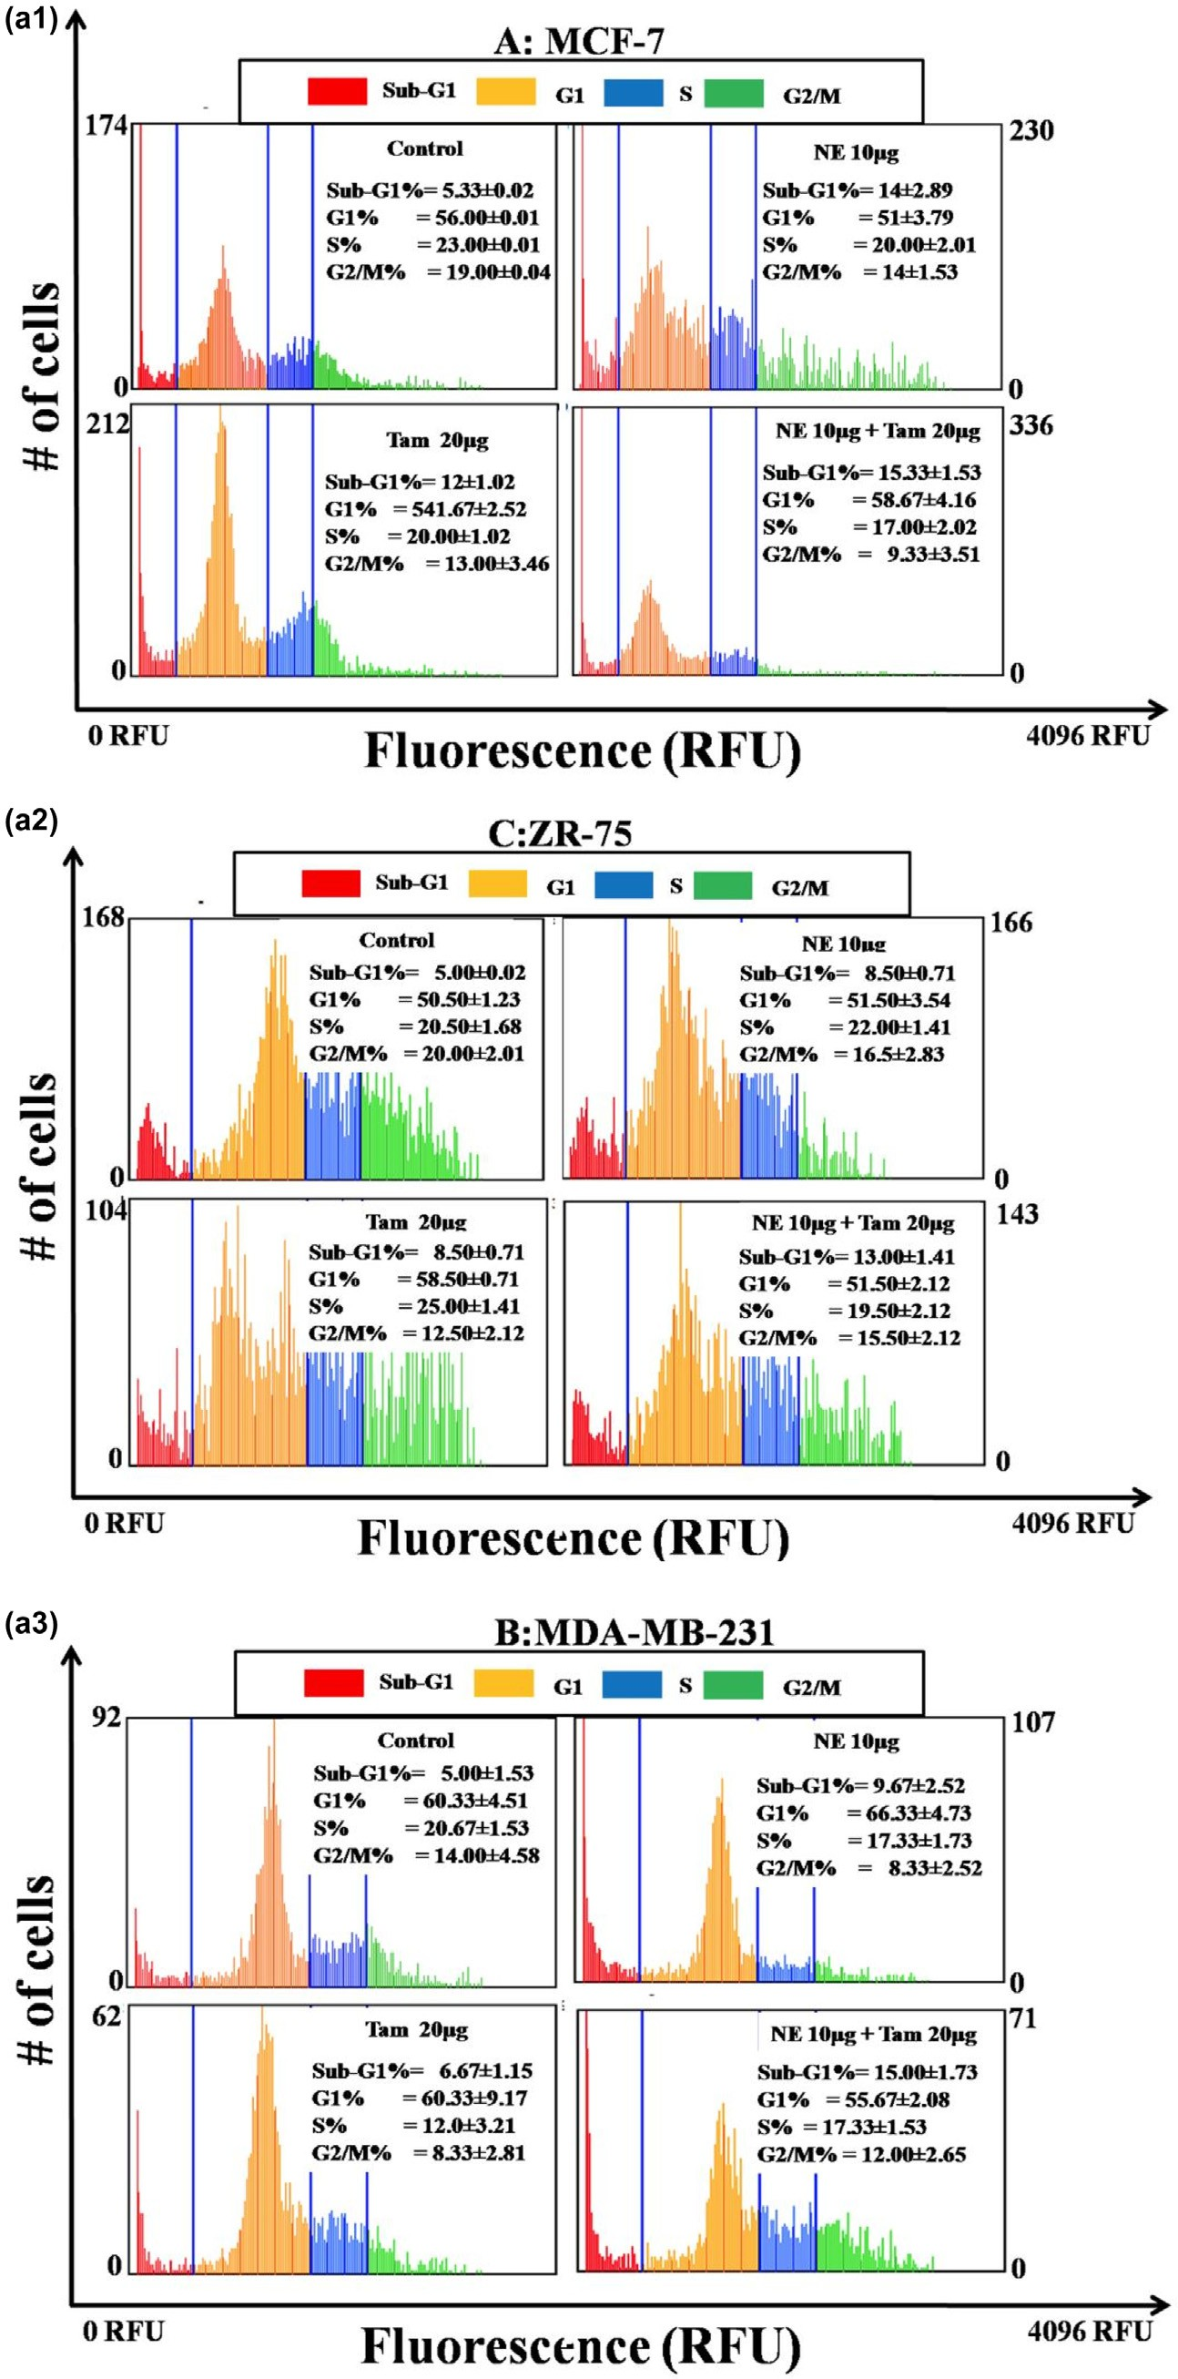

Fig. 3. a (1, 2, 3) and b: Panels A, B, C represent the cell cycle histograms of MCF-7, ZR-75 and MDA-MB-231 cells respectively after treatment with different extracts. Medium control is the vehicle for NE mix and Ethanol control is the vehicle for Tamoxifen. The blue coloured gatings in the histogram segregate the Sub-G1, G1, S and G2/M phases of the cell cycle. Percentages of cells in each phase of the cell cycle are indicated inside the individual histogram representing different treatments. The X-axis of each histogram represents the propidium iodide (PI) fluorescence based on the DNA content in each phase of the cell cycle. The Y-axis of each histogram represents the number of cells in each phase.

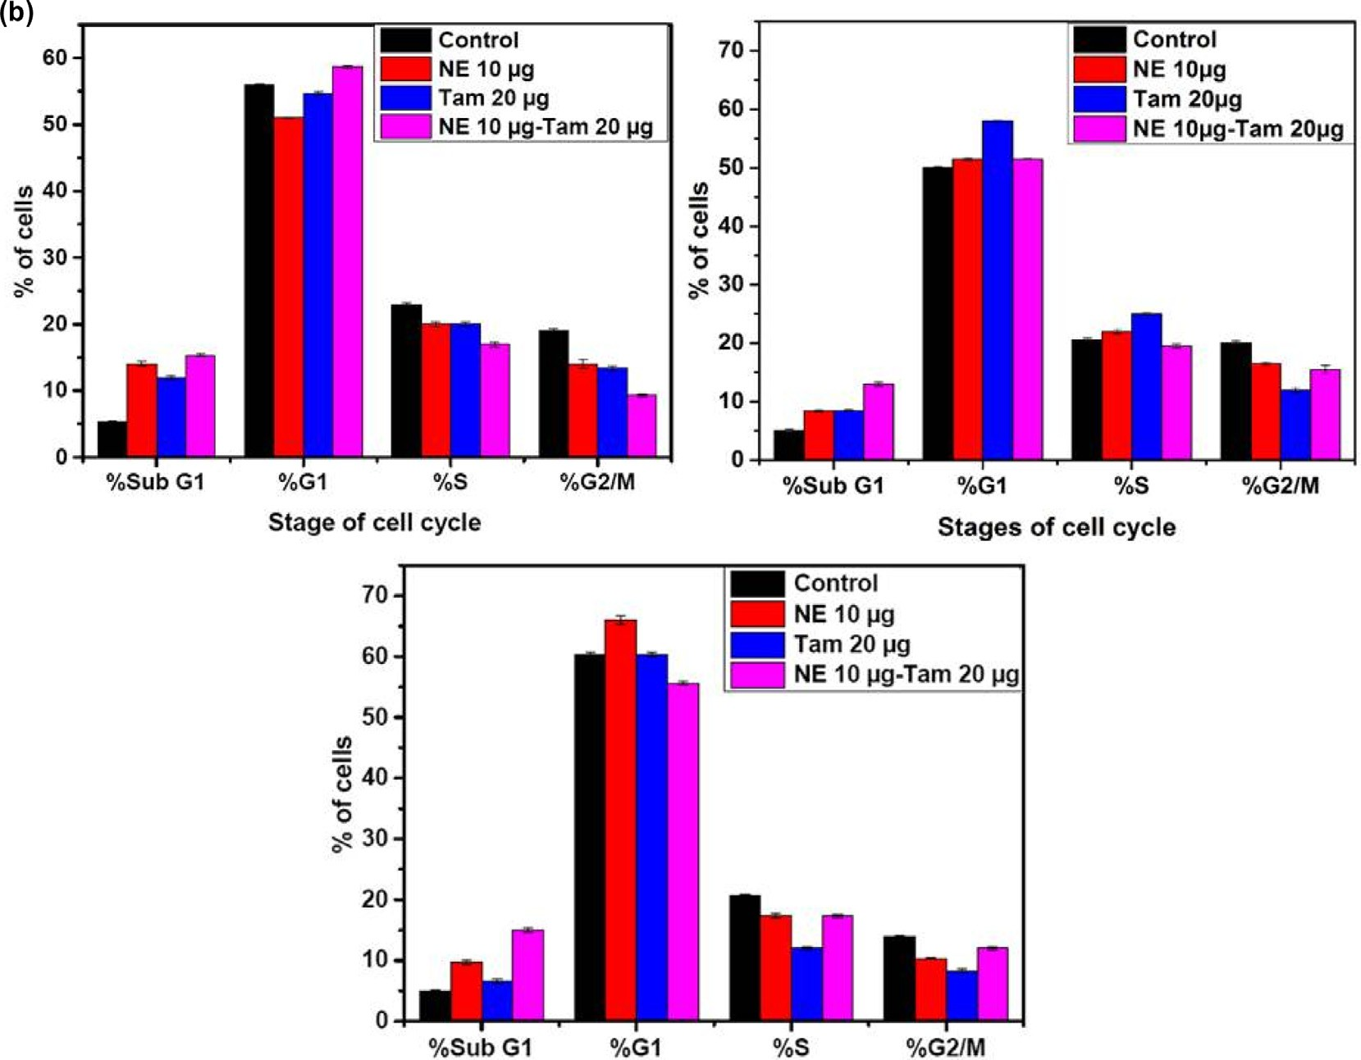

Fig. 3 (*continued*)

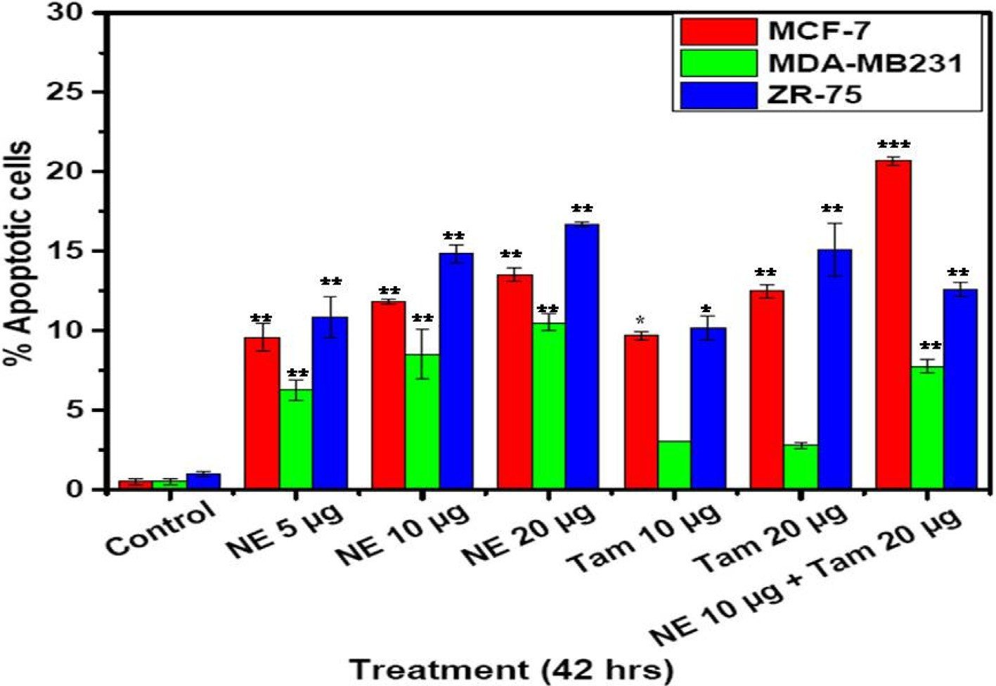

Fig. 4. Apoptotic cell death in breast cancer cells with NE mix and Tamoxifen treatment. Percentage of apoptotic cells (Average ± SE) as assessed by Annexin-V-Alexa Fluor 488 binding, following the treatment with different concentrations of extracts NE mix and Tamoxifen (Tam). Two way ANOVA and student’s T-test were used to test for statistical significance between the groups and the difference was considered significant for *p* values <0.05*.

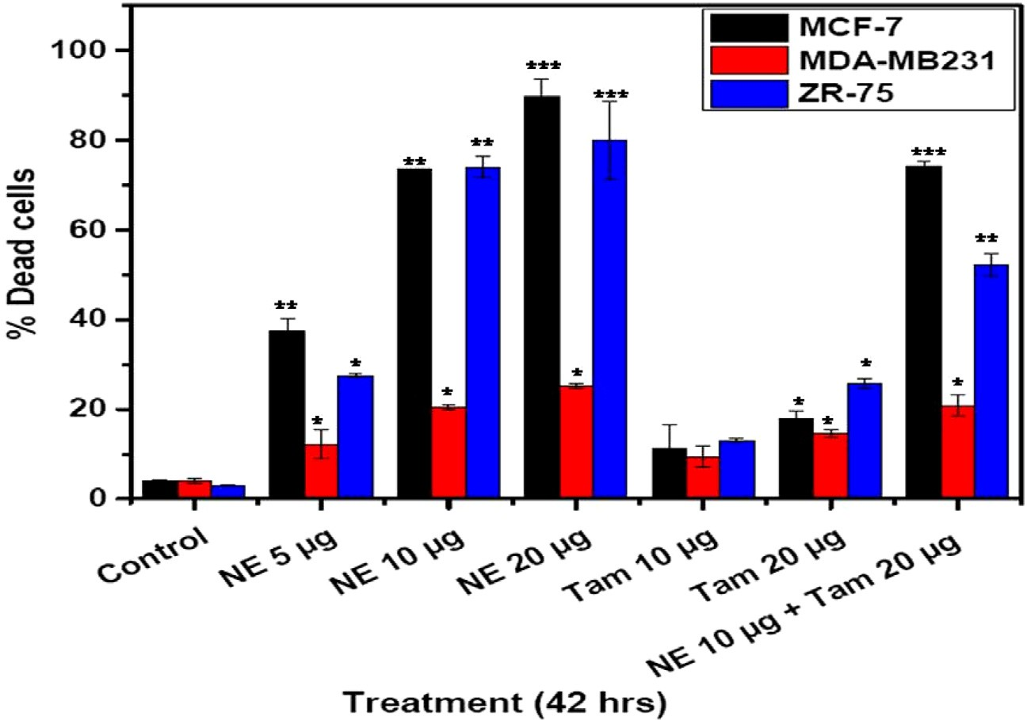

Fig. 5. Apoptosis in breast cancer and melanoma cells treated with NE mix and Tamoxifen. Percentage of PI-positive (Average ± SE) in cells after treatment with different concentrations of extracts NE mix, and Tam. One way ANOVA was used to test for statistical significance between the groups and the difference was considered significant for *P* values <0.05 (\**P* < 0.05, \*\**P* < 0.005, \*\*\**P* < 0.001).

IS are shown in Fig. 8(a–c). The chromatograms show qualitative analysis of the metabolites and active compounds present in the natural extract (turmeric, ginger, garlic).

1. Discussion

Concern over cancer-related morbidity and mortality exists, notwithstanding significant advancements in developing chemotherapeutic drugs and radiotherapy. Further, preventive medicine modalities are few and are of limited use. Our present study was envisaged to examine the anti-cancer potential of food components consumed routinely. Such food components could have potential in preventive medicine, can be widely acceptable and put into use with little effort.

In India, different natural extracts including turmeric, ginger and garlic are used in cooking on a daily basis. These spices contain bio-active components such as; curcumin from *Curcuma longa* L. (turmeric), allicin from *Allium sativum* L. (garlic), 6-gingerol and oleoresin from *Zingiber officinale* R. (ginger). These natural extracts have been a part of Ayurveda, an ancient system of Indian medi- cine. Curcumin, a bio-active component of turmeric which is an important constituent of natural extracts powder is used in Indian culinary dishes [36,37] and extracts of ginger [38] or garlic [39] have been shown to induce apoptosis.

In the present communication, we report that aqueous extracts of commonly used food ingredients have excellent anti-oxidant and free radical scavenging properties (Fig. 1) and they can induce cell death in cancer cells, particularly those of breast cancer cells. The treatment also decreased number of actively dividing cells, both in MCF-7 and in ZR-75 cells. Additionally, we found a higher effect on the cancer cells of Tamoxifen (Tam) when administered in combination with natural extracts.

The MTT assay suggests that the NE mix (5, 10 and 20 mg) has dose dependent effect on the different immortal cell lines (MCF- 7, ZR-75, MDA MB231), similarly the Tamoxifen treatment also showed dose dependent activity (10 and 20 mg). Whereas the com- bination of NE mix 10 mg – Tamoxifen 20 mg showed enhanced effi- ciency in controlling the cell proliferation in comparison to the

individual treatments i.e. NE mix and Tamoxifen. Based on the results it is safe to mention that our NE mix is sensitizing the cells towards Tamoxifen treatment, as a result the cells are getting arrested at G1 phase of cell cycle and ultimately death (Fig. 2).

Our novel aqueous extracts made from a blend of natural extracts exhibited pro-apoptotic and anti-proliferative properties in breast cancer cell lines. Cell cycle analysis shown in Fig. 3 indi- cates perturbed cell cycle events in treated cells. MCF-7 cells trea- ted with NE and Tam or a combination of NE and Tam had over 50% cells in G1 phase when compared to the untreated control cells The percentage of cells in the Sub-G1 phase was also found to be low in all the treatments. NE extract concomitantly reduced the number of cells in the G2/M phase and substantially increased the number of cells in G1 phase (Fig. 3a and b). MDA-MB-231 cells treated with NE had more cells in the Sub-G1 phase (19.67%) compared to the control or Tam or the combination of NE and Tam. More number of cells tended to accumulate in G1-phase after the treatments (Fig. 3b). ZR-75 cells treated with NE 20 mg or Tam 20 mg had more

than 50% of the cells under G1 phase while the percentage of Sub-

G1 phase cells were equivalent to the respective control. When treated with a combination of NE and Tam, the percentage of cells in sub-G phase was slightly higher than the individual treatments. The NE-induced varied amounts of cell death in the breast can- cer cell lines. The NE induced significantly higher apoptosis in MCF-7 and ZR-75 cells when compared to MDA-MB 231cells. ZR-

75 cells appeared to be more sensitive to natural extracts and Tam-induced apoptotic cell death as compared to MCF-7, though both the breast cancer cell lines are positive for ER. The underlying mechanisms need to be investigated. The apoptosis induced by the natural extracts was more prominent in MCF-7 cells than in ZR-75 or MDA-MB 231 cells.

Tamoxifen induced relatively higher amounts of apoptotic cells in MCF-7 and ZR-75 cell lines than in MDA-MB 231. This may be due to the presence of the Estrogen Receptor (ER) in MCF-7 and ZR-75 cells [40] whereas lower apoptosis was observed in MDA- MB 231 cells duet to absence of ER [41]. Tam also induced minimal levels of cell death in the ER-negative MDA-MB 231 cells which may be due to ER-independent actions of Tamoxifen. Tamoxifen was shown to induce apoptosis through cancerous inhibitor of pro-

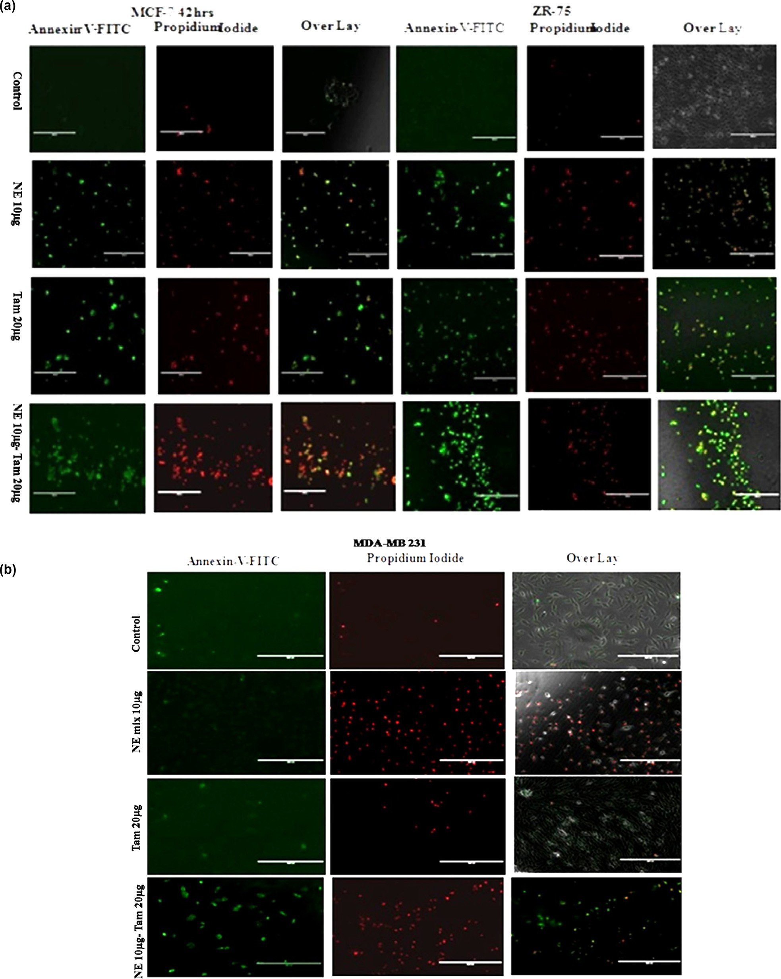

Fig. 6. a and b: For fluorescent imaging of apoptotic cells, cells were labelled with 5 ml of Annexin-V-Alexa Fluor 488 and 1 ml of propidium iodide and incubated for 20 min at 37 °C. EVOS Digital inverted fluorescence microscope (Invitrogen) with a 10X LPlanFL PH fluorescence objective was used to image the labelled cells in the plate.

tein phosphatase 2A and phospho-AKT [42], independent of its actions mediated through ER. Additionally, absence of PR in MDA-MB 231cells [43] is linked with over expression of Her-2 [44], and Her-2 has been reported to reduce Tam’s ability to induce cell death [45]. Signalling molecules such as, TGF-b, MAPK, c-Myc

and JNK were also shown to be sensitive to Tam [46]. 4-hydroxy- tamoxifen was also reported to induce autophagic degradation of K-Ras in breast cancer cells [47].

Additionally, the natural extracts were found to have an enhanced effect when combined with Tamoxifen, as judged by

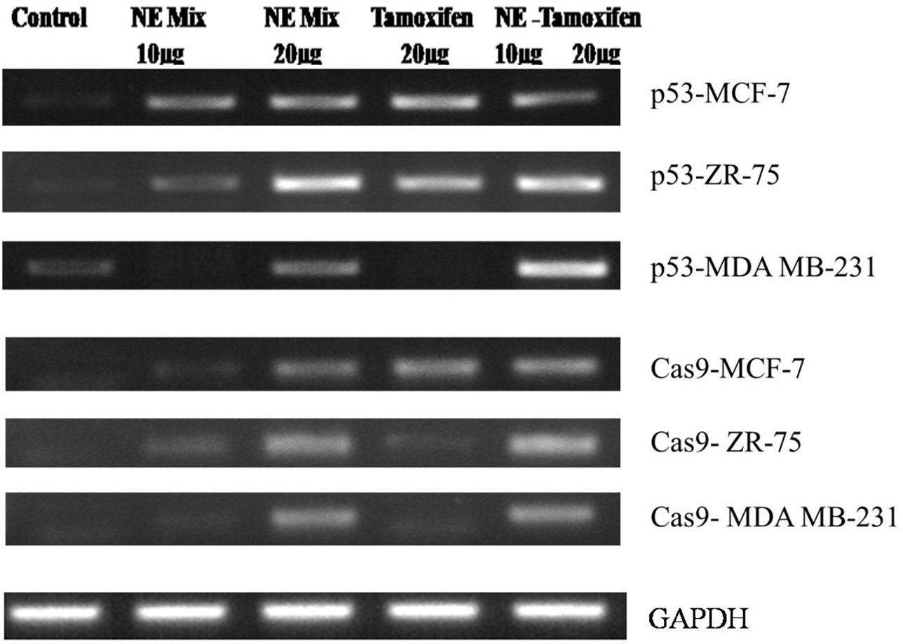

Fig. 7. Gene expression of apoptotic markers in immortal cell lines (MCF-7, ZR-75, MDA MB-231) when treated with NE mix and Tamoxifen individually and in combination.

the increased effect on the cell lines (Figs. 3 and 4). MCF-7 and ZR- 75 cell lines clearly showed greater Tam-mediated cell death when treated together with NE mix. On the other hand, MDA-MB 231 cells did not exhibit such an increased effect when treated with both natural extracts and Tamoxifen together.

The gene expression studies of p53 and CASP-9 genes in immor- tal cell lines i.e. MCF-7, ZR-75 and MDAMB-231 cells when treated with NE mix (10 and 20 mg), Tamoxifen 20 mg and NE mix 10 mg – Tamoxifen 20 mg. Results from RT-PCR studies are represented in Fig. 7, wherein the expression of p53 was less significant in all con- trols samples, but on treatment with NE mix (10 and 20 mg), Tamoxifen 20 mg and NE mix 10 mg – Tamoxifen 20 mg there was increased expression indicating the induced apoptosis in all cell lines, but in comparison to MCF-7 was more significant than in ZR-75 and MDA MB 231. MDA MB231 cells undergoing apoptosis was least among all three cell lines. The NE mix 10 mg and Tamox-

ifen 20 mg treatment did induce apoptosis but it wasn’t as signifi-

cant as NE mix 20 mg and NE mix 10 – Tamoxifen 20 mg, hence it evident that the NE mix is sensitizing the immortal cell lines (ER

+ve and —ve cell lines) to Tamoxifen treatment.

Similarly the Cas9 gene expression was not observed in all the

control samples, but with the treatment with NE mix (10 and 20 mg), Tamoxifen 20 mg and NE mix 10 mg – Tamoxifen 20 mg showed enhanced expression of Cas9 gene in all the drug concen-

trations and combinational treatment. The Cas9 gene was signifi- cant high in MCF-7 cell line in comparison to the ZR-75 and MDA MB 231 cell lines, where as the MDA MB 231 cells showed least expression among all three cell lines. The NE mix 10 mg con-

centration has enhanced the Cas9 expression when compared to

NE mix 20 mg, Tamoxifen 20 mg, but the combinational treatment showed more Cas9 expression in all the cell lines suggesting the cells becoming sensitive towards Tamoxifen and undergoing apoptosis.

Anti-cancer effects of the natural extracts observed in the pre- sent study when taken together with other reported benefits of plant products [48–52] indicate potential anti-cancer and preven- tive potential of the extracts and call for further investigations to realize the benefits of the extracts. If the natural extracts prove to possess cancer prevention potential, preventive strategies based on the commonly used dietary sources will be ideal as they are likely to be free of side effects and could be implemented with

ease. Moreover, the human system is adapted to these dietary ingredients. Additionally, these extracts may be taken along-side with the conventional chemotherapy and radiotherapy treatment regimens to augment their therapeutic potency. Such a notion is in line with the present study and the reported enhancement of Tamoxifen-induced cell death of MCF-7 cells with equol, a soya phytochemical [52]. Several other reports also suggest that bio- active compounds in natural ingredients reduce proliferation [12] and transformation of cells, tumor angiogenesis and metastasis, though the underlying mechanisms of action of these compounds are yet to be understood [53–55].

A sensitive and reliable LC-MS/MS method was developed for the determination of bioactive compounds in turmeric, ginger and garlic (Fig. 8). The specificity of the extraction indicates that the chromatographic method tested possessed the capacity to dif- ferentiate and quantitate the analyte in the presence of other endogenous constituents in samples, as well as to detect potential interferences. The analytical procedure used was based on liquid– liquid extraction to obtain sufficiently high recoveries. Chromato- graphic peak areas from Curcumin standards and turmeric extract spiked with neat standards at concentrations of the test samples of the three compounds were monitored. The results obtained showed that the matrix effect of the turmeric extract was signifi- cant. Similar results were observed in case of ginger and garlic extracts and the bioactive composition was in concord with the lit- erature [56].

1. Conclusions

The hormone therapy drugs raloxifene and tamoxifen are used to treat breast cancer. Reported studies support an explicit role of selected phyto and dietary products in the prevention and treat- ment of cancers by targeting different signal transduction path- ways. Additive or synergistic effect of natural compounds combined with chemopreventive agents has been reported and it is also helping in mitigating drug-associated toxicities [49]. Genis- tein which is used for its chemopreventive effects in human breast cancers has also shown anti-proliferatory effect in both ER-positive and ER-negative breast cancer cells [56]. According to literature, it is found that genistein was sensitizing the prostate cancer to radi- ation, and similarly *iso*-flavones from soya were able to reduce the

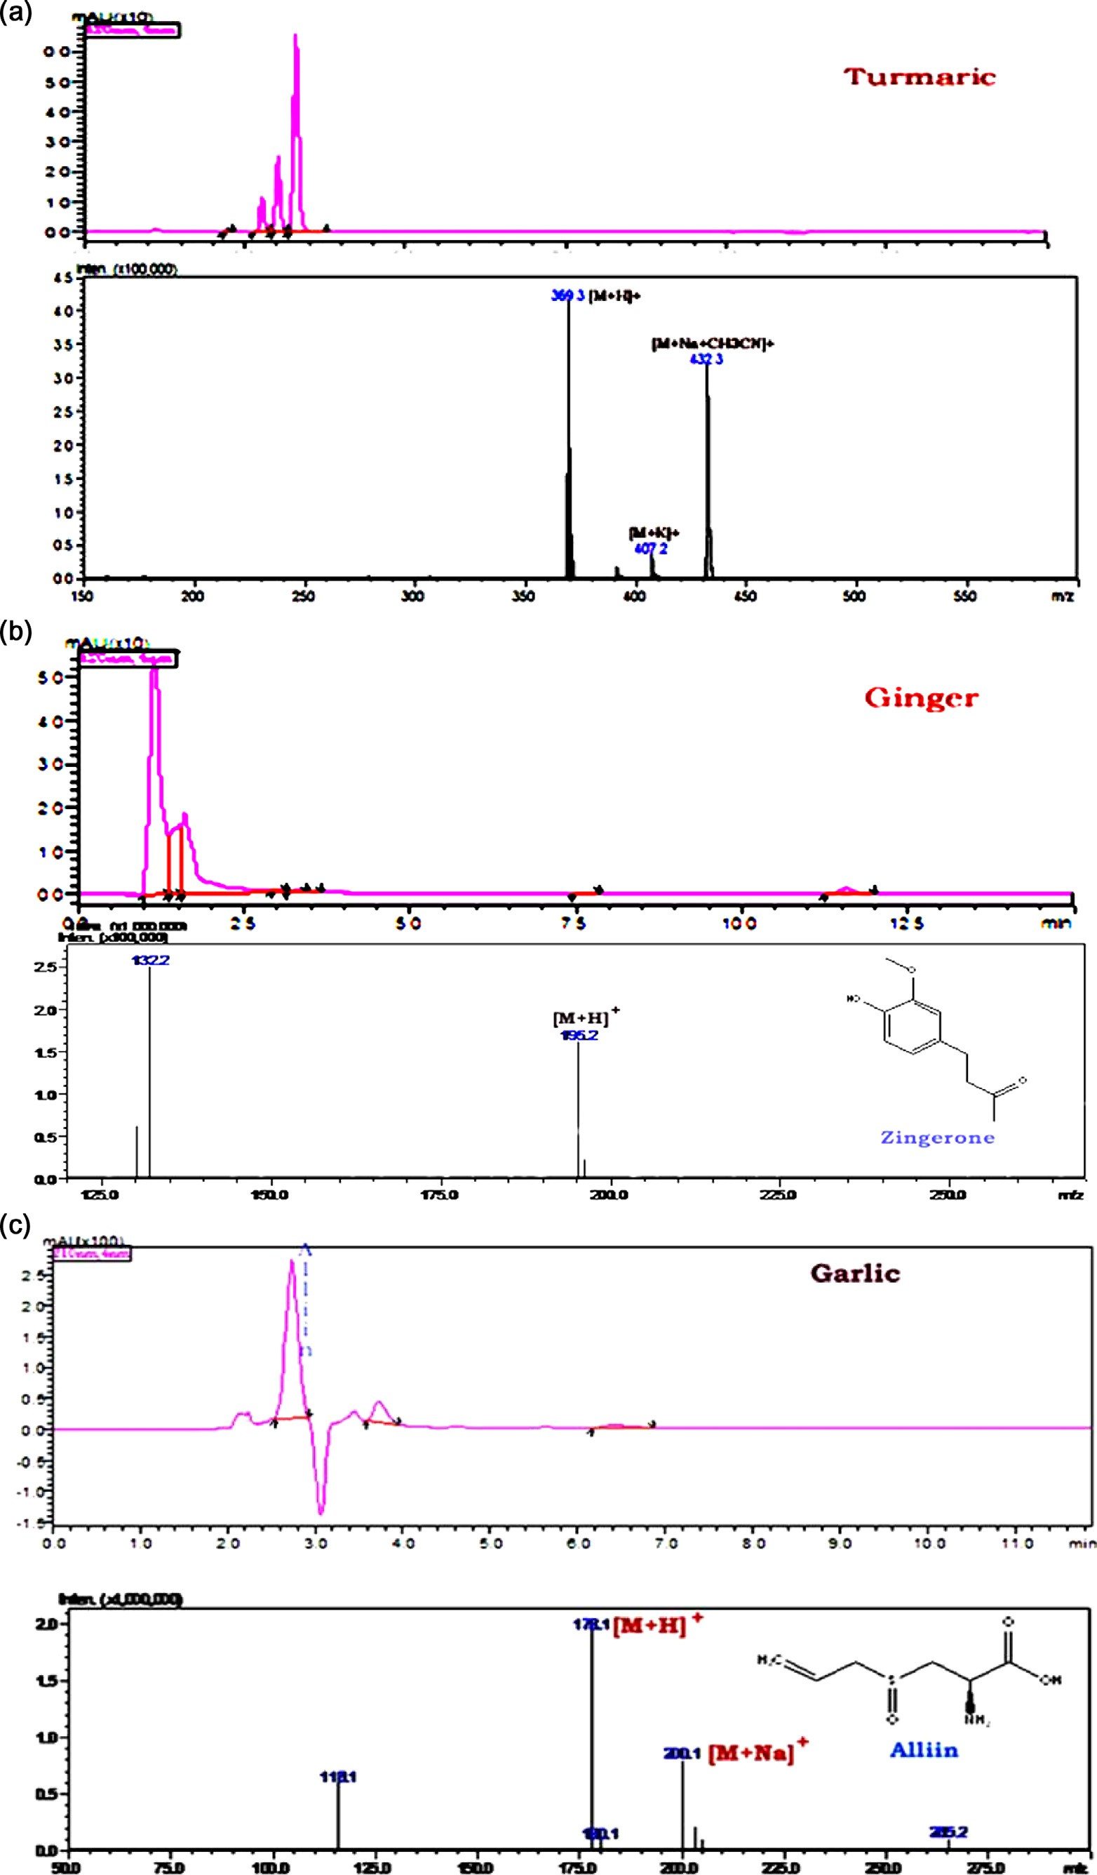

Fig. 8. a–c: The positive ion LC-MS/MS spectra of standards of curcumin, turmeric, ginger and garlic.

adverse effects of radiation in men. Since the bioactive compounds of turmeric, ginger and garlic have been reported to possess anti- cancer properties such as cell atrophy, anti-proliferative effect, cytotoxicity and free scavenging properties, they have the poten- tial to act as chemopreventive agents.

We have examined the anti-proliferative, apoptotic properties of the natural extract mix against both ER-positive and ER- negative breast cancer cell lines (MCF 7, ZR-75 and MDA-MB 231) with or without Tamoxifen. Our results show increased effects of tamoxifen when combined with the natural extracts. In conclusion, our findings indicate that commonly used aqueous nat- ural extracts can induce cell death and lower the number of divid- ing cells. In addition, our data also suggest the possibility that the extracts may be sensitizing the cancer cells to Tamoxifen, which needs further study. Our results open up the possibility to develop natural extracts that can target breast cancers and also give under- standing of the exact mechanism of action i.e. which signalling molecules are getting activated or repressed.

Conflict of interest

We declare that we have no conflict of interest with anyone.

Acknowledgments

We extend our sincere thanks to Sunshine Hospitals for their support and facilities and we want to extend our sincere thanks to Dr. Suresh Babu (senior scientist) and Mr. Kumar Katragunta, Indian Institute of Chemical Technology for helping with us LC- ESI-MS-MS analysis. We acknowledge Dr. Kiranam Chatti, Dr. Red- dy’s Institute of Life Sciences for providing us with cancer cells and Ms. Prasanthi Sampara, SMART-Sunshine Hospitals for her assis- tance in manuscript editing.

References

1. [Kumar P, Bolshette NB, Jamdade VS, Mundhe NA, Thakur KK, Saikia KK, et al.](http://refhub.elsevier.com/S2314-808X(17)30226-9/h0005) [Breast cancer status in India: an overview. Biomed Prevent Nutr](http://refhub.elsevier.com/S2314-808X(17)30226-9/h0005) [2013;3:177–83](http://refhub.elsevier.com/S2314-808X(17)30226-9/h0005).
2. [Youlden DR, Cramb SM, Yip CH, Baade PD. Incidence and mortality of female](http://refhub.elsevier.com/S2314-808X(17)30226-9/h0010) [breast cancer in the Asia-Pacific region. Cancer Biol Med 2014;11:101–15](http://refhub.elsevier.com/S2314-808X(17)30226-9/h0010).
3. [Azizi E, Abdolmohammadi MH, Fouladdel SH, Shafiee A, Amin GH, Ghaffari SM.](http://refhub.elsevier.com/S2314-808X(17)30226-9/h0015) [Evaluation of p53 and Bcl-2 genes and proteins expression in human breast](http://refhub.elsevier.com/S2314-808X(17)30226-9/h0015) [cancer T47D cells treated with extracts of *Astrodaucus persicus* (Boiss.) Drude in](http://refhub.elsevier.com/S2314-808X(17)30226-9/h0015) [comparison to Tamoxifen. DARU 2009;17(3):181–6](http://refhub.elsevier.com/S2314-808X(17)30226-9/h0015).
4. [Bertheau P, Lehmann-Che J, Varna J, Dumay A, Poirot B, Porcher R, et al. P53 in](http://refhub.elsevier.com/S2314-808X(17)30226-9/h0020) [breast cancer subtypes and new insights into response to chemotherapy.](http://refhub.elsevier.com/S2314-808X(17)30226-9/h0020) [Breast 2002;22(2):S27–9](http://refhub.elsevier.com/S2314-808X(17)30226-9/h0020).
5. [Luo W, Wu F, Elmaoued R, Beck BB, Fischer E, Meng X, et al. Amifostine](http://refhub.elsevier.com/S2314-808X(17)30226-9/h0025) [enhancement of the anti-cancer effects of paclitaxel in endometrial cancer is](http://refhub.elsevier.com/S2314-808X(17)30226-9/h0025) [TP53-dependent. Int J Oncol 2010;37:1187–94](http://refhub.elsevier.com/S2314-808X(17)30226-9/h0025).
6. [Vousden KH, Lu X. Live or let die: the cell’s response to p53. Nat Rev Cancer](http://refhub.elsevier.com/S2314-808X(17)30226-9/h0030) [2002;2(8):594–604](http://refhub.elsevier.com/S2314-808X(17)30226-9/h0030).
7. [Haupt S, Berger M, Goldberg Z, Haupt Y. Apoptosis-the p53 network. J Cell Sci](http://refhub.elsevier.com/S2314-808X(17)30226-9/h0035) [2003;116(Pt 20):4077–85](http://refhub.elsevier.com/S2314-808X(17)30226-9/h0035).
8. [Attardi LD, Jacks T. The role of p53 in tumor suppression: lessons from mouse](http://refhub.elsevier.com/S2314-808X(17)30226-9/h0040) [models. Cell Mol Life Sci 1999;55(1):48–63](http://refhub.elsevier.com/S2314-808X(17)30226-9/h0040).
9. Milena G, Shukri S. TimC. The p53 pathway in breast cancer. Breast Cancer Res 2002;4:70. doi: <http://dx.doi.org/10.1186/bcr426>.
10. [Michael HC, Natalie R, Henning RS, Guy SS, Thomas FF, Eric S, et al. Regulation](http://refhub.elsevier.com/S2314-808X(17)30226-9/h0050) [of cell death protease caspase-9 by phosphorylation. Science 1998;282](http://refhub.elsevier.com/S2314-808X(17)30226-9/h0050) [(5392):1318–21](http://refhub.elsevier.com/S2314-808X(17)30226-9/h0050).
11. [Qiao CUI, Jing-hua YU, Jin-nan WU, Shin-ichi T, Satoshi O, Mutsuhiko M, et al.](http://refhub.elsevier.com/S2314-808X(17)30226-9/h0055) [P53-mediated cell cycle arrest and apoptosis through a caspase-3-](http://refhub.elsevier.com/S2314-808X(17)30226-9/h0055) [independent, but caspase-9-dependent pathway in oridonin-treated MCF-7](http://refhub.elsevier.com/S2314-808X(17)30226-9/h0055) [human breast cancer cells. Acta Pharmacol Sin 2007;28(7):1057–66](http://refhub.elsevier.com/S2314-808X(17)30226-9/h0055).
12. [Würstle ML, Laussmann MA, Rehm M. The central role of initiator caspase-9 in](http://refhub.elsevier.com/S2314-808X(17)30226-9/h0060) [apoptosis signal transduction and the regulation of its activation and activity](http://refhub.elsevier.com/S2314-808X(17)30226-9/h0060) [on the apoptosome. Exp Cell Res 2011;31811:1213–20](http://refhub.elsevier.com/S2314-808X(17)30226-9/h0060).
13. Guerrero AD, Schmitz I, Chen M, Wang J. Promotion of caspase activation by caspase-9-mediated feedback amplification of mitochondrial damage. J Clin Cell Immunol 2012;3(3). doi: <http://dx.doi.org/10.4172/2155-9899.1000126>.
14. [Madeddu C, Gramignano G, Kotsonis P, Paribello F, Macciò A. Ovarian](http://refhub.elsevier.com/S2314-808X(17)30226-9/h0070) [hyperstimulation in premenopausal women during adjuvant tamoxifen](http://refhub.elsevier.com/S2314-808X(17)30226-9/h0070) [treatment for endocrine-dependent breast cancer: a report of two cases.](http://refhub.elsevier.com/S2314-808X(17)30226-9/h0070) [Oncol Lett 2014;8:1279–82](http://refhub.elsevier.com/S2314-808X(17)30226-9/h0070).
15. [Shen L, Hong L, Zhang G, Mai R. Synchronous uterine carcinosarcoma and](http://refhub.elsevier.com/S2314-808X(17)30226-9/h0075) [contralateral breast cancer after tamoxifen therapy: a case report. Int J Clin](http://refhub.elsevier.com/S2314-808X(17)30226-9/h0075) [Exp Pathol 2014;7:5295–301](http://refhub.elsevier.com/S2314-808X(17)30226-9/h0075).
16. [Onder HI, Kilic AC, Kose SA, Karatas A, Kaya E, Kaya M, et al. Branch retinal vein](http://refhub.elsevier.com/S2314-808X(17)30226-9/h0080) [occlusion associated with tamoxifen use. Semin Ophthalmol 2013;28](http://refhub.elsevier.com/S2314-808X(17)30226-9/h0080) [(2):88–90](http://refhub.elsevier.com/S2314-808X(17)30226-9/h0080).
17. [Hernandez RK,](http://refhub.elsevier.com/S2314-808X(17)30226-9/h0085) Sørensen [HT, Pedersen L, Jacobsen J, Lash TL. Tamoxifen](http://refhub.elsevier.com/S2314-808X(17)30226-9/h0085) [treatment and risk of deep venous thrombosis and pulmonary embolism, a](http://refhub.elsevier.com/S2314-808X(17)30226-9/h0085) [Danish population-based cohort study. Cancer 2009;115(19):4442–9](http://refhub.elsevier.com/S2314-808X(17)30226-9/h0085).
18. [Fisher B, Costantino JP, Wickerham DL, Cecchini RS, Cronin WM, Robidoux A,](http://refhub.elsevier.com/S2314-808X(17)30226-9/h0090) [et al. Tamoxifen for prevention of breast cancer: report of the National Surgical](http://refhub.elsevier.com/S2314-808X(17)30226-9/h0090) [Adjuvant Breast and Bowel Project P-1 Study. J Natl Cancer Inst 2005;97](http://refhub.elsevier.com/S2314-808X(17)30226-9/h0090) [(22):1652–62](http://refhub.elsevier.com/S2314-808X(17)30226-9/h0090).
19. [Gorin MB, Day R, Costantino RJ, Fisher B, Redmond CK, Wickerham L, et al.](http://refhub.elsevier.com/S2314-808X(17)30226-9/h0095) [Long-term tamoxifen citrate use and potential ocular toxicity. Am J](http://refhub.elsevier.com/S2314-808X(17)30226-9/h0095) [Ophthalmol 1998;125(4):493–501](http://refhub.elsevier.com/S2314-808X(17)30226-9/h0095).
20. [Dmitri OL, Valery MD. Anti-breast cancer agents derived from plants. Nat Prod](http://refhub.elsevier.com/S2314-808X(17)30226-9/h0100) [Bioprospect 2015;5(1):1–16](http://refhub.elsevier.com/S2314-808X(17)30226-9/h0100).
21. [Lee CC, Houghton P. Cytotoxic of plants from Malaysia and Thailand used](http://refhub.elsevier.com/S2314-808X(17)30226-9/h0105) [traditionally to treat cancer. J Ethnopharmacol 2005;100(3):237–43](http://refhub.elsevier.com/S2314-808X(17)30226-9/h0105).
22. Kasturi M, Ibrahim BA, Renu GB, Hwei-San L, Sivakumar M. Exceedingly higher co-loading of curcumin and paclitaxel onto polymer-functionalized reduced graphene oxide for highly potent synergistic anticancer treatment. Sci Rep 2016;6:32808. doi: <http://dx.doi.org/10.1038/srep32808>.
23. Charalambous C, Pitta CA, Constantinou AI. Equol enhances tamoxifen’s anti- tumor activity by induction of caspase-mediated apoptosis in MCF-7 breast cancer cells. BMC Cancer 2013;13:238. doi: [http://dx.doi.org/10.1186/1471-](http://dx.doi.org/10.1186/1471-2407-13-238) [2407-13-238](http://dx.doi.org/10.1186/1471-2407-13-238).
24. Goel A, Aggarwal BB. Curcumin, the golden spice from indian saffron, is a chemosensitizer and radiosensitizer for tumors and chemoprotector and radioprotector for normal organs. Nutr Cancer 2010;62(7):919–30. doi: [http://](http://dx.doi.org/10.1080/01635581.2010.509835) [dx.doi.org/10.1080/01635581.2010.509835](http://dx.doi.org/10.1080/01635581.2010.509835).
25. [Sartippour MR, Pietras R, Marquez-Garban DC, Chen HW, Heber D, Henning](http://refhub.elsevier.com/S2314-808X(17)30226-9/h0125) [SM, et al. The combination of green tea and tamoxifen is effective against](http://refhub.elsevier.com/S2314-808X(17)30226-9/h0125) [breast cancer. Carcinogenesis 2006;27(12):2424–33](http://refhub.elsevier.com/S2314-808X(17)30226-9/h0125).
26. Ho YS, Pan MH. Tea extracts confer its antiproliferating effects through inhibition of nicotine- and estrogen-induced 9-nicotinic acetylcholine receptor upregulation in human breast cancer cells. In: Nutrition, Functional and Sensory Properties of Foods. 2013, pp. 256-268. doi:10.1039/9781849737685- 00256.
27. Noolu B, Rajanna A, Chauhan A, Nagalla B, Manchala R, Ismail A. Murraya koenigii leaf extract inhibits proteasome activity and induces cell death in breast cancer cells. BMC Complement Altern Med 2013;13(7):1472–6882. doi: <http://dx.doi.org/10.1186/1472-6882-13-7>.
28. Ouhtit A, Gaur RL, Abdraboh M, Ireland SK, Rao PN, Raj SG, et al. Simultaneous inhibition of cell-cycle, proliferation, survival, metastatic pathways and induction of apoptosis in breast cancer cells by a phytochemical super- cocktail: Genes that underpin its mode of action. J Cancer 2013;4(9):703–15. doi: [http://dx.doi.org/10.7150/jca.7235. eCollection 2013](http://dx.doi.org/10.7150/jca.7235.eCollection2013).
29. Srivastava M, Hegde M, Chiruvella KK, Korot HJ, Bhattacharya S, Choudhary B, et al. *Sapodilla plum* (*Achrassapota*) induces apoptosis in cancer cell lines and inhibits tumor progression in mice. Sci Rep 2014;4:6147. doi: [http://dx.doi.](http://dx.doi.org/10.1038/srep06147) [org/10.1038/srep06147](http://dx.doi.org/10.1038/srep06147).
30. [Ravishankara MN, Shrivastava N, Padh H, Rajani M. Evaluation of antioxidant](http://refhub.elsevier.com/S2314-808X(17)30226-9/h0150) [properties of root bark of *Hemidesmus indicus* R. Br. (Anantmul).](http://refhub.elsevier.com/S2314-808X(17)30226-9/h0150) [Phytomedicine 2002;92(2):153–60](http://refhub.elsevier.com/S2314-808X(17)30226-9/h0150).
31. [Umamaheswari M, Chatterjee TK. In vitro antioxidant activities of the fractions](http://refhub.elsevier.com/S2314-808X(17)30226-9/h0155) [of Coccinia grandis L. leaf extract. Afr J Tradit Complement Altern Med 2007;5](http://refhub.elsevier.com/S2314-808X(17)30226-9/h0155) [(1):61–73](http://refhub.elsevier.com/S2314-808X(17)30226-9/h0155).
32. Kwon DY, Kim SJ, Lee JW, Kim YC. Comparison of hydroxyl radical, peroxyl radical, and peroxynitrite scavenging capacity of extracts and active components from selected medicinal plants. Toxicol Res 2010;26(4):321–7. doi: <http://dx.doi.org/10.5487/TR.2010.26.4.321>.
33. [Niharika M, Samanta SK. Ameliorative action of aqueous extract of *Acalypha*](http://refhub.elsevier.com/S2314-808X(17)30226-9/h0165)[*indica* against puffer fish *Lagocephalus lunaris* induced toxicity. Int J Drug Dev](http://refhub.elsevier.com/S2314-808X(17)30226-9/h0165) [Res 2013;5(2):257–71](http://refhub.elsevier.com/S2314-808X(17)30226-9/h0165).
34. Banala RR, Vemuri SK, Reddy AVG, Subbaiah GPV. Aqueous extract of Acalypha indica leaves for the treatment of Psoriasis: In-vitro studies. Int J Bioassays 2017;6(54):5360–4. <http://dx.doi.org/10.21746/ijbio.2017.04.007>.
35. [Xiu-Mei W, Qi-Zhi Z, Jian Y, Rong-Hua Z, Jun Z, Li-Jing C, et al. Validated HPLC–](http://refhub.elsevier.com/S2314-808X(17)30226-9/h0175) [MS/MS method for simultaneous determination of curcumin and piperine in](http://refhub.elsevier.com/S2314-808X(17)30226-9/h0175) [human plasma. Trop J Pharm Res 2011;11(4):621–9](http://refhub.elsevier.com/S2314-808X(17)30226-9/h0175).
36. [Choudhuri T, Pal S, Das T, Gaurisankar S. Curcumin selectively induces](http://refhub.elsevier.com/S2314-808X(17)30226-9/h0180) [apoptosis in deregulated cyclin d1-expressed cells at G2 phase of cell cycle in a](http://refhub.elsevier.com/S2314-808X(17)30226-9/h0180) [p53-dependent manner. J Biol Chem 2005;280(20):20059–68](http://refhub.elsevier.com/S2314-808X(17)30226-9/h0180).
37. Elkady AI, Abuzinadah OA, Baeshen NA, Rahmy TR. Differential control of growth, apoptotic activity, and gene expression in human breast cancer cells by extracts derived from medicinal herbs *Zingiber officinale*. J Biomed Biotech 2012;2012:614356. doi: <http://dx.doi.org/10.1155/2012/614356>.
38. [Tsubura A, Lai YC, Kuwata M, Uehara N, Yoshizawa K. Anticancer effects of](http://refhub.elsevier.com/S2314-808X(17)30226-9/h0190) [garlic and garlic-derived compounds for breast cancer control. Anticancer](http://refhub.elsevier.com/S2314-808X(17)30226-9/h0190) [Agents Med Chem 2011;11(3):249–53](http://refhub.elsevier.com/S2314-808X(17)30226-9/h0190).
39. [Freund A, Chauveau A, Brouillet JP, Lucas A, Lacroix M, Licznar A, et al. IL-8](http://refhub.elsevier.com/S2314-808X(17)30226-9/h0195) [expression and its possible relationship with estrogen-receptor- negative](http://refhub.elsevier.com/S2314-808X(17)30226-9/h0195) [status of breast cancer cells. Oncogene 2003;22(2):252–65](http://refhub.elsevier.com/S2314-808X(17)30226-9/h0195).
40. [Vladusic EA, Hornby AE, Guerra-Vladusic FK, Lakins J, Lupu R. Expression and](http://refhub.elsevier.com/S2314-808X(17)30226-9/h0200) [regulation of estrogen receptor beta in human breast tumors and cell lines.](http://refhub.elsevier.com/S2314-808X(17)30226-9/h0200) [Oncol Rep 2000;7(1):157–67](http://refhub.elsevier.com/S2314-808X(17)30226-9/h0200).
41. Liu CY, Hung MH, Wang DS, Chu PY, Su JC, Teng TH, et al. Tamoxifen induces apoptosis through cancerous inhibitor of protein phosphatase 2 A-dependent phospho-Akt inactivation in estrogen receptor-negative human breast cancer cells. Breast Cancer Res 2014;16(5):431. doi: [http://dx.doi.org/10.1186/](http://dx.doi.org/10.1186/s13058-014-0431-9) [s13058-014-0431-9](http://dx.doi.org/10.1186/s13058-014-0431-9).
42. [Subik K, Lee JF, Baxter L, Strzepek T, Costello D, Crowley P, et al. The expression](http://refhub.elsevier.com/S2314-808X(17)30226-9/h0210) [patterns of ER, PR, HER2, CK5/6, EGFR, Ki-67 and AR by immunohistochemical](http://refhub.elsevier.com/S2314-808X(17)30226-9/h0210) [analysis in breast cancer cell lines. Breast Cancer 2010;4:35–41](http://refhub.elsevier.com/S2314-808X(17)30226-9/h0210).
43. [Kim HJ, Cui X, Hilsenbeck SG, Lee AV. Progesterone receptor loss correlates](http://refhub.elsevier.com/S2314-808X(17)30226-9/h0215) [with human epidermal growth factor receptor 2 overexpression in estrogen](http://refhub.elsevier.com/S2314-808X(17)30226-9/h0215) [receptor-positive breast cancer. Clin Cancer Res 2013;12(3 Pt 2):1013s–8s](http://refhub.elsevier.com/S2314-808X(17)30226-9/h0215).
44. [Osborne CK, Schiff R, Arpino G, Lee AS, Hilsenbeck VG. Endocrine](http://refhub.elsevier.com/S2314-808X(17)30226-9/h0220) [responsiveness: understanding how progesterone receptor can be used to](http://refhub.elsevier.com/S2314-808X(17)30226-9/h0220) [select endocrine therapy. Breast 2014;14(6):458–65](http://refhub.elsevier.com/S2314-808X(17)30226-9/h0220).
45. [Mandlekar S, Kong ANT. Mechanisms of tamoxifen-induced apoptosis.](http://refhub.elsevier.com/S2314-808X(17)30226-9/h0225) [Apoptosis 2001;6(6):469–77](http://refhub.elsevier.com/S2314-808X(17)30226-9/h0225).
46. Kohli L, Kaza N, Coric T, Byer SJ, Brossier NM, Klocke BJ, et al. 4- hydroxytamoxifen induces autophagic death through K-Ras degradation. Cancer Res 2013;73(14):4395–405. doi: [http://dx.doi.org/10.1158/0008-](http://dx.doi.org/10.1158/0008-5472.CAN-12-3765) [5472.CAN-12-3765](http://dx.doi.org/10.1158/0008-5472.CAN-12-3765).
47. [Aggarwal BB, Sundaram C, Malani N, Ichikawa H. Curcumin: the Indian solid](http://refhub.elsevier.com/S2314-808X(17)30226-9/h0235) [gold. Adv Exp Med Biol 2007;595:1–75](http://refhub.elsevier.com/S2314-808X(17)30226-9/h0235).
48. Yaacob NS, Kamal NN, Norazmi MN. Synergistic anticancer effects of a bioactive subfraction of *Strobilanthes crispus* and tamoxifen on MCF-7 and MDA-MB-231 human breast cancer cell lines. BMC Complementary Altern Med 2014;14:252. doi: <http://dx.doi.org/10.1186/1472-6882-14-252>.
49. [Chen J, Li L, Su J, Li B, Chen T, Wong YS. Synergistic apoptosis-inducing effects](http://refhub.elsevier.com/S2314-808X(17)30226-9/h0245) [on A375 human melanoma cells of natural borneol and curcumin. PLoS One](http://refhub.elsevier.com/S2314-808X(17)30226-9/h0245) [2014;9(6):e101277](http://refhub.elsevier.com/S2314-808X(17)30226-9/h0245).
50. [Brusselmans K, De Schrijver E, Heyns W, Verhoeven G, Swinnen JV.](http://refhub.elsevier.com/S2314-808X(17)30226-9/h0250) [Epigallocatechin-3- gallate is a potent natural inhibitor of Fatty acid](http://refhub.elsevier.com/S2314-808X(17)30226-9/h0250) [synthase in intact cells and selectively induces Apoptosis in prostate cancer](http://refhub.elsevier.com/S2314-808X(17)30226-9/h0250) [cells. Int J Cancer 2003;106(6):856–62](http://refhub.elsevier.com/S2314-808X(17)30226-9/h0250).
51. Modem S, DiCarlo SE, Reddy TR. Fresh garlic extract induces growth arrest and morphological differentiation of MCF-7 breast cancer cells. Genes Cancer 2012;3(2):177–86. doi: <http://dx.doi.org/10.1177/1947601912458581>.
52. Giuditta FS, Mauro DS, Giorgio B, Mirco F, Anahi B, Laura G, et al. Inhibition of breast cancer cell proliferation and in vitro tumorigenesis by a New Red Apple Cultiva. PLoS ONE 2015;10(8):e0135840. doi: [http://dx.doi.org/10.1371/](http://dx.doi.org/10.1371/journal.pone.0135840) [journal.pone.0135840](http://dx.doi.org/10.1371/journal.pone.0135840).
53. [Bhanot A, Sharma R, Noolvi M. Natural sources as potential anti-cancer agents:](http://refhub.elsevier.com/S2314-808X(17)30226-9/h0265) [A review. Intl J Phytomedicine 2011;3:9–26](http://refhub.elsevier.com/S2314-808X(17)30226-9/h0265).
54. Sarkar FH, Li Y, Wang Z, Kong D. Cellular signaling perturbation by natural products. Cell Signal 2009;21(11):1541–7. doi: [http://dx.doi.org/10.1016/](http://dx.doi.org/10.1016/j.cellsig.2009.03.009) [j.cellsig.2009.03.009](http://dx.doi.org/10.1016/j.cellsig.2009.03.009).
55. Shanmugam MK, Kannaiyan R, Sethi G. Targeting cell signalling and apoptotic pathways by dietary agents: Role in the prevention and treatment of cancer. Nutr Cancer 2011;63(2):161–73. doi: [http://dx.doi.org/10.1080/](http://dx.doi.org/10.1080/01635581.2011.523502) [01635581.2011.523502](http://dx.doi.org/10.1080/01635581.2011.523502).
56. [Zhi-Ming S, Zhen-Zhou S, Can-Hui L, Maryam RS, Vay LG, David H, et al.](http://refhub.elsevier.com/S2314-808X(17)30226-9/h0280) [Curcumin exerts multiple suppressive effects on human breast carcinoma](http://refhub.elsevier.com/S2314-808X(17)30226-9/h0280) [cells. Int J Cancer 2002;98(2):234–40](http://refhub.elsevier.com/S2314-808X(17)30226-9/h0280).