[Egyptian Journal of Basic and Applied Sciences 5 (2018) 145–150](https://doi.org/10.1016/j.ejbas.2018.05.002)

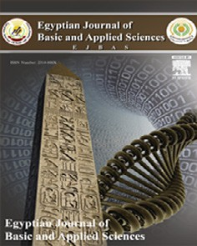

Contents lists available at [ScienceDirect](http://www.sciencedirect.com/science/journal/2314808X)

Egyptian Journal of Basic and Applied Sciences

journal homepage: [www.elsevier.com/locate/ejbas](http://www.elsevier.com/locate/ejbas)

Full Length Article

[](http://crossmark.crossref.org/dialog/?doi=10.1016/j.ejbas.2018.05.002&domain=pdf)Antifungal activity of fabricated mesoporous silica nanoparticles against early blight of tomato

Aly Derbalah a,b,⇑, Mohamed Shenashen a, Amany Hamza b, Ahmed Mohamed c, Sherif El Safty a,d

a *National Institute for Materials Science (NIMS), 1-2-1 Sengen, Tsukuba-shi, Ibaraki-ken 305-0047, Japan*

b *Pesticides Chemistry and Toxicology Department, Faculty of Agriculture, Kafr-El-Shiekh University, 33516, Egypt*

c *Plant Pathology Research Institute, Agriculture Research Centre, Giza, Egypt*

d *Graduate School for Advanced Science and Engineering, Waseda University, 3-4-1 Okubo, Shinjuku-ku, Tokyo 169-8555, Japan*

# a r t i c l e i n f o

*Article history:*

Received 12 August 2017

Received in revised form 28 April 2018 Accepted 2 May 2018

Available online 18 May 2018

*Keywords:* Control Disease Nanoparticles Tomato

Silica

# a b s t r a c t

There is a growing interest in the development of alternative strategies in plant disease management to reduce dependency on synthetic chemicals. In this study, we described synthesis and evaluation of the direct antifungal activity of mesoporous silica nanoparticles (MSN) compared to metalaxyl (recom- mended fungicide) against *A. solani* under laboratory and greenhouse conditions. The structural features of MSN such as high porosity, small particle size and suitable shape contributed to its high antifungal effi- cacy against *Alternaria solani*. Laboratory synthesized MSN showed marked increase in tomato growth parameters compared to untreated control. Our study presents promising results of the use of MSN as an effective and safe alternative of fungicides for managing tomato early blight.

© 2018 Mansoura University. Production and hosting by Elsevier B.V. This is an open access article under

the CC BY-NC-ND license (<http://creativecommons.org/licenses/by-nc-nd/4.0/>).

Introduction

Tomato (*Lycopersicon esculentum* L. H. Karst.) is an important vegetable crop worldwide. Tomato early blight caused by *Alter- naria solani* is one of the most destructive diseases worldwide; yield losses of up to 80% have been attributed to this disease [1–3]. The control of tomato early blight mainly relies on the frequent use of synthetic fungicides. Numerous fungicides are potential compounds against this pathogen but these chemicals are not ideal long-term solutions because of the high cost, residues, and the impacts on the environment and human health [4–7]. Moreover, the evolution of resistance of plant pathogens such as *A. solani* against fungicides is a problem of major concern [8,9]. Therefore, safe, effective, and eco-friendly control agents are in demand [10]. Recently, the search for new control agents in pest management has become an urgent task. Nanotechnology can play significant role in this regard. The development of novel agents for detection and control of plant diseases are examples of the major contribu- tions of nanotechnology to agriculture and food systems [11]. Nanotechnology can play several roles in the progress of available plant protection tools [12] and may be used in the control of plant pathogens in terms of control agents delivery or disease detection.

* Corresponding author at: Pesticides Chemistry and Toxicology, Faculty of Agriculture, Kafr El-Sheikh Univ., 33516 Kafr El-Sheikh, Egypt.

*E-mail address:* [ali.derbala@agr.kfs.edu.eg](mailto:ali.derbala@agr.kfs.edu.eg) (A. Derbalah).

Mesoporous materials such as silica have widespread applica- tions, i.e., in disease diagnosis and therapy [13–17]. Recently, the attention given to mesoporous silica is attributed to their unique characteristics, such as uniformed mesoporous tunnels, narrow pore size distribution, good biocompatibility, low toxicity, and chemical stability. Much effort has been devoted toward the improvement and manipulation of this material for various appli- cations. In addition, the design of mesoporous and nanomaterials with engineered features, including geometrical shapes, frame- work matrices, compositions, and active-site functions, have important advantages in applications for medical and agricultural purposes.

In this study we described the synthesis and evaluation of mesoporous silica nanoparticles (MSN) with large, tunable, and open cylindrical pores as potential antifungal agent against *A. solani* under laboratory and greenhouse conditions. The efficacy of MSN was evaluated against tomato early blight as compared with the recommended fungicide, metalaxyl.

Materials and methods

*Source of chemicals*

Tetramethylorthosilicate (TMOS), dodecane (C12H26), and the triblock copolymers of poly(ethyleneoxide–b-propylene oxide–b-

<https://doi.org/10.1016/j.ejbas.2018.05.002>

2314-808X/© 2018 Mansoura University. Production and hosting by Elsevier B.V.

This is an open access article under the CC BY-NC-ND license (<http://creativecommons.org/licenses/by-nc-nd/4.0/>).

ethylene oxide) (Pluronic P123; EO20PO70EO20) were obtained from the Sigma-Aldrich Company, Ltd. (USA). These analytical- grade chemicals were used without further purification. Metalaxyl is the recommended fungicide for the control of tomato early blight pathogen; this chemical with a trade name of Metalaxyl 25% EC Nanjing Essence Fine-Chemical Co., Ltd. was obtained from the Agricultural Development Co., Ltd. (Cairo, Egypt).

*Synthesis of MSN*

The one-pot direct template approach was used to synthesize the MSN, as previously reported [18–20].

*Characterization of MSN*

A Belsorp Min-II analyzer was used to test the N2 adsorption– desorption isotherms at 77 K. Based on the Brunauer–Emmett–Te ller (BET) theory, the specific surface area (*S*BET) was determined with multi-point adsorption data from the linear portion of the N2 adsorption isotherms. The cylindrical pore diameter was defined by Barrett–Joyner–Halenda (BJH) analyses. The small/wide angle powder X-ray diffraction (XRD) measurements of the fabri-

cated material were conducted with a 18 kW diffractometer (Bru- ker D8 Advance) with monochromated Cu Ka irradiation. Transmission electron microscopy (TEM) micrographs were obtained with a 200 kV electron microscope (JEOL 2000 EX II).

Field-emission scanning electron microscopy (FE-SEM) images were obtained with a Hitachi S-4300 microscope. Carbon tape was used as a substrate to fix the MSN powder on a SEM stage before insertion into the chamber. The 29Si MAS NMR spectra were obtained with a Bruker AMX-500 spectrometer.

*Assessment of growth inhibition*

The efficacy of MSN and metalaxyl were evaluated against *A. solani* under laboratory conditions. The efficacy was determined as the per cent of inhibition in the growth relative to the control treatment. Potato dextrose agar (PDA) medium was poured into Petri dishes with 15 ml per dish. One well was punched in the cen- ter of each plate after solidification. The plates were inoculated in the center with a disk (5 mm diameter) bearing the mycelium growth from the *A. solani* culture (5 days old culture). A 50 ml ali-

quot of MSN and metalaxyl, at concentrations of 100, 200, 300

and 400 mg/l, was added to the respective punched holes. A 50 ml aliquot of sterilized liquid medium was added into selected wells as the control. The plates were sealed with parafilm to reduce the evaporation of the tested materials. The incubation time for the plates at 28 °C was extended until the full growth of *A. solani* (mycelia reached the edge of the plate) in the untreated control. The formula by Vincent [21] was used to calculate the percentage of inhibition of *A. solani* as shown in Eq. (1). Each treatment was

replicated three times and per replication five plates were maintained.

I% = (A — B)/A × 100 (1)

where A is the fungal radial growth in the control, and B is the fun-

gal radial growth in the treatment.

*Preparation of spore suspension*

Pathogenic *A. solani* isolated from infected tomato plant and identified in Plant Pathology Research Institute, Giza Egypt, was grown on potato dextrose agar for culturing. To enhance sporula- tion, cultures were exposed to fluorescent light (80 mmol/m2/s)

for 6 h daily prior to use. For each Petri dish, 10 ml of sterilized

water was added and the conidia were collected using a sterilized

brush. The spore suspension of the fungus was filtered through three layers of nylon mesh. The concentration of conidia was deter- mined and adjusted to 106 conidia/mL with a hemocytometer.

*Experimental design and treatments*

The efficacy of MSN was studied in pots under greenhouse con- ditions at the Kafr El-Sheikh University Farm in Egypt for two growing seasons (2013/2014–2014/2015). Completely randomized design was used for this experiment with four replicates for accu- rate data. For each pot, 5 one-month-old tomato seedlings (GS13 variety) were transplanted (20 cm high; 25 cm diameter) filled with sterilized soil. After two weeks of transplanting, tomato seed- lings (45 days old) were inoculated with *A. solani* as foliar spray with a spore suspension of 106 conidia/ml [22]. The inoculated plants were covered with plastic bags for 48 h to maintain the high relative humidity and support fungal infection [23]. After one week of incubation, the respective growing seedlings were sprayed with MSN and metalaxyl at concentration levels of 200 and 400 mg/l using hand atomizer. Tomato seedlings were sprayed twice with 10 days intervals. Control treatment was sprayed with water only. Disease severity was determined after 10 days of last spray. The scale by [24] was used to calculate disease severity. Plant height, fresh and dry weight were measured after 10 days of the last spray to evaluate the effect of applied treatments on tomato growth parameters.

*Statistical analysis*

Statistical analysis for the data was performed with JMP soft- ware version 8 using the Turkey Kramer HSD test for determining significant differences among treatment at P = 0.05 level.

Results

*Characterization of the fabricated MSN antifungal agent*

The SA-XRD pattern of MSN antifungal agent is shown in Fig. 1A. This pattern reflects the well-ordered structure of the fab- ricated MSN, with the well-resolved diffraction peaks and charac- teristic SA-XRD patterns of the Ia3d symmetry with a highly ordered mesostructure. The SA-XRD pattern showed the well- defined (2 1 1), (2 2 0), (4 0 0), and (3 3 2) diffraction planes that are features of highly ordered cubic Ia3d nanophase domains (Fig. 1A).

The pore size distribution of cubic Ia3d silica MSN was exam- ined by N2 adsorption isotherms (Fig. 2). The isotherm exhibited typical type-IV sorption with the typical H1 hysteresis loop of char- acteristic cylindrical mesoporous materials [19,25]. The analysis of the adsorption isotherms with the BET method revealed that the *S*BET of silica was 489 m2/g, the *V*P was 0.69 cm3/g, and the *D*P was 10.7 nm.

Key features of this material design include the high level of 3D arrangement, nano-sized particle morphology, and uniform meso- porous distribution of the target into the mesoporous surface architectures, as proven by analyzing the TEM and SEM micro- graphs, XRD patterns, and N2 isotherm profiles (Figs. 1–3). The TEM images of cubic *Ia3d* silica monoliths were recorded along the [3 1 1] direction (Fig. 2A) and showed the well-defined and reg- ulated mesopore channels that were harmonized along all direc- tional configurations. The insert in Fig. 2A is the corresponding ED pattern analysis, which reveals that the formation of ordered cubic Ia3d lattice symmetry of the silica monolith is congruous with the well-defined XRD patterns. FE-SEM micrographs of the silica monoliths demonstrated the stable morphologies of the

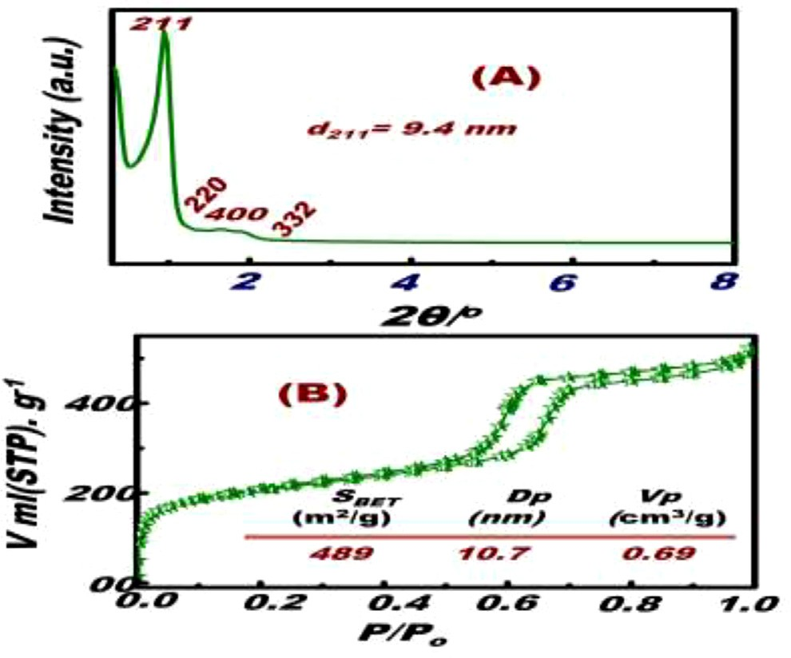 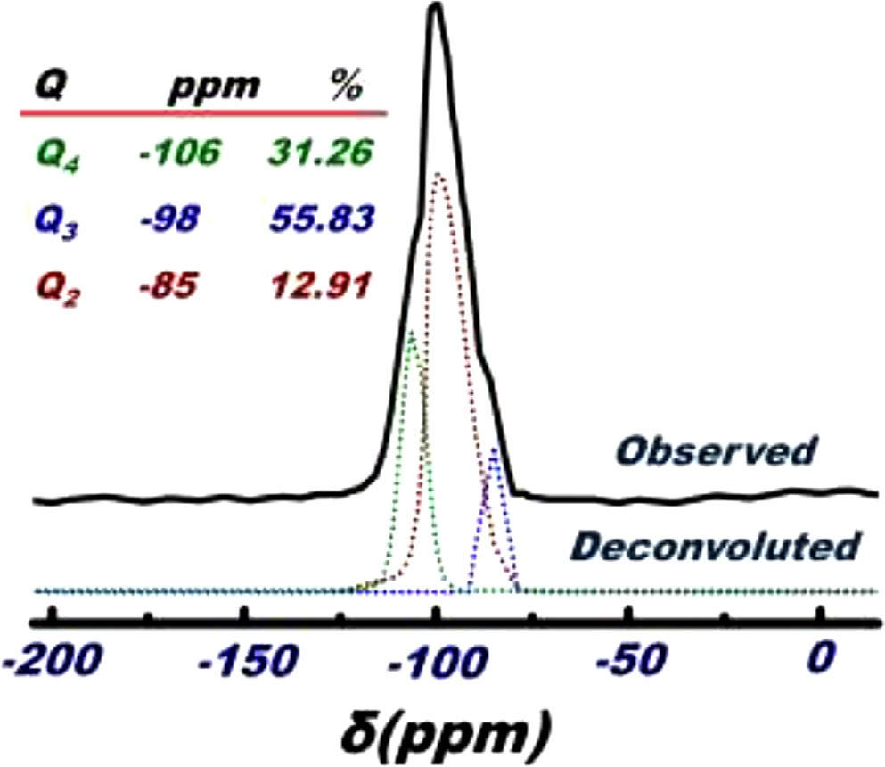

Fig. 1. SA-XRD (A) and N2 isothermal (B) patterns of MSN antifungal agents. Inserts A, the assignment of the diffraction peaks of cubic Ia3d mesostructures. Inserts B, The structural surface parameters of Surface area (SBET), pore size (Dp) and pore volume (Vp), respectively of cubic Ia3d mesostructures.

Fig. 3. 29Si NMR spectra of MSN antifungal agent. The percentage ratios of Q3 and Q2 indicated the surface hydrophilicity of cubic Ia3d mesostructures, leading to the strong binding to fungicide species during the inhibition of growth process.

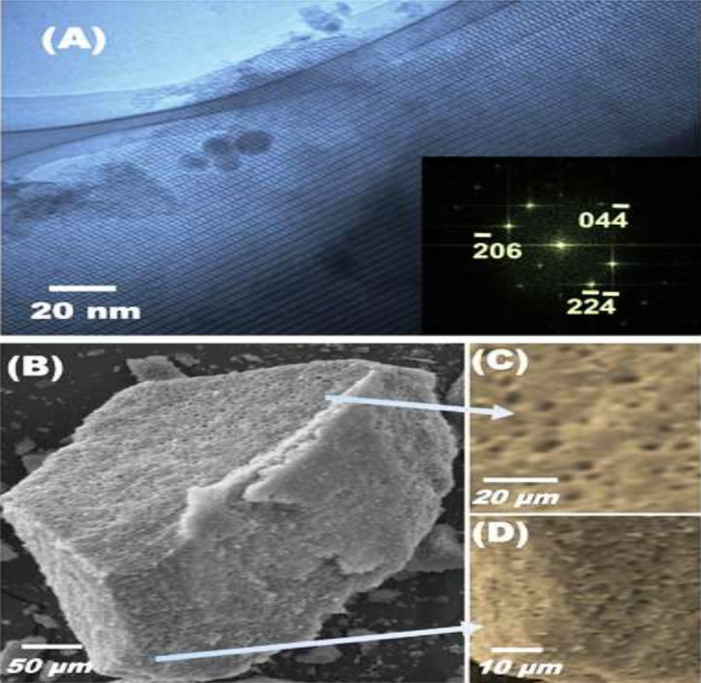

Fig. 2. HR-TEM (A) and FE-SEM (B-D) micrographs of MSN antifungal agents. Inserts A, the electron diffraction of selected area recorded along the {3 1 1} zone axis f cubic Ia3d mesostructures. (C-D) the morphological surface of cubic Ia3d mesostructures clearly showed the formation of large micrometric voids (1–4 mm), leading for high absorptivity and diffusivity of bulk fungicide species.

molecules for all cases of calcined and crushed monoliths, In addi- tion, large-sized particles with diameters of 20–150 lm were pre- sent (Fig. 2B–D). Remarkably, the monoliths in micrometer-sized particles were a result of the aggregation of large amounts of

nanoparticles. The developed MSN featured such as 3D cubic Ia3d structures, with cylindrically-shaped and uniform pore sizes, as well as the conversion of monodispersed meso-/macro-

porosities into ultra- or micrometer-sized particles (≥150 lm).

These features probably increased its efficiency as a potential anti-

fungal agent against early blight disease of tomato. Fig. 3 showed

ple at the chemical shift (d) of —85, —98, and —106 ppm. These fea- the three resolved signals of the monolithic cubic Ia3d silica sam-

tures can be readily assigned by spectra to provide the deconvolution of the silicon atoms of silanol groups on the surface, which were described as the (Q2), (Q3), and (Q4) species, respec- tively [26,27].

*Growth inhibition of A. solani under laboratory conditions*

*A. solani* growth was significantly inhibited by MSN and meta- laxyl at various concentrations compared with the untreated con- trol. However, the highest growth inhibition percentage of *A. solani* was achieved at the highest concentration (400 mg/L) (Table 1 and Fig. 4). The degree of growth inhibition positively correlated with MSN and metalaxyl concentration level.

*Efficacy under greenhouse conditions*

MSN and metalaxyl significantly reduced the severity of early blight of tomato as compared with untreated control in two grow- ing seasons (Table 2). The degree of severity reduction positively correlated with concentration levels of the tested materials. The severity reduction was higher in the second season than in the first one.

*Effects on growth parameters*

The effect of MSN on the growth characters of tomato plants was assessed by comparing with metalaxyl (Table 3). The mea- sured growth parameters were plant height, fresh weight, and dry weight. The tomato growth characters were significantly increased in treated plants compared to the untreated control. Fresh and dry weight of tomato plants treated with MSN increased two fold more than untreated control in both growing seasons.

Discussion

Early blight is a fungal disease that caused by *Alternaria solani* that occurs on tomatoes worldwide. This fungal disease is gener- ally one of the most severe tomato problems faced and if uncon- trolled, early blight can cause significant yield reduction [28]. Therefore, for top yield of high quality tomato fruit, control of this

Table 1

*In vitro* efficacy of different concentrations of MSN and metalaxyl against *A. solani*.

|  |  |  |  |
| --- | --- | --- | --- |
| Treatments | Concentation (mg/L) | Growth inhibition Percentage | Regression equation *R*2 |
| MSN | 100 | 20 | Y = 0.185x + 4 0.98 |
|  | 200 | 43 |  |
|  | 300 | 63 |  |
|  | 400 | 75 |  |
| Metalaxyl | 100 | 35 | Y = 0.213x + 17.5 0.975 |
|  | 200 | 64 |  |
|  | 300 | 85 |  |
|  | 400 | 99 |  |

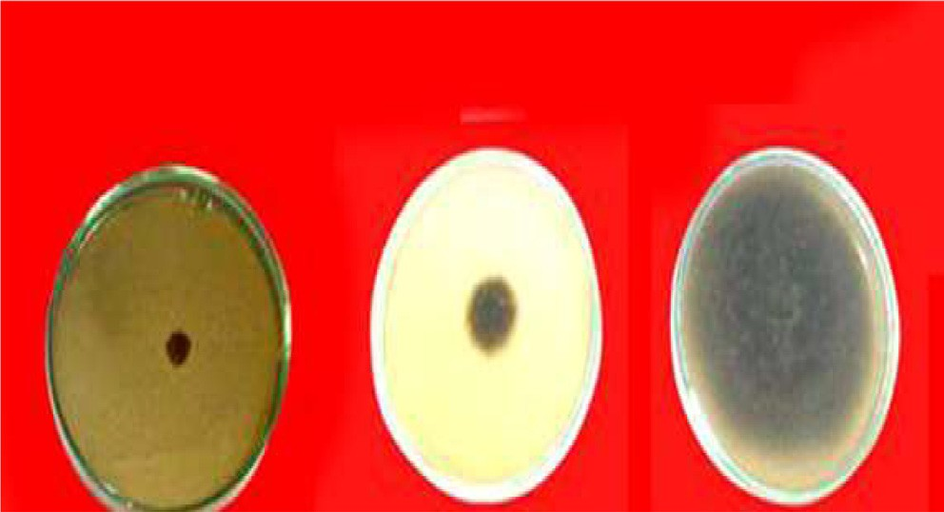

Metalaxyl

MSN

Control

Fig. 4. Growth inhibition of *A. solani* under the tested treatments at concentration level of 400 mg/L compare to control.

pathogen is essential. The frequent use of fungicides for control of early blight disease resulted in environmental pollution and haz- ardous effects on human [4,5,7]. This is beside that the application of fungicides led to the emergence of resistant strains of fungi to fungicides [8,9]. Therefore new safe and effective alternatives of fungicides to control plant pathogens such as early blight of tomato considered a source of major concern. The concept of utilizing sil- ica nanoparticles as an antimicrobial agent is comparatively new [29], as the focus has now been shifted towards making non- toxic, safe nanoparticles [30]. The potential effect MSN against early blight disease agrees with many studies reported that several nanoparticles such as silver and selenium controlled this disease effectively [31,32]. The physical characteristics and structural fea- tures of MSN, such as the high surface area, unique structure, cylindrically-shaped and uniform pore sizes led to its high antifun- gal efficacy against *A. solani*.

The mode of action of any control agents are very important and help in improving the efficacy of it when we faced some defects of its efficacy. The mechanism of MSN action against *A. solani* is not clearly known till now but there are many theories in this regard. The fungicidal activity of MSN as proposed in Fig. 5 may be attrib- uted to the deactivation of protein molecules or the direct contact with pathogen DNA and cause mutations in DNA and affect

replication [33–34]. In addition, the antifungal effect of MSN may be achieved via the facile breakdown of the cell wall due to its small size by forming hydrogen bonds between lipopolysaccha- rides of the cell wall and surface hydroxyl groups present in MSN [35]. Then the accumulation of MSN in the membrane may induce cell lysis [36] by preventing the trans-membrane energy cycle or form insoluble compounds in the fungal membrane that disrupt the electron transport chain or oxidation of the cell membrane due to the positive charge of MSN and the negative charge of cell membrane which produces the electromagnetic attraction between bot and cell immediately dies [37]. The surface character- istics of MSN support this point of view since the positively charged MSN interacts with the protein thiol groups (-SH) on the fungal cell surface to cause cell lysis [38]. Finally, MSN may func- tion against *A. salani* by increasing tomato plant resistance, physi- ological characteristics and its self-defense against the disease by absorbing silicon (Si) into plants. [39–42].

The unique features of MSN such as high surface area (*S*BET) of 489 m2/g and small pore size (*D*p) of 10.7 expected to improve the significance of its surface morphology participating in the cellular interaction i.e., the number of active sites coming in contact with the cells which render cytotoxic effect against early blight fungus. Also, it is well known that the smaller particles have larger surface area available for interaction and will give more antimicrobial effect than the larger particles.

Any management strategy for plant pathogens should not focus only on the effective control of the pathogens that attack the agri- cultural crops. It should also take in consideration its effect on growth and yield characters of crops. Significant increase in growth parameters of tomato plants treated with MSN were recorded and this is agreed with findings of [43], who reported that the applica- tion of control agents suppresses diseases incidence and can have positive effects on plant growth and yield. This increase may be attributed to the fact that MSN and metalaxyl could reduce the influence of early blight fungus on the green area in tomato leaves; thus, decreased the damaged green leaf area which finally led to increase the plant growth because the leaves can undergo more photosynthesis [44].

Also, one of the most important factors is the amount of MSN that could be used under field conditions and its suitability/appli-

Table 2

Effect of the MSN and metalaxyl treatments on the severity of *A. solani* in tomato in two tested seasons.

|  |  |  |  |  |  |  |
| --- | --- | --- | --- | --- | --- | --- |
| Treatments | % Disease severity |  | | | | |
|  | 1st season |  |  | 2nd season |  |  |
|  | 200 (mg/L) | 400 (mg/L) |  | 200 (mg/L) | 400 (mg/L) |  |
| MSN  Metalaxyl | 36.0 ± 2.11c  16.00 ± 0.45b | 16.00 ± 1.25c  8.00 ± 0.79b |  | 36.00 ± 1.2c  16.00 ± 0.35b | 20.00 ± 0.60c  8.00 ± 0.45b |  |
| Control | 68.00 ± 2.41a | 65.00 ± 0.85 a |  | 68.00 ± 0.56a | 64.00 ± 0.89 a |  |

Each value is mean of five replicates. Mean ± SE followed by same letter in column of each treatment are not significant different at p = 0.05 as determined by Tukey–Kramer HSD.

Table 3

Effect of the MSN and metalaxyl on some growth parameters of treated tomato plants in the last season.

against other plant pathogens because the fungus is unlikely to become genetically or physiologically resistant to such physical mechanism. In addition, the multiple sites of action limit the pos-

Treatments Plant height

(cm)

Fresh weight/plant (g)

Dry weight/plant (g)

sibility that fungi will become resistant to MSN.

MSN 96.67 ± 2.88c 67.57 ± 0.30c 20.07 ± 0.15c Metalaxyl 85.00 ± 2.80b 45.33 ± 0.10b 12.90 ± 0.15b Control 61.67 ± 5.00a 28.60 ± 0.10 a 4.97 ± 0.10a

Each value is mean of four replicates. Mean ± SE followed by same letter in column of each treatment are not significant different at p = 0.05 as determined by Tukey– Kramer HSD.

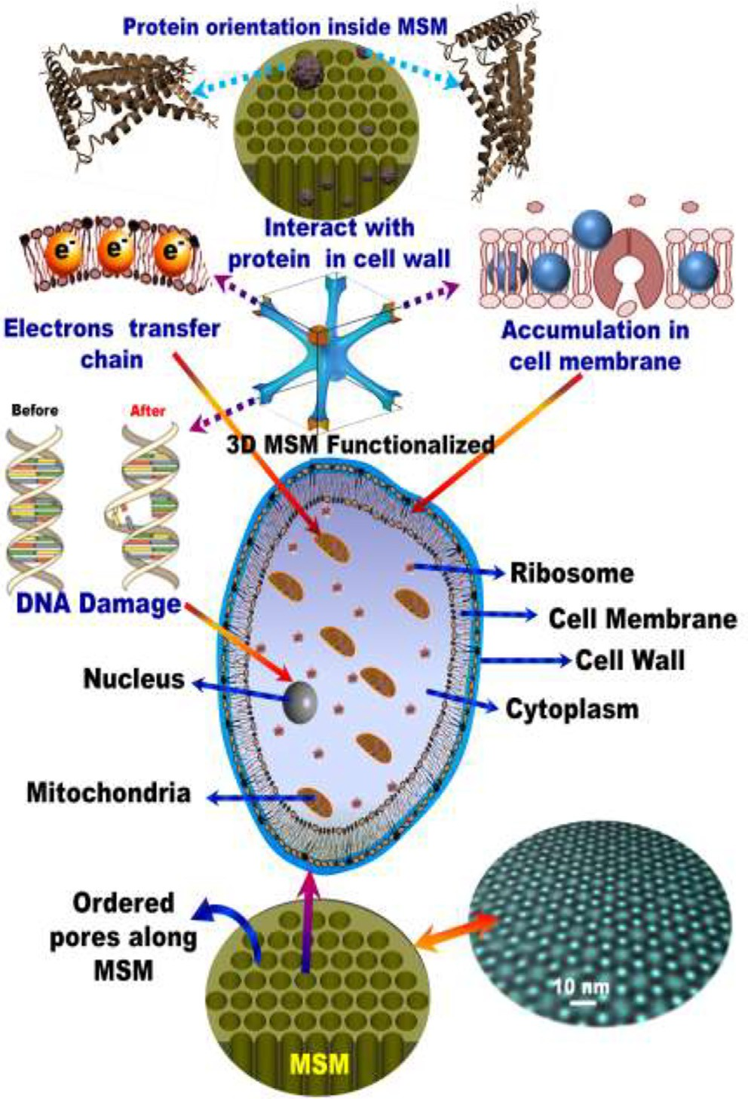

Fig. 5. Schematic representation of various mechanisms (cell membrane interac- tion, DNA damage, protein interaction in cell wall, interruption electron transfer chain) of antifungal activity of MSN.

cability is not known. The amount needed from MSN to spray one acre depend on our results if we supposed that one acre (4046.85 m2) need 100 L water may be 40 g. We think, this amount is appli- cable and comparable to the tested fungicide amount (30 g/4046.85 m2) and cost effective.

The safety is considered one of the key factors for any agents used control agricultural pests. These control agents should not affect the environment and the public health. Recently in two stud- ies with different designs of silica nanoparticles have been found effective in killing bacterial cells without damaging human cells [45,46]. This confirms the safety of MSN to human health and its use can reduce the hazards effects caused by chemical fungicides. The physical mode of action of MSN against *A. solani* make it not specific to this fungus only which strongly supports the use of MSN

Conclusions

MSN effectively reduced the severity of early blight disease in tomato and improved tomato growth characters also. It is expected that the application of MSN nanoparticles at low concentrations will be eco-friendly and decrease farm management costs. The easy synthesis of MSN is a highly promising approach to designing and synthesizing other metal oxides with powerful antifungal activity; that can be used as a safe alternative to chemical fungi- cides to control tomato early blight.

References

1. [Singh RS. Diseases of vegetable crops. New Delhi, Bombay, Calcutta: Oxford](http://refhub.elsevier.com/S2314-808X(17)30378-0/h0005) [and IBH Publishing Co.; 1985. p. 346](http://refhub.elsevier.com/S2314-808X(17)30378-0/h0005).
2. [Mathur K, Shekhawat KS. Chemical control of early blight in kharif sown](http://refhub.elsevier.com/S2314-808X(17)30378-0/h0010) [tomato. Indian J Mycol Plant Pathol 1986;16:235–6](http://refhub.elsevier.com/S2314-808X(17)30378-0/h0010).
3. [Chandravanshi SS, Singh BP, Thakur MP. Persistence of different fungicides](http://refhub.elsevier.com/S2314-808X(17)30378-0/h0015) [used against Alternaria alternata in tomato. Indian Phytopathol](http://refhub.elsevier.com/S2314-808X(17)30378-0/h0015) [1994;47:241–4](http://refhub.elsevier.com/S2314-808X(17)30378-0/h0015).
4. [Kookana RS, Baskaran S, Naidu R. Pesticide fate and behaviour in Australian](http://refhub.elsevier.com/S2314-808X(17)30378-0/h0020) [soils in relation to contamination and management of soil and water: a review.](http://refhub.elsevier.com/S2314-808X(17)30378-0/h0020) [Aust J Soil Res 1998;36:715–64](http://refhub.elsevier.com/S2314-808X(17)30378-0/h0020).
5. [Wightwick A, Allinson G. Pesticide residues in Victorian waterways: a review.](http://refhub.elsevier.com/S2314-808X(17)30378-0/h0025) [Aust J Ecotoxicol 2007;13:91–112](http://refhub.elsevier.com/S2314-808X(17)30378-0/h0025).
6. [Yousuf KG, Haroon AK, Nugegoda D, Rose G. Climate change environmental](http://refhub.elsevier.com/S2314-808X(17)30378-0/h0030) [and biological aspects. Delhi India: New India Publishing Agency; 2010](http://refhub.elsevier.com/S2314-808X(17)30378-0/h0030).
7. [Komarek M, Cadkova E, Chrastny V, Bordas F, Bollinger JC. Contamination of](http://refhub.elsevier.com/S2314-808X(17)30378-0/h0035) [vineyard soils with fungicides: a review of environmental and toxicological](http://refhub.elsevier.com/S2314-808X(17)30378-0/h0035) [aspects. Environ Inter 2010;36:138–51](http://refhub.elsevier.com/S2314-808X(17)30378-0/h0035).
8. [Pasche JS, Piche LM, Gudmestad NC. Effect of the F129L mutation in Alternaria](http://refhub.elsevier.com/S2314-808X(17)30378-0/h0040) [solani on fungicides affecting mitochondrial respiration. Plant Dis](http://refhub.elsevier.com/S2314-808X(17)30378-0/h0040) [2005;89:269–78](http://refhub.elsevier.com/S2314-808X(17)30378-0/h0040).
9. [Abu-El Samen F, Goussous SG, Al-Shudifat A, Makhadmeh I. Reduced](http://refhub.elsevier.com/S2314-808X(17)30378-0/h0045) [sensitivity of tomato early blight pathogen (*Alternaria solani*) isolates to](http://refhub.elsevier.com/S2314-808X(17)30378-0/h0045) [protectant fungicides, and implication on disease control. Arch of Phytopathol](http://refhub.elsevier.com/S2314-808X(17)30378-0/h0045) [Plant Protect 2016;49:120–36](http://refhub.elsevier.com/S2314-808X(17)30378-0/h0045).
10. [Mdee LK, Masoko P, Eloff JN. The activity of extracts of seven common invasive](http://refhub.elsevier.com/S2314-808X(17)30378-0/h0050) [plant species on fungal phytopathogens. South Afri J Bot 2009;75:375–9](http://refhub.elsevier.com/S2314-808X(17)30378-0/h0050).
11. [Weiss J, Takhistov P, McClements DJ. Functional materials in food](http://refhub.elsevier.com/S2314-808X(17)30378-0/h0055) [nanotechnology. J Food Sci 2006;71:107–16](http://refhub.elsevier.com/S2314-808X(17)30378-0/h0055).
12. [Nair R, Varghese SH, Nair BG, Maekawa T, Yoshida Y, Kumar DS.](http://refhub.elsevier.com/S2314-808X(17)30378-0/h0060) [Nanoparticulate material delivery to plants. Plant Sci 2010;179:154–63](http://refhub.elsevier.com/S2314-808X(17)30378-0/h0060).
13. [Thangam SR, Sujitha V, Vimala K, Kannan S. Ligand-conjugated mesoporous](http://refhub.elsevier.com/S2314-808X(17)30378-0/h0065) [silica nanorattles based on enzyme targeted prodrug delivery system for](http://refhub.elsevier.com/S2314-808X(17)30378-0/h0065) [effective lung cancer therapy. Toxicol Appl Pharmacol 2014;27:232–43](http://refhub.elsevier.com/S2314-808X(17)30378-0/h0065).
14. [Yuan Z, Xin Z, Jingwen Z, Guoqing P, Wangwang Q, Xiaohu W, et al. Synergistic](http://refhub.elsevier.com/S2314-808X(17)30378-0/h0070) [mediation of tumor signaling pathways in hepatocellular carcinoma therapy](http://refhub.elsevier.com/S2314-808X(17)30378-0/h0070) [via dual-drug-loaded pH-responsive electrospun fibrous scaffolds. J Mater](http://refhub.elsevier.com/S2314-808X(17)30378-0/h0070) [Chem B 2015;17:3436–46](http://refhub.elsevier.com/S2314-808X(17)30378-0/h0070).
15. [Yao J, Sun N, Deng C, Zhang X. Designed synthesis of Graphene @titania](http://refhub.elsevier.com/S2314-808X(17)30378-0/h0075) [@mesoporous silica hybrid material as size-exclusive metal oxide affinity](http://refhub.elsevier.com/S2314-808X(17)30378-0/h0075) [chromatography platform for selective enrichment of endogenous](http://refhub.elsevier.com/S2314-808X(17)30378-0/h0075) [phosphopeptides. Talanta 2016;150:296–301](http://refhub.elsevier.com/S2314-808X(17)30378-0/h0075).
16. [Xie X, Li F, Zhang H, Lu Y, Lian S, Lin H, et al. EpCAM aptamer-functionalized](http://refhub.elsevier.com/S2314-808X(17)30378-0/h0080) [mesoporous silica nanoparticles for efficient colon cancer cell-targeted drug](http://refhub.elsevier.com/S2314-808X(17)30378-0/h0080) [delivery. Europ J Pharma Sci 2016;83:28–35](http://refhub.elsevier.com/S2314-808X(17)30378-0/h0080).
17. [Rehman F, Abdur Rahim A, Claudio Airoldi Volpe PLO. Preparation and](http://refhub.elsevier.com/S2314-808X(17)30378-0/h0085) [characterization of glycidyl methacrylate organo bridges grafted mesoporous](http://refhub.elsevier.com/S2314-808X(17)30378-0/h0085) [silica SBA-15 as ibuprofen and mesalamine carrier for controlled release.](http://refhub.elsevier.com/S2314-808X(17)30378-0/h0085) [Mater Sci Eng 2016;59:970–9](http://refhub.elsevier.com/S2314-808X(17)30378-0/h0085).
18. [El-Safty SA, Hanaoka T. Fabrication of crystalline, highly ordered three-](http://refhub.elsevier.com/S2314-808X(17)30378-0/h0090) [dimensional silica monoliths (HOM-n) with large, mmorphological mesopore](http://refhub.elsevier.com/S2314-808X(17)30378-0/h0090) [sstructure. Adv Mater 2003;15:1893–9](http://refhub.elsevier.com/S2314-808X(17)30378-0/h0090).
19. [El-Safty SA, Hanaoka T, Mizukami F. Transparent cubic Fd3m mesoporous](http://refhub.elsevier.com/S2314-808X(17)30378-0/h0095) [silica monoliths with highly controllable pore architectures. J Mater Chem](http://refhub.elsevier.com/S2314-808X(17)30378-0/h0095) [2005;15:2590](http://refhub.elsevier.com/S2314-808X(17)30378-0/h0095).
20. [El-Safty SA, Kiyozumi Y, Hanaoka T, Mizukami F. Cationic surfactant templates](http://refhub.elsevier.com/S2314-808X(17)30378-0/h0100) [for newly developed cubic Fd3m silica mesocage structure. Mater Lett](http://refhub.elsevier.com/S2314-808X(17)30378-0/h0100) [2008;62:2950](http://refhub.elsevier.com/S2314-808X(17)30378-0/h0100).
21. [Vincent JH. Distortion of fungal hyphae in presence of certain inhibitor. Nature](http://refhub.elsevier.com/S2314-808X(17)30378-0/h0105) [1947;15:850](http://refhub.elsevier.com/S2314-808X(17)30378-0/h0105).
22. [Datar VV, Mayee CD. Chemical management of early blight of tomato. J](http://refhub.elsevier.com/S2314-808X(17)30378-0/h0110) [Maharashtra Agric Univ 1985;3:278–80](http://refhub.elsevier.com/S2314-808X(17)30378-0/h0110).
23. [Hilaal MR. Epidemiological study on early blight of tomatoes in relation to](http://refhub.elsevier.com/S2314-808X(17)30378-0/h0115) [fungicidal resistance (M.Sc. Thesis). Faculty of Agriculture Ain Shams](http://refhub.elsevier.com/S2314-808X(17)30378-0/h0115) [University Egypt; 1992. p. 167](http://refhub.elsevier.com/S2314-808X(17)30378-0/h0115).
24. [Chirst BJ. Effect of disease assessment methods on ranking potato cultivars for](http://refhub.elsevier.com/S2314-808X(17)30378-0/h0120) [resistance to early blight. Plant Dis 1991;75:353](http://refhub.elsevier.com/S2314-808X(17)30378-0/h0120).
25. [El-Safty SA, Shenashen MA, Shahat A. Tailor-made micro-object optical sensor](http://refhub.elsevier.com/S2314-808X(17)30378-0/h0125) [based on mesoporous pellets for visual monitoring and removal of toxic metal](http://refhub.elsevier.com/S2314-808X(17)30378-0/h0125) [ions from aqueous media. Small 2013;9(13):2288–96](http://refhub.elsevier.com/S2314-808X(17)30378-0/h0125).
26. [El-Safty SA, Shahat A, Ismael M. Mesoporous aluminosilica monoliths for the](http://refhub.elsevier.com/S2314-808X(17)30378-0/h0130) [adsorptive removal of small organic pollutants. J Hazard Mater](http://refhub.elsevier.com/S2314-808X(17)30378-0/h0130) [2012;201:23–32](http://refhub.elsevier.com/S2314-808X(17)30378-0/h0130).
27. [Shenashen MA, Elshehy EA, El-Safty SA, Khairy M. Visual monitoring and](http://refhub.elsevier.com/S2314-808X(17)30378-0/h0135) [removal of divalent copper, cadmium, and mercury ions from water by using](http://refhub.elsevier.com/S2314-808X(17)30378-0/h0135) [mesoporous cubic Ia3d aluminosilica sensors. Sep Purificat Technol](http://refhub.elsevier.com/S2314-808X(17)30378-0/h0135) [2013;116:73–86](http://refhub.elsevier.com/S2314-808X(17)30378-0/h0135).
28. [Hassanein NM, Abouzeid MA, Youssef KA, Mahmoud DA. Control of tomato](http://refhub.elsevier.com/S2314-808X(17)30378-0/h0140) [early blight and wilt using aqueous extract of neem leaves. Phytopathol Med](http://refhub.elsevier.com/S2314-808X(17)30378-0/h0140) [2010;49:143–51](http://refhub.elsevier.com/S2314-808X(17)30378-0/h0140).
29. [Besinis A, De Peralta T, Handy RD. The antibacterial effects of silver, titanium](http://refhub.elsevier.com/S2314-808X(17)30378-0/h0145) [dioxide and silica dioxide nanoparticles compared to the dental disinfectant](http://refhub.elsevier.com/S2314-808X(17)30378-0/h0145) [chlorhexidine on *Streptococcus mutans* using a suite of bioassays. Nanotoxicol](http://refhub.elsevier.com/S2314-808X(17)30378-0/h0145) [2014;8(1):1–16](http://refhub.elsevier.com/S2314-808X(17)30378-0/h0145).
30. [Tank CS, Raman S, Karan S, Gosavi NP, Lalla V, Sathe R, et al. Antimicrobial](http://refhub.elsevier.com/S2314-808X(17)30378-0/h0150) [activity of silica coated silicon nano-tubes (SCSNT) and silica coated silicon](http://refhub.elsevier.com/S2314-808X(17)30378-0/h0150) [nano-particles (SCSNP) synthesized by gas phase condensation. J Mater Sci](http://refhub.elsevier.com/S2314-808X(17)30378-0/h0150) [2013;24:1483–90](http://refhub.elsevier.com/S2314-808X(17)30378-0/h0150).
31. [Ismail AA, Sidkey NM, Arafa RA, Fathy RM, El-Batal AI. Evaluation of](http://refhub.elsevier.com/S2314-808X(17)30378-0/h0155) [in vitro antifungal activity of silver and selenium nanoparticles against](http://refhub.elsevier.com/S2314-808X(17)30378-0/h0155) [*Alternaria solani* caused early blight disease on Potato. Br Biotechnol J](http://refhub.elsevier.com/S2314-808X(17)30378-0/h0155) [2016;12:1–11](http://refhub.elsevier.com/S2314-808X(17)30378-0/h0155).
32. [El-Batal AI, Sidkey NM, Ismail AA, Arafa RM, Rasha Fathy M. Impact of silver](http://refhub.elsevier.com/S2314-808X(17)30378-0/h0160) [and selenium nanoparticles synthesized by gamma irradiation and their](http://refhub.elsevier.com/S2314-808X(17)30378-0/h0160) [physiological response on early blight disease of potato. J Chem Pharmaceut](http://refhub.elsevier.com/S2314-808X(17)30378-0/h0160) [Res 2016;8(4):934–51](http://refhub.elsevier.com/S2314-808X(17)30378-0/h0160).
33. [Petica A, Gavriliu S, Lungu M, Buruntea N, Panzaru C. Colloidal silver solutions](http://refhub.elsevier.com/S2314-808X(17)30378-0/h0165) [with antimicrobial properties. Mater Sci Eng 2008;152(1–3):22–7](http://refhub.elsevier.com/S2314-808X(17)30378-0/h0165).
34. [Salem HF, Eid K, Sharaf M. Formulation and evaluation of silver nanoparticles](http://refhub.elsevier.com/S2314-808X(17)30378-0/h0170) [as antibacterial and antifungal agents with a minimal cytotoxic effect. Inter J](http://refhub.elsevier.com/S2314-808X(17)30378-0/h0170) [Drug Deliv 2011;3:293–304](http://refhub.elsevier.com/S2314-808X(17)30378-0/h0170).
35. [Capeletti LB, De Oliveria LF, DeAlmeida Goncalves K, DeOliveira JFA, Saito A,](http://refhub.elsevier.com/S2314-808X(17)30378-0/h0175) [Kobarg J, et al. Tailored silica–antibiotic nanoparticles: overcoming bacterial](http://refhub.elsevier.com/S2314-808X(17)30378-0/h0175) [resistance with low cytotoxicity. Langmuir 2014;30:7456–64](http://refhub.elsevier.com/S2314-808X(17)30378-0/h0175).
36. [Gill S, Fouts DE, Archer GL, Mongodin EF, Deboy RT, Ravel J, et al. Insights on](http://refhub.elsevier.com/S2314-808X(17)30378-0/h0180) [evolution of virulence and resistance from the complete genome analysis of an](http://refhub.elsevier.com/S2314-808X(17)30378-0/h0180) [early methicillin-resistant *Staphylococcus aureus* strain and a biofilm-](http://refhub.elsevier.com/S2314-808X(17)30378-0/h0180) [producing methicillin-resistant *Staphylococcus epidermidis* strain. J Bacteriol](http://refhub.elsevier.com/S2314-808X(17)30378-0/h0180) [2005;187:2426–38](http://refhub.elsevier.com/S2314-808X(17)30378-0/h0180).
37. [Rezaei-Zarchi S, Javed A, Ghani MJ, Soufian S, Firouzabadi FB, Moghaddam AB,](http://refhub.elsevier.com/S2314-808X(17)30378-0/h0185) [et al. Comparative study of antimicrobial activities of TiO2](http://refhub.elsevier.com/S2314-808X(17)30378-0/h0185) [and CdO](http://refhub.elsevier.com/S2314-808X(17)30378-0/h0185) [nanoparticles against the pathogenic strain of *Escherichia coli*. Iran J Pathol](http://refhub.elsevier.com/S2314-808X(17)30378-0/h0185) [2010;5(2):83–9](http://refhub.elsevier.com/S2314-808X(17)30378-0/h0185).
38. [Zhang H, Chen G. Potent antibacterial activities of Ag/TiO2 nanocomposite](http://refhub.elsevier.com/S2314-808X(17)30378-0/h0190) [powders synthesized by a one-pot sol-gel method. Environ Sci Technol](http://refhub.elsevier.com/S2314-808X(17)30378-0/h0190) [2009;43(8):2905–10](http://refhub.elsevier.com/S2314-808X(17)30378-0/h0190).
39. [Garver TLW, Thomas BJ, Robbins MP, Zeyen RJ. Phenyalanine ammonia-lyase](http://refhub.elsevier.com/S2314-808X(17)30378-0/h0195) [inhibition, auto fluorescence, and localized accumulation of silicon, calcium](http://refhub.elsevier.com/S2314-808X(17)30378-0/h0195) [and manganese in oat epidermis attacked by the powdery mildew fungus](http://refhub.elsevier.com/S2314-808X(17)30378-0/h0195) [Almeria graminis (DC) speer. Physiological Mol Plant Pathol 1998;52:223–43](http://refhub.elsevier.com/S2314-808X(17)30378-0/h0195).
40. [Ma JF, Goto S, Tami K, Ichii M. Role of root hairs and lateral roots in silicon](http://refhub.elsevier.com/S2314-808X(17)30378-0/h0200) [uptake by rice. Plant Physiol 2001;127:1773–80](http://refhub.elsevier.com/S2314-808X(17)30378-0/h0200).
41. [Brecht M, Datnoff L, Nagata R, Kucharek T. The role of silicon in suppressing](http://refhub.elsevier.com/S2314-808X(17)30378-0/h0205) [tray leaf spot development in St. Augustine grass. Publication in University of](http://refhub.elsevier.com/S2314-808X(17)30378-0/h0205) [Florida; 2003. p. 1–4](http://refhub.elsevier.com/S2314-808X(17)30378-0/h0205).
42. [Kanto T, Miyoshi A, Ogawa T, Maekawa K, Aino M. Suppressive effect of](http://refhub.elsevier.com/S2314-808X(17)30378-0/h0210) [potassium silicate on powdery mildew of strawberry in hydroponics. J Gen](http://refhub.elsevier.com/S2314-808X(17)30378-0/h0210) [Plant Pathol 2004;70:207–11](http://refhub.elsevier.com/S2314-808X(17)30378-0/h0210).
43. [El-Mougy NS, Abdel-Kader MM, Lashin SM, Megahed AA. Fungicides](http://refhub.elsevier.com/S2314-808X(17)30378-0/h0215) [alternatives as plant resistance inducers against foliar diseases incidence of](http://refhub.elsevier.com/S2314-808X(17)30378-0/h0215) [some vegetables grown under plastic houses conditions. Inter J Eng Innovat](http://refhub.elsevier.com/S2314-808X(17)30378-0/h0215) [Technol 2013;3(6):71–81](http://refhub.elsevier.com/S2314-808X(17)30378-0/h0215).
44. [Paveley ND, Lockley KD, Sylvester-Bradley R, Thomas J. Determination of](http://refhub.elsevier.com/S2314-808X(17)30378-0/h0220) [fungicide spray decisions for wheat. Pesticide Sci 1997;49:379–88](http://refhub.elsevier.com/S2314-808X(17)30378-0/h0220).
45. [Liong M, France B, Bradley KA, Zink JI. Antimicrobial activity of silver](http://refhub.elsevier.com/S2314-808X(17)30378-0/h0225) [nanocrystals encapsulated in mesoporous silica nanoparticles. Adv Mater](http://refhub.elsevier.com/S2314-808X(17)30378-0/h0225) [2009;21:1684–9](http://refhub.elsevier.com/S2314-808X(17)30378-0/h0225).
46. [Song J, Kim H, Jang Y, Jang J. Enhanced antibacterial activity of silver/](http://refhub.elsevier.com/S2314-808X(17)30378-0/h0230) [polyrhodanine-composite-decoratedsilica nanoparticles. ACS Appl Mater Inter](http://refhub.elsevier.com/S2314-808X(17)30378-0/h0230) [2013;5:11563–8](http://refhub.elsevier.com/S2314-808X(17)30378-0/h0230).